Climate sensitivity of Kharif rice yield in Manipur, Northeast India

.
ABSTRACT

Aims: This study quantifies climatic drivers of Kharif-season rice yield variability in Manipur.
Study design: The present study conducted using seasonally aggregated rainfall and temperature indicators with regression-based attribution and scenario modelling.
Place and Duration of Study: This study focused on the state of Manipur in Northeast India, where rice constitutes the dominant staple crop and agricultural production is largely dependent on monsoon rainfall. The present study was conducted during 2014–2021 using seasonal climate data obtained from the Indian Meteorological Department (IMD) Data Service Portal.
Methodology: The climate data were aggregated across the Kharif growing season (June–October) to capture hydroclimatic conditions relevant to key rice growth stages. In the present study, we conducted bivariate association of rice yield with rainfall and with temperature, while also estimating conditional (partial) associations that net out the covariance between rainfall and temperature. Further, structural multivariate specification used to generate mean yield projections under counterfactual climate perturbations relative to a recent baseline period.
Results: Seasonal rainfall during the Kharif period exhibited pronounced inter-annual variability, ranging from 589.6 to 1252.1 mm, whereas seasonal mean temperature varied within a comparatively narrow range (25.2–26.1 °C). Rice yield fluctuated substantially between 1.74 and 2.68 t ha⁻¹ and closely tracked rainfall anomalies. Correlation analysis revealed a strong negative association between rainfall and yield (r = −0.78) and a weaker negative association between temperature and yield (r = −0.54). Regression results indicate that a 100 mm increase in Kharif-season rainfall is associated with an average yield reduction of approximately 0.10 t ha⁻¹ over 2014–2021, while temperature effects are not statistically significant once rainfall is accounted for. Across bivariate, conditional, and multivariate specifications, rainfall consistently emerged as the dominant climatic driver, with higher seasonal rainfall significantly reducing yield (β ≈ −0.001, p < 0.05), whereas temperature effects remained statistically weak. The joint climate model explained 70% of inter-annual yield variation (R² = 0.700). Scenario projections anchored to recent climate conditions yielded a baseline estimate of 2.44 t ha⁻¹ and indicated progressively larger yield declines under wetter and warmer conditions.
Conclusion: Overall, short-term climate risk in Manipur’s rainfed rice systems is governed primarily by rainfall variability, particularly excess monsoon precipitation, highlighting the need for adaptation strategies focused on flood management, drainage, climate-resilient varieties, and early-warning systems.

Keywords: Rainfed, climatic variability, climate risk, crop yield modelling, temperature, rainfall, yield, regression
1. INTRODUCTION

Achieving food security and nutrition while reducing climate-related risks remains central to the United Nations Sustainable Development Goals (SDGs), particularly SDG 2 (Zero Hunger) and SDG 13 (Climate Action) (UN, 2023). Recent global assessments indicate that chronic hunger persists at scale, underscoring the need to strengthen the resilience of staple-food systems in climate-sensitive regions (FAO, IFAD, UNICEF, WFP, & WHO, 2025). Rice-based systems are especially relevant in this context because rice remains a dominant staple across large parts of Asia, where livelihoods and local food availability are closely coupled to seasonal climate conditions and the reliability of monsoon rainfall. In the Northeast Indian region, rice is the primary staple crop across diverse agro-ecological settings, with production systems characterised by strong dependence on seasonal rainfall and limited buffering capacity against inter-annual climate variability.

Within Northeast India, the state of Manipur provides an instructive setting for examining how year-to-year variations in rainfall and temperature co-occur with fluctuations in rice productivity (Singh, 2025). The rice production environment in Manipur is shaped by a combination of rainfed dominance, complex topography, and heterogeneous farming systems spanning valley-based settled cultivation and upland practices. The rainfall distribution across the monsoon and post-monsoon months governs the timing and feasibility of land preparation, crop establishment, and subsequent field operations, while also influencing the likelihood of excess water exposure during sensitive stages. Studies focusing on Manipur and the wider Northeast repeatedly emphasise that intra-seasonal and inter-annual climate variability is a plausible driver of production instability in rice, particularly where irrigation coverage is limited and the production system depends on timely monsoon onset and adequate rainfall during establishment (Wangkheimayum and Paliwal, 2023; Kalita et al., 2024; Gogoi et al., 2025).

A growing climate–agriculture literature documents that staple yields can respond nonlinearly to climate anomalies, with both deficit and excess rainfall posing risks depending on timing, intensity, and the interaction with temperature and management conditions (Arshad et al., 2017). In rice systems, excessive rainfall may increase the probability of waterlogging, lodging, disease pressure, and operational disruptions, while rainfall deficits can impose soil-moisture stress during vegetative growth and reproductive stages. Parallel evidence from rice-based systems beyond Manipur similarly shows that climate variability can translate into yield variability through multiple agronomic pathways, including constraints on sowing windows, disrupted crop calendars, and elevated exposure to extremes during flowering and grain filling (Arshad et al., 2017; Aravindakshan et al., 2024; Mohanty et al., 2024). These mechanisms are particularly salient in monsoon-dominated environments where the distribution of seasonal rainfall, rather than seasonal totals alone, can influence realised yield outcomes.

At the same time, climate signals in small-sample, subnational yield series are often difficult to isolate because yield also responds to time-varying management, varietal choice, and unobserved shocks. This motivates the use of parsimonious, transparent parametric designs that can (i) characterise trends in climate variables over time, (ii) quantify the association between yield and climate covariates at the seasonal scale, and (iii) provide interpretable scenario-based projections anchored to an observed baseline climate state. Recent applied studies in environmental and climate-change journals increasingly combine descriptive trend diagnostics (including flexible smoothers), correlation structure checks, and regression-based attribution of mean responses—often emphasizing clarity in assumptions, careful variable definition, and transparent uncertainty reporting (e.g., Paul and Maity, 2023). Complementary evidence from conservation and environmental management literature likewise stresses the value of linking climate variability metrics to outcome variability using approaches that remain interpretable for policy-relevant inference, especially where data constraints limit more complex process-based modelling (Chakraborty et al., 2021; Krumhansl et al., 2021; Buenafe et al., 2023).

Against this backdrop, the present study examines Kharif-season rice yield variability in Manipur over 2014–2021 using seasonally aggregated rainfall and temperature metrics, coupled with a structured set of regression models and scenario-based yield projections. The analysis is designed to: (i) describe inter-annual variability and directionality in Kharif-season rainfall and temperature; (ii) quantify the bivariate association of rice yield with rainfall and with temperature, while also estimating conditional (partial) associations that net out the covariance between rainfall and temperature; and (iii) use a structural multivariate specification to generate mean yield projections under counterfactual climate perturbations relative to a recent baseline period. This framing is consistent with an applied climate-modelling approach in which explanatory climate variables are defined at the seasonal scale most relevant for crop growth and field operations, and in which inference prioritises interpretability and uncertainty characterization. Related analyses in the regional literature similarly motivate focusing on monsoon-season rainfall totals and mean temperature as first-order seasonal indicators of the climate conditions faced by rainfed rice systems in Northeast India, including Manipur (Wangkheimayum and Paliwal, 2023; Singh, 2025; Singh et al. 2025).

More broadly, recent Northeast-focused studies underscore that climate variability interacts with landscape heterogeneity and rainfed dependence to shape agricultural vulnerability and production outcomes, reinforcing the value of subnational analyses that link observed climate variability to crop-performance indicators (Varah and Varah, 2022). By focussing on Manipur’s Kharif rice system—where monsoon rainfall variability is substantial, while seasonal mean temperature varies within a relatively narrow range over short time horizons—this study contributes evidence on how inter-annual climate variability aligns with yield fluctuations and how simple scenario perturbations map into expected yield changes under a transparent regression framework. The resulting empirical characterization provides a basis for interpreting the relative role of rainfall variability versus temperature variability in shaping yield outcomes over the study period, and it establishes a reproducible analytical foundation for subsequent discussion of implications for climate risk management in rainfed rice systems.

2. material and methods

2.1 Study area and agricultural context
The study focuses on the state of Manipur in Northeast India (Fig. 1), where rice constitutes the dominant staple crop and agricultural production is largely dependent on monsoon rainfall. Cultivation systems are characterised by settled agriculture in valley, foothill, and terraced landscapes, alongside shifting cultivation (jhum) in upland hill regions. During 2014–2015, approximately 99,100 ha in valley areas and 23,360 ha in hill areas were under permanent paddy cultivation, while shifting cultivation accounted for about 55,740 ha across hill districts (GoM, 2016). Rice plays a central role in regional food security. In 2020–2021, estimated food grain requirements for human consumption were approximately 671 thousand tonnes, while rice production reached about 491 thousand tonnes, underscoring the dominance of paddy within the state’s agricultural economy. Manipur experiences a humid subtropical monsoon climate characterised by high seasonal rainfall and relatively moderate thermal variability. The Kharif season (June–October) coincides with the primary rice growing period and accounts for the majority of annual precipitation, making crop performance particularly sensitive to inter-annual monsoon variability.
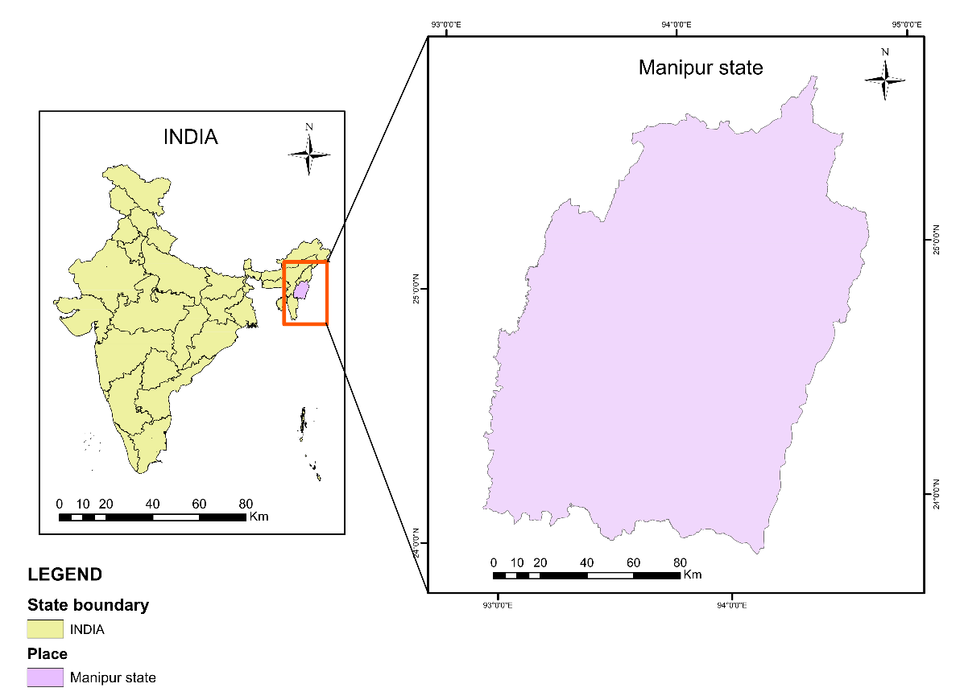

Figure 1. Geographic location of the study area in Manipur State, Northeast India. The inset map highlights the Northeast India region within India, with Manipur marked in red, while the enlarged map in blue colour shows the boundary of Manipur State.

2.2 Data sources, climate variable construction, and modelling approach
Seasonal climate data for the period 2014–2021 were obtained from the Indian Meteorological Department (IMD) Data Service Portal and aggregated over the Kharif growing season (June–October) to characterise hydroclimatic conditions relevant to key rice growth stages. Two seasonal climate indicators were constructed: cumulative Kharif-season rainfall and mean Kharif-season temperature. Rice yield data were compiled from official statistics of the Department of Agriculture, Government of Manipur. For assessing climate impacts, a range of alternative modelling approaches is available, including AI-driven physics-informed frameworks (Inam et al., 2025a; Inam et al., 2025b; Inam et al., 2026), Ricardian regression models that capture long-run climate responses (Mendelsohn, 2009), process-based crop simulation models such as DSSAT and APSIM (Jones et al., 2003; Holzworth et al., 2014), and machine-learning or panel econometric methods that exploit spatial and temporal variation in climate and yields (Lobell & Burke, 2010). In this analysis, we adopt a parsimonious regression-based framework to estimate short-run climate sensitivity using inter-annual variability. Throughout the analysis, year is indexed by t (2014–2021), Kharif rice yield is denoted as Yₜ (t ha⁻¹), cumulative seasonal rainfall as Rₜ (mm), and seasonal mean temperature as Tₜ (°C). Although the study is based on eight Kharif growing seasons (2014–2021), this period encompasses substantial inter-annual hydroclimatic variability, including both wet and dry anomaly years characteristic of monsoon-dominated systems in the region. The modelling framework detailed below is therefore designed to estimate short-run climate sensitivity and mean yield responses under observed variability, rather than to detect long-term climatic trends or nonlinear threshold behaviour, which would require longer historical time series.

Temporal variability in rainfall and temperature was first examined using observed time-series plots combined with locally estimated scatterplot smoothing (LOESS) to describe inter-annual dynamics without imposing parametric structure (Cleveland and Devlin, 1988). Directional changes were assessed using linear trend models in which the climate variable Cₜ (representing either Rₜ or Tₜ) was expressed as a function of time (Cₜ = α + βt + εₜ; Eq. 1), where α is the intercept, β denotes the annual rate of change, and εₜ is a stochastic error term (Kalita et al., 2024). Anomaly years were identified based on visible departures from smoothed climatic trajectories (Hsiang, 2016). Pairwise linear associations among rice yield, rainfall, and temperature were assessed using the Pearson correlation coefficient, defined as rₓᵧ = Cov(X, Y)/(σₓσᵧ) (Eq. 2), where X and Y denote any two variables among Yₜ, Rₜ, and Tₜ, Cov(·) denotes covariance, and σ denotes the corresponding standard deviation (Gogoi et al., 2025; Lobell and Burke, 2010).

To quantify climate sensitivity of rice yield, a sequence of regression models was implemented. Unconditional marginal effects were first estimated using bivariate ordinary least squares (OLS) regressions in which yield was regressed separately on rainfall (Yₜ = α₁ + β₁Rₜ + εₜ; Eq. 3) and on temperature (Yₜ = α₂ + β₂Tₜ + εₜ; Eq. 4) (Zhao et al., 2016). In these expressions, α terms represent intercepts, β terms represent marginal yield responses to climate variables, and εₜ captures unexplained yield variability.

To isolate conditional marginal effects while accounting for co-movement between rainfall and temperature, the Frisch–Waugh–Lovell (FWL) residual approach was applied. Rainfall was first regressed on temperature (Rₜ = γ₀ + γ₁Tₜ + uₜ), where uₜ denotes rainfall residuals net of temperature effects, and these residuals were subsequently included in the yield regression (Yₜ = α₃ + δ₁ûₜ + εₜ; Eq. 5). An analogous procedure was applied to temperature by first removing rainfall-related variation (Tₜ = φ₀ + φ₁Rₜ + vₜ), where vₜ represents temperature residuals net of rainfall, and then regressing yield on these residuals (Yₜ = α₄ + δ₂v̂ₜ + εₜ; Eq. 6). The coefficients δ₁ and δ₂ represent conditional marginal climate effects, while preserving equivalence to the full multivariate model (Greene, 2003). Because FWL regressions are estimated on residualised variables, their goodness-of-fit statistics reflect residual-level variation and are not directly comparable to standard OLS R² values (Lovell, 2008). The Frisch–Waugh–Lovell residual approach isolates conditional climate effects by removing shared variance between rainfall and temperature, while preserving coefficient equivalence to the full multivariate model; fit statistics for FWL regressions therefore reflect residual-level variation and are not directly comparable to standard OLS R² values.

Joint hydrothermal effects were subsequently estimated using a multivariate OLS specification in which yield was regressed simultaneously on seasonal rainfall and temperature (Yₜ = α₅ + β₃Rₜ + β₄Tₜ + εₜ; Eq. 7). This joint model served as the primary structural framework for scenario-based yield projections (Roberts and Schlenker, 2013; Lobell et al., 2011; Kalita et al., 2024).

Using estimated coefficients from the joint climate model, expected mean rice yields under alternative climate scenarios were computed by substituting scenario-specific rainfall and temperature values into the fitted yield function (Ŷₛ = α̂₅ + β̂₃Rₛ + β̂₄Tₛ; Eq. 8). Here, the scenario climate variables $R_{s}$and $T_{s}$were constructed by perturbing a baseline climate defined as the 2018–2021 mean conditions. Specifically, baseline seasonal rainfall and temperature were adjusted by prescribed percentage and absolute increments to generate a set of discrete climate scenarios, such that $R_{s}=R_{b}(1+Δr)$ and $T_{s}=T_{b}+ΔT$, where $Δr$denotes proportional rainfall change and $ΔT$denotes absolute temperature change. Yield deviations relative to the baseline climate were then calculated as ΔYₛ = (Xₛ − X_b)β̂ (Eq. 9), where $X$represents the vector of climate variables (rainfall and temperature) and β̂ is the corresponding vector of estimated coefficients. Uncertainty in projected yield changes was quantified using covariance-corrected standard errors, SE(ΔYₛ) = √[(Xₛ − X_b) Var(β̂)(Xₛ − X_b)′] (Eq. 10), where Var(β̂) denotes the variance–covariance matrix of estimated coefficients and the prime symbol (′) indicates matrix transposition. The magnitudes of the imposed perturbations ($Δr$ and $ΔT$) were selected to reflect observed inter-annual hydroclimatic variability rather than long-term climate change trajectories. Seasonal rainfall perturbations of −15%, +20%, and +40% correspond to the documented range of year-to-year variability in South Asian monsoon rainfall, where seasonal totals frequently deviate by ±20–40% during wet and dry anomaly years, and where variability is projected to intensify under warming (Lau, 1992; Brown et al., 2017; Katzenberger et al., 2021). Seasonal warming increments of +0.5 °C and +1.0 °C represent plausible near-term deviations in seasonal mean temperature consistent with observed warming rates and regional climate projections for South Asia (Katzenberger et al., 2021). The use of such perturbation-based scenarios follows established practice in regression-based crop–climate sensitivity analyses designed to characterise mean yield responses under realistic climate variability rather than extrapolate long-run trends (Lobell & Burke, 2010). Finally, a continuous climate response surface was generated as Ŷ(R, T) = α̂₅ + β̂₃R + β̂₄T (Eq. 11) and visualised using iso-yield contours to illustrate trade-offs between rainfall and temperature across the perturbation space. All statistical analyses were conducted using R software (version 4.5.1).

2.3 Data quality and preprocessing
Climate data were obtained from the Indian Meteorological Department (IMD) Data Service Portal and represent spatially aggregated seasonal averages for Manipur State. All rainfall and temperature observations for the 2014–2021 Kharif seasons were complete, and no missing values were recorded. Rice yield data were compiled from official statistics of the Department of Agriculture, Government of Manipur, and likewise contained no missing observations. Seasonal aggregation from June to October was applied uniformly across all years to ensure temporal consistency between climate indicators and crop outcomes.

3. results and discussion

3.1 Rainfall distribution during the Kharif rice-growing season (2014–2021)
Rainfall during the Kharif season in Manipur over the period 2014–2021 is concentrated in the early monsoon months and declines progressively toward the post-monsoon period (Table 1). Mean monthly rainfall was highest in June (213.7 mm) and July (206.2 mm), indicating that these months receive the bulk of seasonal precipitation critical for rice transplanting and early crop establishment. Adequate rainfall during this period supports puddling, transplanting operations, and early vegetative growth, which are decisive for subsequent crop performance. Rainfall levels moderated during August (168.1 mm) and September (148.1 mm), suggesting relatively stable moisture availability during the active vegetative and reproductive growth stages of rice. However, substantial interannual variability persisted during these months, with September rainfall ranging from 76.6 mm to 301.7 mm, indicating the potential for both moisture stress and excess water conditions during sensitive phenological stages. Such variability can disrupt nutrient uptake, increase lodging risk, and complicate pest and disease management.

By October, average rainfall declined sharply to 97.7 mm, reflecting monsoon withdrawal and reduced water availability during the late reproductive to maturity stages of rice. The lower minimum rainfall observed in October (31.0 mm) suggests a heightened risk of terminal moisture stress, particularly for late-planted or longer-duration varieties. Overall, the pronounced intra-seasonal and interannual variability in rainfall—especially during July and September—highlights the sensitivity of Kharif rice cultivation in Manipur to fluctuations in monsoon rainfall distribution, with direct implications for field operations, crop growth, and yield stability.

Table 1. Monthly rainfall distribution during the Kharif season in Manipur (2014–2021)

Month | Mean rainfall (mm) | Minimum (mm) | Maximum (mm)
June | 213.7 | 90.5 | 319.7
July | 206.2 | 72.3 | 358.2
August | 168.1 | 76.9 | 249.7
September | 148.1 | 76.6 | 301.7
October | 97.7 | 31.0 | 198.9
Notes: Monthly rainfall statistics are based on Kharif season months (June–October) for the period 2014–2021. Mean values represent interannual monthly averages, while minimum and maximum values capture observed interannual variability within each month. Rainfall is expressed in millimetres (mm).

3.2 Temperature regime during the Kharif rice-growing season (2014–2021)
Mean monthly temperatures during the Kharif season in Manipur over 2014–2021 remained relatively stable from June to September, ranging narrowly between 25.8°C and 26.2°C, indicating uniform thermal conditions during most of the rice-growing period (Table 1). Such temperature stability coincides with critical rice growth stages, including transplanting, tillering, and panicle initiation, during which sustained warm conditions support vegetative growth and biomass accumulation. August recorded the highest mean temperature (26.2°C), while September showed a slight decline to 25.8°C, reflecting the onset of seasonal cooling without abrupt thermal stress during reproductive development.

By October, mean temperature declined more noticeably to 23.8°C, corresponding with the transition to post-monsoon conditions and the late reproductive to grain-filling stages of rice. While mean temperatures decreased, maximum monthly temperatures remained consistently high throughout the Kharif season, ranging from 30.3°C to 30.9°C, indicating continued exposure of rice crops to warm daytime conditions across growth stages. Such conditions can enhance photosynthetic activity but may also increase evaporative demand, particularly under declining rainfall later in the season.

In contrast, minimum temperatures exhibited greater seasonal variation, decreasing from approximately 21.5–21.9°C during June–August to 20.9°C in September and further to 16.4°C in October. This widening diurnal temperature range toward the end of the season suggests cooler night-time conditions during crop maturity. Cooler nights during the grain-filling stage can influence assimilate partitioning and grain development, potentially affecting final yield and harvest timing. Overall, the Kharif temperature regime in Manipur is characterised by thermally stable early- and mid-season conditions followed by increased diurnal variability during crop maturation, with direct relevance for rice physiological processes and yield formation.

3.3 Climatic variability, anomaly years, and rice yield outcomes during the Kharif season in Manipur (2014–2021)
Table 3 and Figure 2 summarise inter-annual variability in Kharif-season mean temperature, seasonal total rainfall, and rice yield in Manipur over the period 2014–2021. Seasonal mean temperature exhibited limited inter-annual variability, remaining within a narrow range of 25.2–26.1 °C. The highest Kharif-season mean temperature occurred in 2016 (26.1 °C), while the lowest value was recorded in 2018 (25.2 °C), identifying these years as relative thermal anomalies within the study period (Figure 2-A). Visual inspection of the temperature time series (Figure 2-B) indicates weak directional change, with year-to-year variability dominating over any systematic trend. In contrast, Kharif-season total rainfall displayed pronounced inter-annual variability. Seasonal rainfall ranged from 589.6 mm in 2021 to 1252.1 mm in 2017, indicating substantial fluctuations in monsoon-season water availability. Rainfall increased sharply between 2014 and 2015, declined moderately in 2016, and reached a clear maximum in 2017, which constitutes a wet anomaly year. Following 2017, rainfall declined markedly, with 2019 and 2021 representing dry anomaly years. Although a fitted linear trend suggests a gradual decline in seasonal rainfall, the dominant feature of the series is strong inter-annual variability rather than monotonic change.

Table 2. Monthly temperature distribution during the Kharif rice season in Manipur (2014–2021)

Month | Mean temperature (°C) | Minimum (°C) | Maximum (°C)
June | 26.0 | 21.5 | 30.9
July | 26.1 | 21.8 | 30.3
August | 26.2 | 21.9 | 30.9
September | 25.8 | 20.9 | 30.7
October | 23.8 | 16.4 | 30.6
Notes: Monthly temperature statistics are based on Kharif season months (June–October) for the period 2014–2021. Mean values represent interannual monthly averages, while minimum and maximum values capture observed interannual variability. Temperature is expressed in degrees Celsius (°C).

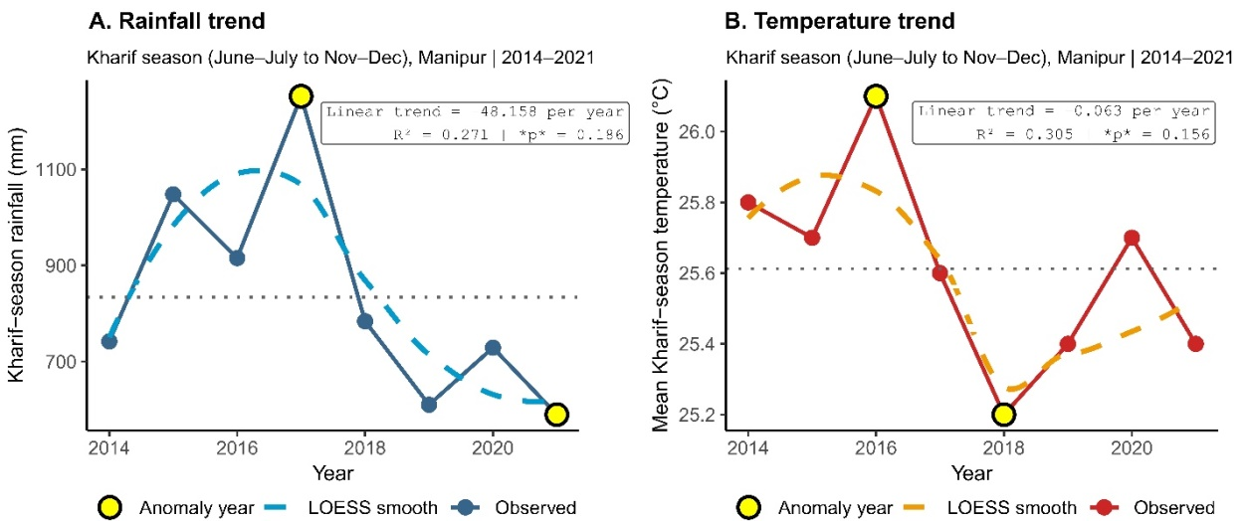

Figure 2. Climate trends during the Kharif rice season in Manipur (2014–2021). Observed annual trends in (A) Kharif-season rainfall and (B) mean Kharif-season temperature in Manipur. Solid lines represent observed values, dashed lines indicate LOESS-smoothed trends, and dotted horizontal lines show long-run means. Highlighted points denote anomaly years exceeding ±1 standard deviation from the mean. Linear trend statistics are reported within each panel.

Rice yield exhibited considerable year-to-year variability during the study period, ranging from 1.74 t ha⁻¹ in 2016 to 2.68 t ha⁻¹ in 2021 (Table 3). Yield declined between 2014 and 2016, reaching a minimum in 2016, followed by partial recovery in 2017 and higher values in 2018–2019. Yield decreased again in 2020 before increasing to the highest observed level in 2021. The temporal pattern indicates substantial short-term variability rather than a consistent long-term trajectory.
Table 3. Inter-annual variability in Kharif-season climate conditions and rice yield in Manipur (2014–2021)

Year | Kharif-season mean temperature (°C) | Kharif-season total rainfall (mm) | Rice yield (t ha⁻¹)
2014 | 25.8 | 741.9 | 2.59
2015 | 25.7 | 1048.0 | 1.96
2016 | 26.1 | 915.3 | 1.74
2017 | 25.6 | 1252.1 | 1.86
2018 | 25.2 | 784.0 | 2.30
2019 | 25.4 | 610.1 | 2.41
2020 | 25.7 | 728.9 | 2.11
2021 | 25.4 | 589.6 | 2.68
Notes: Kharif-season mean temperature represents the seasonal average across June–October. Kharif-season total rainfall denotes cumulative rainfall over the same period. Rice yield is reported as average yield per hectare. The table highlights pronounced inter-annual variability in seasonal rainfall and yield relative to comparatively limited variability in seasonal mean temperature over 2014–2021.

Years characterised by high seasonal rainfall, including 2015 (1048.0 mm) and 2017 (1252.1 mm), coincided with relatively lower rice yields (1.96 and 1.86 t ha⁻¹, respectively). Conversely, years with comparatively lower seasonal rainfall, such as 2019 (610.1 mm) and 2021 (589.6 mm), were associated with higher yields (2.41 and 2.68 t ha⁻¹). This pattern suggests sensitivity of rice production outcomes to rainfall magnitude and inter-annual variability during the Kharif season. Variations in seasonal mean temperature over the same period were comparatively small and did not exhibit an obvious correspondence with year-to-year yield fluctuations. The results indicate that climatic variability during the Kharif season in Manipur over 2014–2021 was characterised by relatively stable thermal conditions and highly variable seasonal rainfall, with identifiable wet and dry anomaly years. Rice yield outcomes co-varied more closely with rainfall variability and anomalies than with seasonal mean temperature. These observed patterns provide the empirical basis for subsequent correlation and regression analyses examining the conditional and marginal relationships between climate variables and rice yield.

3.4 Climate–yield relationships during the Kharif season (2014–2021)
The correlation matrix (Figure 3) shows a strong negative association between Kharif-season total rainfall and rice yield (Pearson r = −0.78) and a moderate negative association between seasonal mean temperature and yield (r = −0.54). The correlation between rainfall and temperature is positive but weak (r = 0.33), indicating limited co-variation between the two climate variables during the study period.

Figure 4 and Table 4 summarise the relationships between Kharif-season climate variability and rice yield in Manipur during 2014–2021 using standardised bivariate models, conditional (FWL) residual regressions, and a multivariate structural OLS specification. Consistent with this correlation structure, Model 1 (Yield ~ Rainfall) indicates a statistically significant negative association between rainfall and yield (β = −0.001, p < 0.05; R² = 0.611). The rainfall effect remains statistically significant and similar in magnitude when estimated as a conditional marginal effect using the FWL residual regression in Model 2 (Rainfall | Temp) (β = −0.001, p < 0.05; residual-level R² = 0.576). In the standardised scatterplots (Figure 4, Panels A–B), years with high rainfall deviations correspond to negative yield deviations, including rainfall anomaly years such as 2015 and 2017. For temperature, Model 3 (Yield ~ Temp) estimates a negative association between temperature and yield (β = −0.663), but this effect is not statistically distinguishable from zero at conventional levels (p > 0.10; R² = 0.291). The conditional marginal temperature effect in Model 4 (Temp | Rainfall) remains negative (β = −0.387) and similarly not statistically distinguishable from zero (p > 0.10; residual-level R² = 0.228). In Figure 4 (Panels C–D), temperature anomaly years (notably 2016 and 2018) align with yield deviations, but the dispersion around the fitted relationships is wider than in the rainfall models.

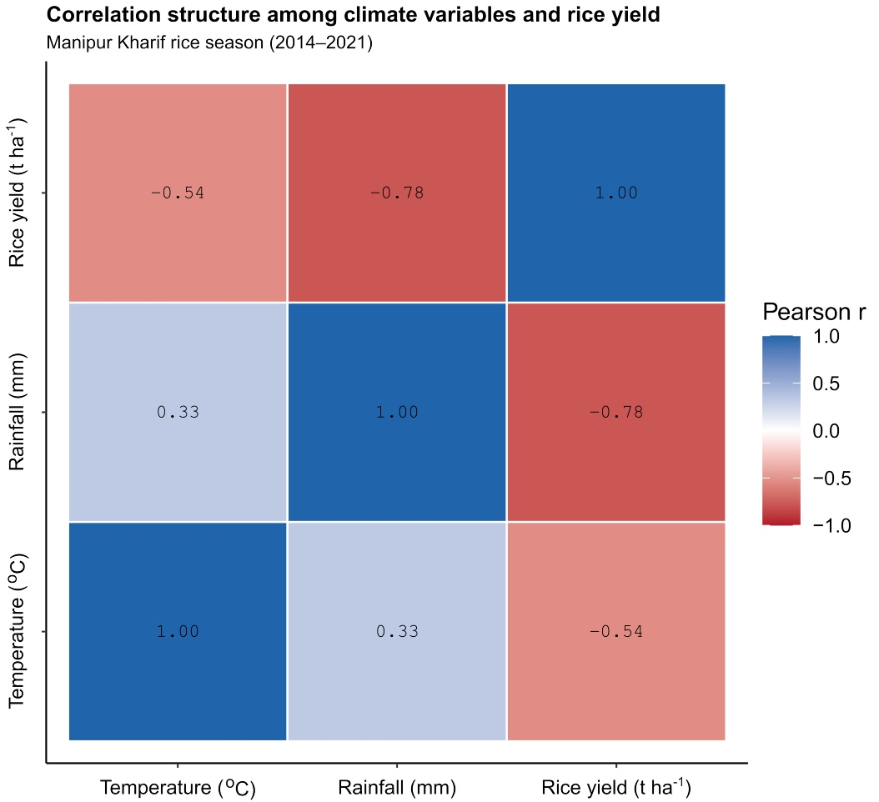

Figure 3. Correlation structure among climate variables and rice yield.
Pearson correlation matrix for Kharif-season rainfall, temperature, and rice yield in Manipur (2014–2021). Cell colours indicate the direction and magnitude of correlations, with numerical values reporting correlation coefficients.

Model 5 (Yield ~ Temp + Rainfall) provides the structural multivariate OLS specification used for scenario-based projections. In Model 5, rainfall retains a statistically significant negative association with yield after accounting for temperature (β = −0.001, p < 0.05), while the temperature coefficient remains negative (β = −0.387) but not statistically distinguishable from zero at conventional levels (p > 0.10). Model 5 achieves the highest explained variance among the reported models (R² = 0.700; adjusted R² = 0.580) and the lowest RMSE (0.223), indicating improved fit relative to the bivariate specifications. Model 5 is used as the basis for scenario-based yield projections reported in Section 3.5.
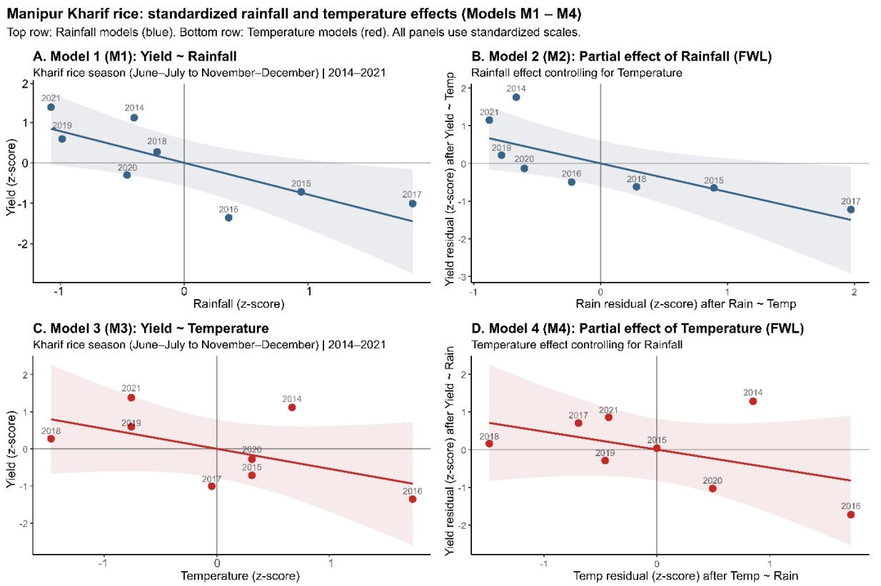`
Figure 4. Regression relationships between climate variables and rice yield (Models 1–4).
Standardised regression relationships between Kharif rice yield and (A) rainfall, (B) rainfall conditional on temperature (FWL), (C) temperature, and (D) temperature conditional on rainfall (FWL) for Manipur (2014–2021). Points represent annual observations, and fitted lines denote estimated marginal effects from Ordinary Least Squares and Frisch–Waugh–Lovell residual regressions.

Table 4. Regression analysis: Manipur Kharif rice (2014–2021)

Variables | Model 1:  Yield ~ Rainfall | Model 2:  Rainfall | Temp (FWL) | Model 3:  Yield ~ Temp | Model 4:  Temp | Rainfall (FWL) | Model 5:  Yield ~ Temp + Rainfall (OLS)
Model intercept | 3.20 (0.33)*** | 0.00 (0.07) | 19.19 (10.83) | 0.00 (0.07) | 12.98 (8.07)
Rainfall | −0.001 (0.000)** | −0.001 (0.000)** | — | — | -0.001 (0.000)**
Temperature | — | — | −0.663 (0.423) | −0.387 (0.291) | -0.387 (0.319)
R² | 0.611 | 0.576 | 0.291 | 0.228 | 0.700
Adjusted R² | 0.547 | 0.505 | 0.172 | 0.099 | 0.580
RMSE | 0.232 | 0.224 | 0.313 | 0.290 | 0.223
Log-likelihood | 1.710 | 2.090 | −2.110 | −1.830 | 2.530
AIC | 0.581 | −0.180 | 8.220 | 7.660 | 2.900
BIC | 0.740 | 0.010 | 8.380 | 7.820 | 3.300
Notes: Regression coefficient estimates are reported with standard errors in parentheses. ‘*’, ‘**’ and, ‘***’ denote significance levels at the 10%, 5%, and 1% levels, respectively. Models (1) and (3) are bivariate ordinary least squares (OLS) regression models, while Models (2) and (4) estimate conditional marginal effects using Frisch–Waugh–Lovell (FWL) residual regressions. R², RMSE, log-likelihood, AIC, and BIC values for the FWL models reflect residual-level fit and are not directly comparable to those reported for Models (1) and (3). Model (5) is a structural multivariate Ordinary Least Squares (OLS) regression and is used for scenario-based yield projections reported in section 3.5.

Model diagnostics indicated no severe violations of OLS assumptions despite the small sample size. Residual plots showed no systematic heteroscedasticity, leverage and influence statistics indicated that no single year dominated the estimated rainfall coefficient, and variance inflation factors were below conventional thresholds, suggesting limited multicollinearity.

3.5 Climate sensitivity and scenario-based yield responses of Kharif rice in Manipur (2014–2021)
The mean-only scenario analysis based on the multivariate OLS specification (Model 5) characterises the conditional response of Kharif rice yield in Manipur to joint perturbations in seasonal rainfall and temperature relative to a recent-climate baseline (2018–2021 mean) (Fig. 5). The imposed scenarios span a range of deviations in monsoon-season rainfall (−15%, +20%, and +40%) combined with modest increases in seasonal mean temperature (+0.5 °C and +1.0 °C), providing a structured representation of hydroclimatic variability around the baseline (Fig. 5A). The joint response surface derived from Model 5 indicates that expected yield varies systematically across the combined temperature–rainfall space, with iso-yield contours revealing trade-offs between thermal and moisture conditions (Fig. 5B). Scenario locations embedded within this surface show that higher rainfall perturbations combined with additional warming are associated with lower expected yields relative to the baseline, whereas moderate warming under reduced rainfall produces comparatively smaller deviations (Fig. 5B). The configuration of the response surface is consistent with stronger sensitivity to rainfall variability, with temperature acting as a secondary modifier within the narrow range of seasonal means observed during 2014–2021 (Fig. 5B).

Projected mean yields under the defined scenarios show clear differentiation relative to the baseline climate, with uncertainty expressed as confidence intervals for the conditional mean (Fig. 5C). The baseline scenario, anchored at the recent-climate mean, yields an expected value of approximately 2.44 t ha⁻¹, while the drier scenario combined with moderate warming shows a comparatively small negative deviation from this reference (Fig. 5C). In contrast, wetter and very wet scenarios are associated with progressively lower expected yields (Fig. 5C). Expressed relative to the baseline, the estimated effect sizes indicate reductions in mean yield under wetter conditions, with the largest negative deviation occurring under the very wet, warmer scenario (Fig. 5D). The covariance-corrected confidence intervals highlight uncertainty linked to the joint estimation of rainfall and temperature effects while retaining the baseline as the zero-reference condition (Fig. 5D). Collectively, these results indicate that within the observed climatic range of the study period, mean Kharif rice yield in Manipur is more responsive to variations in seasonal rainfall than to small shifts in mean temperature, and that the combined influence of increased rainfall and warming is associated with lower expected yields relative to recent conditions (Fig. 5).

4. Discussion
Rice productivity in smallholder systems is shaped by interacting climatic, ecological, and management drivers, with longitudinal evidence showing that environmental variability and production constraints jointly influence agrarian outcomes in rice-based farming systems (Aravindakshan et al., 2020). Inter-annual hydroclimatic variability during the Kharif season emerged as a central driver of rainfed rice yield outcomes in Manipur over 2014–2021, with rainfall fluctuations exerting substantially stronger statistical influence than seasonal mean temperature. The study period was characterised by pronounced year-to-year rainfall departures, including anomaly years associated with both excess and deficit precipitation, while temperature remained confined to a relatively narrow range. Across marginal, conditional, and multivariate specifications, rainfall consistently exhibited a negative association with yield, indicating that high seasonal totals were linked to yield reductions even after accounting for temperature co-movement. This pattern aligns with longer-horizon evidence from Manipur demonstrating that elevated monsoon rainfall has persistently depressed rice productivity through flooding stress and field management disruptions (Murasingh et al., 2022; Singh, 2025). It also mirrors findings from broader Northeast India where rainfall extremes, rather than gradual thermal change, dominate short-run yield volatility in rainfed rice systems (Kalita et al., 2024). At the same time, because climate indicators are aggregated at the seasonal scale, short-duration extremes such as intense rainfall events or brief heat spells are not explicitly resolved; this aggregation may mask nonlinear damage mechanisms and may partly explain the observed negative rainfall–yield relationship.

In contrast, temperature effects over the 2014–2021 window were weaker and statistically less robust once rainfall variability was controlled. Although seasonal mean temperature displayed a modest negative relationship with yield, its explanatory contribution remained secondary to rainfall in all modelling frameworks. This does not imply thermal stress is agronomically unimportant; rather, it reflects the limited inter-annual variation in seasonal averages captured in the dataset and the likelihood that yield sensitivity operates through intra-seasonal heat exposure and minimum temperature dynamics not resolved by seasonal aggregation. Physiological studies from Manipur and neighbouring regions highlight that elevated night temperatures and heat stress during reproductive stages can impair grain formation and yield stability (Laishram et al., 2023), while longer time-series analyses confirm temperature as a significant yield determinant once broader climatic variability is incorporated (Singh, 2025).

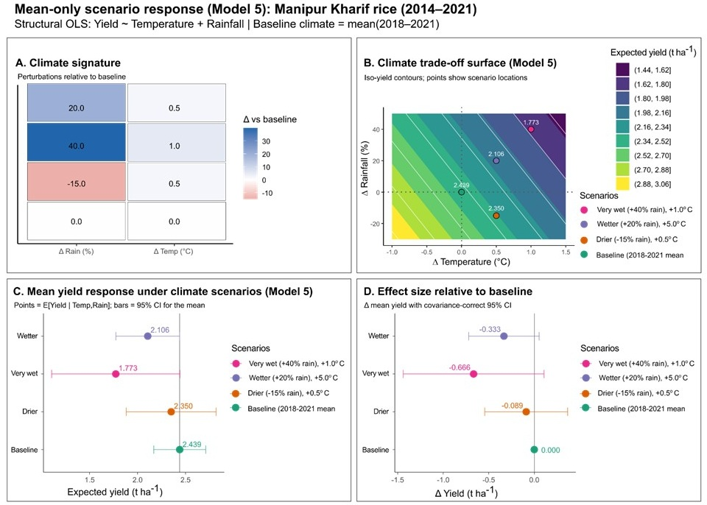

Figure 5. Mean yield response of Manipur Kharif rice to alternative climate scenarios (2014–2021).
Expected yield responses are derived from a structural multivariate OLS model (Yield ~ Temperature + Rainfall; Model 5), with baseline climate defined as the 2018–2021 mean. Panel A shows rainfall and temperature perturbations relative to baseline. Panel B depicts the temperature–rainfall trade-off surface with iso-yield contours and scenario locations. Panel C reports scenario-specific expected mean yields with 95% confidence intervals for the mean. Panel D presents yield changes relative to baseline with covariance-correct 95% confidence intervals. Confidence intervals reflect uncertainty in the estimated mean response, not prediction uncertainty.

The observed correlation structure reinforces the need for joint hydrothermal modelling, with rainfall and temperature positively correlated while both exhibit negative contemporaneous relationships with rice yield. Conditional marginal effects estimated through Frisch–Waugh–Lovell residualisation demonstrate that rainfall retains its negative influence independently of temperature, validating the multivariate structural framework used for scenario analysis. Scenario-based projections further indicate asymmetric yield penalties under wetter and warmer conditions relative to the recent baseline, with the largest declines occurring under high-rainfall perturbations combined with moderate warming. These responses are consistent with documented production risks in Northeast India where excess rainfall intensifies flooding, pest pressure, and delays in transplanting and harvesting, often outweighing benefits of enhanced moisture availability (Kalita et al., 2024).

Overall, the findings indicate that short-term climate risk in Manipur’s rainfed Kharif rice systems is currently dominated by rainfall variability—particularly episodes of excessive precipitation—while temperature effects are likely to become more evident over longer horizons or under more extreme warming regimes. This rainfall-centric vulnerability aligns with regional assessments emphasizing hydroclimatic hazards as the primary constraint to rice-based livelihoods and the focal point of farmer adaptation strategies (Lotha et al., 2024). Although constrained by the short time series and seasonal aggregation, the convergence of trend diagnostics, correlation structure, regression estimates, and scenario responses provides coherent evidence that managing rainfall-induced production risk will remain central to climate resilience in Manipur’s rice systems.

5. Conclusion
This study provides empirical evidence that inter-annual hydroclimatic variability is the primary determinant of Kharif rice yield fluctuations in Manipur’s predominantly rainfed production system. Across marginal, conditional, and multivariate regression frameworks, seasonal rainfall consistently emerged as the dominant climatic driver, with higher monsoon rainfall associated with significant yield reductions even after accounting for temperature co-movement. In contrast, seasonal mean temperature effects were comparatively weak and statistically less robust within the narrow thermal range observed over 2014–2021, indicating that short-run production risk is currently governed more by hydroclimatic extremes than by gradual warming. Scenario-based yield projections further reinforced this asymmetry. Simulated increases in seasonal rainfall and temperature relative to recent baseline conditions produced progressively larger yield penalties, whereas modest rainfall reductions combined with limited warming resulted in comparatively smaller deviations. These results highlight that excess monsoon rainfall—rather than moisture scarcity alone—constitutes a central source of climate risk for rainfed rice systems in Manipur.

From an adaptation and risk-management perspective, the findings point to three priority areas. First, investments in field-level drainage and flood mitigation are critical to reducing yield losses associated with excessive rainfall. Second, the deployment of flood-tolerant rice varieties and the adoption of flexible crop calendars can help buffer production against monsoon variability. Third, strengthening early-warning systems for extreme precipitation events would support timely farm-level decision-making in a region where rainfall shocks dominate yield volatility. While longer time series and higher-frequency climate data are needed to assess nonlinear thresholds and longer-term warming impacts, the present analysis provides robust short-run evidence linking rainfall variability to yield instability. By combining transparent regression-based inference with scenario analysis, this study contributes a reproducible framework for diagnosing climate sensitivity in data-constrained, monsoon-dependent rice systems and for informing targeted, context-specific adaptation strategies.

Disclaimer (Artificial intelligence)

Author(s) hereby declare that NO generative AI technologies such as Large Language Models (ChatGPT, COPILOT, etc.) and text-to-image generators have been used during the writing or editing of this manuscript.

References

- Aravindakshan, S., Krupnik, T. J., Groot, J. C., Speelman, E. N., Amjath-Babu, T. S., & Tittonell, P. (2020). Multi-level socioecological drivers of agrarian change: Longitudinal evidence from mixed rice-livestock-aquaculture farming systems of Bangladesh. Agricultural Systems, 177, 102695.
- Aravindakshan, S., Krupnik, T. J., Laing, A. M., Pin, S., Rica, J. F., & Saito, K. (2024). Mechanized direct-seeding and best management practices for rice in Cambodia: How and why are they complementary? EIA, IRRI, CIMMYT, & CGIAR. https://hdl.handle.net/10883/35340
- Arshad, M., Amjath-Babu, T. S., Krupnik, T. J., Aravindakshan, S., Abbas, A., Kächele, H., & Müller, K. (2017). Climate variability and yield risk in South Asia’s rice–wheat systems: Emerging evidence from Pakistan. Paddy and Water Environment, 15(2), 249–261.
- Brown, J. R., Moise, A. F., & Colman, R. A. (2017). Projected increases in daily to decadal variability of Asian‐Australian monsoon rainfall. Geophysical Research Letters, 44(11), 5683-5690.
- Buenafe, K. C. V., Dunn, D. C., Everett, J. D., Brito-Morales, I., Schoeman, D. S., Hanson, J. O., Dabalà, A., Neubert, S., Cannicci, S., Kaschner, K., & Richardson, A. J. (2023). A metric-based framework for climate-smart conservation planning. Ecological Applications, 33(4), e2852.
- Chakraborty, D., Başağaoğlu, H., & Winterle, J. (2021). Interpretable vs. noninterpretable machine learning models for data-driven hydro-climatological process modeling. Expert Systems with Applications, 170, 114498.
- Cleveland, W. S., & Devlin, S. J. (1988). Locally weighted regression: An approach to regression analysis by local fitting. Journal of the American Statistical Association, 83(403), 596–610.
- FAO, IFAD, UNICEF, WFP, & WHO. (2025). The state of food security and nutrition in the world 2025: Addressing high food price inflation for food security and nutrition. FAO. https://doi.org/10.4060/cd6008en
- Gogoi, N., Pathak, B., Rehman, R., Upadhyaya, S., Mahanta, P., Borah, A., Baishya, K. J., & Bhuyan, K. (2025). Rice yield responses to climate variability in Northeast India using a machine learning approach. Theoretical and Applied Climatology, 156, 233. https://doi.org/10.1007/s00704-025-05452-9
- Government of Manipur. (2016). Statistical year book of Manipur. Directorate of Economics & Statistics.
- Greene, W. H. (2003). Econometric analysis (5th ed.). Prentice Hall.
- Holzworth, D. P., Huth, N. I., deVoil, P. G., Zurcher, E. J., Herrmann, N. I., McLean, G., ... & Keating, B. A. (2014). APSIM–evolution towards a new generation of agricultural systems simulation. Environmental Modelling & Software, 62, 327-350.
- Hsiang, S. (2016). Climate econometrics. Annual Review of Resource Economics, 8(1), 43–75.
- Inam, S. A., Hashim, H., Ashraf, S. N., Naim, S. W., Rajput, H., & Umer, S. (2025a). AI-driven physics informed neural network for daily temperature forecasting with constraint aware learning and explainable feature attribution. VFAST Transactions on Software Engineering, 13(4), 53-67.
- Inam, S. A., Hashim, H., Awan, A. M., Rajput, H., & Umer, S. (2025a). Interpretable Physics-Informed Neural Network for Reliable Humidity Forecasting in Contrasting Climates of Sindh. VAWKUM Transactions on Computer Sciences, 13(2), 135-148.
- Inam, S. A., Umer, S., & Rajput, H. (2026). A physics informed deep learning framework for rainfall forecasting in diverse climatic regions. Discover Artificial Intelligence.
- Jones, J. W., Hoogenboom, G., Porter, C. H., Boote, K. J., Batchelor, W. D., Hunt, L. A., ... & Ritchie, J. T. (2003). The DSSAT cropping system model. European Jjournal of Agronomy, 18(3-4), 235-265.
- Kalita, B., Kumar, C. J., Hazarika, N., Baruah, K. K., & Borah, L. (2024). Exploring climate change adaptation practices and agricultural livelihoods among rice farmers of the Brahmaputra Valley in Northeast India. Environmental Management, 73, 1180–1200. https://doi.org/10.1007/s00267-024-01954-w
- Katzenberger, A., Schewe, J., Pongratz, J., & Levermann, A. (2021). Robust increase of Indian monsoon rainfall and its variability under future warming in CMIP6 models. Earth System Dynamics, 12(2), 367-386.
- Khinchi, S. S., & Neog, D. (2016). Impact of climate on agricultural environment of North-East India: Problems and prospects. In S. S. Khinchi & M. Tanwar (Eds.), Global climate change and biodiversity (pp. 1–45). V. L. Media Solutions.
- Krumhansl, K. A., Dowd, M., & Wong, M. C. (2021). Multiple metrics of temperature, light, and water motion drive gradients in eelgrass productivity and resilience. Frontiers in Marine Science, 8, 597707.
- Laishram, O., Meetei, S., Khan, M. H., Singh, A. R., Shah, M. Z., & Yuingamla, S. W. (2023). Climatic factors influencing local rice varieties in Thoubal (Valley) and Ukhrul (Hill) districts of Manipur: A case study. Journal of Diversity Studies, 1(2), 11–15.
- Lau, K. M. (1992). East Asian summer monsoon rainfall variability and climate teleconnection. Journal of the Meteorological Society of Japan. Ser. II, 70(1B), 211-242.
- Lobell, D. B., & Burke, M. B. (2010). On the use of statistical models to predict crop yield responses to climate change. Agricultural and Forest Meteorology, 150(11), 1443–1452.
- Lobell, D. B., Schlenker, W., & Costa-Roberts, J. (2011). Climate trends and global crop production since 1980. Science, 333(6042), 616–620.
- Lotha, T. N., Ritse, V., Nakro, V., Rudithongru, L., Hazarika, N., & Jamir, L. (2024). Climate change impact and traditional adaptation practices in Northeast India: A review. Current World Environment, 19(2), 558.
- Lovell, M. C. (2008). A simple proof of the FWL theorem. The Journal of Economic Education, 39(1), 88–91.
- Mendelsohn, R. (2009). The impact of climate change on agriculture in developing countries. Journal of Natural Resources Policy Research, 1(1), 5-19.
- Miao, R., Khanna, M., & Huang, H. (2016). Responsiveness of crop yield and acreage to prices and climate. American Journal of Agricultural Economics, 98(1), 191–211.
- Mohanty, U. C., Sinha, P., Rao, M. N., Swain, D. K., & Singh, K. K. (2024). Climate risk management in agriculture. Springer. https://doi.org/10.1007/978-3-031-51862-1
- Murasingh, S., Kuttippurath, J., Dash, S. S., Raj, S., Remesan, R., Jha, M. K., & Kumar, P. (2022). Long-term trends and projections of hydrological fluxes under RCP climate change scenarios for a mountainous river catchment of northeast India. Journal of Water and Climate Change, 13(4), 1776–1789.
- Paul, A. R., & Maity, R. (2023). Future projection of climate extremes across contiguous northeast India and Bangladesh. Scientific Reports, 13(1), 15616.
- Roberts, M. J., Schlenker, W., & Eyer, J. (2013). Agronomic weather measures in econometric models of crop yield with implications for climate change. American Journal of Agricultural Economics, 95(2), 236–243.
- Singh, A. M., Elangbam, G., Sharma, G. N., Singh, T. C., & Teresa, K. (2025). Long-term rainfall seasonality trends and abrupt shifts in the Northeast Indian Province of Manipur. Discover Sustainability, 6(1), 881.
- Singh, K. S. (2025). A study on the impact of rainfall and temperature on rice yield in Manipur during 1991–2024. The NEHU Journal, 23(1), 85–99. https://nehu.ac.in/public/uploads/ea0b11dc6c51e255c70ffe6ee86be517.pdf
- United Nations. (2023). The Sustainable Development Goals report 2023. https://sdgs.un.org/gsdr/gsdr2023
- Varah, F., & Varah, S. K. (2022). Indigenous knowledge and seasonal change: Insights from the Tangkhul Naga in Northeast India. GeoJournal, 87(6), 5149–5163.
- Wangkheimayum, N., & Paliwal, H. B. (2023). Development of rice yield forecasting model using linear regression for Imphal West district, Manipur, India. International Journal of Environment and Climate Change, 13(9), 485–490.
- Zhao, C., Piao, S., Wang, X., Huang, Y., Ciais, P., Elliott, J., Huang, M., Janssens, I. A., Li, T., Lian, X., & Liu, Y. (2016). Plausible rice yield losses under future climate warming. Nature Plants, 3(1), 1–5.

