VARIABILITY OF PHYSICO-CHEMICAL CHARACTERISTICS OF MEENACHIL RIVER DURING THE MONSOON SEASON, AT KOTTAYAM, KERALA, INDIA

Abstract
This study evaluates the monsoon-season water quality of the Meenachil River by analyzing samples collected from seven stations which are Bharananganam, Panackappalam, Erattupetta, Poonjar, Panachipppara, Idappadi and Pala. A comprehensive assessment of physico-chemical parameters was carried out along the river. The study revealed that pH values ranged from 5.36 to 6.83, while total hardness varied between 8.09 and 11.16 mg/L. Dissolved oxygen concentrations were recorded in the range of 5.76–6.17 mg/L, and BOD₅ values remained low at 0.94–1.18 mg/L, collectively indicating strong dilution effects and efficient hydrological mixing during periods of high flow. Meenachil river shows physiochemical parameter values within the permissible limit at all seasons except turbidity. Turbidity value was high at all stations during monsoon season.
Keywords: Meenachil River, Water Quality, Dissolved Oxygen, Health risks
1. Introduction
Rivers are among the most important freshwater ecosystems, playing a critical role in sustaining biodiversity, supporting agricultural production, facilitating industrial activities, and meeting the domestic water demands of growing human populations. In tropical regions, river systems are particularly significant as they serve as lifelines for socio-economic development while simultaneously maintaining ecological balance. However, increasing anthropogenic pressures have led to widespread deterioration of river water quality, making systematic assessment and monitoring essential for sustainable water resource management.
The Meenachil River, flowing through the Kottayam District of Kerala, is a major west-flowing river that significantly contributes to the region’s environmental stability and socio-economic framework. The river supports extensive agricultural activities, particularly rubber plantations, paddy cultivation, and other plantation crops, which form the backbone of the local economy. In addition to irrigation, the Meenachil River serves as a vital source of domestic and municipal water supply for several urban and rural settlements along its course (CPCB, 2014). The riverine corridor and adjacent wetlands host diverse aquatic organisms, riparian vegetation, fish species, and migratory birds, thereby enhancing regional biodiversity and ecosystem resilience. Furthermore, periodic flooding and sediment deposition along the floodplains improve soil fertility by replenishing essential nutrients, thereby sustaining agricultural productivity. Consequently, soil quality monitoring, alongside water quality assessment, becomes crucial for ensuring long-term ecological sustainability and land resource management. Studies on the Meenachil River have recorded seasonal variations in physico-chemical and biochemical parameters, highlighting the dynamic nature of the river system and the need for integrated watershed management approaches. (Vakapadath et al., 2023).
During the past few decades, however, the Meenachil River basin has experienced increasing environmental stress due to rapid population growth, land-use changes, urban expansion, and intensified agricultural practices. Anthropogenic activities such as discharge of untreated or partially treated domestic sewage, agricultural runoff carrying fertilizers and pesticides, and waste from small-scale commercial units have exerted considerable pressure on the river’s water quality (Venkatesharaju et al., 2010; Singh & Nath, 2019; Minz & Nath, 2023). Seasonal variations in runoff further influence the concentration of pollutants, particularly during the monsoon period, when surface runoff increases significantly. Studies on river water quality in Kerala, including analyses of multiple river systems, have highlighted spatial variability associated with land use and hydrology (Jose & Ambili, 2021).
In addition to chemical pollution, physical alterations such as sand mining, encroachment into floodplains, and modification of natural flow regimes have affected channel morphology and sediment transport processes within the river system (Kondolf, 1997;). These activities collectively threaten the ecological integrity of the river by altering its physico-chemical characteristics, degrading habitat quality, and increasing potential risks to human health and aquatic life (UNEP, 2016; WHO, 2017).
Meenachil river facing environmental pollution near in urban area. In this context, the present study aims to evaluate the physico-chemical characteristics of the Meenachil River during the monsoon season of 2024 and to assess their implications for river ecology. Seasonal variations in the water quality of the Meenachil River have been reported during the monsoon season, mainly due to increased surface runoff and catchment inputs (Radhika et al., 2024). The findings are expected to provide baseline information for sustainable management and conservation of the river system.

2. Materials and Methods
River water sampling was carried out at seven monitoring stations along the Meenachil River, namely Bharananganam, Panackappalam, Erattupetta, Poonjar, Panachippara, Idappadi, and Pala. These stations were selected to represent different land-use patterns, population density, and anthropogenic influences along the river course. Sampling was conducted on a fortnightly basis during the monsoon season to capture short-term variations in water quality associated with rainfall, surface runoff, and increased river discharge. Water samples were collected following standard procedures to avoid contamination and to ensure representativeness. Clean polyethylene bottles were used for sample collection, and samples were transported under appropriate conditions to the laboratory for further analysis. The sampling locations along the river are illustrated in Fig. 1. Water sampling was based on its critical role in influencing river water quality through enhanced dilution and mobilization of pollutants from the catchment.
All physico-chemical andbiochemical parameters were analysed using standard methods recommended by the American Public Health Association (APHA, 2017). The parameters selected for analysis included pH, turbidity, alkalinity, calcium, magnesium, total hardness, chloride, sulphate, nitrate, phosphate, dissolved oxygen (DO), and biochemical oxygen demand (BOD₅). These parameters were chosen to assess the overall water quality status of the river and to understand the influence of natural processes and anthropogenic activities during the monsoon period. The observed values were compared with drinking water quality standards prescribed by the Bureau of Indian Standards (BIS) and guidelines issued by the Central Pollution Control Board (CPCB).
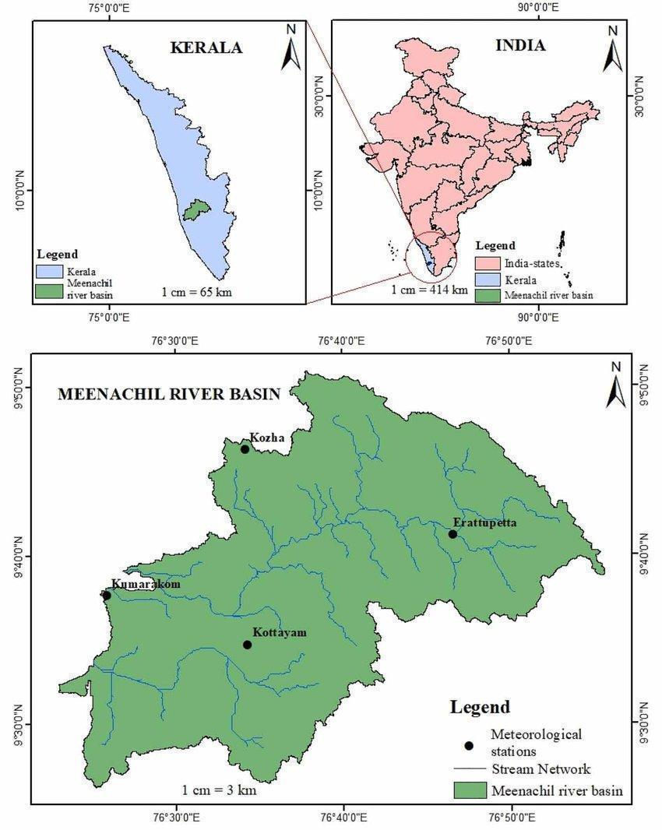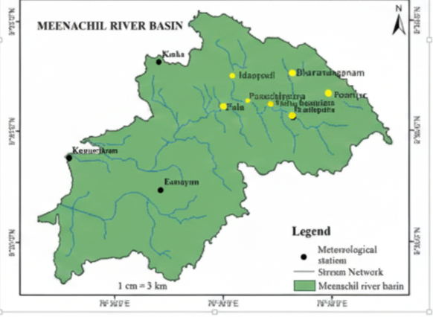
Fig. 1: Meenachil River Basin along with sampling location
2.1. Analysis of River water Samples
Collected water samples were transported to the laboratory at the School of Environmental Sciences, Mahatma Gandhi University, Kerala, for detailed analysis. Parameters such as pH and dissolved oxygen were measured immediately after sample collection to minimize changes due to storage and handling. Other parameters were analysed under controlled laboratory conditions following established protocols.
Turbidity was determined using the nephelometric method (2130 B), while total solids were analysed using the gravimetric method (2540 B). Alkalinity was estimated by titration (2320 B), and total hardness was determined using the EDTA titrimetric method (2340 C). Chloride concentration was analysed using the argentometric method (4500-Cl⁻ B). Nitrate detected by (4500 NO₃ B. ultraviolet spectrophotometric screening method). Phosphate was analyzed by the ascorbic acid spectrophotometric method (APHA ,12017) where the blue-colored complex formed was measured at 880 nm using a UV–Visible spectrophotometer. Sulphate concentration was measured using the turbidimetric method (4500-SO₄²⁻ E). All analyses were conducted following quality control procedures to ensure accuracy and reliability of the results.

Stations | pH | Turb | Alk | T.H | Ca .H | Mg.H | DO | BOD | Cl⁻ | SO₄²⁻ | NO₃⁻ | PO₄³⁻
Bharananganam | 6.83 | 13.59 | 16.30 | 8.09 | 3.34 | 4.75 | 6.13 | 1.00 | 7.90 | 3.20 | 0.79 | 0.10
Panackappalam | 6.26 | 18.83 | 16.44 | 10.55 | 5.59 | 4.96 | 6.13 | 0.98 | 8.68 | 2.60 | 0.70 | 0.03
Erattupetta | 5.98 | 19.76 | 14.31 | 10.16 | 5.28 | 4.89 | 6.03 | 0.98 | 6.58 | 3.78 | 0.86 | 0.02
Poonjar | 5.36 | 11.46 | 17.90 | 8.78 | 4.16 | 4.61 | 6.43 | 1.18 | 9.41 | 2.78 | 0.84 | 0.53
Panachippara | 6.18 | 15.86 | 13.25 | 11.56 | 5.29 | 6.28 | 6.43 | 1.08 | 6.87 | 3.50 | 0.74 | 0.33
Idappadi | 6.66 | 13.98 | 18.36 | 9.53 | 5.53 | 4.00 | 6.69 | 1.03 | 8.24 | 3.06 | 0.73 | 0.01
Pala | 6.21 | 14.33 | 16.61 | 10.70 | 5.48 | 5.23 | 5.76 | 0.94 | 8.50 | 3.90 | 0.94 | 0.15
Table 1: Meenachil River water quality during the Monsoon Season All value represents in mg/l except pH and Turbidity

3. Results and Discussion
Water quality analysis of the Meenachil River was carried out at stations, namely Bharananganam, Panackappalam, Erattupetta, Poonjar, Panachippara, Idappadi, and Pala, representing different land-use settings along the river course. The spatial variation in physico-chemical parameters observed during the monsoon season reflects the combined influence of natural processes and localized anthropogenic activities within the basin.
Table 1, Fig. 2, and Fig. 3 indicates that the river water during the monsoon period exhibited slightly acidic to near-neutral pH conditions, with values ranging from 5.36 at Poonjar to 6.83 at Bharananganam. Such mild acidity is characteristic of tropical monsoon rivers, where intense rainfall enhances surface runoff, leaching of acidic soils, and decomposition of organic matter, all of which influence river water chemistry (Meybeck, 2003). The observed pH range remains within acceptable limits for most aquatic organisms, although slightly acidic conditions may influence nutrient availability and metal solubility in certain river stretches.
Turbidity levels were relatively high across all stations due to monsoon-driven erosion and runoff processes, with values ranging from 11.46 NTU at Poonjar to 19.76 NTU at Erattupetta. Elevated turbidity during the monsoon season is a common feature in rivers draining regions with high rainfall and disturbed catchments. The highest turbidity observed at Erattupetta suggests significant sediment mobilization, possibly linked to catchment slope, land-use disturbances, and runoff from nearby settlements. In contrast, comparatively lower turbidity at Poonjar may reflect reduced sediment input or localized dilution effects during the sampling period (Venkatesharaju et al., 2010). Increased turbidity can limit light penetration and affect primary productivity, thereby influencing the aquatic food web during monsoon months.
Alkalinity values showed moderate variation across stations, ranging from 13.25 mg/L at Panachipppara to 18.36 mg/L at Idappadi. These values indicate low buffering capacity, which is typical of rivers flowing through regions dominated by lateritic soils and silicate-rich geological formations. Calcium and magnesium concentrations followed similar spatial patterns and remained well within permissible limits, suggesting limited mineral enrichment from geological sources and minimal influence of industrial effluents (Hem, 1985; Meybeck, 2003). The relatively low hardness values reflect the soft-water nature of the Meenachil River, which is consistent with rivers in the humid tropical belt.
Dissolved oxygen (DO) concentrations were found to be satisfactory throughout the study stretch, ranging from 5.76 mg/L at Pala to 6.69 mg/L at Idappadi. DO levels above 5 mg/L indicate favourable conditions for sustaining aquatic life and reflect the river’s strong dilution capacity and enhanced aeration during monsoon-induced turbulence. The continuous mixing of water during high flow conditions promotes oxygen diffusion, thereby supporting healthy ecological conditions even in areas influenced by human activities.
Biochemical oxygen demand (BOD) values were low across all monitoring stations, varying between 0.94 mg/L at Pala and 1.18 mg/L at Poonjar. These low BOD values indicate minimal organic pollution during the monsoon season, largely due to dilution effects and increased flow volume. Slightly elevated BOD at Poonjar may be attributed to localized domestic wastewater discharge or agricultural runoff; however, the overall organic load in the river remained low. The combined interpretation of DO and BOD values suggests that the Meenachil River maintains good ecological health with respect to organic matter during the monsoon period (Bidyabati & Nath, 2023; Nath et al., 2024).

Fig.2: Variation of water quality parameters pH, Turbidity, Alkalinity, Ca, Mg, Total Hardness, DO at different sampling stations
Chloride and sulphate concentrations exhibited low to moderate spatial variation, with chloride values ranging from 6.58 mg/L at Erattupetta to 9.41 mg/L at Poonjar, and sulphate concentrations varying between 2.60 mg/L at Panackappalam and 3.90 mg/L at Pala. These concentrations indicate limited anthropogenic influence and reflect the dominance of natural weathering processes and surface runoff. Nitrate concentrations remained low across all stations (0.70–0.94 mg/L), despite the river basin supporting extensive agricultural activities such as rubber plantations, paddy cultivation, and other plantation crops. This suggests that, during the study period, fertilizer-derived nutrient runoff into the river was limited, possibly due to effective soil retention, controlled fertilizer application, or dilution under prevailing hydrological conditions.
Phosphate concentrations were generally low across most stations; however, noticeable elevations were observed at Poonjar (0.53 mg/L) and Panachipppara (0.33 mg/L). These localized increases may result from detergent residues, domestic wastewater discharge, or agricultural runoff entering the river during rainfall events. Although the overall nutrient levels do not indicate eutrophic conditions, localized nutrient enrichment highlights the need for continuous monitoring to prevent future ecological degradation (CPCB, 2020). Seasonal changes in phosphorus concentrations are commonly associated with surface runoff and land-use practices in monsoon-influenced aquatic systems (Hydrology, 2024).
Seasonal assessment of river water quality using physico-chemical parameters has been widely recognized as an effective approach for understanding the combined effects of hydrological processes and anthropogenic pressures on freshwater systems. Several studies have emphasized that monsoon-driven rivers in tropical regions exhibit improved dilution of organic pollutants and enhanced dissolved oxygen levels, while simultaneously experiencing increased turbidity and nutrient influx due to surface runoff (Meybeck, 2003). In Indian river systems, seasonal water quality evaluation has been shown to provide valuable insights into spatial variability and pollution sources, particularly in basins influenced by agriculture and expanding settlements (Kannel et al., 2007; Venkatesharaju et al., 2010). Similar observations have been reported for rivers in Kerala, where monsoon rainfall plays a dual role in both improving overall water quality and introducing localized contamination through diffuse inputs (CPCB, 2014). The present findings from the Meenachil River align with these observations, highlighting the importance of seasonal monitoring for identifying vulnerable stretches and supporting effective river management and conservation strategies. Multiple studies have been widely used to assess the influence of anthropogenic activities on sediment quality in tropical river systems (Benchamin et al., 2024).

Overall, the results indicate that the Meenachil River water quality during the monsoon season is largely influenced by natural hydrological processes, with limited but identifiable anthropogenic inputs at specific locations. While the physico-chemical characteristics suggest that the river water is suitable for drinking after appropriate treatment, potential microbial contamination associated with monsoon runoff restricts direct consumption or recreational use without adequate disinfection.
The monsoon season plays a crucial role in governing the water quality characteristics of the Meenachil River. Heavy rainfall during this period increases river discharge, resulting in enhanced dilution of dissolved pollutants and organic matter. This dilution effect explains the generally low concentrations of BOD, nutrients, and dissolved ions observed across most stations. At the same time, intense surface runoff contributes to increased sediment transport, which is reflected in elevated turbidity values at several locations. The interaction between dilution and sediment mobilization is a defining feature of monsoon-driven river systems in tropical regions. Increased flow velocity and turbulence during high rainfall also promote effective reaeration of river water, thereby maintaining dissolved oxygen concentrations at ecologically favourable levels. Although monsoon flows help reduce the accumulation of pollutants, they can also act as carriers of diffuse pollution from agricultural fields, residential areas, and disturbed catchments. Therefore, the monsoon season represents a critical phase during which both natural self-purification processes and anthropogenic influences operate simultaneously within the river system.
The observed water quality characteristics of the Meenachil River during the monsoon season are broadly consistent with findings reported for other tropical river systems in India. Studies conducted in similar hydro-climatic settings have documented slightly acidic to near-neutral pH, elevated turbidity during monsoon months, high dissolved oxygen levels, and low biochemical oxygen demand, largely attributed to dilution and enhanced flushing processes (Meybeck, 2003; Venkatesharaju et al., 2010). Comparable trends have also been reported in river systems assessed using physico-chemical indicators, where monsoon rainfall was found to improve overall water quality while simultaneously introducing localized nutrient inputs through surface runoff (Bidyabati & Nath, 2023; Nath et al., 2024). The localized increases in phosphate concentrations observed at Poonjar and Panachipppara align with earlier observations that nutrient enrichment during monsoon periods often originates from domestic wastewater discharge and agricultural activities rather than point-source pollution. Such site-specific deviations underscore the importance of spatially distributed monitoring to identify vulnerable stretches of the river. The comparison with previous studies reinforces the view that while the Meenachil River retains good ecological status during monsoon, targeted management interventions are necessary to address localized anthropogenic pressures.

Fig.3: Variation of water quality parameters BOD, Chloride, Sulphate, Nitrate and Phosphate at different sampling stations
Conclusion
The assessment of the Meenachil River during the monsoon season indicates that the river generally maintains good water quality across the seven monitoring stations. The observed physico-chemical characteristics reflect low mineral content, soft-water nature, adequate dissolved oxygen levels, and low biochemical oxygen demand, all of which point to favourable ecological conditions during the study period.
Despite the overall positive water quality status, the study also reveals localized variations at certain stations. Elevated turbidity and phosphate concentrations observed at locations such as Poonjar and Panachipppara suggest site-specific influences arising from domestic wastewater discharge, agricultural runoff, and land-use practices within the catchment. The findings emphasize the importance of improving sanitation infrastructure, effective management of domestic wastewater, and implementation of catchment-level pollution control measures to safeguard the long-term health of the Meenachil River. Sustainable agricultural practices, regulation of waste disposal, and protection of riparian zones can further minimize localized pollution inputs and maintain ecological balance within the river basin. Overall, the present study provides valuable baseline information on the monsoon water quality of the Meenachil River and underscores the need for integrated management approaches to ensure the sustainable use of this vital freshwater resource.

Disclaimer (Artificial intelligence)
Option 1:
Author(s) hereby declare that NO generative AI technologies such as Large Language Models (ChatGPT, COPILOT, etc.) and text-to-image generators have been used during the writing or editing of this manuscript.

References
- Alfa Omega Minz and Satyendra Nath (2023). Assessment of River Water Quality during Summer Season in Prayagraj, Uttar Pradesh, India, International Journal of Environment and Climate Change, 13, Issue 11, 487–497. DOI: 10.9734/IJECC/2023/v13i113192
- APHA (2017). Standard Methods for the Examination of Water and Wastewater (23rd ed.). American Public Health Association, Washington, DC.
- Benchamin, D., Raghavan, S., & Sajidevi, A. M. (2024). Environmental monitoring of sediment quality and trace metal status in a tropical perennial river in South India: An exploration using multivariate analysis. https://doi.org/10.1590/s2179-975x8923
- Central Pollution Control Board (CPCB) (2014). River Water Quality in India. Central Pollution Control Board, Ministry of Environment, Forest and Climate Change, New Delhi.
- Central Pollution Control Board (CPCB) (2020). Water Quality Criteria and Goals. Central Pollution Control Board, New Delhi.
- Dahanga, Preety, and Satyendra Nath (2024). Monitoring and Assessment of Subarnarekha River Water Quality Using Water Quality Index, International Journal of Environment and Climate Change, 14(10), 81–91. https://doi.org/10.9734/ijecc/2024/v14i104469
- Hem, J. D. (1985). Study and Interpretation of the Chemical Characteristics of Natural Water (3rd ed.). U.S. Geological Survey Water-Supply Paper 2254.
- Hydrology (2024). Temporal assessment of phosphorus speciation in a model Ramsar lake system in Asia. Hydrology, 11(5), 70. https://doi.org/10.3390/hydrology11050070
- Jose, J. M., & Ambili, T. R. (2021). A comparative study on the water quality of selected rivers in Kerala. Devagiri Journal of Science, 7(1), 1–10.
- Kerala State Pollution Control Board (KSPCB) (2019). Water Quality Monitoring Report. Kerala State Pollution Control Board, Thiruvananthapuram.Kondolf, G. M. (1997). Hungry water: Effects of dams and gravel mining on river channels. Environmental Management, 21(4), 533–551.
- Meybeck, M. (2003). Global analysis of river systems: From natural controls to anthropogenic impacts. Philosophical Transactions of the Royal Society B, 358(1440), 1935–195

- Nath, S., Pandey, J., Nath, S., Jacob, S. S., & Masih, S. (2024). Water Quality of Yamuna River at Prayagraj, U.P., India. ShodhKosh: Journal of Visual and Performing Arts, 5(3), 491–497. DOI: 10.29121/shodhkosh. v5.i3.2024.2094
- Radhika, S., Mathew, S., & Prasad, S. (2024). Seasonal variations of iron levels in the Meenachil River, Kottayam, Kerala, India. Journal of Chemical Health Risks, 14(2), 861–873.
- Sasam Bidyabati and Satyendra Nath (2023). Monitoring and Assessment of Water Quality of Iril River, Manipur, India. International Journal of Environment and Climate Change, 13(11), 221–230. DOI: 10.9734/IJECC/2023/v13i113161
- Singh Shrestha and Nath Satyendra (2019). Assessment of Ganga River water quality in Allahabad, U.P. Indian Journal of Environmental Protection, 39(8), 770–775.
- UNEP (2016). A Snapshot of the World’s Water Quality: Towards a Global Assessment. United Nations Environment Programme, Nairobi.
- Vakapadath, G. E., Thomas, S. P., & Mendez, R. M. (2023). Physico-chemical and biological water quality analyses of Meenachil River, Kottayam, Kerala, South India. Uttar Pradesh Journal of Zoology, 44(2), 79–94.
- Venkatesharaju, K., Ravikumar, P., Somashekar, R. K., & Prakash, K. I. (2010). Physico-chemical and bacteriological investigation on the river Cauvery of Kollegal stretch in Karnataka. Environmental Monitoring and Assessment, 161(1–4), 1–12.
- World Health Organization (WHO) (2017). Guidelines for Drinking-water Quality (4th ed.). WHO Press, Geneva.
.

