Automated NDVI generation from LISS-III Images for Vegetation Monitoring in an Arid Environment: A Case Study in Jodhpur, India

- Abstract
Recent advancements in remote sensing technologies have significantly improved the capability to observe, monitor, and analyse the Earth’s surface at multiple spatial and temporal scales. Satellite-based multispectral imagery has become a vital resource for environmental monitoring, land-use planning, agricultural assessment, and ecosystem health analysis. This paper presents an automated image processing algorithm developed to compute the Normalized Difference Vegetation Index (NDVI) using LISS-III multispectral data acquired over Jodhpur district, Rajasthan, India. The algorithm systematically preprocesses multiple satellite image tiles, performs mosaicking based on geographic coordinates and calculates NDVI for a user-defined region of interest. MATLAB is used as the primary computational environment to automate the entire workflow, minimizing human intervention and ensuring consistent processing. The results demonstrate the effectiveness of NDVI in distinguishing dense vegetation, sparse vegetation, and non-vegetated surfaces in an arid environment. The study highlights the importance of automated remote sensing workflows for vegetation monitoring in semi-arid and desert regions, where spatial variability and climatic extremes significantly influence vegetation distribution.

Keywords: False Color Composite, Image mosaicking, MATLAB, Multispectral data, Normalized Difference Vegetation Index.

- Introduction

Remote sensing has emerged as one of the most powerful tools for acquiring large-scale environmental information in a cost-effective and time-efficient manner. With the increasing availability of high-resolution satellite imagery, the need for automated and efficient image processing algorithms has become crucial (Bharambe, S.N. et. al., 2024, Zeybek M., 2025). The different earth observation satellites offer vast amount of imagery in panchromatic (PAN), multispectral (MS), hyperspectral (HS), synthetic aperture radar (SAR) imagery, covering different parts of electromagnetic spectrum (Romero, A. et. al., 2015). These remote sensing data products are further processed and used for crop production forecast, forest cover and type mapping, mineral/oil exploration, weather prediction, watershed development and monitoring, urban sprawl mapping of major cities, disaster management, etc. (Mahrad, B. E. et. al, 2020, McRoberts, R. E. et. al., 2010).
Automated algorithms are computational procedures designed to perform specific tasks with minimal human intervention. In remote sensing applications, automated algorithms play a key role in image correction, feature extraction, classification, and index computation. They can process large volumes of data efficiently, making them invaluable in various fields such as data analysis, machine learning, and remote sensing (Hutter, F., 2009, Pandit, V. R., & Bhiwani, R. J., 2015). Automated algorithms are set of rules or instructions that allow a computer to perform tasks automatically, such as data collection, processing, and analysis. Automated algorithms streamline data cleaning, transformation, and integration, making large datasets manageable (Sasmal, S., 2023). These algorithms follow predefined rules to make decisions or classifications. The introduction to these algorithms reduces human error by applying the same rules uniformly and enhances the scalability of the data for complex tasks. Designing effective algorithms can be intricate, requiring a deep understanding of the domain (Najafabadi, M. M. et. al., 2015).
Vegetation monitoring is one of the most widely studied applications of satellite remote sensing (Chen, Y. et. al., 2019). Vegetation indices derived from multispectral data provide valuable information about plant health, biomass, and ecosystem productivity (Kalaitzidis, C. et. al., 2010). Among these indices, the Normalized Difference Vegetation Index (NDVI) remains the most commonly used due to its simplicity, robustness, and interpretability. NDVI exploits the contrast between red and near-infrared (NIR) reflectance, as healthy vegetation absorbs red light for photosynthesis and reflects a large portion of NIR radiation (Zeng, Y. et. al., 2022).
This paper determines normalized difference vegetation index (NDVI), which gives a measure of greenness by estimating the satellite imageries. NDVI is considered as an indicator of vegetation health, measuring the degradation of ecosystem vegetation, or a decrease in green cover by low NDVI value. Therefore, for monitoring the degradation process a relationship can be identified between the quantity of an indicator – aerial biomass – in various forest ecosystems and the NDVI (Meneses-Tovar C.L., 2011). This study focuses on the automated generation of NDVI for Jodhpur district, Rajasthan, using LISS-III satellite imagery. In this study, Google Earth high-resolution imagery was used as a reference for geometric correction of LISS-III data due to its high positional accuracy and visual clarity. Ground control points were selected from distinct, temporally stable features visible in both datasets. An affine transformation model was applied, and nearest-neighbour resampling was used to preserve original spectral values. Registration accuracy was assessed using RMSE, which was maintained within one pixel resolution of the LISS-III data. This ensured spatial consistency for subsequent NDVI computation and validation.
The arid and semi-arid climatic conditions of the region make vegetation monitoring particularly important, as small changes in rainfall or land use can significantly affect vegetation cover (Almalki, R. et. al., 2022). The primary objective of this research is to develop and implement an automated image processing algorithm that preprocesses multispectral satellite data, generates mosaicked imagery, and computes NDVI for user-defined regions with minimal manual intervention.
- Study Area
Jodhpur district is the second-largest district in the state of Rajasthan, India, and is centrally located within the western part of the state. The district covers a total geographical area of approximately 22,850 km², accounting for nearly 11.60% of Rajasthan’s arid zone. Geographically, Jodhpur lies between latitudes 26°00′ N and 27°37′ N and longitudes 72°55′ E and 73°52′ E, based on the WGS84 datum.
The district is bounded by Nagaur district to the east, Jaisalmer to the west, Bikaner to the north, and Barmer and Pali districts to the south. The spatial extent of Jodhpur stretches roughly 197 km in the north–south direction and about 208 km from east to west. The average elevation ranges from 250 to 300 meters above mean sea level, with terrain characterized by undulating plains, rocky outcrops, sand dunes, and isolated hill ranges.
Popularly known as the “Blue City,” Jodhpur is a major cultural and tourist hub, featuring historic forts, palaces, and temples. However, from an environmental perspective, the district forms part of the Thar Desert ecosystem, characterized by sparse vegetation, limited water resources, and extreme climatic conditions. The climate is classified as hot and arid, with four distinct seasons: pre-monsoon, monsoon, post-monsoon, and winter.
The region experiences extremely high summer temperatures, often exceeding 42°C during daytime, while nighttime temperatures drop to approximately 37°C. Winter temperatures are relatively mild, with daytime highs around 27.5°C and nighttime lows reaching approximately 15.5°C. The average annual rainfall is about 366 mm, most of which occurs during the monsoon season. Rainfall distribution is highly uneven, leading to significant inter-annual variability in vegetation cover. Given these harsh climatic conditions, vegetation in Jodhpur is primarily composed of sparse shrubs, grasslands, and drought-resistant plant species. Monitoring vegetation dynamics in such an environment is essential for understanding land degradation, desertification processes, and ecosystem resilience.

- Data Description
The satellite data used in this study were acquired from the Indian Remote Sensing Satellite IRS-P6, also known as RESOURCESAT-1. Launched by the Indian Space Research Organisation (ISRO), RESOURCESAT-1 is specifically designed for natural resource monitoring and management. The satellite is equipped with three primary sensors: the Linear Imaging and Self Scanning sensor (LISS-III), the Advanced Wide Field Sensor (AWiFS), and the LISS-IV high-resolution multispectral camera.
The LISS-III sensor is a medium-resolution multispectral sensor that operates in four spectral bands, covering the visible, near-infrared, and short-wave infrared regions of the electromagnetic spectrum. The spectral characteristics of LISS-III are as follows:
- Band 2 (Green): 0.52 – 0.59 µm
- Band 3 (Red): 0.62 – 0.68 µm
- Band 4 (Near Infrared): 0.77 – 0.86 µm
- Band 5 (Short-Wave Infrared): 1.55 – 1.70 µm
The spatial resolution of the visible and NIR bands is 23.5 meters, with a swath width of approximately 141 km. The SWIR band has a coarser spatial resolution of 70.5 meters and a swath width of 148 km. The revisit cycle of RESOURCESAT-1 is 24 days, making it suitable for seasonal vegetation monitoring. All LISS-III products are referenced to the Universal Transverse Mercator (UTM) projection system with the WGS84 datum. The imagery used in this study corresponds to October 2008 and was obtained from the Bhuvan Geo-portal, which is developed and maintained by ISRO (Collins, C. B. et. al., 2017).
- Methodology
In this paper the images of the Jodhpur region of October 2008 are downloaded from the LISS- III sensor of the RESOUCESAT-1 satellite using the Bhuvan Geo-portal, developed and hosted by ISRO. MATLAB a high performing language is used for automating the process defined in Fig. 1. The proposed algorithm (Fig. 1) reads all the scenes corresponding to the Jodhpur region from the local disk, arranges it according to the latitudes and longitudes and starts mosaicking these images according to the coordinate values. Fig. 2 shows L3-NG42F14 and L3-NG43A04 tiles mosaicked together. On mosaicking all the tiles of the study area one raster image having all scenes of the Jodhpur region is formed which is then clipped according to the Jodhpur region shapefile.

. This image is then registered using Google map imagery to improve its geometric accuracy. In this study, Google Earth high-resolution imagery was used as a reference for geometric correction of LISS-III data due to its high positional accuracy and visual clarity. The registered image is again preprocessed for improving its contrast adjustment using histogram equalization method. This method involves transforming the intensity values of the image so that the histogram of the output image approximately matches a specified histogram with equal bins such that the output image has pixel values evenly distributed throughout the range. Since histogram equalization alters pixel value distributions, it was applied just for visualization purpose. NDVI values were calculated using original DN values thus accurately representing vegetation conditions based on original sensor radiometry.
Fig. 4 visualizes the study region in false color composite format. Subsequently, NDVI is calculated for the user defined area as shown in Fig. 6. The detailed process is defined below:
5.1 Data Acquisition and Preprocessing
The LISS-III images corresponding to the Jodhpur district were downloaded from the Bhuvan Geo-portal. Due to the large spatial extent of the study area, multiple satellite scenes were required to fully cover the region. These scenes were stored locally and served as input to the automated processing algorithm.
Preprocessing is a crucial step in satellite image analysis, as raw imagery often contains geometric distortions, radiometric inconsistencies, and varying illumination conditions. The proposed algorithm automatically reads all image tiles from the local disk and organizes them based on their geographic coordinates (latitude and longitude).
The image processing workflow was divided into two independent components: (i) quantitative analysis and (ii) visualization. NDVI computation was performed using the original pixel values derived from the LISS-III sensor without applying radiometric transformations such as histogram equalization or contrast stretching, thereby preserving the physical significance of spectral relationships. Image enhancement techniques were applied exclusively for visual interpretation of individual spectral bands and False Colour Composite images and were not used as input for NDVI calculation.

5.2 Image Mosaicking
Image mosaicking involves stitching multiple overlapping satellite images to create a single seamless raster. In this study, mosaicking was performed based on the spatial reference information embedded within each image tile. The algorithm sorts the scenes according to their coordinate values and merges them sequentially to form a continuous image covering the entire Jodhpur district.
Figure 2 illustrates the mosaicking of LISS-III tiles L3-NG42F14 and L3-NG43A02. Once all tiles were mosaicked, a single raster image representing the complete study area was generated.
5.3 Clipping and Geometric Registration
The mosaicked image was clipped using a shapefile representing the administrative boundary of Jodhpur district. This step ensured that analysis was restricted strictly to the study area. To improve geometric accuracy, the clipped image was registered using Google Maps imagery as a reference. Image registration minimizes spatial misalignment between satellite imagery and real-world coordinates. Geometric correction of LISS-III multispectral imagery was carried out using high-resolution Google Earth imagery as reference data. Ground control points were selected from distinct, temporally stable features visible in both datasets. An affine transformation model was applied, and nearest-neighbour resampling was used to preserve original spectral values. Registration accuracy was assessed using RMSE, which was maintained within one pixel resolution of the LISS-III data. This ensured spatial consistency for subsequent NDVI computation and validation.

5.4 Image Enhancement and False Color Composite
Contrast enhancement was applied using histogram equalization to improve the visual interpretability of the imagery. A False Color Composite (FCC) was generated by assigning the NIR band to the red channel, the red band to the green channel, and the green band to the blue channel. FCC imagery enhances vegetation features, making it easier to distinguish vegetated and non-vegetated areas.
5.5 NDVI Computation
NDVI, or the Normalized Difference Vegetation Index, is a widely used remote sensing index that measures vegetation health and density. It leverages the differences in how healthy vegetation reflects sunlight in the red and near-infrared (NIR) spectral bands and ranges between -1 to 1. NDVI is calculated using the following formula:
$$NDVI={(NIR-Red)}/{(NIR+Red)}$$
NDVI values range from −1 to +1, where higher values indicate healthier and denser vegetation. The automated algorithm computes NDVI pixel-by-pixel for the user-defined region of interest.
NDVI Calculation
Scene Mosaicking
LIS III Data Collection (2008)
Vector Overlay & Clipping
Band Co-registration and DN Preservation
Image Enhancement (Visualization only)
Vegetation Monitoring and Assessment
(NDVI-based vegetation status in arid environment)

Fig.1: Methodology block diagram

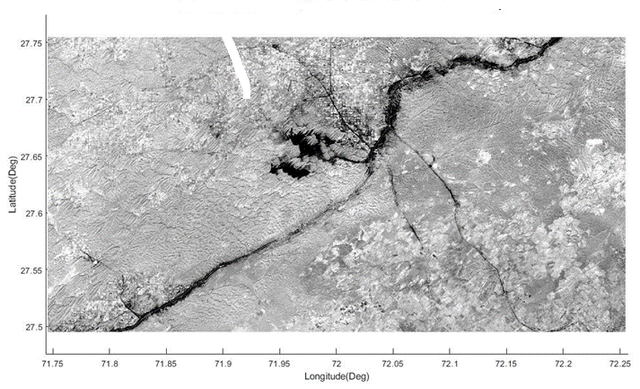
Fig. 2: LISS III (Band 2: Green) Images L3-NG42F14 & L3-NG43A02, October, 2008 mosaicked together
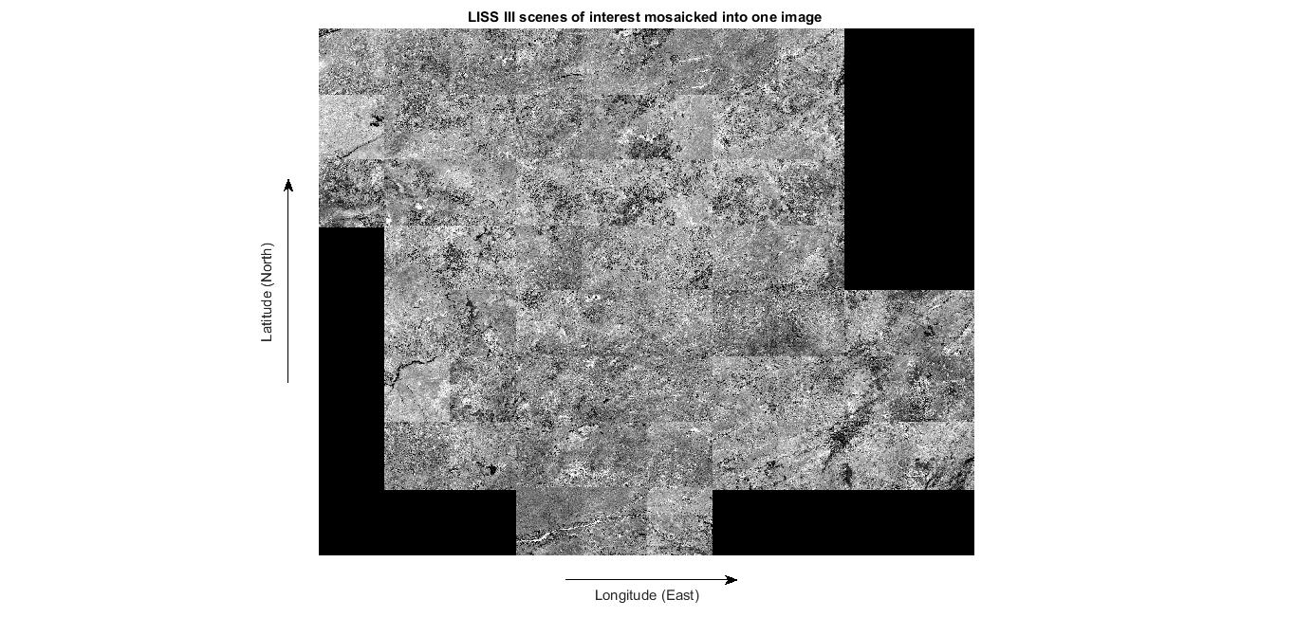

Fig. 3: LISS III Scene (Band 2) Images of interest mosaicked into one Image

  - Validation
The NDVI ranges were validated by comparison with land-use/land-cover information obtained from NRSC (ISRO) LULC datasets available through the Bhuvan geoportal, supplemented by visual interpretation of high-resolution satellite imagery (Kowarkar, R., et. al., 2024; Tempa, K., et. al., 2024). Recent studies have demonstrated the effectiveness of NDVI for vegetation monitoring in arid and semi-arid regions using multispectral satellite data (Almalki, R., et. al., 2022, Gxokwe, S., et. al., 2020, Al-Ali, Z. et/. al., 2020).
The table below shows how NDVI ranges correspond to expected land-cover types in an arid environment.
NDVI Range | NDVI Class | Corresponding LULC Type | Validation Interpretation
< 0.0 | Water / Non-vegetation | Water bodies, shadows | Correct identification of non-vegetated surfaces
0.0 – 0.2 | Barren / Built-up | Sand dunes, rocky terrain, urban areas | Strong agreement with desert and urban land cover
0.2 – 0.3 | Very Sparse Vegetation | Fallow land, scrub, grass patches | Typical semi-arid transitional vegetation
0.3 – 0.5 | Sparse to Moderate Vegetation | Rainfed agriculture, shrubs | Corresponds to seasonal vegetation cover
> 0.5 | Dense Vegetation | Irrigated cropland, vegetation clusters | Matches high-biomass agricultural zones
Table 1. Validation of NDVI classes derived from LISS-III imagery using land-use/land-cover information and reference imagery for Jodhpur district.
  - Results
NIR (Near-Infrared) vegetation reflects a significant amount of near-infrared light, which is crucial for assessing plant health. Healthy vegetation absorbs most of the red light for photosynthesis. It is sensitive to changes in vegetation health and density. This index is easy to compute and interpret using satellite imagery or aerial photographs. NDVI is a powerful tool for assessing and monitoring vegetation health, providing valuable insights for agriculture, forestry, and environmental management.

In this study area on extracting a portion of it and then visualizing the False Colour Composite and NDVI images the insight about the image becomes prominent which was otherwise not visible with a single band image data (Fig. 5 and Fig. 7). The brighter tones in Fig. 3 corresponding to the values of 0.6-1.0 represents dense vegetation. NDVI values between 0.59-0.20 represents sparse vegetation areas or shrubs. NDVI values nearing to 0 in the negative range represents builtup areas, rocky surface or hilly terrain with no evidence of vegetation (Fig. 6). Fig. 7 visualizes NDVI in different color scale to distinguish between the features sharply.
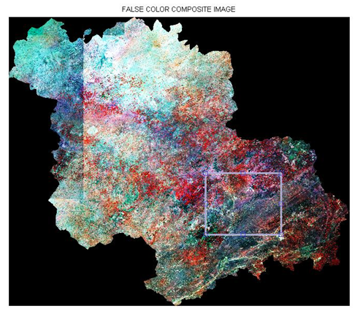 | 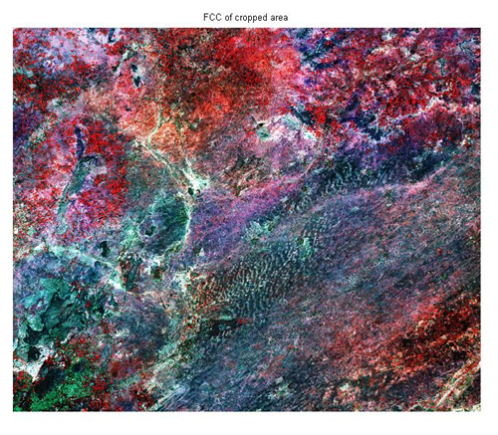
Fig. 4: False Color Composite of Jodhpur, Rajasthan, India | Fig. 5: User defined clipped False Color Composite of Jodhpur, Rajasthan, India
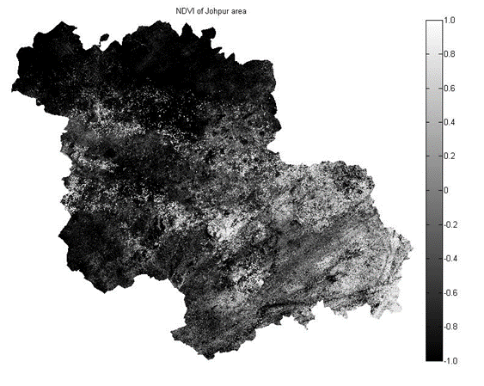 | 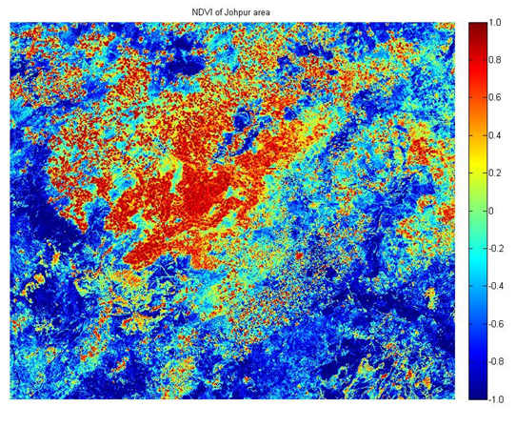
Fig. 6: NDVI of Jodhpur, Rajasthan, India | Fig. 7: User defined clipped NDVI of Jodhpur, Rajasthan, India

  - Discussion
The proposed automated mosaicking framework effectively integrates multiple LISS-III scenes using geospatial metadata (latitude–longitude coordinates), resulting in a spatially continuous raster dataset for the Jodhpur region. The mosaicking process minimizes radiometric discontinuities at tile boundaries, which is critical for pixel-based spectral index computation such as NDVI. The spatial resolution of LISS-III (23.5 m) provides an appropriate balance between regional coverage and spatial detail, enabling reliable vegetation analysis at a district scale.
Geometric correction through image-to-image registration with Google Map imagery improves positional accuracy by reducing residual geometric errors. The registration process can be expressed using a transformation function:
$$\left(x^{'},y^{'}\right)=T(x,y)$$
where
(x, y) are the original pixel coordinates and
(x', y') are the corrected coordinates after applying the transformation (T).
The reduction in root mean square error (RMSE) between ground control points before and after registration indicates improved spatial alignment, which is essential for overlay analysis with vector datasets such as shapefiles.
Radiometric enhancement using histogram equalization redistributes pixel intensity values to improve contrast:

$$s_{k}=(L-1)\sum_{j=0}^{k}{p(r_{j})}$$
where,
$s_{k}$ is the output pixel value,
L is the number of gray levels, and
$p\left(r_{j}\right)$is the probability density function of the input image.
This enhancement facilitates better visual interpretation of land cover classes in the false color composite, particularly in areas with low spectral variability typical of arid landscapes.
Vegetation analysis was performed using the Normalized Difference Vegetation Index (NDVI). For LISS-III data, the Red band (Band 3: 0.62–0.68 µm) and NIR band (Band 4: 0.77–0.86 µm) were utilized. NDVI values theoretically range from −1 to +1; however, in the Jodhpur region, observed NDVI values predominantly fall within −0.1 to 0.4, reflecting the arid to semi-arid vegetation conditions.
Based on standard NDVI thresholding, land cover categories can be interpreted as follows:
- NDVI < 0.0: Water bodies, barren land, built-up areas
- 0.0 ≤ NDVI < 0.2: Sparse vegetation or fallow land
- 0.2 ≤ NDVI < 0.4: Moderate vegetation (croplands, shrubs)
- NDVI ≥ 0.4: Dense vegetation (limited in arid regions)
Higher NDVI values were spatially correlated with irrigated agricultural zones and vegetated patches, while low and negative values dominated desert, rocky, and urban areas. Soil brightness and background reflectance, common in arid regions, may suppress NDVI values even in vegetated areas, indicating a potential limitation of NDVI in such environments.
Overall, the results confirm that the proposed methodology is suitable for large-scale vegetation monitoring using LISS-III imagery. However, NDVI sensitivity to atmospheric effects, soil background, and seasonal variability suggests that incorporating atmospheric correction models (e.g., DOS or radiative transfer models) and multi-temporal NDVI analysis could improve the robustness and accuracy of vegetation assessment in future work. The generated NDVI maps provide a practical basis for vegetation monitoring in arid environments and can support applications such as agricultural condition assessment, land degradation analysis, and drought monitoring.

  - Conclusion
This study demonstrates an effective methodology for generating a geometrically corrected and radiometrically enhanced satellite image of the Jodhpur region using LISS-III data from the RESOURCESAT-1 satellite. The automated mosaicking process implemented in MATLAB successfully integrates multiple scenes based on their geographic coordinates, producing a seamless raster image of the study area. Clipping the mosaicked image with the Jodhpur region shapefile ensures spatial accuracy, while registration with Google Map imagery further improves geometric precision. Histogram equalization enhances the visual quality and contrast of the processed imagery, enabling clearer interpretation in false color composite format.
The subsequent computation of NDVI provides valuable insights into vegetation distribution and health within the user-defined area. By exploiting the spectral differences between red and near-infrared bands, NDVI effectively highlights vegetated and non-vegetated regions, making it a reliable indicator for vegetation analysis. Overall, the proposed workflow proves to be robust and efficient for large-area satellite image processing and vegetation assessment, and it can be extended to other regions and time periods for environmental monitoring and land-use analysis.

Disclaimer (Artificial intelligence)

Author(s) hereby declare that NO generative AI technologies such as Large Language Models (ChatGPT, COPILOT, etc.) and text-to-image generators have been used during the writing or editing of this manuscript.

References

- Collins, C. B., Beck, J. M., Bridges, S. M., Rushing, J. A., & Graves, S. J. (2017, November). Deep learning for multisensor image resolution enhancement. In Proceedings of the 1st Workshop on Artificial Intelligence and Deep Learning for Geographic Knowledge Discovery (pp. 37-44).
- Hutter, F. (2009). Automated configuration of algorithms for solving hard computational problems (Doctoral dissertation, University of British Columbia).
- Sasmal, S. (2023). Streamlining Big Data Processing with Artificial Intelligence. International Research Journal of Engineering & Applied Sciences (IRJEAS), 11(3).
- Series, I. R. S. S. (2013). National natural resources management system.
- Meneses-Tovar, C. L. (2011). NDVI as indicator of degradation. Unasylva, 62(238), 39-46.
- Bharambe, S. N., Mathew, M. S., Khan, M. A., & Deore, R. R. (2024). GIS & Remote Sensing: Recent Trends and Applications.
- Zeybek, M. (2025). Integrating Advanced Remote Sensing Technologies and Machine Learning in Urban Forestry: A Comprehensive Review and Future Outlook. Measurement Science and Technology.
- Chen, Y., Guerschman, J. P., Cheng, Z., & Guo, L. (2019). Remote sensing for vegetation monitoring in carbon capture storage regions: A review. Applied energy, 240, 312-326.
- Kalaitzidis, C., Heinzel, V., & Zianis, D. (2010). A review of multispectral vegetation indices for biomass estimation. Imagin [e, g] Europe, 201-208.
- Zeng, Y., Hao, D., Huete, A., Dechant, B., Berry, J., Chen, J.M., Joiner, J., Frankenberg, C., Bond-Lamberty, B., Ryu, Y. and Xiao, J., 2022. Optical vegetation indices for monitoring terrestrial ecosystems globally. Nature Reviews Earth & Environment, 3(7), pp.477-493.
- Almalki, R., Khaki, M., Saco, P. M., & Rodriguez, J. F. (2022). Monitoring and mapping vegetation cover changes in arid and semi-arid areas using remote sensing technology: A review. Remote Sensing, 14(20), 5143.
- Najafabadi, M. M., Villanustre, F., Khoshgoftaar, T. M., Seliya, N., Wald, R., & Muharemagic, E. (2015). Deep learning applications and challenges in big data analytics. Journal of big data, 2(1), 1.
- Pandit, V. R., & Bhiwani, R. J. (2015). Image fusion in remote sensing applications: A review. International journal of computer applications, 120(10).
- Romero, A., Gatta, C., & Camps-Valls, G. (2015). Unsupervised deep feature extraction for remote sensing image classification. IEEE Transactions on Geoscience and Remote Sensing, 54(3), 1349-1362.
- Mahrad, B. E., Newton, A., Icely, J. D., Kacimi, I., Abalansa, S., & Snoussi, M. (2020). Contribution of remote sensing technologies to a holistic coastal and marine environmental management framework: a review. Remote Sensing, 12(14), 2313.
- McRoberts, R. E., Cohen, W. B., Næsset, E., Stehman, S. V., & Tomppo, E. O. (2010). Using remotely sensed data to construct and assess forest attribute maps and related spatial products. Scandinavian Journal of Forest Research, 25(4), 340-367.
- Sobrino, J. A., Jiménez-Muñoz, J. C., & Paolini, L. (2004). Land surface temperature retrieval from LANDSAT TM 5. Remote Sensing of environment, 90(4), 434-440.
- Almalki, R., Khaki, M., Saco, P. M., & Rodriguez, J. F. (2022). Monitoring and mapping vegetation cover changes in arid and semi-arid areas using remote sensing technology: A review. Remote Sensing, 14(20), 5143.
- Gxokwe, S., Dube, T., & Mazvimavi, D. (2020). Multispectral remote sensing of wetlands in semi-arid and arid areas: A review on applications, challenges and possible future research directions. Remote Sensing, 12(24), 4190.
- Al-Ali, Z. M., Abdullah, M. M., Asadalla, N. B., & Gholoum, M. (2020). A comparative study of remote sensing classification methods for monitoring and assessing desert vegetation using a UAV-based multispectral sensor. Environmental monitoring and assessment, 192(6), 389.
- Kowarkar, R., Karkera, J., & Kulkarni, S. (2024, May). Exploring Change Detection in Classified Land Cover and Land Use Imagery: A Comprehensive Analysis. In 2024 Second International Conference on Data Science and Information System (ICDSIS) (pp. 1-6). IEEE.
- Tempa, K., Ilunga, M., Agarwal, A., & Tashi. (2024). Utilizing Sentinel-2 satellite imagery for LULC and NDVI change dynamics for Gelephu, Bhutan. Applied Sciences, 14(4), 1578.

