Delineation of Seasonal Rice Efficient Cropping Zones in Tamil Nadu, India

ABSTRACT
Rice is the staple food crop of Tamil Nadu and is cultivated under distinct seasonal environments influenced by monsoon rainfall, irrigation availability and agro-climatic conditions. Rice area and productivity vary considerably across districts and seasons due to differences in water availability, climate variability and management practices. Identifying season-specific efficient cropping zones is therefore essential for improving productivity, optimizing resource use and ensuring sustainable rice cultivation under changing climatic conditions. This study delineated season-wise Efficient Cropping Zones (ECZs) for rice in Tamil Nadu using district level time series data on area of production, and productivity for the period 2014-15 to 2024-25. Separate analyses were carried out for Kuruvai (June to September), Samba (August to January) and Summer (February to April or May) seasons. The Relative Spread Index (RSI) and Relative Yield Index (RYI) were computed to classify districts into Most Efficient, Area Efficient, Yield Efficient, and Non-Efficient Cropping Zones. The results indicated that Kuruvai season rice cultivation is confined to a limited number of districts with assured early season irrigation. However, several districts achieved high productivity despite having a relatively smaller area under cultivation. The Samba season emerged as the principal rice growing season, showing wider spatial coverage and higher efficiency across diverse agro-climatic regions due to its alignment with the Northeast monsoon. In contrast, summer rice cultivation was comparatively less efficient and predominantly constrained by water scarcity, resulting in a greater proportion of non-efficient zones. Across seasons 7 to 9 districts were classified as most efficient cropping zones, whereas 15 to 20 districts consistently fell under not efficient cropping zones, highlighting substantial spatial variability in rice performance. Overall, rice efficiency across Tamil Nadu is strongly influenced by seasonal water availability and climatic suitability. These findings provide a scientific basis for the season specific rice planning, targeted intensification in efficient zones and promotion of crop diversification in inefficient areas to support sustainable and climate resilient rice production.

Keywords: Rice, Efficient Cropping Zone, Seasonal Analysis. Relative Spread Index, Relative Yield Index.
INTRODUCTION
Rice (Oryza sativa L.) is one of the most important food crops in the world and serves as the staple diet for more than half of the global population (Tagliapietra et al., 2024). In Asia, rice contributes nearly 60-70% of the daily caloric intake, highlighting its central role in food security, livelihoods and socio-economic stability (Biswajith et al., 2013). India is the second largest producer of rice in the world witnessing a total cultivable area of 512.67 lakh hectares with the production of 1501.84 lakh tonnes and the productivity level is 2929 kg per hectare in the year 2024-25 (Indiastat.com). Rice plays a pivotal role in the agricultural economy, and Tamil Nadu is one of India’s major rice growing states. In Tamil Nadu, the area under rice cultivation during 2024-25 was 21.58 lakh hectares, with a production of 70.94 lakh tonnes and an average productivity of 3,288 kg per hectare, supported by a distinctive multi seasonal cultivation system. (Indiastat.com). In Tamil Nadu Rice is cultivated during Kuruvai (June to September), Samba (August to January) and Summer (February to April or May) seasons, depending on monsoon behaviour, irrigation availability and agro-climatic conditions (Ramesh et al., 2023). However, rice productivity and area under cultivation vary considerably across districts and seasons due to spatial differences in rainfall distribution, water resources, soil characteristics, technological adoption and management practices (Kumar et al., 2022).
Climate change is a serious concern today and an urgent evolving threat to global food security (Ammaiyappan et al., 2023). In recent decades, rice cultivation in Tamil Nadu has been increasingly challenged by climate variability, erratic monsoon rainfall, groundwater depletion and competing demand for water from non agricultural sectors (Thavaprakaash et al., 2008). These factors have led to shifts in cropping patterns, contraction of rice area in certain seasons particularly summer and differential yield performance across regions. Under such conditions, uniform promotion of rice across all districts and seasons often results in inefficient use of natural resources and economic losses to farmers (Prakash et al., 2023). Identifying location and season specific suitability for rice cultivation is therefore crucial for improving productivity, ensuring sustainability and optimizing resource use. The concept of Efficient Cropping Zones (ECZ) provides a scientific framework to evaluate crop performance by integrating both area concentration and yield advantage. (Sanbagavalli et al., 2020)
Earlier studies in Tamil Nadu have demonstrated that ECZ based analysis is an effective tool for identifying prospective zones for major crops, including rice and for understanding temporal changes in crop performance. However, most assessments give limited emphasis to season wise variability, which is crucial in a state where rice cultivation is strongly influenced by seasonal water availability and climatic conditions. In this context, the present study aims to identify prospective zones for season wise efficient rice cultivation in Tamil Nadu by analyzing the Kuruvai, Samba, and summer seasons. The findings aim to inform season specific regional planning in Tamil Nadu, promote resource efficient farming practices, and support climate resilient rice cultivation.
MATERIALS AND METHODS
Study Area: The study covers the entire state of Tamil Nadu spanning from 7.875°S to 13.083°N in latitude and 76.5°E to 80.375°E in longitude, for analysing season wise efficient cropping zones for rice (Figure 1).
Data Collection: The season wise efficient cropping zones for rice was analysed for all the districts of Tamil Nadu. Hence the time series data pertaining to the area production, productivity of rice for each district wise, season wise and the state were collected for 2014-15 to 2024-25 (11 years) from the respective season and the crop report released by the Department of Economics and Statistics, Government of Tamil Nadu.
Methodology Adopted: The methodology proposed by Kanwar (1972), involving the computation of the Relative Spread Index (RSI) and Relative Yield Index (RYI), was adopted to delineate season wise efficient cropping zones for rice in Tamil Nadu. The criteria for identifying the efficient cropping zones are furnished in Table 1. Multi year average RSI and RYI values were used to reduce inter-annual variability, and districts showing consistent performance across seasons and years were considered reliable, ensuring that the identified efficient cropping zones reflect stable spatial patterns.
The analysis was carried out separately for the three major rice growing seasons of Tamil Nadu, namely Kuruvai (June to September), Samba (August to January), and Summer (February to April or May), to capture seasonal variability in area and productivity. This season wise stratification ensures that differences in monsoon dependence, climate variability, irrigation availability and crop duration are adequately represented. The computed value of RSI and RYI for different season across Tamil Nadu were furnished in Table 2. Districts were classified into different efficient cropping zones based on the criteria presented in Table 3.

RSI | = | Area of particular crop expressed as % of total cultivable area in the district | × 100
RSI | = | Area of crop expressed as % to the total cultivable area in the state | × 100
Where RSI: Relative Spread Index

RYI | = | Mean yield of particular crop in a district (Kg/ha) | × 100
RYI | = | Mean yield of crop in the state (Kg/ha) | × 100
Where RYI: Relative Yield Index
Table 1: The criteria for the Effective Cropping Zone
Category No. | RSI | RYI | Combination of RSI and RYI | Cropping Zone
1. | >100 (High) | >100 (High) | High + High | Most Efficient Cropping Zone (MECZ)
2. | >100 (High) | < 100 (Low) | High + Low | Area Efficient Cropping Zone (AECZ)
3. | <100 (Low) | >100 (High) | Low + High | Yield Efficient Cropping Zone (YECZ)
4. | <100 (Low) | < 100 (Low) | Low + Low | Not Efficient Cropping Zone (NECZ)

RESULTS AND DISCUSSION
Kuruvai Season - Efficient Cropping Zones
An analysis of Kuruvai rice area and productivity indicated that the most efficient cropping zone characterized by high Relative Spread Index (RSI) and high Relative Yield Index (RYI), comprises the districts of Chengalpattu, Cuddalore, Kancheepuram, Kanyakumari, Ranipet, Thiruvallur and Tirunelveli (Table 3). These districts reflecting not only wider adoption of Kuruvai rice cultivation but also superior productivity levels. These districts are mainly located in areas with assured early season irrigation from river basins, reservoirs, and canal networks. Timely water availability supports early transplanting, quick crop establishment and efficient water use, thereby improving Kuruvai rice performance (Chaudhari et al., 2024). The yield efficient cropping zone consists of districts showing high RYI but low RSI, including Dharmapuri, Dindigul, Erode, Kallakurichi, Krishnagiri, Perambalur, Theni, Tiruchirapalli, Vellore, Villupuram and Virudhunagar (Table 3). This pattern reflects the presence of favourable micro climatic conditions and efficient crop management practices, resulting in higher productivity despite a relatively limited area under rice cultivation (Rayalu, 2025). The limited spread of rice in these districts may be due to irrigation constraints or competition from other crops, however, there is considerable scope for expansion if irrigation and water support systems are improved. The districts of Mayiladuthurai, Nagapattinam, Thanjavur, Thiruvannamalai and Thiruvarur. are classified under the area efficient cropping zone, as they exhibit high RSI but comparatively low RYI (Table 3). These districts exhibit a wide spatial spread of rice cultivation but comparatively lower productivity levels, indicating the existence of substantial yield gaps. The observed yield limitations may be attributed to sub optimal agronomic practices, varietal constraints, soil related limitations and inefficiencies in crop management (An et al., 2018) Therefore, appropriate technological and agronomic interventions, including improved high yielding varieties, quality inputs, refined nutrient and water management and strengthened extension support, are essential to enhance yield performance in these AECZ districts. Districts including Ariyalur, Chennai, Coimbatore, Karur, Madurai, Namakkal, Pudukkottai, Ramanathapuram, Salem, Sivagangai, Tenkasi, Thiruppur, The Nilgiris, Thoothukudi and Tirupathur are classified under the non-efficient cropping zone (Table 3) due to their low values of both RSI and RYI. The persistently low area and productivity of rice in these districts indicate that Kuruvai rice is poorly adapted to the prevailing agro climatic conditions (Ramesh et al., 2009). These constraints necessitate the promotion of alternative crops better adapted to local resource conditions to ensure sustainable land use. During the Kuruvai season, the spatial distribution of efficient cropping zones (Figure 2) shows clustering of MECZ districts along major irrigation commands and coastal deltaic regions, whereas NECZ districts are largely concentrated in rainfed and water stressed interior areas.
Samba Season – Efficient Cropping Zones
An assessment of Samba season rice cultivation indicates that nine districts in Tamil Nadu such as Chengalpattu, Cuddalore, Kancheepuram, Madurai, Thanjavur, Thiruvallur, Tiruchirapalli, Tirunelveli and Villupuram constitute the most efficient cropping zone (Table 3). Favourable conditions during the Samba season, including longer crop duration, improved moisture availability and relatively stable climate, contribute to higher yields and wider area coverage in these districts. (Vala et at., 2024). The yield efficient cropping zone comprises the districts of Ariyalur, Coimbatore, Dharmapuri, Dindigul, Erode, Kallakurichi, Kanyakumari, Karur, Krishnagiri, Namakkal, Perambalur, Ranipet, Salem, Tenkasi, Theni, Thiruppur, Thiruvannamalai, Thoothukudi, Tirupathur and Vellore (Table 3). YECZ, indicating that although rice area is limited in some regions, productivity remains high due to adequate rainfall, improved varietal adoption and better crop management. This highlights Samba season as the most suitable rice growing season across diverse agro-climatic zones (Arun et al., 2020). AECZ includes Mayiladuthurai, Nagapattinam, Pudukottai, Ramanathapuram, Sivagangai and Thiruvarur (Table 3). During Samba Season Rice continues to occupy large areas mainly due to the crucial influence of the Northeast monsoon on rice area and productivity. This is evident even in districts where yields remain comparatively low, largely because of traditional cropping practices and limited crop diversification (Tamilmounika et al., 2025). Chennai, The Nilgiris and Viruthunagar fall under the NECZ (Table 3). These districts remain limited to areas due to unsuitable soil and climatic conditions for rice cultivations. In the Samba season, MECZ districts are predominantly clustered in deltaic and canal-irrigated regions benefiting from the Northeast monsoon, while NECZ districts are mainly located in interior regions (Figure 3) characterized by limited and uncertain water availability.
Summer Season – Efficient Cropping Zones
The analysis indicated that during the summer season, five districts in Tamil Nadu such as Kancheepuram, Ranipet, Thirunelveli, Thiruvannamalai and Vellore recorded high values of both RSI and RYI, therefore classified under the most efficient cropping zone. (Table 3). Rice cultivation during this season in Tamil Nadu is highly constrained by irrigation availability, as it depends almost entirely on stored water from reservoirs, groundwater extraction and lift irrigation (Selvaraj and Ramasamy, 2006). The districts of Ariyalur, Dharmapuri, Dindigul, Erode, Karur, Krishnagiri, Nagapattinam, Namakkal, Perambalur, Salem, Sivagangai and Theni exhibit high RYI but low RSI, thereby indicating their classification under the yield efficient cropping zone (Table 3). These districts during summer indicate efficient productivity under limited area, reflecting the adoption of short-duration varieties, controlled irrigation and intensive crop management practices. However, the limited spread of rice suggests water scarcity and higher production costs (Connor et al., 2023). AECZ includes districts such as Chengalpattu, Madurai, Tenkasi, Thanjavur, Thiruvallur and Villupuram (Table 3). AECZ districts demonstrate continued cultivation of rice over larger areas but with reduced productivity, possibly due to heat stress, higher evapotranspiration losses, and declining groundwater levels in the regions (Hussain et al., 2023). Districts such as Chennai, Coimbatore, Cuddalore, Mayiladuthurai, Pudukkottai, Ramanathapuram, Thiruvarur, The Nilgiris, Thoothukudi, Tiruchirapalli, Tirupathur and Virudhunagar. recorded low values of both RSI and RYI are classified under the non-efficient cropping zone (Table 3). The predominance of NECZ during the summer season highlights the unsuitability of rice as a water-intensive crop under dry-season conditions and underscores the need for crop diversification (Hanafi et al., 2026). For the summer season, MECZ districts are primarily concentrated in areas with access to assured stored or groundwater irrigation (Figure 4), whereas NECZ districts are largely distributed across hot, arid and water-scarce interior regions.

CONCLUSION
The season wise analysis clearly indicates that rice efficiency in Tamil Nadu is strongly influenced by seasonal water availability and climatic suitability. Kuruvai rice cultivation is confined to a limited number of districts with assured early season irrigation facilities. In contrast, the Samba season extends across a much wider spatial area, encompassing several districts where rice cultivation is either absent or remains inefficient during the Kuruvai and summer seasons. The synchronization of Samba cultivation with the Northeast monsoon further establishes it as the principal rice growing season in the state. Summer rice cultivation is comparatively less efficient and is largely constrained by limited water availability.
The findings highlight the necessity for season specific rice planning, emphasizing crop intensification in identified efficient zones and crop diversification in inefficient areas to ensure sustainable rice production and optimal utilization of water resources. Identifying efficient cropping zones is therefore critical for enhancing productivity to meet the demands of a growing population. Furthermore, the adoption of recommended climate-resilient agricultural practices has become essential to mitigate the adverse impacts of climate change on rice production.
FUTURE SCOPE
The present study relies on district level data, which may not fully capture variations in rice performance within districts at block or village levels. Moreover, increasing climate variability and the occurrence of extreme weather events can influence seasonal rice productivity beyond what is reflected by long term averages. Future research incorporating finer spatial resolution data, farm level information, and explicit climate parameters would further enhance the accuracy of efficient cropping zone delineation and strengthen the applicability of the framework for adaptive rice planning.

POLICY SUGGESTIONS
The season wise identification of efficient cropping zones in Tamil Nadu provides a practical and evidence-based framework for strengthening rice planning under the prevailing agro-climatic conditions. In the context of declining the cultivable land, non-availability of farm labours, increasing water scarcity and climate variability, a targeted, decentralized, and incentive-based policy approach is most appropriate for operationalizing ECZs. Rice intensification and input support should be prioritized in most efficient cropping zone districts, while yield efficient cropping zone districts may be supported for selective expansion and productivity enhancement through improved crop and resource management practices. Aerea efficient cropping zone districts require focused yield improvement interventions supported by high yielding variety, extension services and access to quality inputs, whereas non-efficient cropping zone districts should be encouraged towards crop diversification through suitable incentives rather than restrictive measures.
Priority should be given to promoting short duration, drought tolerant, fine grain rice varieties to improve productivity, stabilize yields under stress conditions, and enhance market competitiveness across Tamil Nadu. To improve rice productivity and long-term sustainability, the adoption of salinity tolerant and climate resilient rice varieties is particularly important in coastal areas where soil salinity constrains yield potential. In situations where irrigation releases from the mettur dam are delayed or insufficient for the kuruvai season, farmers may be encouraged to adopt direct-seeded rice as a water saving establishment method to reduce dependence on timely canal water and ensure timely crop establishment. Moreover, during years of severe water scarcity, farmers may be supported to shift from kuruvai rice to alternative low water requiring crops such as pulses, millets, and short duration cereals to improve water use efficiency, reduce production risk and sustain farm incomes. The Government of Tamil Nadu may also consider extending the special rice cultivation package from delta districts to all non deltaic districts to strengthen kuruvai season rice production in efficient cropping zones.
As water is the principal resource for rice cultivation, policies promoting water conservation, groundwater recharge, and optimal water use should be strengthened across all regions. This can be achieved through incentives for micro-irrigation, promotion of on-farm water harvesting structures, rehabilitation of tanks and canals and adoption of community based water management approaches. A focused effort is also required to integrate digital and smart technologies across the rice supply chain, encompassing production, post harvest management, storage, processing and distribution, in order to improve operational efficiency, reduce post harvest losses, and enhance system adaptability during peak production seasons. Furthermore, Integrating ECZ based planning with existing schemes related to irrigation scheduling, crop insurance, Agricultural credit, and procurement schemes, can enhance resource-use efficiency, reduce production risk, and promote sustainable, season-specific rice cultivation and climate resilient rice economy across Tamil Nadu.

Disclaimer (Artificial intelligence)

Author(s) hereby declare that NO generative AI technologies such as Large Language Models (ChatGPT, COPILOT, etc.) and text-to-image generators have been used during the writing or editing of this manuscript.

REFERENCES
- Ammaiyappan, A., Geethalakshmi, V., Bhuvaneswari, K., Kalarani, M. K., Thavaprakaash, N., & Prahadeeswaran, M. (2023). Long-term response of rainfed sorghum to diverse growing environments and optimal sowing window at Coimbatore. Journal of Agrometeorology, 25(4), 532-538.
- An, N., Wei, W., Qiao, L., Zhang, F., Christie, P., Jiang, R., & Fan, M. (2018). Agronomic and environmental causes of yield and nitrogen use efficiency gaps in Chinese rice farming systems. European Journal of Agronomy, 93, 40-49.
- Arun, D., Sunandini, G. P., Kumari, R. V., & Meena, A. (2020). An economic analysis of different Rice varieties in Cauvery Delta region of Tamil Nadu. Indian Journal of Economics and Development, 8(3), 1-5.
- Bishwajit, G., Sarker, S., Kpoghomou, M. A., Gao, H., Jun, L., Yin, D., & Ghosh, S. (2013). Self-sufficiency in rice and food security: a South Asian perspective. Agriculture & Food Security, 2(1), 10.
- Chaudhari, S. K., Singh, D. V., Yadav, O. P., Bhaskar, S., Rao, C. R., & Raju, B. M. K. (2024). 3 Economic and Policy Issues of Drought Management. In Managing Soil Drought (pp. 41-84). CRC Press.
- Connor, M., Malabayabas, A. J. B., de Guia, A. H., Wehmeyer, H., Pame, A. R. P., Htwe, N. M., & Tuan, L. A. (2023). Environmental, social, and economic challenges in lowland rice production. In Closing rice yield gaps in Asia: innovations, scaling, and policies for environmentally sustainable lowland rice production (pp. 27-92). Cham: Springer Nature Switzerland.
- Hanafi, F., Wijayanti, L. A., Ramadhan, M. F., Priakusuma, D., & Kubiak-Wójcicka, K. (2026). Impact of Climate and Land Cover Dynamics on River Discharge in the Klambu Dam Catchment, Indonesia. Water, 18(2), 250.
- Hussain, S., Mubeen, M., Nasim, W., Fahad, S., Ali, M., Ehsan, M. A., & Raza, A. (2023). Investigation of irrigation water requirement and evapotranspiration for water resource management in Southern Punjab, Pakistan. Sustainability, 15(3), 1768.
https://www.indiastat.com
- Kanwar, J. (1972). Cropping patterns, scope and concept. In Proceeding of the Symposium, on Cropping Pattern in India, ICAR, New Delhi (pp. 11-32).
- Kumar, N., Chhokar, R. S., Meena, R. P., Kharub, A. S., Gill, S. C., Tripathi, S. C., & Singh, G. P. (2022). Challenges and opportunities in productivity and sustainability of rice cultivation system: a critical review in Indian perspective. Cereal research communications, 50(4), 573-601.
- Prakash, M. A., Pazhanivelan, S., Muthumanickam, D., Ragunath, K. P., & Sivamurugan, A. P. (2023). Mapping Rice Area in the Cauvery Delta Zone of Tamil Nadu Using Sentinel 1A Synthetic Aperture Radar (SAR) Data. Int. J. Environ. Clim. Change, 13(10), 195-204.
- Ramesh, P., Raten Panwar, N., Bahadur Singh, A., Ramana, S., & Subba Rao, A. (2009). Impact of organic‐manure combinations on the productivity and soil quality in different cropping systems in central India. Journal of Plant Nutrition and Soil Science, 172(4), 577-585.
- Ramesh, T., Palanisami, K., & Senthilvel, S. (2023). Spatial and Temporal Variations in Water Productivity of Rice in Tamil Nadu. Madras Agricultural Journal, 96(jul-dec), 1.
- Rayalu, M. (2025). Optimizing rice yield prediction: A policy-oriented approach to agricultural sustainability. Results in Engineering, 107844.
- Sanbagavalli, S., Nagarajan, K., & Jeeva, S. P. M. (2020). Identification of efficient cropping zone for rice in Tamil Nadu. IJCS, 8(6), 452-454.
- Selvaraj, K. N., & Ramasamy, C. (2006). Drought, agricultural risk and rural income: Case of a water limiting rice production environment, Tamil Nadu. Economic and Political Weekly, 2739-2746.
- Tagliapietra, B. L., Soares, C. F., & Clerici, M. T. P. S. (2024). Rice (Oryza sativa L.) and its products for human consumption: general characteristics, nutritional properties, and types of processing. Food Science and Technology, 44.
- Tamilmounika, R., Muthumanickam, D., Pazhanivelan, S., Ragunath, K., Kumaraperumal, R., & Sivamurugan, A. P. (2025). Rice area mapping and methane emission pattern in the Cauvery Delta region of Tamil Nadu. Environment Conservation Journal, 26(3), 775-783.
- Thavaprakaash, N., Velayudham, K., & Muthukumar, V. B. (2008). Response of crop geometry, intercropping systems and INM practices on yield and fodder quality of baby corn.
- Vala, Y. B., Sekhar, M., Sudeepthi, B., Thriveni, V., Lallawmkimi, M. C., Ranjith, R., & Reddy, S. E. (2024). A review on influence of climate change on agronomic practices and crop adaptation strategies. Journal of Experimental Agriculture International, 46(10), 671-686.

Table 2. Computed value of RSI and RYI for Rice Season wise efficient cropping zone in Tamil Nadu
Sl. No | District | Kuruvai Season |  | Samba Season |  | Summer Season
Sl. No | District | RSI | RYI | RSI | RYI | RSI | RYI
1 | Ariyalur | 51.3 | 96.4 | 79.7 | 122.3 | 10.3 | 100
2 | Chengalpattu | 219.2 | 108.5 | 90.4 | 67.4 | 389.3 | 99.4
3 | Chennai | 91.2 | 8.2 | 90.8 | 8.5 | 52.9 | 8.5
4 | Coimbatore | 3.1 | 98.7 | 1.7 | 102.5 | 2.7 | 81.8
5 | Cuddalore | 212.8 | 101.1 | 131.1 | 105.3 | 53.5 | 95.2
6 | Dharmapuri | 7 | 108.3 | 29.1 | 133.7 | 48 | 111.8
7 | Dindigul | 7.7 | 101.7 | 10.5 | 128.6 | 41.4 | 106.3
8 | Erode | 25 | 100.6 | 54.5 | 134 | 47.7 | 100
9 | Kallakurichi | 63.7 | 100.6 | 80.1 | 118.1 | 72.2 | 98.4
10 | Kancheepuram | 326.4 | 110.9 | 135 | 113.5 | 549.4 | 106.7
11 | Kanyakumari | 128.8 | 100.2 | 33.8 | 122.2 | 0.8 | 63.4
12 | Karur | 0.5 | 36.2 | 66.2 | 111.1 | 12.1 | 100
13 | Krishnagiri | 34.6 | 115.4 | 25.5 | 136.5 | 70.2 | 108.7
14 | Madurai | 51.9 | 98.3 | 115.4 | 119.7 | 137.1 | 86.4
15 | Mayiladuthurai | 354.4 | 94.1 | 188.4 | 88.9 | 0.3 | 97.4
16 | Nagapattinam | 228.4 | 86.5 | 227.5 | 79 | 6.9 | 100
17 | Namakkal | 11.3 | 96.7 | 14.6 | 140.8 | 8.5 | 100
18 | Perambalur | 3.5 | 100.2 | 21.7 | 127.8 | 39.6 | 100
19 | Pudukottai | 61.3 | 97 | 257.9 | 86.6 | 63.9 | 85.1
20 | Ramanathapuram | 0 | 0 | 317.3 | 54.3 | 0.5 | 17
21 | Ranipet | 297.8 | 108 | 83.1 | 115.1 | 310.6 | 102.1
22 | Salem | 3.7 | 98.4 | 22.4 | 136.5 | 30.1 | 106.9
23 | Sivagangai | 7 | 90.7 | 317.6 | 67.4 | 15.6 | 100
24 | Tenkasi | 68.6 | 93.1 | 79.3 | 117.7 | 115.2 | 84
25 | Thanjavur | 317 | 92.9 | 198.8 | 104.5 | 106.2 | 89.3
26 | The Nilgiris | 3.6 | 84 | 0.1 | 17.3 | 0 | 0
27 | Theni | 65.7 | 120.4 | 21.2 | 140.9 | 31.1 | 100
28 | Thiruppur | 3.1 | 43.6 | 19.4 | 147 | 10.9 | 92.9
29 | Thiruvallur | 304 | 108.6 | 155.8 | 101.3 | 324.8 | 99.6
30 | Thiruvannamalai | 148.6 | 98.2 | 93.9 | 118 | 349.2 | 103.2
31 | Thiruvarur | 236.3 | 99.6 | 223.5 | 96.6 | 71.6 | 92.6
32 | Thoothukudi | 17.3 | 94.6 | 10 | 110.3 | 71.7 | 95.5
33 | Tiruchirapalli | 55 | 107.7 | 119.3 | 125.4 | 48.9 | 96.1
34 | Tirunelveli | 145 | 103.9 | 108.1 | 139 | 255.1 | 101.4
35 | Tirupathur | 58 | 96.2 | 45.1 | 115.9 | 54 | 99.9
36 | Vellore | 94.5 | 103 | 30.6 | 118.1 | 186.1 | 104.1
37 | Villupuram | 95.2 | 104.6 | 105.5 | 121.3 | 163.7 | 96.8
38 | Virudhunagar | 5.7 | 100.2 | 66.1 | 96.7 | 61.2 | 82.5
RSI - Relative Spread Index; RYI – Relative Yield Index

Table 3. Efficient cropping zones of rice across different seasons in Tamil Nadu
Sl. No | District | Kuruvai Season |  |  | Samba Season |  |  |  | Summer Season
Sl. No | District | RSI | RYI | Result | RSI | RYI |  | Result | RSI | RYI | Result
1 | Ariyalur | L | L | NECZ | L |  | H | YECZ | L | H | YECZ
2 | Chengalpattu | H | H | MECZ | H |  | H | MECZ | H | L | AECZ
3 | Chennai | L | L | NECZ | L |  | L | NECZ | L | L | NECZ
4 | Coimbatore | L | L | NECZ | L |  | H | YECZ | L | L | NECZ
5 | Cuddalore | H | H | MECZ | H |  | H | MECZ | L | L | NECZ
6 | Dharmapuri | L | H | YECZ | L |  | H | YECZ | L | H | YECZ
7 | Dindigul | L | H | YECZ | L |  | H | YECZ | L | H | YECZ
8 | Erode | L | H | YECZ | L |  | H | YECZ | L | H | YECZ
9 | Kallakurichi | L | H | YECZ | L |  | H | YECZ | L | L | NECZ
10 | Kancheepuram | H | H | MECZ | H |  | H | MECZ | H | H | MECZ
11 | Kanyakumari | H | H | MECZ | L |  | H | YECZ | L | L | NECZ
12 | Karur | L | L | NECZ | L |  | H | YECZ | L | H | YECZ
13 | Krishnagiri | L | H | YECZ | L |  | H | YECZ | L | H | YECZ
14 | Madurai | L | L | NECZ | H |  | H | MECZ | H | L | AECZ
15 | Mayiladuthurai | H | L | AECZ | H |  | L | AECZ | L | L | NECZ
16 | Nagapattinam | H | L | AECZ | H |  | L | AECZ | L | H | YECZ
17 | Namakkal | L | L | NECZ | L |  | H | YECZ | L | H | YECZ
18 | Perambalur | L | H | YECZ | L |  | H | YECZ | L | H | YECZ
19 | Pudukottai | L | L | NECZ | H |  | L | AECZ | L | L | NECZ
20 | Ramanathapuram | L | L | NECZ | H |  | L | AECZ | L | L | NECZ
21 | Ranipet | H | H | MECZ | L |  | H | YECZ | H | H | MECZ
22 | Salem | L | L | NECZ | L |  | H | YECZ | L | H | YECZ
23 | Sivagangai | L | L | NECZ | H |  | L | AECZ | L | H | YECZ
24 | Tenkasi | L | L | NECZ | L |  | H | YECZ | H | L | AECZ
25 | Thanjavur | H | L | AECZ | H |  | H | MECZ | H | L | AECZ
26 | The Nilgiris | L | L | NECZ | L |  | L | NECZ | L | L | NECZ
27 | Theni | L | H | YECZ | L |  | H | YECZ | L | H | YECZ
28 | Thiruppur | L | L | NECZ | L |  | H | YECZ | L | L | NECZ
29 | Thiruvallur | H | H | MECZ | H |  | H | MECZ | H | L | AECZ
30 | Thiruvannamalai | H | L | AECZ | L |  | H | YECZ | H | H | MECZ
31 | Thiruvarur | H | L | AECZ | H |  | L | AECZ | L | L | NECZ
32 | Thoothukudi | L | L | NECZ | L |  | H | YECZ | L | L | NECZ
33 | Tiruchirapalli | L | H | YECZ | H |  | H | MECZ | L | L | NECZ
34 | Tirunelveli | H | H | MECZ | H |  | H | MECZ | H | H | MECZ
35 | Tirupathur | L | L | NECZ | L |  | H | YECZ | L | L | NECZ
36 | Vellore | L | H | YECZ | L |  | H | YECZ | H | H | MECZ
37 | Villupuram | L | H | YECZ | H |  | H | MECZ | H | L | AECZ
38 | Virudhunagar | L | H | YECZ | L |  | L | NECZ | L | L | NECZ
H – High; L – Low; MECZ – Most Efficient Cropping Zone; YECZ – Yield Efficient Cropping Zone; AECZ - Area Efficient Cropping Zone; NECZ – Not Efficient Cropping Zone

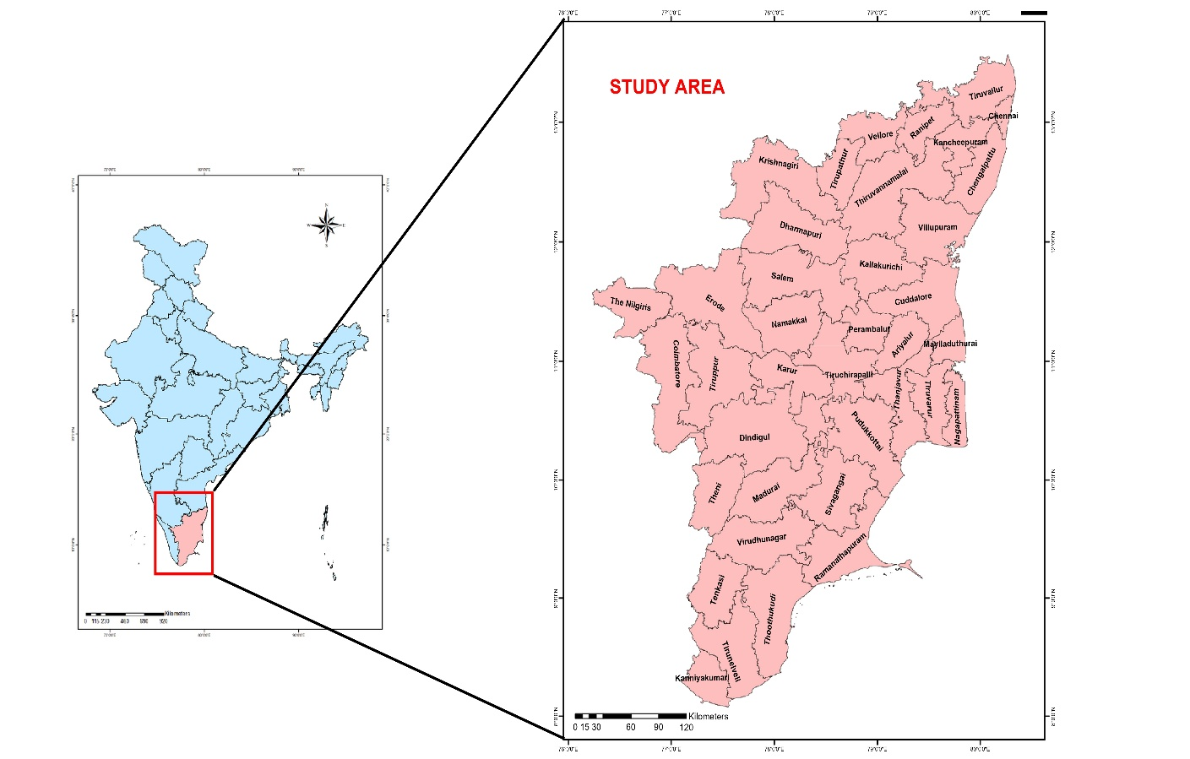
Fig. 1. Study Area Map
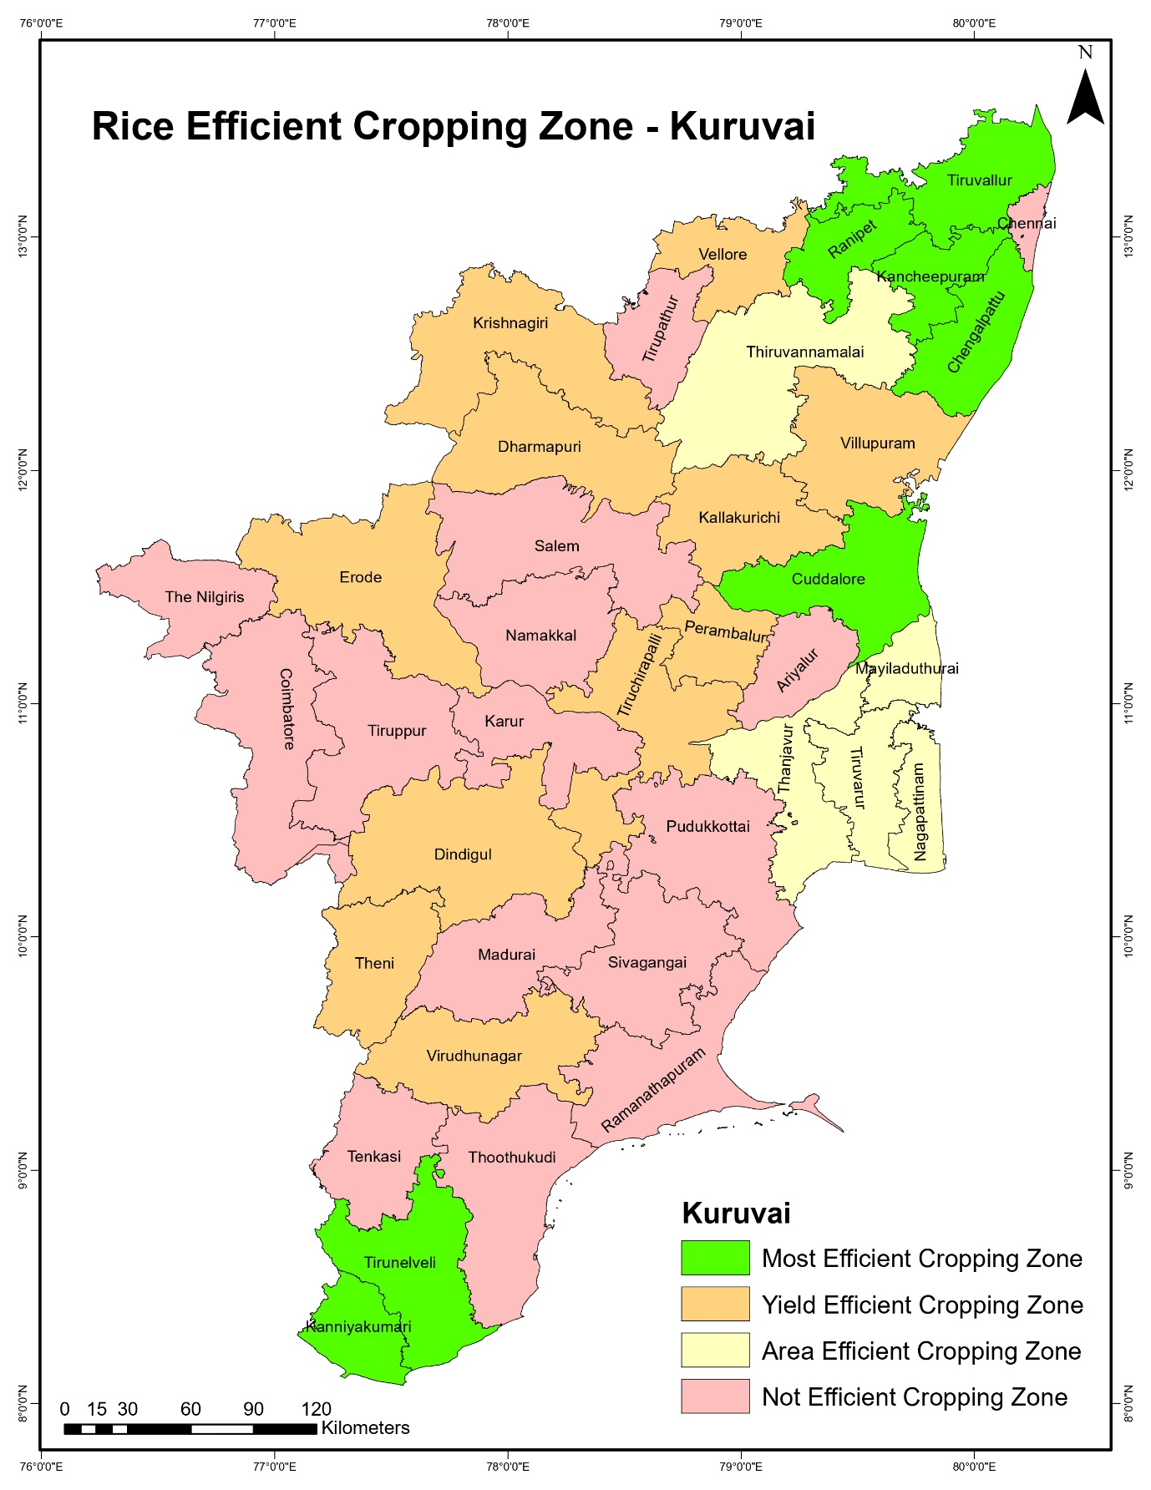
Fig. 2. Efficient Cropping Zones for Rice in Tamil Nadu during the Kuruvai Season
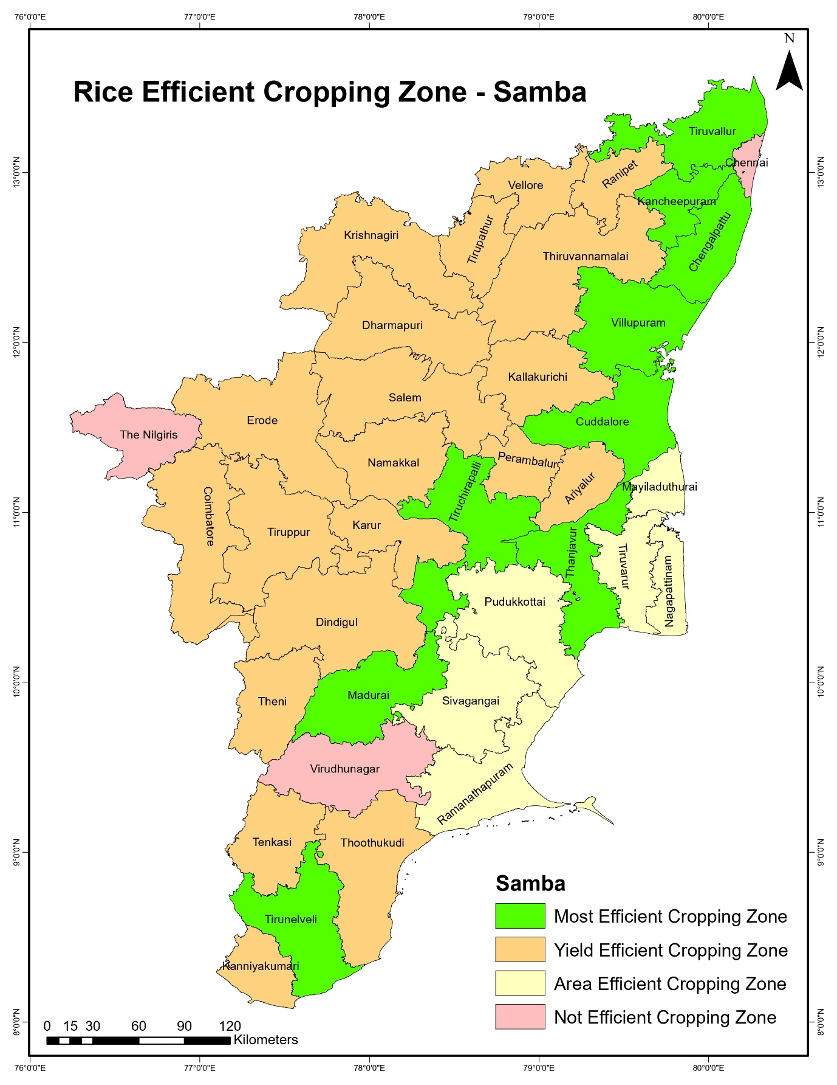
Fig. 3. Efficient Cropping Zones for Rice in Tamil Nadu during the Samba Season
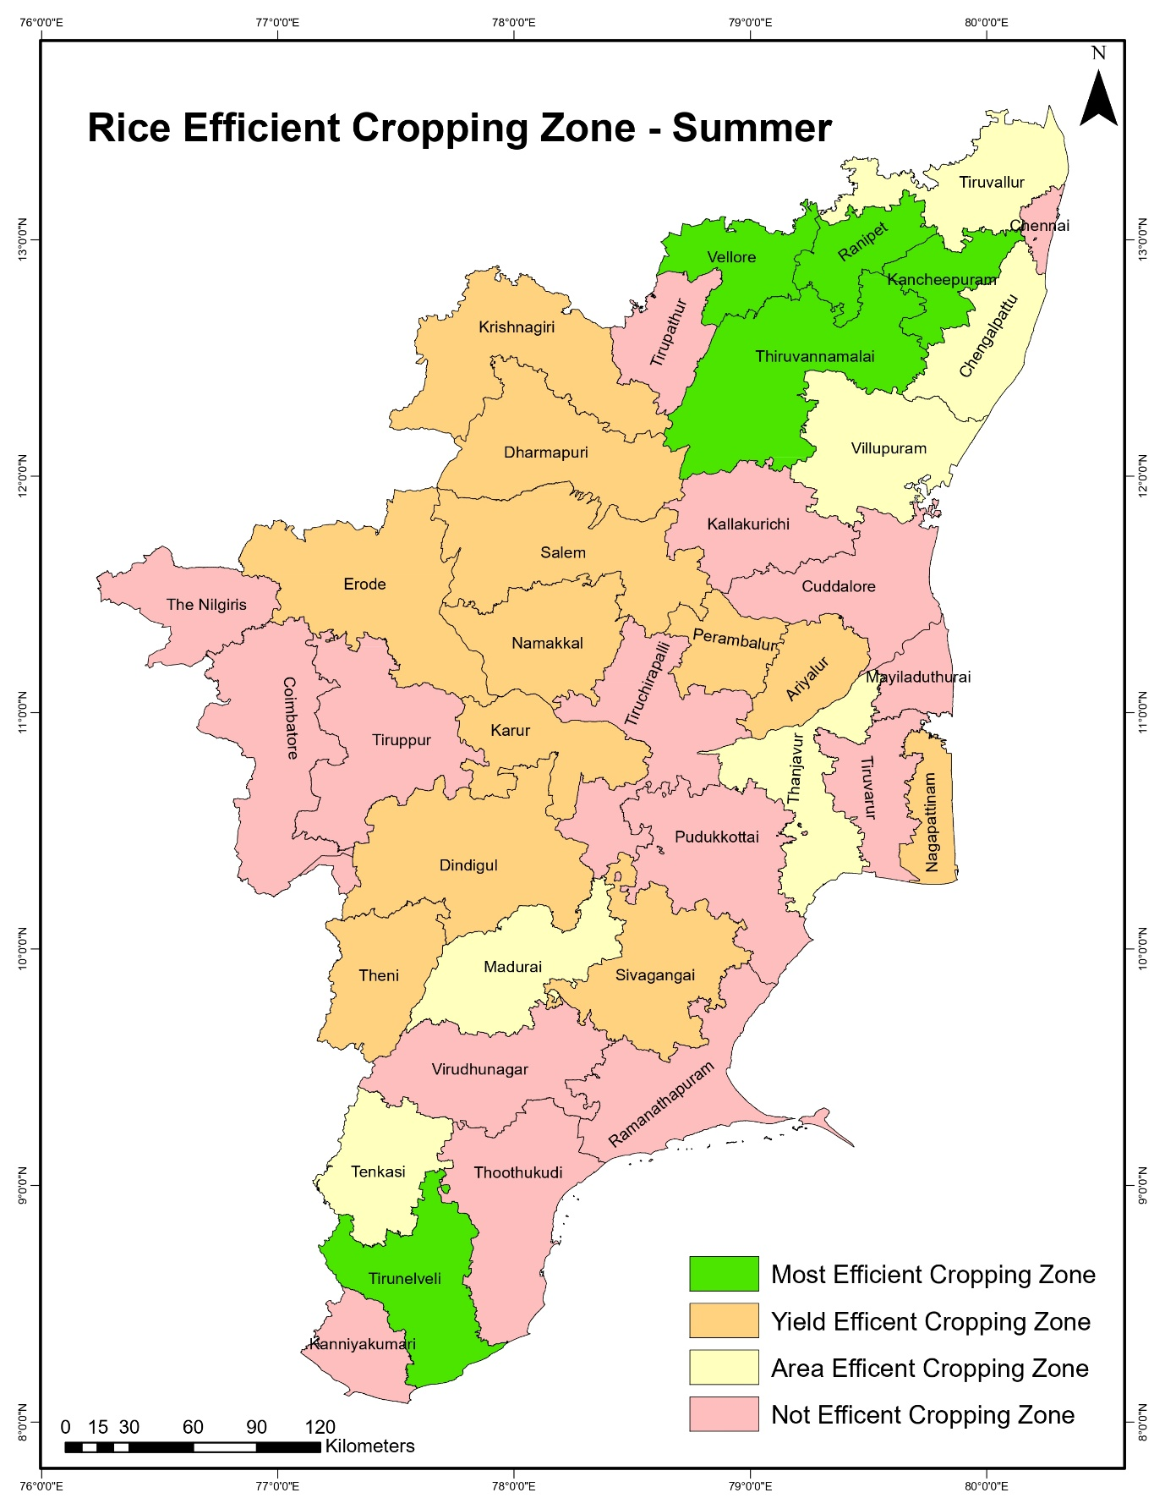
Fig. 4. Efficient Cropping Zones for Rice in Tamil Nadu during the Summer Season

