Evaluation of Coriandrum sativum Leaves and Stems as Natural Coagulants for Sustainable Drinking Water Treatment

.
ABSTRACT

Natural coagulation processes are essential for the removal of colloidal particles by aggregating them into larger flocs that can easily settle in sedimentation basins—a method known for its simplicity and cost-effectiveness. This study aimed to enhance the efficiency of a water treatment plant through the use of a natural product, cilantro (Coriandrum sativum), as an adsorbent. Both fresh and dried cilantro leaves and stems were utilized. Comprehensive analyses were conducted on various physicochemical parameters of water samples, both before and after treatment, including the concentration of selected heavy metals. Additionally, biological assessments were performed to determine total bacterial and algal counts, as well as the presence of diatoms, protozoa, and pathogenic helminths. Water samples were collected from a conventional water treatment facility situated at the endpoint of freshwater streams in the Daqahliya governorate. The samples underwent a pretreatment process using natural coagulation/flocculation with cilantro as the adsorbent, tested via a jar flocculator apparatus. Results indicated that dried cilantro stems achieved the highest turbidity removal efficiency at 76.33% with an optimal dosage of 0.6 g/L. Dried leaves followed with 69% efficiency at 0.3 g/L. Fresh stems and fresh leaves showed removal efficiencies of 35.4% and 33%, respectively, both at a dosage of 0.3 g/L and within a pH range of 6 to 7. In conclusion, one-sixth of people do not have access to any kind of safe and improved water supply within one kilometer of their residence. So cilantro presents promise as a sustainable, low-cost natural coagulant for enhancing water treatment and meeting the rising demand for clean water.

Keywords: Cilantro, Coagulant, adsorbent agent, Bio-based, Coagulation/precipitation, Coriander.

1. INTRODUCTION

Water is essential for sustaining life, and access to safe and adequate water supply is a basic human necessity. Improving access to clean drinking water yields significant public health benefits (Kithiia, 2012). Nevertheless, water pollution remains a major concern, leading to the deterioration of aquatic ecosystems, reduced drinking water quality, and limitations on recreational use. While natural factors such as geology, climate, and soil composition can influence water quality, anthropogenic activities, particularly agriculture and domestic wastewater, often pose greater threats (APHA, 2017). Therefore, regular monitoring and assessment of water quality are vital for sustainable watershed and water-resource management.

Water scarcity indicators highlight the growing gap between water demand and availability, offering valuable insights into the temporal and spatial distributions of water shortages. This challenge is expected to intensify as freshwater sources increasingly struggle to meet the needs of rapidly expanding urban populations, many of which contribute significantly to the pollution of adjacent water bodies (Hoekstra et al., 2012). In arid and semi-arid regions, the situation is further exacerbated by an absolute lack of water resources, leading to frequent and severe water shortages. The Nile River, often referred to as the lifeline of Egypt, plays a critical role in agriculture, drinking water supply, transportation of goods, and replenishment of desert soils (Pereira et al., 2009).
The deterioration of water quality has become a significant global concern, particularly in regions already facing water scarcity. This issue hampers sustainable development and poses serious public health risks by increasing the incidence of waterborne and infectious diseases. Several studies have highlighted these challenges and emphasized the urgent need for effective water management strategies (Ali et al., 2014; El-Salam et al., 2017; El-Bady, 2019; Gad et al., 2022; El-Batrawy et al., 2023; Hasballah et al., 2023; Malik et al., 2024; Hasaballah et al., 2024; Recio-Colmenares et al., 2025; Das & Mishra, 2025).
Biosorption leverages the natural capacity of biological materials to retain metal ions in contaminated water through physical, chemical, or metabolic pathways. This process often involves mechanisms such as hydrolysis, and the ionic charge of biosorptive polymers is typically influenced by the pH of the solution (Gupta & Rastogi, 2008). Adsorption, a widely adopted technique for fluid purification, has proven to be effective in multiphase separation of solutes. The efficiency of this technology is governed by several operational parameters, including the contact time, pH, solute concentration, temperature, and adsorbent dosage. These factors are usually optimized under batch adsorption conditions using either modified or unmodified adsorbent materials (Al-Essa & Khalili, 2018).
Natural coagulants have gained attention as effective and sustainable alternatives in water clarification processes because of their biodegradability, non-toxicity, and renewable origin (Kumar, 2024). These coagulants are commonly derived from plant-based materials, such as seeds, fruit peels, leaves, stems, and legumes. Examples include Moringa oleifera, Coriandrum sativum (cilantro), Plantago ovata, and Aloe vera, which have shown promising results in reducing turbidity and enhancing water quality through natural coagulation and flocculation (Ramavandi, 2014; Choy et al., 2016). Cilantro (Coriandrum sativum) commonly referred to as coriander or dhania, is an annual herb belonging to the parsley family (Apiaceae) in the order Apiales. Native to the Mediterranean region, it is extensively cultivated in countries such as Russia, India, Central Europe, Bangladesh and Morocco (Nazrul, et al., 2009). Cilantro possesses medicinal and nutritional properties. It is widely available, cost-effective, and has demonstrated notable potential for the removal of toxic metal ions, including copper, mercury, and lead, which pose serious health risks to humans. The adsorption efficiency and capacity of cilantro biomass for reducing turbidity and removing dissolved metal ions from water were examined by Martin et al. (2020). Owing to its technical feasibility, low cost, social acceptability, and simplicity, cilantro is increasingly recognized as a highly effective and practical solution for treating contaminated water (Foo & Hameed, 2010). Water pollution remains one of the most critical global challenges. This study addresses an important aspect of environmental science and water treatment by exploring the use of an eco-friendly plant-based material (Coriandrum sativum) as a natural coagulant/adsorbent for drinking water treatment. The study contributes to the growing body of research on sustainable and low-cost alternatives to conventional chemical coagulants, which is particularly relevant for developing regions facing water scarcity and economic constraints. The comprehensive evaluation of physicochemical, microbiological, and heavy metal parameters enhanced the scientific value of this study. Overall, the findings provide useful applied knowledge that may support greener water treatment strategies and future pilot-scale and field applications. Therefore, this study aimed to enhance the performance of water treatment plants by utilizing cilantro (Coriandrum sativum) in both fresh and dried forms of leaves and stems as a natural adsorbent.
2. material and methods

2.1 Sampling

A total of 36 water samples were collected from a conventional Water Treatment Plant (WTP) located in Sherbin City, within the Daqahliya Governorate (Fig. 1). Daqahliya is situated at the downstream end of several freshwater sources, including the terminal point of the Damietta branch and other minor water streams in the Nile Delta. The collected samples were subjected to a pretreatment process using cilantro (Coriandrum sativum) as a natural adsorbent. Provide adequate information to allow the experiment to be reproduced.
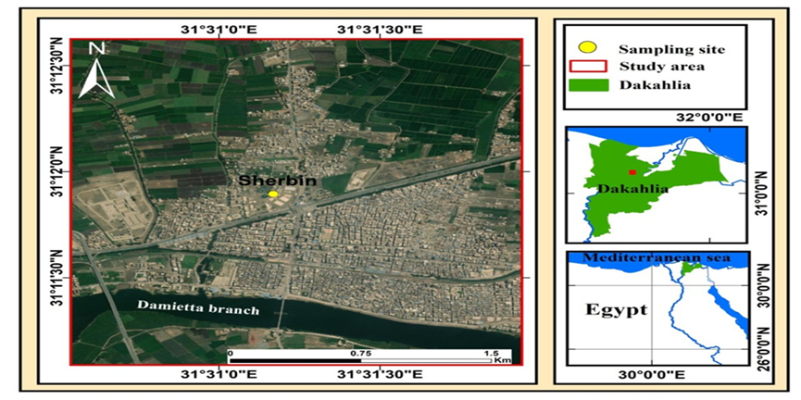

Fig. 1. Map of Sherbin City within the Daqahliya Governorate, Egypt, and the location of the investigated Water Treatment Plant (WTP).

2.2 Cilantro Samples Preparation

Cilantro samples were taxonomically identified by a plant specialist at the Department of Botany and Microbiology, Damietta University. The biomass was taken to the laboratory, where it was thoroughly washed with distilled water to remove any adhering soil or dust. For wet biomass preparation, fresh leaves and stems were chopped into small pieces ranging from 1–2 cm. For dry biomass, fresh cilantro stems and leaves were air-dried at room temperature until a constant dry weight was achieved, ensuring complete moisture removal. The dried material was then cut into pieces of similar size (1–2 cm) (Martin et al., 2020). All subsequent analyses were conducted at the Department of Environmental Science, Damietta University.

2.3 Physico-Chemical Characterization

All water samples were analyzed for various physicochemical parameters, including turbidity, temperature, pH, alkalinity, electrical conductivity (EC), total dissolved solids (TDS), total hardness, calcium hardness (Ca²⁺), magnesium hardness (Mg²⁺), chlorides (Cl⁻), sulfates (SO₄²⁻), aluminum (Al³⁺), ammonia (NH₃), nitrite (NO₂⁻), nitrate (NO₃⁻), iron (Fe²⁺), manganese (Mn²⁺), silica (Si⁴⁺), and a range of heavy metals such as copper (Cu²⁺), cobalt (Co²⁺), cadmium (Cd²⁺), nickel (Ni²⁺), zinc (Zn²⁺), and lead (Pb²⁺). All parameters were determined in accordance with the Standard Methods for the Examination of Water and Wastewater (APHA 2017). The pH was measured directly using a pH meter (Model 211; HANNA, USA). Electrical conductivity and TDS were measured using a digital portable TDS/conductivity meter (Model 8033, HANNA, USA). Turbidity was assessed using a turbidimeter (Model AL1000, Aqualytic, Germany) with a measurement range of 0–200 nephelometric turbidity units (NTU). Heavy metal concentrations were determined using Atomic Absorption Spectrometry (AAS) with a PinAAcle 500 instrument (PerkinElmer Optima 500, USA).

2.4 Treatment of Raw Water by Adsorption Process Using Cilantro

The natural adsorbent was utilized in a Water Treatment Plant during the coagulation/flocculation process, either as a primary coagulant or as a coagulant aid. Adsorption experiments using cilantro were performed using standard jar test procedures. Various dosages of cilantro biomass (ranging from 0.1 to 1.5 g) were accurately weighed and introduced into the flocculator beakers (Martin et al., 2020). Six beakers, each containing 1000 mL of raw water, were used, one of which served as a control. A standard jar test apparatus was used, with all stirring paddles immersed in the beakers. Following the addition of the adsorbent, rapid mixing was conducted at 122 rpm for 2 min, followed by slow mixing at 22 rpm for 20 min. Subsequently, the samples were allowed to settle undisturbed for 10 min, as outlined in Table 1. The influence of adsorbent dosage and pH on treatment efficiency was investigated. Turbidity was the primary parameter monitored throughout the optimization process, and additional parameters were analyzed at the end of the experiments.

Table 1. Experimental characteristics for Jar test study.

Characteristics | Description
Coagulant | Cilantro
Coagulant dose range | 0.1-1.5 g/l
Rapid mixing | 2 min at 122 (rpm)
Slow mixing | 20 min at 22 (rpm)
Settling time | 10 min

2.5 Microbiological analyses

Different microbial indicators were determined as follows: the counts of total coliforms (TC), fecal coliforms (FC), and fecal streptococci (non-fecal coliforms) were determined using the membrane filtration technique. Total coliform colonies were counted after 24 h of incubation of membranes on M-Endo (total coliform), M-Entere (fecal Streptococci), and M.F.C agar (fecal coliform). Incubate the plates for 20–22 h at 35 ͦ C for M-Endo, M-Entere, and M. F. C. agar for 44.5 ͦ C. Total bacterial count (TBC) analysis was performed using Plate Count Agar (also called tryptone glucose yeast agar), incubated at 35°C for 48 ± 3 h (APHA, 2017).

2.5.1 Culture technique of algae

The algal assay involved both total algal count and identification of all algal species present in the water samples before and after treatment. Lugol's Iodine Solution was added to the samples to stain the algal cells and inhibit further algal growth. The samples were then allowed to settle for 48 h. The volume was concentrated from 1000 mL to 50 mL, and only 1 mL of this concentrate was examined microscopically. Diatoms, green algae, blue-green algae (cyanobacteria), and total algae were counted using a compound microscope with a Sedgewick Rafter Counting Chamber after preservation in Lugol’s iodine solution. Algal cell counts were conducted with a minimum precision of ±20%, in accordance with standard counting protocols (APAH, 2005).

Algal count/ml = algal total count × square total count ×examine sample size
numbered count square ×original sample size

2.5.2 Protozoa and all kinds of pathogen worms' examination

Raw water samples were filtered using nitrocellulose acetate or polycarbonate membranes with a thickness of 150 μm and pore diameter of 0.45 μm. Similarly, water samples collected after both the physicochemical treatment and disinfection process were filtered using the same type of membranes. All membranes used during the filtration procedures were rinsed twice with distilled water to ensure cleanliness and to reduce contamination. To concentrate the samples, the rinsing volumes were collected and transferred into sterile polystyrene tubes and centrifuged for 20 min. Following centrifugation, the supernatant was carefully discarded, leaving approximately 1 mL of liquid in the pellet. The concentrate was then transferred to a new sterile tube for further analysis. Microscopic examination of the microbial forms was conducted using either a compound or inverted microscope, depending on the nature of the sample (APHA, 2017).

2.6 Statistical analysis

The comparison of means for the four adsorbents and the standard deviations were checked for significance (P <0.05) using ANOVA and post hoc tests. In addition, the relationships among water parameters were assessed using regression and Pearson’s correlation coefficient. All statistical analyses were conducted using SPSS Computer Software, IBM 26.0 Version (SPSS Inc. Chicago, USA).

3. RESULTS

3.1 Adsorption Process Using Cilantro

3.1.1. Optimum dose affecting the adsorption process

The influence of Cilantro dose on the removal turbidity of raw water samples was critically investigated. In Fig. 2, the optimum dose of Cilantro Fresh Leaves (FL) was 0.3 g/l by removal percentage increased from 27 to 34% for turbidity, but the turbidity removal efficiency of Dry Leaves (DL) increased from 29 to 41% at fixed optimum dose of DL of 0.3 g/l. While the turbidity removal percentage increased from 19 to 31% for turbidity by increasing Fresh Stems (FS) dose up to 0.3 g/l. However, the turbidity removal percentage increased from 37 to 42% for Dry Stems (DS) dose up to 0.6 g/l.
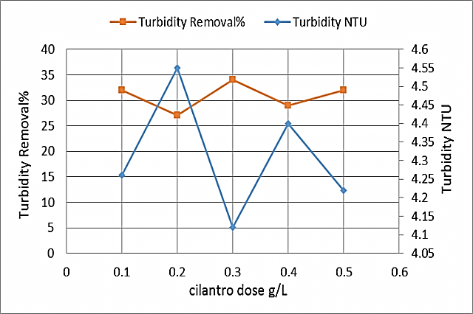  a) | 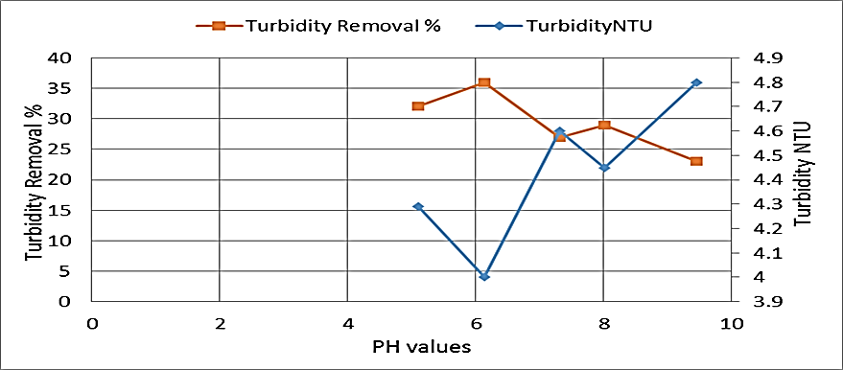
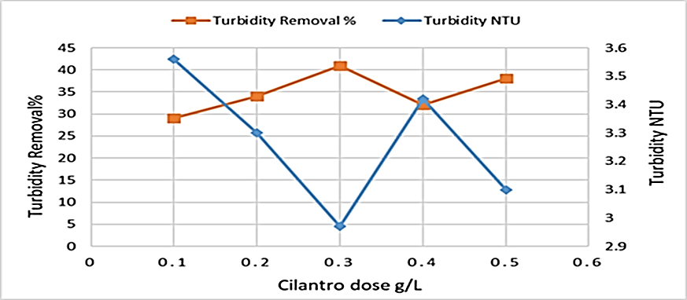  b) | 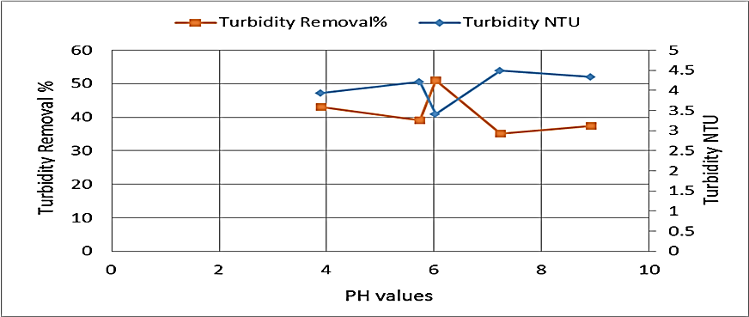
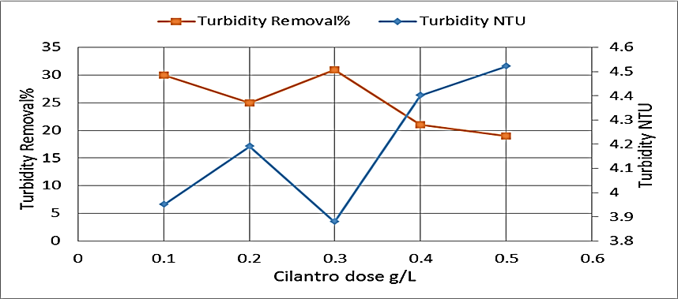  c) | 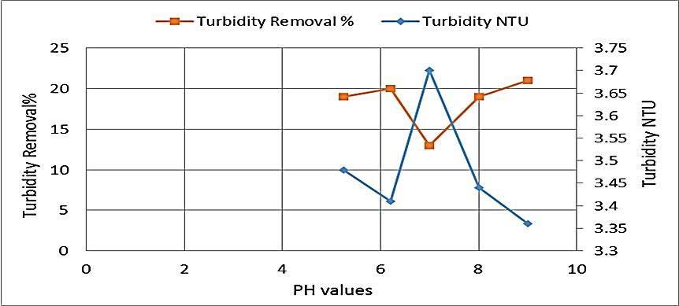
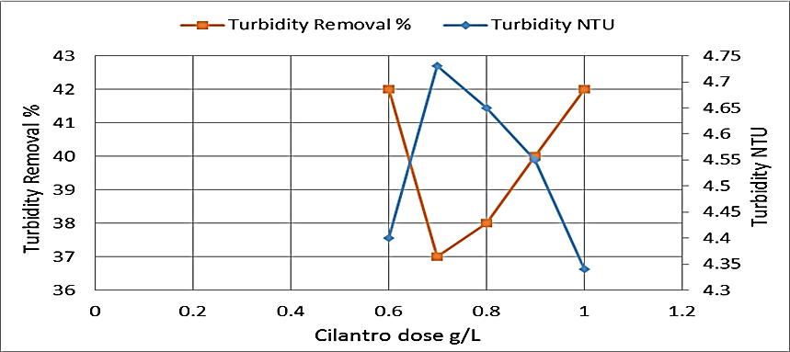  d) | 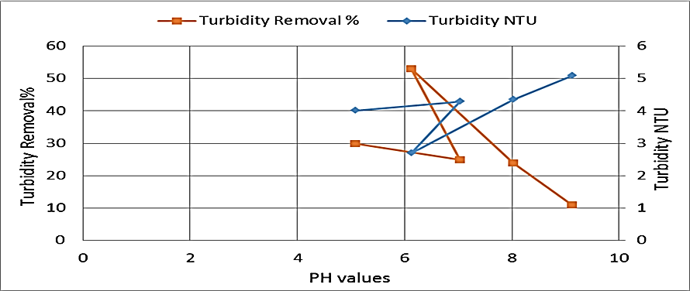

Fig. 2. Optimum conditions for the adsorption process using Cilantro-based biosorbents: (a) fresh leaves (FL), (b) dry leaves (DL), (c) fresh stems (FS), and (d) dry stems (DS). Each subfigure illustrates the optimal dose and pH values at which maximum removal efficiency was achieved.

3.2 Optimum pH affecting the adsorption process

After determining the optimum doses of FL, DL, FS, and DS, these doses were used to determine the optimum pH for raw water treatment. This specific optimum dose was mixed with water samples at different pH values. The lowest turbidity occurred for FL, DL, FS, and DS at pH values of 6.14, 6.03, 6.21, and 6.13, respectively, as shown in Fig. 2.

3.3 Treatment of raw water

The results in Fig. 2 show that the optimum factors defined and used in the batch C/F process experiments for the treatment of raw water were pH (6.14, 6.03, 6.21, and 6.13) and dosage (0.3, 0.3, 0.3, and 0.6 g/l) for FL, DL, FS, and DS, respectively. After the treatment, pH was observed to have a slight decrease and become within neutral range with mean values of 6.14 with FL, which achieved a turbidity removal percentage of 36% and 6.03 with DL by removal percentage of 51% for turbidity. The optimum pH was 6.21 for FS with a removal percentage of 20%, while the highest removal efficiency was achieved at an optimum pH 6.13 of for DS, which achieved a turbidity removal percentage of 53%.
3.4 Physico-chemical characterization for raw & treated samples with Cilantro at optimum conditions

Fig. 3 shows the percentage change of water quality parameters after treatment. The physicochemical parameters of raw and treated water samples using fresh leaves (FL), dry leaves (DL), fresh stems (FS), and dry stems (DS) as adsorbent agents are shown in Table 2. The turbidity of raw water, initially measured at 10.14 ± 0.325 NTU, decreased to 6.85 ± 0.066 NTU when treated with fresh leaves, achieving a removal efficiency of 33%. A greater reduction was observed with dry leaves, reaching 3.15 ± 0.052 NTU (69% removal efficiency). Treatment with fresh stems resulted in a turbidity of 6.55 ± 0.053 NTU, corresponding to a 35.4% reduction efficiency. The most effective reduction was achieved using dry stems, which lowered the turbidity to 2.4 ± 0.041 NTU, corresponding to a removal efficiency of 76.33%.
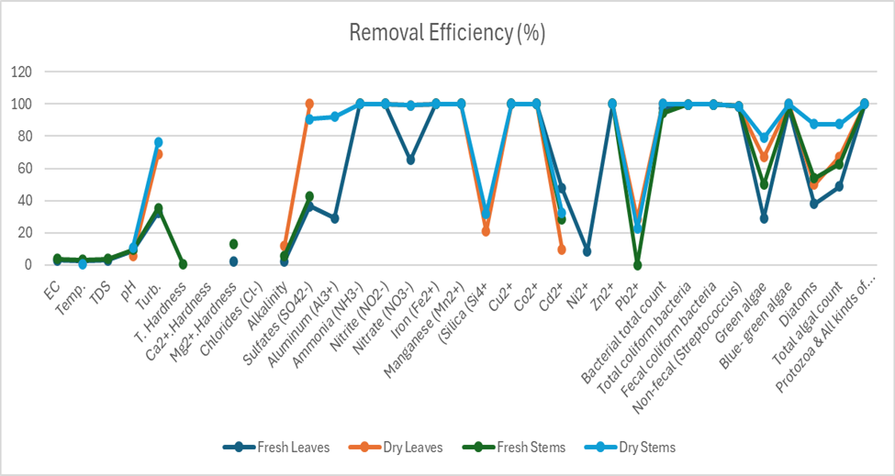
Fig. 3. Removal efficiency of cilantro (Coriandrum sativum) for physicochemical characteristics, heavy metals, bacteriological parameters, and algal counts in water samples collected from (WTP)

The pH value of the raw water, initially recorded at 7.94 ± 0.045, decreased to approximately 7 after treatment, with all treated samples exhibiting lower pH values than the raw water. The electrical conductivity (EC) of the water treated with fresh leaves (FL) was 330.25 ± 0.5 µmohs/cm, which is lower than that of the raw water (339.75 ± 2.06 µmohs/cm). This value is also lower than that obtained using dry leaves (DL) (360.5 ± 0.58 µmohs/cm) but slightly higher than the result from fresh stems (FS) (327.5 ± 0.58 µmohs/cm), and significantly lower than that recorded for dry stems (DS) (452.65 ± 0.94 µmohs/cm).
The total dissolved solids (TDS) in raw water were 224.14 ± 1.36 mg/L, which decreased to 218.02 ± 0.31 mg/L following FL treatment. This was lower than the TDS value for DL (237.9 ± 0.32 mg/L), higher than that for FS (216.24 ± 0.49 mg/L), and lower than that recorded for DS (298.75 ± 0.62 mg/L). Alkalinity decreased from 140 ± 1.63 mg/L in raw water to 136.75 ± 0.9 mg/L with FL treatment. This was higher than the values recorded for DL (123.35 ± 1.17 mg/L) and FS (132 ± 0.08 mg/L), but lower than that of DS (146.05 ± 0.13 mg/L). The total hardness slightly increased from 114.5 ± 2.52 mg/L in raw water to 116.6 ± 0.77 mg/L with FL treatment. This value was lower than that of DL (143.5 ± 1 mg/L) and DS (142.25 ± 0.3 mg/L), but higher than that of FS (114.15 ± 0.19 mg/L). Calcium hardness increased from 64.5 ± 3.79 mg/L to 67.65 ± 0.47 mg/L with FL, while magnesium hardness slightly decreased from 50 ± 4.1 mg/L to 48.85 ± 0.96 mg/L. These values remained lower than those observed for DL (Ca: 76.75 ± 0.95 mg/L; Mg: 66.75 ± 1.89 mg/L) and DS (Ca: 77.43 ± 0.68 mg/L; Mg: 64.83 ± 0.71 mg/L), but FL calcium was lower than FS (70.5 ± 1 mg/L), and FL magnesium was higher than FS (43.65 ± 0.84 mg/L). The chloride concentration increased from 21.25 ± 0.96 mg/L in raw water to 33 ± 1.41 mg/L with FL treatment. This value was lower than those recorded for DL (219.75 ± 0.5 mg/L), FS (43.1 ± 0.14 mg/L), and DS (108.58 ± 1.05 mg/L), which contradicts the findings of Mustapha et al. (2019). Sulfate concentration decreased from 34.25 ± 0.95 mg/L in raw water to 21.75 ± 0.25 mg/L with FL. Sulfate was not detected in the DL-treated samples. The value was lower in the FS group (19.73 ± 0.001 mg/L) and significantly lower in the DS group (3.15 ± 0.043 mg/L), in agreement with Mustapha et al. (2019). Aluminum levels decreased from 0.076 ± 0.014 mg/L in raw water to 0.054 ± 0.007 mg/L with FL treatment. This value was lower than that for DL (0.22 ± 0.017 mg/L) and FS (0.092 ± 0.061 mg/L), but higher than that for DS (0.006 ± 0.0002 mg/L). The ammonia and nitrite concentrations in the raw water were 0.098 ± 0.09 mg/L and 0.07 ± 0.02 mg/L, respectively. Neither ammonia nor nitrite was detected in any of the treated samples (FL, DL, FS, and DS). The nitrate concentration decreased from 0.66 ± 0.06 mg/L in raw water to 0.23 ± 0.013 mg/L with FL. This value was higher than that of DL (0.005 ± 0.001 mg/L), lower than that of FS (1.43 ± 0.008 mg/L), and higher than that of DS (0.004 ± 0.0002 mg/L). Similar to ammonia and nitrite, nitrate levels were reduced in all treated samples, and iron and manganese were not detected. The silica concentration increased from 1.78 ± 0.087 mg/L in raw water to 2.43 ± 0.022 mg/L after FL treatment. This value was higher than that of DL (1.41 ± 0.029 mg/L) and DS (1.21 ± 0.03 mg/L), but lower than that of FS (2.71 ± 0.083 mg/L).
3.5 Determination of Heavy Metal

As shown in Table 2, copper (Cu²⁺) was not detected in the raw water nor in any of the treated samples with fresh leaves (FL), dry leaves (DL), fresh stems (FS), or dry stems (DS). Similarly, cobalt (Co²⁺) was not detected in either the raw or treated water samples.
The cadmium (Cd²⁺) concentration in raw water was 0.021 ± 0.0008 mg/L. Treatment with FL reduced this level to 0.011 ± 0.002 mg/L, achieving a removal efficiency of 47.6%. This was followed by DS (0.0142 ± 0.0002 mg/L; 32.38% removal), FS (0.015 ± 0.0006 mg/L; 28.57% removal), and DL (0.019 ± 0.0002 mg/L), which had the least reduction with a removal efficiency of only 9.52%. Nickel (Ni²⁺) concentration in raw water was 0.047 ± 0.0002 mg/L. After treatment, Ni²⁺ levels slightly increased in most samples, with the highest value recorded for DL (0.053 ± 0.001 mg/L), followed by DS (0.049 ± 0.001 mg/L) and FS (0.048 ± 0.0031 mg/L). However, a slight reduction was observed for FL (0.043 ± 0.0005 mg/L), corresponding to a removal efficiency of 8.5%. Lead (Pb²⁺) concentration in raw water was 0.067 ± 0.0005 mg/L. In the treated samples, Pb²⁺ increased slightly in FL (0.068 ± 0.0004 mg/L) and FS (0.067 ± 0.0008 mg/L), while it decreased in DS (0.052 ± 0.002 mg/L) and DL, which achieved the highest removal efficiency of 28.36%, reducing the concentration to 0.048 ± 0.0002 mg/L.
3.6 Bacteriology Analysis

Table 2 presents the results of using fresh leaves (FL), dry leaves (DL), fresh stems (FS), and dry stems (DS) as adsorbent agents at dosages of 0.3, 0.3, 0.3, and 0.6 g/L, respectively, under near-neutral pH conditions (~7). These treatments achieved turbidity removal efficiencies of 33%, 69%, 35.4%, and 76.33%, respectively. According to Table 2, a positive correlation was observed between the bacterial load in raw water and the reduction levels achieved through treatment with the different adsorbents. At 35°C, the total bacterial count in raw water was 36 × 10³ ± 408.24 CFU/mL. After treatment, FL reduced this count to 1 × 10³ ± 8.16 CFU/mL (removal efficiency: 97.2%). In contrast, bacterial counts were undetectable in water treated with DL and DS, indicating a removal efficiency of 99.99%, which is higher than the 94.44% removal achieved by FS (2 × 10³ ± 0 CFU/mL).
At 44.5°C, the average total coliform count in raw water was 23 × 10² ± 141.42 TC/100 mL, a value lower than the 610.75 × 10³ TC/100 mL reported by El-Salam et al. (2017). No total coliforms were detected in any of the treated water samples (FL, DL, FS, DS). Similarly, fecal coliforms (15 × 10² ± 40.82 FC/100 mL) and fecal streptococci (69.5 ± 6.35 FS/100 mL) were present in raw water but were not detected in any of the treated samples. Table 2 displays the results of algal removal. The total algal count in raw Nile River water was 2632 ± 102 units/mL. Treatment with FL reduced this count to 1348 ± 3 units/mL (removal efficiency: 48.78%), DL to 864 ± 35 units/mL (67.17%), FS to 978 ± 20.7 units/mL (62.84%), and DS to 324 ± 16.8 units/mL—the highest removal efficiency at 87.68%.
For green algae (Chlorophyceae), the concentration in raw water was 860 ± 40 units/mL. Post-treatment levels were 498 ± 10 units/mL for FL (29.06% removal), 284 ± 15 units/mL for DL (66.97%), 432 ± 9.5 units/mL for FS (49.79%), and 180 ± 10.8 units/mL for DS, achieving the highest removal of 79.06%. The blue-green algae (Cyanophyceae) concentration in raw water was 612 ± 2 units/mL. This was reduced to 18 ± 6 units/mL with FL (97.06% removal) and 10 ± 3.2 units/mL with FS (98.36%). Notably, DL and DS achieved complete removal (100%). For diatoms (Bacillariophyceae), raw water contained 1160 ± 60 units/mL. Treatment with FL reduced the count to 720 ± 7 units/mL (37.93% removal), DL to 580 ± 20 units/mL (50%), FS to 536 ± 8 units/mL (53.79%), and DS achieved the highest removal, reducing the count to 144 ± 6 units/mL (87.58%).

Table 2. Comprehensive Characterization of Raw and Treated Water Samples Under Optimum Conditions (Dose and pH) Compared with Egyptian and WHO Standards (Mean ± SD)

Parameter | Unit | Raw water | Treated water with  Fresh Leaves | Treated water with Dry Leaves | Treated water with  Fresh Stems | Treated water with Dry Stems | Max. allowed in drinking water (EWQS, 2007( | Max. allowed in drinking water (WHO, 2011)
Electrical Conductivity | µmohs/cm | 339.75  ±2.06 | 330.25  ± 0.5 | 360.5  ±0.58 | 327.5  ± 0.58 | 452.65  ±0.94 | 1000 | -
Temperature | ͦC | 26.025  ±0.33 | 25.4  ± 0.24 | 25.65  ±0.1 | 25.21  ± 0.14 | 25.9  ±0.48 | 8-12 | -
Total Dissolved Solids | mg/l | 224.14  ±1.36 | 218.02  ± 0.31 | 237.9  ±0.32 | 216.24  ± 0.49 | 298.75  ±0.62 | 500 | -
pH | - | 7.94  ±0.045 | 7.25  ± 0.049 | 7.52  ±0.067 | 7.19  ± 0.028 | 7.09  ±0.034 | 6.5-8.5 | -
Turbidity | NTU | 10.14  ±0.325 | 6.85  ± 0.066 | 3.15  ±0.052 | 6.55  ± 0.053 | 2.40  ±0.041 | 1 | -
Total Hardness | mg/l | 114.5  ±2.52 | 116.6  ± 0.77 | 143.5  ±1 | 114.15  ± 0.19 | 142.25  ±0.3 | 500 | -
Ca²⁺. Hardness | mg/l | 64.5  ±3.79 | 67.65  ± 0.47 | 76.75  ±0.95 | 70.5  ± 1 | 77.43  ±0.68 | 350 | -
Mg²⁺. Hardness | mg/l | 50  ±4.1 | 48.85  ± 0.96 | 66.75  ±1.89 | 43.65  ± 0.84 | 64.83  ±0.71 | 150 | -
Chlorides (Cl⁻) | mg/l | 21.25  ±0.96 | 33  ± 1.41 | 219.75  ±0.5 | 43.1  ± 0.14 | 108.58  ±1.05 | 250 | -
Alkalinity | mg/l | 140  ±1.63 | 136.75  ± 0.9 | 123.35  ±1.17 | 132  ± 0.08 | 146.05  ±0.13 | 200 | -
Sulfates (SO₄²⁻) | mg/l | 34.25  ±0.95 | 21.75  ± 0.25 | N.D | 19.73  ± 0.001 | 3.15  ±0.043 | 250 | -
Aluminum (Al³⁺) | mg/l | 0.076  ±0.014 | 0.054  ± 0.007 | 0.22  ±0.017 | 0.092  ± 0.061 | 0.006  ±0.0002 | 0.2 | -
Ammonia (NH₃⁻) | mg/l | 0.098  ±0.09 | N.D | N.D | N.D | N.D | 0.5 | -
Nitrite (NO₂⁻) | mg/l | 0.07  ±0.02 | N.D | N.D | N.D | N.D | 0.2 | -
Nitrate (NO₃⁻) | mg/l | 0.66  ±0.06 | 0.23  ± 0.013 | 0.005  ±0.001 | 1.43  ± 0.008 | 0.004  ±0.0002 | 45 | -
Iron (Fe²⁺) | mg/l | 0.079  ±0.003 | N.D | N.D | N.D | N.D | 0.3 | -
Manganese (Mn²⁺) | mg/l | 0.044  ±0.006 | N.D | N.D | N.D | N.D | 0.4 | -
(Silica (Si⁴⁺ | mg/l | 1.78  ±0.087 | 2.43  ± 0.022 | 1.41  ±0.029 | 2.71  ± 0.083 | 1.21  ±0.03 | 0.1 | -
Cu²⁺ | mg/l | N.D | N.D | N.D | N.D | N.D | - | 2
Co²⁺ | mg/l | N.D | N.D | N.D | N.D | N.D | - | 0.05
Cd²⁺ | mg/l | 0.021  ±0.0008 | 0.011  ±0.002 | 0.019  ±0.0002 | 0.015  ±0.0006 | 0.0142  ±0.0002 | - | 0.003
Ni²⁺ | mg/l | 0.047  ±0.0002 | 0.043  ±0.0005 | 0.053  ±0.001 | 0.048  ±0.0002 | 0.049  ±0.0031 | - | 0.02
Zn²⁺ | mg/l | N.D | N.D | N.D | N.D | N.D | - | 3
Pb²⁺ | mg/l | 0.067  ±0.0005 | 0.068  ±0.0004 | 0.048  ±0.0002 | 0.067  ±0.0008 | 0.052  ±0.002 | - | 0.01
Bacterial total count | CFU/ml | 36×10³  ±408.24 | 1×10³  ± 8.16 | <1 | 2×10³  ±0 | <1 | 50 | -
Total coliform bacteria | TC/100ml | 23×10²  ±141.42 | <1 | <1 | <1 | <1 | 2 | -
Fecal coliform bacteria | FC/100ml | 15×10²  ±40.82 | <1 | <1 | <1 | <1 | (Free) | -
Non-fecal (Streptococcus)  Bacteria | FS/100ml | 69.5  ±6.35 | <1 | <1 | <1 | <1 | (Free) | -
Bacterial total count | CFU/ml | 36×10³  ±408.24 | 1×10³  ± 8.16 | <1 | 2×10³  ±0 | <1 | 50 | -
Green algae | Unit /ml | 860  ±40 | 610  ±10 | 284  ±15 | 432  ±9.5 | 180  ±10.8 | - | -
Blue- green algae | Unit /ml | 612  ±2 | 18  ±6 | Free | 10  ±3.2 | Free | Free | -
Diatoms | Unit /ml | 1160  ±60 | 720  ±7 | 580  ±20 | 536  ±8 | 144  ±6 | - | -
Total algal count | Unit /ml | 2632  ±102 | 1348  ±3 | 864  ±35 | 978  ±20.7 | 324  ±16.8 | - | -
Protozoa & All kinds of pathogen worms | Unit /ml | +ve | -ve | -ve | -ve | -ve | Free | -
N.D: Not detected,
< below count colonies/ml,
+)ve )indicates the presence of Protozoa & All kinds of pathogen worms,
whereas (_ve) denotes the absence of Protozoa & All kinds of pathogen worms.

4. DISCUSSION
4.1 Adsorption Process Using Cilantro

4.1.1. Optimum dose affecting the adsorption process

The current study's findings disagree with those of Martin et al. (2020), who reported that FL did not remove the turbidity from the river water. The higher removal efficiency of the cilantro group in our investigation may be due to that the adsorption of metal ions which is favored by different chemical functional groups. These groups are potential active sites for the adsorption of metal ions depending on factors such as their accessibility, abundance of sites, chemical states, an attraction between metal ions, and adsorption sites, such as –OH, -C=O, -NH2, –OH, Ar-O, and –O-C=O for DL as proved by Jafari & Senobari, (2012), Singh & Kaur, (2013). Similarly, DS possess fibrous components rich in cellulose, hemicellulose, and lignin, which contain active functional groups capable of binding metal ions and enhancing removal efficiency (Hongkun et al., 2024; Yang et al., 2025).

4.2 Optimum pH affecting the adsorption process

As illustrated in Fig. 2, This result when the pH was adjusted to its natural level. However, at pH values of 6 and 7, the results were quite similar, and increasing the pH value above 9 was not desired.

4.3 Treatment of raw water

A slight decrease in pH was observed with increasing dose, and the removal efficiency increased at low pH, but this is not desired because low-pH water will corrode or dissolve metals and other substances. The results were quite similar around pH 7-8, and increasing the pH value above 9 was not desired because it makes the taste bitter and decreases the effectiveness of the chlorine disinfection, thereby causing the need for additional chlorine. Pollution can modify the pH of water, which can damage animals and plants that live in the water (Omer, 2019). Our results are in agreement with Rao & Kashifuddin (2012), who reported that the adsorption process was pH-dependent, with the maximum adsorption of these ions occurring in the pH range 4–6. However, the surface of the adsorbent becomes deprotonated in the alkaline range, favoring the uptake of metal ions under restricted limitations because of hydrolysis, as reported by Das (2012).

4.4 Physico-chemical characterization for raw & treated samples with Cilantro at optimum conditions

According to Foo and Hameed (2010), the adsorption process on the surface of cilantro leaves and stems involves the formation of chemical or physical bonds, enabling the attachment of multi-component fluids to the solid adsorbent surfaces. Among the tested components, dry stems exhibited the highest turbidity levels, reaching 2.4 ± 0.041 NTU.
In alkaline conditions, the adsorbent surface tends to become deprotonated, enhancing the uptake of metal ions; however, this process is limited due to hydrolysis constraints (Das, 2012). The current study observed temperature fluctuations ranging between 15°C and 30°C throughout the monitoring period. These variations may be attributed to solar radiation and the discharge of heated effluents, which could exert significant ecological impacts (APHA, 2005; Ljiljana et al., 2019).

The pH value decreased to approximately 7. This is commonly higher in raw water due to the natural presence of carbonates and bicarbonates, as indicated by Friendl et al. (2004). Elevated pH levels in river water may also result from photosynthetic activity and the growth of aquatic vegetation (APHA, 2017).
EC and TDS are interrelated parameters governed by ionic concentration, abundance, and temperature. EC is directly proportional to dissolved ions (Mustapha et al., 2019); its increase reflects higher ion concentrations, while a decrease may indicate adsorption onto available binding sites. Additionally, fluctuations in water volume can influence EC levels (Koloanda & Oladimeji, 2004). Our results align with Hasaballah et al. (2024), who observed reduced TDS and EC in wastewater treated by Lemna minor and Pistia stratiotes. TDS primarily consists of inorganic salts (chlorides, bicarbonates, sulfates, and nitrates) and trace elements like iron. High TDS levels, often driven by agricultural runoff and untreated sewage, can cause pipe corrosion and mineral scaling (APHA, 2017). Our findings regarding alkalinity are consistent with Ali et al. (2014), who noted that the Nile River near Mansoura exhibits an alkaline tendency due to carbonates and bicarbonates. Variations in pH and alkalinity are further influenced by CO₂ release during nitrification, typically following nutrient influxes and phytoplankton peaks.
The highest recorded values of total hardness can be attributed to the dissolution of calcium-containing compounds, particularly in environments with elevated carbon dioxide concentrations. Conversely, the lowest hardness values may result from the precipitation of calcium as CaCO₃, often associated with reduced dissolved oxygen levels (Ali et al., 2014). Additionally, calcium ions can form complexes with ionogenic groups present on coagulants and particle surfaces (Ramavandi, 2014). Regarding chloride levels, caution is advised when using such water for irrigating cilantro plants, as high chloride concentrations may negatively affect soil and plant health (ElBastamy et al., 2021). Elevated chloride may also result from efforts to disinfect raw water, reducing chlorine demand during post-treatment disinfection processes that eliminate residual microorganisms after sedimentation and filtration (Ljiljana et al., 2019).
The observed decrease in sulfate concentration may be attributed to the adsorbent's high surface area and the presence of active binding sites (Mustapha et al., 2019). Aluminum, a naturally abundant metal, may also be present in water due to both anthropogenic and natural sources. A reduction in aluminum levels is likewise linked to the effectiveness of adsorbent materials with available binding sites and large surface areas (Mustapha et al., 2019). The speciation of metals and the reactivity of binding sites are both strongly influenced by the pH of the solution. This is consistent with the findings of Ghawi (2017), who reported that Moringa oleifera, at a dosage of 32 to 80 mg/L using 25% (w/w) oil-extracted leaves, achieved only modest removal rates (75.1%).
Ammonia typically exists in raw water as ammonium and nitrate, originating from algal blooms and both natural and anthropogenic sources. Elevated ammonia concentrations may be attributed to inputs from drainage water, while lower concentrations are associated with increased plankton activity, which tends to assimilate ammonia preferentially over other nitrogen forms (Hasballah, 2008).
Nitrite acts as an intermediate product in the transformation of organic matter into more stable nitrogenous forms. Its concentration increases due to the oxidation of free ammonia via nitrification. When chlorine is added to water containing nitrites and minimal ammonium nitrogen, it reacts rapidly with the nitrites as free chlorine, thus increasing the chlorine demand required to achieve acceptable coliform levels (Chen & Jensen, 2001). The subsequent decline in nitrite levels may result from its oxidation into nitrate—a more stable nitrogen compound—potentially absorbed by plankton (Hasballah, 2008). The elevated nitrate concentration observed in the water samples may be attributed to the release of organic matter from sewage and agricultural drainage, which typically contains high levels of nitrate (Hasballah, 2008). The initial rapid adsorption rates were due to the abundance of active binding sites available on the surface of the adsorbents, facilitating swift adsorption and diffusion of pollutants from the bulk solution to the adsorbent surfaces (Mustapha et al., 2019). A critical step in evaluating the treatment results is comparing the physicochemical characteristics of the treated water with the Egyptian Drinking Water Quality Standards (EWQS, 2007), as shown in Table 2.
Overall, the study revealed that treated water complied with EWQS limits, except for silica, temperature, and turbidity, which exceeded drinking water standards. The removal of Fe²⁺ and Mn²⁺ occurs via a two-step mechanism: the oxidation of soluble ions into insoluble precipitates, followed by solid separation. This oxidation is driven by chemical reactions with oxygen or agents like chlorine (Khadse et al., 2015). These findings align with Ghawi (2017), who achieved a 98% iron removal efficiency using 60 mg/L of crude Moringa oleifera extract. Such high efficiency is attributed to the adsorbent's extensive surface area and abundant active binding sites (Mustapha et al., 2019). Silica persists in natural water in dissolved, suspended, or colloidal states. Elevated concentrations are typically linked to the skeletal remains of aquatic flora and fauna, particularly algae (Shehata et al., 2008).
The microbiological analysis indicated that, although raw water samples were contaminated, all treated samples fell within the permissible limits defined by EWQS (2007) and were free from sewage contamination. The exception was the total bacterial counts for FL and FS treatments, which exceeded the acceptable limit of 50 CFU/mL. Similar trends were previously reported by El-Salam et al. (2017).

4.5 Determination of Heavy Metal

Table 2 illustrates the concentrations of various heavy metals. Copper was not detected in the raw water, contrasting with El-Emam (2020), who reported a concentration of 0.223 mg/L. Copper was also undetected in water treated with FL, DL, FS, and DS, in agreement with findings by Rao and Kashifuddin (2012).
Cobalt was similarly undetected in raw water, differing from previously reported concentrations of 0.012 mg/L (El-Bady, 2019), 0.223 mg/L (El-Emam, 2020), and 0.0046 mg/L (Gad et al., 2022). The cadmium concentration in the raw water matched the 0.02 mg/L reported by Smysem et al. (2020) but was lower than the 0.149 mg/L found by El-Emam (2020) and higher than the 0.002 mg/L noted by El-Bady (2019). Nickel levels in the raw water were consistent with those reported by Smysem et al. (2020) at 0.04 mg/L, exceeding the values reported by El-Bady (2019) at 0.011 mg/L and Gad et al. (2022) at 0.0183 mg/L, but lower than the 0.12 mg/L reported by El-Emam (2020). Zinc was not detected in the raw water, which contrasts with previous findings by El-Bady (2019) at 0.191 mg/L, El-Emam (2020) at 0.466 mg/L, and Gad et al. (2022) at 0.0161 mg/L.
The lead (Pb²⁺) concentration in raw water was lower than the 0.401 mg/L reported by El-Emam (2020), but higher than values from Smysem et al. (2020) at 0.03 mg/L and El-Bady (2019) at 0.020 mg/L. The lowest removal efficiency for Pb²⁺ was observed in DL treatment (28.36%), which contrasts with the findings of Rao and Kashifuddin (2012). Among the tested materials, fresh leaves exhibited the highest removal efficiency for heavy metals, followed by dry stems and dry leaves. Fresh stems showed limited effectiveness in metal adsorption. The efficiency of metal ion adsorption is influenced by the presence of various functional groups such as –NH, –NH₂, –OH, –CN, –C=O, and –C–O–C, which act as active binding sites depending on factors like their accessibility, abundance, and chemical states (Gupta & Rastogi, 2008; Jafari & Senobari, 2012; Singh & Kaur, 2013).
4.6 Bacteriology Analysis

Bacterial removal in the studied treatment processes occurred primarily through mechanical trapping and adsorption mechanisms. The highest total bacterial count in raw water was recorded at 36×10³ ± 408.24 CFU/mL, which exceeds the value reported by El-Salam et al. (2017), who found 28×10³ CFU/mL. In contrast, the average counts of fecal coliforms and fecal streptococci in raw water did not align with those previously reported by El-Salam et al. (2017), who documented 229 FC/100 mL and 463 FS/100 mL, respectively, nor with the findings of El-Bastamy et al. (2021), who recorded 46×10³ FC/100 mL.
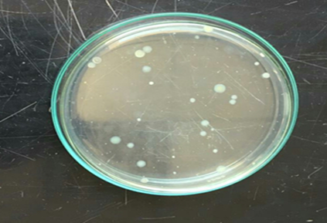  Raw water | 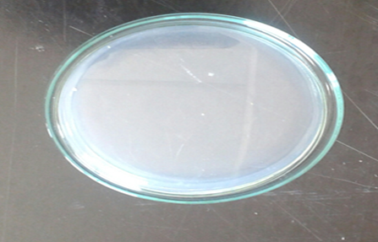  Fresh Leaves
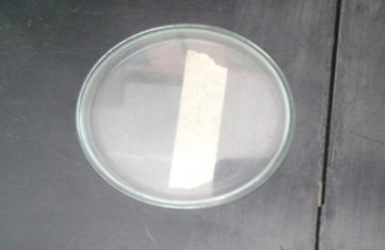
Dry Leaves
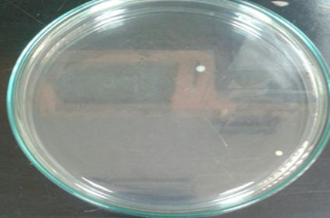  Fresh Stems | 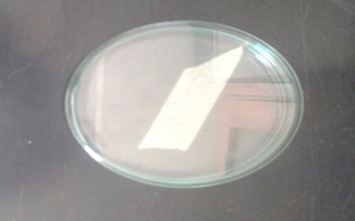  Dry Stems

Fig. 4. Petri dishes showing the total bacterial count in raw water and water samples treated with FL, DL, FS, and DS. A significant reduction in bacterial colonies is observed in treated samples compared to the raw water.

Notably, fecal coliforms and fecal streptococci were entirely absent in the treated water samples (FL, DL, FS, and DS), in agreement with the current study’s results but in contrast to El-Bastamy et al. (2021), who reported post-treatment values of 2400, 180, and 180 FC/100 mL using zeolite, bentonite, and diatomite, respectively.
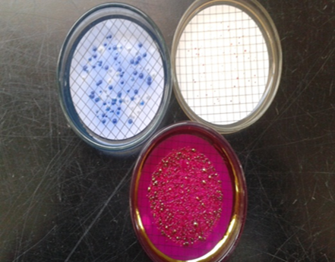  Raw water | 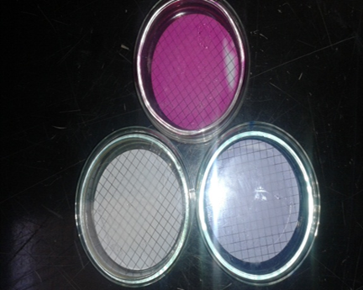  Fresh Leaves
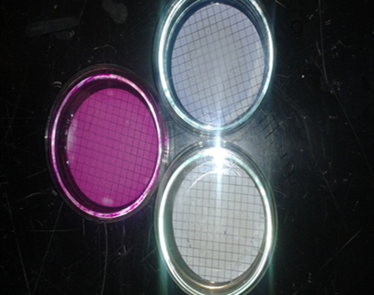
Dry Leaves

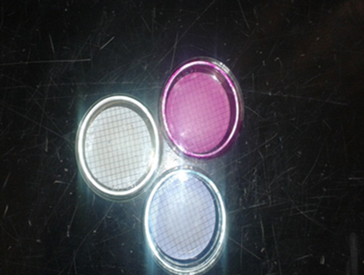  Dry stems | 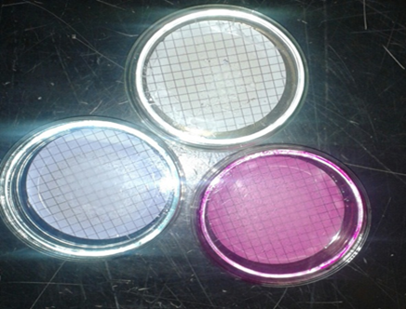  Fresh Stems
Fig. 5. Membrane filter test results showing the presence of coliform bacteria in raw water and the absence of coliforms in water samples treated with FL, DL, FS, and DS adsorbents.

Pre-chlorination plays a crucial role in microbial and algal control. Chlorine inactivates microorganisms by oxidizing cellular components, altering membrane permeability, damaging protoplasm, inhibiting enzyme activity, and destroying DNA and RNA. It particularly targets lipids in the cell membrane, which explains why cysts and ova are generally more resistant than bacteria (EPA, 1999). The effectiveness of chlorine is pH-dependent, with optimal performance occurring in the pH range of 6–7. Ramavandi (2014) also noted that increasing chlorine doses beyond optimal levels may reduce removal efficiency.
Regarding algal populations, the total algal count in this study conflicted with the findings of El-Dars et al. (2015), who reported increased algal metabolic activity at higher temperatures, with the presence of carbonates in raw water attributed to both elevated pH and salinity levels, as indicated by TDS. According to Abd El-Hady (2014), higher alkalinity (as CaCO₃) encourages phytoplankton proliferation due to increased availability of dissolved CO₂ and HCO₃⁻, which are utilized in biomass production (Mana-han, 2000). Numerous studies have demonstrated that chemical coagulation is more effective in algae removal when combined with pretreatment using agents such as chlorine or chlorine dioxide (Fathy et al., 2020). Mahapatra et al. (2010) reported that increased presence of Chlorophyceae and Cyanophyceae indicates organic pollution and nutrient accumulation in surface waters.
Diatoms were observed in treated water, which may be attributed to their resistance to coagulation and adsorption processes. This observation supports findings by El-Dars et al. (2015), who reported that diatoms (Bacillariophyceae) were more prevalent than other algal groups such as Chlorophyta, Cyanophyta, and Euglenophyta. Abd El-Hady (2014) similarly observed year-round dominance of diatoms in the Nile River system. Shehata et al. (2008) linked high diatom concentrations to the presence of iron and dissolved silica. Diatom dominance under low-stress environmental conditions is often considered an indicator of high-water quality (Mahapatra et al., 2010). This was further supported by Fathy et al. (2020), who ranked algal groups in terms of population size as diatoms > green algae > blue-green algae.
Algal biomass was found to peak when daily water temperatures ranged between 21 and 21–24 °C, while higher temperatures (above 24°C) led to a gradual decline in algal cell concentrations. Lastly, while various pathogenic worms and protozoa were detected in raw water samples, they were absent in treated samples. This absence is attributed to effective disinfection, which minimizes the chlorine demand needed to eliminate any remaining microorganisms following sedimentation and filtration (Ljiljana et al., 2019).
4.7 Statistical analysis
Significance values were calculated to assess the mean differences in various physicochemical and microbiological parameters between raw Nile River water and water treated with different Coriandrum sativum (cilantro) groups: fresh leaves (FL), dry leaves (DL), fresh stems (FS), and dry stems (DS). Parameters analyzed included turbidity, temperature, pH, alkalinity, electrical conductivity (EC), total dissolved solids (TDS), total hardness, calcium and magnesium hardness, chloride, sulfate, aluminum, ammonia, nitrite, nitrate, iron, manganese, silica, heavy metals, and bacteriological indicators.
The one-way ANOVA test revealed no statistically significant differences between the raw and treated groups across the tested parameters (F (2) = 1.395, P = .24), as shown in Table 3. Additionally, Tukey's post hoc test indicated that there were no significant differences in the physicochemical properties between the raw water and each cilantro treatment group (P = .36 for FL, .32 for DL, .34 for FS, and .36 for DS). Likewise, no significant differences were observed among the cilantro treatment groups themselves (P = .97). These findings were further supported by the Scheffé and LSD verification tests (Table 5), which confirmed the statistical homogeneity among the groups. Subset means also showed consistent performance across the cilantro groups (Table 4). Furthermore, Pearson’s correlation coefficient confirmed the lack of statistically significant correlation between the cilantro treatments and the measured parameters (P > .05), reinforcing the conclusion that all cilantro treatments had comparable effects. Regarding heavy metals (Table 3), one-way ANOVA showed no statistically significant differences in concentrations of Cu²⁺, Cd²⁺, Co²⁺, Zn²⁺, Ni²⁺, and Pb²⁺ between raw and treated samples (P >.05). These results contrast with those reported by Lasheen et al. (2008) and El-Emam (2020), who found no significant differences in heavy metal concentrations using one-way ANOVA. However, in the present study, despite the lack of statistical significance, the treatment process effectively reduced the concentrations of Cd²⁺, Ni²⁺, and Pb²⁺. The percentage removal of cadmium was 47.6%, 9.52%, 28.57%, and 32.38% for FL, DL, FS, and DS, respectively. Nickel levels were reduced by 8.5% with FL treatment, while lead concentrations were reduced by 28.36% using DL treatment.
Table 3. Statistical Analysis (ANOVA Test)

P1 | Sum of Squares | Df | Mean Square | F | Sig.
Between Groups | 45237714.761 | 4 | 11309428.690 | 1.395 | .238 ^{oo}
Within Groups | 1256276339.610 | 155 | 8105008.643
Total | 1301514054.372 | 159
Non-significant (P >.05), * = low significant (P ≤.05),
** = intermediate significant (P ≤.01) and *** = highly significant (P ≤.001)

Table 4. Tests of Homogeneity of Variances

 |  | Levene Statistic | df1 | df2 | Sig.
P1 | Based on Mean | 4.162 | 4 | 155 | .003 *
P1 | Based on Median | 1.392 | 4 | 155 | .239 ^{oo}
P1 | Based on Median and with adjusted df | 1.392 | 4 | 31.484 | .259 ^{oo}
P1 | Based on trimmed mean | 1.614 | 4 | 155 | .173 ^{oo}
^{oo} Non-significant (P >.05), * = low significant (P ≤.05),
** = intermediate significant (P ≤.01) and *** = highly significant (P ≤.001)

Table 5. A Tukey Post Hoc Tests (Multiple Comparisons)
 | (I) Treatment | (J) Treatment | Mean Difference (I-J) | Std. Error | Sig. | 95% Confidence Interval
 |  |  |  |  |  | Lower Bound | Upper Bound
Tukey HSD | Raw Water | Fresh Leaves | 1295.54812 | 711.73242 | .366 ^{oo} | -668.9431- | 3260.0394
Tukey HSD | Raw Water | Dry Leaves | 1349.20926 | 711.73242 | .324 ^{oo} | -615.2820- | 3313.7005
Tukey HSD | Raw Water | Fresh Stems | 1350.09408 | 711.73242 | .323 ^{oo} | -614.3972- | 3314.5853
Tukey HSD | Raw Water | Dry Stems | 1318.52443 | 711.73242 | .348 ^{oo} | -645.9668- | 3283.0157
Tukey HSD | Fresh Leaves | raw water | -1295.54812- | 711.73242 | .366 ^{oo} | -3260.0394- | 668.9431
Tukey HSD | Fresh Leaves | Dry Leaves | 53.66113 | 711.73242 | 1.000 ^{oo} | -1910.8301- | 2018.1524
Tukey HSD | Fresh Leaves | Fresh Stems | 54.54596 | 711.73242 | 1.000 ^{oo} | -1909.9453- | 2019.0372
Tukey HSD | Fresh Leaves | Dry Stems | 22.97630 | 711.73242 | 1.000 ^{oo} | -1941.5150- | 1987.4676
Tukey HSD | Dry Leaves | raw water | -1349.20926- | 711.73242 | .324 ^{oo} | -3313.7005- | 615.2820
Tukey HSD | Dry Leaves | Fresh Leaves | -53.66113- | 711.73242 | 1.000 ^{oo} | -2018.1524- | 1910.8301
Tukey HSD | Dry Leaves | Fresh Stems | .88482 | 711.73242 | 1.000 ^{oo} | -1963.6064- | 1965.3761
Tukey HSD | Dry Leaves | Dry Stems | -30.68483- | 711.73242 | 1.000 ^{oo} | -1995.1761- | 1933.8064
Tukey HSD | Fresh Stems | raw water | -1350.09408- | 711.73242 | .323 ^{oo} | -3314.5853- | 614.3972
Tukey HSD | Fresh Stems | Fresh Leaves | -54.54596- | 711.73242 | 1.000 ^{oo} | -2019.0372- | 1909.9453
Tukey HSD | Fresh Stems | Dry Leaves | -.88482- | 711.73242 | 1.000 ^{oo} | -1965.3761- | 1963.6064
Tukey HSD | Fresh Stems | Dry Stems | -31.56966- | 711.73242 | 1.000 ^{oo} | -1996.0609- | 1932.9216
Tukey HSD | Dry Stems | raw water | -1318.52443- | 711.73242 | .348 ^{oo} | -3283.0157- | 645.9668
Tukey HSD | Dry Stems | Fresh Leaves | -22.97630- | 711.73242 | 1.000 ^{oo} | -1987.4676- | 1941.5150
Tukey HSD | Dry Stems | Dry Leaves | 30.68483 | 711.73242 | 1.000 ^{oo} | -1933.8064- | 1995.1761
Tukey HSD | Dry Stems | Fresh Stems | 31.56966 | 711.73242 | 1.000 ^{oo} | -1932.9216- | 1996.0609
LSD | raw water | Fresh Leaves | 1295.54812 | 711.73242 | .071 ^{oo} | -110.3989- | 2701.4952
LSD | raw water | Dry Leaves | 1349.20926 | 711.73242 | .060 ^{oo} | -56.7378- | 2755.1563
LSD | raw water | Fresh Stems | 1350.09408 | 711.73242 | .060 ^{oo} | -55.8530- | 2756.0411
LSD | raw water | Dry Stems | 1318.52443 | 711.73242 | .066 ^{oo} | -87.4226- | 2724.4715
LSD | Fresh Leaves | raw water | -1295.54812- | 711.73242 | .071 ^{oo} | -2701.4952- | 110.3989
LSD | Fresh Leaves | Dry Leaves | 53.66113 | 711.73242 | .940 ^{oo} | -1352.2859- | 1459.6082
LSD | Fresh Leaves | Fresh Stems | 54.54596 | 711.73242 | .939 ^{oo} | -1351.4011- | 1460.4930
LSD | Fresh Leaves | Dry Stems | 22.97630 | 711.73242 | .974 ^{oo} | -1382.9708- | 1428.9234
LSD | Dry Leaves | raw water | -1349.20926- | 711.73242 | .060 ^{oo} | -2755.1563- | 56.7378
LSD | Dry Leaves | Fresh Leaves | -53.66113- | 711.73242 | .940 ^{oo} | -1459.6082- | 1352.2859
LSD | Dry Leaves | Fresh Stems | .88482 | 711.73242 | .999 ^{oo} | -1405.0622- | 1406.8319
LSD | Dry Leaves | Dry Stems | -30.68483- | 711.73242 | .966 ^{oo} | -1436.6319- | 1375.2622
LSD | Fresh Stems | raw water | -1350.09408- | 711.73242 | .060 ^{oo} | -2756.0411- | 55.8530
LSD | Fresh Stems | Fresh Leaves | -54.54596- | 711.73242 | .939 ^{oo} | -1460.4930- | 1351.4011
LSD | Fresh Stems | Dry Leaves | -.88482- | 711.73242 | .999 ^{oo} | -1406.8319- | 1405.0622
LSD | Fresh Stems | Dry Stems | -31.56966- | 711.73242 | .965 ^{oo} | -1437.5167- | 1374.3774
LSD | Dry Stems | raw water | -1318.52443- | 711.73242 | .066 ^{oo} | -2724.4715- | 87.4226
LSD | Dry Stems | Fresh Leaves | -22.97630- | 711.73242 | .974 ^{oo} | -1428.9234- | 1382.9708
LSD | Dry Stems | Dry Leaves | 30.68483 | 711.73242 | .966 ^{oo} | -1375.2622- | 1436.6319
LSD | Dry Stems | Fresh Stems | 31.56966 | 711.73242 | .965 ^{oo} | -1374.3774- | 1437.5167

Non-significant (P >.05), * = low significant (P ≤.05),
** = intermediate significant (P ≤.01) and *** = highly significant (P ≤.001)

5. Conclusion

Coriander leaves and stems showed an excellent potential for the removal of turbidity and heavy metals from raw water. The adsorption process was pH-dependent, with the maximum adsorption of these ions occurring in the pH range 6-7. The efficiency of DS to remove turbidity increased with increasing dosage, with removal of 76.33% at a dosage of 0.6 g, while DL showed a decrease in percentage removal of turbidity with increasing adsorbent dosage, with a percentage removal of 69% at a 0.3 g dosage. However, the FS and FL did not remove turbidity efficiently from the river water. The efficiency of FS to remove turbidity increased with an increase in dosage, with a removal of 35.4% at a dosage of 0.3 g, while FL showed a decrease in the percentage removal of turbidity with an increasing adsorbent dosage, with a percentage removal of 33% at a 0.3 g dosage. So, selection of appropriate adsorbents and their doses, and combination of other useful methods as a part of an integrated approach are some of the ways to preserve and improve the drinking raw water quality and safe environment in particular.

Competing interests

The authors declare that they have no conflict of interest. 9.2 Ethics statement. This article does not contain any studies with human participants or animals performed by any of the authors. In addition, the ethical issues, including plagiarism, informed consent, misconduct, data fabrication or submission, and redundancy, has been completely observed by the authors.

Abbreviations

BOD: Biological Oxygen Demand
C/F processes: Coagulation/ Flocculation processes
DL: Dry Leaves
DS: Dry Stems
EWQS: Egyptian Drinking Water Quality Standards
FC: Fecal Coliforms
FL: Fresh Leaves
FS: Fresh Stems
FCs: Fecal Streptococci
TBC: Total Bacterial Count
TC: Total Coliforms
WTP: Water Treatment Plant

Disclaimer (Artificial intelligence)

Author(s) hereby declare that NO generative AI technologies such as Large Language Models (ChatGPT, COPILOT, etc.) and text-to-image generators have been used during the writing or editing of this manuscript.

References

- Abd El-Salam, S., Amer, M., Nasr El-din, M., Radwan, A. (2017). Physical-chemical and bacteriological evaluation of River Nile water and drinking water in Benha City, Egypt. Egyptian Journal of Botany, 57(3), 495-506.‏ https://doi.org/10.1108/14777830810866473
- Abhijeet Das and Satchidananda Mishra (2025). Smart and sustainable water management: policy, technology, and innovation pathways for resource resilience. Green Technology Resilience and Sustainability, 5:5. DOI: 10.1007/s44173-025-00022-8
- Al-Essa, K., Khalili, F. (2018). Heavy metals adsorption from aqueous solutions onto unmodified and modified Jordanian kaolinite clay: batch and column techniques. American Journal of Applied Chemistry, 6(1), 25-34.‏
- Ali, E. M., Shabaan-Dessouki, S. A., Soliman, A. R. I., El Shenawy, A. S. (2014). Characterization of chemical water quality in the Nile River, Egypt. International Journal of Pure & Applied Bioscience, 2(3), 35-53.‏
- APHA, (American Public Health Association), American Water Works Association, Water Pollution Control Federation, & Water Environment Federation. (2005). Standard methods for the examination of water and wastewater (21 th Ed). American Public Health Association. Washington, 143-147.
- APHA, (American Public Health Association), American Water Works Association, Water Pollution Control Federation, & Water Environment Federation. (2017). Standard methods for the examination of water and wastewater (23 th Ed). American Public Health Association. Washington, 209-216
- Chen, W. L., Jensen, J. N. (2001). Effect of chlorine demand on the ammonia breakpoint curve: Model development, validation with nitrite, and application to municipal wastewater. Water environment research, 73(6), 721-731.‏
- Choy, S. Y., Prasad, K. N., Wu, T. Y., Raghunandan, M. E., Ramanan, R. N. (2016). Performance of conventional starches as natural coagulants for turbidity removal. Ecological engineering, 94, 352-364.‏
- Das, P. (2012). Meandering nature of Barak River in subtropical climate of Southern Assam, Northeast India-A Geospatial analysis. International Journal of Environmental Sciences, 2(4), 2110-2119.‏
- E. ElBastamy, E., Ibrahim, L. A., Ghandour, A., Zelenakova, M., Vranayova, Z., Abu-Hashim, M. (2021). Efficiency of natural clay mineral adsorbent filtration systems in wastewater treatment for potential irrigation purposes. Sustainability, 13(10), 5738.‏
- El-Bady, M. S. M. (2019). "Evaluation of water quality of the surface water of the Damietta Nile Branch, Damietta Governorate, Egypt." International Journal of Environmental and Ecological Engineering, 13(11): 665-674.‏
- El-Batrawy, O. A. Hasballah, A. F. El-Gohary, H. A. (2023). Assessment of Surface Water Quality of the Nile River at Damietta Branch, Egypt. Scientific Journal for Damietta Faculty of Science, 12(2), 1-9.‏ https://doi.org/10.21608/sjdfs.2023.173123.1065
- El-Dars, F. M., Abdel Rahman, M. A. M., Salem, O. M., Abdel-Aal, E. S. A. (2015). Algal control and enhanced removal in drinking waters in Cairo, Egypt. Journal of water and health, 13(4), 1060-1072.‏ https://doi.org/10.2166/wh.2015.287
- El-Emam, D. A. (2020). Monitoring and Assessment of Water Pollution in River Nile–Damietta Branch-Egypte. A Ph. D thesis in Science Environmental Science/Environmental Quality Monitoring Environmental Sciences Department Faculty of Science, Damietta University, Egypte.‏ https://doi.org/10.13140/RG.2.2.16655.10408
- El-Hady, H. H. A. (2014). Alternations in biochemical structures of phytoplankton in Aswan Reservoir and River Nile, Egypt. J Biodivers Environ Sci, 4, 68-80.‏
- EPA’s, C. S. O. (United States Environmental Protection Agency), (1999).‏ "Combined Sewer Overflow Technology Fact Sheet."
- EWQS, (Egyptian Drinking Water Quality Standards), (2007). Ministry of Health, Population Decision, 458.
- Foo, K. Y., Hameed, B. H. (2010). Insights into the modeling of adsorption isotherm systems. Chemical engineering journal, 156(1), 2-10.‏ https://doi.org/10.1016/j.cej.2009.09.013
- Friedl, G., Teodoru, C., Wehrli, B. (2004). Is the Iron Gate I reservoir on the Danube River a sink for dissolved silica? Biogeochemistry, 68(1), 21-32.‏ https://doi.org/10.1023/B:BIOG.0000025738.67183.c0
- Gad, M., Saleh, A. H., Hussein, H., Farouk, M., Elsayed, S. (2022). Appraisal of surface water quality of Nile River using water quality indices, spectral signature and multivariate modeling. Water, 14(7), 1131.‏ https://doi.org/10.3390/w14071131
- Ghawi, A. H. (2017). Using natural coagulant to remove turbidity and heavy metal from surface water treatment plant in Iraq. International Journal of Engineering Technology and Scientific Innovation, 2(1), 1851-2456.‏
- Gupta, V. K., Rastogi, A. (2008). Biosorption of lead from aqueous solutions by green algae Spirogyra species: kinetics and equilibrium studies. Journal of hazardous materials, 152(1), 407-414.‏ https://doi.org/10.1016/j.jhazmat.2007.07.028
- Hasaballah, A. F., A. Hegazy T. and El-Emam D. (2024). Performance evaluation of Pistia stratiotes and Lemna minor for wastewater phytoremediation: optimum conditions for pilot scale. International Journal of Environmental Science and Technology, 21:467-480. DOI: 10.1007/s13762-023-05001-9
- Hasballah, A. F. A. (2008). Studies on some Physiological Parameters and Environmental Planning of some Toxins in Damietta Governorate. M.Sc. Thesis, Environmental Sciences Department, Damietta Faculty of Science, Mansoura University, Egypt, 48-119.
- Hasballah, A. F., El-Gohary, H. A. El-Batrawy. O. A. (2023). "Using Ozone instead of Chlorine for Drinking Water Treatment under Egyptian Conditions." Scientific Journal for Damietta Faculty of Science, 13(2) 10-18.‏ https://doi.org/10.21608/sjdfs.2023.175333.1070
- Hoekstra, A. Y., Mekonnen, M. M., Chapagain, A. K., Mathews, R. E., Richter, B. D. (2012). Global monthly water scarcity: blue water footprints versus blue water availability. PloS one, 7(2), e32688.‏ https://doi.org/10.1371/journal.pone.0032688
- Hongkun, X. U. E., Xiaohong, H. U., Qi, Z. H. A. N. G., Xinghua, Z. H. A. N. G., Longlong, M. A. (2024). Advances in Separation of Cellulose, Hemicellulose and Lignin from Biomass Under Different Component Prioritization Strategies. Chemistry and Industry of Forest Products, 44(4), 149-162
- Jafari, N., Senobari, Z. (2012). Removal of Pb (II) ions from aqueous solutions by Cladophora rivularis (Linnaeus) hoek. The scientific world journal, 2012 (1), 793606.‏ https://doi.org/10.1100/2012/793606
- Jatin Kumar, Megha Choudhary, Pritam Kumar Dikshit, Sanjay Kumar (2024). Recent advancements in utilizing plant-based approaches for water and wastewater treatment technologies. Cleaner Water, 2, 100030 https://doi.org/10.1016/j.clwat.2024.100030.
- Khadse, G. K., Patni, P. M., Labhasetwar, P. K. (2015). Removal of iron and manganese from drinking water supply. Sustainable Water Resources Management, 1(2), 157-165.‏ https://doi.org/10.1007/s40899-015-0017-4
- Kithiia, S. M. (2012). Water quality degradation trends in Kenya over the last decade. Water quality monitoring and assessment, 509.‏ https://doi.org/10.5772/32010
- Koloanda, R. J., Oladimeji, A. A. (2004). Water quality and some nutrient levels in Shiroro Lake, Niger State, Nigeria. Journal of Aquatic sciences, 19(2), 99-106.‏ https://doi.org/10.4314/jas.v19i2.20031
- Lasheen, M. R., El‐Kholy, G., Sharaby, C. M., Elsherif, I. Y., El‐Wakeel, S. T. (2008). Assessment of selected heavy metals in some water treatment plants and household tap water in Greater Cairo, Egypt. Management of Environmental Quality: An International Journal, 19(3), 367-376.‏ https://doi.org/10.1108/14777830810866473
- Ljiljana, T. Dejan, V. Srdjan, M. Zijah, B. (2019). "The equation for the optimum dosage of coagulant for water treatment plant." Tehnički vjesnik, 26(2) 571-575.‏ https://doi.org/10.17559/TV-20180213104907
- M. Fathy, M., Nasr El-Deen, F., M Kamal, A. (2020). the Relationship between algal counting and chemicals consumption of conventional purification systems at Qena Governorate, Egypt. Egyptian Journal of Aquatic Biology and Fisheries, 24(1), 161-172.‏ https://doi.org/10.21608/EJABF.2020.70228
- Mahapatra, D. M., Guruprasad, S., Chanakya, H. N., Ramachandra, T. V. (2010). Algal photosynthetic dynamics in urban lakes under stress conditions. In Proceedings of the Conference on Infrastructure, Sustainable Transportation and Urban Planning CiSTUP@ CiSTUP (Vol. 20).‏
- Malik, S., Khyalia, P., Laura, J. S. (2024). Conventional methods and materials used for water treatment in rural areas. In Water resources management for rural development (pp. 79-90). Elsevier.‏ https://doi.org/10.1016/B978-0-443-18778-0.00010-6
- Mana-han, S. (2000). Environmental Chemistry, 7th ed. Lewis Publishers, London, 221-311.
- Martin, N., Harun, M., Nga’nga, M., Gerald, M. (2020). Using cilantro (Coriandrum sativum) to remove cadmium from contaminated water. World Environment, 10(1), 1-9.‏ https://doi.org/10.5923/j.env.20201001.01
- Mustapha, S., Ndamitso, M. M., Abdulkareem, A. S., Tijani, J. O., Mohammed, A. K., Shuaib, D. T. (2019). Potential of using kaolin as a natural adsorbent for the removal of pollutants from tannery wastewater. Heliyon, 5(11).‏ https://doi.org/10.1016/j.heliyon.2019.e02923
- Nazrul, I. B. Jaripa, B. Mahbuba, S. (2009). "Chemical composition of leaf and seed essential oil of Coriandrum sativum L. from Bangladesh." ||| Bangladesh Journal of Pharmacology|||, 4(2) 150-153.‏
- Omer, N. H. (2019). Water quality parameters. Water quality-science, assessments and policy, 18, 1-34.‏ https://doi.org/10.5772/intechopen.89657
- Pereira, L. S., Cordery, I., Iacovides, I. (2009). Coping with water scarcity: Addressing the challenges. Springer Science & Business Media.‏ https://doi.org/10.1007/978-1-4020-9579-5_1.
- Ramavandi, B. (2014). Treatment of water turbidity and bacteria by using a coagulant extracted from Plantago ovata. Water Resources and Industry, 6, 36-50.‏ https://doi.org/10.1016/j.wri.2014.07.001
- Rao, R. A. K., Kashifuddin, M. (2012). Adsorption properties of coriander seed powder (Coriandrum sativum): extraction and pre-concentration of Pb (II), Cu (II) and Zn (II) ions from aqueous solution. Adsorption Science & Technology, 30(2), 127-146.‏ https://doi.org/10.1260/0263-6174.30.2.127
- Recio-Colmenares, C. L., Rivera, J., PHinestroza, J. F., and Sulbarán B. S. and Rangel S.P. (2025). Green Materials for Water and Wastewater Treatment: Mechanisms and Artificial Intelligence. Processes, 13(2), 566. https://doi.org/10.3390/pr13020566
- Shehata, S. A., Ali, G. H., Wahba, S. Z. (2008). Distribution pattern of Nile water algae with reference to its treatability in drinking water. Journal of Applied Sciences Research, 4(6), 722-730.‏
- Singh, J., Kaur, G. (2013). Freundlich, Langmuir adsorption isotherms and kinetics for the removal of malachite green from aqueous solutions using agricultural waste rice straw. International Journal of Environmental Sciences, 4(3), 250-258.‏ https://doi.org/10.6088/ijes.2013040300004
- Smysem, I. H., Khidr, A. A. A., Bahnasawy, M. H., El-Komi, M. M. (2020). Assessment of Surface Water Quality in the Damietta Branch of Nile River, Egypt. Scientific Journal for Damietta Faculty of Science, 10(1), 1-12.‏ https://doi.org/10.21608/SJDFS.2020.194994
- Yang, Z., Wan, X., Chen, Y., Chen, X., Wang, Z., Zhang, C., Huang, W. (2025). A review of lignin-based adsorbent materials: synthesis and applications in the remediation of heavy metal/antibiotic-containing wastewater. Journal of Environmental Chemical Engineering, 119080.‏

