Analysis of Discharge in Subsurface Drip Irrigation System Operated by Boat-Based Solar Energy

Abstract
The sustainable use of water in agriculture is a critical concern in the face of depleting groundwater resources, erratic rainfall patterns, and growing food demands. Subsurface drip irrigation (SDI), when combined with solar energy, offers a viable technological intervention to enhance water productivity, reduce operational costs, and promote environmentally conscious farming. This research presents a field-based study on a subsurface drip irrigation system powered by a boat-based solar pump installed at the riverbanks of Burhi Gandak, near Pusa, Samastipur in Bihar. The study evaluates spatial and temporal variations in emitter discharge under real-world field conditions using an engineering-based methodology. A total of 45 discharge observations were recorded in April and May, 2022 across multiple laterals and emitter positions. The overall average discharge was found to be 1.876 lph, with minimal deviation suggesting good hydraulic performance. The findings underscore the potential of integrating renewable energy with micro-irrigation systems to support sustainable agriculture in energy-deficient, water-stressed environments.

Keywords
Subsurface drip irrigation (SDI), solar irrigation, emitter discharge, spatial variation, temporal analysis, micro-irrigation, solar pumping

1. Introduction
Water is an essential and limited input resource for agricultural productivity. The growing challenges posed by water scarcity, climate variability, and increasing population demand necessitate a shift from conventional irrigation systems toward more efficient and precise water management strategies. Traditional irrigation practices in India, such as flood and furrow irrigation, are characterized by poor water use efficiency, typically below 40%. In contrast, micro-irrigation systems like drip and sprinkler irrigation have shown the potential to raise water use efficiency (WUE) up to 80-95% by delivering water directly to the root zone with minimal losses.
Subsurface drip irrigation (SDI) is a variation of drip irrigation where water is delivered below the soil surface through a system of buried pipes and emitters. This approach minimizes evaporation losses, reduces weed growth, and enhances root-zone moisture availability. SDI has been successfully adopted in arid and semi-arid regions for high-value crops, improving crop yield and quality while conserving water.A major challenge to widespread adoption of SDI in rural and remote areas is the dependency on electricity or diesel for pump operation. Solar-powered irrigation systems (SPIS) overcome this challenge by using renewable energy to drive pumps, making irrigation accessible even in off-grid locations.
The present study investigates the integration of SDI with a boat-mounted solar pump to serve a bamboo plantation near the Burhi Gandak river in Bihar. This configuration serves dual purposes: it utilizes river water sustainably and provides a decentralized energy source for irrigation.This paper presents an in-depth evaluation of the hydraulic performance of this unique SDI system. Specific focus is given to average emitter discharge, spatial and temporal variability, and implications for system design and field application. The study aims to determine average emitter discharge in the subsurface drip irrigation system and to analyze spatial and temporal variations in discharge performance.

2. Literature Review

Micro-irrigation technologies have evolved over the last century, with early experiments dating back to Germany in the late 19thcentury. The advent of plastic tubing and pressure-compensating emitters in Israel and the United States catalyzed large-scale adoption in arid zones. Studies by Ayars et al. (1987) compared the operation of a subsurface drip irrigation (SDI) and a furrow irrigation system in the presence of shallow saline ground water; and found notable improvements in yield and soil health.
Azab and Sirhan (2006) carried out an experiment at steep slope area plantedwith trees in different elevation terraces. The difference in elevation between upper andlower terraces at the area of study was about 8m irrigated by drip irrigation system. Thesystem of irrigation has a problem in distribution uniformity of water resulted from initialfilling of the pipes and drainage of water after stopping irrigation. Therefore, the lowestterrace receives the highest while the upper terrace receives the lowest amount of water.The distribution uniformity of the system is affected also by research was to reduce thewater flow variation between terraces by changing the distribution, length and distancebetween laterals on manifold to solve the existing problems. The results indicated that theflow variation between terraces was reduced from 40% in the traditional design to 8%afterthenewdesign.
Zhang et al (2007) reported that in order to imitate accurately flow deviation in drip irrigation system, based on the hydraulic theory, the variation regulation of the headloss of the lateral under different slopes was analyzed, and the dripper distribution of maximal and minimal working pressure under different slopes were determined. Taking into account of hydraulic variation and terrain slope a formula to compute the flow deviation of single lateral and the method for calculating flow deviation in blocks were deduced. Compared with calculation method in technical standard of micro-irrigation projects, calculation result is more consistent with actual situation. It can provide the more accurate technological guidance for designers, and makes that the practical operational targets keep pace with the designed target in drip irrigation system.
Persad et al (2011) investigated on the use of solar energy for powering the pumps of a drip irrigation system. The work showed encouraging results for the two-acre area plot of land with hot peppers as the crop planted. Small area of 3-5 meters was needed to house the solar panels and the cost was not high.
Pendergast et al (2013) conducted a study on the benefits of oxygation of subsurface drip-irrigation water for cotton in a Vertosol. Australian cotton (Gossypium hirsutum L.) is predominantly grown on heavy clay soils (Vertosols). Cotton grown on Vertosols often experiences episodes of low oxygen concentration in the root-zone, particularly after irrigation events. In subsurface drip-irrigation (SDI), cotton receives frequent irrigation and sustained wetting fronts are developed in the rhizosphere. This can lead to poor soil diffusion of oxygen, causing temporal and spatial hypoxia. As cotton is sensitive to waterlogging, exposure to this condition can result in a significant yield penalty. Use of aerated water for drip irrigation (‘oxygation’) can ameliorate hypoxia in the wetting front and, therefore, overcome the negative effects of poor soil aeration. The efficacy of oxygation, delivered via SDI to broadacre cotton, was evaluated over seven seasons (2005–06 to 2012–13). Oxygation of irrigation water by Mazzei air-injector produced significantly (P < 0.001) higher yields (200.3 v. 182.7 g m–2) and water-use efficiencies. Averaged over seven years, the yield and gross production water-use index of oxygated cotton exceeded that of the control by 10% and 7%, respectively. The improvements in yields and water-use efficiency in response to oxygation could be ascribed to greater root development and increased light interception by the crop canopies, contributing to enhanced crop physiological performance by ameliorating exposure to hypoxia. Oxygation of SDI contributed to improvements in both yields and water-use efficiency.

Olusola et al (2018) conducted a study to develop an automated solar-powered irrigation system. This provides a cost-effective solution to the traditional irrigation method. This project is aimed at designing a system that harnesses solar energy for smart irrigation and allows for more efficient way to conserve water on the farmland. The system developed is portable. The system incorporates wireless communication technology established using NRF module. For easy operations, the system can be controlled via an Android app-enabledwith Bluetooth network. The user experience allows selection of either manual control forscheduledirrigation orautomaticcontrol usingwirelesssensors.
Mansour and Alijughaiman (2020) documented the assessment of surface and subsurface drip irrigation systems with different slopes by Hydrocalc Model.TheHydroCalc simulation model is considered one of thedesigns,planning and evaluating the hydraulic parameters of irrigation systems, and using this model added more advantages to the measurements of hydraulic evaluations of irrigation system. Field trials were conducted in the research farm and production centre of the National Research Centre at El-Nubaria, El-Behaira Governorate, Egypt. In the field of irrigation system management, in the drip irrigation, automatic system, the use of sensors installed in the soil determines the water needs. So as to adjustthe water added amounts depending onthetimetablefor theprocess of irrigation field, which varies from one crop to another. The results indicated that using a lateral line length of 60 meters, the friction loss values expected and calculated which were estimated under drip surface and subsurface irrigation systems; subsurface was greater than the surface drip irrigation. The correlation coefficient between the values of the compressor losses due to friction were greater than 0.9.This shows a strong correlation between the predicted values, which were estimated. Significant differences were found between the treatments and the interactions between irrigation systems.
Srivastava et al. (2020) designed and piloted a boat-based solar pumping system comprising of a wooden boat fitted with a 2 hp pump (either AC or DC) powered by an 1800 watt solar photovoltaic array. The solar system powers the boat as well as the pump which can withdraw water at the rate of 5.75 lps (liters per second) or 20 m³/hr. Solar Pump mounted boat is designed to provide irrigation to small and marginal farmers using the riverbed land for farming. Since the land in riverbed farming is available for a few months in a year, the pumps and other equipment mounted on land, get flooded and are difficult to use. Therefore, the boat-mounted solar pump is providing a floating alternative to the conventional land-based pump apart from making it movable from one point to the other in the river/water body. The current case is a contextual solution targeted at the niche segment of riverbed farming.
In addition to the solar pumping system developed by Srivastava et al. (2020), many others like Manfo and Şahin (2024) have developed photovoltaic cell-battery powered water irrigation systems in different countries of the world.
These studies collectively affirm that integrating solar power with SDI can significantly contribute to climate-resilient and resource-efficient agriculture.

3. Materials and Methods

3.1 Site Description
The field study was conducted in the bamboo plantation field located at the riverbank (riparian/dhab area) of the Burhi Gandakriver at Pusa, Samastipur (Bihar), under the jurisdiction of RPCAU. The region falls under the semi-arid agro-climatic zone. The site has sandy-textured soils with high infiltration rates and an alkaline pH, which poses unique challenges for irrigation design. The average annual rainfall is 1123 mm, and mean daily temperatures range from 19°C in winter to 38°C in summer. The experimental period fell during April-May 2022, with ambient temperatures averaging 28–29°C.
3.2 System Specifications:
In the present study, the boat-based solar pumping system developed by Srivastava et al. (2020) and comprising of a wooden boat fitted with a 2 hp pump powered by an 1800 watt solar photovoltaic array was used. The major specifications are given below:
- Pump: 2HP submersible, boat-mounted, drawing river water.
- Filters: Hydro-cyclone filter (65mm, 4 kg/cm²) and screen filter (120 mesh).
- Pipelines: PVC mainline (75 mm), submain (63 mm), laterals (16 mm).
- Emitters: Inline, non-pressure compensating, 4 lph nominal discharge.

3.3 System Configuration
The subsurface drip irrigation system was powered by a 2 HP solar submersible pump mounted on a floating platform. The pump directly extracts water from the river and feeds it into a filtration unit comprising a hydrocyclone filter followed by a screen filter. These ensure removal of suspended solids and protect the emitters from clogging. The specifications of the two filters used in the system is presented in Table 1.
The mainline (75 mm PVC) was buried underground and connected to submains (63 mm PVC), which further branched into laterals (16 mm PVC). Inline drippers with a nominal discharge capacity of 4 liters per hour (lph) were spaced at uniform intervals of 50 cm. The entire layout was designed to simulate practical field conditions of medium-scale bamboo farming.
Table 1 Filter Specifications
Hydro-cyclone Filter | Screen Filter
Nominal Size – 65 mm | Nominal Size – 65 mm
Nominal Pressure – 4 kg/cm² | Nominal Pressure – 2 kg/cm²
Rate of flow rate – 25-40 m³/hr | Size of Aperture – 120 mesh

3.4 Data Collection
Emitter discharge measurements were recorded from laterals 3, 4, and 9 (L3, L4 and L9). On each lateral, emitters at positions of Plant 1 (near submain), Plant 3 (middle), and Plant 5 (farthest) were selected. Observations were taken on five alternate days, with discharge recorded at three time intervals per day (morning, noon, and afternoon).Water discharged from emitters was collected using a calibrated 1-liter measuring cylinder, and timing was recorded with a digital stopwatch. Measurements were taken over 3-, 4-, and 5-minute intervals to increase accuracy.

3.5 Discharge Calculation and Variability Analysis

In the present study, the emitter discharge was computed by using the following basic formula:

Discharge (lph) = (Volume collected in liters) / (Time in hours)
Temporal variation was analyzed by comparing discharge values across days and time slots for each emitter. Spatial variation was assessed by comparing discharges at different distances from the submain within each lateral.Statistical tools such as average, standard deviation, and coefficient of variation (CV) were used to quantify performance. According to Bureau of Indian Standards IS 13487:1992, a CV below 10% indicates good distribution uniformity.

4. Results and Discussion

4.1 Emitter Discharge Performance
The emitter discharge data revealed that all emitters performed close to their rated discharge of 4 lph, though field-measured values ranged between 1.650 lph and 2.187 lph due to low pressure head availability, subsurface installation losses, minor clogging, and pressure drop. The overall average discharge was calculated as 1.876 lph across 45 readings. Fig. 1 depicts the variation in emitter discharge at various positions across the selected laterals while Fig. 2 illustrates the discharge uniformity across Laterals 3, 4, and 9. All CVs are well below the 10% threshold, confirming good hydraulic performance.
This study examined a subsurface drip irrigation (SDI) system powered by a solar pump at Burhi Gandak in Bihar. Evaluating 45 discharge observations, the average discharge was 1.876 lph, demonstrating effective hydraulic performance. The results highlight the benefits of combining renewable energy with micro-irrigation systems to enhance sustainable agriculture in water-scarce areas.

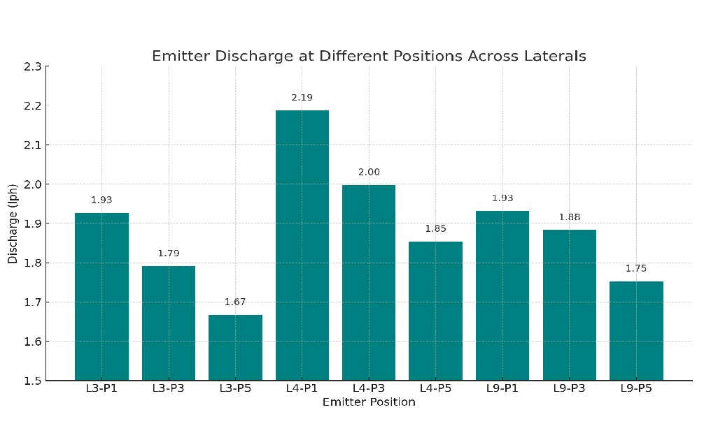
Fig. 1 Variation in emitter discharge at various positions across the selected laterals

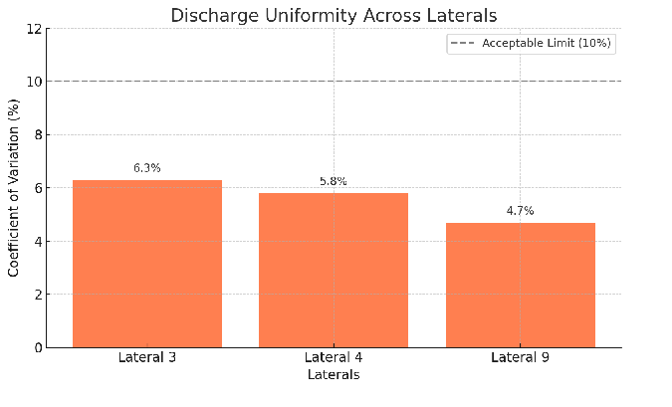
Fig. 2 Emitter discharge uniformity in the selected laterals

4.2 Temporal Stability
Fig.3 shows the temporal variation in emitter discharge over five different days at three time intervals: Morning, Noon, and Afternoon. It demonstrates stable performance with minor fluctuations—supporting your claim of good operational stability.Temporal analysis showed relatively stable performance across the five observation days (Fig. 3). The CV for time-based discharge fluctuations ranged from 4.1% to 7.5%, indicating excellent operational stability. Slight dips during peak afternoon may be attributed to air entrapment or minor temperature-induced pressure changes.

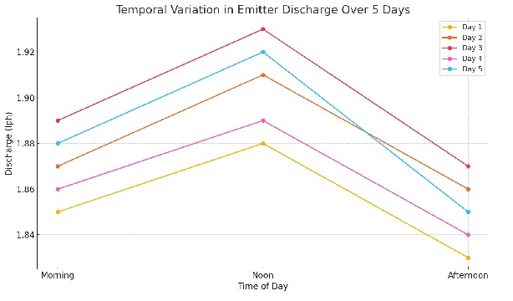
Fig. 3 Temporal variation in emitter discharge over five different days at three time intervals: Morning, Noon, and Afternoon

4.3 Spatial Distribution
Spatial analysis revealed a trend of decreasing discharge with increasing distance from the submain, consistent with theoretical expectations due to head loss along the lateral. For example, average discharge in Lateral 3 decreased from 1.927 lph (Plant 1) to 1.668 lph (Plant 5). Similar patterns were observed in Laterals 4 and 9.While the variation remained within acceptable limits (CV < 10%), the use of pressure-compensating emitters could further enhance distribution uniformity, especially in longer laterals or uneven terrain.
4.4 System Efficiency and Applicability
The integration of solar power with SDI proved to be energy-efficient and field-compatible. The system operated entirely on renewable energy with no fossil fuel dependency. It demonstrated applicability in areas with river water access and sandy soils where surface irrigation is inefficient.This configuration can be particularly useful in regions with limited power supply or where land is adjacent to rivers, lakes, or irrigation canals. The floating solar pump platform enhances mobility and reduces land-use conflict.
The present study provides field based evidence on integrating subsurface drip irrigation with solar powered pumping systems under real farm conditions. The study contributes to sustainable water and energy management research by demonstrating a practical solution for irrigation in water stressed and energy deficient regions. The findings support climate resilient agriculture and can guide future research and policy related to solar driven irrigation systems.

5. Conclusions

The experimental evaluation of a boat-based solar-powered subsurface drip irrigation system demonstrated promising results in terms of emitter performance, discharge uniformity, and renewable energy utilization. Evaluating 45 discharge observations, the average discharge was 1.876 lph, indicating an effective hydraulic performance. The observed spatial and temporal discharge variations were minor and fell within acceptable standards. The study validates that combining SDI with floating solar pumping is a viable, scalable, and sustainable solution for agricultural water management in semi-arid regions and can guide future research and policy related to climate resilient agriculture.

Acknowledgements
We express sincere gratitude to the Dean, College of Agricultural Engineering & Technology, Pusa (Samastipur) and the Vice Chancellor of Dr. Rajendra Prasad Central Agricultural University, Pusa, Samastipur, India for guidance, infrastructure and logistical support which made this research possible.

Conflict of Interest
The authors declare no conflict of interest.

Author Contributions
Manav Dutta: Methodology, Data Analysis, Manuscript Preparation.
ShubhamTetarwal: Field Data Collection, System Setup, Observations Recording.
Dr. R.K. Sahu: Conceptualization, overall guidance and supervision
Dr. D.K. Das: Technical support (related to bamboo plantationand growth)

Disclaimer (Artificial intelligence)

Author(s) hereby declare that NO generative AI technologies such as Large Language Models (ChatGPT, COPILOT, etc.) and text-to-image generators have been used during the writing or editing of this manuscript.

References

- AI-Azab T.A. and Sirhan A A (2006). Drip irrigation system for sleep slope land. Journal of Food, Agriculture and Environment. 4(1): 301-303. https://www.researchgate.net/publication/268270995_Drip_irrigation_system_for_steep_slope_land

- Ayars, J. E., Schoneman, R. A., Dale, F., Meso, B., & Shouse, P.(2001). Managing subsurface drip irrigation in the presence of shallow groundwater. Agricultural Water Management, 47(3):243-264. DOI:10.1016/S0378-3774(00)00112-X

- Manfo, T.A. and Şahin, M.E. (2024). Development of an automatic photovoltaic cell-battery powered water irrigation system incorporated with Arduino software for agricultural activities. Gazi Mühendislik Bilimleri Dergisi, (Erken Görünüm):1-1.

- Mansour, H. A., & Aljughaiman, A. S.(2020). Assessment of surface and subsurface drip irrigation systems with different slopes by hydrocalc model. International Journal of GEOMATE, 19(73). DOI:10.21660/2020.73.28135.

- Persad P, Sangster N, Cumberbatch E, Ramkhalawan A and Maharajh A (2011). Investigating the Feasibility of Solar Powered Irrigation for Food Crop Production: A Caroni Case. The Journal of the Association of Professional Engineers of Trinidad and Tabago. 40(2): 61-65. https://www.researchgate.net/publication/325270340_Investigating_the_Feasibility_of_Solar_Powered_Irrigation_for_Food_Crop_Production_A_Caroni_Case

- Pendergast, L., Bhattarai, S.P. and Midmore, D.J. (2013) Benefits of oxygation of subsurface drip-irrigation water for cotton in a Vertosol. Crop and Pasture Science, 64 (12): 1171-1181. https://doi.org/10.1071/CP13348.
- Srivastava R.C., Jain S.K. and Chandra R. (2020). Boating beyond sailing: solar pump fitted boats in Samastipur, Bihar. Compendium on solar powered irrigation systems in India, Published by the CGIAR Research Program on Climate Change, Agriculture and Food Security, P. 12-14. https://www.researchgate.net/publication/345973563.
- Wu, I. P. (1997). An assessment of hydraulic design of micro-irrigation systems. Agricultural water management, 32(3): 275-284. https://doi.org/10.1016/S0378-3774(96)01270-X.

- Zhang L, Fan X, Wu P & Niu W (2009). Calculation of flow deviation rate of drip irrigation system taking three deviation rates into account on uniform slopes. Transactions of the Chinese Society of Agricultural Engineering, 25(4):7-14. https://www.researchgate.net/publication/285526559.

