Contribution of remote sensing and GIS to the morphometric assessment of the Abéché watershed, Chad

Abstract

The various morphological parameters of watersheds play a crucial role in determining their hydrological behavior. The analysis of morphometric parameters is the fastest and most economical way to represent the hydrological and physiographic characteristics of watersheds. This study uses GIS and remote sensing to determine morphometric parameters in order to assess the understanding of physiographic, morphological, and hydrographic properties. The parameters were analyzed using a digital elevation model (DEM) combined with Excel software. A total of thirteen parameters (Gravelius Compact, Shape factor, hypsometric curve, soils, average elevation, Equivalent rectangle, Average slope index, Total elevation difference, Overall slope index, Specific elevation difference, Drainage density, River frequency, Concentration time) were determined to assess the various characteristics of the Abéché watershed. The values of the relief parameters show that the watershed has a steep relief (382 m). The density of the hydrographic network indicates a very coarse nature (1.16 km) and represents an elongated shape. The hypsometric curve shows that the Abéché watershed is at a mature stage of formation. These results would be useful for evaluating watersheds for drainage management and environmental planning for sustainable management and development.

Keywords: Watershed, Abeche, Chad, GIS, Morphometric, Hypsometric curve

INTRODUCTION

Understanding the hydrological functioning of watersheds is a major challenge in arid and semi-arid provinces, where population pressure and climate change are increasing the variability of water resources (Yair and Kossovsky 2002; Zhang et al. 2019). Morphometric analysis provides an essential quantitative framework for characterizing the spatial organization of drainage, runoff dynamics, and the hydrological response of a watershed (Altaf et al. 2013; Raja Shekar and Mathew 2024). The seminal work (Bassey Eze and Efiong 2010; Pelikán and Šlezingr 2011) established the main geometric and hydrological parameters for assessing the shape, slope, drainage density, and flow properties of a basin. Since then, numerous studies have shown that morphometric parameters are reliable indicators for understanding infiltration capacity, surface water potential, erosion, and environmental and hydrological dynamics (Arabameri et al. 2020; Mohammed et al. 2025). These analyses are particularly relevant in ungauged basins, where hydrological data are scarce or unavailable (Hrachowitz et al. 2013; Guo et al. 2021).
Recent advances in remote sensing and geographic information systems (GIS) have greatly enhanced the capacity for morphometric analysis due to the availability of free, high-resolution, and easily integrated spatial data (Al-Saady et al. 2016; Chatrabhuj et al. 2024). Its tools have been widely applied in various geological and climatic contexts to extract hydrographic networks, characterize basin shapes, and estimate key hydrological parameters (Waters et al. 1990; Cui et al. 2019; Abdelkareem and Al-Arifi 2021). However, no morphometric study has yet been conducted on the Abéché watershed, located in eastern Chad, despite its strategic position in an arid province with a high dependence on surface water resources. The lack of morphometric characterization is a major gap in understanding its hydrological behavior and in developing sustainable development and management strategies (González del Tánago et al. 2015; Garcia et al. 2024).
This study therefore aims to characterize the morphometric parameters of the Abéché watershed by combining remote sensing and GIS data. It provides: (i) accurate extraction of the hydrographic network and geometric parameters; (ii) an integrated assessment of drainage properties; and (iii) an analysis of the relationship between morphometry and hydrological potential in an ungauged basin in a semi-arid context. The results obtained will provide essential information for land use planning, surface water management, and the direction of future hydrological and climatological research in the province.

STUDY AREA

Geographical and geological context

The Abéché watershed is located in Chad, between 15° N and 13° N latitude and 20° E and 22° E longitude (Fig. 1). This basin is drained by two ephemeral rivers, the Chao and the Djilney, which originate in the mountains and hills of the northeast, converge at Sounar, and eventually join the Batha. This basin features rugged terrain, with altitudes ranging from 979 to 444 meters. The basin is located in a semi-arid zone, characterized by temperatures ranging from 23°C to 37°C, with annual rainfall varying between 400 and 600 mm. Geologically, the basin consists of Precambrian rocks, comprising intrusive and metamorphic granitoid formations, which are covered by small Cretaceous formations. The outcrops are covered everywhere by a thin deposit of Quaternary sandy silt (Plote 1970).

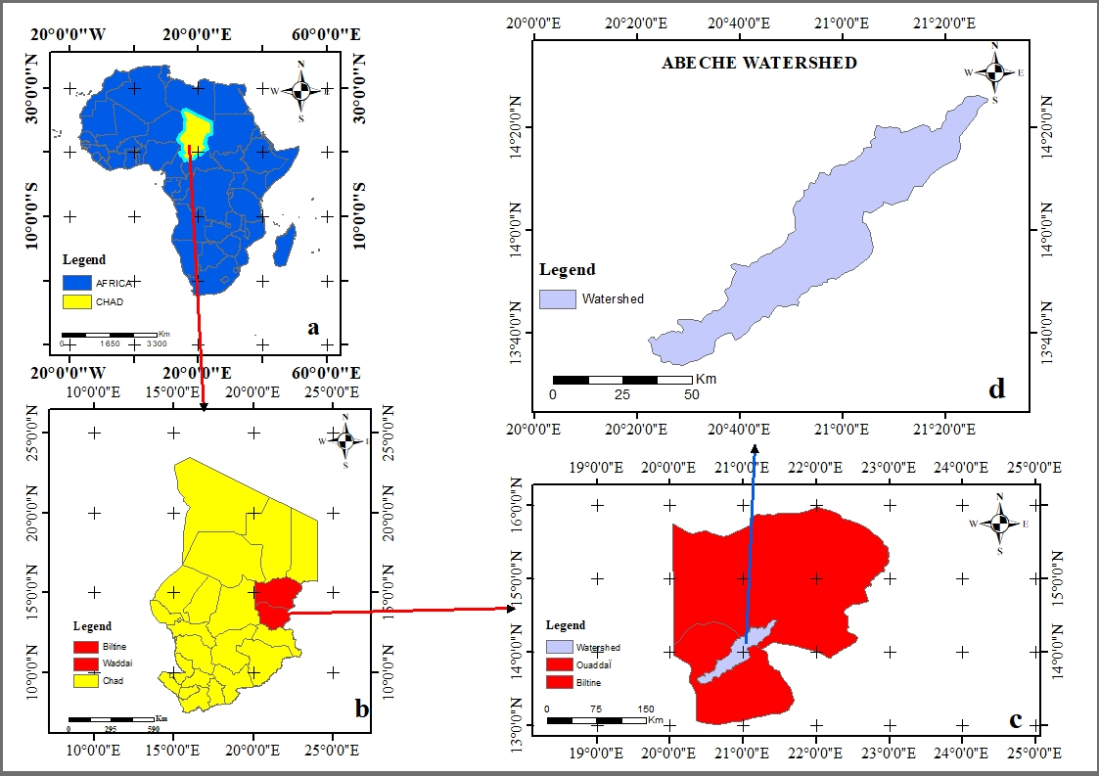
Figure 1 : Location map a Africa, b Chad, c Waddai province and d Abeche Watershed

METHODOLOGY

Data

This work is based on a morphometric assessment of the Abéché watershed, determining several parameters for this watershed. These parameters are determined using SRTM data (30 m resolution). The SRTM data at a resolution were downloaded from the website (https://opentopography.org). A geological and topographical map of eastern Chad. The data were georeferenced using ground control points (GCP) using the UTM zone 34 N projection and the WGS 84 reference system. The watershed 10.8. These parameters provide information on the hydrological context of the rock formation exposed in the watershed. Its various parameters, such as area, perimeter, order of watercourses, length of watercourses, number of watercourses, density of the hydrographic network, frequency of watercourses, texture of the hydrographic network, length of the basin, shape factor, circulation ratio, and elongation ratio, etc., are calculated automatically using GIS software and Microsoft Excel.
The use of such powerful tools derived from a high-resolution digital terrain model is very necessary and useful in this study in order to meet the requirements of rational surface water management. The characteristics of the watershed are used to understand the various parameters of the interdependent properties of relief and slope.

Morphometric analysis

According to previous studies, there is no universal methodology for delimiting, characterizing, and analyzing a watershed. For two decades, quantitative morphometry has provided information on the hydrological context. Morphometric analysis of a basin provides an indication of the permeability and storage capacity of rocks, as well as the yield of the basin. The methodology adopted for calculating the parameters is described in the figure.

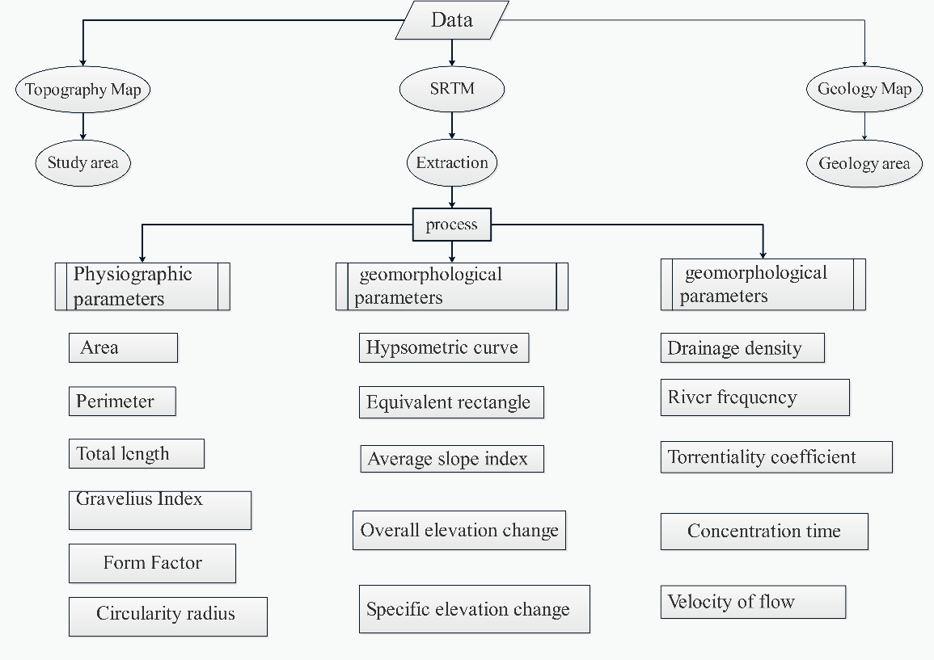
Figure 2: Flowchart of the methodology to this study

RESULTS AND DISCUSSION

Physiographic parameters of a watershed

Based on these parameters, we can describe its area, perimeter, total length, centroids, average width, Gravelius compact, and shape factor of the watershed.
Table 1 : Physiographic parameters of a watershed
Physiographic characteristics of a watershed
 |  |  | Unit of measurement | Watershed
Water shed parameters | Total area |  | km² | 2634.57
Water shed parameters | Perimeter |  | km | 382.35
Water shed parameters | Total length |  | km | 170.46
Water shed parameters | Centroid | Est (X) | m | 493656.13
Water shed parameters | Centroid | Nord (Y) | m | 1547290.09
Water shed parameters | Average width |  | km | 15.46
Water shed parameters | Gravelius compact |  | - | 2.09
Water shed parameters | Shape factor |  | km | 0.09

Gravelius Compact

The most common index used to determine the shape of a watershed. It is also an indicator that measures the compactness of a watershed. The compactness coefficient is defined as the ratio of the perimeter of the basin to that of a circle with the same surface area. If the Gravelius compact value is less than 1, the basin is circular in shape, and if it is greater than 1, it is said to be elongated. Based on Equation 1
$Gc=0.28*P\sqrt{A}$ (1)
That is: Gc = Gravelius compact; p: perimeter; A = surface area
The result for Kc is 2.09.
Based on the results, we found a value greater than 1. Therefore, the watershed is elongated in shape. According to Table 2, if the basin is elongated, it is also classified into four categories (Round to oval round (compact), round oval to oblong oval). Oblong oval to oblong rectangular, almost rectangular (elongated).
Table 2. Classification of watershed shape
Rang | Forme
< 1 | Circular
1.00 – 1.25 | Round to oval round (compact)
1.25 – 1.50 | Round oval to oblong oval
1.50 – 1.75 | Oblong oval to oblong rectangular
>1.75 | Almost rectangular (elongated)
This watershed is therefore almost rectangular in shape.

Shape factor

The shape factor is calculated as the ratio between the surface area of the watershed and the square of its total length (Sassolas-Serrayet et al. 2018). A high shape factor indicates a more fan-shaped watershed. The shape factor is classified into eight (8) value classes (Table 3).

Table 3. Approximate ranges of shape factor
Form factor | Shape of the basin
<0.22 | Very elongated
0.22 - 0.30 | Elongated
0.30 - 0.37 | Slightly elongated
0.37 - 0.45 | Neither elongated nor widened
0.45 - 0.60 | Slightly widened
0.60 - 0.80 | Widened
0.80 - 1.20 | Very widened
>1 20 | Surrounding the drain

By applying equation 2, we were able to determine the shape factor.
Ff = shape factor;
$Ff=\frac{A}{L²}$ (2)

That is: Ff= A : L : (where A is the surface area and L is the length of the basin).
The result of Ff is 0.09.

Based on the result, we found a value less than < 0.22. Based on Table 3, we can conclude that the Abéché watershed has a very elongated shape.

Geomorphological parameters of a watershed

Hypsometric curve

The hypsometric curve is very important in hydrological and geomorphological studies. This curve represents the distribution of watershed area according to its altitude and the shape of the curve (Pérez-Peña et al. 2009). It is used to understand hydrological functioning and morphology (age, erosion rate). It is therefore an essential tool for modeling physical processes and estimating key parameters such as concentration time or average rainfall. The x-axis represents the surface area (or percentage of surface area) of the basin that is above (or below) the altitude represented on the y-axis figure 3. The hypsometric curve can provide information about the age of the watershed. The age of the watershed (young, mature, or old) can be determined by comparing it to that shown in Figure 4.

Figure 3: Hypsometric curve of Abeche Watershed
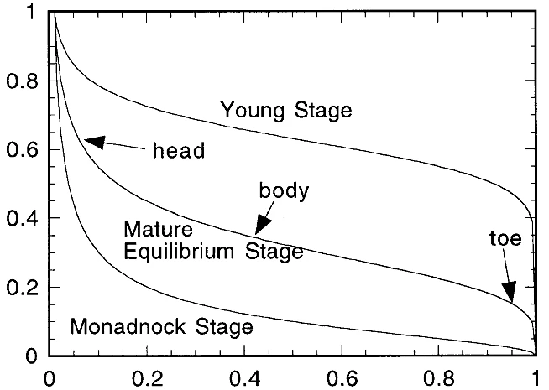
Figure 4 : Hypsometric curve classification (Willgoose G 1998)
Compared to the figure, the hypsometric curve has a steep concave slope. This explains why the Abéché watershed is in a state of equilibrium. We can deduce that the basin is in equilibrium in terms of erosion and transport processes within the watershed.

Soil map

In the Abeche watershed, we have four types of soil, namely: sandy loam, sandy clay loam, clay loam, and loam. Sandy loam is a well-balanced growing medium with excellent drainage. It is composed of 60% to 70% sand, 20% to 30% silt, and 10% to 20% clay. Sandy clay loam offers a compromise between the lightness of sand and the richness of clay. It is also a fertile soil, considered one of the most balanced soil types for a variety of crops. It has a good nutrient retention capacity while maintaining good porosity, which prevents root asphyxiation. It is composed of approximately 45% to 80% sand and 20% to 35% clay. Clay loam, on the other hand, is a heavy but rich soil. It is a soil that requires work to farm. Finally, loam is the ideal soil, containing a perfect balance of the three figure 5.
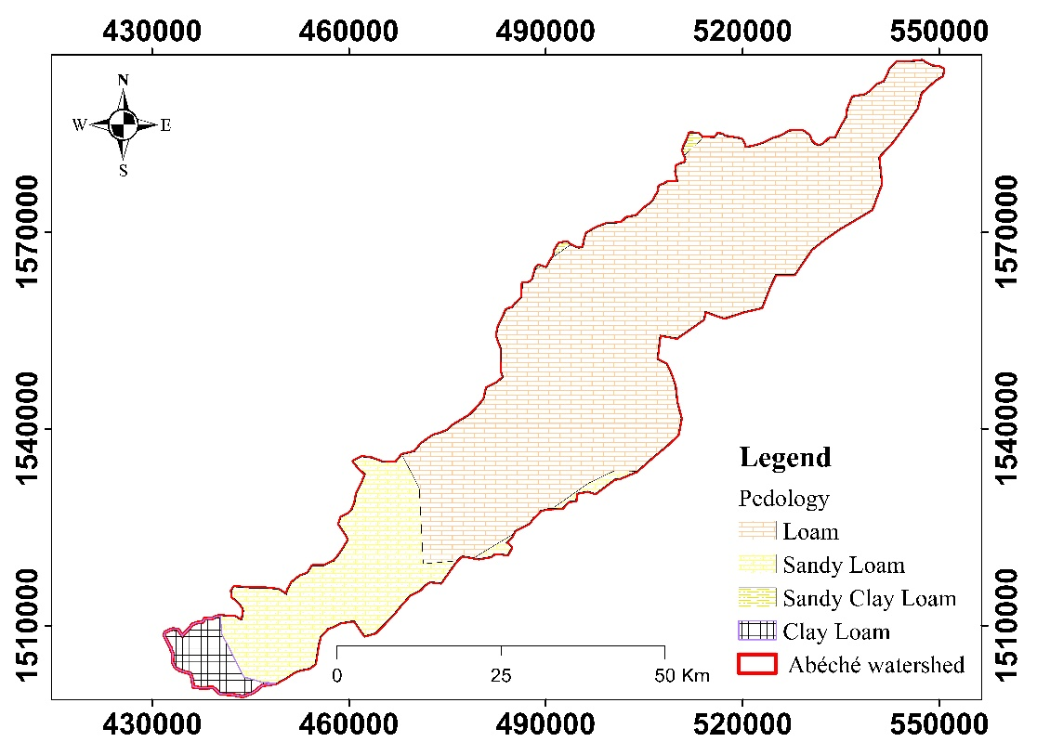
Figure 5 : map of soils

Average elevation

The average height was determined using equation 3. It is the product of the differences in altitude and the partial surface area.
$Average elevation= ∑\frac{hi. Si}{A}$ (3)

Average altitude 648 m
Where Ai is the area between two contour lines (km²); hi is the average altitude between two contour lines (m); A is the surface area of the basin (km²)
The characteristic altitudes of the Abéché watershed A reveal that the average altitude is higher than the median altitude. This means that the basin has an irregular relief. The altitudes of the basin are high upstream, where mountains predominate, and become gentler downstream.

Equivalent rectangle

The concept of an equivalent rectangle is a geometric transformation of the watershed. This transformation preserves the area and perimeter of the basin, thus ensuring that the hypsometric distribution is conserved (Walcott and Summerfield 2008). It is expressed by the following equations: Equation 4 and Equation 5
$L=\frac{KC\sqrt{A}}{1.12}\left(1+\sqrt{1-{\left(\frac{1.12}{KC}\right)}^{2}}\right)=176.255 km$ (4)
$l=\frac{KC\sqrt{A}}{1.12}\left(1-\sqrt{1-{\left(\frac{1.12}{KC}\right)}^{2}}\right)$= 14.95 km (5)
Where Leq and leq represent the length and width of the rectangle (km); A is the surface area of the basin (km²); Gc is the compactness index.

Average slope index

The average slope provides information on the travel time of surface water runoff in a watershed and also on the concentration time based on equation 6.

$Average slope index =\frac{Hmax-Hmin}{Lr}$ (6)
(979 m – 444 m) / 176. 225 km = 3.03 m/ km
Where: Asi = average slope index (in m/km or %); H max = maximum elevation (in m); H min = minimum elevation (in m) and Lr = equivalent rectangle length (in km).
This is the quotient of the difference between the elevations (maximum and minimum) divided by the length of the equivalent rectangle (Hill and Neary 2005). The average slope of the basin is lower, reaching 3.03 m/km, which indicates that the basin has moderate slopes. This suggests that the water takes a little time to reach the outlet.

Total elevation difference

The total elevation difference was calculated using equation 7. It gives an idea of the difference in altitude between the upstream and downstream parts of a watershed. These altitudes were extracted from the hypsometric curves (Harsha et al. 2020).
elevation difference =H5% - H95% (7)
(979 m – 550 m) = 429 m (7)

Where: Ed = overall elevation difference (in m); H95% = elevation corresponding to 95% of the total area of the watershed (in m), and H5% = elevation corresponding to 5% of the total area of the watershed (in m).

Overall slope index

The overall slope index Ig is defined as the ratio between the overall elevation difference Dg and the length of the equivalent rectangle Leq. The overall slope index Ig is expressed in m/km and is used to characterize the relief of the watershed based on equation 8.
$OSI=\frac{Dg}{Lr}$ (8)
429 m /176.255 = 2.43 m/km
Where: Osi = overall slope index (in m/km); Dg = overall elevation difference (in m) and Lr = length of equivalent rectangle (in km).
The overall slope index is equal to 2.43 m/km

Specific elevation difference

The specific elevation difference allows the relief of watersheds of different sizes to be compared. It is defined as the product of the overall slope index and the square root of the watershed area. Equation 9 was used to calculate the specific elevation difference. Referring to the ORSTOM relief classification, Table 4.
$Ds=OSI\sqrt{A}$ (9)

$2.43m/km\sqrt{176.255 km}$ = 382 m.

Where: Ds = specific elevation difference (in m); OSI = overall slope index (m/km), and A = watershed area (km²).
Table 4: Relief classification according to the ORSTM method
Class | Type of relief | Ds
R1 | Very low relief | 10 m
R2 | Low relief | 10 – 25 m
R3 | Fairly low relief | 25 – 50 m
R4 | Moderate relief | 50 – 100 m
R5 | Fairly high relief | 100 – 250 m
R6 | High relief | 250 – 500 m
R7 | Very high relief | >500 m

According to Table 4, the Abéché watershed has a rugged terrain.

Hydrographic parameters

The hydrographic network is defined as all permanent or temporary watercourses that contribute to runoff. Hydrographic networks are one of the most essential characteristics of a watershed.

Drainage density

Drainage density is one of the most commonly used hydrographic characteristics in hydrological studies. It reflects the influence of various factors such as relief, slope, and permeability of geological outcrops, and is therefore a determining factor in the hydrographic response of a watershed figure 6.
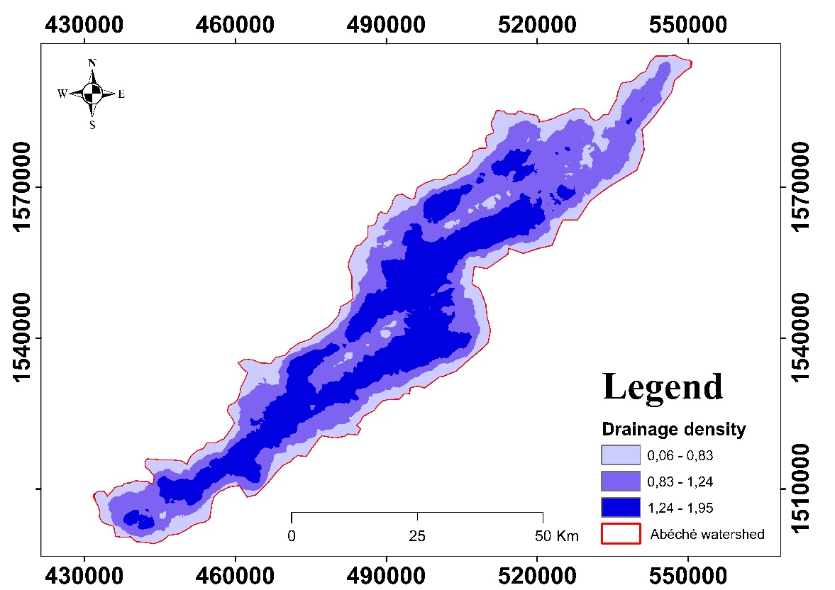
Figure 6: Drainage density map
It is defined by dividing the length of watercourses by their surface area and is expressed in km/km² (Godsey and Kirchner 2014; Meierdiercks et al. 2017). It was calculated using equation 10.

$Dd=\sum{Li/A}$ (10)

$Dd=\sum{3064.204 km/176.255km²}$ = 1.16 Km

Where: Dd = drainage density in (km/km²); Li = sum of the lengths of all thalwegs, including the main thalweg (km), and A = watershed area (km²). It is therefore classified into five categories.

Table 5: Drainage density class
Class | Categories
<1,2 | Very coarse
1,2 - 2,4 | Low
2,4 - 3.6 | Moderate
3.6 - 4.8 | High
4.6 - 6 | Very high

According to the classification in Table 5, the drainage density of the Abéché watershed is very coarse. This can be explained by a permeable subsoil, stunted vegetation cover, and a relief with little contrast.

River frequency

River frequency is defined as the ratio between all orders of drains per unit area (Horton). A small watershed reacts differently from a large watershed. If the basins have low values, the rivers are controlled by faults or runoff. A higher value indicates that the slope controls surface water runoff (equation 11).
$Fr=\sum{Ni/A}$ (11)

$Fr= 3242km/176.255km²$ = 1.23km

Where: Rf = stream frequency; Nt = total number of thalwegs of all orders; and A = watershed area.
Based on the result, we can deduce that the frequency of the Abéché watershed is moderate.

Concentration time

The concentration time of water depends not only on the morphology of the basin but also on other parameters such as lithology (permeable formations favor infiltration over runoff, which delays the concentration of water at the outlet), rainfall (the greater the rainfall intensity, the shorter the concentration time, regardless of soil type) and the distance from the basin to the outlet (Fang et al. 2008). This concentration time is very important for flood risk alerts in a watershed (Acosta-Coll et al. 2018).
The concentration time is calculated using equation 13.
${tc=0.0195*L}^{0.77}*S^{-0.385 }=0.0195*{170.460}^{0.77}m*{648 m}^{-0.385 }=17.213 mn$
Ct= concentration time
L= length
S= average slope

CONCLUSION

This study highlights the essential role of spatial analysis in the study and evaluation of hydro-morphometric characteristics. The delimitation of the Abéché watershed has made it possible to build a reliable database for calculating various hydro-morphometric indices. For an ungauged basin, hydro-morphometric analysis is a key method for understanding the influence of physiographic, morphometric, and hydrographic parameters. The Abéché watershed has a very diverse relief, with a stepped plateau structure downstream and rugged mountainous terrain upstream. The upstream part benefits from both the orographic effect and more intense rainfall than downstream. Despite its elongated configuration, the results obtained can contribute to a better understanding of the drainage and hydrological functioning of the Abéché watershed.

Disclaimer (Artificial intelligence)

Author(s) hereby declare that NO generative AI technologies such as Large Language Models (ChatGPT, COPILOT, etc.) and text-to-image generators have been used during the writing or editing of this manuscript.

REFERENCES

- Abdelkareem, M. and Al-Arifi, N. 2021. The use of remotely sensed data to reveal geologic, structural, and hydrologic features and predict potential areas of water resources in arid regions. Arabian Journal of Geosciences 2021 14:8, 14, 704-, https://doi.org/10.1007/S12517-021-06942-6.
- Acosta-Coll, M., Ballester-Merelo, F. and Martínez-Peiró, M. 2018. Early warning system for detection of urban pluvial flooding hazard levels in an ungauged basin. Natural Hazards, 92, 1237–1265, https://doi.org/10.1007/S11069-018-3249-4.
- Al-Saady, Y.I., Al-Suhail, Q.A., Al-Tawash, B.S. and Othman, A.A. 2016. Drainage network extraction and morphometric analysis using remote sensing and GIS mapping techniques (Lesser Zab River Basin, Iraq and Iran). Environmental Earth Sciences, 75, 1243-, https://doi.org/10.1007/S12665-016-6038-Y/FIGURES/13.
- Altaf, F., Meraj, G. and Romshoo, S.A. 2013. Morphometric Analysis to Infer Hydrological Behaviour of Lidder Watershed, Western Himalaya, India. Geography Journal, 2013, 178021, https://doi.org/10.1155/2013/178021.
- Arabameri, A., Tiefenbacher, J.P., et al. 2020. Morphometric Analysis for Soil Erosion Susceptibility Mapping Using Novel GIS-Based Ensemble Model. Remote Sensing, 12, https://doi.org/10.3390/RS12050874.
- Bassey Eze, E. and Efiong, J. 2010. Morphometric Parameters of the Calabar River Basin: Implication for Hydrologic Processes. Journal of Geography and Geology, 2, 18–26, https://doi.org/10.5539/jgg.v2n1p18.
- Chatrabhuj, Meshram, K., Mishra, U. and Omar, P.J. 2024. Integration of remote sensing data and GIS technologies in river management system. Discover Geoscience , 2, 67-, https://doi.org/10.1007/S44288-024-00080-8.
- Cui, X., Guo, X., et al. 2019. Application of remote sensing to water environmental processes under a changing climate. Journal of Hydrology, 574, 892–902, https://doi.org/10.1016/J.JHYDROL.2019.04.078.
- Fang, X., Thompson, D.B., Cleveland, T.G., Pradhan, P. and Malla, R. 2008. Time of Concentration Estimated Using Watershed Parameters Determined by Automated and Manual Methods. Journal of Irrigation and Drainage Engineering, 134, 202–211, https://doi.org/10.1061/(ASCE)0733-9437(2008)134:2(202).
- Garcia, R.G.V., Mohammadizadeh, S., et al. 2024. Geological Insights from Porosity Analysis for Sustainable Development of Santos Basin’s Presalt Carbonate Reservoir. Sustainability, 16, https://doi.org/10.3390/SU16135730.
- Godsey, S.E. and Kirchner, J.W. 2014. Dynamic, discontinuous stream networks: Hydrologically driven variations in active drainage density, flowing channels and stream order. Hydrological Processes, 28, 5791–5803, https://doi.org/10.1002/HYP.10310;PAGE:STRING:ARTICLE/CHAPTER.
- González del Tánago, M., Gurnell, A.M., Belletti, B. and García de Jalón, D. 2015. Indicators of river system hydromorphological character and dynamics: understanding current conditions and guiding sustainable river management. Aquatic Sciences, 78, 35–55, https://doi.org/10.1007/S00027-015-0429-0.
- Guo, Y., Zhang, Y., Zhang, L. and Wang, Z. 2021. Regionalization of hydrological modeling for predicting streamflow in ungauged catchments: A comprehensive review. Wiley Interdisciplinary Reviews: Water, 8, e1487, https://doi.org/10.1002/WAT2.1487;REQUESTEDJOURNAL:JOURNAL:20491948;PAGEGROUP:STRING:PUBLICATION.
- Harsha, J., Ravikumar, A.S. and Shivakumar, B.L. 2020. Evaluation of morphometric parameters and hypsometric curve of Arkavathy river basin using RS and GIS techniques. Applied Water Science, 10, 86–101, https://doi.org/10.1007/S13201-020-1164-9.
- Hill, A.J. and Neary, V.S. 2005. Factors Affecting Estimates of Average Watershed Slope. Journal of Hydrologic Engineering, 10, 133–140, https://doi.org/10.1061/(ASCE)1084-0699(2005)10:2(133).
- Hrachowitz, M., Savenije, H.H.G., et al. 2013. A decade of Predictions in Ungauged Basins (PUB)—a review. Hydrological Sciences Journal, 58, 1198–1255, https://doi.org/10.1080/02626667.2013.803183.
- Meierdiercks, K.L., Kolozsvary, M.B., Rhoads, K.P., Golden, M. and McCloskey, N.F. 2017. The role of land surface versus drainage network characteristics in controlling water quality and quantity in a small urban watershed. Hydrological Processes, 31, 4384–4397, https://doi.org/10.1002/HYP.11367;CTYPE:STRING:JOURNAL.
- Mohammed, J.A., Gashaw, T. and Yimam, Z.A. 2025. Identification of erosion-prone watersheds for prioritizing soil and water conservation in a changing climate using morphometric analysis and GIS. Natural Hazards, 121, 4171–4189, https://doi.org/10.1007/S11069-024-06952-Z/FIGURES/2.
- Pelikán, P. and Šlezingr, M. 2011. Methodology for the establishment of physical and geometric properties of a drainage basin. Acta Universitatis Agriculturae et Silviculturae Mendelianae Brunensis, 59, 265–270, https://doi.org/10.11118/actaun201159060265.
- Pérez-Peña, J. V., Azañón, J.M. and Azor, A. 2009. CalHypso: An ArcGIS extension to calculate hypsometric curves and their statistical moments. Applications to drainage basin analysis in SE Spain. Computers & Geosciences, 35, 1214–1223, https://doi.org/10.1016/J.CAGEO.2008.06.006.
- Plote, H. 1970. Hydrogéologie de l’Ouaddaï, pro- Gramme Quadriennal d’aménagement Hydraulique de l’Ouaddaï.
- Raja Shekar, P. and Mathew, A. 2024. Morphometric analysis of watersheds: A comprehensive review of data sources, quality, and geospatial techniques. Watershed Ecology and the Environment, 6, 13–25, https://doi.org/10.1016/J.WSEE.2023.12.001.
- Sassolas-Serrayet, T., Cattin, R. and Ferry, M. 2018. The shape of watersheds. Nature Communications 2018 9:1, 9, 3791-, https://doi.org/10.1038/s41467-018-06210-4.
- Walcott, R.C. and Summerfield, M.A. 2008. Scale dependence of hypsometric integrals: An analysis of southeast African basins. Geomorphology, 96, 174–186, https://doi.org/10.1016/J.GEOMORPH.2007.08.001.
- Waters, P., Greenbaum, D., Smart, P.L. and Osmaston, H. 1990. Applications of remote sensing to groundwater hydrology. Remote Sensing Reviews, 4, 223–264, https://doi.org/10.1080/02757259009532107.
- Willgoose G, H.G. 1998. Revisiting the hypsometric curve as an indicator of form and process in transport-limited catchments. Earth Surf Process Landf, 611–623.
- Yair, A. and Kossovsky, A. 2002. Climate and surface properties: hydrological response of small arid and semi-arid watersheds. Geomorphology, 42, 43–57, https://doi.org/10.1016/S0169-555X(01)00072-1.
- Zhang, X., Xu, Y., et al. 2019. Hydrological Components Variability under the Impact of Climate Change in a Semi-Arid River Basin. Water 2019, Vol. 11, 11, https://doi.org/10.3390/W11061122.

