Study of the spatio-temporal variability of climate extremes in the Nouhao sub-basin in Burkina Faso over the period1981-2020

.
ABSTRACT

Extreme weather events are attracting growing scientific interest due to their impact on natural and socio-economic systems. However, few studies have focused on extreme weather events in the regions of Burkina Faso, a Sahelian country in West Africa. The objective of this study is to analyze the spatio-temporal variability and trends of climate extremes (precipitation and temperatures) in the Nouhao sub-basin. To this end, the analysis is based on observational and ERA5 reanalysis data for rainfall and temperature parameters for the period 1981-2020. These data were used to calculate climate extreme indices defined by the Expert Team on Climate Change Detection and Indices (ETCCDI) using Rclimdex. Trends were assessed using the Mann-Kendall test and Sen's slope estimator, while spatial structures were analyzed by geostatistical interpolation (kriging). The study showed strong decadal variability in extreme precipitation indices, with no monotonic trend over the period 1981-2020. However, the study highlights strong variability in extreme temperature indices, with a general trend towards a decrease in cold extremes and an increase in hot extremes, reflecting a gradual warming of the temperature regime. These results constitute an important climate signal for water resource management and the development of climate change adaptation strategies in the Nouhao sub-basin.

Keywords: Climate extremes; spatial-temporal variability; ETCCDI indices; Climate trend; Nouhao sub-basin

1. INTRODUCTION

Climate change is one of the major concerns of the 21st century. Indeed, climate, as the result of meteorological phenomena, is an essential indicator of the state and evolution of the biosphere (Lavorel et al., 2019). Since the mid-19th century, the increase in greenhouse gases in the atmosphere has led to global warming. This phenomenon has resulted in rising sea levels, a decrease in the extent of snow and ice cover, and marked changes in global climate extremes in terms of trends, frequency, and intensity (Brohan et al., 2006; Schleussner et al., 2016). These extreme weather events, particularly precipitation patterns, are characterized by uneven distribution in time and space (Donat et al., 2013). As a result, these changes are having a profound impact on natural ecosystems, water management, and agricultural production (Ge et al., 2021). Since the 1970s, Burkina Faso, like other Sahelian countries, has been affected by high climate variability characterized by alternating dry and wet periods. This succession of contrasting episodes has profoundly altered the country's rainfall and hydrological patterns (Nicholson, 2013; Panthou et al., 2014). This climate dynamic, often amplified by extremes, has a decisive influence on food security, water availability, and ecosystem stability. In the Nouhao sub-basin, as in other Sahelian areas, rainfall and temperature extremes play a central role in the dynamics of surface water resources, dam recharge, and the living conditions of local populations (Damiba et al., 2020; Noba et al., 2023; Zeba et al., 2025). Given this variability and the intensification of extremes, understanding local climate trends is essential to guide water resource management, agricultural planning, and climate risk reduction. The analysis of climate extremes is based on indices developed by the Expert Team on Climate Change Detection and Indices (ETCCDI), which provide a robust framework for quantifying the frequency, intensity, and persistence of extreme events from temperature and precipitation time series. The objective of this study is to analyze, based on observed data, the spatiotemporal evolution of climate extremes in the Nouhao basin over the period 1981-2020. More specifically, it examines trends in rainfall and temperature indices in order to assess the risks associated with droughts, floods, and interannual precipitation variability in this sensitive area of Burkina Faso.

2. material and methods

2.1 Material

2.1.1 Study area

The Nouhao sub-basin is located in the central-eastern region of Burkina Faso and is a tributary of the Nakanbé (Fig.1). It extends between latitudes 12°35' and 10°55' north and longitudes 1°00' west and 0°45' east. It covers an area of approximately 4,050 km². The climate of the area is Sudano-Sahelian. It is characterized by two seasons per year, a rainy season from May to October and a dry season from November to May. Annual rainfall generally varies between 600 and 900 mm, with high interannual variability. Temperatures range from average minimums of 18-22°C to maximums above 35°C in the hot season (Doumounia et al., 2020). Socio-economically, the basin is mainly dominated by agro-pastoral activities. There are also booming sectors such as trade, crafts, road transport, and non-timber forest products.

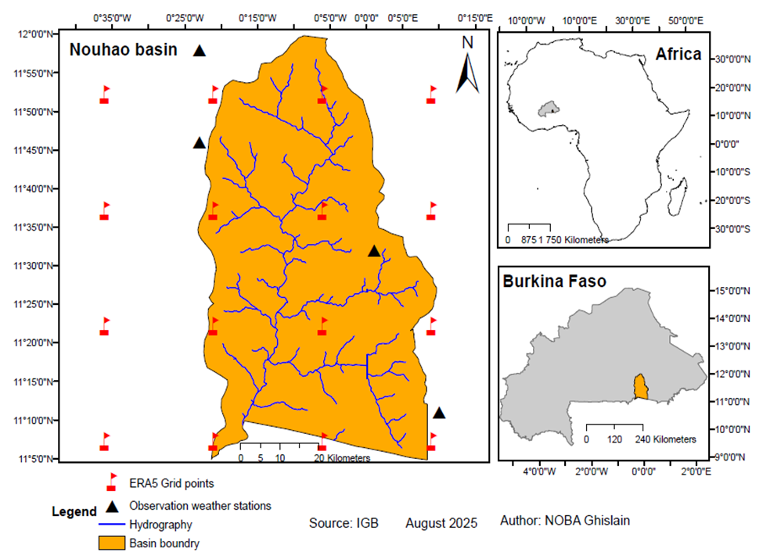
Fig. 1. Map of the Nouhao sub-basin (Source: author)

2.1.2 Data

For this study, we used two types of observational data. These include field observation data and reanalysis data. Field observation data on precipitation comes from four weather stations located in and around the Nouhao basin: Dialgaye, Ouargaye, Sangha, and Tenkodogo. The temperature observation data series came mainly from the Fada synoptic station, which covers the basin in terms of meteorological temperature measurements. Field observations were obtained from the National Meteorological Agency of Burkina Faso (ANAM). The reanalysis data used in this study come mainly from the ERA5 reanalysis, which is the fifth generation of atmospheric reanalysis from the European Center for Medium-Range Weather Forecasts (ECMWF), covering the period from January 1940 to the present. ERA5 is a reanalysis that uses a more advanced forecasting system recognized for its ability to replace incomplete observation data (Store, 2023). Numerous studies claim that ERA5 is one of the reanalyzes that best reproduces most meteorological variables, particularly temperature in West Africa (Olauson, 2018). The period considered for analysis in this study spans from 1981 to 2020, representing 40 years of continuous data. ERA5 reanalysis data were obtained from the COPERNICUS website, accessible via the link (https://cds.climate.copernicus.eu/).

2.2 Methods
2.2.1 Selection and calculation of climate extremes indices

The Expert Team on Climate Change Detection and Indices (ETCCDI) has developed a set of 27 reference indices to standardize the analysis and description of climate extremes, 16 of which relate to temperature and the others to precipitation (Sillmann et al., 2013). These indices are grouped into four main categories:
• Percentile-based indices
• Absolute indices
• Duration indices
• And threshold-based indices
In this study, eight (08) climate indices were selected, including four for precipitation and four for temperature. These indices, selected on the basis of their ability to assess the frequency, intensity, and duration of extreme weather events, are defined and detailed in Table 1 (World Climate, 2007); (Sillmann et al., 2013; Zhang et al., 2011).The index values were calculated using RClimdex software, which incorporates standardized calculation methods recommended by ETCCDI and approved by WMO (World Climate, 2007). For further details on the calculation of climate extremes indices and the operation of RClimdex, please visit the official ETCCDI website: (http:// etccdi.pacificclimate.org/indices.shtml).

Table 1. Climate indices studied in this study
Type index | Index | Definition | Unit
Precipitations | CDD (Consecutive Dry Days) | Maximum number of consecutive days with daily precipitation < 1 mm per year | Days
Precipitations | CWD (Consecutive Wet Days) | Number of consecutive days with precipitation greater than 1 mm | Days
Precipitations | RX1day (Maximum consecutive 1-day precipitation) | Maximum amount of precipitation recorded in a single day per year | mm
Precipitations | RX5day (Maximum consecutive 5-day precipitation) | Maximum amount of precipitation recorded over five consecutive days per year | mm
Precipitations | TN10p (Cool Nights) | Percentage of days when the minimum temperature is below the 10th percentile | °C
Precipitations | TN90p (Warm Nights) | Percentage of days when the minimum temperature is above the 90th percentile | °C
Temperature | TX10p (Cool Days) | Percentage of days when the maximum temperature is below the 10th percentile | °C
 | TX90p (Warm Days) | Percentage of days when the maximum temperature is above the 90th percentile | °C

2.2.2 Evaluation and analysis of statistical trends in extreme weather events

The variability of the values of the various extreme climate indices was analyzed using a ten-year graphical representation of the annual average index values for the period from 1980 to 2020. The ten-year representation of these different values, which takes the form of a trend curve, is accompanied by a trend line. The trend of the ten-year curves was determined using the non-parametric Mann-Kendall test, applied to the annual meteorological average of the index values for the Nouhao sub-basin with a significance threshold of 5%, i.e., a probability (p-value) less than or equal to 0.05. Given that this test only provides the statistical significance of the trend, the Sen slope was also evaluated to estimate the magnitude of the trend over time. This approach, recommended by the World Meteorological Organization (WMO), has been widely adopted in recent work on hydroclimatic trends (Abdullahi et al., 2023; Adeyemi et al., 2024; Agbo et al., 2023; Ndabagenga et al., 2023).
The average values of the climate extreme indices in the Nouhao sub-basin are determined in this study using the Thiessen method, which determines the weight of each weather station based on its position. This method involves subdividing the basin into zones of influence of the meteorological observation stations, depending on whether they are inside or outside the basin. In this study, the method is performed using ArcGIS 10.3 software (Brassel & Reif, 1979).

2.2.3 Evaluation of the spatial distribution of climate extremes

Spatial distribution is a means of evaluating the index values of climate extremes on a spatial level. In this study, it allows us to analyze spatial variability on a decadal basis over the period from 1981 to 2020 in the Nouhao sub-basin. Spatial distribution here is achieved through kriging interpolation of data from ERA5 reanalysis. Kriging consists of creating grids that interpolate irregular x, y, z data (longitude, latitude, and value) in order to order them. The model is created from these grids in the form of a contour map (Lichtenstern, 2013; Oliver & Webster, 1990). In this study, we performed kriging interpolation using the kriging module of ArcGIS mapping software.

3. results and discussion

3.1 Results

3.1.1 Statistical characteristics of climate extremes

3.1.1.1 Variability and trends in extreme precipitation indices

Fig.2 illustrates the decadal evolution of the CDD, CWD, RX1day, and RX5day extreme precipitation indices over the period 1981–2020, highlighting strong interannual variability and contrasting trends across decades, revealing gradual changes in the rainfall regime in the study area.
The CDD (Consecutive Dry Days) index shows marked variability from one decade to another. A slight downward trend is observed over the period 1981-1990 (slope = –0.97; pₘₖ = 0.721), followed by a moderate increase between 1991-2000 (slope = 1.50; pₘₖ = 0.283). The decade 2001-2010 is characterized by near stability, with a slight negative trend (slope = –1.02; pₘₖ = 0.858), while the period 2011-2020 shows a more marked increase in the CDD (slope = 2.70; pₘₖ = 0.371). Although these trends are not statistically significant, they suggest a recent lengthening of dry sequences, particularly over the last decade. The CWD (Consecutive Wet Days) index also confirms contrasting decadal dynamics. A slight decline was observed during 1981–1990 (slope = –0.97; pₘₖ = 0.721), followed by a moderate increase during 1991-2000 (slope = 1.50; pₘₖ = 0.283). The decade 2001-2010 shows a more pronounced negative trend (slope = –1.02; pₘₖ = 0.858), before an upward recovery during 2011-2020 (slope = 2.70; pₘₖ = 0.371). This trend reflects significant variability in wet sequences, with no significant long-term trend.
Precipitation intensity indices reveal a more contrasting trend. The RX1day index shows a slight increase during 1981-1990 (slope = 0.67; pₘₖ = 1.00) and 1991-2000 (slope = 1.70; pₘₖ = 0.721), followed by a gradual decrease over 2001-2010 (slope = –1.87; pₘₖ = 0.210) and 2011-2020 (slope = –1.59; pₘₖ = 0.858).
This trend suggests a recent reduction in maximum daily intensities, although the trends remain insignificant. Similarly, the RX5day index shows a slight increase during 1981-1990 (slope = 1.08; pₘₖ = 0.858) and a more marked increase during 1991-2000 (slope = 4.19; pₘₖ = 0.371). However, a clear negative trend is observed from 2001-2010 (slope = –2.79; pₘₖ = 0.152), which becomes more pronounced in 2011-2020 (slope = –5.78; pₘₖ = 0.0736). Although some values approach the significance threshold, most of the trends estimated for the various indices remain statistically insignificant. The changes highlighted should therefore be interpreted mainly in light of the Sen slope, which nevertheless suggests a gradual decrease in episodes of prolonged extreme rainfall over the last two decades.

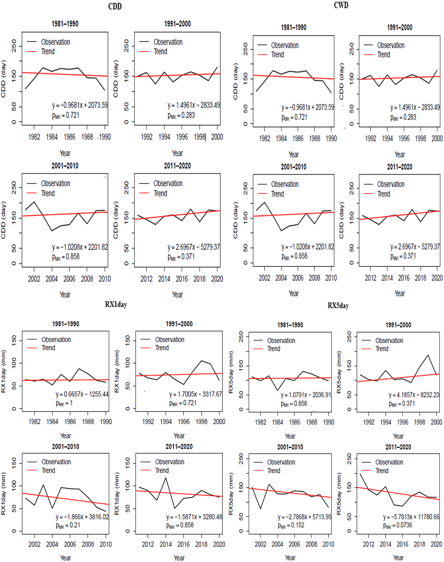
Fig. 2. Decadal trends in extreme precipitation indices (CDD, CWD, RX1day, RX5day) for Nouhao over the period 1981-2020.

3.1.1.2 Variability and trends in extreme temperature indices

Fig. 3 shows the decadal evolution of temperature extremes using the TN10p, TN90p, TX10p, and TX90p indices over the period 1981-2020 in the Nouhao sub-basin. All of the indices show strong interannual variability and contrasting trends across decades, reflecting a gradual change in the regional temperature regime. The TN10p index, which represents the frequency of cold nights, shows an overall downward trend over the study period. A moderate decrease was observed during 1981-1990 (slope = –0.31; pₘₖ = 0.592), followed by near stability over 1991–2000 (slope = –0.13; pₘₖ = 1). The decade 2001-2010 confirmed this downward trend (slope = –0.25; pₘₖ = 0.592), while 2011-2020 saw a more marked decrease (slope = –0.35; pₘₖ = 0.21). Although these trends are not statistically significant, they suggest a gradual decrease in cold nights, consistent with nocturnal warming. Conversely, the TN90p index, which indicates hot nights, shows a general upward trend. A moderate increase has been observed since 1981-1990 (slope = 0.37; pₘₖ = 0.0736), close to the significance threshold. The periods 1991-2000 (slope = 0.08; pₘₖ = 0.721) and 2001-2010 (slope = 0.11; pₘₖ = 0.858) are characterized by relative stability. In contrast, the decade 2011–2020 shows a clear and statistically significant increase in the frequency of warm nights (slope = 0.80; pₘₖ = 0.0491), indicating a recent intensification of nighttime warming. Indices related to maximum temperatures reveal more contrasting trends. The TX10p index, representing the frequency of cold days, shows high interannual variability with no significant trend over the entire period. Weak positive trends are observed for 1981-1990 (slope = 0.19; pₘₖ = 0.721) and 2001-2010 (slope = 0.15; pₘₖ = 0.592), while 1991-2000 shows a slight decrease (slope = –0.13; pₘₖ = 0.721). The decade 2011-2020 shows a moderate upward trend (slope = 0.27; pₘₖ = 0.371), suggesting relatively stable diurnal thermal dynamics. Finally, the TX90p index, which indicates extreme hot days, reveals an overall upward trend. Increases are observed for 1981-1990 (slope = 0.45; pₘₖ = 0.474) and 1991-2000 (slope = 0.25; pₘₖ = 0.474), followed by relative stability during 2001-2010 (slope = 0.07; pₘₖ = 1). The period 2011-2020 shows a resumption of the upward trend (slope = 0.37; pₘₖ = 0.592). Although not statistically significant, these trends, assessed using the Sen slope, indicate a gradual increase in hot daytime extremes.

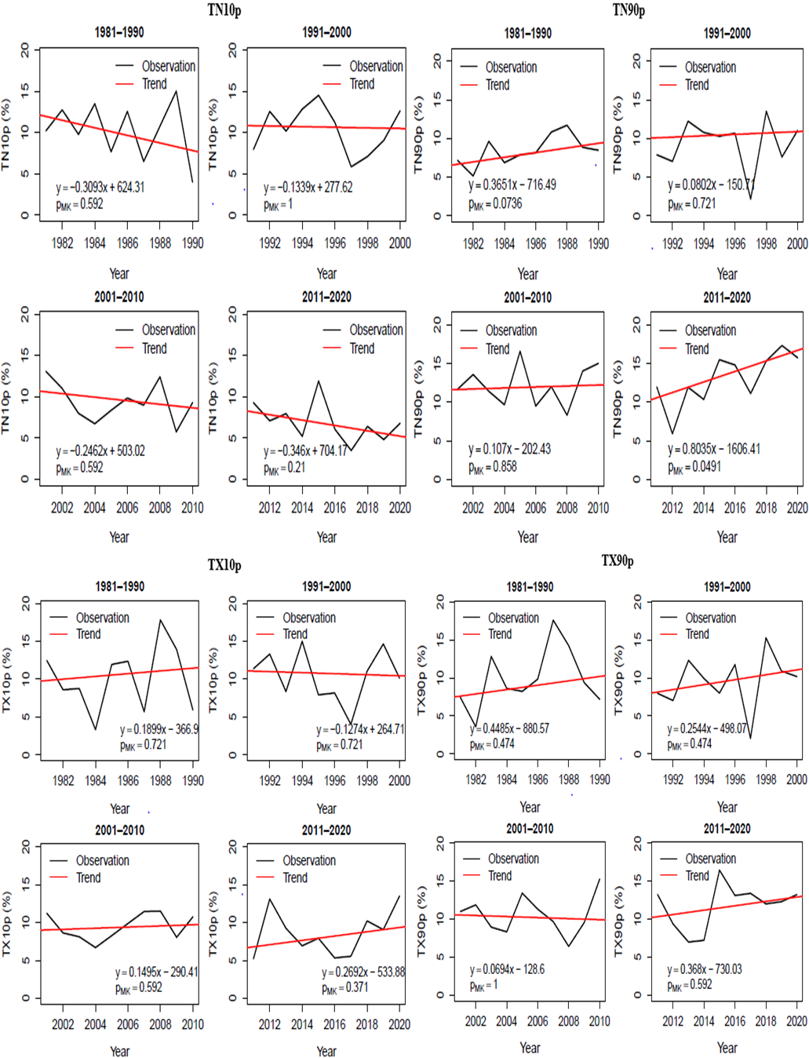
Fig. 3. Evolution of decadal trends in minimum and maximum temperature extremes (TN10p, TN90p, TX10p, TX90p) in Nouhao during the period 1981-2020.

3.1.2 Analysis of the spatial variability of climate extremes

3.1.2.1 Analysis of the spatial distribution of extreme precipitation indices

The spatial distribution of the mean values of the four extreme precipitation indices shown in Fig.4 varies greatly from one decade to another over the period 1981-2020. The CDD, representing consecutive dry days, shows that during the period 1981-1990, dry spells were relatively shorter in the northern part of the basin, where values ranged from 142 to 152 days, while the southern zone experienced longer dry periods, although these did not exceed 171 days. During the decade 1991-2000, areas of high dry persistence expanded in the center and south, where values ranged between 147 and 166 days, reflecting a notable intensification of arid conditions. Between 2001 and 2010, consecutive dry days remained high in the southeast, with values ranging from 156 to 171 days, while a slight decrease was observed in the northwest (142 to 155 days). Finally, for the period 2011-2020, a spatial redistribution is emerging: the northwest is experiencing shorter dry spells, between 142 and 156 days, while the center and south are maintaining long dry periods of up to 170 days, reflecting an increase in droughts in these areas.
With regard to consecutive wet days (CWD), the period 1981-1990 shows longer durations in the northwest of the basin, reaching approximately 4.5 days, while the center and south show shorter values, around 3 to 3.75 days. During the decade 1991-2000, a slight reduction in wet days was observed in the northwest (3 to 3.75 days) and a homogenization of durations was evident in the central and southern parts, with values ranging from 3.75 to 4.5 days. For the period 2001-2010, a small portion of the western part retained the longest wet periods (3.75 to 4.25 days), while the north, center, and south remained relatively stable with values between 3 and 4 days. Over the period 2011-2020, a new spatial redistribution appears, with the entire basin showing relatively high values between 4 and 4.5 days, reflecting an intensification of prolonged rainy episodes in this area.
For the RX1day index, representing maximum precipitation in a single day, the period 1981-1990 shows average values of around 63 to 72 mm, while the center and south record higher precipitation, around 72 to 85 mm. During the decade 1991-2000, a general increase was observed throughout the basin, with values ranging from 77 mm in the south to 88 mm in the north. Between 2001 and 2010, maximum daily precipitation increased more uniformly across the basin, with values ranging from 68 to 79 mm in the north and northwest and from 79 to 84 mm in the center and south. For the last decade (2011-2020), the southeast of the basin continues to have the highest values (80 to 85 mm), while the northwest remains more moderate (76 to 80 mm), reflecting an intensification of heavy rainfall events in the southern part.
Finally, analysis of the spatial distribution of the RX5day index, representing maximum cumulative precipitation over five days, shows that during the period 1981-1990, the north recorded values between 104 and 120 mm, while the center and south had higher precipitation (120 to 137 mm). Between 1991 and 2000, a spatial redistribution took place: a slight increase was observed in the central part, extending towards the northwest (104 to 126 mm), while a decrease was recorded in the northwest (110 to 120 mm). During the period 2001-2010, cumulative five-day precipitation remained high in the central and southern parts (120 to 137 mm), while in the northern and northeastern parts it remained moderate, with values between 110 and 120 mm. Finally, for the period 2011-2020, relative homogenization is evident across the basin: the north and northwest reach values between 104 and 126 mm, while the southeast and central parts remain the wettest areas with maximum cumulative precipitation over five days ranging from 126 to 137 mm, reflecting the persistence of prolonged intense rainfall events in the southern part of the basin.
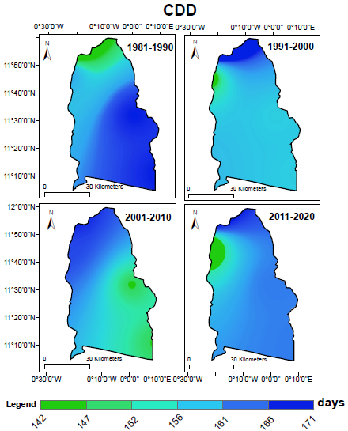
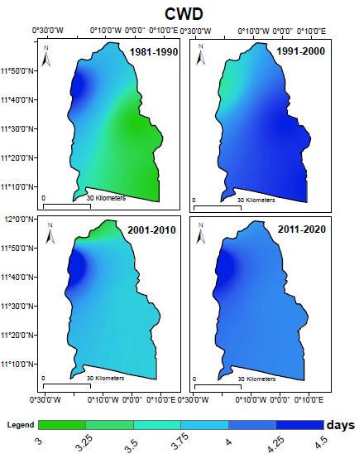
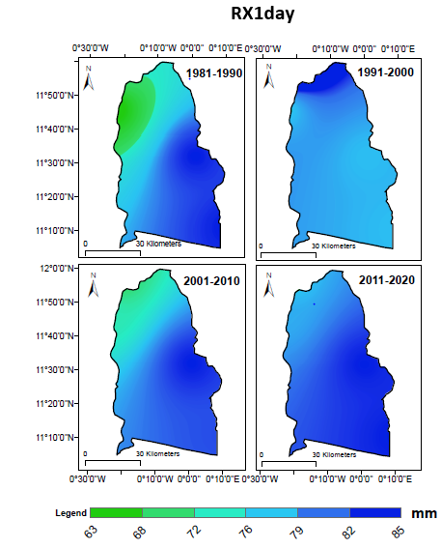
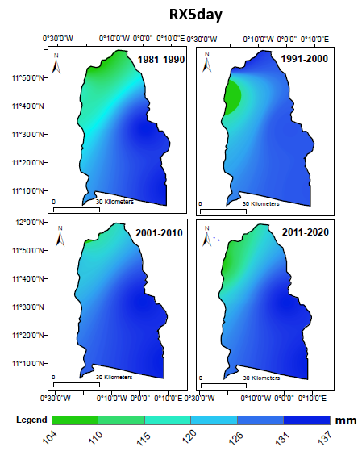
Fig. 4. Spatial distribution of the climatological average of extreme precipitation indices (CDD, CWD, RX1day, RX5day) for Nouhao during the period 1981–2020.

3.1.2.2 Analysis of the spatial distribution of extreme temperature indices

The study of extreme temperatures highlights a clear change in minimum and maximum temperatures over the period 1981-2020 in the Nouhao sub-basin (Fig.5). Analysis of the percentage of cold nights (TN10p) shows that during the decades 1981-1990, 1991-2000, and 2001-2010, values across the entire basin fluctuated between 8.48% and 11.28%, with slightly lower values occasionally appearing in the southern and northeastern parts. The period 2011-2020 shows a general decrease in TN10p (6.8%), especially in the center and north, indicating a continuing decline in cold nights and a gradual rise in nighttime temperatures.
The complementary evolution of the percentage of warm nights (TN90p) confirms this nighttime warming. During 1981-1990, the frequency of warm nights was moderate (8.4-10%), with a more pronounced core in the south-central region, which recorded values between 10 and 12% over most of the basin, with occasional drops to 8% in the central region and further north. For the decades 2001-2010 and 2011-2020, the distribution becomes more homogeneous and lower, with values ranging from 8.46% to 10.361%, reflecting a general decline in nighttime highs.
Daytime indices show a similar trend but with specific intensities. The percentage of cold days (TX10p) was relatively high during the decade 1981-1990 (17-19%). The decade 1991-2000 shows a gradual decrease in TX10p values from northwest to south. These values range from 9.86 to 17.28%. The decade 2001-2010 marks a more pronounced decline, particularly in the southern part, where values fall below 11%, indicating a significant decrease in cool days. For 2011-2020, TX10p is around 9-10% in the south and northwestern part. The central part shows values ranging from 13.57% to 17.58%, confirming the increase in cold days and reflecting marked daytime warming.
Finally, the hot day index (TX90p) illustrates an increase in extreme daytime heat. During 1981-1990, values were moderate (9-11%) with a few southern pockets. The period 1991-2000 shows a clear increase in the central-western region (11-12%), while 2001-2010 sees this signal strengthen, with areas exceeding 12% in the northeast and south. The decade 2011-2020 shows the highest values in the series (11.71-12.27%) across most of the basin, reflecting a continuous increase in the number of exceptionally hot days.

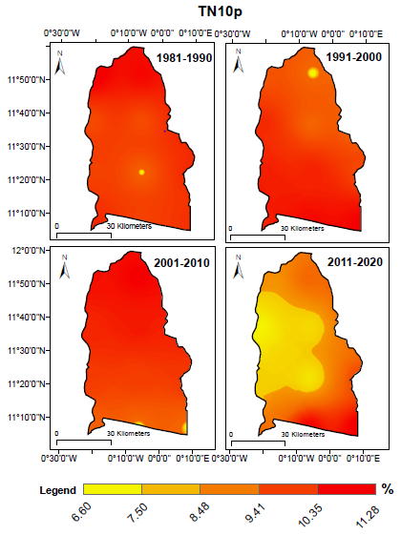
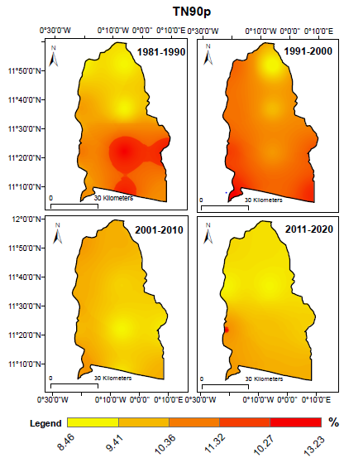
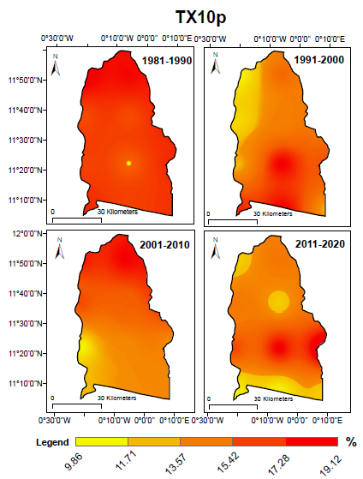
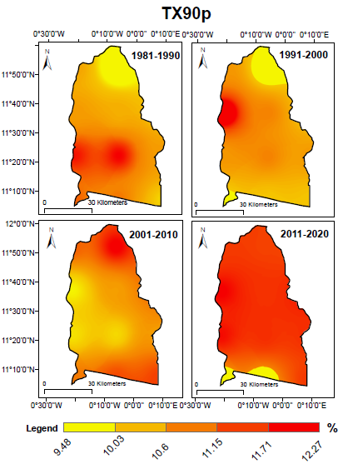
Fig. 5. Spatial distribution of the climatological average of extreme temperature indices (TN10p, TN90p, TX10p, TX90p) for Nouhao during the period 1981-2020.

3.2 Discussion

This study used data from four (4) rain gauge stations and one synoptic station, as well as ERA5 reanalysis observations covering the Nouhao sub-basin over a 40-year period (1981-2020) to provide an annual, decadal, and temporal analysis of climate extreme indices in the Nouhao sub-basin. Analysis of the four extreme precipitation indices (CDD, CWD, RX1day, and RX5day) shows significant interannual variability and changes in the rainfall regime over the period 1980-2020. The CDD index shows a general trend towards longer dry periods, particularly after 2010. This change reflects a strengthening of conditions, consistent with recent climate observations in the Sahelian zone (Biasutti, 2019; Nicholson, 2013). The increase in consecutive dry days in West Africa, particularly in the Sahel, is attributed to global warming, the variability of the West African monsoon, and the influence of teleconnection systems such as ENSO and the Indian Ocean Positive Dipole (Ojara et al., 2021; Seneviratne et al., 2021).
At the same time, the CWD index shows significant decadal variability, with a slight increase in recent years. This trend suggests that rainfall is becoming more concentrated in short sequences, despite an overall reduction in the frequency of rainy events. These results are consistent with those of (Akinsanola & Zhou, 2019; Panthou et al., 2014), who observe that in several regions of West Africa, rainfall events tend to be more intense but shorter, leading to an increased risk of local and sporadic flooding. Recent studies in Tanzania (Ogega et al., 2020) also confirm this concentration of precipitation over short periods, linked to variations in convective systems and the combined effects of ENSO and tropical cyclones in the southwestern Indian Ocean basin.
The RX1day and RX5day intensity indices reveal contrasting trends over the period 1980-2020. Maximum daily precipitation (RX1day) and precipitation over five consecutive days (RX5day) increased slightly during the decades 1980-2000, before declining significantly since 2001. This trend suggests that prolonged rainy episodes were more intense at the end of the 20th century, while the last two decades have been characterized by less extreme accumulations, although wet periods remain concentrated in short sequences.
The results obtained are consistent with other previous studies conducted in Burkina Faso and West Africa. Indeed, an increase in extreme precipitation indices, particularly Rx1day and Rx5day, was observed in Burkina Faso over the period 1961-2015 by (Tazen et al., 2019). This trend is confirmed by the work of (Rouamba et al., 2023) in the Boucle du Mouhoun region, where these same indices also show an upward trend between 1991 and 2021. This trend has also been observed in other West African countries by various authors. In Niamey, Niger, the same indices (RX1day, RX5day) also increased between 1990 and 2020 (Bassirou et al., 2023). This confirms the studies conducted by (Konate et al., 2023) in Côte d'Ivoire between 1961 and 2015. Similar conclusions have been reported by other recent studies in West Africa and regional basins (Ndiaye et al., 2023; Saley & Salack, 2023; Yaméogo, 2024), highlighting an increase in extreme precipitation with marked spatial and temporal contrasts. Analysis of the extreme temperature indices TN10p, TN90p, TX10p, and TX90p for the Nouhao sub-basin reveals a gradual overall warming, both nocturnal and diurnal, during the period 1981-2020. TN10p shows a continuous decrease in cold nights, particularly marked during the last decade, reflecting an increase in nighttime warming. This trend is corroborated by the increase in TN90p, indicating an increasing frequency of exceptionally warm nights, especially between 2011 and 2020. Thus, minimum temperatures are rising steadily, with an intensification of hot nighttime extremes, reflecting a growing imbalance in nighttime temperature distribution across the sub-basin.
For maximum temperatures, the TX10p index shows significant interannual variability with no statistically significant trend over the entire period, suggesting that the frequency of cold days remains moderate and sporadic.
Conversely, the TX90p reveals a gradual increase in extreme hot days, with a more marked rise over the last decade, confirming the rise in maximum temperatures and the increase in episodes of intense daytime heat. The joint evolution of daytime and nighttime indices shows that the Nouhao sub-basin is experiencing marked and widespread warming, characterized by an increase in hot extremes and a decrease in cold extremes.
The work of Yaméogo (2024) in the Sudano-Sahelian region highlights a more pronounced warming during the night than during the day, corroborating the structural change in climate observed in the Nouhao sub-basin.

4. Conclusion

This study analyzed the spatio-temporal variability of climate extremes in the Nouhao sub-basin over the period 1981-2020. Extreme precipitation indices show high decadal variability with no clear monotonic trend, while extreme temperature indices indicate a more consistent trend, characterized by a decrease in cold extremes and an increase in hot extremes, reflecting a gradual warming of the temperature regime.
These results confirm the complexity of local hydroclimatic regimes and highlight the need to integrate regional climate projections and sectoral impact analyses in order to better anticipate the future effects of climate change and support the development of adaptation strategies tailored to the basin context.

Definitions, Acronyms, Abbreviations

CDD: Consecutive Dry Days (maximum number of consecutive days with precipitation < 1 mm)
CWD: Consecutive Wet Days (maximum number of consecutive days with precipitation ≥ 1 mm)
RX1day: Annual maximum 1-day precipitation amount (mm)
RX5day: Annual maximum consecutive 5-day precipitation amount (mm)
TN10p: Percentage of cold nights (minimum temperature below the 10th percentile)
TN90p: Percentage of warm nights (minimum temperature above the 90th percentile)
TX10p: Percentage of cold days (maximum temperature below the 10th percentile)
TX90p: Percentage of warm days (maximum temperature above the 90th percentile)
ETCCDI: Expert Team on Climate Change Detection and Indices
ERA5: Fifth-generation ECMWF atmospheric reanalysis of the global climate
ECMWF: European Centre for Medium-Range Weather Forecasts
GIS: Geographic Information System

Disclaimer (Artificial intelligence)

Author(s) hereby declare that NO generative AI technologies such as Large Language Models (ChatGPT, COPILOT, etc.) and text-to-image generators have been used during the writing or editing of this manuscript.

REFERENCES

- Abdullahi, N. I., Mohammad, S. J., Oweseni, Y., Ijimdiya, S. J., & Sulaiman, K. (2023). A Non-Parametric Mann-Kendall and Sen’s Slope Estimate as a Method for Detecting Trend Within Hydro-Meteorological Time Series: A Review. Academy Journal of Science and Engineering, 17(1), 119‑122.
- Adeyemi, K. A., Ahmad, M. J., Adelodun, B., Odey, G., & Choi, K. S. (2024). Spatial and temporal variability of climate extremes and their impact on maize yield in North-Central Nigeria. Theoretical and Applied Climatology, 155(4), 2545‑2558. https://doi.org/10.1007/s00704-023-04770-0
- Agbo, E. P., Nkajoe, U., & Edet, C. O. (2023). Comparison of Mann–Kendall and Şen’s innovative trend method for climatic parameters over Nigeria’s climatic zones. Climate Dynamics, 60(11‑12), 3385‑3401. https://doi.org/10.1007/s00382-022-06521-9
- Akinsanola, A. A., & Zhou, W. (2019). Projections of West African summer monsoon rainfall extremes from two CORDEX models. Climate Dynamics, 52(3‑4), 2017‑2028. https://doi.org/10.1007/ s00382-018-4238-8
- Bassirou, H., Masamaéya, D.-T. G., Sanda, I. S., Cheo, A. E., Sougue, M., & Pouye, I. (2023). Extreme Rainfall and Streamflow in Niamey City: Trends and Relationship Between Higher Streamflow and Rainfall. International Journal of Water Resources Engineering, 9(1), 21‑32. https://doi.org/10.37628/jwre.v9i1.802
- Biasutti, M. (2019). Rainfall trends in the African Sahel: Characteristics, processes, and causes. WIREs Climate Change, 10(4), e591. https://doi.org/10.1002/wcc.591
- Brassel, K. E., & Reif, D. (1979). A Procedure to Generate Thiessen Polygons. Geographical Analysis, 11(3), 289‑303. https://doi.org/10.1111/j.1538-4632.1979.tb00695.x
- Brohan, P., Kennedy, J. J., Harris, I., Tett, S. F. B., & Jones, P. D. (2006). Uncertainty estimates in regional and global observed temperature changes: A new data set from 1850. Journal of Geophysical Research: Atmospheres, 111(D12), 2005JD006548. https://doi.org/10.1029/2005JD006548
- Damiba, L., Doumounia, A., Casey, V., Bounkoungou, A., & Zougmoré, F. (2020). Analysis of rainfall variability on the groundwater levels of wells in the Nouaho Basin in East-Central Burkina Faso.
- Donat, M. G., Alexander, L. V., Yang, H., Durre, I., Vose, R., Dunn, R. J., Willett, K. M., Aguilar, E., Brunet, M., & Caesar, J. (2013). Updated analyses of temperature and precipitation extreme indices since the beginning of the twentieth century: The HadEX2 dataset. Journal of Geophysical Research: Atmospheres, 118(5), 2098‑2118.
- Doumounia, A., Zeba, A., Damiba, L., Zougmore, F., & Nikiema, M. (2020). Climate variability analysis in the Nouhao Sub-Basin in eastern center of Burkina Faso. LARHYSS Journal P-ISSN 1112-3680/E-ISSN 2521-9782, 41, 57‑69.
- Ge, F., Zhu, S., Luo, H., Zhi, X., & Wang, H. (2021). Future changes in precipitation extremes over Southeast Asia: Insights from CMIP6 multi-model ensemble. Environmental Research Letters, 16(2), 024013.
- Konate, D., Didi, S. R., Dje, K. B., Diedhiou, A., Kouassi, K. L., Kamagate, B., Paturel, J.-E., Coulibaly, H. S. J.-P., Kouadio, C. A. K., & Coulibaly, T. J. H. (2023). Observed changes in rainfall and characteristics of extreme events in Côte d’Ivoire (West Africa). Hydrology, 10(5), 104. https://doi.org/10.3390/hydrology10050104
- Lavorel, S., Colloff, M. J., Locatelli, B., Gorddard, R., Prober, S. M., Gabillet, M., Devaux, C., Laforgue, D., & Peyrache-Gadeau, V. (2019). Mustering the power of ecosystems for adaptation to climate change. Environmental Science & Policy, 92, 87‑97.
- Lichtenstern, A. (2013). Kriging methods in spatial statistics.
- Ndabagenga, D. M., Yu, J., Mbawala, J. R., Ntigwaza, C. Y., & Juma, A. S. (2023). Climatic indices’ analysis on Extreme Precipitation for Tanzania Synoptic stations. Journal of Geoscience and Environment Protection, 11(12), 182‑208.
- Ndiaye, A., Mbaye, M. L., Arnault, J., Camara, M., & Lawin, A. E. (2023). Characterization of extreme rainfall and river discharge over the Senegal River basin from 1982 to 2021. Hydrology, 10(10), 204.
- Nicholson, S. E. (2013). The West African Sahel: A Review of Recent Studies on the Rainfall Regime and Its Interannual Variability. ISRN Meteorology, 2013, 1‑32. https://doi.org/10.1155/2013/453521
- Noba, W. G., Damiba, L., Doumounia, A., Zongo, I., & Zougmore, F. (2023). Assessing Water Resources Access of Nouhao Sub-Basin, Burkina Faso. Journal of Water Resource and Protection, 15(4), 149‑164.
- Ogega, O. M., Koske, J., Kung’u, J. B., Scoccimarro, E., Endris, H. S., & Mistry, M. N. (2020). Heavy precipitation events over East Africa in a changing climate: Results from CORDEX RCMs. Climate Dynamics, 55(3‑4), 993‑1009. https://doi.org/10.1007/s00382-020-05309-z
- jara, M. A., Yunsheng, L., Babaousmail, H., & Wasswa, P. (2021). Trends and zonal variability of extreme rainfall events over East Africa during 1960–2017. Natural Hazards, 109(1), 33‑61. https://doi.org/10.1007/s11069-021-04824-4
- Olauson, J. (2018). ERA5: The new champion of wind power modelling. Renewable energy, 126, 322‑331.
- Oliver, M. A., & Webster, R. (1990). Kriging: A method of interpolation for geographical information systems. International Journal of Geographical Information Systems, 4(3), 313‑332. https://doi.org/10.1080/02693799008941549
- Panthou, G., Vischel, T., & Lebel, T. (2014). Recent trends in the regime of extreme rainfall in the Central Sahel. International Journal of Climatology, 34(15), 3998‑4006. https://doi.org/10.1002/joc.3984
- Rouamba, S., Yaméogo, J., Sanou, K., Zongo, R., & Yanogo, I. P. (2023). Trends and variability of extreme climate indices in the Boucle du Mouhoun (Burkina Faso). GEOREVIEW: Scientific Annals of Stefan cel Mare University of Suceava. Geography Series, 33(1), 70‑84. https://doi.org/10.4316/GEOREVIEW.2023.01.07
- Saley, I. A., & Salack, S. (2023). Present and future of heavy rain events in the Sahel and West Africa. Atmosphere, 14(6), 965.
- Schleussner, C.-F., Lissner, T. K., Fischer, E. M., Wohland, J., Perrette, M., Golly, A., Rogelj, J., Childers, K., Schewe, J., & Frieler, K. (2016). Differential climate impacts for policy-relevant limits to global warming: The case of 1.5 C and 2 C. Earth system dynamics, 7(2), 327‑351.
- Seneviratne, S. I., Zhang, X., Adnan, M., Badi, W., Dereczynski, C., Luca, A. D., Ghosh, S., Iskandar, I., Kossin, J., & Lewis, S. (2021). Weather and climate extreme events in a changing climate. 1513‑1766.
- Sillmann, J., Kharin, V. V., Zhang, X., Zwiers, F. W., & Bronaugh, D. (2013). Climate extremes indices in the CMIP5 multimodel ensemble: Part 1. Model evaluation in the present climate. Journal of Geophysical Research: Atmospheres, 118(4), 1716‑1733. https://doi.org/10.1002/ jgrd.50203
- Store, C. C. D. (2023). ERA5 hourly data on single levels from 1940 to present. Copernicus Climate Change Service (C3S).
- Yaméogo, J. (2024). Changes in the seasonal cycles of extreme temperatures in the Sudano-Sahelian domain in West Africa: A case study from Burkina Faso. Meteorology Hydrology and Water Management. Research and Operational Applications, 12(2), 1‑25.
- Tazen, F., Diarra, A., Kabore, R. F. W., Ibrahim, B., Bologo/Traoré, M., Traoré, K., & Karambiri, H. (2019). Trends in flood events and their relationship to extreme rainfall in an urban area of Sahelian West Africa: The case study of Ouagadougou, Burkina Faso. Journal of Flood Risk Management, 12(S1), e12507. https://doi.org/10.1111/jfr3.12507
- Zeba, A., Noba, W. G., Damiba, L., Kabré, A., Doumounia, A., Ouédraogo, S., Ouattara, F., & Zougmoré, F. (2025). Study of the Spatio-Temporal Variability of Rainfall in the Nouhao Sub-basin. Journal of Water Resource and Protection, 17(8), 563‑576. https://doi.org/10.4236/jwarp.2025.178029
- Zhang, X., Alexander, L., Hegerl, G. C., Jones, P., Tank, A. K., Peterson, T. C., Trewin, B., & Zwiers, F. W. (2011). Indices for monitoring changes in extremes based on daily temperature and precipitation data. WIREs Climate Change, 2(6), 851‑870. https://doi.org/10.1002/ wcc.147

