Original Research Article

Modelling Surface Runoff for Kal River Basin with SCS-CN Method in a GIS Environment

ABSTRACT
Water is one of the most important natural resource. For the effective management of water resources, an accurate understanding of hydrological behaviour of an area is very important. Runoff is the most basic and important parameter needed for planning water management strategies. The present research work was carried out for estimation of surface runoff from Kal River basin by SCS-CN curve method. Satellite Images, digital elevation model data, hydrological Soil Data and precipitation data combined with Geospatial technologies was used for land use/land cover classification, drainage extraction, basin delineation and for the surface runoff estimation of the study area. The Kal River Basin belongs to Raigad district in Konkan region of Maharashtra state. It is one of the major tributary of the Savitri River basin. The total drainage area of basin is 272.63 sq. km. The Kal basin is in Elongated shape which indicates heavier flow for the long duration. The runoff estimation by SCS-CN curve method is determined by integrating land Use/land cover classification with antecedent moisture condition and hydrological soil groups. The study area receives the good rainfall but most of it is lost by surface runoff due to undulating topography and overland flow in the study area. The surface runoff depth has been calculated based on CN values for 33 years period (1990 to 2022) and found that average annual runoff depth of (1485.18mm) representing the average annual rainfall of 3389.06 mm which indicates 43.83 % of runoff contributed from the total rainfall. From the runoff depth for thirty-three years, rainfall-runoff relationship has been established which showed that the statistically positive correlation (R² = 0.91) between rainfall and runoff depth. The runoff estimated by SCS-CN method has been compared with observed runoff, the value correlation coefficient (r =73) indicates strong correlation between estimated and observed runoff of the study area. The study reveals that the integration of GIS with the SCS CN method is a powerful tool for estimating runoff for better watershed management and conservation purposes.
Keywords: Rainfall, Runoff, Curve Number, Land use land cover (LULC), Sentinel, Remote Sensing, GIS

1. INTRODUCTION
Water as one of the most important natural resources to the mankind always plays a crucial role to all kind of development activities (Saha et al. 2021a). However, the widespread scarcity and the gradual depletion of water resource have been making the major problems to the entirely living being on the earth surface. Looking into the current scenario regarding the growing problems of water scarcity throughout the world, many researchers argue that within the couple of decades majority of the world’s existing population would be affected by the severe water deficiency (Alcamo et al. 2000; Wallace and Gregory 2002). Thus, to manage water resources, knowing the rainfall–run off dynamics of a particular region or a watershed is indeed necessary, especially in the geo-hydrological point of views.
1.1 Runoff
Runoff is a significant hydrologic component in the water resources assessment (Ibrahim et. al.,2021). River basin features such as length, width, area, shape, drainage design, soil type, vegetation cover, land usage, and hydrological conditions affect the rainfall-runoff procedure considerably (Caletka et al., 2020). Rainfall characteristics like intensity, duration, and distributions are the main factors for the runoff occurrence. Estimating surface runoff is a very complex process as it is nonlinear, time-varying and spatially distributed. It is estimated by determining the gradient, soil type, permeability and land use. Surface runoff evaluations are vital for evaluating the water efficiency potential of water deposits, soil design and water conservation structures, sedimentation reduction, and downstream flood risks (Singh et al., 2015). The relationship between the quantity of precipitation and the significant runoff is generally dependent on soil Infiltration. Estimation of runoff is of paramount importance for understanding hydrologic behavior of watershed. The importance of estimating surface runoff is not only to know the hydrological processes of the area but also essential for proper planning of storage structures, irrigation schemes, water ways, water harvesting and erosion control structures, ground water development strategies etc.
1.2 SCS-CN method
There are many methods for rainfall runoff modelling like Soil water Analysis tool (SWAT), MIKE 11, HEC-RAS etc., among that SCS-CN curve is the simplest method for estimating runoff in a basin after rainfall event. It has been developed by Soil Conservation Service (SCS-1985), United States Department of Agriculture (USDA). It is simple, predictable and stable conceptual model for estimation of direct runoff depth from rainfall depth. The process aims to determine the precise runoff curve number (CN) that defines the runoff potential. The method requires less input data such as daily rainfall with minimum information on soil-vegetation, which is readily available at any ungauged watershed sites. The SCS CN approach is popular because of its ease of use, universal acceptance, applicability to ungauged watersheds, and only one parameter, i.e., CN is required to run the model (Bhuyan et al. 2003). The curve number defines the runoff potential of an area based on the hydrologic soil group, land cover type, hydrologic condition, and antecedent moisture condition (USDA, 1986).
  - Geospatial approach
The conventional method of of field study for computing the curve number and modelling of rainfall–runoff interaction is expensive, time consuming and difficult process. Advance techniques like remote sensing and geographic information system have been usually applied with enhancing the accuracy to estimation of rainfall–runoff and to predict the hydrological condition of a watershed (Das et al. 1997; Martz and Garbrecht 1999; Xu 2006). Remote sensing satellite imagery provides a synoptic view and extensive area coverage of any river basin. The GIS environment facilitates integrating various thematic data sets in one platform and performs spatial analysis for decision making. Due to the synergism between the two techniques, RS and GIS play a fundamental role in hydrological applications. An effective tool in analyzing parameters such as land use, land cover, soil, topographical and hydrological conditions is the GIS, designed to restore, manipulate, retrieve and view spatial and non-spatial data. With the GIS framework, remote sensing allows quickly capturing, evaluating, and interpreting multi-disciplinary data on a wide scale and is very helpful for planning watersheds. The SCS-CN method is the most common and widely used for runoff assessment all over the world. These techniques play an essential role in studying river basins. In the present case study, estimation of surface runoff was done through SCS–CN model using conventional database and geospatial techniques in the Kal River basin.
2. MATERIALS AND METHODS
2.1 Study area details
The Kal River Basin belongs to Raigad district in Konkan region of Maharashtra state (Fig.1). It is one of the main tributary of the Savitri River basin. The geographical coordinates of the Kal basin lie between North latitudes of 18°22' to 18°15' and East longitudes of 73°26' to 73°19' approximately. The region falls within hot-humid climate with alternate dry and wet periods This region experiences a subtropical climate characterized by alternating dry and wet periods. Categorized as the 2nd VRN (Very High Rainfall Zone) by the Agriculture Department of the Government of Maharashtra (2005), it witnesses an average annual rainfall of 3390 mm, indicating substantial precipitation spread across the year.
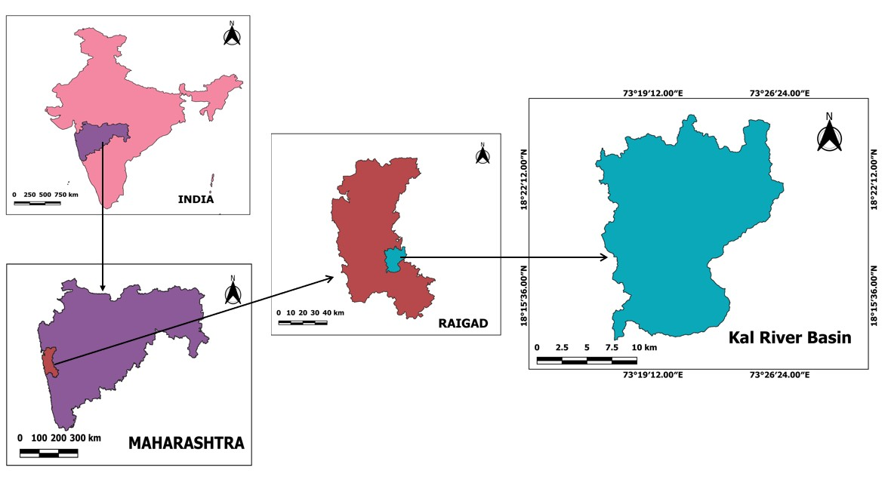
Fig 1: Location Map of the Study Area
2.2 Data required
Daily rainfall data for past 33 years (1990-2022) were collected from Indian Meteorological Department (IMD), Pune. The soil texture map of the study area was obtained from the National Bureau of Soil Survey and Land-use Planning (NBSS & LUP) Nagpur. Satellite imagery SENTINEL 2 (10 m Resolution) downloaded from Land Viewer Portal for year 2022 and discharge data for validation was collected from Central Water Commission (CWC), Hyderabad for the study area.
2.3 Methodology
2.3.1 SCS-Curve Number Method
U. S. Department of Agriculture (USDA) developed and introduced the frequently used empirical techniques Soil Conservation Service Curve Number method in 1972. The SCS-CN (Soil Conservation Service Curve Number) method is a widely used approach for estimating direct surface runoff from rainfall, favored by hydrologists, environmentalists, and irrigation engineers” (Gajbhiye S. 2015, Verma et.al., 2018, Verma et.al.,2020 a). The SCS model is primarily employed for direct runoff assessment. The SCS-CN method is the most commonly used empirical technique to determine direct runoff from a watershed or river basin (USDA,1972).
The SCS-CN approach is based on water balance calculations and two essential hypotheses were developed (Li et al., 2015).
(1) Ratio of the actual quantity of direct runoff to the maximum possible runoff is equal to the ratio of the amount of actual infiltration to the quantity of the potential maximum retention.
(2) Amount of initial abstraction is some fraction of the probable maximum retention.
In the mathematical form, the empirical relationship is

$\frac{F}{S}=\frac{Q}{P-I_{a}}$ … (1)
Where,
F= Actual retention (mm)
S= Potential maximum retention (mm)
Q= Accumulated runoff depth (mm)
P= Accumulated rainfall depth (mm)
I_{a}= Initial abstraction (mm)
The initial accumulation of rainfall represents interception, depression storage, and infiltration before the start of runoff and is called initial abstraction. After runoff has started, some of the additional rainfall is lost, mainly in the form of infiltration; this is called actual retention. With increasing rainfall, the actual retention also increases up to some maximum value: the potential maximum retention. The potential maximum retention is the maximum value of actual retention.
The second assumption is based on water balance equation is
After runoff has started, all additional rainfall becomes either runoff or actual retention (i.e. the actual retention is the difference between rainfall minus initial abstraction and runoff).
$F=P-I_{a}-Q$ … (2)
Combining equation (1) and (2)
$Q=\frac{{\left(P-I_{a}\right)}^{2}}{P-I_{a}+S}$ … (3)
Soil Conservation Services gives the average relationship between I_{a} and S is,
$I_{a}=0.2 S$ … (4)
Runoff will generate only when rainfall will be more than I_{a} i.e., Q=0
Combining equations 4 and 5 yields
$Q=\frac{{\left(P-0.2 S\right)}^{2}}{P+0.8 S}$ For P > 0.2 S … (5)
$Q=0$ For P < 0.2 S
Equation (6) is the rainfall-runoff relationship used in the Curve Number Method. It allows the runoff depth to be estimated from rainfall depth, given the value of the potential maximum retention S. The initial abstraction (Ia) was found to be 20 % of the potential maximum retention. For Indian conditions, depending upon antecedent moisture conditions and hydrological soil type initial abstraction can be 10% or 30% of the potential retention.
2.3.2 Computation of Curve Number (CN)
The potential maximum retention S has been converted to the Curve Number CN in order to make the operations of interpolating, averaging, and weighting more nearly linear. The relationship between Curve Number (CN) and potential maximum retention (S) is given by equation
$CN=\frac{25400}{254+S}$ … (6)
This relationship shows that potential maximum retention (S) is inversely proportional to Curve Number (CN). The value of CN ranges from 0 to 100 and it is dimensionless number. For CN=0, watershed is completely pervious (ideal condition) and for CN = 100, watershed is completely impervious. For paved areas, for example, S will be zero and CN will be 100; all rainfall will become runoff. For highly permeable, flat-lying soils, S will go to infinity and CN will' be zero; all rainfall will infiltrate and there will be no runoff. As CN value increases, imperviousness also increases.
The value of Curve Number is determined by using following factors-
- Land Use Land Cover (LULC)
- Hydrologic Soil Group (HSG)
- Antecedent moisture condition (AMC)
2.3.3 Land Use Land Cover Classification:
Land use land cover is considered one of the most important factors which greatly affect the pattern of rainfall–runoff of any geographical region over time (Saha et al. 2021c). The rate of runoff and infiltration capacity of any water shed is performed differently based on various types of land use land cover (Pal et al. 2021). Land use land cover map gives the status of land utilization. Land use land cover is main feature which shows direct influence on runoff, evapotranspiration and infiltration. In this study, Classification process and analysis of the different LULC classes were done using the Sentinel 2 (10 m resolution) satellite imagery were downloaded from Land Viewer portal.
The selection of this satellite imagery dates was influenced by the quality of the image especially for those with limited or low cloud cover and then georeferenced to the WGS-84 datum and Universal Transverse Mercator Zone 43 North coordinate system and the band composition were done in QGIS environment. Maximum Likelihood classifier was used in the supervised classification method. “Supervised classification is the process most frequently used for quantitative analyses of remote sensing image data”. The supervised classification was applied after defined area of interest (AOI) which is called training classes. More than one training area was used to represent a particular class. The training sites were selected in agreement with the Sentinel 2 Image, Google Earth pro, NRSC Bhuvan, Copernicus and Google Map (Rwanga and Ndambuki, 2017). Many literatures reviewed for the selection of the appropriate and best classification method. (Rao & Narendra 2006, Remi et al. 2007 and Chaudhary et al 2008) have widely used popular supervised classification technique, the maximum likelihood classifier for the LULC classification in their respective studies.
2.3.4 Accuracy Assessment and Kappa Coefficient
The accuracy assessment estimation is a critical last step in the processing of remote sensing data. The purpose of accuracy evaluation is to quantify how well pixels were sampled into the appropriate land cover groups. Accuracy generates the information value of the produced data for the user. The overall accuracy of the classified image compares how each of the pixels is classified versus the definite land cover conditions obtained from their corresponding ground truth data. Producer’s accuracy measures errors of omission, which is a measure of how well real-world land cover types can be classified. User’s accuracy measures errors of commission, which represents the likelihood of a classified pixel matching the land cover type of its corresponding real-world location.
A substantial number of recent studies that employ accuracy evaluations use kappa coefficient (K)-based indices and overall accuracy to determine the viability of a classification system. However, new improvements in accuracy evaluation technique have highlighted the impact of the kappa indices (Pontius and Millones 2011). Numerous writers have evaluated categorization accuracy assessments (Congalton 1991; Janssen and van der Wel 1994). The Kappa coefficient is an error matrix for overall accuracy assessment that is calculated using non-diagonal elements information. Kappa analysis is well recognized as a powerful tool for assessing a single error matrix and comparing differences between error matrices (Smits et al. 1999, Foody 2004). Based on the accuracy evaluation, the traditional error matrix was analyzed for improved presentation (Hardin and Shumway 1997, Stehman 2004; Verma et al. 2020).
The formula to calculate user accuracy, producer accuracy and overall accuracy:
User accuracy = $\frac{Number of correctly classfied pixels in each category}{Total number of reference points in the category (row total)} ×100$ … (7)
Producer Accuracy = $\frac{Number of correctly classfied pixels in each category}{Total number of reference points in the category (cloumn total)}×100$ …(8)
Overall Accuracy = $\frac{ Total number of correctly classfied pixels (diagonal)}{Total number of reference points}×100$ … (9)
Kappa Coefficient (T) = $\frac{TS×TCS-∑(Column total×Row total) }{{TS}^{2}-∑(Column total-Row total)}×100$ … (10)
Where,
TS = Total number of samples
TCS = Total correctly number of samples
The values of different accuracy indicate the quality of land use mapping. The higher the value of user accuracy, producer accuracy and overall accuracy, higher is the precision and quality of the data. Table. 1 shows the kappa coefficient agreement.
Table.1. Kappa coefficient agreement
Sr.no | Kappa Coefficient | Rate
1. | <0.44 | Poor
2. | 0.44 – 0.55 | Fair
3. | 0.55 – 0.75 | Good
4. | 0.75 – 0.85 | Very good
5. | > 0.85 | Excellent
Source: Tewabe and Fentahun, 2020)

2.3.5 Hydrologic Soil Group (HSG):
SCS developed a soil classification system that consists of four groups, which are identified as A, B, C, and D according their minimum infiltration rate. Runoff potential from watershed is greatly influenced by soil properties. The influence of both the soil surface condition (infiltration rate) and its horizon (transmission rate) Ritzema (1994). The hydrological soil groups are shown in Table.2. The explanation of group A, B, C and D is given below.
Group A- Soils in this group have a low runoff potential (high infiltration rates) even when thoroughly wetted. They consist of deep, well to excessively well-drained sands or gravels. These soils have a high rate of water transmission. Water is transmitted freely through the soil. Group A soil typically have less than 10 percent clay and more than 90 percent sand or gravel and have gravel or sand textures.
Group B- Soils in this group have moderate infiltration rates when thoroughly wetted and consists chiefly of moderately deep to deep, well-drained to moderately well-drained soils with moderately fine to moderately coarse textures. These soils have a moderate rate of water transmission. Soils in this group have moderately low runoff potential. Group B soils typically have between 10 percent and 20 percent clay and 50 percent to 90 percent sand and have loamy sand or sandy loam textures.
Group C- Soils have slow infiltration rates when thoroughly wetted and consist chiefly of soils with a layer that impedes the downward movement of water, or soils with moderately fine-to fine texture. These soils have a slow rate of water transmission. Water transmission through the soil is somewhat restricted. Group C soils typically have between 20 percent and 40 percent clay and less than 50 percent sand and have loam, silt loam, sandy clay loam, clay loam, and silty clay loam textures.
Group D- Soils have a high runoff potential (very slow infiltration rates) when thoroughly wetted. These soils consist chiefly of clay soils with high swelling potential, soils with a permanent high-water table, soils with a clay layer near the surface, and shallow soils over nearly impervious material. These soils have a very low rate of water transmission. Water movement through the soil is restricted or very restricted. Group D soils typically have greater than 40 percent clay, less than 50 percent sand, and have clayey textures.

Table 2. Soil conservation service classification (USDA-SCS Soil classification 1974)
Hydrologic Soil Group | Soil Textures | Type of Soil | Runoff Potential | Water transmission rate  (in/hr) | Final infiltration rate (mm/h)
A | Sand, Loamy sand, or Sandy loam | Deep, well-drained sands and gravels | Low | High  (0.30 in/hr) | >7.5
B | Silt loam or loam | Moderately deep, well-drained with moderately fine to coarse textures | Moderate | Moderate  (0.15 0.30 in/hr) | 3.8-7.6
C | Sandy clay loam | Clay loams, shallow sandy loam, soils with moderately fine to fine textures | Moderate | Moderate-low  (0.05-0.15 in/hr) | 1.2-3.8
D | Clay loam, silty Clay loam, Sandy clay, Silty clay, or Clay | Clay soils that swell significantly when wet | High | Low  (0-0.05 in/hr) | <1.2

2.3.6 Antecedent Moisture Condition (AMC):
Antecedent Moisture Condition (AMC) refers to the water content present in the soil at a given time. The soil moisture condition of watershed before runoff is important factor influencing the final curve number value. AMC is used as wetness index of soil. The Soil Conservation Service of USDA has established three types of AMC which are based on 5-day antecedent rainfall are given in Table.3, such as AMC-I (for dry condition), AMC-II (for average condition), and AMC-III (for wet condition).
Antecedent Moisture Condition I (AMC I):
Dry soil conditions. This occurs when the soil is dry and little or no moisture is present. AMC I is associated with lower curve numbers.
Antecedent Moisture Condition II (AMC II):
Average or typical soil moisture conditions. This is considered a moderate state, with some moisture present in the soil. AMC II has moderate curve numbers.

Antecedent Moisture Condition III (AMC III):
Wet soil conditions. This occurs when the soil is saturated, and significant moisture is present. AMC III is associated with higher curve numbers.
In which, for rainfall–runoff modelling purpose using SCS-CN within a watershed, AMC-II is the fundamental of average moisture condition. CN value from AMC-II is converted into AMC-I and AMC-III by using following formula by Sobhani (1975) and Hawkins et al. (1985).
For AMC-I condition $CN (I)=\frac{CN II}{2.334-(0.01334*CN II)}$ … (9)
For AMC-III condition $CN (III)=\frac{CN II}{0.427+\left(0.00573*CN II\right)}$ … (10)
Where,
CN (I) = curve number for dry condition,
CN (II) = curve number for normal or average condition,
CN (III) = curve number for wet condition.
2.3.7 Slope Correction and Curve Number for AMC-I
The land slope parameter has been considered as an important factor in determining water movement (El-Hassanin et al., 1993; Chaplot and Bissonnais, 2003; Huang et al., 2006).The average CN values of AMC-II were slope corrected proposed by Huang et,al., (2006) by using equation (11) and converted to equivalent antecedent moisture condition (AMC-I), for dry condition of the study area by using the equation (9).
${CN}_{2∝}={CN}_{2}\frac{322.79+15.63(∝)}{∝+323.52}$ … (11)
Table 3. Classification of Antecedent Soil Moisture Conditions
AMC Class | Soil characteristics | Total 5-day antecedent rainfall (mm)
AMC Class | Soil characteristics | Dormant season | Growing season | Average
I | Dry condition | < 13 | < 36 | <23
II | Average condition | 13-28 | 36-53 | 23-40
III | Heavy/ Wet condition | > 28 | > 53 | >40
(Soil Conservation Services, 1972)

2.3.8 Hydrological Soil-Cover Complex:
The curve number method (USDA 1972) is also known as the hydrologic soil cover complex method, and it is primarily used for estimating surface runoff (Karunanidhi et al. 2020b). Hydrological Soil-Cover Complex or runoff curve numbers (CN) for hydrologic soil cover is the superimposition of land use land cover and soil-group map. According to hydrological soil-cover complex, curve number values are given to the soil classes. The CN has the potential to estimate runoff under the same precipitation conditions. The value of CN ranges between 0 and 100. For CN = 0, watershed is completely pervious (ideal condition) and for CN = 100, watershed is completely impervious. As CN value increases, imperviousness also increases. The CN has the potential to estimate runoff under the same precipitation conditions, and low CN values indicate that the surface has a high potential to retain water in contrast, high values indicate that the land surface can only store a small amount of rainfall. As a result, areas with a high CN value will generate a large amount of direct runoff (Rawat et. Al., 2017). Curve Numbers (CN) for Hydrologic Soil Cover Complexes (Under AMC-II Conditions) are given in table.4:
Table 4. Runoff Curve Numbers for hydrological soil cover complexes under AMC-II
for Indian Conditions
Sr. No | Land use | Hydrologic Soil Group
1. | Forest | A | B | C | D
2. | High Density Residential (Built-up) | 25 | 55 | 70 | 77
3. | Waterbodies | 77 | 85 | 90 | 92
4. | Agriculture | 100 | 100 | 100 | 100
5. | Agricultural plantations | 67 | 77 | 83 | 87
6. | Shrub/Scrub | 57 | 73 | 82 | 86
7. | Barren/ Waste Land | 55 | 72 | 81 | 86
(Source: Handbook of Hydrology,1972 & HEC-HMS Technical Reference Manual,2000)
3. RESULTS AND DISCUSSION
3.1 Land Use/Land Cover Pattern
Land use and land cover (LULC) are frequently used to manage the environment sustainably (Karunanidhi et al. 2020). The rate of runoff and infiltration capacity of any water shed is performed differently based on various types of land use land cover (Pal et al. 2021). The area with forest cover generally increases the infiltration rate. On the other side, fallow land with bare soil surface increases the rate of run off (Saha et al. 2021b). In the present study, The LULC map was prepared using sentinel satellite data in a GIS environment. The LULC features were identified using supervised image classification. Hence, Scrub land, Forests, settlements, water bodies, agriculture, plantations, and barren land are the main LULC types identified in the study area (Fig.2). The area of each class was calculated taking into account the pixel count and total area (study area). Thus, allocations of each classified area, (percentage) are tabulated in Table.5. The percentage of areas as classified are; Forest (21.5 %), settlement (6.06 %), waterbodies (0.72%), agriculture (18.68 %), plantations (15.77 %), scrub land (30.09 %) and barren land (7.63 %) Barren land. Scrub land was found to be the dominant type of land use classified which covers about 30.09 % of the total study area, followed by forest areas while the least classified was waterbodies which accounts for 0.72 %.
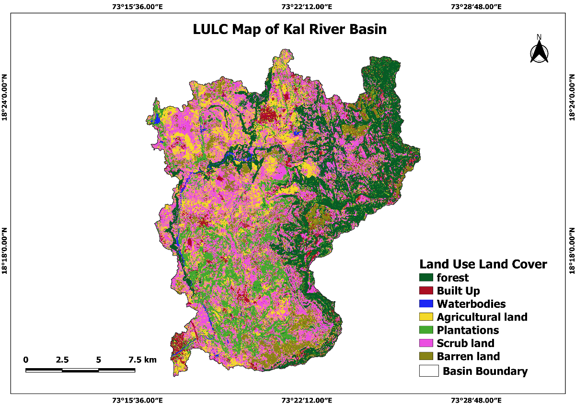
Fig 2. Land Use Land Cover Map of Kal River Basin
Table 5. Area covered by land use land cover classes
LULC Classes | Area (ha) | Area (%)
Forest | 5739.21 | 21.05
Built-up | 1651.05 | 6.06
Waterbodies | 194.04 | 0.72
Agricultural Land | 5091.03 | 18.68
Plantations | 4297.77 | 15.77
Scrub Land | 8203.14 | 30.09
Barren Land | 2081.33 | 7.63
Total | 27263 | 100

3.2 Classification Accuracy Assessment and Kappa Coefficient
The accuracy of land use land cover for Kal River basin was estimated using the kappa coefficient.t the different reference points selected from the land use map of study area were compared with the google earth engine. From table no.6. it was observed that correctively identified points are positioned diagonally from the top left to the bottom right. The total reference points used for comparison are aggregated in the user total column, while all points identified as specific land use are summed up in the producer total row. In the present study, the diagonal elements denote accurate predictions for each class, while the off-diagonal elements represent misclassification. The total row and column provide the overall number of instances for each class. Table no. 7 represents overall accuracy, users’ accuracy and producer accuracy and kappa coefficient. The overall accuracy and kappa coefficient is 0.88 and 0.78 indicating a good quality grade.
Table 6: Accuracy assessment & Kappa Coefficient of Land use land cover pattern
Sr.no | Land use pattern | User Accuracy | Producer Accuracy | Overall Accuracy | Kappa Coefficient
1. | Forest | 98.15 | 98.32 | 0.88 | 0.78
2. | Settlement | 93.37 | 99.79 | 0.88 | 0.78
3. | Waterbodies | 96.27 | 97.80 | 0.88 | 0.78
4. | Agricultural land | 69.85 | 69.63 | 0.88 | 0.78
5. | Plantations | 78.31 | 83.42 | 0.88 | 0.78
6. | Scrub land | 85.94 | 53.31 | 0.88 | 0.78
7. | Barren land | 35.38 | 56.95 | 0.88 | 0.78

3.3 Hydrologic Soil Group (HSG)
The SCS has invented a unique soil classification system on the basis of lowest infiltration rate. Using the SCS-CN soil classification method, soils were classified into four hydrologic soil groups based on their characteristics: A, B, C, D tabulated in Table 6. (USDA 1974). In the Kal River basin, two types of soil texture have been found, namely loam and clay, i.e., HSGs: B and D, as shown in Fig. 3. Group ‘D’ soil has high runoff potential with prolonged infiltration rates when thoroughly wetted. Moreover, primarily impervious, B group of the hydrologic soil is specified to reasonably infiltration rate as well as moderately well drained and has moderate runoff potential (USDA-SCS, 1974, Karunanidhi et al. 2020, Parvez & Inayathulla 2019). In this study, group B was found to be the dominant type of HSG which covers about 78.15 % of the total study area, while the group D accounts for 21.85 %.
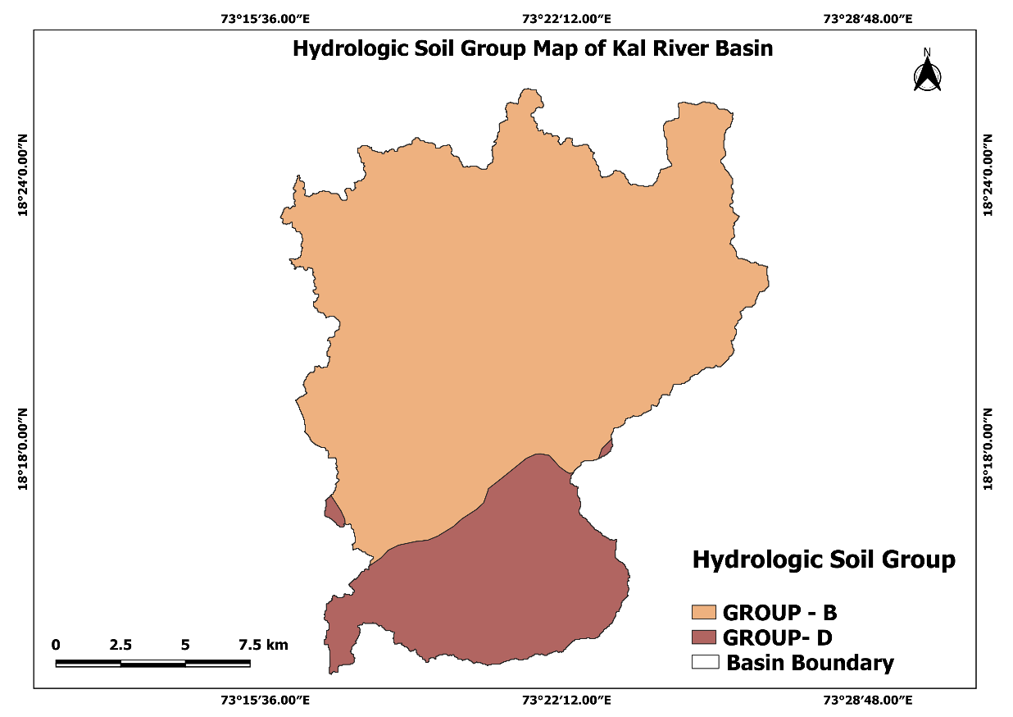
Fig.3. Hydrologic soil group map of Kal River Basin
3.4 Generation of runoff curve number (CN)
The curve number is a parameter for catchment retention (S) or perviousness. The soil and land use maps of the study area were transferred to the QGIS to create new polygons by using the “Join attributes by location” tool were reflecting the combined soil land map. Proper curve numbers were assigned to the overlaid layer of hydrologic soil group (B, D) and LULC map of the Kal River Basin. Curve number values for the entire study area are ranged from 55 to 100. The values of composite curve numbers for dry, average and wet conditions for AMC-I, II and III (shown in table. 7) are estimated by using formula 9, 10 and 11 respectively.
Table. 7. Runoff curve numbers under various antecedent moisture conditions (AMC)
AMC Class | Soil characteristics | Curve Numbers
I | Dry condition | CN₁ = 59.03
II | Average condition | CN₂ = 74.88
III | Heavy/ Wet condition | CN₃ = 86.62

3.5 Slope Character
Slope of an area is the foremost regulatory factor which determines the surface runoff and associated rate of infiltration capacity. Very steep slope area permits high rate of surface runoff and less infiltration whereas in the area of gentle slope permits slow surface runoff and high infiltration (Das et al. 2019). Topographically, the present study area is characterized by undulating rugged hilly terrain. The general elevation ranges between 7 and 1049 m. Slope varies from gentle to very steep classes (Table 8). The Fig. 4 shows the slope map of the present study area. Depending on the sloping character, moderate to high rate of surface runoff is estimated, i.e., moderate runoff in the nearly gentle surface and high runoff in the steep slope of hilly areas. Furthermore, maximum area of the present study region is covered by gentle slope followed by very steep slope.
Sr.no | Slope (%) | Class | Area (%) | Implication of runoff potential (Saha and Ghosh, 2022)
1. | 0-5 | Gentle | 35.22 | Low to medium surface runoff
2. | 5-10 | Moderate | 21.86 | Medium surface runoff
3. | 10-15 | Moderately steep | 10.55 | Moderate to high surface runoff
4. | 15-20 | Steep | 6.84 | High surface runoff
5. | >20 | Very steep | 25.53 | Very high surface runoff
 |  | Total | 100
Table.8. Details of slope classification in Kal River basin

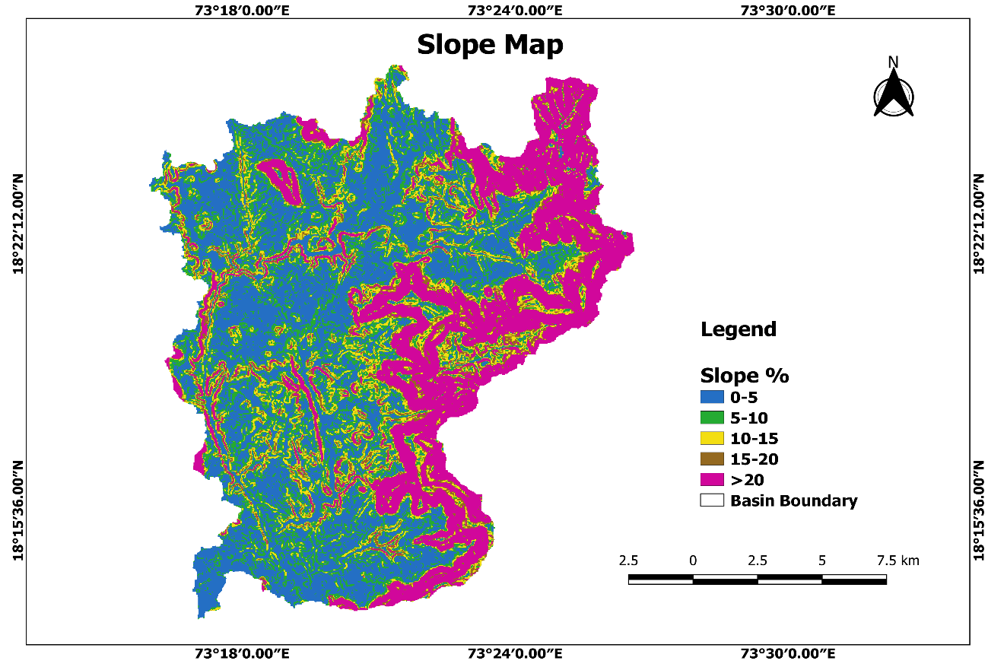
Fig 4. Slope Map of Kal River Basin

3.6 Estimation of surface runoff
Data on daily precipitation from the years 1990 to 2022 have been collected and by using the equations (5) & (6) of the SCS-CN method, surface runoff of the present study area is determined. For estimation of surface runoff spatial distribution of curve numbers, initial abstraction and potential maximum retention are determined for entire study area. Initial abstraction was determined based on the soil and land use land cover characteristics of catchments through the use of tabulated curve number values (shown in Table.3) which were corrected to account for antecedent soil moisture conditions and the surface runoff estimated, if rainfall event is more than the initial abstraction (0.2S), if not then runoff considered as zero. Hence, the rainfall events, which are more than initial abstraction, were considered for further runoff estimation. The daily runoff estimations were aggregated monthly, and the cumulative scenario on rainfall, runoff, and runoff coefficient is presented in the Table 9.
Table.9. Annual average rainfall-runoff depth and runoff coefficient (1990–2022)
Sr.no | Year | Rainfall (mm) | Runoff (mm) | Runoff coefficient
1. | 1990 | 4800.00 | 2287.12 | 47.65
2. | 1991 | 3490.00 | 1736.38 | 49.75
3. | 1992 | 3067.00 | 1447.83 | 47.21
4. | 1993 | 4240.00 | 2051.66 | 48.39
5. | 1994 | 4102.20 | 1935.79 | 47.19
6. | 1995 | 2649.00 | 1048.59 | 39.58
7. | 1996 | 3351.00 | 1403.64 | 41.89
8. | 1997 | 3318.00 | 1540.94 | 46.44
9. | 1998 | 4163.00 | 1948.59 | 46.81
10. | 1999 | 3727.70 | 1743.67 | 46.78
11. | 2000 | 3279.50 | 1775.48 | 54.14
12. | 2001 | 2504.20 | 833.19 | 33.27
13. | 2002 | 2437.50 | 916.75 | 37.61
14. | 2003 | 3453.70 | 1447.82 | 41.92
15. | 2004 | 3684.90 | 1728.12 | 46.90
16. | 2005 | 3790.80 | 2013.74 | 53.12
17. | 2006 | 3665.20 | 1492.65 | 40.72
18. | 2007 | 3763.60 | 1844.89 | 49.02
19. | 2008 | 3357.90 | 1561.14 | 46.49
20. | 2009 | 2194.10 | 700.90 | 31.94
21. | 2010 | 3182.70 | 1206.38 | 37.90
22. | 2011 | 3987.40 | 1817.53 | 45.58
23. | 2012 | 3666.40 | 1630.23 | 44.46
24. | 2013 | 3553.10 | 1529.59 | 43.05
25. | 2014 | 2227.60 | 819.52 | 36.79
26. | 2015 | 2037.30 | 612.23 | 30.05
27. | 2016 | 3615.20 | 1637.19 | 45.29
28. | 2017 | 3793.00 | 1628.31 | 42.93
29. | 2018 | 3066.30 | 1218.67 | 39.74
30. | 2019 | 4678.90 | 2314.83 | 49.47
31. | 2020 | 3084.00 | 1103.07 | 35.77
32. | 2021 | 3071.80 | 1069.73 | 34.82
33. | 2022 | 2835.90 | 964.79 | 34.02
 | AVERAGE | 3389.06 | 1485.18 | 43.83

From table 9, it was observed that, from the last 33 years of rainfall data in the study area shows that the average annual rainfall is about 3389.06 mm and the average annual runoff is 1485.18 mm. However, the present study reveals that, annual rainfall varies between 2037.30 mm and 4800.00 mm, and runoff varies between 612.23 and 2314.83 mm, respectively shown in (Figure.5). The average percentage runoff to rainfall has been found as 43.83 %. Similar results were also found by (Kumari et.al.,2023). The highest average annual rainfall depth was recorded as 4800.00 mm in 1990, while the highest average annual runoff depth was 2314.83 mm was recorded in 2019 and the minimum average annual rainfall depth was recorded as 2037.30 mm in 2015, while the lowest average annual runoff depth was 612.23 mm was recorded in 2019. Similar results are also found by (Kale et. Al., 2022 and Mulu et al. (2025). The rainfall-runoff depth relationship has been established for 33 years (1990-2022) and found that the statistically positive correlation (R² = 0.91) between rainfall and runoff depth (Figure.6) and it means if the rainfall increased, the runoff will be also increased and vice versa.

Fig.5. Variation of Rainfall and Runoff for Kal River basin (1990-2022)

Fig.6. Rainfall–runoff relationship of Kal River basin (1990-2022)
Estimated discharge of Kal River basin generated through soil conservation service (SCS) curve number method is validated with the observed discharge data of last 33 years (1990-2022) with a simple statistical analysis. (Fig.7). The estimated value of (R² = 0.73) shows the statistically positive correlation between the estimated and observed discharge. Another statistical parameter is correlation coefficient (r = 0.79) was also estimated between the observed and simulated discharge of the basin shows good level of accuracy. It further confirms that the said method can be used to predict the discharge rate of the afore Kal River basin.

Fig.7. Validation of simulated runoff and observed runoff for Kal River basin
CONCLUSION
In the present study, SCS-CN method was used to estimate surface runoff potential of the Kal River basin for 33 years period (1990 to 2022). In SCN Curve number method, Antecedent moisture condition of the soil plays a very important role as the curve number varies according to the soil moisture and that is considered while estimating the runoff depth. Values of composite curve numbers estimated are 59.03, 74.88 and 86.62 for CNI-I (AMC-I), CN-II(AMC-II) and CNIII (AMC-III) respectively. Land use of the study area is classified into seven major classes: forest, built-up, waterbodies, agriculture, plantations, scrub and barren land. The land use map indicates that scrub land is the dominant land use class in the Kal River basin. In the study area, group B was found to be the dominant type of HSG which covers about 78.15 % of the total study area, while the group D accounts for 21.85 %. The amount of runoff (1485.18mm) represents 43.83% of the total annual rainfall (3389.06). The rainfall-runoff depth relationship has been established for 33 years (1990-2022) and found that the statistically positive correlation (R² = 0.91) between rainfall and runoff depth. The estimated value of (R² = 0.73) shows the statistically positive correlation between the estimated and observed discharge. Another statistical parameter is correlation coefficient (r = 0.79) was also estimated between the observed and simulated discharge of the basin shows good level of accuracy. Hence, it can be said that there is a strong positive linear dependence between the estimated and observed runoff in the study area. SCS-CN method is capably recognized as a good technique, which consumes less time for extensive data sets as well as bigger environmental area to recognize site selection of artificial recharge structures.
Disclaimer (Artificial intelligence)
Option 1:
Author(s) hereby declare that NO generative AI technologies such as Large Language Models (ChatGPT, manuscript.
REFERENCES
Alcamo J, Henrichs T and Rosch T. (2000) World water in 2025—global modeling scenarios for the World Commission on Water for the 21st Century. World Water Series Report no. 2, Centre for Environmental Systems Research, University of Kassel, Germany.
Bhuyan J, Mankin K R and Koelliker J K. (2003). Watershed-Scale AMC Selection for Hydrologic Modeling. Transactions of the ASAE. American Society of Agricultural Engineers. 46:(2).
Caletka, M, Michalkoa SM, Karásek P and Fucik P. (2020). Improvement of SCS-CN initial abstraction coefficient in the Czech Republic: a study of five catchments. Water. 12 (7).
Chaplot V and Bissonnais Y. (2003). Runoff Features for Interrill Erosion at Different Rainfall Intensities, Slope Lengths, and Gradients in an Agricultural Loessial Hillslope. Soil Science Society of America Journal67(3):844-851.
Chaudhary BS, Saroha GP and Yadav M. (2008). Human Induced Land Use Land Cover Changes in Northern Part of Gurgaon District, Haryana, India: Natural Resources Census Concept. Journal of Human Ecology. 23(3):243-252.
Congalton RG. (1991). A review of assessing the accuracy of classifications of remotely sensed Data. Remote Sensing of Environment; 37(1): pp. 35–46.
Das B, Pal SC, Malik S, Chakrabortty R. (2019). Modeling ground water potential zones of Puruliya district, West Bengal, India using remote sensing and GIS techniques. Geol Ecol Land scapes 3:223–237.
Das S, Behera SC and Kar A. (1997). Hydrogeomorphological map ping in ground water exploration using remotely sensed data - a case study in keonjhar district, orissa. J Indian Soc Remote Sensing 25:247–259.
El-Hassanin A S, Labib L M and Gaber E I. (1993). Effect of vegetation cover and land slope on runoff and soil losses from the watersheds of Burundi. Agriculture, Ecosystems & Environment 43:3-4.
Foody GM. (2004). Thematic map comparison: Evaluating the statistical significance of differences in classification accuracy. Photogrammetric Engineering and Remote Sensing, 70, 627−633.
Gajbhiye S. (2015). Estimation of surface runoff using remote sensing and geographical information system. International J. Serv. Sci. Technol., 8(4): 113-122.
Handbook of Hydrology. (1972). Soil Conservation Department, Ministry of Agriculture, New Delhi.
Hardin PJ, Shumway J M. (1997) Statistical significance and normalized confusion matrices. Photogrammetric Engineering and Remote Sensing. 63: 735–740.
Hawkins RH, Hjelmfelt AT, Zevenbergen AW. (1985). Runoff probability, storm depth and curve numbers. J Irrig Drain Eng ASCE 111(4):330–340.
Huang GB, Zhu QY, Siew CK. (2006). Extreme learning machine: Theory and applications. Neurocomputing.70(1–3):489–501.
Ibrahim A, Zakaria N, Harun N, Muzamil M and Hashim M. (2021). Rainfall runoff modelling for the basin in Bukit Kledang, Perak. IOP Conf. Ser. Mater. Sci. Eng. 1106, 012033.
Janssen LF and Van der wel. (1994). Accuracy assessment of satellite derived land-cover data: A review. Photogrammetric Engineering & Remote Sensing. 60(4).
Kale SS, Ayare BL, Bhange HN, Patil ST and Bansode PB. (2022(b). Estimation of runoff of Kudavale micro watershed using SCS Curve Number Method and GIS Approach. International Journal of Novel Research and Development, 7:296-304.

Karunanidhi D, Anand B, Subramani T and Srinivasamoorthy K. (2020). Rainfall-surface runoff estimation for the Lower Bhavani basin in south India using SCS-CN model and geospatial techniques. Environ Earth Sci.79(13):1-19.
Kumari N, Ayare B L, Bhange H N, Ingle P M, and Kasture M C. (2023). Geospatial analysis of morphometric parameters in the Kal River Basin, Western Konkan: Implications for hydrological characteristics. The Pharma Innovation Journal. 12(12): 2657-2667.
Li J, Liu C, Wang Z and Liang K. (2015). Two universal runoff yield models: SCS vs. LCM. J Geogr Sci.25(3):311-318.
Martz LW and Garbrecht J. (1999). An outlet breaching algorithm for the treatment of closed depressions in a raster DEM. Comput Geosci 25:835–844.
Mulu A, Kassa SB, Wossene ML, Meshesha TM, Fenta AA and Hailu YB. (2025). Runoff estimation using the SCS-CN method and GIS: a case study in the Wuseta watershed, upper Blue Nile Basin, Ethiopia. Discover Water.5 (32).

Pal SC, Chakrabortty R and Roy P. (2021). Changing climate and land use of 21st century influences soil erosion in India. Gondwana Res 94:164–185.
Pontius RG and Millones M. (2011). Death to Kappa: birth of quantity disagreement and allocation disagreement for accuracy assessment. Int J Remote Sens 32(15):4407–4429.
Rao KN and Narendra K. (2006). Mapping and Evaluation of Urban Sprawling in the Mehadrigedda Watershed in Visakhapatnam metropolitan region using Remote Sensing and GIS. Current Science, 91(11):1552-1557.
Rawat KS and Singh SK. (2017). Estimation of surface runoff from semiarid ungauged agricultural watershed using SCS-CN method and earth observation data sets. Water Conserv. Sci. Eng.1(4): 233-247.
Remi A, Huang S, Jiren L, Herve Y and Yvew-Louis D. (2007). Large Scale Land Cover Map Generation based on low and medium resolution, Envisat ASAR Data, Application of Poyang Lake area (JIANG XI, P.R. China). Proc. Envisat Symposium. 23-27.
Ritzema H P. (1994). Drainage Principles and Applications. International Institute for Land Reclamation and Improvement, ILRI Publication. 16:121-130.

Rwanga SS and Ndambuki JS. (2017). Accuracy Assessment of Land Use/Land Cover Classification Using Remote Sensing and GIS. International Journal of Geosciences, 2017, 8, 611-622.
Saha A, Ghosh M, and Chandra Pal S. (2021a). Identifying suitable sites for rainwater harvesting structures using runoff model (SCS-CN), remote sensing and GIS techniques in Upper Kangsabati Water shed, West Bengal, India. Geostatistics and geospatial technologies for groundwater resources in India. Springer International Publishing.119–150.
Singh PK, Mishra SK, Berndtsson R, Jain MK and Pandey RP. (2015). Development of a modified SMA based SCS-CN model for runoff estimation. Water Resour. Manag. 29: 4111–4127.

Smits PC, Dellepiane SG and Schowengerdt RA. (1999). Quality assessment of image classification algorithms for land-cover mapping: A review and a proposal for a cost- based approach. International Journal of Remote Sensing, 20, 1461−1486.
Sobhani G. (1975). A review of selected small watershed design methods for possible adoption to Iranian conditions. M.S. Thesis, Utah State University, Logan, UT.
Soil Conservation Service. (1972). National Engineering Handbook, Section 4, Hydrology, U.S. Department of Agriculture, Washington DC,762.
Soil Conservation Service. 1985. National Engineering Handbook, Section 4, Hydrology, U.S. Department of Agriculture, Washington DC.
Stehman SV. (2004). A critical evaluation of the normalized error matrix in map accuracy assessment. Photogrammetric Engineering and Remote Sensing, 70, 743−756.
Tewabe and Fentahun (2020). Assessing land use and land cover change detection using remote sensing in the Lake Tana Basin, Northwest Ethiopia. Cogent Environmental Science. 6: 1778998.
U.S. Army Corps of Engineers, Hydrologic Engineering Center. (2000). HEC-HMS Hydrologic Modeling System, Technical Reference Manual, CPD-74B. Hydrologic Engineering Center, Davis, CA.
United States of Department of Agriculture (USDA), (1972). National Engineering Hand book of Hydrology Handbook Section-4, Chapter-21.
USDA-SCS (1974) Soil survey of Travis County, Texas. College Station, Tex.: Texas Agricultural Experiment Station, and Washington, D.C: USDA Soil Conservation Service.
United States of Department of Agriculture (USDA), (1986). Natural Resources Conservation Service, Handbook of Hydrology, Technical Release (TR). 55.
Verma S, Mishra SK and Verma RK. (2020a). Improved runoff curve numbers for a large number of watersheds of the USA. Hydrol. Sci. J. 65 (16), 2658–2668.
Verma S, Singh A, Mishra SK, Singh PK and Verma RK. (2018). Efficacy of slope-adjusted curve number models with varying initial abstraction coefficient for runoff estimation. Int. J. Hydrol. Sci. Technol. 8 (4), 317–338.
Wallace JS and Gregory PJ. (2002). Water resources and their use in food production systems. Aquatic Sciences. 64(4):363-375.
Xu AL (2006) A new curve number calculation approach using GIS Technology. ESRI 26th Int’l User Conference 2006. Dallas, USA, pp 1–7.

