The Growing Effects of Climate Change and its Environmental and Socio-Economic Consequences in Nigeria

Abstract
Our planet, Earth, is faced with diverse environmental issues, amongst which is climate change. Climate change, which is caused by increasing greenhouse gas emissions poses this challenge. Nigeria being a leading oil producer and a major gas-flaring country, experiences severe impacts. This paper examines the growing effects of climate change on Nigeria’s environment and society, focusing not only on agriculture as most previous studies have done but also on health, water resources, energy, transportation, and tourism. Nigeria’s fertile land and economy are increasingly weakened by climate-induced disruptions such as erratic rainfall, rising temperatures, and extreme weather events which undermine agricultural productivity, worsen rural poverty, and strain the country’s fragile economy. Public health is at risk as well, with rising sea levels and temperature variations causing increased diseases and compromised water quality. Current mitigation strategies are inadequate to achieve long-term positive outcomes. Thus, urgent and more effective climate strategies are essential to preserve Nigeria’s future, protect its vital resources, and ensure socio-economic stability.

Keywords: Climate Change, Socio-Economic, global temperature

- Introduction
Climate change refers to an increase in the average global temperature. It refers to the long-term warming of the planet, which is caused by the increasing levels of greenhouse gases in the Earth’s atmosphere. These gases are released into the environment as a result of man’s day-to-day activities. Activities such as deforestation, burning of fossil fuels, industrial processes, and so on. These gases such as carbon dioxide and methane trap heat from the sun and prevent it from being released back into space, leading to a rise in global temperatures, thus causing a surge of environmental and social effects.
Over the years, climate change has been at the forefront of public concern across the globe and the undeniable effects of climate change have been witnessed in many forms, some more drastic than others. As climate change has gained prominence on the global stage, its varied effects have become increasingly evident. From more frequent and severe weather events to disruptions in ecosystems and economies, the repercussions of climate change are extensive and complex. According to a report by the African Development Bank(2023), Africa has been short listed as the most vulnerable continent to climate change impacts. Although a low contributor to greenhouse gases emission, Africa experiences widespread losses and damages due to human-induced climate change. A study conducted by the Global Climate Risk Index as at 2022, Africa is the most vulnerable continent to climate change with;

- 6 out of the top 10 countries most affected by climate change located in Africa
- 17 out of the top 20 countries most affected by climate change located in Africa.

According to this report, Nigeria, a major oil producer and one of the world’s top gas-flaring countries, is ranked 6th place globally on the list of most affected countries by climate change. Due to our country’s fossil-based energy-generation infrastructure, high rate of deforestation and less than sufficient means of mitigating the harsh effect of climate change, we are faced with particularly severe effects than any other country in Africa.
In this paper, I emphasize on the growing effects of climate change and its environmental and social consequences in Nigeria, examining its impact on key areas such as agriculture, health, water resources, energy, transportation, and tourism.
Nigeria’s fertile land and resource-rich economy are under significant threat from climate-induced disruptions, including erratic rainfall patterns, rising temperatures, and extreme weather events. A significant but old event that gives attestation to this fact is the infamous flooding that took place at the Niger Delta region of Nigeria as at 2012. Among the affected states was Benue state, the state tagged as the food basket of the nation. Hectares of farmland were destroyed, leading to significant crop losses. Livestock were also lost and food prices skyrocketed almost immediately, food security challenges were also exacerbated. According to World Bank(2013), the Country’s GDP was reduced by 2.5%, equivalent to about $11.7 billion, just because of this singular effect due to climate change. These changes not only undermine agricultural productivity but also exacerbate rural poverty and strain the nation’s fragile economy as proven by this article. Additionally, public health is compromised through increased disease incidence and deteriorating water quality.
References can be made to other articles that also highlighted the effects climate change has brought on the country. Kanu and Onyekwere (2023) examined the impact of climate change on food security. This article also discusses the vulnerability of different regions and populations in Nigeria to climate-related food insecurity. It talks about the need for agricultural practices that are climate resilient, improved water management and enhances food storage in order to ensure food security. The Food and Agriculture Organization (FAO) as at 2020 released an article that assesses the impacts of climate change on agricultural productivity, food availability and access to food in Nigeria. As mentioned earlier, Africa was ranked 1st place as the continent most vulnerable to climate change, with Nigeria coming in at 6th place on the list of countries most affected by climate change(ADP 2023). Other countries like Ghana, Tanzania and South Africa are also not left out in this plight. Research carried out by Hilda and Ali et al. (2019), Atitsogbey et al. (2018) documents the negative impacts climate change has made on food security in Ghana. In 2014,Zakari et al analyzed the relationship between crop yields and climatic factors in Nigeria. An obvious relation was established between them and this article also talks about how crops are affected in size and nutrients due to abnormal difference in climatic conditions of areas.
Despite significant efforts to address food insecurity, FAO (2020) and Concern Worldwide (2019) highlight that many remain chronically undernourished, with FAO (2008) predicting worsening conditions for the poor, especially in rural areas dependent on subsistence farming. Offor (2009), Umunnakwe et al. (2015), and Chidiebere-Mark (2019) reveal various local adaptation strategies, while Ekpenyong et al. (2015), Idumah et al. (2016), and Pendino (2017) confirms the adverse effects of climate change on agricultural productivity and food security in Nigeria. Additional evidence from Odoemela and Ajuka (2012), Duru and Obiechefu (2013), and Okorie et al. (2019) highlight the negative impact of climate variability on food security as studies by FAO, IFAD, UNICEF, WFP, and WHO (2021) have consistently linked climate change with increased global food insecurity.
Overall, past studies have focused significantly on agriculture, but this paper discusses, in broader contexts, Nigeria’s vulnerabilities and emphasizes the urgent need for a comprehensive climate action roadmap, a well-structured one that will not accidentally stifle the country’s already fragile economy. Understanding these impacts will help in developing effective strategies to mitigate and even adapt to climate change, ensuring the preservation of Nigeria’s resources and socio-economic stability.
- Effects of Climate Change and their Societal Consequences in Nigeria
Nigeria is a country well known for its fertile soil and abundance of mineral resources. Having a land with such fertility has encouraged farming practices since the days of old. It has also become a source of livelihood for many. The agricultural sector of the country contributes a high percentage of the National Gross Profit (NGP). Accoring to NBS (2024), the agricultural sector was the 2nd largest contributor to the Nigeria’s GDP, accounting over 25% of the entire GDP, compared to the service sector which accounted for more than 50%. Also, it is the second highest employer of labor in Nigeria, accounting for over 35% of the workforce in 2022 (World Bank, 2023) When disturbing issues like persistent droughts and flooding, off-season rains, and dry spells arise due to climate change, the rate at which crops are produced and the stipulated time for harvest are also affected.
  - Agriculture
The key climate change factors affecting Nigeria’s agriculture include increased precipitation variability, rising surface temperatures, and more frequent extreme weather events. While there are some strategies to mitigate these effects, they are not permanent solutions. This in turn causes a decline in the productivity of the agricultural sector. An example of how climate change has negatively affected agricultural practices is the 2020 flashflood that affected several states including Kogi, Niger and Delta. Apart from the massive loss of lives and properties, agriculture was also severely affected in these areas. The Guardian Nigeria (October 2020) reported this incident.
Another flood that occurred some years back is the 2018 flooding incident that affected northern areas of Nigeria. This flood was due to the overflowing of rivers in these regions. As a matter of fact, in an article written by Premium Times(2020) titled “Nigeria’s Worst Floods’, the 2018 flood was ranked as the second most severe flood case to over occur in the country. Coming in first place is the 2012 flashflood that caused the most casualties. Over 200 people lost their lives to this flood and over 100,000 homes were damaged. The agricultural sector also suffered a huge blow during that time and the country’s GDP was reduced by over 2.5%. There are many such cases of flooding that has occurred over the years and have also caused similar effects on the agricultural sector, the only difference is the severity of these events.
A point to be noted is how these events are now sequential more than random. They seem to have formed some sort of sequence and rather than being a natural disaster. As rightly said, a first is considered an accident, a second is considered a coincidence and a third is considered a trend. These events should serve as a wake-up call to the government of the country. Blows like this may prove deadly and unrecoverable from if these events continue to occur and are not tackled.
A comparative analysis between Nigeria and other selected countries was made and is shown in Figure 1 below. It goes to say without question that the government will be affected severely when the already fragile economy of the country comes crumbling down as a result of insufficient funding. Thus, addressing climate change is crucial for ensuring Nigeria’s food security and overall economic buoyancy given the importance of this sector in development and job creation as stated earlier, see Figure 2.

Figure 1: Agricultural Productivity of Nigeria Relative to Selected Countries
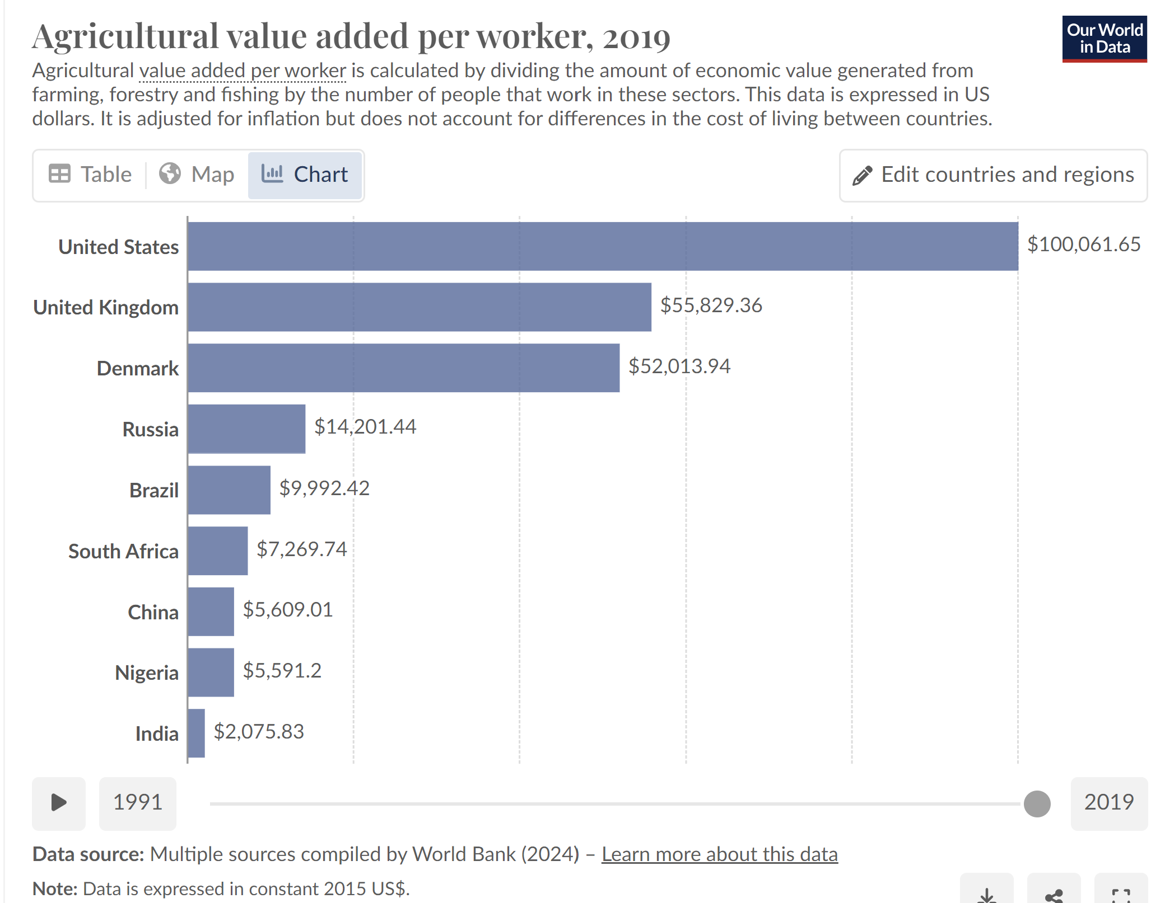
Source: Statistence (2024)s
Figure 2: Agriculture as a Job Creator and Economic Booster in Nigeria
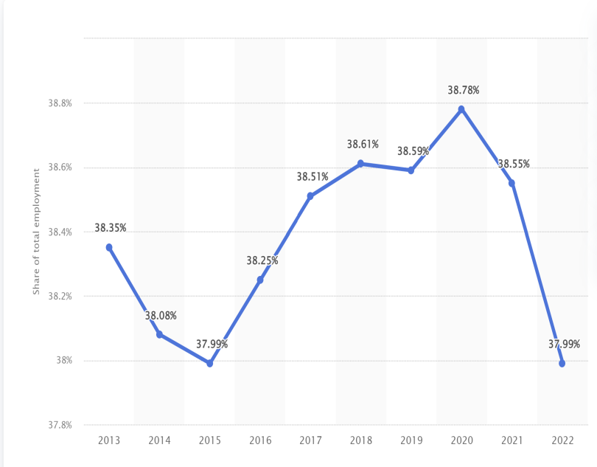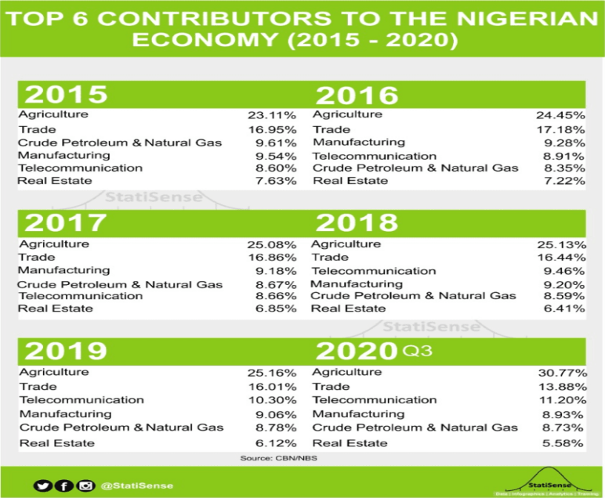
Source: Statistense (2023)
  - Energy
Highlighted as one of the major suppliers of oil in a recent article by the World Bank titled ‘Nigeria Overview’ and a statistical annual bulletin released by OPEC as at 2022, Nigeria is ranked 7th place as the largest producer of oil and the 12th largest oil producer in the world(OPEC 2022), though bottlenecks in production and production unaccountability due to persistent oil thefts have shrunk the official output production figures over time.
Figure 3: Oil Production of Nigeria and Other Major Producers
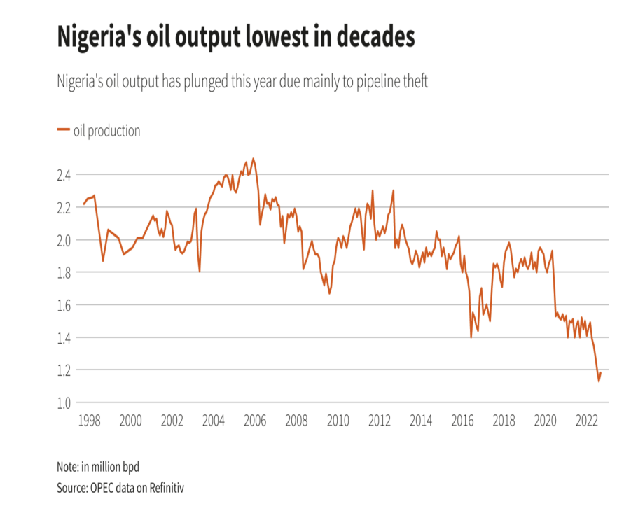
Source: https://www.worldometers.info/oil/oil-production-by-country/ and https://www.reuters.com/business/energy/nigerias-oil-output-drops-below-1-mln-bpd-2022-09-09/

It is no debate that Nigeria is a country blessed with abundant mineral resources like coal, bitumen, petroleum, natural gas, and so on. Articles written by World Bank(2019) and USGS(2018) also support this claim. An article written by Bloomberg(2022) and OPEC(2022) attests to the fact that other developed countries, far and wide, come to Nigeria in need of these resources and Nigeria delivers to thems. These articles provideIt is one of the reasons why the country is regarded as the “giant” of Africa, despite the undeniable underdevelopment in many other sectors. Tagged as a major exporter of oil and gas(OPEC 2020), there is a huge need for a functioning industrial sector, capable of producing oil at the rate at which it is being demanded. According to statistics given by the United Nations Organization, Nigeria alone, accounts for roughly one-sixth of the worldwide gas flaring, which means about 400 million tons of carbon dioxide is spewed into the atmosphere through industrial activities in Nigeria. This makes the country a notable producer of greenhouse gases that destroy the climate and also labels the country as an encourager of climate change, even if it is not a deliberate act.

Figure 4: Africa Bitumen Market, Revenue Share (%) By Country (Left), and Coal Production (Middle and Right)
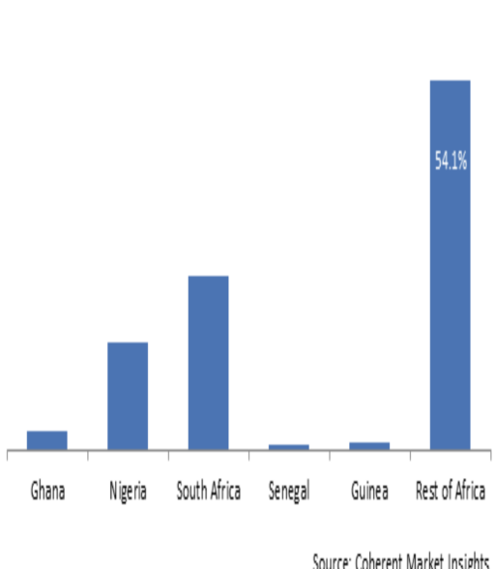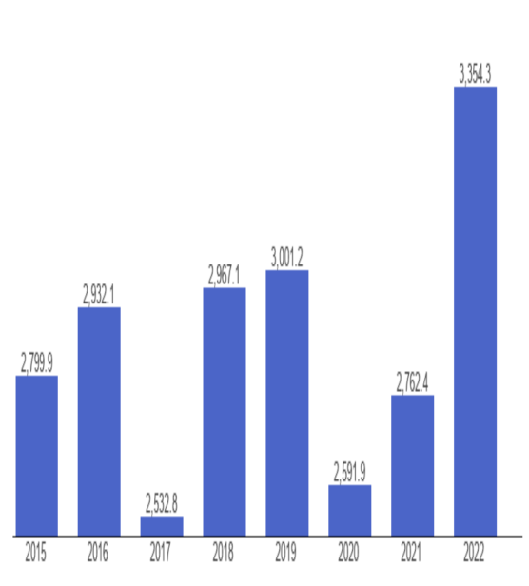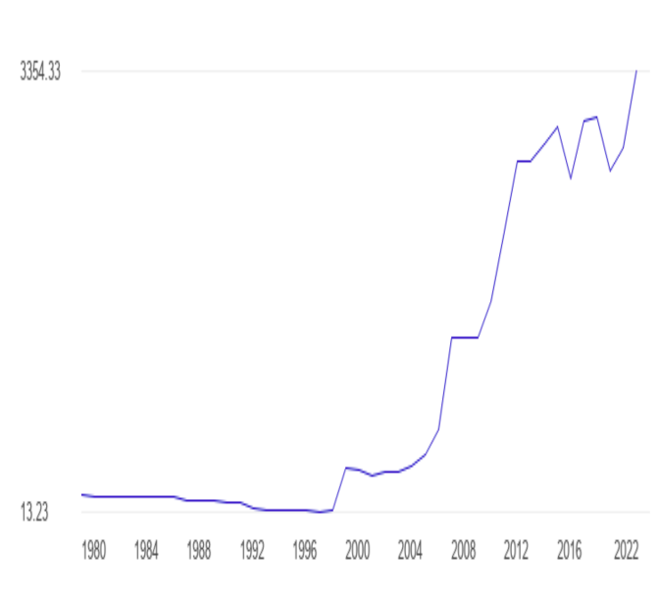
Source: https://www.theglobaleconomy.com/Nigeria/coal_production/ and https://www.coherentmarketinsights.com/market-insight/africa-bitumen-market-4899

  - Poverty
- No doubt, Climate Change is an undeniable global problem but for developed countries, a better coping mechanism can be established due to high adaptation techniques and technologies, effective research-proven policies, mechanized agricultural system, and wealthy economic status. It helps to reduce the harsh effects felt due to climate change. For developing and sub-standardized countries like Nigeria, the effects of climate change are felt more, so much more that the IPCC Assessment report[6th edition], emphasizes how brutally Africa will experience climate change as the years go by. Dire consequences like water scarcity and decreased water quality, loss of biodiversity and ecosystem disruption, decreased crop yields and food security cornerns, increased risk of heat-related mortality and disease will be inevitable. Poverty will also become more rampant than as of now due to the fact that a failing economical system, coupled with life threatening diseases and unemployment will serve as a breeding ground for poverty. Factors capable of exacerbating the already high rate of poverty the country is already faced with are all being provided unconsciously by our nonchalant attitude towards climate change. Climate change has impacted our country in diverse ways we are still recovering from but a significant effect that needs urgent attention is the exacerbation of rural poverty due to a failing economy. This occurs because the agricultural sector, a sector that provides a means of livelihood for the common man and also provides employment for some youths, has been deeply affected in terms of growth and expansion, as explained previously in this essay. Other oil producing countries like us, although not totally exempted from facing the problem of rural poverty, are doing much better than us in this area. Countries like Saudi Arabia and the United Arab Emirates have lower rural poverty rates compared to Nigeria. This is due to
- Effective management of oil revenues
- Investment in rural development and infrastructures
- Diversified economies and
- Strong social safety nets
These comparisons highlight the need for Nigeria to address its rural poverty challenges through sustainable economic development, good governance and social inclusion strategies.
  - Health
Another sector affected by climate change is the health sector. Climate change affects human health directly and indirectly in many ways. Factors like variations from acceptable temperature, rising sea levels, and increasing frequencies have great implications on human health in the areas of injury, illness, morbidity, and mortality. The abnormal rise of sea levels is known to be a result of climate change. It is only a matter of time before flooding of coastal areas occurs, this likely increases the vulnerability of the poor to sicknesses like malaria, typhoid, cholera, and pneumonia. In a study conducted by UNICEF(2019), the vulnerability of children especially to climate-related heath risks was highlighted. World Bank(2016) also discussed the impacts of climate change on water resources and health in Nigeria. Temperature and rainfall dynamics increase the distribution of disease vectors such as dengue, malaria and the incidence of diarrheal disease. As it stands, climate change increases the rate of threats to human health, thereby affecting their productivity.

  - Water and Flooding
Climate change also affects the nature and characteristics of freshwater resources on which Nigeria depends for its freshwater. Changes in weather and climate have been known to influence water resources a great deal. The impact felt varies between ecozones experiencing problems of problems of too much water (floods) to little or no water source at all (drought). It also leads to problems like reduced water quality, saltwater intrusion, sea level rise, and contaminated or diseased water system which in turn leads to the death of aquatic life. As per a study conducted on the impact of climate change in Nigeria by the Nigerian Environment Study/Action Team (NEST), it is observed that various regions of the coastal parts of Nigeria experience adverse effects of climate change more than any other parts of the country.
In Akwa Ibom state, a coastal city in Nigeria, heavy rainfall is being experienced which leads to constant flooding of homes, the disappearance of local streams, and heavy erosion damages. Nigeria’s coastal cities are currently faced with the threat of inundation due to the constant rise in sea level, along the coastal axis. According to the intergovernmental panel on climate change(IPCC), For every 1m rise in sea level, up to 600km² of land would be at risk of erosion. The periodic overflow of the Atlantic Ocean across Bar Beach is an indication of a phenomenon that may accelerate as climate change intensifies and the sea level rises even further. Cities on the coastal side of Nigeria sleep with one eye open during the rainy seasons. The constant fear of flash floods that result in loss of lives and property does not allow us to rest easy. This fear is not easy to live with but has become a thing of normality for citizens living in such areas. This is because successive governments have paid limited attention to the matter. The citizens have therefore succumbed to their fate and have learnt to live with this problem, even if it may one day lead to their deaths.

  - Clean Energy
Climate change has also affected the energy generation and supply in Nigeria. How? One may ask. Although not directly, climate change has influenced the generation of energy in Nigeria. It is a fact that energy services are necessary inputs for every nation’s development and growth. No economy can sufficiently thrive without adequate access to clean, reliable, and adequate energy. Nigeria is a country blessed with many sources of energy, sources as thermal, hydro, solar, and oil resources. Yet, in many articles and studies, Nigeria is termed as an energy-poor country. Examples of such articles are “Energizing Economic Growth in Nigeria” written by the World Bank(2020). In this paper, Nigeria is labeled as one of the poorest countries in the world in terms of energy consumption per capita. Another example is the IEA’s 2020 report titled “Africa Energy Outlook”. This article classified Nigeria as an energy-poor country, with only 45% of the population having access to electricity.
The major source of generating electricity in Nigeria is hydroelectric power(HEP). In a recent report from BNRCC(Building Nigeria’s Response to Climate Change), it is asserted that hydroelectric power is the energy source most likely to be affected by climate change as it is sensitive to the timing and the geographical pattern of precipitation as well as temperature.

  - Roads and Transportation
Nigeria’s transport system will not be exempted from the list of sectors faced with the effects of global warming and climate change. In the 2022 budget analysis and all years before that, there has always been an amount of money dedicated to the building and maintenance of roads. In the 2022 budget, over 67.33 billion naira was allocated to road maintenance only(Premium Newspaper 2020). Analysis of results released by the Nigerian budget office(2015-2022) shows that debt servicing has increased by 271% between 2015 and 2022, while capital expenditure has decreased by 24% over the same period. In 2022, debt servicing accounted for 104% of Nigeria’s revenue, leaving little or no room for capital expenditure. As a result of sea level rise, constant floods, and erosion, costly changes need to be implemented on ports, roads, and railways in order to preserve them. For a struggling economy like ours, the right amount needed to neutralize the effect of climate change on our roads are hard to come by, not to mention the corruption and embezzlement the officials in power are normally fond of.
Constant rainfall and erosion are known to cause potholes on roads, and this may lead to accidents if not curbed. Rail tracks also begin to rust when exposed to rain frequently. This could result in fatal accidents too if not handled. Along the coast where erosion is frequently experienced and more drastic, roads with improper drainage systems could remain covered with intruding seawater. This renders the roads inaccessible for some time until the water is evaporated or pumped out. During this season, few roads that remain accessible are always faced with the issue of traffic congestion. Armed robbers and kidnappers make use of this opportunity and perform all sorts of vices on road users. This increases the crime rate in such areas as well. This is another effect caused by climate change.

  - Tourism
Climate change has far-reaching consequences for Nigeria’s tourism industry, including rising temperatures, flooding, erosion, drought and loss of biodiversity, which damage infrastructure, disrupts tourist events, and impact wildlife populations. This changes also increase the spread of diseases, damage cultural heritage sites, and lead to displacement and conflict, ultimately affecting tourist safety and security. To mitigate these effects, Nigeria’s tourism industry can adopt climate-resilient practices like sustainable tourism development, climate-smart infrastructure design, eco-tourism initiatives and climate change awareness and education. By addressing these challenges, Nigeria can reduce the impact of climate change on its tourism industry and promote sustainable development.

Conclusion
Nigeria, a major oil producer and one of the world’s top gas-flaring countries, is not spared of the challenge and far-reaching consequences of climate change. At its core, climate change is driven by rising greenhouse emissions. It poses significant environmental and social challenges globally, with severe implications for Nigeria. This paper explores the growing effects of climate change on Nigeria's environment and society, emphasizing its impact not only on agriculture but also on health, water resources, energy, transportation, and tourism. Nigeria's fertile soil and resource-rich landscape, crucial for its agricultural sector and economic stability, are increasingly threatened by climate-induced issues such as erratic rainfall, temperature rises, and extreme weather events. These changes disrupt crop production, exacerbate rural poverty, and strain the nation’s already fragile economy. Additionally, climate change impacts public health, with rising sea levels and temperature shifts contributing to increased disease incidence and compromised water quality. Urgent action is needed to address these challenges, as current mitigation strategies are insufficient for ensuring long-term positive impact. Effective climate action is essential to safeguard Nigeria's future and preserve its vital resources and socio-economic stability.
Nigeria needs several targeted actions to address the multifaceted impacts of climate change. The first step to becoming climate-resilient is to introduce drought-resistant crops, improve soil management, and invest in irrigation systems to cope with erratic rainfall and temperature fluctuations. Second, improving water management infrastructure is vital to addressing flooding as well as drought, including rainwater harvesting, efficient irrigation, and improved sanitation to safeguard water quality. Developing early warning systems for climate-sensitive diseases and strengthening public health systems are necessary for managing climate-induced health risks. In addition, the transition to sustainable energy solutions will reduce reliance on fossil fuels; expanding renewable energy sources such as solar and wind, as well as modernizing the energy sector will reduce greenhouse gas emissions. Lastly, coastal areas must be protected, and infrastructure must be made more resilient. Constructing coastal defenses, upgrading infrastructure to withstand climate impacts, and enforcing climate-resilient building codes will help mitigate the effects of sea level rise and erosion that have affected the Southeast and South-south regions of the country. Collectively, these measures will contribute to mitigating the adverse effects of climate change and support Nigeria in its quest for advancement.

Disclaimer (Artificial intelligence)
Option 1:
Author(s) hereby declare that NO generative AI technologies such as Large Language Models (ChatGPT, COPILOT, etc.) and text-to-image generators have been used during the writing or editing of this manuscript.
Option 2:
Author(s) hereby declare that generative AI technologies such as Large Language Models, etc. have been used during the writing or editing of manuscripts. This explanation will include the name, version, model, and source of the generative AI technology and as well as all input prompts provided to the generative AI technology
Details of the AI usage are given below:
1.
2.
3.
- References
Ali et al. (2019) - Ali, R., Ali, R., Sundas, S. M., Xiling, Z., Xuekun, Z., Yan, L., & Jinsong, X. (2019). Impact of Climate Change on Crops Adaptation and Strategies to Tackle Its Outcome: A Review.
Atitsogbey et al. (2018) - Atitsogbey, P., Steiner-Asiedu, M., Nti, C., & Ansong, R. (2018). The impact of climate change on household food security in the Bongo District of the Upper East Region of Ghana. Ghana Journal of Agricultural Science.
Zakari et al. (2014) - Zakari, D. M., Mohammed, A. B., Medugu, N. I., & Sandra, I. (2014). Impact of climate change on yam production in Abuja, Nigeria. International Journal of Science, Environment and Technology, 3 (2), 458-472.
FAO (2008) - Food and Agricultural Organization (FAO) (2008). Climate change adaptation and mitigation in the food and agricultural sector.
FAO (2015) - Food and Agricultural Organization (FAO) (2015). Climate change and food security: risks and responses.
FAO et al. (2021) - Food and Agricultural Organization (FAO), International Fund for Agricultural Development (IFAD), United Nations Children's Fund (UNICEF), World Food Programme (WFP), & World Health Organization (WHO) (2021). The State of Food Security and Nutrition in the World 2021. Transforming food systems for food security, improved nutrition, and affordable healthy diets for all. Rome: FAO.
Ekpenyong & Ogbuagu (2015) - Ekpenyong, I. U., & Ogbuagu, M. I. (2015). Climate change and agricultural productivity in Nigeria: An econometric analysis.
Idumah et al. (2016) - Idumah, F. O., Mangodo, C., Ighodaro, U. B., & Owombo, P. T. (2016). Climate change and food production in Nigeria: Implication for food security in Nigeria. Journal of Agricultural Science, 8(2), 74.
Odoemelam & Ajuka (2012) - Odoemelam, L. E., & Ajuka, N. (2012). Effect of climate change on household food security in Ideato North Local Government Area of Imo State, Nigeria. Journal of Agriculture and Social Research (JASR), 12 (2).
Duru & Obiechefu (2013) - Duru, P. N., & Obiechefu, H. (2013). Climate Change and Food Security in Ikeduru Local Government Area Imo State, Nigeria: The Way Forward. International Journal of Science and Research (IJSR).
Okorie et al. (2019) - Okorie, F. C., Njoku, J. D., Iwuji, M., & Onweremmadu, E. U. (2019). Climate change and food crop production in Imo State Nigeria: An analysis of the 30-year period. African Journal of Behavioural Sciences, 9 (2).
Umunnakwe et al. (2015) - Umunnakwe, P. C., Ozor, N., & Nnadi, F. (2015). Indigenous Practices for Climate Change Adaptation among Rural Households in Imo State, Nigeria. Current Journal of Applied Science and Technology, 8 (1), 67-79.
Concern Worldwide (2019) - Concern Worldwide (2019). How climate change threatens food security - and why we're all at risk.

