Local medicinal uses and phytochemical profiling of Phragmanthera capitata and Tapinanthus bangwensis (Loranthaceae) for treatment hypertension in Daloa, Côte d’Ivoire

ABSTRACT
Aim: Hypertension is a major public health problem in West Africa. Plants of the Loranthaceae family, particularly Phragmanthera capitata and Tapinanthus bangwensis, are commonly used to treat this condition, but their bioactive properties remain poorly documented. This study aimed to document traditional practices and perform a qualitative phytochemical analysis of the leaves of these two species in Daloa, Côte d'Ivoire.
Methods: A semi-structured ethnopharmacological survey was conducted among 60 participants, mainly herbalists, followed by phytochemical screening. The harvested leaves were dried, powdered and extracted by aqueous and hydro-ethanolic maceration. The extracts were analysed for the presence of alkaloids, flavonoids, tannins, saponins, polyphenols, terpenes and steroids.
Results: Traditional knowledge was mainly passed down through ancestral means. The leaves were unanimously cited and used exclusively in the treatment of hypertension, mainly in the form of decoctions administered orally. Phytochemical screening revealed the presence of flavonoids, tannins, saponins and alkaloids in all extracts, with aqueous extracts showing a greater abundance of flavonoids and saponins, while terpenes and steroids were only detected in hydro-ethanolic extracts.
Conclusion: This study provides solid scientific evidence linking ethnopharmacological practices to the phytochemical composition of Loranthaceae, thus supporting their traditional use and providing a valuable basis for future pharmacological and toxicological research.

Keywords: Hypertension, Loranthaceae, ethnopharmacological survey, phytochemical screening, Daloa, Côte d'Ivoire, Traditional medicine, Bioactive compounds.

1. INTRODUCTION
Hypertension (HTN) is a chronic disorder, usually without symptoms, which is one of the major factors contributing to cardiovascular morbidity and mortality globally. Hypertension causes 8.4 million deaths per year around the world (WHO, 2013). In sub-Saharan Africa, there were approximately 80 million hypertensive patients in 2007, and according to projections based on current epidemiological data, this figure is expected to rise to 150 million by 2025 (Fourcade et al., 2007). In Côte d’Ivoire, the management of high blood pressure faces considerable structural obstacles, including the high cost of antihypertensive drugs, their scarcity and the lack of adequate health infrastructure, especially in rural and peri-urban areas (Edmond, 1987). In this context, the use of traditional medicine is a treatment option commonly adopted by local inhabitants. Medicinal plants play a key role here, thanks to their availability, their socio-cultural roots and the faith placed in indigenous knowledge. Among these species are often parasitic vascular plants of the Loranthaceae family, particularly Phragmanthera capitata and Tapinanthus bangwensis, mentioned by various authors in the context of treating high blood pressure. This is due to their presumed hypotensive effects and their widespread use in local pharmacopoeias (Kalis, 1997; Amon et al., 2017; Ladoh et al., 2019). However, despite their importance in the field of ethnomedicine, scientific information on their specific applications and phytochemical composition remains incomplete. The objective of this research is to systematically document the local medicinal use of P. capitata and T. bangwensis in the treatment of high blood pressure in Daloa. It also aims to qualitatively describe their main secondary metabolites in order to establish a solid scientific basis for future pharmacological research and their potential therapeutic use.

2. MATERIALS AND METHODS
2.1. Biological material
The biological material consists of leafy stems of Phragmanthera capitata and Tapinanthus bangwensis (Loranthaceae), which were collected from their host plants in various rural areas on the outskirts of the municipality of Daloa.
The botanical identification of the species was validated by examining morphological traits, based on the Flora of the National Centre for Floristics (CNF) Herbarium and existing scientific references (Boussim, 2002; Soro, 2010; Amon et al., 2017). To ensure accurate visual identification and document the biological material, both species were illustrated (Fig. 1).

Fig. 1. Leafy branches of P. capitata (A) and T. bangwensis (B) collected from
their host plants in the outskirts of Daloa.
A
B
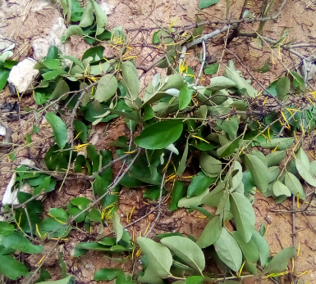
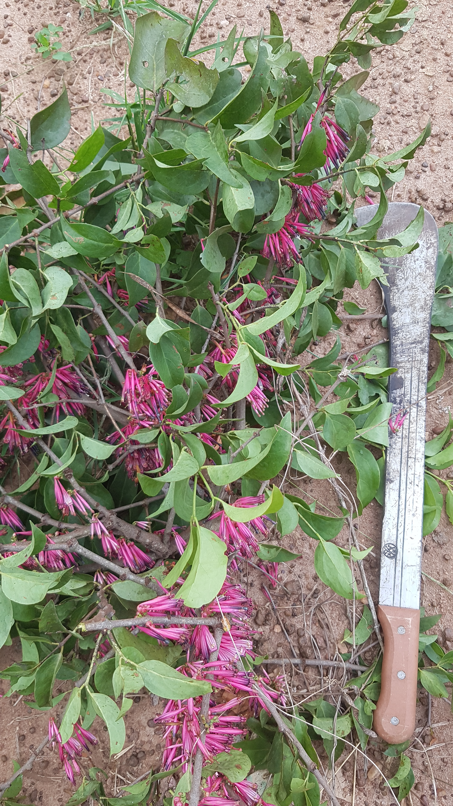
Fig. 1. Leafy branches of P. capitata (A) and T. bangwensis (B) collected from
their host plants in the outskirts of Daloa.
A
B

2.2.1. Selection of Loranthaceae species

We chose the species Phragmanthera capitata and Tapinanthus bangwensis for this research because of their common use in traditional medicine preparations in Côte d’'Ivoire. Their choice is based on numerous references cited by traditional practitioners, highlighting their ethnomedical and therapeutic value (Kalis, 1997; Amon et al., 2019).

2.2.2. Ethnopharmacological survey
An ethnopharmacological study was conducted among 60 informants in three major markets in the city of Daloa (Fig. 2), namely the Orly market (06°52.228' N, 006°27.332' W), the Great Market (06°52.899' N, 006°52.459' W) and the Lobia Market (06°53.891' N, 006°27.180' W). These markets are recognised as hubs for the commercialisation and transmission of knowledge about medicinal plants.
Of these informants, 40 individuals were selected for in-depth analysis. They consisted mainly of herbalists (36) and a limited number of traditional medicine practitioners. The informants were chosen on the basis of their recognised expertise and practical experience in the use of Loranthaceae to treat high blood pressure, with preference given to those who possessed traditional knowledge passed down from generation to generation.

Fig. 2. Map showing the locations of ethnopharmacological survey sites
within the district of Daloa

The information was collected using a questionnaire administered through semi-structured interviews (Tra Bi et al., 2008), conducted in French and local languages, with the support of an interpreter if necessary, following the freely given consent of the interviewees. The information concerned the parts of the two species used, methods of preparation, modes of administration, empirical doses, frequency and duration of treatment, and the perceived effectiveness of the remedies for treating high blood pressure. Data on the origin of ethnomedical knowledge and users' opinions on the effectiveness of treatments were also recorded.

The data were then encoded and examined using Microsoft Excel 2013. The citation frequency (CF) of the various parts of plants used was calculated using the formula indicated by Begossi (1996):

2.2.3. Extraction preparation
For aqueous extraction, 50 g of powder was macerated in 500 mL of distilled water at a temperature of 60 °C for 24 hours, with continuous stirring. The solution was then filtered, concentrated at 50 °C, and the extract obtained was stored at a temperature of 4 °C. For hydro-ethanol extraction, 50 g of powder was macerated in 500 mL of a mixture of ethanol and water (70:30, v/v) at room temperature for 24 hours (Zirihi et al., 2005). Following filtration, the ethanol was removed by evaporation and the extract was kept at 4 °C. The percentage yield of the extracts was determined using the formula below (Harborne, 1998; Zirihi et al., 2005):

where the dry extract weight corresponds to the mass of the extract remaining after evaporation of the solvent, and the initial powder weight indicates the mass of dry powder used for extraction.

2.2.4. Qualitative phytochemical screening
Qualitative phytochemical screening of crude extracts of Phragmanthera capitata and Tapinanthus bangwensis was performed to determine the presence of different families of secondary metabolites, including tannins, saponins, flavonoids, alkaloids, phenols, terpenes, and steroids. Identification was performed using specific chemical tests:
- tannins: 3 drops of a 2% ferric chloride (FeCl₃) solution added to the extract to note a colour change;
- saponins: Add 10 mL of distilled water to the sample for two minutes, followed by shaking to create a lasting foam;
- flavonoids: Add 5 mL of hydrochloric alcohol (prepared by combining 10 mL of 96° ethanol, 10 mL of distilled water and 10 mL of concentrated hydrochloric acid, then diluted twice) to the sample, followed by the addition of 2 to 3 magnesium chips and three drops of isoamyl alcohol to indicate the presence of flavonoids by colouration;
- alkaloids: Add 6 mL of 60°C alcohol with two drops of Dragendorff's reagent (aqueous solution of potassium iodo-bismuth) to detect the precipitation of alkaloids.
- phenols: A specific colour change can be observed by adding a drop of a 2% aqueous solution of FeCl₃ to the sample.
- terpenes and steroids: 2 mL of acetic acid and 2 mL of concentrated sulphuric acid added to the extract, followed by observation of a blue-green colour for steroids and a red-purple colour for terpenes according to the Liebermann-Burchard test.
These tests made it possible to qualitatively determine the presence or absence of each family of metabolites in the extracts studied.

3. RESULTS
3.1. Socio-demographic characteristics of informants
Table 1 presents the results of the survey conducted among 40 informants from the Orly, Grand Marché and Lobia markets in Daloa. Most were herbalists (36 out of 40, or 90% of participants) and women (31 out of 40, or 77.5% of participants). The age distribution of participants was as follows: over 35 years old (17.5% of respondents), 36 to 45 years old (32.5% of respondents) and 46 to 69 years old (50% of respondents). The ethnic groups represented included Malinké (37.5% of respondents), Baoulé (25%), Senoufo (20%), Agni (15%) and Bété (2.5%). It indicates that the majority of individuals surveyed (92.5% of respondents) acquired their knowledge through traditional transmission, while 7.5% opted for an empirical learning approach.

Table 1. Respondents’ socio-demographic characteristics (n = 40)

Characteristics | Modalities | Number | Frequency (%)
Gender | Male | 9 | 22.50
Gender | Female | 31 | 77.50
Age | > 35 years | 7 | 17.50
Age | 36 - 45 years | 13 | 32.50
Age | 46 - 69 years | 20 | 50
Ethnicity | Agni | 6 | 15
Ethnicity | Baoulé | 10 | 25
Ethnicity | Malinké | 15 | 37.50
Ethnicity | Bété | 1 | 2.50
Ethnicity | Sénoufo | 8 | 20
Professional group | Herbalists | 36 | 90
Professional group | Traditional healers | 4 | 10
Aquired knowledge | Ancestral | 37 | 92.50
Aquired knowledge | Empirical | 3 | 7.50

3.2. Ethnopharmacological uses of Loranthaceae species
3.2.1. Frequency of use of species parts
Table 2 shows the frequency with which parts of Phragmanthera capitata and Tapinanthus bangwensis are cited. It should be noted that 100% of respondents mention the leaves for both species. The stems have low citation rates, with 10% of respondents for P. capitata and 8% for T. bangwensis. Neither group of species was mentioned (0% of respondents) with regard to flowers and fruits.

Table 2. Frequency of citation of parts of Loranthaceae used

Part | Phragmanthera capitata | Tapinanthus bangwensis
Leaves | 100 % | 100 %
Stems | 10 % | 8 %
Flowers | 0 % | 0 %
Fruits | 0 % | 0 %

3.2.2. Methods of Preparation, routes of administration, doses, and duration of treatment
Table 3 shows that for Phragmanthera capitata and Tapinanthus bangwensis, only the leaves are used in the preparation of remedies. The predominant method of preparation is decoction, cited by 95% of respondents for both species, while infusion is indicated less frequently, by 20% of respondents for P. capitata and 15% for T. bangwensis, representing alternative practices. For both species, the only method of administration is oral. The only therapeutic use associated with these preparations is the treatment of high blood pressure.

Table 3. Ethnopharmacological practices involving the leaves of P. capitata and
T. bangwensis for treating hypertension

Species | Part used | Preparation method | Route of administration | Main indication
P. capitata | Leaves | Decoction (95 %), Infusion (20 %) | Oral | Hypertension
T. bangwensis | Leaves | Decoction (95 %), Infusion (15 %) | Oral | Hypertension

3.3. Phytochemical screening
3.3.1. Phragmanthera capitata
Table 4 presents the results of phytochemical screening carried out on aqueous and hydroalcoholic extracts of Phragmanthera capitata. The phytochemical study reveals the presence of alkaloids, flavonoids, tannins, saponins and polyphenols in both types of extract, with varying degrees of abundance. The aqueous extract is rich in flavonoids and saponins, while terpenes and steroids are not found in the aqueous extract but are only identified in the hydro-ethanolic extract.

Table 4. Phytochemical screening results of aqueous and hydro-ethanolic extracts
of P. capitata

Component | Aqueous extract | Hydro-ethanolic extract
Alkaloids | + | +
Flavonoids | +++ | +
Tannins | ++ | ++
Saponins | +++ | +
Polyphenols | + | +
Terpenes/steroids | − | +

- : Absent, + : Low abundance; ++ : Moderate abundance; +++ : Very high abundance

3.3.2. Tapinanthus bangwensis
Table 5 presents the results of phytochemical screening of aqueous and hydro-ethanolic extracts of Tapinanthus bangwensis. The phytochemical study demonstrates the presence of alkaloids, flavonoids, tannins, saponins and polyphenols in both extracts, with a notable variation in their abundance. The aqueous extract is rich in flavonoids and saponins, while terpenes and steroids are not present in the aqueous extract and can only be identified in the hydro-ethanolic extract.

Table 5. Phytochemical screening results of aqueous and hydro-ethanolic extracts
of T. bangwensis

Component | Aqueous extract | Hydro-ethanolic extract
Alkaloids | + | +
Flavonoids | +++ | +
Tannins | ++ | ++
Saponins | +++ | +
Polyphenols | + | +
Terpenes/steroids | − | +

- : Absent, + : Low abundance; ++ : Moderate abundance; +++ : Very high abundance

4. DISCUSSION
Ethnopharmacological data reveal that the leaves of Phragmanthera capitata and Tapinanthus bangwensis are used almost exclusively by the inhabitants of Daloa to treat hypertension, while the stems, flowers and fruits are rarely used. This preference reflects specific traditional knowledge and is consistent with the findings of Kalis (1997) and Amon et al. (2025), who assert that the leaves contain a considerable number of bioactive metabolites.
Decoction is the preferred method of preparation, used by 95% of respondents. This method favours the extraction of water-soluble compounds such as flavonoids, tannins, polyphenols and saponins, known for their antioxidant, antihypertensive and vasodilatory effects (Brun et al., 1997; Harborne, 1998; Amon et al., 2025). The almost exclusive use of oral administration is consistent with the systemic nature of the disease being treated, which requires internal assimilation of the active ingredients.
The presence of flavonoids, tannins, saponins, polyphenols and alkaloids in all extracts has been confirmed by phytochemical screening. The exclusive identification of terpenes and steroids in hydro-ethanolic extracts highlights the importance of solvent choice for the extraction of lipophilic compounds with pharmacological potential. The metabolic profile observed provides a probable scientific justification for the historical efficacy of these plants, with flavonoids and polyphenols playing a role in blood pressure regulation, while saponins and alkaloids influence cardiac contractility and urinary excretion (Anderson, 2003).
The interchangeable use of P. capitata and T. bangwensis to treat hypertension may be due to their similar phytochemical profiles, although quantitative or qualitative variations in metabolite concentration may affect therapeutic performance.

5. CONCLUSION
Phragmanthera capitata and Tapinanthus bangwensis are significant ethnopharmaceutical plants in the traditional treatment of hypertension in Daloa. Their leaves, often prepared as a decoction, contain flavonoids, tannins, saponins, polyphenols, and alkaloids. Terpenes and steroids, on the other hand, are only found in hydro-ethanolic extracts. This information provides a robust scientific foundation for future pharmacological research and the development of products that may have an antihypertensive effect.

Consent
As per international standards or university standards, respondents’ written consent has been collected and preserved by the author(s).

DISCLAIMER (ARTIFICIAL INTELLIGENCE)
The authors hereby declare that NO generative AI technology such as large language models (ChatGPT, COPILOT, etc.) and text-to-image generators were used in the writing or revision of this manuscript.

REFERENCES
Amon, A. D. E., Seguena, F., Soro, K., Soro, D. & N’guessan, K. (2017). Ethnobotanical study of Loranthaceae, hemiparasitic plants used in traditional medicine by the population, in the Sud-Comoé region (Côte d’Ivoire). Journal of Medicinal Plant Studies, 5(5): 217-224 https://www.plantsjournal.com/archives/2017/vol5issue5/PartC/5-4-21-248.pdf
Amon, A. D. E., Boyé, M. A. D., Groga, N., Soro, K., Soro, D., N’guessan, K. & Sebe, F. D. (2019). Contribution to the identification of Loranthaceae commercialized in the markets by bete and niaboua of Daloa, Côte d’Ivoire. World Journal of Pharmaceutical and Life Sciences, 56-59.
https://www.wjpls.org/home/article_abstract/1330
Amon, A. D. E., Ackah, B. J. A. A., Kouadio, Y. G., Konan, K. E. & Soro, D. (2025). Ethnobotanical survey and phytochemical screening of Phragmanthera capitata (Spreng.) Ballé and Tapinanthus bangwensis (Engl. and K. Krause) Danser (Loranthaceae) justifying their use in traditional medicine against hypertension. GSC Biological and Pharmaceutical Sciences, 2025, 33(02) : 046-053 DOI: https://doi.org/10.30574/gscbps.2025.33.2.0421
Begossi, A. (1996). Use of ecological methods in ethnobotany : Diversity indices, Economic botany, 50, 3 : 280-289. https://link.springer.com/article/10.1007/BF02907333
Boussim, I. J. (2002). Parasitic phanerogams of Burkina Faso: inventory, taxonomy, ecology and some aspects of their biology. Special case of Loranthaceae parasites of shea. State doctoral thesis in natural sciences, Ouagadougou, Burkina Faso, 285 p. https://dicames.online/jspui/handle/20.500.12177/2359
Edmond, B. (1987). Les particularités de la pathologie cardiovasculaire en région tropicale, édité par PEC Manson Bahr, publié par Baillière-Tindall, East bourne, Englande, 45p.
Fourcade, L., Paule, P. & Mafart, B. (2007). Hypertension artérielle en afrique subsaharienne actualité et perspectives. Med Trop, 67 : 559-567 https://www.jle.com/fr/MedSanteTrop/2007/67.6/559-567%20Hypertension%20art%C3%A9rielle%20en%20Afrique%20subsaharienne%20(Fourcade).pdf
Harborne, J. B. (1998) Textbook of Phytochemical Methods. A Guide to Modern Techniques of Plant Analysis. 5th Edition, Chapman and Hall Ltd, London, 21-72. https://link.springer.com/book/9780412572609
Kalis, S. (1997). Traditional medicine, religion and divination among the Seereer Siin of Senegal. Knowledge of the night. L’Harmattan, 335 p.
https://www.persee.fr/doc/hom_0439-4216_1998_num_38_148_370615
Ladoh, Y. C. F., Ndongo, D. & Tomedi, E. M. (2019). Medicinal possibilities of Phragmanthera capitata (Sprengel) ball S. (Loranthaceae) Used in the City of Douala (Cameroon). Haya Saudi Journal Life Sciences 4(1): 1-14
DOI: 10.21276/haya.2019.4.1.1
WHO (2013). World Health Day 2013. Control your blood pressure, control your life. WHO-EM/NCD/083/F, 13 p. https://iris.who.int/server/api/core/bitstreams/128bb4a1-4214-4f82-ab41-c745bec54f6f/content
Soro, K. (2010). Loranthaceae (mistletoe) in agroecosystems in western Côte d’Ivoire: flora, parasitism and uses in the departments of Oumé, Gagnoa and Soubré. Thesis submitted to the University of Cocody-Abidjan, Agroforestry option, 183 p.
file:///C:/Users/Mme%20AMON/Searches/Downloads/CS_06103%20(13).pdf
Tra Bi, F. H., Guy, M. I., Koue, C. C., Ngaman, C & Lejesson, H. B ( 2008). Study of several therapeutic plants used in the treatment of high blood pressure and diabetes: two emerging diseases in Côte d’Ivoire (Abidjan), Sciences et Nature (5) 1: 39–48.
https://www.ethnopharmacologia.org/prelude2020/pdf/biblio-ht-40-tra-bi.pdf
Zirihi, G. N., Grellier, P., Guédé-Guina, F., Bodo, B. & Lengo, M. (2005). Isolation, Characterisation and Antiplasmodial Activity of Steroidal Alkaloids from Funtumia elastic (Preuss) Stapf. Biorganic and Medicinal Chemistry Letters 15, 2637-2640.
http://dx.doi.org/10.1016/j.bmcl.2005.03.021

