P-SELECTIN MARKER IN VENOUS THROMBOEMBOLISM

ABSTRACT

Venous thrombosis is a life threatening disease associated with high morbidity and mortality. Predisposing factors of venous thrombosis associated with obesity, age, varicose veins etc. There is an interaction between the thrombosis and inflammation. P selectin unregulated glycoprotein, has an ability to bind to the ligand of leucocytes and platelets. Modulation contributes of initial thrombus, plays an important role in development and progression of thromobocytic events and may acts as a biomarker for venous thrombo embolism

INTRODUCTION:

Venous thromboembolism (VTE) is a common condition that occurs when a blood clot forms in a vein. VTE encompasses both deep vein thrombosis (DVT) and pulmonary embolism (PE). DVT has been associated with the blood clot formation in a deep vein of the lower limb and in the upper limbs, particularly in presence of a large intravenous central line in the vein. Pulmonary embolism occurs when a clot lyses and passes to the lungs. In patients with acute symptomatic pulmonary embolism (PE), the presence of lower limb deep vein thrombosis (DVT) has been associated with a higher mortality rate.¹

RISK FACTORS:
The combination of acquired and genetic risk factors acts as an etiological factors of VTE. Several factors such as venous wall injury, stasis, and hypercoagulability are the three main pathophysiological factors that, either alone or in combination, contribute to the development of venous thrombosis.²
Occurrence of DVT has been noted high in patients with acquired risk factors, undergoing major abdominal and orthopedic surgeries.³ As well it has been associated with the abdominal neoplasm. Women with inherited thrombophilia disorders, such as activated protein C resistance deficiencies of protein C, protein S, and antithrombin III, have a significantly higher hereditary risk of pregnancy-related venous thromboembolism than women without these disorders.⁴

While VTE is linked to antithrombin deficiency, protein C deficiency, factor V Leiden, and prothrombin G20210A mutation, these thrombotic risk factors are not frequently present in chronic Thromboembolic Pulmonary Hypertension patients.⁵ Femoral neuropathy, the neurological side effect of VTE, is caused by retroperitoneal hemorrhage and typically follows pelvic and lower extremity trauma, though it can also be a side effect of antithrombotic medications. Patients with VTE undergoing nephrectomy have been associated with high mortality rate.⁶

PATHOGENESIS:
The presence of Virchow's triad abnormalities in blood flow, blood vessel wall, and blood clotting components are necessary for thrombus formation. Venous obstruction may result from intravascular compression from previous thrombosis, external compression from enlarged lymph nodes or presence of tumors.⁷ Evolution of venous thrombosis originates at venous valves involving low blood flow locations leading to tiny fibrin deposits at the vessel walls and these deposit areas expand leading to the obstructing the blood flow ultimately triggering the coagulation cascades. Similarly, endothelial damage following surgery or trauma can also contributes to the venous thrombosis.
Antithrombotic proteins including thrombomodulin and endothelial protein C receptor (EPCR), which are located locally on the valves, are susceptible to hypoxia and inflammation. Hypoxia and an increased hematocrit have been associated with valvular sinus stasis, resulting in a hyper coagulable micro environment.⁸
VCAM-1 is a cytokine-inducible endothelial cell adhesion molecule ⁹, its increased serum concentrations were found during the acute phase of deep vein thrombosis (DVT) ¹⁰ ,interleukin-10 (IL-10) is key regulator of immune homeostasis ^{11,12} , and decreased in patients with idiopathic venous thrombosis ¹³ Toll like receptors (TLRs) play a considerable role in the host defense against microorganism ¹⁴, and TLR3 might be involved in the inflammatory development of venous thrombosis ¹⁵.

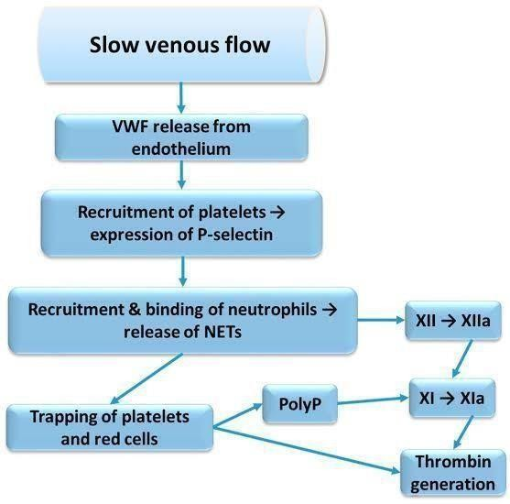

Figure 1: The image shows a flowchart illustrating the process of thrombosis.⁷

CLINICAL FEATURES:

Signs of DVT on physical examination include tenderness, warmth, erythema, cyanosis, edema, palpable thrombotic vein and superficial venous dilatation. If the upper portion of the calf becomes uncomfortable due to abrupt dorsiflexion of the ankle joint while the knee is flexed to 30°; this is known as the Homans sign. Coughing or sneezing that worsens pain along a thrombotic vein is known as the Louvel sign. When a sphygmomanometer cuff is inflated around each calf, the Lowenberg sign shows that pain is felt in the affected calf at a lower pressure than in the unaffected one.¹⁶ The clinical features of PE include shortness of breath and chest pain (commonly pleuritic) and DVT includes leg pain, unilateral swelling, leg-related sleep problems, skin discoloration, cosmetic appearance, activity limitation and emotional distress.¹⁷

COMPLICATIONS: Venous thromboembolism (VTE) complications include post-thrombotic syndrome (PTS), a chronic illness that develops after deep vein thrombosis (DVT) and pulmonary hypertension, commonly referred to as chronic thromboembolic pulmonary hypertension (CTEPH), which can be caused by unresolved pulmonary emboli. Signs and symptoms of post-thrombotic syndrome can vary from patient to patient, and proximal DVT is more likely to develop post thrombotic syndrome than calf or popliteal vein DVTs.¹⁸

DIAGNOSIS: The initial diagnostic step for determining of VTE is the clinical probability assessment.
Clinical assessment: For suspected DVT, the Wells score has been well established.¹⁹
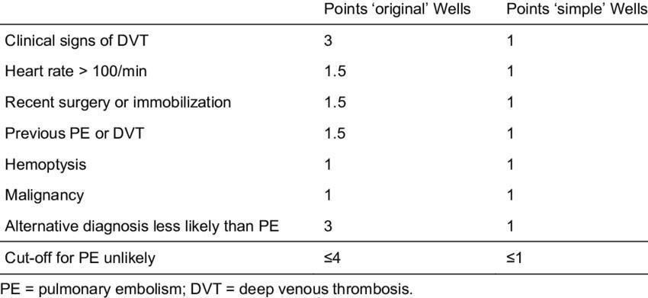
Table 1- The clinical probability assessment model
Based on the clinical model, the pre-test probability may be predicted for patients with clinical features based on this clinical model. The chance of DVT is probable if the score is ≥2, PE is likely if the score is ≥4, and PE is unlikely if the score is ≥4.
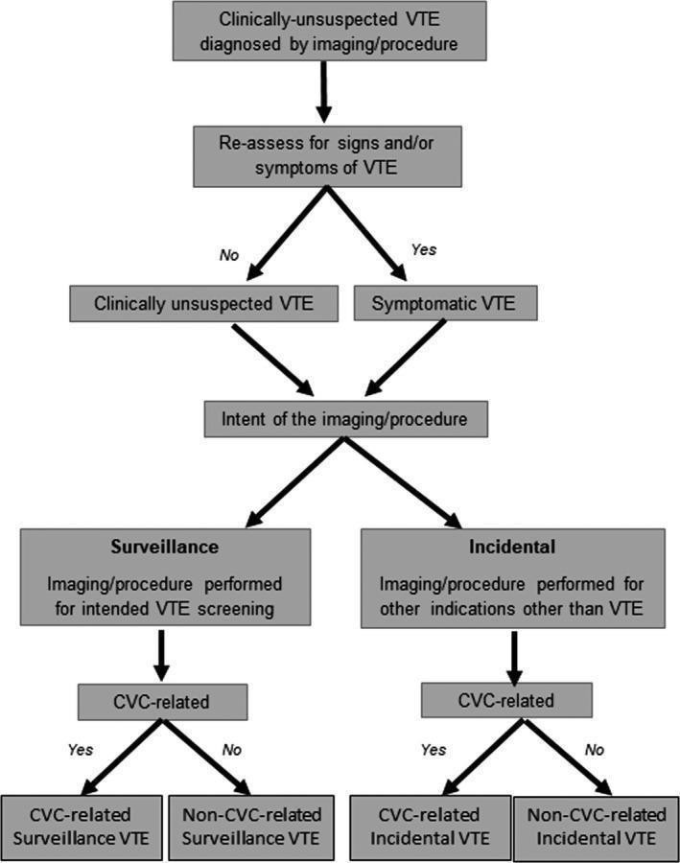

FIGURE 2: Diagnosis and management of clinically unsuspected venous thromboembolism²⁰

PROBLEMS WITH CURRENT DIAGNOSTICS:
Contrast venography is no longer suitable as the first diagnostic test for the assessment of symptoms that point to acute DVT since it is invasive and requires contrast material. Even in high-risk individuals, DVT cannot be accurately identified based only on the history and physical examination, according to numerous clinical studies.²¹ Erythema, warmth, discomfort, swelling, or tenderness are frequently absent in patients with lower extremity DVT. For instance, when five clinical investigations were evaluated, the specificity ranged from 3 to 87% and the sensitivity of calf pain for acute DVT varied from 66 to 91%.²¹ The most accurate methods for diagnosing PE are computed tomography pulmonary angiography and ventilation-perfusion scans; however, ultrasonography is utilized to diagnose lower or upper extremity DVT. In order to confirm clinical decision guidelines for patients with suspected recurrent VTE, proper diagnostic marker is need of the hour.

PLETHYSMOGRAPHY:
The recording of changes in limb size caused by tissue fluid or pooled blood in the veins is known as plethysmography. There are several techniques to carry out this measurement: electrical impedance, strain gauge, and photoplethysmography.²² D dimer tests and plethysmography are screening tests for deep vein thrombosis.
Final examinations for deep vein thrombosis is definitively diagnosed with investigations that visualize the thrombus. Magnetic resonance imaging, computed tomography, contrast venography, and ultrasonography are some of these tests. Contrast venography has been the gold standard for diagnosing deep vein thrombosis.¹⁶ However, there is a slight danger of an allergic reaction or venous thrombosis, this treatment is invasive, and it is not always technically feasible.²² Higher initial CRP levels (pCRP as a dichotomized variable) in patients with primary ICH are significantly associated with an increased risk of LEDVT and may help identify high-risk patients with LEDVT.²³

WHOLE-EXOME SEQUENCING:
In families with an unexplained propensity for venous thromboembolism (VTE), whole-exome sequencing (WES) may promote the identification of low-frequency variations in genes known to contribute to hemostasis or linked to symptoms associated with VTE.²⁴ (CRP Leu61Pro, F2 Asn514Lys, SERPINA1 Arg63Cys, THBS1 Asp901Glu, VWF Arg1399His, and PLAT Arg164Trp).²⁴

D-DIMER ASSAY:
D-dimer, a fibrin-specific breakdown product that identifies crosslinked fibrin from endogenous fibrinolysis and consequently deep vein thrombosis (DVT) is measured. Numerous investigations have demonstrated that this assay is a relatively sensitive but nonspecific marker for DVT with a strong negative predictive value. ²⁵
There are several d-dimer assays used in clinical settings. The SimpliRED whole blood agglutination test and the laboratory-based VIDAS enzyme linked immunosorbent assay (ELISA) are two of the most predominant assays followed world over.²⁶ The SimpliRED test is appropriate for near-patient testing and yields a qualitative answer (positive or negative) in ten minutes. Recently, an immunochromatography d-dimer test (Simplify) that is appropriate for near-patient testing was also introduced; however, no published studies have assessed the test’s utility²⁷

LIMITATIONS OF D-DIMER:
Plasma D-dimer levels can be raised by pregnancy, aging, trauma, cancer, inflammation, and a number of other clinical conditions. However, in patients with acute VTE, D-dimer levels may not rise for a number of reasons (impaired fibrinolytic activity, use of heparin or oral anticoagulants, onset of symptoms more than two weeks prior to blood sampling). These elements contribute to the high sensitivity but low specificity of D-dimer testing for acute VT diagnosis.²⁸

P SELECTIN:
Cell-cell interactions mediating leukocyte trafficking, thrombogenesis and inflammation are crucial for the host defense mechanism. the types of cellular adhesion molecules known as selectins (CD62) are known to bind to complex sugar (carbohydrate) patterns across the cell membrane. The majority of leukocytes express L-selectin; platelets and endothelial cells express P-selectin ²⁹

P-selectin is known to be the primary indicator of platelet activation and may have a role in thrombosis, inflammation, proliferation, and adherence of cancer cells.³⁰ Additionally, it facilitates the adherence of cancer cells to stimulated endothelial cells and the heterotypic aggregation of activated platelets to cancer cells. The significance of P selectin-mediated cell adhesive contacts in the pathophysiology of inflammation, thrombosis, cancer growth, and metastasis has been well illustrated using P-selectin mutant mice.³⁰

ROLE OF P SELECTIN IN THROMBOSIS:
This type-1 transmembrane protein is encoded by the human Selectin-P (SELP) gene. It is produced by megakaryocytes and endothelial cells, and endothelial cells package it. Weibel-Palade bodies and platelet alpha granules. The majority of leukocytes include P selectin glycoprotein ligand-1 (PSGL-1), which is the primary ligand for P-selectin. Additionally, P-selectin binds platelet glycoprotein (Gp) 1b, which promotes adhesion and rolling of leukocytes and platelets.³¹ In addition, P-selectin promotes tissue factor expression on monocytes and causes the production of procoagulant microparticles. These two activities increase thrombosis. In individuals with unprovoked VTEP, PSGL-1 plus micro vesicles, which come from monocytes and endothelial cells, are increased. Platelet-derived PSGLselectin expression also stabilizes the initial glycoprotein. Large, stable platelet aggregates are formed as a result of IIb/IIIa-fibrinogen interactions.³²

P SELECTIN MARKER IN VENOUS THROMBOEMBOLISM:

Numerous studies have assessed its soluble form as a biomarker for VTE, despite the fact that the membrane-associated P-selectin is the primary contributor to the pathophysiology of DVT. In situations when sP-selectin is present as a monomer that is insufficient to interact with its functional ligands, membrane P-selectin forms dimers or oligomers to boost leukocyte membrane binding, resulting in significant inflammatory and thrombotic reactions. The primary source of sP-selectin is the proteolytic cleavage of transmembrane P-selectin, which is released from endothelial cells and activated platelets. Elevations of sP-selectin have been linked to VTE and, when compared to D-dimer, have been suggested as a biomarker with superior diagnostic performance.³³
In a prospective experiment, sP-selectin >90 ng/ml showed a 100% positive predictive value for the diagnosis of DVT when paired with a Wells Score ≥2. Low probability of sP-selectin levels of less than 60 ng/ml. Given that obesity is a risk factor for VTE, a recent study raises the possibility that sP-selectin contributes to VTE in obese people.³⁴
P-selectin inhibition reduced vein wall fibrosis. P-selectin might be helpful in identifying individuals for whom anticoagulation is recommended and could play a part in the early risk stratification of VTE mainly in cancer patients.³⁵ Compared to patients without a VTE recurrence, those who experienced one showed noticeably greater levels of sP-selectin.³⁵

PREVENTION AND TREATMENT:

Numerous conventional and novel anticoagulant generations are the primary components of the pharmaceutical methods. Various coagulation cascade phases are the focus of different pharmacological therapies for VTE. Vitamin K antagonists, low-molecular-weight heparin, and unfractionated heparin are examples of traditional anticoagulants that target distinct stages. Even so, certain coagulation pathways are targeted by the current generation of anticoagulants, such as fondaparinux, rivaroxaban, apixaban, dabigatran etexilate, and rNAPc2 (recombinant nematode anticoagulant protein c2).³⁷
Vitamin K antagonists, low molecular weight heparin, and unfractionated heparin (UFH) are examples of conventional anticoagulants used to treat VTE. Novel Anticoagulants for the Management of VTE These anticoagulants target particular coagulation cascade phases, including thrombin, activated protein C, soluble thrombomodulin, factor VIIa/tissue factor, and factor Xa. They may be a viable substitute for warfarin, Nematode Anticoagulant Protein c2 (NAPc2), Fondaparinux, Rivaroxaban, Apixaban, and Dabigatran Etexilate, as they have demonstrated efficacy in phase II and III trials for the long-term therapy of VTE.³⁷

Mechanical approaches, which are non-pharmacological therapies, such as inferior vena cava filters, intermittent pneumatic compression devices, and graduated compression stockings, have the benefit of managing VTE without posing a risk of bleeding. Compression stockings that are graduated by applying more pressure at the ankle than farther up the leg, graduated compression stockings lessen blood pooling in the deep veins, which can speed up blood flow to the heart. Compression bandages or medical compression stockings are advised for patients with acute proximal DVT treated with LMWH in order to aid in their recovery from discomfort and swelling.³⁵ Devices for Intermitted Pneumatic Compression in order to encourage venous return, intermittent pneumatic compression devices use cyclic inflation and deflation^{. 38}

CONCLUSION:
Venous thromboembolism is not a rare and is associated with high rates of morbidity and mortality. It occurs when there is formation of blood clot in a vein. It includes two entities deep vein thrombosis and pulmonary embolism. Venous wall injury, stasis, and hypercoagulability are the three main pathophysiological factors that contribute to venous thromboembolism which constitute the Virchow’s triad. Weil’s score and D dimer assay are the main tools used in screening and diagnosis of venous thromboembolism. Definitive investigations include contrast venography, ultrasonography, computed tomography, and magnetic resonance imaging.

P selectin is under extensive research to be included as a biomarker as it has been noted to acts a biomarker showed a 100% positive predictive value for the diagnosis of DVT when paired with a Wells Score ≥2. Further research to evaluate the role of P selectin as a marker for early detection of venous thrombosis is a necessary event to be carried out in larger population to establish as a novel marker for detection of venous thrombosis.

Disclaimer (Artificial intelligence)
Author(s) hereby declare that NO generative AI technologies such as Large Language Models (ChatGPT, COPILOT, etc.) and text-to-image generators have been used during the writing or editing of this manuscript.

REFERENCES:

- Dubois-Silva, Álvaro et al. “Deep vein thrombosis symptoms and 30-day mortality in acute pulmonary embolism.” European journal of internal medicine vol. 108 (2023): 43- 51.
- Virchow R. Cellular pathology. As based upon physiological and pathological histology. Lecture XVI--Atheromatous affection of arteries. 1858. Nutr Rev. 1989;47(1):23-25.
- Clagett GPAnderson FA JrHeit J et al. Prevention of venous thromboembolism. Chest. 1995; 108(suppl) 312S- 334S
- Kahn, S R. “The clinical diagnosis of deep venous thrombosis: integrating incidence, risk factors, and symptoms and signs.” Archives of internal medicine vol. 158,21 (1998): 2315-23
- Torbicki, Adam et al. “Guidelines on the diagnosis and management of acute pulmonary embolism: the Task Force for the Diagnosis and Management of Acute Pulmonary Embolism of the European Society of Cardiology (ESC).” European heart journal vol. 29,18 (2008): 2276-315
- The Impact of Venous Thromboembolism on Mortality and Morbidity During Nephrectomy for Renal Mass. Urology. 2022; 168:122-128
- Turpie, Alexander G G et al. “Venous thromboembolism: pathophysiology, clinical features, and prevention.” BMJ (Clinical research ed.) vol. 325,7369 (2002): 887-90.
- Moheimani, Fatemeh, and Denise E Jackson. “Venous thromboembolism: classification, risk factors, diagnosis, and management.” ISRN hematology vol. 2011 (2011): 124610. Bonderman, D et al. “Risk factors for chronic thromboembolic pulmonary hypertension.”The European respiratory journal vol. 33,2 (2009): 325-31.
- Abdel Hammed MR, Ahmed YA, Adam EN, et al. (2022). sVCAM-1, and TGFβ1 in chronic phase, chronic myeloid leukemia patients treated with tyrosine kinase inhibitors. Egypt J Immunol. Oct;29(4):163-173. PMID: 36208045
- González-Ordóñez AJ, Fernández-Carreira JM, Fernández-Alvarez CR, Venta Obaya R, Macías-Robles MD, González-Franco A, Arias Garcìa MA. The concentrations of soluble vascular cell adhesion molecule-1 and lipids are independently associated with venous thromboembolism. Haematologica. 2003 Sep;88(9):1035-43

- Mohammed D, Khallaf S, El-Naggar M. et al. (2021). Interleukin-10: A Potential Prognostic Marker in Patients with Newly Diagnosed Multiple Myeloma. Research in Oncology. 17(1): 38-41. doi: 10.21608/resoncol.2021.51503.1127
- Fergany, Aya1; Hassanein, Khaled M.2; Zahran, Asmaa M.3; Abdel Hameed, Muhamad R.4; Kamel, Ayat M.5. Clinical significance of interleukin 10, interleukin 33, and interleukin 35 on induction chemotherapy in acute myeloid leukemia patients. The Egyptian Journal of Haematology 50(1):p 125-132, January-March 2025. | DOI: 10.4103/ejh.ejh_83_24
- Zhang Y, Miao X, Zhang Z, Wei R, Sun S, Liang G, Li H, Chu C, Zhao L, Zhu X, Guo Q, Wang B, Li X. miR-374b-5p is increased in deep vein thrombosis and negatively targets IL-10. J Mol Cell Cardiol. 2020 Jul;144:97-108. doi: 10.1016/j.yjmcc.2020.05.011. Epub 2020 May 21. PMID: 32445843.
- Abdel Hammed MR, Elgendy SG, El-Mokhtar MA, Sayed D, Mansour SM, Darwish AM. T-lymphocytes Expression of Toll-like Receptors 2 and 4 in Acute Myeloid Leukemia Patients with Invasive Fungal Infections. Mediterr J Hematol Infect Dis. 2022 Mar 1;14(1):e2022022
- Catherine A Lemarie, Sandrine Laurance, Mark Blostein; Toll-Like Receptor 3 Activation Is Involved in Venous Thrombosis Development, Blood 2011; 118 (21): 3277. doi: https://doi.org/10.1182/blood.V118.21.3277.3277
- Leclerc JRIllescas FJarzem P Diagnosis of deep vein thrombosis. Leclerc JRed. Venous Thromboembolic Disorders. Philadelphia, Pa Lea & Febiger1991;176- 228
- Hudgens, Stacie A et al. “Deep vein thrombosis: validation of a patient-reported leg symptom index.” Health and quality of life outcomes vol. 1 76. 15 Dec. 2003,
- Labropoulos, Nicos et al. “The effect of venous thrombus location and extent on the development of post-thrombotic signs and symptoms.” Journal of vascular surgery vol. 48,2 (2008): 407-12
- Gibson NS, Sohne M, Kruip MJ, et al. Further validation and simplification of the Wells clinical decision rule in pulmonary embolism. Thromb Haemost. 2008;99(1):229-234

- Caprini, Joseph A et al. “Laboratory markers in the diagnosis of enous thromboembolism.” Circulation vol. 109, 12 Suppl 1 (2004): I4-8
- Tovey C, Wyatt S. Diagnosis, investigation, and management of deep vein thrombosis. BMJ. 2003;326(7400):1180-1184.
- Tapson VF, Carroll BA, Davidson BL, et al. The diagnostic approach to acute venous thromboembolism. Clinical practice guideline. American Thoracic Society. Am J Respir Crit Care Med. 1999;160(3):1043-1066.
- Wang, Gang et al. “C-reactive protein is a predictor for lower-extremity deep venous thrombosis in patients with primary intracerebral hemorrhage.” European journal of medical research vol. 29, 1 311. 6 Jun. 2024
- Lunghi B, Ziliotto N, Balestra D, Rossi L, Della Valle P, Pignatelli P, Pinotti M, D'Angelo A, Marchetti G, Bernardi F. Whole-Exome Sequencing in a Family with an Unexplained Tendency for Venous Thromboembolism: Multicomponent Prediction of Low-Frequency Variant Deleteriousness and of Individual Protein Interaction. Int J Mol Sci. 2023 Sep 7;24(18):13809
- Imberti D. D-dimer testing: advantages and limitations in emergency medicine for managing acute venous thromboembolism. Intern Emerg Med. 2007;2(1):70-71
- John MA, Elms MJ, O'Reilly EJ, Rylatt DB, Bundesen PG, Hillyard CJ. The simpliRED D dimer test: a novel assay for the detection of crosslinked fibrin degradation products in whole blood. Thromb Res. 1990 May 1;58(3):273-81.
- Akinshina YA, Nikitina AV, Amelina EA, Mardanly SG. [Immunochromatographic test for determination of D-dimer.]. Klin Lab Diagn. 2019;64(11):654-658.
- Brotman DJ, Segal JB, Jani JT, Petty BG, Kickler TS. Limitations of D-dimer testing in unselected inpatients with suspected venous thromboembolism. Am J Med. 2003 Mar;114(4):276-82.
- Takada YK, Simon SI, Takada Y. The C-type lectin domain of CD62P (P-selectin) functions as an integrin ligand. Life Sci Alliance. 2023 Apr 25;6(7):e202201747.
- Purdy M, Obi A, Myers D, Wakefield T. P- and E- selectin in venous thrombosis and non- venous pathologies. J Thromb Haemost. 2022;20(5):1056-1066.
- Jamaly S, Basavaraj MG, Starikova I, Olsen R, Braekkan SK, Hansen JB. Elevated plasma levels of P-selectin glycoprotein ligand-1-positive microvesicles in patients with unprovoked venous thromboembolism. J Thromb Haemost. 2018 May 31.
- Théorêt JF, Chahrour W, Yacoub D, Merhi Y. Recombinant P-selectin glycoprotein-ligand-1 delays thrombin-induced platelet aggregation: a new role for P-selectin in early aggregation. Br J Pharmacol. 2006 Jun;148(3):299-305.
- Ramacciotti E, Blackburn S, Hawley AE, Vandy F, Ballard-Lipka N, Stabler C, Baker N, Guire KE, Rectenwald JE, Henke PK, Myers DD Jr, Wakefield TW. Evaluation of soluble P-selectin as a marker for the diagnosis of deep venous thrombosis. Clin Appl Thromb Hemost. 2011 Aug;17(4):425-31
- De Pergola G, Pannacciulli N, Coviello M, Scarangella A, Di Roma P, Caringella M, Venneri MT, Quaranta M, Giorgino R. sP-selectin plasma levels in obesity: association with insulin resistance and related metabolic and prothrombotic factors. Nutr Metab Cardiovasc Dis. 2008 Mar;18(3):227-32.
- G Sorici, N Diaconu, I Civirjic, A Plugaru, M Gorohova, R Ambroci, V Caraus, I Ivanes, A Grosu, Evaluation of Genetic Parameters and P-Selectin as Potential Prognostic Biomarkers in Venous Thromboembolism, P-Selectin - predictor of venous thromboembolism in cancer patients?, European Heart Journal, Volume 46, Issue Supplement_1, November 2025, ehaf784.4148

- Geng JG, Chen M, Chou KC. P-selectin cell adhesion molecule in inflammation, thrombosis, cancer growth and metastasis. Curr Med Chem. 2004;11(16):2153-2160.
- Cohen AT, Imfeld S, Rider T. Phase III trials of new oral anticoagulants in the acute treatment and secondary prevention of VTE: comparison and critique of study methodology and results. Adv Ther. 2014;31(5):473-493.
- Phalak MO, Chaudhari AK, Gurnani S. Non-pharmacological Methods of Deep Vein Thrombosis Prophylaxis in Orthopaedic Wards. Cureus. 2024 Nov 7;16(11):e73255.

