Determination of Engineering Properties and Mechanical Properties of Drumstick Pod (Moringa oleifera): An Experimental Study

Abstract
The lack of sufficient knowledge about the physical and mechanical properties of agricultural products often leads to higher postharvest losses. Given the importance of the drumstick pod (Moringa oleifera) and the limited information available on its engineering characteristics, this study was conducted to bridge this gap. The research aimed to determine the physical and mechanical properties of drumstick pods to aid in the design and optimization of harvest and postharvest machinery. The engineering properties evaluated included length, width, thickness, arithmetic and geometric mean diameters, mass, sphericity, surface area, and aspect ratio. Mechanical characterization was performed using a Texture Analyzer testing machine following standard procedures to measure the cutting strength of drumstick pod halves of varying lengths. The mean values obtained for geometric mean diameter, surface area, and sphericity were 14.28 mm, 1.186 mm², and 0.45%, respectively. The maximum force required for cutting the drumstick pod was 200.43 N. The results on the engineering and mechanical properties of the drumstick pod provide valuable data for designing harvesting and peeling machine for drumstick pod to reducing post-harvest waste and supporting the mechanization in food processing industry.
Keywords:- Drumstick; Food physical properties; Mechanical properties; Peeling;
1. Introduction
Moringa oleifera, commonly referred to as drumstick, is primarily cultivated for its tender pods, which are widely consumed as a vegetable in South Indian cuisine due to their distinct and appealing flavor. The species is known by various vernacular names across India, including Saijan (Hindi), Shevaga (Marathi), Murungai (Tamil), Muringa (Malayalam), and Munagakaya (Telugu). Moringa oleifera, commonly known as drumstick, originated in northern India and has spread across tropical and subtropical regions worldwide due to its rapid growth and exceptional drought tolerance. This versatile plant serves multiple roles, including as a nutrient-rich food source for humans and livestock, a medicinal herb with antimicrobial properties effective against various diseases, and an asset for environmental and industrial applications such as water purification and biofuel production. Its leaves, pods, and seeds boast a rich chemical profile featuring proteins, vitamins, minerals, and bioactive compounds like flavonoids and glucosinolates, while bio-ecological traits such as thriving in 25–35°C with minimal rainfall and nitrogen-fixing roots enhance soil fertility and adaptability. Despite these benefits, Moringa faces pest challenges from aphids, pod borers, and fungal pathogens, necessitating integrated management strategies; this paper explores its geographical distribution, bio-ecology, composition, uses, and pest constraints to underscore its potential in sustainable agriculture (Outani et al., 2023). M. oleifera a exhibits remarkably high levels of vital nutrients when compared to commonly consumed food items: it contains 7 to 10 times more vitamin C than oranges, 10 times more vitamin A than carrots, 17 times more calcium than milk, 9 times more protein than yogurt, 15 times more potassium than bananas, and 25 times more iron than spinach (Rockwood et al., 2013). Moringa oleifera has been extensively recognized for its role in combating malnutrition, particularly among vulnerable groups such as infants and lactating mothers. Several studies have demonstrated that the leaves of M. oleifera retain their nutritional integrity when consumed in various forms including raw, boiled, or as dried powder making them a practical dietary supplement across seasons (Oyeyinka et al., 2018).
Moringa oleifera stands out as a highly valuable food crop due to its exceptional nutritional profile and remarkable adaptability to extreme conditions, including drought and heavy rainfall. This fast-growing species requires minimal maintenance and outpaces many other plants in development speed. Beyond nutrition, it offers multifaceted benefits in developing regions like India, Pakistan, the Philippines, Hawaii, and parts of Africa, where its wood supports crafting applications and its seeds enable effective water purification. The pods, in particular, rank among the most nutrient-dense parts, boasting high levels of proteins, essential amino acids, calcium, potassium, vitamins, and micronutrients that support physiological functions, promote overall health, and aid in preventing or treating various diseases (Adeeyo et al., 2013).
The introduction of the annual cultivar PKM-1 marked a significant advancement in moringa cultivation. This variety has largely supplanted traditional perennial types in South India, owing to its superior adaptability to diverse agro-climatic and soil conditions. PKM-1 demonstrates robust growth even in marginal lands characterized by high temperatures and limited water resources, where cultivation of conventional crops is often unfeasible (Nouman et al., 2014).
Moringa oleifera is widely used in traditional medicine for its diverse healing properties. It helps treat respiratory, infectious, neurological, gastrointestinal, and metabolic disorders, supports reproductive and lactation issues, and provides anti-inflammatory and immune-boosting benefits, making it valuable in both preventive and curative healthcare (Mishra et al., 2012).
Moringa oleifera, widely recognized as a medicinal plant, has garnered extensive research on its leaves' functional attributes, yet its pods—commonly consumed in India and beyond—remain underexplored. This research evaluates how different drying techniques influence the proximate composition, color profile, ascorbic acid levels, solubility, water absorption capacity, phenolic and flavonoid contents, along with in vitro antioxidant and antidiabetic effects in Moringa pod pulp powder (MPP). Results indicate notable differences across freeze drying, microwave drying, oven drying, and sun drying: freeze drying maintains superior moisture retention and maximizes ascorbic acid preservation, while oven drying yields the lowest moisture; macronutrients like carbohydrates, proteins, fats, ash, and fiber show stability regardless of method, affirming MPP's nutritional reliability. Freeze-dried MPP demonstrates enhanced solubility, absorption, total phenolics, and flavonoids, coupled with the strongest antioxidant capacity and antidiabetic inhibition against α-amylase, α-glucosidase, and ACE enzymes. These outcomes emphasize the critical role of drying techniques in retaining MPP's bioactive quality, positioning it as a promising functional ingredient for food and pharmaceutical sectors (Shivana et al., 2024).
Agricultural products often experience losses during different stages such as harvesting, handling, transportation, and processing due to unexpected mechanical loads and stresses. Additionally, many processing operations involve applying force through cutting or compression, which can lead to damage if not properly controlled. Therefore, understanding and evaluating the physical and mechanical characteristics of agricultural materials is essential to minimize mechanical damage, reduce losses throughout harvesting and post-harvest stages, and improve the design and efficiency of processing equipment (Akbarnejad, Azadbakht, & Asghari, 2017; Vishwakarma, Shivhare, & Nanda, 2012).
Efficient processing and safe transportation of agricultural products depend on accurate knowledge of their physical characteristics, including dimensions, form, porosity, surface area, and density (Jahanbakhshi, Yeganeh, & Akhoundzadeh Yamchi, 2016; Topuz, Topakci, Canakci, Akinci, & Ozdemir, 2005).
Density and porosity play a key role in determining structural loads and are vital considerations when designing storage and drying systems (Mpotokwane, Gaditlhatlhelwe, Sebaka, & Jideani, 2008). The stiffness characteristics of agricultural materials serve as indicators of their susceptibility to mechanical damage. Additionally, properties such as weight, volume, density, and geometric mean diameter are commonly used to describe and evaluate agricultural products (Goyal, Kingsly, Kumar, & Walia, 2007; Jahanbakhshi et al., 2016).
Kılıçkan and Güner (2008) investigated the physical and mechanical behavior of olive fruits when subjected to compressive forces. Their findings revealed that both specific deformation and rupture energy varied notably with changes in fruit size and deformation rate, with the greatest variations occurring along the longitudinal axis.
Several researchers have examined the physical and mechanical characteristics of various agricultural products, including banana (Akbarnejad et al., 2017), tomato (Reddy & Srinivas, 2017), crabapple (Altuntaş, 2015), scolymus (Jahanbakhshi et al., 2016), pomegranate (Jithender, Vyas, Abhisha, & Rathod, 2017), and cherry (Çalışır & Aydın, 2004).
The objective of this research is to examine selected engineering and mechanical properties of drumstick pods. The outcomes of this study are expected to contribute to the design and development of equipment and systems that enhance production efficiency while minimizing product loss and mechanical damage.
2. Materials and Methods
2.1 Determination of engineering properties of drumstick
In this study, only drumstick (Moringa oleifera) pods at full maturity were selected for analysis. Samples exhibiting any external defects, signs of immaturity, or physical damage were carefully excluded during sorting. To maintain the initial moisture content and physiological integrity prior to experimentation, the drumstick samples were transitioned from refrigerated storage to the laboratory environment to allow equilibration to ambient temperature. Subsequently, the samples underwent moisture determination using a universal moisture meter (AND MX-50 moisture analyzer, Japan), which offers a precision of 0.01%. The samples were subjected to drying at 105°C for a duration of three hours, conducted in five replications (Jahanbakshi et al., 2016). The weights of the samples were recorded before and after the drying process to calculate moisture content and dry matter. The moisture content and dry matter of the drumstick samples were subsequently determined using the mathematical expressions provided in Equations (1) and (2), respectively, as delineated by Moghadam and Kheiralipour (2015):
$MC=\frac{M_{w}-M_{d}}{M_{w}}×100,$ (1)

$DM=\frac{M_{d}}{M_{w}}×100,$ (2)
The variables are defined as follows: MC represents the moisture content of the drumstick expressed as a percentage (%), $M_{w}$ denotes the initial mass of the drumstick sample in grams (g), $M_{d}$ is the mass of the drumstick after drying, also in grams (g), and DM refers to the dry matter content of the drumstick expressed as a percentage (%).These measurements were conducted on samples maintained at their inherent natural moisture level prior to analysis.
A total of 10 drumstick samples were randomly chosen for physical property assessment. Their dimensions length (L), width (W), and thickness (T) were measured using a woven meter tape (Truvic Company) with a minimum measurement accuracy of 1 mm (Fig 1) and a digital caliper (Adoric 0-6'') providing precision up to 0.01 mm (Fig 2). The geometric mean diameter, arithmetic mean diameter, and sphericity of the samples were then computed using the formulas presented in Equations 3, 4, and 5, respectively.
$D_{g}=\sqrt[3]{L.W.T.}$ (3)
$D_{a}=\frac{L+W+T}{3},$ (4)
$∅=\frac{D_{g}}{L},$ (5)
The geometric mean diameter ($D_{g}$), arithmetic mean diameter ($D_{a}$), and sphericity ($ϕ$) of the drumstick samples were defined as follows: $D_{g}$ represents the size of a hypothetical sphere whose diameter reflects the combined dimensions of length, width, and thickness; $D_{a}$ is the simple average of these three linear dimensions; and $ϕ$ indicates the degree to which the drumstick shape approximates a sphere, measuring the ratio of the geometric mean diameter to the length. The surface area ($S$) and aspect ratio ($R_{α}$) of the drumstick were determined using Equations 6 and 7, respectively.
$S=π{rD_{g}}^{2}$, (6)
$R_{a}=\frac{W}{L}$, (7)
The mass of the drumstick was determined using a digital electronic balance (Luniya brand) featuring a sensitivity of 0.01 g (Mohsenin, 1986).
2.2 Determination Mechanical properties (Cutting Force) of drumstick
Cutting force evaluation was performed using a Texture Analyzer (TA HD Plus) equipped with a specialized cutting probe. Four drumstick pieces samples were randomly selected and individually placed on the cutting probe for testing (Warner-Bratzler and Guillotine). The analysis was conducted under compression mode with test parameters set to a speed of 2.00 mm/s, a travel distance of 16.00 mm, and a trigger force of 5.0 g. Each measurement was repeated four times to ensure data reliability, and all results were captured directly from the analyser’s system for subsequent analysis, all tests were carried out at a room temperature of 35-37 ⁰C. A single segment of drumstick pod was positioned on a slotted steel test platform (Fig. 3) for shear testing. Four pods were tested, and a force–deformation curve was recorded for each replicate. The shear characteristics of the drumstick pod were then derived from these individual force–deformation curves in accordance with standard mechanical testing practice for biological material. (Abbott 2004)

3. Results and Discussion
3.1 Engineering Properties
The engineering characteristics of drumstick samples were determined, and the results are summarized in Table 1. The average length, width, and thickness of the drumsticks were found to be 422 mm, 14.28 mm, and 11.75 mm, respectively. The arithmetic mean diameter was calculated as 22.74 mm, while the geometric mean diameter was 19.15 mm. The surface area of the samples averaged 1.186 mm². Sphericity and aspect ratio were recorded as 0.45% and 34.30%, respectively. The mean mass of the drumstick samples was measured as 0.044 g, moisture content of drumstick pod were determined 83.92 % respectively. The engineering properties of drumstick pods, including length, width, thickness, mean diameters, surface area, sphericity, aspect ratio, and mass, provide essential information for post-harvest handling, processing, and equipment design. The high length and low sphericity indicate that drumsticks are elongated and less spherical, which affects their flow, packing, and susceptibility to mechanical damage during transport and processing. The aspect ratio suggests that specialized handling systems may be required to minimize breakage. The measured mass and surface area are critical for optimizing packaging, storage, and drying protocols. These findings highlight the need for custom-designed machinery and handling methods to efficiently process drumstick pods, ensuring product quality and reducing losses during mechanical operation
Table 1. Engineering Properties of drumstick Pod
Parameter | Mean | Max | Min | SD | CV %
Length (mm) | 422 | 510 | 330 | 90.01 | 21.40
Width (mm) | 14.28 | 17.2 | 12.4 | 2.42 | 16.54
Thickness (mm) | 11.75 | 14.3 | 10.1 | 2.12 | 17.56
Arithmetic mean diameter (mm) | 22.74 | 25.50 | 20.33 | 2.59 | 11.32
Geometric mean diameter (mm) | 19.15 | 22.29 | 17.39 | 2.48 | 12.66
Sphericity (%) | 0.45 | 0.53 | 0.38 | 2.075 | 16.56
Surface area (mm²) | 1.186 | 1.279 | 1.113 | 0.083 | 6.98
Aspect ratio | 34.30 | 41.14 | 27.45 | 6.85 | 19.96
Mass (g) | 0.044 | 0.065 | 0.035 | 0.015 | 32.07
Moisture content (%) | 83.91 | 85.05 | 82.94 | 1.06 | 1.26

Table 2. Mechanical Properties of drumstick Pod in the cutting force test
Batch Test | Peak force (N) | Peak positive force (N)
T₁₁ | 28.63 | 231.99
T₁₂ | 87.90 | 253.63
T₁₃ | 4.73 | 4.73
T₁₄ | 54.60 | 311.23
Mean(g) | 43.93 | 200.43
S.D. (g) | 35.64 | 134.72
CV % | 81.13 | 67.19
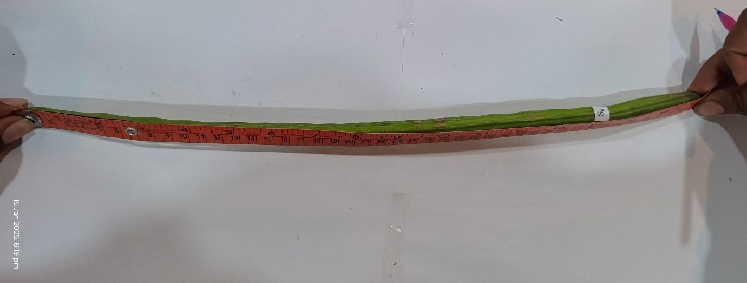Fig 1: Measuring Cloth Tape
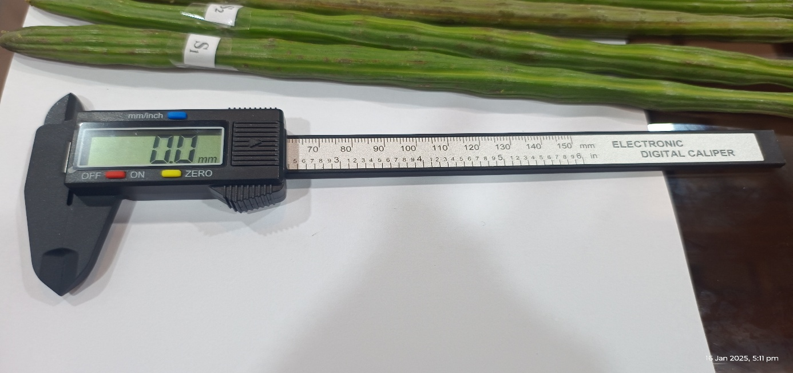
Fig 2: Vernier caliper
3.2 Mechanical properties
Table 2 show mechanical properties of drumstick pod, mechanical cutting force of the locally available PKM-1 variety drumstick pod was comprehensively determined using a Texture Analyzer (TA HD Plus) equipped with a P-5 probe (Fig. 3). The critical force parameters necessary for post-harvest management equipment design were recorded, showing the peak force and peak positive force to be 43.93N and 200.42N, respectively. The significant difference between these two values is primarily attributed to the irregular shape and non-uniform structural density of the drumstick pod, which causes fluctuating resistance during cutting. Furthermore, the cutting force is directly influenced by the moisture content of the pod. For processing applications, such as cutting the drumstick into smaller pieces, the maximum required forces were considerably higher, demanding a maximum peak force of 87.90N and a maximum peak positive force of 311.23N (Fig 4). These maximum values represent the essential design capacity for any mechanical cutting system to ensure consistent and complete sectioning of the pod.
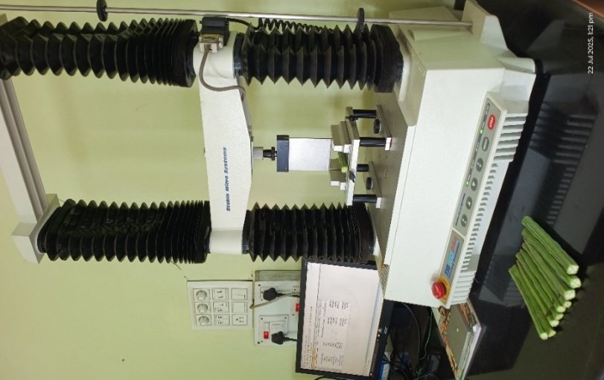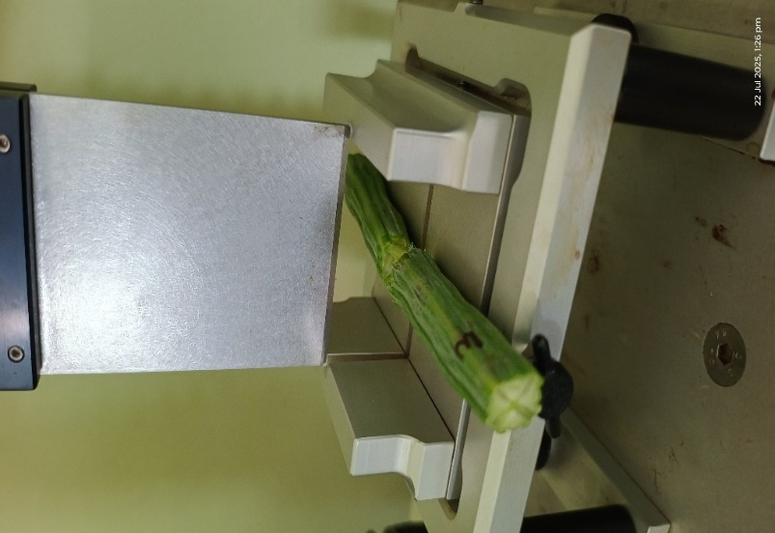
Fig 3: Cutting test of drumstick pod by using Texture analyser
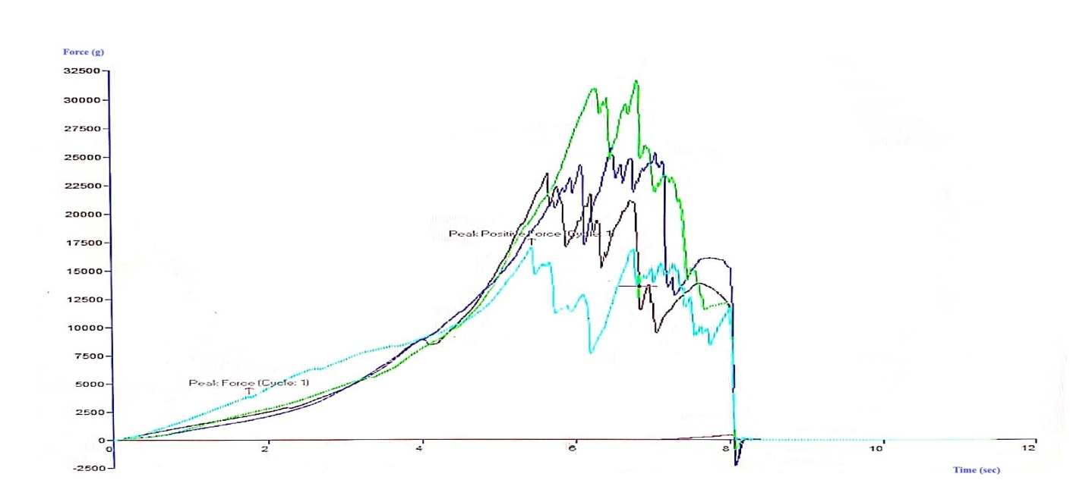
Fig 4: Force-time curve for cutting drumstick pod
4. Conclusion
- Engineering and mechanical properties of drumstick pods are essential for minimizing mechanical damage and designing efficient harvesting and post-harvest machinery.
- The maximum cutting force and peak positive force (43.93 N and 200.43 N, respectively) are key parameters for equipment design and operational optimization.
- Cutting force increases with higher moisture content (wet basis), influencing the design and operation of post-harvest tools.
- These findings support the development of machinery that adapts to varying pod conditions, improving efficiency and reducing product losses in post-harvest management.
- Disclaimer (Artificial intelligence)
Author(s) hereby declare that NO generative AI technologies such as Large Language Models (ChatGPT, COPILOT, etc.) and text-to-image generators have been used during the writing or editing of this manuscript.

REFRENCES
Adeeyo, O., Adefule, A. K., Ofusori, D. A., Aderinola, A. A., & Caxton-Martins, E. A. (2013). Antihyperglycemic effects of aqueous leaf extracts of mistletoe and Moringa oleifera in streptozotocin-induced diabetes Wistar rats. Diabetology Croatica, 2(2), 42-43.
Akar, R., & Aydin, C. (2005). Some physical properties of gumbo fruit varieties. Journal of Food Engineering, 66(3), 387–393. https://doi.org/10.1016/j.jfoodeng.2004.04.005
Altuntaş, E. (2015). The post-harvest engineering properties of Japan flowering crabapple (Malus floribunda) fruits. Agricultural Engineering International: CIGR Journal, 17(1), 264-272.
Bibata Ali Outani, Haougui Adamou, Ali Mahamadou, Patrick Delmas (2023). Moringa (Moringa oleifera Lam): a Review on its Importance Worldwide. East African Scholars J Agri Life Sci, 6(7), 112-120.
Çalışır, S., & Aydın, C. (2004). Some physico-mechanic properties of cherry laurel (Prunus lauracerasus L.) fruits. Journal of Food Engineering. 65(1), 145-150. https://doi.org/10.1016/j.jfoodeng.2004.01.011
Jahanbakhshi, A. (2018). Determination of some engineering proper-ties of snake melon (Cucumis melo var. flexuosus) fruit. Agricultural Engineering International: CIGR Journal, 20(1), 171-176.
Jahanbakhshi, A., Yeganeh, R., & Akhoundzadeh Yamchi, A. (2016). Determination of physical, mechanical and hydrodynamic proper-ties of Scolymus. Electronic Journal Food Processing and Preservation (EJFPP), 8(1), 125-141. https://doi.org/10.22069/ejfpp.2016.3139
Jaliliantabar, F., Lorestani, A. N., Gholami, R., Behzadi, A., & Fereidoni, M. (2011). Physical and mechanical properties of Oak (Quercus persica) fruits. Agricultural Engineering International: CIGR Journal, 13(4), 1-4
Jithender, B., Vyas, D. M., Abhisha, S., & Rathod, P. J. (2017). Determination of physical and mechanical properties of pomegranate (Var. bhagwa) fruit and Aril. International Journal of Current Microbiology and Applied Sciences, 6(10), 879–885. https://doi. org/10.20546/ijcmas.2017.610.105
Kılıçkan, A., & Güner, M. (2008). Physical properties and mechanical behavior of olive fruits (Olea europaea L.) under compression loading. Journal of Food Engineering, 87(2), 222–228. https://doi.org/10.1016/j.jfoodeng.2007.11.028
Moghadam, J. E., & Kheiralipour, K. (2015). Physical and nutritional properties of hawthorn fruit (Crataegus pontica L.). Agricultural EngineeringInternational: CIGR Journal, 17(1), 232–237.
Mohsenin, N. (1986). Physical properties of plant and animal materials (2nd ed.). New York, NY: Gordon and Breach Science Publishers.
Mishra, S.P., P. Singh and S. Singh (2012). Processing of Moringa oleifera leaves for human consumption. Bulletin of Environment, Pharmacology, and Life Sciences. 2:28-31.
Mpotokwane, S. M., Gaditlhatlhelwe, E., Sebaka, A., & Jideani, V. A. (2008). Physical properties of bambara groundnuts from Botswana. Journal of Food Engineering, 89(1), 93–98. https://doi.org/10.1016/j.jfoodeng.2008.05.006
Nouman, W., M. T.Siddiqui, S. M. A. Basra, H. Farooq, M. Zubair and T. Gull (2013). Biomass production and nutritional quality of Moringa oleifera as field crop. Turk. J. Agric. For., 37: 410–419. https://doi.org/10.3906/tar-1208-63
Oyeyinka, A.T., & Oyeyinka, S.A. (2018). Moringa oleifera as a food plant with multiple medicinal uses. Phytotherapy Reserch, 32(8), 1171-1182. https://doi.org/10.1002/ptr.6057
Shivana S.K., Naik L., Rao P.S., (2024). Impact of drying techniques on the composition, physicochemical attributes, antioxidant capacity, antidiabetic potential, and ACE inhibition properties of moringa oleifera pod pulp powder. South African Journal of Botany, 165 (2024)405-416. https://doi.org/10.1016/j.sajb.2024.01.008sciencedirect
Vishwakarma, R. K., Shivhare, U. S., & Nanda, S. K. (2012). Physical properties of guar seeds. Food and Bioprocess Technology, 5(4), 1364– 1371. https://doi.org/10.1007/s11947-011-0514-x

