Effect of Baking Powder and Dough Resting Time on the quality attributes of pearl millet based biscuit
Abstract
Purpose: This study aimed to evaluate the effects of baking powder levels and dough resting time on the nutritive, sensory and textural properties of biscuits, with a focus on pearl millet-based formulations.
Design/methodology/approach: Biscuits were prepared with varying levels of baking powder (0.25%, 0.5%, and 0.75%) and different dough resting times (20, 30, and 40 minutes), and their proximate, spread ratio, hardness, color, and overall acceptability were assessed.
Findings: Results showed that baking powder level and resting period had effect on the composition of biscuit. Further, baking powder and resting time did not impact most sensory attributes, higher baking powder levels resulted in increased lightness and reduced redness and yellowness of the biscuits. The spread ratio increased with a 30-minute resting time (5.09-5.46) but decreased with longer resting durations due to the escape of trapped carbon dioxide. The hardness of the biscuits was influenced by baking powder levels, with higher levels leading to a crisper texture. Additionally, pearl millet-based biscuits exhibited improved nutritional quality compared to wheat-based biscuits, providing a valuable alternative for health-conscious consumers. Overall, up to 0.75% baking powder and a 20-minute resting time were optimal for producing biscuits with desirable sensory and textural properties, enhancing both their quality and nutritional value.
Originality: The study investigates the combined effect of varying baking powder levels and dough resting times on the quality characteristics of pearl millet biscuits. The work identifies optimal processing conditions to improve texture, appearance, and nutritional quality, providing a value-added alternative to conventional wheat-based biscuits.
Keywords: Millets, Baking, Food Processing, Nutritional Value, Sensory Evaluation
Introduction
Biscuit production is a complex process influenced by various ingredients and processing conditions that impact its sensory and textural qualities (Mamat and Hill, 2018). Among these, baking powder and dough resting time play pivotal roles in determining attributes such as spread ratio, hardness, color, and overall acceptability. The spread ratio, which indicates the degree of dough expansion during baking, and hardness, which measures the force required to break the biscuit, are crucial textural parameters that contribute to the biscuit's quality (Vinay & Singh 2025). Effect of ghee residue substitute of bakery fat on quality characteristics of pearl millet based biscuit. The inclusion of alternative ingredients, such as pearl millet flour, in biscuit formulations has garnered attention due to its nutritional and functional benefits, particularly in enhancing the product’s fiber, mineral, and antioxidant content (GM and Singh, 2024). Pearl millet, a drought-tolerant and nutrient-rich cereal grain, has recently gained popularity as a functional ingredient in biscuit formulations due to its superior nutritional profile compared to wheat (Vinay et al., 2025; G M et al., 2025).
The role of baking powder in biscuit production has been extensively studied, with several researchers highlighting its effects on dough leavening and texture. Baking powder, a leavening agent, releases carbon dioxide during baking, which promotes dough expansion and results in a lighter, airier texture. According to Canali et al. (2020), the level of baking powder significantly influences the spread ratio of biscuits, with higher levels generally leading to increased spread due to enhanced gas production. However, excessive baking powder can negatively affect the taste and texture, leading to an overly coarse or soapy flavor (Cauvain, 2017). The dough resting time also plays a crucial role in biscuit quality, with longer resting periods allowing for better gas retention and ingredient interaction, leading to improved texture and uniform expansion (Baldino et al., 2014).
In terms of textural properties, the spread ratio and hardness are critical indicators of biscuit quality. The spread ratio is influenced by the balance of ingredients, such as the flour-to-fat ratio, as well as baking conditions. Sahinet al. (2021) reported that increased resting time of the dough led to higher spread ratios in wheat-based biscuits, while excessive resting time resulted in decreased spread due to the escape of trapped gases. Similarly, hardness is an important measure of biscuit crispness, and while many factors influence it, the amount of leavening agent, hydration, and resting time all contribute to the final product's texture (Arepally et al., 2020)
This study aims to evaluate the impact of baking powder and dough resting time on the sensory and textural properties of biscuits, specifically focusing on pearl millet biscuits, which are considered a healthier alternative to traditional wheat-based biscuits.
Materials and Methods
Materials
Pearl millet flour and refined wheat flour were procured from a local commercial supplier in Anand, Gujarat, India. All reagents and chemicals employed throughout the experimental procedures were of analytical grade and were obtained from reputable suppliers, namely Loba Chemie (Mumbai, India) and Molychem (Mumbai, India). The use of analytical-grade chemicals ensured the reliability, reproducibility, and integrity of the experimental analyses conducted in this study.
Biscuit preparation
The biscuits were prepared using the creaming method, as described by Vinay (2023). Briefly, 40% bakery fat was creamed at high speed until smooth, followed by the gradual addition of 40% icing sugar, which was blended thoroughly. Baking powder was added at the level of 0.25, 0.5 &0.75%. The dry ingredients were then sifted and incorporated into the fat-sugar mixture, and water was added to form a smooth dough. The resulting dough was rested for 20, 30 and 40 minutes. The dough was sheeted to the desired thickness and cut into round shapes using a mould. The biscuits were then baked at 180°C for 12 minutes.
Proximate composition
The moisture, fat, fat acidity, ash, acid-insoluble ash, and protein content were determined following the standard protocols outlined by AOAC (2016).
Colour
The colour of the biscuits was measured using a Lovibond Color Lab (RT850i). The instrument was calibrated with standard black and white references to ensure accuracy. The L*, a*, and b* values were recorded in triplicates to assess the lightness, redness, and yellowness of the biscuits, providing a comprehensive analysis of their colour attributes.
Spread ratio
The spread ratio was determined by stacking six biscuits and measuring their thickness. The average ratio of the biscuit diameter to thickness was calculated to determine the spread ratio.
Hardness
Hardness was measured using a texture analyzer equipped with a cutting blade. The cutting blade was fitted with a 5 kg load cell on a texture analyzer (Model: TA-HD Plus, Make: Stable Micro Systems, Surrey, UK). The maximum force required to break the biscuit was determined by analyzing the force-distance curve obtained during the test (Tyagi et al., 2007).
Sensory analysis
A total of ten trained and semi-trained panellists were selected to assess the sensory attributes of the biscuits. The panellists evaluated the biscuits based on a linear intensity scale (0-10) as part of a quantitative descriptive analysis (Nandagopal, 2017). This method allowed for the assessment of various sensory characteristics, such as taste, texture, color, and overall acceptability, providing detailed and objective feedback on the quality of the biscuits.
Statistical analysis
All analyses were performed in triplicates, and the mean values along with the standard deviation were recorded for each parameter. A two-way analysis of variance (ANOVA) was conducted using SPSS software to assess the interaction effects of the factors on the sensory and textural attributes of the biscuits, with statistical significance set at p<0.05.
Results and Discussion
Effect on proximate composition
Biscuit composition varies with resting powder and baking powder level, as both have a profound effect on the raising power and baking attributes. The dough resting time and baking powder levels are important factors, as the baking powder will determine the texture and physical property of a biscuit. The proximate composition of the biscuit with varying baking powder levels and the resting period is given in Table 1. The moisture content varied from 0.93 to 2.30%. It can be noted from the ANOVA Table 2, that moisture content was non-significant with the resting time but significant with the baking powder levels. However, both resting time and baking powder levels had a significant effect on moisture levels. The variation is due to amount of baking powder present in biscuit, more the baking powder liberates higher gas in the product, hence easing the mass transfer. Fat content varied from 18.51 % to 19.64 % and acidity of the extracted fat ranged from the 0.34- 0.36% oleic acid. The resting time had no effect on the acidity of the extracted fat due to short span of time. Whereas the baking powder had significant effect on the acidity of the fat. It is due to the fact that acidulants present in the baking powder interact with the fat, and fat becomes slightly acidic.
The ash content of the biscuits ranged from 1.22 to 1.29% and acid-soluble ash varied from 0.03-0.09%. The resting time did not influence on the ash content of the biscuit, but the amount of baking powder influenced the effect on the ash content of the dough. The variation from the baking powder is probably due to minerals present in the baking powder like sodium, calcium, etc. The protein content of the biscuit ranged from 5.87 to 6.73%. The interaction effect of the baking powder and resting time had a significant effect on the protein content of the biscuit. However, the resting time did not influence the protein composition of the biscuit, but the amount of baking powder had an impact. This could be due to the addition of ammonium bicarbonate which contributes to the nitrogen content to the biscuit. A Similar composition of biscuits for millet was observed by Vinay and Singh (2024). Therefore, our study is in line with the other study.
Table 1: Effect of dough resting time and different levels of baking powder on the proximate value of the biscuit
 | Baking powder (%)  *Resting time (min) | 20 | 30 | 40
Moisture (%) | 0.25 | 1.34$±$0.04^{aA} | 0.93$±$0.13^{aA} | 1.28$±$0.71^{aA}
Moisture (%) | 0.5 | 1.1$±$0.11^{aA} | 2.08$±$0.56^{aB} | 1.84$±$0.48^{aA}
Moisture (%) | 0.75 | 2.10$±$0.16^{aB} | 2.30$±$0.32^{aB} | 2.02$±$0.19^{aA}
Fat (%) | 0.25 | 18.51$±$0.11^{aA} | 19.43$±$0.35^{bA} | 19.64$±$0.11^{bB}
Fat (%) | 0.5 | 18.61$±$0.17^{aA} | 19.13$±$0.10^{bA} | 19.30$±$0.05^{bA}
Fat (%) | 0.75 | 19.38$±$0.09^{aB} | 19.50$±$0.10^{abA} | 19.62$±$0.03^{bB}
Acidity of extracted fat (% oleic acid) | 0.25 | 0.37$±$0.00^{bB} | 0.35$±$0.01^{aA} | 0.35$±$0.01^{aA}
Acidity of extracted fat (% oleic acid) | 0.5 | 0.35$±$0.01^{aA} | 0.36$±$0.01^{aA} | 0.35$±$0.01^{aA}
Acidity of extracted fat (% oleic acid) | 0.75 | 0.35$±$0.01^{aA} | 0.34$±$0.02^{aA} | 0.36$±$0.01^{aA}
Ash (%) | 0.25 | 1.22$±$0.03^{aA} | 1.26$±$0.02^{abA} | 1.2$9±$0.01^{bA}
Ash (%) | 0.5 | 1.27$±$0.01^{bA} | 1.24$±$0.01^{aA} | 1.29$±$0.01^{bA}
Ash (%) | 0.75 | 1.40$±$0.02^{aB} | 1.41$±0.06$^{aB} | 1.34$±$0.02^{aB}
Acid insoluble ash (%) | 0.25 | 0.03$±$0.01^{aA} | 0.04$±$0.01^{aA} | 0.06$±$0.01^{bA}
Acid insoluble ash (%) | 0.5 | 0.04$±$0.01^{aB} | 0.05$±$0.01^{bB} | 0.09$±0.01$^{cB}
Acid insoluble ash (%) | 0.75 | 0.03$±$0.00^{aA} | 0.06$±$0.00^{bB} | 0.09$±$0.01^{cB}
Protein (%) | 0.25 | 5.87$±$0.10^{aA} | 6.72$±$0.13^{bA} | 6.62$±$0.17^{bA}
Protein (%) | 0.5 | 6.67$±$0.18^{aB} | 6.26$±$0.26^{aA} | 6.16$±$0.38^{aA}
Protein (%) | 0.75 | 6.67$±$0.13^{aB} | 6.73$±$0.02^{aA} | 6.71$±$0.06^{aA}
Data are represented as mean$±$S.D (n=3). ^{abc} indicates within baking powder levels means with different superscripts are significantly different (P<0.05) from each other. ^{ABC} indicates within dough resting time with different superscripts are significantly different (P<0.05) from each other
Table 2: p-values of main effects and interaction effects for proximate analysis
Parameter | Moisture | Fat | Acidity of extracted fat | Ash | Acid insoluble ash | Protein
Baking powder | <0.001* | <0.001* | <0.220* | <0.001* | <0.001* | 0.002*
Resting time | 0.343^{NS} | <0.001* | 0.074^{NS} | 0.742^{NS} | <0.001* | 0.254^{NS}
Baking powder* Resting time | 0.048* | 0.001* | <0.016* | 0.001* | <0.001* | <0.001*
p-value with superscript * and ^{NS} indicates that independent variables or its interaction variables or its interaction have a significant (p<0.05) & non-significant(p>0.05) effect on dependent variables respectively
Effect on biscuit colour
The color of a biscuit is a critical sensory attribute that reflects the baking process and helps anticipate the product's doneness. A properly baked biscuit develops a characteristic golden-brown color, which is a visual cue for its quality and acceptability. The color is primarily influenced by the type of ingredients used and baking conditions, such as temperature and time, which drive the Maillard reaction and caramelization, producing the desired appearance. The color values, including lightness (L*), redness (a*), and yellowness (b*), are presented in Figure 1.
Statistical analysis revealed significant differences (p<0.05) in the color values of biscuits, as shown in Table 3. The lightness value (L*) increased with higher dough resting times and baking powder levels, indicating a brighter appearance. This can be attributed to the longer resting time, which allows the dough ingredients to react and generate more carbon dioxide. The expansion of the dough gives a shinier surface, thereby increasing lightness. Conversely, redness (a*) and yellowness (b*) values decreased significantly as dough resting time and baking powder levels increased. This reduction in redness may result from increased gas production, which disrupts the interaction between proteins and reducing sugars, limiting the Maillard reaction. Additionally, higher levels of baking powder lead to the formation of blisters on the surface, reducing redness and yellowness.
These findings are consistent with the observations of Canali et al. (2020), who reported lower redness values with varying levels of baking powder. Such insights are valuable for optimizing biscuit formulations to achieve the desired color and enhance consumer appeal.
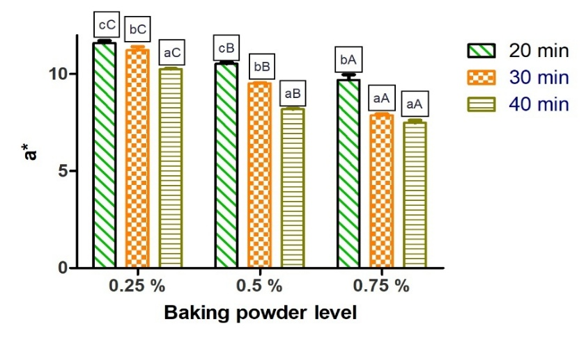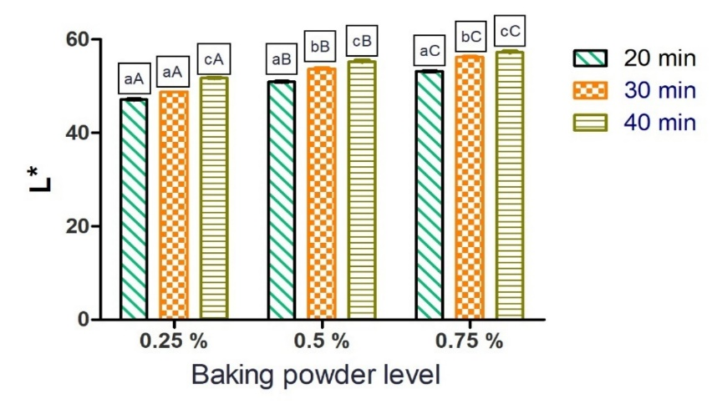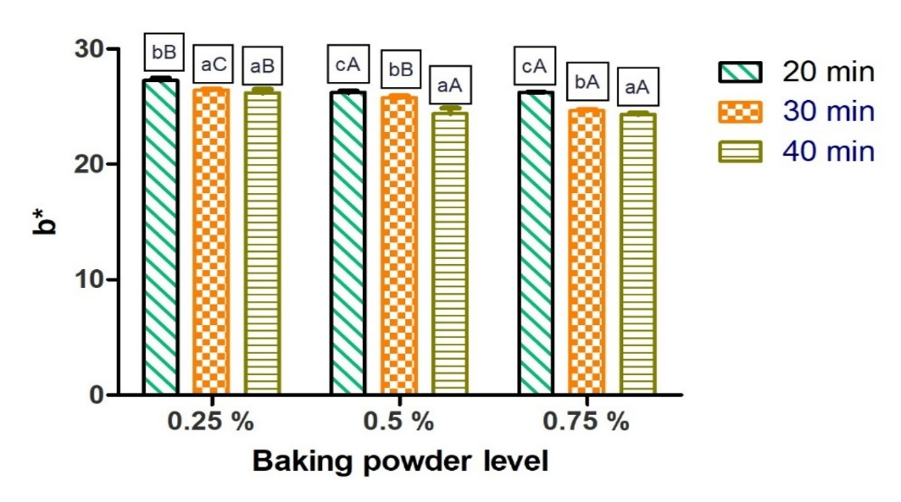
Fig 1: Effect of dough resting time and different levels of baking powder on the colour
Note: ^{abc} & ^{ABC} indicates within baking powder levels means & dough resting time with different superscripts are significantly different (P<0.05) from each other,respecteively
Table 3: p-values of main effects and interaction effects for colour
Parameter | L* | a* | b*
Baking powder | <0.001* | <0.001* | <0.001*
Resting time | <0.001* | <0.001* | <0.001*
Baking powder* Resting time | <0.001* | <0.001* | <0.001*
p-value with superscript * indicates that independent variables or its interaction variables or its interaction have a significant (p<0.05) effect on dependent variables respectively

Effect on the sensory attributes
Sensory evaluation is a critical method used to assess the quality and acceptability of food products by analyzing attributes such as appearance, texture, flavor, and taste through human perception. It provides valuable insights into consumer preferences, aiding in product development and optimisation of ingredients. The main effects of baking powder and dough resting time showed no significant influence on the sensory attributes of the biscuits, including appearance, texture, flavor, and overall acceptability. Similarly, the interaction effect between dough resting time and baking powder levels exhibited no significant difference (p<0.05) across all evaluated sensory parameters. However, baking powder levels significantly (p<0.05) affected the toasted flavor and coarseness of the biscuits, which could be attributed to its leavening action that enhances the porous structure and promotes browning reactions during baking.
Higher levels of baking powder are typically associated with a soapy or saponified taste due to the chemical composition of the leavening agent; however, this undesirable flavor was not detected in the biscuits formulated in this study. The absence of such off-flavors indicates a well-balanced formulation and appropriate usage levels of baking powder. Additionally, the coarseness observed in the biscuits with higher baking powder levels may result from the increased release of gases during baking, creating a less compact structure.
Based on the findings, it can be concluded that up to 0.75% baking powder can be used effectively for biscuit making, ensuring optimal sensory attributes without introducing undesirable tastes or textural changes. This information is valuable for optimizing the formulation and improving consumer acceptance of the product.

Table 4: p-values of main effects and interaction effects for sensory attributes of GR substituted biscuit
Parameter | Powdery Surface | Browning | Raw | Toasted | Sweet | Crispness | Hardness | Coarseness | Chewiness | Adhesiveness | Overall Acceptability
Baking powder | 0.595^{NS} | 0.368 ^{NS} | 0.113 ^{NS} | 0.039 * | 0.248 ^{NS} | 0.578 ^{NS} | 0.314 ^{NS} | 0.03* | 0.865 ^{NS} | 0.112 ^{NS} | 0.485 ^{NS}
Resting time | 0.995 ^{NS} | 0.458 ^{NS} | 0.453 ^{NS} | 0.961 ^{NS} | 0.697 ^{NS} | 0.753 ^{NS} | 0.561 ^{NS} | 0.815 ^{NS} | 0.867 ^{NS} | 0.731 ^{NS} | 0.919 ^{NS}
Baking powder* Resting time | 0.975 ^{NS} | 0.549 ^{NS} | 0.714 ^{NS} | 0.999 ^{NS} | 0.910 ^{NS} | 0.685 ^{NS} | 0.948 ^{NS} | 0.968 ^{NS} | 0.859 ^{NS} | 0.975 ^{NS} | 0.777 ^{NS}

p-value with superscript * and ^{NS} indicates that independent variables or its interaction variables or its interaction have a significant (p<0.05) & non-significant(p>0.05) effect on dependent variables respectively

Effect on spread ratio and hardness
The spread ratio and hardness are key textural parameters that play a crucial role in determining the quality and consumer acceptability of biscuits. The spread ratio, defined as the ratio of the biscuit's diameter to its thickness, indicates the extent of dough expansion during baking and is influenced by ingredient composition and processing conditions. The spread ratio of biscuits with varying baking powder levels is presented in Figure 2. Higher spread ratios were observed at a dough resting time of 30 minutes, but the spread ratio diminished with further increases in resting time. This reduction is likely due to the escape of trapped carbon dioxide as the dough rests longer. Interestingly, while increased baking powder levels are generally associated with higher spread ratios due to the leavening effect that produces carbon dioxide and enhances dough expansion, this study found an opposite trend, where higher baking powder levels led to a decrease in the spread ratio. This may be due to structural changes in the dough caused by excess gas production and surface blistering, which restricts further spread. Ma and Baik (2018) reported that baking powder spreads the biscuit horizontally during the baking process.
Hardness, defined as the force required to break the biscuit, is another critical textural attribute. Statistical analysis presented in Table 5 indicates that dough resting duration and baking powder levels had no significant effect (p>0.05) on biscuit hardness. However, the amount of baking powder was found to have a notable impact on biscuit hardness. This can be attributed to the aerating effect of baking powder, which creates a crisper texture and may result in a harder product (Gm & Srilatha, 2025). These findings suggest that while baking powder improves aeration and crispness, its level must be carefully optimized to achieve a desirable balance between hardness and texture quality in biscuits. The hardness of the biscuit was found to be increase with the increase in dairy ingredients and baking powder (Gallagher et al., 2005).
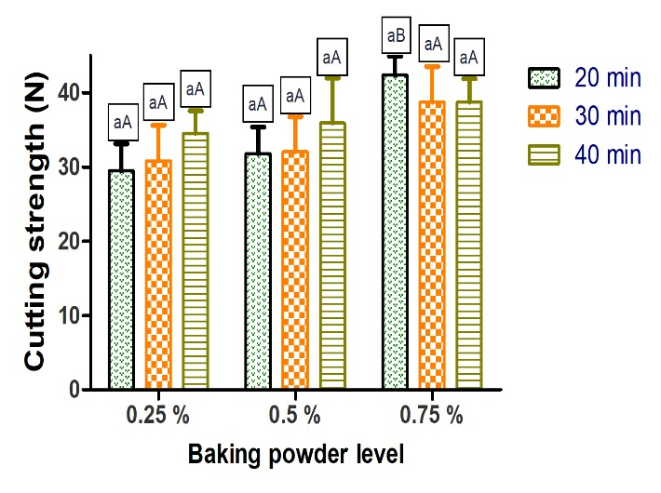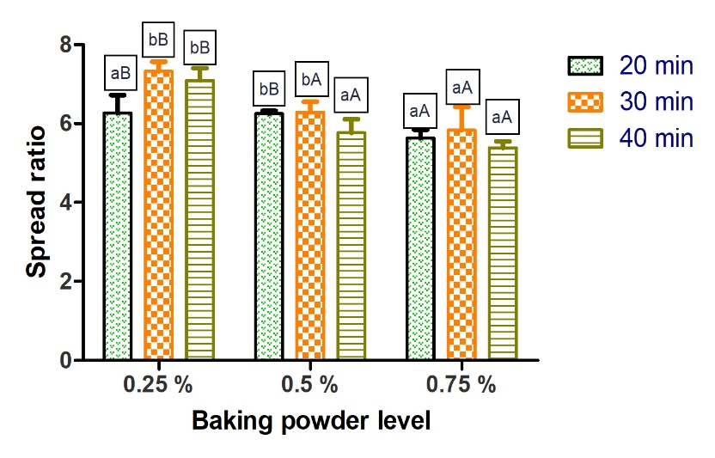
Fig 2: Effect of dough resting time and different levels of baking powder on the spread ratio and hardness biscuit
Note: ^{ab} indicates within baking powder levels mean with superscripts are significantly different (P<0.05) .^{AB} indicates within dough resting time with different superscripts are significantly different (P<0.05) from each other
Table 5: p-values of main effects and interaction effects for spread ratio and hardness
Parameter | Spread ratio | Cutting strength
Baking powder | <0.001* | <0.001*
Resting time | <0.02* | <0.162^{NS}
Baking powder* Resting time | <0.001* | <0.360 ^{NS}
p-value with superscript * and ^{NS} indicates that independent variables or its interaction variables or its interaction have a significant (p<0.05) & non-significant(p>0.05) effect on dependent variables respectively
Conclusion
In this study, baking powder levels and dough resting time were found to influence key nutritive, sensory and textural attributes of biscuits. While neither factor significantly affected most sensory parameters, baking powder levels notably influenced toasted flavor, coarseness, and color values, with lightness increasing and redness and yellowness decreasing due to gas production and reduced Maillard reactions. The spread ratio decreased with longer resting times due to carbon dioxide escape, while higher baking powder levels improved dough expansion. Although resting time and baking powder levels had no significant effect on hardness statistically, increased baking powder contributed to a crisper texture. Overall, up to 0.75% baking powder and 20 minutes of resting time was identified as optimal for achieving desirable sensory and textural qualities in biscuits.
Conflict of interest All the authors declare that they have no conflicts of interest
Data availability All data included in the manuscript.
COMPETING INTERESTS DISCLAIMER:
Authors have declared that they have no known competing financial interests OR non-financial interests OR personal relationships that could have appeared to influence the work reported in this paper.

DISCLAIMER (ARTIFICIAL INTELLIGENCE): Author(s) hereby declare that generative AI technologies such as Large Language Models, etc. have not been used during the writing or editing of manuscripts.
References
AOAC (2016) Official Methods Analysis. Association of Official Analytical Chemists. Ed.: Latimer, G. W. 20th Edition AOAC International: Arlington. VA.
Arepally, D., Reddy, R. S., Goswami, T. K., & Datta, A. K. (2020). Biscuit baking: A review. Lwt, 131, 109726.
Baldino, N., Gabriele, D., Lupi, F. R., de Cindio, B., & Cicerelli, L. (2014). Modeling of baking behavior of semi-sweet short dough biscuits. Innovative Food Science & Emerging Technologies, 25, 40-52.
Canali, G., Balestra, F., Glicerina, V., Pasini, F., Caboni, M. F., & Romani, S. (2020). Influence of different baking powders on physico-chemical, sensory and volatile compounds in biscuits and their impact on textural modifications during soaking. Journal of Food Science and Technology, 57, 3864-3873.
Cauvain, S. P. (2017). Baking problems solved. Woodhead Publishing.
GM, V., & Singh, A. K. (2024). Effect of Ghee Residue Powder and Pearl Millet Flour Substitution on Rheological, Textural, and Sensorial Characteristics of Eggless Muffin. Journal of Food Processing and Preservation, 2024(1), 5519265.
G M, Vinay, S H Akbari, R B Modi, P Srilatha, and Prakasha R. (2025). Arresting Rancidity in Pearl Millet Flour through Halogen Air Frier Treatment. Journal of Advances in Biology & Biotechnology 28 (1):31-38. https://doi.org/10.9734/jabb/2025/v28i11858.
Gm, V., & Srilatha, P. (2025). A variation in quality characteristics of ghee residue powder fortified pearl millet based biscuit upon baking powder level. International Journal of Advanced Biochemistry Research, 9(1), 377-382.
Gallagher, E., Kenny, S., & Arendt, E. K. (2005). Impact of dairy protein powders on biscuit quality. European Food Research and Technology, 221, 237-243.
Ma, F., & Baik, B. K. (2018). Soft wheat quality characteristics required for making baking powder biscuits. Journal of Cereal Science, 79, 127-133.
Mamat, H., & Hill, S. E. (2018). Structural and functional properties of major ingredients of biscuit. International food research journal, 25(2).
Nandagopal, P. (2017). Shelf-life studies on high fiber reduced calorie biscuits made from dairy-multigrain composite applying selected packaging materials. (Master thesis, National Dairy Research Institute, Karnal)
Sahin, A. W., Coffey, A., & Zannini, E. (2021). Functionalisation of wheat and oat bran using single-strain fermentation and its impact on techno-functional and nutritional properties of biscuits. European Food Research and Technology, 247(7), 1825-1837.
Tyagi SK, Manikantan MR, Oberoi HS, Kaur G (2007) Effect of mustard flour incorporation on nutritional, textural and organoleptic characteristics of biscuits. J Food Eng 80(4):1043-1050. https://doi.org/10.1016/j.jfoodeng.2006.08.016
Vinay, G. M. (2023). A comparison study on nutritional, textural and sensory evaluation of biscuits made from millet. International Journal of Science and Research, 12(11), 1278-1282.
Vinay, G. M., & Singh, A. K. (2025). Effect of ghee residue substitute of bakery fat on quality characteristics of pearl millet based biscuit.

Vinay Gm, P Srilatha, Prakasha R. A variation in quality characteristics of ghee residue powder fortified pearl millet based biscuit upon baking powder level. International Journal of Advanced Biochemistry Research, 2025, 9 (1), pp.377-382. ‌10.33545/26174693.2025.v9.i1e.3521‌. ‌hal-04939083

