Original Research Article
Food Safety and Economic Consequences of Cold Chain Disruption: A Case Study of Frozen Food Imports from France to Togo

.
ABSTRACT

ABSTRACT
Aims: This study evaluates the microbiological, sensory, and economic repercussions of a documented 72-hour cold chain disruption affecting frozen food commodities imported from France to Togo. The primary objective was to validate a multi-integrated framework for post-incident risk assessment, capable of distinguishing between food safety compliance and commercial quality degradation, while accurately quantifying the resulting economic prejudice.
Study design: This work employs a descriptive and analytical cross-sectional study design.
Place and Duration of Study: The investigation was conducted at the Port of Lomé, the Laboratory of Biochemistry Applied to Nutrition and Food Sciences (University of Lomé), and the Institut National d’Hygiène (INH) in Lomé, Togo, between December 2024 and March 2025
Methodology: A shipment of 18,689 kg, subjected to a temperature excursion peaking at +2°C, significantly exceeding the international -18°C standard for frozen storage, was analyzed. A forensic evaluation was performed on 135 samples across five product categories. The methodology integrated: (1) continuous thermal traceability; (2) physical auditing for macroscopic deterioration; (3) microbiological screening for pathogens (Listeria monocytogenes, Salmonella spp.) in accordance with ISO 6579 and NF V08-059 standards; and (4) sensory profiling using a 70-member panel and ANOVA statistics.
Results: Analysis revealed that while the products maintained 100% compliance with international microbiological safety standards, they failed critical quality specifications. Visual inspections identified macroscopic deterioration, including structural deformation and syneresis-related recrystallization, in 11.52% of the cargo mass (2,153.8 kg). Sensory evaluation demonstrated significant organoleptic failures; notably, Whole Camembert (250g) exhibited critical textural friability compared to controls (p < 0.05), rendering it commercially non-viable. The total economic prejudice was established at €25,749.11, representing 22.65% of the shipment's valuation. Crucially, auxiliary costs (logistics, expert appraisal, and destruction) effectively doubled the financial burden compared to the direct value of the physical product loss.
Conclusion: The findings indicate that short-duration thermal excursions in tropical logistics hubs may not compromise microbiological safety but do induce critical physical and sensory degradation that necessitates total economic write-offs. This study underscores the vulnerability of the "last mile" in West African logistics and advocates for the implementation of resilient thermal monitoring and mandatory power supply protocols to mitigate systemic economic wastage.

Keywords: [Cold chain integrity, frozen foods, microbiological safety, sensory analysis, economic loss, Togo }

1. INTRODUCTION
Refrigeration serves as a critical technological barrier against food deterioration, effectively mitigating a spectrum of deleterious processes ranging from microbiological proliferation and physiological senescence to biochemical oxidation and physical moisture loss (James & James, 2014). Consequently, it plays a pivotal role in ensuring food safety and quality while addressing the escalating global demand for food security. An efficient cold chain is a fundamental prerequisite in the logistics of perishable goods, spanning transport, storage, and distribution to preserve the intrinsic value of products (Munoz, 2018, Tirivayi et al. 2025)
Any significant deviation from these thermal requirements, whether during maritime transit, port handling, or final distribution, can precipitate quality degradation, rendering products unfit for human consumption. In maritime logistics, reefer containers are engineered to maintain frozen products between –18°C and –25°C. However, evidence suggests that technical failures, power interruptions, or suboptimal handling practices frequently induce cold chain breaks (CCB). Even short-duration thermal abuses can lead to irreversible consequences (Jedermann et al., 2009).

The preservation of food integrity and safety during international trade is governed by a rigorous framework of international quality control specifications. For dairy products, the Codex Alimentarius provides fundamental benchmarks, including the General Standard for Cheese (CXS 283-1978) and specific standards for varieties such as Camembert (CXS 276-1973) and Gouda (CXS 266-1966), which define essential composition, quality factors, and hygiene requirements. Similarly, frozen vegetables are subject to the Code of Practice for the Processing and Handling of Quick Frozen Foods (CXC 8-1976), which stipulates that a continuous temperature of -18°C or colder must be maintained to minimize enzymatic activity and preserve organoleptic properties. Within the European regulatory context, governing the shipment’s origin, Commission Regulation (EC) No 2073/2005 establishes strict microbiological criteria for pathogens such as Listeria monocytogenes and Salmonella spp., which are critical safety indicators for both dairy and vegetable matrices. Furthermore, Regulation (EC) No 37/2005 mandates the continuous monitoring of temperatures during the transport and storage of quick-frozen foodstuffs to ensure compliance with these international safety thresholds.

The implications of CCB are multifaceted. Microbiologically, even temporary temperature elevations can facilitate the resuscitation and growth of pathogenic bacteria such as Listeria monocytogenes, Salmonella spp., and Escherichia coli, while accelerating fungal proliferation, particularly in animal-derived products (Mu et al., 2017). Furthermore, thermal fluctuations significantly curtail shelf life, potentially reducing the useful life of sensitive products like cheese, salmon, or poultry by 25% to 57% (Ndraha et al., 2018, Onyeaka et al., 2023). From a physico-chemical perspective, such fluctuations catalyze protein denaturation, lipid oxidation, and textural degradation (Giannakourou & Taoukis, 2003). These alterations inevitably compromise the sensory profile of the food, negatively impacting consumer acceptance (Hsiao et al., 2018; Ndraha et al. 2018 ; Ndraha et al., 2019 ; Yuan et al., 2024). Beyond safety and quality, these inefficiencies contribute to substantial economic burdens. Approximately 15% of food losses within the logistics sector are attributed to temperature mismanagement, translating to nearly 200 million tons of global waste annually (Kawińska & Zalewski, 2022).
These challenges are disproportionately acute in developing nations, particularly within the Sub-Saharan African context. In countries like Togo, port infrastructures often face significant constraints regarding the availability of reliable energy sources for reefer containers and the implementation of continuous thermal monitoring protocols (Castelein et al., 2019, Shooya & Lukama 2024). The logistical "last mile" and port-side handling in high-ambient temperature zones pose severe risks. Even where equipment exists, maintenance gaps and distinct deficiencies in technical training, particularly within public structures, hamper efficacy (James & James, 2014). Consequently, these structural vulnerabilities lead to considerable losses of imported perishables due to inadequate storage and ineffective thermal control (Kitinoja, 2013 ; Antwi et al., 2024; et GCCA, 2025).
Given the heightened risk of cold chain disruption at the Port of Lomé, a strategic hub for West Africa, it is imperative to adopt a rigorous, multidimensional assessment framework when failures are suspected. The integration of microbiological, physico-chemical, sensory, and economic analyses is increasingly recognized as the gold standard for post-incident risk assessment (EFSA, 2021). This study applies such an integrated approach to evaluate the consequences of a documented cold chain break on a shipment of frozen foods imported from France to Togo. Following the detection of a thermal excursion upon arrival, a comprehensive forensic evaluation was conducted to determine the sanitary conformity, quality retention, and economic impact of the incident.

2. material and methods
2.1. Study design
This work employs a descriptive and analytical cross-sectional study design. The primary objective was to evaluate the impact of a confirmed cold chain break on frozen food commodities imported via maritime freight. The assessment methodology integrates four complementary dimensions : visual physical inspection, microbiological safety testing, sensory (organoleptic) analysis, and economic loss quantification.
2.2. Sampling and product categorization
The study analyzed a shipment of frozen products weighing 18,689 kg, imported from France and received at the Port of Lomé, Togo. A total of 135 representative samples were selected for detailed analysis. The cargo comprised five distinct categories:
- Raw animal proteins: Beef chuck, meatballs, and capon.
- Cooked animal proteins: Sautéed chicken and smoked salmon.
- Dairy products: Various butters (Héritage, Isigny, Président) and cheeses (Old Porche Camembert, Emmental, Fourme d’Ambert, Cantal, Comté, Gouda, and whole Camembert).
- Vegetables and starchy foods: Extra-fine peas, green beans, sliced onions, mixed vegetables (macédoine), and hash browns (pommes rissolées).
- Desserts: Caramel praline crumble.
Following the detection of the incident on December 23, 2024, the entire shipment was immediately placed in emergency negative cold storage (-20°C) at the port facility to halt further degradation. Samples for microbiological and sensory analysis were drawn from this stabilized stock in February 2025. A total of 135 samples were analyzed, comprising 105 test samples (5 per product category) and 30 control samples taken from compliant batches of identical brands.
2.3. Thermal traceability and monitoring
Temperature history throughout the supply chain was monitored using a TempTale® Ultra (Sensitech) data logger positioned within the container (Wu & Hsiao, 2021). The shipment departed France on November 4, 2024, with a scheduled arrival in Lomé on November 26, 2024. The total valuation of the container, including goods and logistics, was €113,670.04. The container was offloaded at the Port of Lomé on December 17, 2024. Data retrieval indicated compliance with frozen storage standards until December 19, 2024. A critical thermal excursion was recorded starting December 20, 2024, at 14:30 GMT, attributed to a disconnection from the power supply. The internal temperature rose from -15.15°C to +2°C by December 23, 2024, marking a continuous cold chain rupture of 72 hours (Figure 1).
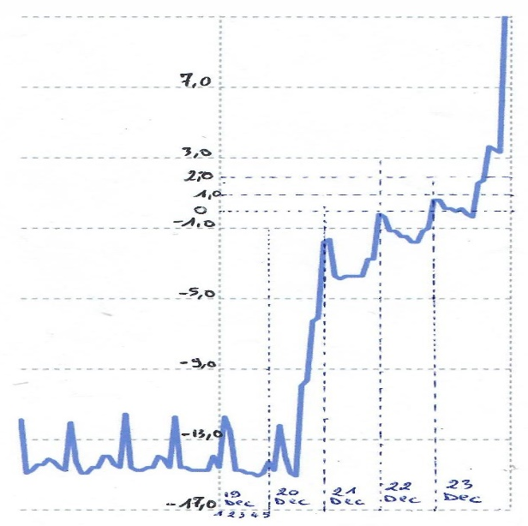
Figure 1: Temperature traceability curve of the Thermobutton
2.4. Physical and visual inspection
A systematic visual inspection was conducted to assess physical integrity. This was performed as a joint inspection involving the Quality, Health, Safety, and Environment (QHSE) team of the importing company (December 23, 2024), an independent insurance surveyor (January 7, 2025), and the Togolese Directorate of Livestock (February 18, 2025). Evaluation criteria focused on packaging integrity (deformation, crushing, moisture saturation) and product state (presence of recrystallized ice, signs of thawing/refreezing, texture collapse).
2.5. Microbiological analysis
To verify food safety, microbiological assays were performed on 135 samples (5 samples per suspected product type). Analyses were conducted in a comparative expertise framework involving the Institut National d’Hygiène (INH) in Lomé, Togo, and the exporter’s reference laboratory in France. The screening targeted hygiene indicators and specific pathogens in accordance with ISO 6579 and NF V08-059 standards. Parameters included aerobic mesophilic bacteria, total coliforms, coagulase-positive Staphylococci, Salmonella spp., and Listeria monocytogenes. (FAO & WHO, 2022)
2.6. Sensory analysis
Sensory profiling was conducted between February 25 and March 11, 2025, using a panel of 70 untrained consumers selected for their familiarity with the product categories. For each tested item (e.g., peas, sliced onions, mixed vegetables), a composite of five samples was evaluated against control samples of the same brand and lot (where available) or compliant reference products. Raw products were cooked under identical standardized conditions prior to tasting. Attributes including taste, odor, texture, aroma, color, and general acceptability were rated using a standard 9-point hedonic scale. Statistical differences were evaluated using a one-way Analysis of Variance (ANOVA) followed by Tukey’s HSD post-hoc test (p < 0.05).

2.7. Economic evaluation
The economic impact assessment was restricted to lots identified as non-compliant via visual or laboratory inspection. The financial loss was calculated based on the volume of damaged goods (number of cartons and weight in kg), the unit value of the products, and associated direct costs. These costs included expenses for expert appraisal, laboratory certification, additional port storage during the investigation, and destruction of spoiled goods. Costs were calculated in Euros (€) and converted to West African CFA Francs (XOF) for local reporting.
]

3. results and discussion

3. RESULTS

3.1. Thermal profile of the container during the critical interval
3.1. Thermal profile analysis: Analysis of the data retrieved from the Thermo-button logger identified a critical cold chain breach spanning 72 hours (December 20–23, 2024). During this interval, the internal temperature rose significantly from a baseline of -15.15 °C to a peak of +2 °C (Figure 1). This excursion occurred during the handling phase at the Port of Lomé, where ambient tropical conditions pose a severe risk to frozen cargo

Figure 2: Curve showing the evolution of the container temperature during the critical period

3.2. Physical inspection and visual assessment
Physical inspections conducted upon the container’s clearance revealed substantial physical deterioration affecting approximately 350 cartons. This damaged volume corresponds to a total mass of 2,153.8 kg, representing 11.52% of the total cargo load (18,689 kg). The observed anomalies were primarily characterized by structural deformation or collapse of packaging, evidence of excessive internal condensation, and the presence of stagnant water within cartons containing vegetable products. Furthermore, signs of recrystallization and significant textural degradation were documented. Specifically, the Whole Camembert (250g) exhibited a loss of structural cohesiveness, resulting in a crumbly and friable texture inconsistent with the standard product profile.
Table 1: Inventory of Products Exhibiting Physical Alterations and Packaging Anomalies
Product type | Observed anomalies | Number of damaged cartons
Extra fine peas | Deformed/damaged cartons, thawed product, presence of ice crystals | 15
Hash browns (pommes rissolées) | Wet, deformed, and flattened cartons | 64
Sliced onions | Wet/flattened cartons, ice crystals, signs of thawing | 86
Green beans | Severely damaged cartons, thawed product | 20
Crumble cara pralin | Collapsed cartons, product degradation | 60
Whole camembert (250g) | Collapsed/damaged cartons, deformed and flattened product | 25
Camembert vieux porche | Damaged/deformed cartons, thawed product | 80
Total |  | 350

3.3. Microbiological safety evaluation
To assess the sanitary impact of the thermal breach, microbiological assays were conducted by the client’s reference laboratory in France (n=1) and the Institut National d’Hygiène (INH) in Togo (n=5). Results demonstrated full compliance with safety standards for human consumption across all suspected batches (Table 2). No pathogenic flora were detected, confirming the sanitary safety of the food products within the limits of their respective Expiry Dates (DLC), despite the recorded temperature fluctuations.

Table 2: Pathogen screening results by product type and laboratory
Data indicates absence of pathogens across all samples
Product type | Expiry date (DLC) | Reference Lab (n=1) | INH Togo (n=5)
Peas | 05/10/2025; 28/02/2027 | Absent | Absent
Green beans | 31/08/2026 | Absent | Absent
Mixed vegetables | 26/09/2026; 06/01/2027 | Absent | Absent
Sliced onions | 23/04/2027 | Absent | Absent
Hash browns | 18/03/2026; 31/08/2026 | Absent | Absent
Crumble cara pralin | 10/12/2025 | Absent | Absent
Butter (Héritage) | 09/04/2026 | Absent | Absent
Butter (Président) | 04/10/2025 | Absent | Absent
Butter (Isigny) | 23/09/2025 | Absent | Absent
Capon | 23/12/2025; 24/12/2025 | Absent | Absent
Cheese (Cantal) | 10/10/2025 | Absent | Absent
Cheese (Comté) | 30/09/2025; 10/10/2025 | Absent | Absent
Cheese (Fourme d’Ambert) | 11/07/2025 | Absent | Absent
Cheese (Gouda) | 15/10/2025 | Absent | Absent
Cheese (Emmental) | 14/10/2025 | Absent | Absent
Camembert Vieux Porche | 15/11/2025 | Absent | Absent
Whole Camembert | 08/11/2025 | Absent | Absent
Smoked Salmon | 28/02/2026 | Absent | Absent
Cooked Chicken Sauté | 30/12/ 2025; 30/04/2026 | Absent | Absent
Beef Chuck | 08/08/2026 | Absent | Absent
Beef Meatballs | 24/09/2026 | Absent | Absent

3.4. Sensory analysis
Sensory evaluation served as a critical complement to microbiological testing to determine organoleptic viability. During the observation period (February 25 – March 11, 2025), no adverse health events or intoxication were reported by the panel. Sensory profiles (detailed in Annex 3) indicated that the majority of suspected dairy products (butters and cheeses including Emmental, Fourme d’Ambert, and Gouda) maintained organoleptic characteristics statistically comparable to control samples (p > 0.05).
However, a divergence was noted for the Whole Camembert (250g). While this product scored higher than the control in terms of aroma, odor, and taste, its texture was rated significantly lower, being described as friable. The overall difference in acceptability for this specific product was statistically significant (p < 0.05). Conversely, evaluations for desserts, cooked and raw proteins (beef, poultry, salmon), and vegetable products revealed no significant sensory deviations between the thermal-abuse samples and controls (p > 0.05).

3.5. Economic loss estimation
The financial impact was stratified into direct product losses and associated auxiliary costs. While the physically damaged goods accounted for 11.52% of the cargo by weight, the total economic prejudice amounted to €25,749.11, representing 22.65% of the initial shipment valuation (Table 3). This discrepancy highlights that post-incident management ; including storage, expert appraisal fees, and destruction costs ; effectively doubles the financial burden of the physical loss itself.

Table 3 : Valuation of frozen cargo and logistics costs (€)

Item | Value (€)
Product Value | 103,780.00
Maritime Transport | 6,717.86
Local Transit Fees | 3,172.18
Total | 113,670.04

Direct financial losses were calculated referencing the specific quantity of damaged goods identified in the visual inspection (Table 4).

Table 4: Financial loss estimation for damaged goods (Values in XOF)
Product | Cartons | Quantity (Kg) | Unit price | Total (XOF)
Whole Camembert 250g | 25 | 75 | 19,593 | 489,834
Extra fine peas | 15 | 150 | 11,204 | 680,540
Hash browns | 64 | 640 | 11,538 | 738,441
Green beans | 20 | 200 | 11,414 | 228,270
Sliced onions | 86 | 860 | 10,233 | 880,019
Crumble cara pralin | 60 | 43.2 | 20,398 | 1,223,889
Camembert vieux porche | 80 | 185.6 | 10,679 | 854,320
Total | 350 | 2,153.8 |  | 4,582,827

The cumulative value of goods exhibiting physical non-compliance was estimated at 4,582,827 XOF. This valuation was based on specific damaged volumes identified during visual inspection, accounting for unit prices and weight-based losses.
Additional costs incurred due to the incident, including counter-expertise and administrative fees, are detailed in Table 5.
Table 5: Expertise and administrative costs (XOF)
Item | Value (XOF)
INH Bacteriological Analysis | 3,132,250
Ref. Lab Bacteriological Analysis | 2,003,348
Sanitary Certificate | 313,250
TOTAL | 5,448,848
The cumulative economic prejudice, combining destroyed goods and associated logistical/expertise costs, amounts to 16,891,344 XOF, equivalent to €25,749.11 (Table 6).
Table 6: Total economic prejudice summary (€)
Component | Value (€)
Value of Destroyed Goods | 6,986.47
Reference Lab Analysis | 3,054.58
INH Analysis | 4,775.47
Directorate of Livestock Analysis | 477.56
Storage Container Rental | 5,036.91
Destruction of Damaged Goods | 3,963.47
Logistics for Destroyed Goods | 1,454.65
TOTAL | 25,749.11
This total loss represents 22.65% of the total container value. Consequently, nearly one-fifth of the initial investment was compromised due to this single logistics incident at the port of entry.

4. DISCUSSION
The recorded temperature elevation from -15.15 °C to 2 °C over 72 hours represents a critical deviation from international safety standards. This thermal behavior aligns with experimental models described by Laguerre et al. (2008), which demonstrate that product temperature in insulated containers correlates closely with ambient fluctuations, a factor particularly relevant in the high-ambient-temperature context of the Togolese coast. The consensus in food science and international regulation establishes -18 °C as the reference threshold for frozen storage (IIR, 2025). Maintaining this temperature is essential to inhibit enzymatic activity and microbial growth while preserving nutritional integrity (EFSA, 2018). The breach observed here highlights the vulnerability of the "last mile" in African port logistics, where infrastructure challenges often intersect with extreme climatic conditions.
Visual inspections confirmed that 11.52% of the cargo suffered physical degradation. The prevalence of deformed packaging and ice crystals is indicative of a thaw-refreeze cycle. The initial temperature rise to +2°C caused partial melting of the ice matrix. Subsequent refreezing in emergency storage likely induced the formation of large, irregular ice crystals, causing mechanical damage to the cellular structure (syneresis) and disrupting the protein-fat network in sensitive dairy matrices like Camembert (Laguerre, 2010). The friable texture of the Camembert specifically suggests a loss of cohesion between the fat phase and protein matrix induced by thermal stress.
Despite the physical markers of temperature abuse, microbiological analysis confirmed the absence of pathogenic proliferation (e.g., Listeria monocytogenes, Salmonella spp.). This outcome can be attributed to the specific dynamics of the incident: the peak temperature reached only 2 °C, which remains below the 4 °C threshold typically required for the rapid exponential growth of most foodborne pathogens (ICMSF, 2005; EFSA, 2018). Thus, while the physical quality was compromised, the sanitary safety of the products was preserved, likely due to the limited duration of the exposure (72 hours) and the thermal inertia of the frozen mass. (Karou et al., 2024)
The findings of this study highlight a critical discrepancy between absolute microbiological safety and regulatory compliance regarding international thermal standards. Although the 72-hour temperature excursion peaked at +2°C, significantly exceeding the -18°C threshold mandated by the Codex Alimentarius (CAC/RCP 8-1976) and the ATP Agreement for quick-frozen commodities [Codex Alimentarius Commission, 1976; UNECE, 2016], the cargo maintained a high level of microbiological stability. The systematic absence of Salmonella spp. and the compliance of Listeria monocytogenes levels with the safety criteria of Commission Regulation (EC) No 2073/2005 [European Commission, 2005] suggest that the thermal breach remained below the activation energy required for significant pathogenic proliferation, which typically necessitates temperatures exceeding +5°C [EFSA, 2018]. However, this safety-quality paradox is central to the observed economic prejudice: while the products remained 'safe' for consumption, they failed the 'quality' benchmarks for quick-frozen labeling, as evidenced by the sensory degradation of the Camembert samples. This aligns with the risk-diagnosis framework proposed by [Wu and Hsiao, 2021], which emphasizes that cold chain disruptions often trigger catastrophic economic losses through quality-driven rejection long before a biological hazard manifests [Wu and Hsiao, 2021].
Sensory analysis revealed that most products, particularly hard cheeses and cooked proteins, exhibited high resilience to the thermal shock, maintaining organoleptic profiles similar to the control group (p > 0.05). This resilience in dairy products with lower free water content is supported by previous studies on cheese microstructure stability (Fontecha et al., 1996; Meneghel et al., 2020; Matle et al. 2021)). However, the statistically significant degradation in the texture of the Whole Camembert underscores that sensory acceptability is product-specific and that texture is often the first quality attribute to fail during thermal excursions.
The economic loss of €25,749 (22.65% of the total value) extends beyond the cost of goods to include substantial post-incident management expenses. This magnitude of loss aligns with global estimates citing 15% wastage in cold chains due to temperature abuse (Aung & Chang, 2014; Antwi et al., 2024). However, in the context of developing countries and specifically West African ports, such losses are exacerbated by infrastructural deficits. Kitinoja (2013) and African Logistics Global (2023) note that losses in African perishable supply chains can reach 40-50% due to unreliable power supplies and handling gaps. This case study validates those macro-level observations at a micro-level, demonstrating how a single breakdown in port electrical supply can erode nearly a quarter of a shipment's value.

4. Conclusion
This investigation into a cold chain rupture at the Port of Lomé highlights the multifaceted consequences of thermal excursions on imported frozen goods. While the incident, characterized by a 3-day rise to +2 °C, did not compromise the microbiological safety of the food, it resulted in significant physical degradation and a 22.65% economic loss. The study confirms that while pathogens like Listeria may not proliferate below 4 °C, physical quality markers (texture, crystallization) are far more sensitive to temperature fluctuations.
To mitigate such risks and enhance cold chain resilience in tropical logistics hubs, several corrective measures are imperative. First, the implementation of integrated logistics protocols specifically for frozen cargo upon arrival is essential. This should be coupled with mandatory continuous power supply measures, such as the requisite use of clip-on gensets during all port-side transfers to eliminate thermal breaks during offloading. Furthermore, establishing a bi-daily physical monitoring schedule for reefer containers and enforcing strict adherence to preventive maintenance protocols for cooling units will reduce mechanical failures. Finally, defining clear liability frameworks for transit agents and instituting independent data logging systems will ensure transparency and accountability throughout the custodial chain.
Implementing these measures is essential not only for reducing economic wastage but also for guaranteeing food security in import-dependent supply chains]

CONSENT
All authors declare that written informed consent was obtained from the 70 participants who served on the sensory evaluation panel. Participants were fully briefed on the nature of the food matrices and the safety protocols followed prior to the tasting sessions. Documentation regarding the panel’s consent is available for review by the Editorial Board of this journal upon request.

ETHICAL APPROVAL
The authors hereby declare that all experimental procedures were performed in accordance with the ethical standards of the University of Lome. The sensory evaluation involving human subjects was conducted following established food science protocols for hedonic testing, ensuring the safety of participants through prior microbiological validation of the food samples. Microbiological analyses were carried out in accredited laboratories (INH Lomé and the exporter’s reference laboratory) in strict compliance with ISO 6579 and NF V08-059 standards for food safety. This study did not involve any experiments on animal subjects.

Disclaimer (Artificial intelligence)
Author(s) hereby declare that NO generative AI technologies such as Large Language Models (ChatGPT, COPILOT, etc.) and text-to-image generators have been used during the writing or editing of this manuscript.

REFERENCES

- African Logistics Global. (2023). Exploring potential and overcoming challenges in the cold chain in Africa. https://www.alg-global.com/
- Antwi, D., Ampofo, E. K., & Boateng, R. (2024). Assessing cold chain logistics performance, capabilities and food losses: Evidence from Ghana (CARISCA Research Series No. 5). Centre for Applied Research on Interactive Solutions in Computing and Communication (CARISCA), Kwame Nkrumah University of Science and Technology.
- Atchadé, G., Hounmanou, Y. M. G., & Douny, L. (2025). Evaluation of the sanitary quality of sales channels and transport equipment for frozen poultry meat imported into Benin. Journal of Food Safety and Quality, 16(2), 123-135.
- Aung, M. M., & Chang, Y. S. (2014). Temperature management for the quality assurance of a perishable food supply chain. Food Control, 40, 198–207.
- Castelein, B., Geerlings, H., & Van Duin, J. H. R. (2019, May). Cold chain strategies for seaports Towards a worldwide policy classification and analysis (Paper presentation). BIVEC-GIBET Transportation Research Days 2019, Ghent, Belgium.
- Codex Alimentarius Commission. (1976). Code of practice for the processing and handling of quick frozen foods (CAC/RCP 8-1976). Food and Agriculture Organization of the United Nations.
- EFSA (European Food Safety Authority), & ECDC (European Centre for Disease Prevention and Control). (2021). The European Union One Health 2020 Zoonoses Report. EFSA Journal, 19(12), 6971
- EFSA Panel on Biological Hazards (BIOHAZ). (2018). Scientific opinion on the evaluation of the safety and efficacy of freezing at −18 °C for food preservation. EFSA Journal, 16(7), Article 5432
- European Commission. (2005). Commission Regulation (EC) No 2073/2005 of 15 November 2005 on microbiological criteria for foodstuffs. Official Journal of the European Union, L 338, 1-26.
- European Food Safety Authority (EFSA). (2018). Listeria monocytogenes contamination of ready-to-eat foods and the risk for human health in the EU. EFSA Journal, 16(1), Article 5134.
- FAO, & WHO. (2022). Global strategy for food safety 2022-2030: Towards stronger food safety systems and global cooperation. World Health Organization.
- Fontecha, J., Kaláb, M., Medina, J. A., Juárez, M., & Rodríguez de Santiago, E. (1996). Effects of freezing and frozen storage on the microstructure and texture of ewe's milk cheese. Zeitschrift für Lebensmittel-Untersuchung und -Forschung, 203(3), 245–251.
- GCCA (Global Cold Chain Alliance). (2025). Africa food cold chain logistics market forecasts to 2030: Investment, growth and infrastructure challenges in West Africa.
- Giannakourou, M. C., & Taoukis, P. S. (2003). Application of a TTI-based distribution management system for quality optimization of frozen vegetables at the consumer end. Journal of Food Science, 68(1), 201–209.
- Hsiao, H. I., Vlajic, J., Yang, M.-F., & Ndraha, N. (2018). Time-temperature abuse in the food cold chain: Review of issues, challenges, and recommendations. Food Control, 89, 12–21.
- International Commission on Microbiological Specifications for Foods (ICMSF). (2005). Microorganisms in foods 6: Microbial ecology of food commodities (2nd ed.). Springer.
- International Institute of Refrigeration (IIR). (2025). IIR Position Statement: Frozen food set points and energy efficiency. Paris: IIR
- James, S. J., & James, C. (2014). The food cold-chain and climate change. Food Research International, 43(7), 1944–1956.
- Jedermann, R., Ruiz-Garcia, L., & Lang, W. (2009). Spatial temperature profiling by semi-passive RFID loggers for perishable food transportation. Computers and Electronics in Agriculture, 65(2), 145–154.
- Karou, S. D., Baba, A. Y., Kere, A., Dossou, J., Tambi, W. G., & Dramane, A. (2024). First detection of resistance genes and virulence factors in Escherichia coli and Salmonella spp. in Togo: The case of imported chicken and frozen by-products. Scientific Reports, 14(1), Article 14567.
- Kawińska, E., & Zalewski, R. (2022). Economic impact of temperature control during food transportation - A COVID-19 perspective. Foods, 11(3), Article 467.
- Kitinoja, L. (2013). Use of cold chains for reducing food losses in developing countries. Global Cold Chain Alliance.
- Laguerre, O. (2010). Heat transfer and air flow in a domestic refrigerator. International Journal of Refrigeration, 33(3), 604-610
- Laguerre, O., Ben Amara, S., & Flick, D. (2008). Heat transfer modelling in a refrigerated display cabinet: The influence of operating conditions. Journal of Food Engineering, 84(4), 526-537
- Leygonie, C., Britz, T. J., & Hoffman, L. C. (2012). Impact of freezing and thawing on the quality of meat: Review. Meat Science, 91(2), 93–98.
- Matle, I., Ngoma, L., Muchadeyi, F. C., & Morey, T. E. (2021). Microbial communities of meat and meat products: An exploratory analysis of the product quality and safety at selected enterprises in South Africa. Microorganisms, 9(3), Article 507.
- Meneghel, J., Passot, S., Fonseca, F., & Gervais, P. (2020). Impact of temperature fluctuations on frozen food quality: A review. Trends in Food Science & Technology, 97, 30–39.
- Mu, G., Jónsson, Á., Bergsson, A. B., & Thorarinsdóttir, K. A. (2017). The effects of short-time temperature abuse on the microbial and sensory quality of chilled saithe (Pollachius virens) fillets. Journal of Food Science, 82(11), 2690–2699.
- Munoz, N. (2018). Using Oxygen and Biopreservation as Hurdles to Improve Safety of Cooked Food during Storage at Refrigeration Temperatures. Washington State University.
- Ndraha, N., Hsiao, H. I., Vlajic, J., Yang, M. F., & Lin, H. T. V. (2018). Time-temperature abuse in the food cold chain: Review of issues, challenges, and recommendations. Food Control, 89, 12-21.
- Ndraha, N., Sung, W. C., & Hsiao, H. I. (2019). Evaluation of the cold chain management options to preserve the shelf life of frozen shrimps: A case study in the home delivery services in Taiwan. Journal of food engineering, 242, 21-30.
- Onyeaka, H., Nwafor, C., & Okpala, C. O. R. (2023). Economic impact of poultry supply chain disruptions on food security: Evidence from post-pandemic market volatility in West Africa. World Journal of Advanced Research and Reviews, 18(2), 045-058.
- Shooya, M., & Lukama, J. (2024). Supply chain integration and resilience in state-owned logistics enterprises at African ports: A case study of Walvis Bay. Journal of Transport and Supply Chain Management, 18, a845.
- Tirivayi, N., Kariuki, S., & Nyamwamu, P. (2025). Perspectives of food safety challenges of selected food commodities in Sub-Saharan Africa: A review. Frontiers in Sustainable Food Systems, 9, Article 1345678.
- United Nations Economic Commission for Europe. (2016). Agreement on the international carriage of perishable foodstuffs and on the special equipment to be used for such carriage (ATP). United Nations.
- Wu, J.-Y., & Hsiao, H.-I. (2021). Food quality and safety risk diagnosis in the food cold chain through failure mode and effect analysis. Food Control, 120, Article 107501.
- Yuan, J., Wang, Z., Li, H., & Xu, B. (2024). Effects of temperature fluctuations on the quality and microbial diversity of beef meatballs during simulated cold chain distribution. Journal of the Science of Food and Agriculture, 104(12), 7704-7712.

APPENDIX
Annexe 1 : Temperature Recording Curve of the Frozen Container Data

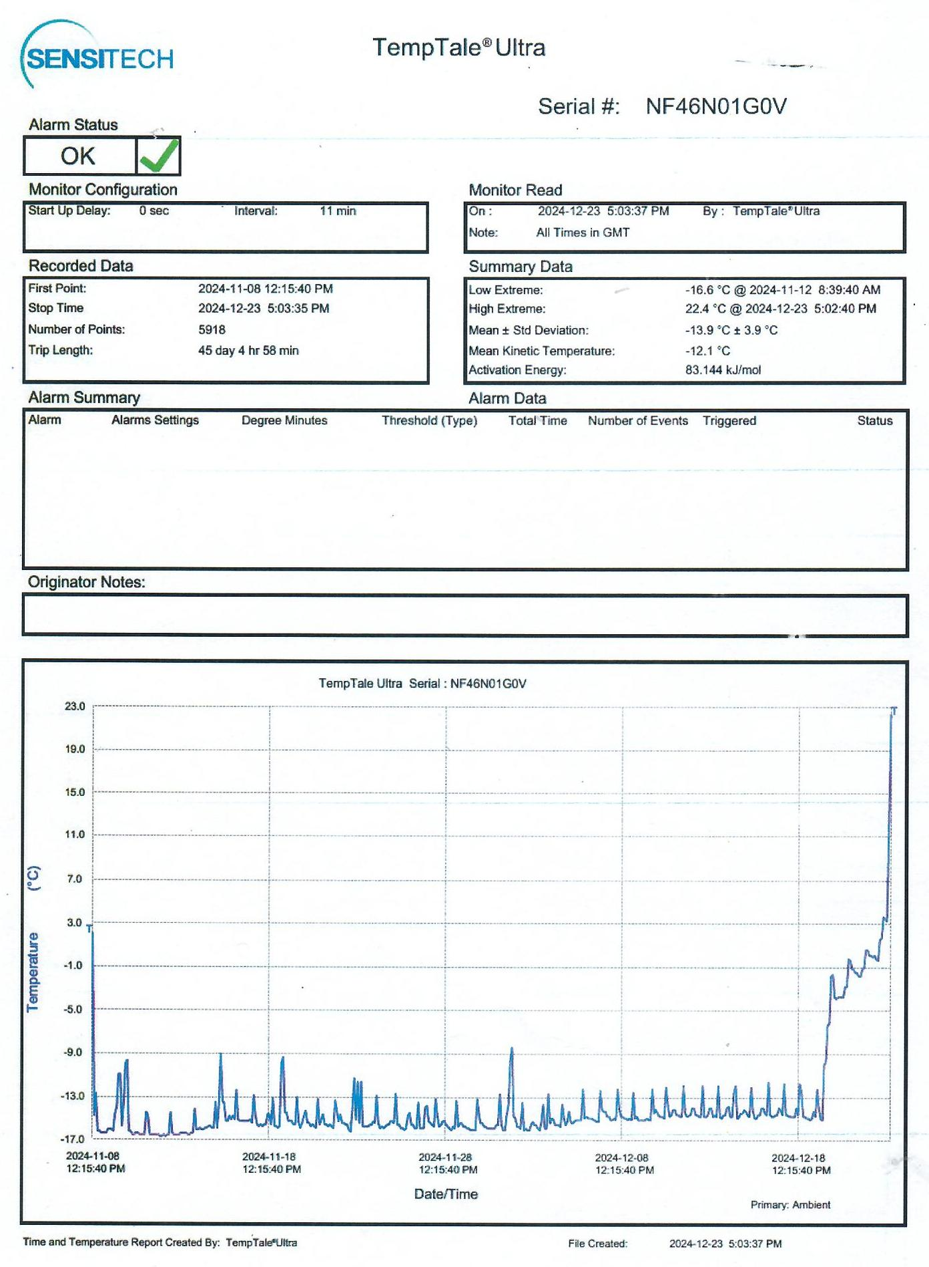

Annexe 2 : Damaged and spoiled food products

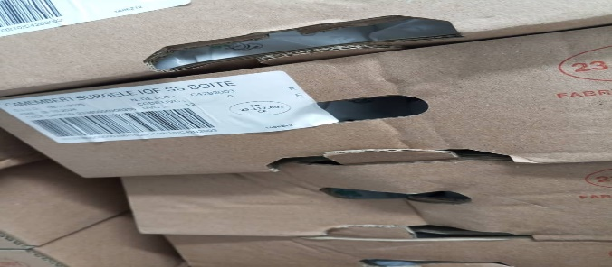
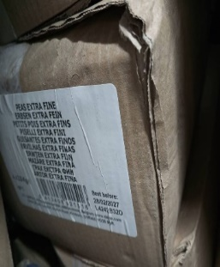
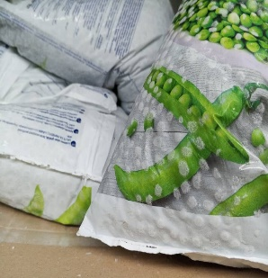
C
B
A
A
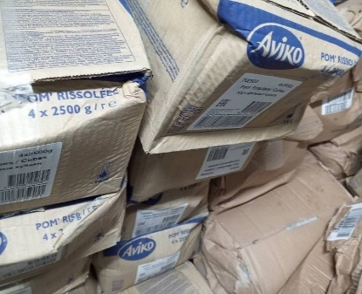

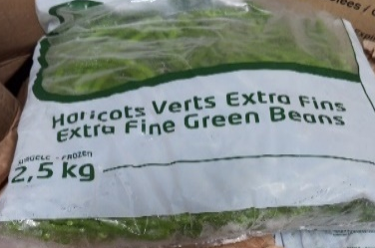

E
F
D

G

Legend for Products A-G:
A: Extra Fine Peas
B: Whole Camembert 250g
C: Vieux Porche Camembert
D: Sautéed Potatoes (Pommes rissolées)
E: Sliced Onions
F: Green Beans
G: Cara Praline Crumble

Annexe 3 : Sensory profile of products

Butters and cheeses
Figure 3: Sensory Profile of Héritage Butter (Héritage butter 101: control sample, Héritage butter 102: test sample). . | Figure 4: Sensory Profile of Isigny Butter (Isigny butter 301: test sample, Isigny butter 300: control sample).
Figure 5: Sensory Profile of Président Butter (Président butter 201: test sample, Président butter 200: control sample). | Figure 6: Sensory Profile of Vieux Porche Camembert (Vieux Porche Camembert 1001: test sample, Vieux Porche Camembert 1000: control sample).
Figure 7: Sensory Profile of Emmental Cheese (Emmental 801: test sample, Emmental 800: control sample). | Figure 8: Sensory Profile of Fourme d’Ambert Cheese (Fourme d’Ambert 601: test sample, Fourme d’Ambert 602: control sample).
Figure 9: Sensory Profile of Cantal Cheese (Cantal 401: test sample, Cantal 402: control sample). | Figure 10: Sensory Profile of Comté Cheese (Comté 501: test sample (Expiry Date 10/10/2026), Comté 502: test sample (Expiry Date 30/09/2025), Comté 503: control sample).
Figure 11: Sensory Profile of Gouda Cheese (Gouda 701: test sample, Gouda 702: control sample). | Figure 12: Sensory Profile of Whole Camembert Cheese (Whole Camembert 901: test sample, Whole Camembert 900: control sample).

Cooked and uncooked proteins
Figure 13: Sensory Profile of Beef Chuck (Beef chuck 1101: test sample, Beef chuck 1100: control sample). | Figure 14: Sensory Profile of Beef Meatballs (Beef meatballs 1201: test sample, Beef meatballs 1200: control sample).
Figure 15: Sensory Profile of Smoked Salmon (Smoked salmon 1301: test sample, Smoked salmon 1300: control sample). | Figure 16: Sensory Profile of Cooked Chicken Cooked chicken specimens 1401 (batch 295), 1402 (batch 297), 1403 (batch 156), and 1404 (batch 296)

Vegetables, starches, and dessert
Figure 17: Sensory Profile of Peas (Peas 1501 and 1502: test samples, Peas 1500: control sample). | Figure 18: Sensory Profile of Sliced Onions (Sliced onions 1601: test sample, Sliced onions 1600: control sample).
Figure 19: Sensory Profile of Sautéed Potatoes (Sautéed potatoes 1701 and 1702: test samples, Sautéed potatoes 1700: control sample). | Figure 20: Sensory Profile of Green Beans (Green beans 1801: test sample, Green beans 1800: control sample).
Figure 21: Sensory Profile of Mixed Diced Vegetables (Mixed diced vegetables 2001 and 2002: test samples, Mixed diced vegetables 2000: control sample). | Figure 22: Sensory Profile of Crumble (Crumble 1901: test sample, Crumble 1900: control sample)

