Impact of Thermal and Membrane Processing on the Biochemical Quality of Pretreated Pomegranate and Pineapple Juices

----------------------------------------------------------------------------------------------------------------------------
Abstract
Pomegranate (Punica granatum L., Punicaceae) and pineapple (Ananas comosus L., Merril) are among the most widely consumed tropical non-citrus fruits, owing to their pleasant aroma, refreshing taste, and desirable °Brix to acid balance. Their juices are commonly utilized in fruit-based beverages either as single-fruit products or in blends with other fruit juices. The present study focused on evaluating the physicochemical characteristics of pomegranate and pineapple juices processed through thermal and membrane techniques during storage. Juices from both fruits were subjected to pretreatment using egg albumin, and it was observed that a concentration of 2 g/L was most effective in removing colloidal matter. Storage studies conducted on the clarified and pretreated juices, involving biochemical analyses, indicated that for pomegranate juice, superior quality retention was observed in treatments ranked as follows: thermal processing with preservative addition; membrane filtration using 0.1 µm at 15 psi (1.0342 bar) and 30 Lph followed by thermal treatment; 70 kDa at 15 psi (1.0342 bar) and 30 Lph with thermal treatment; 44 kDa at 15 psi (1.0342 bar) and 40 Lph with thermal treatment; 10 kDa at 15 psi (1.0342 bar) and 40 Lph with thermal treatment; and thermal processing combined with 44 kDa filtration at 15 psi (1.0342 bar), 40 Lph and preservative addition. In the case of pineapple juice, the treatments showing better quality preservation were ranked as: thermal treatment with added preservative; membrane processing using 70 kDa at 15 psi (1.0342 bar), 30 Lph followed by thermal treatment; 44 kDa at 15 psi (1.0342 bar), 40 Lph with thermal treatment; thermal treatment combined with 44 kDa filtration at 15 psi (1.0342 bar), 40 Lph and preservative addition; and 70 kDa filtration at 15 psi (1.0342 bar), 30 Lph with preservative addition. During a storage period of 180 days, biochemical evaluation of pomegranate juice showed values of 9.914% for total soluble solids, 5.659 for colour intensity, 3.121 for browning index, 0.478% for turbidity, 0.695% for titratable acidity, pH of 4.68, and viscosity of 2.12 cP. Similarly, pineapple juice recorded total soluble solids of 12.782%, colour intensity of 5.562, browning index of 5.27, turbidity of 0.702%, titratable acidity of 0.769%, pH of 4.79, and viscosity of 3.098 cP during the same storage duration.
Keywords: Biochemical quality, Viscosity, Membrane clarification, Thermal treatment, Preservative, Egg albumin
---------------------------------------------------------------------------------------------------------

INTRODUCTION
Globally, the consumption of tropical fruits, fruit juices, and fruit-based beverages has shown a steady rise, largely driven by consumer interest in convenient and health-oriented food products. Fruit juices are liquid food matrices that supply essential nutrients such as vitamins, sugars, minerals, and water. Consumer acceptance of these products is strongly influenced by visual appeal, texture, and sensory attributes, particularly flavour. Among tropical non-citrus fruits, pomegranate (Punica granatum L., Punicaceae) and pineapple (Ananas comosus L., Merril) are especially popular due to their distinctive aroma, refreshing taste, and favourable °Brix to acid balance. Their juices are widely used in beverage formulations either individually, as blended products, or in combination with other fruit juices. Concentrated pomegranate and pineapple juices also serve as valuable ingredients, as they blend harmoniously with other fruit flavours to produce attractive products at competitive costs (Samreen et al., 2024).
Pomegranate is predominantly cultivated in Middle Eastern regions and is recognized for its considerable nutritional and therapeutic value. It is a rich source of bioactive compounds such as anthocyanins, ellagic acid, phytoestrogenic flavonoids, tannins, and organic acids, many of which exhibit strong antioxidant activity. Biological studies have demonstrated that pomegranate juice contains anti-atherosclerotic and anti-atherogenic constituents capable of lowering blood pressure and reducing oxidation of low-density lipoproteins (Aviram and Dornfeld, 2001). Pineapple juice is likewise a highly consumed beverage, with growing demand across several countries. Thailand ranks among the leading producers of pineapple and contributes more than half of the global export volume annually. The worldwide popularity of pineapple juice is attributed to its appealing aroma, pleasant flavour, and nutritional profile. Health-promoting compounds present in pineapple juice include phytochemicals such as vitamin C, carotenoids, flavonoids, and phenolic compounds (Laorko et al., 2010). These compounds play a role in minimizing oxidative stress and lowering the risk of chronic diseases, including cancer, cardiovascular disorders, and neurological conditions.
Owing to these beneficial attributes and increased public awareness regarding functional foods, the demand for pineapple and pomegranate fruits has risen significantly in recent years. This trend has led to the expansion of industries involved in juice production as well as pharmaceutical sectors focused on extracting bioactive compounds from these fruits. However, in their natural state, pineapple and pomegranate juices exhibit a cloudy appearance, which poses challenges for stability and shelf-life during storage. Juice instability, along with colour degradation, remains a major concern for processors, highlighting the need for improved clarification and preservation strategies.
Conventional approaches for polyphenol removal and juice stabilization often involve liquid extraction using organic solvents (Samreen et al., 2020). Although effective, these methods typically require elevated temperatures to enhance extraction efficiency, which may result in the degradation of sensitive polyphenolic compounds and formation of undesirable by-products. As an alternative, membrane-based technologies such as microfiltration (MF) and ultrafiltration (UF) have gained attention as modern clarification techniques. These processes are non-thermal, cost-effective, and increasingly applied in fruit juice, pulp, and wine processing industries, enabling simplification of conventional clarification steps. Additionally, MF and UF can significantly reduce or eliminate the need for pectinolytic enzymes (Samreen et al., 2020).
The objective of the present study was to assess the influence of clarification treatments combined with membrane filtration on organic acid profiles, phenolic constituents, and selected quality attributes such as colour and turbidity in pineapple and pomegranate juices. Previous findings indicate that MF and UF processes alone do not significantly alter phenolic or organic acid compositions. While the effects of various clarifying agents on parameters including pH, turbidity, colour density, total phenolics, and anthocyanins have been documented, membrane filtration is increasingly replacing traditional clarification methods due to its continuous operation, simplified processing, and elimination of chemical clarifying agents and their associated limitations. Furthermore, MF and UF effectively remove proteins exceeding the membrane molecular weight cut-off (MWCO) (Samreen et al., 2020).
In view of these considerations, the present investigation was undertaken to evaluate the processing of pineapple and pomegranate juices using a combination of thermal, chemical, and membrane clarification techniques. The processed juices were subsequently subjected to storage studies, and their physicochemical characteristics were systematically analyzed and reported.
MATERIAL AND METHODS
Fully matured pomegranate and pineapple fruits were selected and cleaned to remove extraneous material. The juices were extracted and subjected to different processing treatments.

Pretreatment on aggregation and clarification of pomegranate and pineapple juices
Pretreatment of the juice samples was carried out using egg albumin as a fining agent. Four different concentrations of egg albumin, namely 0.25, 0.5, 1.0, and 2.0 g/L, were evaluated, and the effectiveness of the pretreatment was assessed through biochemical analyses. Following juice extraction, the measured quantity of egg albumin powder was added to the juice and mixed uniformly to ensure proper dispersion. The treated samples were then filtered using muslin cloth and centrifuged at 4000 rpm (2147 g) for a duration of 5 minutes, as described by Domingues et al. (2011).
The resulting supernatant was collected and analyzed for biochemical quality parameters to evaluate the influence of the pretreatment process. Based on these analyses, the egg albumin concentration that achieved maximum clarification was identified and subsequently applied for pretreatment of pineapple juice in all further experiments. The primary objective of pretreatment was the elimination of colloidal matter present in the juices. Such colloidal components, including enzyme-associated aggregates such as pectinases, cellulases, hemicellulases, xylanases, carbohydrases, glucanases, and arabinose-containing compounds, are known to hinder membrane filtration by reducing permeate flux. Their removal through pretreatment leads to a decrease in particle size and viscosity, thereby enhancing permeate flow during filtration (Valero et al., 2014).

Membrane clarification of pineapple and pomegranate juices
Membrane processing of pineapple and pomegranate juices was carried out in the membrane module setup with different hollow fibre cartridges. The container was filled with 250 mL of juice. The operation was done in total recycle mode. The suction, retentate, by-pass lines were kept in feed solution and continuous operation was carried out. The permeate was collected at permeate line separately. After each run, the set up was flushed with distilled water and then cleaned with 0.1 N hydrochloric acid (HCl) for 30 mins in total recycle mode according to the washing protocol given by the manufacturer. After thorough washing, the permeability of the cartridges was analysed to measure the change in permeability of the hollow fibres. All the experiments were conducted in triplicate at room temperatures (30±2 °C). After every experiment, the membranes were cleaned properly and stored in the 1% formalin solution for future use.
The permeate flux was calculated as
J*= ($\frac{1}{A}$)×($\frac{dv}{dt}$) ……6
Where, J*= Permeate flux (L/h m²)
A= Area of the membrane (m²)
dv= Volume of flow rate (L)
dt= Time of flow rate (h)
The permeate collected was stored in glass bottles. The experiments were performed according to the different conditions laid down in the table 1 and analysed to obtain high permeate flux.
Table 1 Operating variables for microfiltration and ultrafiltration of pineapple and pomegranate juices

Operating variables
Membrane poresizes: | MF - 0.1 and 0.2 µm  UF – 120, 70, 44 and 10 kDa
Transmembrane pressures (TMP): | 0.3447 bar (5 psi), 0.6894 bar  (10 psi), 1.0342 bar (15 psi)  and 1.3789 bar (20 psi)
Crossflow Velocities/ Feed flow rates: | 0.024 m/s (20 Lph), 0.037 m/s (30 Lph) and 0.049 m/s (40 Lph)

Preservation of pineapple and pomegranate juices using membrane and thermal processes with and without added preservative
Juices obtained after processing under varying membrane pore sizes, transmembrane pressures, and feed flow rates were collected and subjected to biochemical evaluation. Based on statistical analysis, the treatments yielding superior quality were further processed under different conditions, including membrane filtration alone, membrane filtration followed by thermal processing, and membrane filtration combined with preservative addition. Sodium benzoate was used as the preservative at a concentration of 175 ppm. In addition, selected pretreated pineapple and pomegranate juice samples were directly exposed to thermal processing without undergoing membrane clarification.
Pasteurization of pineapple juice was carried out by heating at 97 °C for 5 minutes to ensure inactivation of pectinase enzymes, as reported by Goh et al. (2012). Thermal processing of pomegranate juice was performed at 75 °C for 15 minutes following the protocol suggested by Paul et al. (2012). The selected time–temperature combinations were adopted based on literature evidence indicating their effectiveness. Among the thermally treated samples, a subset was supplemented with preservative. Pretreated juice samples without further processing were maintained as controls for shelf-life evaluation. All samples were stored under refrigerated conditions, and analyses were conducted at predetermined storage intervals.
Total soluble solids (TSS) were determined using a refractometer (ATAGO, range 58–90%) and expressed as percentage °Brix. Juice yield was calculated on the basis of juice recovered per 100 g of fruit. The pH of the samples was measured using a digital pH meter (Systronics, model 355). Colour intensity was assessed using a Systronics PC-based double-beam spectrophotometer at an absorbance wavelength of 510 nm. The browning index was calculated as the ratio of absorbance at 420 nm to 520 nm using the same instrument (Valero et al., 2014). Turbidity and colour measurements were also carried out spectrophotometrically at 700 nm and 420 nm, respectively, following the procedure described by Valero et al. (2014). Titratable acidity of both pineapple and pomegranate juices was determined according to standard AOAC methods (2005).

Titrable acidity is expressed as the amount of free acid mainly as anhydrous citric acid present in fruit, conveniently in g acid per 100 g or 100 ml.
% acidity = $\frac{a ×b ×c×d×100}{e×w ×1000}$ ……..1
where, a = titre value (volume of 0.1N NaOH)
b = Normality of the alkali (0.1N)
c = volume made up
d = equivalent weight of the acid
w = weight or volume of sample taken (g or ml)
e = aliquot
Viscosity of the fruit juice was determined by using Digital Viscometer (Brookfield, Model: DV1MLV).
RESULTS AND DISCUSSIONS
The best samples of both pomegranate and pineapple juices pretreated with egg albumin and membrane processed were subjected to only thermal treatment and no added preservative; no thermal treatment and added preservative; no thermal and no added preservative. Control samples which were only pretreated with egg albumin and muslin cloth filtered were also included in storage study. Some of the control samples were subjected to thermal treatment; thermal treatment and added preservative. The various treatments and samples of both pomegranate and pineapple juices were subjected to storage study of 180 days (Fig. 1 and Fig. 2). All the samples were also subjected to biochemical analysis.
.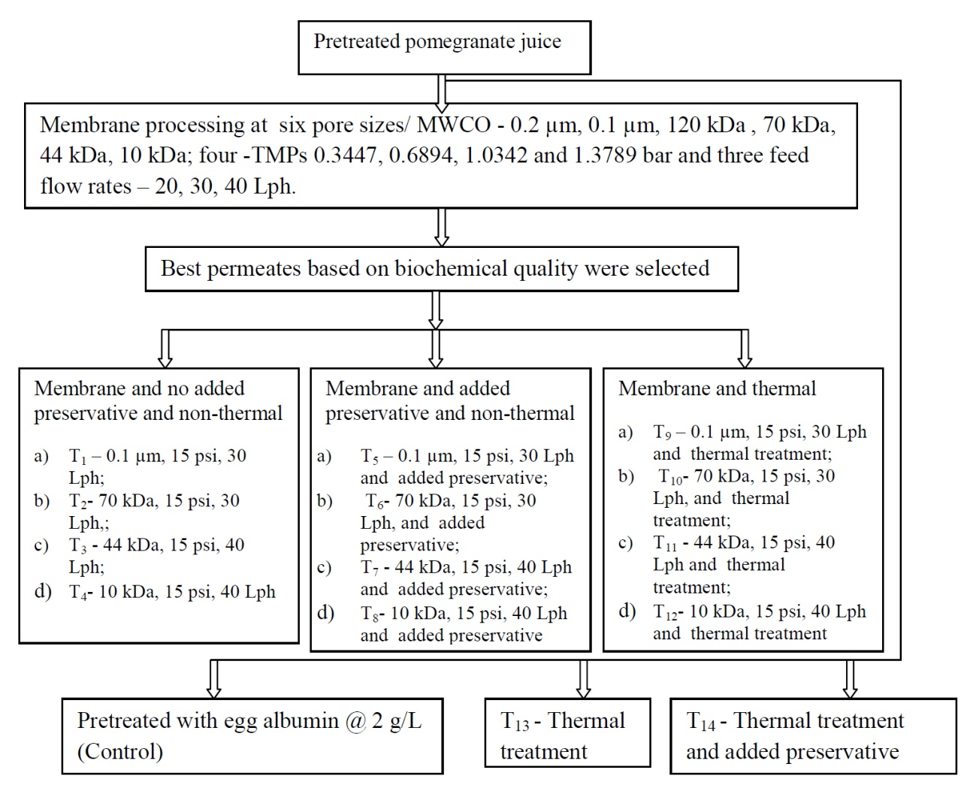
Fig. 1 Flow chart of different samples for storage studies of pomegranate juice
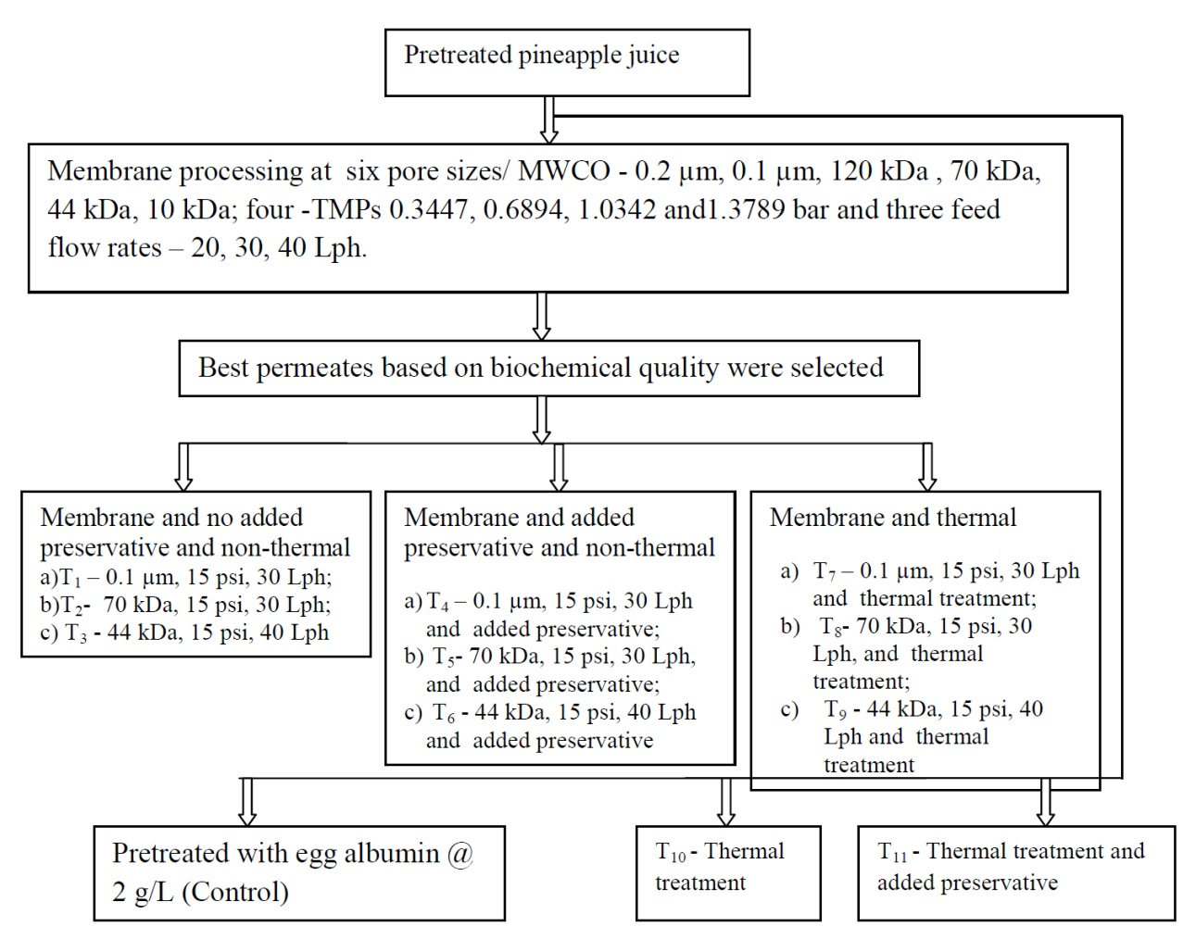
Fig. 2 Flow chart of different samples for storage studies of pineapple juice

1. Variation in total soluble solids
Variations in total soluble solids (TSS) of pomegranate and pineapple juices during storage are presented in Fig. 3. The combined influence of processing treatments and storage duration on TSS was statistically evaluated. For both juices, a progressive rise in TSS was observed with increasing storage time, consistent with earlier findings (Salari et al., 2012). Statistical analysis revealed a significant difference (P < 0.01) among all treatment combinations. Throughout the storage period, pineapple juice consistently exhibited higher TSS values compared to pomegranate juice.
Control samples showed the greatest increase in TSS, reaching 20.20% in pomegranate juice and 23.85% in pineapple juice after 180 days of storage. In contrast, the smallest increase in TSS was recorded in pomegranate juice subjected to treatment T12 (10 kDa membrane, 15 psi, 40 Lph followed by thermal processing) and in pineapple juice treated under T9 conditions (0.1 µm membrane, 15 psi, 30 Lph followed by thermal processing) at the end of the storage period. For pomegranate juice, treatments T8 (10 kDa, 15 psi, 40 Lph with preservative addition), T11 (44 kDa, 15 psi, 40 Lph with thermal processing), T7 (44 kDa, 15 psi, 40 Lph with preservative), and T3 (44 kDa, 15 psi, 40 Lph) exhibited TSS values comparable to T12, recording 10.051%, 10.502%, 10.639%, and 10.775 °Brix, respectively.
Similarly, for pineapple juice, treatments T3 (44 kDa, 15 psi, 40 Lph) and T6 (70 kDa, 15 psi, 30 Lph with preservative) were statistically comparable to T9, with TSS values of 12.782% and 13.123%, respectively. Overall, samples subjected to membrane filtration followed by thermal or chemical treatment showed minimal changes in TSS during storage, indicating the effectiveness of membrane processing in controlling TSS increase up to 180 days.
In thermally processed pomegranate juice samples without membrane clarification, TSS values at 180 days were 19.618% and 17.701% for samples with and without preservative addition (T13 and T14), respectively. The gradual rise in TSS during storage may be attributed to the absence of membrane filtration, as pretreatment with egg albumin alone may not effectively remove all high-molecular-weight colloidal components that contribute to soluble solids. Comparable patterns were noted in pineapple juice; however, TSS values were relatively higher due to the inherently pulpy nature of the juice.
The increase in TSS during storage can also be explained by the conversion of organic acids into sugars, which corresponds with the observed decline in titratable acidity in both juices. Similar trends have been reported for pomegranate juice by Bakaramahire et al. (2007) and Salari et al. (2012), for pineapple juice by Islam et al. (2014), and for strawberry juice by Yildiz et al. (2021).
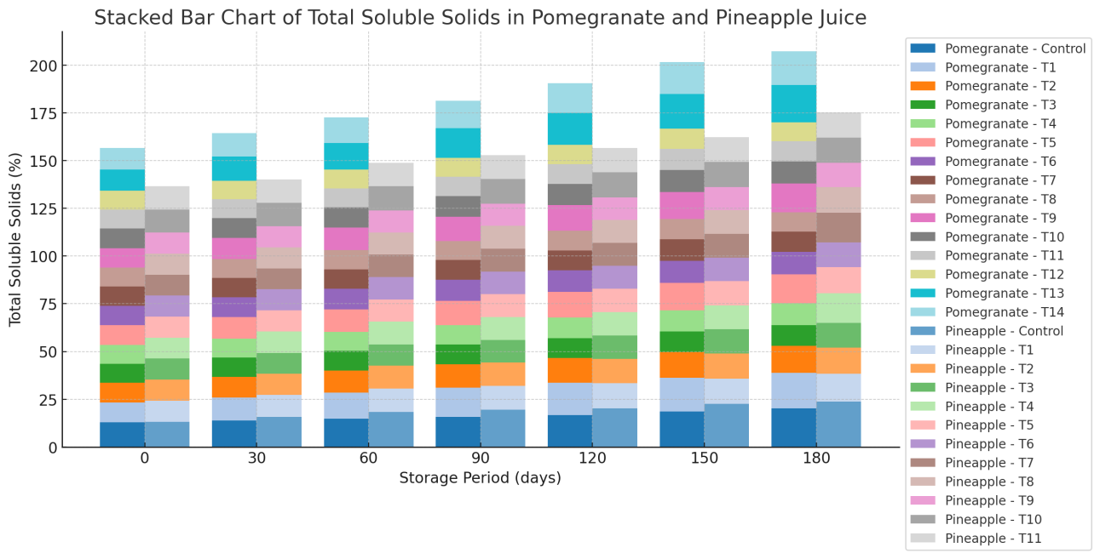
Fig. 3 Variation of TSS in different treatments of pomegranate and pineapple juices during storage

2. Variation in colour intensity
Changes in colour intensity of pomegranate and pineapple juices during storage are illustrated in Fig. 4. The interactive effects of processing treatments and storage duration were statistically evaluated. A consistent decline in colour intensity was observed in all samples of both juices throughout the storage period. A similar reduction in colour intensity during storage of pomegranate juice has been reported by Mirsaeedghazi et al. (2010). Among all samples, control treatments exhibited the greatest loss of colour intensity. Overall, pomegranate juice showed comparatively lower colour intensity values than pineapple juice.
The least reduction in colour intensity at the end of 180 days was recorded in thermally processed samples with preservative addition, namely T14 (thermal treatment at 97 °C for 5 min with preservative) for pomegranate juice and T11 (thermal treatment at 70 °C for 15 min with preservative) for pineapple juice, with colour intensity values of 5.659 and 5.562, respectively. For pomegranate juice, treatments statistically comparable to T14 included T9 (0.1 µm, 15 psi, 30 Lph followed by thermal treatment at 97 °C for 5 min), T5 (0.1 µm, 15 psi, 30 Lph with preservative), T1 (0.1 µm, 15 psi, 30 Lph), T13 (thermal treatment at 97 °C for 5 min), T10 (70 kDa, 15 psi, 30 Lph with thermal treatment at 97 °C for 5 min), and T6 (70 kDa, 15 psi, 30 Lph with preservative), which recorded colour intensity values of 4.505, 4.380, 4.252, 4.057, 3.354, and 3.229, respectively.
Similarly, in pineapple juice, treatments T7 (0.1 µm, 15 psi, 30 Lph with thermal treatment at 70 °C for 15 min), T4 (0.1 µm, 15 psi, 30 Lph with preservative), T8 (70 kDa, 15 psi, 30 Lph with thermal treatment at 70 °C for 15 min), T5 (70 kDa, 15 psi, 30 Lph with preservative), and T9 (44 kDa, 15 psi, 40 Lph with thermal treatment at 70 °C for 15 min) were statistically on par with the best-performing treatment (T11), exhibiting colour intensity values of 5.021, 4.896, 4.688, 4.563, and 4.481, respectively.
The reduction in colour intensity across all treatments can be attributed to the combined effects of pretreatment and membrane filtration, which likely removed or retained colour-imparting compounds within the clarified fractions. Although membrane processing reduced overall colour intensity, the retention of certain chromophoric constituents contributed to acceptable colour stability during storage.

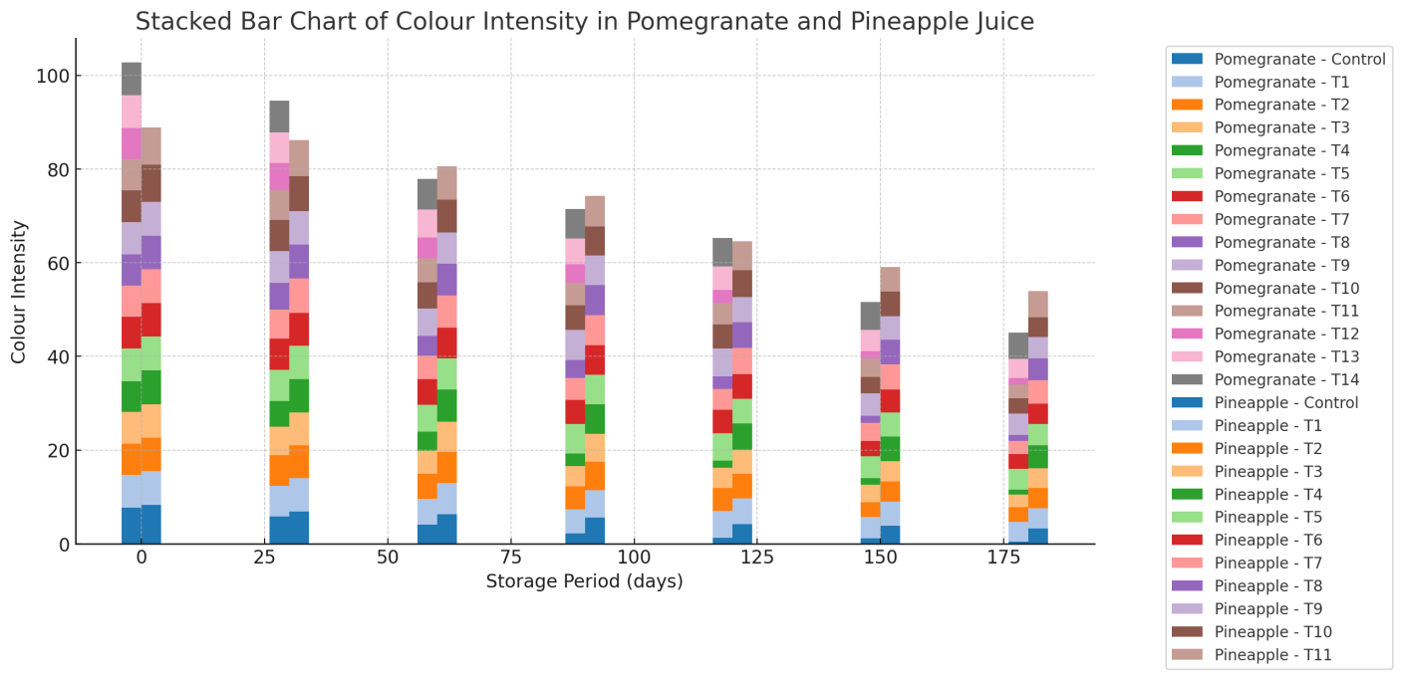
Fig. 4 Variation of colour intensity in different treatments of pomegranate and pineapple juices during storage

3. Variation in browning index
The changes in browning index of pomegranate and pineapple juices during storage are illustrated in Fig. 5. Statistical analysis indicated significant differences (p < 0.01) among all treatment combinations. For both juices, browning index values increased progressively throughout the storage period, with the highest levels observed in the control samples at the end of 180 days.
Among pomegranate juice samples, the lowest browning index values after storage were recorded in treatments T14 (thermal processing at 97 °C for 5 min with preservative addition) and T13 (thermal processing at 97 °C for 5 min without preservative). In the case of pineapple juice, treatment T11 (thermal processing at 70 °C for 15 min combined with preservative addition) exhibited the minimum browning index. These results indicate that thermal processing, particularly when combined with preservative addition, was effective in limiting browning development during storage in both juices.
The subsequent lowest browning index values for pomegranate juice were observed in T12 (10 kDa membrane, 15 psi, 40 Lph followed by thermal treatment at 97 °C for 5 min), T8 (10 kDa, 15 psi, 40 Lph with preservative), and T4 (10 kDa, 15 psi, 40 Lph), with respective values of 8.3112, 8.4322, and 8.594. Similarly, pineapple juice showed relatively lower browning indices in treatments T9 (44 kDa, 15 psi, 40 Lph with thermal treatment at 70 °C for 15 min), T8 (70 kDa, 15 psi, 30 Lph with thermal treatment at 70 °C for 15 min), T6 (44 kDa, 15 psi, 40 Lph with preservative), T5 (70 kDa, 15 psi, 30 Lph with preservative), T10 (thermal treatment at 70 °C for 15 min), and T3 (44 kDa, 15 psi, 40 Lph), which recorded browning index values of 6.48, 6.645, 6.601, 6.766, 6.777, and 6.957, respectively.
The comparatively lower browning index values observed across these treatments may be attributed to egg albumin pretreatment combined with membrane filtration, which likely removed or retained compounds responsible for non-enzymatic browning reactions. Similar findings have been reported by Valero et al. (2014). Overall, a significant increase in browning index (p < 0.01) was evident across all treatment–storage combinations for both pomegranate and pineapple juices.

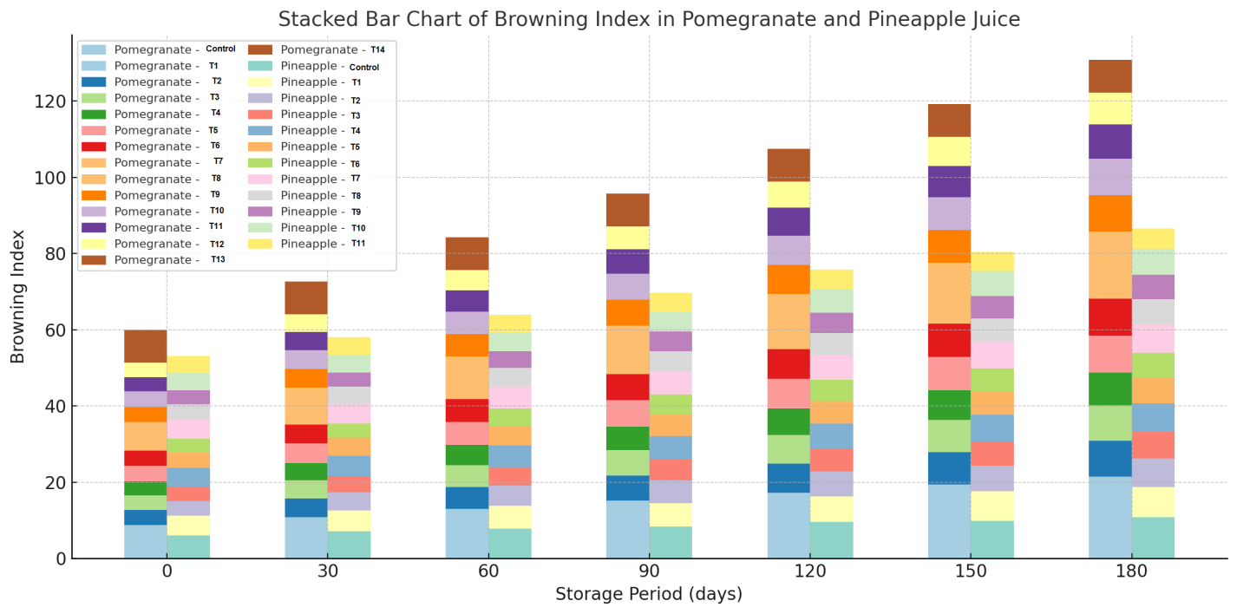
Fig. 5 Variation of Browning index in different treatments of pomegranate and pineapple juices during storage

4. Variation in turbidity
Turbidity reflects the degree of cloudiness in juice and is a critical quality parameter influencing product stability during storage. Lower turbidity values are desirable, as they indicate better clarification and prolonged shelf stability through effective suspension of solids. Changes in turbidity of pomegranate and pineapple juices during storage are presented in Fig. 6. An increase in turbidity was observed in both juices as storage progressed.
For pomegranate juice, the minimum turbidity value (0.478) at the end of 180 days was recorded in treatment T12 (10 kDa membrane, 15 psi, 40 Lph followed by thermal processing). In pineapple juice, the lowest turbidity (0.702) was observed in treatment T11 (thermal processing at 70 °C for 15 min with preservative addition). Overall, pineapple juice exhibited higher turbidity values than pomegranate juice, which can be attributed to its greater total soluble solids content and inherently pulpy nature.

Other pomegranate juice treatments that maintained relatively low turbidity included T4 (10 kDa, 15 psi, 40 Lph), T8 (10 kDa, 15 psi, 40 Lph with preservative), T7 (44 kDa, 15 psi, 40 Lph with preservative), and T11 (44 kDa, 15 psi, 40 Lph followed by thermal treatment at 97 °C for 5 min), recording turbidity values of 0.481, 0.481, 0.508, and 0.506, respectively, on the 180th day of storage. Similarly, in pineapple juice, treatments T9 (44 kDa, 15 psi, 40 Lph with thermal treatment at 70 °C for 15 min), T6 (44 kDa, 15 psi, 40 Lph with preservative), T3 (44 kDa, 15 psi, 40 Lph), and T8 (70 kDa, 15 psi, 30 Lph with thermal treatment at 70 °C for 15 min) exhibited comparatively low turbidity values of 0.747, 0.749, 0.778, and 0.788, respectively.
Lower increases in turbidity were consistently observed in samples processed using membranes with smaller molecular weight cut-offs, particularly 44 kDa and 10 kDa membranes. This effect can be attributed to egg albumin pretreatment followed by tighter membrane filtration, which effectively removed colloidal substances responsible for juice cloudiness. Similar reductions in turbidity during microfiltration have been reported for passion fruit juice by Oliveira et al. (2012) and for apple juice by Brujin et al. (2002). Additionally, Carneiro et al. (2002) reported a decrease in pulp content of pineapple juice during microfiltration, which may further explain the observed reduction in turbidity.

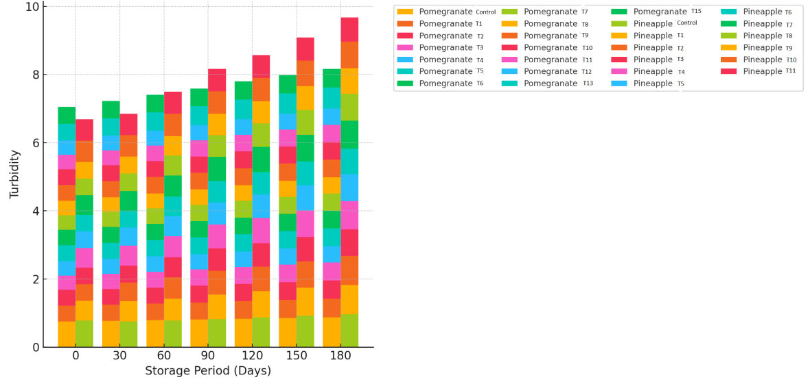
Fig. 6 Variation of Turbidity in different treatments of pomegranate and pineapple juices during storage

5. Variation in titrable acidity
Titratable acidity represents the total organic acid content of fruit juices and is an important indicator of flavour and storage stability in both pomegranate and pineapple juices. Changes in titratable acidity observed during storage are illustrated in Fig. 7. A declining trend in titratable acidity was noted across all treatments for both juices throughout the storage period, with the most pronounced reduction occurring in the control samples.
At the end of 180 days of storage, the highest titratable acidity in pomegranate juice was recorded in treatment T14 (thermal processing at 97 °C for 5 min with preservative addition), with a value of 0.695%. In pineapple juice, treatment T7 (0.1 µm membrane, 15 psi, 30 Lph followed by thermal processing at 70 °C for 15 min) exhibited the maximum acidity value of 0.769% at the same storage interval. For pomegranate juice under T14, titratable acidity decreased from an initial value of 0.803% to 0.695%, whereas in pineapple juice subjected to T7, acidity declined from 1.925% to 0.769% during storage. Overall, pineapple juice consistently exhibited higher titratable acidity than pomegranate juice.
Other pomegranate juice treatments that retained relatively higher acidity levels at the end of storage included T10 (70 kDa, 15 psi, 30 Lph with thermal treatment at 97 °C for 5 min), T11 (44 kDa, 15 psi, 40 Lph with thermal treatment at 97 °C for 5 min), T12 (10 kDa, 15 psi, 40 Lph with thermal treatment at 97 °C for 5 min), and T9 (0.1 µm, 15 psi, 30 Lph with thermal treatment at 97 °C for 5 min), recording values of 0.303%, 0.251%, 0.249%, and 0.248%, respectively.
Similarly, pineapple juice samples showing higher titratable acidity after 180 days included T8 (70 kDa, 15 psi, 30 Lph with thermal processing at 70 °C for 15 min), T11 (thermal processing at 70 °C for 15 min with preservative), T4 (0.1 µm, 15 psi, 30 Lph with preservative), T5 (70 kDa, 15 psi, 30 Lph with preservative), and T10 (thermal processing at 70 °C for 15 min), with corresponding acidity values of 0.760%, 0.703%, 0.624%, 0.615%, and 0.611%, respectively.
The reduction in titratable acidity during storage may be attributed to the conversion of organic acids into salts and sugars, as well as their involvement in metabolic and chemical reactions within the juice matrix. Similar decreases in acidity have been reported by Zaman et al. (2016) in blended pineapple and mango juices.

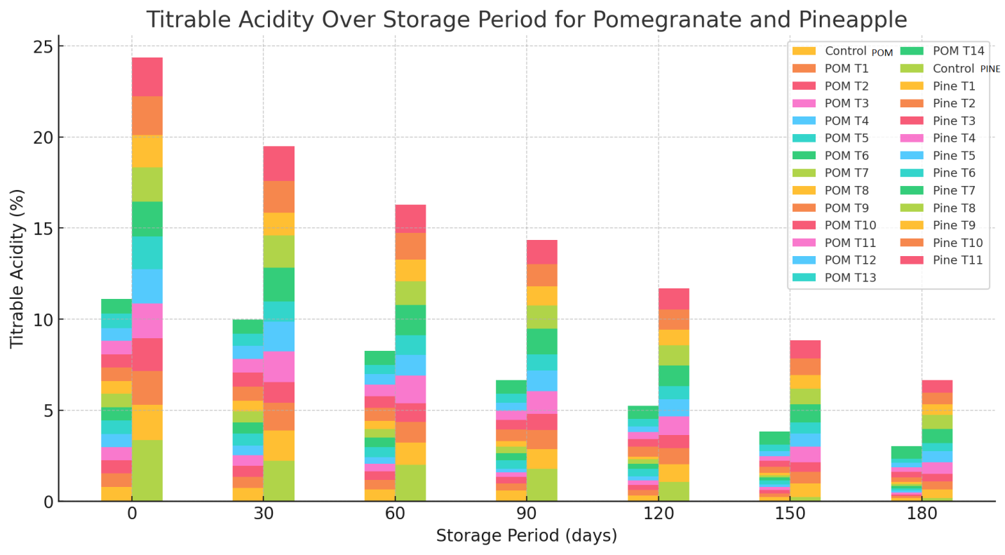
Fig. 7 Variation of Titrable acidity in different treatments of pomegranate and pineapple juices during storage

6. Variation in pH
Variations in pH of pomegranate and pineapple juices during storage are illustrated in Fig. 8. An inverse relationship between titratable acidity and pH was evident, with pH values increasing as acidity declined over the storage period. Among pomegranate juice samples, the lowest pH values were recorded in treatments T13 (thermal processing at 97 °C for 5 min) and T14 (thermal processing at 97 °C for 5 min with preservative addition). For pineapple juice, treatment T7 (0.1 µm membrane, 15 psi, 30 Lph followed by thermal processing at 70 °C for 15 min) exhibited the minimum pH during storage.
In pomegranate juice, pH values for treatments T13 and T14 ranged from 4.62 to 4.80 and from 4.62 to 4.68, respectively, over the storage period. Similarly, pineapple juice subjected to treatment T7 showed pH values between 4.717 and 4.79. The control samples of both juices displayed the greatest increase in pH by the end of storage. On the 180th day, pomegranate juice exhibited higher pH values compared to pineapple juice.
Other pomegranate juice treatments that maintained relatively lower pH values at the end of storage included T9 (0.1 µm, 15 psi, 30 Lph with thermal treatment at 97 °C for 5 min), T5 (0.1 µm, 15 psi, 30 Lph with preservative), T10 (70 kDa, 15 psi, 30 Lph with thermal treatment at 97 °C for 5 min), T6 (70 kDa, 15 psi, 30 Lph with preservative), T11 (44 kDa, 15 psi, 40 Lph with thermal treatment at 97 °C for 5 min), and T7 (44 kDa, 15 psi, 40 Lph with preservative), recording pH values of 5.11, 5.12, 5.26, 5.27, 5.39, and 5.40, respectively.
Similarly, pineapple juice treatments showing comparatively lower pH values included T4 (0.1 µm, 15 psi, 30 Lph with preservative), T8 (70 kDa, 15 psi, 30 Lph with thermal treatment at 70 °C for 15 min), T9 (44 kDa, 15 psi, 40 Lph with thermal treatment at 70 °C for 15 min), T6 (44 kDa, 15 psi, 40 Lph with preservative), and T11 (thermal treatment at 70 °C for 15 min with preservative), with pH values of 4.80, 4.88, 4.89, 4.90, and 4.90, respectively.
Overall, the most favourable pH stability was observed in samples subjected to combined membrane processing, thermal treatment, and preservative addition. Similar trends in pH variation during storage have been reported by Hounhouigan et al. (2014) and Islam et al. (2013).
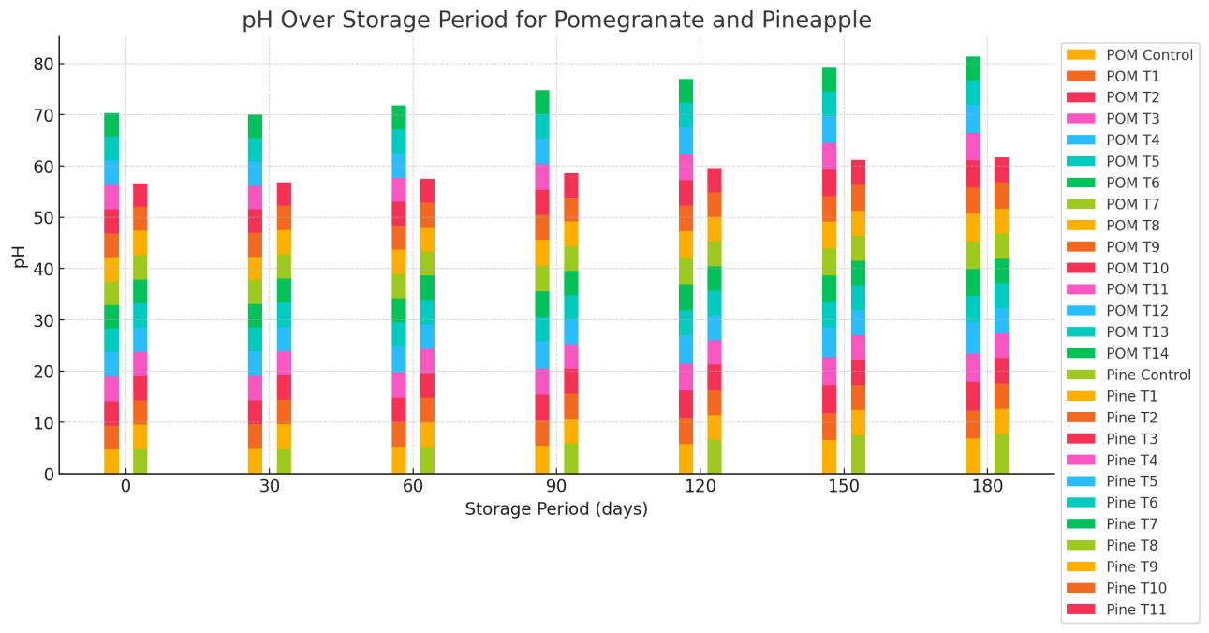
Fig. 8 Variation of pH in different treatments of pomegranate and pineapple juices during storage
7. Variation in viscosity
Although viscosity is primarily a rheological property, it has been included among the biochemical parameters for discussion purposes in this study. Viscosity is a key factor influencing juice stability, as higher viscosity can lead to increased turbidity and loss of clarity. Variations in viscosity of pomegranate and pineapple juices during storage are presented in Fig. 9. Overall, pineapple juice exhibited higher viscosity than pomegranate juice throughout the storage period, and a gradual increase in viscosity was observed in both juices over time.
Among pomegranate juice treatments, the lowest viscosity was recorded in T12 (10 kDa membrane, 15 psi, 40 Lph followed by thermal processing at 97 °C for 5 min), with values ranging from 1.28 to 2.12 cP. In pineapple juice, treatment T9 (44 kDa, 15 psi, 40 Lph followed by thermal processing at 70 °C for 15 min) showed the lowest viscosity, ranging from 1.247 to 3.098 cP.
Other pomegranate juice treatments exhibiting relatively low viscosity at the end of storage included T8 (10 kDa, 15 psi, 40 Lph with preservative), T4 (10 kDa, 15 psi, 40 Lph), T11 (44 kDa, 15 psi, 40 Lph with thermal processing at 97 °C for 5 min), T7 (44 kDa, 15 psi, 40 Lph with preservative), T14 (thermal treatment at 97 °C for 5 min with preservative), and T3 (44 kDa, 15 psi, 40 Lph), with values of 2.14, 2.17, 2.27, 2.29, 2.30, and 2.32 cP, respectively.
In pineapple juice, treatments with lower viscosity included T6 (44 kDa, 15 psi, 40 Lph with preservative), T11 (thermal processing at 70 °C for 15 min with preservative), T10 (thermal processing at 70 °C for 15 min), T3 (44 kDa, 15 psi, 40 Lph), and T8 (70 kDa, 15 psi, 30 Lph with thermal processing at 70 °C for 15 min), with values of 3.118, 3.201, 3.252, 3.315, and 3.387 cP, respectively.
The lower viscosity observed in these treatments can be attributed to the removal of pulp and high-molecular-weight macromolecules during egg albumin pretreatment and subsequent membrane filtration. Egg albumin, being a positively charged flocculant, binds negatively charged tannins and other colloids, causing them to aggregate and settle, thereby reducing turbidity and viscosity. Similar observations have been reported by Carneiro et al. (2002), who noted a substantial decrease in viscosity of microfiltered pineapple juice due to pulp and macromolecule removal, which is consistent with the results of the present study.

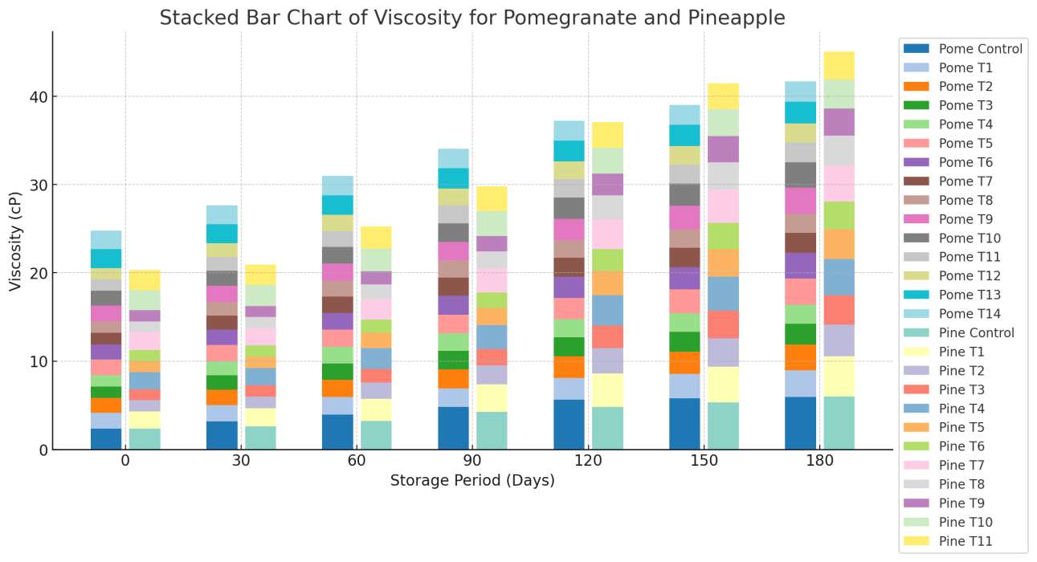
Fig. 9 Variation of viscosity in different treatments of pomegranate and pineapple juices during storage

Conclusions
High-quality pomegranate and pineapple fruits were carefully selected, washed, and processed to extract juice. The juices were pretreated with egg albumin and subjected to membrane filtration, followed by various combinations of thermal treatment and preservative addition for evaluation. The treatments included: (i) thermal treatment only with no preservative, (ii) no thermal treatment with added preservative, and (iii) no thermal treatment and no preservative. Control samples, which were only pretreated with egg albumin and filtered through muslin cloth, were also included in the storage study. All physicochemical analyses were conducted in triplicate and found to be within permissible limits.

Based on biochemical analysis over 180 days of storage, the best-performing treatments for pomegranate juice were, in order: T14 (thermal treatment at 97 °C for 5 min with preservative), T9 (0.1 µm membrane, 15 psi, 30 Lph with thermal treatment), T10 (70 kDa, 15 psi, 30 Lph with thermal treatment), T11 (44 kDa, 15 psi, 40 Lph with thermal treatment), T12 (10 kDa, 15 psi, 40 Lph with thermal treatment), T13 (thermal treatment only), and T7 (44 kDa, 15 psi, 40 Lph with thermal treatment and added preservative). Treatments were considered optimal based on their biochemical stability and quality after processing.

The biochemical parameters of pomegranate juice after 180 days of storage were recorded as follows: total soluble solids (TSS) 9.914%, colour intensity 5.659, browning index 3.121, turbidity 0.478%, titratable acidity 0.695%, pH 4.68, and viscosity 2.12 cP. Similarly, for pineapple juice, TSS was 12.782%, colour intensity 5.562, browning index 5.27, turbidity 0.702%, titratable acidity 0.769%, pH 4.79, and viscosity 3.098 cP.

Disclaimer (Artificial intelligence)

Author(s) hereby declare that NO generative AI technologies such as Large Language Models (ChatGPT, COPILOT, etc.) and text-to-image generators have been used during the writing or editing of this manuscript.

References
AOAC. 2005. Official Methods of Analysis of AOAC International 18th Edition, USA.
Aviram, M and Dornfeld, L. 2001. Pomegranate juice consumption inhibits serum angiotensin converting enzyme activity and reduces systolic blood pressure. Atherosclerosis. 158(1): 195-198.
Bakaramahire, S.D. 2007. Studies on extraction, packaging and storage of pomegranate (Punica granatum L.) juice cv. Mridula. M.Sc Thesis, Mahatma Phule Krishi Vidyapeeth, Rahuri, Maharashtra. India.
Bruijn, J.D., Venegas, A and Borquez, R. 2002. Influence of crossflow ultrafiltration on membrane fouling and apple juice quality. Desalination. 148(1-3): 131-136.
Carneiro, L., Sa, I.D.S, Gomes, F.D.S, Matta, V.M and Cabral, L.M.C. 2002. Cold sterilization and clarification of pineapple juice by tangential microfiltration. Desalination. 148(1-3):93-98.
Domingues, R.C., Junior, S.B., Silva, R.B., Madrona, G.S., Cardoso, V.L and Reis, M.H.2011. Evaluation of enzymatic pretreatment of passion fruit juice. Chemical Engineering Transactions. 24:517-522.
Goh, S.G., Noranizan, M., Sobhi, B., Sew, C.C and Leong, C.M. 2012. Effect of thermal and ultraviolet treatments on the stability of antioxidant compounds in single strength pineapple juice throughout refrigerated storage.International Food Research Journal. 19 (3): 1131-1136.
Hounhouigan, M.H., Linnemann, A.R., Ingenbleek, P.T., Soumanou, M.M., Trijp, H.C.V andBoekel, M.A.V 2014. Effect of physical damage and storage of pineapple fruits on their suitability for juice production. Journal of Food Quality. 37(4):268-273.
Islam, M.A., Ahmad, I., Ahmed, S and Sarker, A. 2014. Biochemical composition and shelf life study of mixed fruit juice from orange & pineapple. Journal of Environmental Science and Natural Resources. 7(1):227-232.
Islam, M., Khan, M.Z.H., Sarkar, M.A.R., Absar, N and Sarkar, S.K. 2013. Changes in acidity, TSS, and sugar content at different storage periods of the postharvest mango (Mangifera indica L.) influenced by Bavistin DF. International Journal of Food Science, 2013: 1-8.
Laorko, A., Li, Z., Tongchitpakdee, S., Chantachum, S and Youravong, W. 2010. Effect of membrane property and operating conditions on phytochemical properties and permeate flux during clarification of pineapple juice. Journal of Food Engineering. 100(3):514-521.
Mirsaeedghazi, H., Djomeh, Z.E., Mousavi, S.M., Aroujalian, A and Navidbakhsh, M. 2010. Clarification of pomegranate juice by microfiltration with PVDF membranes. Desalination.264(3):243-248.
Oliveira, R.C.D, Doce, R.C. and de Barros, S.T.D. 2012. Clarification of passion fruit juice by micro filtration: Analyses of operating parameters, study of membrane fouling and juice quality. Journal of Food Engineering. 111(2):432-439.
Paul, R and Ghosh, U. 2012. Effect of thermal treatment on ascorbic acid content of pomegranate juice Indian Journal of Biotechnology. 11: 309-313.
Salari, H., Sreenivas, K.N., Shankarappa, T.H., Krishna, H.C and Gowda, A.P.M. 2012. Physico-chemical and sensory parameters of muskmelon blended pomegranate squash and syrup. Environment and Ecology. 30(3C): 1052-1057.
Samreen, Satyanarayana, Ch.V.V., Edukondalu, L., Beera, V and Rao, V.S. 2020. Physicochemical characteristics of pomegranate and pineapple juice. Indian Journal of Ecology. 47 Special Issue (11): 60-63.
Valero, M., Vegara, S., Martí, N. and Saura, D. 2014. Clarification of pomegranate juice at industrialscale. Journal of Food Processing and Technology. 5(5):1-6.
Yildiz, S., Pokhrel, P. R., Unluturk, S and Barbosa-Cánovas, G. V. 2021. Changes in quality characteristics of strawberry juice after equivalent high pressure, ultrasound, and pulsed electric fields processes. Food Engineering Reviews, 13(3), 601-612.
Zaman, A.K.,Shamsudin, R and Adzahan, N.M. 2016. Effect of blending ratio on quality of fresh pineapple (Ananas comosus L.) and mango (Mangifera indica L.) juice blends. International Food Research Journal. 23(Suppl):S101-S106.
Samreen, Chilukuri, V. V. S., Lingathoti, E., Beera, V., & Vatluri, S. R. (2024). Effect of membrane processing on biochemical quality of pomegranate and pineapple fruit juices. International Journal of Advanced Biochemistry Research, 8(4), 736–744.

