Consumption patterns and Physicochemical and nutritional Characterization of conventional Artisanal liquids in the Congo

Abstract.
The microorganisms responsible for alcoholic fermentation are generally present on the surface of the raw materials used as substrate. The consumption of alcoholic beverages is a tradition deeply rooted in human society, as these beverages have been present at religious and cultural ceremonies for thousands of years. The objective of this study was to assess consumption and characterize local artisanal beverages in Congo. Consumption was assessed for the most widely consumed beverages in the study area, manufacturing processes were developed, and physicochemical characterization was performed. Consumption and production of these beverages were assessed through a cross-sectional survey. The consumer survey revealed that in Congo, artisanal alcoholic beverages are mainly consumed by men in rural and urban areas. Among the best known and most consumed beverages by the surveyed population are: Oil palm wine (Nsamba), corn and cassava-based liqueur (Bouganda), sugar cane wine (Loungouila), raffia palm wine (Ntsam-Ntsam), and grapefruit or lemon wine (Let me sleep). The production processes for these beverages differ from one beverage to another. Physicochemical analyses revealed that these five beverages are acidic with a pH ranging from 2.68 to 4.10; a Brix of 2.9-14.85 °Brix; a titratable acidity of 0.16-5.35 g/L; a TAV of Bouganda 21.45-22.31 °; Let me sleep of 10.04-11.17°; Loungouila of 6.82-7.54°; Nsamba of 1.00-7.87°; Ntsam-Ntsam 4.00°; ash content 0.23-0.68%; protein content 0.013-0.85%; calcium of 16 to 160.32 mg/L); magnesium (9.72-660.96 mg/L); phosphorus (1.25-65.74 mg/L); iron (1.28-13.78 mg/L); potassium (9.52-2750 mg/L). The energy value ranges from 238.80 to 1297.35 kcal. These results show that most artisanal alcoholic beverages meet physical and chemical standards and are good sources of energy and minerals.

Key words: Local drinks, physicochemical characterization, alcoholic beverages, microorganisms

Introduction
The use of fruits and their by-products in food has dramatically impacted the food industry due to the nutritional benefits and the technological and sensory effects of food matrices. Artisanal liquids constitutes a diverse category of foods created by introducing fermenting bacterial or yeast stains into the milk of different species, resulting in products with different sensory properties, comprising acidic, sour, and tangy flavors and fluid, viscous, and thick textures (Gutiérrez-Álzate et al., 2023). Globally, every culture has a particular beverage that plays a fundamental cultural role in its collective imagination (Nicolas, 2006). From this perspective, we can distinguish several types of beverages, including: water (the most widely consumed beverage), tea, milk, energy drinks (cola or coffee-based), non-alcoholic beverages (soda, etc.), and alcoholic beverages. Among these, alcoholic beverages play a prominent role. This can be explained by the effects of intoxication, which have been associated with conviviality and religion (Nicolas, 2006). The consumption of alcoholic beverages is therefore a tradition deeply rooted in human society, as these beverages have been present at religious and cultural ceremonies for thousands of years. The microorganisms used for the fermentation process may originate from a defined culture—careful cultivation of a defined and identified number of microorganisms, or they may come from the environment in which the fermentation takes place.[Citation^{7]} Spontaneous fermentation uses natural starters, either from the environment, which includes surroundings, the containers and utensils, or from the raw materials being used (Ronquillo Blau et al., 2023).
Among alcoholic beverages, we have modern drinks such as beers, wines, and craft beverages. In sub-Saharan Africa, a study conducted by Hamon et al. (2002) showed that the populations surveyed had a clear preference for industrial alcoholic beverages but, for financial reasons, consumed very little of them compared to artisanal alcoholic beverages. Most local alcoholic beverages are produced using traditional methods, with microorganisms actively involved in the fermentation process (Kobawila, 2003). The microorganisms responsible for alcoholic fermentation are generally present on the surface of the raw materials used as substrate (Kobawila, 2003). In the Republic of Congo, fermented foods and beverages play an important role, both in everyday consumption and during cultural events such as traditional weddings, dowries, etc. (e.g., palm wine). A wide variety of traditional fermented beverages can be found in the Congo, including Loungouila sugarcane wine, palm wine (Nsamba), honey wine (Duma), orange wine, pineapple wine, grapefruit wine (Let me sleep) and banana wine (Kayath et al., 2016). In addition, there is “Bouganda,” a liqueur made from fermented corn and cassava. These beverages are very popular among the urban and rural populations of Congo due to their low cost and their effects, which include stimulating appetite and sexual desire, providing energy during work or daily meals, etc. They are the focus of this study, which aims to determine their level of consumption as well as their physical, chemical, and nutritional composition. Despite their economic importance, cultural value, and popularity among the Congolese population, the consumption of local beverages has attracted the attention of researchers because few studies have been conducted on their physical, chemical, and nutritional composition.
This observation has prompted us to evaluate the consumption and physicochemical and nutritional composition of local beverages consumed in the Republic of Congo in general and in the departments of Brazzaville, Bouenza, and Pool in particular. With this in mind, we ask ourselves: what is the level of consumption and the physical, chemical, and nutritional composition of artisanal alcoholic beverages in the Congo?
Thus, the overall objective of this study is to assess the consumption and physical, chemical, and nutritional composition of traditional alcoholic beverages in the Congo. Specifically, it aims to:

Assess the level of consumption of artisanal alcoholic beverages in the departments of Brazzaville, Bouenza, and Pool;

Assess the production processes for these beverages;

Determine the physical, chemical, and nutritional characteristics of these beverages.
Materials and methods
Materials
Biological material
The food items consisted of the most commonly consumed artisanal alcoholic beverages in the three target locations. These were palm wine (Nsamba “a”), sugarcane wine (Loungouila ‘b’), a drink made from corn and cassava (Bouganda or lotoko “c”), grapefruit juice wine (Let me sleep “d”), and raffia palm wine (Ntsam-Ntsam “e”).
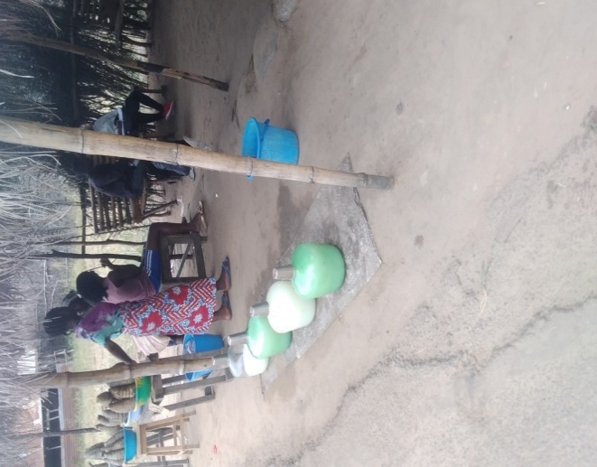 | 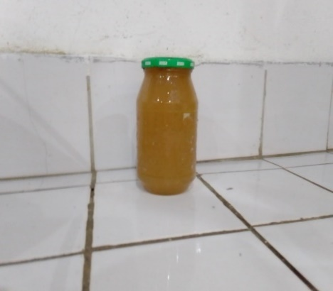 | 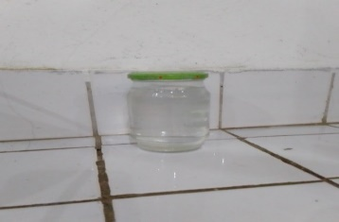 | 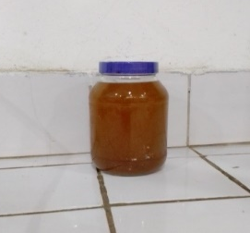 | 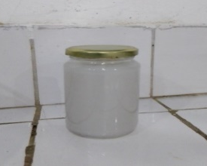
c : photograph of corn drink and foufou (Bouganda)

d : photograph of Grapefruit Wine (Let Me Sleep)

e : Photograph of Raphia palm wine (Ntsam-Ntsam)

b : photograph of sugarcane wine (Loungouila)

a : Photograph of palm wine (Nsamba).

Figure 1: Most commonly consumed artisanal alcoholic beverages in the study area

Teaching materials

The teaching materials consisted of a consumption survey form containing information on the consumption of artisanal alcoholic beverages in the three departments and a survey form for observing the production of artisanal alcoholic beverages.

Methods
Assessment of local beverage consumption and production
Local beverage consumption was assessed through a cross-sectional survey in areas where these beverages are consumed and produced. The data collected focused on: identifying the best-known and most widely consumed artisanal alcoholic beverages, consumer preferences between modern and artisanal beverages, consumption habits, and the effects felt after consuming local beverages. The responses obtained were then noted or checked on the survey form.
Production was monitored using an observation sheet detailing the manufacturing processes for these beverages in order to collect data on the production stages, shelf life, and difficulties associated with producing these beverages.
The target population consisted of potential or occasional consumers and producers of local beverages in the city of Brazzaville, Bouenza (Nkayi), and Pool (Makana).
The topics covered in this work are:
- People residing in Brazzaville, Nkayi, and Makana at the time of the survey;
- Consumers and producers of craft alcoholic beverages ;
- People who agree to participate in the survey.
The biological material for this study requires :
- To be a craft alcoholic beverage ;
- To be among the most popular craft alcoholic beverages in our three localities;
- To be collected only from producers for better monitoring.

Physical, chemical, and nutritional analyses
Samples of artisanal alcoholic beverages, taken from production sites in Brazzaville and Nkayi, were transported in a cooler containing ice cubes to slow down fermentation activity.
The physical, chemical, and nutritional analyses of the various beverages focused on determining the pH, Brix degree, alcohol content, titratable acidity, and protein, ash, and mineral content.
Determination of pH and titratable acidity
The pH of the beverages was determined by direct measurement using a portable pH meter according to the AOAC method (1975). The volume of NaOH used was recorded to enable calculation of the titratable acidity of the product according to the following formula:
$$Titratable acidity=\frac{V_{NaOH}×coefficient×100×10}{V}$$
Coefficient (for citric acid) = 0,0064
V= the volume of the sample taken (10 mL)
Determination of the Brix degree

The Brix degree and refractive index were determined prior to each sample's arrival at the INRSIIT laboratory using a digital refractometer; this made it possible to determine the refractive index and the amount of sucrose and glucose contained in each beverage.
Determination of density and alcohol content
The alcohol content was determined using the OIV 2011 method. After distillation, the alcohol content of 100 mL of distillate was measured using an alcoholometer.
Calculation of ABV (Alcohol by Volume)
$$ABV=\frac{Measured degree×200×Density}{ST}$$
ST = Sample test
Density was calculated using the following formula:
$$Density=\frac{M_{2}-M_{0}}{M_{1}-M_{0}}$$
With :
M₀ : Mass of the empty pycnometer.
M₁ : Mass of the pycnometer containing distilled water.
M₂ : Mass of the pycnometer plus sample.
Determination of ash content
The ash content was determined using the AOAC (1990) method.

Determination of protein content
The protein content was determined using the Kjeldahl method (AOAC, 2000). The nitrogen volume was determined using the following formula:
$$\%N=\frac{(Veq-Vwhite)×0,07}{taking}$$
With : V_{white} = 0,6mL ; Veq = equivalent volume
%Proteins = %N × 6,25
Determining energy value
The energy value of alcoholic beverages is determined based on the amount of pure alcohol in grams and the residual sugar remaining after fermentation.
The following formula is used to calculate the amount of alcohol in grams:
$$Amount of alcohol (g)=\frac{amount of drink \left(mL\right)×vol\left(\%\right)×0.8}{100}$$
Therefore: Energy value = (Amount of alcohol in g × 7.1) + (residual sugar × 4)
Given that:
1g of carbohydrate = 4 Kcal; 1g of pure alcohol = 7.1 Kcal and 0.8 (g/L) = density of pure alcohol.
Source: hhps://methodelaurand. Wordpress.com

The iron, calcium, phosphorus, potassium, and magnesium contents of the various beverages analyzed were determined using the AOAC method, 1990.
Data analysis and processing

The data collected was processed and the raw tables and figures were entered and produced using Word 2016, Excel 2016, and Epi-Info 7 software.

Results and discussion

Results
Results on the consumption of local beverages
Alcoholic beverage consumption habits
Respondents' knowledge of artisanal alcoholic beverages
Table 1 presents the list of alcoholic beverages identified in the field. This table shows that a total of 24 beverages were identified by respondents, the best known of which are: Nsamba (95.67%), Bouganda (95%), Loungouila (76%), Let me sleep (44.33%) and Ntsam-Ntsam (42.67%).
Table 1: Distribution of craft beverages
N° | Beverages | People who know (%) | People who are unfamiliar with (%)
1 | Biyoki | 3.67 | 96.33
2 | Bouganga (Lotoko) | 95 | 5.00
3 | Duma | 1.33 | 98.67
4 | Snack leave (coconut) | 0.33 | 99.67
5 | Gua-gua | 3.67 | 96.33
6 | Kélé – Wélé | 15.67 | 84.33
7 | Let me sleep | 44.33 | 55.67
8 | Lounguila | 76 | 24.00
9 | Mbolo | 1.33 | 98.67
10 | Moléngué | 9.67 | 90.33
11 | Moundjondjo | 0.33 | 99.67
12 | Ngolima | 3.67 | 96.33
13 | Nsamba | 95.67 | 4.33
14 | Ntsam-Ntsam | 42.67 | 57.33
15 | Tombé | 11.67 | 88.33
16 | Touomi | 4 | 96.00
17 | Pineapple wine | 7.33 | 92.67
18 | Banana wine | 1.33 | 98.67
19 | Honey wine | 3 | 97.00
20 | Minguengué wine | 0.66 | 99.34
21 | Sorrel wine | 1 | 99.00
22 | Galé wine | 8.67 | 91.33
23 | Wassa | 3.67 | 96.33
24 | Yonga | 5.33 | 94.67

Level of consumption of various craft alcoholic beverages by respondents.

The results show that among all the beverages surveyed, palm wine (Nsamba) is the most widely consumed (41.33%), followed by sugarcane wine (Loungouila 34.33%), Bouganda (21.67%), and Ntsam-Ntsam (15.67%). 18.33% of those surveyed consume all types of artisanal beverages. The other beverages are consumed in small quantities.

Figure 2: Level of consumption of artisanal alcoholic beverages
Let me sleep
Honey wine
All

Figure 2: Level of consumption of artisanal alcoholic beverages

Preference between industrial alcoholic beverages and craft alcoholic beverages among respondents.
The results on respondents' preferences between craft alcoholic beverages and industrial alcoholic beverages (Figure 3) show that the vast majority of respondents (77.33%) have a clear preference for craft alcoholic beverages, compared to 14.67% who prefer industrial alcoholic beverages.
.

No Preference
Preference for local beverages
Preference for industrial beverages

Figure 3: Preference between industrial alcoholic beverages and craft alcoholic beverages.

Reasons for consuming craft alcoholic beverages among respondents.
The results on the reasons for consuming craft alcoholic beverages (Figure 4) show that some respondents (26.67%) consume them because of culture (habit), others consume them simply for pleasure (14.67%), or because they stimulate the appetite (10.33%) and because they are organic (10.00%).
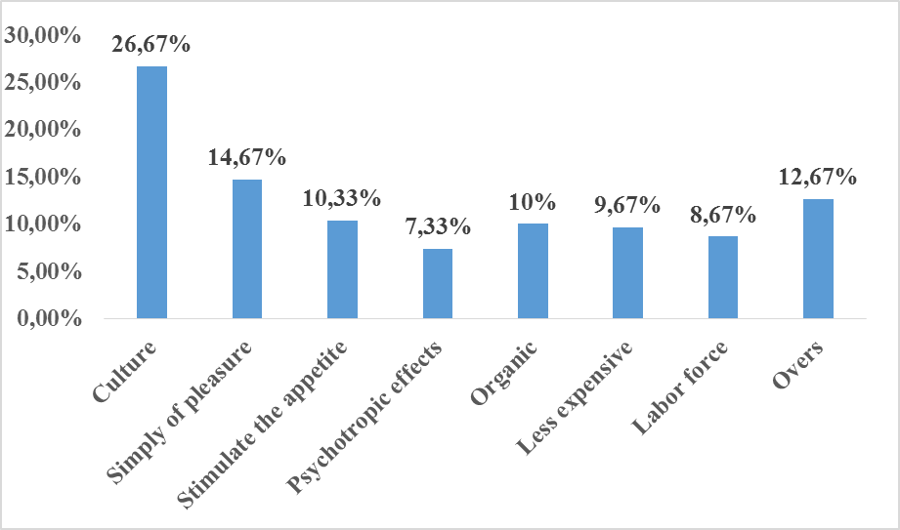
Figure 4: Reasons for consuming craft alcoholic beverages.

Place where respondents consume craft alcoholic beverages.
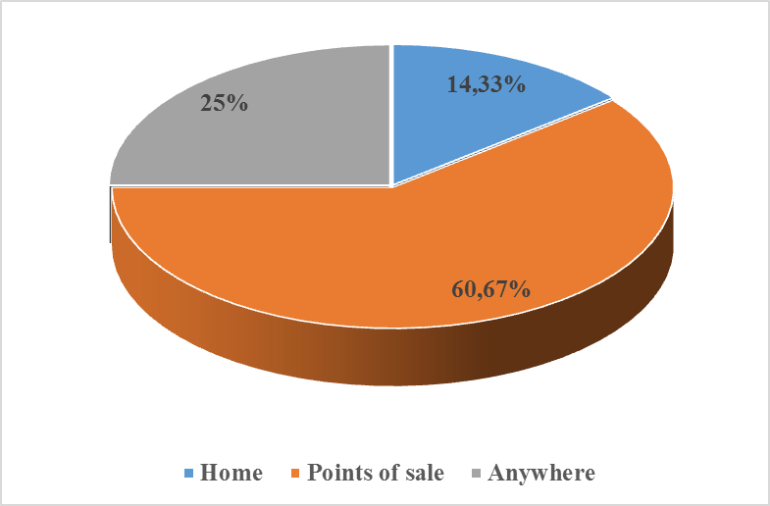
The results (Figure 5) show that the consumers surveyed consume craft alcoholic beverages either at points of sale (60.67%), anywhere (25%), or at home (14.33%).

Figure 5: Where artisanal alcoholic beverages are consumed
Times when respondents consumed craft alcoholic beverages.
Figure 6 shows that consumers drink local beverages after meals (43%), before meals (15%), or without preference (42%).
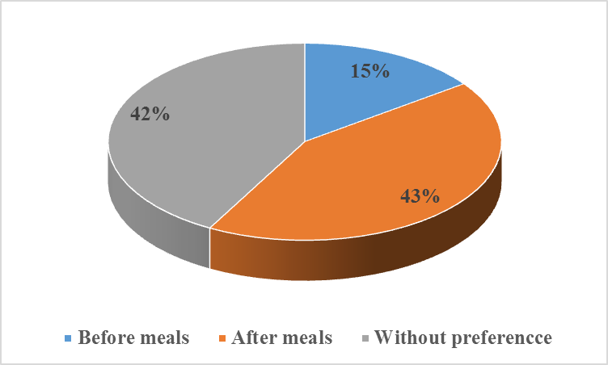
Figure 6: Times of consumption of craft alcoholic beverages

Consumption patterns of craft alcoholic beverages among respondents.
Figure 7 shows that most respondents (88.67%) consume local beverages as a single drink, while 6.6% consume them as a mixture and 4.67% have no preference.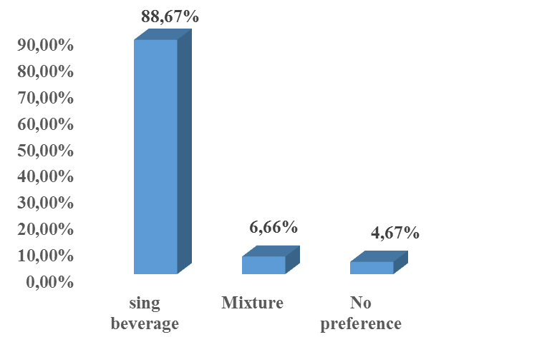
Figure 7: Consumption patterns for craft alcoholic beverages

Frequency of consumption of craft alcoholic beverages by respondents.
Table II shows the frequency of consumption of the various local beverages most commonly consumed by respondents.
The results show that 66% of respondents consume Loungouila seven times a week, 50% consume Nsamba seven times a week, 38% consume Bouganda seven times a week, and 27% consume Ntsam-Ntsam seven times a week. Other local beverages are consumed infrequently on a weekly basis.

Table 2: Frequency of consumption of artisanal alcoholic beverages
Beverages  Weekly frequencies | Bouganda | Lounguila | Nsamba | Ntsam - Ntsam | Let me sleep | Others
Once | 8 | 7 | 2 | 3 | 0 | 2
Twice | 4 | 9 | 26 | 7 | 1 | 0
Three times | 12 | 31 | 20 | 3 | 0 | 0
Four times | 6 | 4 | 16 | 5 | 0 | 1
Five times | 8 | 5 | 5 | 4 | 0 | 0
Six times | 2 | 0 | 2 | 1 | 0 | 0
Seven times | 38 | 66 | 50 | 27 | 2 | 0
Occasionally | 17 | 15 | 23 | 12 | 16 | 10
Total = 300 respondents | 95 | 137 | 144 | 62 | 19 |  | 13

Effects related to the consumption of craft alcoholic beverages by respondents.
Figure 8 shows the effects associated with the consumption of artisanal alcoholic beverages. This figure shows that after consumption, local beverages stimulate appetite (86.33%) or stimulate sexual desire (76%). The least common side effects are diarrhea (11.33%), nausea (2.33%), and vomiting (1.33%).
Figure 8: Effects related to the consumption of artisanal alcoholic beverages

Results of physical, chemical, and nutritional analyses
Physicochemical parameters
Table 3shows the Brix and refractive index results for fresh beverages and the titratable acidity of different beverages after fermentation.
In terms of titratable acidity, Bouganda is the least acidic beverage (0.16 g/L of acetic acid), followed by Ntsam-Ntsam (2.51 g/L), Let me sleep (4.51 g/L), Nsamba (4.68 g/L), and finally Loungouila (5.35 g/L). In terms of Brix, it shows that the amounts of sucrose and glucose are relatively identical. The refractive indices of our beverages vary between 1.335585 and 1.35665.
Table 3: Physicochemical parameters of beverages
Samples | Titratable acidity (g/L) |  | °Brix of newly produced beverages |  |  | Refractive index
Samples |  |  | Sucrose | Glucose | FAO/WHO Standard 2005  11-15 | Refractive index
Bouganda | 0.16 ± 0.03 | FAO/WHO Standard 2005  4 ± 0.5 | 7.44 ± 0.49 | 7.30 ± 0.54 | FAO/WHO Standard 2005  11-15 | 1.343565
Let me sleep | 4.51 ± 0.03 | FAO/WHO Standard 2005  4 ± 0.5 | 15,14 ± 0,08 | 15.15 ± 0.15 | FAO/WHO Standard 2005  11-15 | 1.355145
Loungouila | 5.35 ± 0.04 | FAO/WHO Standard 2005  4 ± 0.5 | 5.58 ± 0.50 | 5.53 ± 0.02 | FAO/WHO Standard 2005  11-15 | 1.340325
Nsamba | 4.68 ± 0.26 | FAO/WHO Standard 2005  4 ± 0.5 | 16.21 ± 0.04 | 16.26 ± 0.06 | FAO/WHO Standard 2005  11-15 | 1.35665
Ntsam-Ntsam | 2.51 ± 0.16 | FAO/WHO Standard 2005  4 ± 0.5 | 3.00 ± 0.26 | 2.95 ± 0.22 | FAO/WHO Standard 2005  11-15 | 1.335585

Changes in pH, Brix, and TAV levels in different beverages.
Table 4 shows the evolution of pH, Brix, and TAV of the different beverages over time. This table shows that all beverages have an acidic pH that gradually decreases over time. We also note a decrease in Brix, whereas the TAV of these beverages increases over time, except for Ntsam-Ntsam, which remained at 4° from the first to the last week.

Table 4: Changes in pH, Brix, and TAV of beverages over time.
 |  | Bouganda | Let me sleep | Loungouila | Nsamba | Ntsam-Ntsam
First week | pH | 4.10 | 3.22 | 2.81 | 3.49 | 3.90
First week | Brix | 7.44 | 15.14 | 5.58 | 16.21 | 3.00
First week | TAV (°) | 21.45 ± 0.16 | 10.04 ± 0.37 | 6.82 ± 0.36 | 1.00 ± 0.00 | 4.00 ± 0.00
2nd week | pH | 3.76 | 3.11 | 2.72 | 2.99 | 3.80
2nd week | Brix | 7.00 | 14.85 | 5.10 | 11.40 | 2.90
2nd week | TAV (°) | 21.56 ± 0.00 | 10.61 ± 0.30 | 7.00 ± 0.00 | 7.14 | 4.00 ± 0.00
3rd week | pH | 3.56 | 3.00 | 2.68 | 3.00 | 3.80
3rd week | Brix | 6.50 | 14.85 | 5.00 | 11.30 | 2.90
3rd week | TAV (°) | 22.31 ± 0.00 | 11.17 ± 0.23 | 7.54 ± 0.00 | 7.87 ± 1.23 | 4.00 ± 0.00

Nutritional composition of different beverages
The results show that the ash content of the most commonly consumed artisanal beverages varies between 0.23 ± 0.03 and 0.68 ± 0.14, while the protein content varies between 0.01 ± 0.00 and 0.85 ± 0.01. The energy value varies between 238.80 and 1297.35 kcal.
Table5: Nutritional composition of various beverages
Contents  Samples | Ash content (%) | Protein content (%) | Energy value (kcal) per 1 liter of beverage
Bouganda | 0.23 ± 0.03 | 0.01 ± 0.00 | 1297.35
Let me sleep | 0.42 ± 0.12 | 0.29 ± 0.00 | 694.74
Loungouila | 0.68 ± 0.14 | 0.06 ± 0.00 | 448.72
Nsamba | 0.57 ± 0.28 | 0.32 ± 0.00 | 493.30
Ntsam-Ntsam | 0.63 ± 0.13 | 0.85 ± 0.01 | 238.80

Mineral content
Table6 shows the mineral content of the most commonly consumed artisanal beverages. This table shows that Laisse-moi-dormir is the beverage richest in calcium (160.32 mg/L), magnesium (660.96 mg/L), and iron (13.78 mg/L). Nsamba is richer in potassium (2750 mg/L). Ntsam-Ntsam has the highest calcium content alongside Let me sleep (160.32 mg/L) and is also the beverage richest in phosphorus (65.74 mg/L). Bouganda has the lowest levels of all the minerals listed in this table.
Table 6: Mineral content of various beverages
Minerals  Samples | Calcium  (mg /L) | Magnesium  (mg /L) | Phosphorus  (mg/L) | Fer  (mg /L) | Potassium  (mg /L)
Loungouila | 128.26 | 106.92 | 42.76 | 10.65 | 385.96
Let me sleep | 160.32 | 660.96 | 30.44 | 13.78 | 631.58
Bouganda | 16.03 | 9.72 | 1.25 | 1.28 | 9.52
Nsamba | 128.26 | 77.76 | 29.11 | 1.63 | 2750.00
Ntsam-Ntsam | 160.32 | 97.26 | 65.74 | 1.56 | 2450.00

DISCUSSION
Our survey identified a total of 24 beverages in our study area, the best known of which are Nsamba (95.67%), Bouganda or Lotoko (95%), Loungouila (76%), Let me sleep (44.33%) and Ntsam-Ntsam (42.67%) . Their high consumption could be explained by their availability in all three localities. Bouganda is available and consumed in all three departments. As for Nsamba, it is available in all three departments but is consumed more in the southern districts of Brazzaville and in the Pool region. Ntsam-Ntsam is more commonly consumed in the northern districts of Brazzaville, as well as in Dolisie and Pointe-Noire, where it is known as “Tombé” by consumers. Loungouila and Let me sleep are generally consumed in Bouenza, more specifically in Nkayi, because their raw materials (sugar cane and grapefruit) are abundant in this area.
Our results showed that 77.33% of consumers surveyed preferred traditional alcoholic beverages, compared to 14.67% who preferred industrial alcoholic beverages. These preferences for traditional alcoholic beverages can be explained by the natural aspect of these beverages due to the fact that they do not contain chemicals; the cultural value attributed to them (Nicolas, 2006) due to their presence at traditional weddings, funerals, mourning ceremonies, to seal relationships (Derache, 1989) or to remedy spiritual problems; their lower cost (Hamon et al, 2002); for the energy they provide and their virtues (no side effects after consumption; stimulation of appetite and sexual desire; relief from aches and pains, stomach aches, and hemorrhoids; cleansing of the bladder; etc.).
Our study showed that these alcoholic beverages are often consumed at points of sale (60.67%) rather than at home (14.33%). This preference can be explained by the fact that retail outlets have a friendly, convivial atmosphere where people can share, meaning that even disadvantaged individuals go there to enjoy drinks offered by other buyers while enjoying the atmosphere. Our results corroborate those of Lipambala (2010), who showed that points of sale for local beverages are not only places of enjoyment, but above all places to let off steam in an almost unbearable urban life. With regard to when and how local beverages are consumed, the results reveal that 15% of respondents usually consume these beverages before meals to stimulate their appetite, 43% often consume them after meals to avoid problems related to acid reflux, and 42% have no preference. As for how these beverages are consumed, it was found that most respondents (88.67%) prefer to consume them as a single beverage, compared to 6.66% who prefer to consume them as a mixture.
The results regarding frequency of consumption reveal that most beverages are consumed seven times a week. This can be explained by the fact that respondents drink these beverages daily to supplement their diet and provide them with the energy they need for their various activities.
The effects experienced by respondents after consumption were also recorded. These effects included increased appetite (88.33% of respondents) and sexual desire (76% of respondents), diarrhea (11.33%), nausea (2.33% of respondents), and vomiting (1.33%). These results show that the consequences of consuming artisanal alcoholic beverages are more positive than negative because, like most alcoholic beverages, these drinks have aphrodisiac effects on consumers and stimulate appetite. However, adverse effects (diarrhea, nausea, vomiting) are generally due to excessive consumption or poor quality of the beverage consumed. This is the case with certain beverages sold in large cities, which are sometimes tampered with by retailers to avoid economic losses. Practices that involve tampering with these beverages include diluting them with water to increase profits, or mixing them with sugar or other products to improve their organoleptic qualities when they are about to spoil.
The pH levels of the beverages when our samples arrived at the laboratory were 4.10 with 7.44° Brix for Bouganda; 3.22 with 15.14° Brix for Let me sleep; 2.81 with 5.58° Brix for Loungouila; 3.49 and 16.21° Brix for Nsamba; 3.90 and 3.00° Brix for Ntsam-Ntsam. These pH values obtained upon arrival of the samples are similar for some beverages and meet the OIV standard for others. This standard stipulates that the pH values of alcoholic beverages (more specifically wines) are around 3 to 4. The pH values of our various beverages differ slightly from those found by Tsiba et al. (2019), who worked on the physicochemical and microbiological characterization of banana wine (Mbamvu), which had a pH of around 4.5.
In the third week of fermentation, the pH and Brix values decreased in all five samples. The decrease in Brix is due to the conversion of sugar into alcohol by yeast. During fermentation, yeast uses fermentable sugars, converting them into alcohol and carbon dioxide. All pH values are close to the OIV standard. Regarding Brix values, those of Nsamba and Let me sleep meet the FAO/WHO standard (2005) as they fall within the range of 11-15 °Brix; while those of Bouganda, Loungouila, and Ntsam-Ntsam are below this standard and the results found by Edwige et al. (2012), who found a Brix value between 7.7 and 11.5 °Brix on the stabilization of a starch-based beer.
This low acidity preserves the microbiological quality of beverages, extends their shelf life, and influences the consumer's taste sensation. The various acids act as preservatives by lowering the pH (Akkouche and Chikhaoui, 2018).
The titratable acidity values of our various beverages are: 0.16 g/L (Bouganda); 4.51 g/L (Let me sleep); 5.35 g/L (Loungouila); 4.68 g/L (Nsamba), and 2.51 g/L (Ntsam-Ntsam). The acidity of Let me sleep and Nsamba is close to the FAO/WHO standard (2005), which states that the titratable acidity of wine should be around 4 ± 0.5. However, the average acidity of all our beverages meets the standard mentioned by Léonard (2021), which stipulates that the titratable acidity should not exceed 7.5 g/L.
Monitoring the alcohol content allowed us to track the ABV of our beverages throughout fermentation. Bouganda's ABV rose from 21.45 to 22.31%; these values place this beverage in the spirits category, which normally has an alcohol content of between 18-45%. The ABV of Let me sleep and Loungouila rose from 10.04 to 11.17% and from 6.82 to 7.54% respectively; that of Nsamba hovered around 7% from the second week onwards. These average TAV values meet the alcohol content standard recommended by FAO/WHO (2005), which stipulates that the alcohol content in wines should be around 12 ± 05. Our results are higher than those found by Dessouassi (2011-2012), who worked on the stabilization of palm wine by pasteurization and the addition of essential oils, and who obtained an alcohol content of 5.9%. As for Ntsam-Ntsam, its ABV remained stable at 4% throughout fermentation. This value is close to that found by Edwige et al. (2012), who found an ABV of 4.8% in the stabilization of starch-based beer, and that found by Augustin Niyomukiza (2020), who worked on a beer called Musururu (in the DRC). In terms of alcohol content, Ntsam-Ntsam is therefore closer to beer than wine.
The ash content of our beverages ranges from 0.23% to 0.68% and is as follows: 0.23% for Bouganda, 0.42% for Let me sleep, 0.57% for Nsamba, 0.63% for Ntsam-Ntsam, and 0.68% for Loungouila. The content of Bouganda is lower than that found by Aka et al., 2008, who obtained an ash content of 0.37% when characterizing Tchapalo, a sorghum-based beer. The ash content of the other four beverages is higher than that of Tchapalo.
The protein content of our beverages is as follows: 0.013% (Bouganda); 0.064% (Loungouila); 0.285% (Let me sleep); 0.32% (Nsamba); and 0.85% (Ntsam-Ntsam). The protein content of Bouganda, Loungouila, Let me sleep, and Nsamba is lower than that found by James et al. (1993), who found a protein content of between 0.5% and 0.6% in sugarcane juice. These results could be explained by the fact that the raw materials used in the production of these beverages are not good sources of protein. These include fufu and corn for Bouganda, sugar cane for Loungouila, grapefruit or lemon for Let me sleep, and finally Nsamba and Ntsam-Ntsam, which are the sap of two types of palm trees.
In terms of energy value, we can note that our drinks are good sources of energy, as they contain 1,297.35 kcal for Bouganda, 694.74 kcal for Let me sleep, 448.72 kcal for Loungouila, 493.3 Kcal for Nsamba, and 238.8 Kcal for Ntsam-Ntsam. These values vary depending on the Brix and TAV of the different beverages.
The mineral analysis focused on determining the calcium, magnesium, phosphorus, iron, and potassium content.
The calcium values were as follows: 160.32 mg/L (Let me sleep and Ntsam-Ntsam); 128.26 (Loungouila and Nsamba) and 16.03 mg/L (Bouganda). These results are higher than those found by Lovelace (1977), cited by Roland (2013), who studied a traditional drink (Munkoyo made from corn) with a calcium content of 1.45 mg/100mL (or 14.5 mg/L).
In terms of magnesium, with a content of 660 mg/L, Let me sleep is richer in this element than other drinks, followed by Loungouila with 160 mg/L, then Ntsam-Ntsam (97.26 mg/L), Nsamba (77.76 mg/L), and finally Bouganda (9.72 mg/L). Our results are higher than those found by Herzog et al. (1995), cited by Adande (2009-2010), whose value was 2.84 mg/100mL of fresh palm wine. The phosphorus content of our five beverages yielded the following values: 65.74 mg/L (Ntsam-Ntsam); 42.76 mg/L (Loungouila); 30.44 mg/L (Let me sleep); 29.11 mg/L (Nsamba) and 1.25 mg/L (Bouganda). The results for Ntsam-Ntsam and Loungouila are higher than those found by Lovelace (1977), while those for Bouganda, Let me sleep and Nsamba are lower than his. Regarding the iron content of our beverages, the results obtained are as follows: 13.78 mg/L (Let me sleep); 10.65 mg/L (Loungouila); 1.63 mg/L (Nsamba); 1.56 mg/L (Ntsam-Ntsam) and finally 1.28 mg/L (Bouganda). Our results are higher than those found by Djamila et al. (2019–2020), who worked on characterizing date palm sap in the Eloued region (Algeria).
Finally, our beverages are rich in potassium, with the following levels: 2,750 mg/L (Nsamba); 2,450 mg/L (Ntsam-Ntsam); 631.58 mg/L (Let me sleep); 385.96 mg/L (Loungouila). Our results are significantly higher than those found by Tsiba et al. (2019), who worked on the characterization of banana wine.
CONCLUSION
At the end of our study on the evaluation of consumption and the physical, chemical, and nutritional characteristics of local beverages in Congo, the consumption survey conducted in the departments of Brazzaville, Bouenza, and Pool enabled us to identify a total of 24 artisanal alcoholic beverages. These beverages are widely consumed in these three localities, particularly Nsamba (palm oil wine), Bouganda (corn and cassava-based liqueur), Loungouila (sugar cane wine), Ntsam-Ntsam (raffia palm wine) and Let me sleep (grapefruit wine). This survey also revealed that these drinks are mainly consumed by men because they find them to be a good source of energy that supplements their daily diet and relieves work-related fatigue and muscle soreness. It also emerged that these drinks are very popular in these three locations, as the majority of respondents said they preferred them to industrial alcoholic beverages, given that the side effects associated with their consumption are negligible. With regard to production, it was noted that the production of artisanal alcoholic beverages contributes to our country's economy, despite the difficulties faced by producers, particularly the lack of appropriate production equipment and the lack of control over fermentation. With regard to physical and chemical characteristics, the pH of our beverages is acidic, decreasing over time, as does the Brix value. However, the TAV values increase during fermentation, except for Ntsam-Ntsam, which remained at 4 during this period. These beverages are rich in minerals and have a high energy value. Mineral analysis revealed that these beverages are important sources of minerals, particularly Let me sleep, which is very rich in calcium, magnesium, and iron; Nsamba, which is very rich in potassium; and Ntsam-Ntsam, which is very rich in calcium, phosphorus, and magnesium. Loungouila has average levels, while Bouganda has lower levels compared to other drinks.
Disclaimer (Artificial intelligence)
Option 1:
Author(s) hereby declare that NO generative AI technologies such as Large Language Models (ChatGPT, COPILOT, etc.) and text-to-image generators have been used during the writing or editing of this manuscript.
Option 2:
Author(s) hereby declare that generativ AI technologies such as Large Language Models, etc. have been used during the writing or editing of manuscripts. This explanation will include the name, version, model, and source of the generative AI technology and as well as all input prompts provided to the generative AI technology
Details of the AI usage are given below:
1.
2.
3.
References
Aka, S., Djeni, N. T., N'guessan, K. F., Yao, K. C., & Dje, K. (2008). Variability of the physico-chemical properties and enumeration of the fermentation flora of tchapalo, a traditional sorghum beer in Côte d'Ivoire. Afrique Science: International Journal of Science and Technology, 4(2), 274-286. http://www.ajol.info/index.php/afsci/article/view/61688
Akkouche, T., & Chikhaoui, K. (2018). Characterization of a melon variety (Cucumis melo-L) and trials of nectar drinks made from two fruits (melon and mandarin). Doctoral thesis, Mouloud Mammeri University.
AOAC. 2000. Official methods of analysis of AOAC, 17th ed.
Baumert, N. (2006). Modes et mondes du boire : vin et saké dans la mondialisation. *Ebisu. Études japonaises*, *35*(1), 97-109. https://doi.org/10.3406/ebisu.2006.1437
DC: Association of Official Analytical Chemists (AOAC).
Derache R. 1989. Toxicology and food safety. Technical and documentation edition. Lavoisier. pp: 55-60.Dessouassi, Oswald ED, ahoussi, Edwige, et Houinsou, Rose de Lima, 2012. Stabilisation du vin de palme par pasteurisation-adjonction d'huiles essentielles extraites des feuilles de Cymbopogon citratus (Citronnelle) Pimenta racemosa (Laurier). EPAC/UAC, vol. 77, p.
Foma Kibwenga, Roland (2013). LeMounkoyo: a traditional fermented drink.
Girard, P. (2021). Leonard Cohen: On a Wire. Drawn & Quarterly. https://drawnandquarterly.com/books/l/leonard-cohen
Hamon, J. F., Camara, P. A., Adou, K. F. J. B., & Yao, K. M. (2002). Alcohol consumption preferences and habits in southern and north-central Côte d'Ivoire: a survey of 3,428 subjects. Afrique Biomédicale, 7(3), 19-26.
Association of Official Analytical Chemists. (1975). Official methods of analysis (12th ed.).
James, G. L., Atkins, J. Gray, R. B., Haworth, T. G., & Ward, K. (1993). The Kenya sugar industry: an appraisal of the current technical and economic issues. International Sugar Journal, Vol. 95 (1134), pp. 225-228.
Kayath, C. A., Nguimbi, E., Goma-Tchimbakala, J., Mamonékéné, V., Lebonguy, A. A., & Hombo, G. (2016). Towards the Understanding of Fermented Food Biotechnology in Congo Brazzaville. Advance Journal of Food Science and Technology, 12(11), 593-602. https://doi.org/10.19026/ajfst.12.3317
Kobawila SC: Fermented foods in Central Africa: the case of Congo. Thesis 2003.
Léonard, N. G., Dhaoui, R., Chantarojsiri, T., & Yang, J. Y. (2021). Electric Fields in Catalysis: From Enzymes to Molecular Catalysts. ACS Catalysis. https://doi.org/10.1021/acscatal.1c02084
Lipambala, John Nkoko, 2010, Palm wine sales outlets and public debates: another side of public space in Kisangani. Africa Development, Vol. 35(3), 145-157.Sanga, P. R., & Kalera, A. Niyomokiza (2020). Improvement of the physical, chemical, and microbiological characteristics of a traditional beer made from sorghum flour called “Musururu” produced in the province of North Kivu in the DRC. Annales de l'UNIGOM, vol. 10, no. 01.
Tsiba-Nkoli, J. A. L., Goma-Tchimbakala, J., & Kayath, A. C. (2019). *Physicochemical and microbiological characterization of banana wine (Mbamvu) produced in the laboratory using a traditional process*. Marien Ngouabi University.
hHps://methodelaurand. Wordpress.com
Gutiérrez-Álzate, K., Rosario, I. L., de Jesus, R. L., Maciel, L. F., Santos, S. A., de Souza, C. O., ... & Costa, M. P. D. (2023). Physicochemical, rheological, and nutritional quality of artisanal fermented milk beverages with cupuassu (Theobroma grandiflorum) pulp and flour. Foods, 12(11), 2217. https://doi.org/10.3390/foods12112217
Ronquillo Blau, C., Escoto, D., Hutzler, M., Zarnkow, M., Jacob, F., & Sampaio, J. P. (2024). Production Process and Physicochemical Characterization of the Guatemalan Artisanal Fermented Beverages Boj and Suchiles. Journal of the american Society of Brewing chemiStS, 82(1), 66-77. https://doi.org/10.1080/03610470.2023.2204300

