Ethnobotanical survey and quantitative indices assesment of traditional medicinal uses of Stylochaeton hypogaeus Lepr. in Bignona, Senegal

Abstract
Stylochaeton hypogaeus (Araceae) is a medicinal plant widely used in the traditional pharmacopoeia of Casamance (Senegal), particularly for the treatment of prostatic disorders, inflammatory conditions, hemorrhoids, and certain forms of cancer. The present study aimed to assess its ethnobotanical importance through a quantitative analysis based on widely recognized ethnobotanical indices, namely citation frequency (CF), use value (UV), fidelity level (FL), and informant consensus factor (ICF). Data were collected from 16 key informants using semi-structured interviews. The results revealed a high citation frequency (CF = 0.875) and a substantial use value (UV = 0.75), reflecting both the strong local recognition of the species and the diversity of its therapeutic applications. Roots were the most frequently used plant part, primarily prepared as a decoction and administered mainly via the oral route. The particularly high-fidelity level for prostatic disorders (FL = 87.5%), combined with a strong informant consensus (ICF = 0.80), indicates marked therapeutic specialization and substantial community agreement regarding its perceived effectiveness. Overall, these findings confirm the central role of Stylochaeton hypogaeus in local traditional healthcare systems and are consistent with ethnobotanical data reported from other parts of West Africa.

Keywords: Stylochaeton hypogaeus, ethnobotany, quantitative indices, therapeutic potential

Introduction
Medicinal plants constitute a fundamental pillar of traditional healthcare systems in sub-Saharan Africa, particularly in Senegal, where a large proportion of the population continues to rely on traditional medicine for the management of common ailments. This dependence is driven by several factors, including socio-economic constraints, limited access to modern pharmaceuticals, and the intergenerational transmission of ethnobotanical knowledge (Koné, 2009; mondiale de la Santé, 2013). In 2004, nearly 75% of the African population depended on local plant resources for healthcare and had inadequate access to so-called modern medicines (Diallo, 2005). Moreover, numerous studies have shown that such traditional knowledge represents a major source for the identification of new bioactive molecules, a significant proportion of modern drugs being plant-derived (Newman et al., 2000).
Among medicinal species used in West Africa, Stylochaeton hypogaeus (Araceae) holds a particular place in several communities, notably among the Diola people of Casamance, due to its recognized therapeutic properties (Yetein et al., 2013). This species is primarily used for the treatment of urogenital disorders, particularly prostatic conditions (Voeks & Leony, 2004). However, despite its cultural and medicinal significance, scientific data on its ethnobotanical value remain limited.
The quantitative ethnobotanical approach, based on indices such as citation frequency, use value, fidelity level, and informant consensus factor, provides an objective means to assess the cultural and therapeutic importance of medicinal plants. Several studies have highlighted the relevance of these methodological tools in the study of medicinal species in West Africa (D’Almeida et al., 2024). This study aligns with this approach and aims to provide a structured assessment of the ethnobotanical importance of Stylochaeton hypogaeus in Bignona of geographic coordinates 12°56’ north latitude and 16°22’ longitude west, contributing to the scientific valorization of traditional knowledge and guiding future pharmacological investigations.
- Materials and Methods
I.1. Study area
To conduct our survey among the Diola communities of Blouf and Fogni in Lower Casamance, within the Bignona Department and its various communes, initial contact was established with local populations. Preliminary interviews were carried out to define the focus of our research. Given the sensitive nature of the subject, the communities recommended that we consult the most recognized traditional healers in these localities, renowned for their extensive knowledge of medicinal plants. Close collaboration with these practitioners allowed for the identification of numerous plant species across Lower Casamance. Following a rigorous collection process, the targeted plant specimens were subjected to herbarium preparation.
Interviews were conducted both with a carefully selected segment of the general population and with traditional healers. Individuals chosen for the survey were considered holders of traditional knowledge, including elders, customary chiefs, and experienced hunters, all recognized for their wisdom and deep understanding of the local environment.
I.2. Plant Species Identification
Regular field visits to the targeted sites, conducted alongside local informants, allowed for the observation, collection, and identification of a wide diversity of medicinal plants. Informants provided detailed information on the growth periods and seasonal availability of the recorded species. After reporting the vernacular names, they also described the various modes of plant use and their associated therapeutic functions. After harvesting, a sample is deposited at the Fundamental Institute of Black Africa (IFAN), where identification is made in the Lebrun and Stork database. All of this information contributed to the reliable identification of the species studied.
(a) 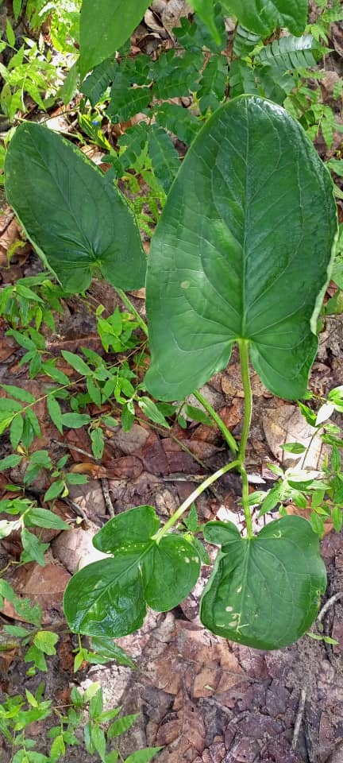 (b) 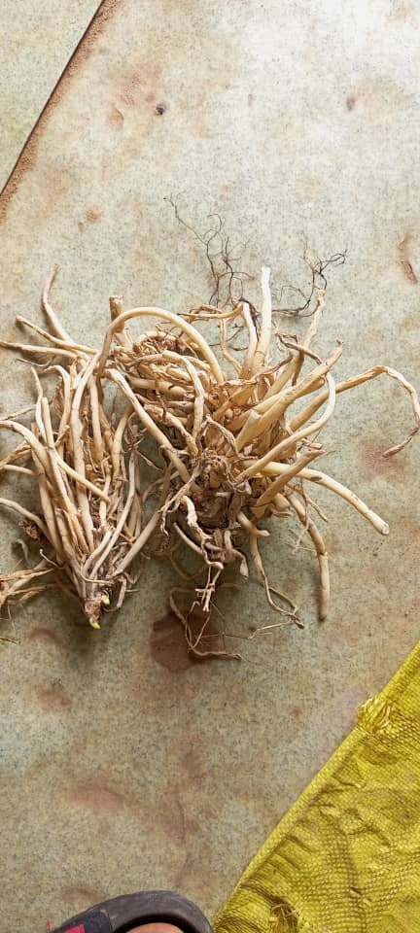
Figure 1. (a) Leaves of Stylochaeton hypogaeus. (b) Roots of Stylochaeton hypogaeus.
I.3. Data Processing and Organization
Data on Stylochaeton hypogaeus were extracted from the general ethnobotanical survey database, which included information from 16 informants in the study area. Data processing and organization were carried out using Microsoft Excel 2016. The analyzed variables included citation frequency, plant parts used, treated ailments, preparation methods, routes of administration, and the total number of therapeutic uses associated with the species.
The data were subsequently subjected to descriptive statistical analysis, complemented by the calculation of ethnobotanical indices, in order to scientifically assess the therapeutic and cultural importance of Stylochaeton hypogaeus.
I.4. Descriptive Statistical Analysis
I.4.1. Sociodemographic Characteristics of Informants
The survey was conducted with 16 informants, categorized by sex, age, and occupation. Men accounted for 81.25% of the sample, while women represented 18.75%. The most represented age group was 45–75 years, reflecting the significant involvement of adults and elders in the preservation and transmission of ethnobotanical knowledge (D’Almeida et al., 2024). The majority of informants were traditional practitioners, farmers, and herbalists, highlighting their central role in the possession and dissemination of phytotherapeutic knowledge within local communities.

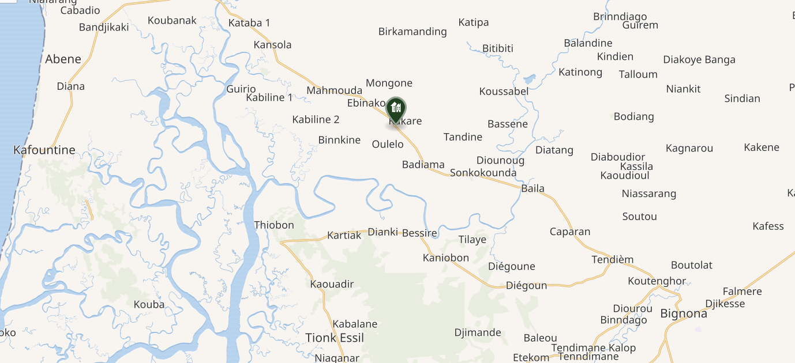
Figure 2. Map illustrating the location of the survey area where the ethnobotanical investigation was conducted (Djinaky Commune, Bignona Department, Senegal).
I.4.2. Ethnobotanical Indices Used
I.4.2.1. Citation Frequency (CF)
Citation frequency (CF) of Stylochaeton hypogaeus was used to assess the relative importance of this species within the studied community. It corresponds to the ratio between the number of informants who mentioned the species and the total number of informants interviewed (Diatta et al., 2019; Ellena et al., 2012). CF was calculated using the following formula:
$$FC=\frac{n}{N}$$
Where n represents the number of informants who cited the species, and N is the total number of informants interviewed.
I.4.2.2. Use Value (UV)
Use value (UV) is an indicator that estimates the practical importance of a medicinal species within a given community. For Stylochaeton hypogaeus, it was calculated using the following formula (Phillips & Gentry, 1993; Tardío & Pardo-de-Santayana, 2008):
$$UV=\frac{ΣU}{N}$$
Where ∑U represents the total number of therapeutic uses reported for the species, and N is the total number of informants interviewed (Begossi A. Use of ecological methods in ethnobotany... - Google Scholar, s. d.). This index provides a quantitative measure of the diversity and frequency of uses attributed to the species in the traditional pharmacopoeia.
I.4.2.3. Fidelity Level (FL)
Stylochaeton hypogaeus is primarily used for the treatment of specific ailments, including prostatic disorders, cancers, hemorrhoids, and inflammatory conditions. This usage specialization is captured by the fidelity level (FL), which reflects the preferential use of the species for a particular ailment.
FL was calculated using the following formula (Giday et al., 2009):
$$FL=\frac{Np}{N}×100$$
Where Np represents the number of informants who recommended the species for a specific ailment, and N is the total number of informants interviewed. This index quantifies the degree of therapeutic specialization of a plant and identifies the ailments for which it is particularly valued in the traditional pharmacopoeia.
I.4.2.4. Informant Consensus Factor (ICF)
The informant consensus factor (ICF) is used to evaluate the level of agreement among informants regarding the use of medicinal plants for a given category of diseases, in this case, prostatic disorders. For Stylochaeton hypogaeus, it was calculated using the following formula (De Albuquerque et al., 2009a) :
$$ICF=\frac{Nur-Nt}{Nur-1}$$
Where Nur represents the total number of use citations for the considered disease category, and Nt the total number of different species used for that category (Albuquerque et al., 2014). ICF values range from 0 to 1, with higher values indicating strong consensus among informants. This index provides a quantitative measure of the coherence of traditional knowledge and helps identify species perceived as the most reliable for the treatment of a specific ailment.
- Results and discussion
The table 1 presents the overall results obtained from the ethnobotanical survey. These data will subsequently be illustrated using graphical representations and will also be used to calculate the various parameters required for a robust interpretation of the results.
Table 1. Medicinal plant species recorded and their traditional uses
Family | Species (scientific name) | Vernacular name | Life form | Parts used | Ethnobotanical uses
Araceae | Stylochaeton hypogaeus Lepr. | Édiékay, Ejumba | Herbaceous | Roots, leaves, whole plant | Prostatic disorders (prostatitis, cancer), hemorrhoids, anti-inflammatory
Lamiaceae | Vitex doniana Sweet | Black plum | Tree | Leaves, fruits, bark | Digestive disorders, fever, food
Anacardiaceae | Anacardium occidentale L. | Cashew tree | Tree | Leaves, bark, nuts | Diarrhea, infections, food
Apocynaceae | Saba senegalensis (A. DC.) Pichon | Madd | Liana | Fruits, roots | Tonic, digestive disorders
Malvaceae | Ceiba pentandra (L.) Gaertn. | Kapok tree | Tree | Bark, leaves | Fever, diarrhea, inflammation
Fabaceae | Cassia podocarpa Guill. & Perr. | — | Shrub | Leaves, roots | Laxative, dermatoses
Caricaceae | Carica papaya L. | Papaya | Tree | Leaves, fruits, seeds | Malaria, digestive disorders, anthelmintic
Fabaceae | Cassia sieberiana DC. | Red kinkeliba | Tree | Roots, bark | Constipation, abdominal pain
Meliaceae | Khaya senegalensis (Desr.) A. Juss. | African mahogany | Tree | Bark | Malaria, fever, infections
Malvaceae | Cola cordifolia (Cav.) R. Br. | Kola tree | Tree | Fruits, bark | Stimulant, fatigue
Annonaceae | Annona senegalensis Pers. | Wild custard apple | Shrub | Roots, leaves, fruits | Antimalarial, diarrhea
Myrtaceae | Psidium guajava L. | Guava | Tree | Leaves, fruits | Diarrhea, infections
Icacinaceae | Icacina senegalensis A. Juss. | — | Shrub | Tubers | Food, tonic
Rutaceae | Citrus limon (L.) Osbeck | Lemon tree | Tree | Fruits, leaves | Cold, infections, digestion
Combretaceae | Guiera senegalensis J.F. Gmel. | Guiera | Shrub | Leaves | Malaria, respiratory disorders
Fabaceae | Piliostigma reticulatum (DC.) Hochst. | Nguiguis | Shrub | Bark, leaves | Diarrhea, wound healing
Capparaceae | Capparis procera DC. | — | Shrub | Roots, leaves | Rheumatism, pain
Euphorbiaceae | Jatropha curcas L. | Physic nut | Shrub | Seeds, latex | Laxative, wound treatment
Convolvulaceae | Ipomoea asarifolia (Desr.) Roem. & Schult. | — | Herbaceous | Leaves | Inflammation
Moraceae | Ficus ingens (Miq.) Miq. | Fig tree | Tree | Bark, latex | Wounds, infections
Apocynaceae | Calotropis procera (Aiton) W. T. Aiton | Sodom apple | Shrub | Latex, leaves | Rheumatism, dermatoses, prostatic disorders
Apocynaceae | Landolphia dulcis (R. Br.) Pichon | — | Liana | Fruits, roots | Tonic
Amaryllidaceae | Allium cepa L. | Onion | Herbaceous | Bulb | Infections, food
Fabaceae | Dialium guineense Willd. | Black tamarind | Tree | Fruits, bark | Diarrhea, food
Anacardiaceae | Mangifera indica L. | Mango tree | Tree | Bark, leaves, fruits | Fever, diarrhea, prostatic disorders
Malvaceae | Adansonia digitata L. | Baobab | Tree | Leaves, fruits, bark | Nutrition, diarrhea
Annonaceae | Uvaria chamae P. Beauv. | — | Liana | Roots | Dysentery
Fabaceae | Cassia occidentalis L. | Coffee senna | Herbaceous | Leaves, seeds | Fever, laxative
Poaceae | Oryza sativa L. | Rice | Herbaceous | Grains | Food
Sapindaceae | Aphania senegalensis (Juss. ex Poir.) Radlk. | — | Tree | Fruits | Food
Combretaceae | Terminalia macroptera Guill. & Perr. | — | Tree | Bark, leaves | Diarrhea, malaria
Fabaceae | Senna occidentalis (L.) Link | Coffee senna | Herbaceous | Leaves | Laxative
Fabaceae | Entada africana Guill. & Perr. | — | Tree | Bark | Pain, inflammation
Malvaceae | Sida rhombifolia L. | — | Herbaceous | Leaves | Inflammation
Lamiaceae | Ocimum × citriodorum Vis. | Lemon basil | Herbaceous | Leaves | Digestive, aromatic
Fabaceae | Dichrostachys cinerea (L.) Wight & Arn. | — | Shrub | Roots, bark | Diarrhea
Menispermaceae | Cissampelos mucronata A. Rich. | — | Liana | Roots | Abdominal pain
Solanaceae | Nicotiana tabacum L. | Tobacco | Herbaceous | Leaves | Repellent, ritual uses
Fabaceae | Faidherbia albida (Delile) A. Chev. | Gao | Tree | Bark, leaves | Diarrhea
Alismataceae | Alisma plantago-aquatica L. | Water plantain | Herbaceous | Roots | Urinary disorders
Rubiaceae | Sarcocephalus latifolius (Sm.) E.A. Bruce | Tabakha | Shrub | Roots, bark | Malaria
Fabaceae | Andira inermis (W. Wright) DC. | — | Tree | Bark | Anthelmintic

II.1. Floristic Diversity
The survey identified 42 medicinal plant species commonly used in the study area, belonging to 42 genera and 21 botanical families. The most represented families included Fabaceae, Apocynaceae, Annonaceae, Lamiaceae, Anacardiaceae, Meliaceae, Bombacaceae, and Combretaceae, reflecting their importance in the local traditional pharmacopoeia (D’Almeida et al., 2024). These families have also been reported as dominant in other ethnobotanical studies conducted in West Africa (Voeks & Leony, 2004).
II.2. Plant Parts Used and Preparation Methods
Analysis of the plant parts of Stylochaeton hypogaeus used for medicinal purposes revealed that roots were the most frequently utilized, followed by leaves and, in some cases, the whole plant. The preference for underground organs may be explained by their higher content of bioactive secondary metabolites, often associated with therapeutic properties.
Traditional preparations were primarily based on decoction, maceration, and infusion, with oral administration being the most common route. However, some topical applications were also reported, particularly for the treatment of inflammatory conditions.
II.3. Quantitative Results for Stylochaeton hypogaeus
II.3.1. Citation Frequency and Use Value of Stylochaeton hypogaeus
Citation frequency (CF) and use value (UV) were calculated to assess the therapeutic importance of Stylochaeton hypogaeus in the study area. These two indices provide insight into both the degree of recognition of the species by informants and the diversity of its medicinal uses. The values obtained are presented in Table 1.

Table 2. Citation Frequency (CF) and Use Value (UV) of Stylochaeton hypogaeus in the Study Area
Species | Number of Informants (n) | Total Informants (N) | CF | Total Number of Uses (∑U) | UV
Stylochaeton hypogaeus | 14 | 16 | 0,875 | 12 | 0,75

The results show that Stylochaeton hypogaeus was cited by 14 out of 16 informants, corresponding to a citation frequency (CF) of 0.875. This high value reflects the strong recognition of the species within the local traditional pharmacopoeia and highlights its important role in the management of various ailments, including prostatic disorders, cancer, hemorrhoids, and inflammatory conditions. Its use value (UV = 0.75) indicates both significant and diverse therapeutic utilization by traditional practitioners. These findings are consistent with those reported for other major medicinal species in West Africa and other regions, where CF values above 0.7 and high UVs reflect strong recognition and intensive therapeutic use (De Albuquerque et al., 2009b). Altogether, these data confirm the central role of Stylochaeton hypogaeus in the traditional treatment of prostatic, urinary, and inflammatory disorders in the study area.
The results show that Stylochaeton hypogaeus was cited by 14 out of 16 informants, corresponding to a citation frequency (CF) of 0.875. This high value reflects the strong recognition of the species within the local traditional pharmacopoeia and highlights its important role in the management of various ailments, including prostatic disorders, cancer, hemorrhoids, and inflammatory conditions. Its use value (UV = 0.75) indicates both significant and diverse therapeutic utilization by traditional practitioners. These findings are consistent with those reported for other major medicinal species in West Africa and other regions, where CF values above 0.7 and high UVs reflect strong recognition and intensive therapeutic use (Teklehaymanot, 2009). Altogether, these data confirm the central role of Stylochaeton hypogaeus in the traditional treatment of prostatic, urinary, and inflammatory disorders in the study area.

Figure 3. Plant Parts Used of Stylochaeton hypogaeus
Figure 3 shows that the roots of Stylochaeton hypogaeus are the most frequently used part in traditional phytotherapy (66.67%), followed by the leaves (25%) and the whole plant (8.33%). This distribution indicates a cultural preference for underground organs, which are considered particularly effective. These results also guide future research toward the phytochemical and pharmacological study of the roots, given their central role in therapeutic preparations.
II.3.2. Preparation Methods
The main preparation methods of Stylochaeton hypogaeus used in traditional phytotherapy are summarized in Figure 4. These data help identify the techniques most commonly employed by traditional practitioners and allow evaluation of their influence on the therapeutic efficacy of the preparations

Figure 4. Preparation Methods of Remedies Based on Stylochaeton hypogaeus
Figure 3 shows that the main preparation methods of Stylochaeton hypogaeus are decoction, maceration, and infusion, with decoction being the most frequently used. These preparation methods reflect local traditional practices and are intended to ensure effective extraction of the plant’s bioactive compounds. Understanding these techniques is essential for guiding future pharmacological and phytochemical studies.
II.3.3. Routes of Administration
Preparations based on Stylochaeton hypogaeus are administered through different routes, primarily oral, in accordance with traditional phytotherapeutic practices. Some topical applications are also reported, particularly for the treatment of inflammatory and skin-related conditions. This distribution of administration routes reflects the adaptation of therapeutic methods to the types of ailments treated and to the expected efficacy of the preparations

Figure 5. Routes of Administration of Stylochaeton hypogaeus Preparations
Preparations of Stylochaeton hypogaeus are primarily administered orally (83.33%), while anal administration represents a minor route (16.67%). The predominance of oral administration aligns with other ethnobotanical studies, where oral ingestion is the preferred route for treating internal ailments, with anal or rectal administration considered secondary (Trotter & Logan, 2019). These results confirm that the observed practices are consistent with traditional uses documented in other regions (Faruque et al., 2018).
II.3.4. Ailments Treated with Stylochaeton hypogaeus

Figure 6. Distribution of Ailments Treated with Stylochaeton hypogaeus
Stylochaeton hypogaeus is primarily used for the treatment of prostatic disorders, accounting for 87.5% of use citations, followed by anti-inflammatory applications (75%). These high percentages reflect a deeply rooted traditional perception of the plant’s effectiveness in these therapeutic domains and indicate marked therapeutic specialization, particularly for prostatic conditions (Teklehaymanot, 2009). The species is also cited for the treatment of cancer (50%) and hemorrhoids (31.25%), demonstrating some therapeutic versatility, although consensus for these uses is less pronounced. Overall, these findings confirm that Stylochaeton hypogaeus is mainly valued for male urogenital disorders while also presenting diversified uses linked to its anti-inflammatory properties (Masengo et al., 2023).
II.3.5. Fidelity Level (FL)

Figure 7. Fidelity Level of Stylochaeton hypogaeus
Fidelity level (FL) values indicate that Stylochaeton hypogaeus is primarily associated with the treatment of prostatic disorders, with a very high FL (87.5%), reflecting strong use specialization and marked informant consensus. These findings are consistent with studies conducted in West Africa, particularly in Nigeria, where prostatic disorders are among the most specialized indications in traditional pharmacopoeias, showing high fidelity level values (Heinrich et al., 1998).
Uses related to cancer (FL = 50%) and inflammatory conditions (FL = 43.75%) indicate moderate therapeutic versatility, comparable to that observed for other African medicinal plants (Ofeimun & Temitope, 2019). In contrast, the low FL associated with hemorrhoids (31.25%) suggests a secondary use. Overall, these results confirm the priority importance of S. hypogaeus for targeted phytochemical and pharmacological investigations focused on prostatic disorders (Semenya & Maroyi, 2018).
II.3.6. Informant Consensus Factor (ICF)
The informant consensus factor (ICF) is employed to assess the level of agreement among informants regarding the use of Stylochaeton hypogaeus for treating a specific category of diseases. A high ICF indicates convergence of traditional knowledge and highlights the most reliable uses of the plant. In the case of Stylochaeton hypogaeus, this index is particularly valuable for quantifying consensus on prostatic disorders and other ailments commonly addressed by the species in the local traditional pharmacopoeia.

Figure 8. Informant Consensus Factor (ICF) for Prostatic Disorders
The results indicate that Stylochaeton hypogaeus holds a prominent position in the traditional treatment of prostatic disorders, as reflected by the high informant consensus factor (ICF = 0.80). This strong consensus aligns with the observations of Heinrich and al. (1998) (Masengo et al., 2023), who reported that urogenital disorders are often associated with well-structured knowledge centered on a limited number of key species.
For inflammatory conditions, consensus was moderate (ICF = 0.69), consistent with the findings of Chaachouay and al. (2020) (Semenya & Maroyi, 2018), who demonstrated that a diversity of species may coexist while maintaining certain shared uses. In contrast, the low values observed for hemorrhoids (ICF = 0.33) and cancer (ICF = 0.36) reflect considerable heterogeneity in remedies, supporting the conclusions of Kudamba and al. (2023) (Mbyemeire et al., 2025) regarding anticancer plants in Uganda, where complex or poorly defined diseases tend to generate lower consensus levels.
Overall, these findings confirm that Stylochaeton hypogaeus is particularly valued for the treatment of prostatic disorders and justify targeted pharmacological investigations focusing on this indication.
II.4. Synthesis of Quantitative Results
All calculated ethnobotanical indices (FC, UV, FL, and ICF) underscore the major therapeutic significance of Stylochaeton hypogaeus in the study area. This species emerges as one of the most widely used plants for the treatment of prostatic disorders, demonstrating marked therapeutic specialization and a high level of consensus among informants.
These findings are consistent with literature reports on the traditional use of S. hypogaeus in various regions of West Africa for managing genitourinary disorders. They further indicate that this species represents a priority candidate for comprehensive phytochemical, pharmacological, and toxicological investigations.

Conclusion
This ethnobotanical study demonstrates that Stylochaeton hypogaeus holds a central role in traditional medicinal practices in Casamance. Its high citation frequency and substantial use value reflect both its cultural significance and the breadth of its therapeutic applications. The predominant use of roots, mainly as decoctions administered orally, aligns with ethnopharmacological practices reported in other regions of West Africa.
The very high-fidelity level and strong informant consensus for the treatment of prostatic disorders indicate marked therapeutic specialization and robust community agreement regarding the species’ efficacy for this indication. Secondary uses, particularly for inflammatory conditions and cancer, suggest broader therapeutic potential, albeit less specialized.
Overall, these results confirm that Stylochaeton hypogaeus is a key species in traditional medicine in Casamance. It is a priority candidate for targeted phytochemical, pharmacological, and toxicological studies, especially concerning prostatic disorders. Scientific valorization of this plant could contribute to the preservation of traditional knowledge and open new avenues for the development of natural therapeutic agents.

Acknowledgements
The authors sincerely thank the local communities and traditional knowledge from Bignona for generously sharing their ethnobotanical knowledge and for their willingness to participate in this study. We are deeply grateful to the informants for their time, trust, and collaboration. Their contributions were essential to the successful completion of this research

Disclaimer (Artificial intelligence)
The authors declare that a generative AI tool (ChatGPT) was used solely to refine the language and improve clarity of the manuscript. The AI tool was not used for data analysis, interpretation of results, or generation of scientific content. The authors remain fully responsible for the content of the manuscript

References :
- Albuquerque, U. P., Cruz Da Cunha, L. V. F., De Lucena, R. F. P., & Alves, R. R. N. (Éds.). (2014). Methods and Techniques in Ethnobiology and Ethnoecology. Springer New York. https://doi.org/10.1007/978-1-4614-8636-7
- Begossi A. Use of ecological methods in ethnobotany... - Google Scholar. (s. d.). Consulté 10 décembre 2025, à l’adresse https://scholar.google.com/scholar?hl=fr&as_sdt=0%2C5&q=Begossi++A.++Use++of++ecological++methods++in+ethnobotany%3A+Diversity+indices.+Ecological+Methods++in+Ethnobotany.1996%3B50%3A280-289.&btnG=
- D’Almeida, S. A., Gbomor, S. E., Osaio-Kamara, B., Olagunju, M. T., Abodunrin, O. R., & Foláyan, M. O. (2024). A scoping review of the use of traditional medicine for the management of ailments in West Africa. PloS one, 19(7), e0306594.
- De Albuquerque, U. P., De Sousa Araújo, T. A., Ramos, M. A., Do Nascimento, V. T., De Lucena, R. F. P., Monteiro, J. M., Alencar, N. L., & De Lima Araújo, E. (2009a). How ethnobotany can aid biodiversity conservation : Reflections on investigations in the semi-arid region of NE Brazil. Biodiversity and Conservation, 18(1), 127‑150. https://doi.org/10.1007/s10531-008-9463-8
- De Albuquerque, U. P., De Sousa Araújo, T. A., Ramos, M. A., Do Nascimento, V. T., De Lucena, R. F. P., Monteiro, J. M., Alencar, N. L., & De Lima Araújo, E. (2009b). How ethnobotany can aid biodiversity conservation : Reflections on investigations in the semi-arid region of NE Brazil. Biodiversity and Conservation, 18(1), 127‑150. https://doi.org/10.1007/s10531-008-9463-8
- Diallo, A. (2005). Etude de la phytochimie et des activités biologiques de Syzygium guineense Willd.(Myrtaceae). PhD. of the University Bamako, Mali, 38‑47.
- Diatta, K., Diatta, W., Fall, A. D., Dieng, S. I. M., Mbaye, A. I., Sarr, A., & Seye, M. B. (2019). Ethnopharmacological survey of medicinal plants used to treat human diseases in the Tivaouane Department, Senegal. Eur J Med Plants, 30(3), 1‑13.
- Ellena, R., Quave, C. L., & Pieroni, A. (2012). Comparative Medical Ethnobotany of the Senegalese Community Living in Turin (Northwestern Italy) and in Adeane (Southern Senegal). Evidence-Based Complementary and Alternative Medicine, 2012, 1‑30. https://doi.org/10.1155/2012/604363
- Faruque, M. O., Uddin, S. B., Barlow, J. W., Hu, S., Dong, S., Cai, Q., Li, X., & Hu, X. (2018). Quantitative ethnobotany of medicinal plants used by indigenous communities in the Bandarban District of Bangladesh. Frontiers in pharmacology, 9, 40.
- Giday, M., Asfaw, Z., & Woldu, Z. (2009). Medicinal plants of the Meinit ethnic group of Ethiopia : An ethnobotanical study. Journal of ethnopharmacology, 124(3), 513‑521.
- Heinrich, M., Ankli, A., Frei, B., Weimann, C., & Sticher, O. (1998). Medicinal plants in Mexico : Healers’ consensus and cultural importance. Social science & medicine, 47(11), 1859‑1871.
- Koné, D. (2009). Enquête ethnobotanique de six plantes médicinales maliennes-extraction, identification d’alcaloïdes-caractérisation, quantification de polyphénols : Étude de leur activité antioxydante. Université Paul Verlaine-Metz, Metz. https://www.academia.edu/download/85805989/document.pdf
- Masengo, C. A., Ngbolua, J.-P. K.-T.-N., Butoto, S. I. wa R., Gbolo, B. Z., Inkoto, C. L., & Mpiana, P. T. (2023). Ethno-botanical survey of medicinal plants species traditionally used for the treatment of diseases in Kasangulu Territory (Democratic Republic of Congo). Moroccan Journal of Agricultural Sciences, 4(2), 76‑85. https://doi.org/10.5281/zenodo.7997793
- Mbyemeire, H., Fasogbon, I. V., Musyoka, A. M., Oviosun, A., Ojiakor, V. O., Agunloye, M. O., Wusa, M., Okon, M. B., Ikuomola, E. O., & Dangana, R. S. (2025). Exploring the use of phytotherapy in benign prostatic hyperplasia [BPH] : A systematic review. F1000Research, 14, 412.
- Mondiale de la Santé, O. (2013). Stratégie de l’OMS pour la médecine traditionnelle pour 2014-2023. https://iris.who.int/bitstream/handle/10665/95009/9789242506099_fre.pdf
- Newman, D. J., Cragg, G. M., & Snader, K. M. (2000). The influence of natural products upon drug discovery. Natural product reports, 17(3), 215‑234.
- Ofeimun, J. O., & Temitope, F. (2019). Herbal Treatment of Benign Prostatic Hyperplasia : Findings from an Ethnobotanical Survey of Akinyele Local Government Area, Oyo State Nigeria: doi. org/10.26538/tjnpr/v4i3. 7. Tropical Journal of Natural Product Research (TJNPR), 4(3), 98‑104.
- Phillips, O., & Gentry, A. H. (1993). The useful plants of Tambopata, Peru : I. Statistical hypotheses tests with a new quantitative technique. Economic Botany, 47(1), 15‑32. https://doi.org/10.1007/BF02862203
- Semenya, S. S., & Maroyi, A. (2018). Plants Used by Bapedi Traditional Healers to Treat Asthma and Related Symptoms in Limpopo Province, South Africa. Evidence-Based Complementary and Alternative Medicine: eCAM, 2018, 2183705. https://doi.org/10.1155/2018/2183705
- Tardío, J., & Pardo-de-Santayana, M. (2008). Cultural Importance Indices : A Comparative Analysis Based on the Useful Wild Plants of Southern Cantabria (Northern Spain)1. Economic Botany, 62(1), 24‑39. https://doi.org/10.1007/s12231-007-9004-5
- Teklehaymanot, T. (2009). Ethnobotanical study of knowledge and medicinal plants use by the people in Dek Island in Ethiopia. Journal of ethnopharmacology, 124(1), 69‑78.
- Trotter, R. T., & Logan, M. H. (2019). Informant consensus : A new approach for identifying potentially effective medicinal plants. In Plants and indigenous medicine and diet (p. 91‑112). Routledge. https://www.taylorfrancis.com/chapters/edit/10.4324/9781315060385-6/informant-consensus-new-approach-identifying-potentially-effective-medicinal-plants-robert-trotter-michael-logan
- Voeks, R. A., & Leony, A. (2004). Forgetting the Forest : Assessing Medicinal Plant Erosion in Eastern Brazil. Economic Botany, 58(sp1), S294‑S306. https://doi.org/10.1663/0013-0001(2004)58[S294:FTFAMP]2.0.CO;2
- Yetein, M. H., Houessou, L. G., Lougbégnon, T. O., Teka, O., & Tente, B. (2013). Ethnobotanical study of medicinal plants used for the treatment of malaria in plateau of Allada, Benin (West Africa). Journal of ethnopharmacology, 146(1), 154‑163.

