Original Research Article
Assessment of Phosphorus Bioavailability and Ecological Risk in Sediments from a Fish Farming Pond in Sinématiali, Côte d’Ivoire

Abstract
The intensive fish farming contributes to the phosphorus accumulating in fish pond, which threatens the quality of the aquatic environment. In this study, the sediments from fish farming ponds at the Lokoli Ecofarm of the Sinematiali department were analyzed using the Heltjes and Lijklema (H&L) method and single pollution index to evaluate the morphological form of phosphorus and ecological risk, respectively. Sediments characterization reveals that they are acidic (average pH= 3.86±0.28) and, predominantly composed of coarse particles, with total organic carbon proportion of 12%. The results showed that the bioavailable fractions of phosphorus were distributed in decreasing following order: P-soluble > P-Fe+Al > P-Ca and the inorganic phosphorus were higher than organic phosphorus. The pollution index (Pi) results indicates that the sediment phosphorus concentration in the study area caused no pollution with Pi values less than 0.5. However, the significant correlation observed between phosphorus exchangeable or soluble fraction and total phosphorus indicated that the bioavailable phosphorus fraction may threated quality of basin water with the intensification of fish farming activities.
Keywords: phosphorus, fish farming, sediments, inorganic phosphorus, Heltjes and Lijklema method, ecological risk.
Introduction
Rapid urbanization and population growth increase the consumption of fish and the demand of high quality of animal protein. The fish farming is one of the fastest responses, which can provide sufficiency and high-quality fish protein and nutrition security in the world (Tada et al., 2023; Mok et al., 2021). However, the excessive sediment generation and accumulation in fish pond contribute to increasing concern and negative impact on water and sediment quality of aquatic ecosystem. This excessive accumulation of sediment load can lead ponds depth and threaten the availability of dissolved oxygen (Karmakar et al., 2022). Furthermore, fish farm generated considerable amount of nutriment derived from uneaten feed, fish faeces and, the metabolism execution product (Zhang et al., 2021).
Phosphorus (P) plays a key role, it’s a non-metallic chemical element, and the eleventh most abundant constituent of the Earth's crust (0.12 %), where it is mainly present in the form of phosphates associated with various elements such as aluminum, calcium, iron, and manganese (Matula et al., 2025; Vogt et al., 2025). Additionally, phosphorus is an essential nutrient for plant growth, alongside carbon, hydrogen, oxygen, and nitrogen. In aquatic ecosystems, the mobilization of phosphorus is controlled by various physicochemical and biological processes, including desorption, precipitation dissolution, ligand exchange, organic matter mineralization, intracellular release, and cell autolysis (Duhamel, 2025; Boström et al., 1988). These processes are modulated by environmental factors such as temperature, dissolved oxygen, pH, and sediment composition, and can occur in both the water column and in sediments (Zeng et al., 2023). However, excessive phosphorus in fish farming ponds have a significantly impact on the health of the fish and the surrounding aquatic environment (Nathanailides et al., 2023; Tabinda et al., 2010). High phosphorus levels in fish feed can lead to poor water quality, which negatively affects fish growth and production and environmental issues such as eutrophication. Maryunis et al. (2013) reported that increasing the of phosphorus content of the fish diet by 1.9 % reduced fish growth and their feed efficiency.
The sedimentation dynamic is influenced by the characteristics of the environment, it depending on local physical and chemical conditions, this phosphorus is either released into the water or remains in the sediment. This accumulation is not passive. It is the result of dynamic sedimentation influenced by the characteristics of the environment. Depending on local physical and chemical conditions, this sedimented phosphorus can be returned to solution and become available again to aquatic organisms (Simoni et al., 2024; Nathanailides et al., 2023). The bioavailable fraction thus represents a double challenge: it can contribute to the eutrophication of water bodies, but it is also a potential source of nutrients for agriculture (Mustapha and El-Bakali, 2021).
Analyzing the different forms of phosphorus present in sediments is therefore essential for assessing the risk of release into the water column, but also for considering recovery options. Indeed, in line with the principles of the circular economy and sustainability, the agricultural use of these nutrient-rich sediments and water could be an
alternative solution to chemical fertilizers.
The Hieltjes and Lijklema (H&L) method offers distinct advantages for extracting the different chemical forms of phosphorus in sediments, particularly in its ability to differentiate between various phosphorus fractions (wang et al., 2013; Hieltjes and Lijklema, 1980). This method is effective in identifying labile phosphorus, which is crucial for understanding phosphorus availability and potential environmental impacts such as eutrophication. The H&L method’s use of NH₄Cl as an extractant provides higher absolute values for labile phosphorus compared to other methods, making it a valuable tool for detailed phosphorus speciation analysis (Abekoe and Sahrawat, 2003).
Fish farming in Côte d'Ivoire, initiated in the 1940s, has become crucial to the agri-food sector, driven by a growing demand for animal protein (Bamory et al., 2025). Production reached a record 8,467 tons in 2023, highlighting its importance for food security and self-sufficiency (MIRAH, 2014; FAO, 1996). However, while phosphorus speciation in aquatic ecosystems has been studied (Kpan et al., 2023; N’goran et al., 2019) specific research on phosphorus in fish pond sediments is scarce, making it essential to assess phosphorus levels and forms in these sediments. This study aims to analyze the impact of fish farming on the P content distribution in surface sediment, use single pollution index to evaluate the P enrichment and speciation through the sequential extraction procedure proposed by Hieljes and Lijklema.
2. Materials and methods
2.1 Study area description and sediment sampling
The Lokoli ecofarm (9°35’27.91’’ N, 5°18’45,43’’ W), is an ecotourism site located in the Poro region just outside of the town of Sinématiali in northern Côte d’Ivoire (Fig. 1). The ecofarm consists of a natural area that extends 180 ha. The Orechromis nioticus species, commonly named Tilapia, is a farmed fish in ponds that are 200 m long and 100 m wide with an average depth of 10 m. In the region, from the top to bottom, the pond lithology consists to Birimian greenstone belt, a Paleoproterozoic geological formation composed of granitoid and metasedimentary rocks (Yao et al., 2025). The climate is characterized by two distinct seasons, including a long dry season (November – March) rainy season (April- October).
Sediment sampling was carried out in November 2024. Samples were collected at 10 stations in the main pond and labelled from S1 to S10. The sampling points were spaced 25 m apart to cover the entire pond surface. The surface sediments were collected by hand protected by sterile gloves, and placed in zip-lock plastic bags. All samples were immediately conserved in a cooler and transported to the laboratory. In the laboratory, sediments were sorted to remove stones, roots, leaves and other plant debris. Then, they were air-dried at room temperature for seven days. Dried sediments were sieved in stainless steel sieves (< 63 µm) mesh before chemical analysis.
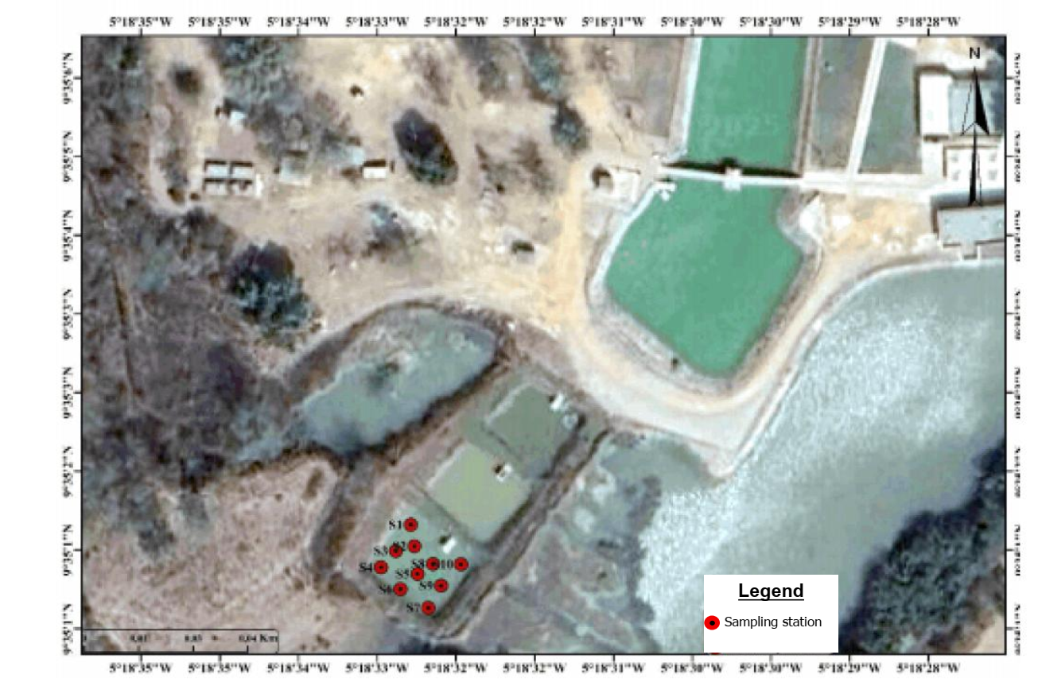
Fig.1: study area location and sampling points
2.2 Sediment physicochemical parameters determination
The sediment's grain size distribution was determined the using the method described by Stemmer et al. (1998).
The coarse sand fraction (2000-200 µm) and the fine fraction (silt+clay) (200 – 63 µm) were separated by manual sieving. The pH values were determined in deionized water: 10 g of the air-dried sample was mixed with 25 mL of distilled water (sediment: water at a ratio of 1:2.5) and stirred (Islam et al., 2000). The mixture was allowed to stand for 30 min to allow it to settle. The slurry was decanted and pH was measured with a calibrated pH meter. The total organic carbon content was determined by the loss-on-ignition method (LOI) (Carbonell-Barrachina et al., 2007). Approximately 1.0 g aliquot of ground sample was placed in porcelain crucibles; moisture was determined by oven drying for 24h at 105°C and then the crucible was placed in a muffle furnace and heated to 550 °C for 4 h to combust organic carbon. The weight loss (measured in the % range of the sediment) was calculated as organic carbon content.
2.3 Total phosphorus concentration determination
Simple extraction was used to determine the total phosphorus concentration bound to sediments. As described by Gächter et al. (1992), this method involved mineralizing the sediment with aqua regia (a mixture of hydrochloric and nitric acids). All elements in the solid fraction were dissolved with heat and a diacid mixture (30% HNO₃ and 70% HCl). Aqua regia hydrofluoric acid was then added to dissolve the silicates because diacid mineralization was incomplete. Phosphorus concentrations were measured using Agilent 200 Series AA (Agilent 200 AA) atomic absorption spectrophotometry (AAS). The quality of the measurements was validated by performing extraction blanks that underwent the same treatments as the samples and by verifying the metal content of a certified reference sediment.
2.4 Phosphorus sequential extraction
The sequential extraction method used is that described by Hieljes and Lijklema (Hieltjes and Lijklema, 1980). It is considered a standardized method for phosphorus extraction or fractionation. The solutions 1.0 NH₄Cl (pH 7), 0.1 M NaOH and 0.5 M HCl, were used as the extractants. The sequential extraction is depicted in Fig. 2. Briefly, 0.3 g of air-dried, fine fractions (< 0.63 µm) were used in the three-stage procedure, which was performed in 50 mL polyethylene tube. This tube was also centrifuged to minimize sediment loss between phases. After each extraction, the liquid supernatant is separated from the solid phase by centrifugation at 4,000 rpm for 10 minutes. The supernatant was placed in a 50 mL polyethylene tube and stored in a refrigerator at 4°C prior to analysis. The residue was washed with 20 mL of distilled water and shaken for 10 minutes. The filtered extracts are removed after centrifugation. After each extraction, the phosphorus concentration is determined by atomic absorption spectrophotometry (AAS).
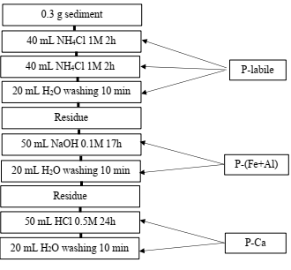
Fig. 2: Hieljes and Lijklema sequential extraction process scheme.
2.5 Ecological risk assessment
The ecological risk of nutrients like phosphorus and nitrogen in river sediments cannot currently be evaluated using a single standard or method. The Ontario Ministry of Environment and Energy in Canada created environmental quality assessment guidelines, which are the basis for the widely used single factor pollution index evaluation approach (Ye et al., 2019; Ye et al., 2018). The evaluation procedure for the single factor pollution index can be stated as follows:
$$P_{i}={C_{Pb}}/{C_{s}}$$
where C_{Pb} is the measurement value of the evaluation factor i, Cs is the standard value of the evaluation factor, and Pi is a single evaluation index or standard index. In the absence of a local safety level for TP, the Ontario, Canada safety value (600 mg kg⁻¹) has been used. According to the values of index P_{i}, the ecological risk level was categorized into four classes (Table 1).
Table 1: Ecological risk classification according to the pollution index for sediment
class | Pi value | Pollution risk level
I | [0 – 0.5[ | No pollution
II | [0,5 - 1[ | Mild pollution
III | [1 - 1.5[ | Moderate pollution
IV | [1.5 - $+∞$[ | Serious pollution

2.6 Statistical analysis
Pearson correlation was performed to examine the relationship between the phosphorus fraction binding to sediment and physicochemical parameters, and all analyses were conducted using Sigmaplot software for window version 15.0.
3. Results and discussion
3.1 Sediment Grain size, TOC, pH(H2O) characteristics and Total phosphorus (TP) concentration
Physicochemical parameters, grain size and total phosphorus (TP) concentration in sediment were presented in Table 2.
Table 2: Values and statistical descriptive of physicochemical characteristics and TP concentrations in sediment from Lokoli fish farm
stations | Silt+clay (%) | Sand (%) | pH (H₂O) | TOC (%) | TP (mg kg⁻¹)
S1 | 32.6 | 67.4 | 4.11 | 11.1 | 5.26
S2 | 31.2 | 68.8 | 4.5 | 6.11 | 5.34
S3 | 36.4 | 63.6 | 3.99 | 7.68 | 5.11
S4 | 35.6 | 64.4 | 3.6 | 11.0 | 5.8
S5 | 23.6 | 76.4 | 3.91 | 12.2 | 7.22
S6 | 25.4 | 74.6 | 3.5 | 8.99 | 3.88
S7 | 37.0 | 63 | 3.91 | 8.68 | 3.44
S8 | 36.4 | 63.6 | 3.7 | 8.94 | 4.87
S9 | 27.2 | 72.8 | 3.74 | 8.99 | 4.07
S10 | 29.1 | 70.9 | 3.6 | 8.84 | 5.45
Min | 23.6 | 63.0 | 3.5 | 6.11 | 3.44
Max | 37.0 | 76.4 | 4.5 | 12.2 | 7.22
mean±SD | 31.45 ±4.69 | 68.5± 4.09 | 3.86± 0.28 | 9.25±1.68 | 5.04 ±1.03
CV (%) | 14.9 | 6.8 | 7.3 |  | 20.3
SD: standard deviation, CV: coefficient of variation
The grain size distribution shows that the coarse fraction (sand) was predominant among the portion of the particle size for all samples. The average proportion was 68.5 ± 4.49% for the coarse fraction (sand) and 31.4 ± 4.69% for the fine fraction (clay+silt). It was obvious that grain size was homogeneously distributed in all sediments, which could be due to the small size of fish farm pond (< 1 ha) and the predominance of the sedimentary rocks in the studied area lithology could also influenced the grain size distribution. TOC content varied from 6.11 to 18.1 with an average of 9.2 5± 1.68 % in all sediment and the pH_{H2O} values fluctuated between 3.5 to 7.3 with an average of 3.86 ± 0.28, indicating that the sediment in fish pond was acidic. It well known that acidic or alkaline conditions can influence the chemical form pf phosphorus and its solubility. The acidic pH H₂O observed in fish farming pond may due to waste feeds, fish faeces, and organic matter desegregation. Similarly to our study, acidic pH values (3.0 to 6) was reported in a grouper fish farming at Umudiba Nekedi Oweri, Nigeria (Ibearugbulam et al., 2021). The organic carbon is an important parameter in phosphorus absorption. The high TOC values obtained could be due to the rapid sedimentation of the organic matter, which reduced the time available for degradation and increased the proportion of organic carbon that was buried rather than remineralized (Ingall and Van Cappellen (1990). Total organic carbon obtained in this study were high than those (0.48 – 1.24 %) reported in cage farming from Dongshan Bay, China (Zhen-Zhen et al., 2023).
Total phosphorus TP was ranged from 3.44 to 7.22 mg kg⁻¹. The average value was 5.04 ± 1.03 mg kg⁻¹. The TP concentration showed intermediate variability with a CV value less than 20%. The highest concentration (7.22 mg kg⁻¹) was recorded at P5 station in the middle of the fishpond. Overall, TP concentration was low in comparison with its corresponding preindustrial value (70 mg kg⁻¹) reported by Häkanson (1980). Also, TP in this study was lower than the total phosphorus concentration (44.7 mg kg⁻¹) reported in an Oreochromis niloticus cage farm in Palminhas Lake (Karmakar et al., 2022). The total phosphorus concentration recorded at Lokoli farm site could reflect the direct impact of P-rich fish feed. According to Mok et al. (2021), uneaten fish feed rich in phosphorus contributes up to 28 % to the phosphorus present in surface sediment from the farm site. On the other hand, phosphorus enters fish pond through both diffuse sources such as atmospheric deposition, and point sources such as runoff, which are impacted by anthropogenic activities. Nonetheless, it is well known that phosphorus’s total concentration does not provide information on its toxicity or bioavailability. Analyzing different chemical forms of phosphorus helps clarify whether sediments serve as adsorbers or sources of phosphorus (Luo et al., 2024).
3.2 Speciation of phosphorus in surface sediment
The partitioning pattern corresponding to sediment samples is shown in the Fig. 2.
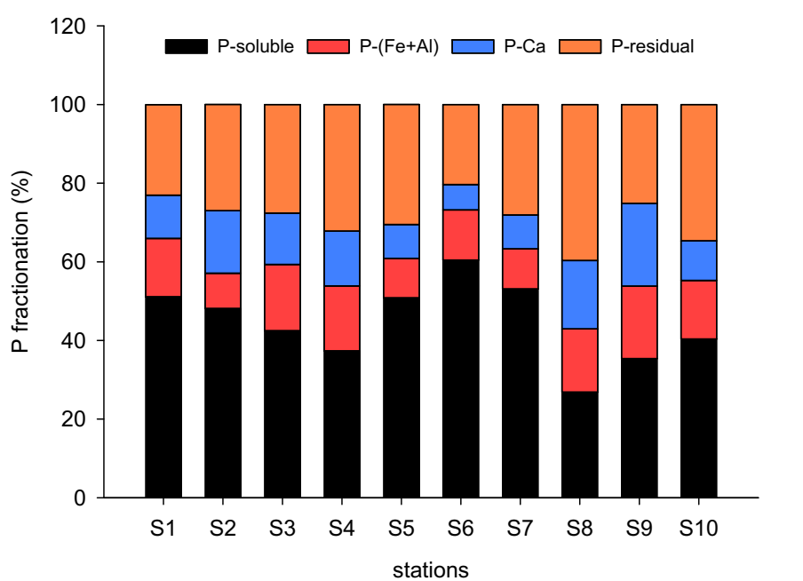
Fig. 3: sequential extraction fractions of phosphorus on sediments from Lokoli fish farm ponds
The distribution of P forms in sediment from fish farm have varied significantly (26 $<$ CV $<$ 33%). This variability of the distribution may due to heterogeneity of the studied area. The phosphorus sharing in sediment sample decreasing in following order: P-Ca $<$ P-Fe+Al $<$ P-residual $<$P-soluble. In overall stations, the phosphorus fractionation in sediment was largely dominated by P-soluble followed by residual fractions with mean percentage of 44.6 ±9.45 % and 28.8 ± 5.39 %, respectively of the total concentration. This equivalent to 2.42 ± 0.64 ¨µg g⁻¹ of P concentration out of the average total 5.04 ± 1.03 µg g⁻¹ (Table 1). In comparison with the preindustrial value reported by Häkonson (1980), the phosphorus concentration in the soluble fraction remained low. Nonetheless, the inorganic phosphorus, which includes calcium-bound phosphorus (Ca-P), iron-bound phosphorus (P-Fe), and exchangeable phosphorus (P-soluble) was higher than the organic phosphorus suggesting the excessive release of phosphorus from sediments due to fish farming can lead to undesirable eutrophication and harmful algal blooms, as benthic phosphorus fluxes can exceed the phosphorus required for primary production (Matula and Wojtkowska, 2025). Similarly to our results, Jiang et al. (2022), reported that inorganic phosphorus was the dominant form of TP, accounting for 67.7 % to 83.6 % of TP in Lake Hongze, China.
Table 2 shows that the Pearson correlation matrix indicates a significant positive correlation between exchangeable phosphorus and the Total phosphorus concentration (r = 0.72, p $<$ 0.05), suggesting an increase in available and mobilisable phosphorus with TP in fish farming sediments. However, the weak positive but non-significant correlation coefficients obtained between P-Fe+Al (r = 0.53, p > 0.05) and P-Ca (r = 0.40, p > 0.05) and TP suggest that the presence of the aluminum and iron oxides affects phosphorus dynamics in fish farm ponds. Also, a slight correlation (r = 0.44, p > 0.05) between TOC, TP, and chemical phosphorus form extracted were observed, suggesting that while they are related, other factors such as redox potential play a role in their distribution (Yuan et al., 2025).
Table 3: Pearson correlation matrix of phosphorus portioning fractions and physicochemical parameters
 | TP | pH | TOC | Fine particle | Coarse particle | P-soluble | P-Fe+Al | P-Ca
TP | 1
pH | 0.19 | 1
TOC | 0.49 | -0.38 | 1
Fine particle | -0.27 | 0.16 | -0.28 | 1
Coarse particle | 0.27 | -0.16 | 0.28 | -1.00 | 1
P-soluble | 0.72 | 0.33 | 0.44 | -0.52 | 0.52 | 1
P-Fe+Al | 0.53 | -0.30 | 0.42 | 0.12 | -0.12 | -0.02 | 1
P-Ca | 0.40 | 0.27 | -0.10 | 0.16 | -0.16 | -0.20 | 0.56 | 1
In bold significant coefficient at 0.05 level
3.3 Ecological risk assessment
Fig. 3 depicts the estimated potential ecological risk through pollution index Pi in each station. The pollution index in the study area ranged from 5.73E-03 to 1.2E-02 with an average of 8.41E-03±1.71E-03. All sediment samples were classified at Grade I of risk (range of 0 to 0.5), suggesting that there is no pollution based on the concentration of phosphorus in fish farming pond sediment. On the contrary, there is a high ecological risk to the aquatic ecosystem due to the concentration of phosphorus accounting for 35 to 86 % of the total concentration in the Haraz River pond ecosystem [36].
Fig. 4: Pollution index values of fish farming pond sediments in Lokoli Ecofarm site.
4. Conclusion
In Lokoli fish farming pond sediments, TP was in the range of 3.44 to 7.22 mg kg⁻¹. Additionally, sediments grain size distribution of the pond sediments was predominantly coarse, with an acidic pH and a relative abundance of total organic carbon (12 % of dry matter). The phosphorus chemical form analysis showed that the bioavailable phosphorus was mainly associated with the exchangeable or soluble fraction (P-soluble), with an IP/TP average value of 71.2 ± 5.39 %. The uneaten feed and fish faeces contribute significantly to TP enrichment in sediments. Furthermore, the high correlation between soluble phosphorus and TP indicates that a substantial portion of the total phosphorus is in a form that can be readily mobilized and potentially contribute to nutrient cycling and eutrophication in fish farming ponds. The phosphorus pollution index (Pi), indicate that the phosphorus concentration does not pose any environmental risk with Pi values less than 0.5. However, using Canadian threshold values instead of those for the study area could result in an underestimation or overestimation of the pollution level.
Disclaimer (Artificial Intelligence)
Author(s) hereby declared that NO generative AI technologies such as large language Models (ChatGPT, COPILOT, etc.) and text-to-image generators have been used during the writing or editing of this manuscript.
Acknowledgements
The authors would like to thank the management team at Lokoli Ecofarm for their help with the sampling campaigns.
Competing interest
Authors have no competing interest.
References

- Abekoe, M. K., and Sahrawat, K. L. (2003). Long-term cropping effect on phosphorus fractions in an Ultisol of the humid forest zone in West Africa. Communications in soil science and plant analysis, 34(3-4), 427-437.
- Bamory, O., Koffi, K., Rosine, Y. D., Julien, C. K., Meliton, D. K., & Eric, Y. K. (2025). Trophic status assessment of the Napié reservoir (Côte d'Ivoire): physico-chemical analysis and chlorophyll-a biomass. Water Science & Technology, 92(5), 803-818.
- Boström, B., Persson, G., & Broberg, B. (1988). Bioavailability of different phosphorus forms in freshwater systems. Hydrobiologia, 170(1), 133-155.
- Carbonell-Barrachina AA, Jugsujinda A, Burlo F, Delaune RD, JrWH P (2007) Arsenic chemistry in municipal sewage sludge as affect ed by redox potential and pH. Water Res 34:216–224
- Duhamel, S. (2025). The microbial phosphorus cycle in aquatic ecosystems. Nature Reviews Microbiology, 23(4), 239-255.
- FAO (1996). État des connaissances sur les pêcheries continentales ivoiriennes. Organisation
des Nations Unies pour l’Alimentation et l’Agriculture (FAO), Rome.
- Gächter, R., Tessier, A., Szabo, E., & Carignan, R. (1992). Measurement of total dissolved phosphorus in small volumes of iron rich interstitial water. Aquatic Sciences, 54(1), 1-9.
- Häkanson, L. (1980). An ecological risk index for aquatic pollution control. A sedimentological approach. Water research, 14(8), 975-1001.
- Hieltjes, A. H., and Lijklema, L. (1980). Fractionation of inorganic phosphates in calcareous sediments (Vol. 9, No. 3, pp. 405-407). American Society of Agronomy, Crop Science Society of America, and Soil Science Society of America.
- Ibearugbulam, H. O., Ugwu, E. I., Ekeleme, A. C., Njoku, C. E., Amanamba, E. C., Ezebuiro, V., & Igwegbe, E. W. (2021). A study on physicochemical parameters of fish pond effluents: A case study of Umudibia fish farm. In IOP Conference Series: Materials Science and Engineering (Vol. 1036, No. 1, p. 012005). IOP Publishing.
- Ingall, E. D., & Van Cappellen, P. (1990). Relation between sedimentation rate and burial of organic phosphorus and organic carbon in marine sediments. Geochimica et Cosmochimica Acta, 54(2), 373-386
- Islam KR, Weil RR (2000) Land use effects on soil quality in a tropical forest ecosystem of Bangladesh. Agric Ecosyst Environ 79:9–16
- Jiang, Z., Liu, C., Wang, S., Li, C., Zou, J., Li, B., & Wu, W. (2022). Impact of the second phase of the eastern route of South-to-North water diversion project on distribution of nitrogen and phosphorus in Hongze Lake. Water Science and Technology, 85(8), 2398-2411.
- Karmakar, A. R., Ullah, M. A., Hasan, M. M., Akter, L., Sarker, M. M., Arai, T., & Hossain, M. B. (2022). Sedimentary nutrient dynamics in homestead fishpond systems from a subtropical coastal area. Agriculture, 12(12), 2077.
- Khademi, A. A., Najafi, M., Nejadian, S. K., & Moghadas, B. (2021). Examination of the Quality Indicators of Haraz River Water, Inflow and Outflow of Water of Fish Farm. Modern Applied Science, 15(3), 1-31.
- Kpan, W. H., Bongoua-Devisme, A. J., Kouadio, K. K. H., Kone, B., & Bahan, F. M. L. (2023). Response of lowland rice to phosphate amendments in three acidics agroecological zones of Côte d'Ivoire: Man-Gagnoa-Bouaké. International Journal of Environment, Agriculture and Biotechnology, 8(5), 135-144.
- Luo, Q., Wei, J., Guo, Z., & Song, Y. (2024). Adsorption and immobilization of phosphorus from water and sediments using a lanthanum-modified natural zeolite: Performance, mechanism and effect. Separation and Purification Technology, 329, 125187.
- Matula, M., & Wojtkowska, M. (2025). Phosphorus speciation in water and sediments. Desalination and Water Treatment, 101102.
- Matula, M., & Wojtkowska, M. (2025). Phosphorus speciation in water and sediments. Desalination and Water Treatment, 101102.
- MIRAH, Ministère des ressources animales et halieutiques (2014). Plan Stratégique de Développement de l’Élevage, de la Pêche et de l’Aquaculture en Côte d’Ivoire (PSDEPA 2014–2020). Tome I : Diagnostic – Stratégie de développement – Orientations. Abidjan, Côte d’Ivoire.
- Mok, J. S., Choi, A., Kim, B., An, S. U., Lee, W. C., Kim, H. C., …& Hyun, J. H. (2021). Phosphorus dynamics associated with organic carbon mineralization by reduction of sulfate and iron in sediment exposed to fish farming. Frontiers in Marine Science, 8, 645449.
- Mustapha, A., & El Bakali, M. (2021). Phosphorus waste production in fish farming a potential for reuse in integrated aquaculture agriculture. Int J Environ Agric Res, 7(1), 5-13.
- N’goran, K. M., Yao, K. M., Kouassi, N. G. L. B., Trokourey, A. (2019). Phosphorus and nitrogen speciation in waters and sediments highly contaminated by an illicit urban landfill: the Akouedo landfill, Côte d’Ivoire. Regional Studies in Marine Science, 31, 100805.
- Nathanailides, C., Kolygas, M., Tsoumani, M., Gouva, E., Mavraganis, T., & Karayanni, H. (2023). Addressing phosphorus waste in open flow freshwater fish farms: Challenges and solutions. Fishes, 8(9), 442.
- Nathanailides, C., Kolygas, M., Tsoumani, M., Gouva, E., Mavraganis, T., & Karayanni, H. (2023). Addressing phosphorus waste in open flow freshwater fish farms: Challenges and solutions. Fishes, 8(9), 442.
- Simoni, G., Cheali, P., Roslev, P., Haasler, S., Reitzel, K., Smith, A. M., & Christensen, M. L. (2024). Flocculating and dewatering of lake sediment: An in-situ pilot study comparing synthetic polymers and biopolymers for restoring lake water quality and reusing phosphorus. Science of The Total Environment, 913, 169597.
- Tabinda, A.B., Ayub, M. (2010). Effect of high phosphate fertilization rate on pond phosphate concentrations, chlorophyll a, and fish growth in carp polyculture. Aquacult Int 18, 285–301 https://doi.org/10.1007/s10499-009-9243-9
- Tada, K., Nakakuni, M., Koomklang, J., Yamaguchi, H., & Ichimi, K. (2023). The impact of fish farming on phosphorus loading of surface sediment in coastal complex aquaculture. Fisheries Science, 89(3), 375-386
- Venturoti, G. P., Veronez, A. C., Salla, R. V., & Gomes, L. C. (2015). Variation of limnological parameters in a tropical lake used for tilapia cage farming. Aquaculture Reports, 2, 152-157.
- Vogt, L. I., Pushie, M. J., Dolgova, N. V., Cotelesage, J. J., Pickering, I. J., & George, G. N. (2025). Harmonic X-ray Incident Energy Calibration for X-ray Spectroscopy at the K-Edges of Phosphorus, Sulfur, and Chlorine. Analytical Chemistry.
- Wang, C., Zhang, Y., Li, H., & Morrison, R. J. (2013). Sequential extraction procedures for the determination of phosphorus forms in sediment. Limnology, 14(2), 147-157.
- Yao, A. N., Kouamelan, A. N., Houssou, G. N., Mondah, O. R., Gballou, C. B., & Coulibaly, Y. (2025). Petrography and Geochemistry of Manganese Protores from Laniokaha (Korhogo, Northern Côte d’Ivoire). Open Journal of Geology, 15(3), 142-154.
- Ye, H. M., Yang, H., Han, N., Huang, C. C., Huang, T., Li, G. P., Yuan, X. Y., & Wang, H. (2019). Risk assessment based on nitrogen and phosphorus forms in watershed sediments: A case study of the upper reaches of the Minjiang Watershed. Sustainability, 11(20), 5565
- Ye, H. M., Yuan, X. Y., Li, G. P., Wan, J., & Xu, J. (2018). Distribution and ecological risk assessment of nutrient elements in surface sediments of Jianxi Watershed in northern Fujian. Environmental Chemistry, 37(11), 2481–2488 (in Chinese).
- Yuan, K., Mu, X., Xiao, G., Li, K., Zhou, W., Wang, R., & Wang, S. (2025). Phosphorus speciation, controlling factors, and ecological risk assessment in lagoon sediments: a case study of the Shamei Lagoon, Qionghai, Hainan. Frontiers in Marine Science, 12, 1707863.
- Zeng, L., Yan, C., Yang, F., Zhen, Z., Yang, J., Chen, J., & Zhang, W. (2023). The effects and mechanisms of pH and dissolved oxygen conditions on the release of arsenic at the sediment–water interface in Taihu Lake. Toxics, 11(11), 890.
- Zhang, Z., Deng, Q., Cao, X., Zhou, Y., & Song, C. (2021). Patterns of sediment fungal community dependent on farming practices in aquaculture ponds. Frontiers in Microbiology, 12, 542064
- Zhen-Zhen, C., Jian, Z., Miao-Feng, Y., Yong-Qing, L., Hui-Dong, Z., Dong-Lian, L., & Sheng-Hua, Z. (2023). Vertical distribution and pollution assessment of TN, TP, and TOC in the sediment cores of cage farming areas in Dongshan Bay of southeast China. Frontiers in Environmental Science, 11, 1216868.

