Review article
Iron Nanoparticles: Synthesis Strategies, Properties, and Multidisciplinary Applications

Abstract
Iron nanoparticles (FeNPs), particularly iron oxide–based nanomaterials, have attracted significant scientific and industrial interest due to their unique physicochemical and magnetic properties, including superparamagnetism, high surface-to-volume ratio, tunable surface chemistry, and excellent biocompatibility. These characteristics enable their extensive application across diverse fields such as biomedicine, agriculture, environmental remediation, energy, electronics, and advanced materials. Conventional physical and chemical synthesis approaches provide controlled nanoparticle formation but are often associated with high energy consumption, toxic reagents, and environmental concerns. Consequently, green and biological synthesis strategies have emerged as sustainable alternatives, employing plants, bacteria, fungi, algae, and their metabolites as natural reducing and stabilizing agents.
This review comprehensively summarizes the fundamental properties of iron nanoparticles, outlines major physical, chemical, and biological synthesis routes, and highlights recent advances in green synthesis using plant extracts and microbial systems. Special emphasis is placed on the role of phytochemicals and biomolecules in nanoparticle reduction, stabilization, and functionalization. Furthermore, the review critically discusses the multifarious applications of iron nanoparticles, including targeted drug delivery, magnetic resonance imaging, hyperthermia therapy, biosensing, nanofertilizers, pollutant removal, wastewater treatment, energy conversion, defense technologies, construction materials, textiles, and electronics. Current challenges related to nanoparticle stability, aggregation, toxicity, and large-scale production are also briefly addressed. Overall, this review provides an integrated perspective on the synthesis–property–application relationship of iron nanoparticles and underscores their growing importance in sustainable and interdisciplinary technological development.
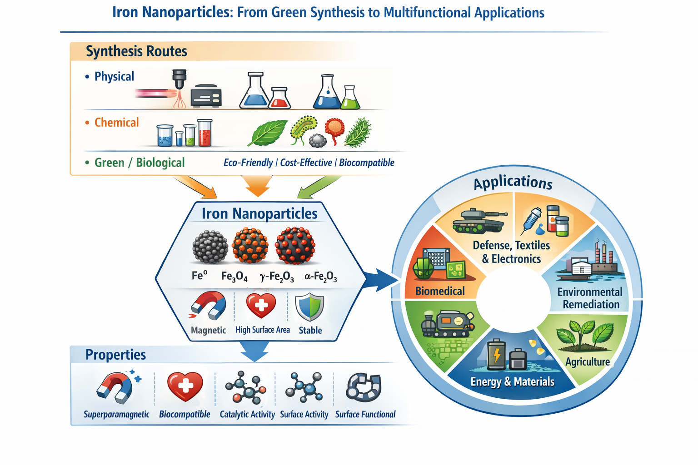
Graphical Abstract
Keywords
Iron nanoparticles; Iron oxide nanoparticles; Green synthesis; Biological synthesis; Plant-mediated synthesis; Magnetic nanoparticles; Biomedical applications; Environmental remediation; Agriculture; Nanotechnology

- General Introduction
Nanotechnology has become a pivotal field within modern materials science, offering new possibilities by manipulating substances at the atomic and molecular scale. At this dimension, materials exhibit novel physicochemical behaviors that differ markedly from their bulk counterparts (Logothetidis et al., 2011). Nanoparticles, in particular, serve as essential components of this discipline due to their distinctive attributes such as an elevated surface area-to-volume ratio, altered electronic structures, and size-dependent quantum effects. These properties have stimulated advancements in numerous fields, including medicine, energy systems, electronics, and environmental engineering.
In recent years, growing environmental and sustainability concerns have driven a shift away from conventional chemical routes for nanoparticle synthesis, which often involve toxic precursors and harsh reaction conditions. This shift has strengthened the integration of nanotechnology with green chemistry principles, encouraging the development of environmentally responsible fabrication techniques. Among these, biological synthesis particularly using plant-derived phytochemicals as natural reducing and capping agents has gained substantial attention. Such green approaches offer benefits including lower energy demands, reduced ecological impact, economic feasibility, and improved biocompatibility of the synthesized nanoparticles (Salem et al., 2021).
Among the wide spectrum of metallic nanomaterials, iron nanoparticles (FeNPs) have gained considerable attention owing to their distinctive magnetic properties, high surface reactivity, and multifunctionality in fields such as biomedicine, agriculture, and environmental remediation (Sharma et al., 2003). Their exceptional physicochemical characteristics including large surface area, superparamagnetism, and redox-active surfaces further extend their utility across diverse technological and therapeutic applications (Laurent et al., 2008). Extensive research has highlighted the biomedical potential of FeNPs, particularly in targeted drug delivery, magnetic hyperthermia for cancer therapy, tissue engineering, and antimicrobial interventions.
Despite their advantages, traditional chemical synthesis methods frequently rely on toxic solvents, hazardous reducing agents, and energy-intensive processes, raising substantial environmental and health-related concerns (Nowack and Bucheli, 2007). Consequently, green synthesis strategies employing biological sources such as plant extracts, microbial cultures, and natural polymers have emerged as sustainable alternatives (Iravani et al., 2014). Biogenic routes are particularly valued for their economic feasibility, minimal toxicity, biodegradability, and environmental compatibility.
Plant-mediated synthesis has received special attention, as plant extracts are naturally enriched with phytochemicals including polyphenols, terpenoids, flavonoids, and alkaloids that act both as reducing and capping agents, enabling efficient metal ion reduction while preventing nanoparticle aggregation. Moreover, FeNPs synthesized through green approaches often exhibit enhanced therapeutic promise due to the incorporation of bioactive plant-derived compounds, which can synergistically contribute to superior biocompatibility and improved biological performance (Khan et al., 2017).
- Properties of iron nanoparticles-
Metallic nanoparticles exhibiting superparamagnetic behavior have gained tremendous attention in recent years because of their distinctive magnetic properties and their ability to be easily recovered using an external magnetic field. Among magnetic metals, nanoparticles derived from nickel, cobalt, and iron, as well as their oxides such as magnetite (Fe₃O₄), maghemite (γ-Fe₂O₃), and cobalt ferrite (Fe₂CoO₄) have been widely investigated for diverse technological and biomedical applications.
Iron, one of the most abundant transition metals in the Earth’s crust, forms the backbone of various industrial materials and functional systems. Despite its ubiquity, iron oxides have historically received less attention compared to noble metals like gold, platinum, and cobalt (Huber, 2005). Nevertheless, iron oxides play a vital role in geological processes, environmental chemistry, and biological systems, where their availability and low cost make them particularly advantageous. Magnetite (Fe₃O₄), maghemite (γ-Fe₂O₃), and hematite (α-Fe₂O₃) represent the three principal crystalline forms of iron oxides occurring in natures.
Magnetic materials are generally classified into paramagnetic, superparamagnetic, ferromagnetic, diamagnetic, and ferrimagnetic types, depending on their response to magnetic fields. Paramagnetic materials show magnetism only in the presence of an external field, whereas superparamagnetic nanoparticles exhibit magnetism even after the external field is removed, making them superior for biomedical and drug delivery applications (Issa et al., 2013). Ferrimagnetic materials possess antiparallel spin arrangements, but due to unequal magnetic moments, they exhibit a net magnetization when exposed to an external magnetic field. Iron nanoparticles, due to their extremely high surface-to-volume ratio and reduced surface charge, often display a strong tendency to aggregate in solution. This aggregation not only affects their stability but also alters their catalytic and biological functionalities. Therefore, understanding and controlling their surface chemistry is essential for practical applications.
In the biomedical field, iron nanoparticles offer several advantages: they are relatively easy to synthesize, can be remotely guided or heated using magnetic fields, and can be tracked in vivo using magnetic resonance imaging. Their biocompatibility and biodegradability make them safer alternatives to many inorganic nanomaterials. Free iron released in the body is naturally incorporated into metabolic pathways and eventually eliminated (Cuenya, 2010). Such characteristics, combined with their tunable magnetic properties, make iron nanoparticles excellent candidates for targeted drug delivery, diagnostics, hyperthermia treatment, and biosensing (Laurent et al., 2008). Superparamagnetism is especially important in nanoparticles below 10–20 nm, enabling rapid magnetic response without residual magnetization, thus preventing particle aggregation once the magnetic field is removed (Huber, 2005). These properties enhance their suitability for immobilization of biomolecules, diagnostic assays, and controlled drug release. At the nanoscale, however, iron becomes highly reactive sometimes even pyrophoric owing to its high surface energy. This extreme reactivity can pose challenges, particularly in environmental and catalytic applications, but it also opens opportunities for using iron nanoparticles as highly efficient catalysts (Huber, 2005). Their physicochemical properties including size, shape, crystallinity, and surface defects—significantly influence magnetic behavior, catalytic performance, and biological interactions.
Size reduction generally enhances properties such as melting point, thermal conductivity, and viscosity, while shape variations alter surface facets and catalytic activity. The biological and catalytic potential of nanoparticles is further determined by their metal ion composition, zeta potential, concentration, and method of synthesis (Foroozandeh and Aziz, 2018). Because nanoparticles tend to undergo oxidation or aggregation, surface modification becomes necessary to improve stability, biocompatibility, and performance. Surface functionalization through polymers, silica coating, organic ligands, or surfactants not only prevents corrosion and aggregation but also imparts chemical groups that enable targeted applications (N. Singh et al., 2020; Verma et al., 2019). For FeNPs, functional coatings are essential to maintain stability against chemical degradation and enhance dispersibility in biological or catalytic media (Sun et al., 2014). Such engineered modifications greatly expand their utility in catalysis, imaging, drug delivery, and environmental remediation.
- Methods for synthesis of iron nanoparticles
Nanoparticles can be generated through two fundamental strategies known as the top-down and bottom-up approaches. In the top-down methodology, bulk materials are broken down into nanoscale structures using physical or chemical techniques such as milling, lithography, or laser ablation. This approach essentially “cuts down” larger particles to achieve nanoscale dimensions. In contrast, the bottom-up approach constructs nanoparticles from molecular or atomic building blocks. Here, controlled chemical reactions such as reduction, oxidation, precipitation, or self-assembly lead to the formation of nanoscale materials. Bottom-up synthesis often results in nanoparticles with more uniform chemical composition, well-defined morphology, and fewer structural defects compared to top-down methods, making it highly suitable for precision nanomaterial fabrication.
3.1. Physical Methods
Physical methods employ external energy sources such as heat, light, sound, or electric fields to induce the formation of iron nanoparticles (FeNPs). Although these methods often produce high-purity materials due to the absence of chemical reagents, they are generally less favored because they provide limited control over particle size and require significant energy input (Ali et al., 2016). Traditional physical techniques such as evaporation–condensation or heating in a tube furnace depend on extremely high temperatures to vaporize bulk iron. These approaches are energy-intensive, time-consuming, and typically yield nanoparticles with broad size distributions due to poor control over nucleation and growth (Iravani et al., 2014).
Among physical methods, laser ablation has gained considerable attention. In this technique, a high-energy laser beam fragments a metal target into nanoscale particles. The characteristics of the resulting FeNPs depend strongly on laser parameters including wavelength, pulse duration, and energy fluence. Because no chemical reagents are involved, the nanoparticles produced are highly pure and free from contamination (Iravani et al., 2014). Another important physical approach is the sonochemical method, which utilizes ultrasonic waves to generate FeNPs. High-frequency ultrasound produces cavitation bubbles in the reaction medium; these bubbles undergo rapid oscillation and eventually collapse, creating transient “hot spots” that reach temperatures of approximately 4500 °C and pressures near 1000 bar (Wu et al., 2015). Such extreme localized conditions drive the reduction of iron precursors, resulting in nanoparticles with enhanced stability and magnetic properties (Ali et al., 2016). Because the process can be carried out in simple aqueous media, sonochemical synthesis is considered efficient and versatile.s
Microwave irradiation represents another physical route for FeNP formation, where electromagnetic energy acts as a reducing stimulus. Microwaves generate rapid, uniform internal heating within the precursor solution, enabling quick nucleation of nanoparticles. However, FeNPs synthesized by this method often exhibit poor morphological uniformity and reduced reactivity, limiting its practical utility. A further physical technique is the electrochemical approach, in which an electric field drives ion reduction at the electrode interface. Parameters such as pH, applied voltage, interelectrode distance, reaction time, and temperature significantly influence nanoparticle characteristics. This method allows partial control over particle size and commonly yields hydrophilic iron oxide nanoparticles suitable for aqueous dispersions. Overall, while physical methods offer certain advantages such as high purity and reagent-free synthesis they often require specialized equipment, consume substantial energy, and provide limited control over nanoparticle size. As a result, they are used less frequently compared to chemical or biological synthesis routes.

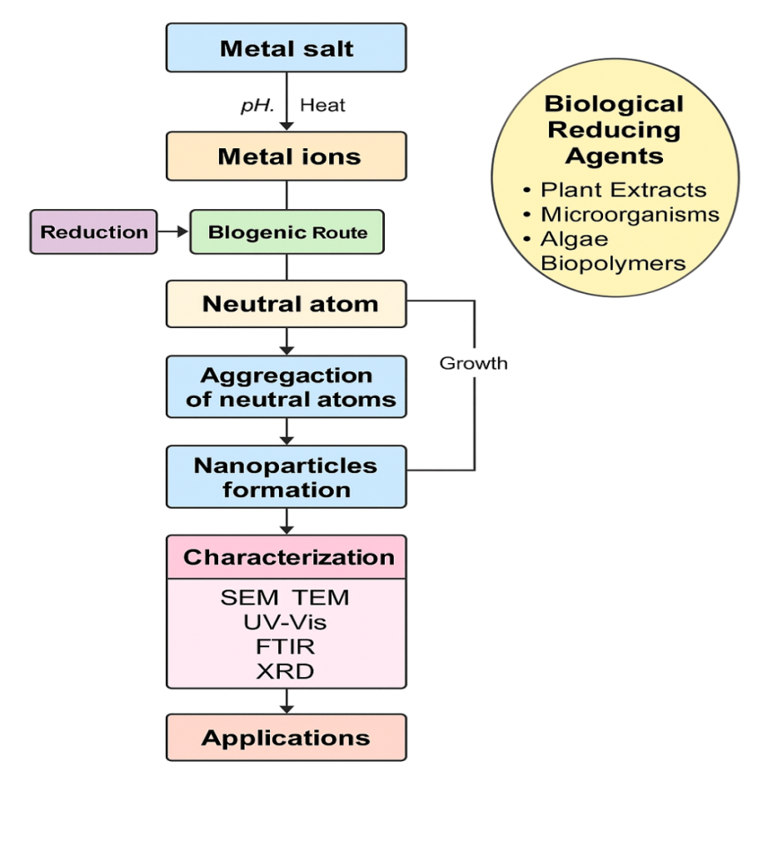
Figure 1: Routes of nanoparticle synthesis
3.2. Chemical Methods
Chemical methods remain the most widely employed strategies for synthesizing iron nanoparticles (FeNPs), largely because they offer excellent control over particle size, morphology, and composition. Nearly 90% of FeNPs reported in the literature are produced through chemical routes, highlighting their reliability and versatility. Among these, co-precipitation of Fe²⁺ and Fe³⁺ ions in alkaline media is one of the most commonly used approaches for synthesizing iron oxides. Parameters such as the type of iron salt, Fe²⁺/Fe³⁺ ratio, pH, ionic strength, and reaction temperature critically determine the final nanoparticle shape and size distribution.
Despite their advantages, chemical methods also present notable limitations, including the use of toxic reagents, generation of hazardous by-products, and the possibility of residual contaminants on nanoparticle surfaces. These concerns raise potential environmental and health risks depending on the reducing agents and stabilizers used (Li et al., 2011). Nevertheless, a variety of chemical reduction routes using both inorganic and organic reducing agents remain standard practice for nanoparticle synthesis due to their efficiency and reproducibility.
In many chemical methods, surfactants, acids, alcohols, and amines are incorporated as stabilizing or capping agents to regulate particle growth and prevent aggregation. A classic example is the Brust-type reaction, where NaBH₄ acts as a strong reducing agent in the presence of dodecanethiol, producing thiol-capped metallic nanoparticles with enhanced stability. Recently, environmentally benign or “green” chemical approaches have also been explored, where plant extracts, biomolecules, or other non-toxic reducing agents facilitate FeNP synthesis at room temperature. Another important chemical route is the microemulsion method, which uses amphiphilic molecules to create nanosized droplets in water-in-oil or oil-in-water systems. These droplets act as nanoreactors, allowing controlled nucleation and growth of iron nanoparticles. The fundamental mechanism relies on mixing iron precursors with a base under controlled microenvironments. The overall co-precipitation reaction can be represented as:
2Fe³⁺ + Fe²⁺ + 8OH⁻ → Fe₃O₄ + 4H₂O
Because magnetite is poorly soluble under alkaline conditions, Fe²⁺ and Fe³⁺ ions readily precipitate to form iron oxide nanoparticles. Using this approach, either magnetite (Fe₃O₄) or maghemite (γ-Fe₂O₃) can be synthesized depending on the Fe³⁺/Fe²⁺ ratio, reaction atmosphere, and oxidation conditions (Nisticò et al., 2017). Co-precipitation can be carried out across a broad temperature range of 20–250 °C, and is influenced by stirring speed, salt concentration, and ionic strength (Yazdani and Seddigh, 2016). Although simple and scalable, this method often lacks fine control over nanoparticle shape, and the final product may require surfactants such as CTAB or PVP to regulate morphology (Nisticò et al., 2017).
While microemulsion systems offer advantages such as narrow size distribution and controllable shapes, they also suffer from drawbacks, including low yields, complex purification steps, and potential contamination from surfactants (Wu et al., 2015). Another widely used route is the sol–gel method, where hydrolysis and condensation of iron salts or alkoxides lead to the formation of oxide networks. This method produces uniform and highly pure iron oxide nanoparticles and allows precise control of composition (Nisticò et al., 2017). However, sol–gel processes may require long aging times and careful pH and temperature control.
The polyol-mediated method represents an additional chemical strategy in which polyols act simultaneously as solvents, reducing agents, and stabilizers. Iron salts are dissolved in polyols and heated until complete reduction and nucleation occur. This approach typically yields highly crystalline, monodisperse iron oxide nanoparticles with excellent dispersion in polar solvents (Nisticò, 2021; Wu et al., 2015). Overall, chemical methods provide robust and flexible routes for FeNP synthesis, enabling tunable particle properties. However, concerns about toxicity and waste generation have driven increasing interest in greener, environmentally benign alternatives.
3.3. Biological Methods
Biological or green synthesis approaches have emerged as highly attractive alternatives for producing iron nanoparticles (FeNPs) due to their eco-friendly nature, low cost, and minimal use of hazardous chemicals. Unlike conventional chemical routes which may involve toxic reducing agents, synthetic stabilizers, and the formation of harmful by-products biological systems utilize naturally occurring biomolecules that act simultaneously as reducing, capping, and stabilizing agents, thereby reducing environmental and health risks (Li et al., 2011).
Biogenic FeNPs synthesized using biological precursors are considered safe, sustainable, and compatible with green chemistry principles (Iravani et al., 2014; Verma et al., 2019). A wide array of biological entities including plants, bacteria, fungi, algae, and yeasts possess inherent biochemical mechanisms that can reduce iron ions to iron nanoparticles under mild reaction conditions. These biological systems offer advantages such as ambient temperature synthesis, low energy consumption, and the use of renewable, naturally derived materials. Additionally, the metabolites and biopolymers present in these organisms function as effective stabilizing agents, preventing aggregation and enhancing nanoparticle stability.
Microorganisms such as bacteria, fungi, and algae can mediate FeNP synthesis through intracellular and extracellular pathways, utilizing enzymes and secreted biomolecules for metal reduction. Plant-based synthesis relies on phytochemicals such as polyphenols, flavonoids, terpenoids, and alkaloids, which act as strong natural reducers. Each biological system offers unique metabolic signatures that influence particle size, morphology, dispersibility, and functional properties (Park et al., 2016; Singh et al., 2016).
Given the diversity of biological resources and their differing mechanisms of nanoparticle formation, the biological synthesis route represents a versatile and highly tunable approach for FeNP production. These green strategies not only minimize environmental impact but also provide opportunities for large-scale, low-cost manufacturing of stable and functional iron nanoparticles. Detailed synthesis mechanisms, advantages, and insights for each biological system including plants, bacteria, fungi, algae, and yeasts are presented separately in the subsequent sections.
3.3.1. Microorganisms for Green Synthesis of FeNPs
Bacteria
Bacteria are among the most widely explored biological systems for the green synthesis of iron nanoparticles (FeNPs), owing to their metabolic versatility, rapid growth, and ability to secrete reducing and stabilizing biomolecules. Various bacterial strains can transform iron ions into biogenic FeNPs with controlled size, crystalline structure, and enhanced stability. The synthesis may occur either intracellularly or extracellularly, depending on the bacterial species and environmental conditions.
Species belonging to Actinobacter have been extensively reported for the aerobic biosynthesis of iron oxide nanoparticles. Actinobacter sp. can convert ferric ions into spherical iron oxide nanoparticles under aerobic conditions. Using similar strains, other iron-based nanomaterials such as maghemite (γ-Fe₂O₃) and greigite (Fe₃S₄) have also been produced. These bacteria secrete specific reductase enzymes particularly iron reductase (Fe³⁺-reductase) which mediate the reduction of Fe³⁺ to Fe²⁺, facilitating nanoparticle nucleation. Reductase activity increases significantly in the presence of excess ferric ions, confirming the enzyme’s role in extracellular formation of magnetic nanoparticles.
In contrast, anaerobic bacteria such as Thermoanaerobacter sp. are capable of reducing iron (III) oxide-hydroxide under oxygen-free conditions, producing magnetite nanoparticles with excellent monodispersity. Magnetite synthesized by these strains displayed a mean diameter of approximately 13.1 nm with uniform morphology. These findings highlight the influence of oxygen availability on nanoparticle type and quality.
Several strains of Bacillus subtilis, commonly found in soil environments, have also been employed in extracellular FeNP biosynthesis. Nanoparticles produced by Bacillus species are predominantly spherical, typically ranging between 60–80 nm in diameter. Other environmentally derived strains such as Thiobacillus thioparus, isolated from an iron ore mining site, have been shown to reduce ferric ions and form FeNPs effectively.
Magnetotactic bacteria including those producing magnetosomes offer another natural model for FeNP biosynthesis. Magnetosomes are intracellular, membrane-bound iron oxide particles coated with specific proteins that control crystal morphology and prevent aggregation. Although these organisms naturally produce magnetosome-associated nanoparticles, their complex growth requirements limit large-scale applications. Additional bacterial strains such as Microbacterium marinilacus, isolated from marine sediments, have demonstrated extracellular FeNP synthesis when exposed to ferric chloride solutions, yielding nanoparticles of controlled size and morphology (Mukherjee, 2017). Sulfate-reducing bacteria (SRB) also play an important role in FeNP biosynthesis. These organisms perform anaerobic reduction of iron salts, producing maghemite nanoparticles through prolonged incubation. SRBs reduced ferrous sulfate and ferric chloride over 35 days, generating maghemite nanoparticles with distinct magnetic properties.
Several other bacterial strains have also been reported to produce iron nanoparticles with diverse sizes and morphologies, further demonstrating the versatility of bacterial systems in FeNP biosynthesis. Thermoanaerobacter species, for example, synthesize iron nanoparticles of approximately 13 nm under anaerobic conditions. Soil-derived Bacillus subtilis strains generate spherical FeNPs ranging from 60–80 nm, supporting their potential in extracellular nanoparticle formation (Sundaram et al., 2012). Alcaligenes faecalis has been shown to produce FeNPs within a size range of 12–43 nm, while Thiobacillus thioparus synthesizes nanoparticles averaging 20 nm (Elcey et al., 2014). Lactic acid bacteria also scontribute to FeNP formation; Lactobacillus casei and Lactobacillus fermentum both form spherical nanoparticles of 10–15 nm (Torabiana et al., n.d.; Fani et al., 2018). Likewise, Bacillus cereus yields nanoparticles between 19–28 nm (Fatemi et al., 2018), and a different strain of B. subtilis has been reported to produce FeNPs ranging from 12–32 nm (Jubran et al., 2020). Collectively, these bacterial species highlight a broad spectrum of nanoparticle sizes and shapes, reinforcing bacteria as highly adaptable biological platforms for the green synthesis of iron nanoparticles. Collectively, bacterial systems provide a diverse platform for biogenic FeNP synthesis, offering advantages such as mild reaction conditions, low energy requirements, inherent reducing/stabilizing capabilities, and the potential for environmentally sustainable nanoparticle production.
Fungi
Fungi are considered excellent biological agents for the green synthesis of iron nanoparticles (FeNPs) due to their high metal tolerance, ease of cultivation, and efficient secretion of extracellular metabolites. These organisms produce large quantities of enzymes, proteins, and secondary metabolites that act as natural reducing and stabilizing agents, thereby enhancing the formation and long-term stability of biogenic FeNPs (Du et al., 2015). Compared with bacteria, fungi typically generate higher biomass and release abundant extracellular components, eliminating the need for additional cell disruption steps. Moreover, unlike plants, fungi develop extensive mycelial networks, making them suitable for large-scale nanoparticle production and continuous biomass harvesting.
An additional advantage of fungal systems is the ability to manipulate metabolic pathways by altering environmental factors such as temperature, incubation time, pH, and biomass concentration. These parameters influence the secretion profile of bioactive molecules and consequently the morphology, crystallinity, and size distribution of the synthesized nanoparticles (Zielonka and Klimek-Ochab, 2017). For instance, Alternaria alternata efficiently synthesized FeNPs when incubated with ferric chloride at 30 °C for 24 hours, demonstrating the favorable role of fungal metabolites under mild reaction conditions.
Extracellular synthesis of magnetic nanoparticles has also been documented using fungi such as Fusarium oxysporum and Verticillium spp., where cationic proteins secreted into the culture medium facilitate the reduction of ferrous ions and hydrolysis of associated anions (Kaul et al., 2012). These species produce nanoparticles with varied sizes and morphologies, highlighting the diversity of fungal reductive mechanisms. Alternaria alternata has similarly been shown to generate FeNPs that were validated using spectroscopic techniques and exhibited significant antibacterial activity against Pseudomonas aeruginosa, Staphylococcus aureus, Escherichia coli, and Bacillus subtilis (Mohamed et al., 2015).
Apart from extracellular routes, fungi are also capable of intracellular nanoparticle biosynthesis. In Pleurotus sp., FeNPs were formed inside the mycelial matrix after 96 hours of exposure to ferrous sulfate at 28 °C, demonstrating that fungal cell walls and intracellular enzymes can actively facilitate metal ion reduction (Mazumdar and Haloi, 2011). This dual ability both intracellular and extracellular synthesis makes fungi one of the most versatile and promising biological systems for FeNP production.
Several fungal species have been widely reported to biosynthesize iron nanoparticles with distinct morphological features and size ranges, demonstrating their strong reducing potential and metabolic versatility. Species belonging to the Aspergillus genus are among the most extensively studied fungal systems. Aspergillus sp. has been shown to generate spherical FeNPs ranging from 5–200 nm (Pavani and Kumar, 2013), while Aspergillus oryzae TFR9 produces smaller nanoparticles in the range of 10–24.6 nm. Another species, Aspergillus japonicus, synthesizes cubic-shaped FeNPs of 60–70 nm, indicating that fungal metabolites can influence nanoparticle crystallinity and geometry (Bhargava et al., 2014). In addition, Alternaria alternata has been reported to form spherical FeNPs of approximately 9 nm, reflecting its efficient extracellular reduction capability (Mohamed et al., 2015). Aspergillus niger YESM strains also produce spherical nanoparticles smaller than 50 nm, further supporting the versatility of this genus. Other filamentous fungi, such as Trichoderma asperellum and Phialemonopsis ocularis, generate FeNPs within the ranges of 18–32 nm and 6–22 nm, respectively. Collectively, these fungal species demonstrate significant potential for the green synthesis of FeNPs, with biosynthetic outcomes highly influenced by fungal strain, metabolic activity, and extracellular biomolecule composition.
Algae
Algae represent another promising biological system for the green synthesis of iron nanoparticles (FeNPs), owing to their rich biochemical composition and natural reducing capabilities. Algal cultures or extracts contain an array of metabolites such as polysaccharides, proteins, pigments, phenolics, and other secondary compounds that can function as reducing, capping, and stabilizing agents, thereby promoting extracellular nanoparticle formation without the need for hazardous chemicals. Among various algal groups, brown seaweeds have demonstrated notable efficiency in metal ion reduction. For example, extracts derived from brown seaweed have been used to synthesize iron oxide nanoparticles, where sulfated polysaccharides played a key role in reducing ferric salts and stabilizing the resulting nanoparticles. The FeNPs produced in this system displayed an average diameter of 18 ± 4 nm, as revealed by TEM analysis, and exhibited a cubic morphology, consistent with XRD data. These studies highlight the strong reducing power of marine algae and their capacity to yield nanoparticles with uniform size and crystalline structure.
Freshwater microalgae have also been explored for FeNP synthesis. Chlorococcum sp., a soil-isolated microalga, was shown to produce iron nanoparticles ranging from 20–50 nm. TEM observations revealed nanoparticles both inside and outside microalgal cells, indicating that algae can facilitate FeNP synthesis through dual pathways extracellularly via secreted biomolecules and intracellularly through enzymatic reduction.
Fourier-transform infrared spectroscopy (FTIR) analyses of algal-mediated FeNPs provide evidence that proteins, polysaccharides, and other functional biomolecules participate in the reduction of iron ions and act as natural stabilizers. These biological macromolecules help control particle size, prevent aggregation, and enhance nanoparticle stability throughout the synthesis process.
Overall, algae offer an environmentally benign, renewable, and efficient platform for the biosynthesis of FeNPs, with their rich metabolic profiles enabling effective nanoparticle formation under mild, aqueous conditions.
Plants
Plant-mediated synthesis has emerged as one of the most efficient green routes for producing iron nanoparticles (FeNPs), offering advantages in scalability, cost, and environmental safety. Compared with microorganisms, plants typically synthesize nanoparticles at a faster rate and generate more monodisperse and stable products, making them ideal candidates for large-scale nanoparticle production (Dhillon et al., 2012; Iravani, 2011). Plant-based systems are inherently rich in natural reducing and stabilizing compounds including polyphenols, flavonoids, terpenoids, amino acids, sugars, organic acids, and tannins which directly participate in metal ion reduction and nanoparticle stabilization. This biochemical diversity contributes to the economic feasibility and reproducibility of plant-based nanoparticle synthesis.
The precise mechanism by which plant extracts reduce metal ions remains complex, but numerous studies support the involvement of secondary metabolites with strong redox properties. Phenolic compounds, particularly tannins, have been proposed to reduce Fe³⁺ to Fe²⁺ and facilitate chelation and subsequent nanoparticle nucleation through ortho-dihydroxyphenyl and phenolic hydroxyl groups (Luo et al., 2014). Alkaloids such as quinine, along with proteins, carbohydrates, vitamins, and polysaccharides, also contribute to nanoparticle formation and stabilization (Iravani, 2011). FTIR analyses in many studies confirm the presence of reducing sugars and functional biomolecules in plant extracts, supporting their role in bioreduction.
One of the earliest and most frequently studied systems involves extracts of Eucalyptus spp., whose polyphenol-rich composition enables the reduction of Fe³⁺ to Fe²⁺, although the extract only partially reduces Fe²⁺ to Fe⁰. The rapid oxidation of Fe²⁺ in the presence of oxygen results in the formation of Fe³⁺–polyphenol complexes, a process known as autoxidation, ultimately yielding colloidal FeNPs (Wang et al., 2015). Similar iron–polyphenol complex nanoparticles have been produced using Rosmarinus officinalis, Melaleuca nesophila, and Eucalyptus tereticornis, generally within the 50–80 nm range (Wang, 2013).
A wide range of medicinal and edible plants has been employed for FeNP biosynthesis. Extracts of Azadirachta indica (neem) produce nanoparticles showing absorbance peaks between 216–265 nm (Pattanayak and Nayak, 2013). Using eucalyptus leaves, spherical FeNPs of 50–100 nm have been synthesized with high stability (Wang, 2013). Vitis vinifera (grape) leaf extract generated 60 nm FeNPs (Luo et al., 2014), while Ceratonia siliqua (carob) leaves produced crystalline magnetite nanoparticles as small as 8 nm in a one-step process (Awwad and Salem, 2012). Various commonly available plants including green tea, curry, orange, rose, and mango have also been used successfully for FeNP production (Pattanayak and Nayak, 2013).
Other plant species produce nanoparticles through carbohydrates and aldehyde-containing metabolites. Tridax procumbens extracts reduce ferric chloride to iron oxide nanoparticles (Senthil and Ramesh, 2012), whereas Punica granatum (pomegranate) leaf extract forms Fe⁰/Fe₃O₄ nanocomposites. Rumex acetosa and Hordeum vulgare extracts generate FeNPs, with the latter producing amorphous nanoparticles around 30 nm; nanoparticle stability increases at lower pH, particularly when citrate buffer (pH 3.0) is used (Makarov et al., 2014). Allium sativum (garlic) leaf extract yields Fe₂O₃ nanocrystals of 18–22 nm, stabilized by organic coatings as confirmed by thermogravimetric analysis (Prasad, 2016).
Fruit extracts also play a major role in the biosynthesis of FeNPs. Terminalia chebula produces amorphous nanoparticles smaller than 80 nm (K. M. Kumar et al., 2013), while Passiflora tripartite fruit extract generates spherical FeNPs of approximately 22 nm with demonstrated catalytic activity in heterocyclic synthesis.
Beyond leaves and fruits, agricultural byproducts such as bran, peels, seeds, and biomass have been explored as green sources for metal reduction. Syzygium cumini seed extract forms magnetic nanoparticles of 9–20 nm with an inverse spinel structure (Venkateswarlu et al., 2014). Medicago sativa extract yields FeNPs of around 10 nm at alkaline pH (Herrera-Becerra et al., 2007). Sorghum bran produces amorphous FeNPs of 40–50 nm (Njagi et al., 2011), whereas Musa paradisiaca peel extract has been used for facile magnetite nanoparticle synthesis (Ikhuoria et al., 2024). Green-synthesized FeNPs have also been reported using Cymbopogon citratus, Thymus vulgaris, Citrus maxima, Psidium guajava, and several other botanical sources (Afsheen et al., 2018; Adhikari et al., 2022).
Hydrothermal plant-assisted synthesis has also gained momentum. Camellia sinensis leaf extract produces porous hematite (α-Fe₂O₃) nanoparticles of approximately 60 nm. Aloe vera extract used with ferric acetylacetonate forms superparamagnetic Fe nanoparticles, with higher temperatures improving crystallinity and magnetization. Additional studies include FeNPs synthesized using Phoenix dactylifera, Cymbopogon citratus, Ficus carica, Moringa oleifera, Lantana camara, and Canna indica, among others (Abdullah et al., 2020; Rajiv et al., 2017).
Collectively, plant-mediated FeNP synthesis has expanded rapidly due to its accessibility, low cost, and compatibility with green chemistry principles. The ability of plant extracts to produce nanoparticles with controlled size, morphology, and stability makes this approach highly desirable for a variety of biomedical, catalytic, and environmental applications.
- Applications of nanoparticles
Iron oxide nanoparticles (IONPs) possess unique physicochemical properties such as superparamagnetism, high surface-area-to-volume ratio, chemical stability, and ease of surface functionalization. These characteristics make them highly suitable for diverse applications in medicine, agriculture, environmental remediation, energy, and advanced materials (Laurent et al., 2008; Gupta and Gupta, 2005; Ali et al., 2016).
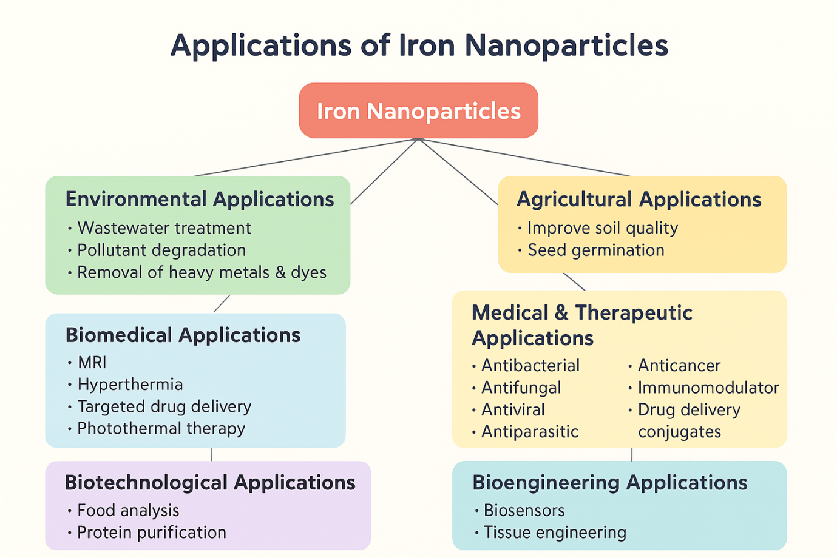
Fig 2: Applications of Iron Nanoparticles
  - Biomedical Applications
Iron oxide nanoparticles are widely employed in biomedical applications, particularly in targeted drug delivery, magnetic hyperthermia, and magnetic resonance imaging (MRI). Superparamagnetic iron oxide nanoparticles (SPIONs) act as efficient MRI contrast agents and enable site-specific drug delivery under an external magnetic field (Gupta and Gupta, 2005; Laurent et al., 2008). Surface-functionalized IONPs are also used for magnetic separation of cells, cell labeling, tissue engineering, and magnetofection, allowing controlled manipulation of biological systems (Pankhurst et al., 2003). Their therapeutic potential extends to inflammation management, musculoskeletal disorders, and pain therapy (Berry and Curtis, 2003).
  - Health Care Applications
In health care, iron oxide nanoparticles serve as multifunctional platforms for diagnostics and therapeutics. They are utilized in nanoscale biosensors, implant coatings, vaccine delivery systems, and antimicrobial formulations (Gupta and Gupta, 2005; Laurent et al., 2008). Nanophotothermolysis using pulsed lasers and iron oxide nanoparticles has shown promise in cancer therapy and viral infections, including hepatitis B, influenza, HIV, and herpes simplex virus (Pankhurst et al., 2009; Ali et al., 2016). Additionally, these nanoparticles play a role in antigen delivery and dermatological formulations aimed at preventing skin aging.
  - Agricultural and Food Applications
Iron oxide nanoparticles contribute significantly to agriculture through nanofertilizers, nanofungicides, and nanopesticides, which improve nutrient use efficiency and crop productivity (Nair et al., 2010; Ali et al., 2016). Pyrite iron nanoparticles used as seed treatment agents enhance germination, leaf morphology, biomass accumulation, and starch metabolism without adverse effects on plant growth (Raliya et al., 2015). In food systems, IONPs are applied in nanosensors, food packaging, nanoencapsulation, precision farming technologies, and gene transfer for crop improvement (Kah et al., 2013).
  - Environmental Remediation
Iron oxide nanoparticles play a critical role in environmental remediation due to their strong adsorption capacity and catalytic activity. They are extensively used for wastewater treatment, heavy metal removal, dye degradation, and pollutant monitoring through permeable reactive barriers and membrane filtration systems (Tratnyek and Johnson, 2006; Laurent et al., 2008). IONPs also contribute to climate change mitigation via carbon capture, CO₂ sequestration, nitrous oxide decomposition, and methane combustion. Their use in environmental sensors and nanocomposite membranes further enhances pollution control strategies (Zhang et al., 2010).
  - Energy Applications
In the energy sector, iron oxide nanoparticles are employed in photovoltaic coatings, thermoelectric materials, fuel cells, batteries, and aerogels to improve energy efficiency (Poizot et al., 2000; Ali et al., 2016). These nanoparticles enable the conversion of waste heat into usable electrical energy and enhance electrochemical performance in next-generation energy storage devices (Gupta and Gupta, 2005).
  - Defense and Aerospace Applications
Iron oxide nanoparticles are used in defense and aerospace applications for developing nanocomposites, nanocoatings, sensors, smart materials, and energy devices. Their lightweight nature, thermal stability, and multifunctional properties make them suitable for advanced structural and electronic systems (Gleiter, 2000; Ali et al., 2016).
  - Construction and Automotive Applications
In construction, iron oxide nanoparticles are incorporated into nanocoatings, smart materials, and pigments for concrete, bricks, and tiles, improving durability and aesthetics (Sanchez and Sobolev, 2010). In the automotive sector, IONPs are used as additives in lubricants and catalysts, fuel cell components, composite fillers, and smart coatings, enhancing engine efficiency and reducing emissions (Köhler et al., 2008).
  - Textile and Electronics Applications
In textiles, iron oxide nanoparticles enable the development of smart fabrics with sensing, antimicrobial, and protective properties (Roco, 2011). In electronics, they are used in printed electronics, nanoscale memory devices, nanowires, spintronics, and nanoelectromechanical systems, supporting miniaturization and improved device performance (Gleiter, 2000; Ali et al., 2016).
Conclusion
Green synthesis of iron nanoparticles has emerged as a sustainable and promising alternative to conventional chemical and physical fabrication methods, addressing critical environmental and health concerns associated with toxic reagents and energy-intensive processes. By exploiting naturally occurring reducing and stabilizing agents from plants, microorganisms, and biopolymers, biogenic approaches enable the production of iron nanoparticles with enhanced physicochemical stability, controlled morphology, and improved biocompatibility. The unique magnetic properties, redox activity, and high surface reactivity of green-synthesized iron nanoparticles underpin their broad applicability in biomedical, environmental, agricultural, and industrial domains. Notably, the incorporation of bioactive phytochemicals during synthesis often results in synergistic effects that enhance antimicrobial efficacy, therapeutic potential, and environmental performance compared to chemically synthesized counterparts.
Despite these advantages, challenges related to reproducibility, scale-up, mechanistic understanding, and long-term toxicity assessment remain significant barriers to widespread commercialization. Variability in biological precursors and limited process standardization highlight the need for systematic optimization and rigorous characterization. Future research should focus on elucidating molecular-level synthesis mechanisms, developing standardized protocols, and integrating advanced analytical and computational tools to improve reproducibility and scalability. Overall, green synthesis represents a vital pathway toward environmentally responsible nanotechnology. Continued interdisciplinary research and technological innovation will be essential to fully harness the potential of iron nanoparticles while ensuring safety, sustainability, and real-world applicability.

Disclaimer (Artificial intelligence)

Author(s) hereby declare that NO generative AI technologies such as Large Language Models (ChatGPT, COPILOT, etc.) and text-to-image generators have been used during the writing or editing of this manuscript.

- References
- Abdullah, J. A. A., Eddine, L. S., Abderrhmane, B., Alonso-González, M., Guerrero, A., & Romero, A. (2020). Green synthesis and characterization of iron oxide nanoparticles by Phoenix dactylifera leaf extract and evaluation of their antioxidant activity. Sustainable Chemistry and Pharmacy, 10, 105–113.
- Adhikari, S., Gascó, G., Méndez, A., Surapaneni, A., Jegatheesan, V., Shah, K., & Paz-Ferreiro, J. (2019). Influence of pyrolysis parameters on phosphorus fractions of biosolids-derived biochar. Science of the Total Environment, 695, 133846. https://doi.org/10.1016/j.scitotenv.2019.133846
- Ahmed, S., Ahmad, M., Swami, B. L., and Ikram, S. (2016). A review on plants extract mediated synthesis of silver nanoparticles for antimicrobial applications: A green expertise. Journal of Advanced Research, 7(1), 17–28. https://doi.org/10.1016/j.jare.2015.02.007
- Ali, A., Zafar, H., Zia, M., Haq, I. U., Phull, A. R., Ali, J. S., and Hussain, A. (2016). Synthesis, characterization, applications, and challenges of iron oxide nanoparticles. Nanotechnology, Science and Applications, 9, 49–67. https://doi.org/10.2147/NSA.S99986
- Awwad, A. M., & Salem, N. M. (2012). A green and facile approach for synthesis of magnetite nanoparticles. Nanoscience and Nanotechnology, 2(6), 208–213.
- Berry, C. C., and Curtis, A. S. G. (2003). Functionalisation of magnetic nanoparticles for applications in biomedicine. Journal of Physics D: Applied Physics, 36(13), R198–R206.
- Bhargava, A., Jain, N., and Nigam, S. (2014). Extracellular biosynthesis of cubic iron nanoparticles using Aspergillus japonicus. Materials Letters, 128, 268–271.

- Cuenya, B. R. (2010). Synthesis and catalytic properties of metal nanoparticles: Size, shape, support, composition, and oxidation state effects. Thin Solid Films, 518(12), 3127–3150. https://doi.org/10.1016/j.tsf.2010.01.018
- Dhillon, G. S., Brar, S. K., Kaur, S., & Verma, M. (2012). Green approach for nanoparticle biosynthesis by fungi: Current trends and applications. Critical Reviews in Biotechnology, 32(1), 49–73.
- Foroozandeh, P., and Aziz, A. A. (2018). Insight into cellular uptake and intracellular trafficking of nanoparticles. Nanoscale Research Letters, 13, 339. https://doi.org/10.1186/s11671-018-2728-6
- Gleiter, H. (2000). Nanostructured materials: Basic concepts and microstructure. Acta Materialia, 48(1), 1–29.
- Gupta, A. K., and Gupta, M. (2005). Synthesis and surface engineering of iron oxide nanoparticles for biomedical applications. Biomaterials, 26(18), 3995–4021.
- Herrera-Becerra, R., Zorrilla, C., & Ascencio, J. A. (2008). Production of iron oxide nanoparticles by a biosynthesis method: An environmentally friendly route. The Journal of Physical Chemistry C, 112(15), 5836–5841. https://doi.org/10.1021/jp072259a
- Huber, D. L. (2005). Synthesis, properties, and applications of iron nanoparticles. Small, 1(5), 482–501. https://doi.org/10.1002/smll.200500006
- Ikhuoria, E. U., Uwidia, I. E., Okojie, R. O., Ifijen, I. H., Chikaodili, I. D., & Fatiqin, A. (2023). Advancing green nanotechnology: Harnessing the bio-reducing properties of Musa paradisiaca peel extract for sustainable synthesis of iron oxide nanoparticles. Journal of Multidisciplinary Applied Natural Science, 3(1), 1–12. https://doi.org/10.47352/jmans.2774-3047.194
- Issa, B., Obaidat, I. M., Albiss, B. A., and Haik, Y. (2013). Magnetic nanoparticles: Surface effects and properties related to biomedicine applications. International Journal of Molecular Sciences, 14(11), 21266–21305. https://doi.org/10.3390/ijms141121266
- Kumar, K. M., Mandal, B. K., Kumar, K. S., Reddy, P. S., & Sreedhar, B. (2013). Biobased green method to synthesise palladium and iron nanoparticles using Terminalia chebula aqueous extract. Spectrochimica Acta Part A: Molecular and Biomolecular Spectroscopy, 102, 128–135. https://doi.org/10.1016/j.saa.2012.10.015
- Khan, I., Saeed, K., and Khan, I. (2017). Nanoparticles: Properties, applications and toxicities. Arabian Journal of Chemistry, 12(7), 908–931. https://doi.org/10.1016/j.arabjc.2017.05.011
- Laurent, S., Forge, D., Port, M., Roch, A., Robic, C., Vander Elst, L., and Muller, R. N. (2008). Magnetic iron oxide nanoparticles: Synthesis, stabilization, vectorization, physicochemical characterizations, and biological applications. Chemical Reviews, 108(6), 2064–2110. https://doi.org/10.1021/cr068445e
- Logothetidis, S. (2006). Nanotechnology in medicine: The medicine of tomorrow and nanomedicine. Hippokratia, 10(1), 7–21.
- Machado, S., Pinto, S. L., Grosso, J. P., Albergaria, J. T., & Santos, S. C. R. (2013). Green production of zero-valent iron nanoparticles using tree leaf extracts. Science of the Total Environment, 445–446, 1–8. https://doi.org/10.1016/j.scitotenv.2012.12.033
- Mazumdar, H., & Haloi, N. (2011). A study on biosynthesis of iron nanoparticles by Pleurotus sp. Journal of Microbiology and Biotechnology Research, 1(4), 39–49.
- Mohamed, Y. M., Azzam, A. M., Amin, B. H., & Safwat, N. A. (2015). Mycosynthesis of iron nanoparticles by Alternaria alternata and its antibacterial activity. African Journal of Biotechnology, 14(14), 1234–1241. https://doi.org/10.5897/AJB2014.14286
- Njagi, E. C., Huang, H., Stafford, L., Genuino, H. C., Galindo, H. M., Collins, J. B., Hoag, G. E., & Suib, S. L. (2011). Biosynthesis of iron and silver nanoparticles at room temperature using aqueous sorghum bran extracts. Langmuir, 27(1), 264–271. https://doi.org/10.1021/la103190n
- Nowack, B., and Bucheli, T. D. (2007). Occurrence, behavior and effects of nanoparticles in the environment. Environmental Pollution, 150(1), 5–22. https://doi.org/10.1016/j.envpol.2007.06.006
- Pankhurst, Q. A., Connolly, J., Jones, S. K., and Dobson, J. (2003). Applications of magnetic nanoparticles in biomedicine. Journal of Physics D: Applied Physics, 36(13), R167–R181.
- Park, Y., Hong, Y. N., Weyers, A., Kim, Y. S., & Linhardt, R. J. (2011). Polysaccharides and phytochemicals: A natural reservoir for the green synthesis of gold and silver nanoparticles. IET Nanobiotechnology, 5(3), 69–78. https://doi.org/10.1049/iet-nbt.2010.0033
- Pattanayak, M., & Nayak, P. L. (2013). Ecofriendly green synthesis of iron nanoparticles from various plants and spices extract. International Journal of Plant, Animal and Environmental Sciences, 3(1), 68–77.
- Prasad, A. S. (2016). Iron oxide nanoparticles synthesized by controlled bio-precipitation using leaf extract of garlic vine (Mansoa alliacea). Materials Science in Semiconductor Processing, 53, 79–83. https://doi.org/10.1016/j.mssp.2016.06.009
- Rajiv, P., Bavadharani, B., Kumar, M. N., & Vanathi, P. (2017). Synthesis and characterization of biogenic iron oxide nanoparticles using green chemistry approach and evaluating their biological activities. Biocatalysis and Agricultural Biotechnology, 12, 45–49. https://doi.org/10.1016/j.bcab.2017.08.015.
- Salem, S. S., Fouda, A., Fouda, M. M. G., Awad, M. A., Al-Olayan, E. M., Allam, A. A., & Shaheen, T. I. (2021). Plant-assisted green preparation of silver nanoparticles using leaf extract of Dalbergia sissoo and their antioxidant, antibacterial and catalytic applications. Journal of King Saud University – Science, 33(1), 101461. https://doi.org/10.1016/j.jksus.2021.101461
- Senthil, M., & Ramesh, C. (2012). Biogenic synthesis of Fe₃O₄ nanoparticles using Tridax procumbens leaf extract and its antibacterial activity on Pseudomonas aeruginosa. Digest Journal of Nanomaterials and Biostructures, 7(4), 1655–1662.
- Shahwan, T., Abu Sirriah, S., Nairat, M., Boyacı, E., Eroğlu, A. E., Scott, T. B., & Hallam, K. R. (2011). Green synthesis of iron nanoparticles and their application as a Fenton-like catalyst for the degradation of aqueous cationic and anionic dyes. Chemical Engineering Journal, 172(1), 258–266. https://doi.org/10.1016/j.cej.2011.05.103
- Sharma, V. K., Yngard, R. A., & Lin, Y. (2009). Silver nanoparticles: Green synthesis and their antimicrobial activities. Advances in Colloid and Interface Science, 145(1–2), 83–96. https://doi.org/10.1016/j.cis.2008.09.002
- Singh, P., Kim, Y.-J., Zhang, D., and Yang, D.-C. (2016). Biological synthesis of nanoparticles from plants and microorganisms. Trends in Biotechnology, 34(7), 588–599.
- Sun, C., Lee, J. S. H., & Zhang, M. (2008). Magnetic nanoparticles in MR imaging and drug delivery. Advanced Drug Delivery Reviews, 60(11), 1252–1265. https://doi.org/10.1016/j.addr.2008.03.018
- Venkateswarlu, S., Natesh Kumar, B., Prasad, C. H., Venkateswarlu, P., & Jyothi, N. V. V. (2014). Bio-inspired green synthesis of Fe₃O₄ spherical magnetic nanoparticles using Syzygium cumini seed extract. Physica B: Condensed Matter, 449, 67–71. https://doi.org/10.1016/j.physb.2014.04.031
- Verma, A., Mohan, R., and Singh, N. (2019). Microbial and plant-based synthesis of iron nanoparticles: A review. Nanomedicine Research Journal, 4(1), 7–17.
- Wang, Z. (2013). Iron complex nanoparticles synthesized by Eucalyptus leaves. ACS Sustainable Chemistry & Engineering, 1(12), 1554–1559. https://doi.org/10.1021/sc400174a
- Yazdani, F., & Seddigh, M. (2017). Magnetite nanoparticles synthesized by co-precipitation method: The effects of various iron anions on specifications. Materials Chemistry and Physics, 184, 318–323. https://doi.org/10.1016/j.matchemphys.2016.09.058
- Zhu, F., Ma, S., Liu, T., & Deng, X. (2018). Green synthesis of nano zero-valent iron/Cu by green tea to remove hexavalent chromium from groundwater. Journal of Cleaner Production, 174, 184–190. https://doi.org/10.1016/j.jclepro.2017.10.302
- Zielonka, A., & Klimek-Ochab, M. (2017). Fungal synthesis of size-defined nanoparticles. Advances in Natural Sciences: Nanoscience and Nanotechnology, 8(4), 045013. https://doi.org/10.1088/2043-6254/aa84d4

