Numerical Simulation of Flooding Using One-Dimensional Saint-Venant Equations with Trigonometry Water Level Representation

Abstract : This paper presents a numerical study of flooding using the one-dimensional Saint-Venant (shallow water) equations, which describe the conservation of mass and momentum in free-surface flows. The model is developed under simplified assumptions, including flat topography and the absence of additional source terms such as friction or rainfall.
Sinusoidal functions are used to define the initial water level profile and analyze spatial flow variations. The numerical solution is obtained using the finite volume method with $β-$Rusanov and HLL flux schemes, and wall-type boundary conditions are applied at the domain edges. The results illustrate the evolution toward hydraulic equilibrium, with increasing water height and decreasing velocity demonstrating the qualitative effectiveness of the proposed approach for understanding flood dynamics in a controlled setting.

Keywords : Flooding; Saint-Venant equation; Trigonometry; Finite volume method; Numerical simulation.

- Introduction
A flood is an overflow of water that covers normally dry areas, often caused by drainage problem or by rivers overflowing after heavy rainfall [1]. Globally, several million people live under the threat of flooding. Floods are among the main natural disaster risks facing the world. Understanding and predicting these phenomena are therefore essential for improving risk management and protecting populations. To this end, mathematical modeling and numerical simulation are essential tools for analyzing, predicting, and mitigating the effects of flooding.
In fluid dynamics, there exists a system of partial differential equations (PDEs) called the Saint-Venant system, which plays a central role in the study of free-surface flows. It describes the dynamic behavior of water while taking into account terrain topography, slopes, and acting forces. Nowadays, it is widely used to model many physical phenomena such as runoff, oceanography, environmental protection, pollution transport, climate change impact, dam-break flows, tidal motion, flood propagation, and sediment transport [2-10]. Trigonometry also plays an important role in representing geometric profiles and in calculating slopes, water depths, and inclination angles using trigonometric functions (sine, cosine, tangent, and cotangent), which are key elements in flow dynamics. It is also applied in many scientific fields such as mechanics, acoustics, geography, geodesy, optics, physics, electricity, and electronics.
Despite its widespread use, the Saint-Venant system has two main difficulties: first, accounting for topography, friction, and infiltration makes the numerical resolution complex; second, analytical solution are generally not available. To overcome these difficulties, numerical methods are used to approximate the solution. One of the most commonly used approaches for solving the Saint-Venant system is the finite volume method. The main advantage of this method is that it ensures mass conservation, which is a fundamental property that must be satisfied in fluid flow simulations.
The objective of this work is to implement a numerical simulation of flooding by combining the homogeneous Saint-Venant equations with trigonometric tools in order to analyze the evolution of water levels and flow velocities in a given domain under prescribed boundary conditions. This approach aims to provide a scientific basis for understanding the phenomenon and improving flood risk prevention and management strategies with resource- limited contexts.
This paper is organized into six sections.
In the second section, we present the one-dimensional Saint-Venant system without source term and its conservative formulation.
The third section is devoted to the numerical solution of the system, including the presentation of the finite volume method [11,12] and the numerical flux schemes, namely β-Rusanov and HLL [13-16].
In the fourth section, we simulate a flooding phenomenon over flat and smooth terrain without infiltration, and impose zero discharge at the outlet of the domain, corresponding to downstream wall boundary condition.
In the fifth section, we present a comparative discussion of the results.
- One-dimensional Saint-Venant system without source term

The Saint-Venant equations are differential equations that describe free-surface flows. These equations are used to simulate variations in water depth and velocity over time and space based on the principles of conservation of mass and momentum.
The one-dimensional homogeneous Saint-Venant system is given by:

$\left\{\begin{aligned}\frac{∂h}{∂t}+\frac{∂hu}{∂x}=0 \\ \frac{∂hu}{∂t}+\frac{∂}{∂x}\left(hu^{2}+\frac{gh^{2}}{2}\right)=0; \end{aligned}\right.$ (1.1)
with
- $h\left(x,t\right)$ represents the water height at point$x$ at time $t;$
- $u\left(x,t\right)$ is the water velocity at the point $x$ at time $t;$
- $g$ is the gravitational constant.
This system can be written in the following conservative formulation :
$\frac{∂U}{∂t}+\frac{∂f(U)}{∂x}=0;$ (1.2)
with $U=\left({h \atop hu}\right)=\left({h \atop q}\right)$ and $f\left(U\right)=\left({hu \atop hu^{2}+\frac{gh^{2}}{2}}\right)=\left({q \atop \frac{q^{2}}{h}+\frac{gh^{2}}{2}}\right)$;
where $q\left(x,t\right)=h\left(x,t\right)u\left(x,t\right)$ is the momentum.
Barré de Saint-Venant derived the nonlinear system (1.1) by vertically integrating the three-dimensional Navier-Stokes equations, under several physical assumptions and approximations [17].
- Numerical Resolution
  - Finite volume method
The finite volume method consist of dividing the computational domain into a set of elementary control volumes, called “cells or mesh elements” that form non-overlapping partition of the domain [18,19]. These volumes may be polygonal, with shapes and numbers of sides depending on the mesh.
The governing partial differential equations are then integrated over each control volume to obtain a system of discrete equations. The main advantage of this method is that it ensures the conservation of fluxes across the interfaces between adjacent cells.
The solution $U$ of problem (1.1) is approximated by the discrete values.
$U_{i}^{n}≅\frac{1}{Δx}\int_{x_{i-\frac{1}{2}}}^{x_{i+\frac{1}{2}}}{U(x,t^{n})dx}$, $i=1,⋯,N$, representing the average of $U$ in the mesh
$M_{i}=\left[x_{i-\frac{1}{2}};x_{i+\frac{1}{2}}\right]$ at time $t^{n}=nΔt$ with $n∈N$ and $∆t$ is the time step. The meshes $M_{i}$ are centered at $x_{i}=\frac{x_{i-\frac{1}{2}}+x_{i+\frac{1}{2}}}{2}$, such that the spatial step $∆x=\left|M_{i}\right|$.
By integrating $(1.2$) over $\left[t^{n};t^{n+1}\right]×M_{i}$, we obtain :
$U_{i}^{n+1}-U_{i}^{n}+\frac{∆t}{∆x}\left(F(U_{i}^{n},U_{i+1}^{n})-F(U_{i-1}^{n},U_{i}^{n})\right)=0$ (1.3)
with
$$F\left(U_{i}^{n},U_{i+1}^{n}\right)=F_{i+\frac{1}{2}}^{n}≃\frac{1}{Δt}\int_{t^{n}}^{t^{n+1}}{f\left(U\left(x_{i+\frac{1}{2}},t\right)\right)dt}$$
and
$$F\left(U_{i-1}^{n},U_{i}^{n}\right)=F_{i-\frac{1}{2}}^{n}≃\frac{1}{Δt}\int_{t^{n}}^{t^{n+1}}{f\left(U\left(x_{i-\frac{1}{2}},t\right)\right)dt}$$

represent approximations of the normal fluxes, i.e., numerical fluxes on the two interfaces of mesh $M_{i}$ at time $t^{n}.$
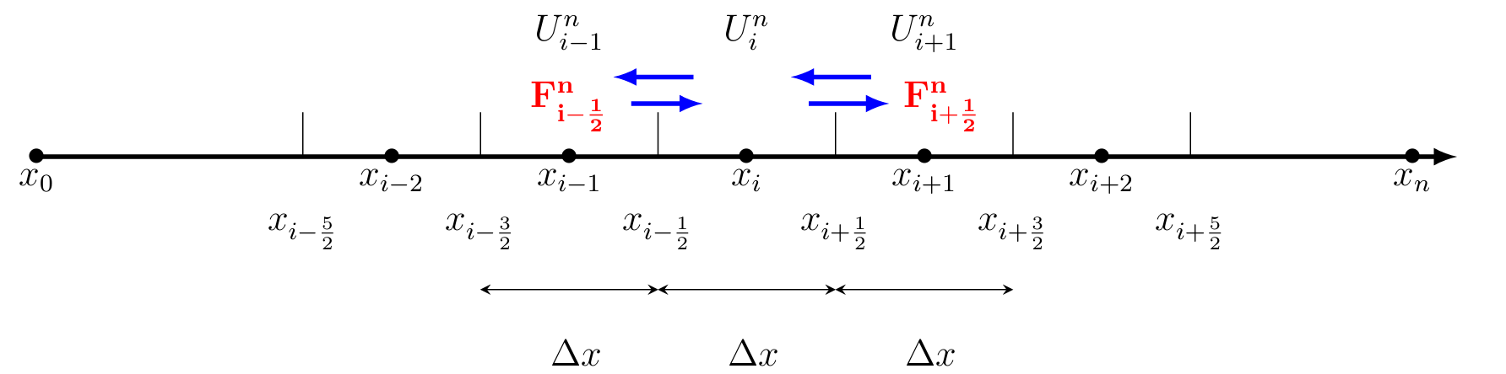
Figure 1 : Domain mesh 1D
$F_{i+\frac{1 }{2}}^{n}$ and $F_{i-\frac{1}{2}}^{n}$ are the fluxes across the small control volume centered at $x_{i}$ and of length $Δx$.
  - Flux approximation
Several methods exist in the literature to approximate the numerical flux. In the present work, we use the simplest and therefore most widely used ones : the HLL flux and the new variant of Rusanov scheme, namely the $β$−Rusanov scheme.
    - $β$−Rusanov scheme
Let $U_{L}^{*}$and $U_{R}^{*}$ denote the data in the two neighboring cells. Then, the $β$−Rusanov flux [13] is given by :
$F\left(U_{L}^{*},U_{R}^{*}\right)=\frac{F\left(U_{L}^{*}\right)+F(U_{R}^{*})}{2}-c\frac{U_{R}^{*}-U_{L}^{*}}{2}$ (1.4)
Where $c$ is the maximum wave speed, computed from the largest eigenvalue of the local Jacobian matrix in the cell, and the new reconstructed data are obtained as follows :
$U_{R}^{*}=U_{R}-\frac{β}{2}\left(U_{R}-U_{L}\right)$ and $U_{R}^{*}=U_{L}+\frac{β}{2}\left(U_{R}-U_{L}\right)$
with $β$ a real such as $\left|β\right|<1$. $c=\max_{k∈\left\{1;2\right\}}\left(\left|λ_{k}\left(U_{L}\right)\right|,\left|λ_{k}\left(U_{R}\right)\right|\right)$ and $λ_{k}=u±\sqrt{gh}$ are eigenvalue of the matrix : $\frac{∂F}{∂U}=\left(\begin{matrix}0 & 1 \\ gh-u^{2} & 2u\end{matrix}\right)$ .
    - HLL scheme
The HLL (Harten, Lax and Van Leer) flux [11] is written as follows :
$$F\left(U_{L},U_{R}\right)=\left\{\begin{aligned}F\left(U_{L}\right) if 0≤ c_{1} \\ \frac{c_{2}F\left(U_{L}\right)-c_{1}F\left(U_{R}\right)}{c_{2}-c_{1}}-\frac{c_{1}c_{2}\left(U_{R}-U_{L}\right)}{c_{2}-c_{1}} if c_{1}<0<c_{2} \\ F\left(U_{R}\right) if c_{2}≤0\end{aligned}\right.$$
With $c_{1}=\inf_{U=U_{L},U_{R}}\left(\inf_{k∈\{1;2\}}{λ_{k}}\left(U\right)\right)$ and $c_{2}=\sup_{U=U_{L},U_{R}}\left(\sup_{k∈\{1;2\}}{λ_{k}}\left(U\right)\right)$
- Numerical simulation of a flooding phenomenon
The domain is $\left[0;L\right]=\left[0;14000\right]$, it is subdivided into $N=50$ cells with Dirichlet boundary conditions :
$\left\{\begin{aligned}h\left(x,0\right)=50-\frac{x}{350}+10\sin\left(π\left(\frac{x}{3500}+\frac{1}{2}\right)\right), q\left(x,0\right)=0 \\ h\left(0,t\right)=64+4\sin\left(π\left(\frac{t}{21600}+\frac{1}{2}\right)\right), q\left(L,t\right)=0\end{aligned}\right.$
We used the Fortran programming language to obtain the following velocity and water-depth profiles :
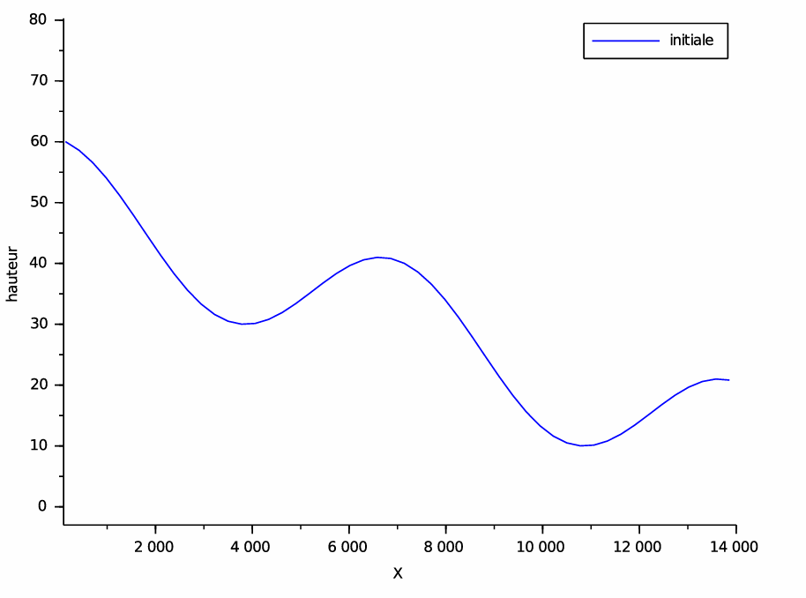
Figure 2 : Profiles of the solution computed t = 0 s

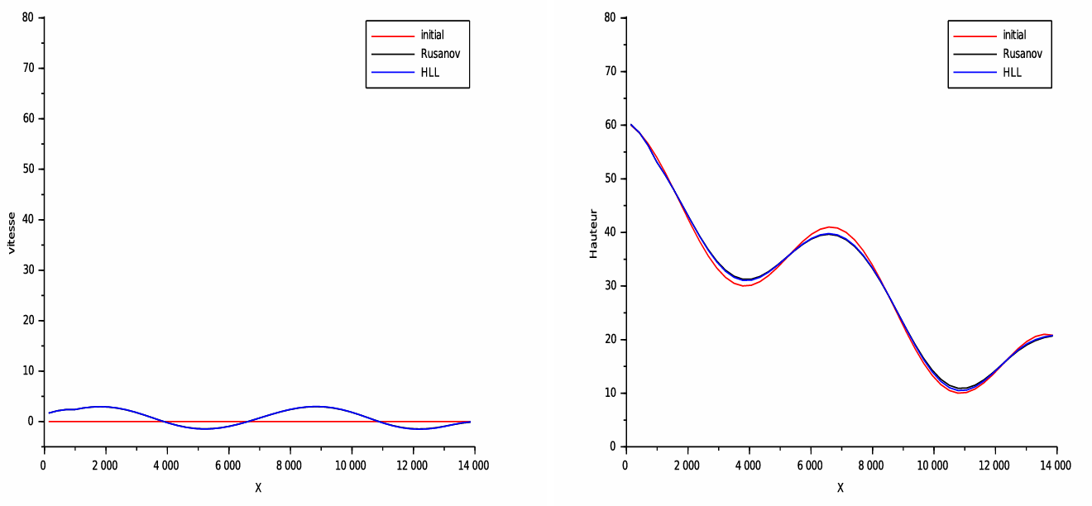
Figure 3 : Profiles of the solutions computed at t=0,02 s

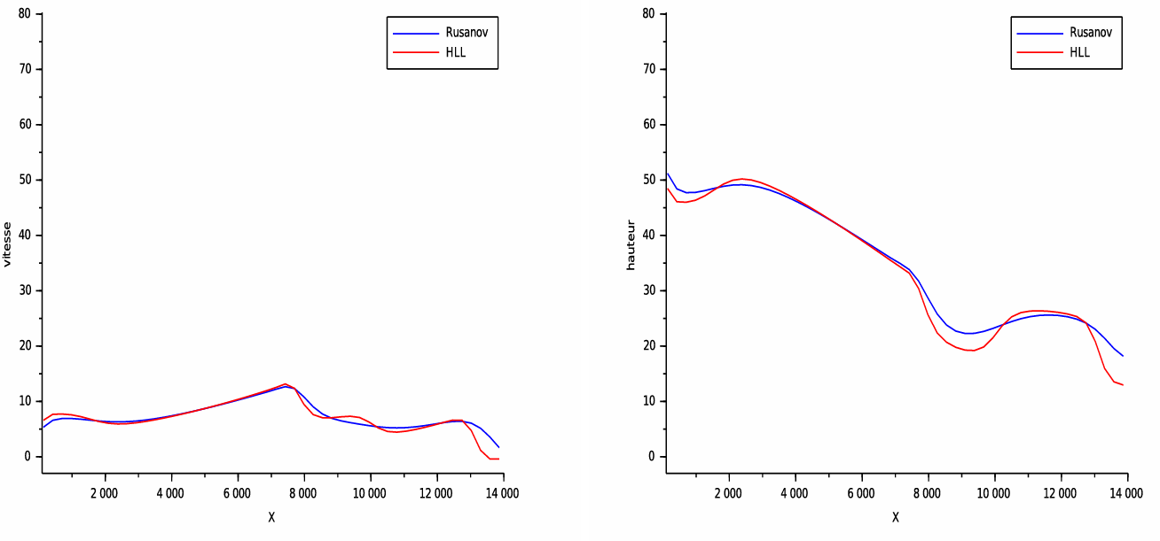
Figure 4 : Profiles of the solutions computed at t=0,12 s
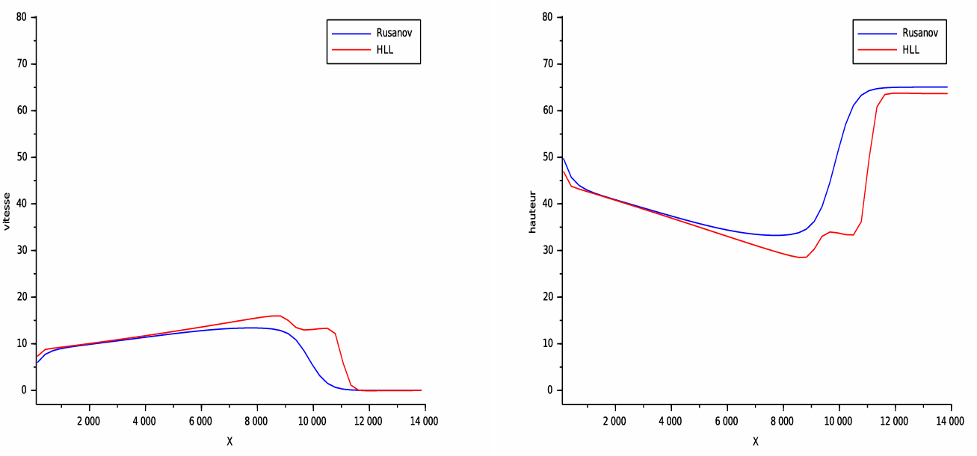
Figure 5 : Profiles of the solutions computed at t=0,15 s

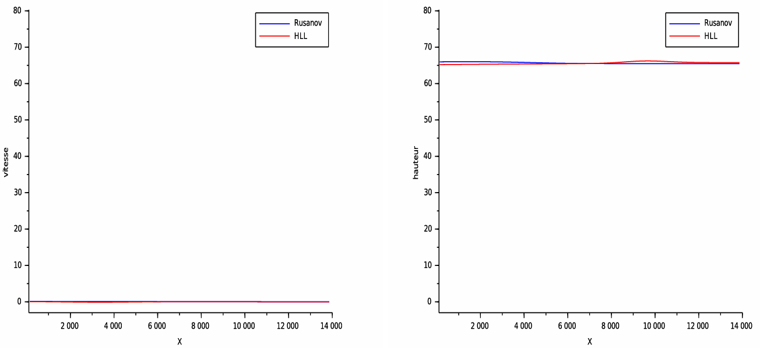
Figure 6 : Profiles of the solutions computed at t=0,24s

Results
The objective of this numerical test is to simulate a flooding phenomenon over flat, impermeable ground using trigonometric initial conditions.
In Fig. 2, a sinusoidal water depth is observed at the initial time. Under the effect of gravity, variations in both velocity and water depth appear in Figs. 3 and 4.
Due to the dowstream wall boundary condition (zero discharge at the outlet of the domain), a reflection of the water surface is observed for both schemes, marking the onset of hydraulic equilibrium.
At time t=0.24 s, both models reach an equilibrium state. The water depth increases progressively while the velocity decreases until it stabilization.
The β-Rusanov scheme converges faster than the HLL scheme, showing a clearly more diffusive behavior.
- Discussions
Numerical simulations based one the one-dimensional Saint-Venant equations demonstrate a consistent evolution of water depth and flow velocity. An initial sinusoidal profile, defined using trigonometric functions, generates pressure gradients that drive water motion under gravity.
The imposition of a downstream wall boundary condition results in gradual water accumulation and upstream waves reflection, illustrating the establishment of hydraulic equilibrium. Over time, water depth increases while velocity decreases, eventually approaching zero.
Comparison of the numerical schemes shows that the β-Rusanov scheme converges more rapidly than the HLL scheme due to its more diffusive characteristics. These results confirm the that the finite volume method can qualitatively reproduce the flooding phenomenon within a simplified computational framework.
  - Comparative discussion with the literature
The results obtained are consistent with those reported in the literature on the modeling of free-surface flows using the Saint-Venant equations. Several studies have shown that finite volume methods can accurately represent wave propagation and the evolution toward hydraulic equilibrium in idealized one-dimensional configurations.
Studies such as those by Navarro et al. [7] and Caleffi et al. [3] also highlight the importance of boundary conditions in water accumulation and the formation of steady states, phenomena observed in the present study. Furthermore, the faster convergence of the β-Rusanov scheme compared with HLL scheme is consistent with results reported in the literature, particularly those presented by Kader and al. [13], where the more diffusive nature of the scheme promotes rapid stabilization of the solution.
However, unlike more advanced studies incorporating topography, friction, or two-dimensional models, the present work is restricted to a simplified framework. Nevertheless, this approach remains relevant for qualitative and educational analysis of flooding phenomenon and provides a solid basis for future extensions toward more realistic models.

- Conclusion
In this study, we investigated flooding phenomenon using a numerical simulation approach based on the Saint-Venant equations and trigonometric functions to represent water depth and velocity.
The obtained results show that numerical simulation is an effective tool for understanding flood dynamics and identifying potentially vulnerable areas. It also offers valuable prospects for decision support in land-use planning and water resource management.

COMPETING INTERESTS DISCLAIMER:
Authors have declared that they have no known competing financial interests OR non-financial interests OR personal relationships that could have appeared to influence the work reported in this paper.
Disclaimer (Artificial intelligence)
Author(s) hereby declare that NO generative AI technologies such as Large Language Models (ChatGPT, COPILOT, etc.) and text-to-image generators have been used during the writing or editing of this manuscript.

References

[1] Christophe Ancey, Hydraulique à surface libre, EPFL, ENAC/IIC/LHE, Ecublens, Lausanne, Suisse, CH-1015.
[2] Benkhaldoun F., Elmahi I., Seaid M. (2006). Well-balanced finite volume schemes for pollutant transport on unstructured meshes, Journal of Computational Physics, 226 (1) :180-203.
[3] Caleffi V., Valiani A., Zanni A. (2003). Finite volume method for simulating extreme flood events in natural channels, Journal of Hydraulic Research, (2) :167-177.
[4] Derakhshan H., Bistkonj M. Z. (2013). A new the two dimensional model for pollutant Transport in Ajichai River, Journal of Hydraulic Structures, 1 (2) : 44-54.
[5]. El Bouajaji M. (2010). Modélisation des écoulements à surface libre : étude du ruissellement d’eau de pluie, Stage de Master 2, calcul scientifique et visualisation, Université Louis Pasteur Strasbroug.
[6] Marche F. Autour des équations de Saint-Venant et applications à l’océanographie côtière, Université de Bordereau 1.
[7] Navarro G., Fras P., Villanueva A. I. (1999). Dam-break flow simulation : some results for one-dimensional models of real cases, Journal of Hydrology, 216(3-4) :227-247.
[8] Ciallella M., Micalizzi L., Michel-Dansac V., Öffner P., Torlo D., (2024). A high-order, fully well-balanced, unconditionally positivity-preserving finite volume framework for flood simulations, GEM - International Journal on Geomathematics, 16(6) :2-33.
[9] Ralph Lteif, (2022), Well-balanced numerical resolution of the two-layer shallow water equations under rigid-lid with wet–dry fronts, Computers & Fluids, 235 : 105277.
[10] Baifen R., Gao Z., Gu Y., Shusen X., (2024). A Positivity-Preserving and Well-Balanced High Order Compact Finite Difference Scheme for Shallow Water Equations. Communications in Computational Physics. 35 : 524-552.
[11] Mohamed K., Seaid M., Zahri M. (2013). A finite volume method for sca lar conservation laws with stochastic time-space dependent flux func tions, Journal of Computational and Applied Mathematics, 237 : 614–632.
[12] Leveque R. J. Finite volume methods for hyperbolic problems, Cambridge University Press, Cambridge, UK. 2002.
[13] Kader M. Y. A., Badé R., Saley B. (2022). A new variant of Rusanov scheme : $β-$Rusanov for numerical resolution of shallow water flows, Int. J. of Appl. Math, 35(4) : 585-600.
[14] Chen G., Noelle S. (2017). A new hydrostatic reconstruction scheme based on subcell reconstructions, SIAM J. Numer. Anal, 55(2) : 758–784.
[15] Duran A., Liang Q., Marche F. (2013). On the well-balanced numerical discretization of shallow water equations on instructured meshes, Journal of Computational Physics, 235 : 565-585.
[16] Eleuterio F. T., Svetlana A. T. (2026) Rusanov-type schemes for hyperbolic equations: Wave-speed estimates, monotonicity and stability, Computers and Fluids, 309 : 107000.
[17] Shi Y. (2006). Résolution numérique des équations de Saint-Venant par la technique de projection en utilisant une méthode des volumes finis dans un maillage non structuré, Thèse de Doctorat. Université de Caen.
[18] Hervouet J. M., (2007). Hydrodynamics of free surface flows modelling with the f inite element method, John Wiley et Sons, Ldt.
[19] Kader M. Y. A., Badé R., Saley B. (2025) Application of the β−Rusanov scheme to two-dimensional shallow water equations and numerical simulation of a flooding phenomenon in a city, Int. J. Adv. Appl. Math. and Mech. 12(3) : 99–109

