IoT-Based Smart Waste Segregation and Monitoring System

Abstract:
Accelerated urbanisation coupled with continuous population growth has substantially amplified the volume of solid waste generated, thereby rendering effective waste management an urgent and complex challenge. Inadequate segregation at source and delays in waste collection frequently contribute to environmental contamination and pose considerable risks to public health.This paper presents an IoT-based smart waste segregation and monitoring system designed to automatically separate waste into dry, wet, and metallic categories while continuously monitoring bin fill levels. The proposed system uses an ESP32 microcontroller integrated with IR, rain (moisture), metal, and ultrasonic sensors to detect waste type and bin status. A stepper motor and servo motor mechanism ensure accurate positioning and controlled disposal of waste into the appropriate bins. Real-time monitoring and alert notifications are enabled through the Blynk IoT platform, allowing timely collection and preventing bin overflow. Experimental results demonstrate reliable segregation, accurate level sensing, and stable IoT communication. The system offers a low-cost, compact, and scalable solution suitable for smart city waste management applications.
Keywords: IoT, Smart Waste Management, Waste Segregation, ESP32, Ultrasonic Sensor,Stepper Motor, Servo Motor, Blynk IoT, Smart City.
1. Introduction
The rapid rise in global population and urbanisation has led to a massive increase in daily waste generation across the world. In developing countries such as India, improper waste management remains a major challenge due to inadequate segregation, irregular collection, and a lack of real-time monitoring. A large portion of waste is still disposed of without separation into biodegradable, recyclable, and hazardous categories, resulting in environmental pollution, health risks, and inefficient recycling processes (Abdel-Shafy& Mansour, 2018).
Traditional waste management systems rely heavily on manual segregation, which islabour-intensive, time-consuming, and unsafe for sanitation workers. Exposure to harmful materials, toxic gases, and unhygienic conditions poses serious health hazards. Moreover, conventional garbage bins often overflow because waste collection is performed on fixed schedules without considering the actual fill level of bins. These limitations highlight the need for an intelligent, automated, and technology-driven approach to waste segregation and monitoring.
The emergence of the Internet of Things (IoT) has opened new possibilities for developing smart waste management solutions. IoT-enabled systems allow real-time data collection, remote monitoring, and automated decision-making, thereby improving efficiency and reliability. By integrating sensors, embedded systems, and cloud platforms, waste can be segregated at the source and monitored continuously, reducing human intervention and operational costs. Chaudhariet al. in (2019) developed smart waste bin monitoring based on IoT and management of municipal waste capable of effectively collecting waste, discovering fires in waste, and predicting estimating of waste generation in the future.A smart waste management system based on IoT technologies is suggested (Gull et al., 2021). They use multiple technologies in public waste collectors to measure the status of rubbish containers in real time (Ahmed et al., 2023).
This paper presents an IoT-Based Smart Waste Segregation and Monitoring System that automates the classification of waste into dry, wet, and metallic categories while simultaneously monitoring bin fill levels in real time. The proposed system uses an ESP32 microcontroller as the core processing unit, along with multiple sensors such as an infrared (IR) sensor, an inductive metal sensor, a rain sensor, and an ultrasonic sensor. Actuation is achieved using a stepper motor to align the appropriate bin and a servo motor to control the waste inlet flap.
Unlike many existing systems that focus either on segregation or monitoring, the proposed model integrates both functionalities into a compact, low-cost prototype. A single ultrasonic sensor, combined with mechanical rotation, is used to measure the fill level of each bin sequentially, reducing hardware complexity and cost. The system connects to the Blynk IoT platform over Wi-Fi, enabling real-time visualisation of bin levels, system status, and alert notifications when bins reach full capacity.
The primary objective of this work is to design a practical and scalable solution suitable for small-scale deployments such as residential complexes, campuses, and public places. By automating waste segregation at the source and providing real-time monitoring, the system aims to improve recycling efficiency, reduce environmental impact, and support smart city initiatives. The proposed solution demonstrates how low-cost IoT technologies can be effectively utilised to address real-world waste management challenges in a sustainable and efficient manner.
2. Literature Review
Waste management has become a critical challenge in modern urban environments due to rapid population growth and increasing solid waste generation. To address this issue, researchers have proposed various smart waste management systems using Internet of Things (IoT), sensors, automation, and intelligent monitoring techniques. This section reviews existing research related to IoT-based waste segregation and monitoring systems, highlighting their contributions and limitations.
Pires et al. [1]have presented an IoT-enabled real-time monitoring system for urban garbage bins using advanced sensing technologies. Their work focused primarily on fill-level detection and cloud-based monitoring for municipal waste collection optimisation. Although effective for large-scale deployments, the system did not address automatic waste segregation at the source level.Lingaraju et al. [2]have proposed an IoT-based waste segregation framework integrated with GPS-based location tracking and air-quality monitoring. The system was suitable for smart city applications and environmental analysis; however, it was mainly designed for centralised monitoring rather than compact, low-cost source-level segregation units.Ali et al. [3]have been developed an IoT-based smart trash bin for solid waste management with real-time monitoring and alert mechanisms. Their system efficiently prevented bin overflow but lacked automated segregation of waste into multiple categories, limiting its applicability for recycling-oriented waste handling.Tariq Ali et al. [4]have been discussed IoT-enabled waste management systems focusing on data collection, cloud integration, and monitoring dashboards for urban waste management. While the study emphasised smart city integration, it did not provide a complete mechanical or sensor-based segregation mechanism.Dahale et al. [5] have presented an IoT-based waste segregation model utilisingdeep-learning techniques for accurate waste classification. While this approach achieved high precision in object recognition, it required camera modules and intensive computation, increasing cost and reducing accessibility for low-budget deployments.Megalan Leo et al. [6]have proposed an automatic waste segregation and monitoring system using sensors and IoT alerts. Their prototype demonstrated effective segregation and remote monitoring but faced challenges related to mechanical alignment, scalability, and the cost of actuation components.Jaikumar et al. [7] have presented an MQTT-assisted IoT framework for waste segregation and monitoring. The work highlighted efficient communication protocols and remote dashboards; however, it focused more on data transmission rather than improving physical segregation accuracy.Mohammed Aarif et al.[8]have developed a smart bin system using deep learning and IoT for waste classification. While the approach improved detection accuracy, the dependency on vision-based models increased system complexity and reduced feasibility for low-cost deployment in developing regions.Fathimal et al. [9] have implemented an IoT-based waste management system combining basic machine learning and ultrasonic sensors for monitoring. Although effective in alert generation, the system lacked robust multi-category segregation and a compact mechanical design.Sowndharyaet al. [10]have proposed a sensor-based smart waste segregation and monitoring system using IoT. The study validated the usefulness of ultrasonic sensing and alerts but offered limited integration between segregation and monitoring processes.An IoT-based irrigation model with cloud computing, a mobile app for remote monitoring and irrigation control and a predictive analysis method for forecasting weather conditions have been proposed by Borkakoty Sangeeta et al[11]. To develop an intelligent monitoring and automated irrigation system that minimises water use based on individual conditions and enables real-time environmental have been proposed by Sharma Priyanka et al[12].
From the literature review, it is observed that most existing systems focus either on waste monitoring or waste classification, but very few integrate both effectively in a compact, low-cost, and source-level system. Vision-based approaches improve accuracy but increase cost and complexity, while monitoring-only systems lack segregation capabilities.
The proposed system addresses this gap by combining sensor-based waste segregation (dry, wet, and metal) with IoT-enabled bin-level monitoring using a single ultrasonic sensor and mechanical rotation, offering a cost-effective, reliable, and scalable solution suitable for smart waste management applications.
3. Methodology:
3.1 System Flowchart:
The system flowchart of the work is shown in the figure-1. At first, the device detects the waste material after inputting the waste material in the container. The proposed model detects the waste model and segregates the material in the different wet, dry and metal buckets and also checks the bucket level. If the bucket is more than 80 percent full,then send a message to the waste management office and then the waste collection person unloads the waste before the dustbins are full.
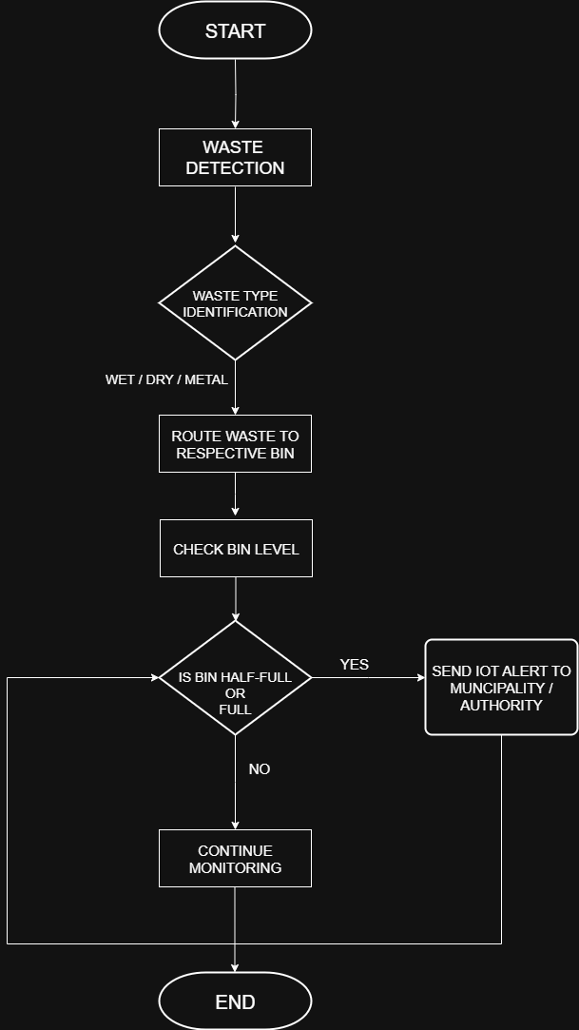
Figure-1: System Flowchart

3.2 Circuit Diagram:
The circuit diagram of the proposed system is given below as shown in Figure 2. It shows the different sensors' connections.
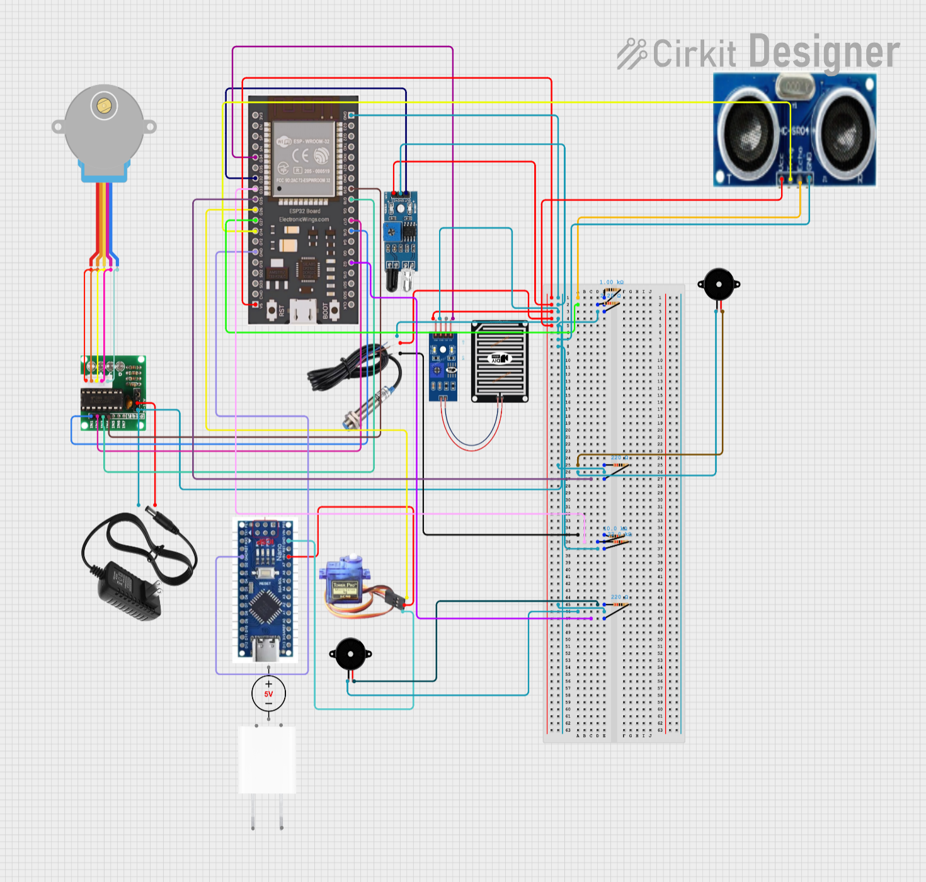
Figure-2: Circuit diagram

3.3 Hardware Components:
Below are the major hardware components used in this project, along withtheir specific role in the IoT-Based Smart Waste Segregation and Monitoring System.
A. ESP32 Microcontroller

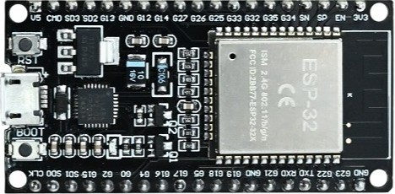
Figure-3 Image of ESP32 Microcontroller

In our system, the ESP32 acts as the central processing unit that reads signals from sensors (IR, Metal, Rain, Ultrasonic), processes them, and drives the servo and stepper motors accordingly. It also connects the hardware system to the Blynk Cloud to provide real-time monitoring and alerts.
B. IR Sensor (Infrared Sensor)
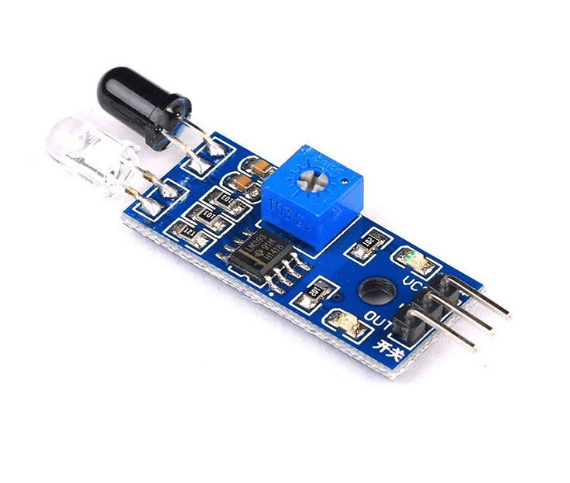
Figure-4 Image of IR Sensor (Infrared Sensor)

In our system, the IR sensor is used to detect dry waste placed near the waste input area. When it detects a reflection, it signals the ESP32 to activate the stepper motor to move the chute to the dry-waste bin.
Specifications: Range 0 – 10 cm, Operating Voltage 5 V DC.
C. Metal Sensor (Inductive Proximity Sensor)
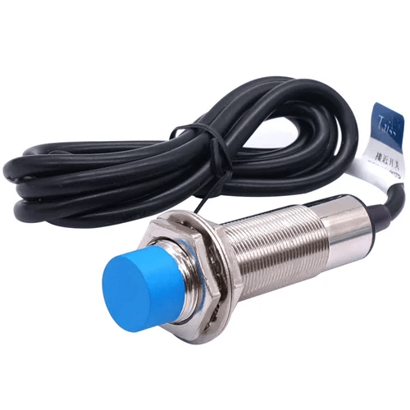
Figure-5 Image of Metal Sensor (Inductive Proximity Sensor)

The metal sensor identifies metallic waste at the input. When it senses a metal object, the ESP32 rotates the stepper motor to align the metal bin below the chute for disposal.
Specifications: Operating Voltage 6–36 V DC, Detection Range 4–8 mm.
D. Rain Sensor (Used as Wet Sensor)
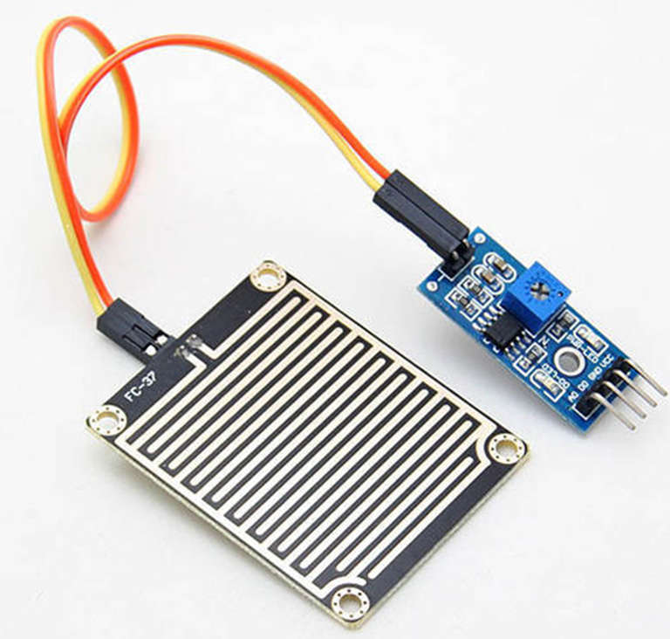
Figure-6 Image of Rain Sensor
The rain sensor acts as a wet-waste detector. When wet waste is detected, the ESP32 rotates the platform to the wet-bin position using the stepper motor, then activates the servo motor to open the flap.
Specifications:Analogue output, Operating Voltage 5 V DC.
E. Ultrasonic Sensor (HC-SR04)
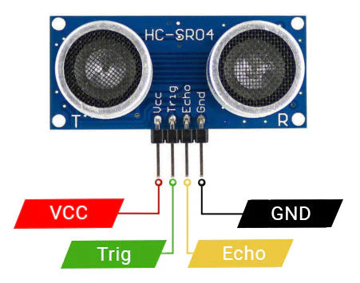

Figure-7 Image of Ultrasonic Sensor

Used to measure the fill level of each bin (dry, wet, and metal). The ultrasonic sensor is fixed under the flap, while the stepper motor rotates each bin sequentially under the sensor at set intervals. The ESP32 records the distance readings to determine bin levels, and the data is displayed on the Blynk dashboard.
Specifications: Range 2 – 400 cm, Accuracy ± 3 mm, Operating Voltage 5 V DC.
F. Stepper Motor (28BYJ-48) with ULN2003 Driver
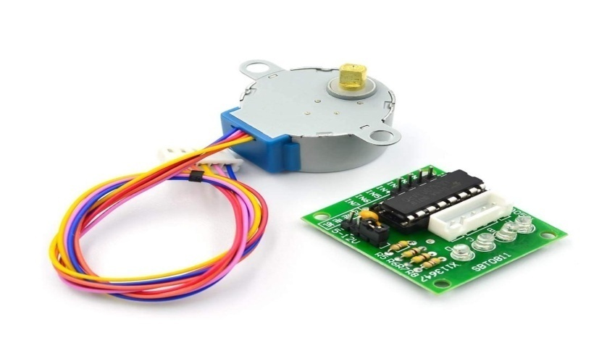
Figure-8 Image of Stepper Motor

The stepper motor rotates the waste chute to align with the correct bin (dry, wet, or metal). It ensures accurate positioning before the servo motor opens the flap to release the waste.
Specifications: Step Angle 5.625°, 2048 steps per revolution, Speed ≈ 10 rpm.
G. Servo Motor (SG90 / MG90S)



Figure-9 Image of Servo Motor

The servo motor is used to open and close the flap of the waste inlet. When a waste type is detected, the servo opens the lid to allow waste to drop into the correct bin, then closes automatically.
Specifications: Operating Voltage 4.8 – 6 V, Rotation 0° – 180°.
H. Buzzer
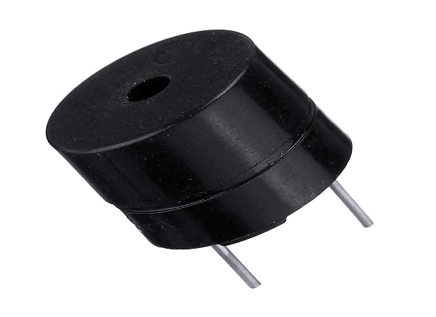
Figure-10 Image of Buzzer

The buzzer is used in this project to provide audio feedback during two key events: first, when waste is being deposited into the input bin, and second, when any bin becomes full. This ensures users are immediately notified of system activity and bin status.
Specifications: Operating Voltage 5 V DC, Sound Level ≈ 85 dB.
I. Power Supply (12v Adapter)
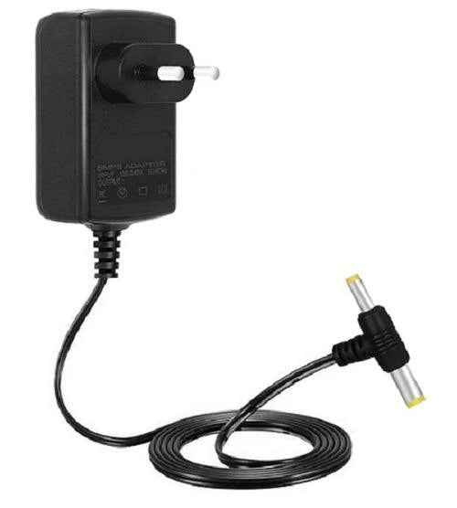

Figure-11 Image of Power Supply (12v Adapter)
The power adapter is used exclusively to supply sufficient current to the stepper motor through the ULN2003 driver module, ensuring stable rotation and avoiding power drops when the motor operates. The ESP32 and sensors receive power separately via USB.
J. Arduino Nano (Used as Secondary Power Controller)
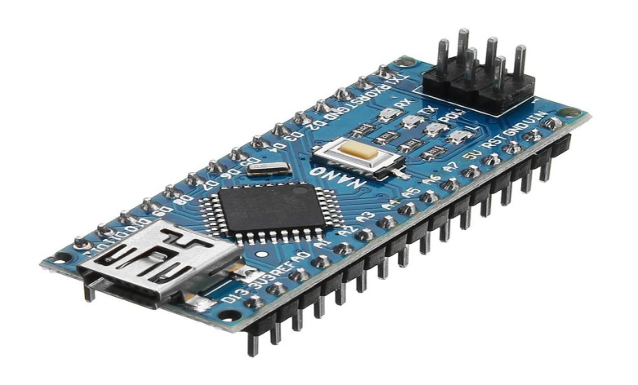
Figure-12 Image of Arduino Nano

The Arduino Nano is used as a secondary power supply controller to provide stable 5V power to the servo motor, ensuring smooth and consistent flap operation without drawing excess current from the ESP32 board.
Specifications: Operating Voltage: 5V DC, Clock Speed: 16 MHz.
K. Breadboard
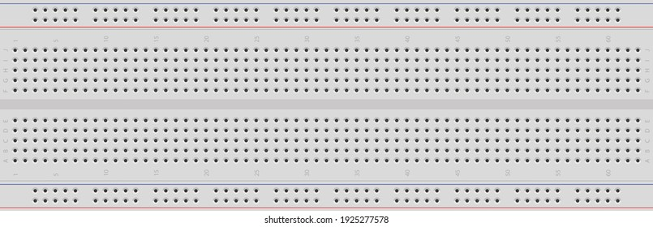

Figure-13 Image of Breadboard
Used as the main wiring platform, connecting the ESP32, sensors, motors, and power modules. It allows quick debugging and easy modifications during testing.
Specifications:
Type: Solderless half breadboard
Terminals: ~400 tie-points
Power Rails: Dual
L. Jumper Wires (Male–Male, Male–Female, Female–Female)

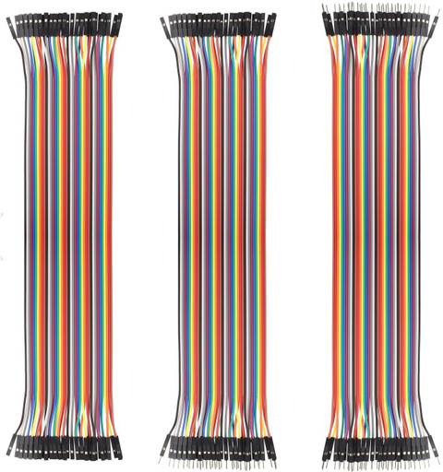
Figure-14 Image of Jumper Wires

Used to connect the ESP32, sensors, motors, and power modules on the breadboard. They ensure organised, reliable, and flexible connections.
Specifications: Type: Male–Male, Male–Female, Female–Female
Length: 10–20 cm, Material: Copper core with PVC insulation
3.4 Software Components:
Software tools are essential for programming, monitoring, and testing the system. The following tools were used:
A. Arduino IDE

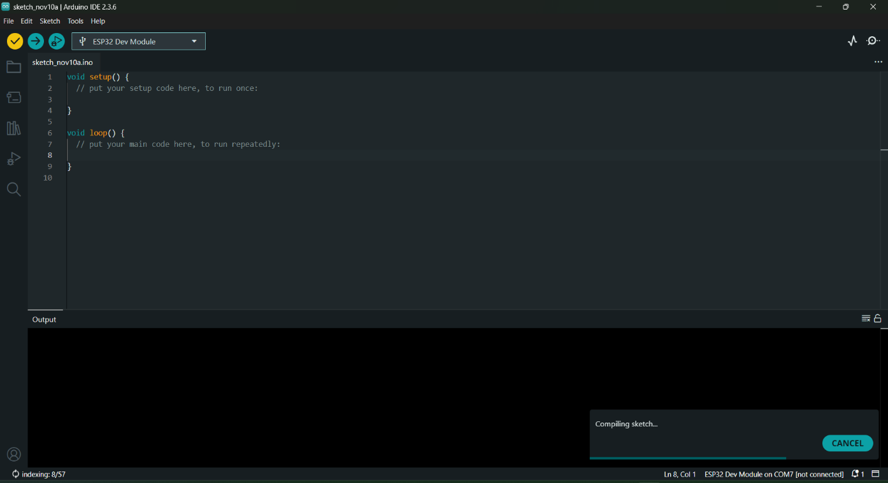
Figure-15 Image of Arduino IDE

It isused to write the main program that controls all sensors and motors, handles IoT data transmission, and uploads firmware to the ESP32.
B. Blynk IoT Platform
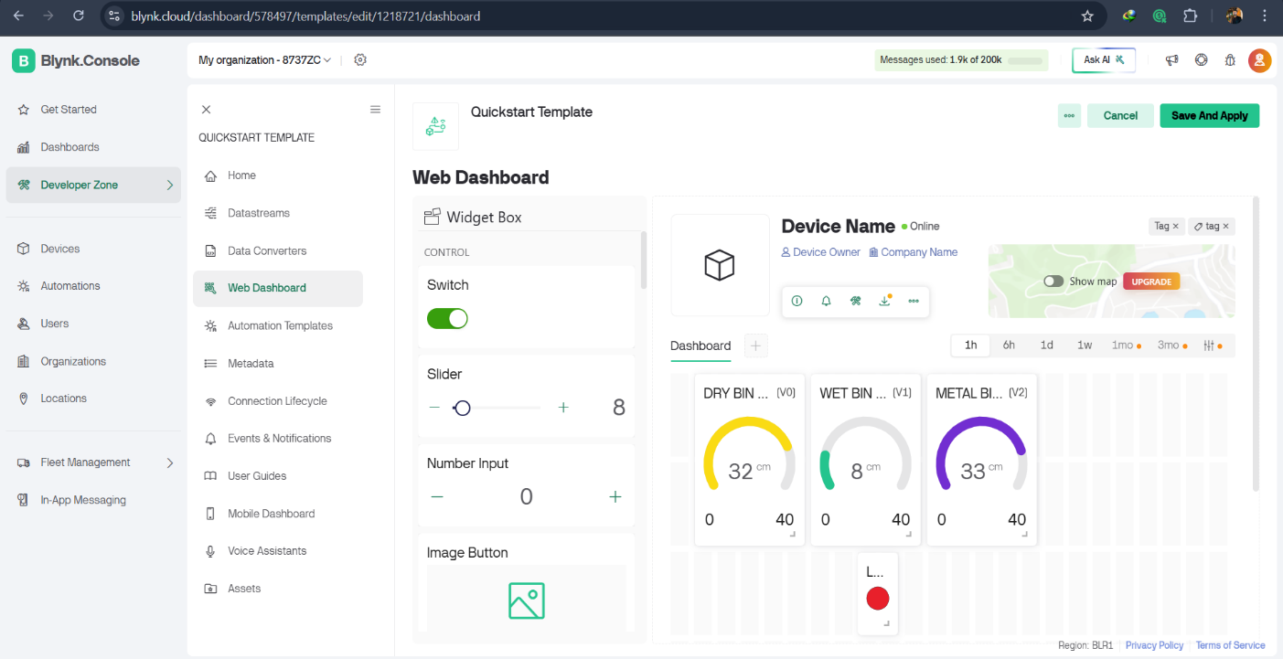

Figure-16Blynk IoT Platform
Used to display bin fill levels, system status, and alert notifications. When a bin becomes full, the ESP32 sends data to Blynk, which triggers an alert on the Authorities system.

3.5 Final Design:
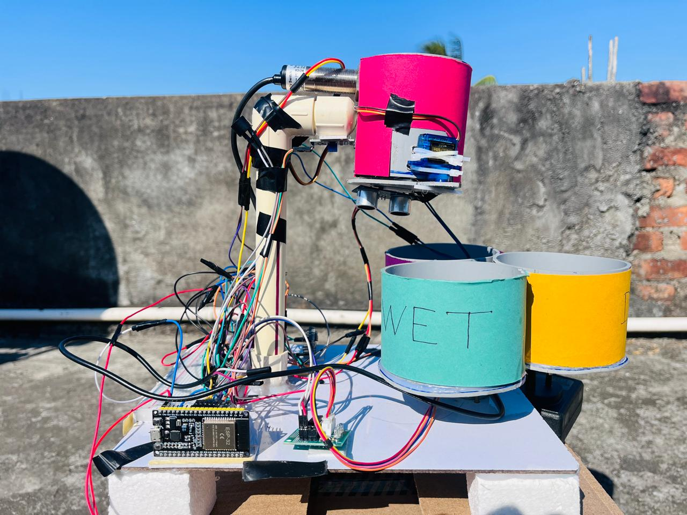
Figure-17: Prototype Model of Segregation waste (side view)

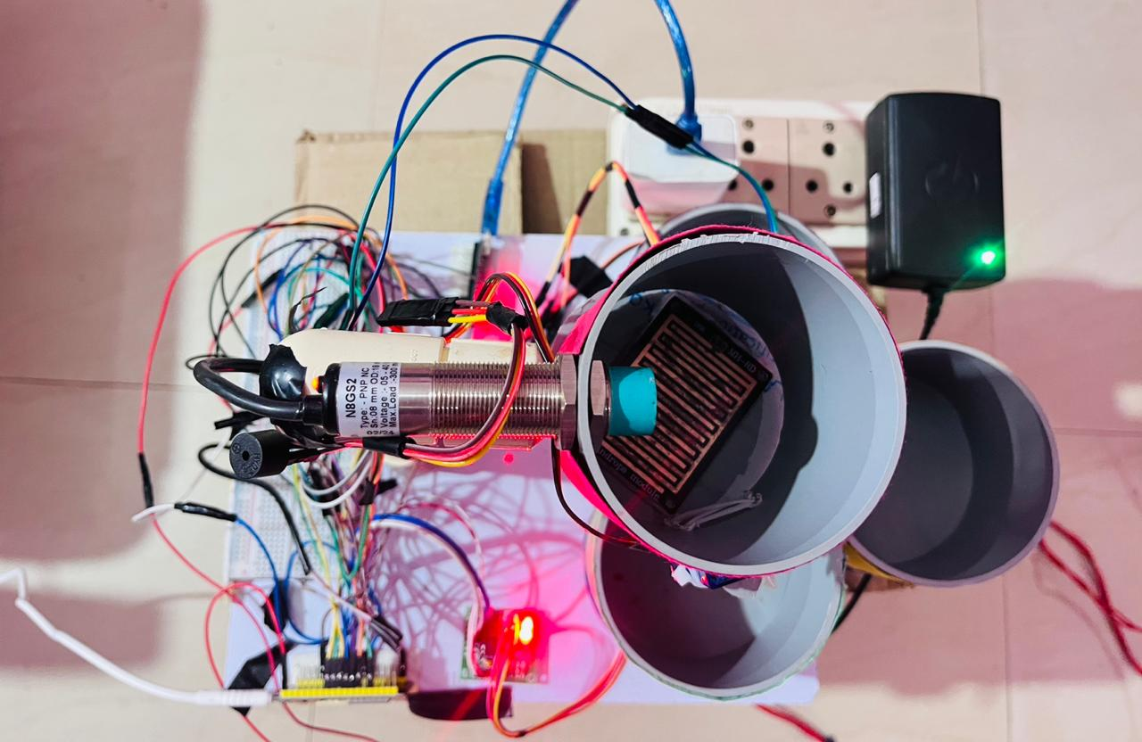
Figure-18 Prototype Model of Segregation waste(top view)
4. Experimental Setup
The experimental setup consists of a prototype IoT-based smart waste segregation and monitoring system developed in a controlled laboratory environment. The system integrates an ESP32 microcontroller, an IR sensor, an inductive metal sensor, a rain sensor, an ultrasonic sensor, a stepper motor with ULN2003 driver, a servo motor, and a buzzer to perform automated segregation and monitoring tasks.
As shown in the figure-17&18, three physically separated bins were arranged to represent dry, wet, and metallic waste categories. The ultrasonic sensor was fixed beneath the waste inlet to measure bin fill levels, while a stepper motor was used to sequentially rotate the bins beneath the inlet for level measurement and waste placement.
The ESP32 was programmed using the Arduino IDE and connected to a Wi-Fi network to enable IoT communication. Waste level data and alert notifications were transmitted to the Blynk IoT platform, allowing real-time visualisation of bin status and overflow alerts.
The system was tested using real waste samples such as paper, plastic, metal objects, and wet waste (vegetables). Each waste type was introduced individually to evaluate detection accuracy and system response. Bin-level monitoring was tested by gradually filling bins and observing ultrasonic sensor readings and corresponding dashboard updates.
Multiple test cycles were performed to validate reliability, mechanical alignment, and IoT communication latency.

5. Results and Discussion
The developed IoT-based smart waste segregation and monitoring system was experimentally evaluated using different categories of waste, including dry (paper), wet (organic waste), and metallic objects. The system successfully performed automatic segregation and real-time monitoring under laboratory conditions as described below.
5.1 Waste Segregation Performance
The IR sensor accurately detected the presence of dry waste, while the inductive proximity sensor reliably identified metallic objects. The rain sensor effectively detected moisture content, enabling proper identification of wet waste. Based on sensor inputs, the ESP32 controlled the stepper motor to align the correct bin and activated the servo motor to open the inlet flap. The segregation accuracy was observed to be approximately 95–98%, with occasional delays in wet waste detection due to residual moisture on the sensor surface.
5.2 Bin Positioning and Actuation
The stepper motor, driven through the ULN2003 driver, provided precise and repeatable bin positioning. The servo motor demonstrated smooth and consistent operation for opening and closing the waste inlet flap. Mechanical alignment remained stable during repeated cycles, ensuring correct waste placement without misrouting.
5.3 Waste Level Monitoring
The ultrasonic sensor measured bin fill levels with high reliability, achieving an accuracy of approximately ±3 mm. The system classified bin status into empty, half-full, and full conditions. Periodic automated scanning enabled effective monitoring of all bins using a single ultrasonic sensor, reducing hardware complexity and cost.

5.4 IoT Monitoring and Alerts
Real-time bin level data were successfully transmitted to the Blynk IoT platform, where users could monitor system status remotely. Alerts were triggered when bins reached the predefined full threshold, ensuring timely waste collection. Data synchronisation delays were minimal (typically 2–3 seconds), demonstrating stable IoT performance.
5.5 Overall System Evaluation
The experimental results confirm that the proposed system provides a low-cost, efficient, and scalable solution for automated waste segregation and monitoring. While sensor-based detection proved reliable, environmental factors such as moisture accumulation slightly affected wet waste detection, highlighting areas for improvement.
6. Future Enhancements
In future developments, the system can be enhanced to improve accuracy, scalability, and sustainability. Individual ultrasonic sensors can be installed for each bin to enable simultaneous level monitoring. Solar power integration with rechargeable batteries can make the system energy-efficient and suitable for outdoor deployment. Advanced AI-based image processing can be incorporated for improved waste classification, especially for mixed or complex waste types. Mobile push notifications can further enhance user awareness and system responsiveness. The system can also be integrated with centralised municipal dashboards to support smart-city waste management and optimisedcollection routes. Additionally, a weather-resistant enclosure and automated flap-cleaning mechanism can be implemented to improve durability and hygiene.
7. Conclusion
This paper presented an IoT-Based Smart Waste Segregation and Monitoring System designed to automate waste handling and improve efficiency and hygienein waste management. The system successfully segregates waste into dry, wet, and metallic categories using IR, rain, and metal sensors, controlled by an ESP32 microcontroller. A stepper motor ensures accurate bin positioning, while a servo motor controls the waste inlet flap.
An ultrasonic sensor is used to monitor bin fill levels, and the collected data is transmitted to the Blynk IoT platform for real-time monitoring and alerts when bins become full. Experimental results show reliable waste detection, accurate motor operation, and effective IoT-based monitoring with minimal human intervention.
The developed prototype demonstrates a cost-effective, compact, and scalable solution suitable for smart homes and institutional environments. With further enhancements such as AI-based waste classification and renewable energy integration, the system can be extended for large-scale smart city applications.
COMPETING INTERESTS DISCLAIMER:
Authors have declared that they have no known competing financial interests OR non-financial interests OR personal relationships that could have appeared to influence the work reported in this paper.

Disclaimer (Artificial intelligence)
Author(s) hereby declare that NO generative AI technologies such as Large Language Models (ChatGPT, COPILOT, etc.) and text-to-image generators have been used during the writing or editing of this manuscript.

8. References
[1]. L.M. Pires, J. Figueiredo, R. Martins and J. Martins (2025). “IoT-Enabled Real-Time Monitoring of Urban Garbage Levels Using Time-of-Flight Sensing Technology.” Sensors, 25(7), 2152. DOI: 10.3390/s25072152
[2]. Abhishek KadalagereLingaraju, MudligiriyappaNiranjanamurthy, Priyanka Bose, Biswaranjan Acharya, Vassilis C. Gerogiannis, Andreas Kanavos and Stella Manika (2023). “IoT-Based Waste Segregation with Location Tracking and Air Quality Monitoring for Smart Cities”.
[3]. A. Ali et al. (2023). “IoT Based Smart Trash Bin for Solid Waste Management.” IJRAR Journal, Vol. 9 (2).
[4]. Tariq Ali, Muhammad Irfan, A. Saeed Alwadie, A. Glowacz et al. (2023). “IoT Enabled Waste Management in Smart Cities.” The Science and Information Organization (THESAI).
[5]. AtharvDahale, Sayali Kadus, Vaishnavi Shinde, Gayatri Ajabe and Nita Gade (2023). “IoT Based Waste Segregation Using Deep Learning.” International Journal of Current Science (IJCSPUB), Vol. 13 (4).
[6]. L. Megalan Leo., S. Yogalakshmi., A. JerrinSimla., R. T. Prabu, P. Sathish Kumar and G. Sajiv (2022). "An IoT Based Automatic Waste Segregation and Monitoring System, “Second International Conference on Artificial Intelligence and Smart Energy (ICAIS), Coimbatore, India, 2022, pp. 1262-1267, doi: 10.1109/ICAIS53314.2022.9742926.
[7]. K. Jaikumar, T. Brindha, T. K. Deepalakshmi and S. Gomathi (2020). "IOT Assisted MQTT for Segregation and Monitoring of Waste for Smart Cities," 6th International Conference on Advanced Computing and Communication Systems (ICACCS), Coimbatore, India, 2020, pp. 887-891, doi: 10.1109/ICACCS48705.2020.9074399.
[8]. K.O. Mohammed Aarif, Caffiyar Mohamed Yousuff, B.A. Mohammed Hashim, C. Mohamed Hashim, P. Sivakumar (2020). “Smart bin: Waste segregation system using deep learning-Internet of Things for sustainable smart cities”.
[9]. S. N., P. M. Fathimal, R. R. and K. Prakash (2019). "Smart Garbage Segregation & Management System Using Internet of Things (IoT) & Machine Learning (ML)," 1st International Conference on Innovations in Information and Communication Technology (ICIICT), Chennai, India, 2019, pp. 1-6, doi: 10.1109/ICIICT1.2019.8741443.
[10]. V. Sowndharya1, P. Savitha1, S. HebzibaJeba Rani (2019). “Smart Waste Segregation and Monitoring System using IoT”.

[11]Sangeeta Borkakoty, Dr.Atowar ul Islam, DevajNeogi, Nilotpal Deka, “An Automated Crop Monitoring And Irrigation System With Predictive AnalysisPeriódicoTchêQuímica,vol-21,2024, DOI:10.52571/PTQ.v21.n47.2024_03_ATOWAR_pg_24_41.pdf
[12]Priyanka Sarma, Dr.Atowar ul Islam, Tony Bayan,” Iot-Based Agriculture Environment And Security Monitoring System, PeriódicoTchêQuímica,vol.20,2023, 23 DOI: 10.52571/PTQ.v20.n44.2023_02_ATOWAR_pgs_15_31.pdf
[13] Ahmed, M. M., Hassanien, E., &Hassanien, A. E. (2023). IoT-based intelligent waste management system. Neural Computing and Applications, 35(32), 23551-23579.
[14] Chaudhari, M. S., Patil, B., & Raut, V. (2019, March). Iot based waste collection management system for smart cities: An overview. In 2019 3rd international conference on computing methodologies and communication (ICCMC) (pp. 802-805). IEEE. https://doi.org/10.1109/ICCMC.2019.8819776
[15] Gull, S., Bajwa, I. S., Anwar, W., & Rashid, R. (2021). Smart eNose food waste management system. Journal of Sensors, 2021(1), 9931228.
[16] Abdel-Shafy, H. I., & Mansour, M. S. (2018). Solid waste issue: Sources, composition, disposal, recycling, and valorization. Egyptian journal of petroleum, 27(4), 1275-1290.

