Original Research Article
Influence of Cement on the Pozzolanic Reactions of Ceramic Waste for the Stabilization of ferralitic Soil in Road Construction

Abstract:
This study investigates the influence of cement on the pozzolanic activation of pulverized ceramic waste (PCW) for the stabilization of ferralitic “Bar soil” from Tori-Dokanmey, Benin, for use in road construction. The soil, naturally rich in silica and alumina but poor in calcium, was combined with PCW (2.5–15%) and cement (1–3%) to develop 18 stabilized formulations. A comprehensive experimental program was conducted to evaluate the geotechnical and mechanical behavior of the mixtures, including compaction characteristics, unconfined compressive strength (Rc), flexural tensile strength (Rt), and stiffness parameters (E₅₀, Eₛₜ). Results show that the addition of PCW alone enhances soil density and bearing capacity through gradual pozzolanic reactions forming C–S–H and C–A–H gels, though strength development remains slow at early ages. The incorporation of small amounts of cement significantly accelerates these reactions, producing early strength gains and denser microstructures. Optimal performance was obtained for the mixture containing 15% PCW and 3% cement, with Rc = 6.5 MPa and Rt = 2.8 MPa after 90 days. The simultaneous increase in E₅₀ and Eₛₜ confirms improved stiffness and load-bearing capacity, indicating the suitability of the stabilized material for pavement foundation layers. Overall, the synergistic use of cement and ceramic waste provides a sustainable and efficient approach for upgrading local ferralitic soils while promoting waste valorization in road infrastructure.
Keywords: pozzolanic, bar soil, pulverized ceramic waste, geotechnical, mechanical behavior

1. Introduction
Ferralitic soils, such as “Terre de Barre” in southern Benin, are widespread in tropical regions and constitute an abundant but geotechnically weak material. Their natural characteristics—high clay content, significant plasticity, and low bearing capacity—limit their direct use in road foundation layers. It is therefore essential to improve their physical and mechanical behavior using appropriate stabilization techniques in order to develop sustainable and cost-effective road infrastructure in tropical environments.
Previous research by Agbelele et al. (2025) has shown that lithostabilization using crushed granite aggregates significantly improves the geotechnical behavior of clayey soil, reducing its plasticity and increasing its bearing capacity, allowing it to be used in foundation and base layers in tropical climatic conditions. However, large-scale extraction and transportation of granite aggregates is not environmentally and economically viable due to their high carbon footprint and energy requirements. To address this limitation, Agbelele et al. (2025) investigated the use of pulverized ceramic waste as an alternative or complementary stabilizing material. The results revealed that fine ceramic particles, rich in silica and alumina, improved soil particle size distribution, compaction characteristics, and California Bearing Ratio (CBR), confirming their pozzolanic potential and beneficial micro-filler effect. In reinforced concrete applications, Özkılıç et al. (2024) demonstrated that the incorporation of ceramic waste powder (CWP) affects the structural performance of reinforced concrete beams, with reductions in load-carrying capacity and bending stiffness for replacement levels above 10%. Nevertheless, the authors concluded that CWP contents up to 10% constitute an economical and environmentally viable option, contributing to reduced CO₂ emissions and energy consumption. Their experimental findings were validated through analytical comparisons.
Building on these results, a subsequent study by Agbelele et al. (2025) combined crushed granite and ceramic waste to develop ternary mixtures that achieved mechanical performance equivalent to that of traditional formulations with high granite content, while reducing granite consumption by up to 64%. Combined stabilization demonstrated clear synergy between ceramic waste and granite, as the fine ceramic powder optimized particle settling and promoted secondary cementitious bonding within the soil matrix.
Despite these advances, the chemical and mechanical mechanisms underlying the performance improvement remain insufficiently characterized. In particular, the role of cement as a chemical activator of pozzolanic reactions in ceramic waste deserves further study. The introduction of small amounts of cement provides calcium and hydroxyl ions that accelerate the dissolution of amorphous silica and alumina in the ceramic powder, leading to the formation of cementitious compounds such as calcium silicate hydrates (C-S-H) and calcium aluminate hydrates (C-A-H). These products contribute to a denser and more cohesive soil matrix and improve the mechanical strength and long-term durability of the stabilized material.
The present study aims to evaluate the influence of cement on the pozzolanic activation of ceramic waste for the stabilization of barren soil in road construction applications. Beyond the physical and chemical characterization of the stabilized mixtures, a detailed experimental program was implemented to determine the key mechanical parameters of the developed composites. These include compressive strength, flexural strength, and estimation of the static modulus of elasticity, which provide information on the stiffness and deformation behavior of the cement-ceramic-soil system. Through a combined analysis of physical, mechanical, and microstructural properties, the study aims to elucidate the mechanisms of cement-induced activation, optimize the formulation of ferralitic soil stabilization mixtures, and propose a durable, high-performance material suitable for foundations and pavement base layers in tropical regions.
2- Materials and methods
2-1 Materials
2-1-1 Bar soil
The soil sample from the bar that is the subject of our study comes from Tori-Dokanmey, a locality located in the municipality of Tori-Bossito, in southern Benin. Tori-Bossito is located in the Atlantic Department, approximately 40 kilometers northwest of Cotonou. Geographically, the municipality is bordered by Allada to the north, Ouidah to the south, Zè and Abomey-Calavi to the east, and Kpomassè to the west. It is located between latitudes 6°25' and 6°37' N and longitudes 2°01' and 2°17' E.
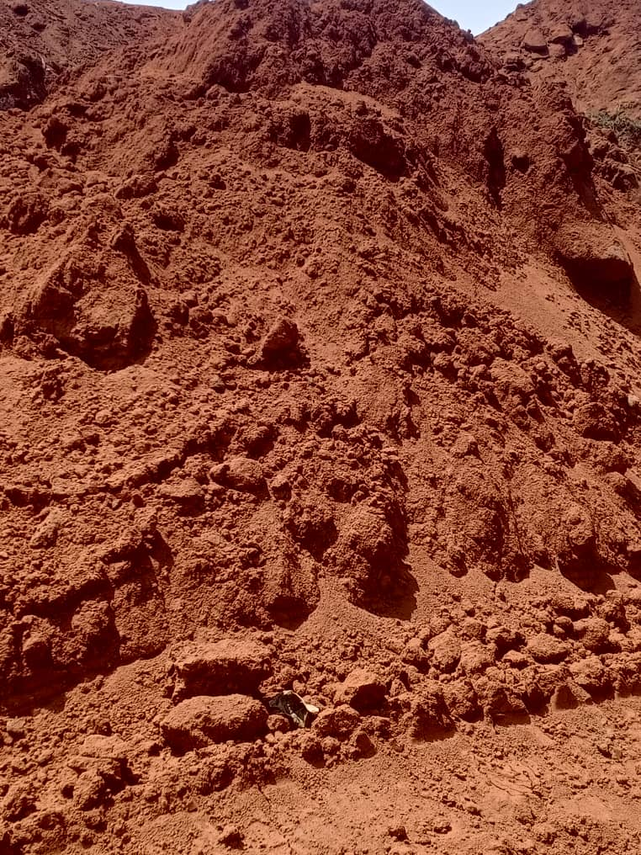

Fig. 1: Bar soil
The chemical analysis of the ferralitic soil, locally known as “terre de barre,” indicates a predominance of silicon dioxide (SiO₂: 62%) and aluminum oxide (Al₂O₃: 24%), with smaller amounts of iron oxide (Fe₂O₃: 2%), potassium oxide (K₂O: 1%), sodium oxide (Na₂O: 0.5%), calcium oxide (CaO: 0.3%), and magnesium oxide (MgO: 0.2%). The soil also contains approximately 10% structural water (H₂O). This composition is characteristic of highly weathered tropical soils, where intense leaching reduces the natural calcium content and enriches the clay fraction in silica and alumina. The high SiO₂/Al₂O₃ ratio (~2.6) confirms a kaolinitic nature, which imparts plasticity but limits natural cementation, making the soil relatively weak in terms of mechanical performance if untreated.
Despite its low inherent cementitious potential, the silica and alumina content of terre de barre provides a favorable basis for stabilization via pozzolanic reactions. When combined with cement or other calcium sources, the reactive silica and alumina can interact with calcium hydroxide to form calcium silicate hydrate (C–S–H) and calcium aluminate hydrate (C–A–H) phases, which densify the microstructure and improve compressive strength. The minor iron oxide content contributes to the formation of calcium alumino-ferrite phases (C₄AF) during cement hydration, slightly enhancing the binding capacity. Overall, the chemical characteristics of terre de barre justify its activation with cementitious materials to develop mechanically stable and durable composites suitable for road construction applications.
The results confirmed that the untreated soil has low bearing capacity and moderate plasticity, requiring stabilization to meet the technical specifications required for use in road construction.
Table 1.
Geotechnical properties of the bar soil (sandy clayey soil) used in this study
sandy clayey soil |  | Value | Standard deviation
Particle Size Distribution Analysis | Dmax (mm) | 2 | 0
Particle Size Distribution Analysis | 2 mm (%) | 100 | 0
Particle Size Distribution Analysis | 0.08 mm (%) | 48 | 1
Atterberg limits | WL | 54 | 1.01
Atterberg limits | WP | 32 | 1.73
Atterberg limits | IP | 22 | 2.3
Methylene blue value | VBS | 1 | 0.01
Dry density | yd (T/m3) | 1.9 | 0.26
Optimal water content | ωopt (%) | 12.1 | 0.06
Maximum dry density | ydmax (T/m3) | 2 | 0.1
CBR index(ICBR) after 96 hours of soaking | 95% Opt | 23 | 1.53
CBR index(ICBR) after 96 hours of soaking | 100% Opt | 41 | 1.52

Table 2
Chemical composition of bar soil
Oxide | SiO₂ | Al₂O₃ | Fe₂O₃ | K₂O | Na₂O | CaO | MgO | H₂O structural
Estimated proportion (%) | 62 | 24 | 2 | 1 | 0.5 | 0.3 | 0.2 | 10

2-1-2 Ceramic waste
The ceramic waste (Fig. 2(a)) used in this study was prepared through a controlled, multi-stage pulverization process. Initially, broken ceramic tile residues were collected from construction sites and waste disposal areas, followed by a sorting phase to eliminate non-ceramic impurities and retain only clean, homogeneous fragments. These fragments were first crushed using a jaw crusher to reduce them to medium-sized particles. Subsequently, the material was finely pulverized using a hammer mill. The resulting powder was then sieved through a 0.08 mm mesh to isolate the fine fraction suitable for the experiments. Coarser particles retained on the sieve were reintroduced into the milling process to ensure uniform granulometry and consistency of the final product (Fig. 2(b)).

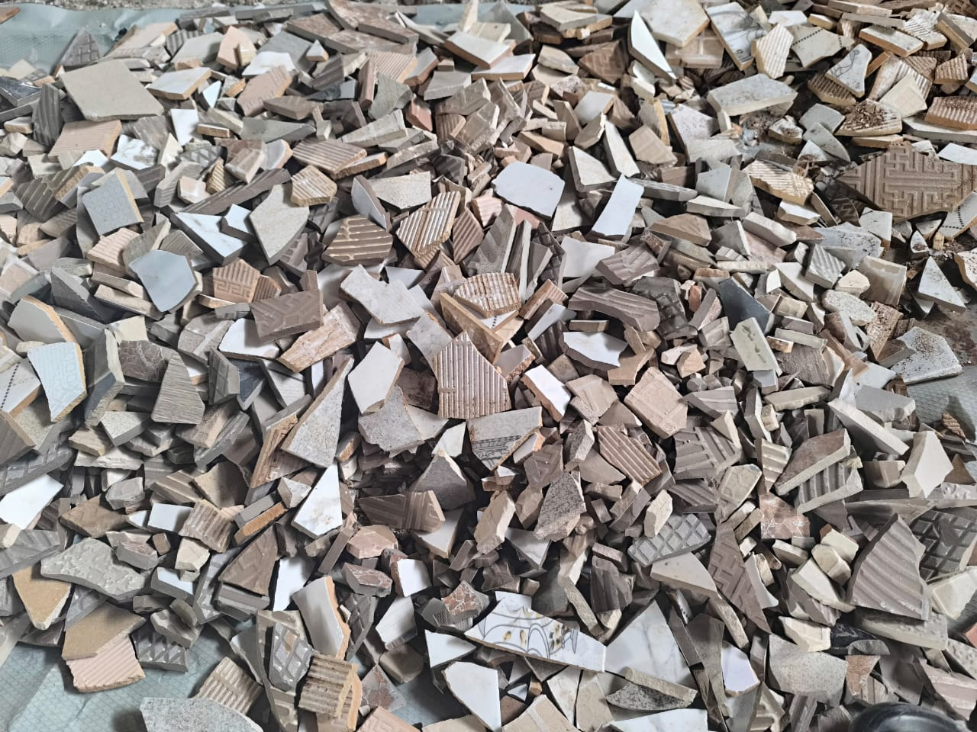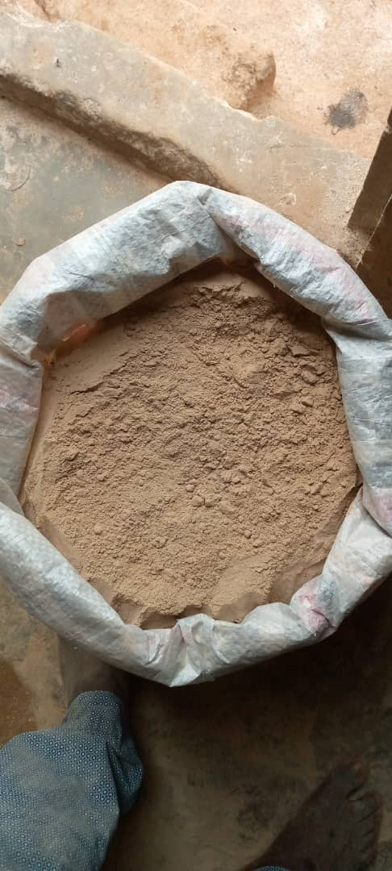
(a) Ceramic waste (b) Pulverized ceramic waste
Fig. 2: Ceramic waste
The chemical composition of the pulverized ceramic waste (Table 3) is dominated by silicon dioxide (SiO₂: 70%) and aluminum oxide (Al₂O₃: 20%), with minor contents of Fe₂O₃ (2%), K₂O (3%), Na₂O (2%), CaO (1.2%), and MgO (0.8%). This silico-aluminous profile indicates a high pozzolanic potential, as the amorphous silica and alumina can react with calcium hydroxide released by cement hydration to form calcium silicate hydrates (C–S–H) and calcium aluminate hydrates (C–A–H), which enhance the strength and durability of the stabilized soil. The low natural calcium content confirms that the material is not self-cementitious and relies on external alkaline activation.
Minor oxides such as K₂O and Na₂O can increase the alkalinity of the pore solution, accelerating the dissolution of silica and alumina and improving the kinetics of pozzolanic reactions, while Fe₂O₃ may participate marginally in forming calcium alumino-ferrite phases (C₄AF). Overall, the chemical composition demonstrates that pulverized ceramic waste is a suitable pozzolanic additive for enhancing the mechanical performance of clay-rich soils such as ferralitic “terre de barre,” offering a sustainable route for road construction stabilization through the valorization of local ceramic residues.
Table 3
Chemical composition of pulverized ceramic waste
Oxide | SiO₂ | Al₂O₃ | Fe₂O₃ | K₂O | Na₂O | CaO | MgO
Estimated (%) | 70 | 20 | 2 | 3 | 2 | 1.2 | 0.8

2-2-1 Sampling method
Samples of ferralitic soil, known locally as “barre soil,” were collected in accordance with French standard XP P94-202:1995. The soil was extracted approximately 1.2 m from the natural ground level of the study area. After sampling, the material was air-dried under laboratory conditions to remove natural moisture, then manually disaggregated and sieved to obtain a homogeneous soil fraction suitable for stabilization. Pulverized ceramic waste (PCW) was obtained by grinding and sieving (mainly broken tiles) until a fine powder passing through an 80 µm sieve was obtained. Commercial Portland cement (CEM II 42.5 R) was used as the activating binder. All materials were stored in airtight containers to prevent any variation in humidity prior to testing.
    - Formulation Method
The formulation of the soil–cement–ceramic mixtures followed a structured seven-step procedure to ensure the reproducibility and uniformity of samples prepared for laboratory testing.
- Drying: Both the ferralitic soil and pulverized ceramic waste were oven-dried at 50 °C for two hours or air-dried at room temperature until constant mass was reached.
- Mix Design: Experimental mixtures were prepared by combining the ferralitic soil (BS) with 2.5%, 5%, 7.5%, 10%, 12.5%, and 15% of PCW, each stabilized with 1%, 2%, or 3% of cement (C) by dry mass of soil. This led to the development of 18 distinct formulations (M1–M18), as summarized in Table 4.
The mixtures of ferralitic Bar soil were prepared by incorporating pulverized ceramic waste (PCW) and cement in varying proportions, guided by previous research on soil stabilization and sustainable construction materials. The PCW contents ranged from 2.5% to 15% by weight, while cement was added at 1% to 3%. These percentages were selected based on evidence that low to moderate PCW additions can enhance geotechnical properties without compromising workability. For instance, Af Cabalar (2016) reported an 8–14% increase in California Bearing Ratio (CBR) of low-plasticity clay soils with ceramic tile waste, while Adeyemi O. Adeboje (2020) found that 12.5% PCW effectively stabilizes lateritic soils for pavement foundation layers. Sondarva et al. (2022) and Lim et al. (2022) demonstrated that PCW as a partial cement replacement increases splitting tensile strength (5–25%) and compressive strength (4–18%). More recently, Saber et al. (2022), Rathore et al. (2023), and Nanda et al. (2024) confirmed that incorporating 5–20% PCW improves CBR, Rc, and Rt, promoting the use of stabilized clay soils in subgrade and pavement layers. Based on these findings, the present study developed 18 stabilized formulations to systematically evaluate the synergistic effects of PCW and cement on compaction, mechanical strength, and stiffness of the ferralitic Bar soil.

Table 4. Experimental formulations of bar soil with pulverized ceramic waste and cement

Mixtures | Different mixing ratios
M1 | BS + 2.5% PCW + 1% C
M2 | BS + 2.5% PCW + 2% C
M3 | BS + 2.5% PCW + 3% C
M4 | BS + 5% PCW + 1% C
M5 | BS + 5% PCW + 2% C
M6 | BS + 5% PCW + 3% C
M7 | BS + 7.5% PCW + 1% C
M8 | BS + 7.5% PCW + 2% C
M9 | BS + 7.5% PCW + 3% C
M10 | BS + 10% PCW + 1% C
M11 | BS + 10% PCW + 2% C
M12 | BS + 10% PCW + 3% C
M13 | BS + 12.5% PCW + 1% C
M14 | BS + 12.5% PCW + 2% C
M15 | BS + 12.5% PCW + 3% C
M16 | BS + 15% PCW + 1% C
M17 | BS + 15% PCW + 2% C
M18 | BS + 15% PCW + 3% C

BS : Bar Soil; C : Cement; PCW : Pulverized ceramic waste
- Batch Calculation: The exact quantities of each component were determined for the required sample mass used in each geotechnical and mechanical test.
- Moisture Content Determination: The optimum moisture content (OMC) for each mixture was determined using modified Proctor tests to ensure adequate compaction and hydration conditions.
- Sample Preparation: The predetermined quantities of soil, PCW, and cement were thoroughly mixed to produce uniform blends for the laboratory tests (compaction, strength, and durability).
- Homogenization: Manual mixing was adopted to ensure uniform distribution of materials and to avoid any alteration of particle size distribution that might occur during mechanical mixing.
- Storage: The prepared mixtures were sealed in airtight polyethylene bags to maintain consistent moisture levels before compaction and testing, minimizing environmental variability.
2-2-3 Geotechnical Testing Protocols
A comprehensive geotechnical testing program was conducted in accordance with French and international standards to characterize both the natural bar soil and its stabilized formulations. The procedure began with the collection of representative samples from the Tori-Dokanmey site, followed by air-drying, crushing, and sieving to obtain homogeneous fractions suitable for laboratory analysis.
The testing sequence covered the determination of the soil’s physical and mechanical characteristics before and after stabilization. The particle size distribution was determined according to NF EN ISO 17892-4 using dry sieving and sedimentation. The natural water content was measured following NF EN ISO 17892-1, while the methylene blue value (NF P 94-068) provided information on clay activity and fines quality. The Atterberg limits were assessed using the Casagrande and rolled wire methods in accordance with NF EN ISO 17892-12, and the apparent density was determined following NF EN ISO 17892-2. Compaction behavior was analyzed through Standard and Modified Proctor tests (NF EN 13286-2), and the California Bearing Ratio (CBR) was obtained under both immediate and soaked conditions according to NF EN 13286-47. These tests were systematically performed on both the untreated bar soil and the stabilized mixtures (bar soil + cement + pulverized ceramic waste), providing the basis for assessing the effectiveness of the stabilization in improving the geotechnical performance of the material for road applications.

2.2.4. Determination of mechanical parameters (compressive strength, flexural strength) and estimation of secant and static modulus
The test specimens were prepared from mixtures of Bar soil (TB), pulverized ceramic waste (PCW), and cement (C), according to the formulations previously defined. After air drying, the materials were manually homogenized to ensure uniform distribution of binders and fine reactive particles. The optimum water content and maximum dry density were determined using the Modified Proctor method (NF EN 13286-2), which provides the most representative compaction energy for road foundation materials. Compaction was carried out using a 25 kg rammer dropped from a height of 30 cm, delivering a unit energy of 73.6 J per blow. Each specimen was compacted in three layers with an equal number of blows per layer, reproducing a total compaction energy equivalent to the Modified Proctor test (~2575 J). This protocol ensures a uniform density representative of field compaction conditions for stabilized road materials.
The mixtures were molded into 4 × 4 × 16 cm prisms (EN 1015-11), compacted layer by layer, demolded after 24 hours, and cured in a humid chamber at (20 ± 2) °C with a relative humidity above 95%. Curing durations of 7, 28, and 90 days were used, but the discussion focuses primarily on 28-day results, which are considered representative of the in-service mechanical performance of stabilized soils in road applications.
Mechanical testing included:
• Unconfined compressive strength (Rc), determined on half-prisms (4 × 4 × 8 cm) according to EN 13286-41;
• Flexural tensile strength (Rt), measured on full prisms (4 × 4 × 16 cm) in accordance with EN 1015-11;
• Secant modulus of elasticity (E₅₀) and static modulus (Eₛₜ), both estimated from empirical correlations with Rc.
Numerous studies have examined the relationship between E₅₀ and unconfined compressive strength (qᵤ) or (UCS), revealing that stiffness increases nonlinearly with strength. Topolnicki (2018) reported that the E₅₀/UCS ratio varies from 50–300 for UCS < 2.0 MPa and 300–1000 for UCS > 2.0 MPa. Similar ranges have been reported by Terashi et al. (1980) [E₅₀ = (75–1000) qᵤ], Baker (2000) [E₅₀ = (50–180) qᵤ], and Bruce (2000) [E₅₀ = (100–500) qᵤ]. Later, Masaki & Terashi (2013) confirmed the interval E₅₀ = (350–1000) qᵤ, while Filz & Navin (2006) proposed an average design value of E₅₀ = 300 qᵤ.
In this study, the empirical relationship proposed by Bruce et al. (2013) was adopted, namely E₅₀ = 120 × UCS for UCS < 1.0 MPa and E₅₀ = 380 × UCS for UCS > 1.0 MPa. This formulation aligns closely with the correlation obtained by Bouchemella & Taibi (2022) for unsaturated compacted clay–sand mixtures (E₅₀ = 156.73 × qᵤ, R² = 0.9512), particularly for low-strength ranges (qᵤ < 1 MPa). The close agreement between both correlations supports the use of Bouchemella & Taibi’s expression as a realistic estimate of E₅₀ for the stabilized Bar soil mixtures studied here.
To estimate the static modulus (Eₛₜ), representing the long-term deformation behavior, the empirical relationship proposed by CEBTP (1984) was used:
Est=(1000–2000) Rc7
The lower bound (≈ 1000 × R₍c7₎) corresponds to highly plastic soils with greater deformability, while the upper bound (≈ 2000 × R₍c7₎) applies to more granular, low-plasticity materials exhibiting higher stiffness. This range provides a rational framework linking early-age compressive strength (7 days) to long-term stiffness. For the mixtures studied—composed of moderately plastic Bar soil blended with granular and pozzolanic additives—an intermediate value (≈ 1500 × R₍c7₎) was considered representative.
Overall, this methodological approach enables the consistent estimation of both the instantaneous stiffness (E₅₀) and the long-term modulus (Eₛₜ), thus providing a comprehensive understanding of the mechanical response of stabilized materials under load, representative of road foundation conditions.
The figure below (Fig. 3) illustrates the different stages of the experimental process: sample preparation (Fig. 3a), the rammer used for compaction (Fig. 3b), the compaction process of the specimens (Fig. 3c), the sealing of the specimens in plastic bags before curing to avoid moisture variations (Fig. 3d), the unconfined compression test (Fig. 3e), and the flexural tensile strength (Fig. 3f).

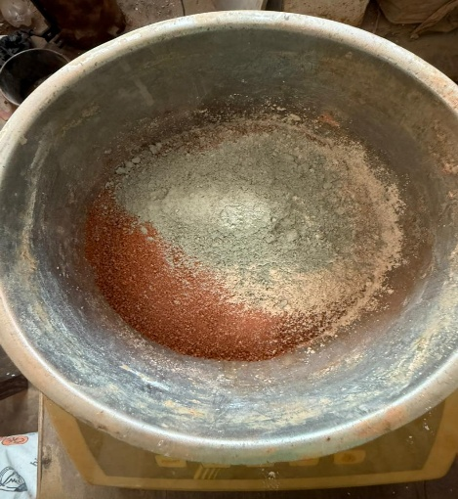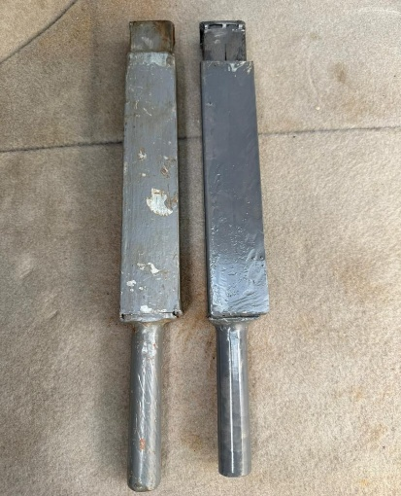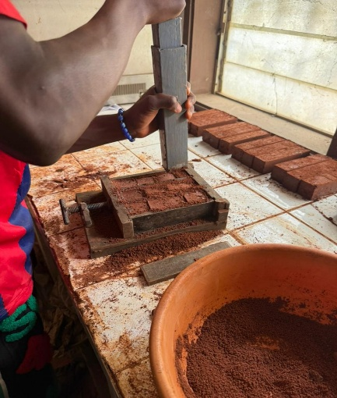
(c): compaction process of the specimens
(b): rammer used for compaction
(a): sample preparation

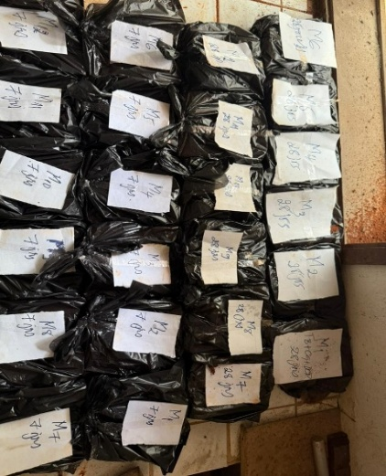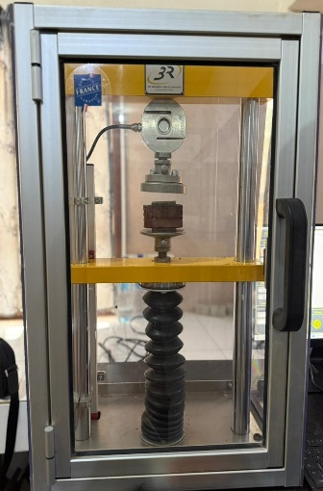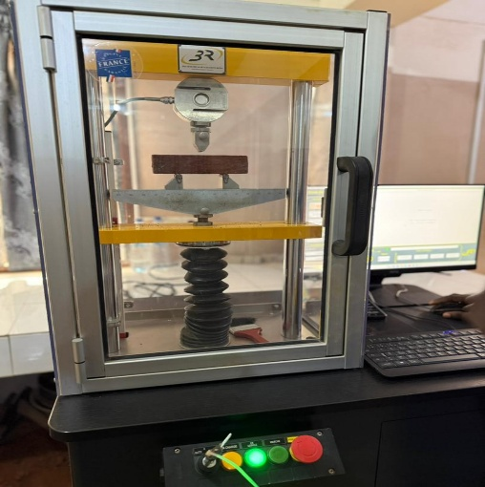
(e): unconfined compression test
(f): flexural tensile strength

(d): sealing of the specimens in plastic bags before curing to avoid moisture variations

Fig. 3. Experimental process for specimen preparation and mechanical testing: (a) preparation of Bar soil–ceramic waste–cement mixtures; (b) rammer used for compaction; (c) specimen compaction process; (d) sealing of specimens in plastic bags before curing to prevent moisture variations; (e) the unconfined compression test ; (f) the flexural tensile strength on 4 × 4 × 16 cm prisms.

3- Results &Discussion
3-1 Geotechnical Characterization of Bar Soil treated with pulverized ceramic waste (PCW)
The following table (Table 5) summarizes the key geotechnical and mechanical properties of the Bar soil–ceramic waste mixtures (BS + PCW).
These results are used as reference values to assess the effect of cement incorporation on the mechanical improvement and stiffness evolution of the composite material (Agbelele, C.R.T et al., 2025)
Table 5:
Summary of geotechnical properties of treated sandy-clayey soil compared to CEBTP sub-base requirements (1984 and 2019 editions)
PCW rate | Passing to 80 µm [%] |  | ɣd OPM [T/m³] |  | Wopm [%] |  | IP [%] |  | ICBR à 95% OPM [%] |  | Swelling |  | Comment
 | obtained | desired | obtained | desired | obtained | desired | obtained | desired | obtained | desired | obtained | desired
- 0.0% | 48 | 10 à 30 % | 2 | 1.9 à 2.1 | 12.1 | 7 à 13% | 22 | 5 à 20 | 23 | ≥30 (25 pr T1 et 35 pr T4 and T5) | 0.17 | 2.50% | unfit
- 2.5% | 35 | 10 à 30 % | 2.03 | 1.9 à 2.1 | 11 | 7 à 13% | 18.4 | 5 à 20 | 24 | ≥30 (25 pr T1 et 35 pr T4 and T5) | 0.26 | 2.50% | unfit
- 5% | 32 | 10 à 30 % | 2.06 | 1.9 à 2.1 | 10.9 | 7 à 13% | 18.3 | 5 à 20 | 30 | ≥30 (25 pr T1 et 35 pr T4 and T5) | 0.2 | 2.50% | unfit
- 7.5% | 28 | 10 à 30 % | 2.08 | 1.9 à 2.1 | 10.1 | 7 à 13% | 18 | 5 à 20 | 34 | ≥30 (25 pr T1 et 35 pr T4 and T5) | 0.19 | 2.50% | suitable
- 10% | 28 | 10 à 30 % | 2.09 | 1.9 à 2.1 | 10.1 | 7 à 13% | 13.4 | 5 à 20 | 37 | ≥30 (25 pr T1 et 35 pr T4 and T5) | 0.19 | 2.50% | suitable
- 12.5% | 27 | 10 à 30 % | 2.1 | 1.9 à 2.1 | 10 | 7 à 13% | 13 | 5 à 20 | 42 | ≥30 (25 pr T1 et 35 pr T4 and T5) | 0.18 | 2.50% | suitable
- 15% | 27 | 10 à 30 % | 2.1 | 1.9 à 2.1 | 10.1 | 7 à 13% | 14.3 | 5 à 20 | 48 | ≥30 (25 pr T1 et 35 pr T4 and T5) | 0.19 | 2.50% | suitable

3-2 Influence of Cement on the Geotechnical and Mechanical Behavior of Bar Soil–Ceramic Waste Mixtures
The following table 6 summarizes the geotechnical and mechanical results obtained for the stabilized mixtures composed of Bar soil, pulverized ceramic waste, and cement (BS + PCW + C). These results are compared with those of the reference mixtures (BS + PCW) in order to highlight the influence of cement addition on the compaction characteristics, strength development, and stiffness evolution of the materials.
The observed variations are primarily attributed to pozzolanic reactions between the reactive silica and alumina contained in the ceramic waste and the hydration products of cement. These reactions promote the formation of additional calcium silicate hydrates (C–S–H) and calcium aluminate hydrates (C–A–H), resulting in a denser and more cohesive microstructure that enhances the overall mechanical performance of the mixtures.
Table 6
Summary of geotechnical and mechanical results for Bar soil–ceramic waste–cement (BS + PCW + C) mixtures.
Mixtures |  | Passing to 80 µm (%) | γd OPM (T/m3) | Wopm (%) | WL | IP | ICBR 95 (%) | Fondation layer | Base layer
M1 |  | 34.5 | 2.03 | 10.8 | 38.9 | 17.9 | 27 | ❌unfit | ❌
M2 |  | 34 | 2.04 | 10.7 | 38.25 | 17.4 | 29 | ❌ unfit | ❌
M3 |  | 33.5 | 2.04 | 10.6 | 37.6 | 16.9 | 32 | ❌ unfit | ❌
M4 |  | 31.5 | 2.04 | 10.65 | 37.82 | 17.27 | 32 | ❌ unfit | ❌
M5 |  | 30 | 2.05 | 10.55 | 37.17 | 16.77 | 35 | ✅ suitable | ❌
M6 |  | 30 | 2.05 | 10.45 | 36.52 | 16.27 | 38 | ✅ suitable | ❌
M7 |  | 27.5 | 2.05 | 10.5 | 36.75 | 16.65 | 38 | ✅ suitable | ❌
M8 |  | 27 | 2.06 | 10.4 | 36.1 | 16.15 | 41 | ✅ suitable | ❌
M9 |  | 26.5 | 2.06 | 10.3 | 35.45 | 15.65 | 44 | ✅ suitable | ❌
M10 |  | 27.5 | 2.06 | 10.35 | 35.67 | 16.02 | 43 | ✅ suitable | ❌
M11 |  | 27 | 2.07 | 10.25 | 35.02 | 15.52 | 47 | ✅ suitable | ❌
M12 |  | 26.5 | 2.07 | 10.15 | 34.37 | 15.02 | 50 | ✅ suitable | ❌
M13 |  | 26.5 | 2.07 | 10.2 | 34.6 | 15.4 | 49 | ✅ suitable | ❌
M14 |  | 26 | 2.08 | 10.1 | 33.95 | 14.9 | 53 | ✅ suitable | ❌
M15 |  | 25.5 | 2.08 | 10 | 33.3 | 14.4 | 57 | ✅ suitable | ❌
M16 |  | 26.5 | 2.08 | 10.05 | 33.52 | 14.77 | 54 | ✅ suitable | ❌
M17 |  | 26 | 2.09 | 9.95 | 32.87 | 14.27 | 58 | ✅ suitable | ❌
M18 |  | 25.5 | 2.09 | 9.85 | 32.22 | 13.77 | 63 | ✅ suitable | ✅ T1
CEBTP 1984 revised 2019 | Fondation layer | 10 à 30 % | 1.9 à 2.1 | 7 à 13 % | ˂ 50 | 5 à 20 | ≥30 (25 pr T1 et 35 pr T4 and T5) |  | - | -
 | Base layer | ˂ 20 % | ≤ 2 | - | ˂ 35 | ˂ 15 | ≥80(60 pr T1) |  | - | -

γd OPM : Optimum Dry Density (ODD); Wopm : Optimum Moisture Content (OMC); WL : Liquid Limit (LL); IP : Plasticity Index (PI); ICBR 95 (%) : California Bearing Ratio at 95% Modified Proctor Density (CBR95)
3-3. Evaluation of Tensile Behavior under Three-Point Bending
The comparative analysis of the flexural tensile strength (Rt) between the bar soil + pulverized ceramic waste (BS + PCW) mixtures (fig.4) and those additionally containing cement (fig.5) reveals a significant improvement in mechanical performance over time and across mixture compositions.
As illustrated in the figures above, the Rt of mixtures without cement slightly decreases with increasing PCW content at 7 days, indicating a low early pozzolanic reactivity. This initial reduction is mainly attributed to the partial substitution of the clay fraction of the bar soil by inert ceramic particles, which temporarily weakens intergranular bonding. However, at 28 and 90 days, Rt values increase substantially, reflecting the progressive formation of cementitious compounds such as C–S–H (calcium silicate hydrate) and C–A–H (calcium aluminate hydrate) through delayed pozzolanic reactions. These products enhance particle bonding and densify the granular matrix.
Conversely, the introduction of cement into the BS + PCW mixtures leads to a much more pronounced increase in strength. From 7 days onward, Rt values rise significantly due to the rapid activation of cement hydration reactions. This trend continues at 28 and 90 days, with an almost linear growth in tensile strength: 1.65 MPa at 7 days, 1.78 MPa at 28 days, and 2.80 MPa at 90 days for the M18 mixture, which exhibited the highest performance. This continuous improvement is attributed to the synergistic interaction between cement and ceramic waste, resulting in progressive matrix densification and improved intergranular cohesion.
Overall, the combined use of cement and ceramic waste optimizes both early and long-term tensile performance. Cement ensures rapid setting and early strength gain, while the delayed pozzolanic activity of PCW contributes to long-term consolidation. This synergistic behavior confirms the efficiency of the multi-technique stabilization approach in developing durable composite materials based on bar soil for sustainable road infrastructure applications.

Fig.4. Tensile strength development in untreated and ceramic waste–stabilized Bar soil mixtures at 7, 28, and 90 days.

Fig.5. Evolution of tensile strength (Rt) with combined ceramic waste and cement content in Bar soil mixtures after 7, 28, and 90 days of curing.
These findings are fully consistent with previous research on cementitious composites, which demonstrated that substituting 5–35% of cement with pulverized ceramic waste leads to a significant increase in tensile strength compared with control mixtures (Balaji et al., 2023; Bhargav and Kansal, 2020; El-Nadoury, 2022; Ganesh et al., 2018; Manogna and Srilakshmi, 2015; Tawfik et al., 2021; Xu et al., 2021; Irassar et al., 2014; Praseeda and Rao, 2021; Sharifi et al., 2020).
3-4. Effect of Cement and Ceramic Waste on the Compressive Strength of Stabilized Bar Soil
Figures 6 and 7 illustrate the evolution of the unconfined compressive strength (Rc) of barre soil stabilized with pulverized ceramic waste (PCW) alone and with PCW–cement mixtures (1–3%). Tests conducted at 7, 28, and 90 days assess the combined effects of curing and material synergy.
For mixtures containing only PCW (Figure 6), the compressive strength increases gradually with PCW content, peaking at 10–12.5%. Strengths range from 2.0–2.2 MPa at 7 days to 5.8–6.0 MPa at 90 days, showing a slow but steady gain due to the delayed pozzolanic activity of PCW. The amorphous SiO₂ and Al₂O₃ in PCW react with portlandite [Ca (OH)₂] to form secondary C–S–H and C–A–H gels, which fill intergranular voids and strengthen the soil matrix.
Adding cement (M1–M18) markedly enhances early and long-term strength (Figure 7). Values reach 3.8–4.2 MPa at 7 days, 5.0–5.5 MPa at 28 days, and up to 7.0 MPa at 90 days for the optimal mix M18 (3% cement + 15% PCW). This improvement stems from the synergy between cement hydration, which provides early C–S–H gels, and PCW pozzolanic reactions, which form additional binding phases that densify the microstructure over time.
Overall, the combined use of cement and ceramic waste provides complementary effects—rapid early strength from cement and sustained long-term hardening from PCW—resulting in a denser, more durable material. This synergistic stabilization offers an efficient, sustainable solution for enhancing the mechanical performance of local bar soils while valorizing industrial ceramic residues.

Fig.6. Compressive Strength development in untreated and ceramic waste–stabilized Bar soil mixtures at 7, 28, and 90 days.

Fig.7. Evolution of compressive Strength (Rc) with combined ceramic waste and cement content in Bar soil mixtures after 7, 28, and 90 days of curing.
These results are consistent with alternative studies showing that incorporating ceramic tile powder (CTP) at moderate substitution levels enhances compressive strength by increasing both pozzolanic reactivity and micro-filler action. Previous works have demonstrated that an optimal cement-to-CTP replacement ratio of about 10–20% leads to remarkable compressive strength gains—typically between 5% and 22% after 28 days (Aswin et al., 2018; Faldessai et al., 2023; Hilal et al., 2021; Li et al., 2020d; Taher et al., 2023).
3-5. Evolution of the Secant Modulus of Elasticity (E₅₀) and Static Modulus (Eₛₜ) of Stabilized Bar Soil
The evolution of the secant (E₅₀) and static (Eₛₜ) moduli presented in Figures 8 and 9 highlights two distinct mechanical behaviors depending on the stabilization technique employed. For the mixtures stabilized solely with pulverized ceramic waste (PCW), both moduli initially increase with the PCW content up to about 10%, reflecting a densification of the soil matrix due to pore filling and the onset of pozzolanic reactions between amorphous silica–alumina phases and clay minerals. Beyond this threshold, a slight decline in Eₛₜ is observed, likely caused by excessive fine content that disrupts particle interlocking and reduces the compactness of the granular skeleton.
In contrast, the ternary blends incorporating both PCW and cement (M1–M18) exhibit a steady and nearly linear increase in both E₅₀ and Eₛₜ with rising stabilizer content. This trend underscores the synergistic interaction between cement hydration and the delayed pozzolanic activity of PCW, leading to the progressive formation of calcium silicate hydrate (C–S–H) and calcium aluminate hydrate (C–A–H) gels. These secondary cementitious products fill interparticle voids, strengthen particle bonding, and thus enhance the overall stiffness and load-bearing capacity of the stabilized material. The highest values recorded for mixture M18 confirm that the combined stabilization approach significantly improves both the elastic and quasi-static response of the lateritic soil.
From a geotechnical standpoint, high values of E₅₀ and Eₛₜ are crucial indicators of the material’s suitability for pavement foundation layers, as they directly influence stress distribution, settlement control, and long-term serviceability. The simultaneous increase of these parameters demonstrates the potential of the cement–PCW system to produce a mechanically resilient and sustainable geomaterial capable of withstanding repetitive traffic loads while promoting the valorization of local ceramic waste resources.

Fig.8. Evolution of the Secant Modulus of Elasticity (E₅₀) of Stabilized Bar Soil with Different Ceramic Waste Contents

Fig.9. Evolution of the Secant Modulus of Elasticity (E₅₀) of Stabilized Bar Soil with Different Cement–Ceramic Waste Contents
5. Conclusion
This research demonstrates that the combined stabilization of ferralitic Bar soil with pulverized ceramic waste and small amounts of cement significantly improves its mechanical and geotechnical performance, making it suitable for road foundation. The fine ceramic particles enhance the soil’s compaction and particle interlocking, while the cement provides early calcium sources that trigger rapid hydration and pozzolanic reactions. The development of C–S–H and C–A–H phases contributes to a progressive increase in strength and stiffness, as reflected in the steady rise of Rc, Rt, E₅₀, and Eₛₜ with curing time. The optimal formulation (15% PCW + 3% C) exhibits superior performance, combining early rigidity with long-term durability. From a sustainability perspective, this approach reduces cement consumption and valorizes local ceramic waste, thus minimizing environmental impact while meeting technical specifications for tropical road construction.

Declaration of Interest
The authors declare that they have no known competing financial interests or personal relationships that could have appeared to influence the work reported in this paper.

COMPETING INTERESTS DISCLAIMER:
Authors have declared that they have no known competing financial interests OR non-financial interests OR personal relationships that could have appeared to influence the work reported in this paper.

Disclaimer (Artificial intelligence)

Author(s) hereby declare that NO generative AI technologies such as Large Language Models (ChatGPT, COPILOT, etc.) and text-to-image generators have been used during the writing or editing of this manuscript.

References

- AGBELELE, C. rocambols T., DOKO, V. k., CHABI, E., GANMAVO, B., & GIBIGAYE, M. (2025). Geotechnical Behavior of Bar Soil Stabilized with Crushed Granite for Road Foundation Applications in Tropical Conditions. American Journal of Civil Engineering and Architecture, 13(4), 89‑95. https://doi.org/10.12691/ajcea-13-4-1
- Agbelele, C. R. T., Doko, V. K., Chabi, E., Ganmavo, B., & Gibigaye, M. (2025). Effect of Ceramic Waste Valorization on the Stabilization of Tori-Dokanmey Ferralitic Soil for Road Pavement Layers in Benin. Civil and Environmental Engineering, 0(0). https://doi.org/10.2478/cee-2026-0019
- Coovi Rocambols Thede Agbelele, Valery Kouandete Doko, Boris Ganmavo, & Mohamed Gibigaye. (2025). Optimization of Clayey Ferralitic Soil Stabilization with Crushed Granite and Pulverized Ceramic Waste Through a Comparative Experimental. https://doi.org/10.11648/j.ijmsa.20251405.15
- Topolnicki M 2018 Zasady stosowania i projektowania wzmocnienia gruntu metodą wgłębnego mieszania na mokro (DSM) Inżynieria i Budownictwo 1 pp 3–16
- Terashi, M., Tanaka, H., Mitsumoto, T., Niidome, Y., and Honma, S. (1980) "Fundamental properties of lime and cement treated soils (2nd report)", Report of the Port and Harbour Research Institute, 19(1), pp33-62.
- Baker, S. (2000) "Deformation behavior of lime/cement column stabilized clay", Chalmers University of Technology.
- Bruce, D. A. (2000) "An introduction to the deep soil mixing methods as used in geotechnical applications".
- Masaki, K., and Terashi, M. (2013) "The deep mixing method", CRC Press.
- Filz, G. M., and Navin, M. P. (2006) "Stability of column-supported embankments".
- Bruce C, Collin J, Berg R, Filz G, Terashi M and Yang D 2013 Federal Highway AdministrationDesign Manual: Deep Mixing for Embankment and Foundation Support p 244
- Bouchemella, S. & Taibi, S. (2022). Effect of suction on the mechanical behaviour of unsaturated compacted clay–sand mixtures. Studia Geotechnica et Mechanica, 44(3), 2022. 175-189. https://doi.org/10.2478/sgem-2022-0016
- Balaji, Y.B., Goud, E.S.K., Yesuratnam, G., 2023. Study of concrete behavior by partial replacement of cement with ceramic waste powder in the presence of Sisal fiber. Mater. Today. Proc. (In press)
- Bhargav, M., Kansal, R., 2020. Experimental investigation to substitute of cement with ceramic tiles powder in concrete. Int. J. Res. Appl. Sci. Eng. Technol. 8 (9), 302–307
- El-Nadoury, W.W., 2022. Eco-friendly concrete using by-products as partial replacement of cement. Front. Mater. 9, 1043037
- Ganesh, V.S.N.V.L., Rao, N.C., Rao, E.V.R., 2018. Partial replacement of cement with tile powder in M40 grade concrete. Int. J. Innov. Eng. Res. Technol. 5 (7), 1–6.
- Manogna, P., Srilakshmi, M., 2015. Tile powder as partial replacement of cement in concrete. Int. Res. J. Eng. Technol. 2 (4), 75–77.
- Tawfik, T.A., Metwally, K.A., El-Beshlawy, S.A., Al Saffar, D.M., Tayeh, B.A., Hassan, H. S., 2021. Exploitation of the nanowaste ceramic incorporated with nano silica to improve concrete properties. J. King Saud Univ. Eng. Sci. 33 (8), 581–588
- Xu, K., Huang, W., Zhang, L., Fu, S., Chen, M., Ding, S., Han, B., 2021. Mechanical properties of low-carbon ultrahigh-performance concrete with ceramic tile waste powder. Constr. Build. Mater. 287, 123036.
- Irassar, E., Rahhal, V., Tironi, A., Trezza, M., Pavlík, Z., Pavlíkov´a, M., Jerman, M., Cerný, R., 2014. Utilization of ceramic wastes as pozzolanic materials. In: Technical Proceedings of the NSTI Nanotechnology Conference and Expo. NSTI-Nanotech., pp. 230–233
- Praseeda, D., Rao, K.S., 2021. Development and performance evaluation of quaternary blended concrete incorporating industrial waste. Cleaner Engineering and Technology 4, 100185.
- Sharifi, Y., Ranjbar, A., Mohit, M., 2020. Acid resistance of cement mortars incorporating ceramic waste powder as cement replacement. ACI Mater. J. 117 (2), 145–156.
- Aswin, S., Mohanalakshmi, V., Rajesh, A.A., 2018. Effects of ceramic tile powder on properties of concrete and paver block. Global Research and Development Journal for Engineering 3 (4), 84–87
- Faldessai, K., Lawande, S., Kelekar, A., Gurav, R., Kakodkar, S., 2023. Utilization of ceramic waste as a partial replacement for cement in concrete manufacturing. Mater. Today. Proc. (in press)
- Hilal, N., Saleh, R.D., Yakoob, N.B., Banyhussan, Q.S., 2021. Utilization of ceramic waste powder in cement mortar exposed to elevated temperature. Innov. Infrastruct. Solut. 6 (35).
- Li, L.G., Zhuo, Z.Y., Kwan, A.K.H., Zhang, T.S., Lu, D.G., 2020d. Cementing efficiency factors of ceramic polishing residue in compressive strength and chloride resistance of mortar. Powder Technol. 367, 163–171.
- Taher, M.J., Abed, E.H., Hashim, M.S., 2023. Using ceramic waste tile powder as a sustainable and eco-friendly partial cement replacement in concrete production. Mater. Today. Proc. (in press).
- Özkılıç, Y. O., Althaqafi, E., Bahrami, A., Aksoylu, C., Karalar, M., Özdöner, N., ... & Thomas, B. S. (2024). Influence of ceramic waste powder on shear performance of environmentally friendly reinforced concrete beams. Scientific Reports, 14(1), 10401.
- Adeboje AO, Kupolati WK, Sadiku ER, Ndambuki JM, Owolabi AO, Kambole C. Stabilisation of lateritic soil with pulverised ceramic waste for road construction. Int J Environ Eng. 2020;10(3):221–242. https://doi.org/ 10.1504/IJEE.2020.10029579
- Cabalar AF, Hassan DI, Abdulnafaa MD. Use of waste ceramic tiles for road pavement subgrade. Road Mater Pavement Des. 2016. https://doi.org/10.1080/14680629.2016.1194884
- Lim SK, Lee YL, Yew MK, Ng WW, Lee FW, Kwong KZ, Lim JH. Mechanical properties of lightweight foamed concrete with ceramic tile wastes as partial cement replacement material. Front Built Environ. 2022; 8:836362.
- Sondarva PR, Pitroda JR, Gujar R, Soni J. An experimental investigation on the strength properties of ceramic tiles waste powder based bacterial concrete. Mater Today Proc. 2022; 62:7062–7067. https://doi.org/10.1016/j.matpr.2022.01.140
- Rathore, P., & Tiwari, S. K. (2023). Soil stabilization using ceramic waste: An experimental study. Journal of Mining and Environment, 14(1), 47–65. https://doi.org/10.22044/jme.2023.12442.2259
- Saber, S. A., & Iravanian, A. (2022). Using Waste Ceramic Dust in Stabilization of Clay Soils. International Journal of Sustainable Construction Engineering and Technology, 13(1), 68–79. https://doi.org/10.30880/ijscet.2022.13.01.007
- Nanda, N., Imani, R., Mursyid, M., & Pratama, A. (2024). Comparative study of soil stabilization using ceramic waste powder and glass waste powder as additives. Jurnal Aplikasi Teknik Sipil, 22(4), 329–334. http://dx.doi.org/10.12962/j2579-891X.v22i4.20448

Kuan, P., Q. Hongxia, and C. Kefan. 2020. “Reliability analysis of freeze–
thaw damage of recycled ceramic powder concrete.”J. Mater. Civ.
Eng. 32 (9): 05020008. https://doi.org/10.1061/(ASCE)MT.1943-5533
.0003360.

Kuan, P., Q. Hongxia, and C. Kefan. 2020. “Reliability analysis of freeze–
thaw damage of recycled ceramic powder concrete.”J. Mater. Civ.
Eng. 32 (9): 05020008. https://doi.org/10.1061/(ASCE)MT.1943-5533
.0003360.

