Furosemide-Induced Acquired Bartter-Gitelman Phenotype

Causing Torsades de Pointes in Acute Coronary Syndrome With

HFrEF: A Case Series

Abstract

Background
Patients with acute coronary syndrome (ACS) complicated by heart failure with reduced ejection fraction (HFrEF) are at increased risk for malignant ventricular arrhythmias due to ischemia-related electrical instability and impaired repolarization reserve.¹,² Loop diuretics are frequently required for the management of congestion; however, furosemide-induced renal potassium and magnesium wasting may produce an acquired electrolyte phenotype resembling Bartter or Gitelman syndromes.⁶,⁷ In the proarrhythmic milieu of ACS and HFrEF, this disturbance can precipitate QT prolongation and torsades de pointes (TdP).¹–³

Case Summary
We report three patients with ACS and HFrEF who developed severe hypokalemia and hypomagnesemia during furosemide therapy, resulting in marked QT prolongation and TdP. All patients were successfully treated with prompt rhythm stabilization, intravenous magnesium, aggressive potassium repletion, withdrawal or modification of precipitating factors, and heart-rate augmentation when required.¹,³,⁴ No patient experienced arrhythmia recurrence after correction of electrolyte abnormalities.

Conclusion
In patients with ACS and HFrEF, the occurrence of TdP should prompt immediate evaluation for diuretic-induced electrolyte depletion representing a reversible acquired pseudo–Bartter/Gitelman syndrome. Early recognition and targeted correction are lifesaving and may prevent unnecessary long-term device therapy.¹–³
Keywords: Acute coronary syndrome; Heart failure; Furosemide; Torsades de pointes; Hypokalemia; Hypomagnesemia; Bartter syndrome; Gitelman syndrome
Introduction
Acute coronary syndrome (ACS) is a well-recognized trigger for malignant ventricular
arrhythmias owing to myocardial ischemia, autonomic imbalance, altered calcium handling,
and increased dispersion of repolarization.¹,² This arrhythmic risk is further amplified in
patients with heart failure with reduced ejection fraction (HFrEF), in whom ventricular
remodeling, fibrosis, and down-regulation of potassium channels reduce repolarization
reserve and facilitate polymorphic ventricular tachycardia.¹,²
Loop diuretics, particularly furosemide, remain a cornerstone of therapy for congestion in
ACS complicated by HFrEF. By inhibiting the Na⁺–K⁺–2Cl⁻ cotransporter in the thick
ascending limb of Henle, furosemide promotes natriuresis but also causes renal potassium
and magnesium wasting.⁶–⁸ Sustained or high-dose therapy may result in hypokalemia,
hypomagnesemia, metabolic alkalosis, and secondary hyperaldosteronism—closely
mimicking inherited Bartter or Gitelman syndromes.⁶,⁷
When this acquired electrolyte disturbance occurs in the setting of ACS and HFrEF, it creates
a potent substrate for QT prolongation and torsades de pointes (TdP).³,⁵ Despite the
widespread use of loop diuretics in this population, this mechanism remains under-
recognized. We present a case series highlighting this reversible but potentially fatal entity.
Case Presentation
Case 1
A 66-year-old woman presented with non–ST-elevation myocardial infarction and acute
decompensated heart failure. Transthoracic echocardiography revealed a left ventricular
ejection fraction (LVEF) of 30%. She was treated with guideline-directed ACS therapy and
intravenous furosemide.
Forty-eight hours later, she developed recurrent syncope. Telemetry demonstrated
polymorphic ventricular tachycardia consistent with torsades de pointes. Electrocardiography
showed QTc prolongation to 560 ms (Bazett). Serum potassium was 2.7 mmol/L and
magnesium 1.2 mg/dL.
She required immediate defibrillation followed by intravenous magnesium sulfate and
aggressive potassium repletion, in accordance with guideline-recommended
management.¹,³,⁴ Furosemide dosage was reduced and QT-prolonging medications were
discontinued. No further ventricular arrhythmias occurred after electrolyte normalization.

Case 2
A 58-year-old man with inferior wall ST-elevation myocardial infarction and HFrEF (LVEF
28%) developed pulmonary edema requiring high-dose loop diuretics. He subsequently

experienced recurrent nonsustained polymorphic ventricular tachycardia initiated by
long–short RR sequences, characteristic of pause-dependent TdP.¹,³
QTc was prolonged to 540 ms. Serum potassium was 2.9 mmol/L and magnesium 1.4 mg/dL,
consistent with an acquired Gitelman-like electrolyte pattern.⁶ Intravenous magnesium and
potassium repletion were initiated. Due to bradycardia-dependent TdP, isoproterenol infusion
was used for heart-rate augmentation, resulting in complete arrhythmia suppression.¹,³

Case 3
A 42-year-old woman with ACS and baseline sinus bradycardia had HFrEF (LVEF 32%) and
was treated with escalating doses of oral furosemide. She suffered sudden cardiac arrest due
to torsades de pointes and was successfully resuscitated.
Post-resuscitation electrocardiography demonstrated marked QTc prolongation to 600 ms.
Laboratory evaluation revealed potassium 2.5 mmol/L and magnesium 1.0 mg/dL, consistent
with acquired pseudo-Bartter syndrome.⁷ She was treated with defibrillation, intravenous
magnesium, aggressive potassium repletion, and temporary transvenous overdrive pacing. No
recurrence of ventricular arrhythmias occurred following electrolyte normalization
.
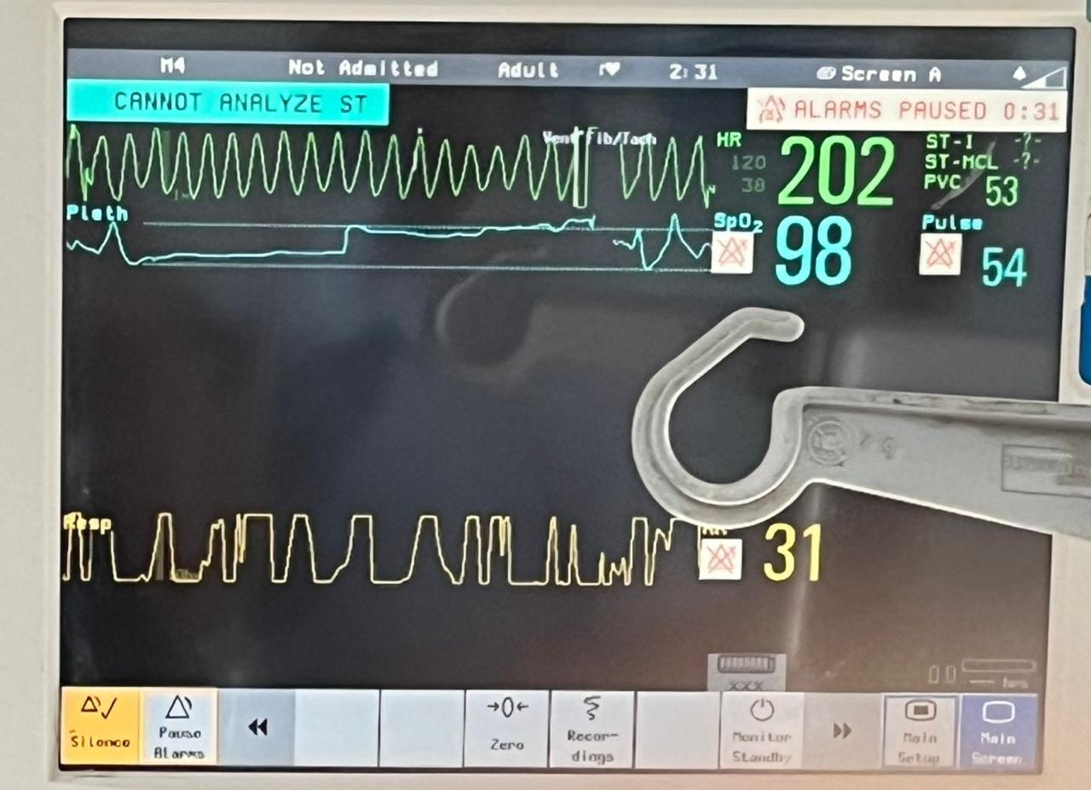
Fig 1. Telemetry Strip Showing Recurrent Torsades Episodes
The rhythm strip demonstrates recurrent, self-terminating episodes of polymorphic ventricular tachycardia with waxing and waning QRS amplitude. This indicates an electrically unstable myocardium with a persistent arrhythmogenic substrate, typical of ongoing hypokalemia and hypomagnesemia.

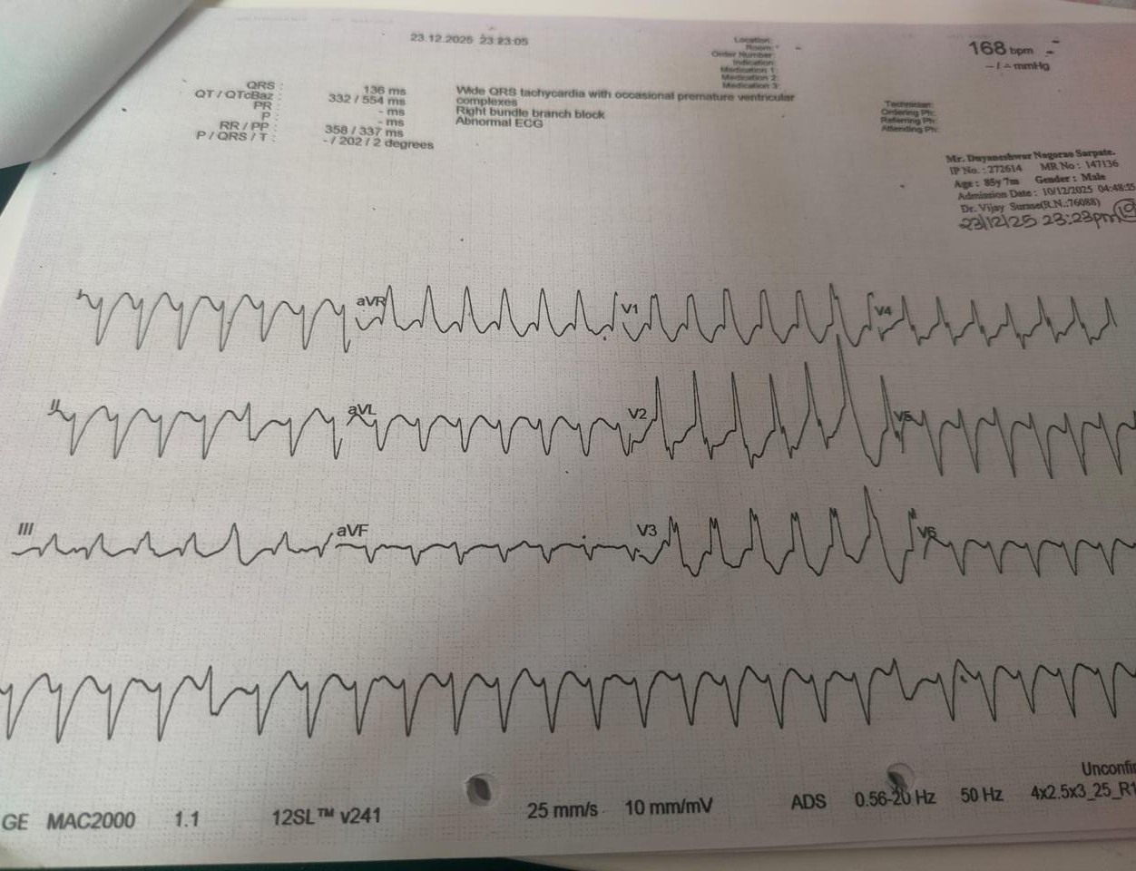

Fig 2. Polymorphic Ventricular Tachycardia (Torsades de Pointes)
This Fig shows rapid polymorphic wide-complex tachycardia with continuous beat-to-beat variation in QRS morphology and axis, characteristic of torsades de pointes. The pattern reflects triggered ventricular activity arising in the setting of prolonged repolarization due to electrolyte imbalance

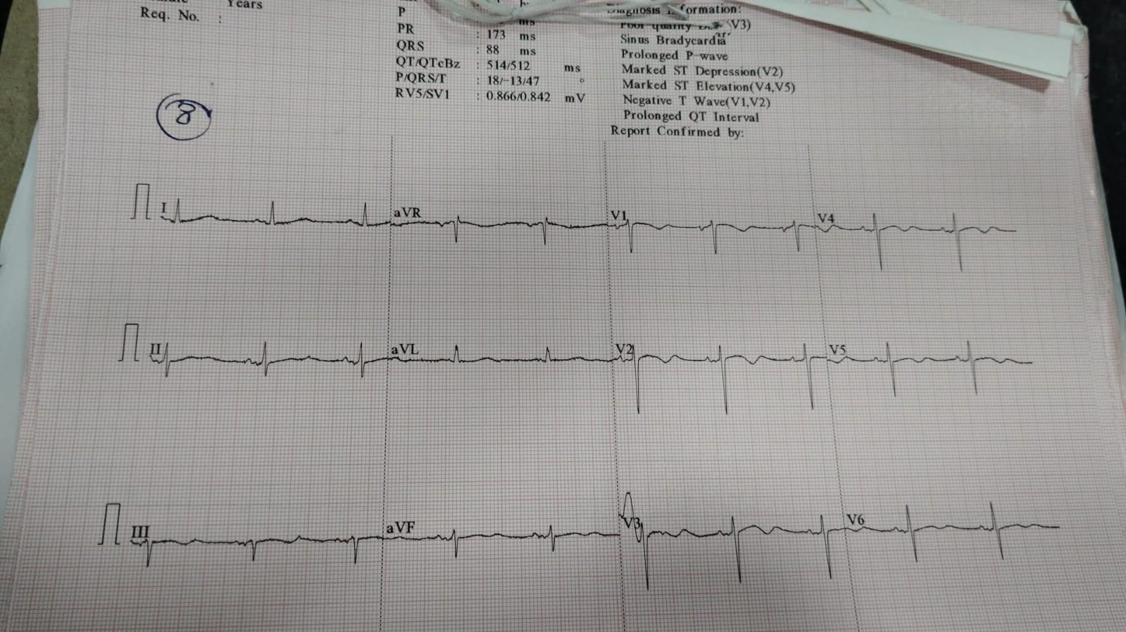

Fig 3. Sinus Rhythm With Marked QT Prolongation
This Fig shows sinus rhythm with significant QT/QTc prolongation, providing the substrate for torsades de pointes. QT prolongation reflects delayed ventricular repolarization, predisposing to pause-dependent early afterdepolarizations and malignant ventricular arrhythmias.

Discussion
Torsades de pointes in patients with ACS and HFrEF represents the culmination of a complex
interaction between ischemia, structural heart disease, autonomic influences, pharmacologic
exposures, and electrolyte disturbances.¹–³ This case series highlights an under-recognized
but clinically critical mechanism: furosemide-induced acquired pseudo–Bartter/Gitelman
syndrome, which markedly lowers the threshold for malignant ventricular arrhythmias.
Reduced Repolarization Reserve
Repolarization reserve reflects the redundancy of outward potassium currents that stabilize
ventricular repolarization.¹,² In HFrEF, this reserve is intrinsically reduced due to ventricular
remodeling, fibrosis, and down-regulation of potassium channels. Consequently,
superimposed insults—such as hypokalemia, hypomagnesemia, ischemia, or QT-prolonging
drugs—can precipitate marked QT prolongation and TdP.¹,²
Electrolyte Abnormalities as Primary Triggers
Hypokalemia suppresses IKr and IK1 currents, prolonging action potential duration and
promoting early afterdepolarizations.³,⁹ Hypomagnesemia further destabilizes myocardial
electrophysiology by impairing Na⁺–K⁺ ATPase function, facilitating intracellular
potassium loss, and enhancing calcium influx.⁸,⁹ These combined effects create a highly
arrhythmogenic substrate.³,⁴ Importantly, serum magnesium levels may underestimate total
body deficiency, explaining the consistent efficacy of intravenous magnesium in terminating
TdP regardless of baseline levels.³,⁴

Acquired Pseudo–Bartter/Gitelman Syndrome
Loop diuretics reproduce key features of inherited Bartter syndrome by blocking the
Na⁺–K⁺–2Cl⁻ cotransporter, resulting in renal salt wasting, hypokalemia, metabolic
alkalosis, and secondary hyperaldosteronism.⁶,⁷ Chronic exposure also impairs distal
tubular magnesium reabsorption, creating a Gitelman-like phenotype.⁶ Unlike genetic
tubulopathies, this acquired condition is fully reversible, emphasizing the importance of early
recognition.
Pause-Dependent and Bradycardia-Mediated TdP
TdP is classically pause-dependent and initiated by long–short RR sequences.¹,³
Bradycardia—due to inferior wall ischemia, enhanced vagal tone, or β-blocker
therapy—exaggerates QT prolongation and facilitates early afterdepolarizations. Suppression
of arrhythmia with isoproterenol or overdrive pacing in our patients confirms the central role
of rate-dependent repolarization dynamics.¹,³
Ischemia and Structural Substrate
Acute myocardial ischemia alters ionic gradients, impairs ATP-dependent ion pumps, and
increases dispersion of repolarization, promoting polymorphic ventricular arrhythmias.¹,² In
HFrEF, structural remodeling and fibrosis further amplify this vulnerability, explaining why
TdP may occur with electrolyte abnormalities that might otherwise be tolerated in structurally
normal hearts.¹,²
Drug and Autonomic Influences
QT-prolonging medications synergize with electrolyte abnormalities to increase TdP risk.³,⁵
Importantly, polymorphic VT in this context should not be reflexively treated with
amiodarone, which may worsen QT prolongation.¹,⁵ Lidocaine is preferred if pharmacologic
therapy is required.¹
Therapeutic and Prognostic Implications
These cases demonstrate that TdP in ACS with HFrEF is frequently reversible. Management
should focus on immediate arrhythmia termination, aggressive electrolyte correction, heart-
rate augmentation, and removal of precipitating factors.¹–⁴ Implantable cardioverter-
defibrillator implantation is not indicated once reversible causes are corrected, in accordance
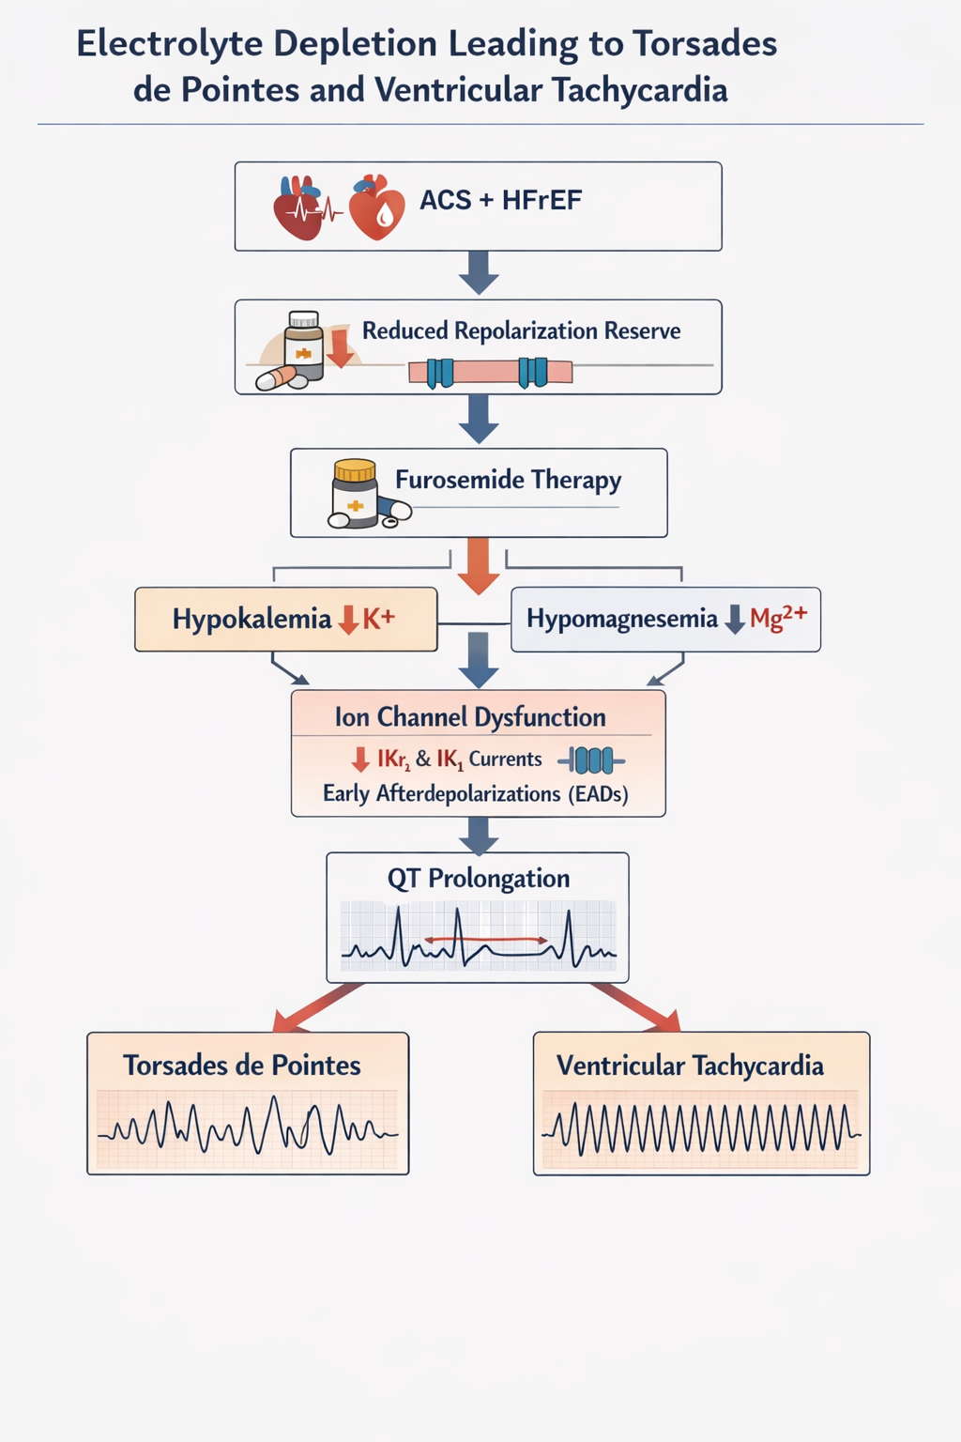

Figure 4. Mechanism of Electrolyte-Mediated Ventricular Arrhythmogenesis
Loop diuretic–induced hypokalemia and hypomagnesemia reduce IKr-mediated repolarizing currents and impair Na⁺/K⁺-ATPase activity, leading to prolonged ventricular action potential duration and QT interval prolongation.
Hypomagnesemia facilitates L-type Ca²⁺ channel reactivation and sustains potassium depletion, promoting early afterdepolarizations.
In the setting of reduced repolarization reserve (acute ischemia and HFrEF), these triggers initiate pause-dependent polymorphic ventricular tachycardia (torsades de pointes), which may degenerate into sustained VT or ventricular fibrillation.¹–³,¹⁰–¹²
Treatment and Acute Management Strategy
The management of torsades de pointes (TdP) in patients with acute coronary syndrome
(ACS) and heart failure with reduced ejection fraction (HFrEF) requires a structured,
stepwise, and mechanism-based approach, targeting both immediate arrhythmia
termination and reversal of the underlying electrophysiological substrate. Given that TdP in

this setting is typically functional and reversible, prompt recognition and appropriate
intervention are often curative and prevent recurrence.¹–³
Immediate Recognition and Hemodynamic Stabilization
Torsades de pointes is a polymorphic ventricular tachycardia that may be self-terminating or
degenerate into ventricular fibrillation. In patients presenting with hemodynamic instability,
syncope, or cardiac arrest, immediate electrical defibrillation is mandatory and
lifesaving.¹,² Early defibrillation interrupts recurrent TdP episodes and restores organized
cardiac rhythm. Continuous cardiac monitoring is essential, as TdP is often episodic and
pause-dependent.³
Intravenous Magnesium Sulfate as First-Line Therapy
Intravenous magnesium sulfate is the cornerstone of acute TdP management, regardless of
baseline serum magnesium levels.³,⁴ Magnesium suppresses early afterdepolarizations by
stabilizing myocardial cell membranes, modulating L-type calcium channel activity, and
reducing triggered activity.⁴,⁹
A bolus of 2 g intravenous magnesium sulfate administered over 10–15 minutes is
recommended, followed by a continuous infusion if recurrent TdP episodes occur.³,⁴
Importantly, the antiarrhythmic benefit of magnesium extends beyond simple correction of
hypomagnesemia and reflects its direct electrophysiological effects.⁴
Aggressive Potassium Repletion and Restoration of Repolarization Reserve
Hypokalemia is a critical driver of QT prolongation and TdP. Reduced extracellular
potassium diminishes outward potassium currents (particularly IKr and IK1), prolongs action
potential duration, and promotes early afterdepolarizations.³,⁹
Aggressive potassium repletion is therefore essential, with a target serum potassium in the
upper-normal range (≥4.5–5.0 mmol/L).³ Intravenous potassium chloride is preferred in
patients with ongoing arrhythmia or hemodynamic instability, with close telemetry and serial
electrolyte monitoring to avoid overcorrection. Restoration of potassium levels shortens the
QT interval and markedly reduces arrhythmia recurrence.³,⁹
Heart-Rate Augmentation for Pause-Dependent TdP
Torsades de pointes is classically pause-dependent and frequently initiated by long–short
RR sequences, particularly in the presence of bradycardia.³ Slower heart rates exaggerate QT
prolongation and facilitate early afterdepolarizations.
In patients with recurrent or bradycardia-dependent TdP, heart-rate acceleration is a critical
therapeutic strategy. This can be achieved pharmacologically using isoproterenol infusion or
mechanically with temporary transvenous overdrive pacing, targeting a heart rate of
90–110 beats per minute.¹,³ Heart-rate augmentation shortens repolarization duration,
suppresses pauses, and effectively terminates TdP when electrolyte correction alone is
insufficient.³

Withdrawal of QT-Prolonging Drugs and Antiarrhythmic Considerations
All QT-prolonging medications should be promptly discontinued, as drug-induced QT
prolongation synergizes with electrolyte abnormalities to precipitate TdP.⁵
Importantly, amiodarone should be avoided in polymorphic ventricular tachycardia
associated with QT prolongation, as it may further lengthen repolarization and exacerbate
TdP.¹,⁵ If antiarrhythmic therapy is required, lidocaine is preferred due to its neutral or QT-
shortening electrophysiological effects.¹
Optimization of Diuretic Therapy and Prevention of Recurrence
Because the arrhythmogenic substrate in these patients was driven by furosemide-induced
potassium and magnesium wasting, modification of diuretic therapy is essential. Strategies
include dose reduction, temporary cessation, or careful reintroduction at lower doses once
congestion improves.⁶–⁸
Long-term prevention requires scheduled electrolyte surveillance in all ACS–HFrEF
patients receiving loop diuretics, particularly during the acute phase of illness. Oral potassium
and magnesium supplementation should be considered in patients requiring ongoing diuretic
therapy.³,⁸
Role of Implantable Cardioverter-Defibrillator Therapy
Despite the dramatic clinical presentation, implantable cardioverter-defibrillator (ICD)
implantation is not indicated when ventricular arrhythmias arise from reversible metabolic
or drug-induced causes.¹,² In all cases presented, arrhythmias resolved completely following
correction of electrolyte abnormalities and elimination of precipitating factors, confirming the
transient nature of the arrhythmogenic substrate.

Conclusion
Torsades de pointes in patients with ACS and HFrEF should immediately raise suspicion for
furosemide-induced hypokalemia and hypomagnesemia, representing a reversible acquired
pseudo–Bartter/Gitelman syndrome. The convergence of electrolyte depletion, ischemia,
bradycardia, and reduced repolarization reserve creates a highly arrhythmogenic substrate.
Early recognition, aggressive electrolyte correction, and appropriate heart-rate management
are lifesaving and prevent unnecessary long-term device therapy.¹–³

Consent

As per international standards or university standards, patient(s) written consent has been collected and preserved by the author(s).

Disclaimer (Artificial Intelligence)
Author(s) hereby declare that NO generative AI technologies such as Large Language Models (ChatGPT, Copilot, etc.) or text-to-image generators were used during the writing or editing of this manuscript.

References
- Al-Khatib SM, Stevenson WG, Ackerman MJ, et al. 2017 AHA/ACC/HRS guideline for management of patients with ventricular arrhythmias and the prevention of sudden cardiac death. Circulation. 2018;138:e272–e391.
- Wellens HJJ, Schwartz PJ, Lindemans FW, et al. Risk stratification for sudden cardiac death. Eur Heart J. 2014;35:1642–1651.
- Roden DM. Drug-induced prolongation of the QT interval. N Engl J Med. 2004;350:1013–1022.
- Tzivoni D, Banai S, Schuger C, et al. Treatment of torsade de pointes with magnesium sulfate. Circulation. 1988;77:392–397.
- Viskin S. Long QT syndromes and torsade de pointes. Lancet. 1999;354:1625–1633.
- Seyberth HW, Schlingmann KP. Bartter- and Gitelman-like syndromes. Lancet. 2011;377:198–210.
- Colussi G, Rombolà G, Airaghi C, De Ferrari ME. Pseudo-Bartter syndrome induced by diuretics. Am J Nephrol. 1992;12:323–327.
- Whang R, Ryder KW. Frequency of hypomagnesemia. JAMA. 1990;263:3063–3064.
- El-Sherif N, Turitto G. Electrolyte disorders and arrhythmogenesis. Cardiol J. 2011;18:233–245.
- Vandael E, Vandenberk B, Vandenberghe J, et al. Risk factors for torsade de pointes: a contemporary review. Eur Heart J. 2021;42:195–204.
- Tse G, Liu T, Li KH, et al. Mechanisms of ventricular arrhythmogenesis in heart failure. Front Physiol. 2020;11:45.
- Drew BJ, Ackerman MJ, Funk M, et al. Prevention of torsade de pointes in hospitalized patients. Circulation. 2022;145:e214–e233

