Parasitism of Loranthaceae in Cocoa Agroecosystems of Daloa in Côte d’Ivoire: Ecological Basis for Management Based on Sustainable Plant Biodiversity

ABSTRACT

Context: In Côte d’Ivoire, Loranthaceae are a major factor in the parasitism of trees and shrubs, particularly cocoa trees, causing damage that can affect productivity. Knowledge of their specific diversity and ecological preferences is essential for the development of sustainable management strategies for cocoa plantations.

Methodology: The study was conducted in fifteen periurban cocoa plantations in Daloa, Côte d’Ivoire. The inventory of parasitic species was carried out using the itinerant method, supplemented by direct observations in the field. Producers and plantations were selected using a purposive (non-random) sampling approach based on accessibility, plantation age and farmers’ experience. At the same time, thirty-five producers were interviewed using semi-structured interviews to analyse local practices for controlling Loranthaceae

Results: Four species belonging to three genera were identified: Globimetula dinklagei, Phragmanthera capitata, Tapinanthus bangwensis and T. globiferus. Their development in the canopy of cocoa trees depends on light and shade. Damage ranges from partial or total invasion (50 %) to progressive depletion of trees (3.5 %). 95% of producers mainly prune infested branches, while only 5% reported manually pulling up clumps due to technical and safety constraints.

Conclusion: These results provide a solid ecological and biological basis for the development of pre-biotechnological management strategies, including varietal selection and integrated biological control to limit the impact of Loranthaceae on cocoa trees in Côte d’Ivoire.

Keywords: Loranthaceae, cocoa trees, visible damage, farmer strategies, prebiotechnological management, Daloa, Côte d’Ivoire.

1. INTRODUCTION
Loranthaceae are epiphytic or hemiparasitic higher plants that grow on tree stems or branches, drawing water and soluble minerals that they cannot absorb directly from the soil (Amon et al., 2010; Houenon et al., 2012). They constitute a distinct biological entity due to their morphological, biological and ecological characteristics, particularly the morphology of their flowers, their mode of attachment and their interaction with the host (Boussim, 2002; Amon et al., 2017). There are approximately 950 species of Loranthaceae divided into 77 genera worldwide. In West Africa, 230 species have been identified (Dibong et al., 2009), highlighting the richness and diversity of this group in tropical ecosystems. In cocoa plantations, Loranthaceae parasitise many species of trees and shrubs. They divert water and mineral salts from their hosts via a sucker, thereby weakening the parasitised trees (Amon et al., 2025). This parasitism can, to varying degrees, slow growth and cause branches to dry out. In the long term, it can lead to the death of the tree, thus posing a threat to the productivity and resilience of agroecosystems (Soro, 2010). In Côte d'Ivoire, these hemiparasitic vascular plants are common in various ecosystems and agricultural systems, particularly cocoa, coffee, rubber and shea plantations (Soro, 2006 ; Osei & Ansong, 2023). Their presence illustrates the interconnection between parasitism and local biodiversity dynamics. The periurban area of Daloa presents a particular context where parasitic pressure is noticeable on crops and where cocoa plantations play a major economic and ecological role. These agroecological systems are reservoirs of plant biodiversity. However, they remain vulnerable to infestation by Loranthaceae, which justifies the need to understand their diversity, ecology and impacts. To this end, this study adopted a combined approach. The itinerant method, combined with direct observations, made it possible to inventory species, assess their distribution in the canopy of cocoa trees and quantify visible damage. At the same time, semi-structured interviews with producers documented their perceptions and farming practices for combating the problem. This information is essential for developing pre-biotechnological and sustainable management strategies, including varietal selection and integrated biological control, in order to limit the impact of Loranthaceae while preserving the plant biodiversity of cocoa systems. The main objective of this study is to provide a solid ecological and biological basis for understanding Loranthaceae parasitism in cocoa agroecosystems in Daloa. It also aims to support the development of sustainable management interventions, integrating the preservation of plant biodiversity and preventive plant biotechnology approaches.

2. MATERIALS AND METHODS
2.1. Study area
The study was conducted in fifteen cocoa plantations spread across three rural localities (Tagoura, Zakoua and Zépreguhé) located on the outskirts of the municipality of Daloa, between 6°52′ and 6.87° N latitude and 6°27′ and 6.45° W longitude (Fig. 1). The area has a sub-equatorial climate with four seasons (N’guessan et al., 2014), with two rainy seasons (April, mid-July; mid-September, November) and two dry seasons (mid-July, mid-September, December, March). Average annual rainfall is around 1,200 mm and the average annual temperature is around 27°C (SODEXAM, 2020).

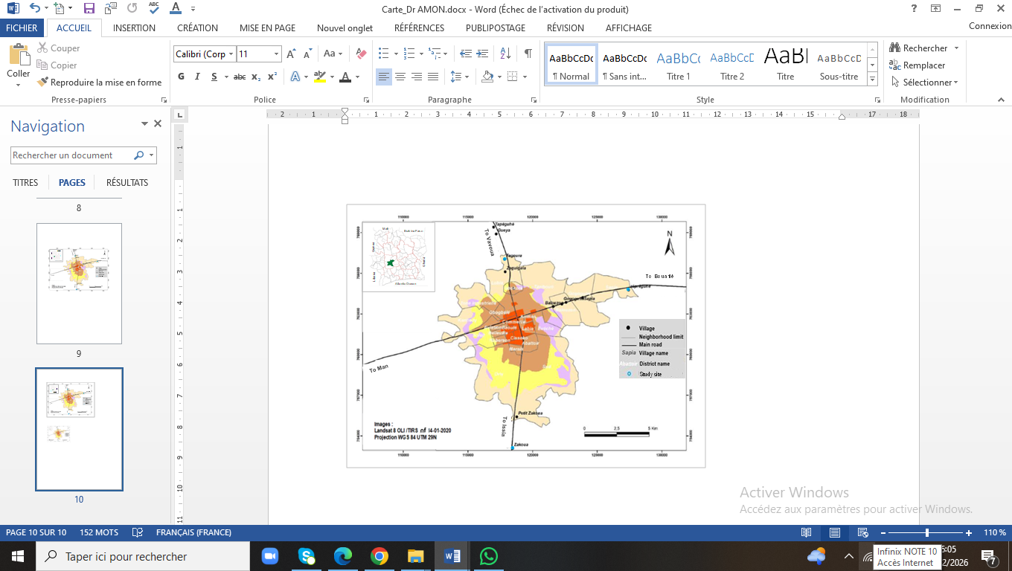
Fig. 1. Map showing the location of study sites in Daloa

2.2 Material
The material used included botanical elements and technical material. The botanical material included various species of Loranthaceae, parasites of cocoa trees and other associated species, while the technical material consisted of a GPS, a digital camera, survey forms and identification guides for Loranthaceae (Soro, 2010, Amon, 2014). In addition, a collection of specimen samples of Loranthaceae species from the National Centre for Floristics (CNF) was used to compare the species collected.

2.3. Methods
This study followed a mixed-methods approach, combining quantitative field observations of parasitised cocoa trees with qualitative data from semi-structured interviews of cocoa producers.

2.2.1. Surveys and direct observations
The mobile method (Boko et al., 2020) was used to survey the cocoa plantations studied. Sampling of cocoa plantations was carried out randomly to ensure representativeness. Thirty-five stakeholders, mainly cocoa producers directly involved in plantation management, were interviewed. Each plantation was systematically explored, and each tree was observed for the presence of Loranthaceae. For each parasitised tree, the following parameters were recorded:
- Loranthaceae species: taxonomic identification based on Amon et al. (2025) keys and confirmed by comparison with specimens from the National Centre for Floristics (CNF), Abidjan ;
- number of tufts: counting of tufts present on the host tree ;
- position in the crown: location of tufts on the main branches, secondary branches or at the ends of the crown ;
- observable damage: assessment of visible impacts on the host tree, including partial or total invasion of the crown, defoliation, desiccation of branches, formation of nodules at attachment points, reduced productivity and progressive decline.
Damage caused by Loranthaceae was assessed using a standardized visual approach based on direct field observations. For each parasitised cocoa tree, damage symptoms (canopy invasion, branch defoliation, swellings at attachment points, branch drying and reduced productivity) were recorded, and their relative importance was determined by the proportion of parasitised trees exhibiting each symptom.

2.2.2 Producer surveys
With the support of local village chiefs, we conducted semi-structured interviews with 35 cocoa producers who were carefully selected using a judicious (non-random) sampling technique. All 35 producers interviewed were male owners of cocoa plantations, selected from the local producer population. The selection criteria included ease of access to the plantations, their age, the producers' (cocoa farm owners) experience in cocoa cultivation, and their knowledge of Loranthaceae, confirmed by visual identification using images of representative species on tangible media. The plots selected were representative of local production systems and were at least 8 years old (the age at which they were assumed to be in production) in order to observe a variety of Loranthaceae management conditions. The aim of the surveys was to record producers' knowledge of Loranthaceae, their assessment of its influence on cocoa trees, and the control measures used, while collecting contextual socio-agronomic data to facilitate the analysis of responses.

2.3. Data processing
The data were analysed using Microsoft Excel 2013 and Statistica 7.1 software. The analyses were based exclusively on descriptive statistics, including the calculation of frequencies and percentages, as well as graphical representations, to describe the different Loranthaceae species encountered, their spatial distribution and their position within the canopy of cocoa trees. Species identification was carried out using identification keys and scientific references such as Soro (2010), Amon (2014) and Amon et al. (2025), and was confirmed by comparison with specimens from the herbarium of the National Centre for Floristics (CNF), Abidjan, Côte d’Ivoire.

3. RESULTS
3.1. Loranthaceae species encountered
Four species divided into three genera were recorded: Globimetula dinklagei subsp. assiana, Phragmanthera capitata, Tapinanthus bangwensis and T. globiferus. The most represented genus, Tapinanthus, comprises two species and also has the highest infestation rate. The specimens collected are illustrated in Fig. 2, showing their morphological characteristics and their position on the cocoa trees.

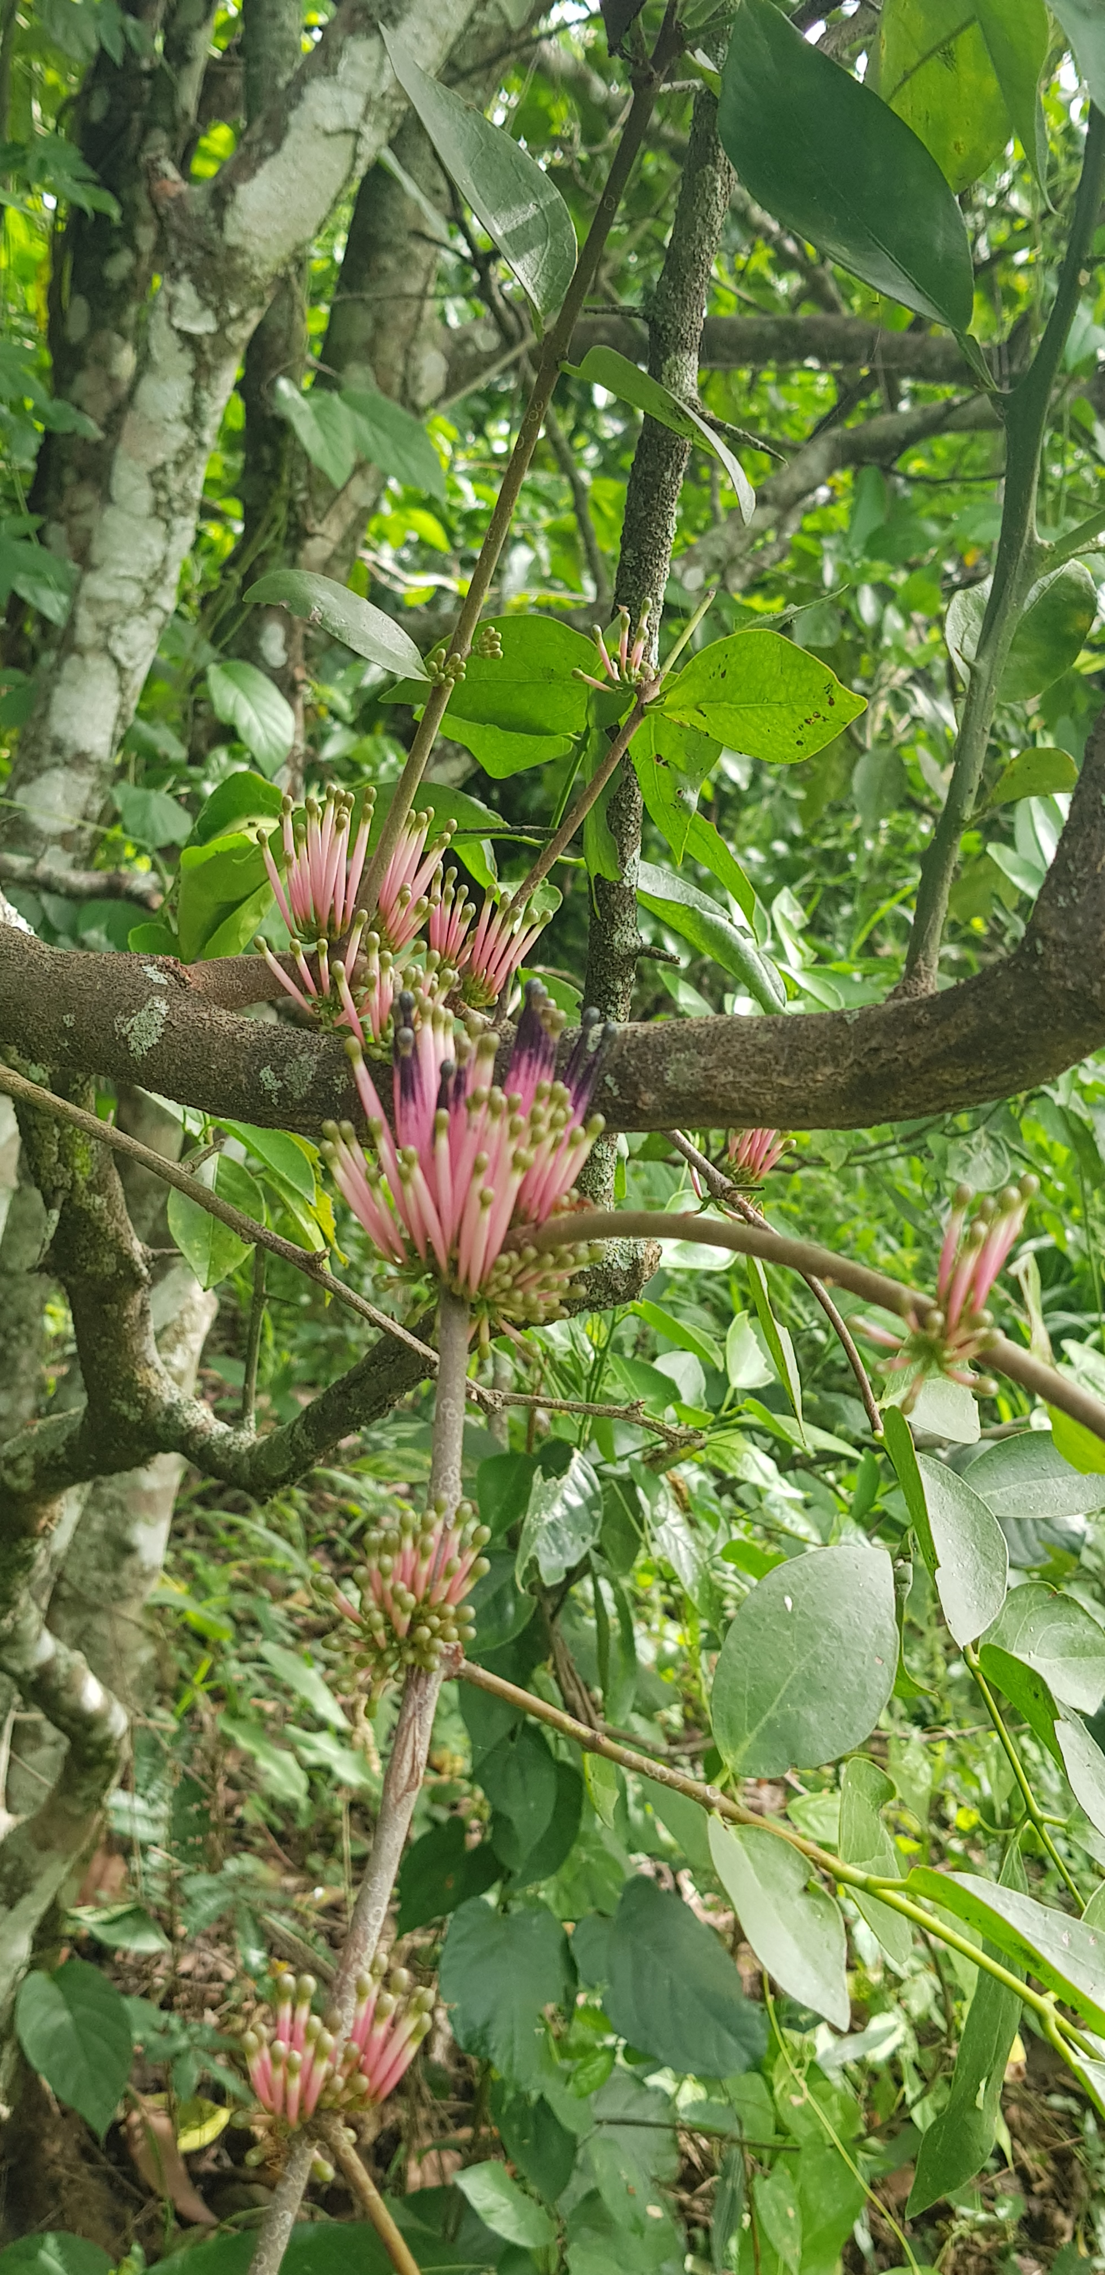
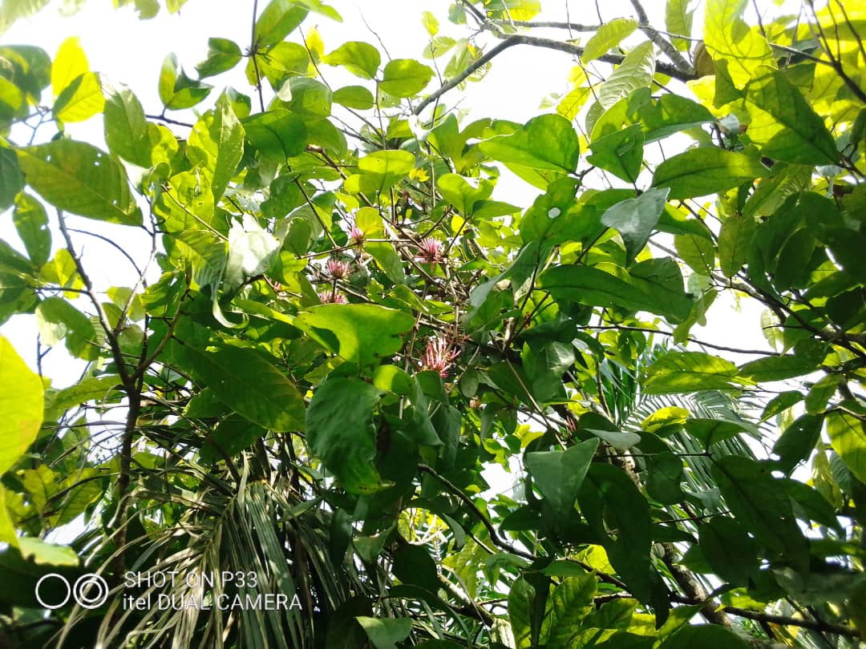
A
B
Fig. 2. View of Tapinanthus bangwensis developing on an outer branch (A) and
T. globiferus present inside the crown on a branch (B).

3.2. Distribution of species
Figure 3 shows the distribution of Loranthaceae species clumps in cocoa plantations in the three locations studied: Tagoura, Zakoua and Zépreguhé. T. bangwensis is the most abundant species in all localities, with a maximum in Zépreguhé (3,695 clumps), followed by Zakoua (2,302) and Tagoura (894), indicating its strong colonisation capacity and the suitability of local conditions for its development. P. capitata is less abundant, with a number of clumps ranging from 758 in Tagoura to 2,167 in Zépreguhé, and appears to coexist with T. bangwensis but with more moderate parasitic pressure. G. dinklagei subsp. assiana and T. globiferus are only present in Zépreguhé, with 583 and 319 clumps respectively, suggesting a restricted distribution probably linked to ecological preferences or specific environmental factors. The high concentration of all species at Zépreguhé highlights this location as a hotspot for parasitism, requiring special attention for management. Overall, this distribution shows that parasitic species are not evenly distributed across the study area, providing a sound ecological basis for developing
targeted and sustainable management strategies tailored to the local diversity and abundance of Loranthaceae.

Meaning of abbreviations : G - Globimetula; P - Phragmanthera T. - Tapinanthus

Fig. 3. Clump distribution of Loranthaceae species in cocoa plantations in the

study area

3.3. Ecological preferences of the parasitic species studied
Table 1 presents the ecological preferences, anchoring strategies, requirements and habitat observed for each Loranthaceae species on parasitised cocoa trees. The results show that G. dinklagei subsp. assiana grows mainly inside the canopy, in line with its shade-loving nature, and rarely outside. P. capitata and T. globiferus are found mainly outside the canopy (85 % of observations) and occasionally inside (15 % of observations). T. bangwensis was observed exclusively outside the canopy (100 % of observations).

Table 1. Ecological preferences, canopy position and habitat of Loranthaceae
on cocoa trees

Species | Ecological requirements | Ecological habitat
Globimetula dinklagei subsp. assiana | Sciaphilous, sometimes heliophilous, but rarely. | Develops mainly within the canopy of parasitised cocoa trees.
Phragmanthera capitata | Mostly heliophilous or semi-heliophilous | Occupies humid and well-ventilated areas of the canopy, both outside and inside.
Tapinanthus bangwensis | Strictly heliophilous | Attaches and grows mainly on the outside of the cocoa tree canopy.
Tapinanthus globiferus | Heliophilous or semi-heliophilous | Grows equally well inside (partial shade) and outside the canopy.

3.4. Damage observed
For all species of Loranthaceae found on parasitised cocoa trees, the consequences of their parasitism were observed. The severity of the damage varied depending on the host trees within the cocoa plots studied. The main visible effects were as follows:
- invasion of the canopy of parasitised cocoa trees, observed in 50 % of cases (Fig. 4) ;
- defoliation of branches, observed in 24 % of observations ;
- formation of ridges or nodules at the attachment points, observed in 9 % of cases;
- drying of branches, recorded in 13 % of cases (Fig. 5);
- reduced tree productivity, observed in 4 % of cases.

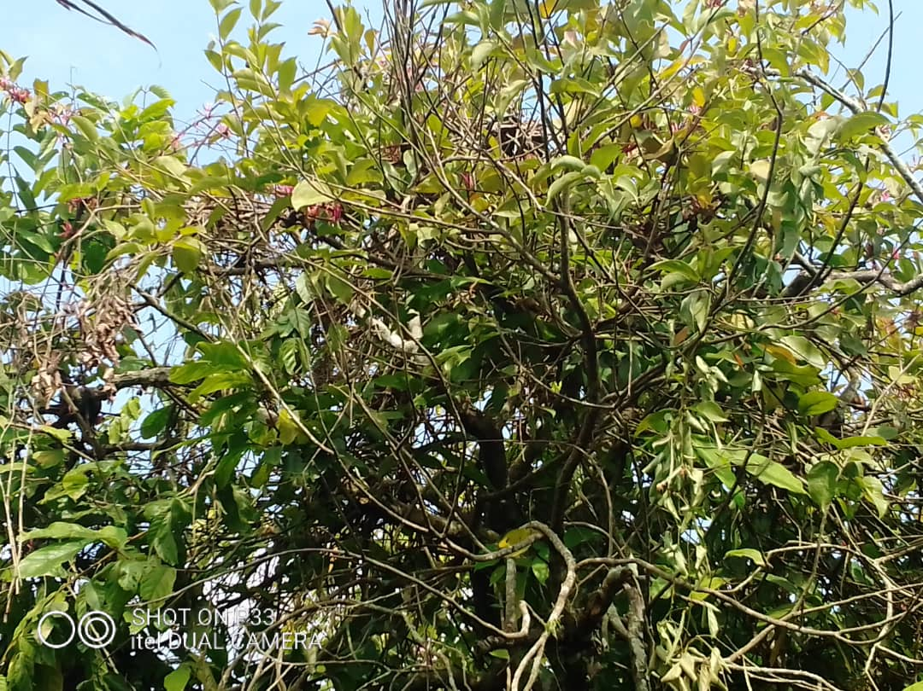
Fig. 4 : View of canopy invasion of a cocoa tree by Loranthaceae

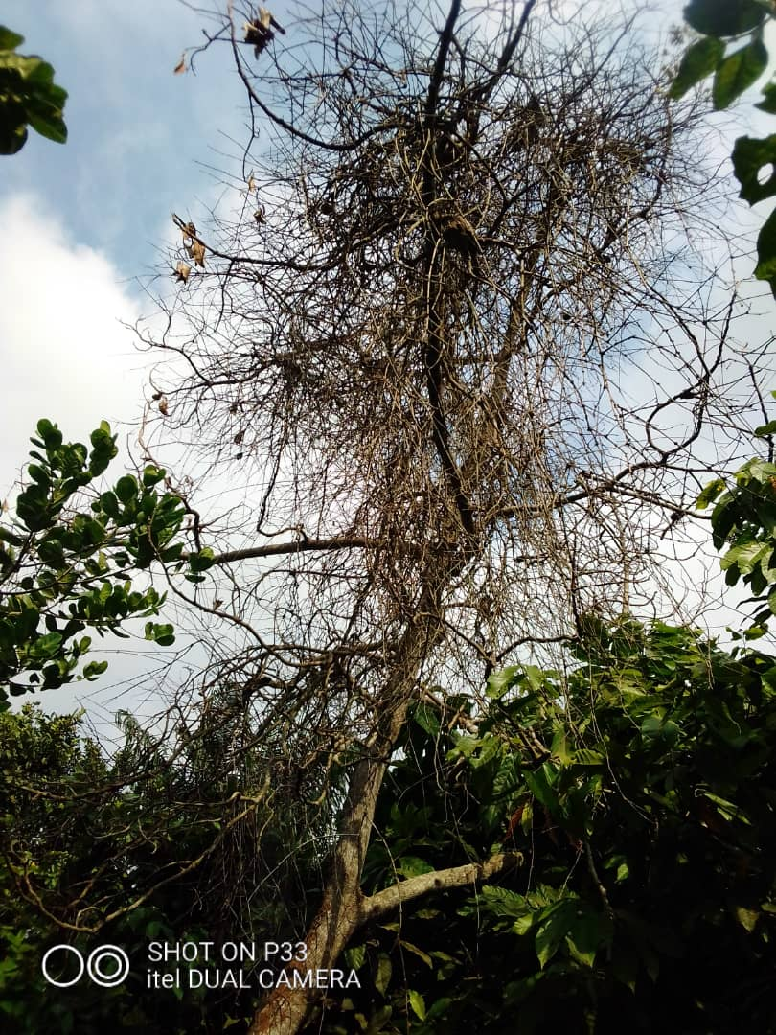
Fig. 5. View of a cocoa tree in decline due to the action of Loranthaceae

Fig. 5. View of a cocoa tree in decline due to the action of Loranthaceae

3.5. Traditional control techniques

The main control techniques used by producers against Loranthaceae are presented in Table 2. The systematic pruning of infested branches, practised by 77.14 % of respondents, mainly concerns trees over 2 m tall. Although commonly used, this method carries risks for the farmer and exposes the cut branches to secondary attacks by microorganisms or insects (termites, ants), which can reduce its effectiveness. The removal of tufts on cocoa trees less than 2 m tall, practised by 42.85 % of respondents, is essentially preventive. It requires regular monitoring to eliminate any regrowth and a significant investment of time and labour, without guaranteeing the permanent elimination of the parasite. Table 2 also lists these techniques along with their limitations and constraints, highlighting the importance of monitoring for the preventive method and the operational and biological risks associated with systematic branch pruning.

Table 2. Methods for controlling Loraanthceae and limitations

Control techniques used by producers | Limits
Removal of clumps from cocoa trees ˂ 2 m high. | - requires work and time ;  - a technique to be applied upstream, requiring follow-up to eliminate any regrowth;  - it is preventive, not curative.
Systematic pruning of parasitic branches | - significant risks for the farmer (cocoa trees > 2 m high) ;  - exposure of the severed part to attacks by microorganisms (termites, ants, etc.).

4. DISCUSSION

Four species of Loranthaceae (Globimetula dinklagei subsp. assiana, Phragmanthera capitata, Tapinanthus bangwensis and T. globiferus) were recorded on cocoa trees in the periurban agroecosystems of Daloa. This species richness is comparable to that reported in other cocoa-growing areas of West and Central Africa (Ngotta et al., 2015 ; Ondoua et al., 2015 ; Osei & Ansong, 2023), although lower than that observed on certain more susceptible hosts. The high frequency of P. capitata and T. bangwensis reflects their strong affinity for cocoa trees, suggesting an ecological and physiological adaptation that favours their parasitic success in agroforestry systems. These species therefore appear to be priority targets for sustainable management strategies based on plant biodiversity (Yao, 2020).

The species identified have contrasting ecological requirements, particularly with regard to light. G. dinklagei subsp. assiana, P. capitata and T. globiferus grow both inside and on the edge of the canopy, reflecting a heliophilic to semi-heliophilic behaviour, while T. bangwensis is strictly heliophilic and prefers to grow outside the canopy (Amon et al., 2025). This non-random distribution confirms the decisive influence of microclimatic conditions on the establishment of Loranthaceae (Soro, 2010 ; Amon et al., 2020 ; Yao, 2020). These results provide a relevant ecological basis for guiding biotechnological approaches, particularly the selection of more tolerant host genotypes and the optimisation of plantation architecture.

Parasitism by Loranthaceae induces a progressive deterioration in the physiological condition of cocoa trees. The invasion of the canopy observed in nearly half of the infested trees, associated with defoliation, branch desiccation, the formation of swellings and reduced productivity, reflects a lasting disruption of water and nutrient flows (Soro, 2010). Although cases of advanced decline remain limited, the cumulative effect of parasitism compromises the sustainability of plantations, in line with previous observations in sub-Saharan Africa (Amon et al., 2017 ; Osei & Ansong, 2023).
Producers mainly resort to pruning infested branches and, to a lesser extent, uprooting clumps on low-growing cocoa trees. However, survey results reveal that these methods have significant limitations. Uprooting is a strictly preventive practice that requires regular monitoring, while pruning poses risks to the producer and promotes secondary attacks on the cut tissue. These constraints reflect limited technical mastery of control methods. From a plant biotechnology and sustainable biodiversity management perspective, these results highlight the need to develop integrated strategies. These must combine ecological knowledge, improved cultivation practices and capacity building for producers.

5. CONCLUSION
This study highlighted the presence of four species of Loranthaceae in the peri-urban cocoa plantations of Daloa, with Phragmanthera capitata and Tapinanthus bangwensis being the most frequently encountered species. Their distribution within the cocoa canopy is closely linked to light exposure. The infestations observed cause damage ranging from partial invasion of the crown to the gradual weakening of host trees, with repercussions on their productivity. The control practices implemented by producers, mainly based on pruning and uprooting, have limitations in terms of effectiveness and sustainability. Taken together, these results provide an essential ecological and biological basis for the development of sustainable management approaches for Loranthaceae. These approaches integrate the enhancement of plant biodiversity and the strengthening of the resilience of cocoa agroforestry systems, with a view to plant biotechnology.

DISCLAIMER (ARTIFICIAL INTELLIGENCE)
Author(s) hereby declare that NO generative AI technologies such as Large Language Models (ChatGPT, COPILOT, etc) and text-to-image

ACKNOWLEDGEMENTS
We express our sincere gratitude to the village chiefs and cocoa farmers for granting us access to their plantations.

COMPETING INTERESTS
Authors have declared that no competing interests exist.

REFERENCES
- Amon, A. D. E., Soro, D., N’guessan, K. & Traore, D. (2010). Loranthaceae : Vascular parasitic plants of trees and shrubs in south – east Côte - d’Ivoire. Journal applied Biosciences, 25 : 1565 – 1572.
- Amon, A. D. E. (2014). Loranthaceae (mistletoe), Vascular Hemiparasites of Trees and Shrubs in Agrosystems of the Sud-Comoé Region, in the Dense Evergreen Forest Zone of Côte d’Ivoire. Doctoral Thesis, Department of Biosciences, Félix Houphouët-Boigny University (Abidjan, Côte d’Ivoire), 213 p.
- Amon, A. D. E., Koulibaly, A., Dro, B. & Soro, D. (2017). Parasitism of Loranthaceae in agroecosystems based on cocoa, coffee and rubber trees in the South Comoé Region (Côte d'Ivoire). Journal of Environment and Biodiversity PASRES, 2(1) : 03-14.
- Amon, A. D. E., Koulibaly, A. V., Sako, H. E. L. & Koffi, A. A. (2020). Prevalence of Phragmanthera capitata (Spreng.) Ballé (Loranthaceae) on rubber trees in smallholder plantations at the Jean Lorougnon Guédé University site in Central-western Côte d'Ivoire. European Scientific Journal, 16 : 215-227
- Amon, A. D. -E., Sylla, M., Kouadio A. R. & Soro, D. (2025). Influence of woody fruit species susceptible to Loranthaceae on the level of infestation of cocoa trees: case of agroforestry cocoa farming systems in Daloa (Côte d’Ivoire). International Journal of Advanced Research (IJAR) 13(04) : 35 46
- Amon, A. D. -E., Sylla, M., Kouadio A. R., Soro, K. & Soro, D. (2025). Prevalence of Loranthaceae on fruit trees in cocoa agroforestry systems in Daloa (Center-West, Côte d’Ivoire): diversity and extent of infestation. GSC Advanced Research and Reviews, 2025, 25(02), 441-456
- Boko, B. B., Koulibaly, A., Amon, A. D. E., Koffi, D. B., M’Bo, K. A. A., Porembski, S. (2020). Farmers Influence on Plant Diversity Conservation in Traditional Cocoa Agroforestry Systems of Côte D’Ivoire. International Journal of Research Studies in Agricultural Sciences 6 (11) : 1 11
- Dibong, S, Engone Obiang, NL, Din, N., Priso, RJ, Taffouo, VD, Fankem, H. & Amougou, A. (2009). Level of infestation of fruit trees in plant communities by Phragmanthera capitata (Sprengel) S. Ballé (Loranthaceae) in the coastal region of Cameroon. International Journal of Biological and Chemical Sciences, 3(2): 347-354.
- Houenon, G.J, Yedomonhan, H., Adomou, A.C., Tossou, G.M., Akoegninou, A. & Traoré, D. (2012). Specific Diversity of Loranthaceae Parasites of Citrus Fruit and Their Impact on Citrus Fruit Production in Southern Benin. European Journal of Scientific Research : 527 538.
- Ngotta Biyon, J. B., Iyodi, A. B., Wafo Tchoue, Y. D., Ondoua, J. M. & Taffouo, V. D. (2022). Loranthaceae Parasitism on Theobroma cacao L. (Malvaceae) in the Tombel District (Southwest Cameroon). International Journal of Biological and Chemical Sciences 16(3): 1113-1122
- N’guessan, A. H., N’guessan, K. F., Kouassi, K. P., Kouamé, N. N. & N’guessan, P. W. (20214). Population dynamics of the cocoa stem borer, Eulophonotus mymeleon Felder (Lepidoptera: Cossidae) in the Haut-Sassandra region of Côte d’Ivoire. Journal of Applied Biosciences 8: 1-11
- Ondoua, J.M., Dibong, S., Didier, T.V.D. & Ngotta, B.J.B. (2015). Parasitism of cocoa seed fields by Loranthaceae in the Nkoemvone area (southern Cameroon). Journal of Applied Biosciences, 85, 7794 7803.
- Osei, R., & Ansong, M. (2023). Drivers of mistletoe (Tapinanthus bangwensis) density in cocoa (Theobroma cacao) agroforests in Ghana. International Journal of Pest Management, 69(1), 46-53
- SODEXAM (Airport, Meteorological Development Aeronautical Operation Company) and and (2020). Meteorological data from 2010 to 2020 collected at the Daloa weather station.
- Soro, K (2010). Loranthaceae (mistletoe) in agroecosystems in western Côte d'Ivoire: flora, parasitism and uses in the departments of Oumé, Gagnoa and Soubré. Thesis submitted to the University of Cocody-Abidjan, Agroforestry option.: 183 p.
- Soro, D. (2006). Shea, Vitellaria paradoxa Gaertn.f. (Sapotaceae). Variability of certain morphological characteristics, fruit production and methods of controlling parasitic Loranthaceae through pruning. The case of the Tengrela Shea Nut Nature Reserve, northern Côte d'Ivoire. Thesis, UFR Biosciences, University of Cocody (Côte d’Ivoire), 142 p.
- Traoré, D., Da, K.P. & Soro, D. (2003). Combating parasitic vascular plants affecting shea trees in northern Côte d'Ivoire. The case of the Tengrela Shea Tree Nature Reserve, Universities of Cocody, Botany Laboratory, Report by PEP/AISA-CI, 116 p.
- Yao, K. M. (2020). Diversity and extent of Loranthaceae attacks in cocoa (Theobroma cacao L.) plantations in the Daloa region (Central-West, Côte d’Ivoire). Master’s thesis in Bioresources-Agronomy, UFR Agroforestry, Jean Lorougnon Guédé University (Daloa, Côte d’Ivoire), 42 p.

