Original Research Article

High-frequency somatic embryogenesis and molecular validation of genetic fidelity in Kaempferia marginata Carey ex Roscoe: An endangered medicinal plant

ABSTRACT:
Kaempferia marginata Carey ex Roscoe is a valuable medicinal plant currently threatened by over-exploitation and habitat loss. We established an efficient in vitro micropropagation protocol via somatic embryogenesis. Rhizome buds were cultured on Murashige and Skoog (MS) medium supplemented with varying concentrations of auxins and cytokinins. The highest frequency of callus induction (87.00 ± 0.10%)—producing friable, embryogenic callus—and subsequent shoot regeneration (7.5 ± 0.16 shoots/explant) was achieved with 2.0 mgL⁻¹ α-naphthalene acetic acid (NAA). Histological analysis confirmed the ontogeny of somatic embryos progressing from globular to torpedo stages. For multiplication, a combination of 4.0 mgL⁻¹ 6-benzylaminopurine (BAP) and 1.0 mg L⁻¹ NAA yielded the maximum number of shoots (16.35 ± 0.22) within 4 weeks. Genetic stability was assessed using 25 RAPD and 11 ISSR primers, which generated 84 and 76 reproducible bands, respectively. All profiles were monomorphic across regenerants and the mother plant, confirming true-to-type propagation suitable for large-scale conservation and commercial utilization.

Keywords: Genetic fidelity, Kaempferia marginata, ISSR, RAPD, Somatic embryogenesis, Micropropagation.

1.INTRODUCTION
Kaempferia marginata Carey ex Roscoe (Zingiberaceae) is an aromatic, perennial, rhizomatous herb widely distributed in China, India (specifically the Northeastern region), Myanmar, and Thailand. It shares a similar growth habit with Kaempferia galanga and is highly valued in traditional medicine. The rhizomes possess ethnomedicinal importance for treating allergies, fever, swellings, toothache, and gastric ailments. Phytochemical investigations have revealed that the genus Kaempferia is rich in bioactive constituents, including cyclohexane oxide derivatives, cinnamates, flavonoids, and diterpenes
such as sandaracopimaradiene, which exhibit significant anti-inflammatory, antimicrobial, and antioxidant activities (Thongnest et al., 2005; Madaka & Tewtrakul, 2011; Elshamy et al., 2023).
Despite its therapeutic potential, natural populations of K. marginata are under severe threat. The species is heavily exploited for pharmaceutical purposes, and its natural habitat in Manipur is degrading due to "Jhum" (shifting) cultivation and lack of organized farming practices (Kishor, 2012). Natural propagation via rhizomes is slow, season-dependent, and prone to soil-borne pathogens, necessitating the development of efficient biotechnological interventions for conservation and mass production.
While in vitro micropropagation protocols utilizing organogenesis have been reported for related species such as K. galanga (Lakshmi & Mythili, 2003) and K. parviflora (Rahman et al., 2023), reports on somatic embryogenesis for K. marginata remain limited. Somatic embryogenesis is often preferred over organogenesis for large-scale propagation as it offers higher multiplication rates and the potential for producing synthetic seeds (Jayanthi & Mandal, 2001; Tokuhara & Mii, 2001).
However, the maintenance of genetic uniformity is a critical prerequisite for the commercial application of tissue culture-derived plants. Long-term in vitro culture can induce somaclonal variation, which is undesirable for conservation and pharmaceutical quality control. Molecular markers, particularly Random Amplified Polymorphic DNA (RAPD) and Inter Simple Sequence Repeats (ISSR), are established tools for assessing genetic fidelity due to their simplicity, cost-effectiveness, and ability to detect variation across the genome (Williams et al., 1990; Zietkiewicz et al., 1994; Sahoo et al., 2023).
In view of the above, this study was undertaken to standardize a high-frequency somatic embryogenesis protocol for K. marginata and to validate the genetic fidelity of the regenerated plantlets using RAPD and ISSR markers.

2. MATERIALS AND METHODS

2.1 PLANT MATERIAL AND SURFACE STERILIZATION:
Rhizomes of K. marginata were collected from the hills in the sub-tropical forest of Keithelmanbi in the western periphery of Imphal Valley of Manipur, India (23˚50’ –25˚42’ N and 92˚58’ – 94˚45’ E). The rhizomes were incubated in autoclaved sand at 27±2°C under a 16h light/8h dark photoperiod. After two weeks, sprouting buds were excised and washed under running tap water for 20 minutes to remove contaminants. The explants were treated with Labklin detergent (SD Fine-Chem Ltd., Mumbai) for 15 minutes, rinsed thoroughly, and surface sterilized with 0.2% mercuric chloride (HgCl₂) for 15 minutes inside a laminar airflow cabinet. Finally, explants were rinsed five times with sterile double-distilled water, and the outer leaf sheaths were removed before inoculation.

2.2 CULTURE MEDIA AND CONDITIONS:
Explants were inoculated on Murashige and Skoog (MS) basal medium (1962) supplemented with 30 gLˉ¹ sucrose (HiMedia, Mumbai, India) and 8.0 gLˉ¹ agar (HiMedia, Mumbai, India). The medium was fortified with varying concentrations of plant growth regulators (PGRs-Sigma, St. Louis, USA): 1.0-4.0mgLˉ¹ 6-benzyl-amino-purine (BAP), 0.5-2.5 mgLˉ¹ α- naphthalene acetic acid (NAA), 1.0-4.0 mgLˉ¹ kinetin, 0.5-2.5 mgLˉ¹ indole acetic acid (IAA) and 0.5-2.5 mgLˉ¹ 2,4- Dichlorophenoxyacetic acid (2,4-D). The pH was adjusted to 5.8 prior to autoclaving at 121 °C for 20 minutes. Cultures were maintained at 25±2°C under a 16-hour photoperiod.

2.3 CALLUS INDUCTION AND SOMATIC EMBRYOGENESIS:
Shoot-tip segments (1–2 mm) were cultured on MS medium supplemented with NAA, 2,4-D, or IAA (0.5-2.5 mgLˉ¹) for callus initiation. Callus formation was recorded after 8 weeks. For somatic embryo maturation and shoot regeneration, calli were subcultured onto MS medium containing combinations of BAP, NAA, and Kinetin. Subculturing was performed every 4 weeks.

2.4 SHOOT MULTIPLICATION:
Regenerated microshoots (5–7 cm) were separated and transferred to fresh MS medium supplemented with optimal concentrations of BAP and NAA for further multiplication.

2.5 MOLECULAR PROFILING:
Genomic DNA was extracted from young leaves of the mother plant and 15 randomly selected regenerants using the CTAB method (Doyle & Doyle, 1987). DNA quality was checked on 0.8% agarose gel and quantified using a Nanodrop Spectrophotometer (ND2000).

2.5.1 RAPD ANALYSIS:
PCR amplification was performed using 25 random decamer primers (Operon Technologies, USA) (Table 3). The reaction mixture (25 µl) contained 50 ng template DNA, 10X PCR buffer, 1.5 mM MgCl₂, 200µM dNTPs, 10 picomol primer, and 1 U Taq polymerase. Thermal cycling conditions: 94ºC for 5 min, followed by 35 cycles of 94ºC (1 min), 37ºC (1 min), and 72ºC (2 min), with a final extension at 72ºC for 7 min.

2.5.2 ISSR ANALYSIS:
A total of 20 ISSR primers were screened, of which 11 produced clear, scorable bands. PCR components were identical to RAPD, but annealing temperatures were optimized for each primer (Table 4). Amplified products were resolved on 1.8% agarose gels stained with ethidium bromide (0.5µg/ml) and visualized under a Gel Documentation system.

2.6 STATISTICAL ANALYSIS:
Experiments followed a completely randomized design (CRD) with 20 replicates per treatment. Data were analysed using ANOVA, and means were separated using Tukey’s test at p < 0.05 (SPSS v.17).

3. RESULTS AND DISCUSSION

3.1 In vitro Embryogenesis and Propagation:
The explants (rhizome buds) responded within 15 days of inoculation on MS media supplemented with various growth regulators. The induced callus was characteristically friable and pale yellow in colour (Fig. 1b), which is indicative of embryogenic potential, a morphological trait recently corroborated in other medicinal species (Kudikala et al., 2020). Among the auxins tested, NAA was found to be significantly more effective than 2,4-D or IAA for callus proliferation and subsequent embryogenesis (Table 1). The highest frequency of callus induction (87.00 ± 0.10%) was achieved on MS medium supplemented with 2.0 mgL⁻¹ NAA.
Histological analysis confirmed the ontogeny of somatic embryos initiating from the peripheral layers of the callus. These embryos exhibited progressive development through distinct developmental stages—from globular to heart-shaped and finally to the torpedo stage (Fig. 1c–f)—before maturing into plantlets. While 2,4-D is often considered the primary inducer for somatic embryogenesis in many species, our results demonstrated the superiority of NAA. This aligns with findings in Trachyspermum ammi (Sehgal & Abbas, 1994) and Cassava (Sofiari et al., 1998). Crucially, recent work by Rahman et al. (2023) on the related species Kaempferia parviflora also highlighted the efficacy of specific auxin treatments in inducing somatic embryogenesis from meristematic tissues, supporting our observation that Kaempferia species may respond more favourably to NAA than the traditional 2,4-D protocols.
The efficacy of NAA over 2,4-D in this study may be attributed to its metabolic pathway. As noted by Peeters et al. (1991), the uptake and utilization of NAA are generally faster than other auxins, potentially leading to earlier maturation of somatic embryos. Conversely, 2,4-D is known to have persistence issues that can inhibit embryo maturation during consecutive subcultures (Zimmermann, 1993; Martin, 2003; Vishal et al., 2024).

3.2 Shoot Multiplication:
Upon transfer to regeneration media, the somatic embryos converted into vigorous shoots. The synergistic combination of cytokinins and auxins played a critical role in this phase. The maximum number of shoots (16.35 ± 0.22) was obtained on MS medium fortified with 4.0 mgL⁻¹ BAP and 1.0 mgL⁻¹ NAA within 4 weeks (Table 2).
This finding is consistent with established protocols for the Zingiberaceae family, including Curcuma spp. (Balachandran et al., 1990; Sunitibala et al., 2001) and Alpinia calcarata (Agretious et al., 1996). More recently, Sahoo et al. (2023) and Nonthalee et al. (2025) have confirmed the efficiency of BAP and NAA combinations for high-frequency shoot multiplication in Alpinia and Kaempferia species, respectively. Our data supports the observation that higher cytokinin concentrations combined with lower auxin levels effectively promote simultaneous shoot multiplication and rooting (Misra et al. 2004; Vidya et al. 2005; Ahmed et al., 2016). This dual efficiency reduces the need for a separate rooting step, thereby shortening the protocol timeline—a critical factor for commercial viability. As emphasized in a recent comprehensive review by Elshamy et al. (2023), the development of such efficient, scalable micropropagation protocols is urgent to meet the industrial demand for bioactive compounds in Kaempferia species without depleting wild populations.

3.3 Assessment of Genetic Fidelity:
A critical limitation of long-term in vitro culture is the risk of somaclonal variation, which can compromise the pharmaceutical quality of medicinal plants. Therefore, validating the genetic uniformity of the regenerants was a primary objective of this study.

3.3.1 RAPD Analysis:
Out of 25 screened primers, 15 produced reproducible and distinct bands ranging from 300 to 1800 bp. The number of bands varied from 2 to 9 per primer, with an average of 5.6 bands. A total of 84 bands were generated, all of which were monomorphic across the mother plant and the 15 randomly selected regenerants (Fig. 2a; Table 3).

3.3.2 ISSR Analysis
ISSR markers, known for their high reproducibility, further corroborated the RAPD results. The 11 selected primers yielded 76 scorable bands, ranging from 2 to 13 bands per primer (average 6.5). Similar to the RAPD profiles, the ISSR banding patterns were identical for all samples (Fig. 2b; Table 4).
The absence of polymorphic bands in both marker systems indicates that high genetic fidelity was maintained throughout the somatic embryogenesis process. This stability is likely due to the use of an organized embryogenic pathway rather than organogenesis via undifferentiated callus, which is more prone to variation. These results align with numerous studies confirming genetic uniformity in micropropagated plants using RAPD and ISSR markers. While earlier reports established the reliability of these markers in species such as Populus (Rani et al., 1995) and Swertia chirayita (Joshi & Dhawan, 2007), recent investigations have further validated their utility in medicinal and commercial plants like Cassia alata (Ahmed et al., 2016), Annona reticulata (Kudikala et al., 2020), Dendrocalamus strictus (Goyal et al., 2023), and Carica papaya (Vishal et al., 2024). Specifically for this genus, our results are in strong agreement with Sahoo et al. (2023) and Nonthalee et al. (2025), who demonstrated high genetic stability in Kaempferia and Alpinia species using similar markers. The confirmed genetic consistency suggests that this protocol is suitable for the commercial production of true-to-type elite clones and germplasm conservation.

Table 1. Effects of different growth regulator combinations in MS medium on callus induction from rhizome buds
Growth regulator (mgL⁻¹) |  |  | Percent of callusing response | Mean no. of shoots formed
NAA | 2,4 – D | IAA | Percent of callusing response | Mean no. of shoots formed
0.5 | - | - | 51.50±0.09e | 0.00e
1.0 | - | - | 56.23±0.12e | 1.09±0.19d
1.5 | - | - | 69.13±0.05d | 3.14±0.21b
2.0 | - | - | 87.00±0.10a | 7.50±0.16a
2.5 | - | - | 60.45±0.24d | 0.00e
- | 0.5 | - | 62.27±0.18d | 0.00e
- | 1.0 | - | 80.19±0.08b | 2.21±0.05c
- | 1.5 | - | 73.33±0.13c | 1.27±0.13d
- | 2.0 | - | 55.05±0.09e | 0.00e
- | 2.5 | - | 49.45±0.14e | 0.00e
- | - | 0.5 | 58.09±0.05e | 0.00e
- | - | 1.0 | 71.15±0.12c | 0.00e
- | - | 1.5 | 78.37±0.01b | 3.20±0.11b
- | - | 2.0 | 63.50±0.10d | 1.15±0.21d
- | - | 2.5 | 60.35±0.19d | 0.00e

Table 2. Effects of different growth regulator combinations in MS medium on shoot regeneration from rhizome buds
Growth regulator (mgL⁻¹) |  |  | Frequency of shoot regeneration (%) | Mean number of shoots / explants
NAA | BAP | Kinetin | Frequency of shoot regeneration (%) | Mean number of shoots / explants
1.0 | 2.0 | - | 61.50±0.22b | 12.30±0.12b
1.0 | 4.0 | - | 81.75±0.14a | 16.35±0.22a
1.0 | 6.0 | - | 46.00±0.01c | 9.20±0.09d
1.0 | 8.0 | - | 40.75±0.19d | 8.15±0.08e
1.0 | - | 2.0 | 56.25±0.23b | 11.25±0.09c
1.0 | - | 4.0 | 51.25±0.11c | 10.25±0.10c
1.0 | - | 6.0 | 41.25±0.21d | 8.25±0.14e
1.0 | - | 8.0 | 36.50±0.06e | 7.30±0.14f

Table 3. List of RAPD primers used in the present study

Sl no. | Primer | Sequence 5’-3’ | Total no. of bands | Total no. of monomorphic bands
1 | OPA-01 | CAGGCCCTTC | 4 | 4
2 | OPA-12 | TCGGCGATAG | 7 | 7
3 | OPA-14 | TCTGTGCTGG | 2 | 2
4 | OPA-18 | AGGTGACCGT | 8 | 8
5 | OPB-01 | GTTTCGCTCC | 6 | 6
6 | OPB-07 | GGTGACGCAG | 7 | 7
7 | OPC-05 | GATGACCGCC | 4 | 4
8 | OPC-07 | GTCCCGACGA | 5 | 5
9 | OPC-09 | CTCACCGTCC | 8 | 8
10 | OPC-11 | AAAGCTGCGG | 4 | 4
11 | OPC-13 | AAGCCTCGTC | 5 | 5
12 | OPD-20 | ACCCGGTCAC | 9 | 9
13 | OPD-18 | GAGAGCCAAC | 7 | 7
14 | OPAM-01 | TCACGTACGG | 4 | 4
15 | OPAM-18 | ACGGGACTCT | 4 | 4
Total |  |  | 84 | 84

Table 4. List of ISSR primers used in the present study

Sl no. | Primer Name | Sequence 5’-3’ | Ann. Temp (°C) | Total no. of bands | Total no. of monomorphic bands
1 | ISSR-6 | CACACACACACAAG | 45 | 10 | 10
2 | UBC-811 | GAGAGAGAGAGAGAGAC | 50 | 11 | 11
3 | IG-10 | AGAGAGAGAGAGAGAGC | 56.4 | 13 | 13
4 | ISSR 10/15 | CCCGTGTGTGTGTGT | 52.2 | 3 | 3
5 | IG-19 | TGGAACACACACACACAC | 55.1 | 5 | 5
6 | IG-09 | AGAGAGAGAGAGAGAGT | 52.2 | 6 | 6
7 | IG-14 | GAGAGAGAGAGAGAGAT | 50.1 | 5 | 5
8 | IG-05 | GACAGACAGACAGACA | 49 | 6 | 6
9 | ISSCR-16 | GAGAGAGAGAGAGAGAGAT | 57 | 5 | 5
10 | ISSCR-10 | GAGAGAGAGAGACC | 45.6 | 2 | 2
11 | UBC-826 | ACACACACACACACACC | 50 | 10 | 10
Total |  |  |  | 76 | 76

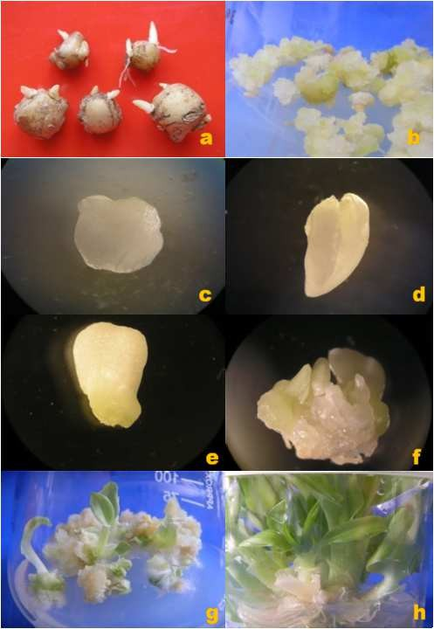

Figure1. (a) Healthy explants, (b) Induction of callus (c) Globular stage (d) Heart shape stage (e) Torpedo stage (f) Regenerating microshoot (g) Regeneration of shoots from callus and (h) Multiple shoots formation
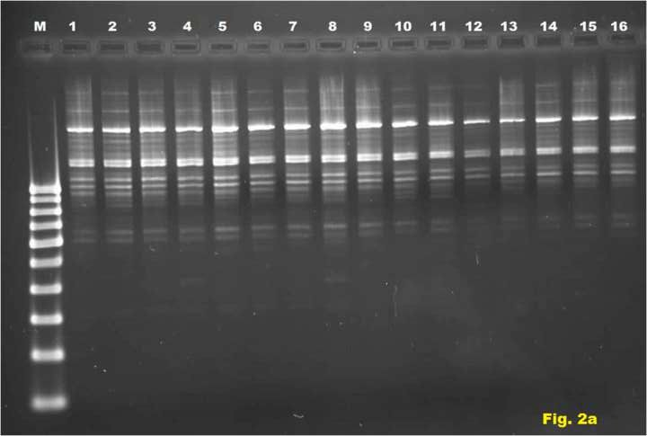

Figure 2a) RAPD profile of micropropagated Kaempferia marginata using OPAM-01. M-Marker: 1- Mother plant: 2 to 16- Regenerants from callus.
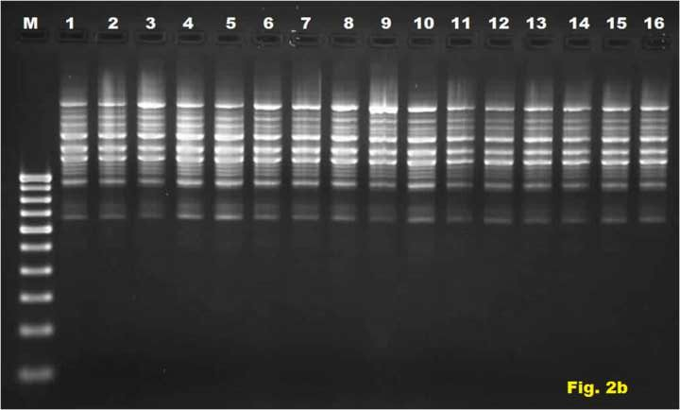

Figure 2b) ISSR profile of micropropagated Kaempferia marginata using IG-12. M-Marker: 1- Mother plant: 2 to 16- Regenerants from callus.

4. CONCLUSION
In conclusion, the present study establishes a highly efficient and reproducible protocol for the micropropagation of the endangered medicinal plant Kaempferia marginata via somatic embryogenesis. The results demonstrate that MS medium supplemented with 2.0 mgL⁻¹ NAA is optimal for the induction of embryogenic callus, while a combination of 4.0 mgL⁻¹ BAP and 1.0 mgL⁻¹ NAA maximizes shoot multiplication [(16.35 ± 0.22) shoots/explant]. Crucially, the molecular assessment using RAPD and ISSR markers confirmed that the regenerated plantlets are genetically identical to the mother plant, exhibiting 100% monomorphism. This lack of somaclonal variation validates the protocol's suitability for commercial applications where clonal fidelity is paramount. Consequently, this method provides a potent tool for the mass propagation of true-to-type elite clones, facilitating both the sustainable supply of pharmaceutical raw materials and the conservation of this valuable germplasm in its natural habitat.

COMPETING INTERESTS DISCLAIMER:
Authors have declared that they have no known competing financial interests OR non-financial interests OR personal relationships that could have appeared to influence the work reported in this paper.

Disclaimer (Artificial intelligence)
Author(s) hereby declare that NO generative AI technologies such as Large Language Models (ChatGPT, COPILOT, etc.) and text-to-image generators have been used during the writing or editing of this manuscript.

REFERENCES
Ahmed, M. R., Anis, M., Alatar, A. A., & Faisal, M. (2016). In vitro clonal propagation and evaluation of genetic fidelity using RAPD and ISSR marker in micropropagated plants of Cassia alata L.: a potential medicinal plant. Agroforestry Systems, 91(4), 637–647.
Agretious, T. K., Martin, K. P., & Hariharan, M. (1996). In vitro clonal multiplication of Alpinia calcarata Roscoe. Phytomorphology, 46(2), 133–138.
Balachandran, S. M., Bhat, S. R., & Chandel, K. P. S. (1990). In vitro clonal multiplication of turmeric (Curcuma spp.) and ginger (Zingiber officinale Rosc.). Plant Cell Reports, 8(9), 521–524.
Doyle, J. J., & Doyle, J. L. (1987). A rapid DNA isolation procedure for small quantities of fresh leaf tissue. Phytochemical Bulletin, 19(1), 11–15.
Elshamy, A. I., Singh, A., Singh, N., Singh, S., Srivastava, R. P., Singh, L., Verma, P. C., Devkota, H. P., Rahman, L., Rajak, B. K., Singh, A., & Saxena, G. (2023). The industrially important genus Kaempferia: An ethnopharmacological review. Frontiers in Pharmacology, 14, 1099523.
Goto, S., Thakur, R. C., & Ishii, K. (1998). Determination of genetic stability in long-term micropropagated shoots of Pinus thunbergii Parl. using RAPD markers. Plant Cell Reports, 18 (3), 193–197.
Goyal, A. K., Pradhan, S., Basistha, B. C., & Sen, A. (2023). Micropropagation and assessment of genetic fidelity of Dendrocalamus strictus (Roxb.) Nees using RAPD and ISSR markers. Proceedings of the National Academy of Sciences, India Section B: Biological Sciences, 93, 123–132.
Hosoki, T., & Sagawa, Y. (1977). Clonal propagation of Ginger (Zingiber officinale Rosc.) through tissue culture. HortScience, 12(5), 451–452.
Jayanthi, M., & Mandal, P. K. (2001). Plant regeneration through somatic embryogenesis and rapid analysis of regenerated plants in Tylophora indica (Burm. F. Merril). In Vitro Cellular & Developmental Biology - Plant, 37(5), 576–580.
Joshi, P., & Dhawan, V. (2007). Assessment of genetic fidelity of micropropagated Swertia chirayita plantlets by ISSR marker assay. Biologia Plantarum, 51(1), 22–26.
Kishor, R. (2012). Rediscovery of Kaempferia marginata (Zingiberaceae) after a lapse of 100 years from India. Rheedea, 22(1), 28–31.
Kudikala, H., Jogam, P., Sirikonda, A., Mood, K., & Allini, V. R. (2020). In vitro micropropagation and genetic fidelity studies using SCoT and ISSR primers in Annona reticulata L.: an important medicinal plant. Vegetos, 33, 566–577.
Lakshmi, M., & Mythili, S. (2003). Somatic embryogenesis and regeneration of callus cultures of Kaempferia galanga – medicinal plant. Journal of Medicinal and Aromatic Plants, 25(4), 947–951.
Madaka, F., & Tewtrakul, S. (2011). Anti-allergic activity of some selected plants in the genus Boesenbergia and Kaempferia. Songklanakarin Journal of Science and Technology, 33(3), 301–304.
Martin, K. P. (2003). Plant regeneration through somatic embryogenesis on Holostemma adakodien, a rare medicinal plant. Plant Cell, Tissue and Organ Culture, 72 (1), 79–82.
Martins, M., Sarmento, D., & Oliveira, M. M. (2004). Genetic stability of micropropagated almond plantlets, as assessed by RAPD and ISSR markers. Plant Cell Reports, 23(7), 492–496.
Misra, P., Datta, S. K., Johri, J. K., Singh, H. B., & Srivastava, A. (2004). An improved method for in vitro largescale propagation of Piper betle L. Journal of Plant Biochemistry and Biotechnology, 13(2), 161–164.
Murashige, T., & Skoog, F. (1962). A revised medium for rapid growth and bioassays with tobacco tissue cultures. Physiologia Plantarum, 15 (3), 473–479.
Nonthalee, S., Saensouk, S., Maneechai, S., & Saensouk, P. (2025). A tissue culture technique for rapid clonal propagation, microrhizome induction, and RAPD analysis of Kaempferia grandifolia Saensouk & Jenjittikul—a rare plant species in Thailand. Horticulturae, 11(1), 1-14
Rahman, Z. A., Ahmad, N. A. S., Basirun, N. N. A., & Othman, A. N. (2023). Regeneration of Kaempferia parviflora from Meristem through Somatic Embryogenesis. European Journal of Applied Sciences, 11(4), 84–93.
Rani, V., Parida, A., & Raina, S. N. (1995). Random amplified polymorphic DNA (RAPD) markers for genetic analysis in micropropagated plants of Populus deltoides Marsh. Plant Cell Reports, 14(7), 459–462.
Sahoo, S., Panda, S. P., Nayak, S., & Kar, B. (2023). Molecular profiling of therapeutically important Alpinia and Kaempferia species using RAPD, ISSR, and SSR markers. Vegetos, 36(1), 1–12.
Sehgal, C. B., & Syed Abbas, N. (1994). Somatic embryogenesis and plant regeneration from hypocotyl tissue of Trachyspermum ammi (L.) Sprague. Phytomorphology, 44(3-4), 265–271.
Sofiari, E., Raemakers, C., Bergervoet, J., Jacobsen, E., & Visser, R. (1998). Plant regeneration from protoplasts isolated from friable embryogenic callus of cassava. Plant Cell Reports, 18(2), 159–165.
Sunitibala, H., Damayanti, M., & Sharma, G. J. (2001). In vitro propagation and rhizome formation in Curcuma longa Linn. Cytobios, 105(409), 71–82.
Thongnest, S., Mahidol, C., Sutthivaiyakit, S., & Ruchirawat, S. (2005). Oxygenated Pimarane Diterpenes from Kaempferia marginata. Journal of Natural Products, 68(11), 1632–1636.
Tokuhara, K., & Mii, M. (2001). Induction of embryogenic callus and cell suspension culture from shoot tips excised from flower stalk buds in Phalaenopsis (Orchidaceae). In Vitro Cellular & Developmental Biology - Plant, 37(4), 457–461.
Vidya, S. M., Krishna, V., Manjunatha, B. K., & Shankarmurthy, K. (2005). Micropropagation of Entada pursaetha DC- An endangered medicinal plant of Western Ghats. Indian Journal of Biotechnology, 4 (4), 561–564.
Vishal, Sidhu, G. S., Gaikwad, P. N., Mann, S. S., Gill, M. S., & Manchanda, P. (2024). Optimized protocol for high-frequency papaya propagation: morpho-stereomicroscopic analysis and genetic fidelity assessment. Plant Cell, Tissue and Organ Culture, 156(3), 81.
Wakhlu, A. K., & Sharma, R. K. (1998). Micropropagation of Heracleum candicans Wall: a rare medicinal herb. In Vitro Cellular & Developmental Biology - Plant, 35(1), 79–80.
Williams, J. G. K., Kubelik, A. R., Livak, K. J., Rafalski, J. A., & Tingey, S. V. (1990). DNA polymorphisms amplified by arbitrary primers are useful as genetic markers. Nucleic Acids Research, 18(22), 6531–6535.
Zietkiewicz, E., Rafalski, A., & Labuda, D. (1994). Genomic fingerprinting by simple sequence repeat (SSR)-anchored polymerase chain reaction amplification. Genomics, 20(2), 176–183.
Zimmermann, J. L. (1993). Somatic embryogenesis: A model for early development in higher plants. Plant Cell, 5(10), 1411–1423.

