Original Research Article

Evaluation of fungal diseases affecting soybean varieties (Glycine max (L.) Merr.) considered disease-resistant in central Burkina Faso

Abstract
Soybean (Glycine max) is a cash crop of economic and agronomic importance in Sahelian countries due to its ability to fix atmospheric nitrogen. Researchers have developed several disease-resistant varieties, but yields remain suboptimal. This situation motivates this study, which aims to evaluate the diseases that attack resistant varieties, causing damage, in order to identify them and propose control methods. Identification was carried out at several levels: first, symptomatology, then macroscopic identification, and finally, microscopic analysis. Following these analyses, four (4) pathogens responsible for fungal diseases were identified. These fungi are Peronospora manshurica, Phomopsis sojae, Sclerotinia sclerotiorum, and Phialophora gregata, responsible respectively for downy mildew, soybean blight, sclerotinia leaf spot, and brown stem rot. Unfortunately, resistant varieties are no longer resistant to fungal diseases. Since resistance is not an indefinite process, the responsible genes will need to be re-evaluated, and environmental factors taken into account, to develop new, more resistant varieties.

Keywords: Glycine max, fungus, productivity, Burkina Faso.

1. INTRODUCTION
In sub-Saharan Africa, soybeans play a crucial role in food security as they provide an accessible source of protein for the most vulnerable populations. Environmentally, their cultivation also offers significant advantages. Soybeans benefit from the symbiotic relationship between their roots and the bacterium Rhizobium japonicum, which reduces their need for nitrogen fertilisers and helps reduce greenhouse gas emissions in crop rotation systems (Zoromé, 2017). In Burkina Faso, soybeans are cultivated in several regions; according to the INSD (2023), the Nazinon region (formerly Centre-Sud) ranks third in terms of producing agricultural households with 7.3%, after Nakambé (formerly Centre-Est) (9.0%) and the East (10.5%). According to MARAH (2023), soybean production in the country has increased over the past ten years, rising from 24,347 tons in 2012 to 106,675 tons in 2021. The area planted with soybeans has also increased, from 22,198 hectares in 2012 to 98,204 hectares in 2021.
Soybeans, despite their nutritional, economic, and environmental advantages, face numerous constraints. The main limiting factors include pests (defoliating insects, aphids, sap-sucking insects, thrips, leafhoppers, nematodes) and fungal diseases, which cause pod, seedling, and crown rot (MARAH, 2021). Climate change and poor soil quality also reduce yields (Lin et al., 2022). Identifying pathogens is an essential step in developing effective and environmentally friendly control strategies, which requires understanding host-pathogen relationships.
2. MATERIALS AND METHODS
2.1. Study Site Overview
The rural commune of Saponé, located 35 km south of Ouagadougou in the Bazèga province, comprises forty administrative villages and belongs to the Nazinon region (formerly the Centre-South region). The study was conducted in this commune, specifically in the village of Baguemnini. The choice of the commune of Saponé is justified by the fact that it constitutes an important soybean production area, where many farmers cultivate soybeans but still face significant biotic constraints, particularly disease pressure, which limits yields. It is characterized by a Sudano-Sahelian climate marked by a Sahelian influence, with annual rainfall between 600 and 900 mm, concentrated over four to five months (FiBL, 2025). This rainfall pattern strongly influences local rainfed agriculture. The climate alternates between a rainy season from May to October, dominated by the monsoon, and a dry season from November to April, marked by the Harmattan winds from the Sahara (INSD, 2022). The vegetation is representative of the Sudanian wooded and shrubby savanna and is structured into agroforestry parks dominated by shea (Vitellaria paradoxa) as well as Fabaceae such as Pterocarpus erinaceus (Ganaba et al. 2005, Compaoré et al. 2021). As for the local fauna, it is composed of small and medium-sized species, including rodents (Mastomys natalensis), hares (Lepus victoriae), mongooses (Herpestes ichneumon), a diverse avifauna, as well as various reptiles and amphibians (Diblioni et al. 2011). Hydrographically, the commune is part of the Volta basin, shared between the Nakambé (white Volta) and the Nazinon (red Volta).
2.2. Plant material
The plant material consists of leaves, stems, and pods at different growth stages of four (04) soybean varieties produced and developed in research centers in Burkina Faso: G196, G197, G115, and TGX 1987-10F. These varieties are the most widely produced in several agro-ecological zones and are resistant to various diseases.
G196
The G196 soybean variety has a short to medium growing cycle, well-suited to Sahelian zones, and good phenological plasticity, allowing for strong performance at both the beginning and end of the season (Zoromé, 2017). Its water requirements range from 450 to 650 mm, with high sensitivity to water stress during flowering and pod filling (FAO, 2016). Yields reach 1.5 to 2.5 t/ha under standard farming conditions and more than 3 t/ha under optimal conditions (Thio et al., 2022). G196 exhibits good tolerance to foliar diseases but remains susceptible to root rot in poorly drained soils (Konaté et al., 2019).
G197
The G197 variety has an average growing cycle of 90 to 110 days, depending on growing conditions (Ouedraogo et al., 2022). Its water requirements, similar to those of early-maturing varieties, range from 500 to 700 mm, with slight drought tolerance thanks to its deep root system. Yields reach 2 to 3 t/ha, making it a suitable variety for commercial production (Thio et al., 2022). It tolerates cercospora leaf spot but remains susceptible to bacterial pustule, requiring monitoring (Konaté et al., 2019). Good nutrition in calcium, magnesium, and trace elements enhances its resistance (Graham, 2000).
G115
The G115 variety is an early-maturing variety with a growing cycle of 80 to 95 days, adapted to areas with a short rainy season (Zoromé, 2017). It requires 450 to 550 mm of rainfall, making it advantageous in areas with high rainfall variability (FAO, 2016). Its yield ranges from 1.2 to 2 t/ha, and its earliness sometimes allows for double cropping (Ouedraogo et al., 2022). It exhibits good tolerance to root diseases such as Fusarium wilt, thanks to a vigorous root system, but remains susceptible to foliar diseases at the end of the growing cycle, particularly Cercospora leaf spot and powdery mildew (Kebede et al., 2024).

TGx 1987-10F
The TGx 1987-10F variety is an early to mid-early maturing line, with a growing cycle of 89 to 97 days, adapted to areas with short or irregular rainy seasons (Tefera et al., 2015). It requires 450 to 550 mm of water, particularly during the flowering-pod-filling stages (FAO, 2016). Its yield varies between 1.5 and 2.0 t/ha thanks to good nodulation and consistent pod production (IITA, 2018). Tolerant to Asian rust and cercospora leaf spot (Konaté et al., 2019), it remains, however, vulnerable to root diseases and prolonged water deficits, which affect pod filling (Kebede et al., 2024).
2.3. Sampling and Collection Methods
Samples were collected from blocks exhibiting foliar symptoms. Each sample consisted of several leaves, placed in a transparent bag, and then labeled. Upon arrival at the laboratory, an initial sorting took place. Subsequently, only samples showing severe and clearly visible symptoms were retained for incubation.
2.4. Preparation of the Culture Medium
PDA (Potato-Dextrose-Agar) culture medium was used for the isolation of fungi. In the case of certain obligate parasites, direct observations were made under a microscope. The culture medium was prepared by taking 39 g of synthetic PDA powder, weighing it using an electronic balance, and adding it to 1 liter of distilled water in a jar. The mixture was stirred to obtain a homogeneous solution. The jar was then placed in an autoclave at a pressure of 1 bar and 121 °C for 15 minutes. The jar was removed from the autoclave and cooled to between 45 °C and 50 °C to prevent condensation. Finally, the medium was transferred under a sterile fume hood into sterile 9 cm diameter Petri dishes, adding approximately 15 ml of medium per dish.
2.5. Incubation
The samples were first washed thoroughly under running water. They were then cut into small fragments of approximately 25 mm² (5 mm on each side), selecting areas close to the spots or lesions, near necrotic zones (Moreau-Moulds, 1991). These fragments were then disinfected for a few seconds in a 2% sodium hypochlorite solution, followed by 30 seconds of rinsing with sterile distilled water. This rinsing was repeated three times to remove as much sodium hypochlorite as possible. This disinfection process eliminated exogenous microflora. Afterwards, the fragments were placed on sterile Watmann filter paper to dry for 30 seconds under a fume hood. Finally, the cut fragments were placed on culture media prepared beforehand in Petri dishes. The incubation was done under alternating light (12h) and darkness (12h) to induce better fungal development.
2.6. Isolation
After colony development during incubation, successive subculturing was carried out under the same conditions to obtain pure colonies in Petri dishes. The pure colonies obtained using the Moreau-Moulds method (1991), which consisted of taking a thin portion of the mycelium with a scalpel blade and then depositing it in a new Petri dish containing a PDA-based medium, were subjected to macroscopic and microscopic identification.
2.7. Symptomatology
Symptomatology consists of the study of symptoms. Symptoms are the visible manifestation of disease. They are characterized by changes in different parts of the plant, such as leaves and stems. Several symptoms are characteristic of diseases. Necrosis is the death of cells, chlorosis is the degradation of chlorophyll, wilting is the loss of turgor, and yellowing is a color change. Galls and many other symptoms can also appear on the plant.
2.8. Macroscopic Identification
Macroscopic identification of fungi is performed by observing pure colonies with the naked eye after successive subculturing on culture medium. Two criteria are considered: the appearance and color of the colonies. The first criterion is based on the appearance of the colonies, which may appear downy, woolly, cottony, velvety, powdery, or granular. As for the second criterion, color, the most common colors are white, cream, yellow, orange, brown, and even black. The pigments may be localized within the mycelium or diffused throughout the culture medium (Boton et al., 1990).
2.9. Microscopic Identification
Microscopic examination consisted of using a scalpel to remove a thin portion of mycelium from a cultured colony and placing it on a slide with a drop of sterile water. Observation under 40x and 100x objectives (400x and 1000x magnification) allowed for the distinction of the main morphological elements, including the presence of spores (shape, size, color) and the structure of the hyphae (presence or absence of septa), in accordance with the identification keys proposed by Barnet and Hunter (1987).

3. RESULTS
3.1. Symptomatology
Collecting samples on-site allowed for an inventory of the main fungal diseases affecting soybeans. These four (4) diseases attack different parts of the plants, including leaves, stems, and pods. Symptoms manifest in various forms: necrotic spots scattered along the leaf (Photo 1), necrosis (Photo 2), whitish rot on the stem and pods (Photo 3), and chlorosis of the veins and leaf blade (Photo 4). All of these manifestations contribute to a decrease in photosynthetic activity.
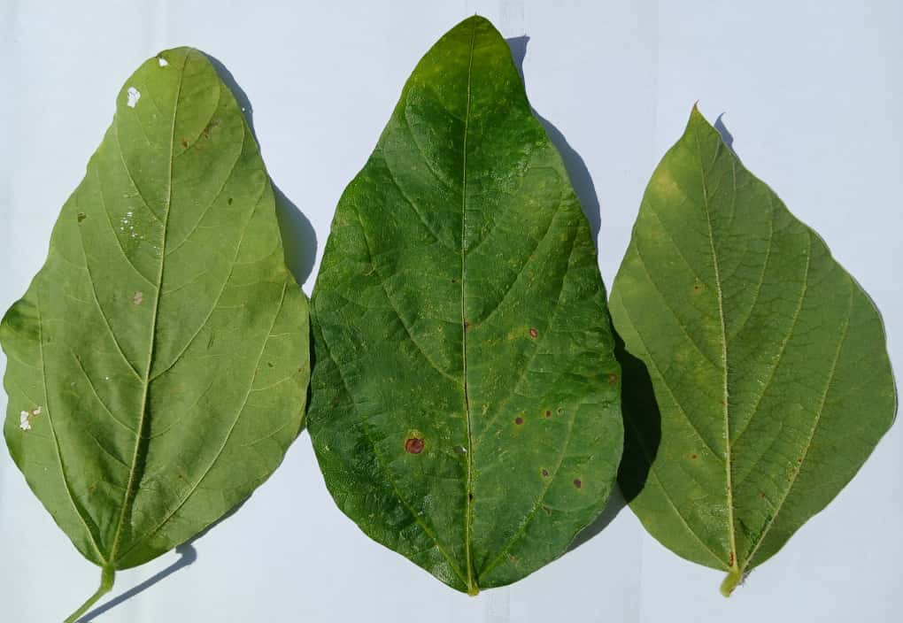  Photo 1: Brownish, rounded, and scattered necrotic spots | 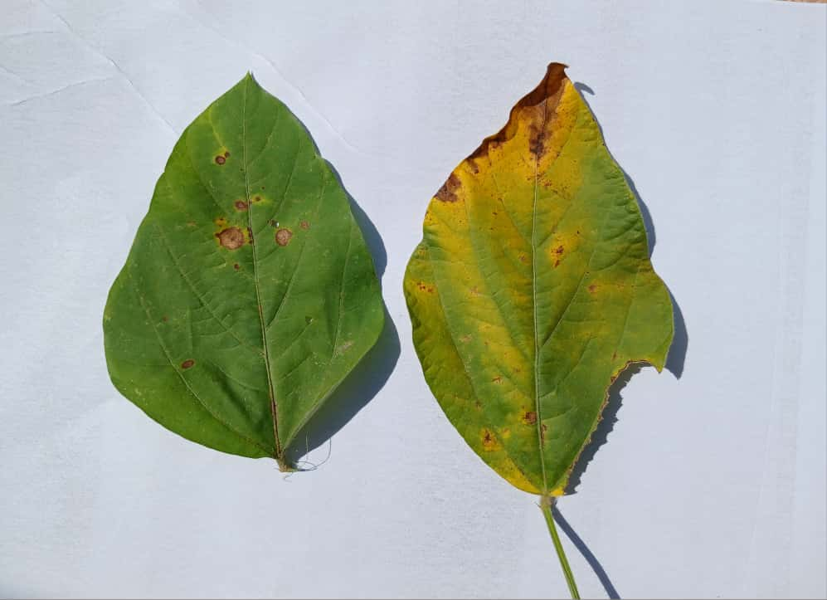  Photo 2: Necrosis followed by desiccation
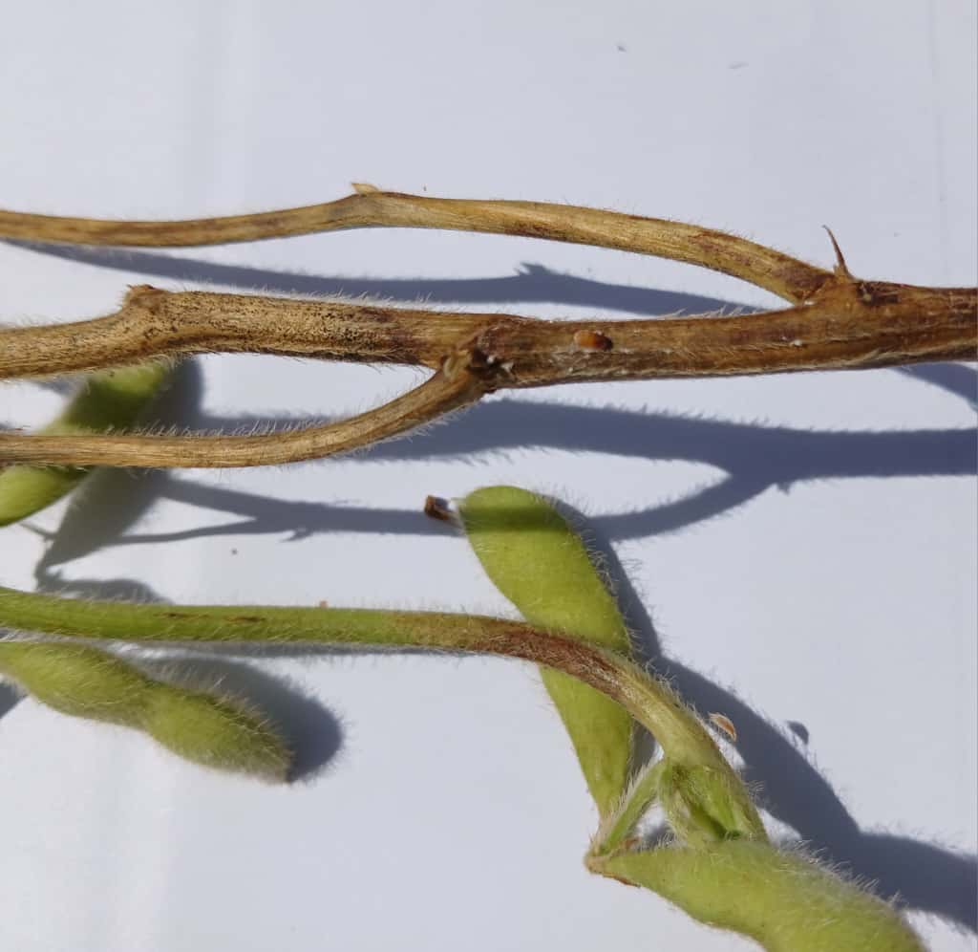  Photo 3: Whitish rot on the stem and pods | 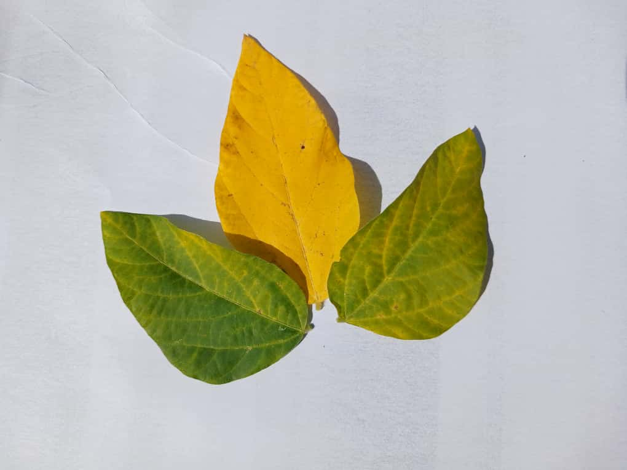  Photo 4: Chlorosis of the veins and leaf blade

3.2. Identification
Macroscopic and microscopic identifications allowed for the identification of four (4) pathogens. These fungi were observed on samples composed solely of leaves.
Downy Mildew
Peronospora manshurica on PDA develops a white, filamentous colony (Photo 5). However, it has a black underside. Observations were made 11 days after subculturing. Under the microscope, Peronospora manshurica exhibits septate mycelium (Photo 6). The spores are oval-shaped (Photo 7).

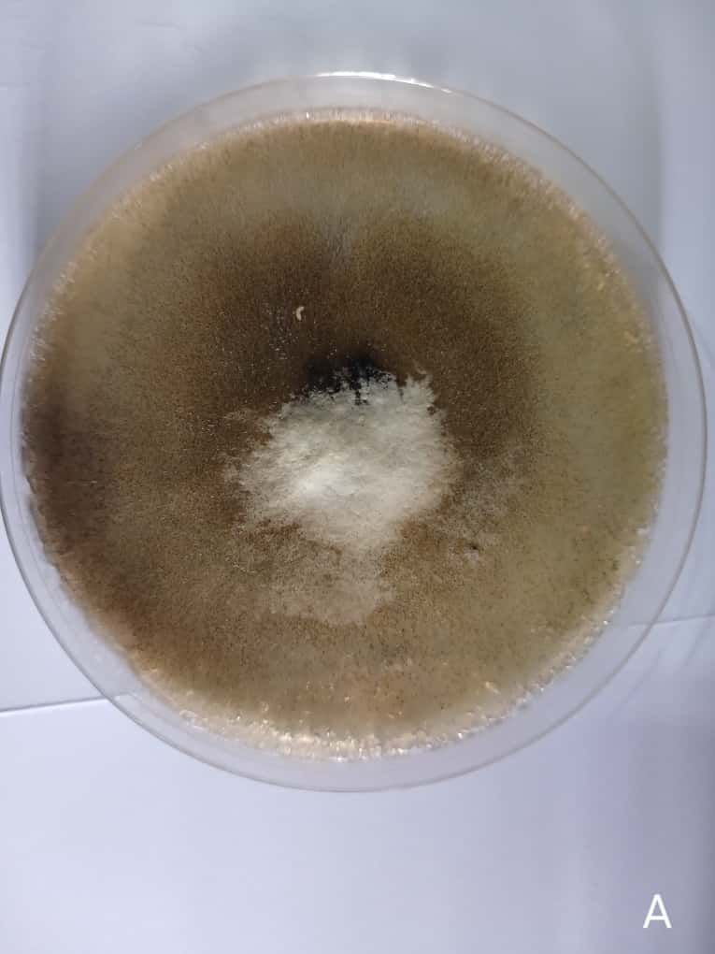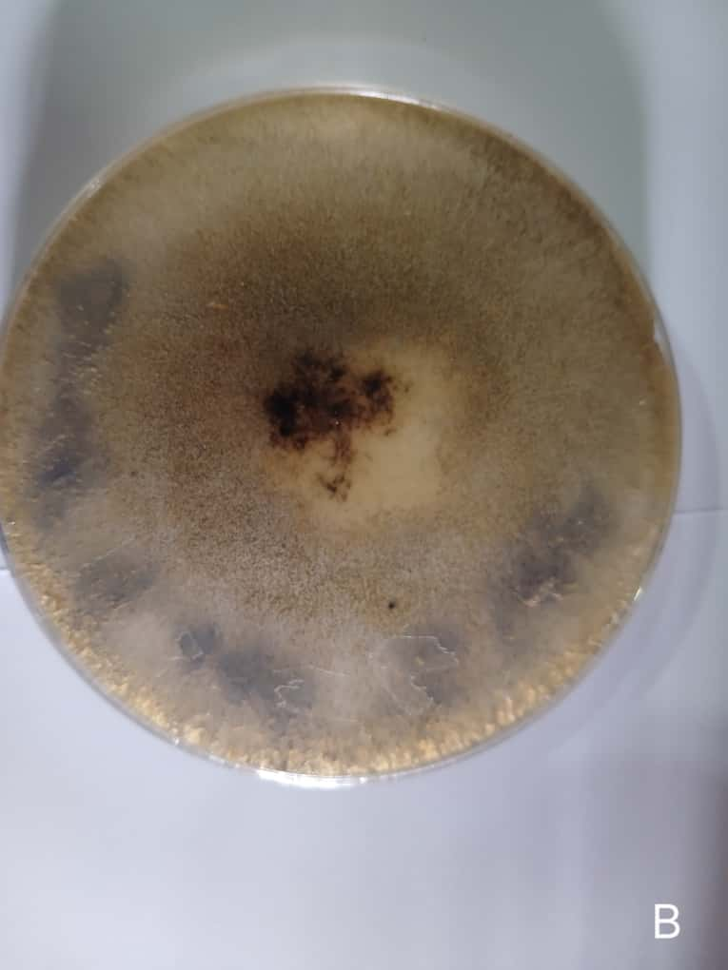
Photo 5: Peronospora manshurica on culture medium (A: upper surface), (B: lower surface)

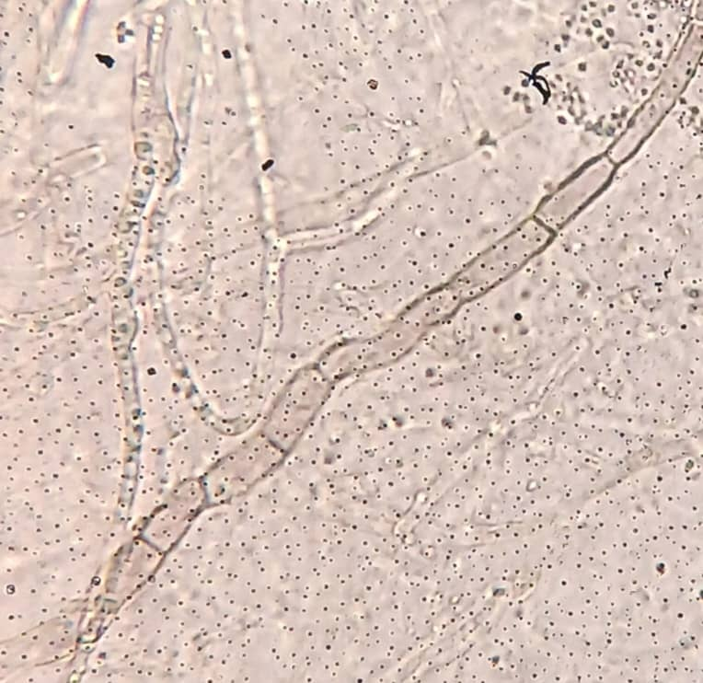  Photo 6: Mycellium of Peronospora manshurica (G X 100) | 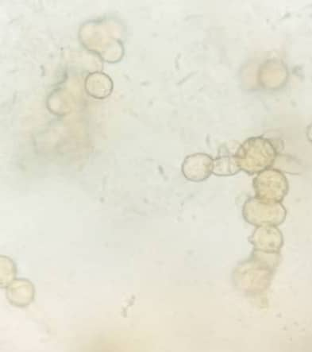  Photo 7: Spores of Peronospora manshurica (G X 100)

Soybean blight
The pathogen that causes soybean blight on culture medium (PDA) presents as a whitish colony (Photo 8), with a cottony appearance and rounded ends. It occupies half of the Petri dish without staining the culture medium. In fact, the upper and lower surfaces are the same creamy-white color. Under the microscope, Phomopsis sojae develops a septate mycelium (Photo 9). The spores (Photo 10) are hyaline and spindle-shaped.
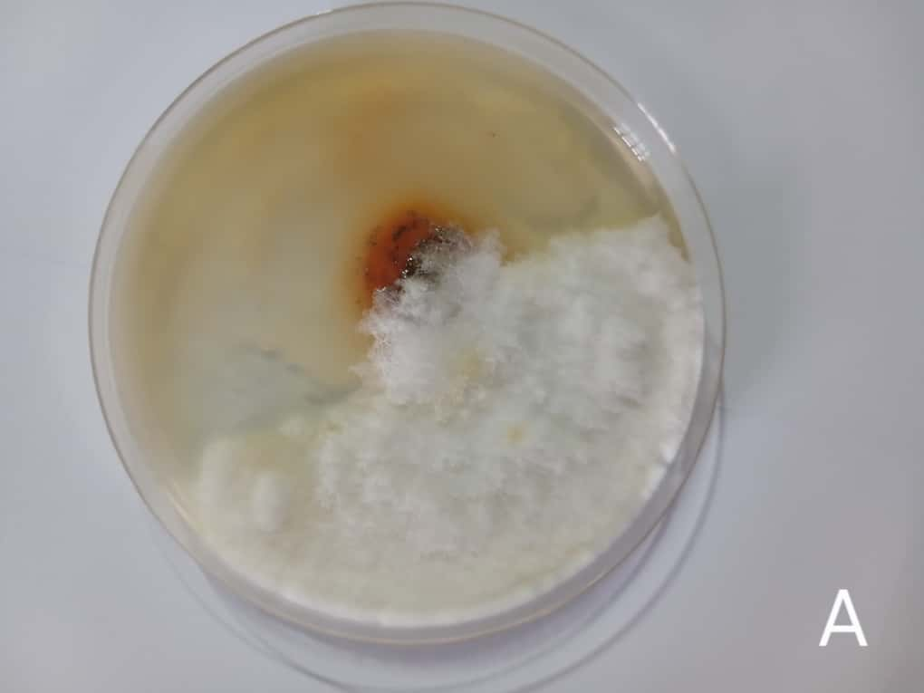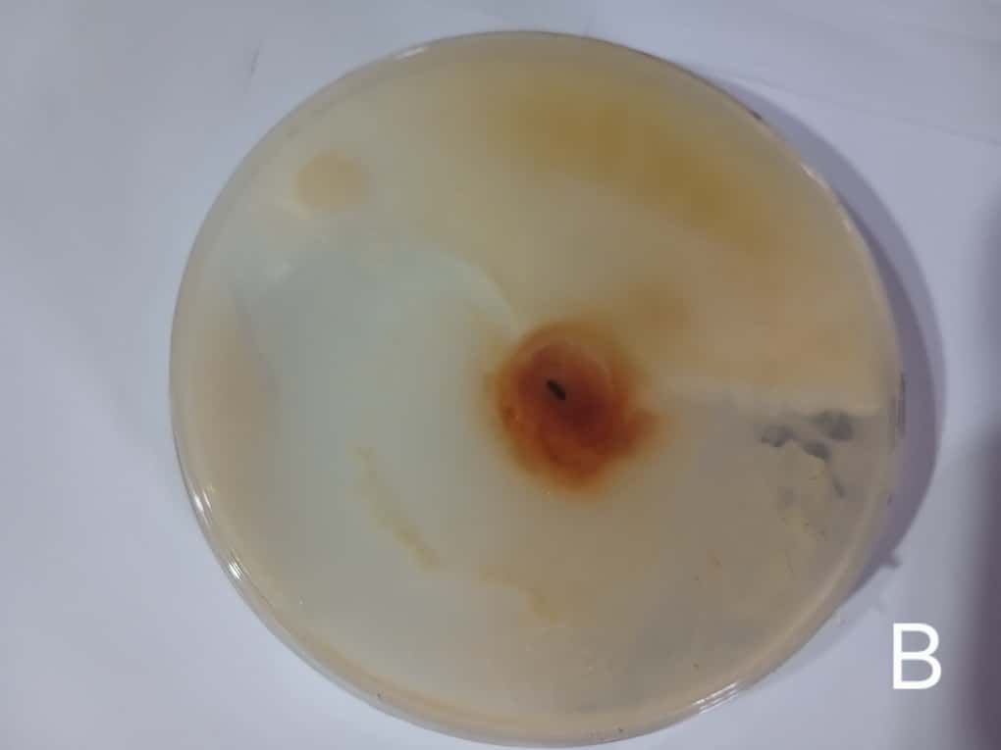

Photo 8: Phomopsis sojae on culture medium (A: upper surface), (B: lower surface)
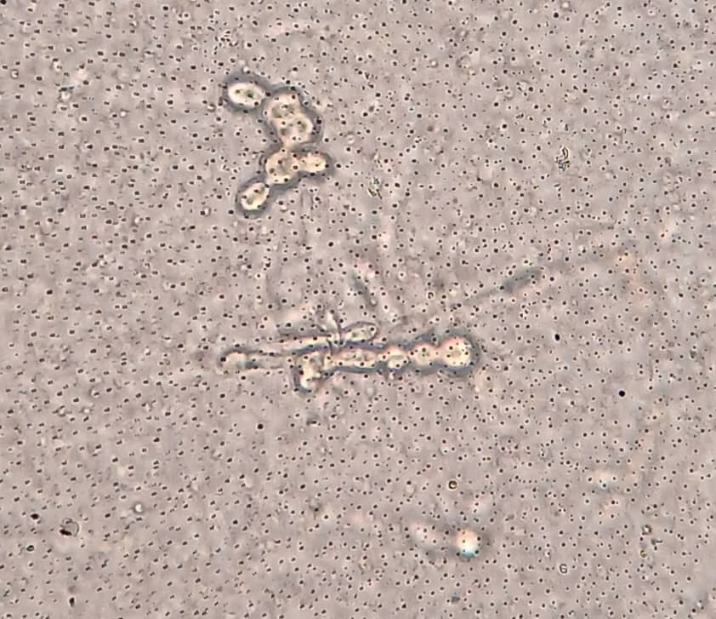  Photo 9: Phomopsis sojae spores (G X 40) | 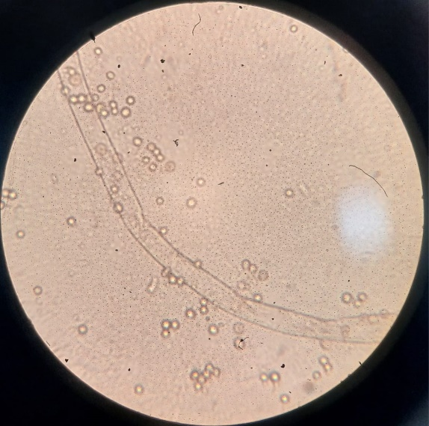  Photo 10: Phomopsis soya mycelium (G X 100)

Sclerotinia infection
The fungus develops a brownish colony (Photo 11) on the Petri dish. It has a filamentous appearance with a creamy center. The upper surface is brown and the lower surface black with a whitish center. Sclerotinia sclerotiorum has a septate (Photo 12), hyaline, and abundant mycelium that branches within the infected tissues. The spores (Photo 13) are unicellular and ellipsoidal.
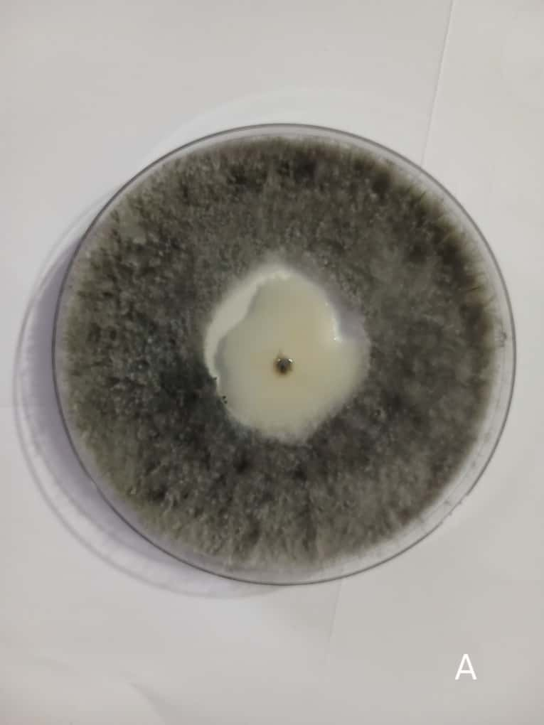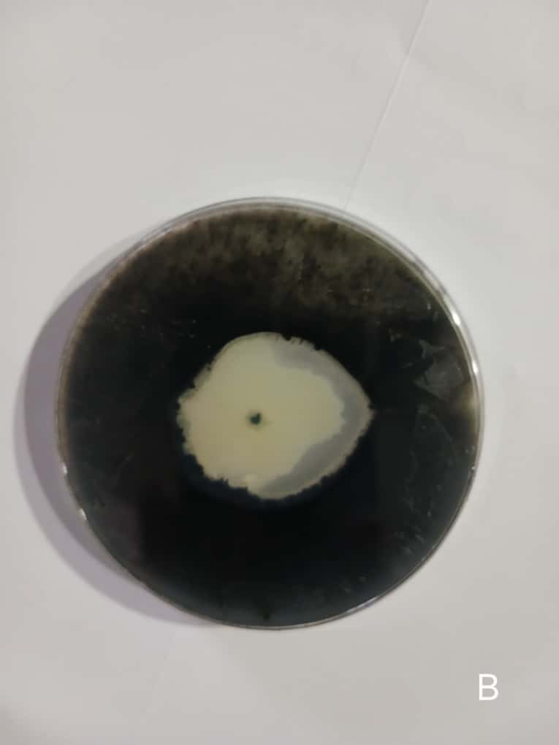
Photo 11: Sclerotinia sclerotiorum on culture medium (A: upper surface), (B: lower surface)
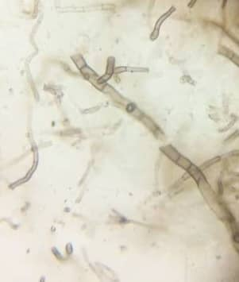  Photo 12: Mycelium of Sclerotinia sclerotiorum (G x 100) | 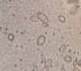  Photo 13: Sclerotinia sclerotiorum spores (G x 100)

Brown stem rot
Phialophora gregata, when grown on culture medium, develops a black colony (Photo 14) that is initially centered and then reduced to the edges. It has a cottony appearance with rounded ends, is colorless on the culture medium, and both sides are the same color. Phialophora gregata is distinguished by its septate mycelium (Photo 15). The spores are circular to rounded (Photo 16).
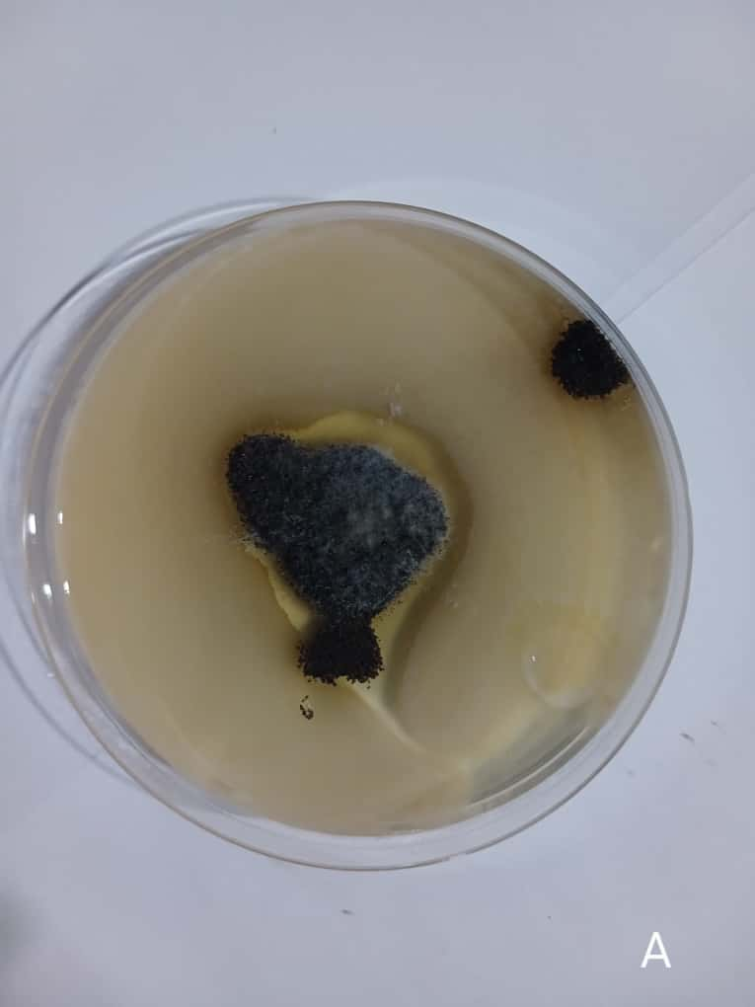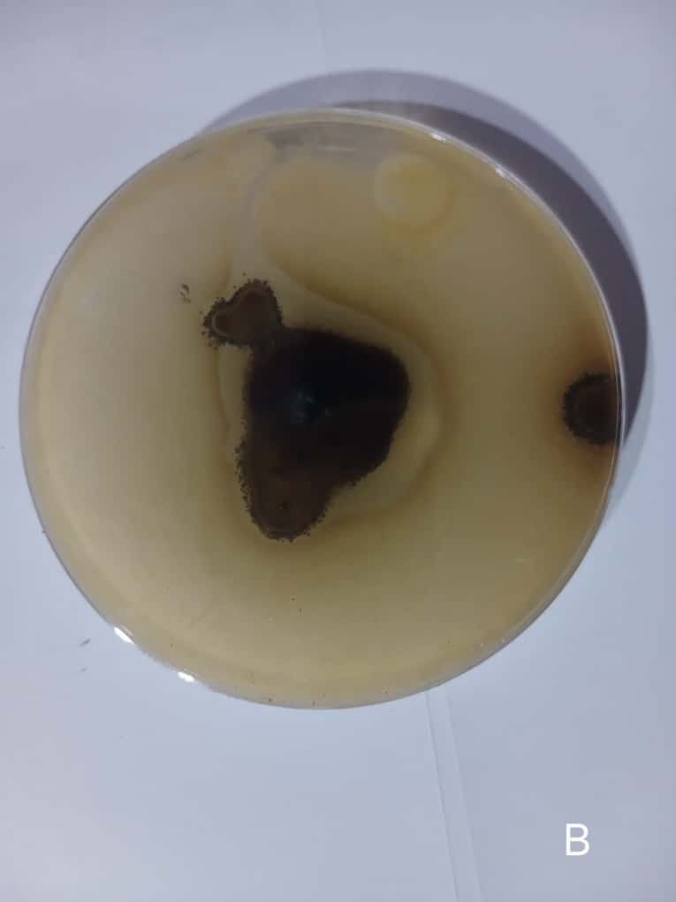

Photo 14: Phialophora gregata on culture medium (A: upper surface), (B: lower surface)
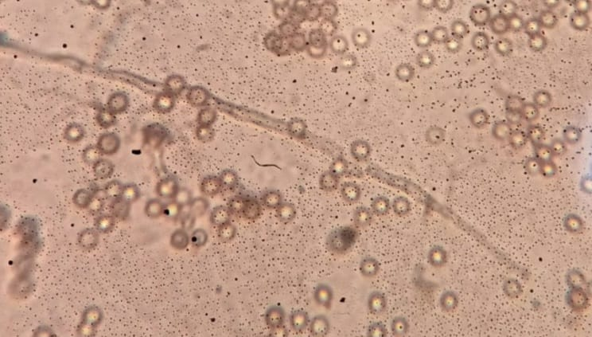  Photo 15: Mycelium of Phialophora gregata (G X 100) | 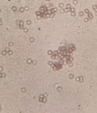  Photo 16: Spores of Phialophora gregata (G X 100)

4. DISCUSSION
Cultural and microscopic observations identified four fungal pathogens responsible for various soybean spoilage: Peronospora manshurica, Phomopsis sojae, Sclerotinia sclerotiorum, and Phialophora gregata. These species exhibit distinct characteristics both in culture media and under the microscope, reflecting their morphological and ecological diversity.
Peronospora manshurica develops a white, filamentous colony on PDA medium, with a black underside observed on the 11th day after subculturing. This pigmentation of the reverse side indicates intense metabolic activity, characteristic of slow-growing oomycetes. Under the microscope, the mycelium appears septate, and the oval-shaped spores are typical of the genus Peronospora, known to cause soybean downy mildew. These morphological structures confirm the descriptions of Chambar (2019), Childs et al. (2018) and Faria and Inacio (2023), who report that P. manshurica produces ellipsoid conidia responsible for chlorotic spots on the leaves.
Regarding Phomopsis sojae, the agent of soybean blight, the colony observed on PDA is whitish, cottony in appearance, and occupies half of the Petri dish without staining the medium. Both sides exhibit a uniform creamy-white hue, indicating homogeneous mycelial growth. Microscopic examination reveals septate mycelium and hyaline, spindle-shaped spores, typical of the conidial forms of the genus Phomopsis. These observations corroborate the results of Amaroli and Garnier (2024), Dong et al. (2018) and Li et al. (2025), who describe Phomopsis sojae as a moderately growing fungus producing spindle-shaped, translucent pycnidiospores responsible for stem and pod rot.
Sclerotinia sclerotiorum, on the other hand, presents a brownish, filamentous colony with a creamy center and a black underside. These characteristics indicate the progressive formation of sclerotia, the species' typical storage organs. The septate, hyaline, and branched mycelium is abundant in infected tissues, reflecting a strong capacity for cellular invasion. The unicellular, ellipsoidal spores conform to the classic descriptions of Solene (2024) and Khori et al. (2023), which associate S. sclerotiorum with soybean sclerotinia rot, a disease responsible for white rot and severe wilting.
Finally, Phialophora gregata is distinguished by a dense, centrally located black colony with a cottony appearance at the tips, occupying a colorless medium. This morphology is characteristic of fungi responsible for vascular brown rot. Under the microscope, the mycelium is septate, thin, and hyaline, while the spores are circular to rounded, sometimes clustered. These observations confirm those of Richard et al. (2023), Lin et al. (2022) and Wang et al. (2024), who described P. gregata as the causal agent of soybean stem brown rot, a slow-progressing systemic disease affecting vascular tissues and reducing sap translocation.
Overall, the analysis of the morphological and cultural characteristics of the four isolated fungi reveals significant fungal diversity affecting soybeans. Differences in colony color, texture, and shape, as well as spore morphology, are essential identification criteria. These pathogens, although distinct, share a septate mycelium, indicating their membership in the Ascomycetes or closely related Oomycetes. Their simultaneous presence on soybeans underscores the complexity of pathogen-host interactions and the importance of an integrated approach combining morphological, molecular, and cultural diagnostics for accurate identification.

5. CONCLUSION
The results of this study have led to a better understanding of fungal diseases affecting soybean production in Saponé. Four pathogens were isolated and identified: Peronospora manshurica, Phomopsis sojae, Sclerotinia sclerotiorum, and Phialophora gregata, confirming that several fungal diseases constitute a major constraint to soybean cultivation in Burkina Faso. These pathogens, responsible for a variety of symptoms, significantly affect yield. Regarding disease resistance, all varieties exhibited symptoms to varying degrees.
Disclaimer (Artificial intelligence)
Author(s) hereby declare that NO generative AI technologies such as Large Language Models (ChatGPT, COPILOT, etc.) and text-to-image generators have been used during the writing or editing of this manuscript.

REFERENCES
Amaroli, E., and Garnier, J.F. 2024. Soybeans: Why are mirror measures necessary to protect the environment, health, and farmers? Agriculture case study. 16p. https://www.veblen-institute.org/IMG/pdf/mm-etude-soja.pdf.
Barnett, H.L., Hunter, B.B. 1987. Illustrated genera of imperfect fungi. Fourt edition. 240p. https://fr.scribd.com/document/325199387/Barnett-Hunter-Illustrated-Genera-of-Imperfect-Fungi
Chambert, C. 2019. Soybeans in crop rotation. Terres Inovia, https://www.terresinovia.fr/web/guest/-/le-soja-dans-la-rotation-culturale?inheritRedirect=true&redirect=%2Fweb%2Fguest%2Frecherche%3Fq%3Dsoja
Chevalier, D., Debeuf, C., Joubrel, G., Kocken, M., and Planchenaul, N. 2016. Soybean foods: consumption in France, nutritional qualities, and recent scientific data on health. Research Article Dossier. 23(4)D405. DOI: 10.1051/ocl/2016025.
Compaore, S., Belemnaba, L., Hounkpevi, A., Idohou, R. ; Zerbo, I., Ouedraogo, S., Thiombiano, A. 2021. Diversity of plants used in the management of hypertension by three associations of traditional healers along a climate gradient in Burkina Faso. Advances in Traditional Medicine, 21. DOI: 10.1007/s13596-020-00495-x.
Childs, S. P., Buck, J. W., & Li, Z. (2018). Breeding soybeans with resistance to soybean rust (Phakopsora pachyrhizi). Plant Breeding, 137(3), 250–261. https://doi.org/10.1111/pbr.12595.
Diblioni, O.T., Millogo, A.N., Ouedraogo, A.J., Guenda, W., and Vermeulen, C. 2011. Faunal diversity and distribution of poaching activities in the Mare aux Hippopotames Biosphere Reserve in Burkina Faso. Int. J. Biol. Chem. Sci. 5(5): 1813-1827. DOI: http://dx.doi.org/10.4314/ijbcs.v5i5.5.
Dong, H., Shi, S., Zhang, C., Zhu, S., Li, M., Tan, J., Yu, Y., Lin, L., Jia, S., Wang, X., Wu, Y., & Liu, Y. (2018). Transcriptomic analysis of genes in soybean in response to Peronospora manshurica infection. BMC Genomics, 19(1), 1–13. https://doi.org/10.1186/s12864-018-4741-7
FAO., 2016. Soil and Crop Water Management. Food and Agriculture Organization of the United Nations.
Faria, C.M.X., Carlos Antonio Inácio, C.A. 2023. Considerations about gender Colletotrichum. Annual review of plant pathology. 29 : 131-147. doi: 10.31976/0104-038321v280006.
FiBL, 2025. Organic Soybean Cultivation. Fact Sheet 2025, Swiss Edition, No. 1834. https://orgprints.org/id/eprint/56433/
Ganaba, S., Ouadba, J.M., Bognounou, O. 2005. Traditional exploitation of spontaneous plants in the Sahelian region of Burkina Faso. International Journal of Environmental Sciences. https://doi.org/10.4000/vertigo.2783.
INSD, 2023. Statistical Yearbook for the Central Region. Avenue Pascal ZAGRE, Ouaga 2000, 01 BP 374 Ouagadougou 01, BURKINA FASO; Website: www.insd.bf. http://cns.bf/IMG/pdf/dr-est_annuaire_statistique_2023_de_la_region_du_centre.pdf. 191p.
INSD, 2022. Overview of Economic Trends. Avenue Pascal ZAGRE, Ouaga 2000, 01 BP 374 Ouagadougou 01, BURKINA FASO; Website: www.insd.bf; Email: xxx@yahoo.fr. https://www.insd.bf/sites/default/files/2023-03/Note_conjoncture_2022T3.pdf.
Kebede, A.A., Kendeya, Y.B., & Araya, G., 2024. An Evaluation on Cultivation Process of Soya Bean Varieties for Yield and Shattering Character at Moisture Stress Area in Western Tigray, Ethiopia. Asian Journal of Plant and Soil Sciences. 9(1) : 57-65. https://doi.org/10.56557/ajopss/2024/v9i1106.
Konaté, A., Sawadogo, W., & Nana, R., 2019. Agronomic and sanitary evaluation of improved soybean varieties in the Sudanian-Sahelian zones of Burkina Faso. African Journal of Agronomy, 12(2), 55–67.
Khori A., Suryati T., Suratman S ., 2023. Detection or Peronospora manshurica in imported soyben and analysis of oospore viability in storage warehouses in ternate City, Indonesia .Ilm. Pertan., 20 (1) 41-50. https://doi.org/10.31849/jip.v20i1.10831
Li Y, Liu J, Shi F, Ma L, Zhang Y, Yu L, Meng Q. 2025. Epidemiology of sclerotinia stem rot and efficacy of integrated control measures for soybean in Northeast China. Front Plant Sci. doi: 10.3389/fpls.2025.1679911.
Lin, F., Satish, S., Caio, C., Vieira, C., Paulo, M., Silva, D., Rojas, A., Lee, D., Liu, N., Mariano, E., Lee, P. Y., Dong, Z., Baldin, J., Leonardo, P., Ploper, D., Rupe, J., Chen, P., Wang, D., Nguyen, H. T., Lee, D. (2022). Breeding for disease resistance in soybean : a global perspective. In Theoretical and Applied Genetics, 135, 3773-3872. https://doi.org/10.1007/s00122-022-04101-3
MARAH, 2023. Yearbook of agricultural, pastoral, and fisheries statistics. http://www.insd.bf/n/index.php/publications?id=36. https://earlywarning.usgs.gov/fews/datadownloads/East%20Africa/eMODIS%20NDVI%20C6.
MARAH, 2021. Yearbook of agricultural, pastoral, and fisheries statistics. http://www.insd.bf/n/index.php/publications?id=36. https://earlywarning.usgs.gov/fews/datadownloads/East%20Africa/eMODIS%20NDVI%20C6.
Moreau-Moulds, C., 1991. Techniques of analyses and control in the food industries.Microbiological control. B.E.D.M. Gembloux.
Ouédraogo, E.R., Konaté, K., Sanou, A., Sama, H.; Compaoré, E.W.R., Sytar, O., Hilou, A., Brestic, M., Dicko, M.H. 2022. Assessing the Quality of Burkina Faso Soybeans Based on Fatty Acid Composition and Pesticide Residue Contamination. Molecules, 27, 6260. https:// doi.org/10.3390/molecules27196260.
Richard, D., Leimbrock-Rosch, L., Keßler, S., Stoll, E., Zimmer, S. 2023. Soybean yield response to different mechanical weed control methods in organic agriculture in Luxembourg. Eur J Agron 147: 126842. https://doi.org/10.1016/j.eja.2023.126842.
Solene, D., 2024. Feasibility study and adaptation of technical approaches for organic soybean and chickpea cultivation in Brittany, in a context of climate change. Master's thesis, Agro Rennes-Angers Institute, 72 pp. https://dumas.ccsd.cnrs.fr/dumas-04836066v1/file/2024_David_Sol%C3%A8ne_SIV.pdf.
Tefera, A., Kamara, A.Y., & Idah, M., 2015. Performance and adaptation of promiscuous soybean genotypes in the tropical savannas of West Africa. Journal of Crop Improvement, 29(1), 1–15.
Thio, I. G., Ouédraogo, N., Drabo, I., Serréme, P. A. E. D., & others., 2022. Evaluation of medium maturity group of soybean (Glycine max L. Merr.) for agronomic performance and adaptation in Sudanian zone of Burkina Faso. African Journal of Agricultural Research, 18(4), 264‑275.
Wang S-Y, Jiang Y-H, Chen X, Herrera-Balandrano DD, Simoes MF, Shi X-C, Laborda P. 2024. Biocontrol strategies for the management of Sclerotinia sclerotiorum in Brassica species: A review. Physiol Mol Plant Pathol. 114(7):1447-1457. doi: 10.1094/PHYTO-01-24-0006-RVW.
Zoromé, I., 2017. Evaluation of the agronomic and morphological values ​​of new early soybean varieties in Burkina Faso. Doctoral thesis, Nazi Boni University, Bobo-Dioulasso, Burkina Faso, 65 p.

