Original Research Article

“Optimized In Vitro Micropropagation Protocol for Acorus calamus L. Using Rhizome Explants.”

ABSTRACT: The present investigation has been conducted on “In-vitro micro propagation of Acorus calamus L. using rhizome explants”. This study was undertaken to identify a suitable media combinations for the micro propagation of Acorus calamus L. The authenticated mother plant of Acorus calamus L. was collected from the Dhanvantari Nursery, Kedgaon. Tal - Nagar, Dist.- Ahilyanagar (Maharashtra). The surface sterilization treatments of 0.1% Bavistin along with 0.1% HgCl₂ and 70% ethanol were found effective for Acorus calamus L. The MS media supplemented with different concentrations of BAP was utilized for initiation. MS medium supplemented with 2.0 mg/L, 2.5 mg/L and 3.0 mg/L BAP shows the maximum direct regeneration. Then the well grown cultures were transferred to the new medium with different concentration of BAP and NAA. The Multiplication of shoots using 3.0 mg/L BAP + 3.0 mg/L NAA provided the highest multiplication rate, with increased number of shoots per explant. Following successful multiplication, the shoots were moved to MS media with varying IBA concentrations (1.0 mg/L and 1.5 mg/L). Both treatments showed significant rooting, with 1.5 mg/L IBA showing the greatest root length and density. These conditions collectively support efficient clonal propagation and hold promise for scalable production and germplasm conservation of Acorus calamus L. Future work could focus on improving acclimatization and field performance.
Keywords: Acorus calamus, in vitro micropropagation, mother plant, Bavistin, MS media.

1. Introduction
Acorus calamus L., commonly known as Vekhand or Sweet Flag, is a perennial, semi-aquatic herb belonging to the family Acoraceae(Ahmed et. al. 2007). It typically thrives in wetlands and marshy habitats of temperate to subtropical regions and is native to India, with wide distribution across Asia, Europe, and North America. (Verma S., and Singh N., 2012) The plant features sword-shaped leaves arising from a branched underground rhizome, which is the primary source of its medicinal properties.
Acorus calamus has been used in Ayurveda, Unani and traditional Chinese medicine. Its rhizomes contain essential oils and α-asarone, β-asarone etc. that confer to it various antimicrobial, anti-inflammatory, analgesic, neuroprotective, antioxidant, and insecticidal activities (Zuba D, Byrska B, 2012). It has been used medicinally to heal everything from asthma and bronchitis, to digestive problems, epilepsy and memory loss. In addition, it is used in perfume and cosmetic industry for its good fragrance. It makes a good addition to other tonics and stimulants. It is a traditional source of medicine for colds, coughs and other respiratory problems, such as bronchitis. It is also used as a cough syrup (Babar et al., 2020). Several traditional names have been associated with sweet flags. Long used by indigenous societies around the world as evidenced by its many names. Calamus, myrtle, myrtle grass, myrtle sedge, cinnamon sedge, gladdon, sweet rush, sweet root, sweet cane, flag root, myrtle flag and sweet cinnamon are just some of the vernacular names (Grieve, 1971). Volatile-oil fragrance is due to aromatic substances, namely asarone in leaves and arylaldehyde in roots. (Altaf et. al. 2010).
Acorus calamus has a great number of medicinal and economic applications, but it has a limitation in its cultivation. The propagation of this species is mostly asexual, via rhizome pieces, consequently with low multiplication rates and high risk of pathogen spread, especially bacterial diseases as leaf blight and rot. In addition, habitat destruction and overharvesting have resulted in a decline of natural populations.
To overcome these limitations, plant tissue culture techniques—particularly micropropagation—offer a promising solution. Micropropagation is a method of clonal propagation under sterile, in vitro conditions that enables the rapid multiplication of genetically uniform and disease-free plantlets. This technique is particularly beneficial for medicinal plants like Acorus calamus, where consistent phytochemical composition and large-scale propagation are crucial for pharmaceutical applications. (Meetei, 2024)
The present study aims to establish a reliable and efficient micropropagation protocol for Acorus calamus using shoot tip and rhizome explants. By optimizing culture media and growth regulator combinations, this research intends to facilitate large-scale production, aid in conservation efforts, and support commercial cultivation of this valuable medicinal herb.
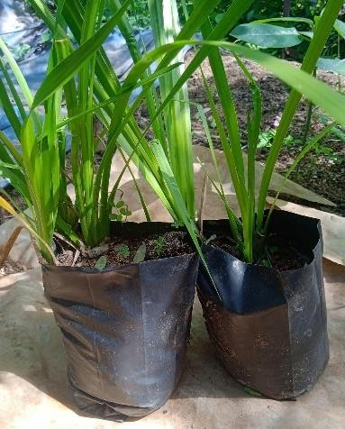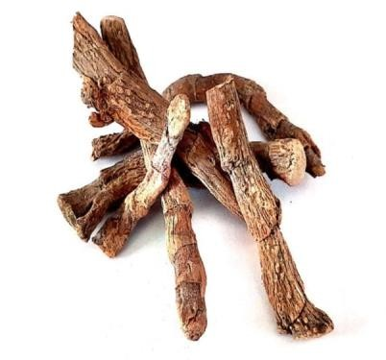

Fig 1-Acorus calamus and its rhizome explants
2. Materials and Methods
2.1 Plant Material and Explant Collection
Authentic Acorus calamus L. mother plants were procured from Dhanvantari Nursery, Tal. Nagar, Dist. Ahilyanagar, Maharashtra. Rhizome segments were selected as explants for in vitro culture.
2.2 Sterilization of Glassware and Instruments
All the glassware and instruments (culture bottles, forceps, scalpels) were first washed with detergent under running tap water, rinsed with double-distilled water (DDW), wrapped in paper, and autoclaved at 121 °C and 15 psi for 20 minutes.
2.3 Preparation of Stock Solutions
Macronutrients, micronutrients, iron, glycine, potassium iodide (KI), vitamins, and inositol were individually prepared as concentrated stock solutions in DDW. Growth regulators were dissolved in suitable solvents before being made up to volume. All stocks were refrigerated; iron solution was stored in amber colour bottles.
2.4 Culture Media Preparation
Murashige and Skoog (MS) medium was used supplemented with 30 g/L sucrose, 100 mg/L inositol, and solidified with 8 g/L agar. The pH was adjusted to 5.6–5.8. Growth regulators were added before autoclaving at 121 °C for 15–20 minutes. The medium was then poured into sterile culture bottles.
2.5 Surface Sterilization of Explants
Rhizome segments (0.5–1 cm) were washed in tap water (10–15 min), treated with Dettol (10 min), and rinsed thoroughly with DDW. Explants were then immersed in afungicideBavistin solution (1.0%) for 30 min on a rotary shaker, followed by multiple rinses with DDW. In the aseptic laminar area, explants were treated with 0.1% (w/v) HgCl₂ for 1 minute and rinsed thoroughly with sterile DDW.
2.6 Inoculation and Shoot Initiation
Surface-sterilized explants were inoculated onto MS media supplemented with varying concentrations of 6-Benzylaminopurine (BAP). Five concentrations (1.0–3.0 mg/L) were selected. Due to limited explants, media volumes were scaled down to 200 mL, and BAP concentrations adjusted accordingly.
2.7 Culture Conditions
Cultures were maintained at 25 ± 2 °C with a photoperiod of 16 hours light and 8 hours dark less than 2000–3000 lux from white fluorescent lamps.
2.8 Culture Initiation and Sub culturing
The initial shoot formation was observed within a week with substantial development after 2-3 weeks. Then the well developed shoots were excised and subculture was done on fresh multiplication media.
  - Shoot Multiplication
The excised shoots were cultured on MS media supplemented with combinations of BAP (3.0 mg/L) and NAA (1.75–3.0 mg/L) to assess the multiplication efficiency.
2.10 Root Induction
Multiplied shoots were transferred to rooting media containing Indole-3-butyric acid (IBA) at 1.0 and 1.5 mg/L concentrations to induce root development.

3. Results
The present study aimed at establishing a protocol for in vitro micropropagation of Acorus calamus L. using rhizome segments as explants.

3.1 Establishment of in vitro Culture
Rhizome segments of Acorus calamus were successfully used as explants and cultured on MS medium supplemented with varying concentrations of BAP. All tested concentrations supported shoot initiation, with differences in shoot length and response rate. The results demonstrate that shoot induction was effectively influenced by BAP concentrations.

3.2 Initiation of Culture
Shoot induction was recorded across all treatments. Among the five tested concentrations of BAP (0.5 mg/L to 3.0 mg/L), the highest average shoot length (6.25 cm) was observed with 3.0 mg/L BAP. A detailed comparison is presented in Table 1

Table 1: Effect of BAP on Shoot Initiation
Sr. No. | Media + BAP (mg/L) | Average Shoot Length (cm)
1 | MS + 0.5 mg/L | 3.85±1.128
2 | MS + 1.5 mg/L | 3.70±1.109
3 | MS + 2.0 mg/L | 5.75±0.629
4 | MS + 2.5 mg/L | 5.00±0.883
5 | MS + 3.0 mg/L | 6.25±2.298
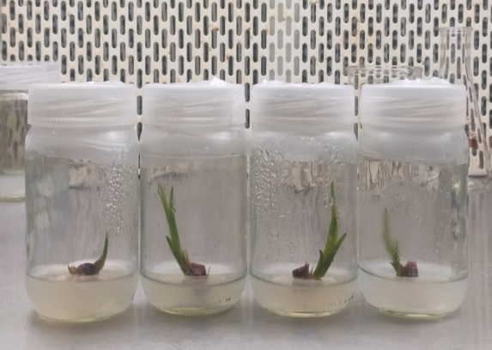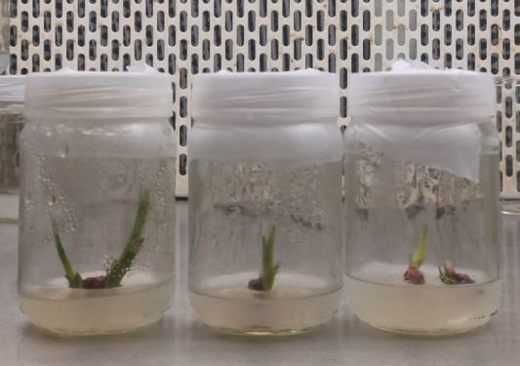
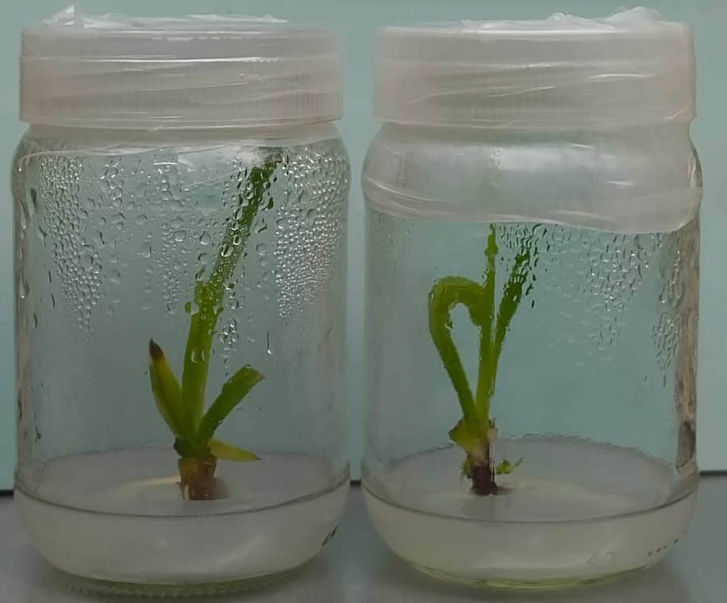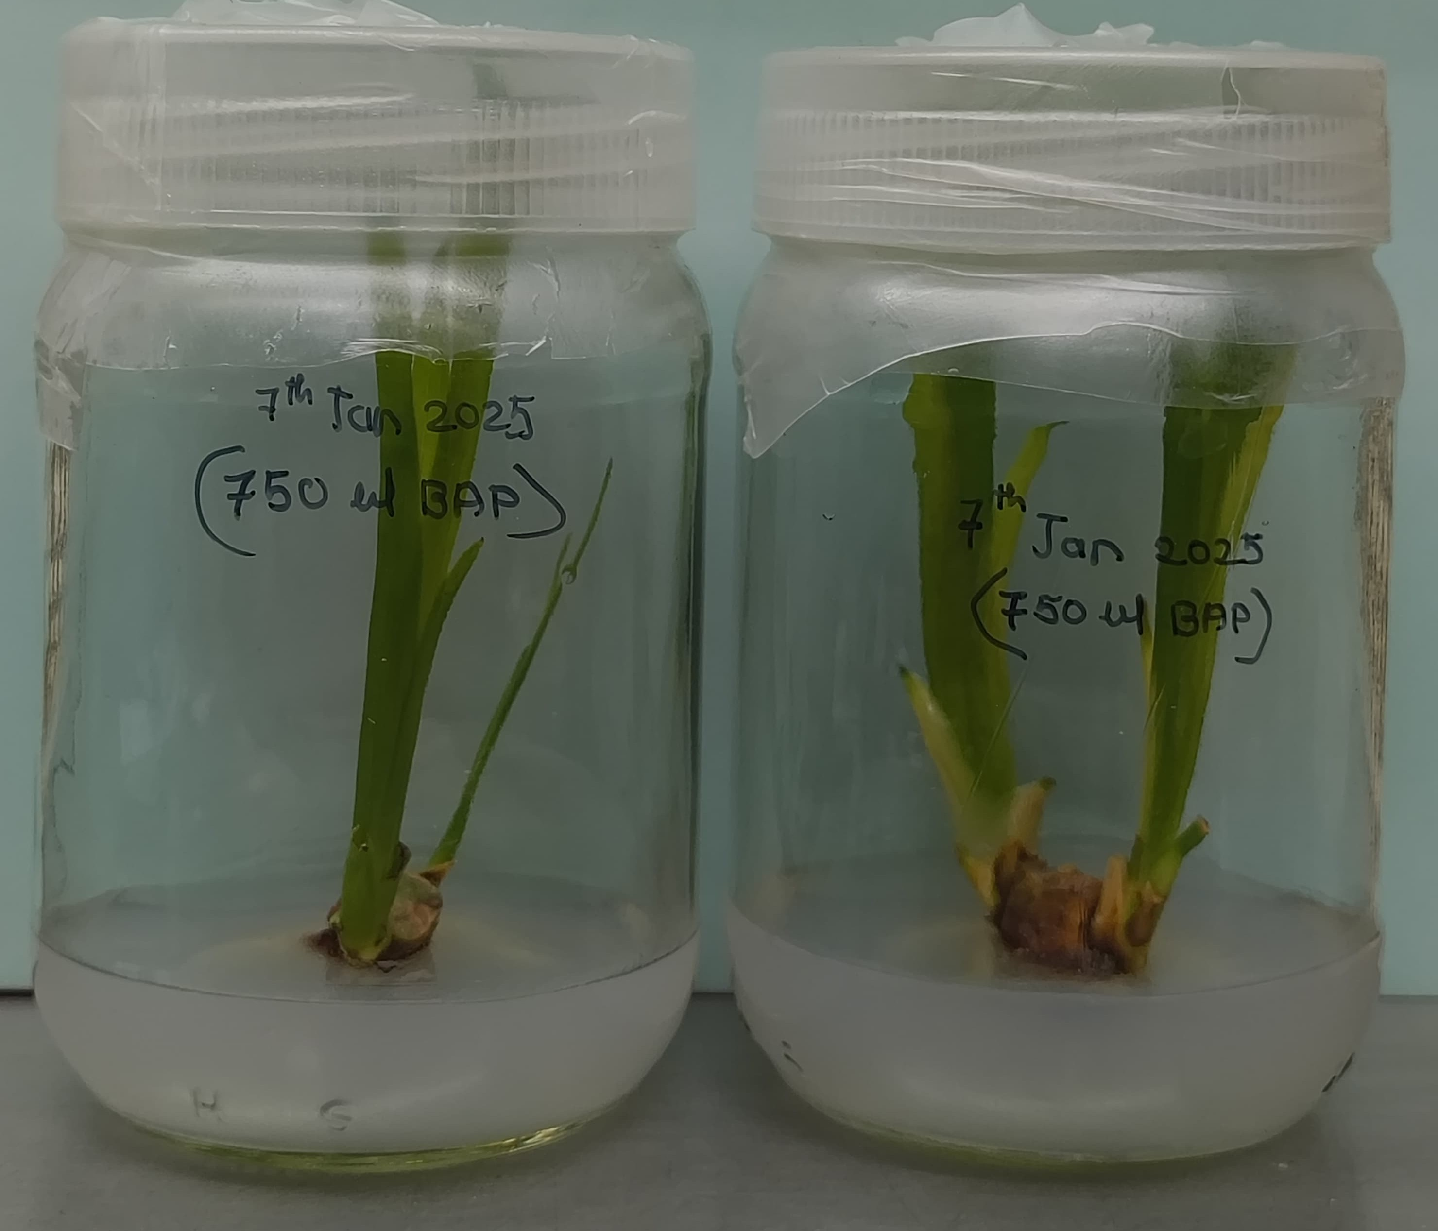

Plate 1: The results of shoot initiation using MS media along with varying concentrations of BAP ranging from 0.5 mg/L to 3.0 mg/L

3.3 Shoot Multiplication
After 20 days in initiation medium, the explants were transferred to multiplication medium containing BAP and NAA. The maximum number of multiple shoots (average 4.5) was observed with a combination of 3.0 mg/L BAP + 1.5 mg/L NAA and 3.0 mg/L BAP + 2.5 mg/L NAA.

Table 2: Shoot Multiplication Using BAP and NAA
Sr. No. | BAP mg/L + NAA mg/L | Avg. no. of Shoots per Explant |  | Avg. Shoot Length after 2 weeks of inoculation (cm)
1 | 3.0 BAP + 1.5 NAA | 4.5 |  | 4.30±0.6639
2 | 3.0 BAP + 2.0 NAA | 4.25 |  | 3.15±0.8131
3 | 3.0 BAP + 2.5 NAA | 4.5 |  | 4.30±0.6639

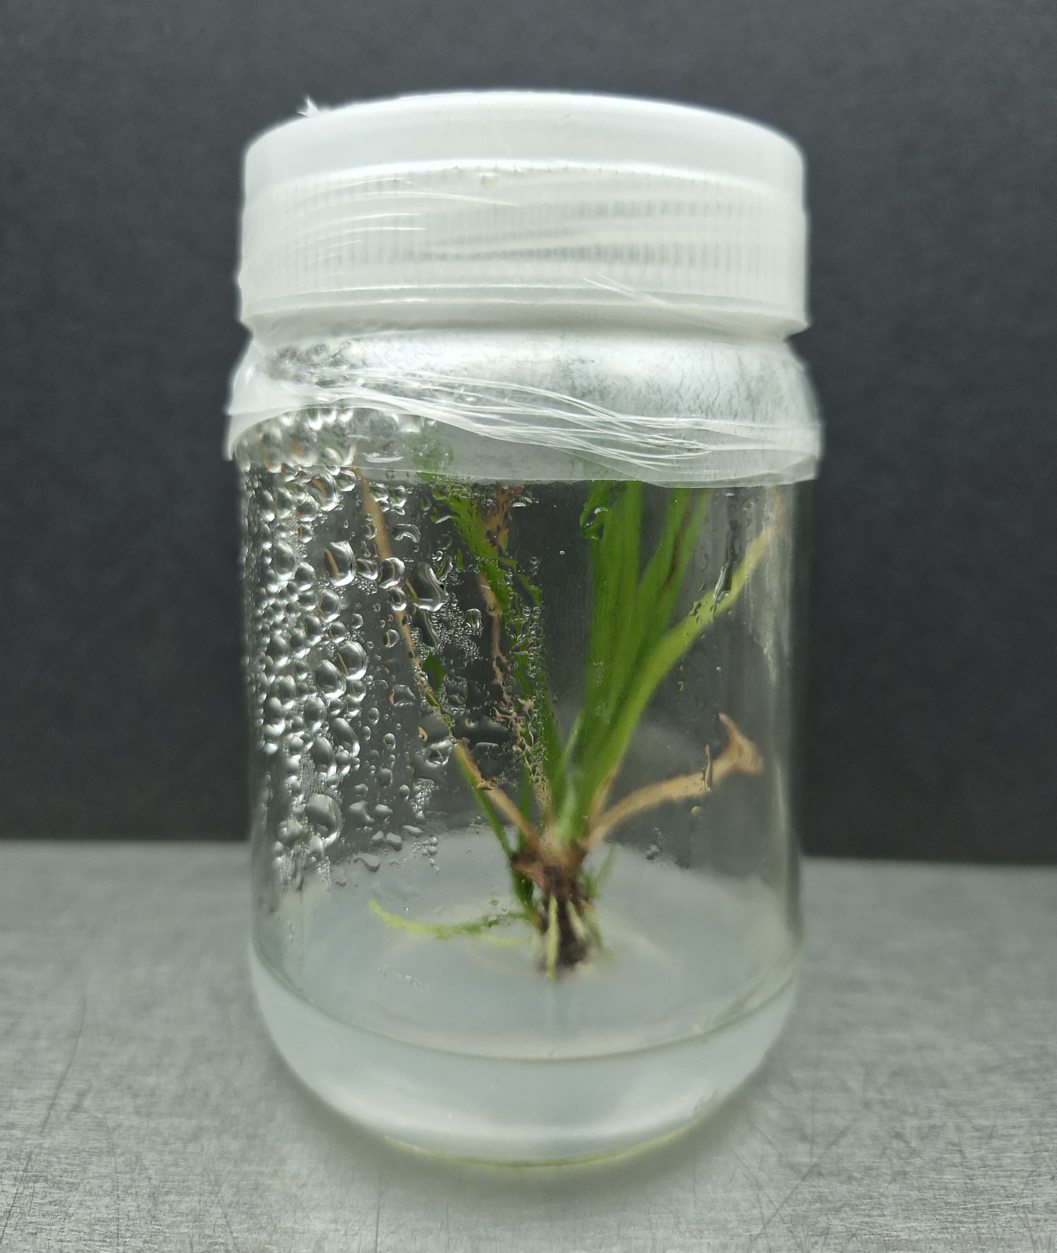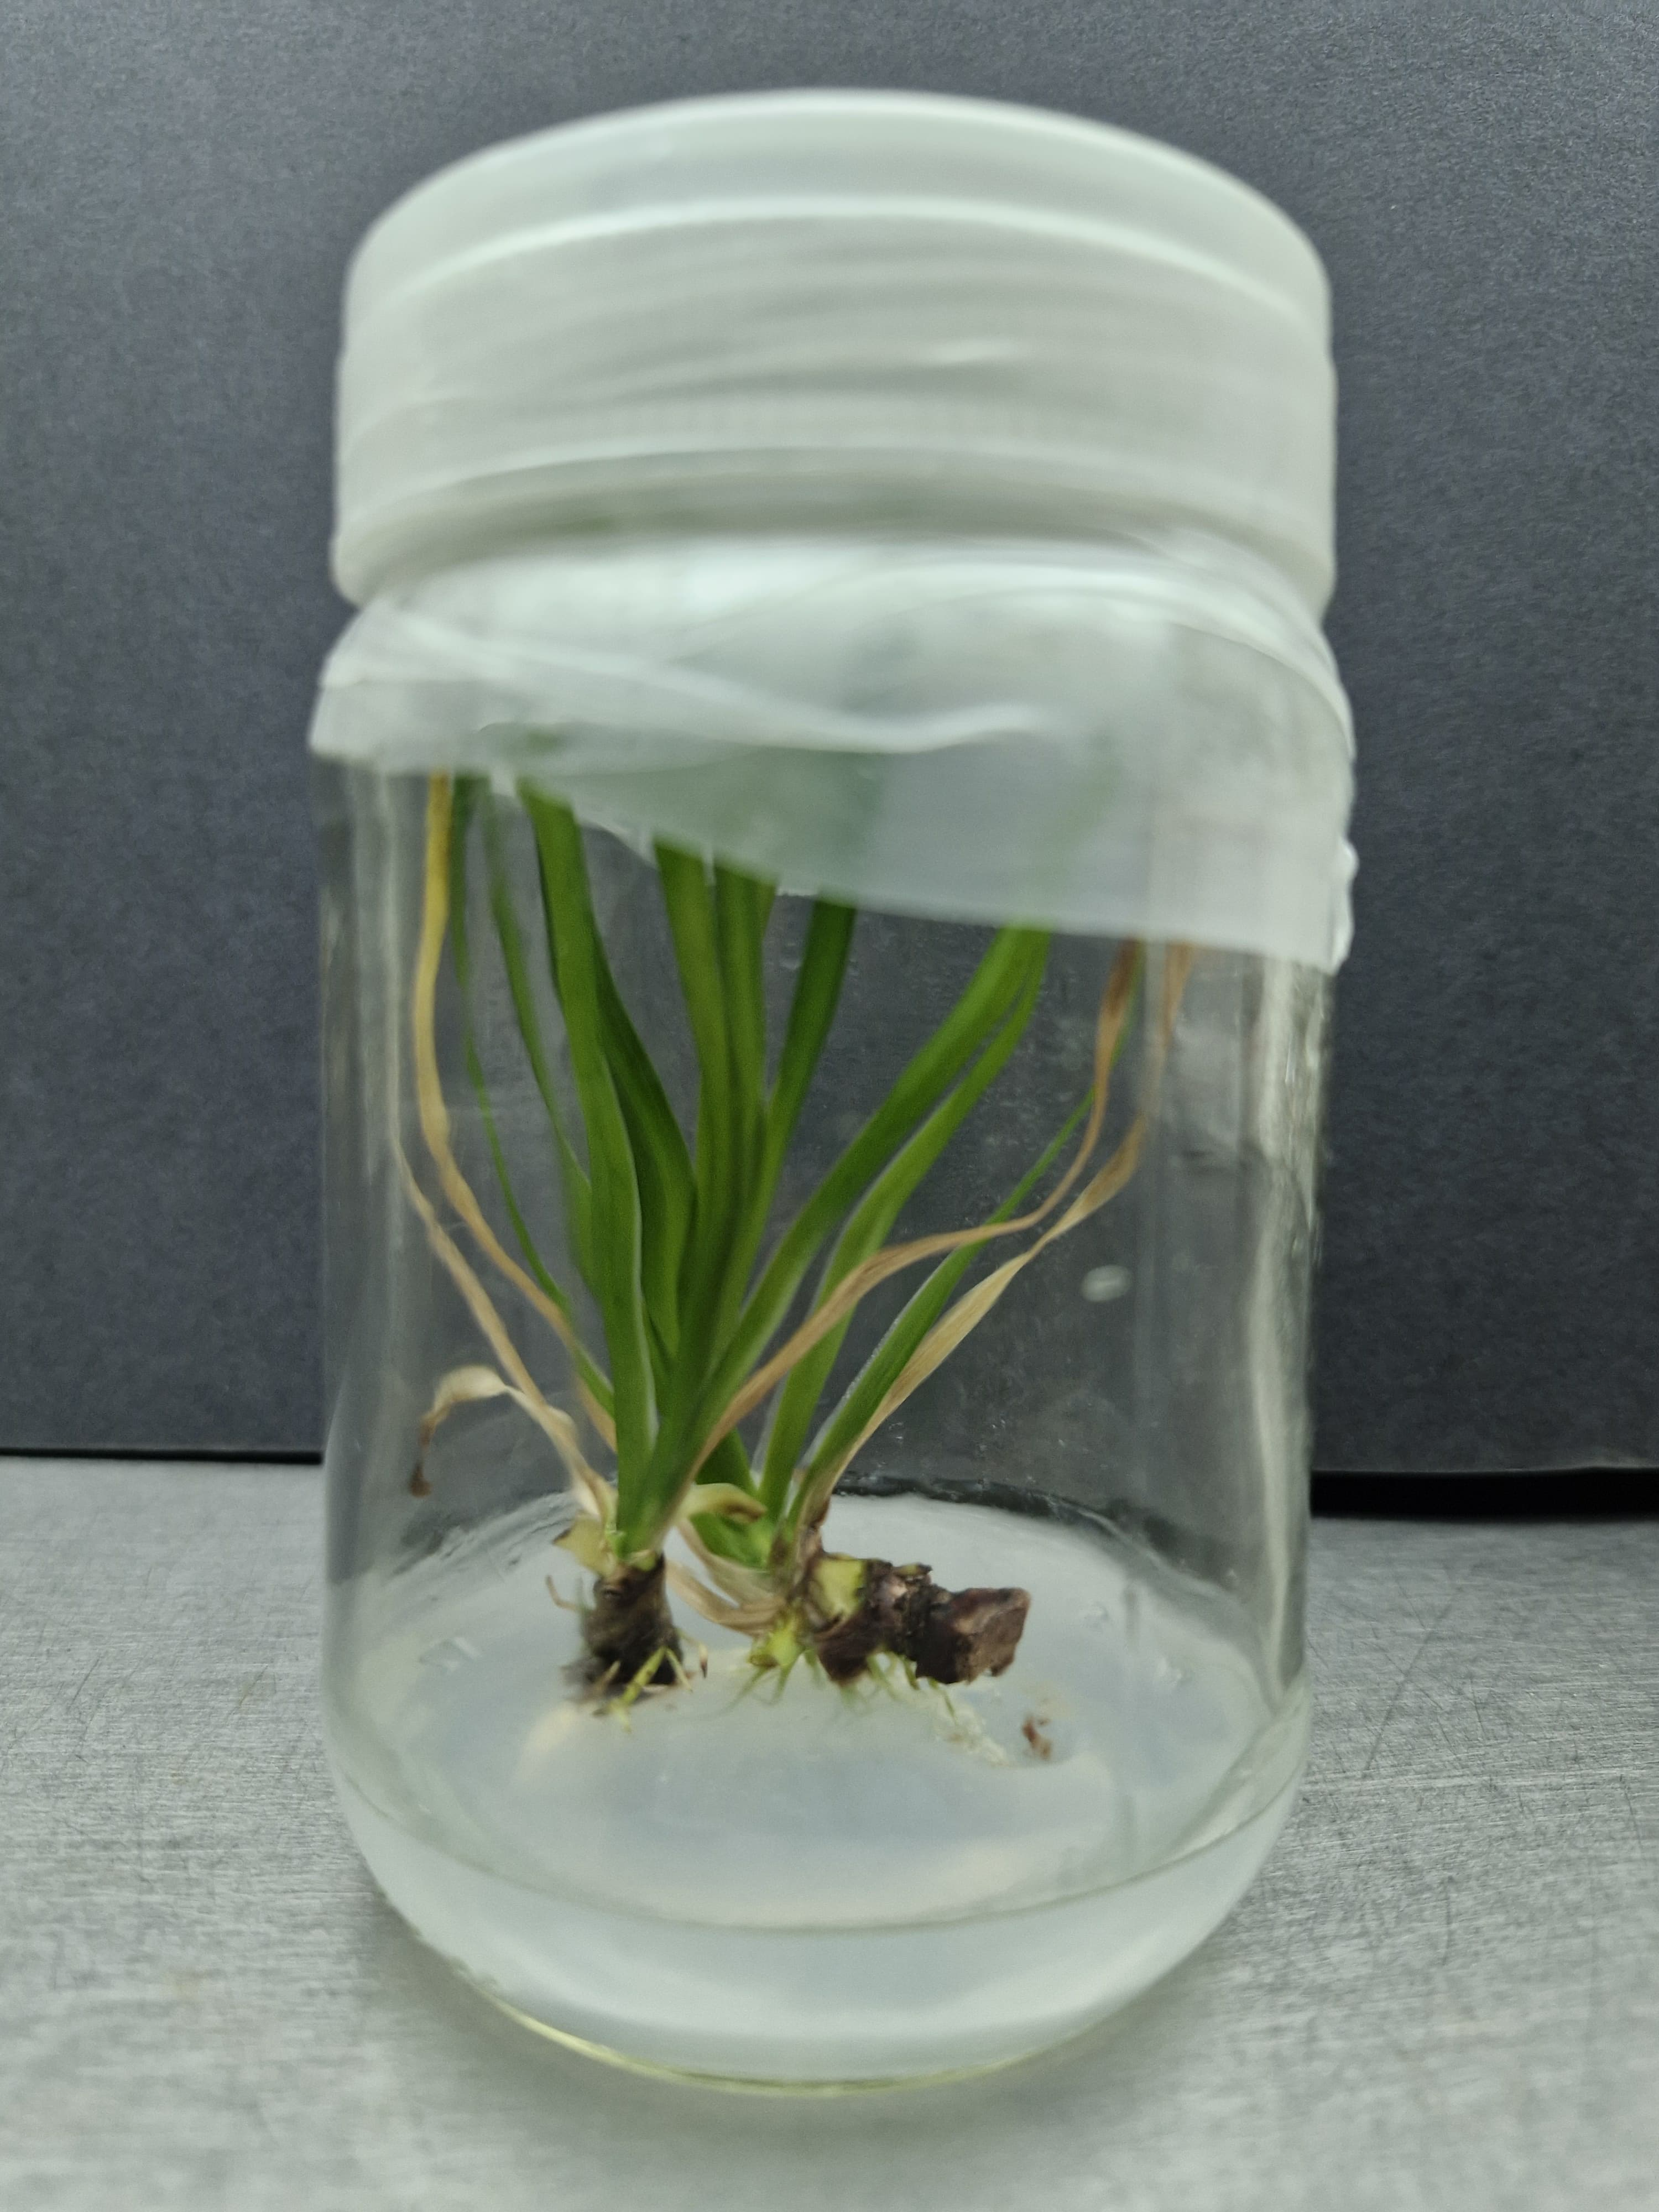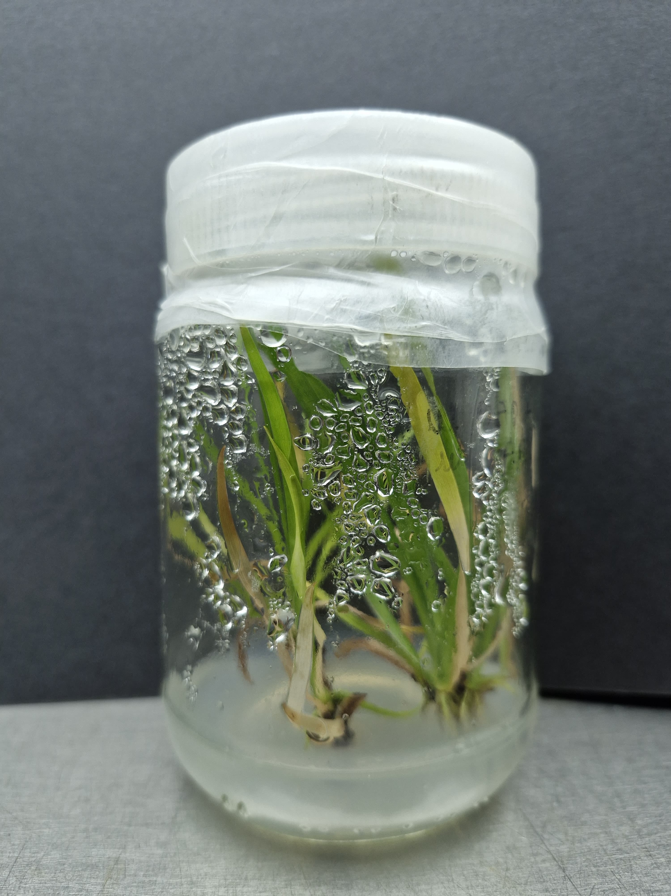

Plate 2: Results of the Shoot multiplication after 4 weeks of inoculation into multiplication media using 3.0 mg/L BAP along with varying concentrations of NAA (1.5mg/L, 2.0 g/L and 2.5 mg/L)

3.4 Root Initiation
The successfully multiplied shoots were transferred to MS medium with different concentrations of IBA (1.0 mg/L and 1.5 mg/L). Rooting was observed in both treatments, with enhanced root length and density in 1.5 mg/L IBA.

Table 3: Rooting Efficiency Using IBA

Sr. No. | IBA (mg/L) | Observation
1 | 1.0 mg/L | Rooting observed, moderate root length
2 | 1.5 mg/L | Increased root length and number

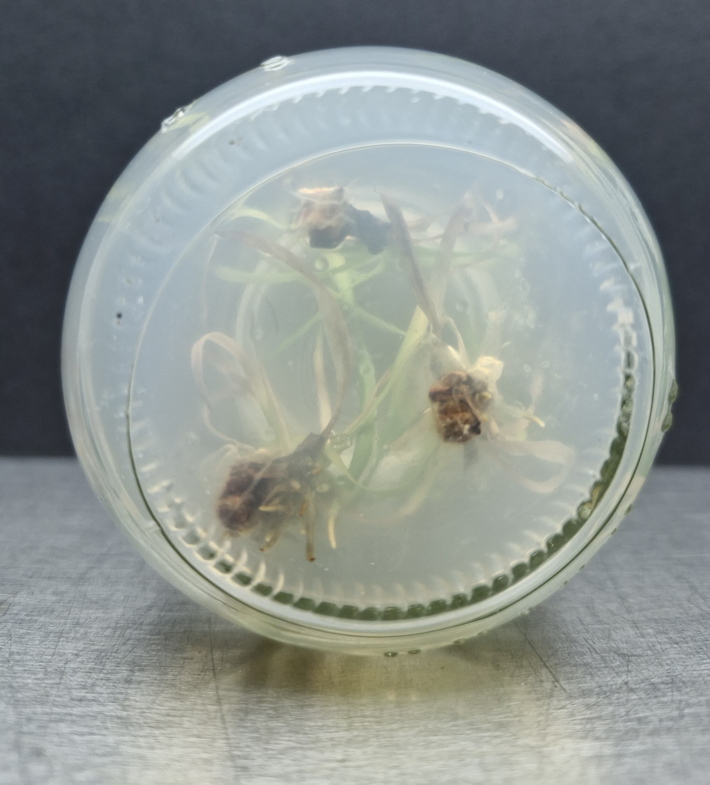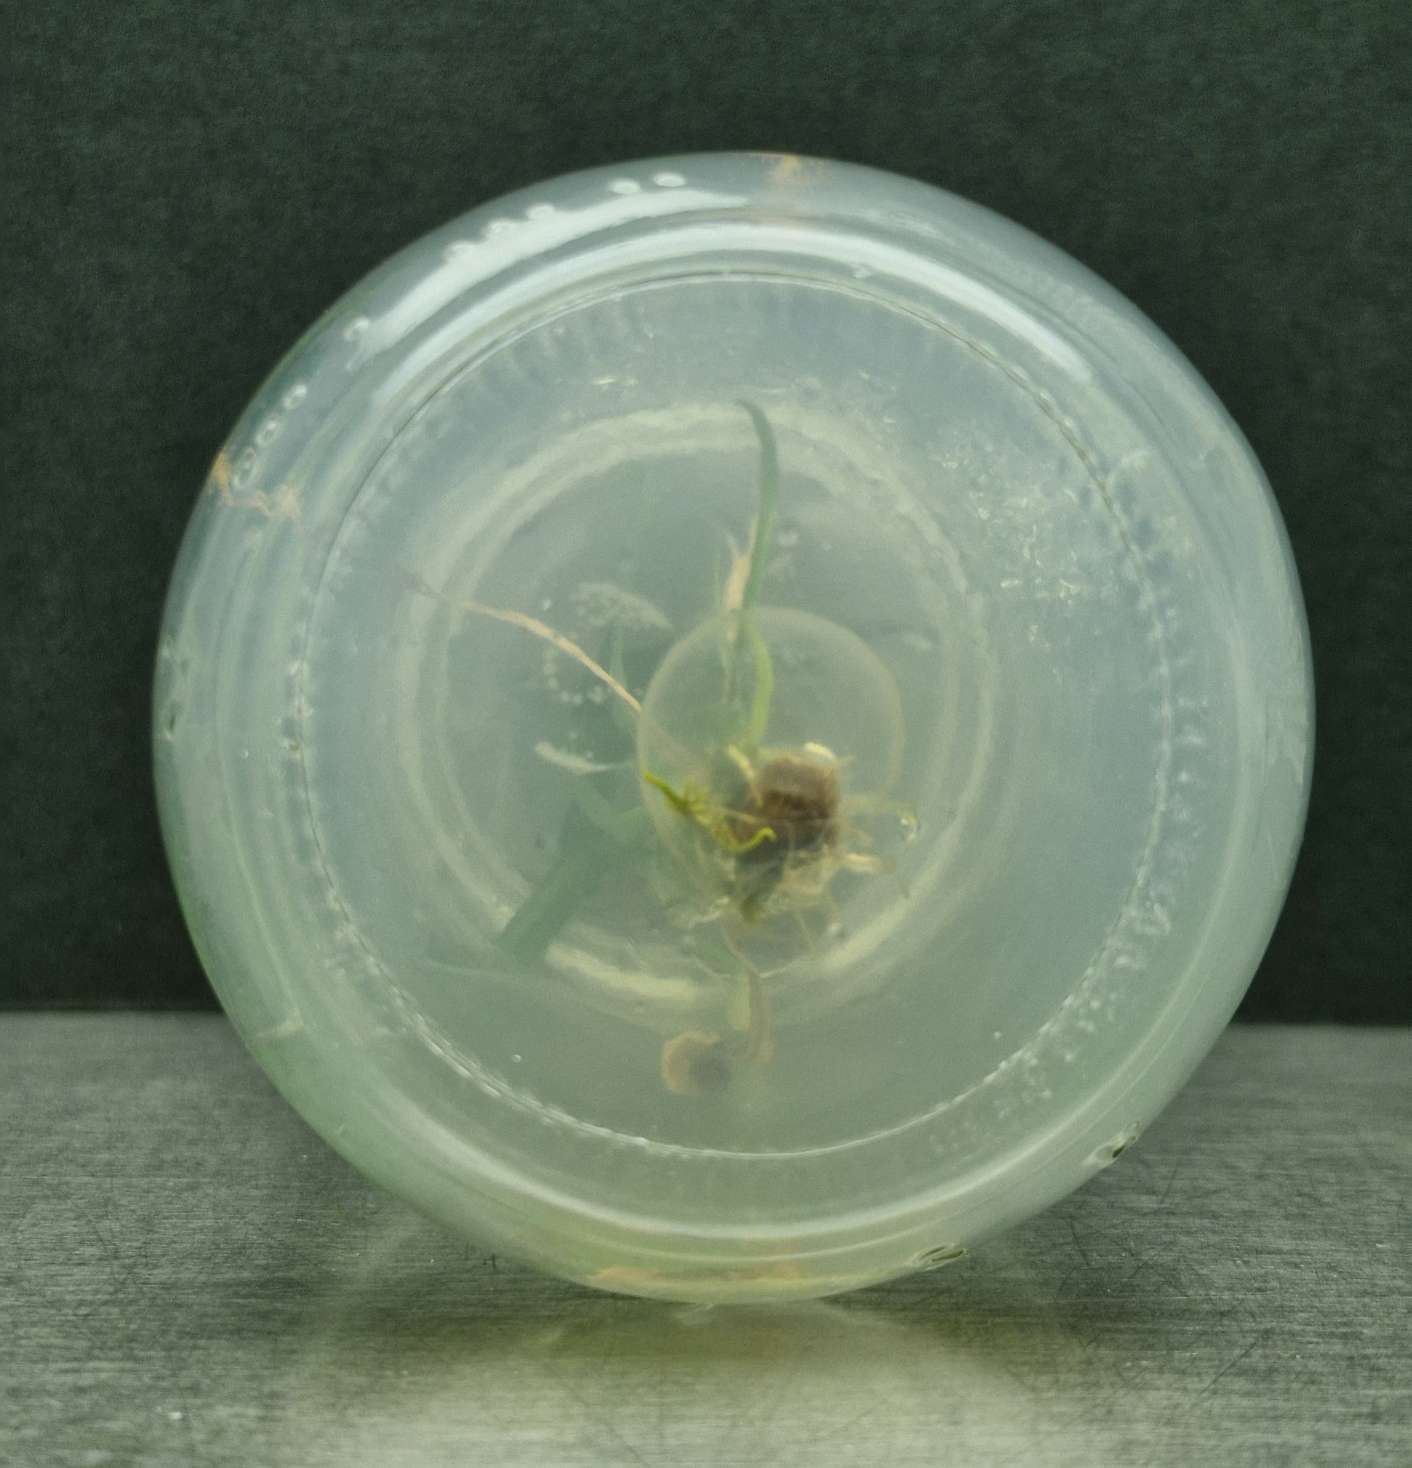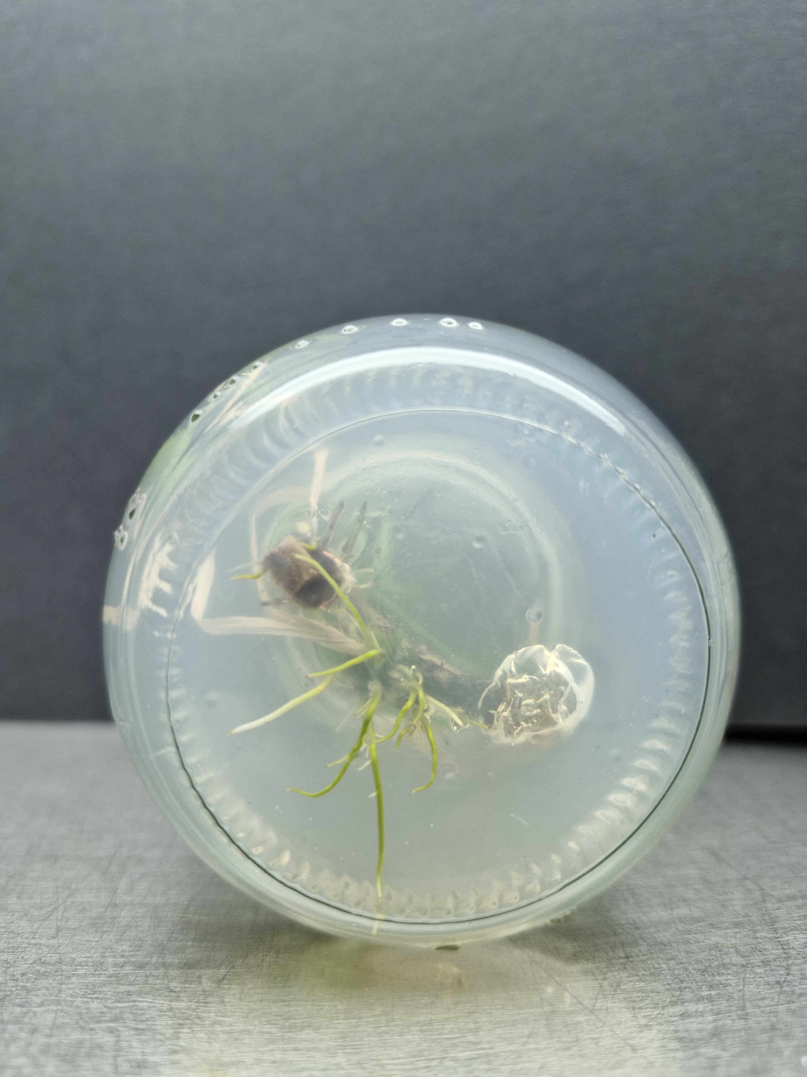

Plate 3: Results of the Rooting using IBA 1.0 mg/L and 1.5 mg/L

3.5 Hardening
Rooted plantlets were removed from culture bottles, washed thoroughly, and treated with 1% Bavistin for 15–20 minutes. They were then transferred to portray containing a sterilized cocopeat-soil mixture (2:1) in polythene bags. Primary hardening was carried out under high humidity conditions, followed by secondary hardening under controlled exposure to ambient conditions.
4. Discussion
The present investigation, titled “In vitro Micropropagation of Acorus calamus L.”, was successfully carried out by investigating the effects of several plant growth regulators on the initiation, multiplication, and roots stages of development, the study sought to design a dependable and effective in vitro propagation strategy.
Rhizome segments of Acorus calamus were cultivated on MS media supplemented with varying doses of Benzyl Amino Purine (BAP) during the initiation phase. These concentrations ranged from 0.5 mg/L to 3.0 mg/L BAP doses of 2.0 mg/L, 2.5 mg/L and 3.0 mg/L showed the best shoot induction among the investigated concentrations; by 20 days, explants showed robust and healthy shoot emergence. These findings imply that moderate BAP concentrations are ideal for Acorus calamus shoot initiation.
After the successful shoot initiation, the explants were transferred to the multiplication medium supplemented with BAP and NAA. The best response was observed with 3.0 mg/L BAP + 3.0 mg/L NAA suggesting that auxin (NAA) greatly increased shoot proliferation. These results are consistent with those of Gholipour A.(2021), who likewise used rhizome explants and a hormonal combination of 1 mg/L BAP and 1 mg/L NAA to demonstrate effective shoot multiplication. The recent study Meetei & Purushottam (2024) also got the similar results by using the similar combination of BAP and NAA for multiplication. Successfully multiplied shoots were transferred on MS media supplemented with 1.0 mg/L and 1.5mg/L of Indole-3-butyric acid (IBA) for the rooting stage. The rooting was enhanced by both the treatments but the more efficient results were obtained in 1.5 mg/L concentration of IBA . Initially Altaf A.(2010), Meetei & Purushottam (2024), also got the similar results by using IBA for rooting. The use of particular growth hormone combinations and its concentration makes a great impact on the micropropagation process.

5. Summary & Conclusion
The present study, conducted at the College of Agricultural Biotechnology, Loni (Maharashtra), was aimed at developing an efficient protocol for the in vitro micropropagation of Acorus calamus L. (commonly known as Vekhand), a perennial aromatic herb belonging to the family Acoraceae. Conventionally propagated through rhizomes, Acorus calamus is prone to fungal diseases such as leaf spot and leaf blight. Micropropagation offers a reliable alternative for producing disease-free planting material on a large scale. The rhizome segments were used as explants. Dettol, Bavistin (1.0%) and Mercuric chloride(0.1%) was used for the surface sterilization followed by repeated washing with sterile distilled water. Explants were cultured on MS medium containing different concentrations of BAP (0.5 mg/L – 3.0 mg/L). Best shoot induction was observed with 2.0 mg/L – 3.0 mg/L BAP, where healthy and elongated shoots formed within 20 days.
Successfully initiated shoots were transferred to multiplication media containing 3.0 mg/L BAP combined with varying concentrations of NAA. Among the combinations tested, 3.0 mg/L BAP + 3.0 mg/L NAA provided the highest multiplication rate, with the increased number of shoots per explants. Rooting was successfully achieved using MS medium supplemented with IBA at 1.0 mg/L and 1.5 mg/L concentration. Root formation was consistent across both concentrations under aseptic culture room conditions. The in vitro rooted plantlets were acclimatized through a two-step hardening process. Initially, plantlets were washed to remove agar, treated with 1% Bavistin solution, and then transplanted into portray trays containing a 2:1 mixture of sterilized cocopeat and soil. Primary hardening was carried out in a humid chamber, followed by secondary hardening under semi-natural conditions to ensure adaptation for field transfer.
Conclusion:
This study successfully established a reproducible protocol for the in vitro propagation of Acorus calamus using rhizome explants. The optimized concentrations of BAP, NAA, and IBA played a crucial role in enhancing shoot induction, multiplication, and rooting efficiency. This method provides a promising tool for rapid clonal propagation and large-scale production of healthy, disease-free Acorus calamus plants, contributing significantly to conservation, commercial cultivation, and the pharmaceutical industry.

Disclaimer (Artificial intelligence): Author(s) hereby declare that No generative AI technologies such as Large Language Models (ChatGPT, COPILOT, etc.) and text-to-image generators have been used during the writing or editing of this manuscript.
Disclaimer (Artificial intelligence)
Option 1:
Author(s) hereby declare that NO generative AI technologies such as Large Language Models (ChatGPT, COPILOT, etc.) and text-to-image generators have been used during the writing or editing of this manuscript.
Option 2:
Author(s) hereby declare that generative AI technologies such as Large Language Models, etc. have been used during the writing or editing of manuscripts. This explanation will include the name, version, model, and source of the generative AI technology and as well as all input prompts provided to the generative AI technology
Details of the AI usage are given below:
1.
2.
3.

References:
- Ahmed M., Ahmed S., Hannan M., Hossain M., Islam R., Khatun M., Salahin M.,Sultana R., George and Razvy M. (2007). Standardization of a Suitable Protocol for in vitro Clonal Propagation of Acorus calamus L. an Important Medicinal Plant in Bangladesh. Amer. Eur. J. of Sci. Res. 2(2), 136-140.
- Ajaikumar B., Kunnumakkara, Anindita D., Ganesan P., Javadi M. Khwairak pm A.,Roy N. and Yengkhom D. (2018). Acorus calamus L. a bio-reserve of medicinal values.J. of Basic and Cli. Phys. And Pharma. (29), 210-216.
- Akhade A., Baokar S., Pawar V. and Shivakumar H. (2011). Antidepressant-like effectsof Acorus calamus L. in forced swimming and tail suspension test in mice. J. of Trop.Bio. Med. (1), S17–S19.
- Altaf A., Hareesh V., Honnesh N., Shashidhara S. and Rajasekharan P. (2010). In vitroregeneration of Acorus calamus L. – an important medicinal plant. J. of Curr. Pharm.Res. 2(1), 36-39.
- Angier, B. (1974) Field Guide to Edible Wild Plants. Stackpole Books; Harrisburg –Pennsylvania. Page 224.
- Anu, A., Babu, K. N., John, C. Z., & Peter, K. V. (2001). In vitro clonal Multiplication of Acorus calamus L. Journal of Plant Biochemistry and Biotechnology, 10(1), 53-55.
- Babar P., Chavan J., Deshmukh A. and Salunkhe S. (2020). Micropropagation,polyphenol content and biological properties of sweet flag (Acorus calamus L.): apotent medicinal and aromatic herb. Vegetos. 33, 296-303.
- Balakumbahan R., Rajamani K., and Kumanan K., (2010), Acorus calamus: Anoverview, Journal of Medicinal Plants Research; 4(25), 2740-2745.
- Devi, N. S., Kishor, R., & Sharma, G. J. (2012). Microrhizome induction in Acorus calamus Linn.—An important medicinal and aromatic plant. Horticulture, Environment, and Biotechnology, 53(5), 410-414.
- Gholipour A., Kazemitabar S. K., Ramzanpour H., (2021), A comparative study on Acorus calamus (Acoraceae) micropropagation and selection of suitable population forcultivation in Iran, Acta BiologicaSzegediensis; 65(1), 29-34.
- Imam H., Riaz Z., Azhar M., Sofi G., Hussain A. (2013), Sweet flag (Acorus calamusLinn.): An incredible medicinal herb, International Journal of Green Pharmacy;7(1), 288-296
- Khan, B.M., J. Bakht, S.H. Shah and M. Shafi. (2016). Micropropagation ofmedicinally important weed, Acorus calamus, rhizome explants with indigenousnatural growth regulators. Pak J. weed Sci. Res. 22(3), 441-462
- Lee, S.C., J.S. Lee, and S.J. Jeong. (2005). Plant growth by bud number and mediumcomposition in division of Acorus calamus. Kor. J. Hort. Sci. Technol. 23, 455–458
- Meetei, N. T., & Purushottam, P. S. (2024). Evaluation of genetic fidelity of in vitro regenerated Sweet flag (Acorus calamus L.) using molecular markers. Indian Journal of Experimental Biology (IJEB), 62(02), 133-139.
- Muthusamy, A., Swathy, P. S., Tantry, S., Thorat, S. A., Kaniyassery, A., & Kiran, K. R. (2022). Large-scale production of in vitro plantlets of sweet flag (Acorus calamus L.) and quantitative analysis of α-and β-asarone contents using high pressure liquid chromatography. Vegetos, 35(1), 122-132.
- Parasher, K., Sharma, C., Sharma, S., Mukherjee, S., & Mukherjee, P. (2024). Cryopreservation and assessment of genetic fidelity Acorus calamus Linn., an endangered medicinal plant. Cryoletters, 45(2), 122-133.
- Quraishi A., Mehar S., Sahu D., Jadhav S. K., (2017), In Vitro Mid-Term Conservationof Acorus calamus L. via Cold Storage of Encapsulated Micro rhizome, An International Journal of Brazilian Archives of Biology and Technology; 60(1), 1-9.

- Rajasekharan, P. E., Ravish, B. S., & Vasantha Kumar, T. (2008, December). Optimization of protocols for the in vitro multiplication and conservation of Acorus calamus, an endangered medicinal plant. In IV International Symposium on Acclimatization and Establishment of Micropropagated Plants 865, 37-41.
- Sabitha Rani A., Subhadra V. V., and Reddy V. D. (2000), In vitro propagation of Acorus
- calamus Linn. – A medicinal plant, Indian Journal of Experimental Biology; 38:730-732

- Sharma V., Sharma R., Gautam D. S., Kuca K., Nepovimova E., and Martins N., (2020)Role of Vacha (Acorus calamus Linn.) in Neurological and Metabolic Disorders:Evidence from Ethnopharmacology, Phytochemistry, Pharmacology and Clinical Study,Journal of Clinical Medicine; 9(1):1-45
- Sharma, V., Singh, I., & Chaudhary, P. (2014). Acorus calamus (The Healing Plant): A review on its medicinal potential, micropropagation and conservation. Natural product research, 28(18), 1454-1466.
- Tikendra, L., Sushma, O., Amom, T., Devi, N. A., Paonam, S., Bidyananda, N., ... & Nongdam, P. (2022). Genetic clonal fidelity assessment of rhizome-derived micropropagated Acorus calamus L.–a medicinally important plant by random amplified polymorphic DNA and inter-simple sequence repeat markers. Pharmacognosy Magazine, 18(77).
- Verma, S., & Singh, N. (2012). In vitro mass multiplication of Acorus calamus L.—an endangered medicinal plant. Am Eurasian J Agric Environ Sci, 12(11), 1514-1521.
- Wulansari, A., Ermayanti, T. M., Al Hafiizh, E., Hapsari, B. W., & Maulana, E. (2023). Modification of media compositions for micropropagation of Acorus calamus L. Biogenesis: Jurnal Ilmiah Biologi, 11(1), 1-13.
- Zuba D, Byrska B (2012). Alpha- and beta-asarone in herbal medicinal products. A case study. Forensic Sci Int 223(1-3): 5-9.

