Minireview Article

Climate Change and Global Nutrition: A Review on Examining the Link Between Livestock Production, Food Security, and Health

ABSTRACT:

Introduction: Global food security, nutrition, and human health are being progressively threatened by climate change. Increased crop yields, decreased livestock productivity due to heat stress, and increased pest and disease transmission are all consequences of rising temperatures, harsh weather, and changes in precipitation patterns. This review paper discusses the factors that are often corelated to climate change and explains how livestock, food security and health are interwined. The review also highlights the impact of climate change on mental and physical health of vulnerable groups like women and children & low-income groups.
Climate Change and Food Security, Livestock and Health: Millions of people are already malnourished and at risk of starvation as a result of these effects. In addition to incurring productivity losses that put further pressure on food systems, the animal production industry is a major contributor to deforestation and greenhouse gas emissions. Vulnerability is heightened, especially in low-income and pastoral communities, by climate-driven disturbances in marine habitats, decreased wheat output, and an increase in foodborne and waterborne infections. Due to a lack of resources and unequal participation in decision-making, women and marginalized groups bear disproportionate health, social, and economic costs from climate consequences. Additionally, climate change has a negative impact on maternity and reproductive health and raises mental health issues.
Conclusion: Building resilient food systems requires sustainable adaptation techniques, such as climate-smart agriculture, agroecological practices, better livestock management, improved early warning systems, and gender-responsive policies. Long-term global food and health security can be supported by enhancing resource availability, encouraging the use of renewable energy, and incorporating cutting-edge technologies.

KEYWORDS: Climate change, Health, Nutrition, Livestock, Food Security, Agriculture

- INTRODUCTION
By 2030, there will be more than 840 million hungry people worldwide, up from the current 690 million (FAO, 2020). Due in part to poor diets, 45.4 million children under the age of five were wasted and 149.2 million were stunted as of 2020. In 2020, 38.9 million children under the age of five were overweight (Owino et al., 2022) [1]. In light of Sustainable Development Goal 2, which is to achieve Zero Hunger by 2030, there is already a significant amount of food insecurity worldwide, with between 720 million and 811 million people undernourished and over 2.3 billion suffering from malnutrition. Furthermore, it is anticipated that climate change would increase the severity and probability of negative effects on nutrition and food security (Mirzabaev et al., 2023) [2].
Foods' nutritional value may deteriorate due to climate change. Children are among the most vulnerable, and trends in climate appropriateness for disease transmission are especially worrisome. Due to decreased physical activity as well as the impact on fruit and vegetable production, which raises prices and causes consumers to switch to less expensive processed foods and beverages, a connection between rising temperatures and obesity has also been proposed. Environmental changes are both a cause and an effect of food systems, and the relationships between food systems, nutrition, and the climate are complicated. The main systems causing the global syndemic are land use, transportation, urban planning, and food and agriculture. The triple planetary crises of pollution, biodiversity loss, and climate change are caused by the current unsustainable patterns of food production and consumption. About 40% of the world's land is used for agriculture, while the production of food accounts for 70% of freshwater consumption and up to 30% of greenhouse gas emissions (Agostoni et al., 2023) [3]. A Recent report from IPCC discussed how human influence has warmed the climate at a remarkable rate. The atmospheric CO₂ concentration was higher than any time in 2 million years. Global temperature increased faster than 50-year periods. Report also suggest that human influence has likely increased the chances of these extreme climate event. The given figure below shows the graph scaling from 1900 to 2020 showing how human influence has causes the global temperature to rise (Allan et al., 2023) [4]
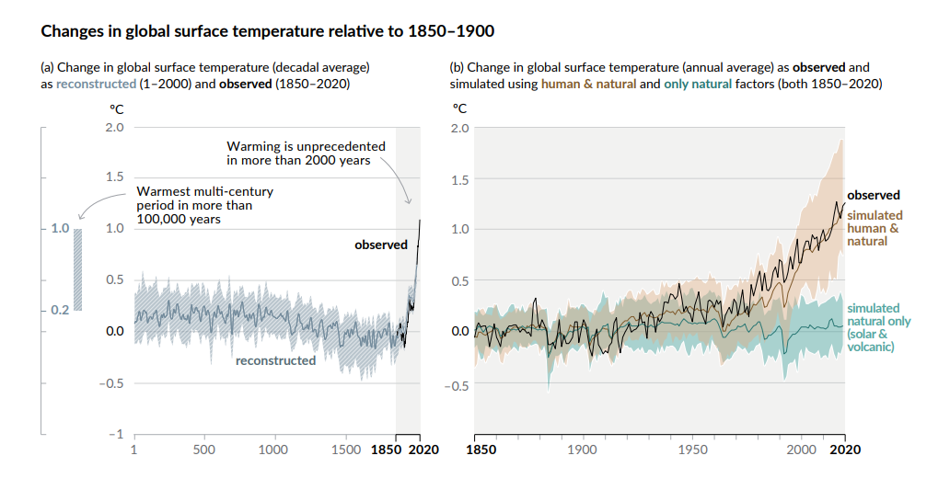
Fig. 1. Human Influence on raising the global climate over last 2000 years.

Various environmental conditions cause metabolic disturbances, oxidative stress, infections and impaired immune system in animals and may adversely affect animals. Meat has an important place among the proteins of animal origin in human nutrition. Animal proteins contain essential amino acids that cannot be synthesized in the human body. Meat and meat products are the most valuable protein sources with high biological value for humans. Nutrition level affects the quality of meat, muscle, bone and adipose tissue of the carcass. Heat stress is the most significant direct effect of climate change on animal output. These environmental factors can negatively impact an animal's health by causing metabolic disorders, oxidative stress, infections, and weakened immune systems. When it comes to domestic and wild animals, as well as the goods we make from them (meat, dairy, leather, etc.), extreme weather events cause significant losses. Animals that survive disasters are always in dangerous situations. “Every domestic animal is homoeothermic." Their comfort zones range from 10°C to 20°C since temperature affects their ability to grow, develop, and produce as well as their metabolic heat output. Although almost all animals have an innate ability to respond appropriately to temperature fluctuations, severe highs (heat waves) or lows (freezing conditions) can have detrimental effects on their welfare and even result in death (Sarıçiçek, 2022) [5].

- RELATION BETWEEN LIVESTOCK, FOOD SECURITY AND HEALTH OUTCOMES:

  - Correlation between Climate change and Animal Production:
Among the proteins derived from animals, meat plays a significant role in human nutrition. Essential amino acids found in animal proteins cannot be produced by the human body. Because of the amino acid content of meat and animal products, they are the most valuable protein sources with great biological value for humans. The quality of the carcass's meat, muscle, bone, and adipose tissue is influenced by the level of nutrition. (Sarıçiçek, 2022) [5] Cattle ranching, therefore, must contribute 80% of the responsibility of deforestation throughout Amazon countries. Processing and transporting animal products also demand additional landmass. Extreme deforestation and the subsequent reshaping of former forest space continues to swiftly and steadily release plant-stored carbon into the air, accelerating, and intensifying global warming (Union of Concerned Scientists, 2020). Cederberg et al. (2011) noted the quest of humans for animal protein simply propels deforestation further. At present, it is widely documented that any kilogram of meat brought to market leaves an unfathomable carbon footprint in its trail (Wu & Etienne, 2021) [6]. According to research, milk output dropped by 50% at 40 °C and 33% at 35 °C. The effects of heat stress are mild, moderate, or severe when THI is between 72 and 80, 80 and 90, or 90 and 98. Cows' dry matter intake and milk production are negatively impacted by both rising ambient temperature (from 25 to 32 °C) and rising THI. When behavioral features like rolling over, seeking refuge, and/or immersing are suppressed, buffalo suffer more heat stress. Additionally, during the summer, when heat stress is paired with high milk production and lactation stress, nursing buffaloes are subjected to extreme heat stress and increased heat milk production (Sarıçiçek, 2022) [5].
Climate control (air conditioning and refrigeration) can mitigate some of the negative impacts of climate change on food processing and distribution. Methane has a 28-fold greater impact on global warming than carbon dioxide and is mostly produced by enteric fermentation and manure storage. Forage digestibility is enhanced and enteric methane production in ruminants is reduced through physical processing of forages, such as chopping, grinding, and steam treatment. Due to low fertility, the herd needs more breeding animals to reach production goals and more replacements to keep the herd size constant, which raises greenhouse gas emissions. A 10–24% decrease in methane emissions and a 9–17% decrease in nitrous oxide emissions could result from increased fertility in dairy cattle (Cheng et al., 2022) [7]. Global milk output is expected to rise by 63% and meat production by 76% by 2050 compared to 2005/2007. It has also been demonstrated that feed supplements and additives such grain, lipids, antibiotics, and ionophores reduce enteric methane emissions. Time-released nitrogen, precision application, organic fertilizers, plant breeding, genetic tweaks, and species shifts are examples of potential solutions. However, calculating the mitigation potential of improving fertilizer efficiency on animal feed production is difficult, leaving a vacuum for further research. Changing the kinds of livestock feed is another potential strategy for lowering emissions from feed production (Godde et al., 2021), (Smith & Gregory, 2013) [8], [9]. Figure 2 explains the percentage of greenhouse gas emission by livestock management (Cheng et al., 2022) [7]
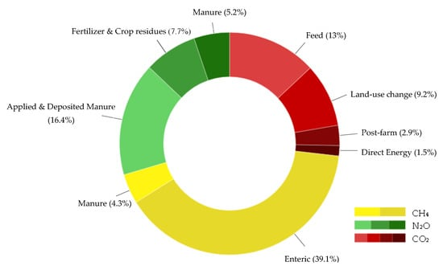
Fig.2. Percentage of emission of greenhouse from Livestock management

Agriculture contributes significantly to atmospheric CO2, CH4, and N2O emissions. The combustion of soil organic matter and plant litter, as well as microbial decomposition, are the main sources of CO2 emissions. When organic materials break down in anoxic environments, such as through fermentative digestion by ruminant livestock, stored manures, and flooded rice, CH4 is created. Compared to a field with plants, bare soil has less carbon and is more vulnerable to erosion and nutrient leaching. Adopting cropping techniques, such as rotating legume crops, offers a significant potential for mitigating the need for fertilizers (Duchenne-Moutien & Neetoo, 2021) [10]. The temperature rise in the upper ocean, an accelerated water cycle, ocean acidification, increased stratification, and variations in the intensity of weather disturbances and rainfall patterns are the primary consequences of climate change linked to seafood contamination (Wu & Etienne, 2021) [6].
The FAO estimates that in order to feed the world by 2050, food production will need to rise by 70%. Growing populations, rising incomes, and urbanization—particularly in recently industrialized nations—have altered food preferences and consumption patterns, increasing the need for animal protein. This situation exacerbates the struggle for land to produce food, feed, and fuel, puts significant strain on already scarce resources, and makes the problem of environmental sustainability even more challenging. On the other hand, it is anticipated that 8.9% of the world's population was undernourished and 25.9% experienced both moderate and severe levels of food insecurity in 2019, despite the fact that one-third of food is wasted. Insects produce healthier and more sustainable food, lessen the production and consumption of animal feed, and lessen the aforementioned societal problems. Insects are exceptionally high in fats (20–40%) and proteins (37–63%), with balanced profiles of fatty acids and amino acids, respectively. They are also excellent providers of vitamins and minerals. Because insects use less land and water and emit less greenhouse gases and carbon dioxide, their production has a smaller environmental impact than that of conventional livestock (Moruzzo et al., 2021) [11]. in significant part to globalization and the development of Western cultural standards, entomophagy is now perceived as an exotic flavor, an emergency diet in the event of a food scarcity, or a diet followed by those with little resources. Consuming insects for sustenance, or entomophagy, is a long-standing custom that preserves cultural elements of continents like Africa, Asia, Australia, Oceania, and Latin America (Ordoñez-Araque & Egas-Montenegro, 2021) [12]

  - Nutrition, Food Security and Climate Change:
When "access to food by all people at all times is adequate for an active and healthy life," food security will continue. By 2026, Climate Change is predicted to cut cereal production by 1 to 7% worldwide. Furthermore, by 2050, it is anticipated that 22% of the world's primary crops will be negatively impacted by climate change. Consequently, it is anticipated that by 2080, Climate Change will put an extra 5–170 million people at risk of starvation. Impacts on crop productivity and food production has been examined in respect to the connections between Climate Change and food security. Reducing food waste, repairing land degradation, and implementing Climate Change mitigation policy measures could all have a beneficial impact (Muluneh, 2021) [13].
Despite climate change, animal production has made food poverty worse globally (World Animal Foundation, 2020). According to Smith et al. (2013), cattle used almost 50% of the world's grains to provide just 13% of the energy needed for global nutrition. Diets rich in animal-based protein (in red meat intake notably) largely contributes to the risk of cardiovascular diseases, obesity, diabetes, and kidney failure (Wu & Etienne, 2021) [6].Better matching of nutrient supply to crop needs (e.g., improved fertilizer management, precision farming), improved nutrient recycling, improved soil management (to reduce erosion, maintain fertility, and improve nutrient status), and better matching of crops with the bioclimatic regions where they thrive are some agronomic mechanisms for increasing crop productivity. Increasing yields using inputs that don't cause environmental issues on-site or off-site is a key necessity for the future. While all of these efficiency gains are now feasible, their effect on reducing the yield gap is still primarily unresolved (Duchenne-Moutien & Neetoo, 2021) [10].
A blue carbon economic model that replaces fossil fuels and food by harvesting, storing, and sequestering carbon from marine ecosystems has been sparked by climate change and environmental degradation. People are looking more to the oceans for food that can be harvested and farmed sustainably due to the global demand for foods that offer functional benefits beyond basic nutritional and health considerations, such as lower risk of a variety of chronic diseases and reduced human-induced pressures on the climate system (Yong et al., 2022) [14]. Decrease of production will be often combined with the loss of livelihoods assets due to the increase of the intensity and frequency of climate-related disasters (Muluneh, 2021) [13]. The temperature rise in the upper ocean, an accelerated water cycle, ocean acidification, increased stratification, and variations in the intensity of weather disturbances and rainfall patterns are the primary consequences of climate change linked to seafood contamination. Insects, diseases, and plant pests all proliferate more quickly in warmer climates. In viticulture, for example, higher humidity and temperatures promote fungal growth and infections, such as powdery mildew (Eysiphe necatrix) and downy mildew (Plasm Opara viticola) on grapes, because of this, pesticides have been used more aggressively in warmer climates (Duchenne-Moutien & Neetoo, 2021) [10].
Other consequences of warming include ice cap melting, ocean acidity and warming, sea level rise, increased erosion, and altered deep ocean circulation. There may be a rise in the usage of tainted irrigation water for farming due to growing water insecurity concerns, which could increase the danger of foodborne and waterborne illnesses. Furthermore, a vicious cycle of food and waterborne illnesses may be sustained by the advent of new waterborne viruses and parasites, endangering food security and safety once more. Moreover, the findings of this study indicate that as the effects of climate change intensify, food insecurity among households increases by 0.331142 (p < 0.01). climate change has greater effects in the shortage of food and the welfare of people especially those living by pastoral activities through the disappearance of pasture, increase of water scarcity, outbreak of animal diseases and death of animals (Kitole et al., 2024) [15]. In a given rural community, if a climate-change-driven drought significantly reduces the harvest and smallholder livelihoods to the point where households migrate to urban areas, such rural out-migration can reduce rural labor supply and, all else equal, future agricultural output, lowering both rural and urban food security (Tuholske et al., 2024) [16]. Figure 3 shows a line diagram of how food security is affected by climate change. (Rahman et al., 2025) [17]
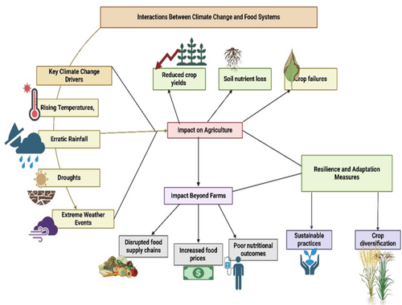
Fig.3. Interaction between Climate Change and Food System

In southern Africa, such as Zimbabwe (-7.2%), Malawi (-6.5%), and Mozambique (-2.8%); in western Africa, such as Mali (-3.9%) and Ghana (-3.8%); and in Asia, such as India (-0.8%) and Nepal (-2.2%), there were especially large annual losses in consumable calories relative to total food calories consumed. Globally, the average annual shift is not insignificant for all consumable food calories (~ -0.5%), but it is significant for individuals who consume these ten crops (~ -1%). This measure indicates that climate change has raised the likelihood of food insecurity in many foods’ insecure nations, despite the fact that it ignores food access, nutrition, and other aspects of food security. In a given rural community, if a climate-change-driven drought significantly reduces the harvest and smallholder livelihoods to the point where households migrate to urban areas, such rural out-migration can reduce rural labor supply and, all else equal, future agricultural output, lowering both rural and urban food security (Leisner, 2020) [18]. Over 14,949 individuals in the district were found to be food insecure, according to the Disaster Prevention and Food Security agency. According to reports, the district's rural kebeles have experienced a string of food shortages since 2010 due to crop losses brought on by a protracted lack of rainfall (Mekonnen et al., 2021) [19].
The most crucial mechanisms are to give climate information, educate households on various adaption strategies, and increase the involvement of female-headed households in income-generating activities. Encouragement of climate-smart farming practices, such as integrated pest control, water-efficient irrigation, and precision farming. incorporating mitigation and adaptation measures for climate change into national and international agricultural policies and initiatives. To improve resilience to shocks and disasters connected to climate change, early warning systems and disaster preparedness measures should be strengthened. (Mekonnen et al., 2021) [19].
A mobile market was established by local vegetable vendors and auto rickshaw drivers to provide vegetables from marketplaces and farmers to urban doorsteps. Another lifeline for businesses and customers with disposable wealth was the creation of an app (Shopsapp) that alerted individuals to open store locations where online ordering was feasible. (Raj et al., 2022) [20]. In addition to minimizing social-ecological costs associated with agriculture, such as soil degradation, water contamination, greenhouse gas emissions, depletion of nonrenewable resources, and unfair social structures, agroecological practices seek to optimize ecological processes, environmental and public health, and well-being (Bezner Kerr et al., 2023) [21]

  - Climate change and impact on Health:
In many areas, shifting precipitation and temperature patterns also make it easier for diseases carried by rodents, ticks, and mosquitoes to spread. Both short-term and long-term effects may result from the health hazards associated with climate change. Acute mental health issues including anxiety, depression, and post-traumatic stress disorder can be brought on by extreme weather. Longer-term mental health disorders can also be brought on by the combined effects of displacement, loss of livelihood, social cohesiveness disruption, and uncertainty brought on by climate change (Campbell-Lendrum et al., 2023) [22].
The majority of households and communities that depend on forests are directly impacted by the effects of climate change in the forestry and biodiversity sectors. This is particularly true for indigenous communities, women, marginalized groups, and the impoverished who rely on non-timber forest products and medicinal herbs for their livelihoods. Environmentally friendly technology like biogas, better cooking stoves, and solar cookers must be adopted in a gender-friendly manner in order to lessen these burdens, improve health conditions, and lower greenhouse gas emissions (Dhimal et al., 2021) [23].
The immediate effects of rising global temperatures, as well as the corresponding rise in the frequency and intensity of extreme weather and climatic events, can deteriorate people's mental health and well-being. For those who have signs of mental disorders, higher temperatures have been associated with lower physical and mental health outcomes. There is evidence of increased hospital attendance and admission for mental health symptoms during heatwaves, as well as greater heat-related mortality rates. Prescription drugs used to treat mental illness can occasionally interfere with the body's ability to regulate temperature (thermoregulation), increasing the risk of more severe heat-related symptoms or mortality at high temperatures, especially in the elderly. The symptoms of mental illness may also intensify as a result of this increased heat stress (Lawrance et al., 2022) [24].
Sexual and reproductive health (SRH) outcomes are adversely affected by an increase in the frequency of extreme heat events, rising average seasonal temperatures, poor air quality, increased force and frequency of natural disasters, and changes in rainfall and temperature patterns. There is increasing interest in recognizing how climate change affects both new and pre-existing infectious diseases. Important biological processes that are essential for maintaining life, from microorganisms to people, are driven by temperature. (Wright et al., 2023) [25]. Maternal and fetal health are greatly impacted by climate change, with rising temperatures and extreme weather events associated with poor pregnancy outcomes worldwide. Higher rates of hypertension during pregnancy are caused by environmental stresses and saltwater intrusion into drinking water, highlighting the intricate relationship between maternal health and climate change (Anjum & Aziz, 2025) [26].
Evidence from Australia [18], Uganda [15], South East Asia [12, 19, 20], and Canada [21] indicates that women are disproportionately threatened by climate change in terms of their socioeconomic status, means of subsistence, food security, and health. In addition, women are not fully involved in climate policy, governance, and other facets of climate governance and leadership due to their low participation in climate-related decision-making processes. According to a Swedish study, women are generally more concerned about climate change than men are. According to five studies, women may be more susceptible to psychiatric disorders as a result of climate change, either through altered weather patterns or catastrophic weather events (Stone et al., 2022) [27].

- CONCLUSION:
The analysis highlights the need for policies that address women's direct health consequences and promotes the integration of gender-responsive frameworks into climate adaptation and mitigation efforts. By improving women's access to resources, involving them more in decision-making, and putting in place focused interventions that strengthen their resilience, we promote women's empowerment (Anjum & Aziz, 2025) [26]. Policy, financial access, government stability and long-term goals, administrative processes and support systems—or lack thereof—and the profitability of investments in renewable energy are the key topics that are emphasized (Fawzy et al., 2020) [28]. Achieving sustainable food systems requires addressing the following factors:
- An agro-food industry which is climate change resilient and environmentally sustainable;
- Primary producers with improved well-being who are practical and flexible;
- High-nutrient, safe food that satisfies the consumer's cultural and customary needs;
- Innovation via competition and the application of cutting-edge technology; -
- New approaches to coexisting with and on the land;
- and respect and care for the water, new ways to live on and with the land, and respect and care for the sea (Wijerathna-Yapa & Pathirana, 2022) [29] Figure 4 explains various strategies to combat climate change using sustainable methods in Asia. (Habib-Ur-Rahman et al.,2022) [30]
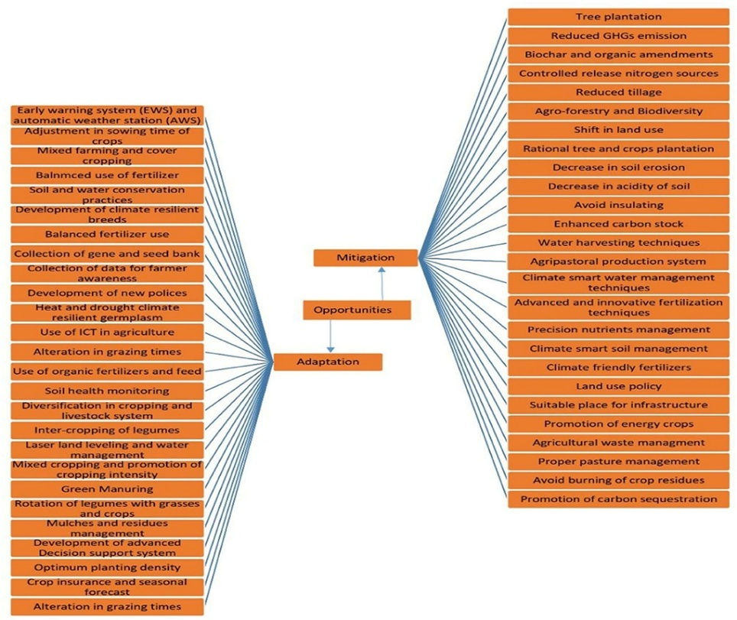

Fig. 4. Strategies to combat Climate Change with Sustainable Development

Climate change adaptation in agriculture systems is aided by organic farming practices. Crop rotation diversification, a type of organic farming, increases temporal plant diversity and strengthens the agricultural system's resistance to warmer, drier conditions.
To achieve carbon-neutral agriculture, emissions from livestock and fertilizer systems must be reduced. This necessitates enhancing the characteristics of bio/organic fertilizers, recycling agricultural waste in agroecosystems, and managing soils and crop-livestock production systems effectively (Wang et al., 2023) [31] To further support the global and local implementation of Climate Smart Agriculture, it is essential to establish a climate alert strategy, acknowledge the threat posed by climate change in national planning agendas, and educate farmers through focused initiatives (Saleem et al., 2025) [32].

ACKNOWLEDGE:
I would like to express my sincere gratitude to my supervisor Ms. Sneha Unhale. I would like to thank Dr. Snehal Kulkarni for her support and constant motivation. I would also like to thank Department of Dietetics, Dr. D.Y. Patil ACS College for their support in the review paper. Lastly thank you to anonymous reviewers for their suggestions.

Disclaimer:
Authors hereby declare that NO generative AI technologies such as Large Language Models (ChatGPT, COPILOT, etc.) and text-to-image generators have been used during the writing or editing of this manuscript.

REFERENCES:
- Owino, V., Kumwenda, C., Ekesa, B., Parker, M. E., Ewoldt, L., Roos, N., Lee, W. T., & Tomé, D. (2022). The impact of climate change on food systems, diet quality, nutrition, and health outcomes: A narrative review. Frontiers in Climate, 4, 941842. https://doi.org/10.3389/fclim.2022.941842

- Mirzabaev, A., Bezner Kerr, R., Hasegawa, T., Pradhan, P., Wreford, A., Tirado von der Pahlen, M. C., & Gurney-Smith, H. (2023). Severe climate change risks to food security and nutrition. Climate Risk Management, 39, 100473. https://doi.org/10.1016/j.crm.2022.100473

- Agostoni, C., Baglioni, M., La Vecchia, A., Molari, G., & Berti, C. (2023). Interlinkages between climate change and food systems: The impact on child malnutrition — narrative review. Nutrients, 15(2), 416. https://doi.org/10.3390/nu15020416

- Allan, R. P., Arias, P. A., Berger, S., Canadell, J. G., Cassou, C., Chen, D., & Zickfeld. (2023). Intergovernmental panel on climate change (IPCC). Summary for policymakers. In Climate change 2021: The physical science basis. Contribution of working group I to the sixth assessment report of the intergovernmental panel on climate change (pp. 3–32). Cambridge University Press.

- Sarıçiçek, Z. (2022). The effects of climate change on animal nutrition, production and product quality and solution suggestions. Black Sea Journal of Agriculture, 5(4), 491–509. https://doi.org/10.47115/bsagriculture.1169680

- Wu, H., & Etienne, F. (2021). Effect of climate change on food production (animal products). In The Impacts of Climate Change (pp. 233–253). Elsevier. https://doi.org/10.1016/B978-0-12-822373-4.00019-7

- Cheng, M., McCarl, B., & Fei, C. (2022). Climate change and livestock production: A literature review. Atmosphere, 13(1), 140. https://doi.org/10.3390/atmos13010140

- Godde, C. M., Mason-D’Croz, D., Mayberry, D. E., Thornton, P. K., & Herrero, M. (2021). Impacts of climate change on the livestock food supply chain; a review of the evidence. Global Food Security, 28(100488), 100488. https://doi.org/10.1016/j.gfs.2020.100488

- Smith, P., & Gregory, P. J. (2013). Climate change and sustainable food production. The Proceedings of the Nutrition Society, 72(1), 21–28. https://doi.org/10.1017/S0029665112002832

- Duchenne-Moutien, R. A., & Neetoo, H. (2021). Climate change and emerging food safety issues: A review. Journal of Food Protection, 84(11), 1884–1897. https://doi.org/10.4315/JFP-21-141

- Moruzzo, R., Mancini, S., & Guidi, A. (2021). Edible insects and sustainable development goals. Insects, 12(6), 557. https://doi.org/10.3390/insects12060557

- Ordoñez-Araque, R., & Egas-Montenegro, E. (2021). Edible insects: A food alternative for the sustainable development of the planet. International Journal of Gastronomy and Food Science, 23(100304), 100304. https://doi.org/10.1016/j.ijgfs.2021.100304

- Muluneh, M. G. (2021). Impact of climate change on biodiversity and food security: a global perspective—a review article. Agriculture & Food Security, 10(1). https://doi.org/10.1186/s40066-021-00318-5

- Yong, W. T. L., Thien, V. Y., Rupert, R., & Rodrigues, K. F. (2022). Seaweed: A potential climate change solution. Renewable and Sustainable Energy Reviews, 159(112222), 112222. https://doi.org/10.1016/j.rser.2022.112222

- Kitole, F. A., Mbukwa, J. N., Tibamanya, F. Y., & Sesabo, J. K. (2024). Climate change, food security, and diarrhea prevalence nexus in Tanzania. Humanities & Social Sciences Communications, 11(1). https://doi.org/10.1057/s41599-024-02875-z

- Tuholske, C., Di Landro, M. A., Anderson, W., van Duijne, R. J., & de Sherbinin, A. (2024). A framework to link climate change, food security, and migration: unpacking the agricultural pathway. Population and Environment, 46(1). https://doi.org/10.1007/s11111-024-00446-7

- Rahman, T. U., Faraz, A., Nawaz, T., Saud, S., Fahad, S., & Harrison, M. T. (2025). Towards sustainable solutions: Climate change and food security in a globalized world. Food and Energy Security, 14(5). https://doi.org/10.1002/fes3.70126

- Leisner, C. P. (2020). Review: Climate change impacts on food security- focus on perennial cropping systems and nutritional value. Plant Science: An International Journal of Experimental Plant Biology, 293(110412), 110412. https://doi.org/10.1016/j.plantsci.2020.110412

- Mekonnen, A., Tessema, A., Ganewo, Z., & Haile, A. (2021). Climate change impacts on household food security and farmers adaptation strategies. Journal of Agriculture and Food Research, 6(100197), 100197. https://doi.org/10.1016/j.jafr.2021.100197

- Raj, S., Roodbar, S., Brinkley, C., & Wolfe, D. W. (2022). Food security and climate change: Differences in impacts and adaptation strategies for rural communities in the global South and north. Frontiers in Sustainable Food Systems, 5. https://doi.org/10.3389/fsufs.2021.691191

- Bezner Kerr, R., Postigo, J. C., Smith, P., Cowie, A., Singh, P. K., Rivera-Ferre, M., Tirado-von der Pahlen, M. C., Campbell, D., & Neufeldt, H. (2023). Agroecology as a transformative approach to tackle climatic, food, and ecosystemic crises. Current Opinion in Environmental Sustainability, 62(101275), 101275.

- Campbell-Lendrum, D., Neville, T., Schweizer, C., & Neira, M. (2023). Climate change and health: three grand challenges. Nature Medicine, 29(7), 1631–1638. https://doi.org/10.1038/s41591-023-02438-w

- Dhimal, M., Bhandari, D., Dhimal, M. L., Kafle, N., Pyakurel, P., Mahotra, N., Akhtar, S., Ismail, T., Dhiman, R. C., Groneberg, D. A., Shrestha, U. B., & Müller, R. (2021). Impact of climate change on health and well-being of people in Hindu Kush Himalayan region: A narrative review. Frontiers in Physiology, 12, 651189. https://doi.org/10.3389/fphys.2021.651189

- Lawrance, E. L., Thompson, R., Newberry Le Vay, J., Page, L., & Jennings, N. (2022). The impact of climate change on mental health and emotional wellbeing: A narrative review of current evidence, and its implications. International Review of Psychiatry (Abingdon, England), 34(5), 443–498. https://doi.org/10.1080/09540261.2022.2128725

- Wright, M. L., Drake, D., Link, D. G., & Berg, J. A. (2023). Climate change and the adverse impact on the health and well-being of women and girls from the Women’s Health Expert Panel of the American Academy of Nursing. Nursing Outlook, 71(2), 101919. https://doi.org/10.1016/j.outlook.2023.101919

- Anjum, G., & Aziz, M. (2025). Climate change and gendered vulnerability: A systematic review of women’s health. Women’s Health (London, England), 21, 17455057251323645. https://doi.org/10.1177/17455057251323645

- Stone, K., Blinn, N., & Spencer, R. (2022). Mental health impacts of climate change on women: A scoping review. Current Environmental Health Reports, 9(2), 228–243. https://doi.org/10.1007/s40572-022-00346-8

- Fawzy, S., Osman, A. I., Doran, J., & Rooney, D. W. (2020). Strategies for mitigation of climate change: a review. Environmental Chemistry Letters, 18(6), 2069–2094. https://doi.org/10.1007/s10311-020-01059-w

- Wijerathna-Yapa, A., & Pathirana, R. (2022). Sustainable Agro-food systems for addressing Climate Change and Food Security. Agriculture, 12(10), 1554. https://doi.org/10.3390/agriculture12101554

- Habib-Ur-Rahman, M., Ahmad, A., Raza, A., Hasnain, M. U., Alharby, H. F., Alzahrani, Y. M., Bamagoos, A. A., Hakeem, K. R., Ahmad, S., Nasim, W., Ali, S., Mansour, F., & El Sabagh, A. (2022). Impact of climate change on agricultural production; Issues, challenges, and opportunities in Asia. Frontiers in Plant Science, 13, 925548. https://doi.org/10.3389/fpls.2022.925548

- Wang, F., Harindintwali, J. D., Wei, K., Shan, Y., Mi, Z., Costello, M. J., Grunwald, S., Feng, Z., Wang, F., Guo, Y., Wu, X., Kumar, P., Kästner, M., Feng, X., Kang, S., Liu, Z., Fu, Y., Zhao, W., Ouyang, C., … Tiedje, J. M. (2023). Climate change: Strategies for mitigation and adaptation. The Innovation Geoscience, 1(1), 100015. https://doi.org/10.59717/j.xinn-geo.2023.100015

- Saleem, A., Anwar, S., Nawaz, T., Fahad, S., Saud, S., Ur Rahman, T., Khan, M. N. R., & Nawaz, T. (2025). Securing a sustainable future: the climate change threat to agriculture, food security, and sustainable development goals. Journal of Umm Al-Qura University for Applied Sciences, 11(3), 595–611. https://doi.org/10.1007/s43994-024-00177-3

ABBREVATIONS:
GHG: Green House Gas
CO2: Carbon Dioxide
CH4: Methane
N2O: Nitrous Oxide
SRH: Sexual and reproductive health
THI: Temperature-Humidity Index
IPCC: Intergovernmental Panel on Climate Change

