Isolation, Identification and Characterization of Keratin Degrading Microorganisms from Poultry Soil and Their Feather Degradation Potential

Abstract
Keratin is an insoluble and protein-rich epidermal material found in feathers, hair, wool and skin but it poses a challenge in environmental waste management because of its resistance to degradation. Particularly, keratinolytic bacteria and fungi, have demonstrated the ability to break down keratin into simpler components, offering solutions for waste management and biotechnological applications. Despite their resistant structure, keratin wastes can be degraded by various microorganisms through the secretion of keratinases, which are excellent enzymes for several applications including detergents, fertilizers, leather and textile industry. In an attempt to isolate keratinolytic microorganisms that can reach commercial values as keratinase producers this project aims to delve into the mechanisms employed by various microbial species in the degradation of keratinaceous materials. Through genomic and proteomic analyses, we explore the enzymatic pathways and key proteins involved in keratin degradation.
This investigation involves cultural and morphological examination to identify and characterize the keratinolytic microorganisms from diverse ecological aspects. Also, the project focuses on the practical implications of keratin degradation. Understanding the enzymatic processes underlying keratin breakdown could pave the way for the design of innovative biocatalysts and bioremediation strategies for the efficient utilization of keratin - rich waste streams.
Keywords-Featherdegrading Bacteria, Characterization, Identification, Keratinase, Poultrywaste.

Introduction

Animal tissues such as hair, feathers, horns, and nails are home to the keratin, it is a structural protein. A number of branches, including biotechnology, environmental science and agriculture, are particularly interested in the keratin breakdown process. The processes involved in keratin degradation may have noteworthy consequences for waste handling, bioremediation and product innovation. Discovery says that microorganisms, including bacteria and fungi, have the enzymes required to decompose keratin into its constituent amino acids. Because, they have the disulfide links in keratin and disrupt the protein structure, these enzymes, often referred to as keratinases, which are essential to the degradation process.
Feathers, which are predominantly composed of keratin, are one of the most available waste products in the poultry industries. Chicken feathers are characterized as a unique source of amino acids, and their content depends on environment, food, age and breed. Generally, feathers have been reported to contain high proportion of non - essential amino acids. 3 2

In addition to Carbon, Nitrogen, Sulphur, Hydrogen, chicken feathers have been found to contain usable macronutrients and micronutrients, including Phosphorus, Calcium, Magnesium, Iron, Zinc, Potassium, Sulphur, Sodium, Copper and Manganese (Staron P et.al, 2017 and Nurdiawati A et.al, 2017). It is a tough and insoluble protein and it poses an environmental challenge due to its slow degradation rate. However, nature provide a great solution in the form of keratinolytic microorganisms, which are capable of breaking down the keratinaceous materials. This study aims to delve into the realm of these microorganisms inhabiting poultry soil, by focusing on isolating, identifying, and characterizing their keratinolytic potential. It helps to understand the diversity and capabilities of these microorganisms which can be studied to explore their enzymatic powers for sustainable waste management practices. Particularly, the process begins with the isolation of keratin–degrading microorganisms from poultry soil samples, by using selective culture techniques and the identified isolates undergo the characterization to illustrate their taxonomic diversity and phylogenetic relationships. This step provides the insights into the microbial community structure but also aids in identifying novel species with their unique keratinolytic capabilities. The enzymatic arsenal of these microorganisms can be explored; we can focus on the production and optimization of keratinases. These enzymes hold a very big potential for various industrial applications and also animal feed production, biofertilizer development, and bioremediation of keratin-rich waste streams. This study seeks to evaluate the feather degradation potential of the isolated microorganisms under the different environmental conditions. By understanding the factors influencing keratin degradation, we can enhance the efficiency of microbial feather degradation processes, paving the way for sustainable and eco-friendly waste management strategies in the poultry industry.
Feathers are primarily composed of keratin, the same protein found in human hair and nails. Keratin provides feathers with strength, flexibility, and resistance to wear and tear. This structural protein forms the central shaft, or rachis of the feather, as well as the barbs and barbules that branch off from it. This intricate arrangement of keratin gives feathers their unique shape and enables birds to perform a variety of functions, such as flying and maintaining their body temperature. Keratin is a structural protein which is found in avian feathers. It is a challenging substrate for degradation because it is highly cross-linked and is resistant in nature. Poultry soil, it is enriched with feather waste, it acts as a promising habitat for keratinolytic microorganisms which are capable of efficiently breaking down feathers. This literature review explores the advancements in isolating, identifying and characterizing keratin–degrading microorganisms from poultry soil and their potential for feather degradation. Researchers have also isolated keratin-degrading microorganisms for various industrial applications, such as in waste treatment and the production of animal feed. Poultry soil harbours a diverse microbial community adapted to thrive on keratin-rich substrates. Singh et al. (2019) isolated a novel Bacillus sp. strain from poultry farm soil, demonstrating robust keratinase activity capable of degrading chicken feathers efficiently (Singh et al, 2019). Similarly, Gupta and associates (2020) identified several keratinolytic bacteria from poultry litter, including species of Bacillus and Micrococcus, exhibiting high feather degradation potential (Gupta et al., 2020).
Molecular techniques such as 16S rRNA gene sequencing have facilitated the accurate identification of keratinolytic microorganisms. Das et al. (2021) employed molecular phylogenetic analysis to identify a feather-degrading bacterial isolate as Bacillus aureus strain KDDB3, highlighting its phylogenetic relatedness to known keratinolytic Bacillus species (Das et al., 2021). Similarly, Sharma and colleagues (2018) utilized PCR-based methods to identify a keratinolytic fungal isolate as Aspergillus niger, providing insights into its genetic basis for keratin degradation (Sharma et al.,2018).
Metagenomic studies have provided valuable insights into the diversity and functional potential of microbial communities in poultry soil. Khan et al. (2020) utilized shotgun metagenomic sequencing to explore the microbial diversity and metabolic pathways associated with keratin degradation in poultry litter, revealing a diverse array of keratinolytic enzymes and pathways (Khan et al.,2020). This approach enables comprehensive characterization of microbial communities and their potential contributions to feather degradation.
Chaturvedi and Jain (2017) characterized a keratinase from Bacillus subtilis strain K1, revealing its optimal activity at alkaline pH and elevated temperatures, indicative of its suitability for industrial applications (Chaturvedi & Jain, 2017). Additionally, Gupta et al. (2020) characterized a feather-degrading enzyme from Micrococcus luteus strain PL1, highlighting its substrate specificity and stability under diverse environmental conditions (Gupta et al.,2020).
Yadav et al. (2022) demonstrated the utilization of feather-degrading bacteria for the efficient conversion of poultry feathers into biofertilizers, emphasizing their role in sustainable agricultural practices (Yadav et al., 2022). Furthermore, Jain and associates (2019) explored the enzymatic degradation of feathers by fungal isolates for the production of keratin hydrolysates with potential applications in the cosmetic and pharmaceutical industries (Jain et al.,2019).
Patel et al. (2022) conducted a study to optimize fermentation conditions, including pH, temperatureand substrate concentration, for the production of keratinase enzyme by a Bacillus strain isolated from poultry soil. Their findings underscored the importance of process optimization in achieving higher yields of keratinolytic enzymes (Patel et al.,2022). Similarly, Wang and colleagues (2020) investigated the effects of different carbon and nitrogen sources on keratinase production by a feather-degrading bacterium, highlighting the significance of substrate utilization for enzyme synthesis (Wang et al.,2020).
Chen et al. (2018) employed transcriptomic analysis to elucidate the expression profiles of genes involved in keratin degradation pathways in a Bacillus strain isolated from poultry litter, shedding light on the molecular mechanisms underlying feather degradation (Chen et al.,2018). Furthermore, metabolic engineering approaches offer opportunities to enhance the efficiency and specificity of keratinase enzymes for targeted applications in various industries (Yang et al.,2021).
The utilization of keratin-degrading microorganisms for feather degradation holds significant environmental and economic implications. By converting poultry feather waste into value-added products such as biofertilizers, animal feed additives, and bioactive compounds, these microorganisms contribute to waste reduction, resource conservation, and sustainable development (Gopinath et al.,2019).
Zhang et al. (2021) demonstrated the utilization of keratinolytic bacteria for the production of bioactive peptides with antioxidant and antimicrobial properties, highlighting their potential in functional food and nutraceutical industries (Zhang et al.,2021). Moreover, Li and colleagues (2019) explored the bioremediation potential of keratinolytic fungi for the degradation of keratinaceous waste in contaminated environments, indicating their role in environmental sustainability (Li et al.,2019).

materialandmethods

SAMPLECOLLECTION
Soil samples was collected from in sterile sampling bottle from Pharghale Poultry Farm, Rahatani and Deepak Poultry farm, Somatane.Feather sample was collected from poultry farm and chicken shop.

PROCESSINGOFCHICKENFEATHERS
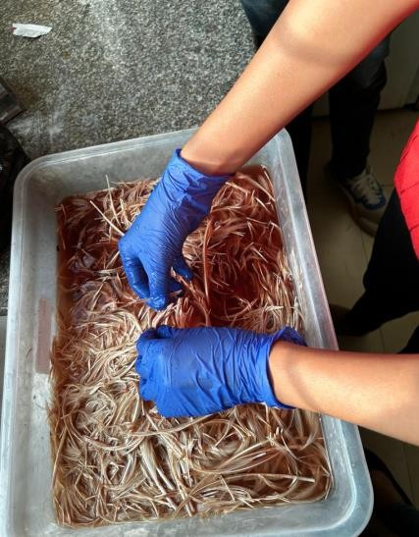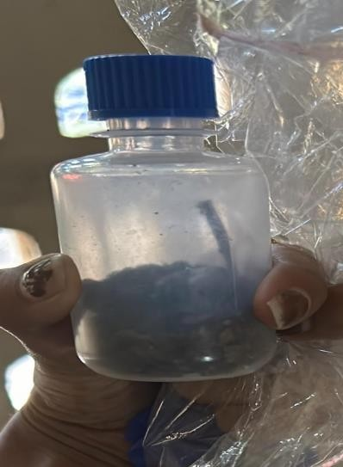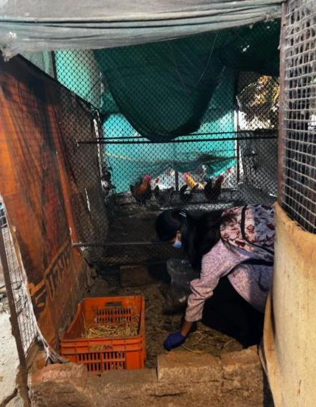The feather was washed with tap water and dried for 24 hours and defatted by soaking in diethyl ether for 24 hours and then again washed and kept for drying. The feathers were cut into small pieces for furtherprocesses.

Fig.3:Cleaning of Feathers

Fig.3:Cleaning of Feathers

Fig.2: Soil Sample

Fig.2: Soil Sample

Fig.1:Collectionof sample

Fig.1:Collectionof sample
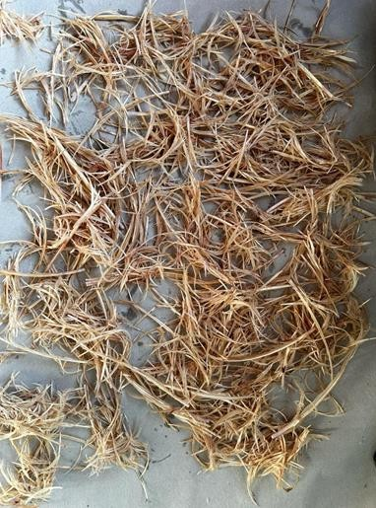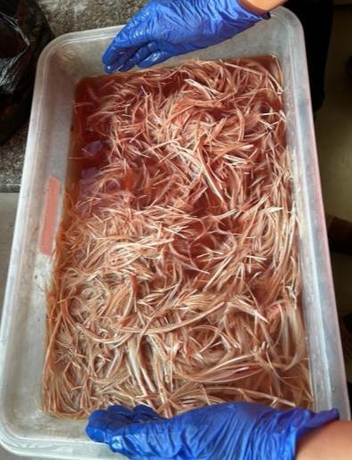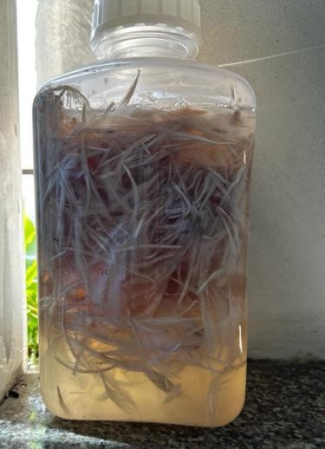The medium used for keratinase production contained the following constituents, (Suchitra Godbole, 2017).

Fig.6:Featherskeptfor drying

Fig.6:Featherskeptfor drying

Fig.5: Feathers again washedwithtapwater

Fig.5: Feathers again washedwithtapwater

Fig.4:SoakedinDiethyl ether for 24hrs

Fig.4:SoakedinDiethyl ether for 24hrs

COMPOSITION OF FEATHER MEAL BROTH (g/100 ml)
NaCl 0.005g,
K2HPO4 0.038g
KH2PO4 0.04g
MgCl2.6H2O0.02g
YeastExtract0.01g
Feathermeal0.05g pH 7.5

ISOLATION OF KERATINOLYTIC BACTERIA.
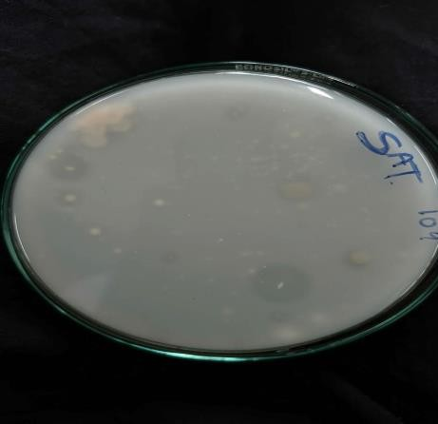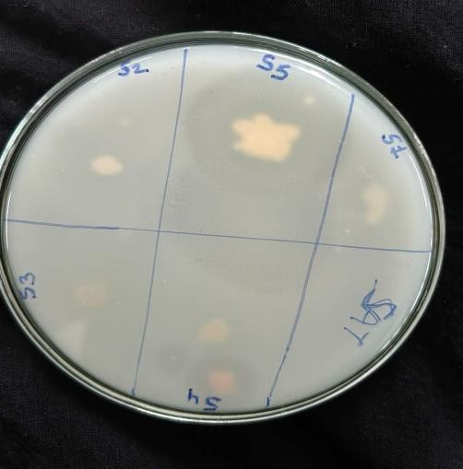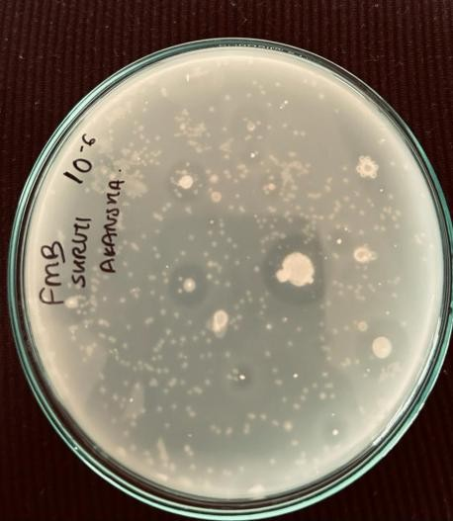Serial dilution of soil suspension was made from 101, 102 ,103, 104, 105, 106, 107, thelast three dilutions were spreaded on skimmed milk agar plates.The petri plates were incubated at 37o C for 24 hours.Isolated bacterial colonies showing zone of clearance on skimmed milk agar were selected for further studies.
Sample 2
Sample 1

Fig.9: Zone of clearance on skimmed milk agar plate

Fig.9:Zoneofclearanceon skimmed milk agar plate

Fig.8: Spot Inoculation. Zone of clearance observed

Fig.8: Spot Inoculation. Zoneofclearanceobserved

Fig.7: Skimmed milk agar plate after incubation

Fig.7:Skimmedmilkagar plate after incubation

The colonies were isolated on nutrient agar plates by streak plate method. The isolates were characterized for colony characteristics, morphological characterization and further identification.
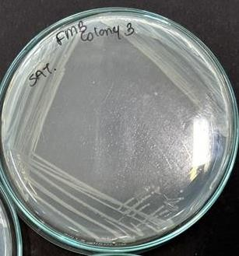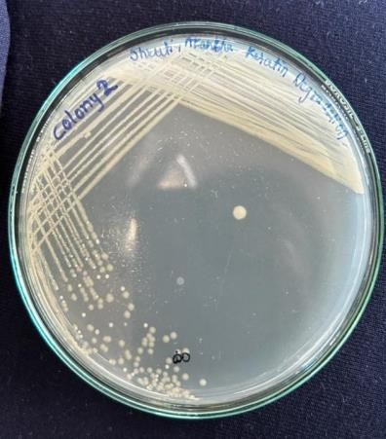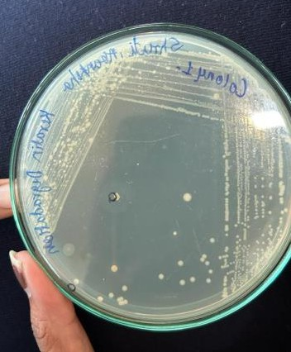

Fig.12: Colony 3 - S3

Fig.12:Colony3-S3

Fig.11: Colony 2 - S2

Fig.11:Colony2- S2

Fig.10: Colony 1 - S1

Fig.10:Colony1 -S1
Sample 1
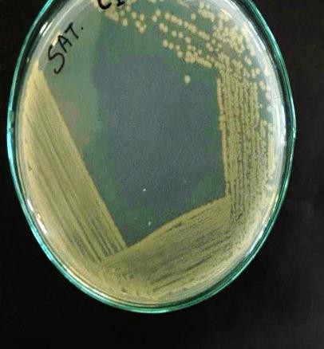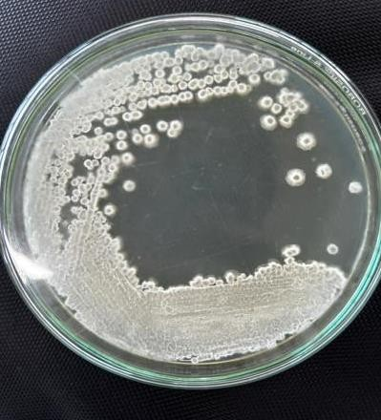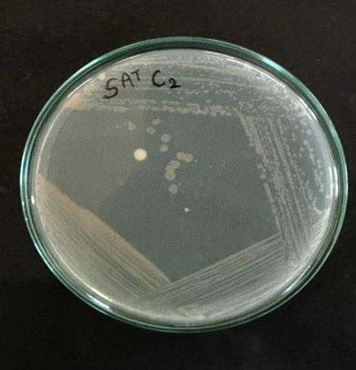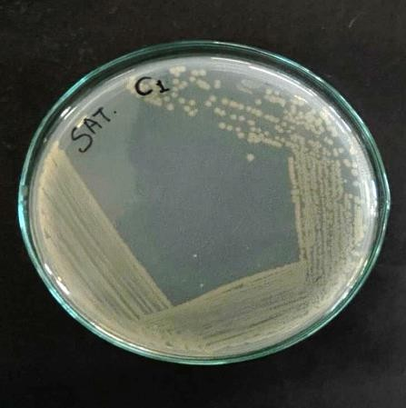

Fig.13: Colony 4 - S4

Fig.13:Colony4-S4

Fig.14: Colony 5 - S5

Fig.14:Colony5 -S5

Fig.16: Colony 7 – C2

Fig.16:Colony7 – C2

Fig.15: Colony 6 – C1

Fig.15:Colony6– C1
Sample 2
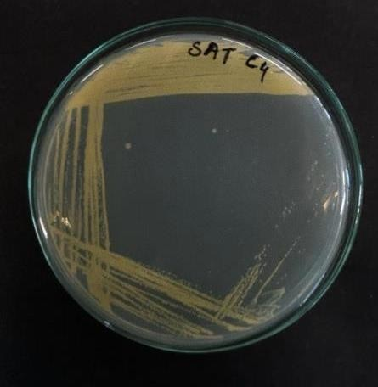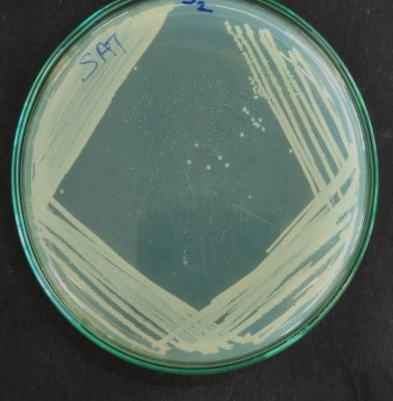

Fig.18: Colony 8 – C3

Fig.18:Colony9 – C4

Fig.17: Colony 8 – C3

Fig.17:Colony8– C3

SCREENING OF KERATINOLYTIC BACTERIA.
Cultivation of isolated cultures was performed in Erlenmeyer Flask containing 100ml of Feather MealBrothmedium,overnightgrowncultureofeachisolate–S1,S2,S3,S4,S5,C1,C2,C3,C4 wasinoculatedin100mlFeatherMealBroth.The brothwasthenincubated onRotaryShakerfor 7-8Days.OpticalDensitywasmeasuredeverydayusingacolorimeter.ControlwasFeatherMeal broth without inoculum. Growth was observed for visible turbidity and recorded at 620nm, degradation of feathers was visually observed.
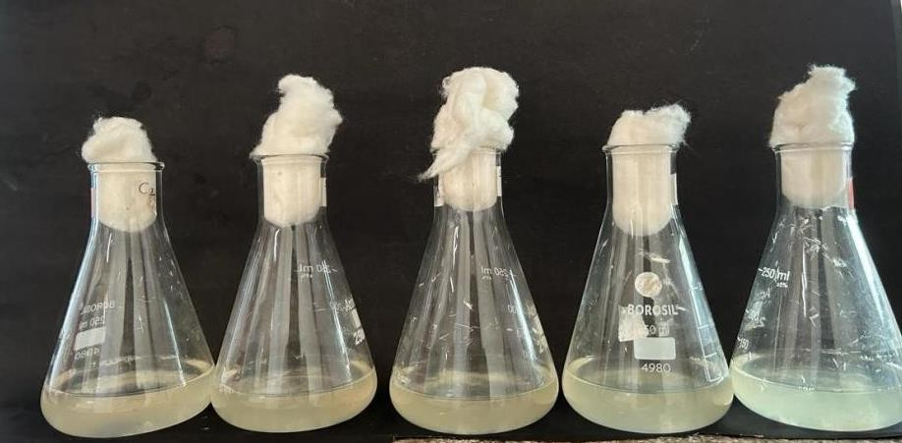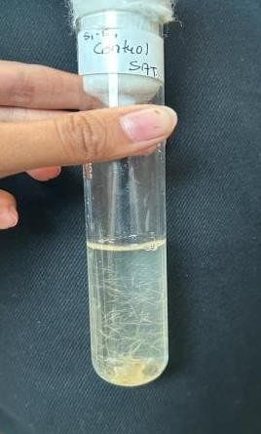

F
Fig.19: Feather meal broth of sample S1,S2,S3,S4, S5

Fig.19:FeathermealbrothofsampleS1,S2,S3,S4,S5

Fig.20: Control

Fig.20: Control

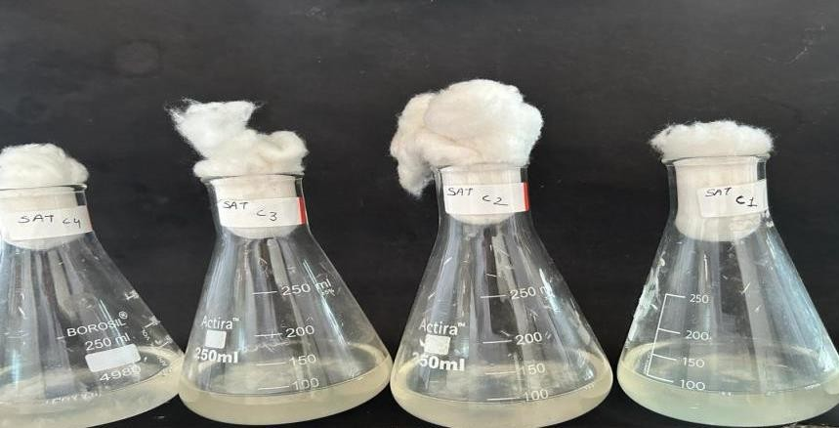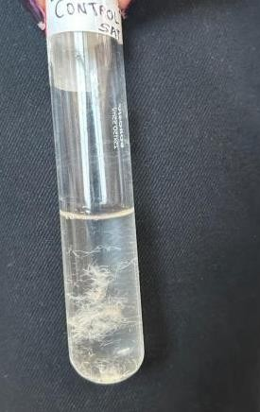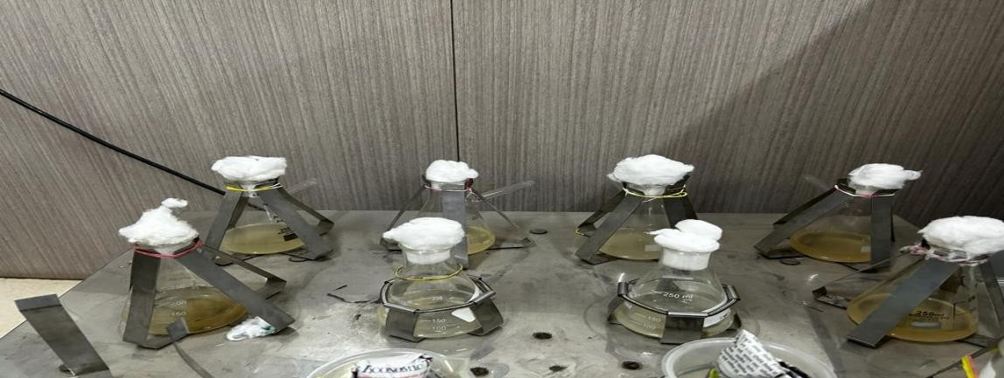

Fig.21: Feather meal broth of sample C1,C2,C3,C4

Fig.21:FeathermealbrothofsampleC1,C2,C3,C4

Fig.22: Control

Fig.22: Control

Fig.23: Broth incubated on Rotary shaker for 7-8 days

Fig.23:BrothincubatedonRotaryshakerfor7-8days

EXTRACTION OF ENZYME
The culture medium was filtered through filter paper to remove un-degraded residues. The filtrate was then centrifuged for 30min to remove the bacterial residue.
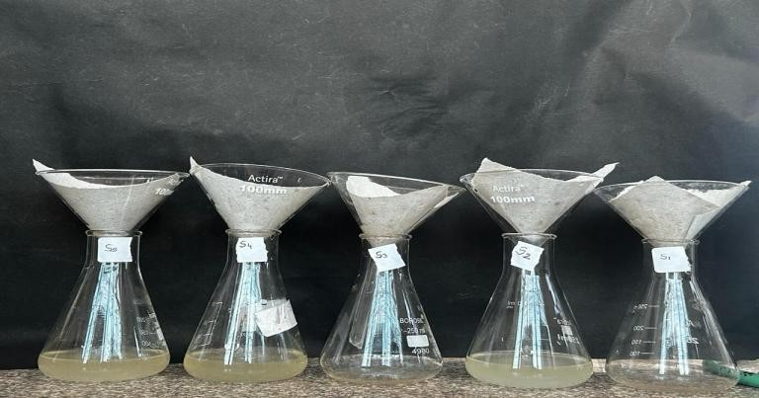After centrifugation the keratinase activity was determined in the supernatant.

Fig.24: Filtration

Fig.24: Filtration

DETERMINATION OF FEATHER DEGRADATION POTENTIAL
Determining feather degradation typically involves examining the physical and chemical changes that occurs in feathers overtime.

ASSAY FOR KERATINASE ACTIVITY
Each culture filtrate was centrifuged for 30 mins.
20mg feather meal + 3.8 ml Phosphate Buffer + 0.2ml supernatant of culture filtrate were taken in a test-tube.
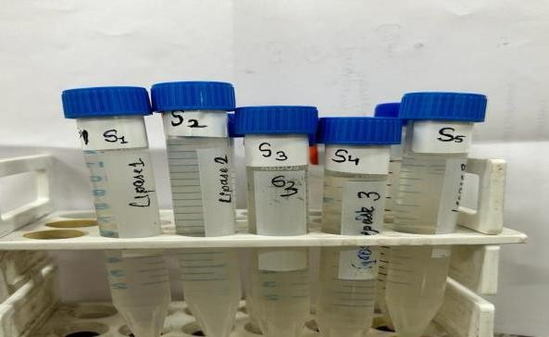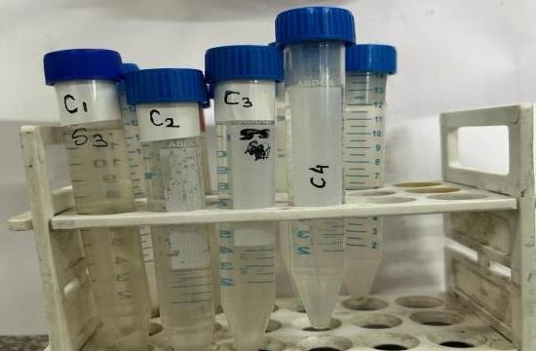Negative control contain– 20mg feather meal + 3.8ml Phosphate buffer + 0.2 ml Distilled water. Positive control contain– 20mg feather meal + 3.8ml Phosphate buffer + 0.2 ml Distilled water + 4g herbal hair removal powder.

Fig.25: After Centrifugation

Fig.25:AfterCentrifugation
The tubes were incubated at 30°c for 1 hour. After incubation the tubes were kept in chilled ice water for 10 mins.
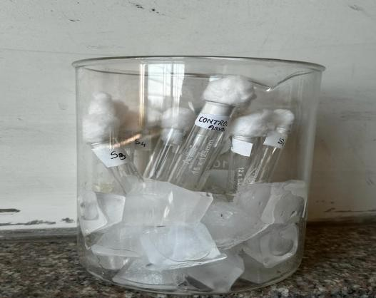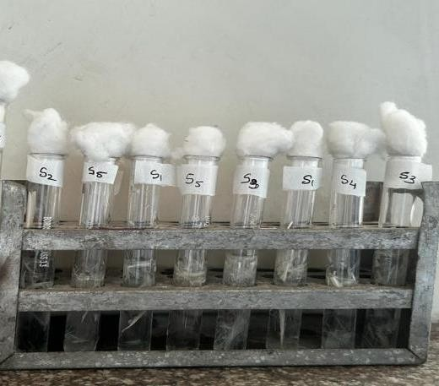The filtrate was then filter and OD was taken at 280nm on spectrometer.

Fig.27: Tubes Chilled in ice water for 10 mins

Fig.27:TubesChilledinicewater for 10 mins

Fig.26: Keratinase assay tubes

Fig.26:Keratinaseassaytubes

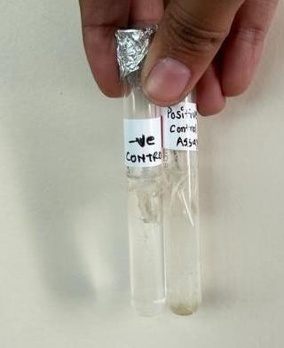

Fig.28: Negative and Positive control

Fig.28: Negative andPositivecontrol

Fig.29: Hair removal powder

Fig.29: Hair removalpowder

OPTICAL DENSITY AT 280 Nm
Negative control – 0.14
Positive control – 1.365

CALCULATIONS:
Enzyme Units per ml = Optical Density x total volume used x dilution rate (0.1) x incubation time. (Tripti Jha, 2017)
Table 1: Keratinase activity of different samples
Sr. no. | Samples | Keratinaseactivity
1 | S1 | 28.44 U/ ml / min
2 | S2 | 16.68 U/ ml / min
3 | S3 | 25.32 U/ ml / min
4 | S4 | 21.86 U/ ml / min
5 | S5 | 23.37 U/ ml / min
6 | C1 | 29.28 U/ ml / min
7 | C2 | 23.78 U/ ml / min
8 | C3 | 36.136 U/ ml / min
9 | C4 | 36.136 U/ ml / min
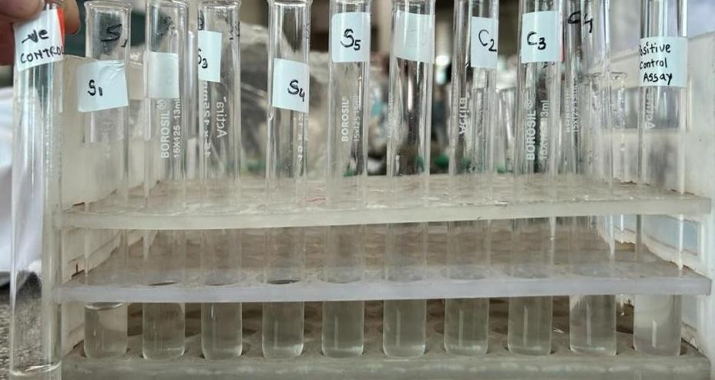

Fig.30: Keratinase enzyme activity assay

Fig.30:Keratinaseenzymeactivityassay

OPTIMIZATION OF DEGRADATION CONDITIONS
As noted, Optical Density was measured to determine effect of time on growth of organisms.

EFFECT OF TIME ON GROWTH OF MICROORGANISMS
The effect of incubation time on growth of isolates was determined in feather meal broth for 7 days. Culture samples of S1, S2, S3, S4, S5, C1, C2, C3, C4 were added to the feather meal broth. Control – Feather Meal broth without inoculum.
Feather meal broth 100 ml with 0.05g feathers was added with overnight grown culture in each flask, incubated on rotary shaker at 150 rpm.
O.D was taken at 620 nm, every 24 hours, up to 7 days for monitoring growth.
Table 2: Effect of Incubation time O.D at 620 nm
No.days | S1 | S2 | S3 | S4 | S5 | C1 | C2 | C3 | C4
Day0 | 0.01 | 0.01 | 0.02 | 0.01 | 0.01 | 0.01 | 0.02 | 0.01 | 0.01
Day1 | 0.03 | 0.04 | 0.07 | 0.03 | 0.02 | 0.06 | 0.05 | 0.06 | 0.02
Day2 | 0.03 | 0.06 | 0.08 | 0.03 | 0.10 | 0.11 | 0.06 | 0.09 | 0.03
9Day3 | 0.03 | 0.07 | 0.08 | 0.05 | 0.04 | 0.11 | 0.08 | 0.10 | 0.04
Day4 | 0.04 | 0.08 | 0.12 | 0.14 | 0.04 | 0.11 | 0.07 | 0.11 | 0.04
Day5 | 0.07 | 0.06 | 0.12 | 0.15 | 0.07 | 0.12 | 0.10 | 0.11 | 0.10
Day6 | 0.08 | 0.05 | 0.17 | 0.21 | 0.08 | 0.13 | 0.12 | 0.12 | 0.13
Day7 | 0.09 | 0.03 | 0.16 | 0.19 | 0.06 | 0.10 | 0.09 | 0.09 | 0.09

Table3:Statistical analysis for the effect of temperature on Keratinase Activity
ANOVA
Source of Variation | SS | df | MS | F | P-value | F crit
Rows | 0.077489 | 7 | 0.01107 | 15.35911906 | 4.96537E-11 | 2.178155555
Columns | 0.032861 | 8 | 0.004108 | 5.699242946 | 2.64185E-05 | 2.108688484
Error | 0.040361 | 56 | 0.000721
Total | 0.150711 | 71

The analysis of variance (ANOVA) was performed to evaluate the effects of Incubation time on the keratinase activity, when the keratinase producing organisms were grown at different incubation time. The detailed results are summarized in Table 3, which includes the F-values and p-values for each incubation time, along with their significance levels. The calculated F value is more than F-critical for the rows, indicating that these group means do not significantly differ from one another. Conversely, the F-calculated is larger than the F-critical in the columns, indicating that the group means also do not deviate significantly. According to the statistical research, incubation time has no significant impact on keratinase production and, consequently, its activity.

EFFECT OF DIFFERENT TEMPERATURE ON KERATINASE ENZYME ACTIVITY
The optimum temperature for keratinolytic activity was determined by performing the enzyme reaction at incubation temperatures between 40°C to 80°C.
0.02 g feathers + 3.8 ml Phosphate buffer + 0.2 ml supernatant of culture filtrate of each microorganisms were taken in sterile test tubes, and tubes were incubated at different temperatures (40°C, 50°C, 60°C, 70°C, 80°C) for 1 hour.
After incubation at different temperatures all tubes were chilled in ice water for 10 min, filtered and O.D was taken at 280 nm O.D values were converted to Enzyme Unit / ml. (Tamreiho.K, 2019)

Table 4: Effect of temperature O.D at 280 nm
Temperature | 40°𝒄 | 50°𝒄 | 60°𝒄 | 70°𝒄 | 80°𝒄
+VE control | 1.186 | 0.931 | 1.079 | 1.145 | 1.02
-VE control | 0.920 | 0.855 | 0.960 | 0.898 | 0.927
S1 | 0.763 | 0.648 | 0.759 | 0.729 | 0.754
S2 | 0.835 | 0.698 | 0.887 | 0.650 | 0.792
S3 | 0.752 | 0.818 | 0.716 | 0.982 | 0.840
S4 | 0.710 | 0.763 | 0.707 | 0.790 | 0.925
S5 | 0.898 | 0.773 | 0.854 | 0.782 | 0.955
C1 | 0.720 | 0.782 | 0.863 | 0.890 | 0.848
C2 | 0.698 | 0.728 | 0.759 | 0.783 | 0.822
C3 | 0.723 | 0.936 | 0.862 | 0.737 | 0.950
C4 | 0.732 | 0.749 | 0.722 | 0.685 | 0.906

Table5:Statistical analysis for the effect of temperature on Keratinase Activity
Source of Variation | SS | df | MS | F | P-value | F crit
Rows | 0.06015 | 8 | 0.007519 | 1.178229 | 0.351983 | 2.355081
Columns | 0.005954 | 3 | 0.001985 | 0.311025 | 0.817197 | 3.008787
Error | 0.153153 | 24 | 0.006381
Total | 0.219257 | 35
The analysis of variance (ANOVA) was performed to evaluate the effects of temperature on thekeratinase activity, when the keratinase producing organisms were grown at different temperatures. The detailed results are summarized in Table 5, which includes the F-values and p-values for each temperature, along with their significance levels. The calculated F value is less than F-critical for the rows, indicating that these group means significantly differ from one another. Conversely, the F-calculated is smaller than the F-critical in the columns, indicating that the group means deviate significantly. According to the statistical research, temperature has a significant impact on keratinase production and, consequently, its activity.

Calculations:
Valuesconvertedtoenzymeunitperml
Enzyme unit per ml = optical density x total volume x dilution rate x incubation time.

Table 6: Temperature O.D converted to Enzyme Unit per ml

Sr.no. | Samples | Effect of temperature on Keratinaseactivity (U/ ml / min)
 | Temperature | 40℃ | 50℃ | 60℃ | 70℃ | 80℃
 | +vecontrol | 28.464 | 22.344 | 25.896 | 27.48 | 24.48
 | -vecontrol | 22.08 | 20.52 | 23.04 | 21.522 | 22.248
1 | S1 | 15.552 | 18.312 | 17.496 | 18.216 | 18.096
2 | S2 | 20.04 | 16.752 | 21.288 | 15.6 | 19.008
3 | S3 | 19.632 | 18.048 | 23.568 | 17.184 | 20.16
4 | S4 | 17.04 | 18.312 | 16.968 | 18.96 | 22.2
5 | S5 | =21.552 | 18.552 | 20.496 | 18.768 | 22.92
6 | C1 | 17.28 | 18.768 | 20.712 | 21.36 | 20.352
7 | C2 | 16.752 | 17.472 | 18.216 | 18.792 | 19.728
8 | C3 | 17.352 | 22.464 | 20.688 | 17.688 | 22.8
9 | C4 | 17.568 | 17.976 | 17.324 | 16.44 | 21.744

Table7:Statistical analysis for the effect of temperature on Keratinase Activity
ANOVA
Source of Variation | SS | df | MS | F | P-value | F crit
Rows | 41.41619 | 8 | 5.177024 | 1.758656 | 0.122779 | 2.244396
Columns | 48.84553 | 4 | 12.21138 | 4.148256 | 0.008085 | 2.668437
Error | 94.19963 | 32 | 2.943738
Total | 184.4613 | 44

The analysis of variance (ANOVA) was performed to evaluate the effects of temperature on the keratinase activity, when the keratinase producing organisms were grown at different temperatures. The detailed results are summarized in Table 7, which includes the F-values and p-values for each temperature, along with their significance levels. The calculated F value is less than F-critical for the rows, indicating that these group means significantly differ from one another. Conversely, the F-calculated is larger than the F-critical in the columns, indicating that the group do not deviate significantly. According to the statistical research, temperature has a significant impact on keratinase production and, consequently, its activity.

EFFECT OF DIFFERENT pH ON KERATINASE ENZYME ACTIVITY
Keratinolytic enzyme activity was studied in the pH range of 4 to 9 using Phosphate buffer.
0.04 g feathers + 3.8 ml phosphate buffer having different pH from 4 to 9, to which 0.2 ml supernatant of culture filtrate of each microorganism was added.
All tubes were incubated at 30° C for 1 hour, and then chilled in ice water for 10 min then filtered and O.D was taken at 280 nm.
O.D values were converted to Enzyme Unit / ml.

Table8:Effect of pHO.DconvertedtoEnzymeUnitperml
pH | 5 | 6 | 7 | 8 | 9
Positivecontrol | 35.64 | 20.808 | 20.808 | 24.84 | 16.92
Negativecontrol | 23.64 | 14.568 | 16.392 | 17.376 | 14.184
S1 | 25.656 | 15.96 | 17.904 | 17.808 | 14.256
S2 | 33.48 | 17.496 | 17.232 | 16.344 | 15.48
S3 | 27.24 | 17.472 | 18.912 | 17.016 | 16.728
S4 | 28.32 | 16.248 | 19.896 | 16.944 | 17.712
S5 | 29.016 | 14.736 | 16.632 | 17.832 | 15.888
C1 | 23.016 | 17.088 | 15.384 | 16.058 | 14.736
C2 | 20.808 | 15.84 | 17.88 | 16.128 | 15.456
C3 | 30.6 | 17.76 | 16.728 | 14.976 | 16.08
C4 | 22.5 | 15.768 | 14.88 | 15.408 | 15.84

Table9:Statistical analysis for the effect of pH on Keratinase Activity
ANOVA
Source of Variation | SS | df | MS | F | P-value | F crit
Rows | 57.06255 | 8 | 7.132819 | 1.837654 | 0.106182 | 2.244396
Columns | 762.3133 | 4 | 190.5783 | 49.09938 | 3.25E-13 | 2.668437
Error | 124.2074 | 32 | 3.881482
Total | 943.5833 | 44
The analysis of variance (ANOVA) was performed to evaluate the effects of pH on the keratinase activity, when the keratinase producing organisms were grown at different pH. The detailed results are summarized in Table 9, which includes the F-values and p-values for each pH, along with their significance levels. The calculated F value is less than F-critical for the rows, indicating that these group means significantly differ from one another. Conversely, the F-calculated is larger than the F-critical in the columns, indicating that the group means do not deviate significantly. According to the statistical research, pH has a significant impact on keratinase production and, consequently, its activity.

Calculations:valuesconvertedintoEnzymeunit perml
Enzyme unit per ml = optical density x total volume x dilution rate x incubation time.

Table 10: Effect of pH O.D at 280 nm
Sr. no. | Samples | Effect of pH on Keratinaseactivity (U/ ml / min)
 | pH | 5 | 6 | 7 | 8 | 9
 | +vecontrol | 1.485 | 0.867 | 0.867 | 1.035 | 0.705
 | -vecontrol | 0.985 | 0.607 | 0.683 | 0.724 | 0.591
1 | S1 | 1.069 | 0.665 | 0.746 | 0.742 | 0.594
2 | S2 | 1.395 | 0.729 | 0.718 | 0.681 | 0.645
3 | S3 | 1.135 | 0.728 | 0.788 | 0.709 | 0.697
4 | S4 | 1.180 | 0.677 | 0.829 | 0.706 | 0.738
5 | S5 | 1.209 | 0.614 | 0.693 | 0.743 | 0.662
6 | C1 | 0.959 | 0.712 | 0.641 | 0.669 | 0.614
7 | C2 | 0.867 | 0.660 | 0.745 | 0.672 | 0.644
8 | C3 | 1.275 | 0.740 | 0.697 | 0.624 | 0.670
9 | C4 | 1.050 | 0.657 | 0.620 | 0.642 | 0.660

Table11:Statistical analysis for the effect of pH on Keratinase Activity
ANOVA
Source of Variation | SS | df | MS | F | P-value | F crit
Rows | 0.085581 | 8 | 0.010698 | 1.706059 | 0.135188 | 2.244396
Columns | 1.401275 | 4 | 0.350319 | 55.86889 | 5.51E-14 | 2.668437
Error | 0.200652 | 32 | 0.00627
Total | 1.687508 | 44

The analysis of variance (ANOVA) was performed to evaluate the effects of pH on the keratinase activity, when the keratinase producing organisms were grown at different pH. The detailed results are summarized in Table 11, which includes the F-values and p-values for each pH, along with their significance levels. The calculated F value is less than F-critical for the rows, indicating that these group means significantly differ from one another. Conversely, the F-calculated is larger than the F-critical in the columns, indicating that the group means do not deviate significantly. According to the statistical research, pH has a significant impact on keratinase production and, consequently, its activity.

Results
Characterization and identification of bacteria by studying morphological and biochemical characteristics

COLONY CHARACTERISTICS
Table12:Bacterialcolonycharacteristics
Colony | Size | Shape | Color | Margin | Opacity | Elevation | Consistency | Grams character
S1 | 2mm | Circular | Off-  white | Entire | Opaque | Flat | Smooth | Grampositive  cocci
S2 | <1mm | Circular | Off-  white | Entire | Translucent | Convex | Smooth | Grampositive  cocci
S3 | 2mm | Circular | Off- white | Entire | Translucent | Convex | Smooth | Gramnegative short rods
S4 | <1mm | Circular | Yello  w | Entire | Translucent | Flat | Smooth | Grampositive  short rods
S5 | 4mm | Irregular | White | Irregular | Opaque | Raised Mid-depth | Sticky | Grampositive rods
C1 | 1mm | Circular | Off-  white | Entire | Translucent | Raised | Smooth | Grampositive  short rods
C2 | 1m m | Circular | Off- white | Entire | Translucent | Flat | Smooth | Gramnegative long rods
C3 | <1mm | Circular | Off- white | Entire | Opaque | Flat | Smooth | Gramnegative short rods
C4 | <1mm | Circular | Pale yellow | Entire | Opaque | Raised | smooth | Grampositive cocci

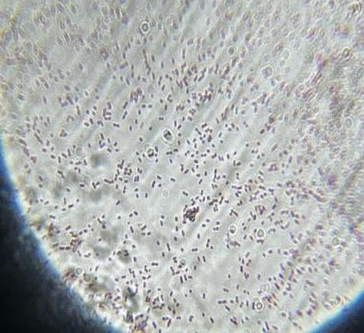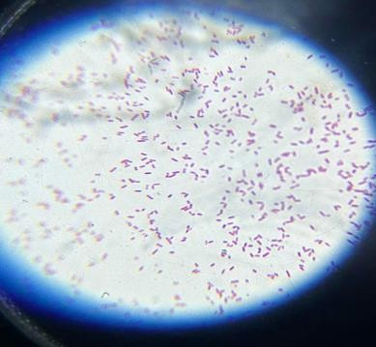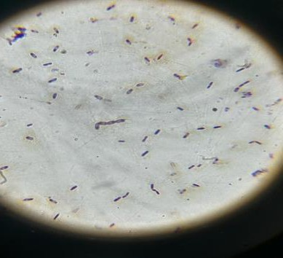GRAM STAINING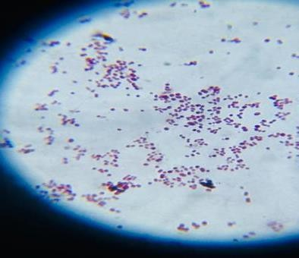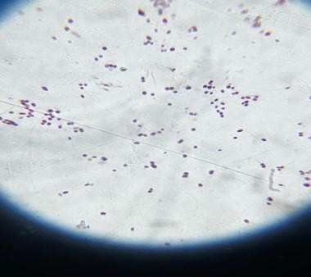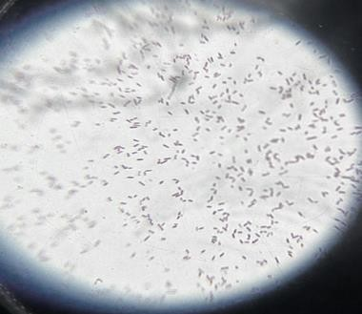

Fig.34: S4- Gram positive short rods

Fig.34: S4- Gram positiveshortrods

Fig.36: C1- Gram positive rods

Fig.36:C1-Gram positive rods

Fig.35: S5- Gram positive rods

Fig.35:S5-Gram positive rods

Fig.31: S1- Gram positive cocci

Fig.31:S1-Gram positive cocci

Fig.32: S2- Gram positive cocci

Fig.32:S2-Gram positive cocci

Fig.33: S3- Gram negative short rods

Fig.33: S3- Gram negativeshortrods

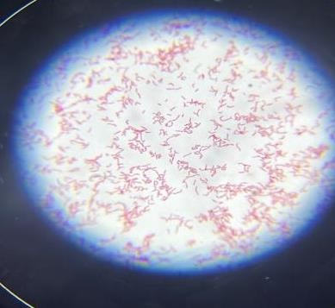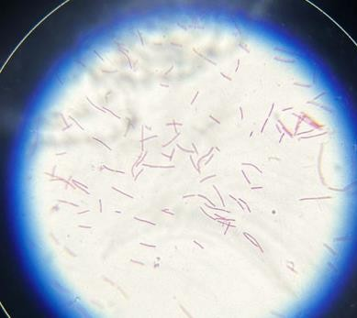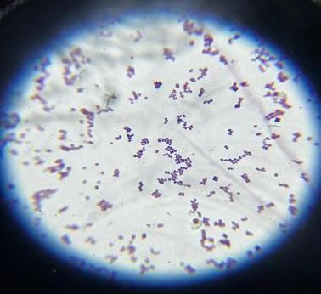

Fig.38: C3- Gram negative rods

Fig.38:C3-Gram negative rods

Fig.37: C2- Gram negative long rods

Fig.37: C2- Gram negativelongrods

Fig.39: C4- Gram positive cocci

Fig.39:C4-Gram positive cocci

CATALASE/ OXIDASE TEST- [(+) = Positive, (-) = Negative]
Table 13: Catalase/Oxidase result
Sample | Catalase | Oxidase
S1 | (+) | (+)
S2 | (+) | (-)
S3 | (+) | (+)
S4 | (+) | (+)
S5 | (+) | (-)
C1 | (+) | (+)
C2 | (+) | (+)
C3 | (+) | (-)
C4 | (+) | (-)

SUGAR FERMENTATION TEST RESULTS: (+ve = Positive, -ve =Negative)
Table 14: Sugar Fermentation Test Results
Sugars | S1 | S3 | S4 | S5 | C1 | C2 | C3 | C4
Xylose | +ve |  |  |  |  | +ve |  | +ve
Arabinose | -ve |  | +ve |  |  | +ve |  | +ve
Cellobiose | +ve | -ve |  |  |  |  |  | -ve
Sucrose | +ve | +ve | +ve | +ve | +ve |  |  | +ve
Maltose | +ve | -ve |  | +ve |  |  |  | +ve
Mannitol | +ve | +ve |  |  |  |  |  | +ve
Lactose | +ve |  |  |  | -ve |  | -ve | -ve
Galactose | -ve |  |  |  |  |  |  | +ve
Fructose | +ve | +ve |  |  |  | +ve |  | +ve
Raffinose | +ve |  |  | +ve |  |  |  | +ve
Cellulose |  | -ve |  |  | -ve
Glucose |  | +ve |  | +ve | +ve | +ve | +ve

DIFFERENCE IN WEIGHT OF FEATHER MEAL
FeathermealwaspreparedbysoakingthefeatherinDiethyletherandcuttingthemintopieces.Bacterialcultureswereisolatedfromthesoilsampleandinoculatedinfeathermealbrothforkeratinaseproductionandbiodegradationusingfeather(keratin)assolecarbonsource.Afteraweekofincubationonrotaryshakertheflasksshowedturbidityanddegradationoffeatherswereobserved.Thepercentageoffeatherdegradationiscalculatedfromthedifferenceintheinitialweightandweightobtainedafteroneweekofincubation.
Followingtableshowsthedifferenceininitialandfinalweightofthefeathersdegraded.
Table 15: Change in Sample Weight Before and After Experiment
Sample | Initial Weight  (in grams) | Final Weight  (in grams)
S1 | 0.05 | 0.0395
S2 | 0.05 | 0.02
S3 | 0.05 | 0.0263
S4 | 0.05 | 0.0176
S5 | 0.05 | 0.0008
C1 | 0.05 | 0.0269
C2 | 0.05 | 0.0401
C3 | 0.05 | 0.0044
C4 | 0.05 | 0.0051
SampleS5showsthehighestdegradabilityfollowedbysampleC3andSampleC4alsoshowingmaximumamountofdegradation.

GRAPHICAL REPRESENTATION OF EFFECT OF TIME ON GROWTH OF MICRO-ORGAMISMS
The optical density was recorded at600nm to study the effect of time on growth of micro organism.
Graph 1: Effect of Incubation time on growth of microorganisms

GRAPHICAL REPRESENTATION OF EFFECT OF TEMPERATURE ON GROWTH OFMICROORGANISMS

Graph 2: Effect of Temperature on growth of microorganisms

GRAPHICAL REPRESENTATION OF EFFECT OF PH ON GROWTH OF MICROORGANISMS

Graph 3: Effect of pH on keratinase enzyme activity

Discussion
Keratin, the protein that makes up our hair, skin, and nails, might seem invincible. But in nature, there are many organisms that have developed specialized ways to break it down. This process, called keratin degradation, is a fascinating example of how nature recycles materials.
Keratin is a tough nut to crack because of its complex structure and strong chemical bonds. Here's how microbes overcome this challenge:
- Breaking the Bonds: Keratinases come in different varieties, some targeting specific bonds within the keratin structure. This weakens the overall structure, making it easier to break down.
- Disulfide Reduction: A crucial step for many keratinases is breaking down disulfide bonds, which link keratin strands together. This often involves another enzyme, reductase, working alongside the keratinase.
- Proteolysis: Finally, the fragmented keratin is broken down further into smaller units like amino acids. These can then be used by the microbes as nutrients or become building blocks for other organisms in the ecosystem.
Why itMatters:Keratin degradation plays a vital role in the environment:
  - Waste Disposal: It helps decompose keratin-rich materials like feathers, hair, and animal leftovers, preventing waste buildup.
  - Nutrient Cycling: By breaking down keratin into usable components, microbes contribute to nutrient cycling, making these nutrients available for other organisms.
  - Biotechnology: Keratinases have potential applications in various fields. For instance, they can be used in the treatment of keratin-rich waste products or in the development of eco-friendly leather processing methods.
  - Waste Management: Isolates with high feather degradation potential could be useful in developing eco-friendly methods for managing poultry feather waste, a significant byproduct of the poultry industry.
  - Enzyme Production: The keratinase enzymes from these microbes have potential applications in various industries, such as leather processing or the development of feather-based bioproducts.
  - Understanding Microbial Diversity: This project can contribute to the knowledge of keratin- degrading microbes present in poultry farms, shedding light on the microbial communities that play a role in keratin breakdown in these environments.
This study has the potential to be not only scientifically interesting but also practically relevant. By isolating and characterizing these feather-degrading microbes, you can contribute to developing solutions for poultry waste management and exploring the potential of keratinolytic enzymes.
Three parameters were done which include- The Keratinase assay, Effect of temperature on the growth of microorganisms and Effect of pH on the growth of microorganisms.
Effect of pH on the growth of microorganisms – Table 10 shows the graphical representation of the activity of an enzyme (keratinase, given the label on the y-axis) at different pH levels. The pH levels ranges from 5 to 9 and the sample categories labelled S1 through S5, C1 through C4 with their positive control and negative control. From the graph, it seems that the enzyme activity varies with pH, with some pH levels promoting higher activity than others. The positive control likely represents a condition known to induce high enzyme activity, while the negative control represents a condition with minimal or no enzyme activity.
Effect of Temperature on growth of microorganism – Table 9 shows the graphical representation of activity of an enzyme. The bars of different colours that correspond to different temperatures. The height is each bar indicates the temperature recorded for the growth of microorganisms under each conditions. The positive control is a condition known to promote growth, while the negative control is a condition where growth is not expected to occur.
Thestudycountedcoloniesonskimmilkagarandobservedtheircharacteristics,morphology,and biochemical properties. Four types of bacterial isolates were identified from sample 2 based on these characteristics: C1, C2, C3, C4 as genus Sphaebacteria, Acidomonas, Acetobacter, Micrococcus.
The study identifies five bacterial isolates from sample 1, S1, S2, S3, S4, and S5, based on colony, morphological, and biochemical characteristics as genusStaphylococcus,Tricoccus,Alcaligens,Curtobacterium and Brachybacterium. The isolates were identified based on Bergey's manual of determinative bacteriology (9th edition).
The genus Brachybacterium, Acetobacter, Micrococcus has the maximum ability to degrade keratin. The isolation of keratin degrading strain of micrococcus from Patagonian merino wool was recently reported (Iglesias et al.2017).The study shows that this strain was able to produce several keratinases with high molecular weights.
Researchers are isolating microorganisms that can degrade keratin, the main protein in feathers, which could impact waste management in poultry farms and develop environmentally friendly feather disposal solutions.
Characterizing these microorganisms can help determine their enzymatic pathways, optimal growth conditions, and potential applications in industries like bioremediation and biofertilizer production. Understanding the diversity of keratinolytic microorganisms in poultry soil can provide insights into their ecological role and contribution to agricultural ecosystems.
Optimizing Enrichment: The success of isolating keratinolytic microbes hinges on creating an environment that favors their growth. Poultry soil likely harbors a diverse microbial community. Additionally, adjusting incubation parameters like temperature and pH could further enhance the enrichment process.
Identification Nuances: While basic morphological analysis and biochemical tests provide valuable clues, definitive identification through 16S rRNA gene sequencing can offers a more precise picture. However, this technique requires specialized equipment and expertise. We can further identify a representative subset of isolates using sequencing or rely primarily on the combined information from morphological and biochemical tests.
By carefully considering these details, we can design a comprehensive procedure that effectively isolates, identifies, and characterizes feather-degrading microbes from poultry soil, providing valuable insights into their potential for feather waste management and enzyme applications.

Conclusion
Isolating and characterizing feather-degrading microbes from poultry soil holds significant promiseforbothenvironmentalandindustrialapplications.Byenrichingforthesemicrobesusing selective media and keratin-based substrates, researchers can unlock a treasure trove of potential solutions. Identifying these "feather fighters" through a combination of morphological, biochemical unveils their unique capabilities. Evaluating their feather degradation potential through well-designed assays sheds light on their effectiveness in breaking down this abundant agricultural waste product. Ultimately, this project has the potential to contribute to the developmentofsustainablefeatherwastemanagementstrategieswhileexploringthepossibilities of utilizing keratinolytic enzymes from these microbes in various industries. The knowledge gained from this endeavor can not only benefit the poultry industry but also contribute to our understanding of microbial diversity and their role in degrading natural materials.
Thekeratinaseassayisacrucialtoolforcharacterizingthefeatherdegradationpotentialofisolated microbes from poultry soil. The keratinase assay plays a central role in this project, acting as a window into the feather-degrading abilities of isolated microbes. By measuring the activity of keratinase enzymes produced by these microbes, researchers can assess their effectiveness in breaking down keratin.
In conclusion, the keratinase assay serves as a vital link between microbial isolation and their practical application in feather degradation. By providing a quantitative measure of enzyme activity,thisassayempowersresearcherstoselectthemosteffectivefeather-degradingmicrobes, paving the way for sustainable waste management solutions and the exploration of novel applications for these enzymes in various industries.
This study isolated total nine bacterial cultures producing keratinase from habitats where keratin- containing substrates were disposed in natural conditions. These isolates were categorized based oncolonymorphology,growthcharacteristics,andbiochemical characteristics.Thefivebacterial isolates were identified as belonging to genus Sphaebacter, Acidomonas, Acetobacter, Micrococcus, Staphylococcus, Tricoccus, Alcaligens, Curtobacterium and Brachybacterium.
Theoptimumtemperatureforallbacterialisolateswas30°C,whiletheoptimumpHwas9except for S2. The newly isolated Curtobacterium and Brachybacterium demonstrated feather degradation of 70-72% under unoptimized conditions, making them potential biotechnological applications in processing feather waste from the poultry industry. Further research is needed to understand the factors enabling the enzyme's complete degradation of native keratinase substrate and to explore the use of a consortium of bacteria and fungi for feather degradation.
Thestudyrevealstheexistenceofdiversemicrobialpopulationscapableofdegradingkeratinfrom poultry soil, which is crucial for nutrient cycling and waste management in poultry farming. Understanding the enzymatic pathways and optimal conditions for keratin degradation can help develop efficient feather disposal strategies and potentially harness these microorganisms for biotechnological applications.
Further research is needed to explore practical implications, such as bioremediation and biofertilizer production, and to address challenges in waste management and sustainable agriculture.

Future Perspective:
The study explores the economic benefits and cost-effectiveness of microbial keratin degradation, explores partnerships with waste management companies, investigates scalability and efficiency, considers global applications, and continuously monitors and optimizes techniques for maximum efficacy and sustainability.
- This research aims to explore the enzymatic capabilities of isolated microorganisms, potentially leading to novel biotechnological applications such as keratinolytic enzymes for industrial process
- Genomic analysis can provide insights into the genetic basis of keratin degradation, enabling genetic engineering approaches to enhance efficiency. Investigating the ecological roles of keratin-degrading microorganisms in poultry soil ecosystems can contribute to understanding nutrient cycling and microbial community dynamics.

Disclaimer (Artificial intelligence)
I have not used any of the AI technologies such as Large Language Models (ChatGPT, COPILOT, etc.) and text-to-image generators in the complete manuscript.

REFERENCES
[1] Gupta R. And Ramnani P. “Microbial keratinases and their prospective applications an overview, Appl Microbiol Biotechnol”, 2006, vol 70, pp 21 -33.
[2] Rai S.K, Konwarh R., Mukherjee A.K., “Purification, Characterization and biotechnological application of an alkaline β- keratinase produced by Bacillus subtilis RM -01 in solid -state fermentation using chicken -feather as substrate” Biochem. Eng. J. 2009, vol 45, pp 218 -225.
[3] Shrinivas D. And Naik G. R. “characterization of alkaline thermostable keratinolytic protease from Thermoalkalophilic Bacillus halodurans jb 99 exhibiting dehairing activity”, Int. Biodeterioation & Biodegradation, 2011, vol 65(1), pp 29 -35.
[4] Ramnani P., Singh R. And Gupta R. “Keratinolytic potential of Bacillus licheniformis rg1: structural and biochemicalMicrobiol, 2005, vol 51, pp 191-196. 69.
[5] Nam G.W., Lee D.W., Lee H.S., Lee N.J., Kim B.C., Choe E.A., Hwang J.K., Suhartono M.T., Pyun R. “Native feather degradation by Fervidobacterium islandicum AW-1, a newly isolated keratinase - producing thermophilic anaerobe”, Arch. Microbiol. 2002, vol 178, pp 538 -547.
[6] Nagal S., Jain P.C. “Production of feather hydrolysate by Elizabeth kingia meningo septica KB042 (MTCC 8360) in submerged fermentation”, Indian J. Microbiol. 2010, S41 -S45.
[7] Sharma R., Gupta R. “Thermostable, Thiol activated keratinase from Pseudomonas aeruginosa – KS1 for prospective applications in Prion decontamination”, Research J. Microbiol.2010, vol5, pp 954 -965.
[8] Mabrouk M. E. M., “Feather degradation by a new keratinolytic Streptomyces sp. MS -2”, World. J. Microbiol. Biotechnol. 2008, vol 24, pp 2331 -2338.
[9] Shilpa Ashok Jani, Rishit Soni, Hetal Patel, Brinda Prajapati and Gayatri Patel. “Screening, isolation and characterization of keratin degrading actinomycetes: Streptomyces sp. and Saccharothrix xinjiangensi and analysing their significance for production of keratinolytic protease and feed grade amino acids”. Int. J. Curr. Microbiol. App. Sci. 2014, vol 3(9), pp 940 - 955.
[10] Cao L., Tan H., Liu Y., Xue X., Zhou S., “Characterization of a new keratinolytic Trichoderma atroviride strain F6 thatcompletely degrades native chicken feather”, The society for Applied Microbiology. Lett. Appl. Microbiol. 2008, vol 46, pp 389 -394. 70.
[11] Gradisar H., Friedrich J., Krizaj I., Jerala R.; Similarities and specificities of fungal keratinolytic proteases: comparison of keratinases of Paecilomyces marquandii and Doratomyces microsporus to some known proteases, Appl. Environ. Microbiol. 2005, vol 71, pp 3420 -3426.
[12] Rodrigues N.M. Ledesma C.T., Cirena D.V. “New feather – degrading filamentous fungi”, Microb. Ecol. 2008, vol 56, pp 13 - 17.
[13] Neetu Jain, Meenakshi Sharma. “Biodiversity of Keratinophilic Fungal Flora in University Campus, Jaipur, India”. Iranian J Publ Health, 2012, V ol. 41(11), pp.27 -33.
[14] Tamilmani P. Umamaheswari A, Vinayagam A and Prakash B. “Production of extracellular feather degrading enzymes by Bacillus licheniformis isolated from poultry farm soil in Namakal District (Tamilnadu)”, International Journal of Poultry Science, 2008, vol 7 (2), p184 - 188.
[15] Vigneshwaran C., Shanmuga S. and Satish kumar T. “screening and characterization of keratinase from Bacillus licheniformis isolated from Namakkal poultry farm”. 2010, vol 2(4), pp 89-96.
[16]Verma, A., Singh, H., Anwar, S., Chattopadhyay, A., Tiwari, K. K., Kaur, S., et al. (2017). Microbial keratinases: industrial enzymes with waste management potential. Crit. Rev. Biotechnol. 37, 476 –491. doi: 10.1080/07388551.2016. 1185388
[17] Viani, F. C., Santos, J. I. D., Paula, C. R., Larson, C. E., and Gambale, W. (2001). Production of extracellular enzymes by Microsporum canis and their role in its virulence. Med. Mycol. 39, 463–468. doi: 10.1080/mmy.39.5.463.468.
[18] Wang, B., Yang, W., McKittrick, J., and Meyers, M. A. (2016). Keratin: structure, mechanical properties, occurrence in biological organisms, and efforts at bio - inspiration. Prog. Mater. Sci. 76, 229–318. doi:10.1016/j.pmatsci.2015.06.001.
[19] Iglesias MS, Sequeiros C, Garcia S, Olivera NL (2017) Newly isolated Bacillus sp. G51 f rom Patagonian wool produces an enzyme combination suitable for felt-resist treatments of organic wool. Bioprocess Biosystems Eng 40:833 –842.
[20] Wang, Q., Zhao, X., Hu, Z., & Zhang, X. (2020). Effects of carbon and nitrogen sources on keratinase production by a feather -degrading bacterium, Bacillus amyloliquefaciens QY201. International Biodeterioration & Biodegradation, 150, 104937.
[21] Suntornsuk, W. and L. Suntornsuk “Feather degradation by Bacillus sp FK 46 in submerged Cultivation”. Bioresource. Technol.2003, vol 86, pp 239-243.
[22] Alexandre, J.M., O.B. Walter, G. Renata, D. David, P.H. Joao Antonio and T. Carlos “Novel keratinase from Bacillus subtilis S14 exhibiting remarkable dehairing capabilities”. Appl. Environ. Microbiol., 2005, vol71, pp 594 -596.
[23] Sharma R. And Rajak R. C., “keratinophilic fungi: nature’s keratindegrading machines - their isolation, Identification and ecological role”, Resonance, 2003, vol 8, pp 28 -40.
[24] Femi -Ola, T. O., Akinbobola, O. S. and Oluwaniyi, T. T. Isolation and characterization of feather degrading bacteria from poultry soil. Agric. Bio. J.N.Am.2015,Vol 6(5), pp 146 -154.
[26] Brandelli A, et al. Bioconversion of keratin wastes using keratinolytic microorganisms: progress and prospective. Int J Mol Sci. 2022;23:2048031.
[27] El-Refai MA, Salem AA, El-Refai AM. Keratinolytic abilities of Micrococcus luteus from poultry waste. World J Microbiol Biotechnol. 2015;31:1531-1540.
[29] Anonymous. Biodegradation of poultry feather waste by keratinase producing bacteria. Bioresource Technol Rep. 2021;15:100736.
[30] Mohanty S, et al. Efficient degradation of feather by keratinase producing Bacillus sp. ISRN Microbiol. 2013:1-7.
[31] Anonymous. Transcriptomic and proteomic insights into feather keratin degradation by Fervidobacterium. Front Microbiol. 2025;16:1509937.
[32] Zerdani I, Ouaabou R, Ghazal H, Benhsaien I, El Rahali A, Barakate M, et al. Optimization of Keratinase Production by Bacillus olironius Isolated from Poultry Farm Soil. Microbiology Journal. 2024;13(4):2381-2392.
[33] Park S, Lee T, Lee H, Lee S, Moon D, Kim S. Microbial Production of Keratinase from Bacillus velezensis Strain Isolated from Poultry Soil. Journal of Microbial & Biochemical Technology. 2024;16(2):91-98.
[34] Alamri SS, Subhan S, Alhazmi H, Mahfouz M, Hamed A, Ahmad A. Partial Purification and Characterization of a Keratinolytic Enzyme from Psychrobacter pulmonis Isolated from Soil. Journal of Microbiology and Biotechnology. 2022;32(9):1395-1405.
[35] Sultana M, Ahmad F, Ahmad A, Kumar A. Efficient Degradation of Feather by Keratinase Producing Bacillus Species Isolated from Poultry Soil. International Biodeterioration & Biodegradation. 2013;83:1-8.
[36] Vigneshwaran C, Shanmuga S, Satish Kumar T. Screening and Characterization of Keratinase from Bacillus licheniformis Isolated from Namakkal Poultry Farm. International Journal of Poultry Science. 2010;9(8):773-778.

