Agro-morphological stability of five okra (Abelmoschus esculentus L.) candidate varieties for registration in the Beninese Catalogue of Plant Species and Varieties

.
ABSTRACT

Aims : Okra is a vegetable of major nutritional and economic importance in tropical and subtropical regions. In Benin, its production remains limited by disease and pest pressure and the lack of high-performing varieties. This study aims to assess agro-morphological traits of five varieties (TZSMN86, AVOK1501, AVOK1505, AVOK1502 and C101), as part of the requirements for their inclusion in the Beninese Catalogue of Plant Species and Varieties (CaBEV). Methodology : The criteria of Distinctness, Uniformity and Stability (DUS) were assessed over two cycles of on-station trials. Agreement between qualitative parameter classifications across production seasons was assessed using Cohen's Kappa coefficient, while phenological and agro-morphological data were analyzed using generalized linear and linear mixed-effect models, followed by Tukey's posthoc tests for mean comparisons, in R (v4.3.0) with variety and season as fixed factors and block as random factor. Results : Findings revealed that several qualitative traits were uniform, while significant differences (p < 0.05) were noted in leaf blade color and fruit shape. Quantitative data indicate significant variability between genotypes across seasons. Ascending hierarchical clustering (AHC) grouped the varieties into three distinct clusters. Accessions AVOK1502 and AVOK1505 also showed good stability across seasons. Conclusion : These results provide a scientific basis for the approval and registration of high-performing okra varieties (TZSMN86, AVOK1501, AVOK1505, AVOK1502 and C101) in the national variety catalogue.

Keywords : Okra, DUS tests, varietal characterization, yield

1. INTRODUCTION

Okra (Abelmoschus esculentus (L.) Moench), a member of the Malvaceae family, is a vegetable widely cultivated in tropical, subtropical, and warm temperate areas (Yıldız et al, 2016). In addition to its nutritional value, rich in polysaccharides, mucilages, essential vitamins, and minerals, it has recognized therapeutic properties. Several studies have highlighted its antihyperglycemic effects in diabetic patients (Elkhalifa et al, 2021; Olawuyi & Lee, 2021; Peter et al, 2021, Joshi et al, 2025), as well as the anti-inflammatory properties of the polyphenols it contains (Agregan et al, 2023).
In Benin, okra occupies an important place in the diet, being consumed by all sociolinguistic groups and representing approximately 9.3% of national vegetable production (DSA, 2022). However, despite its popularity, national production remains lower than that observed in neighboring countries. For comparison, in 2022, Nigeria produced 1,911,818.5 tons of okra with an average yield of 10,004 kg/ha, compared to only 65,670.09 tons for Benin, with a yield of 3,664 kg/ha (FAOSTAT, 2022). This poor performance can be explained by various factors, including pressure from pests, the lack of varieties adapted to local conditions, and the impacts of climate change, particularly rainfall variability (Sossa et al., 2020). Recently, Blalogue et al, (2025), analyze the challenges and opportunities in the okra (Abelmoschus spp.) seed system in Benin. “Developing crop varieties adapted to local agroclimatic conditions and farmers’ needs constitutes a promising approach to strengthening sustainability and food security (Vernooy, 2004). Genetic improvement of okra is emerging as a strategic solution. In this context, a collaboration between the World Vegetable Center and the National Institute of Agricultural Research of Benin has led to the evaluation of several okra accessions. However, to be accessible to producers, these accessions must be officially registered in the Beninese Catalogue of Plant Species and Varieties (CaBEV) or the West African Catalogue of Plant Species and Varieties (COAfEV). Morphological characterization based on qualitative traits of crops is a very crucial and essential first step in any crop improvement and breeding programme. Hence, morphological characterization is a process by which various genotypes, germplasm lines or accessions are identified, differentiated or distinguished according to theircharacters based on descriptors assigned. Morphological descriptors are the foundation for characterization of plant genotypes based on external/morphological characteristics (Joshi et al., 2020).
In accordance with the manual of approval procedures (MAEP, 2017), this registration requires the evaluation of accessions over two successive cycles, according to the criteria of Distinctness, Uniformity, and Stability (DUS) of the International Union for the Protection of New Varieties of Plants (UPOV, 1999).
This study aims at the agro-morphological evaluation of five okra accessions, with a view to their approval and large-scale dissemination. The introduction of new varieties, adapted to local agro-ecological conditions, aims to strengthen the resilience and sustainability of agricultural production.

2. material and methods

2.1 Study area
This study was carried out at the vegetable program of Horticultural research Center based at Agonkanmey/Abomey-Calavi, Benin, characterized by ferralitic soil.during the big rainy season period.
2.2 Plant material
Five (05) okra varieties were evaluated for DUS testing over two cycles. The seeds were provided by the World Vegetable Center (Table 1).
Table 1: List of okra varieties eligible for DUS testing.
N° | Variety | Genetic Nature | Origin
01 | TZSMN86 | Open pollinisation | World Vegetable Center
02 | AVOK1501 | Open pollinisation | World Vegetable Center
03 | AVOK1505 | Open pollinisation | World Vegetable Center
04 | AVOK1502 | Open pollinisation | World Vegetable Center
05 | C101 | Open pollinisation | World Vegetable Center

2.3 Methodology
2.3.1 Experimental design
The experimental design was a Fisher Block design with five treatments and four replicates. The elementary plots are 25 m² (5 m x 5 m) and consist of six rows. The spacing adopted is 0.80 m between rows and 0.50 m between plants within the row, for a density of 60 plants/elementary plot. Sowing was carried out on September 12, 2023, and April 19, 2024, respectively, for the first and second cycles. To promote better plant development, the plants were fertilized according to the organo-mineral fertilization plan recommended by Mensah et al, 2021.
2.3.2 Data provided
Data collection was carried out according to the descriptors of the International Union for the Protection of New Varieties of Plants (UPOV, 1999) and the manual of procedures for the approval and registration of varieties in the Benin Catalogue of Plant Species and Varieties developed by INRAB (MAEP, 2017). Qualitative and quantitative morphological data (Table 2) were collected on 20 plants from rows 2 and 5 after seed emergence according to the period indicated by UPOV.
Table 2: List of agromorphological and phenological traits evaluated on okra varieties during the two cycles.
N° | Characters
1(*) | Plant: Degree of Branching
2 | Plant: Height
3 | Stem: Diameter
4(*) | Stem: Color
5 | Stem: Color Intensity
6 | Stem: Number of Nodes (up to and including the first flowering node)
7 | Leaf: Size
8(*) | Leaf: Depth of Cut
9 | Leaf: Serration of Edge
10(*) | Leaf: Color Between the Veins
11 | Leaf blade: color intensity
12 | Petiole: length
13 | Petiole: diameter
14 | Flower: size
15 | Flowering time
16 | Commercial harvest time
17(*) | Fruit: color
18 | Fruit: color intensity
19 | Fruit: diameter of young fruit (at the midpoint of the length)
20(*) | Fruit: area between ridges
21 | Fruit: Basal Structure
22 | Fruit: Top Shape
23(*) | Fruit: Number of Cells
24 | Fruit: Carpel Size
25 | Fruit: Length of Mature Fruit
26 | Fruit: Diameter of Mature Fruit (as for 17)
27 | Number of Capsules per Plant
28 | Weight of Fruits per Plant
29 | Number of Seeds per Capsule
30 | Weight of Seeds per Capsule
(*) Mandatory character

2.3.3 Statistical data analysis
Agreement between classifications of qualitative parameters for each variety across two successive production seasons was evaluated using Cohen's Kappa coefficient via the psych package in R. Coefficients were interpreted according to the Landis and Koch (1977) agreement scale. Phenological data and discrete quantitative agro-morphological parameters were analyzed using a generalized linear Poisson mixed-effect model in R software to assess the effect of varieties, blocks and cycle on their variations at a 5% threshold. In addition, linear mixed-effect models were performed on continuous quantitative agro-morphological parameters and yield data. The full, random intercept, random slope, and random intercept and slope models were tested in R software version 4.3.0 (R Core Team, 2023). This analysis was performed in the “lmerTest” package (Kuznetsova et al., 2017). Variety and cycle were considered fixed factors and block as a random factor. The best model was selected based on the Akaike Information Criterion (AIC) scores. Tukey's posthoc test was used for pairwise comparison of means at the 5% significance level.

3. results and discussion

3.1 Qualitative traits of okra accessions
Analysis of the qualitative trait results revealed the existence of variability among the candidate okra accessions. Indeed, all the okra accessions studied have green fruits and stems. Green color was also observed between the leaf veins. However, a difference in color intensity was observed in the fruits and between the leaf veins. The fruit color intensity is clear for accessions AVOK1501, AVOK1502, and TZSMN86 and moderate for accessions AVOK1505 and C101, as shown in Figure 1.

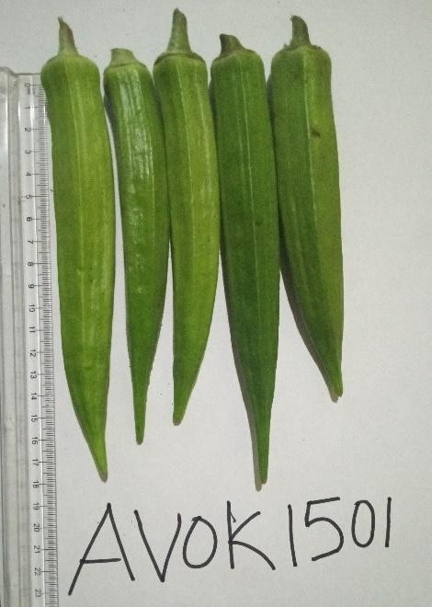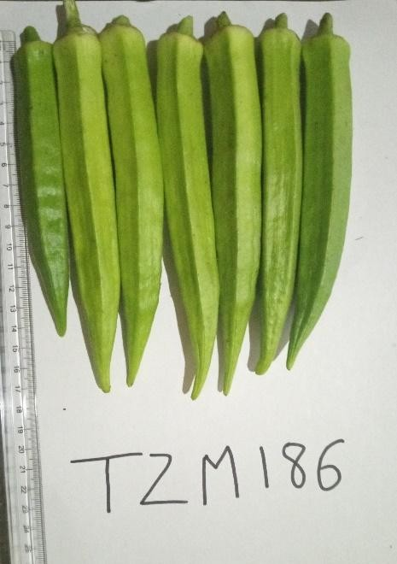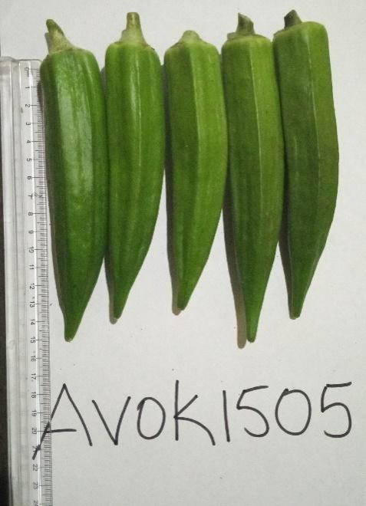

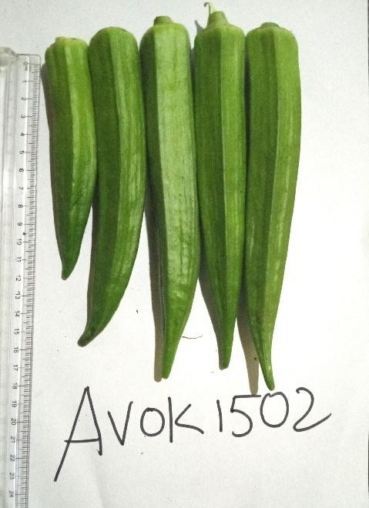
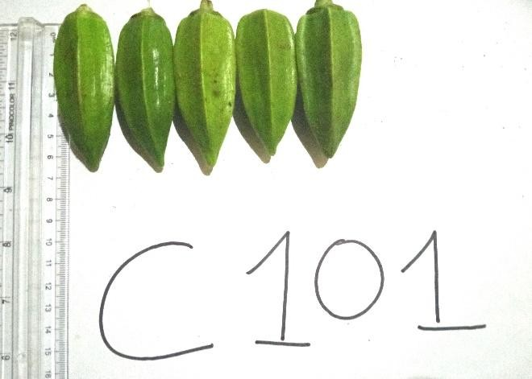

Figure 1: Fruits of the different okra accessions characterized

Regarding the color between the leaf veins, all accessions exhibited a dark green color except for accession TZSMN86, which was light green. The basal part of the fruit was absent or very weakly expressed in accession C101 and weakly expressed in the other accessions. Furthermore, accessions AVOK1501, AVOK1502, AVOK1505, and TZSMN86 had fruits with an acute apex, unlike accession C101, which had a broad, acute apex.
For the depth of the blade cut, accessions AVOK1501, AVOK1502 and AVOK1505 presented a shallow cut while accessions C101 and TZSMN86 presented a medium cut. The surface between the edges of accessions AVOK1501, AVOK1502 and AVOK1505 is flat unlike that of accessions C101 and TZSMN86 which is concave as indicated in Table 3.
All candidate okra accessions are characterized by the presence of fruit pubescence, a moderately serrated leaf edge, and a light green color for stem color intensity.
Table 3: Dynamics of qualitative characteristics of okra accessions following cultivation cycles
PARAMETERS | AVOK  1501 |  | AVOK  1502 |  | AVOK  1505 |  | C101 |  | TZSMN  86
 | CYCLE 1 | CYCLE 2 | CYCLE 1 | CYCLE 2 | CYCLE 1 | CYCLE 2 | CYCLE 1 | CYCLE 2 | CYCLE 1 | CYCLE 2
CF | Green | Green | Green | Green | Green | Green | Green | Green | Green | Green
ICF | Clear | Clear | Clear | Clear | Medium | Medium | Clear or Medium | Clear or Medium | Clear | Clear
PF | Present | Present | Present | Present | Present | Present | Present | Present | Present | Present
CPBF | Weakly expressed | Weakly expressed | Weakly expressed | Weakly expressed | Weakly expressed | Weakly expressed | Absent or very weakly expressed or Weakly expressed | Absent or very weakly expressed or Weakly expressed | Weakly expressed | Weakly expressed
FSF | Acute | Acute | Acute | Acute | Acute | Acute | High or Narrow High or Wide High | High or Narrow High or Wide High | Acute | Acute
LCN | Green | Green | Green | Green | Green | Green | Green | Green | Green | Green
LICN | Medium | Medium | Medium | Medium | Medium | Medium | Clear or Medium | Clear or Medium | Clear | Clear
LPD | Medium | Medium | Medium | Medium | Medium | Medium | Shallow | Shallow | Shallow | Shallow
LDB | Medium | Medium | Medium | Medium | Medium | Medium | Medium | Medium | Medium | Medium
SAF | Plane | Plane | Plane | Plane | Plane | Plane | Concave | Concave | Plane | Plane
CT | Green | Green | Green | Green | Green | Green | Green | Green | Green | Green
ICT | Clear | Clear | Clear | Clear | Clear | Clear | Clear | Clear | Clear | Clear
Kappa (κ*) | 1 |  | 1 |  | 1 |  | 1 |  | 1
*κ = 1 ⟹ Perfect agreement : no differences in classifications between cycle 1 and cycle 2 ; CF: Fruit color; ICF: Fruit color intensity; PF: Fruit pubescence; CPBF: Fruit basal part constriction; FSF: Fruit top shape; LCN: Leaf blade color between veins; LICN: Leaf blade color intensity between veins; LPD: Leaf blade cut depth; LDB: Leaf blade edge serration; SAF: Fruit edge surface area; CT: Stem color; ICT: Stem color intensity.
3.2 Comparative analysis of morphological traits between the two cycles
Plant height
A significant increase in height was observed in Cycle 2 compared to Cycle 1. The averages increased from a relatively low height (between 31.1 and 51.49 cm) to significantly higher values in Cycle 2 (between 60.49 and 127.35 cm). The highly significant p values (P < 2.2e-16 or P = 0.033 for AVOK1505) confirm the robustness of this difference (Table 4).
Number of branches
An increase in the number of branches was also observed, although this change varied between lines (Table 4). Line AVOK1501 showed a highly significant increase (up to 9 branches, P < 2.2e-16), while the other lines (AVOK1502, AVOK1505, C101) did not show significant differences (P ≥ 0.11). This indicates a differentiated genetic response to the environment or culture conditions in Cycle 2.
Number of lodges
The number of lodges remained stable between the two cycles, with an average of around 5. The non-significant p values (P = 1 or close) confirm this stability (Table 4), suggesting that this characteristic is little influenced by cyclical or temporary conditions.
Number of flowers
Unlike vegetative traits, a marked decrease in flower number is observed in Cycle 2. While Cycle 1 shows a high average (8 to 10 flowers), Cycle 2 shows a drastic drop (1 to 2 flowers). The highly significant p values (P < 2.2e-16) validate this trend (Table 5). This reduction may reflect a limitation of the reproductive phase or a phenological change unfavorable to flowering.
Carpel diameter
Carpel diameter followed the same trend, with a significant reduction between cycles (Table 5). In Cycle 1, values were high (6.58 to 7.06 mm, letter a), while in Cycle 2, they decreased significantly (4.41 to 5.57 mm). The differences were significant (P < 0.01), except for line TZSMN86 (P = 0.12). This reduction could directly impact fruit formation and size.
Flower diameter
Finally, flower diameter decreased significantly in Cycle 2, from values between 66.13 and 94.04 mm to smaller values ranging from 42.86 to 73.53 mm (Table 5). Statistical tests confirmed this difference with highly significant p values (P < 2.2e-16). Such a reduction could impair pollination capabilities, or even floral attractiveness to pollinators.
The results show a marked contrast between the two cycles. Cycle 2 is associated with an increase in vegetative traits (increase in height, sometimes in the number of branches), while reproductive traits (number of flowers, flower and carpel diameter) undergo a significant decrease. The number of loci, however, remains unchanged.
This dynamic suggests a differential allocation of resources between the two phases: priority given to vegetative growth in Cycle 2, potentially to the detriment of reproduction. These results could reflect a physiological adaptation, an environmental response, or even effects related to different growing conditions between cycles.
Table 4: Quantitative agro-morphological traits per cycle of okra lines
Cycle | Plant Height (cm) |  |  |  |  | Number of branches |  |  |  |  | Number of locuses
Cycle | AVOK1501 | AVOK1502 | AVOK1505 | C101 | TZSMN86 | AVOK1501 | AVOK1502 | AVOK1505 | C101 | TZSMN86 | AVOK1501 | AVOK1502 | AVOK1505 | C101 | TZSMN86
1 | 47.94±6.58 b | 51.49±5.8 b | 51.42±6.92 b | 40.41±8.44 b | 31.1±3.88 b | 4±3 b | 5±3 a | 3±2 a | 4±3 a | 3±2 b | 5±0 a | 5±1 a | 5±0 a | 5±1 a | 5±1 a
2 | 127.35±5.22 a | 84.36±5.74 a | 79.86±7.51 a | 102.57±7.36 a | 60.49±0.94 a | 9±5 a | 5±1 a | 4±2 a | 5±2 a | 5±2 a | 5±0 a | 5±0 a | 5±0 a | 5±0 a | 6±1 a
Probability | <2.2e-16*** | <2.2e-16*** | 0.033* | <2.2e-16*** | <2.2e-16*** | <2.2e-16*** | 1 | 0.1097 | 0.1099 | 0.0035** | 1 | 1 | 1 | 1 | 0.278

Table 5: Quantitative agro-morphological characteristics by cycle of okra lines
Cycle | Number of flowers |  |  |  |  | Carpel diameter (mm) |  |  |  |  | Flower diameter (mm)
Cycle | AVOK1501 | AVOK1502 | AVOK1505 | C101 | TZSMN86 | AVOK1501 | AVOK1502 | AVOK1505 | C101 | TZSMN86 | AVOK1501 | AVOK1502 | AVOK1505 | C101 | TZSMN86
1 | 10±4 a | 9±5 a | 8±5 a | 9±5 a | 8±4 a | 6.69±0.75 a | 6.58±0.86 a | 6.94±0.8 a | 7.06±0.82 a | 6.93±0.88 a | 68.94±14.34 a | 66.13±15.04 a | 76.17±16.09 a | 94.04±18.5 a | 68.65±10.66 a
2 | 1±1 b | 1±1 b | 2±2 b | 1±1 b | 2±2 b | 4.41±1.01 b | 4.63±1.37 b | 4.65±1.4 b | 5.57±1.46 b | 5.12±1.2 a | 44.8±10.68 b | 51.38±13.23 b | 49.88±12.06 b | 73.53±13.33 b | 42.86±11.67 b
Probability | 2.48e-09* | <2.2e-16*** | <2.2e-16*** | <2.2e-16*** | <2.2e-16*** | 0.00095*** | 0.0081** | 0.00124** | 0.00214** | 0.1219 | <2.2e-16*** | 1.01e-11*** | <2.2e-16*** | 0.00082*** | <2.2e-16***

3.3 Comparative analysis of phenological characteristics between the two cycles
Analysis of phenological data highlights a significant temporal shift in several key stages of plant development between cycles 1 and 2. These differences reflect a change in the phenological behavior of the lines studied, likely influenced by environmental or agronomic factors.
Date of first flower appearance
In Cycle 1, flowering began relatively early, between 38 ± 2 and 56 ± 2 days after sowing (DAS), with some lines (AVOK1501). In Cycle 2, this date was slightly delayed, reaching up to 61 ± 2 DAS. The difference was statistically significant (P = 0.0362), indicating that flowering initiation tended to occur later in Cycle 2 (Table 6).
50% flowering date
The two cycles have statistically similar 50% flowering dates, ranging between 39 and 62 DAS. The p-value (0.9885) indicates no significant difference. This suggests homogeneity of flowering across the population despite the slight delay observed for the first flower (Table 6).
Date of appearance of the first fruit
The formation of the first fruit occurred between 39 ± 2 and 57 ± 2 DAS in Cycle 1 and from 43 ± 1 to 65 ± 21 DAS in Cycle 2. Although a slight apparent delay was observed, the difference was not statistically significant (p = 0.1058), suggesting high variability between plants and an overlap in time ranges between cycles (Table 6).
50% fruiting date
Unlike the first fruit, the date at which 50% of plants bear fruit is significantly later in Cycle 2 (46 to 88 DAS) compared to Cycle 1 (43 to 64 DAS). The p-value is highly significant (p < 2.2e-16). This indicates a clear shift in fruiting dynamics between the two cycles (Table 6).

Table 6: Phenological parameters relating to the dates of flower and fruit appearance per cycle of okra lines
Cycle | Date of first flower (DAS) |  |  |  |  | Date 50% flowering (DAS) |  |  |  |  | Date of first fruit (DAS) |  |  |  |  | Date 50% fruiting (DAS)
Cycle | AVOK1501 | AVOK1502 | AVOK1505 | C101 | TZSMN86 | AVOK1501 | AVOK1502 | AVOK1505 | C101 | TZSMN86 | AVOK1501 | AVOK1502 | AVOK1505 | C101 | TZSMN86 | AVOK1501 | AVOK1502 | AVOK1505 | C101 | TZSMN86
1 | 38±2 b | 39±1 a | 40±2 a | 42±1 b | 56±2 b | 42±0 b | 45±2 a | 45±2 a | 51±1 b | 62±3 b | 39±2 b | 40±1 a | 41±2 a | 43±1 b | 57±2 b | 43±1 b | 47±2 a | 46±2 a | 53±2 b | 64±2 b
2 | 42±1 a | 40±2 a | 42±1 a | 46±1 a | 61±2 a | 47±1 a | 46±2 a | 47±1 a | 67±3 a | 87±8 a | 43±1 a | 41±2 a | 43±1 a | 47±1 a | 62±2 a | 48±1 a | 47±2 a | 48±1 a | 68±3 a | 88±8 a
Probability | 0.0362* | 0.9885 | 0.1058 | <2.2e-16*** | <2.2e-16*** | 3.91e-05*** | 0.856 | 0.05504. | <2.2e-16*** | <2.2e-16*** | 0.028* | 0.9889 | 0.053. | 0.0386* | <2.2e-16*** | 0.0278* | 1 | 0.07248. | 0.0046** | <2.2e-16***
DAS = Days After Sowing

3.4 Comparative analysis of yield components between the two cycles
Analysis of agronomic data reveals notable differences between the two cycles, particularly with regard to overall productivity, the proportion of commercial and non-commercial fruit, and the stability of certain quality parameters. These results make it possible to assess the impact of the cycle on the quantity and quality of fruit production.
Total number of fruits
In Cycle 1, the total number of fruits per plant is higher, with averages ranging from 26 ± 10 fruits (TZSMN86) to 51 ± 16 fruits (AVOK1501). In Cycle 2, a decrease is observed, with values ranging from 9 ± 5 to 48 ± 13 fruits, with a statistically significant difference (p = 0.046), indicating that Cycle 1 is overall more productive in terms of fruit number, particularly for some lines (Table 7).
Average fruit weight
No significant difference was detected between cycles for average fruit weight (p = 0.875). Values remained relatively constant, regardless of cycle or line. This suggests that unit fruit size is stable, even when the total number of fruits varies, indicating morphological resilience of the fruit to cyclical variations (Table 7).
Dried fruit diameter
Dried fruit diameter remained stable between cycles, with no significant difference (P = 0.683). This consistency indicates that fully matured fruits did not undergo significant morphological alteration, which is an indicator of genetic or physiological stability (Table 7).
Commercial fruit yield
Commercial fruit yield decreased significantly in Cycle 2, from up to 28.49 t/ha (Cycle 1) to 26.53 t/ha (Cycle 2) for AVOK1501, and from 26 t/ha to only 9 t/ha for the TZSMN86 line. The difference was highly significant (P < 2.2e-16). This result highlights a marked decrease in the marketability of production in Cycle 2, a critical parameter for economic recovery (Table 8).
Non-commercial fruit yield
Non-commercial fruit yield also decreased significantly between the two cycles. Maximum values decreased from 21.92 t/ha (Cycle 1) to only 3.28 t/ha (Cycle 2). The very high statistical significance (P < 2.2e-16) suggests a real change in the health or morphological quality of the fruit produced. This decrease can be interpreted positively (better overall quality) or as an overall reduction in fruit set, also affecting non-commercial fruit (Table 8).
Total fruit yield
Total fruit yield (including both commercial and non-commercial fruits) did not show any significant difference between cycles (P = 1). This indicates overall stability in weight production, although internal dynamics (distribution between commercial and non-commercial fruits) varied greatly (Table 8).
Cycle 1 is characterized by a greater total number of fruits and higher commercial yields, reflecting better agronomic performance or more favorable growing conditions. Cycle 2 shows a sharp decline in the yield of both commercial and non-commercial fruits, with no change in the average weight or diameter of dried fruits. However, the total yield remains stable, which may be the result of a rebalancing between the two types of fruits. These results suggest that Cycle 2 was less favorable for fruit production, potentially due to abiotic stresses, changes in crop management or a differential varietal effect. However, the absence of changes in certain morphological traits (weight, diameter) demonstrates partial qualitative stability of the tested genetic material.
Table 7: Characteristics of the yield component per cycle of okra lines
Cycle | Total number of fruits |  |  |  |  | Average fruit weight (g) |  |  |  |  | Dried fruit diameter (mm)
Cycle | AVOK1501 | AVOK1502 | AVOK1505 | C101 | TZSMN86 | AVOK1501 | AVOK1502 | AVOK1505 | C101 | TZSMN86 | AVOK1501 | AVOK1502 | AVOK1505 | C101 | TZSMN86
1 | 51±16 a | 46±17 a | 45±18 a | 39±16 a | 26±10 a | 38.57±7.99 a | 36.94±10.14 a | 38.86±8.14 a | 27.67±8.5 a | 24.08±7.4 a | 18.35±1.44 a | 19.55±7.39 a | 20.67±1.82 a | 25.64±3.16 a | 17.7±1.87 a
2 | 48±13 b | 44±18 a | 45±11 a | 34±11 b | 9±5 b | 37.01±13.26 a | 34.44±16.4 a | 35.47±17.75 b | 23.66±8.15 b | 17.9±9.04 b | 17.74±1.97 a | 17.76±1.95 a | 19.96±2.85 a | 27.8±3.52 a | 15.38±1.63 a
Probability | 0.046* | 0.875 | 1 | <2.2e-16*** | <2.2e-16*** | 0.683 | 0.583 | 0.0469* | 0.0492* | 1.41e-05*** | 0.10957 | 0.0682. | 0.4628 | 0.0537. | 0.0529.

Table 8: Yield characteristics per cycle of okra lines
Cycle | Fruit yield (t/ha) |  |  |  |  | Commercial fruit yield (t/ha) |  |  |  |  | Non-commercial fruit yield (t/ha)
Cycle | TZSMN86 | AVOK1501 | AVOK1502 | AVOK1505 | C101 | TZSMN86 | AVOK1501 | AVOK1502 | AVOK1505 | C101 | TZSMN86 | AVOK1501 | AVOK1502 | AVOK1505 | C101
1 | 24.08±7.4 a | 28.49±9.4 a | 26.24±10.82 a | 26.55±11.06 a | 19.92±10.43 a | 12.63±5.33 a | 21.92±7.18 a | 20.44±8.61 a | 19.62±8.13 a | 11.48±5.59 a | 8.75±3.68 a | 6.58±3.92 a | 5.8±3.61 a | 6.92±4.05 a | 8.44±5.45 a
2 | 17.9±9.04 b | 26.53±9.24 a | 24.18±10.71 a | 27.31±8.03 a | 14.89±5.94 b | 3.28±2.31 b | 21.3±7.28 a | 18.44±7.53 a | 19.81±5.76 a | 7.53± 3.61 b | 2.34±1.86 b | 5.22±3.27 a | 5.74±4.65 a | 7.51±4.42 a | 7.36±3.41 a
Probability | 1.41e-05*** | 0.0548. | 0.0595. | 0.657 | 0.0494* | <2.2e-16*** | 0.978 | 0.05769. | 0.958 | 0.0093** | 3.395e-12*** | 0.1628 | 0.794 | 0.1096 | 0.095.

3.5 Analysis of varietal groups by hierarchical clustering according to cycles
Ascending hierarchical clustering (AHC) is an effective method for grouping okra lines based on their morphological or agronomic similarity. The trees generated for both cycles allow us to observe the structural coherence of the groups as well as their potential evolution under different conditions (Figure 2).
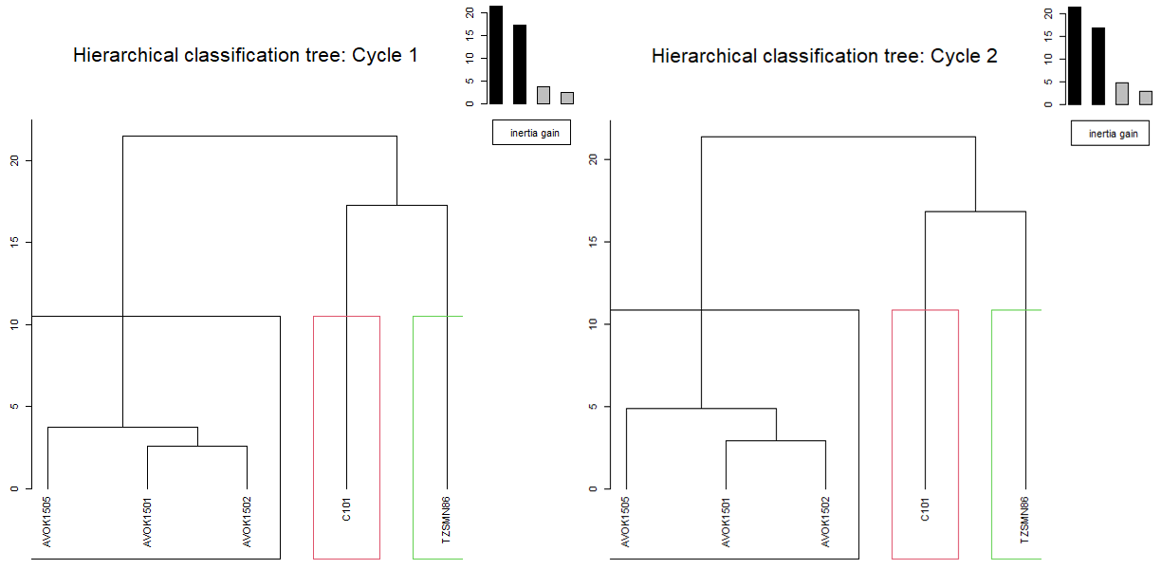
Figure 2: Okra lineage groups by cycle

The hierarchical classification tree organizes the five studied lineages (AVOK1501, AVOK1502, AVOK1505, C101, TZSMN86) according to their level of similarity based on a set of characteristics. Each leaf represents a lineage. The height of the branches on the vertical axis indicates the distance or dissimilarity between lineages or groups of lineages. The closer two lineages are in the tree, the more similar their characteristics are.
In Cycle 1 (Figure 2), the tree reveals two main groups : Group 1 consisting of the varieties AVOK1501, AVOK1502, AVOK1505. These lines show a strong similarity, with a subgroup formed by AVOK1501 and AVOK1502, closer to each other than to AVOK1505. Group 2 had grouped the varieties C101 and TZSMN86. These two lines are clearly separated from the first group, and also distinct from each other, reflecting different agronomic or morphological characteristics. It can be concluded that during cycle 1, three lines (AVOK1501, 1502, 1505) form a homogeneous group, while C101 and TZSMN86 appear isolated, reflecting genetic or functional diversity within the plant material.
As before, Cycle 2 shows a very similar cluster structure. The AVOK1501, AVOK1502, AVOK1505 cluster is formed again, with AVOK1501 and AVOK1502 ever closer together, and AVOK1505 slightly shifted. C101 and TZSMN86 remain outside the main cluster, with even greater dissimilarity between them than in Cycle 1. It appears that at the Cycle 2 level, the cluster structure is maintained, demonstrating stability of the similarity relationships between the lineages despite environmental or experimental variations between cycles.

- DISCUSSION
The results of this study revealed that the varieties exhibit homogeneity for several agro-morphological traits. They are mainly differentiated through the intensity of the color of the leaf blades and the shape of the fruits. The work of Jiro, Sawadogo, & Millogo, 2011 found the same results and showed that the different varieties studied have similar structures at the level of the stem, petiole and leaf blade. The work of Oppong-Sekyere et al. 2011 and Ogwu et al. 2018 confirmed these results and revealed that the color of the fruits and some parts of okra is generally green, but can vary depending on the genotype of the varieties studied. Furthermore, the study revealed significant variability between accessions, particularly with regard to their agronomic performance and increased resistance to major diseases.
In addition, AVOK1505 exhibited the best agronomic performance with a yield of 27.31 t/ha and increased resistance to major diseases (virus, wilt). Mensah et al, (2017) reported that okra accessions such as ICRISAT and KELEYA, grown under optimal conditions, can achieve yields between 20–25 t/ha and 20–30 t/ha respectively.
Regarding quantitative characteristics, the evaluated okra accessions exhibited a high morphological variability. Thus, the tallest, most vigorous plants with the largest petioles were observed in accession TZSMN86, while the shortest and least robust plants were recorded in C101. Accession AVOK1502, on the other hand, exhibited the smallest petiole diameters. These results corroborate those obtained by Dossou-Yovo et al, (2022), who had already highlighted a marked morphological diversity among local okra accessions in Benin.
Significant variability was also observed in the number of locules per fruit. Accession C101 was distinguished by the highest number of locules, although it simultaneously had the lowest number of nodes. These observations are in agreement with those of Nwangburuka et al. (2011), Ogwu et al. (2018) and Dossou-Yovo et al. (2022), who reported considerable diversity in fruit and stem characteristics in different okra accessions. Overall, significant variability was found for quantitative morphological characters, while qualitative parameters showed relatively little variation.
Regarding phenological traits, earliness analysis revealed highly significant differences among accessions, based mainly on flowering date. Earliness, defined as the number of days between sowing and the appearance of the first flowers (Amiteye et al., 2019), varied significantly among accessions. Accessions AVOK1501, AVOK1502, and AVOK1505 were early, with flowering reaching 50% between 42 and 45 days after sowing. Conversely, accessions C101 and TZSMN86 exhibited later flowering, occurring between 51 and 62 days after sowing.
The consistency of the trees between the two cycles indicates a stability of the phenotypic distances between the lines. This suggests that the identified groups are not dependent on cyclic conditions. The traits used for classification are sufficiently robust to reflect deep genetic or structural trends. In other words, lines AVOK1501, AVOK1502 and AVOK1505 can be considered genetically close or showing similar agronomic responses, while C101 and TZSMN86 appear more divergent, probably by their distinct morpho-physiological behavior.
Analysis of the inertia bars resulting from the classification provides quantitative evidence on the relevance of the division. The first two black bars are high, indicating that the division into two large groups (AVOK1501/1502/1505 vs C101/TZSMN86) explains a very significant part of the total variance. The rapid decline of the following bars means that the subsequent subdivisions add little additional information, which validates the obtained binary structure.
The hierarchical classification of okra lines according to their morpho-agronomic characteristics shows a strong consistency between cycles. Three distinct and stable groups emerge: Homogeneous group (AVOK1501, AVOK1502, AVOK1505) and Isolated groups (C101 and TZSMN86). These results complement the previous quantitative analyses, providing a global vision of the relationships between lines, useful for varietal selection, organization of crosses, planning of multi-environment trials and the stability of the groups indicates that the observed differences are structural and robust, despite significant variations in performance according to cycles like showed the work of Khalid et al, (2018), Khursheed et al, (2024).

CONCLUSION
Qualitative and quantitative morphological characteristics enable differentiation between different accessions. Early accessions such as AVOK1501, AVOK1502, and AVOK1505 yield the highest returns. Ascending hierarchical classification (AHC) allowed accessions to be grouped into three distinct clusters, among which AVOK1502 and AVOK1505 showed the best stability over the cycles. These results provide a solid basis for the inclusion of these accessions in the Beninese Catalogue of plant species and varieties (CaBEV). Finally, directed crosses between the best-performing accessions, such as AVOK1502 and AVOK1505, could be considered with the aim of creating new hybrid varieties with improved characteristics.

DATA AVAILABILITY
The datasets analyzed in this study are available from the corresponding author upon reasonable request.

CONFLICTS OF INTEREST
The authors declare no conflicts of interest.

Disclaimer (Artificial intelligence)
Author(s) hereby declare that NO generative AI technologies such as Large Language Models (ChatGPT, COPILOT, etc.) and text-to-image generators have been used during the writing or editing of this manuscript.

References
- Agregán, R., Pateiro, M., Bohrer, B. M., Shariati, M. A., Nawaz, A., Gohari, G., & Lorenzo, J. M. (2023). Biological activity and development of functional foods fortified with okra (Abelmoschus esculentus). Critical Reviews in Food Sci Nutr ;63(23):6018-6033.
- Amiteye, S., Amitaaba, T., & Amoatey, H.M. (2019), “Morphological Characterization of Accessions of Okra (Abelmoschus Spp L.)”, International Journal of Pure & Applied Bioscience 7(1), 1-13.
- Blalogoe J. S., Ayenan M. A. T., Aglinglo L. A., N’Danikou S., Schafleitner R., and E. G. Achigan-Dako. (2025). Challenges and opportunities in the okra (Abelmoschus spp.) seed system in Benin. Front. Sustain. Food Syst. 9:1614338.
- Dossou-Yovo, M. C., Quenum, F. J.-B., Agbidinoukoun, A., & Dossou Koko, L. D.-D. M. (2022). Potential for germplasm variability in local varieties of okra (Abelmoschus esculentus (L.) Moench) collected in southern Benin. Journal of Animal & Plant Sciences, 54(3), 9942-9951.
- DSA (2022). Agricultural Statistics Department of the Ministry of Agriculture, Livestock, and Fisheries. Statistical Service and Plant Production Studies. Evolution of vegetables crops production from 1995 to 2021 in Benin. https://dsa.agriculture.gouv.bj/statistics/vegetale
- Elkhalifa, A. E. O., Alshammari, E., Adnan, M., Alcantara, J. C., Awadelkareem, A. M., Eltoum, N. E., Mehmood, K., Panda, B. P., & Ashraf, S. A. (2021). Okra (Abelmoschus Esculentus) as a Potential Dietary Medicine with Nutraceutical Importance for Sustainable Health Applications. Molecules (Basel, Switzerland), 26(3), 696.
- FAOSTAT. (2022). Food and Agriculture Organization of the United Nations, Statistics Division. Data for over 245 countries and territories and covering all FAO regional, http://www.fao.org/faostat/en/#home
- Jiro H., Sawadogo M., & Millogo J. (2011). Agro-morphological and anatomical characteristics of Yatenga okra and are listed with the local nomenclature of the varieties. Sciences & Nature, 8(1), 23 - 36.
- Joshi, U., Rana, D. K., & Singh, V. (2020). Characterization study based on the morphology of various okra [Abelmoschus esculentus (L.) Moench.] genotypes. Journal of Emerging Technologies and Innovative Research, 7(5), 701-710.
- Joshi, U., Rana, D. K., Kumar, Y., Prakash, A., & Yadav, K. K. (2025). Analysis on genotypic and phenotypic path coefficients for major traits in okra germplasm. Journal of Krishi Vigyan, 13(1), 1-9.
- Khalid Syfullah, Md. Nasir Hossain Sani, Saifullah Omar Nasif, Sohely Parvin, Md. Mahasab Hossain Rony, Mohammad Saiful Islam & Md. Sarowar Hossain. (2018). Genetic Variability, Heritability, Character Association and Morphological Diversity in Okra (Abelmoschus esculentus L. Moench). International Journal of Plant & Soil Science, 25(6), 1–11.
- Khursheed Alam, Manoj Kumar Singh, Muzeev Ahmad, Mohd Wamiq, Amit Kumar, Deepesh Keshari & Vikas Patel. (2024). Genetic Diversity in Okra (Abelmoschus esculentus L.) Genotypes with Various Quantitative Traits. Journal of Advances in Biology & Biotechnology, 27(9), 1283–1290. https://doi.org/10.9734/jabb/2024/v27i91398
- Kuznetsova A., Brockhoff P.B., Christensen R.H.B. (2017). lmerTest Package: Tests in Linear Mixed Effects Models, Journal of Statistical Software, 82(13): 1-26.
- Landis, J. R., & Koch, G. G. (1977). The Measurement of Observer Agreement for Categorical Data. Biometrics, 33(1), 159–174.
- MAEP. (2017). Manual of procedures for approval and registration of varieties in the Beninese Catalogue of Plant Species and Varieties. INRAB/DPV/PPAAO/ProCAD/MAEP & CORAF/WAAPP, Ministry of Agriculture, Livestock and Fisheries, Legal Deposit No. 9431 of June 12, 2017, National Library of Benin, 2nd quarter. ISBN: 978-99919-2-983-5. 260 p.
- Mensah A. C. G., Assogba Komlan F., Eké H., Agbozo R., Aholoukpè D. S. N., and Amoussou I. (2017). Two (2) varieties of okra for the Vallée de l'Ouémé. Legal notice N° 9690 of 17 October 2017, 4th quarter. Bibliothèque Nationale (BN) du Bénin. ISBN: 978-99919-814-6-8. 8 p.
- Mensah, A. C. G., Yarou, B. B., Assogba K., F., Midingoyi, G. S.-K., Koura, W. T., Sikirou, R., Zocli, B., & Ahoyo Adjovi, N. (2021). My production of okra in Bénin. Référentiel Technico Economique. Dépôt légal N° 13024 du 14/04/ 2021, Bibliothèque Nationale (BN) du Bénin, 2nd quarter. ISBN: 978-99982-62-66-9. 64 p.
- Nwangburuka C. C., Kehinde O. B., Ojo D. K, Denton O. A. and Popoola A. R. (2011). Morphological classification of genetic diversity in cultivated okra, Abelmoschus esculentus L. (L) Moench using principal component analysis (PCA) and single linkage cluster analysis (SLCA). African Journal of Biotechnology Vol. 10(54), pp 11165-11172, doi:10.5897/AJB11.285
- Ogwu, Matthew Chidozie; Onosigbere-Ohwo, Uruemu; and Osawaru, Moses Edwin (2018). “Morphological Characterization of Okra (Abelmoschus [Medik.]) Accessions,” Makara Journal of Science: Vol. 22: Iss. 2, Article 2.
- Olawuyi, I. F., & Lee, W. Y. (2021). Structural characterization, functional properties, and antioxidant activities of polysaccharide extract obtained from okra leaves (Abelmoschus esculentus). Food Chemistry, 354, 129-437.
- Oppong-Sekyere, D., Akromah, R., Nyamah, E. Y., Brenya, E., & Yeboah, S. (2011). Characterization of Okra (Abelmoschus spp. L.) germplasm based on morphological characters in Ghana. Journal of Plant Breeding and Crop Science, 3(13), 367-378.
- Peter, E. L., Nagendrappa, P. B., Ajayi, C. O., & Sesaazi, C. D. (2021). Total polyphenols and antihyperglycemic activity of aqueous fruits extract of Abelmoschus esculentus: Modeling and optimization of extraction conditions. PLOS ONE, 16(4), e0250405.
- R Core Team. (2023). A: A language and environment for statistical computing. R Foundation for Statistical Computing, Vienna, Austria. URL https://www.R-project.org/
- Sawadogo, M., Balma, D., Nana, R., & Sumda, R. M.-K. T. L. (2009). Agricultural diversity and commercialization of okra (Abelmoschus esculentus L.) in Ouagadougou and its environments. International Journal of Bi logical and Chemical Sciences, 3(2), 326-336
- Sossa E. L. , L. O. Sintondji , E. C. Agbangba , W. Zoumarou , K. F. Assogba , A. Mensah , J. O. Ayifimi , S. A. Dossou , and G. L. Amadji. (2020). Water consumption of okra (Abelmoschus esculentus) on ferralsol in South of Benin: Case of «Jowizo» variety. International Journal of Innovation and Applied Studies. ISSN 2028-9324 Vol. 30 No. 1 Jul. 2020, pp. 352-362
- UPOV (International Union for the Protection of New Varieties of Plants). (1999). Principal directors for the conduct of the examination of distinct characteristics, homogeny and stability .TG/167/3. Rev.19p
- Vernooy, R., & Song, Y. (2004). New Approaches to Supporting the Agricultural Biodiversity Important for Sustainable Rural Livelihoods. International Journal of Agricultural Sustainability, 2(1), 55–66.
- Yildiz, M., Ekbiç, E., Düzyaman, E., Serçe, S., Abak, K. (2016). Genetic and phenotypic variation of Turkish Okra (Abelmoschus esculentus L. Moench) accessions and their possible relationship with American, Indian and African germplasms. J. Plant Biochem. Biotechnol., 25(3), 234-244.

