Soil Organic Carbon in Mainland Southeast Asia: Threats, Strategies, and Research Priorities for Sustainable Land Management

Abstract: This paper investigates the critical role of soil organic carbon (SOC) in sustaining agricultural and environmental systems across Southeast Asia, with a focus on Vietnam, Lao PDR, Cambodia, and Thailand. SOC is fundamental to soil fertility, agricultural productivity, and climate change mitigation, yet its stocks are increasingly threatened by deforestation, unsustainable land-use practices, soil erosion, and the intensifying impacts of climate change. Through a literature-based review, we assess both the direct and indirect pressures on SOC and evaluate the different national strategies aimed at soil protection and the enhancement of carbon sequestration. By systematically comparing global and national soil carbon datasets, we reveal significant discrepancies and data gaps between global SOC maps provided by FAO platform with national datasets, underscoring the necessity for improved regional coordination. Our review also demonstrates a need for strengthened collaboration in monitoring, reporting, validation, and data sharing to better understand the spatial and temporal variability of soil carbon stocks. Finally, a targeted survey among scientists was conducted in the region, and allowed identifying key research priorities and barriers to effective SOC management. Based on these findings, we propose a collaborative framework designed to foster knowledge exchange and joint action to promote sustainable land management and climate resilience in the region.

Keywords: Southeast-Asia; Regional coordination; International Research Consortium; Carbon: Policy
1. Introduction
Many of the most pressing challenges faced by human societies today are closely tied to the dynamics of soil organic carbon (SOC) within ecosystems. These interconnected issues span from addressing global warming, and reducing methane (CH₄) and carbon dioxide (CO₂) emissions, to promoting sustainable land management practices that safeguard carbon stocks in soils [1-3]. Additionally, SOC plays a key role in maintaining soil fertility, supporting plant growth, and fostering biodiversity [4]. With the global agricultural sector striving for more sustainable practices, there is also a growing interest in how land use changes and soil management techniques, such as reforestation, regenerative farming, and conservation tillage, can both enhance SOC storage and improve crop yields [4, 5]. Finally, the sustainable stewardship of carbon in ecosystems is not only central to mitigating climate change but also essential for fostering ecosystem health, resilience and long-term well-being for both people and our environment [6].
The questions and challenges outlined above are particularly pressing in mainland Southeast Asian countries [7]. In this region, rapid population growth and urban expansion place increasing pressure on agricultural land, often resulting in deforestation, soil degradation, and loss of soil organic matter (SOM). For example, the total annual economic cost of land degradation was estimated at USD 2.7 billion in Thailand in 2018, and USD 677 million in Cambodia in 2010 [8, 9]. Approximately 40% of these costs were attributable to the decline in provisioning ecosystem services, underscoring the substantial economic rationale for investing in soil conservation measures. Societal challenges include language barriers, which significantly hinder the effective transmission of information, especially in rural areas where access to content in local languages is limited. Additionally, limited availability of sustainable land management practices, weak enforcement of a diversity of environmental policies, and the marginalization of smallholder farmers reliant on soil fertility further exacerbate these issues. Environmentally, the region is also highly vulnerable to climate change, characterized by two contrasting monsoon seasons: a wet season with heavy rainfall that accelerates soil erosion and carbon loss, followed by a dry season limiting agricultural activities. Together, these factors threaten the long-term ability of soils to sequester carbon and ensure food security.
The concepts of sustainability and ‘One Health’ [10] provide a novel framework for understanding the interdependence between societies and their environments in mainland Southeast Asian countries. They underscore the importance of integrating stakeholders into the equation and emphasize that there is no one-size-fits-all solution to these complex challenges. Instead, they call for transformative strategies that tackle these issues across multiple dimensions, balancing carbon management with environmental, social and economic priorities [11-13]. Therefore, increasing SOC stocks in mainland Southeast Asian countries cannot be envisioned without achieving food security, protecting biodiversity and improving the livelihoods of farmers and benefiting other key actors. In this landscape, the sharing of knowledge is crucial in driving processes toward sustainability. Thus, informational tools and platforms that facilitate the sharing and comparison of knowledge are essential for scientists, institutions, and civil society. Broadly speaking, scientific knowledge and decision-making emerge from the mutual enrichment of three stakeholder groups. At the institutional level, international organizations, research institutions, universities, and funding agencies provide the vital infrastructure, resources, and frameworks that support scientific inquiry, particularly in areas like carbon-offset programs. Scientists, in turn, are the primary drivers of knowledge creation, conducting experiments, collecting data, and analysing results to generate new insights. In responses to institutions, scientists are increasingly focusing on SOC, given that soils act both as a source and a sink for CO₂. Understanding the processes by which carbon is stored, sequestered, and released in soils is crucial for developing effective strategies to reduce atmospheric CO₂ levels and enhance carbon storage. Equally important is the ongoing feedback loop between scientists and civil society, especially through the media, which serves as a bridge for communicating research findings to the public, policymakers, and broader audiences [14]. The media, and especially online platforms developed by institutions and projects play a critical role providing general information on the distribution of SOC stocks, and translating complex scientific concepts into accessible forms, while scientists leverage these platforms to amplify their work, generate public interest, and sometimes influence the trajectory of future research. This dynamic interaction not only drives scientific progress but also ensures that knowledge is shared in a way that resonates with society.
In this article, we drew upon key reports issued by international organizations and the scientific literature to elucidate the current understanding of the role and distribution of SOC in ecosystems across mainland Southeast Asia, as well as the challenges associated with its preservation. We then compared these sources with the perspectives of regional scientists and the findings of diverse studies and national strategies focused on SOC, with the aim of identifying the principal challenges and research needs in the region.

2. Materials and Methods
2.1. International Research Consortium
This study is the outcome of workshops held in 2024 and 2025 under the European ORCASA Project (https://irc-orcasa.eu/), aimed at establishing an International Research Consortium (IRC) of academic and non-academic partners working on soil carbon in mainland Southeast Asian countries. The workshops were held at the Soil and Fertilizer Institute (SFI) in Hanoi, Vietnam, with 30 delegates from Vietnam (SFI and Vietnam National University, VNU), Lao PDR (Department of Agricultural Land Management, DALaM), Cambodia (Institute of Technology of Cambodia, ITC; Royal University of Agriculture, RUA; and the General Directorate of Agriculture, GDA), and Thailand (Land Development Department, LDD, University of Mahasarakham, and Livelihoods Venture). This workshop was used to establish a review from the literature and from nationals documents describing national policies and roads, comparing the national maps describing SOC contents to the one available in the FAO platform, and establish a survey that was disseminated to other scientists in the region (Figure 1).

2.2. Systematic review and synthesis
During the workshop, a list of ecosystem services provided by SOC and the threats to SOC stocks was created. Those were categorized based on their impact on soil fertility and crop production, climate change mitigation and adaptation, biodiversity and biological regulation, as well as resistance to erosion, landslides, acidification, and salinization. This list was then used to conduct a literature review in English on SOC, referencing sources from Web of Science. The following keywords were employed to identify relevant literature, with the analysis conducted between November 2024 and June 2025: “soil carbon” and “nutrient cycling”, “pest”, “microbial activity”, “crop production”, “yield”, “climate change” and “drought” or “flood” or “mitigation”, “greenhouse gas emission”, “erosion”, “landslides”, “biodiversity”, “salinization”, “acidification” and with addresses either in “Vietnam”, “Laos” or “Cambodia”. Articles were selected based on the following criteria: (i) the articles had to focus on studies conducted in the targeted countries, (ii) the articles had to report on SOC content or quality, and (iii) review articles and book chapters were excluded. In order to allow the comparison of articles, a keyword glossary was developed and used (see supplementary file 1). This information was then used to represent the importance of each thematic via word clouds using the following application: https://www.nuagesdemots.fr/. In addition, reports from the Mekong River Commission (MRC), the International Union for Conservation of Nature (IUCN), the Association of Southeast Asian Nations (ASEAN), Food and Agriculture Organization of the United Nations (FAO) and the Intergovernmental Science-Policy Platform on Biodiversity and Ecosystem Services (IPBES) were consulted to identify mainstream information. Finally, each participant was responsible for presenting the national strategies and roadmaps from their country.

2.3. Comparison of soil carbon maps
The geospatial distribution of carbon (C) stocks in the region was derived from the Global Soil Organic Carbon Map (GSOCmap) v1.5, developed by FAO, and accessible via the GLOSIS platform (https://data.apps.fao.org/glosis/). This dataset is also visualized on the Impact4soil platform (https://www.impact4soil.com/), an output of the ORCASA project. Details on the number of soil samples and the methodologies employed for carbon assessment were obtained from the Global Soil Partnership and cross-referenced with data provided by the national institutions responsible for the GSOC maps.

2.4. Survey on scientific perceptions
A questionnaire was produced during the workshop and sent to regional scientists previously identified as working in the field of soil science in Vietnam, Lao PDR, Cambodia and Thailand, eventually translated into local languages. The bibliometric list compiled in 2.2 was used to identify and contact corresponding authors for survey participation. The list of the questions is given in supplementary file 2. Survey participation was voluntary, based on informed consent, and that responses were anonymized.

3. Results

3.1. Mainstream perceptions and representation of SOC stocks
IPBES report [11] highlights the dramatic degradation of soils in Southeast Asia, then impacting biodiversity and the well-being and spiritual fulfilment of millions of inhabitants. This region faces different key challenges that are in appearance competing the one with the others. For instance, the region is a hotspot of biodiversity for IUCN, then requiring the protection of natural environment from human exploitation, while undergoing one of the highest rates of urbanization and industrialization, and agricultural expansion in the world, which, while contributing to economic growth and improved living standards for many, also leads to significant environmental consequences.
The region is highly diverse, with mountainous areas and expansive alluvial plains, resulting in a wide variety of soil types. According to FAO, rice cultivation dominates the region, a result of adaptation to extensively inundated lowlands and the development of irrigation systems. In contrast, crops cultivation in upland areas in Monsoon Asia faces challenges due to low soil fertility and high vulnerability to soil erosion [15], particularly in the sloping areas (covering 40 million hectares), as well as on poorly covered lands and bare soils.
Both IPBES and FAO regard climate change as one of the most critical factors of soil degradation due to its role in exacerbating soil vulnerabilities. Increasingly frequent extreme weather events and rising sea levels are among the primary impacts. Climate change is expected to continue altering the region's climate, further intensifying extreme events such as floods and droughts [11]. These changes present substantial risks to agriculture, water resources, biodiversity, and human health. For instance, shifting rainfall patterns could lead to water scarcity, undermining crop production and food security. Additionally, the rising frequency and intensity of extreme weather events, including typhoons, droughts, and floods, can result in widespread destruction of infrastructure, homes, and livelihoods. During the 2011 monsoon season, catastrophic flooding in Thailand, especially in the Bangkok region, caused an estimated economic loss of 1,425 billion baht (US$ 45.7 billion), making it the world’s fourth costliest disaster [16, 17]. Rising sea level is also clearly identified as a major factor of by soil degradation by IPBES [11], because it threatens coastal areas, contributing to saltwater intrusion, erosion, and land loss.
Mapping soil organic carbon (SOC) stocks is essential for visualizing their spatial distribution, which exhibits marked variability across landscapes and national boundaries (Figure 2). Notably, the map displayed by the Impact4Soil platform reveals a high and remarkably homogeneous SOC stock in Lao PDR relative to neighbouring countries. In contrast, Thailand displays greater spatial variability in SOC compared to both Cambodia and Vietnam. Substantial discrepancies in SOC stock estimates are apparent when comparing the map generated by the Impact4Soil platform with those produced by national partners, with the most pronounced divergences observed in the case of Lao PDR. While the GSOC map depicts uniformly high soil C concentrations across the Lao territory, the national map produced by DALaM reveals pronounced regional heterogeneity. This difference can be largely attributed to the low number of samples used for producing GSOC map in Laos (n = 155, Table 1) against the 1341 observations used to produce the national map. Although the map seem similar, the same difference can be observed for Vietnam with n= 1,024 samples for the GSCO map vs. 2,838 samples for the national map. Table 1 also displays variations in the availability and coverage of soil carbon (C) data, analytical approaches (Walkey & Black method in Thailand and Vietnam, information non-available in Laos and Cambodia), and mapping technics. Thailand possesses the largest number of samples, whereas only Vietnam provides information on the statistical validation of its dataset.

3.2. Comparison of roadmaps, infrastructures and methodologies for reducing soil degradation and improving C sequestration.
In response to the challenges outlined above, and in alignment with the international agenda for GHG mitigation and carbon market development, a range of strategies and policy frameworks have been implemented across the region.

3.2.1. Cambodia
In Cambodia, measures to address land degradation and promote sustainable resource management are coordinated across three ministries. The Ministry of Agriculture, Forestry and Fisheries (MAFF) is responsible for the sustainable use and management of agricultural lands and has developed the National Action Program (NAP), the principal policy framework for combating land degradation [18]. Within MAFF, the Department of Agricultural Land Resources Management (DALRM) undertakes nationwide land use and suitability mapping, soil classification, and provides technical guidance on land management, while the Cambodian Agricultural Research and Development Institute (CARDI) conducts research on paddy land suitability and soil fertility to enhance crop production. The Ministry of Environment oversees forest lands and protected areas and serves as the national focal point for the UN Convention on Biological Diversity (UNCBD) and the UN Framework Convention on Climate Change (UNFCCC). The Ministry of Land Management, Urban Planning and Construction is responsible for land administration, including acquisition, registration, and ownership. Ongoing programs include the National Forest Program (2010–2029), the National Strategic Plan for Climate Change (2014–2023), and the Climate Change Priority Action Plan (2016–2020).
By 2030, Cambodia has set four primary objectives to combat land degradation and enhance SOC stocks: (1) increase national forest cover to 47% of total land area; (2) improve agricultural productivity by 5% annually; (3) increase SOC stocks in forests and croplands by 1.2% relative to 2015 levels through the promotion of conservation agriculture, organic farming, and the development of policies and legislation on Payment for Ecosystem Services (PES) to incentivize biodiversity conservation and sustainable resource use; and (4) preserve and expand protected and production forests, restore at least 8% of degraded land, and strengthen ecosystem services for vulnerable populations, particularly women, elders, children, and indigenous communities. In addition, the REDD+ program, initially implemented in select provinces, targets the restoration of degraded and deforested forests [18].
Research on SOC in Cambodia is primarily conducted by five institutions: ITC, RUA, CARDEC, under the Department of Agricultural Land Resources Management at GDA, and the National University of Battambang (NUBB). The country hosts several research infrastructures and long-term experimental sites, notably the Bos Khnor Research Center managed by CARDEC, where conservation agriculture trials have been ongoing since 2004 [19]. Additional initiatives include vegetable production experiments in Agricultural Technology Parks in Phnom Penh and selected provinces, and long-term integrated research led by ITC in the Chrey Bak catchment since 2004, encompassing hydrology, soil science, ecology, and socio-economic studies.
Communication between stakeholders in Cambodia follows a structured, sequential process. Scientific knowledge generated from research experiments, often conducted with the support of international cooperation agencies (e.g., AFD, IRD and CIRAD from France, ACIAR from Australia, JICA from Japan, Swisscontact from Switzerland), is transferred to national institutions such as ITC and, under the MAFF, to CARDI, GDA and its Department of DALRM, RUA and NUBB. For example, research activities and results on conservation agriculture generated by CARDEC are first reviewed by DALRM, GDA then communicated through the CASIC to MAFF. This process applies similarly to other research institutions. Upon MAFF approval, the findings are transmitted to the Provincial Departments of Agriculture, Forestry and Fisheries (PDAFF) via the MetKasekor extension model of the Department of Agricultural Extension, Forestry and Fisheries. PDAFF subsequently collaborates with district agricultural offices of agriculture to relay information to agricultural cooperatives and farmers. Since 2024, commune agriculture officers have been recruited to strengthen extension activities. In the same year, the Cambodian government, with support from the FAO, Thailand’s Land Development Department (LDD), and ACIAR, launched the Soil Doctor Program to improve knowledge dissemination to farmers, with pilot initiatives implemented in Banteay Meanchey, Tboung Khmum and Battambang provinces. Additionally, several incentive mechanisms exist to support farmers in adopting sustainable agricultural practices. Examples include the Cambodian Good Agricultural Practices certification scheme for vegetable production; reward systems for rice farmers, such as the IBIS organic rice certification and the Sustainable Rice Platform; and the REDD+ program, although further progress in measurement, reporting, and verification (MRV) systems is required to enable robust assessment of carbon stocks in forests.

3.2.2. Lao PDR
From 1990, the government of Lao PDR, with the support of Asian Development bank (ADB), FAO, the World Bank, and bilateral development agencies, has developed land reforms to accompany farmers towards the production of strategic cultures to eradicate poverty [20], in line with the Paris Agreement, under the United Nations Framework Convention on Climate Change (UNFCCC). This passes via a resettlement of ethnic minorities, an increase of land tenure security for eliminating shifting cultivation agriculture and opium cultivation while protecting forest resources, and an intensification of the cultural practices because the “soil must not remain unproductive and must be farmed yearly” [20, 21]. In 1994, the government decided that shifting cultivation should be eliminated by the year 2000; in 2000, the goal was postponed until 2020 and then in 2003, brought back to 2010. An outcome of these reforms was the increase of government’s revenue through property taxes resulting from the allocation process. However, the success of this policy for the protection of the forests, the modernization of the agriculture and the livelihood of farmers remains uncertain, if not highly criticized [20-22].
In Lao PDR, research on SOC is mostly realized at the Department of Agricultural Land Management (DALaM) from the Ministry of Agriculture and Forestry (MAF), in the National University of Laos (NUoL) and through collaborations with different international research organizations (e.g., IRD, CIRAD, ACIAR). Only one long-term observatory is identified in the country, with the catchment of Ban Lak Sip (Houay Pano catchment) from the M-Tropics network (https://mtropics.obs-mip.fr/).
Communication with stakeholders follows a similar vertical structure as in Cambodia. It begins with research, primarily financially supported by international institutions, and the acquisition of knowledge by scientists. This information is reported by DALaM to the Department of Planning and Cooperation, the vice minister, and the minister of MAF. It is then disseminated to various stakeholders, including line departments, government agencies, international organizations, local authorities, farmers, and private companies. Social media platforms, such as the DALaM website, Land Resources Information Management Systems, and posts on WhatsApp and Facebook, are commonly used to reach farmers. The Soil Doctor program has been implemented in Laos with support from government, GIZ, ASSET, FAO, although ensuring its long-term sustainability remains a challenge.
The Long-Term Low Emission Development Strategy (LT-LEDS) of Lao PDR, currently under preparation with support from international partners, constitutes a national roadmap integrating economic development with long-term GHG mitigation, aiming for net-zero emissions by 2050 in line with the Paris Agreement. The strategy outlines short- and medium-term actions across key sectors, including energy decarbonization, forest conservation, and the promotion of climate-smart agriculture, while addressing institutional, financial, and technical gaps. By prioritizing sustainable land management and the avoidance of deforestation, the LT-LEDS has direct implications for SOC protection, as both forest preservation and climate-smart agricultural practices contribute to maintaining and enhancing soil organic carbon stocks. A key identified incentive is related to the protection of forest areas under the REDD+ program (9th NSEDP 2021-2025) with the objective to earn at least $95 million from the reduction of deforestation, and the preservation of about 30 million tonnes of equivalent CO₂. In addition, the Vision to 2040 and the Strategy on the Management and Development of Agricultural Land to 2030 serve as guiding frameworks for promoting green growth and the sustainable use of agricultural land in Lao PDR.

3.2.3. Vietnam
The Vietnamese government has implemented several strategies to combat land degradation and enhance SOC sequestration. These efforts are led by the newly established Ministry of Agriculture and Environment (MAE), formed by the merger of the former Ministry of Agriculture and Rural Development (MARD) and the Ministry of Natural Resources and Environment (MONRE). Several programs have been implemented to promote sustainable farming practices, particularly in rice-based systems, industrial plantations, and upland farming areas. A flagship initiative is the Vietnam Sustainable Agriculture Transformation Project, which focuses on improving soil and water management to enhance productivity while minimizing environmental impacts. The Department of Science, Technology and Environment and the Department of Cultivation play central roles in soil fertility restoration and sustainable land-use planning. MONRE leads climate change policy coordination and oversees Vietnam’s Nationally Determined Contributions (NDCs) submitted in 2020 under the UNFCCC, which include targets for soil carbon sequestration and land restoration, and a reduction of GHG emissions by 9% below business-as-usual levels by 2030 using domestic resources, and up to 27% with international support. The NDC also includes targets for climate change adaptation, sustainable land management, and soil carbon sequestration, aligning national climate policy with the Agreement’s long-term mitigation and resilience goals. The ministry is also responsible for soil mapping, land degradation monitoring, and long-term land-use planning. Under MONRE, the Vietnam Administration of Forestry (VNFOREST) manages reforestation programs and implements the REDD+ program. The Ministry of Planning and Investment supports financing and the integration of land degradation neutrality objectives into national development plans, while coordinating with international partners to fund and pilot sustainable land-use practices.
Research on soil carbon is conducted by several national institutions, including the Vietnam Academy of Agricultural Sciences (VAAS), the Vietnam Academy of Science and Technology (VAST), the Northern Mountainous Agriculture and Forestry Science Institute (NOMAFSI), and universities such as the Vietnam National University of Agriculture (VNUA) and Hue University. Long-term research infrastructures include the Phu Ho Experimental Station (VAAS), the Dong Cao soil ecology research site (operated jointly by the Soil and Fertilizer Institute and IRD), and agroforestry trial plots in Hue and Gia Lai, which integrate monitoring of soil carbon, erosion, and biodiversity.
By 2030, Vietnam aims to: (1) restore 20% of degraded agricultural land, primarily through conservation agriculture and agroecological approaches; (2) increase SOC stocks by 0.4% annually in targeted agroecosystems; (3) develop Payment for Ecosystem Services (PES) schemes to incentivize sustainable land and forest management; and (4) strengthen policy support for community forestry, agroforestry, and land restoration in climate-vulnerable regions. Land resettlement programs were also effective in Vietnam for accelerating land-use changes and introducing explicit policies to replace traditional shifting-cultivation systems with other forms of land use, including the permanent cultivation of annual crops, rubber and other tree-crop plantations, and greenhouse-based horticulture. National government Policies have included the outright banning of shifting cultivation, the creation of forest-protection areas that exclude population groups that have lived in the forests for hundreds of years, and the movement of people into more crowded settlements along the main roads and in the lowlands. The observed negative effects were consistent with those documented in Lao PDR, compounded by heightened pressure on forest resources due to land allocation policies that facilitated the migration of Kinh agricultural communities into forested regions [20, 23-27].

3.2.4. Thailand
Thailand's approach to soil degradation reduction and carbon sequestration has evolved into an integrated framework that combines traditional policy instruments with innovative technological solutions and economic incentives. The country has embraced the Bio-Circular-Green economic model as part of the Thailand 4.0 strategy, integrating advanced technologies such as precision agriculture, IoT sensors, AI-driven data analysis, and satellite-based monitoring systems to optimize farming operations and resource allocation. The country has set a target of achieving carbon neutrality by 2050 and net-zero GHG emissions by 2065. The country’s Long-Term Low GHG Emission Development Strategy outlines the pathways to achieve these objectives, with soil carbon sequestration identified as a key mitigation component. In line with this challenge, the Ministry of Agriculture and Cooperatives (MOAC) of Thailand has formulated the 20-Year Agriculture and Cooperatives Strategy (2017–2036) as a comprehensive policy framework to guide the long-term development of the agricultural sector. This framework is aligned with the 20-Year National Strategy, the Twelfth National Economic and Social Development Plan (2017–2021), the Reform Plan of the National Reform Steering Assembly (NRSA), and the United Nations Sustainable Development Goals (SDGs). Within this strategic orientation, five priority areas for soil conservation and carbon management have been identified: (i) strengthening farmer organizations; (ii) enhancing the productivity and quality of agricultural commodities; (iii) improving sectoral competitiveness; (iv) developing markets and value chains; and (v) promoting sustainable natural resource management to ensure long-term agricultural resilience. In alignment with these priorities, Thailand has developed roadmaps aimed at reducing soil degradation and achieving land degradation neutrality by 2030. These roadmaps serve as strategic instruments that provide clear guidance, establish measurable targets, and harmonize national initiatives with international sustainability frameworks. Key measures include: (i) increasing national forest cover, targeting up to a 40% expansion, through reforestation and the rehabilitation of degraded forests, particularly in headwater and mangrove ecosystems, with the active participation of local communities; (ii) restoring and rehabilitating degraded lands for productive use, emphasizing sustainable agricultural practices; and (iii) reducing soil carbon losses while enhancing carbon sequestration through soil and water conservation measures. These actions are supported by awareness-raising and capacity-building initiatives, such as the promotion of precision farming, technology transfer, and farmer training through Agricultural Learning Centers, as well as research and development programs aimed at innovations in sustainable land management and reducing post-harvest losses [28], and the development of the Agricultural Map for Adaptive Management (AGRI-Map) platform (https://agri-map-online.moac.go.th), which is a decision-support application designed to facilitate agricultural production management. It integrates spatial data to provide comprehensive information on land area, current agricultural conditions, and strategic plans for enhancing future productivity and resource efficiency.
Thailand’s Land Development Department (LDD) serves as the National Focal Agency responsible for implementing the National Action Programme (NAP) under the United Nations Convention to Combat Desertification. In 2004, LDD initiated the National Action Programme for Combating Desertification (2004–2008), which addressed strategic priorities such as developing basic soil and water resource infrastructure for crop production and enhancing farmers’ access to land development services. More recently, government targets have focused on expanding specific categories of farmland to promote the sustainable revival and conservation of agricultural resources. Notably, the Thai Rice NAMA (2018–2023) sought to reduce GHG emissions from rice cultivation by 26% over its five-year implementation period, targeting the substantial methane emissions associated with paddy rice production. The infrastructure is further strengthened by economic instruments including the Premium T-VER carbon credit scheme promoted by the Thailand Greenhouse Gas Management Organization (TGO), voluntary carbon markets that provide direct income streams for farmers, and a forthcoming comprehensive Climate Change Act expected in 2025 that will establish emissions trading systems and carbon border adjustments

3.3. Scientific evidence and perceptions
In total, 531, 367, 53, and 64 articles were identified for Thailand, Vietnam, Laos and Cambodia, respectively. Among them, only 185, 142, 28, and 20, respectively, were selected based on our criteria. The word clouds shown in Figure 3 highlight the significant role of rice in the region. Rice is not only the primary staple food but also holds considerable cultural, economic, and social importance. It plays a central role in cultural traditions and festivals. Economically, rice farming is crucial to the agricultural sector, with most rural households relying on it for their livelihoods. Thailand, Vietnam, and Cambodia are major exporters of rice, particularly fragrant varieties, contributing significantly to their GDPs. In Cambodia alone, wet season rice covers about 3 million hectares in 2024, making it a key component of the nation’s agriculture, especially in the Tonle Sap region [18, 29]. In Lao PDR, although only 4% of the total land area is cultivated (against 35, 35 and 55% in Vietnam, Cambodia and Thailand), rice occupies 58% of the cropped area (against 34, 66, and 75%, in Vietnam, Cambodia and Thailand, respectively). In addition to rice, the word clouds indicate a focus on other crops, such as maize (across all three countries), cassava (in Vietnam and Cambodia), soybeans (in Cambodia) or sugarcane (Thailand). Forest ecosystems, including tree plantations like teak and rubber in Lao PDR and Acacia in Vietnam, are also prominently features, particularly in relation to shifting agriculture (also called swidden or slash-and-burn agriculture) and its impact on soil erosion and carbon transfer, as seen in both Lao PDR and Vietnam. Finally, beyond common research topics, the word clouds reveal specific areas of interest, such as the role of microbial properties (diversity, abundance and activity) and biochar or black C, the emission of greenhouse gases (GHG) and the impact of mangroves, in Vietnam and Thailand. The transfer of carbon from soil to water, the importance of water management or the impact of drought are also general questions in the region (Vietnam, Lao PDR and Thailand). Research on conservation agriculture and the effects of tillage and termites on soil carbon in Cambodia also stand out, while research on earthworms appear to be more specific in Vietnam.
The final scale of observation concerns the scientists’ own knowledge and their perceptions regarding the importance of SOC and the threats to its preservation. The survey results are presented in Figures 4 and 5, with a detailed breakdown by country provided in Supplementary File 4. SOC is perceived to contribute positively to most of the services listed in the survey, with all mean scores exceeding 2 (Figure 4). The primary benefits of SOC are linked to its role in stimulating biological activity, thereby promoting soil health and enhancing nutrient mineralization. Notably, SOC was also perceived as being associated with a reduction in GHG emissions. The second most important group of environmental benefits attributed to SOC relates to improved soil resistance to environmental hazards, such as erosion and drought. Higher SOC levels were also associated with increased carbon sequestration (mean score ≈ 2.67) and improved crop production, most notably rice (41.8% of responses), followed by vegetables (21.8%), maize (18.2%), cassava (16.4%), fruit trees (10.9%), and sugarcane (5.5%). The perceived positive effects of SOC on soil resistance to landslides and flooding, as well as on reducing acidification and salinization, were considered less important, although their mean scores also exceeded 2.
The perception of scientists to threats on SOC is displayed in Figure 5. Here again, all the proposed factors were considered important (scores > 2), apart from the development of pests and invasive species (score = 1.96). The most important factors associated to SOC losses were deforestation, the burning of residues and soil biodiversity losses (scores > 2.7). Next important factors were environmental (risks of floods and droughts, erosion, soil acidification and salinization), and human due to unsustainable practices (overuse of fertilizers, shifting cultivation, monocropping, mechanization) or the development of infrastructures (roads, urbanization), and finally the lack of knowledge or the recommendation of inappropriate technics at all stakeholder levels (farmers, policymakers and extension services, scientists themselves). Least important factors are inappropriate land concessions and developments, the construction of dams and the development of pests and invasive species.

4. Discussion
4.1. Scientific multilingualism
A significant limitation of this research is that it focuses exclusively on studies published in journals indexed in Web of Science. This narrow approach greatly restricts our understanding of the broader literature, particularly that published in local languages. Notably, journals in Khmer, Lao, Vietnamese and Thai, such as Vietnam Soil Science Journal (Tạp chí Khoa học Đất), the Lao Journal of Science and Technology or Techno-Science Research Journal from ITC, Cambodia, were not considered in this analysis. The reliance on English as the primary language of communication not only limits engagement with non-English-speaking scientists but also impedes the development of knowledge and skills within the local population and educational institutions. Moreover, much of the valuable local knowledge remains confined to a small group of scientists, depriving the global scientific community of diverse perspectives that could potentially lead to new insights and paradigm shifts. In this context, we consider that AI presents a promising opportunity [30]. Its capacity to translate between English and local languages offers significant potential for promoting scientific multilingualism. By enabling scientists in peripheral countries to communicate more effectively, AI could foster their full integration into the global scientific community. This integration would not only enhance multilingualism but also support the involvement of local scientists and media in advancing scientific research and dialogue [31].

4.2. Calling for development of Natural Intelligence
The gap between the general information provided by mainstream institutions, in comparison with the one of scientists and the research conducted in each country, highlights the urgent need to strengthen research efforts in both fundamental and applied sciences within the region. The strong correlation between science and technology development, on the one hand, and economic development, on the other, is very well documented [32, 33]. Scientists from low-income, developing, and emerging countries have been labelled as 'periphery researchers' [31], 'consumers of central scholars' knowledge' [34], or 'obedient slaves' to mainstream ideas and institutions [31]. It is essential that each country not only benefits from a universal understanding of soil functioning, as the questionnaire clearly demonstrates, but also develops its own diagnosis and devises its own solutions. While helicopter research is difficult to avoid, it does not remain the rules [35]. Support for capacity building from international organizations remains crucial for the development of knowledge in the region. However, in these uncertain times when “Science has to Stand”, it is essential to increase the attraction for science, that policymakers recognize the need to strengthen regional cooperation, while also supporting the emergence of a community of local scientists capable of identifying the challenges faced by their countries and providing solutions that are empirical and ground-based, rather than theoretical or produced in other contexts and environments. Indeed, while certain themes show strong alignment with the mainstream knowledge and existing research, such as the importance of forests or rice cultivation, both of which have been the focus of extensive studies in the region, others remain comparatively underexplored, despite being regarded by scientists as important. Notably, topics such as the effects of mechanization, soil biology (bioturbation) or soil acidification and salinization on carbon storage capacity have received considerably less research attention.
Moreover, results from research studies are not all transposable. For instance, while our article underscores the key role of forests in carbon sequestration, several reports also highlight an urgent need to obtain accurate carbon sequestration values to update the IPCC's default estimates for both old-growth and secondary forests. These updated values are crucial for supporting countries in developing their nationally determined contributions (NDCs) as part of the United Nations Framework Convention on Climate Change (UNFCCC) process. Accurate data is vital to ensure that climate action plans are based on the most current and reliable scientific information [36]. Significant challenges in this regard are the lack of reliable data, the need to upscale nationally available data to the international level, thereby contributing to and enhancing global SOC database, and the difficulty in assessing carbon stocks in soils, especially in forested areas. These gaps in knowledge hinder efforts to quantify the loss or gain of carbon due to land use changes in countries like Vietnam, Lao PDR, and Cambodia [37-39]. Without accurate and comprehensive data, it remains challenging for these countries to implement effective climate strategies and meet their emission reduction targets.

4.3. Identification of scientific priorities and future directions of the IRC
This study presents three principal limitations, which should be considered when interpreting conclusions raised in this document, and for guiding the network’s future trajectory of the International Research Consortium on soil C. The first, as previously noted, is that only articles published in English were included in the review, thereby excluding potentially substantial bodies of literature and data published in local-language journals. Second, the limited number of delegates who participated in the workshop, serving both as the designers of the questionnaire and as those responsible for its dissemination, facilitated intensive and constructive exchanges, but also constrained the diversity of perspectives and the scope of questions. An expanded network, incorporating representatives from different environmental contexts and facing distinct challenges (e.g., delegates from mountainous regions could have enabled a more comprehensive examination of the impact of soil erosion and water management on SOC sequestration). Therefore, the development of the Southeast Asian regional node from the IRC on Soil C project has, in the future, to be more integrative and associate a diversity of academic (i.e., regional universities and research centres) and non-academic stakeholders (Farmers, extension services, NGO and policymakers).
The workshop also underscored three major regional challenges, particularly regarding the preparedness of countries to engage in forthcoming pillar initiatives, such as carbon credit schemes.
- Availability of existing data. Mapping C stocks is essential for visualizing their spatial distribution, which varies significantly across landscapes and countries. Spatial representation supports targeted conservation, restoration, and land management by identifying carbon-rich areas and monitoring changes over time. It also facilitates integration with other spatial datasets, aids in policy and carbon market reporting, and communicates complex data effectively to stakeholders. The inadequacy between the GSOC map displayed by FAO and Impact4Soil platform and the values available at the national scales raise concerns concerning the use of the map for stakeholders. Therefore, a foremost challenge lies in the urgent need to integrate locally derived data into the GSOC map and to generate additional information, especially in Lao PDR and Cambodia, which remain comparatively under-studied. A deeper understanding of the processes, distribution and evolution of SOC dynamics also requires the establishment and multiplication of dedicated research stations (e.g., Bac Giang in Vietnam and Bos Khnor in Cambodia) as well as long-term observatories (e.g., Houay Pano in Laos and Chrey Bak in Cambodia). At present, the Asia-Pacific region of the International Long-Term Ecological Research network (ILTER) includes only two sites in Thailand (ILTER East Asia-Pacific) and none in Vietnam, Lao PDR, or Cambodia. This highlights a pressing need to identify and integrate additional national long-term ecological research stations, such as the Me Linh station near Hanoi, into regional and international monitoring efforts. Such initiatives are essential to assess the role of non-cultivated ecosystems, particularly forests, in soil carbon sequestration and their responses to climate change, within the framework of strengthened international cooperation.
- Need for Monitoring, Reporting and Verification (MRV) developments. The diversity of methods, infrastructures, and facilities for assessing carbon stocks across the region underscores the necessity of MRV approaches to ensure robust estimation of soil C stocks, and to enhance the value and usability of national datasets through reliable and collaborative partnerships. This question is especially important in Lao PDR and Cambodia, where the number of samples used for producing GSOC map was limited. In this context, the rapid, effective, and cost-efficient spectroscopic techniques (e.g., VIS-NIRS and FTIR) can offer substantial alternatives to traditional Walkley–Black and dry combustion methods, alongside the development of common strategies for large-scale prediction of SOC stocks. Progress in this area could be further reinforced through enhanced regional cooperation, supported by initiatives such as the FAO’s Global Soil Partnership (GSP) and other international organizations, to promote capacity-building (e.g., training in chemometric analyses and soil mapping), integrate robust MRV frameworks, and harmonize protocols for predicting SOC distribution and dynamics.
- Emergent research questions. In the context of emerging carbon credit schemes, the REDD+ program is expected to gain increasing importance in the near future. Nevertheless, current REDD+ approaches remain largely centered on the assessment of carbon stocks in above-ground biomass [40], with limited consideration of soil properties, particularly at depths greater than 30 cm. To overcome this limitation, it is essential to integrate SOC dynamics into MRV frameworks, thereby providing a more comprehensive evaluation of carbon sequestration potential. Equally important is the integration of social science perspectives, which can contribute to a more comprehensive recognition of the role of SOC in ecosystem service provision, as well as support farmers in the adoption of sustainable agricultural practices. This interdisciplinary dimension remains insufficiently addressed in the existing literature and therefore warrants greater attention in both future research and policy development. Moreover, although numerous studies have examined the impacts of shifting cultivation and conservation agricultural practices (e.g., no-tillage and the use of cover crops), there remains a paucity of information on the ecosystem services provided by nature-based solutions. In particular, little is known about the effects of hedgerows and tree groves on soil properties and crop productivity, or the role of plant diversity, both in terms of crop species and varietal richness, in supporting agricultural sustainability. Similarly, although numerous studies have investigated the effects of land-use changes on soil microbial properties, the influence of soil invertebrates remains poorly understood. In particular, the roles of earthworms, primarily studied in Vietnam, and termites, mostly studied in Cambodia, are under-researched, despite their recognized importance as indicators of soil health in many temperate and tropical ecosystems.

5. Conclusion
This review underscores the remarkable diversity of contexts and approaches across the region in examining the role and dynamics of soil carbon. It not only highlights the range of strategies being implemented but also reveals the complexities and challenges inherent in such studies [41]. Moreover, the findings emphasize a critical need for enhanced coordination among stakeholders, as well as the integration of local and regional knowledge to foster more comprehensive and effective solutions. In response to these insights, the regional node of the IRC project on Carbon has been established, aiming to serve as a platform for collaboration, knowledge-sharing, and the development of targeted strategies to address soil carbon management in a cohesive and impactful manner.

Conflict of interest
All authors certify that they have no affiliations with or involvement in any organization or entity with any financial interest or non-financial interest in the subject matter or materials discussed in this manuscript.

Disclaimer (Artificial intelligence)

Author(s) hereby declare that NO generative AI technologies such as Large Language Models (ChatGPT, COPILOT, etc.) and text-to-image generators have been used during the writing or editing of this manuscript.

References
1. Bellassen, V.; Angers, D.; Kowalczewski, T.; Olesen, A. Soil carbon is the blind spot of European national GHG inventories. Nature Climate Change 2022, 12, 324-331.
2. Longbottom, T.; Wahab, L.; Min, K.; Jurusik, A.; Moreland, K.; Dolui, M.; Berhe, A. What's soil got to do with climate change? GSA Today 2022, 32, 4-10.
3. Raihan, A. A review of climate change mitigation and agriculture sustainability through soil carbon sequestration. Journal of Agriculture Sustainability and Environment 2023, ISSN 2997, 271X.
4. Gerke, J. The central role of soil organic matter in soil fertility and carbon storage. Soil Systems 2022, 6, 33.
5. Francaviglia, R.; Almagro, M. ; Vicente-Vicente, J.L. Conservation agriculture and soil organic carbon: Principles, processes, practices and policy options. Soil Systems 2023, 7, 17.
6. Naika, R.; Sivapragasam, C.; Patoju, S.K.S. Impact of organic farming on sustainable livelihood of farmers. In Building sustainable communities: civil society response in South Asia. Singapore: Springer Nature Singapore, 2020, 361-375.
7. Cheng, W. Soil carbon and nitrogen dynamics by land use and management changes in East and Southeast Asian countries (soil C and N by LUMC). Soil Science and Plant Nutrition 2020, 66, 34-36.
8. Global Mechanism of the UNCCD. Country Profile of Thailand. Investing in Land Degradation Neutrality: Making the Case. An Overview of Indicators and Assessments. 2018, Bonn, Germany.
9. Global Mechanism of the UNCCD. Country Profile of Cambodia. Investing in Land Degradation Neutrality: Making the Case. An Overview of Indicators and Assessments. 2018, Bonn, Germany.
10. Swan, T.; McBratney, A.; Field, D. Linkages between Soil Security and One Health: implications for the 2030 Sustainable Development Goals. Frontiers in Public Health 2024, 12, 1447663, https://doi.org/10.3389/fpubh.2024.1447663
11. IPBES. Summary for policymakers of the assessment report on land degradation and restoration of the Intergovernmental Science-Policy Platform on Biodiversity and Ecosystem Services. R. Scholes, L. Montanarella, A. Brainich, N. Barger, B. ten Brink, M. Cantele, B. Erasmus, J. Fisher, T. Gardner, T. G. Holland, F. Kohler, J. S. Kotiaho, G. Von Maltitz, G. Nangendo, R. Pandit, J. Parrotta, M. D. Potts, S. Prince, M. Sankaran and L. Willemen (eds.). IPBES secretariat, Bonn, Germany. 2018, 44 pages
12. IPBES. Summary for policymakers of the global assessment report on biodiversity and ecosystem services of the Intergovernmental Science-Policy Platform on Biodiversity and Ecosystem Services. S. Díaz, J. Settele, E. S. Brondízio E.S., H. T. Ngo, M. Guèze, J. Agard, A. Arneth, P. Balvanera, K. A. Brauman, S. H. M. Butchart, K. M. A. Chan, L. A. Garibaldi, K. Ichii, J. Liu, S. M. Subramanian, G. F. Midgley, P. Miloslavich, Z. Molnár, D. Obura, A. Pfaff, S. Polasky, A. Purvis, J. Razzaque, B. Reyers, R. Roy Chowdhury, Y. J. Shin, I. J. Visseren-Hamakers, K. J. Willis, and C. N. Zayas (eds.). IPBES secretariat, Bonn, Germany. 2019, 56 pages.
13. Rockström, J.; Steffen, W.; Noone, K.; Persson, A.; Stuart Chapin III, F.; Lambin, E.; Lenton, T.; Scheffer, M.; Folke, C.; Joachim, H.; Björn Nykvist, S.; de Wit, C.; Hughes, T.; van der Leeuw, S.; Rodhe, H.; Sörlin, S.; Snyder, P.; Costanza, R.; Svedin, U.; Falkenmark, M.; Karlberg, L.; Corell, R.; Fabry, V.; Hansen, J.; Walker, B.; Liverman, D.; Richardson, K.; Crutzen, P.; Foley, J. Planetary boundaries: exploring the safe operating space for humanity. Ecology and Society 2009, 14, 32.
14. Peters, H.P. Gap between science and media revisited: Scientists as public communicators. Proceedings of the National Academy of Sciences 2013, 110, 14102-14109.
15. FAO. Status of the World’s Soil Resources (SWSR). Main Report. Food and Agriculture Organization of the United Nations and Intergovernmental Technical Panel on Soils, Rome, Italy, 2015, 650p. ISBN: 978-92-5-109004-6.
16. Koontanakulvong, S. Thailand floods 2011. Causes and future management system. Report Faculty of Engineering, Chulalongkorn University, Bangkok, Thailand, 2012, 8pp.
17. Murphy, T.; Irvine, K.; Sampson, M. The stress of climate change on water management in Cambodia with a focus on rice production. Climate and Development 2013, 5, 77-92.

18. Ministry of Agriculture, Forestry and Fisheries (MAFF), 2025. https://elibrary.maff.gov.kh/book/682aa24378c01
19. Leng, V.; Cardinael, R.; Tivet, F.; Seng, V.; Mark, P.; Lienhard, P.; Filloux, T.; Six, J.; Hok, L.; Boulakia, S.; Briedis, C.; de Moraes S.J.C.; Thuriès, L. Diachronic assessment of soil organic C and N dynamics under long-term no-till cropping systems in the tropical upland of Cambodia. SOIL 2024, 10, 699–725, 2024. https://doi/10.5194/soil-10-699-2024
20. Ducourtieux, O.; Laffort, J.R.; Sacklokham, S. Land policy and farming practices in Laos. Development and Change 2005, 36, 499-526.
21. Evrard, O.; Goudineau, Y. Planned resettlement, unexpected migrations and cultural trauma in Laos. Development and change 2004, 35, 937-962.
22. Lestrelin, G.; Giordano, M. Upland development policy, livelihood change and land degradation: interactions from a Laotian village. Land Degradation and Development 2007, 18, 55-76.
23. Jamieson, N.; Barraclough, D.; Unkovich, M.; Monaghan, R. Soil N dynamics in a natural calcareous grassland under a changing climate. Biology and fertility of soils 1998, 27, 267-273.
24. De Koninck, R. Le recul de la forêt au Viet Nam. Centre de recherches pour le développement international, Ottawa, Canada, 1997, 99pp.
25. McElwee, P. Policies of Prejudice: Ethnicity and Shifting Cultivation in Vietnam. Watershed 1999, 5, 30–38.
26. Mellac, M. La gestion des espaces forestiers au Nord Vietnam: Un modèle et son application. Les Cahiers d’Outre-Mer 1998, 51, 367–84.
27. Mellac, M. ; Rossi, G. Politiques publiques, minorités montagnardes et déforestation au Nord-Vietnam. Paper presented at the Xième Journées d’Ecologie Humaine. L’Homme et la Forêt Tropicale. Marseille, 1998, 20pp.
28. Pongsrihadulchai A. Thailand agricultural policies and development strategies. Food Fertil. Technol. Cent. Asian Pacific Reg, 2019, 8. https://ap.fftc.org.tw/article/1393
29. Marcaida III, M.; Farhat, Y.; Muth, E.N.; Cheythyrith, C.; Hok, L.; Holtgrieve, G.; Kim, S.H. A spatio-temporal analysis of rice production in Tonle Sap floodplains in response to changing hydrology and climate. Agricultural Water Management 2021, 258, 107183. https://doi.org/10.1016/j.agwat.2021.107183
30. Minasny, B.; McBratney, A.B.; Rumpel, C. AI as a Catalyst for Cross‐Disciplinary Breakthroughs in Soil Carbon Sequestration Research. European Journal of Soil Science 2025, 76, e70165.
31. Salager-Meyer, F. Scientific publishing in developing countries: Challenges for the future. Journal of English for Academic Purposes 2008, 7, 121-132.
32. King, D.A. The scientific impact of nations. Nature 2004, 430, 311-316.
33. Man, J.P.; Weinkauf, J.G.; Tsang, M.; Sin, J.H.D.D. Why do some countries publish more than others? An international comparison of research funding, English proficiency and publication output in highly ranked general medical journals. European journal of epidemiology 2004, 19, 811-817.
34. Canagarajah, A.S. “Nondiscursive” requirements in academic publishing, material resources of periphery scholars, and the politics of knowledge production. Written communication 1996, 13, 435-472.
35. Rumpel, C.; Ann, V.; Bahri, H.; Calabi Floody, M.; Cheik, S.; Doan, T.T.; Harit, A.; Janeau, J-J.; Jouquet, P.; Mora, M.L.; Podwojewski, P.; Tran, T.M.; Ngo, Q.A.; Rossi, P.L.; Sanaullah, M. Research for development in the 21st century. Geoderma 2020, 378, 114558.
36. Blundo, C.; Carilla, J.; Grau, R.; Malizia, A.; Malizia, L.; Osinaga-Acosta, O.; Bird, M.; Bradford, M.; Catchpole, D.; Ford, A.; Graham, A.; Hilbert, D.; Kemp, J.; Laurance, S.; Laurance, W.; Yoko Ishida, F.; Marshall, A.; Waite, C.; Woell, H.; Dang Tran, H. Taking the pulse of Earth's tropical forests using networks of highly distributed plots. Biological Conservation 2021, 260, 108849.
37. Framework Convention on Climate Change (FCCC). Report of the technical assessment of the proposed forest reference emission level of Viet Nam submitted in 2016. United Nations, 2017, 15 pp.
38. Framework Convention on Climate Change (FCCC). Report of the technical assessment of the proposed forest reference emission level/forest reference level of the Lao People’s Democratic Republic submitted in 2018, 2019, 15 pp.
39. Framework Convention on Climate Change (FCCC). Report on the technical assessment of the proposed forest reference level of Cambodia submitted in 2021, 2022, 12 pp.
40. Thammanu, S.; Han, H.; Marod, D.; Srichaichana, J.; Chung, J. Above-ground carbon stock and REDD+ opportunities of community-managed forests in northern Thailand. PLoS One 2021, 16(8), e0256005.
41. Amundson, R.; Biardeau, L. Soil carbon sequestration is an elusive climate mitigation tool. Proceedings of the National Academy of Sciences 2018, 115(46), 11652-11656.

Countries | Cambodia | Lao PDR | Thailand | Viet Nam
Source | External dataset: soilgrids.org Data Holder: ISRIC World Soil Information | Joint Effort with GSP | Country submission | Country submission
Number of samples | (~500)* | 155 | 70,000 | 1,024
Sampling period | (1997, 2011-2015)* | NA | 2015 | 1990-2016
SOC analysis method | Walkey & Black method* | Walkey & Black method* | Walkey & Black method | Walkey & Black method
bulk density analysis method | Cylinder* | Cylinder* | Undisturbed sampling | 100 cm3 cylinder
Mapping method | NA | Caret ensemble of Random Forest, Cubist, KKNN, Bayesian trees. Partial Least Squares Regression, Principal Components Regression. No validation statistics | NA | Regression Kriging. Validation statistics: ME: -0.000242; MAE: 0.286; RMSE: 0.3858; R: 0.511
Data holder and Citation | Hengl, T., Mendes de Jesus, J., Heuvelink, G. B.M., Ruiperez Gonzalez, M., Kilibarda, M. et al. (2017) SoilGrids250m: global gridded soil information based on Machine Learning. PLoS ONE 12(2): e0169748. doi:10.1371/journal.pone.0169748. | Ministry of Agriculture and Forestry of Laos | Land Development Department | Soils and Fertilizers Institute

Table 1. Description of the dataset used for mapping C stocks in the 0-30 cm soil layer. Data provided by the Global Soil Partnership (GSP) from FAO.
*Information provided by the General Directorate of Agriculture (GDA) from the Ministry of Agriculture, Forestry, and Fisheries, Cambodia.

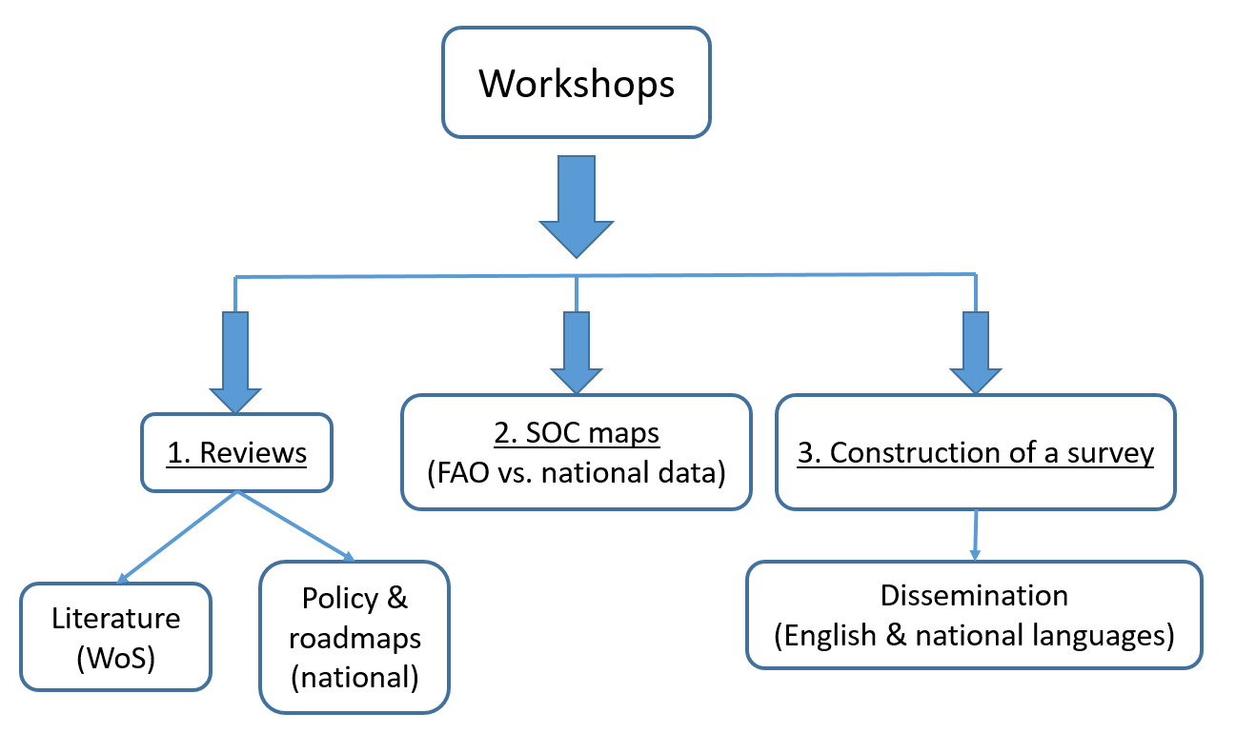
Figure 1. Workshop methodology for assessing regional knowledge and strategies on soil organic carbon. The approach included: (1) A review of scientific literature (via Web of Science) and national policy documents and roadmaps, (2) A comparison of SOC maps between FAO global datasets and national data, and (3) the construction and dissemination of a multilingual survey to gather comprehensive insights.

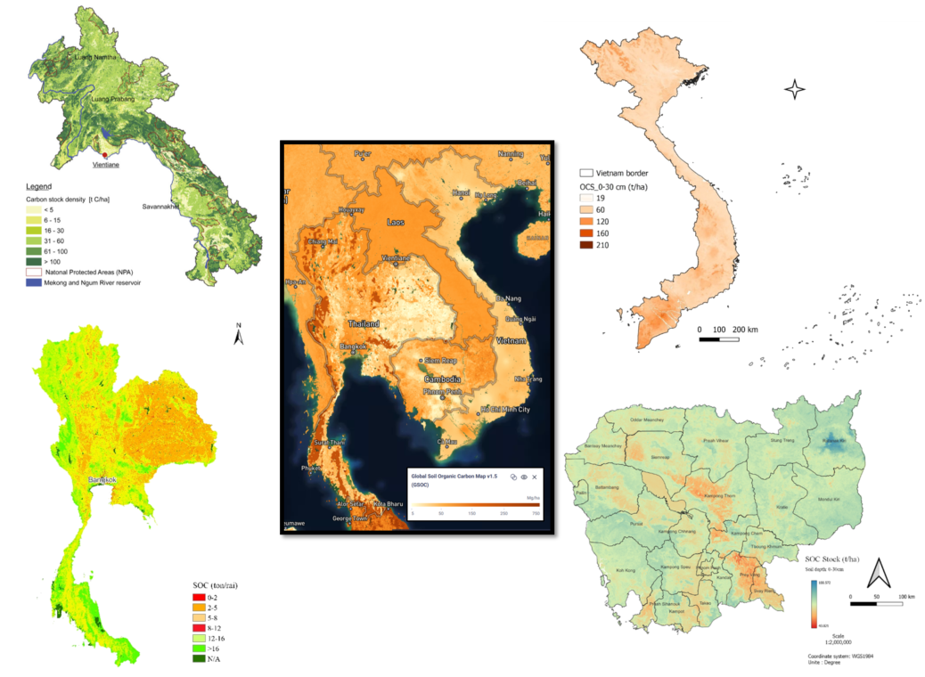
Figure 2. Comparison of soil C maps proposed by GSOC (FAO), and obtained from Impact4Soil (in the centre) and national soil C maps in Laos and Thailand, on the left, and Vietnam and Cambodia, on the right. Data are given for the 0-30 cm depth layer.

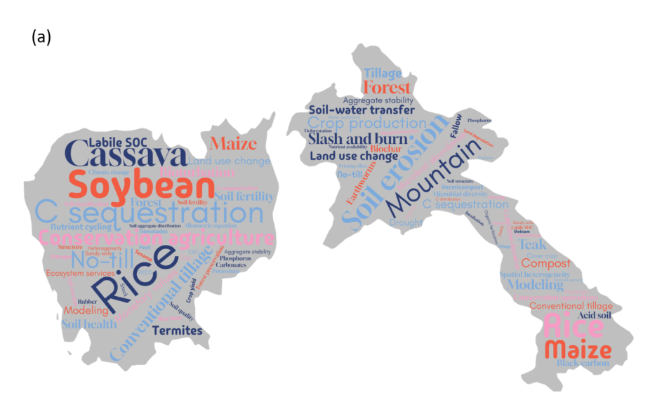
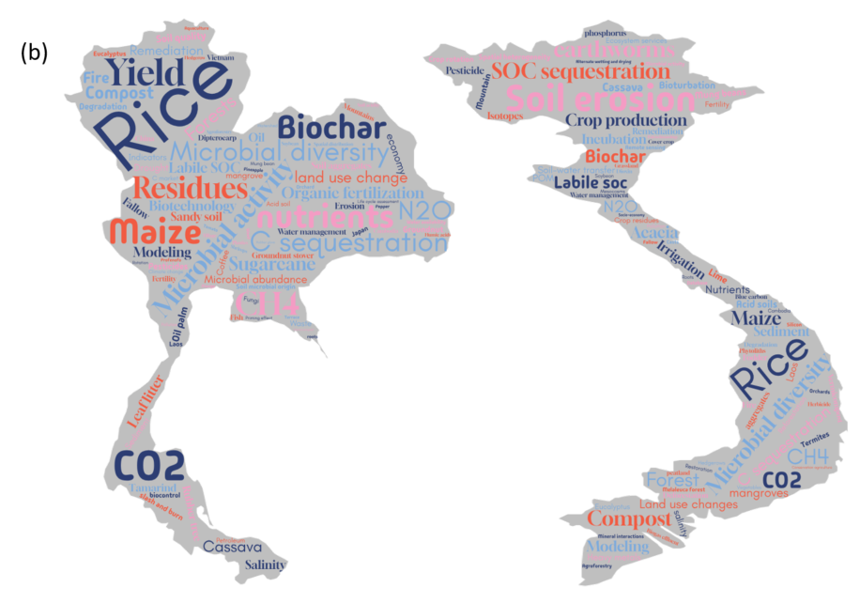

Figure 3. Word clouds illustrating the relative importance of keywords used to describe studies conducted in (a) Cambodia and Lao PDR, based on all extracted keywords, and (b) Thailand and Vietnam, based only on keywords with more than two occurrences.

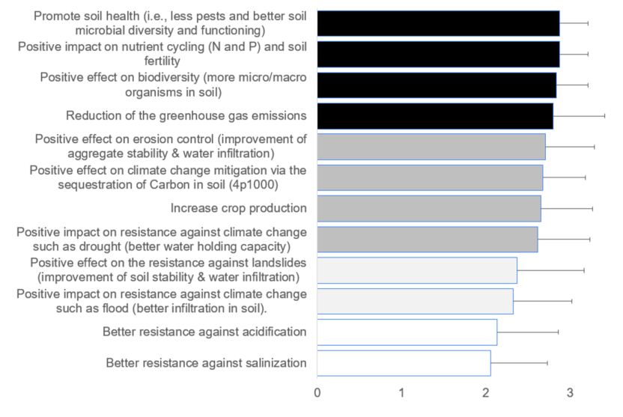
Figure 4. Responses from the survey describing the services provided by soil C ranked from lowest (0) to highest (3). Histograms represent mean values (n = 55), with error bars indicating standard deviations. In the survey, notes were “0” for not important, “1” for slightly important, “2” for significantly important and “3” for very important to crucial.

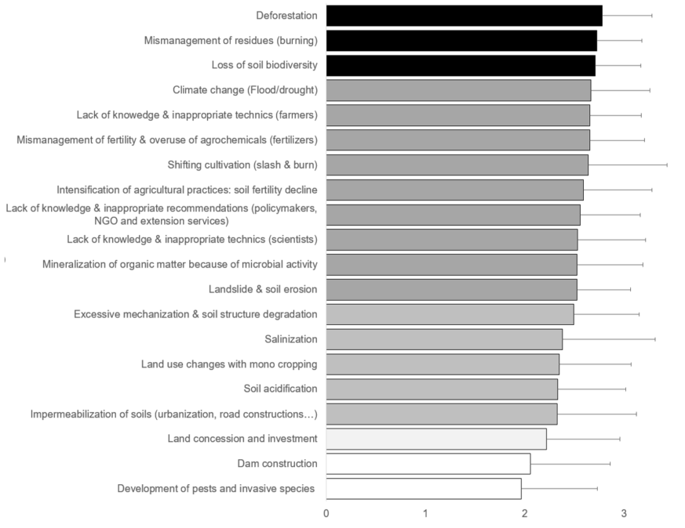
Figure 5. Responses from the survey describing the threats on soil C ranked from lowest (0) to highest (3). Histograms represent mean values (n = 55), with error bars indicating standard deviations. In the survey, notes were “0” for not important, “1” for slightly important, “2” for significantly important and “3” for very important to crucial.

