Phytochemical and Pharmacological Profile of Cissampelos pareira (Patha): A Multi Targeted Therapeutic Approach

ABSTRACT

Cissampelos pareira (Patha) in Ayurveda and other traditional medical systems, the climbing shrub Patha (Menispermaceae) is widely used to treat fever, diarrhea, inflammation, pain, gastrointestinal problems, gynecological illnesses, metabolic abnormalities, infections, and toxic situations. Patha is described under several therapeutic groups in classical Ayurvedic books emphasizing its tridosha-shamaka, jwaraghna, atisaraghna, and vishaghna qualities. The plant is rich in structurally diverse phytoconstituents, predominantly isoquinoline and bisbenzylisoquinoline alkaloids, along with flavonoids, terpenoids, phenolic compounds, pectin, sterols etc. Pharmacological studies conducted using in vitro, in vivo, and clinical models demonstrate a broad spectrum of biological activities such as anti-inflammatory, antipyretic, analgesic, antioxidant, immunomodulatory, antidiabetic, hepatoprotective, cardioprotective, anticancer and antiviral activity against all four dengue virus serotypes. The present review critically compiles and updates the available information on botanical characteristics, traditional uses, phytochemistry, pharmacological properties, and safety aspects of Cissampelos pareira. Relevant literature was systematically collected from major scientific databases covering studies published up to 2025. Although substantial preclinical evidence supports its therapeutic potential, limited clinical trials are available, highlighting the need for further clinical validation.

KEYWORDS: Cissampelos pareira, Patha, Velvet leaf, Pahadavel, Isoquinoline alkaloids.

- INTRODUCTION
The family Menispermaceae, which includes roughly 37 species of sub-erect or climbing shrubs, includes the genus Cissampelos. India is home to just one species, C. pareira. (Bhandari & Mukerji, 1959). In Indian traditional medicine, the perennial climber herb Cissampelos pareira Linn. is frequently referred to as Ambastha or Patha. In tropical and subtropical regions of India, including Himachal Pradesh, Punjab, Rajasthan, West Bengal, Bihar, and Tamil Nadu, it can be found up to 2000 meters above sea level. A wide range of ailments, such as wounds, ulcers, rheumatism, fever, asthma, cholera, diarrhea, inflammation, snakebite, malaria, and rabies, have been treated with it in the traditional medical system from ancient times. It is also recommended for blood purification. (Kumari and others, 2021) . In addition to its diuretic, antiperiodic, and purgative qualities, the root is bitter. It is used to treat coughing, dropsy, diarrhea, dyspepsia, and some urinary issues like cystitis. (Bhandari & Mukerji, 1959)¹ For centuries, South American indigenous peoples have utilized it as a traditional cure for a variety of female maladies, including monthly cramps, postpartum pain, fibroid tumors, uterine haemorrhages following childbirth, and threatening miscarriages (Sudhakaran, 2012) . Many ailments, such as arthritis, diarrhea, hyperglycemia, cardiopathy, hypertension, and other related problems, are treated with plants in this genus in traditional medicine (He et al., 2021). Traditional healers employ ethnomedicinal methods to cure a range of ailments, such as skin infections, urinary tract problems, tumor inhibitors, and antibacterial, antimalarial, diuretic, and anticonvulsant qualities, using the roots of Cissampelos pareira (Gupta et al., 2011).

According to phytochemistry, the main alkaloids identified from this plant are benzylisoquinolines and bisbenzylisoquinolines (Suresh et al., 2023), which seem to be in charge of a sizable amount of the pharmacological effects. Hayatin methiodide, an alkaloid that was discovered from Cissampelos pareira, exhibited curariform action (Pradhan & De, 1953)⁸⁰. Pareirubrines A and B showed antileukemic activity (Morita et al.,1993)⁵⁴, Pectin from leaf part showed antioxidant (Wisidsri & Thungmungmee.,2019)⁴³ and anti-aging properties (Chanpirom et al., 2025)⁸⁴, cissampeloflavone compound from C. pareira showed antiprotozoal activity (Ramírez et al., 2003)⁵³. An alcoholic extract prepared from Cissampelos pareira inhibited the replication of dengue viruses. (Sood et al., 2015)⁴⁵

Cissampelos pareira (Patha) is widely used in traditional medicine to treat a variety of illnesses. Ancient texts like Bruhatrayee (Charaka samhita, Sushruta samhita and Ashtang hridya) and Nighantus have mentioned various uses of C. pareira in Jwara (fever), Atisara (diarrhoea), Hridaya-ruja (cardiac disorders), Visha (toxins/poison), Shwasa (respiratory disorders), Krimi (worm infestation), Prameha (diabetes) etc. (Chunekar, 2015) Many of these conventional claims have been confirmed by contemporary scientific research, which reports a variety of pharmacological actions such as antipyretic, antidiarrheal, cardioprotective, anti-venom, immunomodulatory, antioxidant, anthelmintic, and antidiabetic properties. By correlating traditional claims with modern scientific evidence, this review aims to highlight the therapeutic potential of Patha and provide a scientific foundation for future drug discovery, standardization, and clinical development. This manuscript is significant for the scientific community as it provides a comprehensive and integrative review of Cissampelos pareira, correlating its traditional Ayurvedic applications with contemporary pharmacological evidence. By unifying phytochemical and biological data, the study facilitates a clearer understanding of active constituents and their molecular mechanisms. The review further emphasizes its multi-target therapeutic potential and identifies critical research gaps, thereby supporting future clinical validation and evidence-based phytopharmaceutical development.

- VERNACULAR NAME (API)

Sanskrit | Ambasthaki
Hindi | Patha, Padh, Akanadi
English | Velvet leaf
Punjabi | Patha
Assamese | Tuprilata
Bengali | Patha, Akanadi
Gujarati | Kalipath, Karondhium, Karondium, Venivel, Karedhium
Kannada | Pahadavela, Agalushunthi
Kashmiri | Pad
Malayalam | Patha
Marathi | Pashadvel, Paharrel, Pahadavel, Padali
Oriya | Kanabindhi, Patha
Tamil | Vattha tiruppi
Telugu | Adivibankatiga, chiru boddi, Boddi tiga

- GEOGRAPHICAL DISTRIBUTION

Five continents and numerous islands make up the genus Cissampelos extensive global distribution. Cissampelos pareira is the sole species that has a pantropical distribution, which includes the tropical areas of the three major continents—Africa, Asia, and the Americas. It can be found in America (Brazil, Argentina, Peru, Mexico, Colombia, and Florida), Asia (Indo-China, Southern China, Malaysia, Thailand, India, and Pakistan), Africa (Sierra Leone east to Congo, Rwanda, Tanzania, south to northern Angola, and Zambia), Australia, the West Indies, Comoros, Mauritius, Seychelles, and Madagascar (Semwal et al., 2014). The tropical and subtropical areas of India, such as Himachal Pradesh, Punjab, Rajasthan, West Bengal, Bihar, and Tamil Nadu, are home to it (Kumari et al., 2021)².

- MORPHOLOGICAL DESCRIPTION

Habit: Cissampelos pareira is a climbing, twinning, perennial shrub that grows 2–5 meters along the ground and is held up by trees or their crowns.
Stem: The stem has a maximum diameter of 1 cm and is thin, flexible, and twined for support.
Leaves: The membranous, simple, alternating leaves are oblong to cordate or truncate at the base, palmately 4–7 nerved, somewhat peltate, and the petiole inserts slightly from the blade's edge. The term "velvet leaf" refers to the dark green, light green, and thickly velvety-pubescent or silky-hairy lamina that is sparsely silky-hairy above and below when fully grown.

Flowers: They are tiny, dioecious, unisexual, and green. The leaf axils bear the tiny pistillate and staminate inflorescences. Male inflorescences are 10–12 cm long and form small umbels of 1-3 together.

Fruits: The red-orange, hairy drupes are round, 4–5 mm in diameter, one seeded, and partially covered by a rounded bract. The seeds are shaped like a horseshoe.

Root: cylindrical, frequently tortuous, 1-1.5 cm in diameter, light brown in color, with a rough and occasionally rugged surface caused by transverse wrinkles, cracks, and fissures; short, splintery fractures; a subtle, aromatic smell; and a bitter taste. (Sudhakaran, 2012)³,(API)⁸.
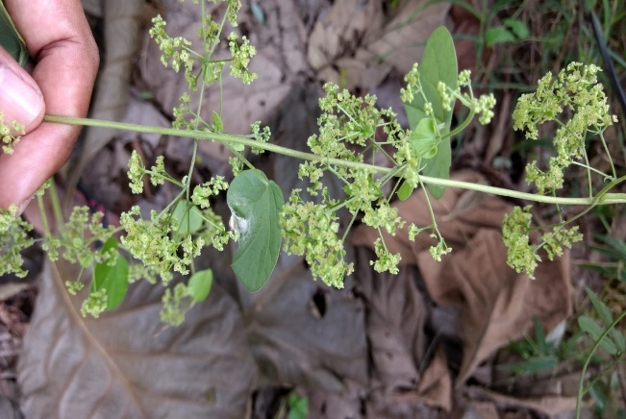
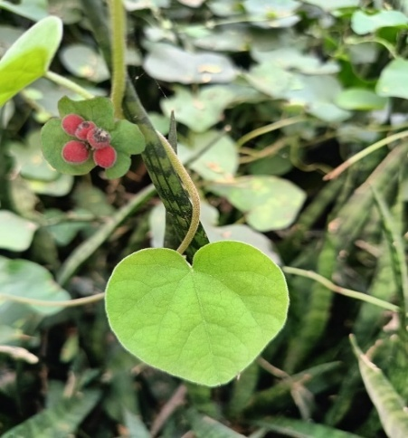

Fig. 1. Leaf & fruits of Cissampelos pareira Fig. 2. Flower of Cissampelos pareira

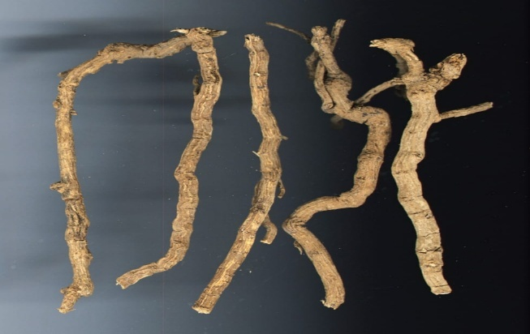
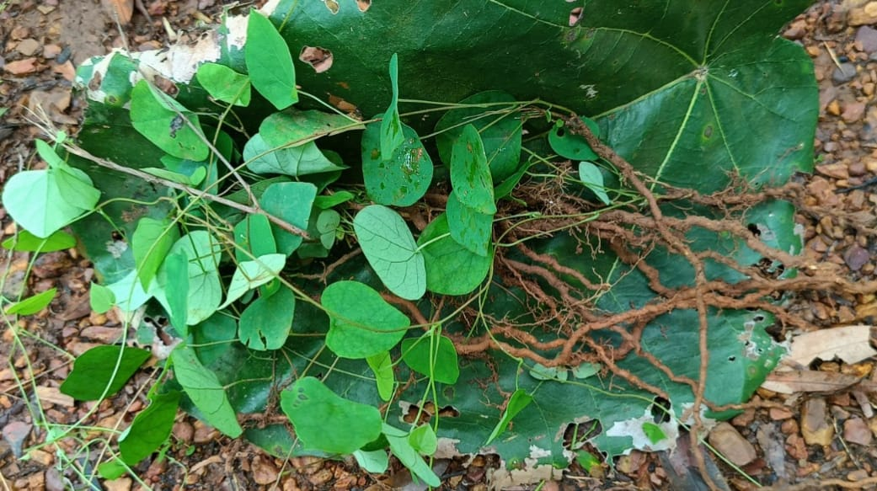

Fig. 3. Fresh roots of Cissampelos pareira Fig. 4. Dry roots of Cissampelos pareira
(Photo credit: Dr. Sanjeet Kumar)

- TAXONOMIC CLASSIFICATION (POWO 2026)

Kingdom | Plantae
Phylum | Streptophyta
Class | Equisetopsida
Subclass | Magnoliidae
Order | Ranunculales
Family | Menispermaceae
Genus | Cissampelos
Species | Cissampelos pareira

- TRADITIONAL USES

A survey on the ethnobotanical uses of C. pareira indicates that it is one of the most widely used species of the genus Cissampelos. This plant has a long history of traditional use and is widely used. Many Ayurvedic medicines, such as Brhatgangadhara churn, Pusyanug churn, Pradarantaka lauha and Sarasvata ghrita, include Patha. According to the Ayurvedic Pharmacopoeia of India, this plant is used to treat pain, diarrhoea, vomiting, fever, itching, skin disorders cough, blood purification, and complications with breast milk secretion. ( API)⁸ The list of some traditional uses of Cissampelos pareira in India: -

6.1 Malaria
Cissampelos pareira is widely used in traditional Indian medicine to treat malaria using a variety of plant components and preparation techniques. In certain regions, roots are soaked in unboiled milk and consumed orally at a dose of 5g per day. In other regions, crushed roots are used orally to treat malaria (Bora et al., 2007), Root decoction is also frequently delivered once day (Namsa et al., 2011), In certain regions, roots are soaked in unboiled milk and consumed orally at a dose of 5g per day. Furthermore, leaf juice taken orally twice a day has been reported to treat malaria (Singh et al., 2018), and a hot infusion made from roots and leaves is also traditionally used for the same reason (Dwivedi et al., 2019).

6.2 Snakebite
According to reports, root paste combined with Piper longum and given once daily is an effective treatment (Upasani et al., 2017), (Chakraborty & Bhattacharjee, 2006). Additionally, snakebite treatment involves taking dried root powder orally with water (Basha, 2012).

6.3 Rabid Dog Bite
The root decoction of C. pareira is traditionally used in the treatment of rabid dog bite, indicating its importance in managing animal bite-related conditions in folk medicine (Upasani et al., 2017)¹⁵.

6.4 Pneumonia
Traditional healers employ root decoction of C. pareira for the management of pneumonia, highlighting its use in respiratory ailments. (Upasani et al., 2017)¹⁵

6.5 Diuretic, Lithotriptic and Febrifugal Uses
The root decoction of C. pareira is also used for its diuretic, lithotriptic and febrifugal properties in traditional medical practices (Upasani et al., 2017)¹⁵.

6.6 Anti-fertility and Birth Control
Cissampelos pareira is reported for antifertility and birth control purposes using different plant parts. Root decoction is traditionally used as an anti-fertility agent (Maurya et al., 2004). In addition, pills prepared from the leaves and administered orally once daily for three days are used as a birth control measure (Tiwari et al., 1982).

6.7 Leucorrhoea
Traditional methods for treating leucorrhea include combining crushed C. pareira leaves with Acacia nilotica bark in a 1:1 ratio, adding silicic acid, and administering the mixture with butter (Thakur et al., 2016).

6.8 Appetizer, Anthelmintic and Anti-ulcer Uses
Traditional medical systems use the roots and entire plant of C. pareira as an appetizer and as anti-ulcer and anthelmintic medicines (Seethapathy et al., 2018).

6.9 Fever, Muscle Strength and Sexual Vigour
C. pareira's leaves and entire plant have long been used to treat fevers and increase sexual arousal and muscle strength, suggesting that it is a tonic for general health (Suresh et al., 2016).

6.10 A natural fermenting agent
Cissampelos pareira plays a crucial role in the herbal starting culture Ranu, or country liquor, which is used in traditional Handia fermentation among tribal groups in Odisha, Jharkhand, and Bihar. Beneficial microbes and bioactive substances that promote fermentation are supported by the plant. Its utilization draws attention to important indigenous knowledge that may find utility in both industrial and sustainable fermentation (Majhi et al.2025)

- PHYTOCHEMISTRY

According to a thorough review of the literature, alkaloids (primarily isoquinoline) are important components of C. pareira. It has been reported that C. pareira contains many isoquinoline alkaloids, including aporphine, pyrrole, protoberberine, benzylisoquinoline, bisbenzylisoquinoline, and tropoloisoquinoline. Additionally, some non-alkaloid components of C. pareira have been identified. Table 1 to 4 list the separated compounds, and Figure 5 show their chemical structures.

Table 1: Alkaloid Constituents from the root part
Compound | Extraction / isolation method | Reference
Cissampareine | Alcoholic extraction followed by acid-base alkaloid separation and silica gel column chromatography, UV, IR, NMR | Kupchan et al., 1965[]
Insularine, Isochondodendrine, cycleanine | Ammonium hydroxide was used to base the acidic extract, which was then extracted using chloroform and column chromatography. | Dwuma-Badu et al., 1975 []
Hayatidin, Bebeerine  Isochondrodendrine, Cycleanine, | Acid-base partitioning and preparative TLC are performed after ethanol extraction. | Bhakuni et al., 1987 []
Pareirubrine A, Pareirubrine B, Norimeluteine, Norruffscine, cissampareine | Ethanolic extraction → repeated column chromatography | Morita et al., 1993[⁵⁴]
Pareitropone | Methanolic extraction → alkaloid fraction → chromatography | Morita et al., 1995[⁵⁵]
Berberine | Methanol extract (HPTLC) | Bafna 2009[⁴²]
Pareirarine, magnoflorine, magnocurarine, salutaridine, cissamine and hayatinine, | Hydro ethanolic extract of root | Bhatt et al., 2020 []
Cularine-type alkaloid | Hydro-ethanolic extraction →chloroform fraction→ NMR spectroscopy and MS analysis | Kumari et al., 2024 []
p-hydroxyphenethyl trans-ferulate, quercitol | Hydro-ethanolic extraction →n-butanol fraction→ NMR spectroscopy and MS analysis | Kumari et al., 2024 []

Table 2: Non-Alkaloidal Constituents from root
Compound | Extraction/ isolation method | Reference
Quercetin | Hydro-ethanolic extraction → solvent fractionation | Amresh et al., 2007[³⁷]
Oleanolic acid, Oleic acid, ethyl oleate, 1-docosene and tetracosane | n-hexane extraction → GC-MS identification | Bala et al., 2015[⁵⁶]
Thymol | Steam / solvent extraction | Gul et al., 2016[³⁸]
Arachidic acid | Soxhlet extraction → GC-MS | Gul et al., 2016[³⁸]
Polyhydroxylated oleanane triterpenoids | Ethanolic extraction →spectroscopic analysis  Anti-tumor and anti-inflammatory applications. | Cao et al., 2025 []

Table 3: Non-Alkaloidal Constituents from aerial parts
Compound | Extraction / isolation method | Reference
A chalcone–flavone dimer, cissampeloflavone | Acetone extract → column chromatographic separation. | Ramírez et al., 2003 []
β-Sitosterol | Chloroform extract column chromatograph, spectroscopic evidences | Shukla et al., 2012 []
Bi-flavonoid, amentoflavone; and two kaempferol glycosides, kaempferol 3-O-b-D-glucopyranoside and kaempferol 3-O-b-D-glucuronopyranoside | Methanol extract | Devkota et al., 2017 []

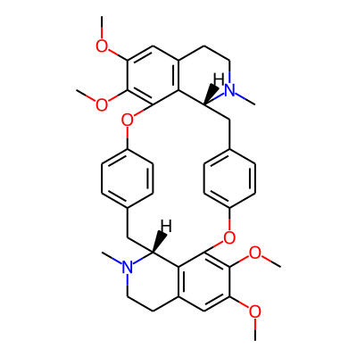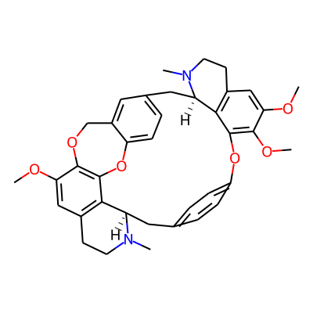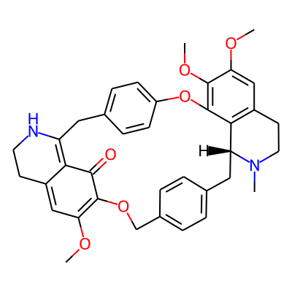
Cycleanine Insularine Cissampareine

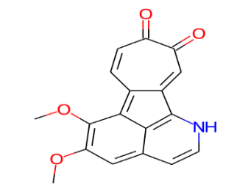
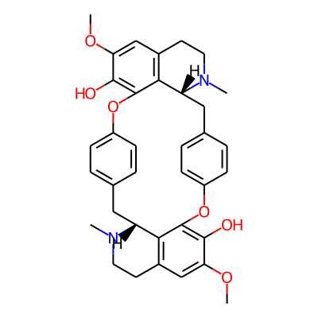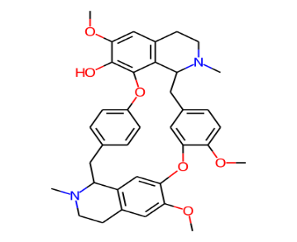

Isochondrodendrine Hayatinine Pareirubrines B
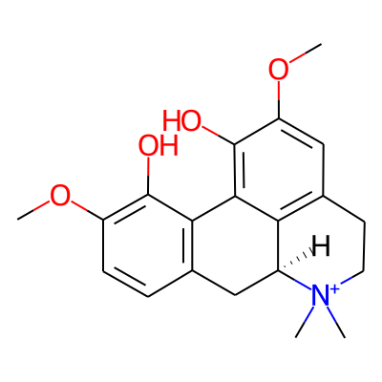
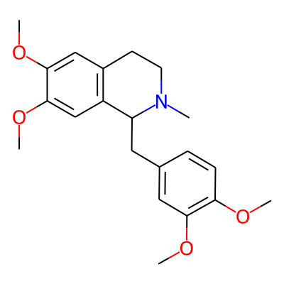
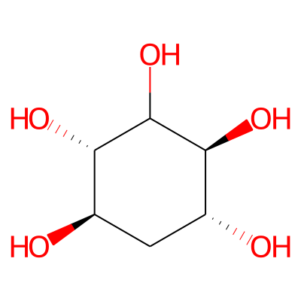

Magnoflorine Quercitol Laudanosine

Figure 5: Alkaloids isolated from C. pareira and their chemical structures (IMPPAT)
- PHARMACOLOGICAL ACTIVITIES

Recent research has examined the pharmacological characteristics of C. pareira extracts and compounds in vitro and in vivo. Its studied pharmacological qualities, which include anti-inflammatory, analgesic, anti-pyretic, anti-arthritic, anti-diarrheal, anti-malarial, anti-diabetic, and anti-venom qualities, scientifically validate the plant's traditional claims. The pharmacological activities are compiled in Table 5.

Table 4: Pharmacological activities of C. pareira
(In in-vitro research, concentration is mentioned, whereas in in-vivo studies, dose is mentioned)

Activity | Extract  And Dose/concentration | Study Model | Action | Reference
Anti-inflammatory | Ethanolic root extract (200 & 400mg/kg) | Sprague- Dawley rats | Anti-inflammatory action by inhibiting mediators like histamine, serotonin, and prostaglandins in carrageenan and histamine induced paw edema model. | Amresh et al., 2007[]
Anti-inflammatory | Hydro-ethanolic whole plant extract (250 and 500 mg/kg) | Rats | Inhibition of inflammatory mediators in Carrageenan-induced paw edema model. | Reza et al., 2014[]
Anti-inflammatory and  Analgesic | Ethanolic extract of aerial parts (50-200mg/kg) | Rats | Inhibition of prostaglandins in Carrageenan- and arachidonic acid–induced paw edema models | Amresh et al., 2007 []
Anti-inflammatory and  Analgesic | Ethanolic extract of aerial parts (100-200mg/kg) | Mice | Evaluates peripheral and central analgesic activity in Acetic acid induced abdominal writhing test and hot-plate test. | Amresh et al., 2007 []
Antinociceptive and  Antiarthritic | Hydro-ethanolic root extract (200–400 mg/kg) | Wistar strain mice | Shows strong analgesic (central and peripheral) in acetic-induced writhing and hot plate test | Amresh et al., 2007 []
Antinociceptive and  Antiarthritic | Hydro-ethanolic root extract (200-400mg/kg) | Sprague-Dawley rats | Reduces lysosomal enzymes and increases glycoproteins | Amresh et al., 2007 []
Antioxidant | C. pareira extract (50 to 400 μg /kg) | DPPH radical scavenging assay. | By scavenging of DPPH radicals, superoxide radicals, hydrogen peroxide, hydroxyl radicals, nitric oxide radicals, inhibited hydroxyl radical induced protein oxidation. | Amresh et al., 2007 []
Antioxidant | C. pareira extract (50 mg/kg & 100 mg/kg) | Mice | Protected gastric mucosa from oxidative stress, reduced gastric lipid peroxidation, restored glutathione levels, and antioxidant enzymes in benzo(a)pyrene-induced gastric toxicity model. | Amresh et al., 2007 []
Antioxidant | Different leaf extracts of C. pareira | DPPH radical scavenging assay by the phosphomolyb-denum method | By involving Scavenging free radicals, reducing molybdenum ions, neutralizing oxidative stress,  high phenolic and flavonoid content responsible for activity | Gul et al., 2016 []
Antioxidant | Pectin extracted from leaves  0.54 mg/ml (DPPH)  0.52 mg/ml (NO). | DPPH  and nitric oxide free-radicals assay | C. pareira pectin shows dose-dependent antioxidant and anti-inflammatory activities by neutralization of free radicals, electron/hydrogen donation, and stabilization of reactive species. | Wisidsri & Thungmungmee., 2019[]
Antioxidant | Methanolic extract of leaf, stem, root and callus.  100 –600 µg/ml (DPPH)  20 – 350 µg/ml (ABTS)  50–300 µg/mL (RP) | DPPH,  ABTS,  Reducing Power Assay | Acts by scavenging free radicals, reducing oxidized intermediates | Uthpala & Raveesha., 2019[]
Antioxidant | Ethanolic stem and leaf Extract  55.00 µg/mL (DPPH)  25.77 µg/mL (ABTS) | DPPH assay  ABTS assay | Potent free radical scavenging due to phenolic content, high flavonoid content | Thim-Uam et al., 2025[]
Antioxidant  and  Immunomodu-latory activity | Alkaloid fraction of root (berberine) 63.44 μg/ml, 31.99 μg/ml and 61.85 μg/ml | DPPH radical scavenging assay | Showed antioxidant effects by scavenging DPPH free radicals and superoxide ions, inhibiting lipid peroxidation | Bafna & Mishra, 2009[]
Antioxidant  and  Immunomodu-latory activity | Alkaloid fraction of roots (25-75 mg/kg) | Swiss albino mice | Showed immunosuppression by decreasing humoral antibody titre for cell mediated immunity | Bafna & Mishra, 2009[]
Antipyretic  and  Analgesic | C. pareira powder (540mg/kg) and extract (200mg/kg) | Wistar albino rats | Powder form showed moderate antipyretic activity via central PGE₂ inhibition and better central analgesic activity. | Singh et al., 2016[]
Antipyretic | Methanolic root extract (200 mg/kg) | Wistar albino rats | Showed antipyretic effect in yeast- provoked elevation of body temperature in rats. | Hullatti & Sharada, 2007[⁸⁷]
Antipyretic | Methanol leaf extract (50-250 mg/kg) | Wistar rats | The antipyretic effects observed could also be associated with the presence of the alkaloid, cissamine. This alkaloid is known to be a predominant inhibitor of prostaglandin synthetase. | Kimuni et al., 2024 []
Anti-viral  (Anti-dengue) | Alcoholic extract (1.2−11 μg/ml) | Cell based assay NS1 antigen secretion using ELISA, Plaque assays, virus yield reduction assays, | In vitro, the extract demonstrated strong inhibitory efficacy against each of the four DENV serotypes. Cipa extract demonstrated that its direct virucidal action is the cause of inhibition. | Sood et al., 2015[]
Anti-viral  (Anti-dengue) | Alcoholic extract of aerial parts  (25 mg and 250 mg/kg body weight twice daily for 5 days) | AG129 mouse model against dengue virus infection and wistar rats for toxicological study | Administration of the Cipa extract provided statistically significant protection against DENV infection in the AG129 mouse model. In Wistar rats, the extract demonstrated inherent antipyretic activity and significantly down-regulated the production of TNF-α, a key cytokine implicated in severe dengue pathology. | Sood et al., 2015[]
Anti-tubercular | Different solvent extract of roots (50 to 6.25 μg/ml) | In vitro assays. | The antimicrobial action is attributed to the presence of alkaloids, flavonoids, terpenoids, anthraquinones, and phenolic compounds, which interfere with microbial cell wall synthesis, enzyme systems, and metabolic pathways. | Njeru et al., 2015[]
Anti-bacterial | Methanolic stem and roots extract  (100, 200 and 300 μg/ml) | Agar well diffusion method | Showed significant antibacterial activity against both Gram-positive and Gram-negative bacteria. | Uthpala & Raveesha, 2019[]
Anti-bacterial | leaf extract and silver nanoparticle | In vitro (E.Coli) | The result of antibacterial activities showed that Ag- NPs synthesized had an inhibiting activity against E. coli. | Dwivedi & Pawar.,2024 []
Anti-bacterial | ethanol root extract (12.5 to 50 µg/mL) | In vitro (disc diffusion assay) | Showed the presence of antibacterial compounds (alkaloids, flavonoids, tannins, terpenoids and steroids). | Girma, 2024 []
Anti-plasmodial | Methanolic and water extract of roots  (10 μg/ml) | P. falciparum strains | Effectively inhibit the growth of both chloroquine-sensitive (NF54) and chloroquine-resistant (ENT30) strains of Plasmodium falciparum. | Rukunga et al., 2009[]
Anti-plasmodial | Ethanolic root extract (500 mg/kg) | Mice | It inhibits the propagation of the rodent malaria parasite Plasmodium-berghei, resulting in a marked reduction of parasitaemia in infected mice. | Singh & Banyal, 2011[]
Anti-plasmodial | Whole plant hydro-alcoholic extract (0.79-2.26 μg/ml  and root decoction (10.22-7.7 μg/ml) | Plasmodium falciparum strains | This study showed that the root decoction was more effective than decoctions of each of the other parts of the plant and the whole plant hydroalcoholic extract. Attributed to high bisbenzylisoquinoline content | Kumari et al., 2024[]
Anti-protozoal | Compound cissampeloflavone  (3.42 μM and 0.99 Μm) | In vitro assays (KB cell line) | exhibited significant antiprotozoal activity against Trypanosoma cruzi and Trypanosoma brucei rhodesiense, with low cytotoxicity to human cells, | Ramírez et al., 2003 []
Chemo-preventive | Root extract of C. pareira  Pareirubrine A and B  0.89 μM and 0.55 μM | P-388 cell line | Tropo loisoquinoline alkaloids displayed remarkable anti-leukemic activities against P-388 cells | (Morita et al., 1993a,1993b,1993c,1995[,]
Chemo-preventive | Norimeluteine and Norruffscine -  10.61 μM and 18.75 μM | P-388 cell line |  | (Morita et al., 1993a,1993b,1993c,1995[,]
Chemo-preventive | Pareitropone-  2.74 μM | P-388 cell line |  | (Morita et al., 1993a,1993b,1993c,1995[,]
Chemo-preventive | Hydroethanolic roots extract  (168.5 μg/ml) | KB cell | Cytotoxic and chemo-preventive effect against cancer cell lines | Bala et al.2015[,]
Chemo-preventive | Chloroform, n-butanol and water fraction-80.2 μg/ml, 43.2 μg/ml and 159.1 μg/ml | KB cell |  | Bala et al.2015[,]
Chemo-preventive | Cycleanine - 44.2 μM | KB cell |  | Bala et al.2015[,]
Chemo-preventive | Hayatinine - 46.5 μM | KB cell |  | Bala et al.2015[,]
Chemo-preventive | Hayatinine - 88.4 μM | A549 cells |  | Bala et al.2015[,]
Chemo-preventive | Hexane extract of the stem  (0–800μg/mL) | Breast cancer cell lines (MCF-7 and MDA-MB-231, HEK293T cells) | Inhibition of cancer cell proliferation, disruption of cell membrane integrity, induction of apoptosis and cell cycle arrest | Thim-Uam et al., 2025 []
Anti-fertility | Methanolic leaves extract (250-450mg/kg) | Female Albino mice | By altering the estrous cycle, reducing litter number, modifying, key reproductive hormones. | Ganguly et al., 2007[]
Anti-fertility | Aqueous leaf extract (1.0ml/100Gbw) | Male albino mice | Shows dose dependent antifertility activity due to hormonal imbalance and impaired spermatogenesis | Luangpirom et al., 2010 []
Anti-diarrhoeal | Hydroethanolic root extract (25–100 mg /kg) | Sprague-Dawley rats  albino mice | Acts as antidiarrheal by decreasing intestinal secretion, slowing gut movement, reducing oxidative stress, and preventing electrolyte loss. | Reddy et al., 2004[]
Gastroprotective effect | Hydro-ethanolic root extracts (25-100 mg/kg) | Sprague-Dawley rats | It protects gastric mucosa, reduces ulcer severity, enhances mucus components, and lowers oxidative stress. | Amresh et al., 2007[]
Hepatoprotective | Hydro-ethanolic root extract (100, 200 and 400 mg/kg) | on rat hepatocytes | Protects liver cells from toxic injury, Restores altered liver function enzymes, Reduces hepatic oxidative stress, Prevents lipid peroxidation and cellular necrosis | Surendran et al., 2011[]
Hepatoprotective | Hydro-ethanolic root extract (100, 200 and 400 mg/kg) | Wistar albino rats | Hydroalcoholic extract of C. pareira exhibited hepatoprotective activity against anti-tuberculosis drug–induced liver damage. | Balakrishnan et al., 2012 []
Hepatoprotective | Methanolic leaves extract (12.5μg/ml) | In vitro assay (acetaminophen induced Hep G2 cells) | Hepatoprotective action in acetaminophen induced Hep G2 cells due to its antioxidant | Latha & Venugopal.,2024 []
Hepatoprotective | Hydroethanolic leaves extract  (200 and 400 mg/kg) | Albino wistar rats | significant antihyperglycemic activity and improved body weight in streptozotocin-induced diabetic rats, with efficacy comparable to glibenclamide | Vishwanath Jannu et al., 2011[]
Hepatoprotective | Aqueous leaves extract (250 and 500 mg/kg) | Swiss-albino mice | the decrease in blood glucose level may be attributed to the stimulation of glucose uptake by peripheral tissues and/ or decrease in the gluconeogenesis | Yadav et al., 2013 []
Hepatoprotective | Aqueous leaves extract (50, 100 and 150 mg/kg) | Albino rats | Exhibited significant hypoglycemic activity in alloxan-induced diabetic rats. | Piero et al., 2015 []
Hepatoprotective | Hydroalcoholic extract  (200 and 400 mg/kg) | Wistar rats | Reduced blood glucose, liver enzymes, lipid levels, and oxidative stress, while improving body weight, HDL, and glutathione | Asif et al., 2021[]
Hepatoprotective | Aqueous-ethanolic root extract (500 mg/kg) | rats | The extract showed α-amylase and α-glucosidase inhibitory effects | Upadhyaya & Aggarwal, 2024 []
Cardioprotective | Hydroethanolic root extract  (100 and 200 mg/kg) | Albino-Wistar rats | The protection is probably due to multiple mechanisms involving free-radical-scavenging properties, attenuating CaN and lipid peroxidation, and augmenting antioxidant status. | Singh et al., 2013 []
Cardioprotective | Hydroethanolic root extract  (100 and 200 mg/kg) | Albino-Wistar rats | This effect may be due to amelioration of calcineurin activity and free radical formation, and augmentation of antioxidant enzyme activities | Singh et al., 2016 []
Antilithiatic | Ethanolic leaves extract (100-400mg/kg) | Albino rats | Inhibition of crystal formation and aggregation, protection of renal tissue from chemical toxicity, antioxidant and nephroprotective effect. | Sayana et al., 2014 []
Diuretic | Hydroethanolic leaves extract (100, 200 and 400 mg/kg) | Albino rats | by increasing urinary output and increased excretion of sodium, potassium, chloride levels | Sayana et al.,2014 []
Anxiolytic | Hydroethanolic leaves extract (100, 200 and 400 mg/kg) | Albino rats | exhibited significant anxiolytic activity in rats, increasing exploratory behaviour and reducing anxiety-related responses, with effects comparable to diazepam. | Thakur & Rana, 2013 []
Anti-venom | Aqueous leaves extract | Swiss Webster mice | Neutralization of the hemorrhagic effect of venom | Badilla et al., 2008 []
Anti-venom | Ethanolic extract of aerial parts | CF1 Mice | characterized a flavonoid enriched fraction responsible for the antivenom activity | Verrastro et al., 2018[]
Anti-venom | Aqueous and alcoholic leaf extract | SDS-PAGE electrophoresis | Showed concentration-dependent inhibition of venom-induced haemolysis. | Torres et al., 2018 []
Wound healing action | Aqueous and methanolic extracts (200-400mg/kg) | Two in-vivo experimental animal models | Significant wound healing potential by reducing oxidative stress, lowering inflammatory cytokines, promoting tissue regeneration in exicision wound and carrageenan models. | Satpathy & Saini, 2024 []
Curariform | Hayatine methiodide  (0.1 mg/kg) | Mice, Cat, dog and rabbit | This substance works mainly by blocking transmission of nerve impulses at the neuromuscular junction, it has also some direct depressant action on the muscle | Pradhan & De, 1953[]
Anthelmintic | Aqueous extract of aerial parts  (50 and 100 mg/ml) | Earthworm | significant anthelmintic activity, causing paralysis (vermifuge) and death (vermicide) of earthworms. | Shukla et al., 2012 []
Acetylcholinesterase  (AChE) inhibitory activity | Aerial parts (12.32 µg/mL) | In-vitro AChE inhibition assay | The alkaloid (N-Methylneolitsine) could be potentially useful for the treatment of various neurodegenerative diseases | Haldar et al., 2024 []
Neuroprotective effects | Methanol and n-hexane extract (50 mg/kg) | Male Sprague–Dawley rats | neuroprotective activity in MCAO-induced cerebral ischemia in rats through antioxidant and anti-inflammatory mechanisms. | Khalid et al., 2024 []
Anti-Aging Applications | Pectin isolated from C.pareira  (0.5% w/w and 1.0% w/w PCP) | Human clinical trial | Demonstrated antioxidant, non-cytotoxic, non-irritant, and skin-hydrating and elasticity-enhancing effects | Chanpirom et al., 2025 []

- SAFETY AND TOXICITY PROFILE
The 50% aqueous ethanolic extract of Cissampelos pareira was shown to be safe following tests for acute and subacute toxicity. Rats that received repeated therapy at 1-2 g/kg/day for 28 days did not die, although rats given an oral dose of 2 g/kg did not exhibit any behavioral changes or die in acute testing. While long-term toxicity studies are still required, these results indicate a good safety profile (Amresh et al., 2008).
The hydroethanolic extract's acute toxicity was evaluated in accordance with OECD guideline 425. Rats given 1600 and 3200 mg/kg orally did not die or experience any negative side effects, suggesting that 3200 mg/kg is safe (Thakur & Rana, 2013).
Studies on the acute and subacute toxicity of C. pareira and C. hirsutus in rats revealed no negative effects, behavioural alterations, or mortality. The extracts are safe for continued therapeutic use because no appreciable changes in body weight, haematological, biochemical, or histopathological markers were found (Nisha et al., 2024).

- CONCLUSION AND FUTURE PERSPECTIVES
This review summarizes the medicinal significance and updated overview of Cissampelos pareira (Patha), a well-known herb in ayurvedic and traditional medicine. The convergence of classical Ayurvedic descriptions and modern pharmacological evidence confirms its multi-target therapeutic potential, particularly in inflammatory disorders, infections, fever, dengue, metabolic diseases, cancer, liver and cardiovascular conditions. Its high concentration of isoquinoline alkaloids and other bioactive substances is primarily responsible for these actions.
This thorough analysis supports Cissampelos pareira's potential as a useful medicinal plant for upcoming drug development and clinical applications by combining traditional knowledge, phytochemistry, pharmacological activity, and safety considerations. Clinical validation is still lacking despite strong in vitro and in vivo evidence supporting its therapeutic potential. Many of the mechanisms of action are still unclear. Consequently, a thorough investigation is required to elucidate the structure activity connections or mechanism of action to minimize negative effects and establish the usual dose. Traditional knowledge should ideally be converted into basic scientific research before moving on to the clinical trial stage to validate traditional uses. This includes biological activity to assess efficacy, toxicity studies to assess safety, the isolation of active compounds and biomarkers to facilitate quality control, and the clarification of the mechanism of action for plant combinations, single extracts, and isolated compounds. Overall, Cissampelos pareira represents a promising phytopharmaceutical candidate and systematic scientific exploration may facilitate its transformation from a traditional remedy into an evidence-based modern therapeutic agent.

Disclaimer (Artificial intelligence)

Author(s) hereby declare that NO generative AI technologies such as Large Language Models (ChatGPT, COPILOT, etc.) and text-to-image generators have been used during the writing or editing of this manuscript.

REFERENCES:

Mukerji B, Bhandari PR. Cissampelos pareira l. source of a new gurariform drug. Planta médica. 1959 Sep;7(03):250-9. DOI: 10.1055/s-0028-1101606.
Kumari S, Bhatt V, Suresh PS, Sharma U. Cissampelos pareira L.: A review of its traditional uses, phytochemistry, and pharmacology. Journal of Ethnopharmacology. 2021 Jun 28;274:113850.
Sudhakaran MV. Histo-morphological, fluorescent and powder microscopic characterization of Cissampelos pareira Linn. Pharmacognosy Journal. 2012 Dec 1;4(34):57-68.
He J, Li F, Yan X, Cheng Q, Xue R, Yu H, Li Z, Wang C. Phytochemical constituents and biological activities of plants from the genus Cissampelos. Chemistry & Biodiversity. 2021 Oct;18(10):e2100358.
Gupta A, Pandey S, Shah DR, Seth NR, Yadav JS. Pharmacognostical and phytochemical evaluation of leaves of Cissampelos pareira. Pharmacognosy journal. 2011 Apr 1;3(21):25-8.
Suresh PS, Kesarwani V, Kumari S, Shankar R, Sharma U. Bisbenzylisoquinolines from Cissampelos pareira L. as antimalarial agents: Molecular docking, pharmacokinetics analysis, and molecular dynamic simulation studies. Computational Biology and Chemistry. 2023 Jun 1;104:107826.
Prof. Krushnachandra Chunekar, Bhavprakash Nighantu, Chaukhambha Bharati Academy, Varanasi, Reprinted 2015, Guduchyadi varga, Pg. No.- 382
Ayurvedic pharmacopoeia of India, Ministry of health and family welfare - Part-1, Volume-1, Page No. 122-123.
Semwal DK, Semwal RB, Vermaak I, Viljoen A. From arrow poison to herbal medicine–the ethnobotanical, phytochemical and pharmacological significance of Cissampelos (Menispermaceae). Journal of ethnopharmacology. 2014 Sep 11;155(2):1011-28.
POWO (2025). “Plants of the World Online, Available from Cissampelos pareira L. | Facilitated by the Royal Botanic Garden Kew.
Bora U, Sahu A, Saikia AP, Ryakala VK, Goswami P. Medicinal plants used by the people of Northeast India for curing malaria. Phytotherapy Research. 2007 Aug;21(8):800-4.
Namsa ND, Mandal M, Tangjang S. Anti-malarial herbal remedies of northeast India, Assam: an ethnobotanical survey. Journal of ethnopharmacology. 2011 Jan 27;133(2):565-72.
Singh H, Dhole PA, Krishna G, Saravanan R, Baske PK. Ethnomedicinal plants used in malaria in tribal areas of Odisha, India. Indian Journal of Natural Products and Resources (IJNPR)[Formerly Natural Product Radiance (NPR)]. 2018 Sep 25;9(2):160-7.
Dwivedi MK, Shyam BS, Lal M, Singh PK, Sharma NK, Shukla R. Geospatial mapping of antimalarial plants used by the ethnic groups of Anuppur district (Madhya Pradesh, India). Indian J Tradit Know. 2019 Apr 1;18(2):261-71.
Upasani SV, Beldar VG, Tatiya AU, Upasani MS, Surana SJ, Patil DS. Ethnomedicinal plants used for snakebite in India: a brief overview. Integrative medicine research. 2017 Jun 1;6(2):114-30.
Basha SK. Traditional use of plants against snakebite in Sugali tribes of Yerramalais of Kurnool district, Andhra Pradesh, India. Asian Pacific Journal of Tropical Biomedicine. 2012 Feb 1;2(2):S575-9.
Maurya R, Srivastava S, Kulshreshta DK, Gupta CM. Traditional remedies for fertility regulation. Current medicinal chemistry. 2004 Jun 1;11(11):1431-50.
Tiwari KC, Majumder R, Bhattacharjee S. Folklore information from Assam for family planning and birth control. International Journal of Crude Drug Research. 1982 Jan 1;20(3):133-7.
Thakur M, Asrani RK, Thakur S, Sharma PK, Patil RD, Lal B, Parkash O. Observations on traditional usage of ethnomedicinal plants in humans and animals of Kangra and Chamba districts of Himachal Pradesh in North-Western Himalaya, India. Journal of ethnopharmacology. 2016 Sep 15;191:280-300.
Seethapathy GS, Ravikumar K, Paulsen BS, de Boer HJ, Wangensteen H. Ethnobotany of dioecious species: Traditional knowledge on dioecious plants in India. Journal of ethnopharmacology. 2018 Jul 15;221:56-64.
Suresh M, Irulandi K, Siva V, Mehalingam P. An ethnobotanical study on medicinal plants in southern Western Ghats of Virudhunagar district, Tamil Nadu, India. International Journal of Ayurvedic Herb Medicine. 2016;6(4):2321-9.
Majhi S, Das A, Das K, Samantray PK. A note on Cissampelos pareira L. (Menispermaceae): a natural fermenting agent (2025). DOI: https://doi.org/10.5281/zenodo.16948462.
Kupchan SM, Patel AC, Fujita E. Tumor inhibitors VI. Cissampareine, new cytotoxic alkaloid from Cissampelos pareira. Cytotoxicity of bisbenzylisoquinoline alkaloids. Journal of Pharmaceutical Sciences. 1965 Apr;54(4):580-3.
Dwuma-Badu D, Ayim JS, Mingle CA, Tackie AN, Slatkin DJ, Knapp JE, Schiff PL. Alkaloids of Cissampelos pareira. Phytochemistry. 1975;14(11):2520-1. https://doi.org/10.1016/0031-9422(75)80388-8
Bhakuni DS, Jain S, Chaturvedi R. The biosynthesis of the alkaloids of Cissampelos pareira Linn. Tetrahedron. 1987 Jan 1;43(17):3975-82
Bhatt V, Kumari S, Upadhyay P, Agrawal P, Sahal D, Sharma U. Chemical profiling and quantification of potential active constituents responsible for the antiplasmodial activity of Cissampelos pareira. Journal of Ethnopharmacology. 2020 Nov 15;262:113185
Kumari S, Anmol, Sharma U. A cularine-type isoquinoline alkaloid from the root part of Cissampelos pareira. Natural Product Research. 2024 Feb 1;38(3):440-6.
Cao SQ, Pan RY, Zhang TT, Gong JH, Li M, Chen H, Zhang JK, Hao ZY, Zheng XK, Sun YJ, Feng WS. Cissatriterpenoids DL, nine undescribed polyhydroxylated oleanane triterpenoids from Cissampelos pareira var. hirsuta. Phytochemistry. 2025 Dec 16:114750.
Ramı́rez I, Carabot A, Meléndez P, Carmona J, Jimenez M, Patel AV, Crabb TA, Blunden G, Cary PD, Croft SL, Costa M. Cissampeloflavone, a chalcone-flavone dimer from Cissampelos pareira. Phytochemistry. 2003 Sep 1;64(2):645-7
Shukla P, Shukla P, Gopalakrishna B. Isolation and characterization of β-sitosterol from Cissampelos pareira Linn. Current Research in Pharmaceutical Sciences. 2012;1(1):31–33
Devkota HP, Miyazaki S, Yahara S. Amentoflavone and kaempferol glycosides from the aerial parts of Cissampelos pareira. Nepal Journal of Biotechnology. 2017 Dec 31;5(1):1-4.
IMPPAT 2.0: An Enhanced and Expanded Phytochemical Atlas of Indian Medicinal Plants, R. P. Vivek-Ananth, Karthikeyan Mohanraj, Ajaya Kumar Sahoo and Areejit Samal*, ACS Omega 8:8827-8845 (2023).
Amresh G, Reddy GD, Rao CV, Singh PN. Evaluation of anti-inflammatory activity of Cissampelos pareira root in rats. Journal of ethnopharmacology. 2007 Apr 4;110(3):526-31.
Reza HM, Shohel M, Aziz SB, Pinaz FI, Uddin MF, Al-Amin M, Khan IN, Jain P. Phytochemical and pharmacological investigation of ethanol extract of Cissampelos pareira. Indian journal of pharmaceutical sciences. 2014 Sep;76(5):455.
Amresh, G., Zeashan, H., Rao, V., & Singh, P. N. (2007). Prostaglandin mediated anti-inflammatory and analgesic activity of Cissampelos pareira. Acta Pharmaceutica Sciencia, 49(2).
Amresh G, Singh PN, Rao CV. Antinociceptive and antiarthritic activity of Cissampelos pareira roots. Journal of ethnopharmacology. 2007 May 22;111(3):531-6.
Amresh G, Rao CV, Singh PN. Antioxidant activity of Cissampelos pareira on benzo (a) pyrene-induced mucosal injury in mice. Nutrition Research. 2007 Oct 1;27(10):625-32.
Gul, M. Z., Chandrasekaran, S., Bhat, M. Y., Maurya, R., Qureshi, I. A., & Ghazi, I. A. (2016). Antioxidant and enzyme inhibitory activities of Cissampelos pareira L. leaf extracts. Ann. Phytomed, 5(1), 91-8.
WISIDSRI, N., & THUNGMUNGMEE, S. (2019). Radical Scavenging and Anti-Inflammatory Properties of Pectin from Cissampelos pareira Linn. Walailak Journal of Science and Technology (WJST), 16(11), 841-850.
Uthpala T, Raveesha HR. Studies on antioxidant and antibacterial activity of Cissampelos pareira (L.). International Journal of Advanced Scientific Research and Management. 2019;4(4):35-42.
Thim-Uam, A., Thepmalee, C., Chaiwangyen, W., Kangwan, N., Chokchaisiri, R., Nuntaboon, P., ... & Onsa-Ard, A. (2025). Phytochemical Screening and In Vitro Antioxidant and Anticancer Evaluation of Stem and Leaf Extracts of Cissampelos pareira L. Mediators of Inflammation, 2025(1), 7555073.
Bafna A, Mishra S. Antioxidant and immunomodulatory activity of the alkaloidal fraction of Cissampelos pareira linn. Scientia pharmaceutica. 2009 Dec 6;78(1):21.
Singh SG, Nishteswar K, Patel BR, Nariya M. Comparative antipyretic and analgesic activities of Cissampelos pareira Linn. and Cyclea peltata (Lam.) Hook. F. & Thomas. AYU (An International Quarterly Journal of Research in Ayurveda). 2016 Jan 1;37(1):62-6.
Kimuni SN, Gitahi SM, Ngugi MP, Njagi EM. Bio efficacy of methanol leaf extracts of Cissampelos pareira Linn., Lantana camara Linn. and Ocimum gratissimum Linn. against fever in Wistar rats. Acta Marisiensis. Seria Medica. 2024 Dec 1;70(4).
Sood R, Raut R, Tyagi P, Pareek PK, Barman TK, Singhal S, Shirumalla RK, Kanoje V, Subbarayan R, Rajerethinam R, Sharma N. Cissampelos pareira Linn: natural source of potent antiviral activity against all four dengue virus serotypes. PLoS neglected tropical diseases. 2015 Dec 28;9(12):e0004255.
Njeru SN, Obonyo MA, Nyambati SO, Ngari SM. Bioactivity of Cissampelos pareira medicinal plant against Mycobacterium tuberculosis. J. Pharmacogn. Phytochem. 2015;3(6):167-73.
Uthpala T, Raveesha HR. Studies on antioxidant and antibacterial activity of Cissampelos pareira (L.). International Journal of Advanced Scientific Research and Management. 2019;4(4):35-42.
Dwivedi D, Pawar RS. FORMULATION AND EVALUATION OF SILVER NANOPARTICLE OF EXTRACT OF CISSAMPELOS PAREIRA.(2024)
Girma A. Screening for antibacterial activity of Cissampelos pareira L. root extract: an in-vitro study. Universa Medicina. 2024 Aug 21;43(2):220-8.
Rukunga GM, Gathirwa JW, Omar SA, Muregi FW, Muthaura CN, Kirira PG, Mungai GM, Kofi-Tsekpo WM. Anti-plasmodial activity of the extracts of some Kenyan medicinal plants. Journal of Ethnopharmacology. 2009 Jan 21;121(2):282-5.
Singh V, Banyal HS. Antimalarial effect of Tinospora cordifolia (Willd.) Hook. f. & Thoms and Cissampelos pareira L. on Plasmodium berghei. Current Science. 2011 Nov 25:1356-8.
Kumari S, Agrawal P, Sahal D, Sharma U. Evaluation of antiplasmodial potential of Cissampelos pareira L.: Characterization and quantification of isoquinoline alkaloids responsible for the biological activity. South African Journal of Botany. 2024 Jun 1;169:72-81.
Ramı́rez I, Carabot A, Meléndez P, Carmona J, Jimenez M, Patel AV, Crabb TA, Blunden G, Cary PD, Croft SL, Costa M. Cissampeloflavone, a chalcone-flavone dimer from Cissampelos pareira. Phytochemistry. 2003 Sep 1;64(2):645-7.
Morita H, Matsumoto K, Takeya K, Itokawa H, Iitaka Y. Structures and solid state tautomeric forms of two novel antileukemic tropoloisoquinoline alkaloids, pareirubrines A and B, from Cissampelos pareira. Chemical and pharmaceutical bulletin. 1993 Aug 15;41(8):1418-22.
Morita H, Takeya K, Itokawa H. A novel condensed tropone-isoquinoline alkaloid, pareitropone, from Cissampelos pareira. Bioorganic & Medicinal Chemistry Letters. 1995 Mar 16;5(6):597-8.
Bala M, Pratap K, Verma PK, Padwad Y, Singh B. Cytotoxic agents for KB and SiHa cells from n-hexane fraction of Cissampelos pareira and its chemical composition. Natural Product Research. 2015 Apr 3;29(7):686-91.
Bala M, Kumar S, Pratap K, Verma PK, Padwad Y, Singh B. Bioactive isoquinoline alkaloids from Cissampelos pareira. Natural Product Research. 2019 Mar 4;33(5):622-7.
Thim-Uam, A., Thepmalee, C., Chaiwangyen, W., Kangwan, N., Chokchaisiri, R., Nuntaboon, P., ... & Onsa-Ard, A. (2025). Phytochemical Screening and In Vitro Antioxidant and Anticancer Evaluation of Stem and Leaf Extracts of Cissampelos pareira L. Mediators of Inflammation, 2025(1), 7555073.
Ganguly M, Borthakur MK, Devi N, Mahanta R. Antifertility activity of the methanolic leaf extract of Cissampelos pareira in female albino mice. Journal of ethnopharmacology. 2007 May 22;111(3):688-91.
Luangpirom A, Sirisarn W, Pontaisog J. Antifertility activity of the aqueous leaf extract of Cissampelos pareira in male albino mice. Animal Biology & Animal Husbandry. 2010 Dec 1;2(2).
Reddy GD, RAO CV, Shirwaikar A. Ethnomedical value of Cissampelos pareira extract in experimentally induced diarrhoea. Acta Pharmaceutica. 2004 Mar 1;54(1):27-35.
Amresh G, Zeashan H, Gupta RJ, Kant R, Rao CV, Singh PN. Gastroprotective effects of ethanolic extract from Cissampelos pareira in experimental animals. Journal of natural medicines. 2007 Jul;61(3):323-8.
Surendran S, Bavani Eswaran M, Vijayakumar M, Rao CV. In vitro and in vivo hepatoprotective activity of Cissampelos pareira against carbon-tetrachloride induced hepatic damage. Indian Journal of Experimental Biology. 2011 Dec 1;49(12):939.
Balakrishnan S. Hepatoprotective effect of hydroalcoholic extract of Cissampelos pareira against rifampicin and isoniazid induced hepatotoxicity. Continental Journal of Pharmaceutical Sciences. 2012 Jan 1.
Latha B, Venugopal L. HEPATOPROTECTIVE EFFICACY OF METHANOLIC EXTRACT OF LEAVES OF CISSAMPELOS PAREIRA IN ACETAMINOPHEN INDUCED TOXICITY ON HEP G2 CELLS.(2024)
Vishwanath Jannu SV, Ranjith Babu V HB, Ravi Chandra Sekhara Reddy D. Antidiabetic activity of hydro-alcoholic extract of cissampelos pareira linn. Leaves in streptozotocin-induced diabetic rats. International Journal of Pharmacy & Technology. 2011 Dec;3:3601-11.
Yadav KS, Yadav NP, Shanker K, Thomas SC, Srivastav S, Srivastava S, Rai VK, Mishra N, Sinha P. Assessment of antidiabetic potential of Cissampelos pareira leaf extract in streptozotocin–nicotinamide induced diabetic mice. journal of pharmacy research. 2013 Aug 1;6(8):874-8.
Piero NM, Eliud NN, Susan KN, George OO, David, N.J.M.M. In vivo antidiabetic activity and safety in rats of Cissampelos pareira traditionally used in the management of diabetes mellitus in Embu County, Kenya. Journal of Drug Metabolism & Toxicology. 2015;6(03). doi:10.4172/2157-7609.1000184
Asif M, Gilani SJ, Taleuzzaman M, Kala C, Godara D, Rahat I, Khan NA. GC-MS Analysis of Chemical Constituents of Hydroalcoholic Leaf Extract of Cissampelos Pareira and Their Anti-Diabetic Activity. Asian Plant Research Journal. 2021 Feb 24;7(1):36-49.
Upadhyaya LM, Aggarwal S. Viewing the Blood Glucose Levels of the Drug-Induced Diabetic Experimental Rats Treated with the Cissampelos Pareira L. (Menispermaceae) Root Extract-II. Partners Universal International Research Journal. 2024 Jun 25;3(2):102-19.
Singh BK, Pillai KK, Kohli K, Haque SE. Effect of Cissampelos pareira root extract on isoproterenol-induced cardiac dysfunction. Journal of natural medicines. 2013 Jan;67(1):51-60.
Singh BK, Pillai KK, Kohli K, Haque SE. Cissampelos pareira Linn. ameliorates thyroxin-induced cardiac hypertrophy in rats. Journal of ethnopharmacology. 2016 Feb 3;178:281-8.
Sayana SB, Chavan VR, Mudium R. ANTILITHIATIC EFFECT OF CISSAMPELOS PAREIRA LEAVES IN AMMONIUM CHLORIDE AND ETHYLENE GLYCOL INDUCED UROLITHISIS IN RATS. Asian J Pharm Clin Res. 2014 Nov.
Suresh Babu Sayana C, Medabala T, PATIL PS. STUDY OF DIURETIC ACTIVITY OF ETHONOLIC EXTRACT OF LEAVES OF CISSAMPELOS PAREIRA IN RATS. Asian J Pharm Clin Res. 2014;7(4):157-9.
Thakur P, Rana AC. Effect of cissampelos pareira leaves on anxiety-like behavior in experimental animals. Journal of traditional and complementary medicine. 2013 Jul 1;3(3):188-93.
Badilla B, Chaves F, Jiménez S, Rodríguez G, Poveda L. Effects of an extract of Cissampelos pareira on the hemorrhagic and proteolytic activities from Bothrops asper venom. Pharmacognosy Magazine. 2008;4(13):27.
Verrastro BR, Torres AM, Ricciardi G, Teibler P, Maruñak S, Barnaba C, Larcher R, Nicolini G, Dellacassa E. The effects of Cissampelos pareira extract on envenomation induced by Bothropsdiporus snake venom. Journal of Ethnopharmacology. 2018 Feb 15;212:36-42.
Torres AM, Camargo F, Ricciardi GA, Dellacassa E, Ricciardi AI. Study of antihemolytic activity of Cissampelos pareira extract against poison of Bothrops neuwiedi diporus (COPE)(yarará chica).
Satpathy, M., & Saini, V. (2024). Exploring the Therapeutic Potential of Cissampelos pareira in Wound Healing: A Comprehensive Investigation into its Anti-Inflammatory and Antioxidant Properties. Research Journal of Pharmacy and Technology, 17(3), 1336-1341
Pradhan SN, De NN. Hayatin methiodide: a new curariform drug. British Journal of Pharmacology and Chemotherapy. 1953 Dec;8(4):399.
Shukla P, Shukla P, Gopalakrishna B. Investigation of in-vitro anthelmintic activity of Cissampelos pareira Linn against Pheretima posthuma. International Journal of Pharmaceutical Sciences and Research. 2012;3(1):265.
Haldar S, Mohapatra S, Ganguly P, Paul N, Ash A, Biswas R, Singh R, Katiyar CK. N-Methylneolitsine as a new and potent acetylcholinesterase inhibitor of Cissampelos pareira Linn. aerial parts: bioassay-guided isolation and quantitative densitometric analysis. Natural Product Research. 2024 Mar 18;38(6):1044-8.
Khalid MS, Sarwar S, Shah FA, Alamro A, Algamdi AA, Alghamdi S, Malik I. Investigation of Neuroprotective Effect of n-Hexane Extract of Cissampelos pareira in Ischemic Stroke-Induced Nerve Damage and Underlying Mechanisms. Natural Product Communications. 2024 Apr;19(4):1934578X241249069.
Chanpirom S, Khat-udomkiri N, Tree-Udom T, Ditthawutthikul N, Saewan N, Vinardell MP, Sripisut T. Potential of Cissampelos pareira L. Pectin as a Bioactive Compound in Moisturizing and Anti-Aging Applications. Cosmetics. 2025 Jan 3;12(1):5.
Amresh G, Singh PN, Rao CV. Toxicological screening of traditional medicine Laghu patha (Cissampelos pareira) in experimental animals. Journal of ethnopharmacology. 2008 Mar 28;116(3):454-60.
Thakur P, Rana AC. Effect of cissampelos pareira leaves on anxiety-like behavior in experimental animals. Journal of traditional and complementary medicine. 2013 Jul 1;3(3):188-93.
Nisha A, Rizvi A, Shamim A, Goswami B, Akhtar W, Ul Hasan R. Assessing the individual and combined toxicity profile of cissampelos pareira and cocculus hirsutus in animal models. Bulletin of Pure & Applied Sciences-Zoology. 2024 Jul 2;43. ⁸⁸Hullatti KK, Sharada MS. PHCOG MAG.: Research Article Comparative Antipyretic activity of Patha: An Ayurvedic drug. Phcog Mag. 2007 Jul;3(11):173.

