Modelling the Socio-Demographic Determinants of Loan Default Risk of Individual Borrowers: A Survival Analysis Approach
Abstract
Loan default is a growing concern to financial institutions globally. The situation is worst for rural banks and micro-finance institutions undertaking rural and small-scale financing in Ghana, a Sub-Saharan African country, and by extension Africa as a whole. Although stringent measures are set to ensure maximum recovery, loan default remains a great challenge to financial institutions. This study applied methods of survival analysis to monthly survival data for 270 individuals, to examine the determinants of risk of loan default. Occupation was found to have the highest statistically significant impact on the formulated model, followed by sex, marital status, and then age. There were statistically significant differences among the three levels of occupation and two levels of sex: Individuals into formal occupation posed the least likely of risk to default, followed by those into informal–commerce and foods, and then those into informal-trades. Males were more likely to risk of default compared with females. Age and marital status showed some statistically significant impact on the model only in the presence of occupation and sex. However among the levels of age and marital status the risk of default is similar. From the results, banks, policy makers or risk managers may have the highest likelihood of loan recovery when they consider giving loans to individuals based on occupation rather than sex, marital status and age. The results further show that individuals into formal occupation should be prioritised compared to those into informal occupation.
Key words: Loan default, Survival function, Hazard function, Survival analysis, Financial institution, Credit risk, Socio-economic determinants.
1 Introduction
Granting of loans for small-scale businesses has traditionally been regarded as the primary basis for financial intermediation. Banks normally invest their assets into consumer or business loans, government bonds and credit cards where customers borrow and pay back with interest (Bennett, 2023; New York Times, 2021). About two-thirds of the projects of International Fund for Agricultural Development (IFAD) worldwide have a rural finance intervention targeting rural and small-scale producers and meant to achieve some of the millennium development goals (IFAD, 2025). In Ghana, the Rural Financial Services Project (RFSP) seeks to promote growth and reduce poverty through broadening the financial intermediation in rural areas by strengthening the operational linkages between microfinance institutions (MFI) and rural and commercial banks, and building their capacities (AFDB, 2025).
Although stringent modalities are set to maximise recovery of loans and minimise default, the risk of loan default is still a great threat to these financial institutions globally. A press release by Bank of Ghana (BOG) indicated that individuals who defaulted in repaying loans acquired on mobile money platforms deliberately refused to register their SIM cards with the intention of avoiding repayment of the loans (Bank of Ghana, 2022). Banks and financial institutions in Ghana and particularly those in the Ashanti region of Ghana are no exceptions to this challenge. Studies have indicated that loan default or credit risk is more sensitive to the institutional factors and economic cycle (Abusharbeh, 2023; Haddadha et al., 2024). Other studies have also indicated that board gender diversity is positively associated with financial stability of MFIs (Dang et al., 2023). Although some work in the area of statistical/mathematical modelling of financial risk assessment on loans, application of methods of survival analysis has not been well studied, particularly, in Ghana (Mantey, et al., 2021). The objective of the study is to examine the impact of the explanatory variables, namely, occupation, age, sex, and marital status on a model appropriately formulated for the risk of loan default using methods of survival analysis.
Survival analysis is a statistical approach used to analyze time-to-event data, measuring the duration from a clearly defined starting point to the occurrence of a specific event of interest. This method has been applied in several fields of study and disciplines where the focus is not only on whether an event occurs, but also on the time frame within which the event occurs (Jiang & Guterman, 2024; Collett, 2023). Survival data are not amenable to standard statistical procedures used in data analysis since they are generally not symmetrically distributed and do not have normal distribution. This is usually resolved by transforming the data by taking logarithm although some traditional statistical approaches or many machine learning algorithms may also work (Collett, 2023; Wang & Reddy, 2019).
Survival data are also frequently censored which means that the end-point of interest has not been observed for an individual (Nagy et al., 2021). This occurs more often when some of the individuals are lost to follow-up, still alive, or their survival time cannot be determined at the end-point of study (Collett, 2023; Allison, 2010). “An actual survival time can also be considered censored when the end-event is known to be unrelated to a particular treatment under the study. Left–, or right–censoring occurs when a data point is below or above a certain value $t_{0}$, but it is unknown by how much whilst interval-censoring occurs somewhere on an interval between two values” (Collett, 2023; Ranganath et al., 2016).
Individuals are recruited into a typical study at different times occurring over a period of weeks, months or years. After entering into a study, individuals are followed–up until an event of interest occurs or a calendar time marking the end of the study is attained. In this study repayment time is referred to as survival time, loan repayment data as survival data, and default is referred to as loan default and the event of interest (Collett, 2023; Ranganath et al., 2016).
2 Background to study
2.1 Survivor and hazard functions
The survival/survivor and hazard functions are the key functions underpinning analysis of survival data. Whilst survival function measures the probability that an individual survives from the time origin $t_{0}$, to some other time $t$, or even beyond, hazard function measures the risk of failure or default that defines the event of interest.
Suppose the survival time, $t$, of an individual is a certain variable $T$ which can take only nonnegative values. Then $T$ is a random variable associated with the survival time $t$, and the different values $T$ can take has a probability distribution. Suppose further that $f(t)$ denotes the probability density function underlying this distribution, then the distribution function, $F\left(t\right),$ of $T$ is given by (Jiang & Guterman, 2024; Collett, 2023)
$$F\left(t\right)=P\left(T<t\right)=\int_{t_{0}}^{t}{f(u)}du (1)$$
Equation (1) represents the probability that the survival time is less than a certain value $t$, which means the survival function is the probability that the survival time is greater than or equal to that time $t$ and is given by
$$S\left(t\right)=P\left(T≥t\right)=1-F\left(t\right) (2)$$
Suppose, however, the probability that the random variable $T$ associated with an individual’s survival time, $t$, is between $t$ and $t+∂t$, where $∂t$ is a change in $t$. Since $T$ is greater or equaal to $t$, this can be expressed as a conditional probability
$$P\left(t≤T<t+∂t | T≥t\right). (3)$$
Expression (3) as a rate per unit time is
$$\frac{P(t≤T<t+∂t|T≥t)}{∂t}$$
In the limit as $∂t⟶0$ this quantity tends to the hazard function
$$h\left(t\right)=\lim_{∂t⟶0}\left(\frac{P(t≤T<t+∂t|T≥t)}{∂t}\right) (4)$$
also called the hazard rate, instantaneous rate, intensity rate or force of mortality (Jiang & Guterman, 2024; Collett, 2023; Kausar et al, 2023; Wang & Reddy, 2019) which expresses the risk of loan default at a certain time. By deduction from Equation (4), the quantity $h(t)∂t$ is the approximate probability that an individual defaults in repaying a loan facility in the time interval $t≤T<t+∂t$, conditional on the individual having survived up until time $t$. For instance if an individual alive or having made repayment in month $t$, defaults in the month following month $t$, then $h\left(t\right)$ measures the approximate probability that simply interpretes the risk of failure to repay or default.
Given that $F\left(t\right)$ is the distribution function of $T$, then using Equations (2), (3) and (4), the definition of the hazard function according to probability theory can be written as (Everitt, 2021; Ramachandran & Tsoko, 2020)
$$P\left(t≤T<t+∂t | T≥t\right)=\frac{P\left(t≤T<t+∂t\right)}{P\left(T≥t\right)}=\frac{F\left(t+∂t\right)-F(t)}{S(t)} (5)$$
which becomes
$$h\left(t\right)=\lim_{∂t⟶0}\left(\frac{F\left(t+∂t\right)-F(t)}{∂t}\right)\frac{1}{S(t)}$$
But the derivative of $F(t)$ with respect to $t$ is given by
$$\frac{dF(t)}{dt}=\lim_{∂t⟶0}\left(\frac{F\left(t+∂t\right)-F(t)}{∂t}\right)=f(t)$$
And so
$$h\left(t\right)=\lim_{∂t⟶0}\left(\frac{F\left(t+∂t\right)-F(t)}{∂t}\right)\frac{1}{S(t)}=\frac{f(t)}{S(t)} (6)$$
Equation (6) leads to another important result given by (Collett, 2023)
$$h\left(t\right)=-\frac{d}{dt}\left[\ln{S\left(t\right)}\right] ⟹ -\int_{0}^{t}{h\left(u\right)du}=\ln{S\left(t\right)}=-H\left(t\right) (7)$$
$$⟹ S\left(t\right)=exp\left(-H\left(t\right)\right)$$
Therefore the function, $H\left(t\right)$, called the integrated or cumulative hazard function can be deduced from the survival function, $S\left(t\right)$, by $H\left(t\right)=-\ln{S\left(t\right)}$ (Collett, 2023)
2.1.1 Estimating the survivor and hazard functions
Survival data are conveniently examined through estimates of survival and hazard functions. Without censored observations, the survival function can simply be estimated empirically by (Collett, 2023)
$$\hat{S}\left(t\right)=\frac{Number of individuals with survival times ≥t}{Number of individuals in the data set}=1- \hat{F}\left(t\right) (8)$$
$\hat{F}\left(t\right)$ is the corresponding empirical distribution function defined by
$$\hat{F}\left(t\right)=\frac{Number of individuals surviving at time t}{Number of individuals in the data set} (9)$$
From Equation (8), $\hat{S}\left(t\right)=1$ for values of $t$ before the first default time, $\hat{S}\left(t\right)=0$ after the final default time, and $\hat{S}\left(t\right)$ is constant between any two consecutive default times. With censored observations, these functions are estimated from a single sample of survival data using nonparametric or distribution-free methods.
In this study, the Kaplan-Meier method was used to estimate the survival and hazard functions since the survival data included censored observations. The process of estimation consisted of constructing a series of time intervals each of which contains exactly one default time, preferably occuring at the start of the interval with at least one individual defaulting at any particular default time.
Let $d_{i}$ and $r_{i}$ be the number of individuals who default at time $t_{i}$ and those who are surviving just before time $t_{i}$ including those who are about to default at this time, respectively. The time interval $[t_{i}-∂, t_{i}]$ where $∂$ is an infinitesmal time interval thus includes exactly one default time. The probability of an individual defaulting during the interval $[t_{i}-∂, t_{i}]$ is estimated by ${d_{i}}/{r_{i}}$ and the corresponding probability that an individual surviving is estimated by ${(r_{i}-d_{i})}/{r_{i}}$. In the event that a default time and a censored time occur simultaneously, the default time must immediately precede the censored time (Collett, 2023). The time immediately before the next default time in the interval $[t_{i}, t_{i+1}-∂]$ contains no defaults and so the probability of survival from $t_{i}$ to $t_{i+1}-∂$ is therefore unity (1). The joint probability of survival from $t_{i}-∂$ to $t_{i}$ and from $t_{i}$ to $t_{i+1}-∂$ can be estimated by ${(r_{i}-d_{i})}/{r_{i}}$ which in the limits as $∂⟶0$ becomes the estimate for the probability of survival in the interval $[t_{i}, t_{i+1}]$. Assuming default times occur independently of one another, then the estimated survival function at any time, $t$, in the $k^{th}$ time interval $[t_{k}, t_{k+1}]$, $k=1, 2, …, n$ must be the estimated probability of surviving beyond time $t_{k}$. This measures the probability of surviving through the interval $[t_{k}, t_{k+1}]$ and all preceding intervals that determines the Kaplan-Meier estimate of the survival function given by (D'Arrigo, et al., 2021)
$$\hat{S}\left(t\right)=\prod_{i=1}^{k}{\left(\frac{r_{i}-d_{i}}{r_{i}}\right)}, t_{k}≤t<t_{k+1};k=1, 2, …, r (10)$$
$\hat{S}\left(t\right)=1$ for $t<t_{1}$ where $t_{r+1}$ is infinity ($∞$). If the largest observed survival time is censored, say $t^{*}$, then $\hat{S}\left(t\right)$ is undefined for $t>t^{*}$. However, $r_{i}=d_{i}$ and so $\hat{S}\left(t\right)=0$ for $t≥t_{r}$, if the largest observed survival time, $t_{r}$, is uncensored. The Kaplan-Meier estimate of the survival function in Equation (10) is a product of a series of estimated probabilities, and its plot is a step-function in which the estimated probabilities are constant between adjacent default times and decrease at each default time (Collett, 2023; D'Arrigo, et al., 2021).
2.1.2 Kaplan-Meier estimates for the hazard function
The hazard function shows the dependence of the instantaneous risk of default on time and may also be used to summarize a single sample of survival data. The hazard function for ungrouped survival data is estimated as the ratio of the number of defaults at time $t$ to the number of individuals at risk at that time. Assuming the hazard function is constant between successive default times, then the hazard per unit time is obtained by dividing the resulting ratio further by the time interval. Suppose there are $d_{i}$ defaults at the $i^{th}$ default time $t_{i}$ and $r_{i}$ are at risk at $t_{i}$, then for $t_{i}≤t<t_{i+1}$ where $τ_{i}=t_{i+1}-t_{i}$, the hazard function in the interval $[t_{i}, t_{i+1}]$ can be estimated by (Collett, 2023; D'Arrigo, et al., 2021)
$$\hat{h}\left(t\right)=\frac{d_{i}}{r_{i}τ_{i}} (11)$$
Equation (11) is called Kaplan-Meier estimate because its derivation is based on the Kaplan-Meier estimate for the survival function, $\hat{S}\left(t\right)$. Note that $\hat{h}\left(t\right)$ is an estimate of the risk of default per unit time in the $i^{th}$ interval and so the probability of default in the interval is $\hat{h}\left(t\right)τ_{i}={d_{i}}/{r_{i}}$. The complement, $1-{d_{i}}/{r_{i}}$, is the corresponding estimate for the survival function in that interval. (Collett, 2023; D'Arrigo, et al., 2021).
2.1.3 Estimating the cumulative hazard function
The cumulative hazard function is important when identifying models for examining survival data. This is because the derivative or slope of the cumulative hazard function being the hazard function itself provides information about the shape of the underlying hazard function. For instance, a linear cumulative hazard function over some time interval suggests a constant hazard over the interval. From Equations (6) and (7), the cumulative hazard function is given as $H\left(t\right)=\int_{0}^{t}{h\left(u\right)du}=-\ln{S(t)}$. Using the Kaplan-Meier estimate for survival function, $\hat{S}\left(t\right)$, the cumulative hazard at time $t$ is given by $\hat{H}\left(t\right)=-\ln{\hat{S}\left(t\right)}$. Thus from Equation (10), $\hat{H}\left(t\right)=-\sum_{i=1}^{k}{\ln\left(\frac{{r_{i}-d}_{i}}{r_{i}}\right)}$ for $t_{k}≤t<t_{k+1};k=1, …, r$ and $t_{1}, t_{2}, …, t_{r}$ are the $r$-ordered default times with $t_{r+1}=∞$ (Collett, 2023; D'Arrigo, et al., 2021).
2.1.4 Hypothesis testing
To assess the strength of the evidence in sample survival data against the null hypothesis, the probability value or p-value is computed. This test statistic is the probability of obtaining a value extreme or more extreme than the observed value when the null hypothesis is true. Generally, a large p-value indicates some likelihood that the observed data would have been obtained when the null hypothesis was true and that there is no evidence to reject it. Otherwise, a small p-value is interpreted to be evidence against the null hypothesis. Thus the smaller the p-value the stronger the evidence. If a p-value is smaller than some value $α$, the null hypothesis is said to be rejected at the $100α\%$ level of significance. Although traditionally a p-value of $0.05$ or $0.01$ have been used, it is however suitable to consider p-values depending on the range within which they lie (Armitage & Conner, 2001). For purposes of comparing two groups of survival data in this study the following nonparametric procedures were considered:
2.1.5 The log-rank test
The log-rank test also known as Mantel-Cox and Peto-Mantel-Haenzel test begins with separating each default time in two groups, say Group $1$ and Group $2$. Suppose there are $r$ default times $t_{(1)}, t_{(2)}, …, t_{(r)}$ across the two groups. At $t_{(i)}$, let $d_{1i}$ and $d_{2i}$ be the number of individuals who default in Groups $1$ and $2$ respectively for $i=1, …, r.$ Depending on whether two or more individuals in a group have the same default time, the values of $d_{1i}$ and $d_{2i}$ are either zero or unity (Armitage & Conner, 2001). If $r_{1i}$ and $r_{2i}$ are the number of individuals at risk of default in Groups $1$ and $2$ respectively, just before time $t_{(i)}$, then there are a total of $d_{i}=d_{1i}+d_{2i}$ defaults out of $r_{i}=r_{1i}+r_{2i}$ individuals at risk. The total number of individuals surviving beyond time $t_{(i)}$ is $r_{i}-d_{i}$ which represents $r_{1i}-d_{1i}$ and $r_{2i}-d_{2i}$ individuals in Groups $1$ and $2$ respectively. Assessing the validity of a null hypothesis that there is no difference in the survival experiences of the individuals in the two groups is to consider the extent of the differences among the observed number of defaults, $d_{1i}$, in the two groups at each default time and the expected number of defaults, $e_{1i}$, under the null hypothesis. Information about the extent of these differences can then be combined over each of the default times. The overall measure of the deviations among the observed and expected values in the two groups is given by $U_{L}=\sum_{i=1}^{r}{\left(d_{1i}-e_{1i}\right)}=\sum_{i=1}^{r}{d_{1i}}-\sum_{i=1}^{r}{e_{1i} }$ (Collett, 2023; Demyanov et al, 2022; D'Arrigo, et al., 2021; Cox, 2018).
2.1.6 The Wilcoxon test
Wilcoxon test also called Breslow test is used to test the null hypothesis that there is no difference in the survival functions for two groups of survival data. The Wilcoxon test uses the statistic, $U_{w}$, given by $U_{w}=\sum_{i=1}^{r}{r_{i}(d_{1i}-e_{1i})}$ where $e_{1i}={{(r}_{1i}d_{i})}/{r_{i}}$, and $r_{i}$ are as defined under the log-rank test section. The difference between $U_{w}$ and $U_{L}$ is the weight, $r_{i}$, given to each difference, $d_{1i}-e_{1i}$, in the Wilcoxon test. This effect lends to the difference, $d_{1i}-e_{1i}$, at the longest survival times when the total number of individuals still surviving is small. The statistic, $U_{w}$, is therefore less sensitive compared to the log-rank statistic, $U_{L}$, in terms of deviations of the quantity $d_{1i}$ from $e_{1i}$ in the tail of the distribution of survival times (Collett, 2023).
2.2 Modelling the hazard function
Although the nonparametric methods are useful in analysing a single sample of survival times, in most studies involving explanatory variables, a statistical modelling approach is adopted to effectively describe the relationship between the survival experience of an individual and the explanatory variables. The modelling approach examines how the survival experience of a group of individuals depends on the values of the explanatory variables recorded for each of them at the time origin. Since the main interest of analysis of survival data is to determine the risk or hazard of default at any time, the hazard function is modelled directly in the survival analysis.
The key departure of survival analysis models from the linear models is that in modelling survival data, dependence of mean response or some of its functions on certain explanatory variables is not modelled although it adopts many of the principles and procedures used in linear modelling. The two broad reasons for modelling survival data are (Collett, 2023):
- To determine the combination of potential explanatory variables that impact the form of the hazard function.
- To determine the estimate of the hazard function for an individual.
In addition, an estimate of the survival function can be found from the relationship between the survival function in Equation (7). The median survival time, which is a function of the explanatory variables in the model, could be estimated for current and future individuals with particular values of these explanatory variables. The resulting estimate could be useful in informing policy decision like treatment regimen or counselling a client regarding prognosis.
2.2.1 A model for the comparison of two groups
The basic model for survival data to be considered in this study is the proportional hazards model also called Cox regression model. “This model is based on the assumption of proportional hazards in which no particular form of probability distribution is assumed for the survival times and so it is referred to as a semi-parametric model” (Collett, 2023; Cox, 2018).
Suppose there are survival data for $n$ individuals and that $h_{j}$, $j=1, 2, …, n$, is the hazard function for the $j^{th}$ item. Let $h_{0}\left(t\right)$ denote the baseline hazard function and, $Φ$, the hazard ratio such that (Collett, 2023; Cox, 2018):
- When $Φ<1$, the hazard of default at time $t$ is smaller for an individual on the new treatment relative to that of an individual on the standard treatment. This means the new treatment is an improvement on the standard treatment.
- When $Φ>1$, the hazard of default at time $t$, is greater for an individual on the new treatment compared to that of an individual on the standard treatment and so the standard treatment is superior.
Then since $Φ$ is nonnegative, it is convinient to let $Φ=exp⁡(β)$ where $β=\log{Φ}$ and $Φ>0$ for $β∈(-∞, ∞)$. It follows that $β>0$ when the hazard ratio $Φ>1$ which means the new treatment is inferior to the standard treatment (Collett, 2023; D'Arrigo, et al., 2021; Cox, 2018). Further let $X$ denote an indicator variable such that $X=0$ when an individual is on the standard treatment and $X=1$ otherwise. Suppose $x_{j}$, $j=1, 2, …, n$, is the value of $X$ for the $j^{th}$ individual in the study, then the hazard function for this individual that also define the proportional hazards model for comparing two treatment groups is given by $H_{j}\left(t\right)=h_{0}\left(t\right)exp⁡(βx_{j})$, where $x_{j}=0$ when the $j^{th}$ individual is on the standard treatment and $x_{j}=1$ otherwise (Van Wijk & Somonsson, 2022; Read & Vogel, 2016).

2.2.2 The general proportional hazards model
Suppose the hazard of death at time $t$ depends on the values $x_{j}$, $j=1, 2, …, p$ of $p$ explanatory variables $X_{j}$, $j=1, 2, …, p$ assumed to have been recorded at the time origin, $t_{0}$, of the study. Let $x={(x_{1}, x_{2}, …, x_{p})}^{'}$ denote a vector that represents the set of values of the explanatory variables in the proportional hazards model. The hazards function for the $j^{th}$ individual can then be written as $h_{j}\left(t\right)=h_{0}\left(t\right)Ψ(x_{j})$, where $Ψ(x_{j})$ is a function of the vector of explanatory variables and $h_{0}\left(t\right)$, called the baseline hazard function, is the hazard function when $x=0$. The function $Ψ$ is interpreted as the hazard at time $t$ for the $j^{th}$ individual with vector of explanatory variable $x_{j}$ relative to the hazard for an individual whose vector $x=0$ (Collett, 2023; Everitt, 2021; Cox, 2018).
Since $Ψ(x_{j})$ is nonnegative, it can conviniently be written as $Ψ\left(x_{j}\right)=exp⁡(λ_{j})$, where $λ_{j}= β_{1}x_{j1}+β_{2}x_{j2}+…+β_{p}x_{jp}=\sum_{i=1}^{p}{β_{j}x_{ji}}$, is the linear combination of the $p$ explanatory variables $X_{j}$, $j=1, 2, …, p$. Thus the quantity $λ_{j}$ is the linear component of the model and defined as the risk score or prognostic index for the $j^{th}$ individual. The matrix notation is $λ_{j}=β^{'}x_{j}$, where $β$ is the vector of coefficients of the explanatory variables $x_{j}$, $j=1, 2, …, p$. The general proportional hazards model can then be given by (Collett, 2023; Everitt, 2021; Cox, 2018)
$$h_{j}\left(t\right)=h_{0}\left(t\right)\exp\left(β_{1}x_{j1}+β_{2}x_{j2}+…+β_{p}x_{jp}\right) (12)$$
which may also be expressed as a linear model for the logarithm of the hazard ratio
$$\log\left(\frac{h_{j}\left(t\right)}{h_{0}\left(t\right)}\right)=β_{1}x_{j1}+β_{2}x_{j2}+…+β_{p}x_{jp} (13)$$
The linear component of the proportional hazards model depends on two main types of variables, namely variates and factors. Whilst variates take numerical values often on continuous scale of measurement, factors take limited set of values known as levels. For example age would normally be considered as a variate and sex a factor with two levels.
2.2.3 Incorporating a factor into the proportional hazards model
Consider a hazard function that depends on a single factor $A$ with $k$ levels. In the hazards model, an individual whose level of the factor $A$ is $j$ must include the value $α_{j}$ which represents the effect due to the $j^{th}$ level of the factor. Therefore for $j=1, 2, …, k$ the main effects of the factor $A$ are $α_{j}$, $j=1, 2, …, k$ (Collett, 2023; Cox, 2018). By definition of the baseline hazard function, $h_{0}(t)$, one of the main effects of the levels must be held to zero. Choosing the constraint, say $α_{1}=0$, the baseline hazard function is considered to be the hazard for an individual at level one of factor $A$. The constraint, $α_{1}=0$, allows for the definition of ($k-1$) indicator or dummy variables, $X_{j}$, $j=1, 2, …, k$ of the form

List 1: Incorporating a factor into the proportional hazards model

Level of A | $$X_{2}$$ | $$X_{3}$$ | $⋯$ | $$X_{k-1}$$ | $$X_{k}$$
1 | 0 | 0 | $$⋯$$ | 0 | 0
$$⋮$$ | $$⋮$$ | $$⋮$$ | $$⋮$$ | $$⋮$$ | $$⋮$$
$$k-1$$ | 0 | 0 | $⋯$ | 1 | 0
$$k$$ | 0 | 0 | $$⋯$$ | 0 | 1

The effects $α_{j}$, $j=1, 2, …, k$ can be incorporated into the linear part of the proportional hazards model by including the ($k-1$) explanatory variables $X_{j}$, $j=1, 2, …, k$ with values $x_{j}$, $j=1, 2, …, k$ to give $α_{2}x_{2}+α_{3}x_{3}+…+α_{k-1}x_{k-1}+α_{k}x_{k}$. The hazard function of the $j^{th}$ individual at level $j$ of the factor $A$ is given by (Collett, 2023; Allison, 2010), $h_{j}\left(t\right)=h_{0}\left(t\right)exp⁡(α_{j}x_{j})$. The degrees of freedom of the factor $A$ is the number of parameters, ($k-1$), associated with the main effect of the factor.
2.2.4 Fitting the proportional hazards model to observed set of survival data
Fitting the proportional hazards model to observed set of survival data involves estimating the unknown coefficients $β_{j}$, $j=1, …, k$, of the explanatory variables $X_{j}$, $j=1, …, k$ in the linear component of the model. The estimates of the baseline hazard function, $h_{0}(t)$, is then constructed using the estimated values of the coefficients $β_{j}$, $j=1, …, k$. Therefore making inferences about the effects of the $k$ explanatory variables $X_{j}$, $j=1, …, k$ on the ralative hazard ${h_{j}\left(t\right)}/{h_{0}\left(t\right)}$ do not require the estimate of $h_{0}\left(t\right)$. The $β$-coefficients in the model can also be estimated by method of maximum likelihood but the more convenient way, however, is by maximising the logarithm of the likelihood function. From the second derivative of the log–likelihood function, the variance of the maximum likelihood estimates can be approximated (Collett, 2023; Everitt, 2021; Cox, 2018).
Consider a sample survival data for $n$ individuals, which consist of $r$ distinct default times and ($n-r$) right–censored survival times, assuming there is only one individual default at each default time and no ties in the data. Let $t_{1}<t_{2}<…<t_{r}$ be the $r$ ordered default times where $t_{j}$ is the $j^{th}$ ordered default time, then the quantity, $R(t_{j})$ called the risk set, represents the group of individuals who are alive and uncensored at a time just prior to the time $t_{j}$. The relevant likelihood function for the proportional hazards model in Equation (12) is given by
$$L\left(β\right)=\prod_{j=1}^{r}{exp⁡(β^{'}x_{j})}{\left(\sum_{j∈R(t_{j})}{exp⁡(β^{'}x_{j})}\right)}^{-1} (14)$$
where $x_{j}$ is the vector of covariates for the individual who defaults at the $j^{th}$ ordered default time. However suppose the data consist of $n$ observed survival times $t_{j}$, $j=1, 2, …, n$, and $ρ_{j}$ is an event indicator such that $ρ_{j}=0$ if the $j^{th}$ survival time $t_{j}$, $j=1, 2, …, n$ is right-censored and $ρ_{j}=1$ otherwise. The likelihood function in Equation (16) can then be written as (Collett, 2023; Everitt, 2021),
$$L\left(β\right)=\prod_{j=1}^{r}{{\left\{exp⁡(β^{'}x_{j}){\left(\sum_{j∈R(t_{j})}{exp⁡(β^{'}x_{j})}\right)}^{-1}\right\}}^{ρ_{j}}}$$
And the corresponding log-likelihood function is given by
$$\log\left(L\left(β\right)\right)=\sum_{j=1}^{n}{ρ_{j}}\left\{β^{'}x_{j}-log\left(\sum_{j∈R\left(t_{j}\right)}{\exp\left(β^{'}x_{j}\right)}\right)\right\} (15)$$
The maximum likelihood estimate of the $β$-parameters can be obtained by maximising this log-likelihood function using the Newton-Raphson procedures, or more conviniently by major statistical softwares like SAS and SPSS.
2.2.5 The $-2\log{\hat{L}}$ statistic
In order to measure the extent to which the observed survival data are fitted by a particular model, a suitable summary statistic which gives the likelihood function when the parameters are replaced by their maximum likelihood estimates is required. For a given set of data, the larger the value of the maximised likelihood the better the agreement between the model and the observed data. Suppose the maximum likelihood for a given set of data is denoted $\hat{L}$, then the summary measure of agreement between the model and the data is $-2\log{\hat{L}}$. Since $\hat{L}$ is the product of a series of conditional probabilities, $\hat{L}<1$ and so $-2\log{\hat{L}}>0$. For a given data, the smaller the value of $-2\log{\hat{L}}$, the better the model adequacy. The statistic $-2\log{\hat{L}}$ is however useful when comparing models fitted to the same data since it depends on the number of observations in the set of data and may not be used as a sole measure of model adequacy (Collett, 2023; Everitt, 2021; Cox, 2018).
2.2.6 Model selection
In practice a hazard function would not depend on a unique combination of variables and so the most crucial step in the process of selecting a model among a wide range of possible models is to identify a set of explanatory variables that have the potential for inclusion in the linear component of the Cox regression model. The following general strategy is recommended (Cox, 2018):
- Fit models that contain one variable each at a time and compare the values of $-2\log{\hat{L}}$ with that of the null model to determine which variables on their own significantly reduce the value of the statistic.
- Fit together in a single model the variables that show significant reductions in step 1. Compute the change in the value of $-2\log{\hat{L}}$ when each of the variables is removed from the new model. Retain the variables that significantly increase the value of $-2\log{\hat{L}}$ and discard those ones that show less significant increase in the statistic while observing the impact of removing each of the remaining variables.
- Variables discarded in step 2 have to be reintroduced into the model, one at a time, and any that reduces the value of $-2\log{\hat{L}}$ then retained. These step is to ensure that every important variable is included in the model.
- The resulting model is checked using a flexible but not rigid significant level to ensure that the variables retained adequately fit the model. A significant level around $10\%$ is recommended (Cox, 2018).
2.2.7 Checking the Cox regression model
Model checking involves diagnostic procedures or carefully inspecting the set of observed data. The most effective method is a combination of both diagnostic and inspection. To check for model adequacy is to ensure that the appropriate set of explanatory variables is included and also the correct functional forms of the variables are used. (Su et al., 2022; Zhang et al., 2018; Harrell & Harrell, 2015). Model check involves calculating for each individual a quantity called residual, which is characterised by a behaviour at least approximately known when the fitted model is adequate.
2.2.8 Residuals for the Cox regression model
Consider survival times for $n$ individuals comprising $r$ default times and $(n-r)$ right – censored times. Suppose a Cox regression model fitted to these data contains $p$ explanatory variables $X_{1}, X_{2}, …, X_{p}$ in the linear component, then the fitted hazard function for the $i^{th}$ individual, $i=1, …,n$ is given by ${\hat{h}}_{i}\left(t\right)={\hat{h}}_{0}\left(t\right)exp⁡({\hat{β}}^{'}x_{i})$, where ${\hat{β}}^{'}x_{i}={\hat{β}}_{1}x_{1i}+{\hat{β}}_{2}x_{2i}+…+{\hat{β}}_{p}x_{pi}$ is the value of the fitted component or the linear predictor of the model, and ${\hat{h}}_{0}\left(t\right)$ is the baseline hazard function. The Cox-Snell residual, denoted $r_{ci}$, for the $i^{th}$ individual where $i=1, …,n$ is given by $r_{ci}={\hat{H}}_{0}\left(t_{i}\right)exp⁡({\hat{β}}^{'}x_{i})$, and its value is ${\hat{H}}_{i}\left(t_{i}\right)=-\log{{\hat{S}}_{i}\left(t_{i}\right)}$, where ${\hat{H}}_{i}\left(t_{i}\right)$, ${\hat{S}}_{i}\left(t_{i}\right)$, and ${\hat{H}}_{0}\left(t_{i}\right)$ are the estimated values of the cumulative hazard, cumulative survival, and cumulative baseline hazard functions, respectively of the $i^{th}$ individual at time $t_{i}$ (Kausar et al., 2023; Cox, 2018). A model fitted to an observed data is satisfactory when the model-based estimate of the survival function, ${\hat{S}}_{i}\left(t_{i}\right)$ is close to the corresponding true value $S_{i}\left(t_{i}\right)$ (Collett, 2023; Cox, 2018).
2.2.9 Assessment of model fit
The cumulative hazard plot is one particular tool that is used to assess the overall fit of a model. This plot is based on a random variable, $T$, which has an exponential distribution with unit mean and so the survival function is $exp⁡(-t)$. A plot of the cumulative hazard function $H\left(t\right)=-\log{S(t)}$ against $t$ is a straight line through the origin with unit slope (Collett, 2023; Everitt, 2021; Cox, 2018). This plot enables an assessment of whether the residuals are a plausible sample from a unit exponential distribution. The Kaplan-Meier estimates, ${\hat{S}}_{i}\left(t_{i}\right)$, of the survival function and the corresponding cumulative hazard functions ${\hat{H}}_{i}\left(r_{ci}\right)=-\log{{\hat{S}}_{i}\left(r_{ci}\right)}$ of the Cox-Snell residuals are computed and plotted against $r_{ci}$. This cumulative hazard plot of the residuals is a straight line with unit slope and zero intercept and it indicates that the fitted survival model is satisfactory. A plot that displays a systematic departure from a straight line or that does not have approximately unit slope and zero intercept might suggest that the model needs a further modification.
3 Materials and methods
Survival data comprising loan repayment schedules for a sample of 270 individuals de-identified and categorised were used in this study. The main data comprised date on which each individual was entered into the study (individual’s time origin), and the date on which an individual defaulted loan repayment (event of interest), or the date an individual was last seen. Based on these data the survival times, in months, were calculated for each individual. In addition, explanatory/predictor variables namely age, occupation, sex and marital status of each individual were included. These unpublished secondary data were sourced from a conglomerate of rural banks and microcredit institutions in Ashanti region of Ghana.
The explanatory variables used were all classified as factors. Age was categorised into three levels; age less than 40 ($age<40$), age greater than or equal to 40 but less than 60 ($40≤age<60$), and age greater than or equal to 60 ($age≥60$). Similarly, sex and marital status were categorised into two levels each; male and female, and single and married respectively. Occupation was also categorised into three levels; formal (coded F1 – F10), informal-trades (coded INFT1 – INFT9), and informal-commerce and foods (coded INFC1 – INFC6, INFFP1 – INFFP3) as displayed in table 1.
Table 1: Levels of Occupation with Codes
Formal | Informal-Trades | Informal-Commerce and Foods
Education Institution– F1 | Shoemaking – INFT1 | Trading – INFC1
Church Organisation– F2 | Dressmaking – INFT2 | Chemical Seller – INFC2
Health Organisation– F3 | Disk-jockeying – INFT3 | Store Keeping – INFC 3
Nursing – F4 | Barbering – INFT4 | Agro-Chemical store – INFC4
Transport Organisation-F5 | Photography – INFT5 | Communication Centre– INFC5
Farming – F6 | Butchery – INFT6 | Mobile Phone vendor – INFC6/7
Poultry – F7 | Kente Weaving – INFT7 | Foodstuffs Seller INFFP1/2
Garage – F8 | Hair Dressing – INFT8 | Drinking Bar Operator–INFFP3
Contracting Firm – F9 | Driving – INFT9 | Chop-Bar Operator – INFFP4
Funeral Agency – F10 |  | Fast food operator – INFFP5

For the purpose of this study, formal occupation refers to the type of job that requires organised subgroupings each assigned a special duty to contribute to a whole, whilst informal occupation refers to jobs involving individual effort. Informal-trades involves jobs that require manual skills and special training whilst informal-commerce and foods are jobs involving buying and selling.
Survival data of an individual who defaults loan repayment (event of interest) was assigned unity (1), and zero (0) otherwise. Some of the data were considered censored since the individuals were either lost to follow-up or their repayment schedule had not ended when the study time ended. Since some censored survival data were included, it was assumed that the actual survival time, $t$, of an individual is independent of any mechanism that causes that particular time to be censored at time c, where c < t. Thus given that the censoring process operates randomly, an individual’s censored survival time is representative of all those at risk at the time c.
3.1 The Cox regression model
Both parametric and nonparametric methods of survival data analysis were used in the study. The Kaplan-Meier method was used to estimate the survival and hazard functions which underpin the survival analysis approach to data analysis. Some predictor or explanatory variables were introduced to these estimates and the extent of variations in the response variable were analysed using the Cox regression or Cox proportional hazards model. The Cox regression model formulated and used in this study was of the form,
$h_{i}\left(t\right)=h_{0}\left(t\right)\exp\left(β_{1}{Age}_{ij}+β_{2}{Sex}_{ij}+β_{3}{Marital}_{ij}+β_{4}{Occupation}_{ij}\right) (18)$
for the $i^{th}$ level of a factor and the $j^{th}$ individual at a level, and $h_{0}$ is the baseline hazard function which defines the hazard function for levels of the four explanatory variables whose main effects on the model have been set to zero.
The model was fitted by computing the estimates of the $β$-coefficients of the explanatory variables as well as their corresponding standard errors using methods of maximum likelihood. The estimates were further used to summarise the survival data. To ensure that appropriate set of explanatory variables were included and also their correct functional forms used, the model was subjected to a check by the Cox-Snell residuals to assess its adequacy. Figure 1 displays the cumulative hazard plot of the Cox-Snell residuals which approximates a straight line with a slope of unity (1) and zero (0) intercept indicating that the formulated model in Equation (18) was a good fit for the data. The covariates were determined and analysed using the SPSS, version 2021 software.
Figure 1: Cumulative hazard plot of the Cox-Snell residuals.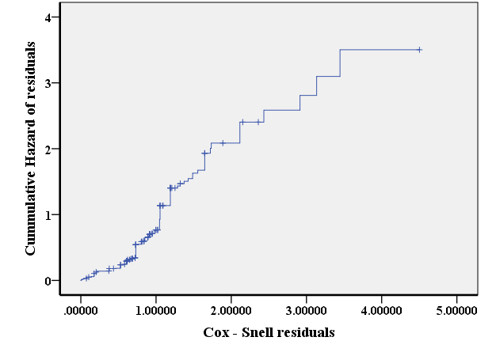
4 Result and Discussion
Survival data of 270 individuals and data on their sex, marital status, age, and occupation were used in the study. Summary of the case processing data is displayed in Table 2.

Table 2: Case Processing Summary of Survival Data
 |  | N | Percent
Cases available in analysis | Event | 189 | 70.0%
Cases available in analysis | Censored | 81 | 30.0%
Total |  | 270 | 100.0%
a. Dependent Variable: Time
In Table 2, out of the 270 individuals on the study 189 representing 70% were found to have defaulted repayment of loans they acquired at the end of the study period. A total of 81 individuals representing 39% of the data were right-censored, meaning they were lost to follow-up or repayment was ongoing but their schedule had not expired by the end of the study period. The categorical coding for explanatory variables age, occupation, marital status, and sex, used in the study are displayed in Table 3.
Table 3: Categorical Variable Coding^{a,b,c,d} of the Explanatory Variables
 |  | Frequency | (1) | (2)
Ageª | 1.00=<40 | 134 | 1 | 0
Ageª | 2.00=40-59 | 123 | 0 | 1
Ageª | 3.00=>59 | 13 | 0 | 0
Occupation^{b} | 1.00=F1, F2, F3, F4, F5, F6, F7, F8, F9, F10 | 52 | 1 | 0
Occupation^{b} | 2.00=INFT1, INFT2, INFT3, INFT4, INFT5, INFT6, INFT7, INFT8, INFT9 | 22 | 0 | 1
Occupation^{b} | 3.00=INFC1, INFC2, INFC3, INFC4, INFC5, INFC6/7, INFC7, INFFP1/2, INFFP3, INFFP4, INFFP5 | 196 | 0 | 0
Martal status^{c} | 1.00=Single | 45 | 1
Martal status^{c} | 2.00=Married | 225 | 0
Sex^{d} | 1.00=Male | 163 | 1
Sex^{d} | 2.00=Female | 107 | 0
Category variable: a) age b) occupation c) marital status d) sex
In Table 3, individuals aged less than 40 years (level one) were 134, those aged from 40 to 59 years (level two) were 123 and those aged 60 years and above (level three) were 13. Level three of the factor age with all zeros coding was defined as the baseline hazard for the variable. Similarly the all zero coding at level three of the factor occupation, with 196 individuals engaged in informal-commerce and foods was defined as the baseline hazard for the variable. There were 22 and 52 individuals engaged in informal-trades and formal occupations respectively. Married individuals at level one of the factor marital status defined as the baseline hazard comprise 225 whilst single individuals at level two were 45. Level two of the factor sex comprising 107 females was defined as the baseline hazard whilst level one was made up of 163 males.
The model in Equation (18) was fitted to the survival data by computing the Kaplan-Meier estimates for the $β$-coefficients of the explanatory variables. Table 4 displays the $β$-coefficients together with their exponents, standard errors at 95% confidence intervals, p-values and the Wald test values for each category of the explanatory variables in the model.
Table 4: Kaplan-Meier estimates for categories of explanatory variables
 | $$β$$ | SE | Wald | df | Sig. | Exp($β$) | 95.0% CI for Exp($β$)
 |  |  |  |  |  |  | Lower | Upper
Age |  |  | 0.979 | 2 | 0.613
Age(1) | -0.250 | 0.354 | 0.497 | 1 | 0.481 | 0.779 | 0.389 | 1.559
Age(2) | -0.026 | 0.350 | 0.006 | 1 | 0.940 | 0.974 | 0.491 | 1.933
Occupation |  |  | 13.130 | 2 | 0.001
Occupation(1) | -0.659 | 0.212 | 9.675 | 1 | 0.002 | 0.518 | 0.342 | 0.784
Occupation(2) | 0.366 | 0.256 | 2.043 | 1 | 0.153 | 1.442 | 0.873 | 2.384
Marital Status | 0.137 | 0.194 | 0.497 | 1 | 0.481 | 1.147 | 0.784 | 1.678
Sex | 0.549 | 0.254 | 4.676 | 1 | 0.031 | 1.731 | 1.053 | 2.845
$β$-coefficients of variables in the model with their Wald test values and p-values
In Table 4, the Wald test value of approximately 13.13 for $β$-coefficients of occupation, with p-value = 0.001, was the highest compared to approximately 4.68 for sex with p-value = 0.031, followed by approximately 0.98 for age with p-value = 0.613 and then approximately 0.50 for marital status with p-value = 0.481. This indicates that occupation relatively has the highest statistical significant impact on the model, followed by sex, age, and then marital status. In terms of the p-values, one would infer that only occupation (p-value = 0.001) and sex (p-value = 0.031) had statistically significant impact on the model.
Furthermore, the hazards ratio exp($β$) of approximately 0.5 computed for individuals into formal occupation (level one) indicates that the risk of loan default by individuals into formal occupation is relatively half of that of individuals into informal-commerce and foods (base level three). Similarly, the hazards ratio of approximately 1.4 for the $β$-coefficient of individuals into informal-trades occupation (level two), indicates that the risk of loan default by individuals into informal-trades is relatively 1.4 times that of individuals into informal-commerce and foods (base level three). By similar argument, individuals aged < 49 (level one) and those aged 40 – 59 (level two) relatively risk defaulting loans by approximately 0.8, and 1.0 times, respectively, of that for individuals aged > 59 (base level three). For marital status, single individuals (level one), have risk of loan default approximately 1.1 times compared with married individuals (level two), and for levels of sex, males (level one), have a relative risk of loan default of approximately 1.7 times compared with that of females.
Using the Log Rank (Mantel-Cox), Tarone-Ware, and Breslow tests, the relationship among the levels of each explanatory variable were examined. Table 5 displays the comparison test results for levels of Occupation.
Table 5: Overall Comparisons for levels of Occupation
 | Chi-Square | df | Sig.
Log Rank (Mantel-Cox) | 20.516 | 2 | 0.000
Breslow (Generalized Wilcoxon) | 20.217 | 2 | 0.000
Tarone-Ware | 22.096 | 2 | 0.000
Test of equality of survival distributions for the different levels of Occupation.
In Table 5, all the three tests show p-values (0.000) less than 5% significant level, which indicate that there are significant differences among the three levels of Occupation. This is interpreted to mean each of the levels of occupation has a different likelihood of survival and hence a different likelihood of loan default.
Table 6: Overall Comparisons for levels of Sex
 | Chi-Square | df | Sig.
Log Rank (Mantel-Cox) | 10.730 | 1 | 0.001
Breslow (Generalized Wilcoxon) | 12.122 | 1 | 0.000
Tarone-Ware | 12.575 | 1 | 0.000
Test of equality of survival distributions for the different levels of Sex.
Table 6 displays the overall comparison test results for levels of Sex. In Table 6, all the three tests show p-values (0.000 minimum) less than 5% significant level which indicate that there is statistically significant difference between the two levels of sex. This is interpreted to mean males and females have different likelihoods of survival and of loan default.
Table 7: Overall Comparisons for levels of Age.
 | Chi-Square | df | Sig.
Log Rank (Mantel-Cox) | 3.860 | 2 | 0.145
Breslow (Generalized Wilcoxon) | 2.624 | 2 | 0.269
Tarone-Ware | 3.392 | 2 | 0.183
Test of equality of survival distributions for the different levels of Age.
Table 7 displays the overall tests statistics for comparison of levels of age. In Table 7, all the three p-values (minimum 0.145) are greater than 5% significant level, which indicate that there are no statistically significant differences among the levels of age. This is interpreted to mean age <40, age 40 – 59, and age >59 have similar likelihoods to survival and loan default.
Table 8: Overall Comparisons for levels of marital status
 | Chi-Square | df | Sig.
Log Rank (Mantel-Cox) | 2.188 | 1 | 0.139
Breslow (Generalized Wilcoxon) | 2.989 | 1 | 0.084
Tarone-Ware | 2.644 | 1 | 0.104
Test of equality of survival distributions for the different levels of Age.

Table 8 displays the overall tests statistics for comparison of levels of marital status. In Table 8, the three tests values exceed 5% significant level which indicate that there is no statistically significant difference between the levels of marital status. It means married and single categories of marital status have similar likelihood of survival and loan default
Figures 2: Survival function plot for levels of occupation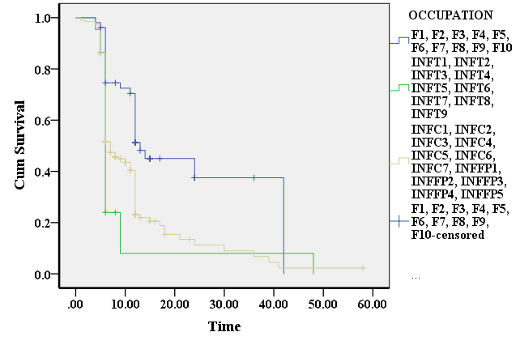
Figure 3: Hazard function plot for levels of Occupation 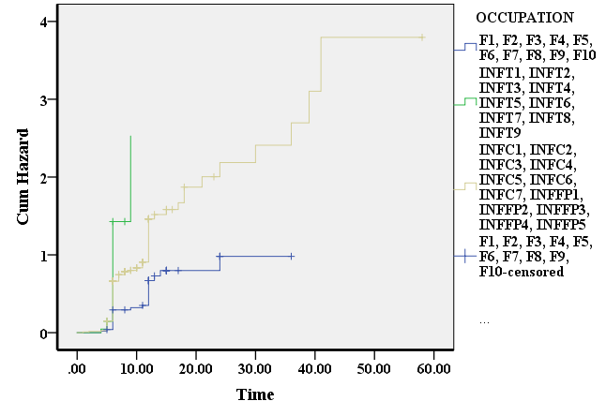
Figures 2 and 3 display the plots of Kaplan-Meier estimates of the survival and hazard functions, respectively, for the levels of occupation. In Figure 2 the graph of formal occupation (level one – blue) is on top of the graphs of informal-trades (level two – green) and informal-commerce and foods (level three – Brown). The graph indicates that formal occupation (level one) has the highest likelihood of surviving loan repayment, followed by informal-commerce and foods (level three), and then informal-trades (level two). The plot of the hazard function in Figure 3 shows the opposite. In Figure 3, the graph of formal occupation (level one) is below informal-commerce and foods (level three) and that of informal-trades (level two) is on top. This indicates that formal occupation has the least risk of loan default, followed by informal-commerce and foods and then informal-trades. The two plots are interpreted to mean that individuals into formal occupation have the highest likelihood to survive loan repayment and the least likelihood to risk loan default, followed by individuals into informal-commerce and foods and then those into informal-trades.
Figures 4a: Survival function plot for levels of Sex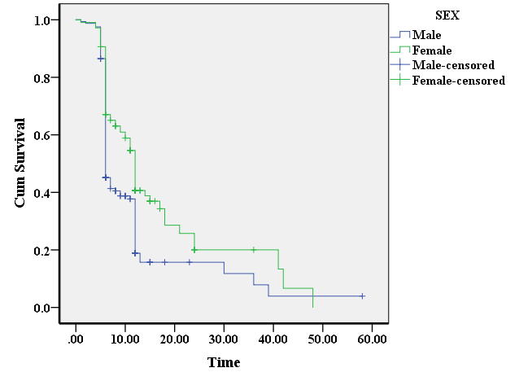
Figures 4b: Hazard function plot for levels of Sex
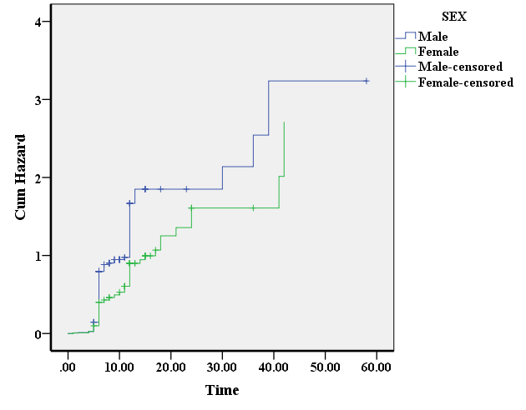
Figures 4a and 4b display the plots of Kaplan-Meier estimates of the survival and hazard functions respectively for the levels of sex. In Figure 4a, the graph of female category (level two – green) is on top of that of the male category (level one - blue). This indicates that females have a higher likelihood of surviving loan repayment compared with males. In Figure 4b the hazard function plot of the female category is below that of the male category indicating that females are less likely to default loan repayment compared with Males.
Figure 5a displays the survival function plot for the levels of age. In Figure 5a the graph of age 40 – 59 (level two - green) appears to be on top compared with that of age < 40 (level one – blue), and age > 59 (level three – brown). However the many overlaps in the graphs over the time frame indicate that there is no clear significant difference among the levels. The hazard plots in Figure 5b also show similar overlaps of the graphs. The two plots thus indicate that the three levels of age have similar likelihood of surviving loan repayment and loan default as confirmed by the comparison tests.
Figures 5a: Survival function plot for levels of Age
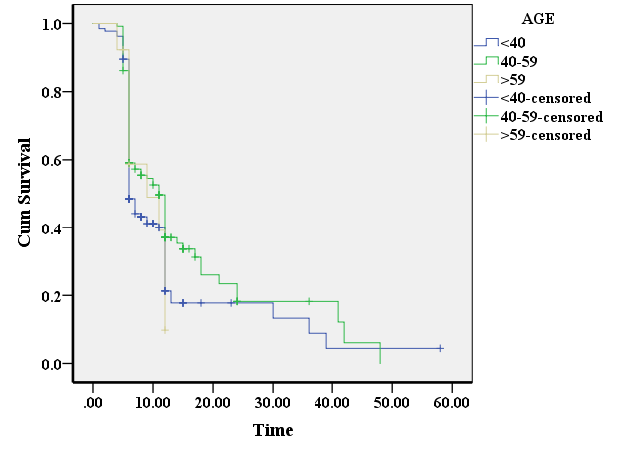
Figure 5b: Hazard function plot for levels of Age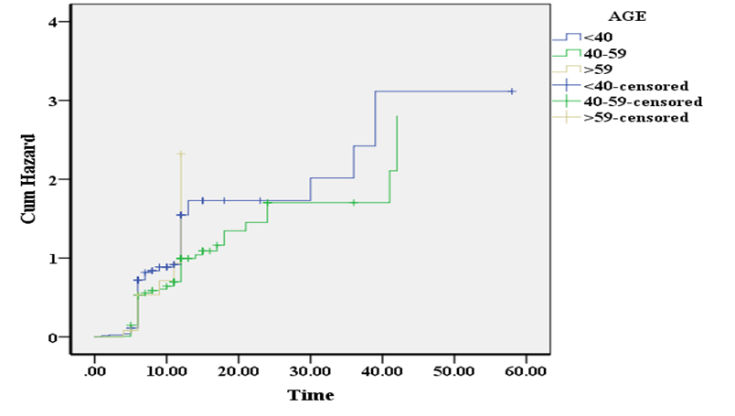
Figures 6a and 6b display the survival and hazard function plots respectively for the levels of marital status. The graphs of single (level one – blue) and married (level two - green) categories in both plots show many overlaps which indicate no clear significant difference between them. This means that the likelihood of surviving repayment or risking loan default between single and married categories is similar as confirmed by the comparison tests.
Figures 6a: Survival function plot for levels of Marital Status
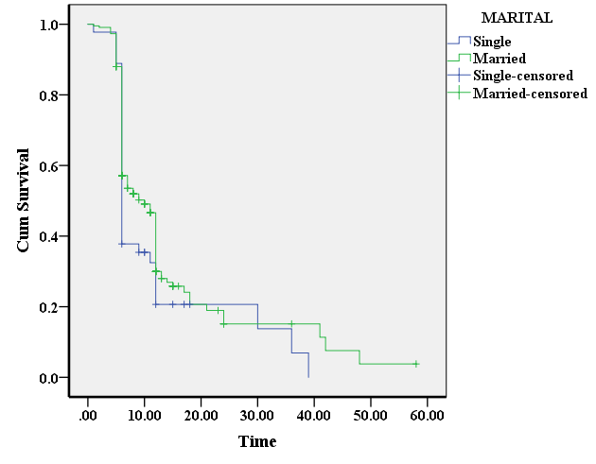
Figures 6b: Hazard function plot for levels of Marital Status
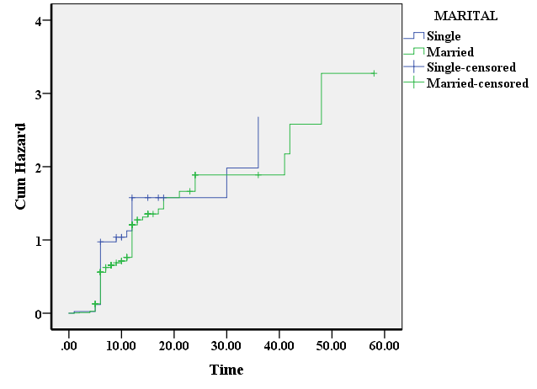
The omnibus test was used to compare alternative models in order to determine the most appropriate one. The process began with fitting the null model and recording the value 1881.005 of $-2\log{\hat{L}}$. This was followed by models containing individual explanatory variables on their own, and then models containing combinations of the explanatory variables excluding interactions. The results were compared using the statistic$-2\log{\hat{L}}$. Table 9 displays the values of $-2\log{\hat{L}}$, chi-square ($χ^{2}$), and changes in $-2\log{\hat{L}}$ relative to the omnibus test value of the null model, and the corresponding p-values.
Table 9: Omnibus Test results for Model coefficients
Variables | $-2\log{\hat{L}}$ | $$χ^{2}$$ | df | p-values | Change in $χ^{2}$ from previous step/block
None | 1881.005
Sex | 1872.936 | 7.947 | 1 | 0.005 | 8.069
Marital | 1879.469 | 1.617 | 1 | 0.204 | 1.536
Age | 1878.153 | 2.853 | 2 | 0.240 | 2.852
Occupation | 1864.428 | 15.343 | 2 | 0.000 | 16.577
Occupation + Age | 1862.016 | 17.762 | 4 | 0.001 | 18.989
Occupation + Marital | 1862.733 | 17.059 | 3 | 0.001 | 18.272
Occupation + Sex | 1857.970 | 21.613 | 3 | 0.000 | 23.035
Age + Marital | 1877.099 | 3.989 | 3 | 0.263 | 3.905
Age + Sex | 1870.990 | 10.203 | 3 | 0.017 | 10.015
Marital + Sex | 1872.347 | 8.622 | 2 | 0.013 | 8.658
Occupation + Age + Marital | 1860.754 | 19.012 | 5 | 0.002 | 20.251
Occupation + Age + Sex | 1856.720 | 23.015 | 5 | 0.000 | 24.285
Occupation + Marital + Sex | 1857.180 | 22.410 | 4 | 0.000 | 23.825
Marital + Age + Sex | 1870.719 | 10.515 | 4 | 0.033 | 10.286
Occupation + Marital + Age + Sex | 1856.233 | 23.519 | 6 | 0.001 | 24.772

In Table 9, occupation recorded the largest reduction of 16.577 ($χ^{2}$ = 15.343; p-value < 1%) in the value of $-2\log{\hat{L}}$ from 1881.005 to 1864.428. Next to occupation is sex recording a reduction of 8.069 ($χ^{2}$ = 7.947; p-value < 1%) in $-2\log{\hat{L}}$ from 1881.005 to 1872.936, followed by age with a reduction of 2.852 ($χ^{2}$ = 2.853; p-value = 24%) in $-2\log{\hat{L}}$ from1881.005 to 1878.153, and then marital Status which recorded the least reduction of 1.536 ($χ^{2}$ = 1.617; p-value = 20%) in $-2\log{\hat{L}}$ from 1881.005 to 1879.469. These results indicate that occupation has the greatest impact, followed by sex, age and marital status in that order.
Occupation and Sex combined recorded the highest reduction of 23.035 ($χ^{2}$ = 21.613; p-value < 1%) in the value $-2\log{\hat{L}}$ among the paired combinations. Occupation and age combined recorded the second highest reduction of 18.989 ($χ^{2}$ = 17.762; p-value < 1%) in the value of $-2\log{\hat{L}}$, followed by occupation and marital status combined with a reduction of 18.272 ($χ^{2}$ = 17.059; p-value < 1%), age and sex combined with a reduction of 10.015 ($χ^{2}$ = 10.203; p-value < 2%), and age and marital status combined with a reduction of 3.905 ($χ^{2}$ = 3.989; p-value = 26%) in that order. Per the results in Table 9, it is worth noting that occupation and sex combined recorded the highest reduction in the value of $-2\log{\hat{L}}$ having emerged first and second highest variables with significant impact on the model individually on their own.
Occupation, age, and sex combined recorded the highest reduction of 24.285 ($χ^{2}$ = 23.015; p-value < 1%) in the value $-2\log{\hat{L}}.$ Occupation, marital status, and sex combined recorded the second highest reduction of 23.825 ($χ^{2}$ = 22.410; p-value < 1%) in the value $-2\log{\hat{L}}$, followed by occupation, age, and marital status combined with a reduction of 20.251 ($χ^{2}$ = 19.012; p-value < 1%), and age, marital status, and sex combined with a reduction of 10.286 ($χ^{2}$ = 10.515; p-value < 4%) in that order. These results indicate that occupation, age, and sex combined has the highest impact on the model, followed by occupation, marital status, and sex combined. It is worth noting that the presence of occupation and sex in any combination makes a significant reduction in the value of $-2\log{\hat{L}}$ due to their individual impact as stand-alone variables in the model.
Finally, Table 9 recorded a reduction of 24.772 ($χ^{2}$ = 23.519; p-value < 1%) in the value of $-2\log{\hat{L}}$ from 1881.005 to 1856.233 for the model containing all the four explanatory variables, namely occupation, sex, marital status, and age. This result recorded the overall highest reduction in the value of $-2\log{\hat{L}}$ compared to the reductions produced by all other combinations of the explanatory variables in the model. Although age and marital status individually, on their own, appear not to have significant changes in the value of $-2\log{\hat{L}}$, one would agree that their contribution to the quantum of reduction in the presence of the other variables cannot be insignificant. Thus the most appropriate model is the alternative that incorporates all the four explanatory variables, namely, occupation, sex, marital status, and age. However, it suffices to conclude that occupation has the highest impact on the model, followed by sex, marital status, and age in that order.
4.1 Summary
The most appropriate model formulated for this study is given by
$h_{i}\left(t\right)=h_{0}\left(t\right)\exp\left(β_{1}{age}_{ij}+β_{2}{sex}_{ij}+β_{3}{marital}_{ij}+β_{4}{occupation}_{ij}\right)$
where$i=1, 2, …, n$ and j$=1, 2, …, n$ describe the $i^{th}$ level and the $j^{th}$ individual at that level of each explanatory variable. This was obtained following comparison among explanatory variables occupation, age, sex, and marital status, to assess their impact on the model using the values of $-2\log{\hat{L}}$ in the omnibus test. The comparison test results summarised in Table 9 indicate that the alternative model that incorporates all the four explanatory variables produced the highest reduction of 24.772 in $-2\log{\hat{L}}$ from 1881.005 to 1856.233 with chi-squared value of $χ^{2}=$ 23.519 and p-value = 0.001, less than 10% significant level. This means that the collective impact of all the four explanatory variables on the model is statistically most significant compared to the impact due to the other combinations of the explanatory variables.
The test results also show that occupation on its own has the highest reduction of 16.577 in $-2\log{\hat{L}}$ from 1881.005 to 1864.428 with $χ^{2}=$15.343 and p-value = 0.001, less than 10% significant level, compared to that of each of the other individual explanatory variables in the model. This indicates that occupation has the greatest impact on the model and that reflects in the quantum of reduction in the value of $-2\log{\hat{L}}$ whenever it is included in other alternative model combinations. For example in Table 9, occupation paired with sex, age, and marital status recorded reductions of 23.035, 18.989, and 18.272, respectively, compared to reductions of 10.015, 8.658 and 3.905 for pairing age and sex, sex and marital status, and age and marital status respectively, in the value of $-2\log{\hat{L}}$.
In Table 9, sex on its own recorded the second highest reduction of 8.069 in the value of $-2\log{\hat{L}}$ from 1881.005 to 1872.936 with $χ^{2}=$7.947 and p-value = 0.005, less than 10% significant level. This indicates that sex has the second highest impact on the model compared to age and marital status combined which recorded a total reduction of 3.905 in $-2\log{\hat{L}}$ from 1881.005 to 1877.099 with $χ^{2}=$3.989 and p-value = 0.263 (approximately 26%) greater than 10% significant level. The impact of sex is also reflected in the changes in $-2\log{\hat{L}}$ recorded for its inclusion in the other alternative model combinations. Sex recorded reductions of 24.285, 23.825 in $-2\log{\hat{L}}$ when combined with occupation and age, and occupation and marital status, respectively. Sex recorded the least reduction of 10.286 in $-2\log{\hat{L}}$ even in combination with marital status and age.
The test results further show that the impact of marital status and age on the model, individually on their own, is not statistically significant. In Table 9, age and marital status on their own recording reductions in $-2\log{\hat{L}}$ of 2.862 ($χ^{2}=$2.853, p-value = 0.240; approximately 24%) and 1.536 ($χ^{2}=$1.617, p – value = 0.204; approximately 20%) respectively. Although the individual impact of age and marital status on the model is statistically not significant, their inclusion and contribution in the presence of occupation and sex make some remarkable differences.
The Tarone-Ware, Breslow (Generalised Wilcoxons), and Mantel-Cox tests results in Tables 5, 6, 7, and 8 show that there are statistically significant differences among levels of occupation and Sex at less than 10% significant level. Apart from Breslow’s test that showed some statistically significant difference between the levels of marital status at less than 10% significant level, the two other comparison tests showed no statistically significant differences among levels of age and marital status at more than 10% significant level.
In Figure 2, formal occupation (level one) presented the highest likelihood of survival, followed by informal-commerce and foods (level three), and then informal-trades (level two) which presented the least likelihood of survival to loan default. In Figure 3, formal occupation presented the least likelihood of hazard, followed by informal-commerce and foods, and then informal-trades presented the highest likelihood of hazard to loan default. The results indicate that individuals into informal-trades (level two) are most likely to risk default of loan repayment, followed by individuals into informal-commerce (level three), and individuals into formal occupation (level one) are least likely to risk loan default. In Figure 4a, females (level two) presented a higher likelihood of survival compared to males (level one) and so females apparently presented a lower likelihood to risk loan default compared with males (see Figure 4b). Although there might be some differences in the likelihood of risk, or otherwise, to loan default, this study showed evidence of no statistical significant difference between the levels of age and marital status. However the overall impact of the levels of age and marital status on the model is not negligible.

Conclusion
In conclusion, the results of the study indicate that:
- Occupation has the highest impact on the formulated model and individuals undertaking informal-trades occupation have the highest likelihood of risk to default loan repayment, whilst individuals into formal occupation pose the least likelihood of risk to loan default. Furthermore, individuals undertaking jobs in informal-commerce and foods have the second highest likelihood of risk to loan default.
- Sex has the second highest impact on the formulated model and that males are more likely to risk of loan default compared with females.
- Age and marital status in the presence of occupation and sex show some impact, although on their own they show no statistically significant impact on the model. Among the levels of age and marital status, there are no statistically significant differences. This indicates that categories of age and marital Status pose similar risk to loan default or survival.
- From the results, banks, policy makers or risk managers may have the highest likelihood of loan recovery when they consider giving loans to individuals based on occupation rather than sex, marital status and age. The results further show that individuals into formal occupation should be prioritised compared to those into informal occupation.

Disclaimer (Artificial intelligence)

Author(s) hereby declare that NO generative AI technologies such as Large Language Models (ChatGPT, COPILOT, etc.) and text-to-image generators have been used during the writing or editing of this manuscript.

References
- Abusharbeh, M. (2023). Modeling the factors of portfolio at risk for microfinance institutions in Palestine. Cogent Economics & Finance, 11(1), 2186042.
- AFDB. (2025). Ghana-Rural Financial Services Project. Accra: Website. Retrieved fromwww.afdb.org
- Allison, P. D. (2010). Survival Analysis. The reviewer's guide to quantitative methods in the social sciences, pp. 413-425.
- Altman, D. G. (1991). Statistics in medical journals: developments in the 1980s. Statistics in medicine, 10(12), 197-1913.
- Armitage, C. J., & Conner, M. (2001). Efficacy of the theory of planned behaviour: Ameta-anlytic review. British Journal of social psychology, 40(4), 471-499.
- Bank of Ghana. (2022). Mobile Money Loan Defaulters. Accra: Bank of Ghana. Retrieved 9 30, 2025, from https://www..bog.gov.gh
- Bennett, R. (2023). Most Americans are significantly stressed about money - here is how it varies bdemographics. Bankrate.
- Breslow, N. (1974). Covariance analysis of censored survival data. Biometrics, 89-99.
- Clark, T. G., Bradburn, M. J. , Love, S. B. , & Altman, D. G. (2003). Survival analysis part I: basic concepts and first analyses. British Journal of cancer, 89(2), 232-238.
- Collett, D. (1952). Modelling Suurvival Data in Medical Researchh. Chapman & Hall/CRC.
- Collett, D. (2023). Modelling survivaal data in medical research. Chapman and Hall/CRC.
- Cox, D. R. (2018). Analysis of survival data. Chapman and Hall/CRC.
- Crowley, J., & Hu, M. (1977). Covariance analysis of heart transplant survival data. Journal of the American, 72(357), 27-36.
- Dang, T. T., Ho, T. N., & Nguyen, D. N. (2023). Board gender diversity and financial stability: Evidence from microfinace institution. Cogent Economics & Finance, 11(2), 2244860.
- D'Arrigo, G., Leonardis, D., AbdElHafeez, S., Fusaro, M., Tipepi, G., & Roumeliotis, S. (2021). Methods to Analyse Time-to-Event Data: The Kaplan-Meier Survival Curve. Oxidative medicine and cellular longevity, 2021(1).
- Dellana, S., & West, D. (2016). Survival analysis of supply chain financial risk. The Journal of Risk Finance, 17(2), 130-151.
- Demyanov, G. S., Knyazev, D. V., & Levashov, P. R. (2022). Continuous Kubo-Greenwood formula: Theory and numerical implementation. Physical Review E, 105(3).
- Everitt, B. S. (2021). Medical statistics from A to Z: a guide for clinicians and medical students. Cambridge University Press.
- Greenwood, M. (1926). The errors of sampling of the survivorship tables. London: HMSO.
- Haddadha, H. K., Alipour, H., & Kheradyer, S. (2024). Analysis of Challenges and Strategies to Develop More Effective Early Warning System of Bank Bankruptcy. Environmental Energy & Economic Research, 8(1).
- Harrell, J. F., & Harrell, F. E. (2015). "Cox proportional hazards regression model". Regression modeling strategies: With application to linear models, logistic and ordinal reggression, and survival analysis. 475-519.
- Hess, K. R., & Levin, V. A. (2014). Getting more out of survival data by using the hazard function. Clinical Cancer Research, 20(6), 1404-1409.
- Holmes, P., Hunt, A., & Stone, I. (2010). An analysisof new firm survival using a hazard function. Applied Economics, 42(2), 15-195.
- Hougaard, P. (2000). Analysis of multivariate survival data. New York, 564.
- IFAD. (2025). Investing in rural people. Rome: Website. Retrieved from www.ifad.org
- Jiang, F., & Guterman, E. (2024). Survival analysis. Statistical Methods in Epilepsy, 124-142.
- Kalbfleisch, J. D., & Prentice, R. L. (2002). The statistical analysis of failure time data. John Wiley and Sons.
- Kaplan, E. L., & Meier, P. (1958). Nonparametric estimation from incomplete observations. Journal of the American Statistical Association, 53(282), 457-481.
- Kausar, T., Akbar, A., & Qasim, M. (2023). Influence diagnostics for the Cox proportional hazards regression model: method, simulation and applications. Journal of Statistical Computation and Simulations, 93(10), 1580-1600.
- Kay, R. (1982). The analysis of transition times in multistate stochastic processes using proportional hazard regression models. Communications in Statistics-Theory and Methods, 15(11), 1743-1756.
- Mantey, G. K., Dadzie, S. E., Gyasi, I., & Oduro, F. T. (2021). Application of survival model to analyse default rates of personal bank loans: The case of a bank in Ghana. African Journal of Management Research, 28(2), 50-69.
- Nagy, A., Munkacsy, G., & Gyorffy, B. (2021). Pancancer survival analysis of cancer hallmark genes. Scientific reports, 11(1), 6047.
- New York Times. (2021). Banks Are Bingeing on Bonds but not because they want to. New York: New York Times. Retrieved 9 30, 2025, from https://www.nytimes.com
- Peto, R., Pike, M. C., Armitage, P., Breslow, N. E., Cox, D. R., Howaard, S. V., . . . Smith, P. G. (1977). Design and Analysis of Randomised Clinical Trials requiring Prolonged Observation of each Patient (II). Analysis and examples . British Journal of Cancer, 34, 1-30.
- Ramachandran, K. M., & Tsoko, C. P. (2020). Mathematical statistics with applications in R. Academic Press.
- Ranganath, R., Perotte, A., Elhadad, N., & Blei, D. (2016). Deep survival analysis. In Machine Learning for Healthcare Conference (pp. 101-114). PMLR.
- Read, L. K., & Vogel, R. M. (2016). Hazard function theory for nonstationary natural hazards. Natural Hazards and Earth System Sciences, 16(4), 915-925.
- Su, P. F., Lin, C. C., Hung, J. Y., & Lee, J. S. (2022). The proper use and reporting of survival analysis and Cox regression. Worl Neurosurgery, 161, 303-309.
- Therneau, T. M., Grambsch, P. M., & Fleming, T. R. (1990). Martingale-based residuals for survival models. Biometrika, 77(1), 147-160.
- Turkson, A. J., Ayiah-Mensah, F., & Nimoh, V. (2021). Handling censoring and censored data in survival analysis: a standalone systematic literature review. International journal of mathematics and mathematical sciences, 2021(1), 9307475.
- Van Wijk, R. C., & Somonsson, U. S. (2022). Finding the right hazard function for time-to-event modeling: A tutorial and Shiny application. Pharmacometrics & Systems Pharmacology, 11(8), 991-1001.
- Wang, P., Li, Y., & Reddy, C. K. (2019). Machine learning for survival analysis: A survey. ACM Computing Surveys, 51(6), 1-36.
- Zhang, Z., Reinikainen, J., Adeleke, K. A., Pieterse, M. E., & Groothuis-Oudshoorn, C. G. (2018). Time-varying covariates and coefficients in Cox regression models. Annals of translational medicine, 6(7), 121.

