Attia-1 and Attia-2 New Archimedean Bivariate Copulas Modeling Positive Dependency

Abstract
In this paper, the author introduces new methods to construct Archimedean copulas. The generator of each copula fulfills the sufficient conditions as regards the boundary and being continuous, decreasing, and convex. Each inverse generator also fulfills the necessary conditions as regards the boundary conditions, marginal uniformity, and 2-increasing properties. Although these copulas satisfy these conditions, they have some limitations. They do not cover the entire dependency spectrum, ranging from perfect negative dependency to perfect positive dependency, passing through the state of independence. Both copulas exhibit positive dependency and upper tail dependency, but neither has lower tail dependency. The product copula is present for each of them. For each copula, the author discusses the derivation, the properties, whether it has a singular part or not, the Kendall tau measure for dependency, and the upper and lower tail dependency. The article shows figures for depicting the joint CDF, and joint PDF for each copula. For each copula, inference is supported by real data analysis using the inference function for margins (IFM) for estimation. The new copulas, Attia-1 and Attia-2 inherent both the limitations and the advantages of the classical Archimedean copulas as discussed in the introduction. The two new copulas and the Gumbel copula exhibit similarity for modelling weak positive association and upper tail dependence. However, both new copulas can add new substantial contributions to the field of copula theory. The new copula, Attia-1 has a domain (0,1], while Attia-2 copula has a domain [-1,1]-{0}. The Attia-1 copula allows the dependency parameter exploration near the zero adding finer control of the weak positive association and extreme upper tail co-occurrences. Attia-2 copula allows the dependency parameter exploration near the zero and negative dependency parameter adding finer control over the weak positive association and the extreme upper tail co-occurrence. The Gumbel copula also model the weak positive association and upper tail dependency but has a parameter domain that is bounded below by 1. So the new copulas extend the domain of modelling weak positive association and upper tail dependency that are encountered in many medical and financial datasets where the variables are mostly independent but extreme values can co-occur. This enhances the flexibility of Archimedean copula. The Attia-2 copula can be generalized by replacing the (2) in the exponent by a free parameter to partially decouple the global dependency from the tail dependency. This also adds more flexibility to the Archimedean copula.
Classifications: 62H20
Keywords: Archimedean copula, generator, inverse generator, Kendall tau, MBUR.
1-Introduction
A copula can express the nonlinear dependency between two or more variables, in comparison with correlation which can capture linear dependency between variables. It is a technique used to implement the joint distribution of the multiple variables (two or more). This has many wide applications in modern era of science like hydrology and geophysics (Valle & Kaplan, 2019), (Liu et al., 2018), and (Salvadori et al., 2007), transportation research(Ma et al., 2017) and (Bhat & Eluru, 2009) , medicine (Kuss et al., 2014), (Lapuyade-Lahorgue et al., 2017), and(Gomes et al., 2019), engineering (Kilgore & Thompson, 2011), biology (Konigorski et al., 2014) and (Dokuzoğlu & Purutçuoğlu, 2017), climate research (Schölzel & Friederichs, 2008) and (Oppenheimer et al., 2016), economics (Oh & Patton, 2018), (Kole et al., 2007), and (De Lira Salvatierra & Patton, 2015). The new researchers added substantial impacts to the field of copula. (Aich et al., 2025) discussed two new generators, (Pearse & Bondell, 2025) clarified the power divergence copula, (Chesneau, 2023) explained the bivariate strict Archimedean copula, (Chesneau & Alhadlaq, 2024) expounded the Gumbel-Joe Archimedean copula, (Kelner et al., 2026) discussed the multivariate copula,(Alzaid & Alhadlaq, 2022) demonstrated the truncated Poisson family, (Alzaid & Alhadlaq, 2023) depicted the half logistic family, (Susam, 2020) discussed trigonometric generator,(Han et al., 2020) explained an Archimedean copula for probabilistic unbalanced linguistic term set multivariate family, and (Rodrigues et al., 2023)Rodrigues et al. 2023 used a new bivariate copula family in regression models. (Sklar, 1973) showed that a copula exists for any multivariate distribution, such that the joint distribution equals the copula applied to the marginals.
Definition 1 (Sklar’s theorem 1): For any bivariate distribution function F with marginal $F_{1}$ and $F_{2}$ , there exists a copula such that
$$F\left(x,y\right)=C\left(F_{1}\left(x\right),F_{2}\left(y\right) \right), x,y∈\overline{R}=R∪\left\{-∞,∞\right\}$$
If F is continuous, then the copula C is unique. Otherwise, it is uniquely determined on the $F_{1}\left(\overline{R}\right)×F_{2}\left(\overline{R}\right)$ . The converse is also true, for any copula and univariate distribution functions $F_{1}$ and $F_{2}$ , the function $C\left(F_{1}\left(x\right),F_{2}\left(y\right) \right)$ is a bivariate distribution function with margins $F_{1}$ and $F_{2}$ .
A bivariate distribution function $C( u,v)$ with marginal $u=F_{X}(x)$ and $v=F_{Y}(y)$ is said to be generated by an Archimedean copula, if it can be written in the form of equation (1)
$$C\left(u,v\right)= φ^{-1}\left(φ\left(u\right)+φ\left(v\right)\right) (1)$$
The generator $φ\left(u\right)$ should satisfy the following conditions (sufficient conditions):
- $φ\left(u\right)$ is continuous, strictly decreasing and convex function mapping $[0,1]$ onto $[0,∞)$ , in other words , $φ^{'}\left(u\right)<0$( decreasing) and $φ^{''}\left(u\right)>0$ ( convex)
- $φ\left(0\right)=∞$
- $φ\left(1\right)=0$
Definition 2: a bivariate copula is a non-decreasing and a right-continuous bivariate function mapping
$C:\left[0,1\right]×\left[0,1\right]→\left[0,1\right]$ which satisfies the following conditions
- $C\left(0,v\right)=C\left(u,0\right)=0, ∀\left(u,v\right)∈{\left[0,1\right]}^{2}$ (Grounded)
- $C\left(1,v\right)=v$ and $C\left(u,1\right)=u$ $∀\left(u,v\right)∈{\left[0,1\right]}^{2}$ ( uniform marginal)
- $C\left(u_{1},v_{1}\right)-C\left(u_{1},v_{2}\right)-C\left(u_{2},v_{1}\right)+C\left(u_{2},v_{2}\right)≥0, for u_{1}>u_{2} and v_{1}>v_{2}$
$∀ \left(u_{1},u_{2} , v_{1},v_{2}\right)∈{\left[0,1\right]}^{4}$ (2- increasing) . This last property is equal to $\frac{∂C\left(u,v\right)}{∂u∂v}≥0$
$\frac{∂C\left(u,v\right)}{∂u∂v}=c(u,v)$ is the joint PDF of the copula.
So the copula links the marginal distributions through the dependency parameter.
The singular part of the copula is defined by (Genest & Mackay, 1986) in the following theorem.
Theorem 2: the ratio between the generator and the first derivative of the generator evaluated at zero does not equal zero. The theorem states that the distribution $C(u,v)$ generated by $φ$ has a singular component iff $\frac{φ\left(0\right)}{φ^{'}\left(0\right)}≠0$ in that case, $φ\left(u\right)+φ\left(v\right)=φ\left(0\right)$ with probability = $-\frac{φ\left(0\right)}{φ^{'}\left(0\right)}$
The Archimedean copulas, like the Gumbel copula and others, have some limitations. First, the one parameter limitation cannot separately control the global dependency and upper tail dependency. Second, one sided tail dependency. As most copulas can model either upper or lower tail dependency. Gumbel copula can model the upper tail dependency but cannot model the lower tail dependency. Third, lack of shape flexibility. They cannot adjust for the curvature in the center and the tail simultaneously leading to a good fit in the center but a poor fit in the tail or a good tail fit but a bad center fit. Forth, all Archimedean copulas are exchangeable but real multivariate data often exhibit different dependence strengths across the pairs and directional or hierarchical dependence. The unique advantages for Archimedean copulas are also several. They show a well closed CDF formula, easy simulation, fast estimation, and a clear link with the Kendall’s tau coefficient. All these advantages enhance its strong theoretical tractability and interpretability.
2-New copulas
2.1- First Copula: Attia-1 copula
Let’s say the inverse generator is $Φ^{-1}\left(t\right)=z=exp\left(\frac{{-t}^{α}}{α}\right)=C\left(φ\left(u\right)+φ\left(v\right)\right)$ . The generator is $ln Φ^{-1}\left(t\right){ =}\ln\left\{exp\left(\frac{{-t}^{α}}{α}\right)\right\}=\frac{{-t}^{α}}{α}$ and hence, $- α ln Φ^{-1}\left(t\right) =t^{α}$. The generator ${φ\left(z\right)=\left(- α ln Φ^{-1}\left(t\right)\right)}^{\frac{1}{α}}={\left(- α ln\left(z\right)\right)}^{\frac{1}{α}}= t , z∈\left(0,1\right)$. The generator should fulfill the sufficient conditions: $φ\left(0\right)={\left(-α ln{0}\right)}^{\frac{1}{α}}=∞$ ,$φ\left(1\right)={\left(-α ln{1}\right)}^{\frac{1}{α}}=0$, and $φ^{'}\left(z\right)= \frac{1}{α} {\left(-α\ln{z}\right)}^{\frac{1}{α}-1}\left(\frac{-α}{z}\right)= {\left(-α\ln{z}\right)}^{\frac{1}{α}-1}\left(\frac{-1}{z}\right)<0$ ensures that the generator is a decreasing function. While; $φ^{''}\left(z\right)= \left(\frac{1}{α}-1\right) {\left(-α\ln{z}\right)}^{\frac{1}{α}-2}\left(\frac{-α}{z}\right)\left(\frac{-1}{z}\right)+ {\left(-α\ln{z}\right)}^{\frac{1}{α}-1}\left(\frac{1}{z^{2}}\right)>0$, ensures that the generator is convex for $0<α≤1$ .
for bivariate distribution: ${φ\left(u\right)=\left(-α ln{u}\right)}^{\frac{1}{α}}$ and ${φ\left(v\right)=\left(-α ln{v}\right)}^{\frac{1}{α}}$
$$φ\left(w\right) =φ\left(u\right)+φ\left(v\right)={\left(-α ln{u}\right)}^{\frac{1}{α}}+{\left(-α ln{v}\right)}^{\frac{1}{α}}$$
$C\left(φ\left(u\right)+φ\left(v\right)\right) =exp\left({-\frac{1}{α}\left[{\left(-α ln{u}\right)}^{\frac{1}{α}}+{\left(-α ln{v}\right)}^{\frac{1}{α}}\right]}^{α}\right)$
$$C\left(u,v\right)=C\left(F_{X}\left(x\right),F_{Y}\left(y\right)\right)$$
For a copula to be valid copula it should fulfill the boundary condition, the marginal uniformity and 2- increasing condition. And this is equivalent for the inverse generator the necessary conditions to be fulfilled are the following:
Proposition 1: The boundary conditions are $C\left(0,v\right)=C\left(u,0\right)=0$ and marginal uniformity are $C\left(1,v\right)=v and C\left(u,1\right)=u$
Proof:
$$C\left(1,v\right)=exp\left({-\frac{1}{α}\left[{\left(-α ln\left(1\right)\right)}^{\frac{1}{α}}+{\left(-α ln{v}\right)}^{\frac{1}{α}}\right]}^{α}\right)=exp\left({-\frac{1}{α}\left[0+{\left(-α ln{v}\right)}^{\frac{1}{α}}\right]}^{α}\right)= exp\left({-\frac{1}{α}\left[{\left(-α ln{v}\right)}^{\frac{1}{α}}\right]}^{α}\right)=v$$
$$C\left(u,1\right)=exp\left({-\frac{1}{α}\left[{\left(-α ln{u}\right)}^{\frac{1}{α}}\right]}^{α}\right)=exp\left(\frac{-α ln{u}}{-α}\right)=u$$
Proposition 2: for copula to be valid it should be 2-increasing, in other words, $\frac{∂^{2}C\left(u,v\right)}{∂u∂v}≥0$

Proof:
$$\frac{∂C\left(u,v\right)}{∂u}=exp\left({-\frac{1}{α}\left[{\left(-α ln\left(u\right)\right)}^{\frac{1}{α}}+{\left(-α ln{v}\right)}^{\frac{1}{α}}\right]}^{α}\right)\left(\frac{-1}{α}\right)\left(α\right){\left[{\left(-α ln\left(u\right)\right)}^{\frac{1}{α}}+{\left(-α ln{v}\right)}^{\frac{1}{α}}\right]}^{α-1}\left(\frac{1}{α}{\left(-α ln\left(u\right)\right)}^{\frac{1}{α}-1}\left(\frac{-α}{u}\right)\right)$$
$$\frac{∂C\left(u,v\right)}{∂u}=exp\left({-\frac{1}{α}\left[{\left(-α ln\left(u\right)\right)}^{\frac{1}{α}}+{\left(-α ln{v}\right)}^{\frac{1}{α}}\right]}^{α}\right){\left[{\left(-α ln\left(u\right)\right)}^{\frac{1}{α}}+{\left(-α ln{v}\right)}^{\frac{1}{α}}\right]}^{α-1}\left({\left(-α ln\left(u\right)\right)}^{\frac{1}{α}-1}\left(\frac{1}{u}\right)\right)$$
$$\frac{∂}{∂v}\left(\frac{∂C\left(u,v\right)}{∂u}\right)=exp\left({-\frac{1}{α}\left[{\left(-α ln\left(u\right)\right)}^{\frac{1}{α}}+{\left(-α ln{v}\right)}^{\frac{1}{α}}\right]}^{α}\right) \left(\frac{-1}{α}\right)\left(α\right){\left[{\left(-α ln\left(u\right)\right)}^{\frac{1}{α}}+{\left(-α ln{v}\right)}^{\frac{1}{α}}\right]}^{α-1}$$
$$\left(\frac{1}{α}{\left(-α ln\left(v\right)\right)}^{\frac{1}{α}-1}\left(\frac{-α}{v}\right)\right)×{\left[{\left(-α ln\left(u\right)\right)}^{\frac{1}{α}}+{\left(-α ln{v}\right)}^{\frac{1}{α}}\right]}^{α-1}\left({\left(-α ln\left(u\right)\right)}^{\frac{1}{α}-1}\left(\frac{1}{u}\right)\right)+$$
$$exp\left({-\frac{1}{α}\left[{\left(-α ln\left(u\right)\right)}^{\frac{1}{α}}+{\left(-α ln{v}\right)}^{\frac{1}{α}}\right]}^{α}\right)\left({\left(-α ln\left(u\right)\right)}^{\frac{1}{α}-1}\left(\frac{1}{u}\right)\right){\left(α-1\right)\left[{\left(-α ln\left(u\right)\right)}^{\frac{1}{α}}+{\left(-α ln{v}\right)}^{\frac{1}{α}}\right]}^{α-2}\left(\frac{1}{α}{\left(-α ln\left(v\right)\right)}^{\frac{1}{α}-1}\left(\frac{-α}{v}\right)\right)$$
$$=exp\left({-\frac{1}{α}\left[{\left(-α ln\left(u\right)\right)}^{\frac{1}{α}}+{\left(-α ln{v}\right)}^{\frac{1}{α}}\right]}^{α}\right){\left[{\left(-α ln\left(u\right)\right)}^{\frac{1}{α}}+{\left(-α ln{v}\right)}^{\frac{1}{α}}\right]}^{2α-2}\left({\left(-α ln\left(v\right)\right)}^{\frac{1}{α}-1}\left(\frac{1}{v}\right)\right)×$$
$$\left({\left(-α ln\left(u\right)\right)}^{\frac{1}{α}-1}\left(\frac{1}{u}\right)\right)+exp\left({-\frac{1}{α}\left[{\left(-α ln\left(u\right)\right)}^{\frac{1}{α}}+{\left(-α ln{v}\right)}^{\frac{1}{α}}\right]}^{α}\right)\left({\left(-α ln\left(u\right)\right)}^{\frac{1}{α}-1}\left(\frac{1}{u}\right)\right)×$$
$${\left(α-1\right)\left[{\left(-α ln\left(u\right)\right)}^{\frac{1}{α}}+{\left(-α ln{v}\right)}^{\frac{1}{α}}\right]}^{α-2}\left({\left(-α ln\left(v\right)\right)}^{\frac{1}{α}-1}\left(\frac{-1}{v}\right)\right)$$
$$=exp\left({-\frac{1}{α}\left[{\left(-α ln\left(u\right)\right)}^{\frac{1}{α}}+{\left(-α ln{v}\right)}^{\frac{1}{α}}\right]}^{α}\right){\left[{\left(-α ln\left(u\right)\right)}^{\frac{1}{α}}+{\left(-α ln{v}\right)}^{\frac{1}{α}}\right]}^{α-2}\left[\frac{{\left(α^{2} ln{v\ln{u}}\right)}^{\frac{1}{α}-1}}{vu}\right]\left\{{\left[{\left(-α ln\left(u\right)\right)}^{\frac{1}{α}}+{\left(-α ln{v}\right)}^{\frac{1}{α}}\right]}^{α}-\left(α-1\right)\right\}$$
$$=exp\left({-\frac{1}{α}\left[{\left(-α ln\left(u\right)\right)}^{\frac{1}{α}}+{\left(-α ln{v}\right)}^{\frac{1}{α}}\right]}^{α}\right){\left[{\left(-α ln\left(u\right)\right)}^{\frac{1}{α}}+{\left(-α ln{v}\right)}^{\frac{1}{α}}\right]}^{α-2}\left[\frac{{\left(α^{2} ln{v\ln{u}}\right)}^{\frac{1}{α}-1}}{vu}\right]\left\{{\left[{\left(-α ln\left(u\right)\right)}^{\frac{1}{α}}+{\left(-α ln{v}\right)}^{\frac{1}{α}}\right]}^{α}+1-α\right\}$$
The second derivative is positive at alpha defined on the interval $0<α≤1$ and this copula density integrate to one using MCMC simulation from zero to one, so it is a valid density function. This second derivative is the joint PDF or the copula density function.
Proposition 3: this copula is absolutely continuous copula and it has no singular part.
Proof : to test for singularity: $\frac{φ\left(0\right)}{φ^{'}\left(0\right)}=0$
$$\frac{φ\left(u\right)}{φ^{'}\left(u\right)} = \frac{{\left(-α ln{u}\right)}^{\frac{1}{α}}}{{\frac{1}{α}\left(-α ln{u}\right)}^{\frac{1}{α}-1}\left(\frac{-α}{u}\right)}= \frac{-α ln{u}}{\frac{-1}{u}} and \lim_{u→0}{\frac{φ\left(u\right)}{φ^{'}\left(u\right)}} = \frac{{\left(-α ln{u}\right)}^{\frac{1}{α}}}{{\frac{1}{α}\left(-α ln{u}\right)}^{\frac{1}{α}-1}\left(\frac{-α}{u}\right)}= \frac{-α ln{u}}{\frac{-1}{u}}$$
Using L’Hopital : $\lim_{u→0}{\frac{φ\left(u\right)}{φ^{'}\left(u\right)}} =\lim_{u→0} \frac{{\left(-α ln{u}\right)}^{\frac{1}{α}}}{{\frac{1}{α}\left(-α ln{u}\right)}^{\frac{1}{α}-1}\left(\frac{-α}{u}\right)}= \lim_{u→0} \frac{\frac{α}{u}}{\frac{-1}{u^{2}}} =\lim_{u→0} \left(-αu\right)=-α\left(0\right)=0$
As long as this limit is zero at u=0 so it has no singular part and it is absolutely continuous copula.
Proposition 4: Kendall tau for this copula is $τ=1-α$ and $0<α≤1$
Proof:
$$τ=4 \int_{0}^{1}{\frac{φ\left(u\right)}{φ^{'}\left(u\right)}}du +1 and \int_{0}^{1}{\frac{φ\left(u\right)}{φ^{'}\left(u\right)}} du= \int_{0}^{1}{α u\ln\left(u\right) du=}\frac{-α}{4} , integration by parts$$
$$τ=4 \int_{0}^{1}{\frac{φ\left(u\right)}{φ^{'}\left(u\right)}}du +1= 4 \left(\frac{-α}{4}\right) +1=1-α$$
If $α=1 , then τ=0$indicating independence.
Proposition 5: This copula is product copula at alpha =1, in other word, if alpha=1, $C\left(u,v\right) =uv$
Proof:
$$C\left(u,v\right)=exp\left({-\frac{1}{α}\left[{\left(-α ln{u}\right)}^{\frac{1}{α}}+{\left(-α ln{v}\right)}^{\frac{1}{α}}\right]}^{α}\right)=exp\left(-\left[- ln{u}- ln{v}\right]\right)= exp\left(\left[\ln{u}+ ln{v}\right]\right)=exp\left(\left[\ln{u}v\right]\right)=uv$$
Figures (1-3) illustrate the contour plot and the surface of the copula density and distribution with different values of the dependency parameter. See the appendix for more figures.
The limitation for this copula is that it does not cover the negative dependency between variables. This copula models only positive dependency.
Proposition 6: This copula has no Lower tail dependency and the maximum upper tail dependency coefficient is one.
Proof:
$$λ_{U}=\lim_{u→1}{\frac{1-2u+C\left(u,u\right)}{1-u} }=\frac{1-2u+exp\left({-\frac{1}{α}\left[2{\left(-α ln{u}\right)}^{\frac{1}{α}}\right]}^{α}\right)}{1-u}=\frac{1-2u+exp\left(-\frac{1}{α} 2^{α}\left(-α ln{u}\right)\right)}{1-u}= \frac{1-2u+u^{2^{α}}}{1-u}$$
Using L’Hopital rule
$$λ_{U}=\lim_{u→1}{\frac{1-2u+u^{2^{α}}}{1-u} }=\lim_{u→1}{\frac{-2+2^{α}u^{\left(2^{α}-1\right)} }{-1}= } 2-2^{α} ∈\left[0,1\right] for ∀α ∈ \left(0,\right.\left.1\right]$$
$$λ_{L}=\lim_{u→0}{\frac{C\left(u,u\right)}{u}}=\lim_{u→0}{\frac{exp\left(-\frac{1}{α} 2^{α}\left(-α ln{u}\right)\right)}{u}} =\lim_{u→0}{\frac{u^{2^{α}}}{u}}=u^{\left(2^{α}-1\right)}=0 for ∀α ∈\left(0,\right.\left.1\right]$$
So the maximum upper tail dependence coefficient for $∀α ∈ \left(0,\right.\left.1\right]$ of this copula is 1, however the copula has no lower tail dependency as the lower tail dependence coefficient is zero for$∀α ∈\left(0,\right.\left.1\right]$. The $λ_{U}=1$ , when dependency parameter approaches 0. While $λ_{U}=0$ , when this parameter is 1, which is the product copula (state of independence). The $λ_{U}∈\left(0,\right.\left.1\right]$ when the dependency parameter $α ∈\left(0,\right.\left.1\right]$ . The copula has upper tail dependency for all theta less than one, and this dependence increases as theta decreases.
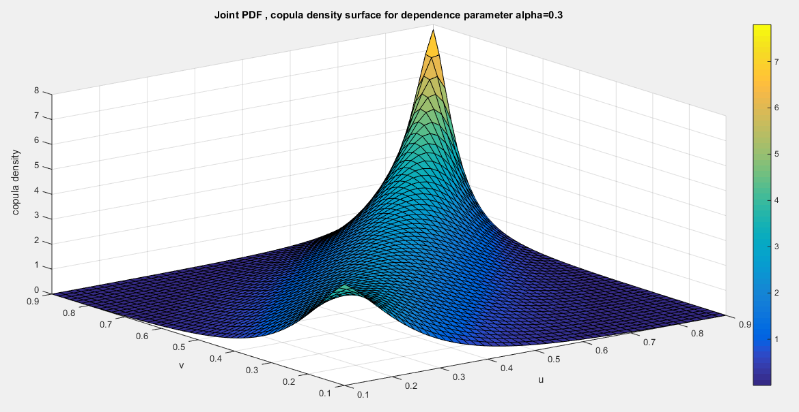
Fig.1 The first copula density surface with dependency parameter 0.3
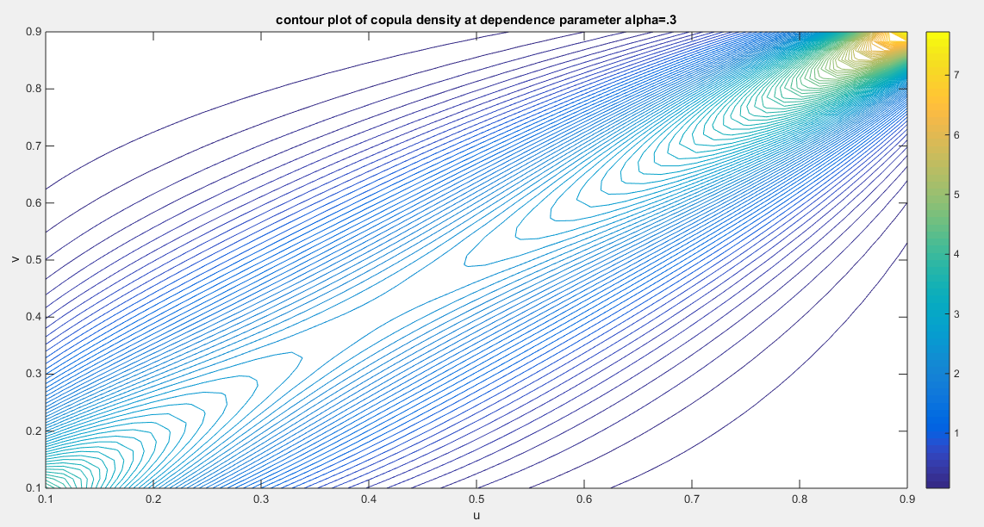
Fig.2 The contour plot of the first copula density with dependency parameter 0.3
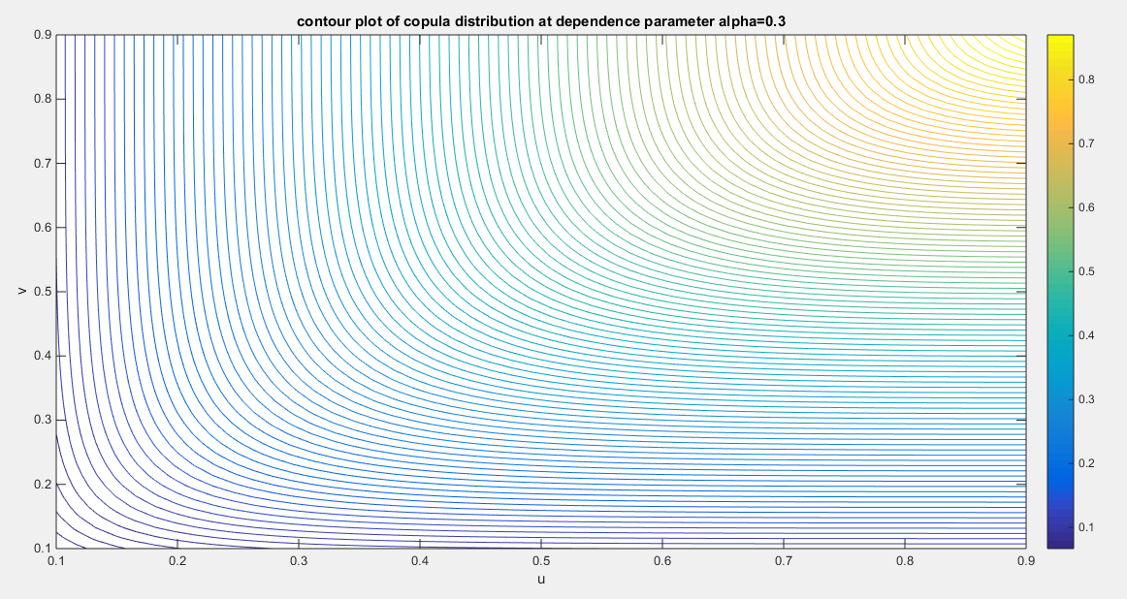
Fig. 3 The contour plot of the first copula distribution with dependency parameter 0.3
2.2- Second Copula: Attia-2 copula
Let’s say the inverse generator is ${C\left(φ\left(u\right)+φ\left(v\right)\right)=Φ}^{-1}\left(t\right)=z=exp\left({-t}^{α^{2}}\right)$ , so the generator is $\ln{z=}\ln\left\{exp\left({-t}^{α^{2}}\right)\right\}={-t}^{α^{2}}$ and hence, the $- ln{z=}t^{α^{2}}$. The generator ${φ\left(z\right)=\left(- ln{z}\right)}^{α^{-2}}=t , z∈\left(0,1\right)$ . And this generator should fulfill the sufficient conditions: $φ\left(0\right)={\left(- ln{0}\right)}^{α^{-2}}=∞$ , $φ\left(1\right)={\left(- ln{1}\right)}^{α^{-2}}=0$ and the first derivative $φ^{'}\left(z\right)= α^{-2} {\left(- ln{z}\right)}^{α^{-2}-1}\left(\frac{-1}{z}\right) <0$ , ensures that the generator is a decreasing function. While the positive second derivative ensures that the generator is a convex function at $-1≤α≤1$ excluding 0 i.e. $α∈[-1,1]-\{0\}$, $φ^{''}\left(z\right)= \frac{1}{α^{2}}\left(\frac{1}{α^{2}}-1\right) {\left(- ln{z}\right)}^{α^{-2}-2}\left(\frac{-1}{z}\right)\left(\frac{-1}{z}\right)+ α^{-2} {\left(- ln{z}\right)}^{α^{-2}-1}\left(\frac{1}{z^{2}}\right)>0$.
For bivariate distribution: ${φ\left(u\right)=\left(- ln{u}\right)}^{\frac{1}{α^{2}}}$ and ${φ\left(v\right)=\left(- ln{v}\right)}^{\frac{1}{α^{2}}}$
$$φ\left(w\right) =φ\left(u\right)+φ\left(v\right)={\left(- ln{u}\right)}^{\frac{1}{α^{2}}}+{\left(- ln{v}\right)}^{\frac{1}{α^{2}}}$$
$C\left(φ\left(u\right)+φ\left(v\right)\right) =exp\left({-\left[{\left(- ln{u}\right)}^{\frac{1}{α^{2}}}+{\left(- ln{v}\right)}^{\frac{1}{α^{2}}}\right]}^{α^{2}}\right)$
$$C\left(u,v\right)=C\left(F_{X}\left(x\right),F_{Y}\left(y\right)\right)$$
For a copula to be a valid copula it should fulfill the boundary condition, the marginal uniformity and 2- increasing condition. And this is equivalent for necessary conditions of the inverse generator to be fulfilled which are the following:
Proposition 7: The boundary conditions are $C\left(0,v\right)=C\left(u,0\right)=0$, and the marginal uniformity conditions are $C\left(1,v\right)=v and C\left(u,1\right)=u$ .

Proof:
$$C\left(1,v\right)=exp\left({-\left[{\left(- ln{1}\right)}^{\frac{1}{α^{2}}}+{\left(- ln{v}\right)}^{\frac{1}{α^{2}}}\right]}^{α^{2}}\right)=exp\left({-\left[0+{\left(- ln{v}\right)}^{\frac{1}{α^{2}}}\right]}^{α^{2}}\right)=exp\left({-\left[{\left(- ln{v}\right)}^{\frac{1}{α^{2}}}\right]}^{α^{2}}\right)=exp\left(-\left[- ln{v}\right]\right)$$
$C\left(1,v\right) =v$ and $C\left(u,1\right)=exp\left({-\left[{\left(- ln{u}\right)}^{\frac{1}{α^{2}}}\right]}^{α^{2}}\right)=exp\left(-\left[- ln{u}\right]\right)=u$
Proposition 8: for copula to be valid it should be 2-increasing, in other words; $\frac{∂^{2}C\left(u,v\right)}{∂u∂v}≥0$
Proof
$$\frac{∂C\left(u,v\right)}{∂u}=exp\left({-\left[{\left(- ln{u}\right)}^{\frac{1}{α^{2}}}+{\left(- ln{v}\right)}^{\frac{1}{α^{2}}}\right]}^{α^{2}}\right)\left(-α^{2}\right){\left[{\left(- ln{u}\right)}^{\frac{1}{α^{2}}}+{\left(- ln{v}\right)}^{\frac{1}{α^{2}}}\right]}^{α^{2}-1}\left(\frac{1}{α^{2}}{\left(- ln\left(u\right)\right)}^{\frac{1}{α^{2}}-1}\left(\frac{-1}{u}\right)\right)$$
$$\frac{∂C\left(u,v\right)}{∂u}={exp\left({-\left[{\left(- ln{u}\right)}^{\frac{1}{α^{2}}}+{\left(- ln{v}\right)}^{\frac{1}{α^{2}}}\right]}^{α^{2}}\right)\left[{\left(- ln{u}\right)}^{\frac{1}{α^{2}}}+{\left(- ln{v}\right)}^{\frac{1}{α^{2}}}\right]}^{α^{2}-1}\left({\left(- ln\left(u\right)\right)}^{\frac{1}{α^{2}}-1}\left(\frac{1}{u}\right)\right)$$
$$\frac{∂}{∂v}\left(\frac{∂C\left(u,v\right)}{∂u}\right)=exp\left({-\left[{\left(- ln{u}\right)}^{\frac{1}{α^{2}}}+{\left(- ln{v}\right)}^{\frac{1}{α^{2}}}\right]}^{α^{2}}\right)× \left(-α^{2}\right){\left[{\left(- ln{u}\right)}^{\frac{1}{α^{2}}}+{\left(- ln{v}\right)}^{\frac{1}{α^{2}}}\right]}^{α^{2}-1}$$
$$\left(\frac{1}{α^{2}}{\left(-ln\left(v\right)\right)}^{\frac{1}{α^{2}}-1}\left(\frac{-1}{v}\right)\right)×{\left[{\left(- ln{u}\right)}^{\frac{1}{α^{2}}}+{\left(- ln{v}\right)}^{\frac{1}{α^{2}}}\right]}^{α^{2}-1}\left({\left(- ln\left(u\right)\right)}^{\frac{1}{α^{2}}-1}\left(\frac{1}{u}\right)\right)+$$
$$exp\left({-\left[{\left(- ln{u}\right)}^{\frac{1}{α^{2}}}+{\left(- ln{v}\right)}^{\frac{1}{α^{2}}}\right]}^{α^{2}}\right)\left({\left(- ln\left(u\right)\right)}^{\frac{1}{α^{2}}-1}\left(\frac{1}{u}\right)\right)×\left(α^{2}-1\right) {\left[{\left(- ln{u}\right)}^{\frac{1}{α^{2}}}+{\left(- ln{v}\right)}^{\frac{1}{α^{2}}}\right]}^{α^{2}-2} \left(\frac{1}{α^{2}}{\left(- ln\left(v\right)\right)}^{\frac{1}{α^{2}}-1}\left(\frac{-1}{v}\right)\right)$$
$$= exp\left({-\left[{\left(- ln{u}\right)}^{\frac{1}{α^{2}}}+{\left(- ln{v}\right)}^{\frac{1}{α^{2}}}\right]}^{α^{2}}\right) {\left[{\left(- ln{u}\right)}^{\frac{1}{α^{2}}}+{\left(- ln{v}\right)}^{\frac{1}{α^{2}}}\right]}^{α^{2}-1}\left({\left(-ln\left(v\right)\right)}^{\frac{1}{α^{2}}-1}\left(\frac{1}{v}\right)\right){\left[{\left(- ln{u}\right)}^{\frac{1}{α^{2}}}+{\left(- ln{v}\right)}^{\frac{1}{α^{2}}}\right]}^{α^{2}-1}$$
$$\left({\left(- ln\left(u\right)\right)}^{\frac{1}{α^{2}}-1}\left(\frac{1}{u}\right)\right)+$$
$$exp\left({-\left[{\left(- ln{u}\right)}^{\frac{1}{α^{2}}}+{\left(- ln{v}\right)}^{\frac{1}{α^{2}}}\right]}^{α^{2}}\right)\left({\left(- ln\left(u\right)\right)}^{\frac{1}{α^{2}}-1}\left(\frac{1}{u}\right)\right)×\left(α^{2}-1\right) {\left[{\left(- ln{u}\right)}^{\frac{1}{α^{2}}}+{\left(- ln{v}\right)}^{\frac{1}{α^{2}}}\right]}^{α^{2}-2} \left(\frac{1}{α^{2}}{\left(- ln\left(v\right)\right)}^{\frac{1}{α^{2}}-1}\left(\frac{-1}{v}\right)\right)$$
$$= exp\left({-\left[{\left(- ln{u}\right)}^{\frac{1}{α^{2}}}+{\left(- ln{v}\right)}^{\frac{1}{α^{2}}}\right]}^{α^{2}}\right) {\left[{\left(- ln{u}\right)}^{\frac{1}{α^{2}}}+{\left(- ln{v}\right)}^{\frac{1}{α^{2}}}\right]}^{2α^{2}-2}\left[\frac{{\left(ln \left(v\right) ln\left(u\right)\right)}^{\frac{1}{α^{2}}-1}}{uv}\right]$$
$$+ \left(α^{2}-1\right)\left(\frac{-1}{α^{2}}\right)\left[\frac{{\left(ln \left(v\right) ln\left(u\right)\right)}^{\frac{1}{α^{2}}-1}}{uv}\right]exp\left({-\left[{\left(- ln{u}\right)}^{\frac{1}{α^{2}}}+{\left(- ln{v}\right)}^{\frac{1}{α^{2}}}\right]}^{α^{2}}\right)×{\left[{\left(- ln{u}\right)}^{\frac{1}{α^{2}}}+{\left(- ln{v}\right)}^{\frac{1}{α^{2}}}\right]}^{α^{2}-2}$$
$$= exp\left({-\left[{\left(- ln{u}\right)}^{\frac{1}{α^{2}}}+{\left(- ln{v}\right)}^{\frac{1}{α^{2}}}\right]}^{α^{2}}\right) {\left[{\left(- ln{u}\right)}^{\frac{1}{α^{2}}}+{\left(- ln{v}\right)}^{\frac{1}{α^{2}}}\right]}^{α^{2}-2}\left[\frac{{\left(ln \left(v\right) ln\left(u\right)\right)}^{\frac{1}{α^{2}}-1}}{uv}\right]\left\{{\left[{\left(- ln{u}\right)}^{\frac{1}{α^{2}}}+{\left(- ln{v}\right)}^{\frac{1}{α^{2}}}\right]}^{α^{2}}- \left(\frac{1}{α^{2}}\right)\left(α^{2}-1\right)\right\}$$
The second derivative is positive at$α∈ \left[-1,1\right]-\left\{0\right\}$ . Integration of this copula density using MCMC simulation from zero to one is one and so it is a valid copula density. Figures (4-6) show the surface and the contour plot of the copula density and distribution at different dependency parameters. This second derivative is the joint PDF or the copula density function.
Proposition 9: this copula is absolutely continuous copula and it has no singular part.
Proof : to test for singularity: $\frac{φ\left(0\right)}{φ^{'}\left(0\right)}=0$
$$\frac{φ\left(u\right)}{φ^{'}\left(u\right)} = \frac{{\left(- ln{u}\right)}^{\frac{1}{α^{2}}}}{{\frac{1}{α^{2}}\left(- ln{u}\right)}^{\frac{1}{α^{2}}-1}\left(\frac{-1}{u}\right)}= \lim_{u→0} \frac{{\left(- ln{u}\right)}^{\frac{1}{α^{2}}}}{{\frac{1}{α^{2}}\left(- ln{u}\right)}^{\frac{1}{α^{2}}-1}\left(\frac{-1}{u}\right)}=\lim_{u→0} \frac{α^{2}(-ln{u) }}{\frac{-1}{u}}=\lim_{u→0} -α^{2}u(-ln{u) }$$
Using L’Hopital rule: $\lim_{u→0}{\frac{φ\left(u\right)}{φ^{'}\left(u\right)}} = \frac{α^{2}\left(\frac{-1}{u}\right)}{\frac{1}{u^{2}}}= -α^{2}u=-α^{2}\left(0\right)=0$
As long as this limit is zero at u=0 so the copula has no singular part and it is absolutely continuous copula.
Proposition 10: Kendall tau for this copula is $τ=1- α^{2}$ and $α∈ \left[-1,1\right]-\left\{0\right\}$
Proof: using integration by parts for the following integrant
$$τ=4 \int_{0}^{1}{\frac{φ\left(u\right)}{φ^{'}\left(u\right)}}du +1= 4 \int_{0}^{1}{\left(-α^{2}u(-ln{u) }\right)}du +1 and \int_{0}^{1}{\frac{φ\left(u\right)}{φ^{'}\left(u\right)}} du= \int_{0}^{1}{-α^{2}u(-ln{u) } du = }\frac{-α^{2}}{4}$$
$$τ=4 \int_{0}^{1}{\frac{φ\left(u\right)}{φ^{'}\left(u\right)}}du +1= 4 \left(\frac{-α^{2}}{4}\right) +1=1-α^{2}$$
If $α is approaching 0 τ=1$indicating perfect positive dependency.
If $α∈\left\{1,-1\right\} so τ=0$ denoting independency with product copula $C\left(φ\left(u\right)+φ\left(v\right)\right)=uv$.
Proposition 11: The product copula is attained at dependency parameter $α∈\left\{1,-1\right\}$
Proof: when $α∈\left\{1,-1\right\}$
$$C\left(φ\left(u\right)+φ\left(v\right)\right) =exp\left({-\left[{\left(- ln{u}\right)}^{\frac{1}{α^{2}}}+{\left(- ln{v}\right)}^{\frac{1}{α^{2}}}\right]}^{α^{2}}\right)=exp\left(-\left[\left(- ln{u}\right)+\left(- ln{v}\right)\right]\right)=uv$$
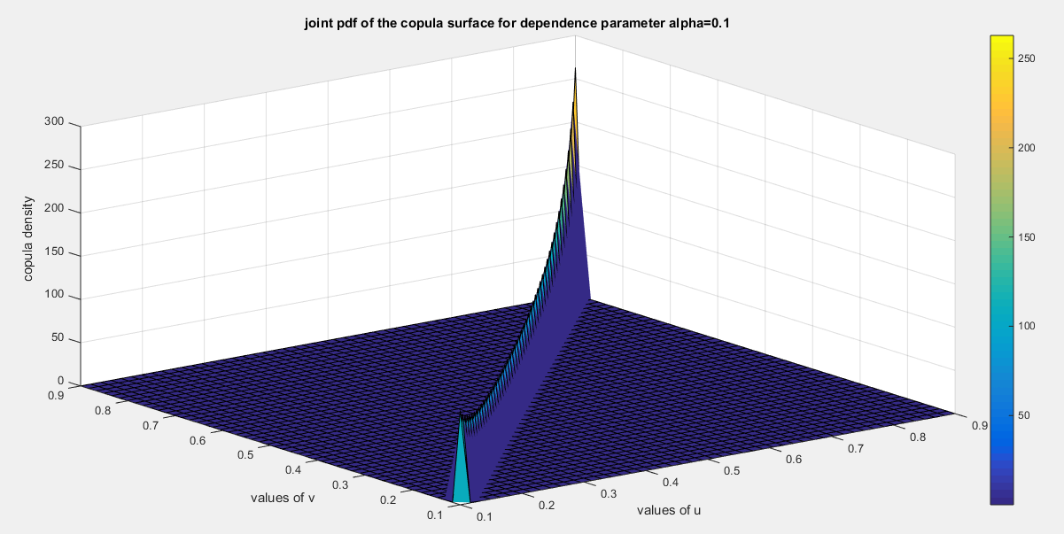
Fig. 4 Second copula density surface with dependency parameter 0.1

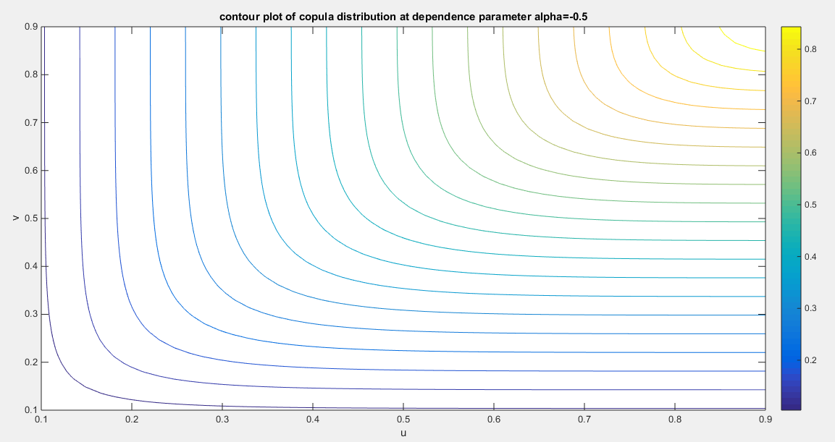
Fig. 5 The contour plot of the second copula distribution with dependency parameter -0.5
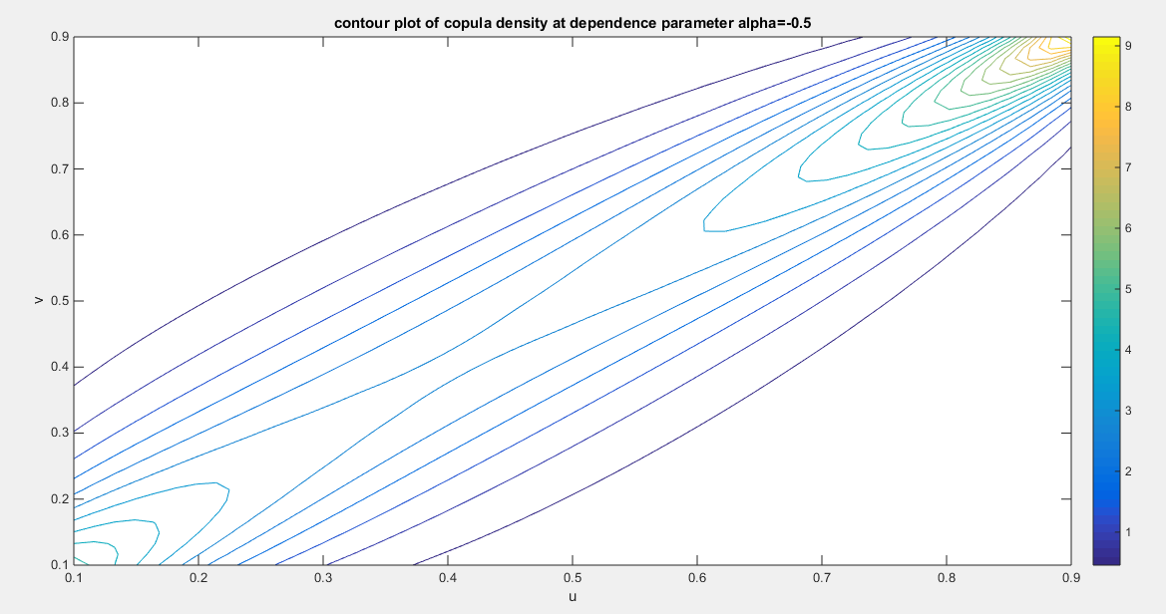
Fig. 6 The contour plot of the second copula Density with dependency parameter -0.5
The limitation of this copula is that it models only positive dependency.
Proposition 12: The copula has no lower tail dependency and the maximum upper tail dependency coefficient is 1.

Proof:
$$λ_{U}=\lim_{u→1}{\frac{1-2u+C\left(u,u\right)}{1-u} }=\frac{1-2u+exp\left({-\left[2{\left(- ln{u}\right)}^{\frac{1}{α^{2}}}\right]}^{α^{2}}\right)}{1-u}=\frac{1-2u+exp\left(- 2^{α^{2}}\left(-α ln{u}\right)\right)}{1-u}= \frac{1-2u+u^{2^{α^{2}}}}{1-u}$$
Using L’Hopital rule
$$λ_{U}=\lim_{u→1}{\frac{1-2u+u^{2^{α^{2}}}}{1-u} }=\lim_{u→1}{\frac{-2+2^{α^{2}}u^{\left(2^{α^{2}}-1\right)} }{-1}= } 2-2^{α^{2}} ∈\left[0,1\right] for ∀α ∈\left[-1,1\right]-\left\{0\right\}$$
$$λ_{L}=\lim_{u→0}{\frac{C\left(u,u\right)}{u}}=\lim_{u→0}{\frac{exp\left(- 2^{α^{2}}\left(- ln{u}\right)\right)}{u}} =\lim_{u→0}{\frac{u^{2^{α^{2}}}}{u}}=u^{\left(2^{α^{2}}-1\right)}=0 for ∀α ∈\left[-1,1\right]-\left\{0\right\}$$
So the maximum upper tail dependence coefficient for $∀α ∈\left[-1,1\right]$ of this copula is 1, however the copula has no lower tail dependency as the lower tail dependence coefficient is zero for$∀α ∈\left[-1,1\right]-\left\{0\right\}$ . The $λ_{U}=1$ , when dependency parameter approaches 0. While $λ_{U}=0$ , when this parameter is 1 or -1, at which the product copula is produced. The $λ_{U}∈\left(0,1\right)$ when the dependency parameter $α ∈\left[-1,1\right]-\left\{0\right\}$ .
3-Methods of Estimation
(Weiß, 2011), (Chen, 2007), and (Tsukahara, 2005) extensively introduced various methods of estimations like the following:
3.1. Maximum likelihood estimation (MLE)
It is one step where all the parameters marginal and copula are estimated for the full joint density function, taking the log-likelihood of this full joint function and differentiating it with respect to each of the marginal parameters and the copula parameter, then equating the resultant functions with zero and solving numerically this system of equations.
3.2. Inference function of margins (IFM)
For bivariate copula-base models for which the maximum likelihood is computationally difficult to estimate all the model parameters jointly in a one-step parametric method (Al Turk et al., 2017), two-stages estimation procedure has been proposed previously by (Joe, 2005) and (Xu, 2009). The first stage involves estimating the marginal parameters separately using maximum likelihood as shown in equation (2), where s stands for the score function or gradient
$$s_{i}^{\left(1\right)}= \frac{∂}{∂θ_{1}}\ln{f_{X}}\left(x_{i};θ_{1 marginal }\right) and s_{i}^{\left(2\right)}= \frac{∂}{∂θ_{2}}\ln{f_{Y}}\left(y_{i};θ_{2 marginal }\right) (2)$$
After estimating the marginal parameter, you get the marginal CDF for each variable as shown in equation (3)
$$u_{i}= {\hat{F}}_{1}\left(x_{i};{\hat{θ}}_{1} \right) and v_{i}= {\hat{F}}_{2}\left(y_{i};{\hat{θ}}_{2} \right) (3)$$
The second stage involves maximum likelihood of the dependence parameters with the marginal parameters held fixed from the first stage, you get the log-likelihood of the copula density as shown in equation (4), then differentiate this log-likelihood with respect to the copula dependency parameter as shown in equation (5).
$$\ln{L_{\left(IFM\right)}}=\sum_{i=1}^{n}{\ln{c \left( {\hat{F}}_{1}\left(x_{i};{\hat{θ}}_{1} \right), {\hat{F}}_{2}\left(y_{i};{\hat{θ}}_{2} \right) ;θ_{copula} \right)}} =\sum_{i=1}^{n}{\ln{c \left( u_{i}, v_{i} ;θ_{copula} \right)}} (4)$$
$$\frac{∂ln{L_{\left(IFM\right)}}}{∂θ_{copula}}= \frac{∂}{∂θ_{copula}}\left[\sum_{i=1}^{n}{\ln{c \left( {\hat{F}}_{1}\left(x_{i};{\hat{θ}}_{1} \right), {\hat{F}}_{2}\left(y_{i};{\hat{θ}}_{2} \right) ;θ_{copula} \right)}}\right] (5)$$
In this paper, the author used IFM for both the first and second copula.
For the first copula: first derivative of the log-likelihood with respect to copula parameter is in equation (6)
Let: $t_{1}= {\left(-α\ln{u_{i}}\right)}^{1/α}$ , $t_{2}= {\left(-α\ln{v_{i}}\right)}^{1/α}$ , $t_{3}= {\left(-α\ln{u_{i}}\right)}^{\frac{1}{α}-1}$ , $t_{4}= {\left(-α\ln{v_{i}}\right)}^{\frac{1}{α}-1}$
$h= \left\{\frac{1}{α} t_{3} \left(-\ln{u_{i}}\right) +t_{1}\left(\frac{-1}{α^{2}}\right)\ln\left(-α\ln{u_{i}}\right)+\frac{1}{α} t_{4} \left(-\ln{v_{i}}\right) +t_{2}\left(\frac{-1}{α^{2}}\right)\ln\left(-α\ln{v_{i}}\right) \right\}$,
$$g=α{\left(t_{1}+t_{2}\right)}^{α-1}h+{\left(t_{1}+t_{2}\right)}^{α}\ln\left(t_{1}+t_{2}\right)$$
$A_{1}= \frac{1}{α^{2}}{\left(t_{1}+t_{2}\right)}^{α}+ \left(\frac{-1}{α}\right)g$ , $A_{2}=\left(α-2\right){\left(t_{1}+t_{2}\right)}^{-1}h+\ln\left(t_{1}+t_{2}\right)$ ,
$A_{3}= \left(\frac{1}{α}-1\right){\left(α^{2}\ln\left(u_{i}\right)\ln\left(v_{i}\right)\right)}^{-1}\left(2α\ln\left(u_{i}\right)\ln\left(v_{i}\right)\right)+\frac{-1}{α^{2}}\ln\left(α^{2}\ln\left(u_{i}\right)\ln\left(v_{i}\right)\right)$ $A_{4}= \frac{g-1}{{\left(t_{1}+t_{2}\right)}^{α}-α+1}$
$\frac{∂ln{L_{\left(IFM\right)}}}{∂θ_{copula}}= A_{1}+ A_{2}+A_{3}+A_{4} (6)$
For second copula: first derivative of the log-likelihood with respect to copula parameter is in equation (7)
Let: $t_{1}= {\left(-\ln{u_{i}}\right)}^{1/α^{2}}$ , $t_{2}= {\left(-\ln{v_{i}}\right)}^{1/α^{2}}$ , $t_{3}= {\left(-\ln{u_{i}}\right)}^{1/α^{2}}\left(\frac{-2}{α^{3}}\right)\ln\left(-\ln{u_{i}}\right)$ ,
$t_{4}= {\left(-\ln{v_{i}}\right)}^{1/α^{2}}\left(\frac{-2}{α^{3}}\right)\ln\left(-\ln{v_{i}}\right)$ , $h= -\left(α^{2}\right){\left(t_{1}+t_{2}\right)}^{α^{2}-1}\left(t_{3}+t_{4}\right)+ \left\{-{\left(t_{1}+t_{2}\right)}^{α^{2}}\left(2α\right)\ln\left(t_{1}+t_{2}\right)\right\}$
$A_{1}=h$ , $A_{2}= \left(α^{2}-2\right){\left(t_{1}+t_{2}\right)}^{-1}\left(t_{3}+t_{4}\right)+\left(2α\right)\ln\left(t_{1}+t_{2}\right)$ , $A_{3}= \left(\frac{-2}{α^{3}}\right)\ln\left(\ln\left(u_{i}\right)\ln\left(v_{i}\right)\right)$
$A_{4}= \frac{\left(-h-\frac{2}{α^{3}}\right)}{\left({\left(t_{1}+t_{2}\right)}^{α^{2}}+ \frac{1}{α^{2}}-1\right)}$
$$\frac{∂ln{L_{\left(IFM\right)}}}{∂θ_{copula}}= A_{1}+ A_{2}+A_{3}+A_{4} (7)$$
Applying Quasi-Newton method
$α^{\left(a+1\right)}= α^{\left(a\right)}+M^{-1}\left(α^{\left(a\right)}\right)S\left(α^{a}\right)$ where $S\left(α\right)=\frac{∂ln{L_{\left(IFM\right)}}}{∂θ_{copula}}$ , $M=S^{T}S$ and $M^{-1}\left(α\right)$ can approximate the variance of the dependency parameter estimator.
Each marginal parameter has its own variance from stage one, they are treated as fixed when moving to stage two in IFM approach, so they do not contribute to the variance of the estimated dependency parameter directly. The variance of the copula parameter is obtained from the second stage and it is valid under IFM but it underestimates the total uncertainty (because it ignores the variability in marginal parameter estimation). Therefore, in theory, the propagation of uncertainty from the first stage to the second requires the Godambe information matrix (sandwich estimator)(Godambe, 1991), or simultaneous estimator to obtain the joint variance-covariance matrix of all parameters (marginals and copula). Hence, the sandwich estimator also known as robust variance estimator is used to obtain the asymptotic variance of parameter estimates when the likelihood function is estimated in multiple stages or is mis-specified in cases where not using the full joint likelihood. The variance is defined in the following equation (8):
$$var\left(\hat{θ}\right)=H^{-1}SH^{-1} (8)$$
where S is the outer product of the gradient of parameter estimator (marginal and copula) or the score function as shown in equation (9).
$$S=\frac{1}{n}\left[\begin{matrix}\frac{∂\ln{f_{X}\left(x_{i};θ_{1marginal}\right)}}{∂θ_{1marginal}} \\ \frac{∂\ln{f_{Y}\left(y_{i};θ_{2marginal}\right)}}{∂θ_{2marginal}} \\ \frac{∂ln{L_{\left(IFM\right)}}}{∂θ_{copula}}\end{matrix}\right]\left[\begin{matrix}\frac{∂\ln{f_{X}\left(x_{i};θ_{1marginal}\right)}}{∂θ_{1marginal}} & \frac{∂\ln{f_{Y}\left(y_{i};θ_{2marginal}\right)}}{∂θ_{2marginal}} & \frac{∂ln{L_{\left(IFM\right)}}}{∂θ_{copula}}\end{matrix}\right] (9)$$
$H^{-1}$ is the inverse of the negative of expectation of the information matrix, in other word, the variance of the parameter estimator (marginal and copula). It is a diagonal matrix. $H=-E\left(\frac{∂^{2}l}{∂θ^{2}}\right)=I$ , the inverse of this H or inverse of this I is the variance of marginal parameter estimators in the first stage and variance of copula estimator in the second stage. So let’s call this inverse the A matrix, so sandwich estimator can be expressed as shown in equation (10-11)
$$var\left(\hat{θ}\right)=H^{-1}SH^{-1}=ASA (10)$$
$$var-cov\left(\hat{θ}\right)= \left[\begin{matrix}var\left(θ_{1}\right) & 0 & 0 \\ 0 & var\left(θ_{2}\right) & 0 \\ 0 & 0 & var\left(α_{copula}\right)\end{matrix}\right]\left[\begin{matrix}s_{11} & s_{12} & s_{13} \\ s_{21} & s_{22} & s_{23} \\ s_{31} & s_{32} & s_{33}\end{matrix}\right]\left[\begin{matrix}var\left(θ_{1}\right) & 0 & 0 \\ 0 & var\left(θ_{2}\right) & 0 \\ 0 & 0 & var\left(α_{copula}\right)\end{matrix}\right]$$

$$var-cov\left(\hat{θ}\right)=\left[\begin{matrix}{v_{1}^{2}s}_{11} & v_{1}v_{2}s_{12} & v_{1}v_{3}s_{13} \\ v_{1}v_{2}s_{21} & {v_{2}^{2}s}_{22} & {v_{2}v_{3}s}_{23} \\ {v_{1}v_{3}s}_{31} & {v_{2}v_{3}s}_{32} & {v_{3}^{2}s}_{33}\end{matrix}\right] (11)$$
This variance covariance matrix captures the covariance between the marginal and the copula parameter estimators which are not captured in the naive block separated IFM variances.
3.3. Semiparametric method (SP)
The third method introduced by (Kim et al., 2007) is the estimation by semiparametric method (SP). It is carried out in two stages like IFM. The first stage involves transforming the variables into their marginal empirical distribution (eCDF), in other words, transforming the observations into pseudo-observations by using the empirical distribution function for each marginal distribution as shown in equation (12)
$${\tilde{F}}_{i} \left(x_{i}\right)=\frac{\sum_{i=1}^{n}{I\left(X_{i}≤x_{i}\right)}}{n+1} and {\tilde{F}}_{i} \left(y_{i}\right)=\frac{\sum_{i=1}^{n}{I\left(Y_{i}≤y_{i}\right)}}{n+1} (12)$$
The second stage involves estimating the copula dependency parameter using the pseudo likelihood function as shown in equation (13-14) and maximizing this function.
$$\ln{L_{\left(SP\right)}}=\sum_{i=1}^{n}{\ln{c \left( {\tilde{F}}_{i} \left(x_{i}\right), {\tilde{F}}_{i} \left(y_{i}\right) ;θ_{copula} \right)}} (13)$$
$$\frac{∂ln{L_{\left(SP\right)}}}{∂θ_{copula}}=\frac{∂}{∂θ_{copula}}\left[\sum_{i=1}^{n}{\ln{c \left( {\tilde{F}}_{i} \left(x_{i}\right), {\tilde{F}}_{i} \left(y_{i}\right) ;θ_{copula} \right)}}\right] (14)$$

4-real data analysis
4.1 data description
The OECD data platform delivered by the OECD (organization for economic Cooperation and development) collects data on a wide range of economic, social, and environmental sectors including data about economy, health, trade, education, labor, innovation, and development. It contains many indicators describing these data. In this analysis, 3 indicators are used to find the dependency between and how the previously new copulas can model this dependency. The indicators are the quality of support network, water quality, and feeling safe walking alone at night. The data are collected from 41 countries as shown in Table (1). The data can be found on the following site: https://stats.oecd.org/index.aspx?DataSetCode=BLI .
The indicators ( let’s call it the y variable) in Table (1) and in Table (5) are distributed as Median Based Unit Rayleigh (MBUR) previously discussed by Iman Attia (Attia, 2025) with the following PDF in equation (15), CDF in equation (16), and, quantile function in equation (17):
$$f\left(y\right)=\frac{6}{α^{2}}\left[1-y^{\frac{1}{θ^{2}}}\right]y^{\left(\frac{2}{θ^{2}}-1\right)} , 0<y<1 ,θ>0 (15)$$
$$F\left(y\right)={3y}^{\frac{2}{θ^{2}}}-{2y}^{\frac{3}{θ^{2}}} , 0<y<1 , θ>0 (16)$$
$$y={\left\{-.5\left(cos\left[\frac{\cos^{-1}\left(1-2u\right)}{3}\right]-\sqrt{3} sin\left[\frac{\cos^{-1}\left(1-2u\right)}{3}\right]\right)+.5\right\}}^{θ^{2}}, 0<u<1 , θ>0 (17)$$
Table (1): The three indicators of the OECD data
Country | Water quality | Feeling safe walking alone | Quality of support network
Australia | 0.92 | 0.67 | 0.93
Austria | 0.92 | 0.86 | 0.92
Belgium | 0.79 | 0.56 | 0.90
Canada | 0.90 | 0.78 | 0.93
Chile | 0.62 | 0.41 | 0.88
Colombia | 0.82 | 0.50 | 0.80
Costa Rica | 0.87 | 0.47 | 0.82
Czechia | 0.89 | 0.77 | 0.96
Denmark | 0.93 | 0.85 | 0.95
Estonia | 0.86 | 0.79 | 0.95
Finland | 0.97 | 0.88 | 0.96
France | 0.78 | 0.74 | 0.94
Germany | 0.91 | 0.76 | 0.90
Greece | 0.67 | 0.69 | 0.78
Hungary | 0.81 | 0.74 | 0.94
Iceland | 0.97 | 0.85 | 0.98
Ireland | 0.80 | 0.76 | 0.96
Israel | 0.77 | 0.80 | 0.95
Italy | 0.77 | 0.73 | 0.89
Japan | 0.87 | 0.77 | 0.89
Korea | 0.82 | 0.82 | 0.80
Latvia | 0.83 | 0.72 | 0.92
Lithuania | 0.83 | 0.62 | 0.89
Luxembourg | 0.85 | 0.87 | 0.91
Mexico | 0.75 | 0.42 | 0.77
Netherlands | 0.91 | 0.83 | 0.94
New Zealand | 0.85 | 0.66 | 0.95
Norway | 0.98 | 0.93 | 0.96
Poland | 0.82 | 0.71 | 0.94
Portugal | 0.89 | 0.83 | 0.87
Slovak Republic | 0.81 | 0.76 | 0.95
Slovenia | 0.93 | 0.91 | 0.95
Spain | 0.76 | 0.80 | 0.93
Sweden | 0.97 | 0.79 | 0.94
Switzerland | 0.96 | 0.86 | 0.94
Turkey | 0.62 | 0.59 | 0.85
United kingdom | 0.82 | 0.78 | 0.93
United states | 0.88 | 0.78 | 0.94
Brazil | 0.70 | 0.45 | 0.83
Russia | 0.62 | 0.64 | 0.89
South Africa | 0.72 | 0.40 | 0.89
The ‘water quality’ indicator measures the self-reported satisfaction with water quality as regards drinking clean water and extent of water pollution. It is expressed as the percentage of people who report satisfaction. The indicator of ‘feeling safe walking alone’ measures the percentage of people who report feeling safe when walking alone in their local area after dark. The ‘quality of support network’ indicator measures the accessibility and trustworthiness of social support for individuals and it is explicated as the percentage of population with social support who described having someone they can depend on for support when they need it. Table 2 shows the descriptive statistics of the 3 indicators. The indicators show different degree of left skewness. Table 3 shows the empirical Kendall tau coefficient and its associated p-value. The different pairs of the indicators are positively associated with each other. This association is highly statistically significant. Figure 7 shows the boxplot for each indicator. Figure 8-10 show the scatter plot of each indicator. Each variable is mainly concentrated in the upper right corner of the plot, pointing to upper tail dependency. Each indicator fits the Median-Based Unit Rayleigh Distribution (MBUR). Table 4 shows the statistical validity indices for each indicator. Figure 11 shows the histogram and the fitted MBUR curve for each indicator.
Table (2): descriptive statistics for the 3 indicators:
indicator | min | mean | Standard deviation | skewness | kurtosis | 25_{percentile} | 50_{percentile} | 75_{percentile} | max
Water quality | 0.62 | 0.8332 | 0.0972 | -0.6059 | 2.9144 | 0.7775 | 0.83 | 0.91 | 0.98
Feeling safe walking alone | 0.4 | 0.7207 | 0.143 | -0.9486 | 3.0353 | 0.655 | 0.76 | 0.8225 | 0.93
Quality of support network | 0.77 | 0.9078 | 0.0538 | -1.176 | 3.5406 | 0.89 | 0.93 | 0.95 | 0.98

Table (3): empirical Kendall tau coefficient of the three indicators:
 | Water quality | Feeling safe walking alone | Quality of support network
Water quality | 1 | 0.5206  (0.000) | 0.3929  (0.0006)
Feeling safe walking alone | 0.5206  (0.000) | 1 | 0.4344  (0.0001)
Quality of support network | 0.3929  (0.0006) | 0.4344  (0.0001) | 1

Table (4): statistical validity indices of the distributional fit (MBUR) of the three indicators:
indicator | Estimated theta | variance | AIC | CAIC | BIC | HQIC | KS-test | Ho | p-value of KS-test
Water quality | 0.4776 | 0.00072157 | -78.9952 | -78.8926 | -77.2817 | -78.3712 | 0.0991 | Fail to reject | 0.7789
Feeling safe walking alone | 0.6494 | 0.0013 | -47.1347 | -47.0321 | -45.4211 | -46.5107 | 0.1206 | Fail to reject | 0.5492
Quality pf support network | 0.3444 | 0.00037494 | -131.6505 | -131.6505 | -131.5479 | -131.0265 | 0.1806 | Fail to reject | 0.1217

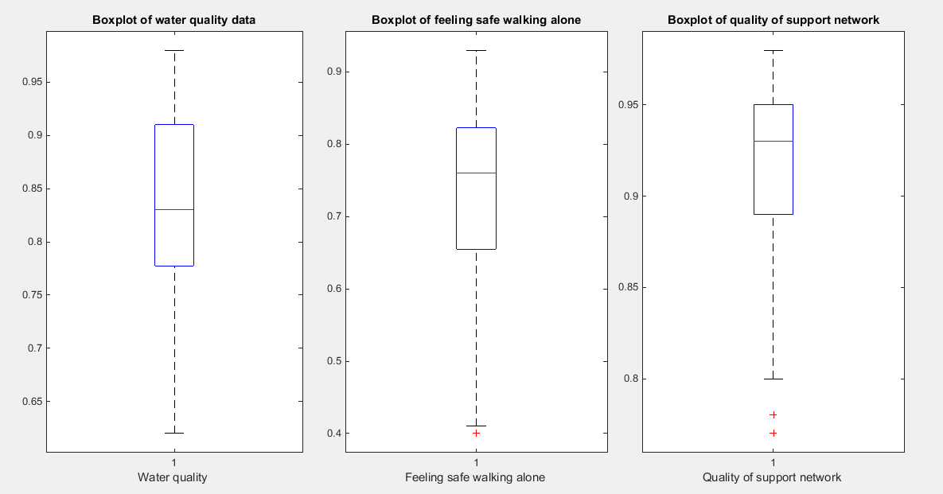
Fig. 7 The Boxplot for each indicator. The first two indicators show similar pattern of skewness (left sides skewness) while the third indicator exhibits more left sided skewness than the previous two indicators.
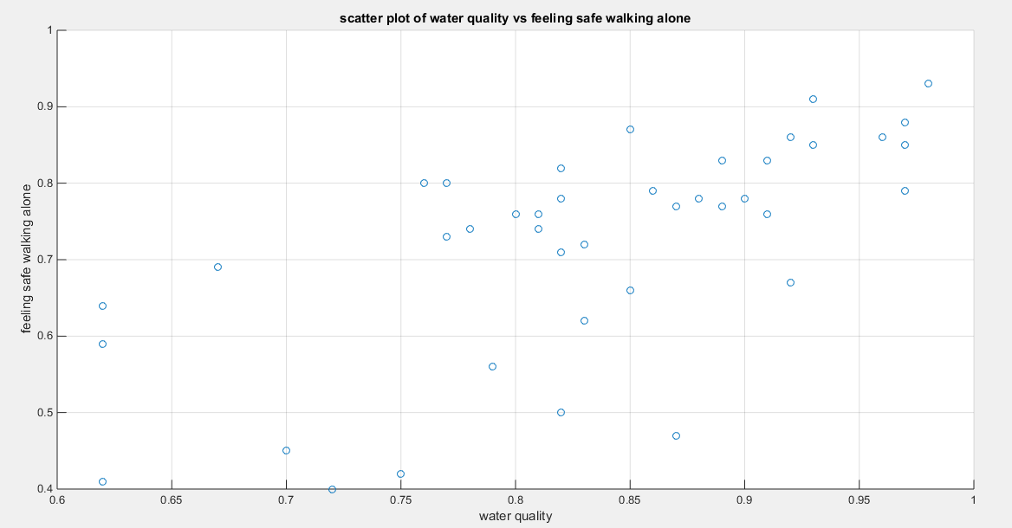
Fig. 8 The scatter plot of the water quality variable vs the variable describing feeling safe walking alone. The data are mainly concentrated on the upper right side of the graph most probably reflecting upper tail dependency.
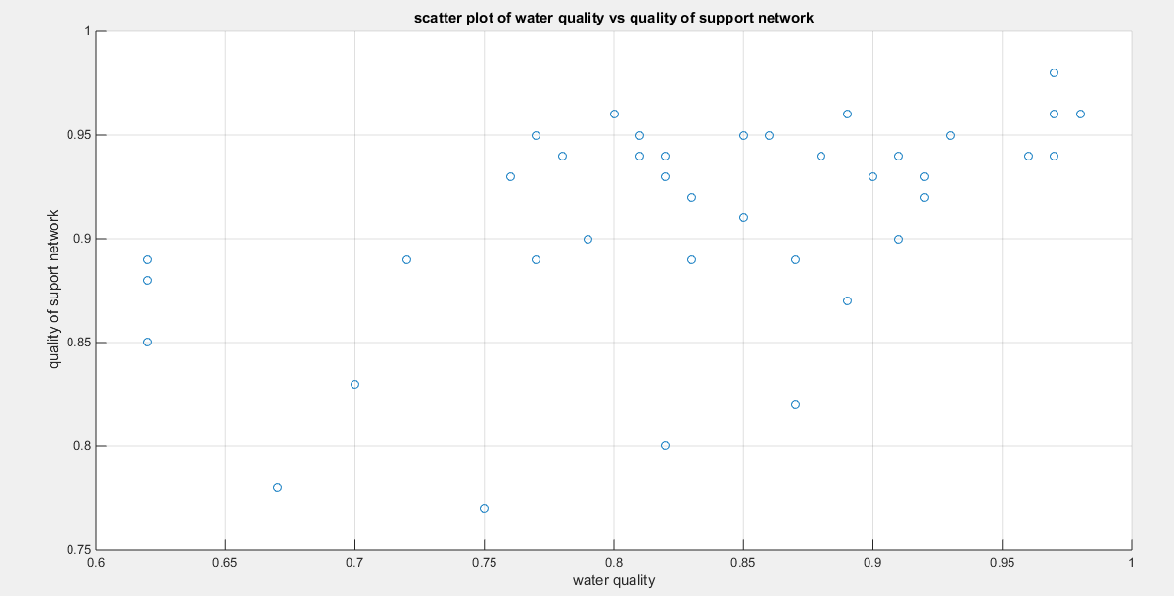
Fig. 9 The scatter plot of the variable water quality vs the variable quality of support network, also the data are mainly concentrated in the upper right corner of the scatter presumably reflecting upper tail dependency.
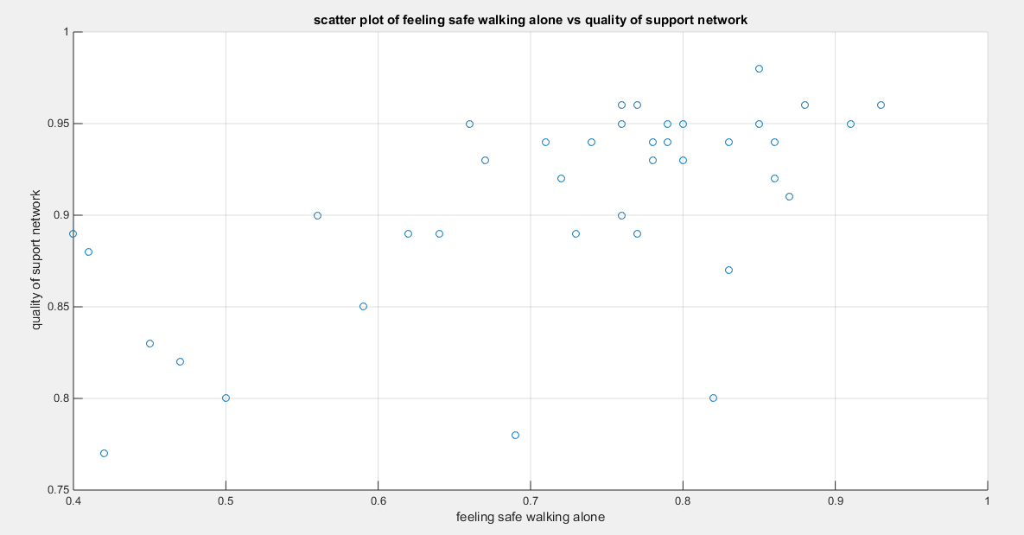
Fig. 10 The scatter plot of the variable feeling safe walking alone vs the variable of the quality of support network. The data are also concentrated on the right upper corner of the graph likely denoting the presence of upper tail dependency.
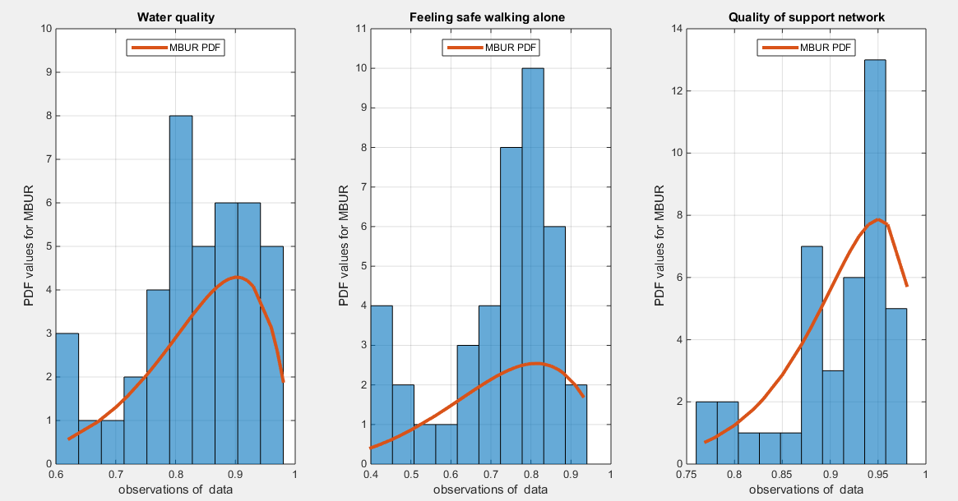
Fig. 11 The histogram of the three indicators which exhibit left sided skewness. The graph also shows the fitted MBUR curve for each indicator.
4.2. procedure of analysis (IFM)
The steps of analysis and Goodness of Fit tests to assess the dependence relationship for each pair of the variables are as follows:
- Estimate the marginal parameters for each variable.
- Use the IFM procedure to estimate the dependency parameter of the proposed copula model.
- Obtain the theoretical tau from the specific relation between dependency parameter and the Kendall tau for each copula.
- Obtain the Cramer Von Mises test from this estimation process and call it CVM_{data} that will be compared to CVM_{samples}
- Run sampling technique like Metropolis Hastings (MH) procedure to test the null hypothesis using the estimated dependency parameter and both the estimated marginal parameters.
- Construct sampling distribution for the estimated-theta_{samples} , theoretical-tau_{samples} , and CVM_{samples} .

For each of the sample generated by MH using the estimated dependency parameter and the estimated marginal parameters, they will be transformed back into variables using the specific quantiles. These variables will be subjected to the IFM procedure; first estimate the marginal parameters then using the estimated marginal CDF for each variable to estimate the dependency parameter, in other words, repeat steps (1 to 4) for each sample so you can be able to construct the sampling distribution, hence, constructing the confidence interval for each of the statistical indices. ${theta}_{data}$ denotes theta estimated from the data.

The null hypothesis for the dependency parameter is: $H_{0}: {theta}_{samples} = {theta}_{data}$
The alternative hypothesis for the dependency parameter is: $H_{1}: {theta}_{samples} ≠ {theta}_{data}$

The null hypothesis for the Kendall tau coefficient is: $H_{0}: {tau}_{samples }= {tau}_{data }$
The alternative hypothesis for the Kendall tau coefficient is: $H_{1}: {tau}_{samples }≠ {tau}_{data }$

The null hypothesis for the CVM is: $H_{0}: {CVM}_{samples} = {CVM}_{data}$
The alternative hypothesis for the CVM is: $H_{1}: {CVM}_{samples} ≠ {CVM}_{data}$

$C_{n}\left(u_{i},v_{i}\right)=\frac{1}{n}\sum_{i,j}^{n}{I \left( U_{j}≤u_{i},V_{j}≤v_{i}\right)}$ , this is the empirical copula at the point $C_{n}\left(u_{i},v_{i}\right)$ and the Cramer Von –Mises statistics is defined as following
$$S_{n}=\frac{1}{n}\sum_{i=1}^{n}{{\left(C_{n}\left(u_{i},v_{i}\right)-C_{θ}\left(u_{i},v_{i}\right)\right)}^{2}}$$

First Copula: Attia-1 copula
Model the dependency between the ‘water quality’ and ‘feeling safe walking alone’: The empirical tau equals 0.5206 while the theoretical tau is 0.5202 with difference value of 3.6968e-04. The estimated dependency parameter, theta $\hat{θ}$ , is 0.4798 with estimated variance of 8.3533e-06. The Cramer Von Mises test (CVM) is 0.1388. The null hypothesis for dependency was tested by conducting resampling using the Metropolis Hastings algorithm of MCMC procedure. The proposed null hypothesis was that the dependency parameter equals the estimated theta against the alternative hypothesis that the population dependency parameter does not equal the estimated theta. Also the null hypothesis for the population Kendall tau coefficient being equal to the theoretical tau against the alternative hypothesis of not being equal to it was tested. The null hypothesis for the CVM proposing that the sampling CVM equals observed CVM obtained from the estimation procedure was investigated. The sampling distribution of each of the previously mentioned indices, thetas, tau and CVM is shown in Figures (12-14). For each figure, the descriptive statistics indices are shown. From the figures the indices are placed within the acceptance zone between the 2.5th and 97.5th quantiles. So the null hypotheses fail to be rejected. The copula fits the data well. And the dependence parameter models, within the context of the copula, the relation between the two variables. The confidence interval (CI) for the estimated dependence parameter is (0.1822, 0.8084), for the theoretical tau; it is (0.1916, 0.8178), and for CVM; it is (0.0316, 0.2937).
According to the sandwich variance the variance covariance matrix for this model is:
$$var-cov=\left[\begin{matrix}0.0081 & 0.0144 & 0.00002 \\ 0.0144 & 0.0257 & 0.00003 \\ 0.00002 & 0.00003 & 2.0301e-07\end{matrix}\right]$$
The validity indices for the second stage are:
$AIC=-21.4395 , CAIC=-21.337 BIC= -19.726 HQIC=-20.8156$
The validity indices for the whole model is the summation of these indices for marginal (first stage) and copula (second stage):
$$AIC=-147.5694 , CAIC=-147.2617 BIC= -142.4287 HQIC=-145.6974$$
Theoretical upper tail coefficient is 0.6054. At quantile 0.85; the empirical upper tail coefficient in the direction of the ‘water quality’ variable is 0.2 (one point showing joint match out of 5 points in the upper tail at this threshold, 0.85) and in the direction of the ‘feeling safe walk at night’ variable is 0.5 (one point showing joint match out of 2 points in the upper tail at this threshold, 0.85) while the confidence interval of the empirical distribution obtained from bootstrap sampling under the null hypothesis is [0,1]. This is expected because of the small sample size and left skewness of data.
Figure 15 shows the P-P plot of the empirical vs the theoretical copula. Figure 16-18 show the surface of the copula density, the contour plot of the copula density, and the contour plot of the copula distribution at the estimated parameter.
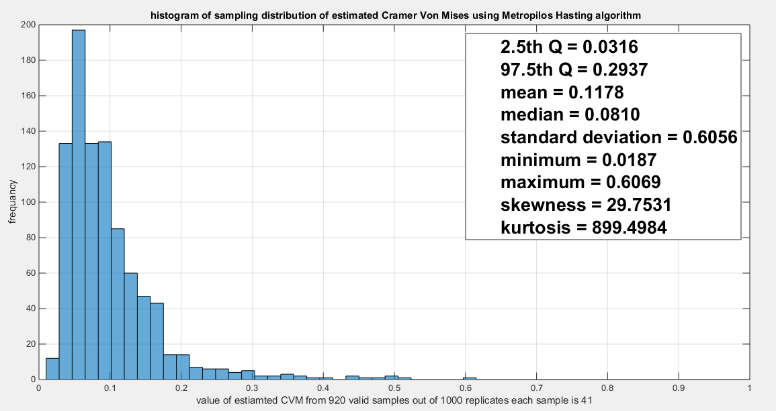
Fig. 12 The sampling distribution of the CVM. The CVM data is 0.1388 and it is between the 2.5th and the 97.5th quantiles so null hypothesis is failed to be rejected and the copula fits the data well. The p-value (probability of values less than or equal to 0.1388) is 0.8207, in other words, this 0.1388 is not in either of the tail regions of rejection.
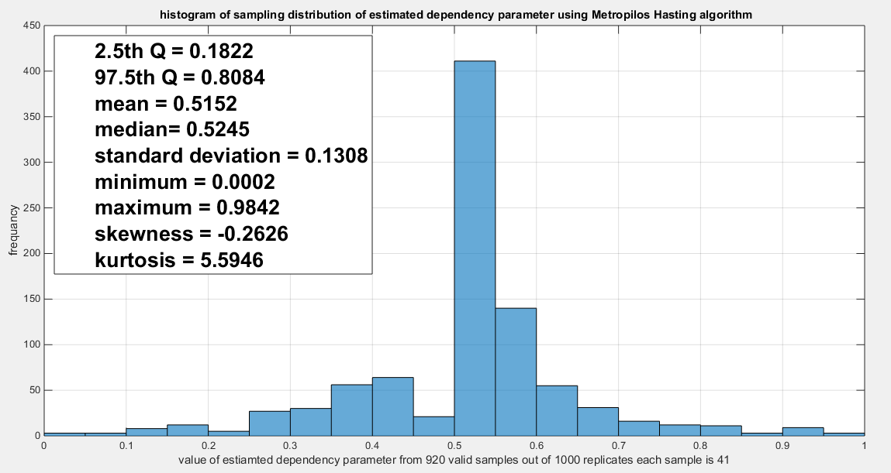
Fig. 13 The sampling distribution of the dependency parameter. The 0.4798 lays in the acceptance region between the two quantiles, the 2.5th and the 97.5th quantiles. So the null hypothesis fails to reject its assumption. The p-value (probability of the values being less than or equal to this 0.4798) is 0.2304 which indicates that 0.4798 is not in either zones of rejection.
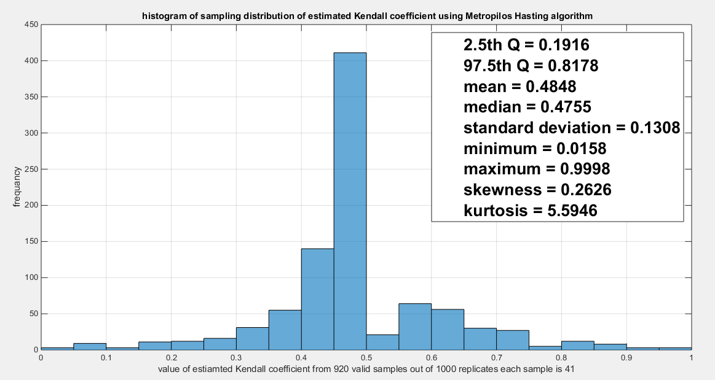
Fig. 14 The sampling distribution of the Kendal tau coefficient. The 0.5202 is between the two quantiles 2.5th and 97.5th which is in the acceptance zones. So the null hypothesis fails to reject its assumption. The p-values (probability of the values less than or equal to 0.5202) is 0.7696 which denotes that 0.5202 is far away from both rejection zones.
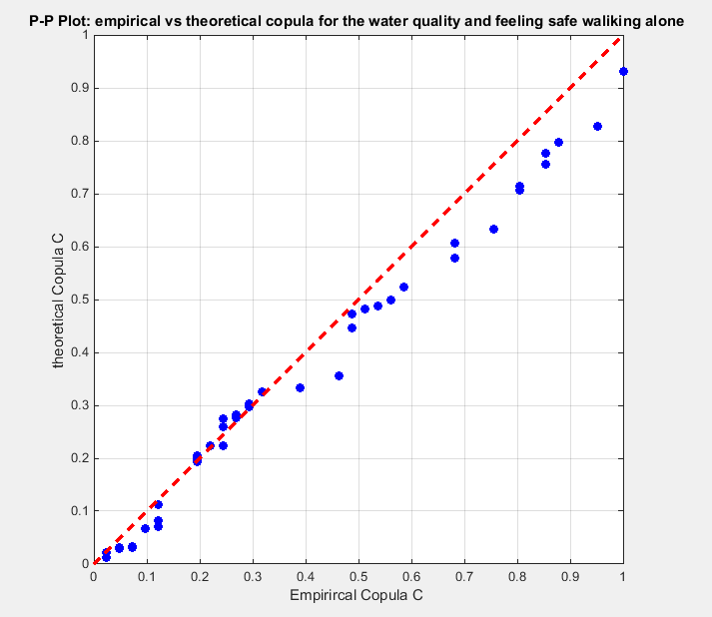
Fig. 15 The P-P plot of the empirical vs the theoretical copula. The theoretical copula shows near perfect alignment with the diagonal line.
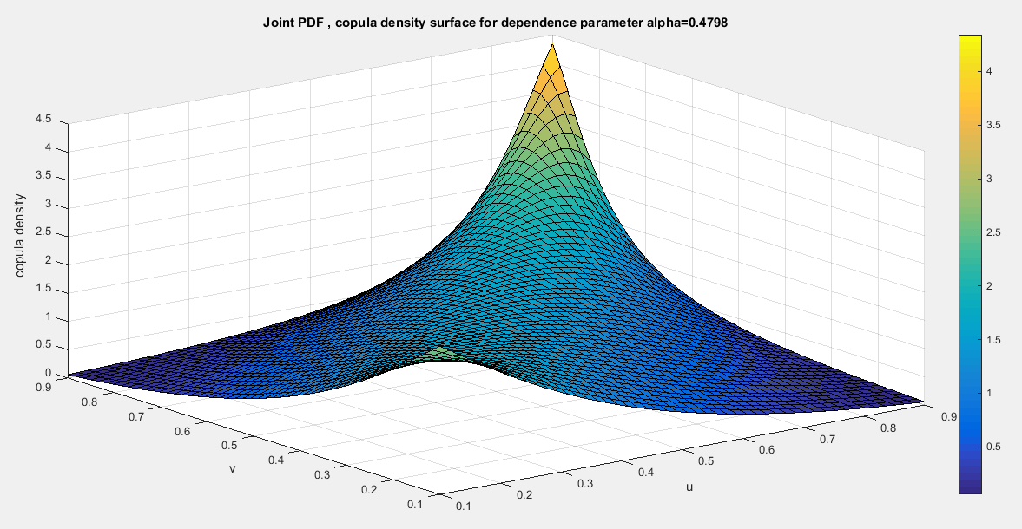
Fig.16 The PDF surface of copula density with parameter 0.4798
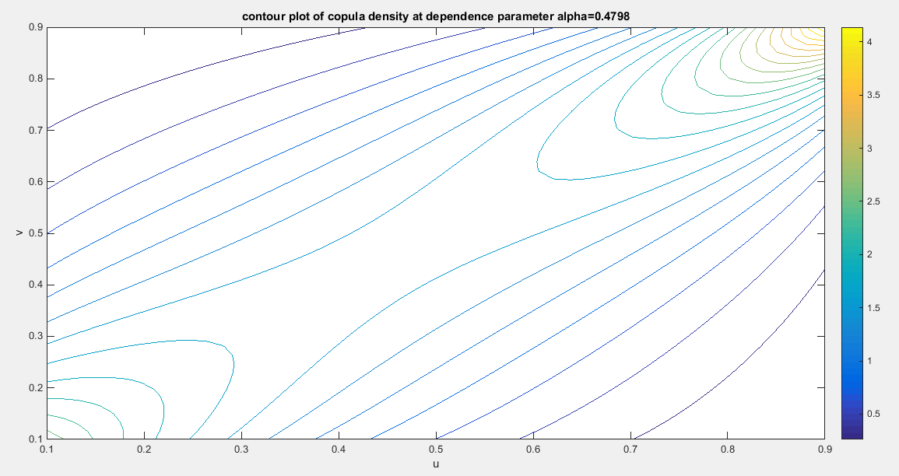
Fig.17 The contour plot of the copula density with parameter 0.4798
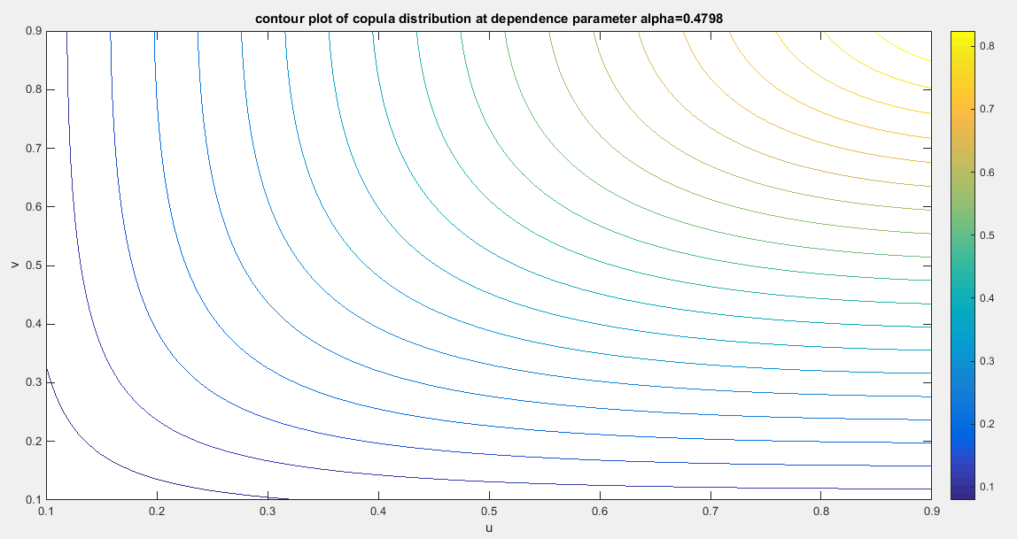
Fig. 18 The contour plot of the copula distribution with dependency parameter 0.4798
Second copula: Attia-2 copula
Model the dependency between the ‘water quality’ and ‘quality of support network’: The empirical tau is 0.3929 and the theoretical tau is 0.3926 with dissimilarity value of 3.8927e-04 The estimated dependency parameter, theta $\hat{θ}$ , is 0.7794 and estimated variance of 0.0018. The Cramer Von Mises test (CVM) is 0.2142. To test the null hypothesis for dependency, resampling using the Metropolis Hastings algorithm of MCMC procedure was performed. The null hypothesis was stated that the population dependency parameter equals the estimated theta against the alternative hypothesis that the population dependency parameter does not equal the estimated theta. Moreover, the null hypothesis for the equality of the population Kendall tau with the theoretical tau is tested against the alternative hypothesis of not being equal to each other. The null hypothesis for the CVM suggesting that the sampling CVM equals the observed CVM attained from the estimation procedure was also investigated. These are all two sided tests. The sampling distribution of each of the previously mentioned indices, thetas, tau and CVM is shown in Figures (19-21). The descriptive statistical indices are shown in each figure. Analysis of the figures denoted that the indices are within the acceptance region between the 2.5th and 97.5th quantiles. So the null hypotheses fail to be rejected. The copula can be said to pass some of the goodness of fit (GOF) tests for this data. And the dependence parameter reflects, within the context of this copula, the relationship between the two variables. The confidence interval (CI) for the estimated dependence parameter is (0.2571, 0.9530), for the theoretical tau; it is (0.0918, 0.9078), and for CVM; it is (0.0485, 0.3715).
According to the sandwich variance the variance covariance matrix for this model is:
$$var-cov=\left[\begin{matrix}0.0269 & 0.0143 & -0.0004 \\ 0.0143 & 0.0076 & -0.0002 \\ -0.0004 & -0.0002 & 0.00005\end{matrix}\right]$$
The validity indices for the second stage are:
$AIC=-11.1291 , CAIC=-11.0265 BIC= -9.4155 HQIC=-10.5051$
The validity indices for the whole model is the summation of these indices for marginal (first stage) and copula (second stage):
$$AIC=-221.7747 , CAIC=-221.467 BIC= -216.634 HQIC=-219.9028$$
Theoretical upper tail coefficient is 0.4764. At quantile 0.85; the empirical upper tail coefficient in the direction of the ‘water quality’ variable is 0.2 (one point showing joint match out of 5 points in the upper tail at this threshold, 0.85) and in the direction of the ‘Quality of support network’ variable is 1 (one point showing joint match out of 1 point in the upper tail at this threshold, 0.85) while the confidence interval of the empirical distribution obtained from bootstrap sampling under the null hypothesis is [0,1]. This is expected because of the small sample size and left skewness of data.
Figure 22 shows the P-P plot of the empirical vs the theoretical copula. Figure 23-25 show the contour plot of the copula density, the contour plot of the copula distribution, and the surface of the copula density at the estimated parameter.
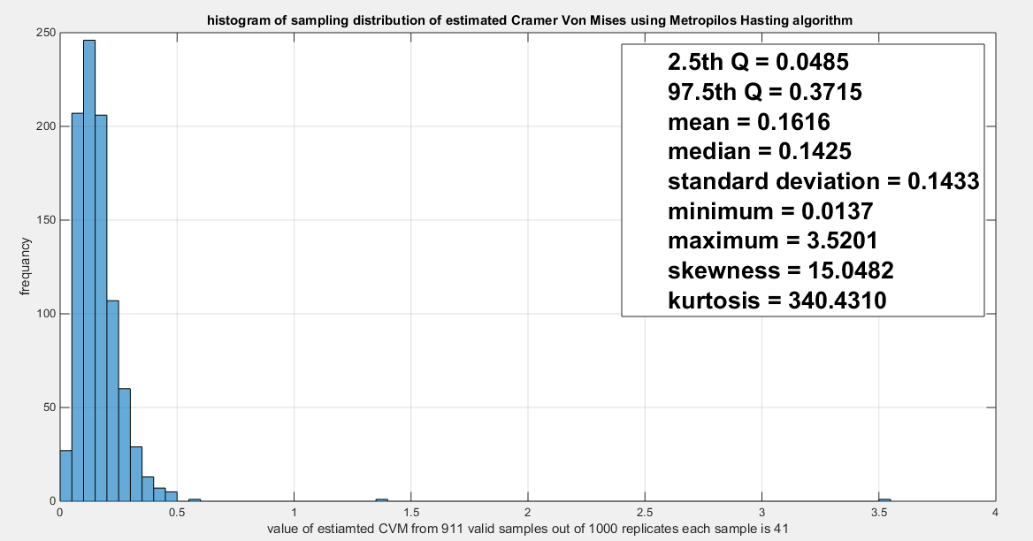
Fig. 19 The sampling distribution of the CVM. The data obtained CVM is 0.2142 and it is between the 2.5th and the 97.5th quantiles so the null hypothesis is failed to be rejected and the copula fits the data well. The p-value (probability of values less than or equal to 0.2142) is 0.7846, in other words, this 0.2142 is not in either of the tail regions of rejection.
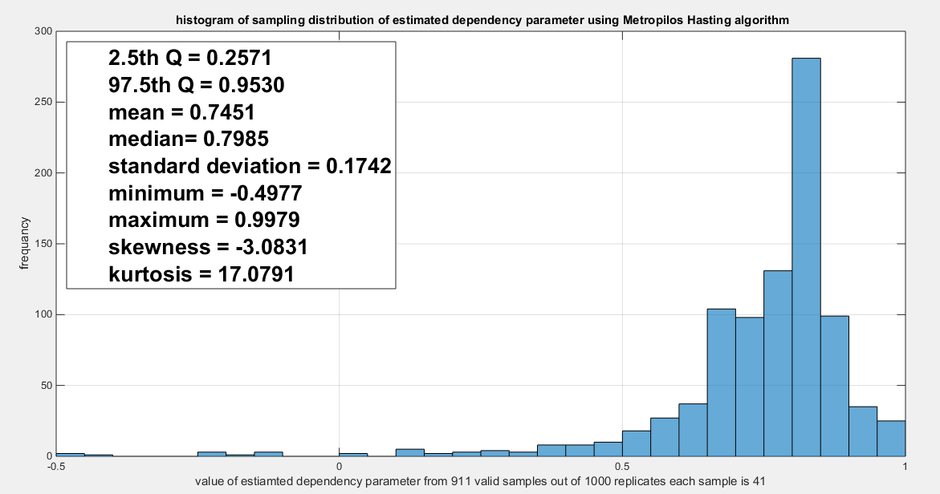
Fig. 20 The sampling distribution of the dependency parameter. The 0.7794 is in the acceptance region between the two quantiles, the 2.5th and the 97.5th quantiles. So the null hypothesis fails to reject its assumption. The p-value (probability of the values being less than or equal to this 0.7794) is 0.3725which indicates that 0.7794 is not in either zones of rejection.
. 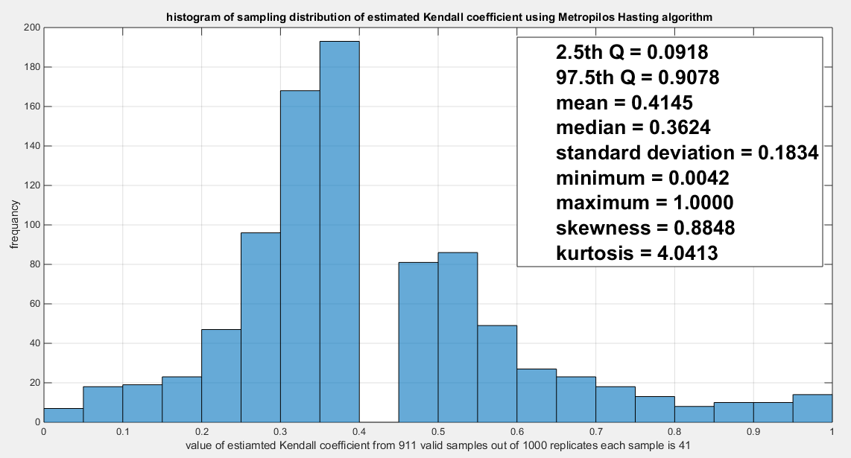
Fig. 21 The sampling distribution of the Kendal tau coefficient. The 0.3926 is between the two quantiles 2.5th and 97.5th which is in the acceptance zones. So the null hypothesis fails to reject its assumption. The p-values (probability of the values less than or equal to 0.3926) is 0.6275 which denotes that this value 0.3926 is far away from both rejection zones on the right and the left.
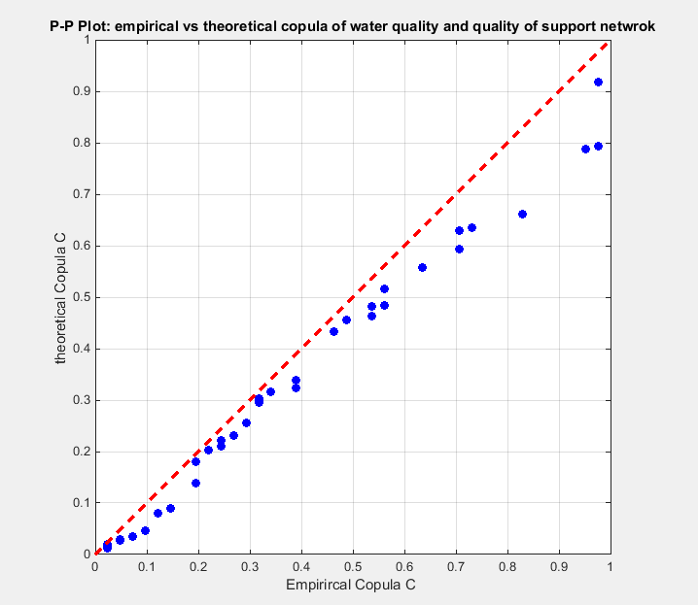
Fig. 22 The P-P plot of the empirical vs the theoretical copula. The theoretical copula shows near perfect alignment with the diagonal line.
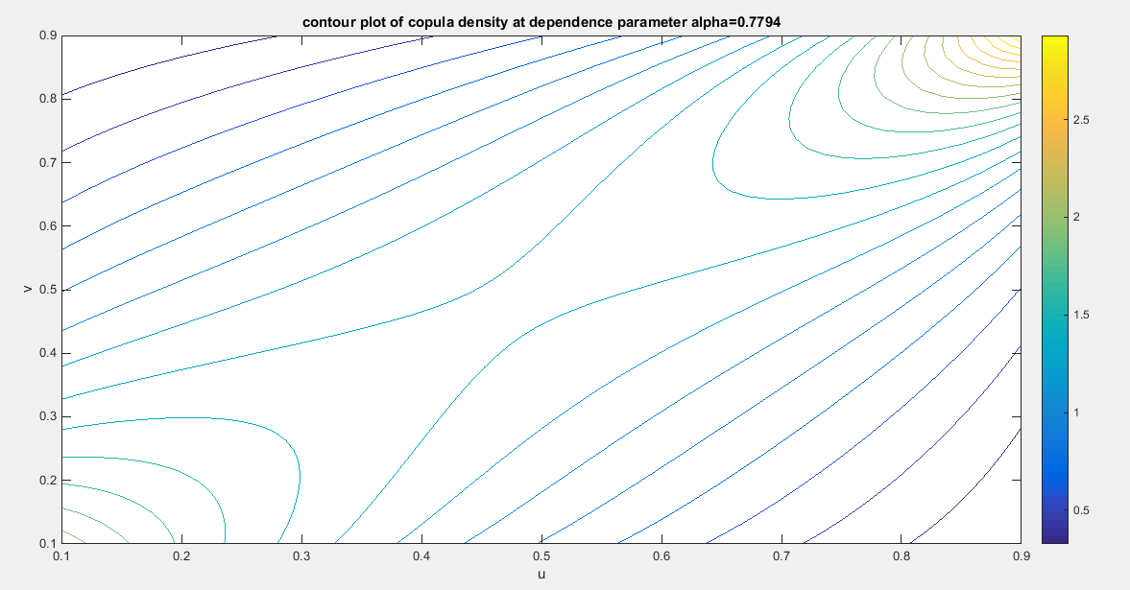
Fig. 23 The contour plot of the copula density with parameter 0.7794
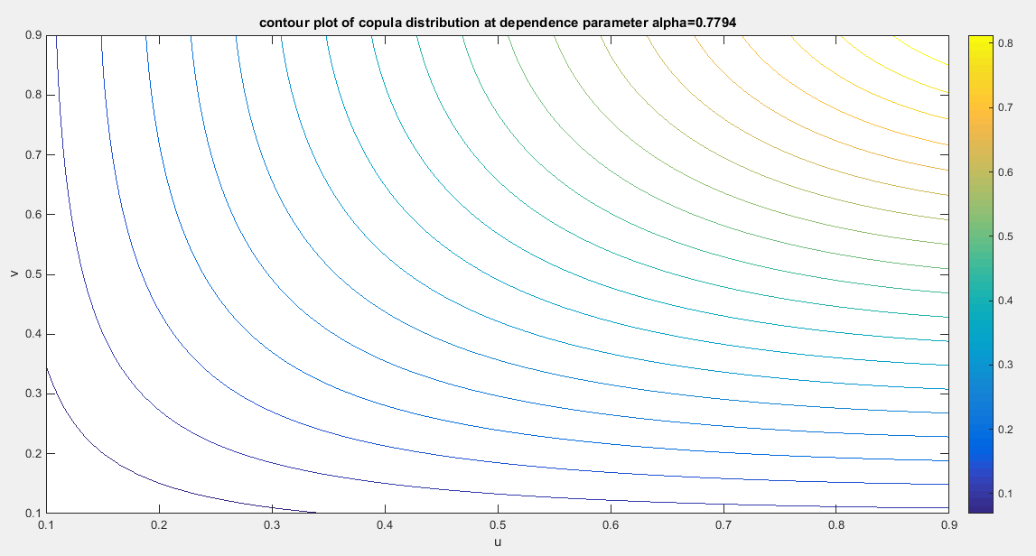
Fig. 24 The contour plot of the copula distribution with parameter 0.7794
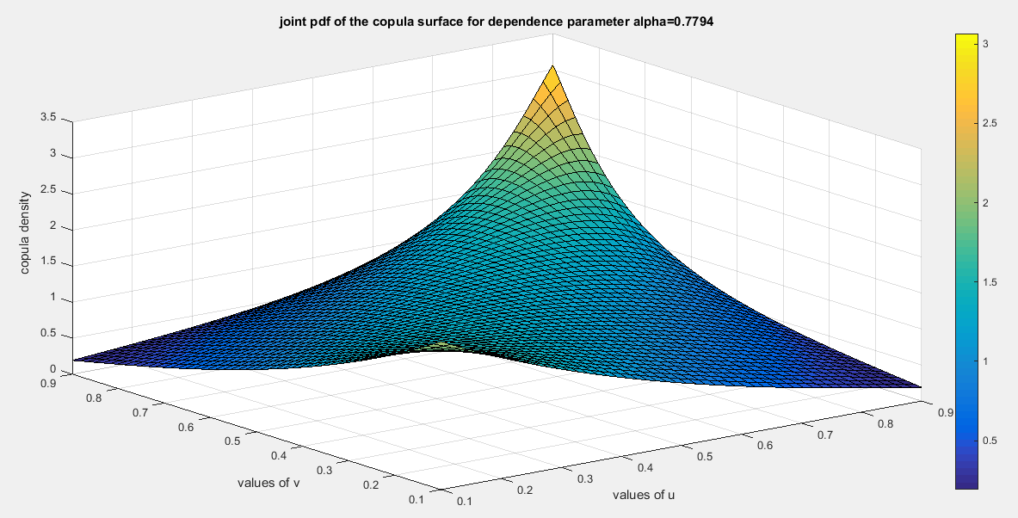
Fig. 25 The surface of the copula density with dependency parameter 0.7794
Another 2 pair of variables for the second copula:
For the OECD data, another two pair of variables are analyzed, the household net wealth and the personal earnings. The household net wealth measures the total value of assets possessed by the household minus their obligations like debts, loans, and mortgages. These data are available in USD, and converted to unit interval through division by 1000000. The personal earnings measure the average income earned by persons, typically on an annual or monthly basis, reflecting the income levels and earning potential of the workforce. These data are also expressed in USD and converted to belong to unit interval through division by 100000. These data are available for 24 countries in this same data platform as shown in Table 5. Table 6 illustrates the descriptive statistics for the two variables. They exhibit positive skewness. The household net wealth variable shows excess positive skewness and kurtosis than the personal earnings variable. Table 7 depicts the Kendall tau coefficient between the two indicators and its associated p value. They are positively correlated with high statistical significance. The two variables fit the Median-Based Unit Rayleigh (MBUR) distribution. Table 8 shows the validity statistical indices for each variable. Figure 26 illustrates the boxplot for each variable. The household net wealth shows excess right skewness than the personal earnings. Figure 27 clarifies the scatter plot of the two variables. Figure 28 shows the histogram for each indicators with the associated fitted curve of the MBUR distribution.

Table (5): Household net wealth indicator versus personal earnings indicator in the OECD countries.
 | Austria | Belgium | Canada | Chile | Denmark | Estonia | Finland
Household net wealth | 309637 | 447607 | 478240 | 135787 | 149864 | 188627 | 230032
Personal earnings | 53132 | 54327 | 55342 | 26729 | 58430 | 30720 | 46230
 | France | Germany | Greece | Hungary | Ireland | Italy | Latvia
Household net wealth | 298639 | 304317 | 148323 | 150296 | 370341 | 295020 | 79245
Personal earnings | 45581 | 53745 | 27207 | 25409 | 49474 | 37769 | 29876
 | Lithuania | Luxembourg | Netherlands | Poland | Portugal | Slovak  Republic | Slovenia
Household net wealth | 182039 | 941162 | 248599 | 233221 | 255303 | 171425 | 233286
Personal earnings | 31811 | 65854 | 58828 | 32527 | 28410 | 23619 | 41445
 | Spain | United Kingdom | United states
Household net wealth | 366534 | 524422 | 684500
Personal earnings | 37922 | 47147 | 69392

Table (6): descriptive statistics of the indicators (household net wealth and personal earnings)
indicator | min | mean | Standard deviation | skewness | kurtosis | 25_{percentile} | 50_{percentile} | 75_{percentile} | max
Household net wealth | 0.0792 | 0.3094 | 0.1951 | 1.8194 | 6.9370 | 0.1767 | 0.252 | 0.3684 | 0.9412
Personal earnings | 0.2362 | 0.4296 | 0.1369 | 0.2503 | 1.8851 | 0.3030 | 0.4351 | 0.5404 | 0.6939

Table (7): Kendall tau coefficient of the indicators
 | Household net wealth | Personal earnings
Household net wealth | 1 | 0.5507  (0.0001)
Personal earnings | 0.5507  (0.0001) | 1

Table (8): statistical validity indices of the two indicators
indicator | Estimated theta | variance | AIC | CAIC | BIC | HQIC | KS-test | Ho | p-value of KS-test
Household net wealth | 1.2689 | 0.0087 | -10.423 | -10.2411 | -9.2449 | -10.1104 | 0.2341 | Fail to reject | 0.1219
Personal earnings | 1.0418 | 0.0058 | -12.9361 | -12.7543 | -11.758 | -12.6236 | 0.2496 | Fail to reject | 0.0837

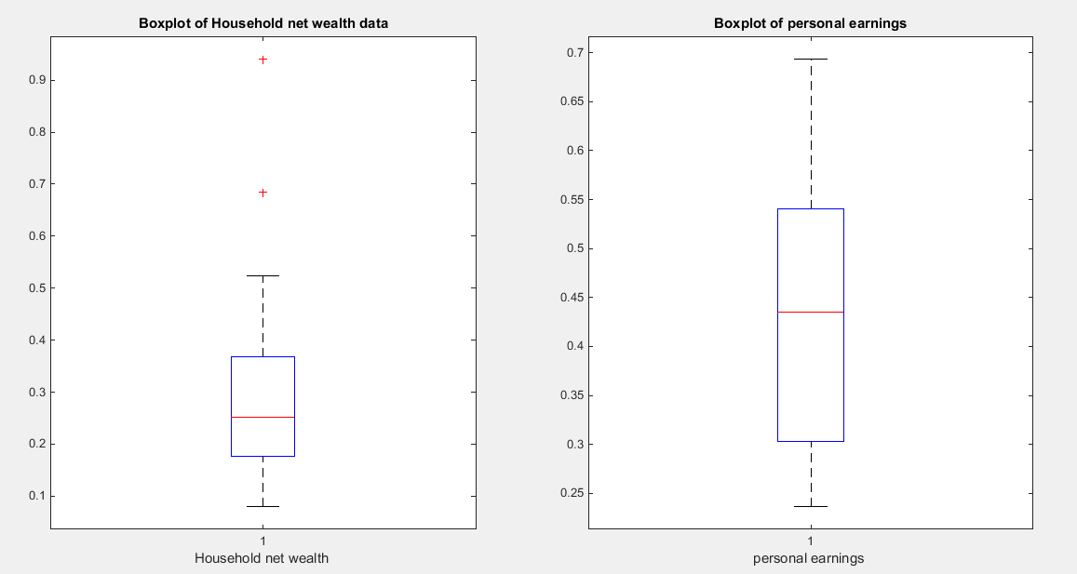
Fig. 26 Boxplot of household net wealth and the personal earnings denoting right side skewness.
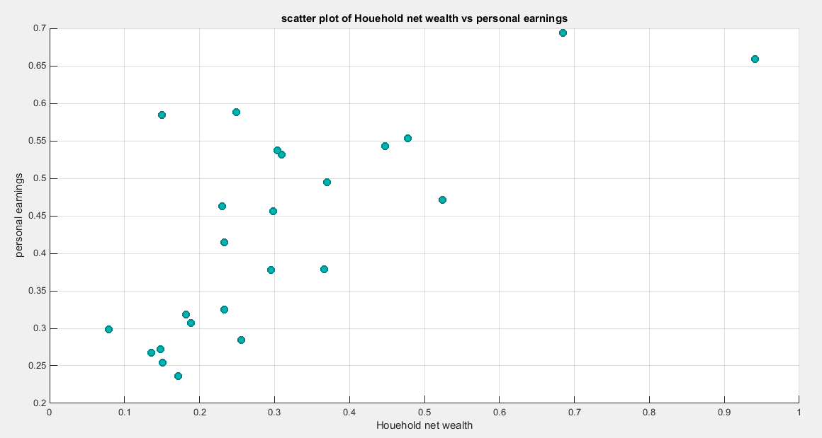
Fig. 27 scatter plot of the household net wealth vs personal earnings and the data are mainly concentrated on the left lower corner and the center. Few data are centered at the upper right corner pointing to the presence of upper tail dependency.
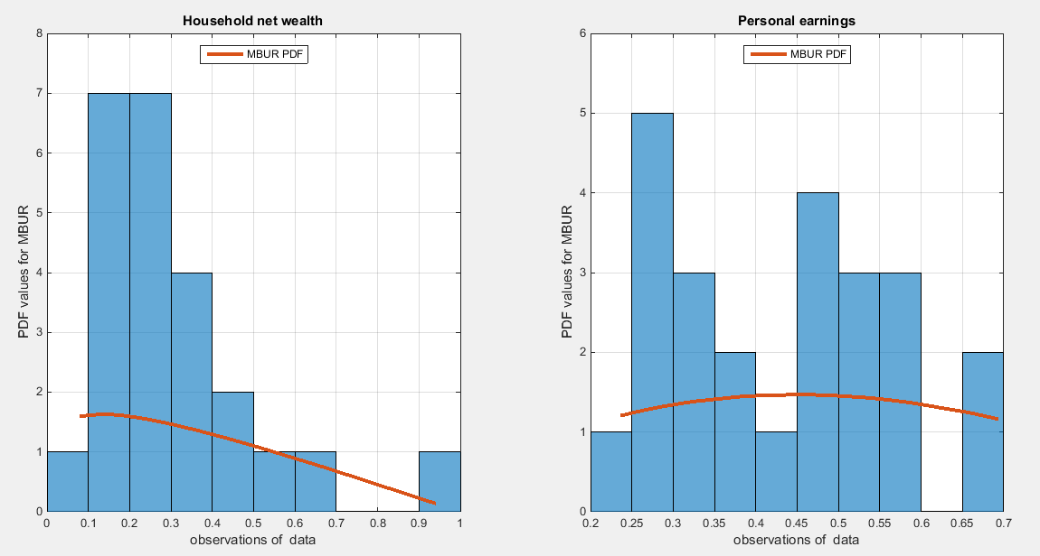
Fig. 28- the histogram of the two indicators which exhibit right sided skewness. The graph also shows the fitted MBUR curve for each indicator. The household net wealth indicator exhibits more kurtosis and skewness than the personal earnings indicator.
Second copula Model the dependency between the ‘household net wealth’ and ‘personal earnings’: The empirical tau is 0.5507 and the theoretical tau is 0.5507 with dissimilarity value of 7.1985e-05. The estimated dependency parameter, theta $\hat{θ}$ , is 0.6703 and estimated variance of 0.0018. The Cramer Von Mises test (CVM) is 0.4281. To test the null hypothesis for dependency, resampling using the Metropolis Hastings algorithm of MCMC procedure was performed. The null hypothesis was stated that the population dependency parameter equals the estimated theta against the alternative hypothesis that the population dependency parameter does not equal the estimated theta. Moreover, the null hypothesis for the equality of the population Kendall tau with the theoretical tau is tested against the alternative hypothesis of not being equal to each other. The null hypothesis for the CVM suggesting that the sampling CVM equals the observed CVM attained from the estimation procedure was also investigated. These are all two sided tests. The sampling distribution of each of the previously mentioned indices, thetas, tau and CVM is shown in Figures (29-31). The descriptive statistical indices are shown in each figure. Analysis of the figures denoted that the indices are within the acceptance region between the 2.5th and 97.5th quantiles. So the null hypotheses fail to be rejected. The copula can be said to pass some of the goodness of fit (GOF) tests for this data. And the dependence parameter reflects, within the context of this copula, the relationship between the two variables. The confidence interval (CI) for the estimated dependence parameter is (-0.0408, 0.9268), for the theoretical tau; it is (0.1314, 0.9756), and for CVM; it is (0.0368, 0.4871).
According to the sandwich variance the variance covariance matrix for this model is:
$$var-cov=\left[\begin{matrix}0.1418 & 0.0964 & 0.0002 \\ 0.0964 & 0.0657 & 0.0002 \\ 0.0002 & 0.0002 & 0.0001\end{matrix}\right]$$
The validity indices for the second stage are:
$AIC=-10.833 , CAIC=-10.6512 BIC= -9.655 HQIC=-10.5205$
The validity indices for the whole model is the summation of these indices for marginal (first stage) and copula (second stage):
$$AIC=-34.1921 , CAIC=-33.6466 BIC= -30.6579 HQIC=-33.2544$$
Theoretical upper tail coefficient is 0.6346. At quantile 0.7; the empirical upper tail coefficient in the direction of the ‘households net wealth’ variable is 0.6667 (2 points showing joint match out of 3 points in the upper tail at this threshold, 0.7) and in the direction of the ‘personal earnings’ variable is 1 (2 points showing joint match out of 2 points in the upper tail at this threshold, 0.7) while the confidence interval of the empirical distribution obtained from bootstrap sampling under the null hypothesis is [0.333,1] in the ‘ households net wealth’ and [0.2857,1] in the direction of ‘personal earnings’. This is expected because of the small sample size and left skewness of data.

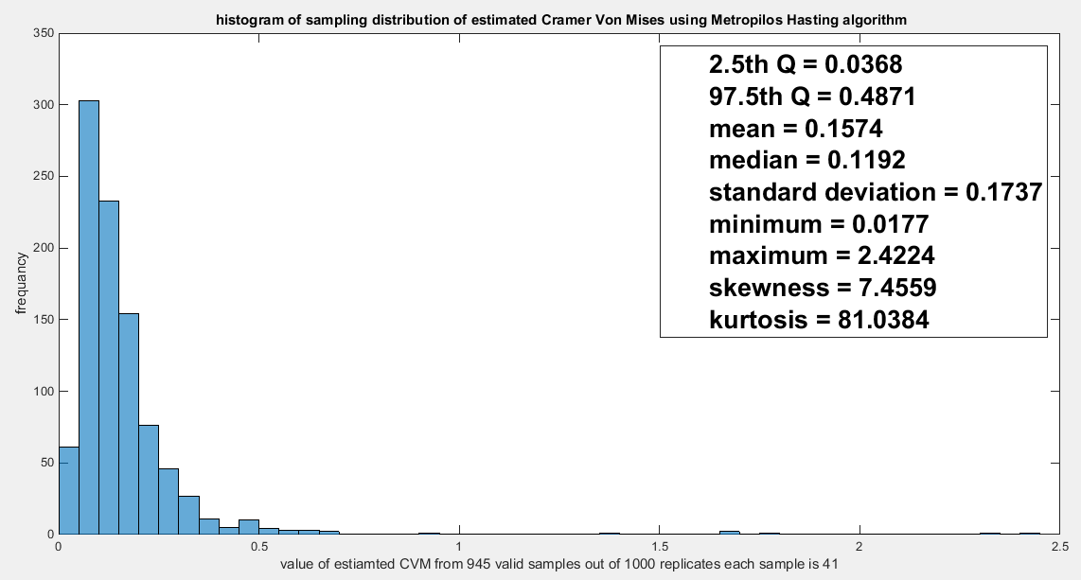
Fig. 29 The sampling distribution of the CVM. The data obtained CVM is 0.4281 and it is between the 2.5th and the 97.5th quantiles so the null hypothesis is failed to be rejected and the copula fits the data well. The p-value (probability of values less than or equal to 0.4281) is 0.9683, in other words, this 0.4281 is not in either of the tail regions of rejection.
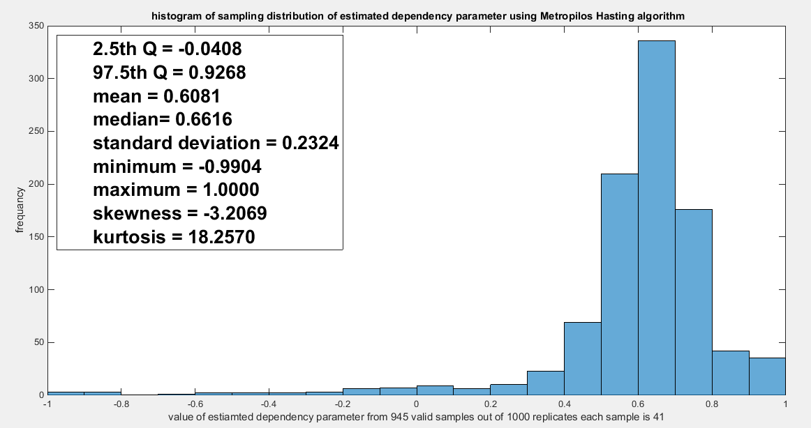
Fig. 30 The sampling distribution of the dependency parameter. The 0.6703 is in the acceptance region between the two quantiles, the 2.5th and the 97.5th quantiles. So the null hypothesis fails to reject its assumption. The p-value (probability of the values being less than or equal to this 0.6703) is 0.5651, which indicates that 0.6703 is not in either zones of rejection.

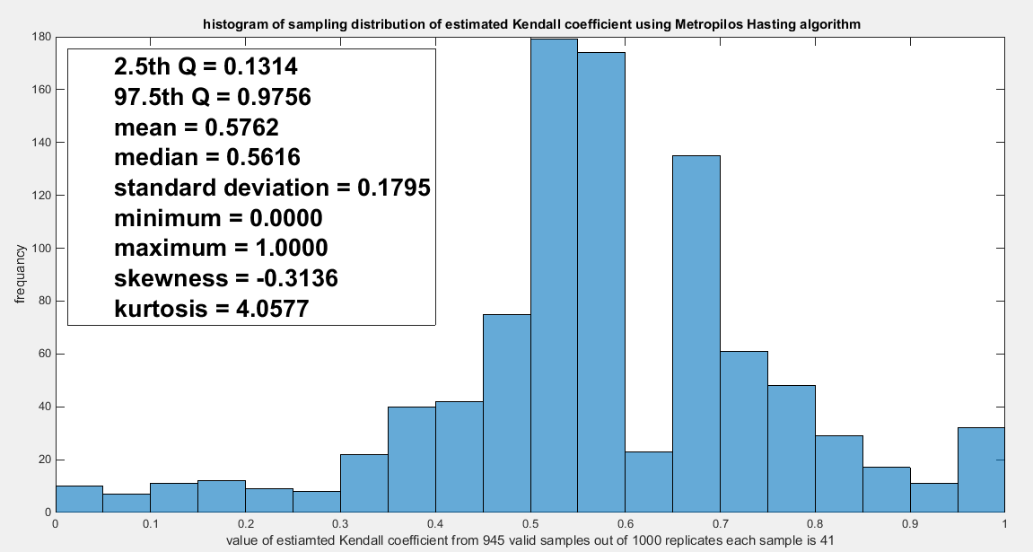
Fig. 31 The sampling distribution of the Kendal tau coefficient. The 0.5507 is between the two quantiles 2.5th and 97.5th which is in the acceptance zone. So the null hypothesis fails to reject its assumption. The p-values (probability of the values less than or equal to 0.5507) is 0.4423 which denotes that this value 0.5507 is far away from both rejection zones on the right and the left.

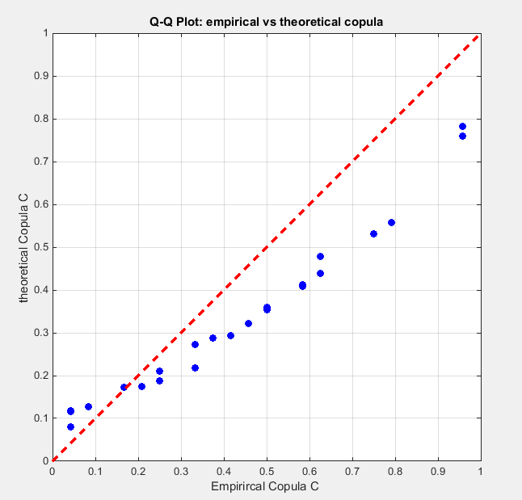
Fig. 32 The P-P plot of the empirical vs the theoretical copula. The theoretical copula shows near perfect alignment of its lower part with the diagonal line than its upper part.
Figure 32 shows the P-P plot of the empirical and theoretical copula. Figure 33-35 show the surface of the density copula, the contour plot of the density copula and the contour plot of the distribution copula at the estimated dependency parameter.
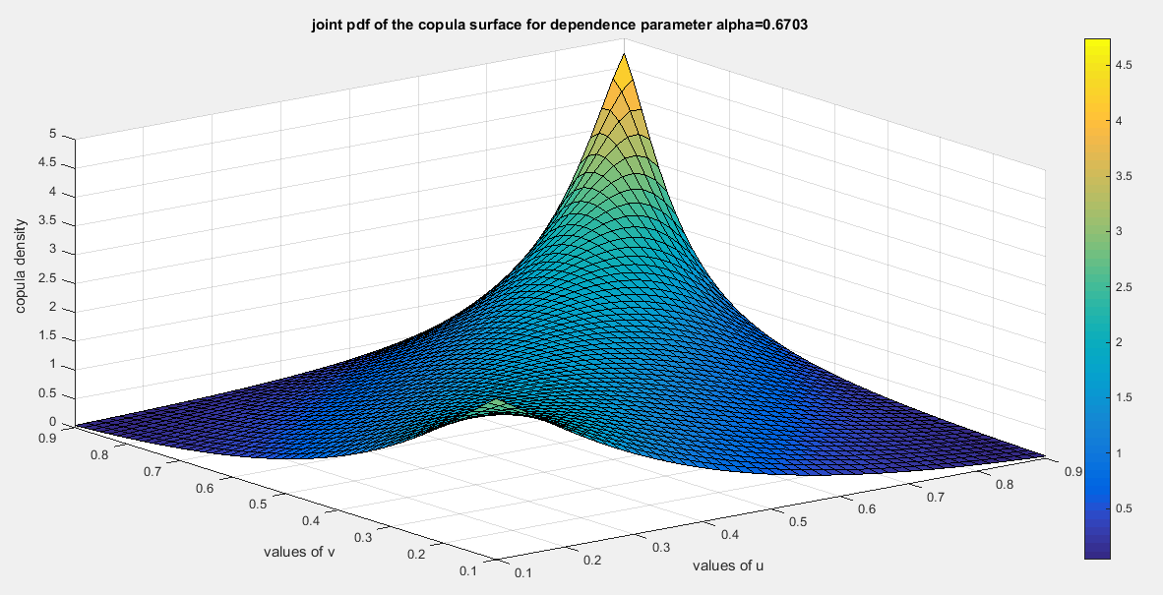
Fig. 33 The surface of the copula density with dependency parameter 0.6703
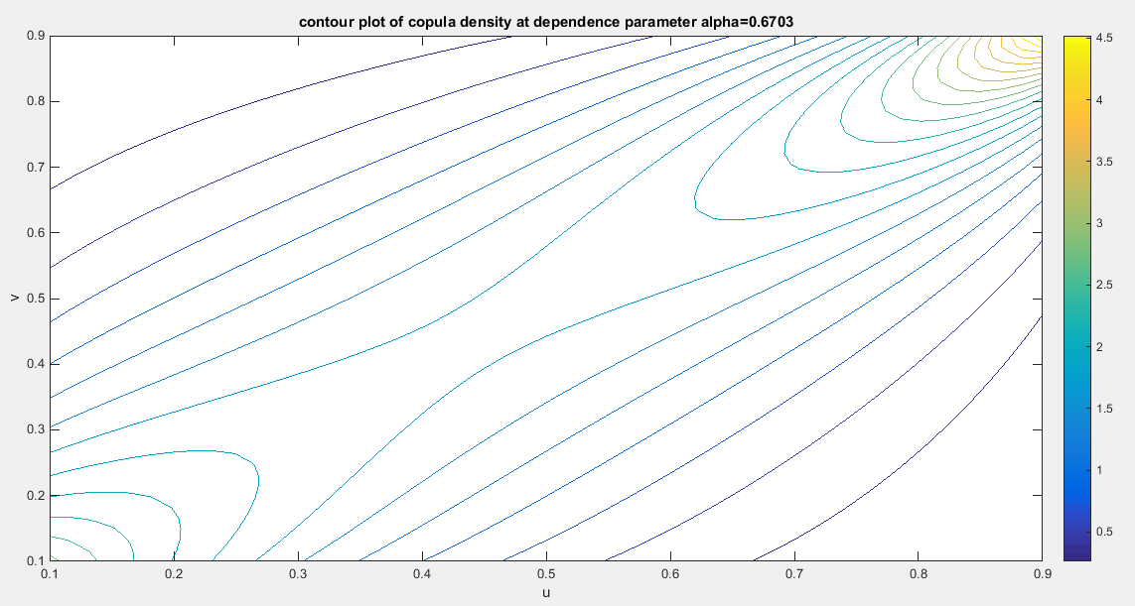
Fig. 34 The contour plot of the copula density with dependency parameter 0.6703

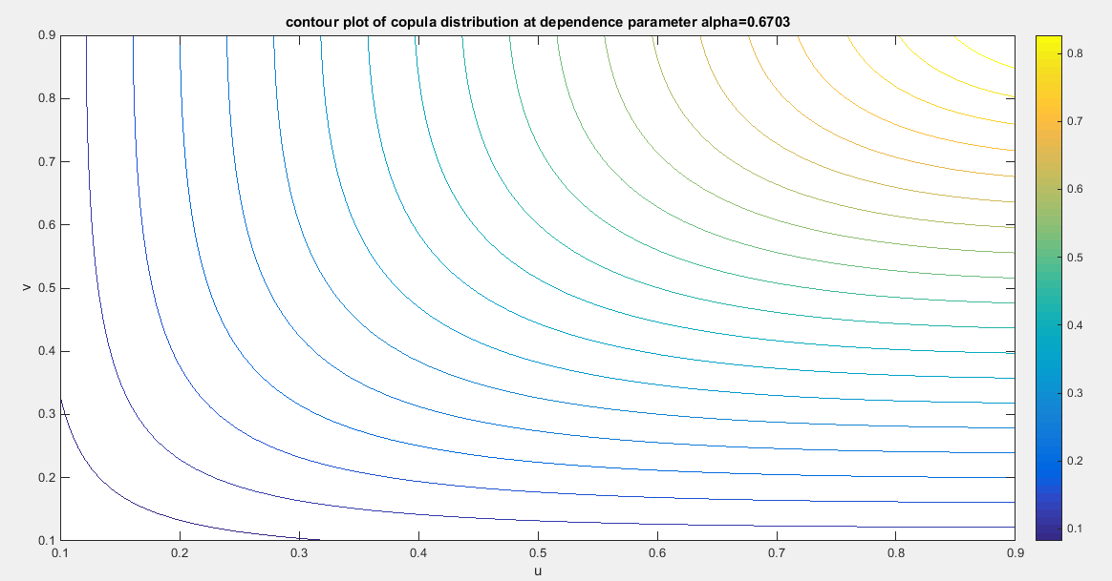
Fig. 35 The contour plot of the copula distribution with dependency parameter 0.6703
5-Conclusions
Both copulas model positive dependency. They can model upper tail dependency but they have no lower tail dependency. The author discussed 2 datasets exhibiting left skewness. Both copulas fit the data well. The author also discussed one dataset exhibiting right skewness and the second copula fit this set well. Both copula fits data that has more or less similar characteristics. The complexity of the the copula density function for both copulas mandates use of IFM method of estimation. This method is preferred over the MLE for its easiness. The robust variance or sandwich variance captures the covariance between the marginal and the copula parameter estimators which are not captures by estimating the variances separately in each stage. The variance of the estimators of marginal parameters increases while the variance of the estimator of copula parameter decreases. Although the sample sizes used in the analysis were small (n=24) and moderate(n=41) both copula model the upper tail dependency well and this was supported by the sampling distribution of the empirical upper tail coefficient.
6-Future Work

These copulas can be mixed with other copulas to better model data with asymmetric dependency. Also other methods of estimation can be attempted like the semiparametric estimation and MLE. Bayesian inference can be considered. Attia-2 copula can be generalized by replacing the exponent (2) in the copula by a free parameter to partially decouple the global dependency from the tail dependency, hence, makes the copula more flexible to real data allowing for asymmetric or extreme heavy tail behaviors. The old dependency parameter controls the global dependence and the newly added parameter controls how strongly the tail behaves relative to the global dependence. Attia-1 and Attia-2 copulas can be nested to obtain the hierarchical Archimedean copulas. Their generators can be attempted to distortion enabling new versions of compound Archimedean copulas.

Disclaimer
This paper is an extended version of a preprint document of the same author.
The preprint document is available in this link: https://doi.org/10.21203/rs.3.rs-7087406/v1
[As per journal policy, preprint /repository article can be published as a journal article, provided it is not published in any other journal]
Disclaimer (Artificial intelligence)

Author(s) hereby declare that NO generative AI technologies such as Large Language Models (ChatGPT, COPILOT, etc.) and text-to-image generators have been used during the writing or editing of this manuscript.

References
Aich, A., Baran Aich, A., & Wade, B. (2025). Two new generators of Archimedean copulas with their properties. Communications in Statistics - Theory and Methods, 54(17), 5566–5575. https://doi.org/10.1080/03610926.2024.2440577
Al Turk, L. I., Abd Elaal, M. K., & Jarwan, R. S. (2017). Inference of bivariate generalized exponential distribution based on copula functions. Applied Mathematical Sciences, 11, 1155–1186. https://doi.org/10.12988/ams.2017.7398
Alzaid, A. A., & Alhadlaq, W. M. (2022). A New Family of Archimedean Copulas: The Truncated-Poisson Family of Copulas. Bulletin of the Malaysian Mathematical Sciences Society, 45(S1), 477–504. https://doi.org/10.1007/s40840-022-01333-w
Alzaid, A. A., & Alhadlaq, W. M. (2023). A New Family of Archimedean Copulas: The Half-Logistic Family of Copulas. Mathematics, 12(1), 101. https://doi.org/10.3390/math12010101
Attia, I. M. (2025). The new generalized odd Median Based Unit Rayleigh. Frontiers in Applied Mathematics and Statistics, 11, 1648127. https://doi.org/10.3389/fams.2025.1648127
Bhat, C. R., & Eluru, N. (2009). A copula-based approach to accommodate residential self-selection effects in travel behavior modeling. Transportation Research Part B: Methodological, 43(7), 749–765. https://doi.org/10.1016/j.trb.2009.02.001
Chen, X. (2007). Chapter 76 Large Sample Sieve Estimation of Semi-Nonparametric Models. In Handbook of Econometrics (pp. 5549–5632). Elsevier. https://linkinghub.elsevier.com/retrieve/pii/S157344120706076X
Chesneau, C. (2023). Extensions of Two Bivariate Strict Archimedean Copulas. Computational Journal of Mathematical and Statistical Sciences, 0(0), 159–180. https://doi.org/10.21608/cjmss.2023.205330.1007
Chesneau, C., & Alhadlaq, W. (2024). Exploring a new two-parameter Archimedean copula: The Gumbel-Joe copula. Hacettepe Journal of Mathematics and Statistics, 53(6), 1742–1758. https://doi.org/10.15672/hujms.1444175
De Lira Salvatierra, I., & Patton, A. J. (2015). Dynamic copula models and high frequency data. Journal of Empirical Finance, 30, 120–135. https://doi.org/10.1016/j.jempfin.2014.11.008
Dokuzoğlu, D., & Purutçuoğlu, V. (2017). Comprehensive Analyses of Gaussian Graphical Model under Different Biological Networks. Acta Physica Polonica A, 132(3–II), 1106–1111. https://doi.org/10.12693/APhysPolA.132.1106
Genest, C., & Mackay, J. (1986). The Joy of Copulas: Bivariate Distributions with Uniform Marginals. The American Statistician, 40(4), 280–283. https://doi.org/10.1080/00031305.1986.10475414
Godambe, V. P. (Ed.). (1991). Estimating Functions. Oxford University PressOxford. https://doi.org/10.1093/oso/9780198522287.001.0001
Gomes, M., Radice, R., Camarena Brenes, J., & Marra, G. (2019). Copula selection models for non‐Gaussian outcomes that are missing not at random. Statistics in Medicine, 38(3), 480–496. https://doi.org/10.1002/sim.7988
Han, B., Tao, Z., Chen, H., Zhou, L., & Liu, J. (2020). A new computational model based on Archimedean copula for probabilistic unbalanced linguistic term set and its application to multiple attribute group decision making. Computers & Industrial Engineering, 140, 106264. https://doi.org/10.1016/j.cie.2019.106264
Joe, H. (2005). Asymptotic efficiency of the two-stage estimation method for copula-based models. Journal of Multivariate Analysis, 94(2), 401–419. https://doi.org/10.1016/j.jmva.2004.06.003
Kelner, M., Landsman, Z., & Makov, U. E. (2026). Advances in multivariate Archimedean copula modeling. Communications in Statistics - Theory and Methods, 55(2), 357–371. https://doi.org/10.1080/03610926.2025.2496694
Kilgore, R. T., & Thompson, D. B. (2011). Estimating Joint Flow Probabilities at Stream Confluences by Using Copulas. Transportation Research Record: Journal of the Transportation Research Board, 2262(1), 200–206. https://doi.org/10.3141/2262-20
Kim, G., Silvapulle, M. J., & Silvapulle, P. (2007). Comparison of semiparametric and parametric methods for estimating copulas. Computational Statistics & Data Analysis, 51(6), 2836–2850. https://doi.org/10.1016/j.csda.2006.10.009
Kole, E., Koedijk, K., & Verbeek, M. (2007). Selecting copulas for risk management. Journal of Banking & Finance, 31(8), 2405–2423. https://doi.org/10.1016/j.jbankfin.2006.09.010
Konigorski, S., Yilmaz, Y. E., & Bull, S. B. (2014). Bivariate genetic association analysis of systolic and diastolic blood pressure by copula models. BMC Proceedings, 8(S1), S72. https://doi.org/10.1186/1753-6561-8-S1-S72
Kuss, O., Hoyer, A., & Solms, A. (2014). Meta‐analysis for diagnostic accuracy studies: A new statistical model using beta‐binomial distributions and bivariate copulas. Statistics in Medicine, 33(1), 17–30. https://doi.org/10.1002/sim.5909
Lapuyade-Lahorgue, J., Xue, J.-H., & Ruan, S. (2017). Segmenting Multi-Source Images Using Hidden Markov Fields With Copula-Based Multivariate Statistical Distributions. IEEE Transactions on Image Processing, 26(7), 3187–3195. https://doi.org/10.1109/TIP.2017.2685345
Liu, Z., Guo, S., Xiong, L., & Xu, C.-Y. (2018). Hydrological uncertainty processor based on a copula function. Hydrological Sciences Journal, 63(1), 74–86. https://doi.org/10.1080/02626667.2017.1410278
Ma, X., Luan, S., Du, B., & Yu, B. (2017). Spatial Copula Model for Imputing Traffic Flow Data from Remote Microwave Sensors. Sensors, 17(10), 2160. https://doi.org/10.3390/s17102160
Oh, D. H., & Patton, A. J. (2018). Time-Varying Systemic Risk: Evidence From a Dynamic Copula Model of CDS Spreads. Journal of Business & Economic Statistics, 36(2), 181–195. https://doi.org/10.1080/07350015.2016.1177535
Oppenheimer, M., Little, C. M., & Cooke, R. M. (2016). Expert judgement and uncertainty quantification for climate change. Nature Climate Change, 6(5), 445–451. https://doi.org/10.1038/nclimate2959
Pearse, A. R., & Bondell, H. (2025). Power-divergence copulas: A new class of Archimedean copulas, with an insurance application (Version 1). arXiv. https://doi.org/10.48550/ARXIV.2510.06177
Rodrigues, G. M., Ortega, E. M. M., Vila, R., & Cordeiro, G. M. (2023). A New Bivariate Family Based on Archimedean Copulas: Simulation, Regression Model and Application. Symmetry, 15(9), 1778. https://doi.org/10.3390/sym15091778
Salvadori, G., Michele, C. D., Kottegoda, N. T., & Rosso, R. (2007). Extremes in Nature: An Approach Using Copulas (Vol. 56). Springer Netherlands. https://doi.org/10.1007/1-4020-4415-1
Schölzel, C., & Friederichs, P. (2008). Multivariate non-normally distributed random variables in climate research – introduction to the copula approach. Nonlinear Processes in Geophysics, 15(5), 761–772. https://doi.org/10.5194/npg-15-761-2008
Sklar, A. (1973). Random Variables, Joint distribution functions , and copulas. Kybernetika, 9(6), 449–460.
Susam, S. O. (2020). A New Family of Archimedean Copula via Trigonometric Generator Function. Gazi University Journal of Science, 33(3), 806–813. https://doi.org/10.35378/gujs.635032
Tsukahara, H. (2005). Semiparametric estimation in copula models. Canadian Journal of Statistics, 33(3), 357–375. https://doi.org/10.1002/cjs.5540330304
Valle, D., & Kaplan, D. (2019). Quantifying the impacts of dams on riverine hydrology under non-stationary conditions using incomplete data and Gaussian copula models. Science of The Total Environment, 677, 599–611. https://doi.org/10.1016/j.scitotenv.2019.04.377
Weiß, G. (2011). Copula parameter estimation by maximum-likelihood and minimum-distance estimators: A simulation study. Computational Statistics, 26(1), 31–54. https://doi.org/10.1007/s00180-010-0203-7
Xu, J. J. (2009). Statistical modelling and inference for multivariate and longitudinal discrete response data. https://doi.org/10.14288/1.0087914

APPENDIX
First Copula
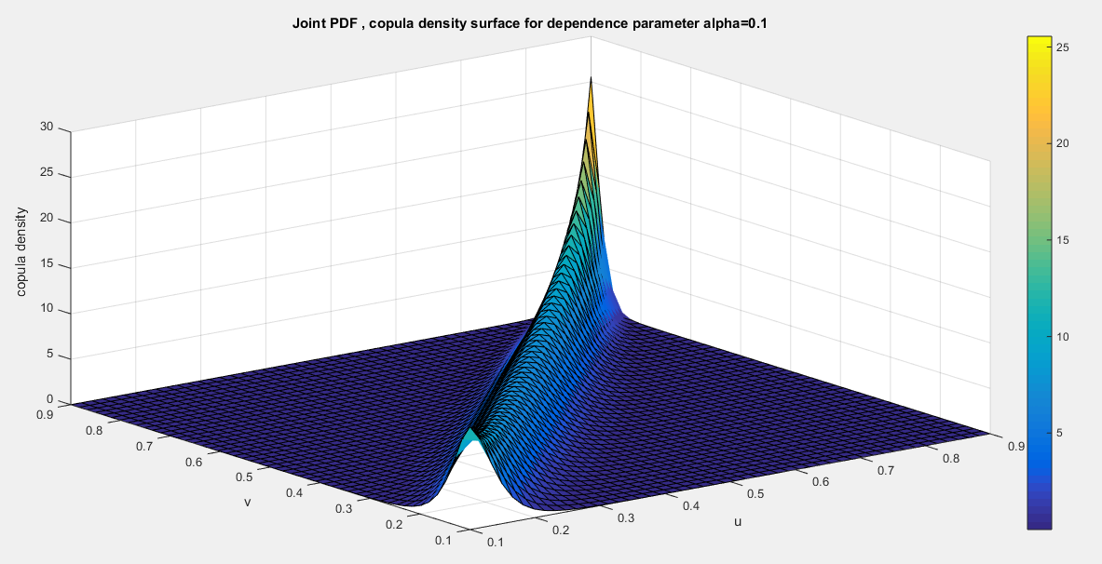
Fig A1: First Copula density surface for Dependence parameter alpha=0.1
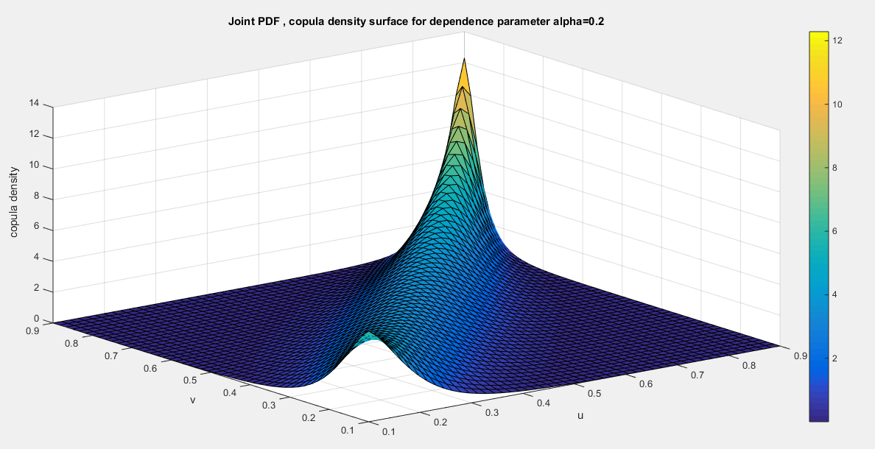
Fig A2: First Copula density surface for Dependence parameter alpha=0.2

Fig A3: First Copula density surface for Dependence parameter alpha=0.3
Fig A4: Contour plot of First Copula density at Dependence parameter alpha=0.3
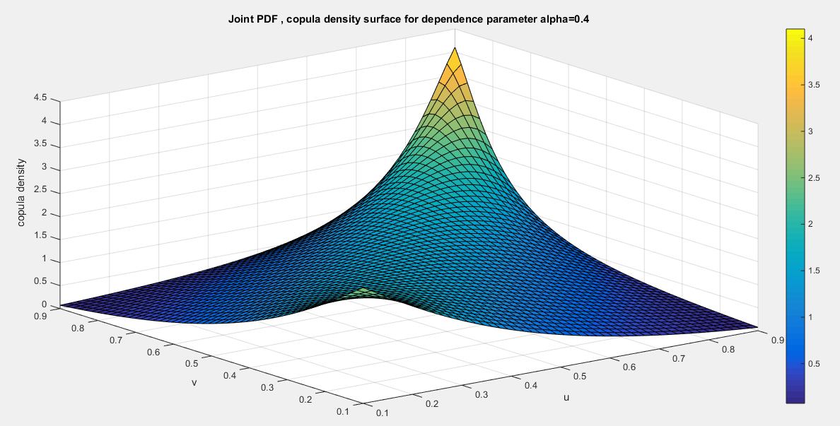
Fig A5: First Copula density surface for Dependence parameter alpha=0.4
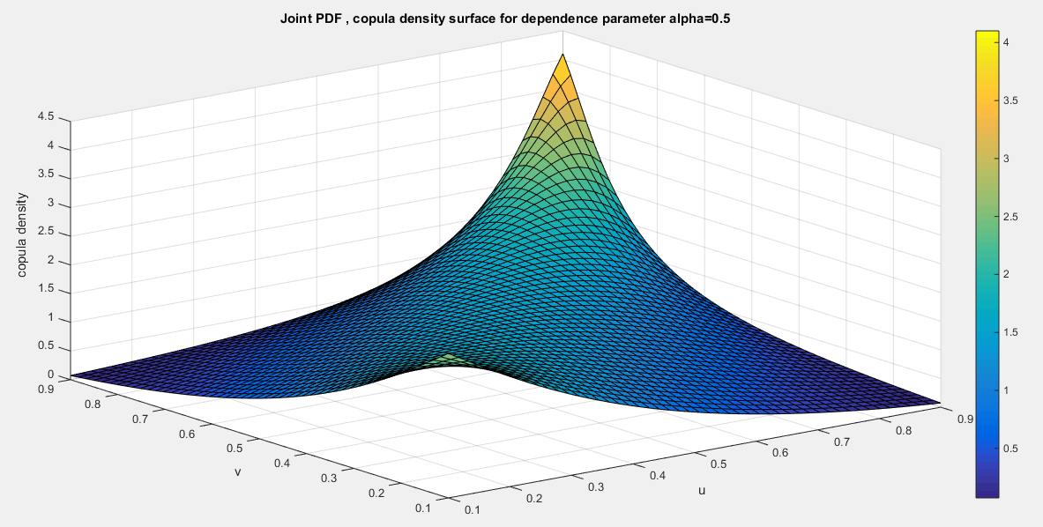
Fig A6: First Copula density surface for Dependence parameter alpha=0.5
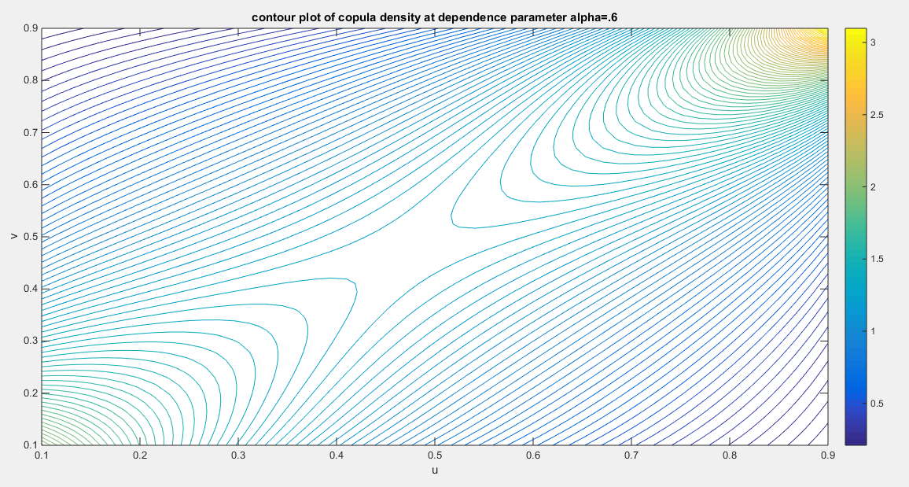
Fig A7: Contour plot of First Copula density at Dependence parameter alpha=0.6
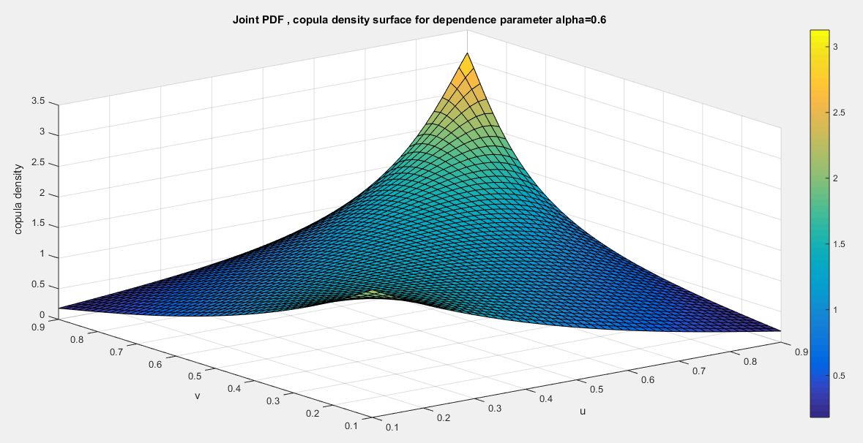
Fig A8: First Copula density surface for Dependence parameter alpha=0.6
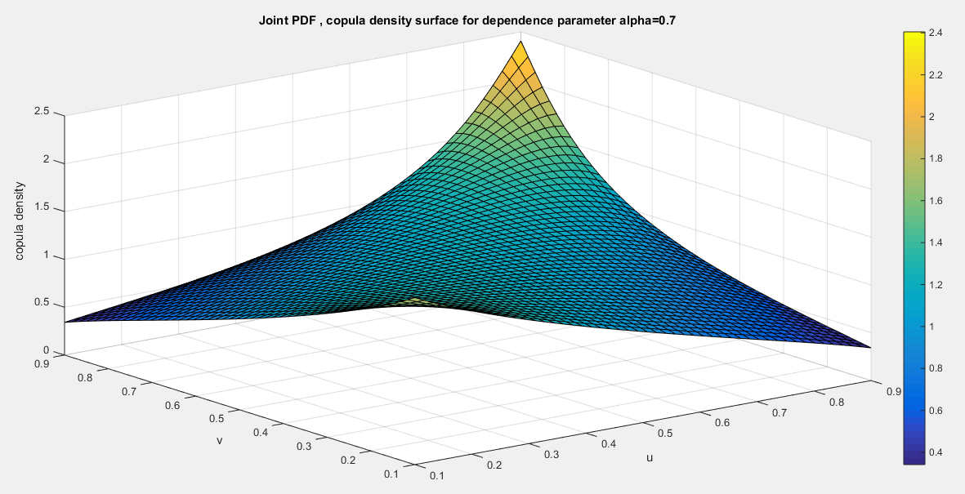
Fig A9: First Copula density surface for Dependence parameter alpha=0.7
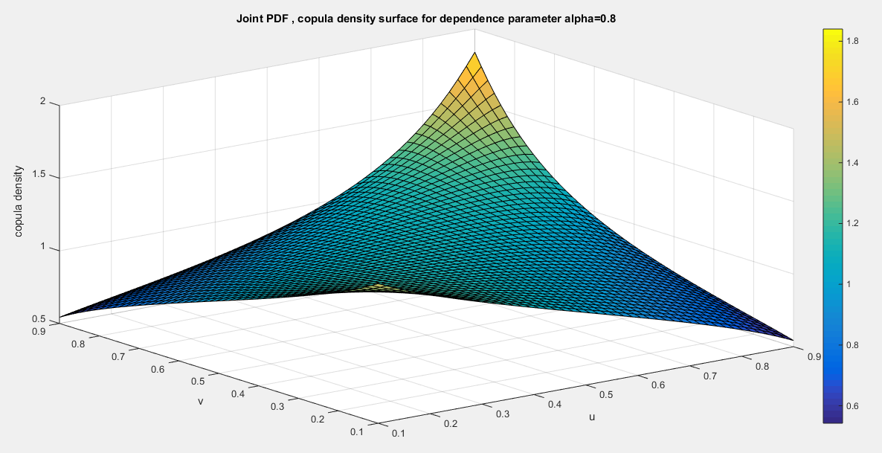
Fig A10: First Copula density surface for Dependence parameter alpha=0.8
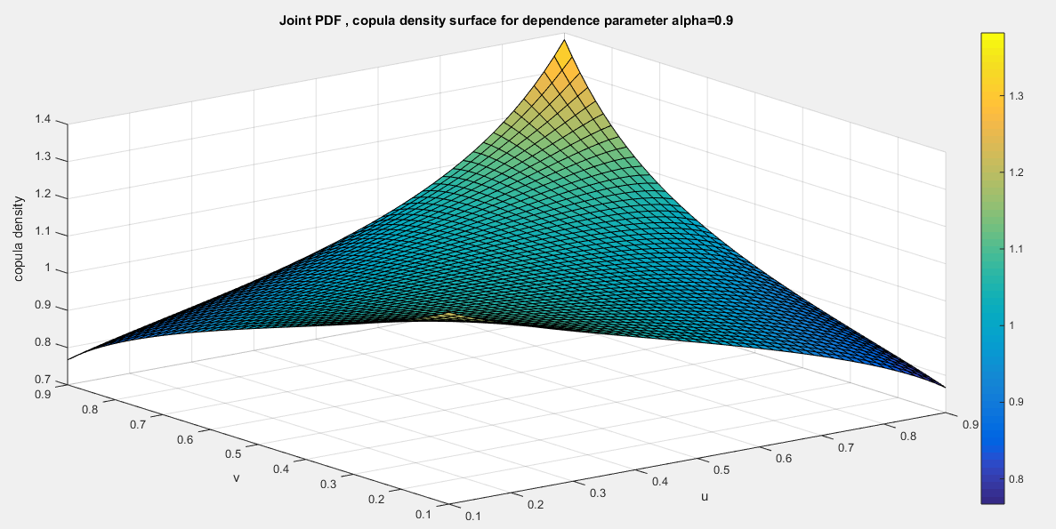
Fig A11: First Copula density surface for Dependence parameter alpha=0.9
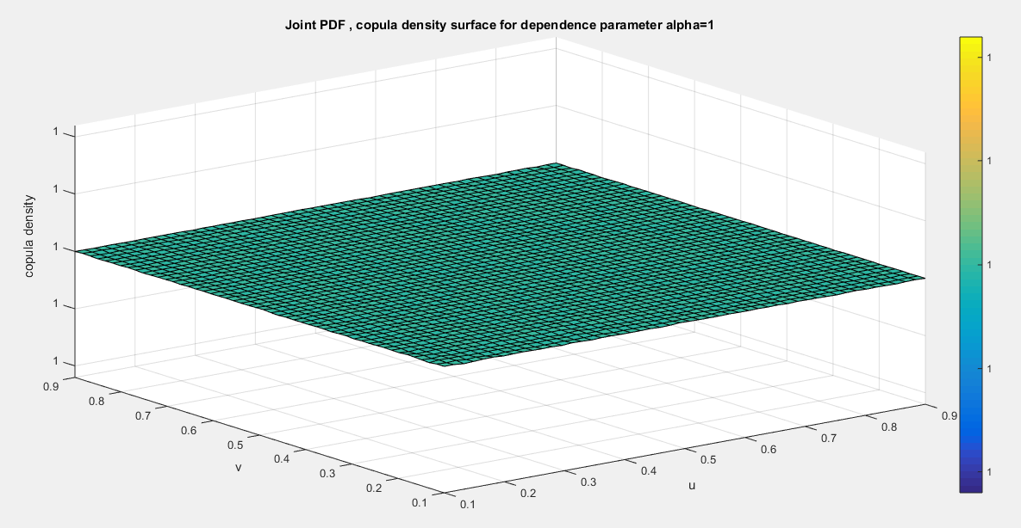
Fig A12: First Copula density surface for Dependence parameter alpha=1
This is the product copula that can be attained at dependency parameter 1

Second copula
Fig A13: Second Copula density surface for Dependence parameter alpha=0.1
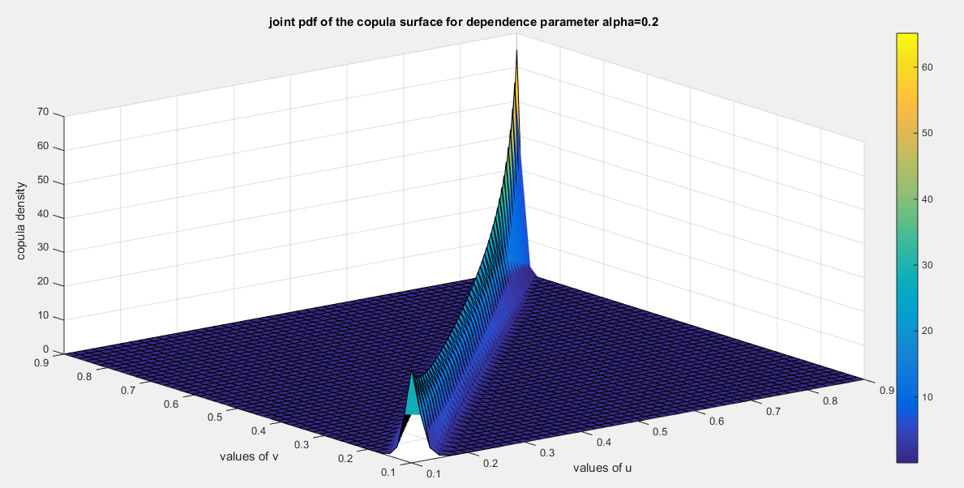

Fig A14: Second Copula density surface for Dependence parameter alpha=0.2

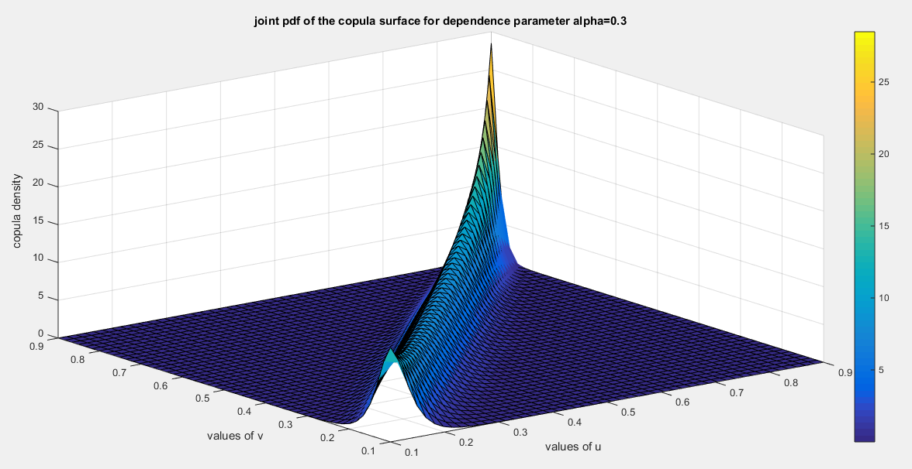
Fig A15: Second Copula density surface for Dependence parameter alpha=0.3
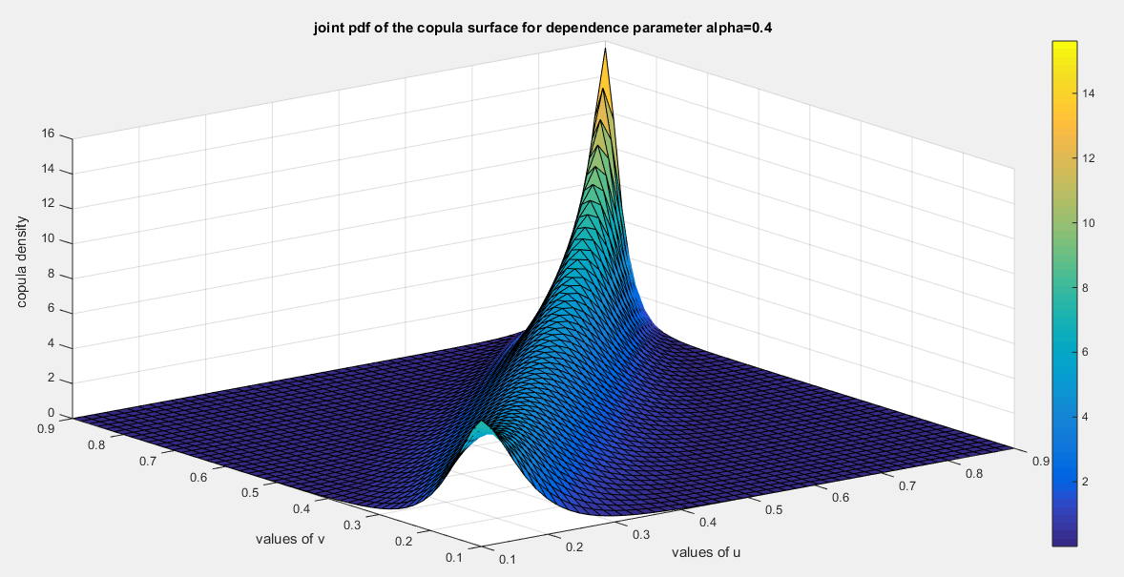
Fig A16: Second Copula density surface for Dependence parameter alpha=0.4

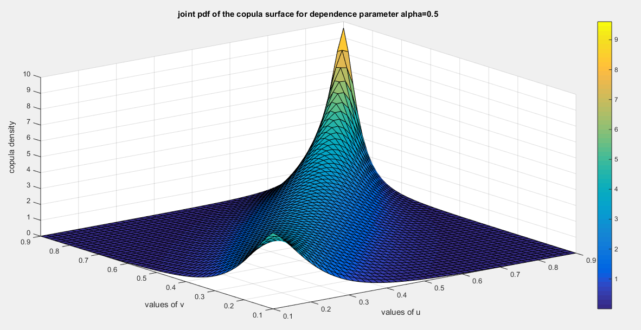
Fig A17: Second Copula density surface for Dependence parameter alpha=0.5
Fig A18: Contour Plot of Second Copula density at Dependence parameter alpha=0.5
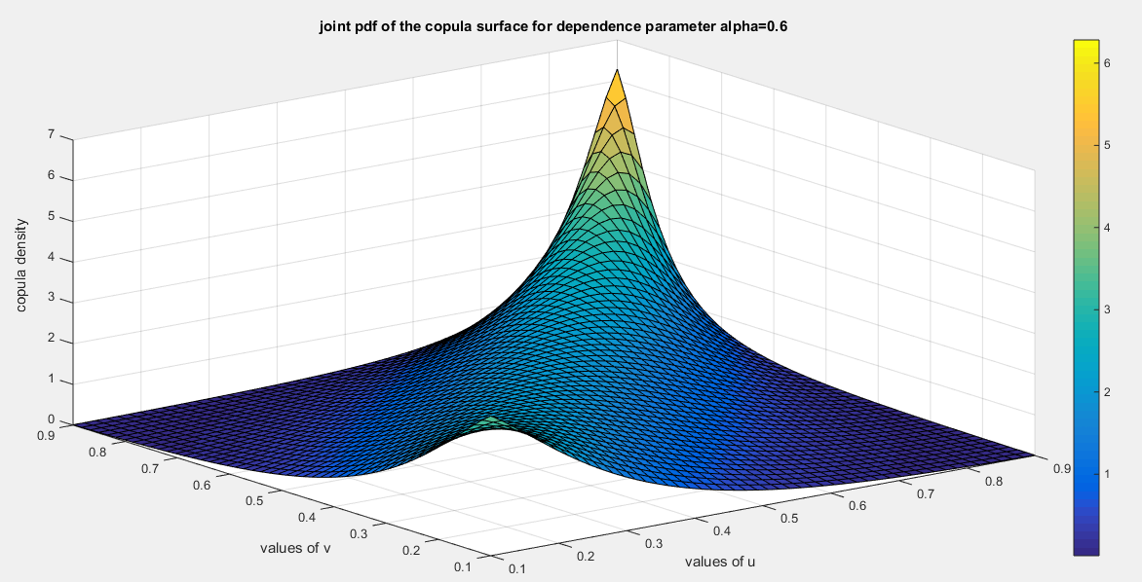
Fig A19: Second Copula density surface for Dependence parameter alpha=0.6
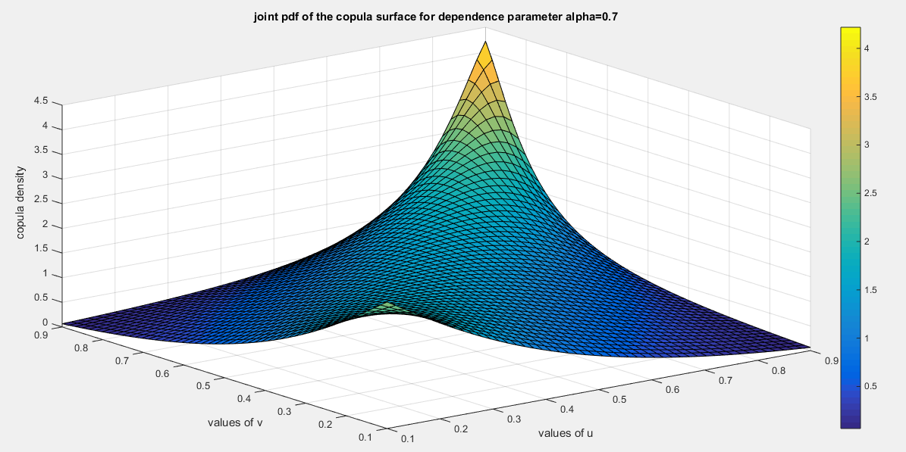
Fig A20: Second Copula density surface for Dependence parameter alpha=0.7
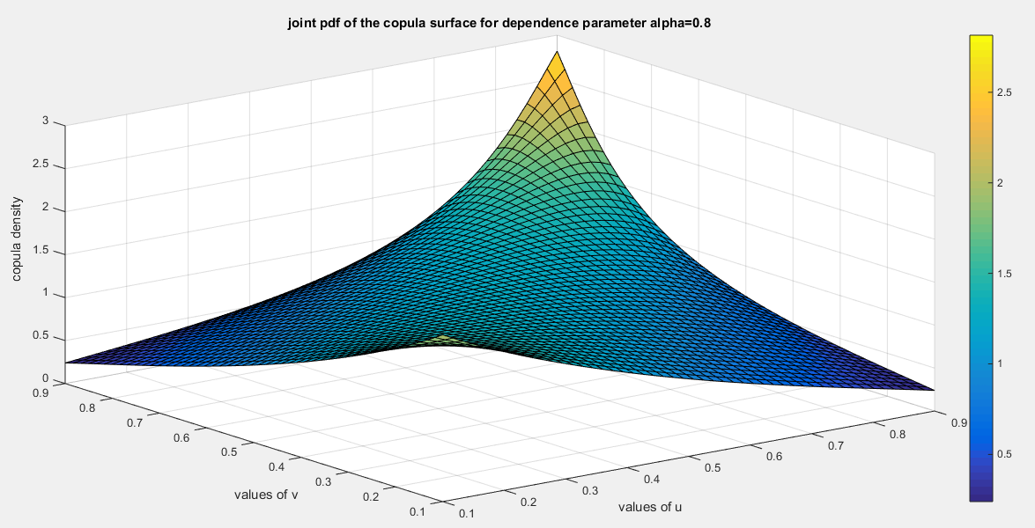
Fig A21: Second Copula density surface for Dependence parameter alpha=0.8
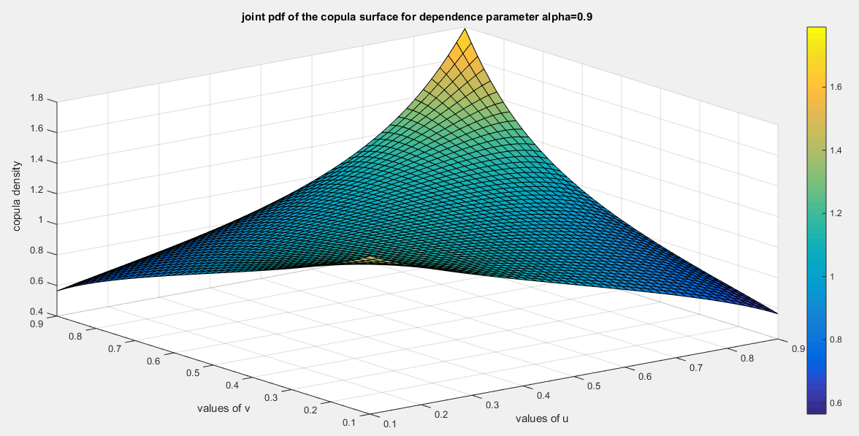
Fig A22: Second Copula density surface for Dependence parameter alpha=0.9

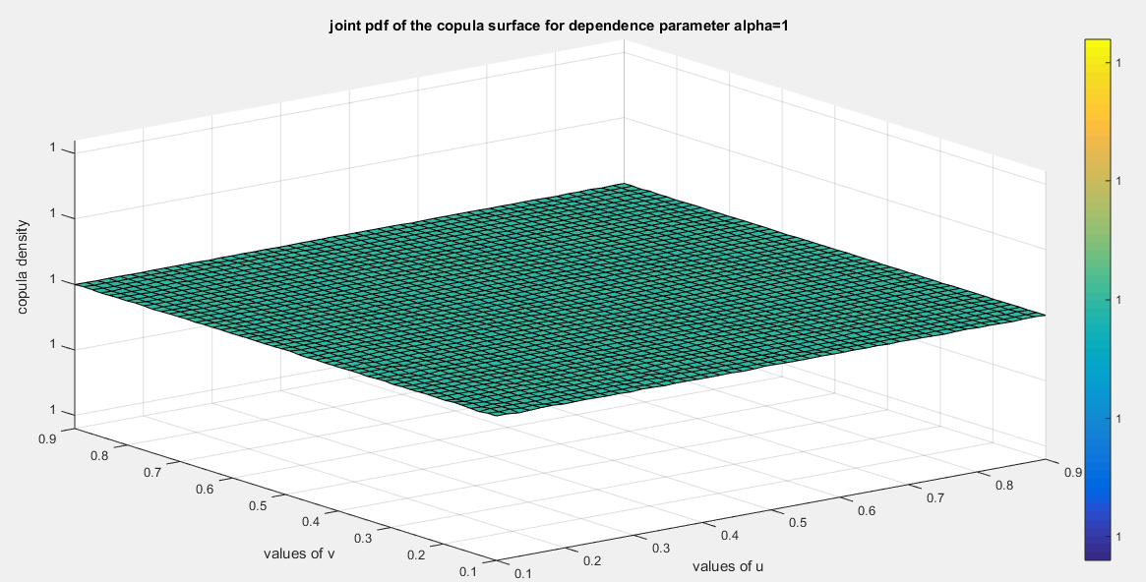
Fig A23: Second Copula density surface for Dependence parameter alpha=1

This is the product copula that can be attained at dependency parameter 1 or -1

