Parametric Quantile Regression using Median Based Unit Rayleigh Distribution: Analysis of OECD Safety Indicators

Abstract: This study conducts an in-depth exploration of the field of parametric quantile regression while introducing the new Median Based Unit Rayleigh (MBUR) distribution. The estimation process is meticulously designed through a re-parameterized maximum likelihood function, which is exemplified using a real-world dataset that effectively illustrates the underlying theoretical concepts. The author further engages in a comprehensive analysis of inference and goodness of fit. The study encompasses a thorough analysis of a real-world dataset characterized by proportions, which exposed significant deviations from the assumptions of normality and homoscedasticity. This intricate dataset revealed the presence of outliers, rendering traditional regression methods and generalized linear models ineffective for accurate analysis. Conversely, parametric quantile regression emerged as a robust alternative, adeptly addressing the challenges associated with outliers while negating the requirement for normality and accommodating heteroscedasticity. By examining the complexities inherent in proportional data, this study emphasizes the potential of both parametric quantile regression and the median-based unit Rayleigh in facilitating analysis. The core findings reveal a positive association between the employment rate and safety outcomes, whereas air pollution demonstrates a negative association in the analyses involving single predictors. However, in the context of the multivariate model, the employment rate exhibits a dominant effect. The exclusion of the employment rate results in a notable decline in likelihood, as indicated by a significant likelihood ratio test (LRT), whereas the removal of the air pollution variable yields minimal changes, accompanied by a non-significant LRT. Consequently, the recommended final model supports the inclusion of the employment rate exclusively.
Keywords:
Parametric Quantile Regression Models, Median Based Unit Rayleigh (MBUR) distribution, logit link function, clog-log function, Nelder-Mead optimizer
Introduction
Quantile regression is a powerful tool for examining the relationships between covariates and response variables, particularly when dealing with highly skewed distributions. This method becomes especially valuable when the distribution has a well-defined, closed-form quantile function, allowing for reparameterization of the probability density function (PDF) and the log-likelihood function. In these scenarios, parametric quantile regression presents a compelling alternative to traditional least squares regression models, particularly when the underlying assumptions—such as normality and homoscedasticity—may not hold true.
Moreover, quantile regression demonstrates robustness in the presence of outliers, which can distort the estimation of regression coefficients and affect the inference process. The extensive literature on quantile regression showcases its varied applications across many disciplines. Notably, using the median as a conditioning point is often more resilient to outliers and skewed data compared to the mean. This makes it a preferable choice in regression models influenced by these characteristics, although any quantile can be employed for analysis.
The revolutionary transmuted Unit Rayleigh distribution, unveiled by Korkmaz et al. in 2021 [1], stands out as an intriguing and innovative alternative to the well-established beta and Kumaraswamy regression models. In the same year, Korkmaz and Chesneau introduced the unit Burr-XII distribution, along with a sophisticated quantile regression model that expands the horizons of statistical analysis [2].
Adding to this wealth of knowledge, Korkmaz et al.[3] also presented the novel Arcsecant hyperbolic normal distribution, accompanied by a set of powerful quantile regression models. In 2023, Korkmaz et al. [4] further enriched the discourse by introducing the Arcsecant hyperbolic Weibull distribution, demonstrating its practical applications in quantile regression tailored for proportionate data sourced from the OECD platform.
Korkmaz et al. [5] have also conducted a significant investigation into the unit Chen distribution and its quantile regression model, shedding light on their potential applications and benefits. Kumar et al. [6] employed the Unit-Gompertz model to adeptly characterize inter-record times, showcasing its versatility
Mazucheli et. al., have significantly advanced the field of quantile regression models, particularly with his pioneering work on unit distributions. Their contributions include the refined unit Weibull regression models [7], the innovative unit Birnbaum-Saunders model [8], and the sophisticated Vesicek quantile and mean regression models designed for proportional data [9]. Further, they introduced a one-parameter unit Lindley application in 2019 [10], and unit Gompertz regression quantile model [11] .
Noufaily and Jones [12] have provided an in-depth exploration of the generalized gamma distribution, including its application within the framework of parametric quantile regression modeling. This work originated from Noufaily's Ph.D. thesis in 2011 and has been further disseminated through published research since 2013.
Leiva and his team have shared their expertise on Birnbaum-Saunders distributions, providing detailed descriptions and analyses that have evolved since their initial work in 2016 [13]. Their insights are further supported by a range of contributions from multiple authors, including Sánchez, Leiva, and Galea, who have collectively documented the characteristics of this distribution in several studies [14]&[15]. Gracia-Papani et al. have also provided a detailed explanation of this distribution [16]. Sanchez et al. introduced the quantile regression model for the Wiebull distribution [17].
The exploration of quantile regression models unveils a diverse array of distributions that significantly enhance the analytical capabilities available to researchers. The insights derived from these models, as articulated by Marchant et al. [18] , Leão et al. [19] , and Leiva et al. [20], ], are of great value, providing robust methodologies that improve data interpretation.
To facilitate these analyses, various R packages have been developed that implement quantile regression techniques. In 2020, Mazucheli collaborated with Alves to create the Vasicekreg package, designed to handle specific types of regression tasks. The following year, they introduced the Ugomquantreg package, which further extends capabilities in this domain. Meanwhile, in the same year of 2020, Mazucheli partnered with Menezes to develop the unitBSQuantReg package, which focuses on unit-based distributions. Menezes also contributed to the toolkit by creating the UWquantreg package, designed for weighted quantile regression. Lastly, in 2021, Roger Koenker unveiled the quantreg package, a foundational tool widely utilized in the field of quantile regression analysis.
Numerous authors have delved into the intricacies of parametric quantile regression, a powerful statistical tool used to analyze proportional data. This approach allows researchers to uncover and illuminate the complex relationships between variables and their predictors, offering a deeper understanding of how these elements interact within various contexts. To mention some of those authors: [21], [22], [23], [24], [25], [26], [27], [28], [29], [30], [31].
This paper offers a comprehensive examination of the Median-based Unit Rayleigh (MBUR) distribution, a concept recently introduced by the author [32]. Utilizing OECD data, the author applies parametric MBUR quantile regression techniques, focusing on response variables that are characterized by the MBUR distribution. The study aims to deepen the understanding of this distribution and its applications in statistical modeling.
Methodology
1.1. Parametric MBUR Quantile Regression Model
The response variable adheres to the Median Based Unit Rayleigh (MBUR) distribution, which adds complexity to the analysis. To uncover the association between this variable and its influencing covariates, it is essential to define both the parametric function and the link function meticulously. Given that the response variable may exhibit significant skewness and potentially breach the assumptions of normality and homoscedasticity, employing parametric quantile regression could provide a resilient alternative. Nevertheless, it is vital to delve into a myriad of other methodologies to ensure the most accurate and reliable estimation outcomes. The MBUR distribution was discussed by Attia [33]. It has the following PDF, CDF, and quantile function as respectively expressed in equations (1-3). The parametric quantile regression (PQR) depends on the quantile function.
$$f\left(y\right)=\frac{6}{α^{2}}\left[1-y^{\frac{1}{α^{2}}}\right]y^{\left(\frac{2}{α^{2}}-1\right)} , 0<y<1 , α>0 ( 1 )$$
$$F\left(y\right)={3y}^{\frac{2}{α^{2}}}-{2y}^{\frac{3}{α^{2}}} , 0<y<1 , α>0 ( 2 )$$
$$y=F^{-1}\left(y\right)={\left\{-.5\left(cos\left[\frac{\cos^{-1}\left(1-2u\right)}{3}\right]-\sqrt{3} sin\left[\frac{\cos^{-1}\left(1-2u\right)}{3}\right]\right)+.5\right\}}^{α^{2}} (3)$$

Re-parameterize the PDF and CDF of MBUR using the quantile function, $=c^{α^{2}}$, where c is $c=-.5\left(cos\left[\frac{\cos^{-1}\left(1-2u\right)}{3}\right]-\sqrt{3} sin\left[\frac{\cos^{-1}\left(1-2u\right)}{3}\right]\right)+.5 , u∈\left(0,1\right) .$ U represents the chosen percentile, if it is the median, so u=0.5, if it is the 25th percentile so u=0.25 so $α^{2}=\frac{ln\left(y\right)}{ln\left(c\right)}$ .When replacing u=0.5 in c, this gives $ln(.5)=-.6931$ , $α^{2}=\frac{ln\left(y\right)}{ln\left(c\right)}=\frac{ln\left(median\right)}{ln\left(c\right)}$ . As y is the median corresponding to u=0.5.
1.2. The Link Function
The linear predictor, $φ=X^{'}B= β_{0}+β_{1}x_{i1}+…+β_{k}x_{ik} ; i=1,..., n \& k=1,…,k$, can be expressed using different link functions as the logit, clog-log, or the log-log link function. This linear predictor represents the median that should be estimated, where n is the number of cases or observations and k is the number of variables. These link functions of the median are discussed in details by Attia [34].
1.2.1. Logit Link Function
Using the logit function of the median, which will be called $μ$
$$Logit \left(median\right)= logit\left(μ\right)=φ=X^{'}B= β_{0}+β_{1}x_{i1}+…+β_{k}x_{ik} ; i=1,..., n \& k=1,…,k$$
where n is the number of cases or observations and k is the number of variables. Logit median is the linear combination of variables.
So; $μ=\frac{e^{X^{'}B}}{1+e^{X^{'}B}} = \frac{e^{φ}}{1+e^{φ}}$ & $α^{2}=\frac{ln\left(y\right)}{ln\left(c\right)}=\frac{ln\left(median\right)}{ln\left(c\right)}= \frac{ln\left(\frac{e^{X^{'}B}}{1+e^{X^{'}B}}\right)}{ln\left(c\right)}= \frac{ln\left(\frac{e^{φ}}{1+e^{φ}}\right)}{ln\left(c\right)} , 0<y<1 , α>0$
1.2.2. Complementary Log-Log Link Function
$$\log\left\{-\log\left(1-median\right)\right\}= X^{'}B=φ= β_{0}+β_{1}x_{i1}+…+β_{k}x_{ik} ; i=1,.., n \& k=1,..,k$$
$$median=1- e^{-e^{X^{'}β}}=1-exp\left(-exp\left(X^{'}β\right)\right) \& α^{2}=\frac{ln\left(median\right)}{ln\left(c\right)}=\frac{ln\left(1- e^{-e^{φ}}\right)}{ln\left(c\right)}$$
1.2.3. Log-Log Median Link Function
A link function other than the logit can be used. The author used the log-log function
$$\log\left\{-\log\left(median\right)\right\}= X^{'}B=φ= β_{0}+β_{1}x_{i1}+…+β_{k}x_{ik} , i=1,2,….., n \& k=1,2,…..,k$$
$$median= e^{-e^{X'β}}=exp\left(-exp\left(X^{'}β\right)\right) \& α^{2}=\frac{ln\left(median\right)}{ln\left(c\right)}=α^{2}=\frac{ln\left( e^{-e^{X'β}}\right)}{ln\left(c\right)}=\frac{-e^{X^{'}β} }{ln\left(c\right)}$$
Goodness of Fit criteria
2.1. Diagnostic Tests for Model Specification
Model adequacy, as regards the appropriate response variable distribution and the used link function, can be appraised using two residual-based diagnostics: randomized quantile residuals (RQ)[35] and Cox-Snell residuals (CS)[36]. The RQ residuals follow approximately a standard normal distribution, and the (CS) residuals follow a standard exponential distribution , [37] , [38].

2.1.1. Randomized quantile (RQ) residuals: $r_{i}^{RQ}= Φ^{-1}\left(F\left(y_{i} , \hat{β}\right)\right)$
$Φ$ is the standard normal CDF. F is the re-parameterized MBUR CDF. $y_{i}$’s are the observations and $\hat{β}$ are the estimated regression coefficients. These residuals are approximately distributed as standard normal. When the model is correctly specified, these residuals approximately follow the standard normal distribution.
2.1.2. Cox-Snell (CS) residuals: $r_{i}^{CS}= -log\left(1-F\left(y_{i} , \hat{β}\right)\right)$
Cox-Snell residuals are approximately distributed as a standard exponential distribution with a scale parameter one. The negative logarithm mentioned above represents the cumulative distribution function (CDF) of the standard exponential distribution with this scale parameter. When the model is correctly specified, these residuals will approximately follow a standard exponential distribution.
2.2. Model Selection Criteria:
Model selection is conducted by identifying the options with the minimum values of AIC (Akaike Information Criterion), BIC (Bayesian Information Criterion), and Corrected AIC, ensuring that the chosen models are optimal for analysis. $AIC=-2l\left(\hat{θ}\right)+2 p$, $CAIC=AIC+\frac{2 p\left(p+1\right)}{n-p-1}$ , $BIC=-2l\left(\hat{θ}\right)+ p\log\left(n\right)$ , where p is the number of parameters and n is the sample size.
In the study conducted by Sánchez, Leiva, Saulo, and colleagues in 2021 [14], they applied a specific methodological approach, $R_{M}^{2}$ , that corresponds directly to established practices, usual $R^{2}$ , in mean regression. This approach is instrumental in yielding reliable estimates and is meticulously defined within the context of regression analysis. Through these criteria and methodologies, researchers can effectively compare and assess the suitability of various models, facilitating improved decision-making in statistical modeling, $R_{M}^{2}=1-exp\left(\frac{2}{n}\left(l\left(\check{θ}\right)-l\left(\hat{θ}\right)\right)\right)$, where $l\left(\check{θ}\right) and l\left(\hat{θ}\right)$ are the maximum log-likelihood for the model without covariates (null model) and the model with all covariates (Full model).
OECD Data Analysis, Results and Discussion
Appendix A presents the dataset obtained from the OECD database, which stands for the Organization for Economic Co-operation and Development. The author utilized the Nelder-Mead optimizer in MATLAB to estimate the parameters and applied the finite central difference method to estimate the variance. The dataset can be accessed at (https://stats.oecd.org/index.aspx?DataSetCode=BLI). The OECD platform records numerous variables, and the author conducted distributional fits for these indicators after transforming them into a ratio defined on the unit interval. The distribution tested was the Median-Based Unit Rayleigh (MBUR) distribution. The variable that best fit the MBUR distribution was used as the response variable, while those that did not conform to this specific distribution served as predictors. The analysis aimed to uncover the relationship between the response variable, feeling safe while walking alone, and the predictors, which included the employment rate and air pollution. The MBUR distribution effectively fits the response variable, which demonstrated skewness and violated the normality assumption. Consequently, the author employed parametric quantile regression, specifically the parametric median regression, since the median is a robust measure in cases where the normality assumption is violated and when outliers are present.
The descriptive statistics for the response variable (feeling safe walking alone) are as follows: the mean is 0.7207, the standard deviation is 0.143, the skewness is -0.9486, the kurtosis is 3.0353, the minimum is 0.4, the maximum is 0.93, the 25th percentile is 0.655, the median is 0.76, and the 75th percentile is 0.8225.
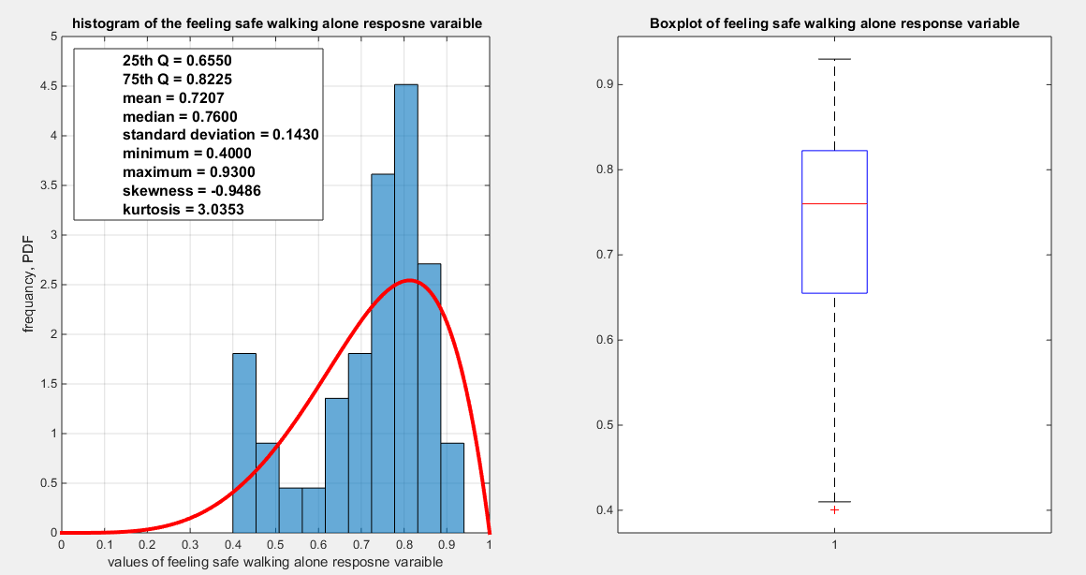
Fig. 1 The histogram and the boxplot of the feeling safe walking alone variable
The response variable is left-skewed, exhibiting nearly normal kurtosis (mesokurtic), with one extreme value present in the lower tail. The MBUR fits this response variable. The dataset consists of 41 observations, which is the highest number of observations for any variable within this database. Figure 1 displays the histogram and box plot of the response variable.
For the response variable, three different link functions were used and the results were compared. The first link function is the logit, the second one is the log-log complementary link function or the clog-log link function, and the third is the log-log link function. The aspects of comparison are the LL, AIC, CAIC, BIC, HQIC, LRT, and pseudo R squared. The estimation of regression coefficients is performed using the Nelder-Mead optimizer and the variance covariance matrix is obtained using the Finite Central difference formula. Each analysis is accompanied by figures illustrating the estimated curve, a QQ plot for the residuals, and plots of the residuals against the predictors.
Feeling safe walking alone was regressed on two predictors, one at a time and then combined in a full model. Figure 2 shows the scatter plot that detects the relationship between the response variable and each transformed predictor. The author displayed figures for the logit model, illustrating the estimated curve, the relationship between the predictor and the residuals, and the QQ plot comparing the empirical residuals to the theoretical residuals.
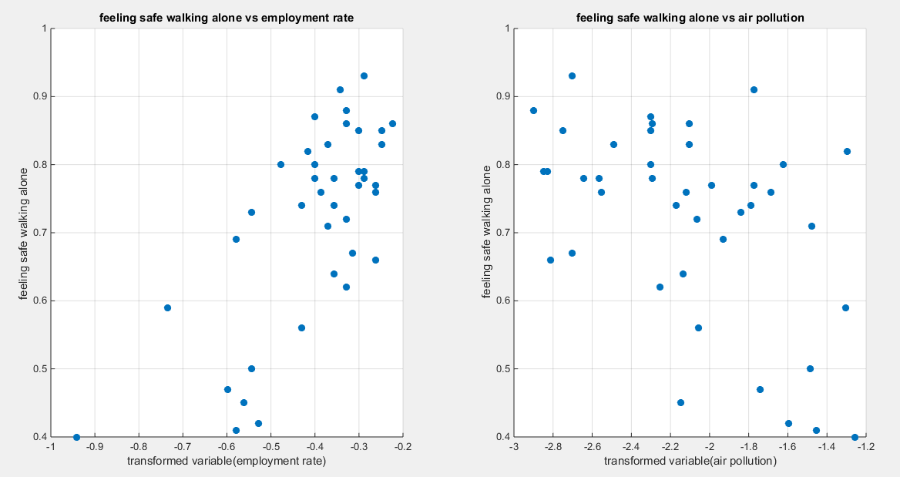
Fig. 2 The scatter plot of the response variable and each of the predictor. The relationship is nonlinear relationship.
The predictors are the employment rate (X1) and the air pollution (X2). Both variables are transformed using the division by 100 then taking the log of the result. The relationship can be modeled using the parametric median quantile regression. The relationship between the response variable and each of the predictor is nonlinear. Tables 1 and 2 present the results obtained from regressing the feeling safety walking alone on each predictor. Different link functions were used, and a comparison of various statistical indices was made, including estimated coefficients, the Likelihood Ratio Test (LRT) and its p-value, as well as AIC, CAIC, BIC, HQIC, and the log-likelihood (LL).
Table 1: Regressing feeling safe walking alone on the employment rate
 | Logit link function |  | Log-log complementary |  | Log-log median
B0 | 2.5148 |  | 1.0998 |  | -2.4163
B1 | 3.3982 |  | 1.8957 |  | -2.7691
LL | 31.3853 |  | 31.3853 |  | 31.2662
Wald stat. of b0 | 5.9094 (p < 0.025) |  | 4.9135 (p < 0.025) |  | 6.9349 (p < 0.025)
Wald stat. of b1 | 3.2037 (p < 0.025) |  | 3.1599 (p < 0.025) |  | 3.3565 (p <0.025)
AIC | -58.7706 |  | -58.8158 |  | -58.5324
CAIC | -58.4548 |  | -58.5001 |  | -58.2166
BIC | -55.3434 |  | -55.3887 |  | -55.1052
HQIC | -57.5226 |  | -57.5679 |  | -57.2844
LRT | 13.6359 (p=2.2190e-4) |  | 13.6812(p=2.1662e-4) |  | 13.3977 (p=2.5193e-4)
R-squared | 0.2829 |  | 0.2837 |  | 0.2788
P-value for randomized quantile residuals | 0.0630 at 5% significance level |  | 0.0848 at 5% significance level |  | 0.0442 at 1% significance level
p-value for Cox-Snell residuals | 0.0630 at 5% significance level |  | 0.0848 at 5% significance level |  | 0.0442 at 1% significance level
Variance-covariance matrix | 0.1811 | 0.4301 | 0.0501 | 0.1283 | 0.1214 | 0.2721
Variance-covariance matrix | 0.4301 | 1.1251 | 0.1283 | 0.3599 | 0.2721 | 0.6806
QR vs. predictor(tau,p) | (-0.0174,0.8837) |  | (-0.0174,0.8837) |  | (-0.0149 , 0.9015 )
CS vs. predictor(tau,p) | (-0.0174,0.8837) |  | (-0.0174,0.8837) |  | (-0.0149 , 0.9015 )

Table 1 shows that the predictor is significant as likelihood ratio test (LRT) is high around 13. The R squared is also high for this predictor around 0.28 across the different link functions. The AIC, CAIC, BIC, HQIC and LL are more or less equal across the different models. The LL is around 31 across the link functions. The residuals plotted against the predictors show no specific trend and they are randomly scattered. The QQ plot shows that the randomized quantile residuals are perfectly aligned with the diagonal at the center, while the Cox Snell residuals shows perfect alignment at the lower tail. Figure 3-5 show that the relationship between the estimated median and the transformed predictor is increasing reflecting that the more the employment rate is, the more the percentage expressing feeling safe walking alone is. This relationship is consistent across different links. The difference is mainly manifested in the slope of the estimated curve of the estimated median against the predictor. To assess the assumption of constant variance in the median parametric regression model, residual-based diagnostic tests were conducted using both randomized quantile (RQ) and Cox-Snell (CS) residuals. For each type of residual, an auxiliary regression of the squared residuals on the corresponding predictor was estimated by ordinary least squares, and the null hypothesis of homoscedasticity (H₀: constant variance) was tested. The results indicted no significant relationship between the squared residuals and the predictor variable (CS: p=0.538, R-squared=0.00979; RQ: p=0.408, R-squared=0.0176), suggesting that the variance of the residuals remained approximately constant across the range of the predictor. Furthermore, the magnitude of the CS residuals was within a reasonable range (four values between 2.1136 and 3.0478), which supports the absence of heteroscedasticity. These findings provide evidence that the fitted median regression model satisfies the homoscedasticity assumption. These results are for the logit model. Figures 3-9 show the previous results.
Table 2: Regressing feeling safe walking alone on air pollution
 | Logit link function |  | Log-log complementary |  | Log-log median
B0 | -0.4385 |  | -0.4842 |  | 0.0944
B1 | -0.7413 |  | -0.3869 |  | 0.6492
LL | 28.3374 |  | 28.2522 |  | 28.3682
Wald stat. of b0 | 0.7358 ( p >0.025) |  | 1.4844 (p>0.025) |  | 0.1857 ( p >0.025)
Wald stat. of b1 | 2.7362 (p <0.025) |  | 2.7155 (p<0.025) |  | 2.7607 (p<0.025)
AIC | -52.6748 |  | -52.5045 |  | -52.7363
CAIC | -52.3590 |  | -52.1887 |  | -47.0321
BIC | -49.2476 |  | -49.0773 |  | -49.3092
HQIC | -51.4268 |  | -51.2565 |  | -51.4883
LRT | 7.5401 (p-val.=0.006) |  | 7.3698 (p-val.=0.006) |  | 7.6016 (p-val.=0.0058)
R-squared | 0.1680 |  | 0.1645 |  | 0.1692
P-value for randomized quantile residuals | 0.2505 |  | 0.2830 |  | 0.2378
p-value for Cox-snell residuals | 0.2505 |  | 0.2830 |  | 0.2378
Variance-covariance matrix | 0.3552 | 0.1577 | 0.1064 | 0.0454 | 0.2585 | 0.1166
Variance-covariance matrix | 0.1577 | 0.0734 | 0.0454 | 0.0203 | 0.1166 | 0.0553
QR vs. predictor(tau,p) | (0.0159, 0.8927) |  | (0.0159, 0.8927) |  | (0.0159, 0.8927)
CS vs. predictor(tau,p) | (0.0159, 0.8927) |  | (0.0159, 0.8927) |  | (0.0159, 0.8927)

Table 2 shows that the predictor is significant as likelihood ratio test (LRT) is high around 7; but it is less than that of the employment rate. The R squared is also high for this predictor around 0.16 across the different link functions. The AIC, CAIC, BIC, HQIC and LL are more or less equal across the different models. The LL is around 28 across the link functions. The residuals plotted against the predictors show no specific trend and they are randomly scattered. The QQ plot shows that the randomized quantile residuals are perfectly aligned with the diagonal at the center while the Cox Snell residuals show perfect alignment at the lower tail. Figures 10-12 shows that the relationship between the estimated median and the transformed predictor is decreasing reflecting that the more the air pollution is, the less the percentage expressing feeling safe walking alone is. The difference is mainly manifested in the slope of the estimated curve. To assess the assumption of the constant variance in the median parametric regression model, residual-based diagnostic tests were conducted using both randomized quantile (RQ) and Cox-Snell (CS) residuals. For each type of residual, an auxiliary regression of the squared residuals on the corresponding predictor was estimated by ordinary least squares, and the null hypothesis of homoscedasticity (H₀: constant variance) was tested. The results indicted no significant relationship between the squared residuals and the predictor variable (CS: p=0.816, R-squared=0.0014; RQ: p=0.873, R-squared=0.000667), suggesting that the variance of the residuals remained approximately constant across the range of the predictor. Furthermore, the magnitude of the CS residuals was within a reasonable range (one value 2.0259), which supports the absence of heteroscedasticity. These findings provide evidence that the fitted median regression model satisfies the homoscedasticity assumption. These results are for the logit model. Figures 10-16 show the previous results.
The marginal correlations between the response and the predictors are shown in Table 3. The response variable, feeling safe walking alone, shows a positive and statistically significant correlation with the employment rate, in contrast to a negative and statistically significant correlation with the air pollution. Additionally, the employment rate exhibits a statistical significant negative correlation with the air pollution.
Table 3: The marginal correlation matrix Kendall tau coefficient and associated p-value
 | Feeling safe walking alone (Y) | Employment rate (X1) | Air  Pollution (X2)
Feeling safe walking alone(Y) | 1 | 0.4038  P=2.8625e-4 | -0.3333  P=0.0025
Employment rate (X1) | 0.4038  P=2.8625e-4 | 1 | -0.4135  P=1.9355e-4
Air  Pollution (X2) | -0.3333  P=0.0025 | -0.4135  P=1.9355e-4 | 1

The condition indices obtained from the standardized transformed X’X are 2.0437, and 1. The VIF for the employment rate is 1.6040 and for the air pollution is 1.6040. So as the largest condition index is 2.0437 is less than 10 and the VIF values are less than 5 so there is no evidence of significant multi-collinearity between the predictors.
The signs of the coefficients for the marginal correlations align with the signs of the conditional correlation coefficients when regressing the response variable "feeling safe walking alone" on each predictor individually. In the multiple regression analysis, the employment rate shows a positive relationship with the response variable, while air pollution is negatively associated with "feeling safe walking alone," which is consistent with findings from simple regression.
The author included these two predictors in a single equation and applied different link functions. Subsequently, each predictor was removed one at a time, and the likelihood ratio test (LRT) was calculated to assess the significance of each predictor while controlling for the other. The results are summarized in Tables 4 and 5. Each row represents a model. The first row is the full model and the associated standard error for each coefficient (SE). The second row represents the second model with the removed predictor X1 (Rx1 stands for the removed first predictor from the full model) and this is applicable to the remaining rows. The estimated standard error is recorded below each estimated coefficient for each variable. The colored area represents the removed predictor from the model. The LRT is recorded with its associated p-value below it. The Log-Likelihood is also recorded. There is a column documenting the sign preservation if all predictors keep their sign consistent with the signs in the simple regression model. All the models presented in Table 4 show the model adequacy diagnostic tests for residual types, the QR and CS residuals. Table 5 shows the AIC, CAIC, BIC, and HQIC for different models. The author used the logit link function for the full model and for each of the nested and reduced models.
Table 4: the coefficients of parametric median regression analysis with removal of different predictors and the associated standard error
 | intercept | X1  Coeff. | X2  Coeff. | Preserve sign | LRT &  P value | LL
Full  Model  SE | 2.1946  11.9447 | 3.1597  0.2790 | -0.1071  2.7688 | Yes | 13.7226  0.001 | 31.4286
Rx1  SE. | -0.4385  11.3807 |  | -0.7413  2.5953 | Yes | 6.1825  0.019 | 28.3374
Rx2  SE | 2.5148  0.5648 | 3.3982  0.2604 |  | yes | 0.0867  0.7684 | 31.3853
Reduced  model | 1.0804 |  |  |  |  | 24.5673
Table 5: AIC, CAIC, BIC and HQIC.
 | AIC | CAIC | BIC | HQIC | R squared
Full  model | -56.8573 | -56.2086 | -51.7166 | -54.9853 | 0.2844
Rx1 | -52.6748 | -52.3590 | -49.2476 | -51.4268 | 0.1400
Rx2 | -58.7706 | -58.4548 | -55.3434 | -57.5226 | 0.0021
Reduced  model | -47.1347 | -47.0321 | -45.4211 | -46.5107

Tables 4 and 5 show that when removing the employment rate (X1), LL decreases from 31.4286 to 28.3374 and the LRT is 6.1825 which is statistically significant (p=0.019); while removing X2 minimally decreases the LL from 31.4286 to 31.3853 and the LRT is 0.0867 which is statistically insignificant (p= 0.7684) denoting that the employment rate is more significant and important than the air pollution. Furthermore; the LL of the full model is minimally reduced when removing X2 since X1 is remaining and the LL of regressing the response on X1 is 31.3853. The AIC of the model involving X1 (AIC= -58.7706) is less than that of the full model with two predictors (AIC=-56.8573) and this is due to the penalty of the number of the parameters paid when the number of parameters increases. So removing X2 is advised. Hence, regressing feeling safe walking alone on the employment rate is the best model.
Conclusions
The regression analysis is a fundamental statistical tool used to model the relationship between the response variable and the and one or more of the explanatory variables. The classical regression, focuses on modeling the mean response. It requires some assumptions to be fulfilled like normality, homoscedasticity and lack of outliers. When any of these assumptions is violated especially if the response distribution is skewed, heavy tailed or heteroscedastic and in the presence of outliers, the classical regression model may lead to misleading estimates and inference, in other words; model misspecification. The parametric quantile regression generalizes this framework by modeling the conditional quantiles, allowing for a richer understanding of the response distribution. It produces more reliable and interpretable results particularly for asymmetric and heavy-tailed data. In both simple and multiple settings, it provides a comprehensive view of how predictors influence different regions of the response distribution, rather than only its average behavior. It is robust to outliers so it is valuable for skewed or heavy-tailed data. It allows the response distribution to follow non-normal distribution so it flexibly provides a complete description of the response distribution at different regions and how the predictors affect its low, median and high quantiles differently. It naturally handles the heteroscedasticity violation (non-constant variance) across the predictors by allowing quantile specific slopes. In this study, and for the above mentioned properties, the author harnessed the power of parametric quantile regression to elegantly model some of the bounded response data recorded in the OECD data platform adding depth and precision to this statistical technique. In simple parametric quantile regression, the quantile regression lines for the 25th , 50th and 75th percentiles were approximately parallel indicating that the effect of the predictor on the response variable was consistent across the conditional distribution of the response. This suggests a location shift of the effect of the distribution rather than a scale change, implying that the predictor influences the central tendency of the response without affecting its variability. The feeling safe walking alone at night is positively correlated with the employment rate and negatively correlated with the air pollution. Both predictors are statistically significant in the simple regression models. But in the multiple regression models, the employment rate surpasses the air pollution in significance and importance. The nested model and the full model discussed in this paper, passed the model adequacy tests as regards the diagnostic tests of the randomized quantile residuals and the Cox-Snell residuals. The models are well specified as regards the chosen parametric PDF of the MBUR distribution and any of the link functions like the logit, clog-log and the log-log functions. The author tested for the presence of the multicollinearity between predictors, and there was no evidence of significant multicollinearity problem. There was also no evidence of heteroscedasticity, although the parametric quantile regression accounts for this problem and can naturally manage it.
Future work
The limitation of this study is that other well-known unit distributions modeling the skewed data like the beta, Kumaraswamy and other new unit distributions have not been tested against the MBUR. Also the generalized linear model that models the conditional mean of the distribution in relation with the predictors can be attempted in the future to compare the results with that of the parametric quantile regression models and which of these models are better. Also the non-parametric quantile regression models can be for further studies. The non-parametric quantile regression models can be an alternative solution especially if the response variables have no closed form for their quantile functions or their moments require special function and cannot be expressed in a closed and analytic form. Some of the new unit distributions have such quantile functions and moments. Hence when used in comparisons the non-parametric quantile regression is the alternative option for regression model.
Disclaimer for Preprint:

This paper is an extended version of a preprint document of the same author.
The preprint document is available in this link: https://doi.org/10.21203/rs.3.rs-7943007/v1
[As per journal policy, preprint /repository article can be published as a journal article, provided it is not published in any other journal]

Disclaimer (Artificial intelligence)

Author, Iman Attia hereby declares that NO generative AI technologies such as Large Language Models (ChatGPT, COPILOT, etc.) and text-to-image generators have been used during the writing or editing of this manuscript.

Reference
[1] M. C. Korkmaz, C. Chesneau, and Z. S. Korkmaz, “TRANSMUTED UNIT RAYLEIGH QUANTILE REGRESSION MODEL: ALTERNATIVE TO BETA AND KUMARASWAMY QUANTILE REGRESSION MODELS,” U.P.B. Sci. Bull., Series A, vol. Vol. 83, no. 3, pp. 149–158, 2021.
[2] M. Ç. Korkmaz and C. Chesneau, “On the unit Burr-XII distribution with the quantile regression modeling and applications,” Comp. Appl. Math., vol. 40, no. 1, p. 29, Feb. 2021, doi: 10.1007/s40314-021-01418-5.
[3] M. Ç. Korkmaz, C. Chesneau, and Z. S. Korkmaz, “On the Arcsecant Hyperbolic Normal Distribution. Properties, Quantile Regression Modeling and Applications,” Symmetry, vol. 13, no. 1, p. 117, Jan. 2021, doi: 10.3390/sym13010117.
[4] M. Ç. Korkmaz, C. Chesneau, and Z. S. Korkmaz, “A new alternative quantile regression model for the bounded response with educational measurements applications of OECD countries,” Journal of Applied Statistics, vol. 50, no. 1, pp. 131–154, Jan. 2023, doi: 10.1080/02664763.2021.1981834.
[5] M. Ç. Korkmaz, E. Altun, C. Chesneau, and H. M. Yousof, “On the Unit-Chen distribution with associated quantile regression and applications,” Mathematica Slovaca, vol. 72, no. 3, pp. 765–786, June 2022, doi: 10.1515/ms-2022-0052.
[6] D. Kumar, S. Dey, E. Ormoz, and S. M. T. K. MirMostafaee, “Inference for the unit-Gompertz model based on record values and inter-record times with an application,” Rend. Circ. Mat. Palermo, II. Ser, vol. 69, no. 3, pp. 1295–1319, Dec. 2020, doi: 10.1007/s12215-019-00471-8.
[7] J. Mazucheli, A. F. B. Menezes, L. B. Fernandes, R. P. De Oliveira, and M. E. Ghitany, “The unit-Weibull distribution as an alternative to the Kumaraswamy distribution for the modeling of quantiles conditional on covariates,” Journal of Applied Statistics, vol. 47, no. 6, pp. 954–974, Apr. 2020, doi: 10.1080/02664763.2019.1657813.
[8] J. Mazucheli, V. Leiva, B. Alves, and A. F. B. Menezes, “A New Quantile Regression for Modeling Bounded Data under a Unit Birnbaum–Saunders Distribution with Applications in Medicine and Politics,” Symmetry, vol. 13, no. 4, p. 682, Apr. 2021, doi: 10.3390/sym13040682.
[9] J. Mazucheli, B. Alves, M. Ç. Korkmaz, and V. Leiva, “Vasicek Quantile and Mean Regression Models for Bounded Data: New Formulation, Mathematical Derivations, and Numerical Applications,” Mathematics, vol. 10, no. 9, p. 1389, Apr. 2022, doi: 10.3390/math10091389.
[10] J. Mazucheli, A. F. B. Menezes, and S. Chakraborty, “On the one parameter unit-Lindley distribution and its associated regression model for proportion data,” Journal of Applied Statistics, vol. 46, no. 4, pp. 700–714, Mar. 2019, doi: 10.1080/02664763.2018.1511774.
[11] J. Mazucheli, B. Alves, and M. Ç. Korkmaz, “The Unit-Gompertz Quantile Regression Model for the Bounded Responses,” Mathematica Slovaca, vol. 73, no. 4, pp. 1039–1054, Aug. 2023, doi: 10.1515/ms-2023-0077.
[12] A. Noufaily and M. C. Jones, “Parametric Quantile Regression Based on the Generalized Gamma Distribution,” Journal of the Royal Statistical Society Series C: Applied Statistics, vol. 62, no. 5, pp. 723–740, Nov. 2013, doi: 10.1111/rssc.12014.
[13] V. Leiva, Ed., The Birnbaum-Saunders distribution. Amsterdam: Elsevier, 2016.
[14] L. Sánchez, V. Leiva, M. Galea, and H. Saulo, “Birnbaum‐Saunders quantile regression and its diagnostics with application to economic data,” Appl Stoch Models Bus & Ind, vol. 37, no. 1, pp. 53–73, Jan. 2021, doi: 10.1002/asmb.2556.
[15] L. Sánchez, V. Leiva, M. Galea, and H. Saulo, “Birnbaum-Saunders Quantile Regression Models with Application to Spatial Data,” Mathematics, vol. 8, no. 6, p. 1000, June 2020, doi: 10.3390/math8061000.
[16] F. Garcia-Papani, V. Leiva, M. A. Uribe-Opazo, and R. G. Aykroyd, “Birnbaum-Saunders spatial regression models: Diagnostics and application to chemical data,” Chemometrics and Intelligent Laboratory Systems, vol. 177, pp. 114–128, June 2018, doi: 10.1016/j.chemolab.2018.03.012.
[17] L. Sánchez, V. Leiva, H. Saulo, C. Marchant, and J. M. Sarabia, “A New Quantile Regression Model and Its Diagnostic Analytics for a Weibull Distributed Response with Applications,” Mathematics, vol. 9, no. 21, p. 2768, Nov. 2021, doi: 10.3390/math9212768.
[18] C. Marchant, V. Leiva, and F. J. A. Cysneiros, “A Multivariate Log-Linear Model for Birnbaum-Saunders Distributions,” IEEE Trans. Rel., vol. 65, no. 2, pp. 816–827, June 2016, doi: 10.1109/TR.2015.2499964.
[19] J. Leão, V. Leiva, H. Saulo, and V. Tomazella, “Incorporation of frailties into a cure rate regression model and its diagnostics and application to melanoma data,” Statistics in Medicine, vol. 37, no. 29, pp. 4421–4440, Dec. 2018, doi: 10.1002/sim.7929.
[20] V. Leiva, R. A. D. Santos, H. Saulo, C. Marchant, and Y. Lio, “Bootstrap control charts for quantiles based on log‐symmetric distributions with applications to the monitoring of reliability data,” Quality & Reliability Eng, vol. 39, no. 1, pp. 1–24, Feb. 2023, doi: 10.1002/qre.3072.
[21] I. S. Ahmad, R. Jan, P. Nirwan, and P. B. Ahmad, “A New Class of Distribution Over Bounded Support and Its Associated Regression Model,” Ann. Data. Sci., vol. 11, no. 2, pp. 549–569, Apr. 2024, doi: 10.1007/s40745-023-00483-3.
[22] E. Altun, M. El-Morshedy, and M. S. Eliwa, “A new regression model for bounded response variable: An alternative to the beta and unit-Lindley regression models,” PLoS ONE, vol. 16, no. 1, p. e0245627, Jan. 2021, doi: 10.1371/journal.pone.0245627.
[23] M. Muhammad, B. Abba, J. Xiao, N. Alsadat, F. Jamal, and M. Elgarhy, “A New Three-Parameter Flexible Unit Distribution and Its Quantile Regression Model,” IEEE Access, vol. 12, pp. 156235–156251, 2024, doi: 10.1109/access.2024.3485219.
[24] K. Karakaya et al., “A new unit distribution: properties, estimation, and regression analysis,” Sci Rep, vol. 14, no. 1, Mar. 2024, doi: 10.1038/s41598-024-57390-7.
[25] A. Fayomi, A. S. Hassan, and E. M. Almetwally, “Inference and quantile regression for the unit-exponentiated Lomax distribution,” PLoS ONE, vol. 18, no. 7, p. e0288635, July 2023, doi: 10.1371/journal.pone.0288635.
[26] S. Hamedi-Shahraki, A. Rasekhi, M. S. Yekaninejad, M. R. Eshraghian, and A. H. Pakpour, “Kumaraswamy regression modeling for Bounded Outcome Scores,” Pak.j.stat.oper.res., pp. 79–88, Mar. 2021, doi: 10.18187/pjsor.v17i1.3411.
[27] L. P. Sapkota, N. Bam, and V. Kumar, “New bounded unit Weibull model: Applications with quantile regression,” PLoS One, vol. 20, no. 6, p. e0323888, June 2025, doi: 10.1371/journal.pone.0323888.
[28] S. Nasiru, A. G. Abubakari, and C. Chesneau, “New Lifetime Distribution for Modeling Data on the Unit Interval: Properties, Applications and Quantile Regression,” MCA, vol. 27, no. 6, p. 105, Dec. 2022, doi: 10.3390/mca27060105.
[29] R. A. R. Bantan et al., “Some New Facts about the Unit-Rayleigh Distribution with Applications,” Mathematics, vol. 8, no. 11, p. 1954, Nov. 2020, doi: 10.3390/math8111954.
[30] F. Condino and F. Domma, “Unit Distributions: A General Framework, Some Special Cases, and the Regression Unit-Dagum Models,” Mathematics, vol. 11, no. 13, p. 2888, June 2023, doi: 10.3390/math11132888.
[31] H. H. Gül, “Unit-Weibull Distribution: Different Method of Estimations,” Karadeniz Fen Bilimleri Dergisi, vol. 13, no. 2, pp. 547–560, June 2023, doi: 10.31466/kfbd.1239446.
[32] I. M. Attia, “The new generalized odd Median Based Unit Rayleigh,” Front. Appl. Math. Stat., vol. 11, p. 1648127, Oct. 2025, doi: 10.3389/fams.2025.1648127.
[33] I. M. Attia, “A Novel One Parameter Unit Distribution: Median Based Unit Rayleigh: Properties and Estimations,” Sept. 24, 2025, Computer Science and Mathematics. doi: 10.20944/preprints202410.0448.v4.
[34] I. M. Attia, “Choosing Between Link Functions for Median Parametric Regression Model Utilizing Median Base Unit Rayleigh Distribution,” Oct. 16, 2025, Computer Science and Mathematics. doi: 10.20944/preprints202510.1272.v1.
[35] P. K. Dunn and G. K. Smyth, “Randomized Quantile Residuals,” Journal of Computational and Graphical Statistics, vol. 5, no. 3, pp. 236–244, Sept. 1996, doi: 10.1080/10618600.1996.10474708.
[36] D. R. Cox and E. J. Snell, “A General Definition of Residuals,” Journal of the Royal Statistical Society Series B: Statistical Methodology, vol. 30, no. 2, pp. 248–265, July 1968, doi: 10.1111/j.2517-6161.1968.tb00724.x.
[37] K. Yu and R. A. Moyeed, “Bayesian quantile regression,” Statistics & Probability Letters, vol. 54, no. 4, pp. 437–447, Oct. 2001, doi: 10.1016/S0167-7152(01)00124-9.
[38] R. Koenker and G. Bassett, “Regression Quantiles,” Econometrica, vol. 46, no. 1, p. 33, Jan. 1978, doi: 10.2307/1913643.

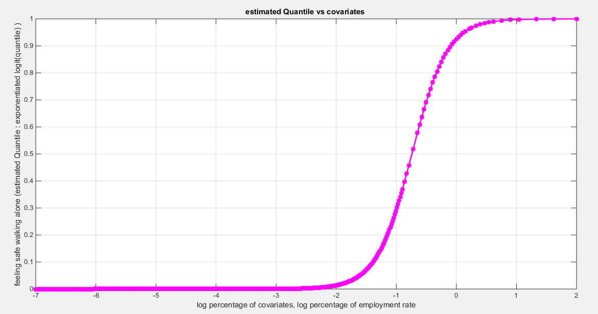
Fig. 3 The estimated curve plotting the transformed predictor against the estimated median (for the logit link).
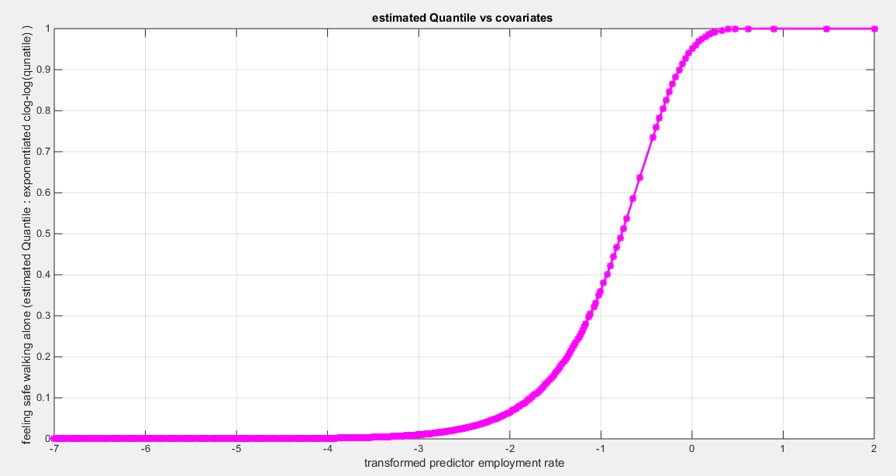
Fig. 4 The estimated curve plotting the transformed predictor against the estimated median (for the clog-log link).

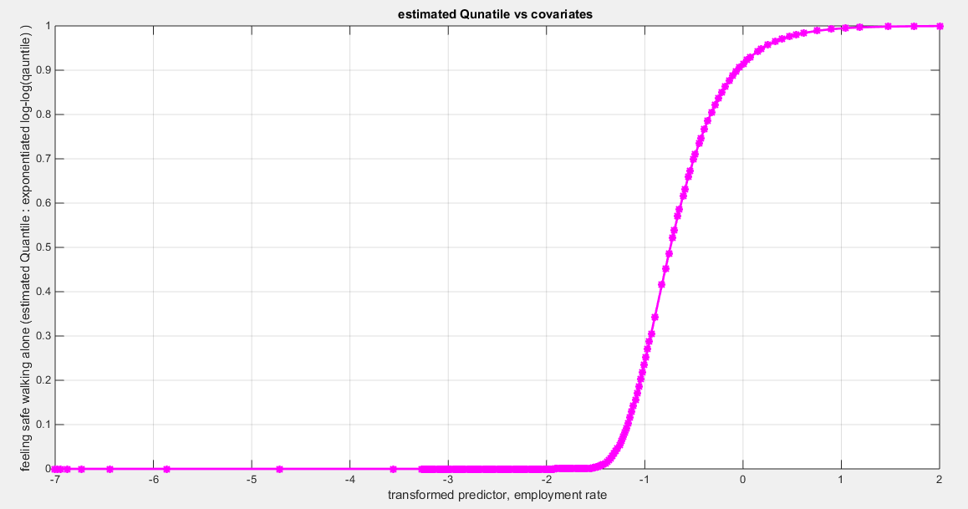
Fig. 5 The estimated curve plotting the transformed predictor against the estimated median (for the log-log link).
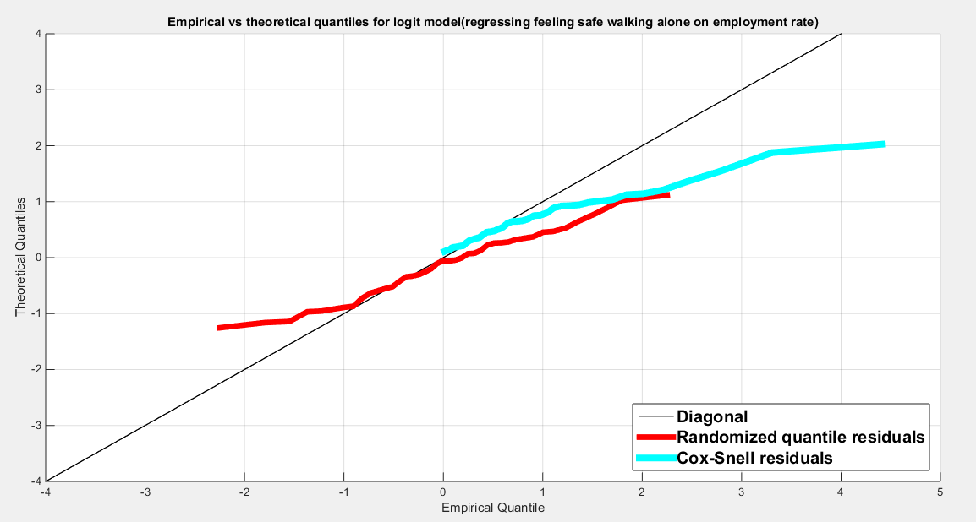
Fig. 6 The QQ plot of the empirical quantiles and the theoretical quantiles for both types of residuals.
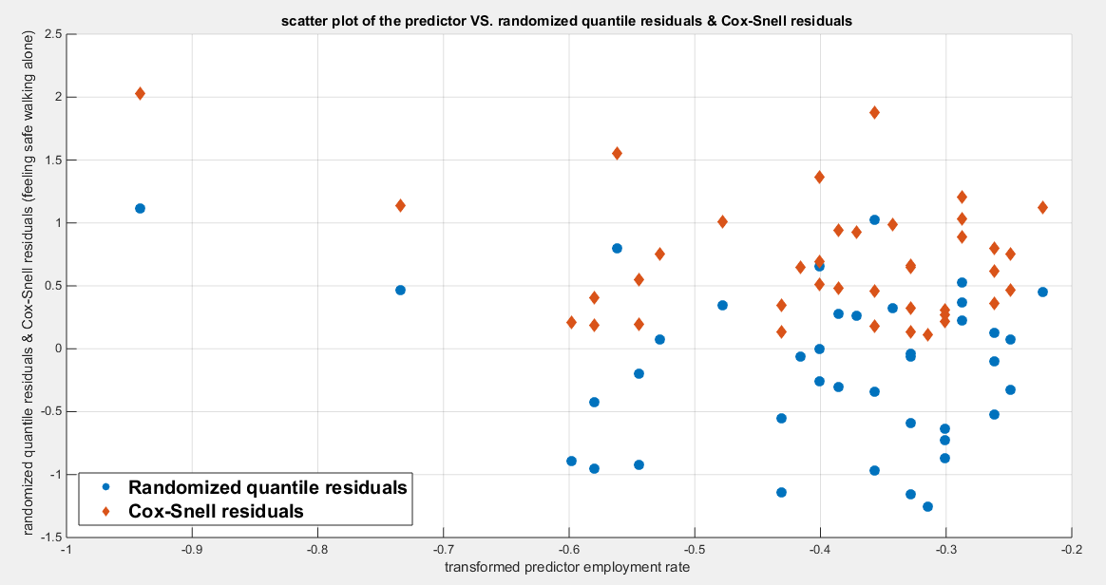
Fig. 7 The scatter plot of residuals of both types against transformed predictors.
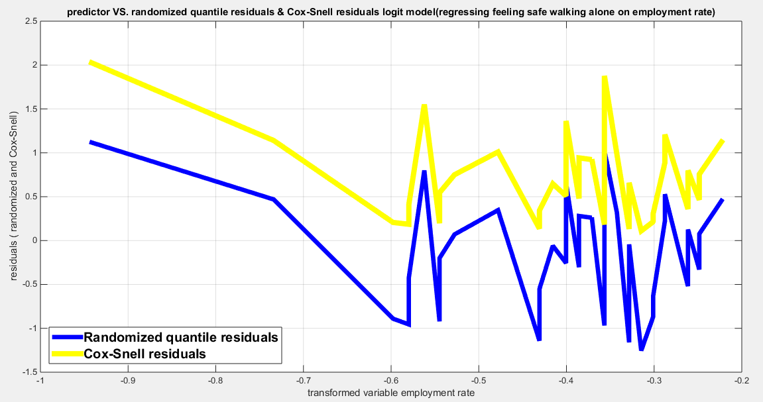
Fig. 8 The plot of residuals of both types against transformed predictors
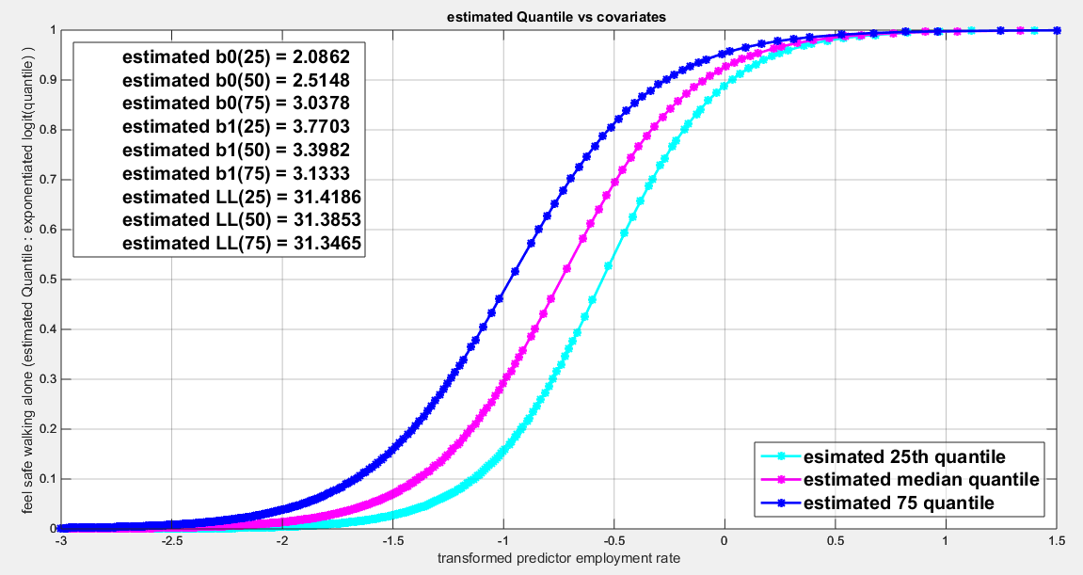
Fig. 9 Parallel quantile curves across 25th , 50th ( median), 75th percentiles, suggesting that the predictor exerts a uniform influence on the response consistent with homoscedasticity.

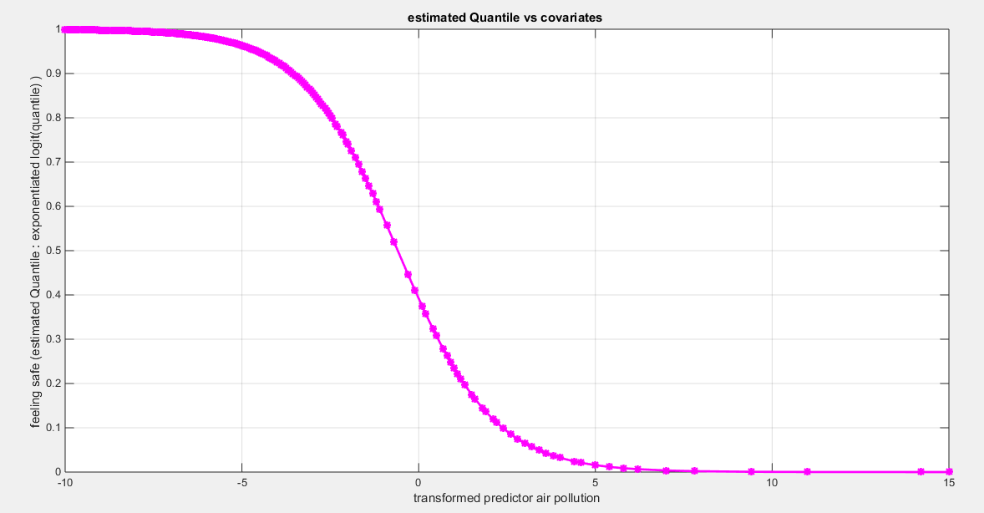
Fig. 10 The estimated curve plotting the transformed predictor against the estimated median (for the logit link).
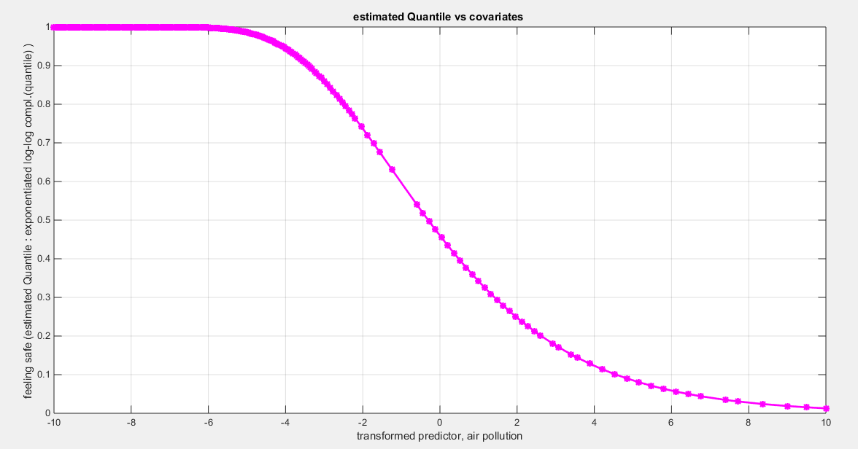
Fig. 11 The estimated curve plotting the transformed predictor against the estimated median (for the clog-log link).
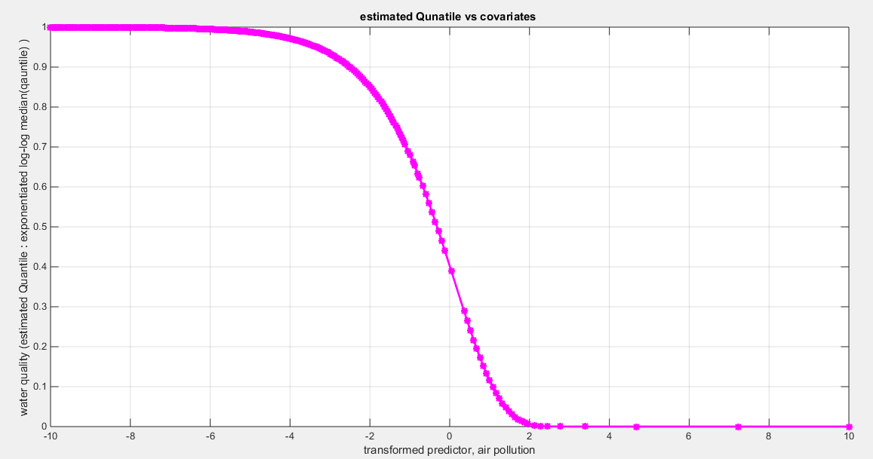
Fig. 12 The estimated curve plotting the transformed predictor against the estimated median (for the log-log link).
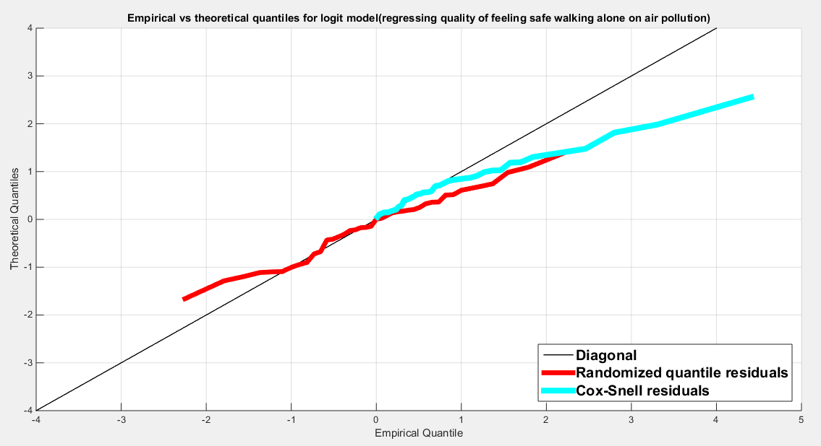
Fig. 13 The QQ plot of the empirical quantiles and the theoretical quantiles for both types of residuals.
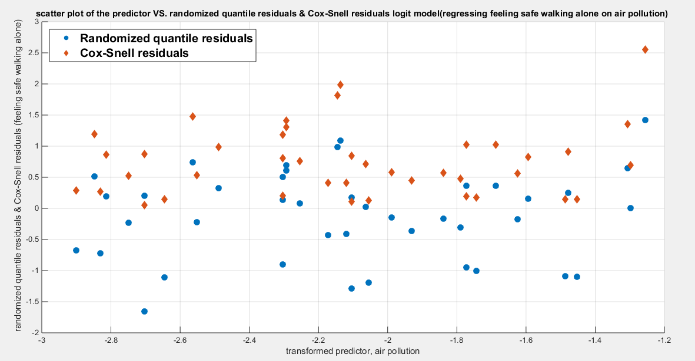
Fig. 14 The scatter plot of residuals of both types against transformed predictors.
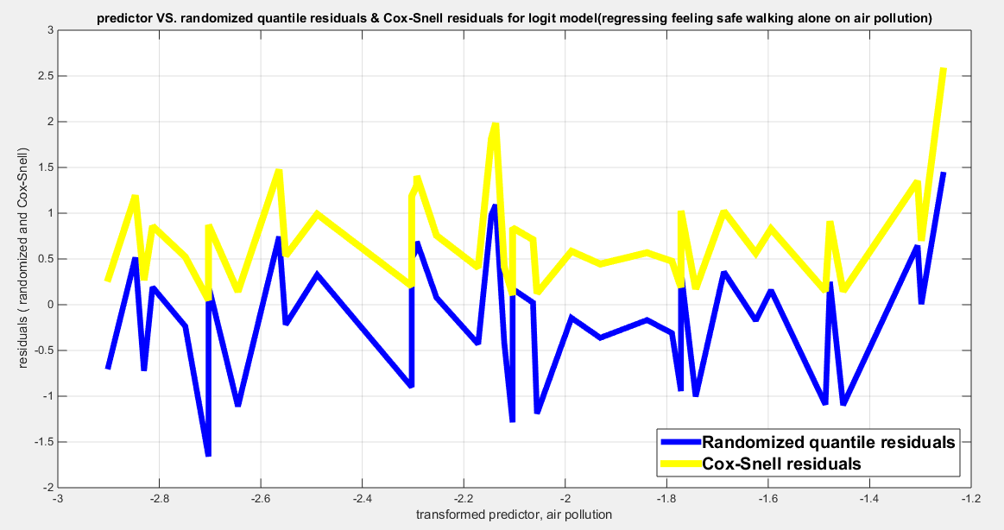
Fig. 15 The plot of residuals of both types against transformed predictors

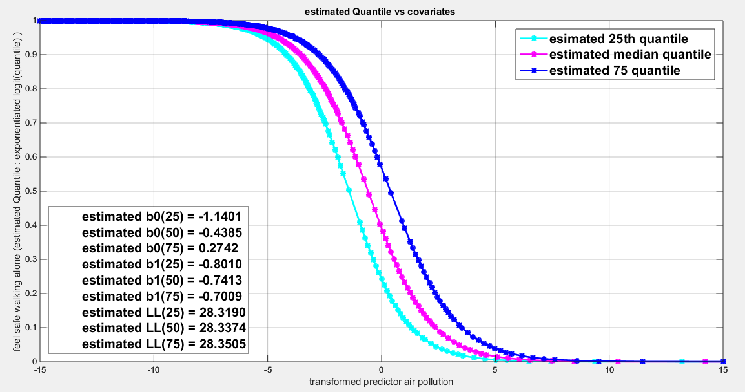
Fig. 16 Parallel quantile curves across 25th , 50th ( median), 75th percentiles, suggesting that the predictor exerts a uniform influence on the response consistent with homoscedasticity.

Appendix A
Brief description of each of the indicators used in the analysis
Air pollution: expressed in OECD database as the percentage of the population exposed to unsafe levels of PM2.5 which is the key pollutant harmful to human health. PM2.5 refers to particulate matter smaller than 2.5 micrometers, which can penetrate deep into the lung and even enter the bloodstream. Higher concentrations indicate poor air quality.
Employment rate: is expressed as percentage of working-age population that is currently employed. It is calculated as the number of employed individuals divided by the total working-age population, multiplied by 100. High rates indicate strong economic conditions and economic prosperity.
Feeling safe walking alone at night: is expressed as the percentage of individuals who report feeling safe when walking alone in their local area after dark. It reflects the social cohesion, trust in the public safety measures, and the level of the crime in the society.

Table A1: the response variables and the predictors.
 | Air pollution | Employment rate | Feeling safe walking alone
Australia | 6.7 | 73 | 0.67
austria | 12.2 | 72 | 0.86
Belgium | 12.8 | 65 | 0.56
Canada | 7.1 | 70 | 0.78
Chile | 23.4 | 56 | 0.41
Colombia | 22.6 | 58 | 0.50
Costa rica | 17.5 | 55 | 0.47
Czechia | 17 | 74 | 0.77
Denmark | 10 | 74 | 0.85
Estonia | 5.9 | 74 | 0.79
Finland | 5.5 | 72 | 0.88
France | 11.4 | 65 | 0.74
Germany | 12 | 77 | 0.76
Greece | 14.5 | 56 | 0.69
Hungary | 16.7 | 70 | 0.74
Iceland | 6.4 | 78 | 0.85
Ireland | 7.8 | 68 | 0.76
Isreal | 19.7 | 67 | 0.80
Italy | 15.9 | 58 | 0.73
Japan | 13.7 | 77 | 0.77
Korea | 27.3 | 66 | 0.82
Latvia | 12.7 | 72 | 0.72
Lithuania | 10.5 | 72 | 0.62
Luxem-bourg | 10 | 67 | 0.87
Mexico | 20.3 | 59 | 0.42
Netherlands | 12.2 | 78 | 0.83
New Zealand | 6 | 77 | 0.66
Norway | 6.7 | 75 | 0.93
Poland | 22.8 | 69 | 0.71
Portugal | 8.3 | 69 | 0.83
Slovak Republic | 18.5 | 68 | 0.76
Slovania | 17 | 71 | 0.91
Spain | 10 | 62 | 0.80
Sweden | 5.8 | 75 | 0.79
Switzerland | 10.1 | 80 | 0.86
Turkiye | 27.1 | 48 | 0.59
United Kingdom | 10.1 | 75 | 0.78
United States | 7.7 | 67 | 0.78
Brazil | 11.7 | 57 | 0.45
Russia | 11.8 | 70 | 0.64
South africa | 28.5 | 39 | 0.40

