Bias-Corrected and Variance-Corrected MLE for the New Median Based Unit Weibull Distribution (MBUW)

Abstract: In this paper, the author discusses the MLE of a new unit distribution called Median-Based unit Weibull (MBUW), previously outlined in another article. The distribution has two parameters, $\left(α\right)$ and $\left(β\right)$ , and the author focuses on the bias corrected MLE, particularly useful for small to moderate samples. The author elaborates on the well-known corrective approach that other researchers have applied for estimating the bias-corrected MLE in various distributions. Additionally, the author presents a new re-parameterization for the negative Log- Likelihood because the two parameters of the MBUW distribution are highly correlated. This correlation, which varies depending on the data, can be either linear or nonlinear and may be positive or negative. It is identified as the primary cause of high variance or even infinite variance, complicating the construction of confidence intervals. The author refers to this method as the variance-corrected MLE. To address this correlation, the author defines one parameter $\left(β\right)$in terms of the other parameter $\left(α\right)$ leading to re-parametrization of the negative Log-Likelihood. Consequently, the author estimates the parameter $\left(α\right)$and then substitutes it into the relationship to get the other parameter $\left(β\right)$. The Nelder-Mead algorithm is utilized for the MLE process. Furthermore, the author employs the expected Fisher information matrix to estimate the variance of $\left(\hat{α}\right)$, then uses the delta method to derive the variance of $\left(\hat{β}\right)$. The author also applies the bias-corrected MLE and compares the estimated parameters to those obtained through the variance-corrected approach. The results show that the parameters are nearly identical. The bias of the estimated $\left(\hat{α}\right)$ is far less than the bias of the estimated $\left(\hat{β}\right)$. Other statistical indices remain nearly equal before and after deploying the bias-corrected MLE, highlighting the effective performance of the variance-corrected MLE in estimating both parameters and their variances. Thus, this new approach helps mitigate the correlation between the two parameters. The MBUW distribution fits the datasets used in the paper, although some well-known unit distributions may slightly outperform MBUW regarding goodness-of-fit (GoF) tests such as the KS-test, CVM test, and AD test, along with indices like AIC, CAIC, BIC, HQIC, and nLL. However, due to the greater dependency between its two parameters compared to other well-known unit distributions like the Beta and Kumaraswamy distributions, the author felt compelled to explore solutions to mitigate the correlation and compare this solution to the established corrective approach of the bias-corrected MLE. This new variance-corrected approach yields minimal bias.
Keywords: Cox and Snell bias-correction, Median Based Unit Weibull (MBUW), Maximum Likelihood estimators, variance-corrected MLE, Bias-corrected MLE.
Introduction
The method most frequently employed for parameter estimation is the maximum likelihood estimation (MLE), a cornerstone in the realm of probability distribution analysis (Pawitan, Y, 2001),(Millar, 2011). The MLE estimator boasts an array of advantageous characteristics: it is asymptotically unbiased, consistent, efficient, and follows an asymptotic normal distribution. However, these commendable traits primarily manifest in large sample sizes. In cases involving small to moderate sample sizes, certain properties—most notably unbiasedness—may begin to falter. As the sample size increases, the discrepancy between the expected value of a parameter and its true value diminishes, leading to more reliable estimates.
To address the challenges posed by smaller samples, researchers have devised nearly unbiased estimators tailored for various distributions. A glimpse into this extensive body of work reveals contributions from notable scholars including: (Saha & Paul, 2005),(Cordeiro et al., 1997), (Giles, 2012),(Cribari-Neto & Vasconcellos, 2002), (Lemonte et al., 2007), additional insights can be found in the studies by (Giles, D. E & H. Feng, 2009),(Giles, 2012), as well as (Schwartz et al., 2013) who continue to expand this field. The exploration doesn’t stop there; the research efforts of (Giles et al., 2013), (Teimouri & Nadarajah, 2013), (Zhang & Liu, 2017), and (Singh et al., 2015) further enrich the discourse. Scholars like (Lagos-Àlvarez, B. et al., 2011), (Schwartz & Giles, 2016), and (M. Wang & Wang, 2017) also lend their voices, while (Ling & Giles, 2014), along with (Lemonte, 2011), and (Mazucheli & Dey, 2018), as well as (Reath, J., 2016), and (Teimouri & Nadarajah, 2016) contribute a wealth of knowledge to this important area of study. Also (Cordeiro & Cribari-Neto, 2014) ,(Mazucheli et al., 2019), (Menezes et al., 2021), (Rasekhi & G. Hamedani, 2019), (Gül & Doğru, 2024), (Teimouri, 2022), (Ahmed et al., 2024), (Giles et al., 2016), (Tsai et al., 2022), (Sangpoom & Klomwises, 2021), (Hashemi & Schneider, 2021), (S. Wang & Gui, 2020), (Gedik Balay, 2021), (Menezes et al., 2023), (Dey et al., 2024), (Dey et al., 2022), (Dey & Wang, 2022)and (Ferrari & Cribari-Neto, 1998) contributed to this subject . Each of these references plays an integral role in advancing our understanding of nearly unbiased estimation in statistical practice.
Estimating the bias of the maximum likelihood estimator (MLE) for distributions with a single parameter can be approached to the $O\left(n^{-1}\right)$ even when the estimated parameter lacks a closed-form expression. Notably, pivotal work by statisticians such as (Bartlett, 1953a) (Haldane & Smith, 1956), (Bartlett, 1953b) and (Haldane, 1953) established the groundwork for this estimation by deriving analytical approximations for two-parameter log-likelihood functions through the application of Taylor series expansions. These expansions allow for an approximation of the behavior of the log-likelihood functions around certain parameter values, making it feasible to analyze the bias associated with the MLE.
However, the complexity increases considerably when extending these methodologies to multi-parameter distributions. This is highlighted in the research conducted by (Shenton & Bowman, 1963), which illustrated the difficulties encountered in applying similar Taylor series techniques. In multi-parameter contexts, the interactions among the parameters can complicate the approximation process, often leading to more intricate relationships that hinder straightforward calculations. As a result, tailoring methods to effectively estimate the bias in such cases necessitates more sophisticated analytical tools and techniques.
Numerous strategies have emerged to address the bias inherent in Maximum Likelihood Estimators (MLE). The first of these strategies, known as the “corrective approach,” is a methodical framework championed by (Cox & Snell, 1968). This approach offers a precise analytical formula that quantifies the bias associated with MLE estimators, enabling researchers to refine these estimators into unbiased forms. Essentially, it lays the groundwork for making MLEs more accurate by systematically correcting the inherent biases. It is an analytical expression for the bias to $O\left(n^{-1}\right)$ of the MLE estimators, then using these expressions to bias-correct the MLE estimator yielding estimators that are unbiased to $O\left(n^{-2}\right)$.
The second method is the parametric Bootstrap resampling technique, put forth by (Efron, 1982). This ingenious approach involves a second-order bias correction, executing the corrections through numerical simulations rather than relying on analytical formulas. Through this technique, estimators can be adjusted without the need for explicit expressions for the bias function, showcasing its flexibility and robustness in addressing bias.
Lastly, the “preventive approach,” advocated by (Firth, 1993), takes a different angle. This analytical procedure alters the score function of the log-likelihood before one attempts to solve for the MLEs, effectively minimizing bias to a specified degree. It reduces the bias to the order $O\left(n^{-2}\right)$.
The first two strategies stand out for their relatively straightforward mathematical expressions, making them both attractive and easy to implement in practical settings. Each approach, with its unique methodology, contributes invaluable tools for enhancing the accuracy of statistical estimations.
The MBUW distribution has been thoroughly explored in previous research conducted by the author (Attia, 2025) focusing on its properties and MLE estimation method, Generalized Method of Moments (GMMs) and its variants, and percentile estimator, which have practical applications in real data analysis. The distribution is characterized by its probability density function (PDF), cumulative distribution function (CDF), and quantile function, which are detailed in equations (1-3).
$$f\left(y\right)=\frac{6}{α^{β}}\left[1-y^{\frac{1}{α^{β}}}\right]y^{\left(\frac{2}{α^{β}}-1\right)} , 0<y<1 , α>0, β>0 (1)$$
$$F\left(y\right)={3y}^{\frac{2}{α^{β}}}-{2y}^{\frac{3}{α^{β}}} , 0<y<1 , α>0, β>0 (2)$$
$$y=F^{-1}\left(y\right)={\left\{-.5\left(cos\left[\frac{\cos^{-1}\left(1-2u\right)}{3}\right]-\sqrt{3} sin\left[\frac{\cos^{-1}\left(1-2u\right)}{3}\right]\right)+.5\right\}}^{α^{β}} (3)$$
This distribution is meticulously defined within the confines of the unit interval, making it adept at accommodating skewed data presented as proportions. Depending on the parameters at play, the distribution can assume fascinating shapes, manifesting either an increasing, decreasing, or a striking unimodal form.
In this paper, the author delves deep into the intricacies of the bias-corrected maximum likelihood estimation (MLE) approach, alongside the innovative variance-corrected MLE technique. The structure of the paper unfolds in a series of well-organized sections. Section 2 is dedicated to elucidating the corrective procedures designed to address the biases inherent in MLE estimators. Here, the author methodically walks the reader through the necessary adjustments needed to refine these estimators.
In Section 3, the narrative unfolds further as the author derives the analytical function for the bias of MLE estimators specific to the MBUW distribution. This section enriches the discussion with significant theoretical findings. Results are then laid bare in Section 3, where the author elaborates on the variance-corrected MLE procedure for the MBUW distribution, showcasing its practical application with real-world data, thus grounding the theoretical elements in tangible outcomes.
The discourse continues in Section 4, where the author critically discusses the application of bias-corrected MLE on real datasets. Here, a comparative analysis is presented, juxtaposing the estimated parameters generated from the variance-corrected MLE with those derived through the bias-corrected approach, revealing insightful contrasts and nuances.
Finally, in Section 5 and 6, the author encapsulates the discussion with conclusions and recommendations, distilling the findings into key takeaways and future directions for research. This comprehensive exploration offers both clarity and depth to the reader, illuminating the path of MLE estimation in the context of the uniquely accommodating distributions discussed.
2. Methods
2.1. Corrective approach of the Bias-corrected MLE
Let $Θ$ be a p-dimensional unknown parameter vector and $l=l\left(Θ|y\right)$ be the log-likelihood function for a sample of n observations. Assume this log-likelihood is regular with respect to all derivatives up to and including those of the third order. The joint cumulants of the log-likelihood derivatives are defined as follows in equations (4-6)
$$k_{ij}=E\left(\frac{∂^{2}l}{∂Θ_{i}∂Θ_{j}}\right) ;i,j=1,2,….,p \left(4\right)$$
$$k_{ijl}=E\left(\frac{∂^{3}l}{∂Θ_{i}∂Θ_{j}∂Θ_{l}}\right); i,j=1,2,….,p \left(5\right)$$
$$k_{ij,l}=E\left(\left[\frac{∂^{2}l}{∂Θ_{i}∂Θ_{j}}\right] \left[\frac{∂l}{∂Θ_{l}}\right]\right) ; i,j=1,2,….,p \left(6\right)$$
The derivative of these cumulants are defined as in equation (7)
$$k_{ij}^{\left(l\right)}=E\left(\frac{∂k_{ij}}{∂Θ_{l}}\right);i,j,l=1,2,…..,p \left(7\right)$$
The expressions in equations (4-7) are assumed to be$O\left(n\right)$ .
According to (Cox & Snell, 1968), it was demonstrated that if the sample data is independent, though not necessarily identically distributed, the bias of the s^{th} element of the MLE of ${\hat{Θ}}_{s}$, can be calculated as in equation (8):
$$Bias\left({\hat{Θ}}_{s}\right)=\sum_{i=1}^{p}{\sum_{j=1}^{p}{\sum_{l=1}^{p}{k^{si}k^{jl}\left[0.5*k_{ijl}+k_{ij,l}\right]+O\left(n^{-2}\right)}}} \left(8\right)$$
where : $s=1,….,p$ and $k^{ij}$ is the $(i,j)th$ element of the inverse of the expected information matrix $K=-k_{ij}$ .
(Cordeiro & Klein, 1994) established that equation (8) still holds if the data are non-independent, and it can be expressed as
$$Bias\left({\hat{Θ}}_{s}\right)=\sum_{i=1}^{p}{k^{si}}\sum_{j=1}^{p}{\sum_{l=1}^{p}{\left[k_{ij}^{\left(l\right)}-0.5*k_{ijl}\right]}}k^{jl}+ O\left(n^{-2}\right) \left(9\right)$$
The bias equation in (9) is largely simpler to calculate than in (8), because it does not include terms of the form given in (6).
Defining the following terms in equations (10-11):
$a_{ij}^{\left(l\right)}=k_{ij}^{\left(l\right)}-0.5k_{ijl} ; i,j,l=1,2,…,p \left(10\right)$
$A^{\left(l\right)}=\left\{a_{ij}^{\left(l\right)} \right\} ; i,j,l =1,2,…,p \left(11\right)$
and collecting terms up into matrices $A=\left[ A^{\left(1\right)}|…| A^{\left(p\right)} \right]$
The $O\left(n^{-2}\right)$ bias of the MLE of $\hat{Θ}$ in (9) can be rephrased in the convenient form equation (12):
$$Bias\left({\hat{Θ}}_{s}\right)= {\hat{K}}^{-1}\hat{A} vec \left({\hat{K}}^{-1}\right)+ O\left(n^{-2}\right) (12)$$
where $\hat{K}=K|_{Θ=\hat{Θ}}$ and $\hat{A}=A|_{Θ=\hat{Θ}}$, the value of ${\hat{Θ}}_{s}$ is obtained by solving the roots of log-likelihood equations using the numerical methods. $Vec\left(.\right)$ means vectorization operator, which stacks the columns of the matrix in question one above the other, forming one extended column vector. Hence the bias adjusted-MLE is defined in equation (13) as
$$\tilde{Θ}=\hat{Θ} - {\hat{K}}^{-1}\hat{A} vec \left({\hat{K}}^{-1}\right) (13)$$
One of the advantages of this methodology is that these expressions can be calculated when determining the roots of the log-likelihood equations, which does not yield an analytic closed-form solution. In such cases, the bias-corrected maximum likelihood estimator (MLE) can be readily derived through standard numerical techniques, ensuring that the resulting estimator remains unbiased, and $\tilde{Θ}$ is unbiased $O\left(n^{-2}\right)$
2.2. Corrective Approach for Bias Reduction and MBUW
The PDF of MBUW satisfies the regularity conditions. In this context, the first-order partial derivatives of the log-likelihood function, concerning the $\left(α\right)$ and $\left(β\right)$ parameters, are articulated in equation (14-15) as follows:
$$\frac{∂l}{∂α}= \frac{-nβ}{α}+\sum_{i=1}^{n}{\frac{y^{α^{-β}}β\left(\ln{y}\right)α^{\left(-β-1\right)}}{1-y^{α^{-β}}}} -2βα^{\left(-β-1\right)} \sum_{i=1}^{n}{\ln{y}} (14)$$
$$\frac{∂l}{∂β}= -n\ln{α}+\sum_{i=1}^{n}{\frac{y^{α^{-β}}α^{-β}\left(\ln{y}\right)\left(\ln{α}\right)}{1-y^{α^{-β}}}} -2α^{-β} \left(\ln{α}\right)\sum_{i=1}^{n}{\ln{y}} (15)$$
Equations (16-24) are the higher order derivatives (for one observation):
$$\frac{∂^{2}l}{∂α^{2}}= \frac{β}{α^{2}}-\left( \frac{y^{α^{-β}}β^{2}{\left(\ln{y}\right)}^{2}α^{\left(-2β-2\right)}}{1-y^{α^{-β}}} \right)- \frac{y^{α^{-β}}β\left(β+1\right)\left(\ln{y}\right)α^{\left(-β-2\right)}}{1-y^{α^{-β}}}$$
$$-\left( \frac{y^{{2α}^{-β}}β^{2}{\left(\ln{y}\right)}^{2}α^{\left(-2β-2\right)}}{{\left(1-y^{α^{-β}}\right)}^{2}} \right)+ 2β\left(β+1\right)α^{\left(-β-2\right)}\left(\ln{y}\right) (16)$$
$$\frac{∂^{2}l}{∂β^{2}} =\left( \frac{{- y}^{α^{-β}}{\left(\ln{α}\right)}^{2}{\left(\ln{y}\right)}^{2}α^{\left(-2β\right)}}{1-y^{α^{-β}}} \right)-\left(\frac{{ y}^{α^{-β}}{\left(\ln{α}\right)}^{2}\left(\ln{y}\right)α^{\left(-β\right)}}{1-y^{α^{-β}}}\right)$$
$$-\left( \frac{y^{{2α}^{-β}}{\left(\ln{α}\right)}^{2}{\left(\ln{y}\right)}^{2}α^{\left(-2β\right)}}{{\left(1-y^{α^{-β}}\right)}^{2}} \right)+2α^{\left(-β\right)}\left(\ln{y}\right){\left(\ln{α}\right)}^{2} (17)$$
$$\frac{∂^{2}l}{∂α∂β}= \frac{-1}{α} - \left( \frac{y^{α^{-β}}β \left(\ln{α}\right){\left(\ln{y}\right)}^{2}α^{\left(-2β-1\right)}}{1-y^{α^{-β}}} \right)+ \frac{y^{α^{-β}}\left(\ln{y}\right)α^{\left(-β-1\right)}}{1-y^{α^{-β}}}$$
$$-\left( \frac{{ y}^{α^{-β}}β\left(\ln{α}\right)\left(\ln{y}\right)α^{\left(-β-1\right)}}{1-y^{α^{-β}}} \right)-\left( \frac{y^{{2α}^{-β}}β\left(\ln{α}\right){\left(\ln{y}\right)}^{2}α^{\left(-2β-1\right)}}{{\left(1-y^{α^{-β}}\right)}^{2}} \right)$$
$$-2α^{\left(-β-1\right)} \left(\ln{y}\right)+2 β α^{\left(-β-1\right)} \left(\ln{α}\right)\left(\ln{y}\right) (18)$$
$$\frac{∂^{3}l}{∂α^{2}∂β}= \frac{1}{α^{2}}+\frac{y^{α^{-β}}β^{2}{\left(\ln{y}\right)}^{3} \left(\ln{α}\right) α^{\left(-3β-2\right)}}{1-y^{α^{-β}}}- \frac{{2 y}^{α^{-β}}β{\left(\ln{y}\right)}^{2}α^{\left(-2β-2\right)}}{1-y^{α^{-β}}}$$
$$+\frac{{2y}^{α^{-β}}β^{2}{\left(\ln{y}\right)}^{2} \left(\ln{α}\right) α^{\left(-2β-2\right)}}{1-y^{α^{-β}}}+ \frac{y^{{2α}^{-β}}β^{2}{\left(\ln{y}\right)}^{3} \left(\ln{α}\right) α^{\left(-3β-2\right)}}{{\left(1-y^{α^{-β}}\right)}^{2}}$$
$$-\frac{y^{α^{-β}} \left(2β+1\right) \left(\ln{y}\right) α^{\left(-β-2\right)}}{1-y^{α^{-β}}}+\frac{y^{α^{-β}} \left(β^{2}+β\right) \left(\ln{α}\right) {\left(\ln{y}\right)}^{2}α^{\left(-2β-2\right)}}{1-y^{α^{-β}}}$$
$$+\frac{y^{α^{-β}} \left(β^{2}+β\right) \left(\ln{α}\right) \left(\ln{y}\right)α^{\left(-β-2\right)}}{1-y^{α^{-β}}}+\frac{y^{{2α}^{-β}}\left(β^{2}+β\right){\left(\ln{y}\right)}^{2} \left(\ln{α}\right) α^{\left(-2β-2\right)}}{{\left(1-y^{α^{-β}}\right)}^{2}}$$
$$+\frac{{2 y}^{{2α}^{-β}}β^{2}{\left(\ln{y}\right)}^{3} \left(\ln{α}\right) α^{\left(-3β-2\right)}}{{\left(1-y^{α^{-β}}\right)}^{2}}-\frac{{2y}^{{2α}^{-β}}β{\left(\ln{y}\right)}^{2} α^{\left(-2β-2\right)}}{{\left(1-y^{α^{-β}}\right)}^{2}}$$
$$+\frac{{2 y}^{{2α}^{-β}}β^{2}{\left(\ln{y}\right)}^{2} \left(\ln{α}\right) α^{\left(-2β-2\right)}}{{\left(1-y^{α^{-β}}\right)}^{2}}+\frac{{2y}^{{3α}^{-β}}β^{2}{ \left(\ln{α}\right) \left(\ln{y}\right)}^{3} α^{\left(-3β-2\right)}}{{\left(1-y^{α^{-β}}\right)}^{3}}$$
$$+ 4βα^{\left(-β-2\right)} \left(\ln{y}\right) +2α^{\left(-β-2\right)} \left(\ln{y}\right)-2 β^{2}α^{\left(-β-2\right)} \left(\ln{y}\right)\left(\ln{α}\right)$$
$$-2 βα^{\left(-β-2\right)} \left(\ln{y}\right)\left(\ln{α}\right) (19)$$
$$\frac{∂^{3}l}{∂β^{2}∂α}= \frac{y^{α^{-β}}β{\left(\ln{y}\right)}^{3} {\left(\ln{α}\right)}^{2} α^{\left(-3β-1\right)}}{1-y^{α^{-β}}}+ \frac{{2 y}^{α^{-β}}β{\left(\ln{y}\right)}^{2} {\left(\ln{α}\right)}^{2} α^{\left(-2β-1\right)}}{1-y^{α^{-β}}}$$
$$-\frac{{2y}^{α^{-β}}{\left(\ln{y}\right)}^{2} \left(\ln{α}\right) α^{\left(-2β-1\right)}}{1-y^{α^{-β}}}+ \frac{y^{{2α}^{-β}}β{\left(\ln{y}\right)}^{3} {\left(\ln{α}\right)}^{2} α^{\left(-3β-1\right)}}{{\left(1-y^{α^{-β}}\right)}^{2}}$$
$$+\frac{y^{α^{-β}}β {\left(\ln{y}\right)}^{2} {\left(\ln{α}\right)}^{2} α^{\left(-2β-1\right)}}{1-y^{α^{-β}}}+\frac{y^{α^{-β}} \left(β\right) \left(\ln{y}\right) {\left(\ln{α}\right)}^{2}α^{\left(-β-1\right)}}{1-y^{α^{-β}}}$$
$$-\frac{{2y}^{α^{-β}} \left(\ln{α}\right) \left(\ln{y}\right)α^{\left(-β-1\right)}}{1-y^{α^{-β}}}+\frac{y^{{2α}^{-β}}\left(β\right){\left(\ln{y}\right)}^{2} {\left(\ln{α}\right)}^{2} α^{\left(-2β-1\right)}}{{\left(1-y^{α^{-β}}\right)}^{2}}$$
$$+\frac{{2 y}^{{2α}^{-β}}β{\left(\ln{y}\right)}^{3} {\left(\ln{α}\right)}^{2} α^{\left(-3β-1\right)}}{{\left(1-y^{α^{-β}}\right)}^{2}}+\frac{{2y}^{{2α}^{-β}}β{\left(\ln{y}\right)}^{2} {\left(\ln{α}\right)}^{2}α^{\left(-2β-1\right)}}{{\left(1-y^{α^{-β}}\right)}^{2}}$$
$$-\frac{{2 y}^{{2α}^{-β}}{\left(\ln{y}\right)}^{2} \left(\ln{α}\right) α^{\left(-2β-1\right)}}{{\left(1-y^{α^{-β}}\right)}^{2}}+\frac{{2y}^{{3α}^{-β}}β{ {\left(\ln{α}\right)}^{2} \left(\ln{y}\right)}^{3} α^{\left(-3β-1\right)}}{{\left(1-y^{α^{-β}}\right)}^{3}}$$
$$-2 βα^{\left(-β-1\right)} \left(\ln{y}\right){\left(\ln{α}\right)}^{2}+4 α^{\left(-β-1\right)} \left(\ln{y}\right) \left(\ln{α}\right) (20)$$

$$\frac{∂^{3}l}{∂α^{3}}=\frac{-2β}{α^{3}}+ \frac{y^{α^{-β}}β^{3}{\left(\ln{y}\right)}^{3} α^{\left(-3β-3\right)}}{1-y^{α^{-β}}}+ \frac{{3 y}^{α^{-β}}β^{2 }\left(β+1\right){\left(\ln{y}\right)}^{2} α^{\left(-2β-3\right)}}{1-y^{α^{-β}}}$$
$$+ \frac{{3β^{3}y}^{{2α}^{-β}}{\left(\ln{y}\right)}^{3} α^{\left(-3β-3\right)}}{{\left(1-y^{α^{-β}}\right)}^{2}}+\frac{y^{α^{-β}}β \left(β+1\right)\left(β+2\right) \left(\ln{y}\right) α^{\left(-β-3\right)}}{1-y^{α^{-β}}}$$
$$+\frac{{3β^{2} \left(β+1\right) y}^{{2α}^{-β}}{\left(\ln{y}\right)}^{2} α^{\left(-2β-3\right)}}{{\left(1-y^{α^{-β}}\right)}^{2}}+\frac{{2y}^{{3α}^{-β}}β^{3}{ \left(\ln{y}\right)}^{3} α^{\left(-3β-3\right)}}{{\left(1-y^{α^{-β}}\right)}^{3}}$$
$$-2 β \left(β+1\right)\left(β+2\right) α^{\left(-β-3\right)} \left(\ln{y}\right) (21)$$
$$\frac{∂^{3}l}{∂β^{3}}= \frac{y^{α^{-β}}{\left(\ln{α}\right)}^{3}\left(\ln{y}\right) α^{\left(-β\right)}}{1-y^{α^{-β}}}+ \frac{{3y}^{α^{-β}}{\left(\ln{α}\right)}^{3}{\left(\ln{y}\right)}^{2} α^{\left(-2β\right)}}{1-y^{α^{-β}}}$$
$$+ \frac{y^{α^{-β}}{\left(\ln{α}\right)}^{3}{\left(\ln{y}\right)}^{3} α^{\left(-3β\right)}}{1-y^{α^{-β}}}+\frac{{3y}^{{2α}^{-β}}{\left(\ln{α}\right)}^{3}{\left(\ln{y}\right)}^{2} α^{\left(-2β\right)}}{{\left(1-y^{α^{-β}}\right)}^{2}}$$
$$+\frac{{3y}^{{2α}^{-β}}{\left(\ln{α}\right)}^{3}{\left(\ln{y}\right)}^{3} α^{\left(-3β\right)}}{{\left(1-y^{α^{-β}}\right)}^{2}}+\frac{{2y}^{{3α}^{-β}}{\left(\ln{α}\right)}^{3}{ \left(\ln{y}\right)}^{3} α^{\left(-3β\right)}}{{\left(1-y^{α^{-β}}\right)}^{3}}$$
$$-2 α^{\left(-β\right)} \left(\ln{y}\right){\left(\ln{α}\right)}^{3} (22)$$
$$\frac{∂^{3}l}{∂β∂α∂α}= \frac{1}{α^{2}}-2 β{\left(β+1\right)α}^{\left(-β-2\right)} \left(\ln{y}\right)\left(\ln{α}\right)+2{\left(2β+1\right)α}^{\left(-β-2\right)}\left(\ln{y}\right)$$
$$+\frac{y^{α^{-β}}β{\left(2β+1\right)\left(\ln{y}\right)}^{2} \left(\ln{α}\right) α^{\left(-2β-2\right)}}{1-y^{α^{-β}}}- \frac{{ y}^{α^{-β}}β{\left(\ln{y}\right)}^{2}α^{\left(-2β-2\right)}}{1-y^{α^{-β}}}$$
$$+\frac{y^{α^{-β}}β^{2}{\left(\ln{y}\right)}^{3} \left(\ln{α}\right) α^{\left(-3β-2\right)}}{1-y^{α^{-β}}}+ \frac{{3y}^{{2α}^{-β}}β^{2}{\left(\ln{y}\right)}^{3} \left(\ln{α}\right) α^{\left(-3β-2\right)}}{{\left(1-y^{α^{-β}}\right)}^{2}}$$
$$-\frac{y^{α^{-β}} β {\left(\ln{y}\right)}^{2} α^{\left(-2β-2\right)}}{1-y^{α^{-β}}}-\frac{y^{α^{-β}} \left(β+1\right) \left(\ln{y}\right) α^{\left(-β-2\right)}}{1-y^{α^{-β}}}$$
$$-\frac{{2y}^{{2α}^{-β}}β {\left(\ln{y}\right)}^{2} α^{\left(-2β-2\right)}}{{\left(1-y^{α^{-β}}\right)}^{2}}+\frac{y^{α^{-β}} β \left(1+β\right) \left(\ln{α}\right) \left(\ln{y}\right)α^{\left(-β-2\right)}}{1-y^{α^{-β}}}$$
$$+\frac{y^{α^{-β}} β^{2} \left(\ln{α}\right) {\left(\ln{y}\right)}^{2}α^{\left(-2β-2\right)}}{1-y^{α^{-β}}}-\frac{y^{α^{-β}} β \left(\ln{y}\right)α^{\left(-β-2\right)}}{1-y^{α^{-β}}}$$
$$+\frac{{ y}^{{2α}^{-β}}β^{2}{ \left(\ln{y}\right)}^{2} \left(\ln{α}\right) α^{\left(-2β-2\right)}}{{\left(1-y^{α^{-β}}\right)}^{2}}+\frac{{β y}^{{2α}^{-β}}\left(2β+1\right){\left(\ln{y}\right)}^{2} \left(\ln{α}\right) α^{\left(-2β-2\right)}}{{\left(1-y^{α^{-β}}\right)}^{2}}$$
$$+\frac{{2y}^{{3α}^{-β}}β^{2}{ \left(\ln{α}\right) \left(\ln{y}\right)}^{3} α^{\left(-3β-2\right)}}{{\left(1-y^{α^{-β}}\right)}^{3}} (23)$$
$$\frac{∂^{3}l}{∂α∂β∂β}= 4{ α}^{\left(-β-1\right)}\left(\ln{y}\right)\left(\ln{α}\right)-2β{ α}^{\left(-β-1\right)}\left(\ln{y}\right){\left(\ln{α}\right)}^{2}$$
$$+\frac{{ βy}^{α^{-β}}{ {\left(\ln{α}\right)}^{2} \left(\ln{y}\right)}^{3} α^{\left(-3β-1\right)}}{1-y^{α^{-β}}}-\frac{{2y}^{α^{-β}}{\left(\ln{y}\right)}^{2} \left(\ln{α}\right) α^{\left(-2β-1\right)}}{1-y^{α^{-β}}}$$
$$+ \frac{{ 3y}^{α^{-β}}β{\left(\ln{y}\right)}^{2}{ {\left(\ln{α}\right)}^{2} α}^{\left(-2β-1\right)}}{1-y^{α^{-β}}}+ \frac{{3y}^{{2α}^{-β}}β {\left(\ln{y}\right)}^{3} {\left(\ln{α}\right)}^{2} α^{\left(-3β-1\right)}}{{\left(1-y^{α^{-β}}\right)}^{2}}$$
$$-\frac{2y^{α^{-β}} \left(\ln{α}\right) \left(\ln{y}\right) α^{\left(-β-1\right)}}{1-y^{α^{-β}}}-\frac{2y^{{2α}^{-β}}β {\left(\ln{y}\right)}^{2} \left(\ln{α}\right) α^{\left(-2β-1\right)}}{{\left(1-y^{α^{-β}}\right)}^{2}}$$
$$+\frac{y^{α^{-β}} β \left(\ln{y}\right) {\left(\ln{α}\right)}^{2}α^{\left(-β-1\right)}}{1-y^{α^{-β}}}+\frac{{ 3y}^{{2α}^{-β}}β{ \left(\ln{y}\right)}^{2} {\left(\ln{α}\right)}^{2} α^{\left(-2β-1\right)}}{{\left(1-y^{α^{-β}}\right)}^{2}}$$
$$+\frac{{2 βy}^{{3α}^{-β}}{ {\left(\ln{α}\right)}^{2} \left(\ln{y}\right)}^{3} α^{\left(-3β-1\right)}}{{\left(1-y^{α^{-β}}\right)}^{3}} (24)$$
The expectation of the derivative discussed previously is determined through the sophisticated technique of Monte Carlo integration, as illustrated in equations (25-31). Within these equations, the integrals can be computed using suitable numerical integration methods, resulting in a constant value. The author employed the trapezoidal method for this integration, ensuring accuracy in the calculations. By substituting the estimated parameters, $\left(α\right)$ and $\left(β\right)$, for each unique data set, we can derive the corresponding integrals, which yield fixed values specific to each dataset.
$E\left(\frac{y^{α^{-β}} {\left(\ln{y}\right)}^{3} }{1-y^{α^{-β}}}\right)= \int_{0}^{1}{\frac{y^{α^{-β}} {\left(\ln{y}\right)}^{3} }{1-y^{α^{-β}}}f\left(y\right)dy}= f_{1} (25)$
$$E\left(\frac{y^{α^{-β}} {\left(\ln{y}\right)}^{2} }{1-y^{α^{-β}}}\right)= \int_{0}^{1}{\frac{y^{α^{-β}} {\left(\ln{y}\right)}^{2} }{1-y^{α^{-β}}}f\left(y\right)dy}= f_{2} (26)$$
$$E\left(\frac{y^{α^{-β}} \ln{y} }{1-y^{α^{-β}}}\right)= \int_{0}^{1}{\frac{y^{α^{-β}} \left(\ln{y}\right) }{1-y^{α^{-β}}}f\left(y\right)dy}= f_{3} (27)$$
$$E\left(\frac{y^{{2α}^{-β}} {\left(\ln{y}\right)}^{3} }{{\left[1-y^{α^{-β}}\right]}^{2}}\right)= \int_{0}^{1}{\frac{y^{{2α}^{-β}} {\left(\ln{y}\right)}^{3} }{{\left[1-y^{α^{-β}}\right]}^{2}}f\left(y\right)dy}= f_{4} (28)$$
$$E\left(\frac{y^{{2α}^{-β}} {\left(\ln{y}\right)}^{2} }{{\left[1-y^{α^{-β}}\right]}^{2}}\right)= \int_{0}^{1}{\frac{y^{{2α}^{-β}} {\left(\ln{y}\right)}^{2} }{{\left[1-y^{α^{-β}}\right]}^{2}}f\left(y\right)dy}= f_{5} (29)$$
$$E\left(\frac{y^{{3α}^{-β}} {\left(\ln{y}\right)}^{3} }{{\left[1-y^{α^{-β}}\right]}^{3}}\right)= \int_{0}^{1}{\frac{y^{{3α}^{-β}} {\left(\ln{y}\right)}^{3} }{{\left[1-y^{α^{-β}}\right]}^{3}}f\left(y\right)dy}= f_{6} (30)$$
$$E\left(\ln{y}\right)= \int_{0}^{1}{\left(\ln{y}\right)f\left(y\right)dy}= f_{7} (31)$$
Define the following quantities:
$$k_{11 }=E \left( \frac{∂^{2}l}{∂α^{2}}\right), k_{22 }=E \left(\frac{∂^{2}l}{∂β^{2}}\right) , k_{12 }=E \left(\frac{∂^{2}l}{∂α∂β}\right)= k_{21}= E \left(\frac{∂^{2}l}{∂β∂α}\right)$$
$$k_{111 }=E \left( \frac{∂^{3}l}{∂α^{3}}\right) , k_{222 }=E \left(\frac{∂^{3}l}{∂β^{3}}\right), k_{121}=E \left(\frac{∂^{3}l}{∂α∂β∂α}\right)= k_{211}= E \left(\frac{∂^{3}l}{∂β∂α∂α}\right)$$
$$k_{122}=E \left(\frac{∂^{3}l}{∂α∂β∂β}\right)= k_{212}= E \left(\frac{∂^{3}l}{∂β∂α∂β}\right)$$
$$k_{112 }=E \left( \frac{∂^{3}l}{∂α^{2}∂β}\right) , k_{221 }=E \left(\frac{∂^{3}l}{∂β^{2}∂α}\right)$$
$$k_{11}^{\left(1\right)}=\frac{∂k_{11}}{∂α} , k_{12}^{\left(1\right)}=\frac{∂k_{12}}{∂α} =k_{21}^{\left(1\right)}=\frac{∂k_{21}}{∂α} , k_{22}^{\left(1\right)}=\frac{∂k_{22}}{∂α}$$
$$k_{11}^{\left(2\right)}=\frac{∂k_{11}}{∂β} , k_{12}^{\left(2\right)}=\frac{∂k_{12}}{∂β} =k_{21}^{\left(2\right)}=\frac{∂k_{21}}{∂β} , k_{22}^{\left(2\right)}=\frac{∂k_{22} }{∂β}$$
$$a_{11}^{\left(1\right)}=k_{11}^{\left(1\right)}-0.5 k_{111} , a_{12}^{\left(1\right)}=k_{12}^{\left(1\right)}-0.5 k_{121} , a_{22}^{\left(1\right)}=k_{22}^{\left(1\right)}-0.5 k_{221}$$
$$a_{11}^{\left(2\right)}=k_{11}^{\left(2\right)}-0.5 k_{112} , a_{12}^{\left(2\right)}=k_{12}^{\left(2\right)}-0.5 k_{122} , a_{22}^{\left(2\right)}=k_{22}^{\left(2\right)}-0.5 k_{222}$$
The information matrix is $K= \left\{-k_{ij}\right\}=-n× \left[\begin{matrix}k_{11} & k_{12} \\ k_{21} & k_{22}\end{matrix}\right],$where n is the number of observations.
Defining $A_{ij}^{\left(q\right)}= \left\{a_{ij}^{\left(q\right)}\right\}$ ; $q=1,2$ and $A= \left[\begin{matrix}A^{\left(1\right)} | & A^{\left(2\right)}\end{matrix}\right]$
$$A=n×\left[\begin{matrix}\begin{matrix}a_{11}^{\left(1\right)} & a_{12}^{\left(1\right)} \\ a_{21}^{\left(1\right)} & a_{22}^{\left(1\right)}\end{matrix} & \begin{matrix}a_{11}^{\left(2\right)} & a_{12}^{\left(2\right)} \\ a_{21}^{\left(2\right)} & a_{22}^{\left(2\right)}\end{matrix}\end{matrix}\right]$$
Upon using Cordeiro and Klein (1994) modification of the Cox and Snell (1968) result; the $Bias\left(\begin{matrix}\hat{α} \\ \hat{β}\end{matrix}\right)= K^{-1}A vec \left(K^{-1}\right)$
The bias-adjusted estimators can be obtained as in equation (32)
$$\left(\begin{matrix}α^{*} \\ β^{*}\end{matrix}\right)= {\hat{K}}^{-1}\hat{A} vec \left({\hat{K}}^{-1}\right) (32)$$
Where $\hat{K}=K|_{α=\hat{α}\& β=\hat{β}}$ , $\hat{A}=A|_{α=\hat{α}\& β=\hat{β}}$ , $α^{*}=Bias\left(\hat{α}\right)$ , $β^{*}=Bias\left(\hat{β}\right)$
And the bias-corrected MLE of $θ$, denoted by ${\hat{θ}}^{CMLE}$ is given by ${\hat{θ}}^{CMLE}=\hat{θ}-{\hat{K}}^{-1}\hat{A} vec \left({\hat{K}}^{-1}\right)$
Please, See Appendix A for the link for the code.
3. Variance-Corrected MLE procedure and MBUW
Maximum likelihood estimators (MLEs) for the parameters of the Median Based Unit Weibull (MBUW) distribution can sometimes exhibit significant variances, and in certain cases, the variances may even be infinite. This behavior arises primarily due to the inherent correlations among the parameters, which further contribute to large covariance values. When examining the landscape of the log-likelihood function, one may observe a relatively flat topology. This flatness indicates the presence of multiple pairs of estimators that effectively fit the distribution, leading to potential instabilities in the estimation process.
To explore this issue further, an examination of the surface of the negative log-likelihood function (nLL) is essential. This analysis reveals the specific pairs of parameters that yield the minimum negative likelihood values. The methodology adopted by the author in this study involves identifying these parameter pairs and analyzing the relationships between them. A key step in this process is to express one parameter in terms of the other, allowing for a more streamlined analysis.
Following this, the author re-parameterizes the negative log-likelihood function, with the possibility of applying a logarithmic scale to one of the parameters if necessary. This careful re-parameterization facilitates the estimation of the chosen parameter. After estimating this specific parameter, the value is substituted back into the established relationship to derive the corresponding value of the other parameter.
To calculate the variance of the parameter estimated through maximum likelihood estimation, one can utilize the inverse of the Fisher information matrix. Meanwhile, for the parameter derived from the established relationship, the author applies the delta method to obtain its variance
3.1. Real data analysis using variance-corrected MLE
Steps of the technique used by the author are outlined below:
1. Begin by inspecting the surface of the negative log-likelihood (nLL) function.
2. Identify and extract the pairs of alpha and beta parameters that minimize the nLL. To achieve this, the ranges for $\left(α\right)$ and $\left(β\right)$ are divided into 500 equally spaced points, with the specific ranges varying based on the datasets. These ranges are selected based on findings from maximum likelihood estimation (MLE) employing the Nelder-Mead algorithm.
3. Establish a relationship between $\left(α\right)$ and $\left(β\right)$ by fitting an optimal curve that describes this connection.
4. Re-parameterize the nLL using the established relationship between $\left(α\right)$ and $\left(β\right)$.
5. Estimate the value of the $\left(α\right)$ parameter.
6. Once $\left(α\right)$is estimated, substitute this value back into the relationship to determine the corresponding $\left(β\right)$ parameter.
7. Utilize the inverse Fisher information obtained from the MLE to calculate the variance of the $\left(α\right)$ parameter, and apply the delta method to derive the variance of the$\left(β\right)$ parameter. The delta method is defined as: $var\left(g\left(\hat{θ}\right)\right)={\left(g^{'}\left(θ\right)\right)}^{2}var\left(\hat{θ}\right)$. So, the $var\left(\hat{β}\right)={\left[\frac{d}{dα}\left(β\right)\right]}^{2}var \left(\hat{α}\right)$ .
8. Finally, assess the goodness of fit for the distribution concerning the data using statistical tests such as the Kolmogorov-Smirnov (KS) test, Anderson-Darling (AD) test, and Cramér-von Mises (CVM) test. Other statistical indices like AIC, CAIC, BIA, HQIC, and $nLL$ are also reported.
3.1.1. first dataset: time between failures data set.
Time between Failures of Secondary Reactor Pumps) (Maya et al., 2024, 1999) (Suprawhardana and Prayoto). The values of the data are: 0.216, 0.015, 0.4082, 0.0746, 0.0358, 0.0199, 0.0402, 0.0101, 0.0605, 0.0954, 0.1359, 0.0273, 0.0491, 0.3465, 0.007, 0.656, 0.106, 0.0062, 0.4992, 0.0614, 0.532, 0.0347, 0.1921. In this analysis, a thorough examination of the surface of the negative log-likelihood (nLL) was conducted. Figure 1 depicts this surface, which contains a notably flat region, indicating that a range of parameter values can yield comparable nLL results. A 246 pairs of parameters, that minimize the nLL , were successfully extracted. The relationship between these parameters is illustrated in Figure 2, which provides a clear visual representation of their interconnections. To further explore this dynamic, the relationship between the parameters $α$ and $β$ was defined by fitting a curve that best represents this correlation. This process is detailed in equations (33-35), which elucidate the interdependence of these parameters within the framework of the analysis. See Appendix A to inspect the inflated variance-covariance matrix.
For exponential decay model: $β=7.1594 e^{-0.97948\left(α\right)}+0.6735 (33)$
For polynomial model: $β=0.1011 α^{2}-1.0218 α+3.2653 (34)$
For reciprocal model: $β=\frac{3.1318}{α}+0.0648 (35)$
Follow the steps from 4 to 8
The exponential decay model demonstrates a strong fit to the data, characterized by a (RSS) value of 0.1239, an R-squared value of 0.9957, and a (RMSE) of 0.0225. These metrics indicate that the model not only accurately represents the dataset but also explains approximately 99.57% of the variability in the data, reflecting high precision in its predictions. On the other hand, the reciprocal model yields an RSS of 0.5583, an R-squared of 0.9808, and an RMSE of 0.0477. While these values illustrate that the reciprocal model also fits the data well, it does so somewhat less effectively than the exponential decay model, capturing about 98.08% of the data's variability, which still indicates a robust fit. Conversely, the quadratic model presents an RSS of 0.9653, an R-squared of 0.9668, and an RMSE of 0.0628. Although it captures around 96.68% of the variability within the dataset, its higher RSS and RMSE values suggest that this model is less optimal compared to the preceding two models. These results indicate that while the quadratic model provides a reasonable fit, it does not match the superior performance of the exponential decay and reciprocal models. Table 1 showcases the compelling results achieved by re-parameterizing the nLL function with the three distinct models. These findings highlight the effectiveness of this approach and underline the significance of this analysis.

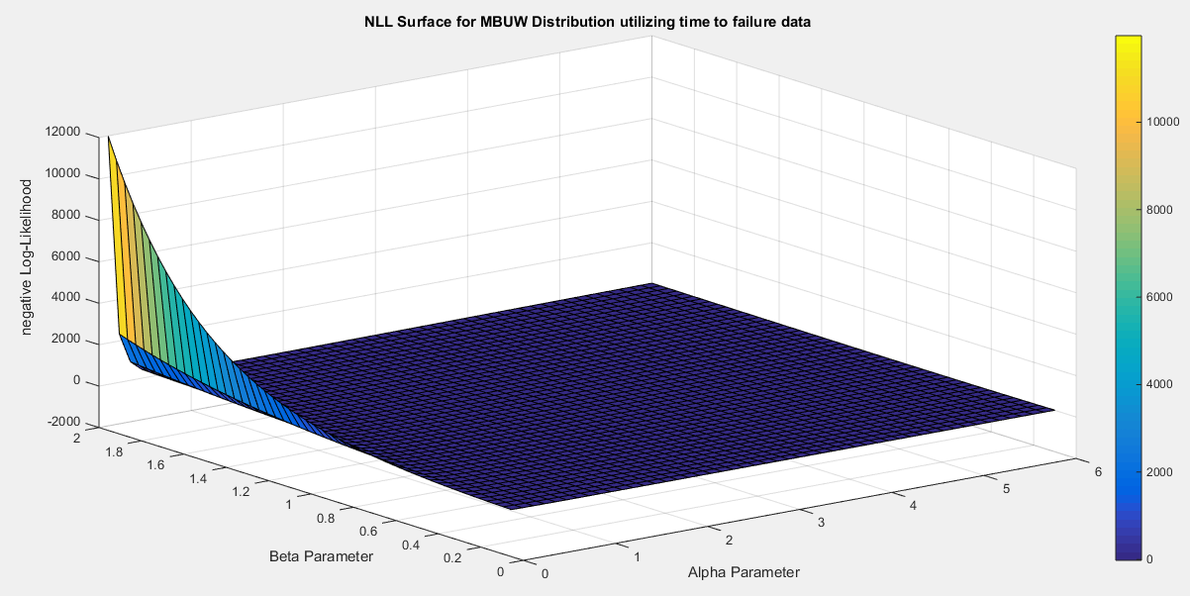
Fig. 1 Negative Log-Likelihood surface using the time between failures dataset.
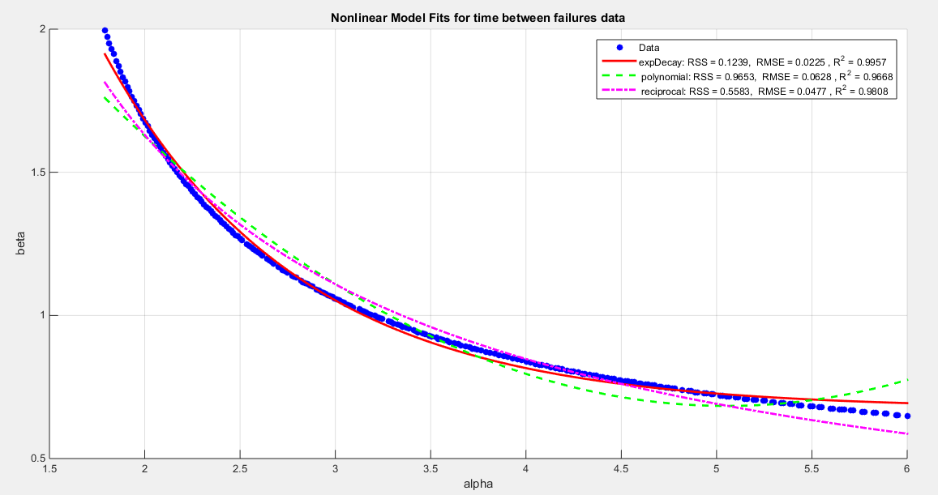
Fig. 2 Graph shows a decreasing convex relationship between alpha and beta. The Nonlinear models for the time between failures dataset, with residual sum of squares (RSS), R^2 and root of mean square error( RMSE) are illustrated in the figure for each curve, high lightening that the exponential is the best model followed by the reciprocal model then the polynomial (quadratic).
Table 1: the results of the 3 nonlinear models using the time between failures data
metric | Exponential decay | Quadratic-polynomial | Reciprocal
$$α$$ | 1.977  (1.6364 , 2.318) | 2.105  (1.7091 , 2.5009) | 2.141  (1.729 , 2.5531)
$$β$$ | 1.7062  (1.3616, 2.0507) | 1.5624  (1.3264 , 1.7984 ) | 1.5276  (1.246 , 1.809 )
Var (SE)  $$α$$ | 0.0302  (0.1737) | 0.0408  (0.2019) | 0.0442  (0.2102)
Var (SE)  $$β$$ | 0.0309  (0.1757) | 0.0145  (0.1204) | 0.0206  (0.1435)
nLL | -19.931 | -19.931 | -19.931
KS | 0.1584 | 0.1584 | 0.1584
AD | 0.6703 | 0.6703 | 0.6703
CVM | 0.1253 | 0.1253 | 0.1253
AIC | -35.862 | -35.862 | -35.862
CAIC | -35.262 | -35.262 | -35.262
BIC | -33.591 | -33.591 | -33.591
HQIC | -35.2909 | -35.2909 | -35.2909
H_{o} = 0 | Fail to reject | Fail to reject | Fail to reject
P-value  (KS-test) | 0.5575 | 0.5575 | 0.5575

The evaluation of the models presented indicates that their variances are notably similar, suggesting a level of consistency in their performance. Furthermore, the estimators derived from these models show minimal differences, allowing for flexibility in model selection without significantly impacting the outcome. The (CIs) are quite narrow, reflecting a high degree of precision in the estimates. Interestingly, the stability of the estimators remains intact regardless of the initial assumptions or starting values used during the estimation process. This characteristic is particularly noteworthy, as it indicates robustness in the results; both the variance and the goodness-of-fit metrics exhibit little variability despite changes in these initial conditions. This pattern is an intriguing feature of the dataset under analysis.
3.1.2. second dataset: capacity factors data set.
data to evaluate the factors concerning the unit capacity, data compare factors between algorithms like SC 16 and P3, (Maya et al., 2024, 1999). The values of the data are: 0.853, 0.759, 0.866, 0.809, 0.717, 0.544, 0.492, 0.403, 0.344, 0.213, 0.116, 0.116, 0.092, 0.07, 0.059, 0.048, 0.036, 0.029, 0.021, 0.014, 0.011, 0.008, 0.006. Upon examining the surface of the negative log-likelihood (nLL), various features in Figure 3 are observed, which notably displays a region that is notably flat. This flat area suggests a range of parameter values that yield similar nLL outcomes, indicating potential stability in the parameter estimates. The author proceeded to extract pairs of parameters that effectively minimize the nLL, resulting in a total of 80 distinct pairs. The relationship between these parameter pairs is illustrated in Figure 4, which provides a visual representation of their interactions and dependencies. The exponential decay model demonstrates impressive performance with the following values: RSS of 0.0442, R squared of 0.9954, and RMSE of 0.0237. In comparison, the reciprocal model shows lesser effectiveness with an RSS of 0.2843, an R squared of 0.9701, and an RMSE of 0.06. Lastly, the quadratic model presents values of RSS at 0.3523, R squared at 0.963, and RMSE at 0.0668 as shown in Figure 4. Clearly, the exponential decay model stands out in terms of accuracy and reliability. To further understand the dynamics between the parameters, the author focuses on defining the relationship between $α$ and $β$. This relationship is captured through a curve-fitting process and utilizing the best-fitting curve based on the provided equations (36-38). This analysis aims to uncover the underlying patterns in how $α$ influences $β$, enhancing our overall comprehension of the model's behavior.
For exponential decay model: $β=9.424 e^{-1.2276\left(α\right)}+0.6253 (36)$
For polynomial model: $β=0.1596 α^{2}-1.3633 α+3.537 (37)$
For reciprocal model: $β=\frac{3.0101}{α}-0.0811 (38)$
Follow the steps from 4 to 8
Table 2 presents the results of re-parameterizing the nLL function with three different models.
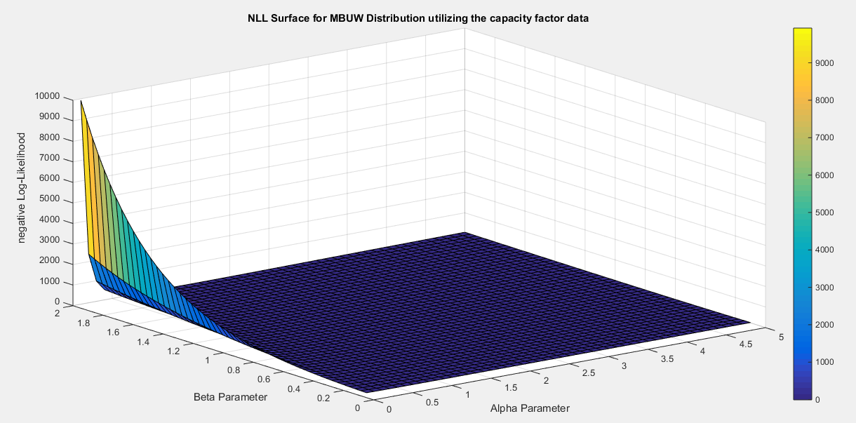
Fig. 3 Negative Log-likelihood surface using the factors affecting the unit capacity dataset.
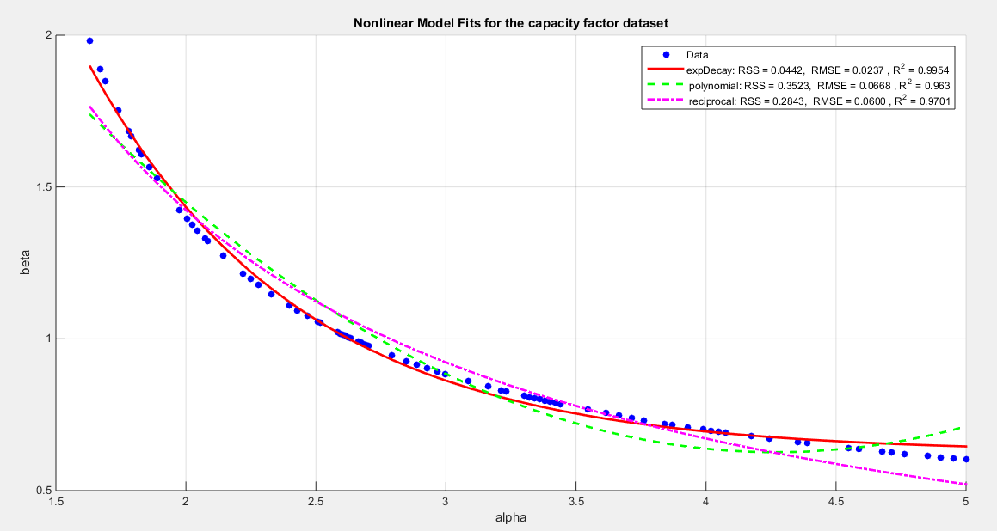
$Fig. 4 Graph shows a decreasing convex relationship between alpha and beta. The Nonlinear models for the capacity factor$ dataset, with residual sum of squares (RSS), R^2 and root of mean square error(RMSE) are illustrated in the figure for each curve, high lightening that the exponential is the best model followed by the reciprocal model then the polynomial (quadratic).

Table 2: the results of the 3 nonlinear models using the unit capacity data
metric | Exponential decay | Quadratic-polynomial | Reciprocal
$α$(CI) | 1.7729(1.4642 , 2.0815 ) | 1.8767(1.5174 , 2.2359) | 1.9217(1.5401 , 2.3037 )
$β$(CI) | 1.6943(1.2892,2.0993) | 1.5412(1.2668 , 1.8156 ) | 1.4853(1.1741 , 1.7969 )
V& (SE)$α$ | 0.0248(0.1575) | 0.0336(0.1833) | 0.0379(0.1947)
V&(SE)$β$ | 0.0427(0.2066) | 0.0196(0.1400) | 0.0252(0.1587)
nLL | -7.6079 | -7.6079 | -7.6079
KS | 0.1518 | 0.1518 | 0.1518
AD | 1.9075 | 1.9075 | 1.9075
CVM | 0.2033 | 0.2033 | 0.2033
AIC | -11.2158 | -11.2158 | -11.2158
CAIC | -10.6158 | -10.6158 | -10.6158
BIC | -8.9448 | -8.9448 | -8.9448
HQIC | -10.6446 | -10.6446 | -10.6446
H_{o} = 0 | Fail to reject | Fail to reject | Fail to reject
P-value  (KS-test) | 0.4074 | 0.4074 | 0.4074
The results generated by the three models exhibit a remarkable level of consistency and alignment and a high degree of comparability. The variances linked to the parameters across these models are strikingly low, underscoring their dependable and uniform performance in making predictions. Furthermore, the confidence interval (CI) is notably narrow, indicating that the estimates are not only trustworthy but also robust, reliable and stable. Given these compelling attributes, any of the three models stands as a strong contender for implementation, as they all demonstrate an impressive degree and a commendable level of accuracy and precision in their outcomes.
4. Discussion
The bias-corrected methodology is implemented on the first and the second datasets to assess the estimated parameters derived from the variance-corrected approach utilizing the Quadratic polynomial model. This evaluation takes place before and after the application of the bias-corrected technique elaborated in section 3. In Table 3, readers will find a comprehensive display of the parameter values before and following the correction, accompanied by the corresponding bias values. Meanwhile, Table 4 reveals the updated metrics post-correction, as calculated using equation 32, offering a clearer view of the improvements made.
Table 3: the bias and values of parameters before and after correction
 | Before correction | bias | After correction
Time between failure
$$\hat{α}$$ | 2.105 | 3.1065e-6 | 2.1050
$$\hat{β}$$ | 1.5624 | 6.7753e-4 | 1.5617
Factors affecting unit capacity
$$\hat{α}$$ | 1.8767 | 2.2681e-5 | 1.8767
$$\hat{β}$$ | 1.5412 | 4.8375e-4 | 1.5407

The captivating illustrations displayed in Figures 5-6 present the cumulative distribution function (CDF) and the quantile-quantile (QQ) plot for the data both before and following the bias adjustments. No noticeable difference is observed.
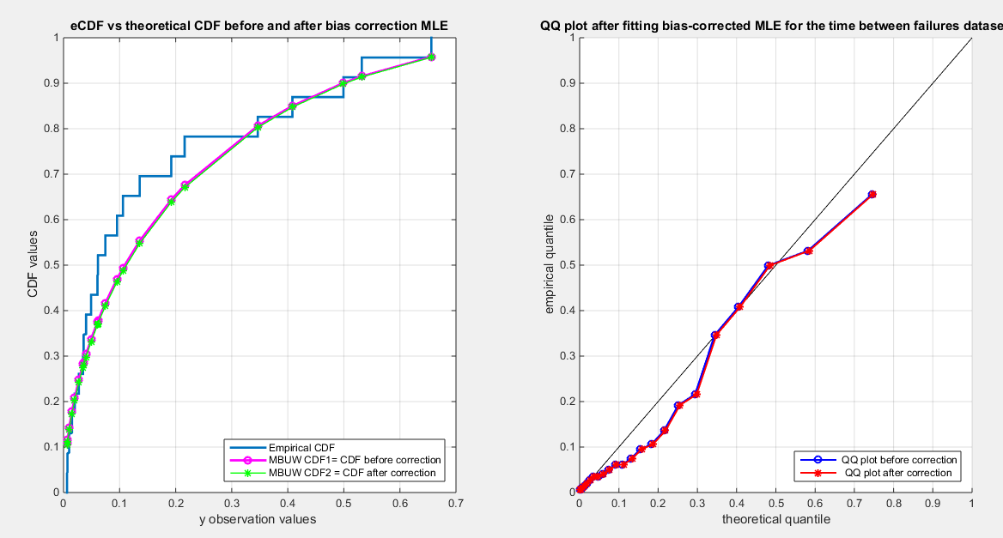
Table 4: Metrics after applying bias-corrected MLE on the mentioned datasets
Metrics | Time between failures | Factors affecting unit capacity
nLL | -19.9310 | -7.6079
AIC | -35.8620 | -11.2158
CAIC | -35.2620 | -10.6158
BIC | -33.5910 | -8.9448
HQIC | -35.2909 | -10.6446
KS | 0.1587 | 0.1520
AD | 0.6719 | 1.9078
CVM | 0.1257 | 0.2035
P(KS) | 0.5576 | 0.4090
Inverse of K matrix=  Var-cov matrix | $$\left[\begin{matrix}2.0215e-4 & -6.1525e-5 \\ -6.1525e-5 & 0.0030\end{matrix}\right]$$ | $$\left[\begin{matrix}6.5107e-4 & -1.3547e-4 \\ -1.3547e-4 & 0.0069\end{matrix}\right]$$

Fig. 5 Graph shows the CDF on the right and QQ plot on the left for the time between failures dataset before and after correction
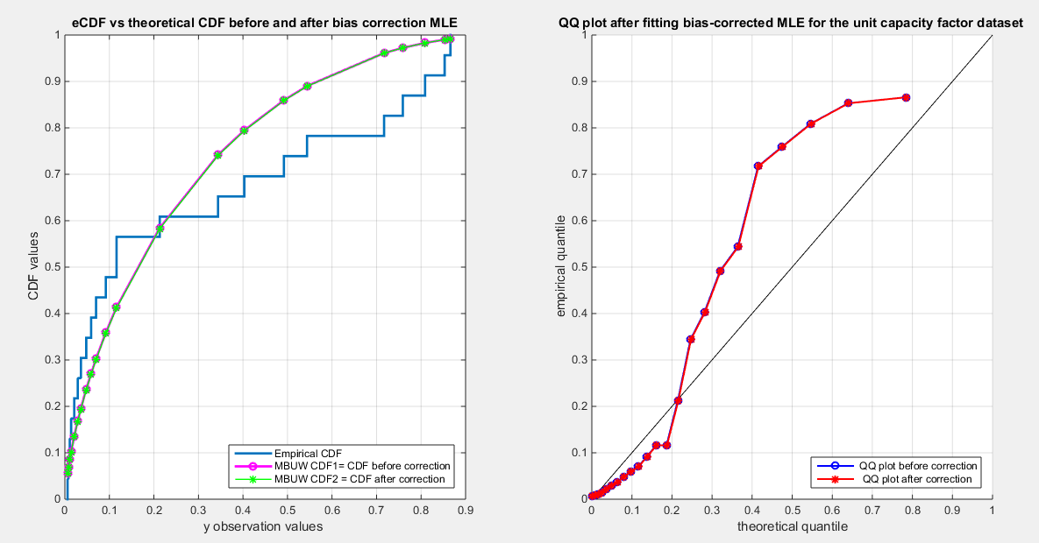
Fig. 6 graph shows the CDF on the right and QQ plot on the left for the factors affecting unit capacity dataset before and after correction
Table 4 presents no noticeable decline in the metrics across the two datasets following the correction. The variance-covariance matrix for each dataset reveals minimal negative co-variances. This indicates an inverse relationship among the parameters, a relationship that was elucidated through the examination of the nLL surface in section 3. The parameters estimated by the variance-corrected approach are highly statistically significant.
Figures 5-6 illustrate the graphs for the time between failures dataset and the factors affecting unit capacity dataset exhibit almost no discernible differences before and after the bias correction. Intriguingly, the inverse of the information matrix, which serves as the variance-covariance matrix, is confirmed to be positive definite. The variance-corrected approach significantly diminishes both the variances and the correlation among the parameters, yielding a clearer understanding of the underlying data patterns. The delta method proved to be effective. This pursuit of uncorrelated estimators, paired with reduced variances, produced distributions adept at fitting various datasets.
The bias-corrected technique is heavily reliant on the expectations of higher-order derivatives, introducing complexity in the integration process that can greatly influence the information matrix and, consequently, the variance-covariance matrix. Notably, the variance-corrected approach consistently outperformed traditional methods like the generalized method of moments (GMM) and percentile techniques previously employed by the author (Attia, 2025). While the alternative methods produced variances that were indeed smaller than those generated by the maximum likelihood estimation (MLE) using the Nelder-Mead optimization algorithm, it is noteworthy that these variances were still larger than the ones achieved through the variance-corrected MLE approach. This suggests that despite the improvements made by the GMM and percentile methods, the variance-corrected MLE is a promising option for minimizing the variance in this context.
Furthermore, visualizing the negative log-likelihood (nLL) surface for each dataset proves invaluable, shedding light on the estimation process's outcomes, along with the uniqueness and identifiability of the parameters and their interrelations.
5. Conclusion
The variance-corrected and bias-corrected approaches are essential techniques utilized after the initial estimation of MBUW parameters, which can be conducted using methods such as maximum likelihood estimation (MLE) with various optimizers tailored to the characteristics of the data, or by employing generalized methods of moments (GMMs) or percentile methods. These latter two methods specifically address the issue of parameter correlation, which is not considered in the initial estimations like(MLE).
In practical applications, a typical workflow begins with MLE, often using the Nelder-Mead optimization method or another suitable optimizer. However, if the characteristics of the data significantly influence the variance-covariance matrix, practitioners may transition to methods like the generalized method of moments or percentile methods that can further reduce the variance and the covariance though they may still exhibit relatively large variances.
Visualizing the negative log-likelihood (nLL) surface can be instrumental in identifying parameter values that lead to an optimal fit of the distribution to the data, aiding in the selection of initial parameter values for the estimation process. By leveraging this visualization, the variance-corrected and bias-corrected approaches can mitigate inflation in variance and decrease the correlation between parameters, resulting in more robust parameter estimates.
Applying the bias correction for the estimated parameters obtained through the new variance-corrected approach yields results that are nearly identical to the outcome before its deployment. In addition to the sample size being small, this new approach yields minimal bias.
6. Future works
In the case of the datasets that demonstrate a variance-covariance matrix lacking positive definiteness, it is advisable to explore alternative numerical integration techniques or to employ Bayesian inference methods. These approaches can significantly enhance the accuracy and reliability of the estimation process when traditional methods fall short. Specifically, numerical integration techniques such as Monte Carlo integration or quadrature methods can effectively address issues arising from non-positive definiteness by providing a more robust framework for calculations. Meanwhile, Bayesian inference offers a powerful modeling perspective that allows the incorporation of prior information and uncertainty, which can lead to more informed and nuanced estimations despite the complications presented by the datasets in question.

Disclaimer
This paper is an extended version of a preprint document of the same author.
The preprint document is available in this link: https://doi.org/10.21203/rs.3.rs-5918154/v1
[As per journal policy, preprint /repository article can be published as a journal article, provided it is not published in any other journal]

Disclaimer (Artificial intelligence)

Author(s) hereby declare that NO generative AI technologies such as Large Language Models (ChatGPT, COPILOT, etc.) and text-to-image generators have been used during the writing or editing of this manuscript.

References
- Ahmed, A. A., Algamal, Z. Y., & Albalawi, O. (2024). Bias reduction of maximum likelihood estimation in exponentiated Teissier distribution. Frontiers in Applied Mathematics and Statistics, 10, 1351651. https://doi.org/10.3389/fams.2024.1351651
- Attia, I. M. (2025). Median‐Based Unit Weibull (MBUW): A New Variants of Generalized Method of Moments and Percentile Estimators. Journal of Probability and Statistics, 2025(1), 1503091. https://doi.org/10.1155/jpas/1503091
- Bartlett, M. S. (1953a). Approximate Confidence Intervals. Biometrika, 40(1/2), 12. https://doi.org/10.2307/2333091
- Bartlett, M. S. (1953b). Approximate Confidence Intervals.II. More than one Unknown Parameter. Biometrika, 40(3/4), 306. https://doi.org/10.2307/2333349
- Cordeiro, G. M., & Cribari-Neto, F. (2014). Analytical and Bootstrap Bias Corrections. In G. M. Cordeiro & F. Cribari-Neto, An Introduction to Bartlett Correction and Bias Reduction (pp. 69–99). Springer Berlin Heidelberg. https://doi.org/10.1007/978-3-642-55255-7_4
- Cordeiro, G. M., Da Rocha, E. C., Da Rocha, J. G. C., & Cribari-Neto, F. (1997). Bias-corrected maximum likelihood estimation for the beta distribution. Journal of Statistical Computation and Simulation, 58(1), 21–35. https://doi.org/10.1080/00949659708811820
- Cordeiro, G. M., & Klein, R. (1994). Bias correction in ARMA models. Statistics & Probability Letters, 19(3), 169–176. https://doi.org/10.1016/0167-7152(94)90100-7
- Cox, D. R., & Snell, E. J. (1968). A General Definition of Residuals. Journal of the Royal Statistical Society Series B: Statistical Methodology, 30(2), 248–265. https://doi.org/10.1111/j.2517-6161.1968.tb00724.x
- Cribari-Neto, F., & Vasconcellos, K. L. P. (2002). Nearly Unbiased Maximum Likelihood Estimation for the Beta Distribution. Journal of Statistical Computation and Simulation, 72(2), 107–118. https://doi.org/10.1080/00949650212144
- Dey, S., & Wang, L. (2022). Methods of Estimation and Bias Corrected Maximum Likelihood Estimators of Unit Burr III Distribution. American Journal of Mathematical and Management Sciences, 41(4), 316–333. https://doi.org/10.1080/01966324.2021.1963357
- Dey, S., Wang, L., & Saha, M. (2022). Modified estimation and confidence intervals of an asymmetric loss‐based process capability index Cpm′$\mathcal {C}^{\prime }_{pm}$. Quality and Reliability Engineering International, 38(8), 4033–4048. https://doi.org/10.1002/qre.3184
- Dey, S., Wang, L., & Saha, M. (2024). Inference of $$S^{\prime }_{pmk}$$ based on bias-corrected methods of estimation for generalized exponential distribution. International Journal of System Assurance Engineering and Management, 15(11), 5265–5278. https://doi.org/10.1007/s13198-024-02533-2
- Efron, B. (1982). The Jackknife, the Bootstrap andother resampling plans (Vol. 1–Vol. 38. Philadelphia, PA, USA: SIAM.). SIAM.
- Ferrari, S. L. P., & Cribari-Neto, F. (1998). On bootstrap and analytical bias corrections. Economics Letters, 58(1), 7–15. https://doi.org/10.1016/S0165-1765(97)00276-0
- Firth, D. (1993). Bias reduction of maximum likelihood estimates. Biometrika, 80(1), 27–38. https://doi.org/10.1093/biomet/80.1.27
- Gedik Balay, İ. (2021). Estimation of the generalized process capability index C _{pyk} based on bias-corrected maximum-likelihood estimators for the generalized inverse Lindley distribution and bootstrap confidence intervals. Journal of Statistical Computation and Simulation, 91(10), 1960–1979. https://doi.org/10.1080/00949655.2021.1879081
- Giles, D. E. (2012). A note on improved estimation for the Topp–Leone distribution. Tech. Rep., Department of Economics, University of Victoria, Econometrics Working Papers.
- Giles, D. E. (2012). Bias Reduction for the Maximum Likelihood Estimators of the Parameters in the Half-Logistic Distribution. Communications in Statistics - Theory and Methods, 41(2), 212–222. https://doi.org/10.1080/03610926.2010.521278
- Giles, D. E., Feng, H., & Godwin, R. T. (2013). On the Bias of the Maximum Likelihood Estimator for the Two-Parameter Lomax Distribution. Communications in Statistics - Theory and Methods, 42(11), 1934–1950. https://doi.org/10.1080/03610926.2011.600506
- Giles, D. E., Feng, H., & Godwin, R. T. (2016). Bias-corrected maximum likelihood estimation of the parameters of the generalized Pareto distribution. Communications in Statistics - Theory and Methods, 45(8), 2465–2483. https://doi.org/10.1080/03610926.2014.887104
- Giles, D. E & H. Feng. (2009). Bias of the maximum likelihood estimators of the two-parameter Gamma distribution revisited. Tech. Rep., Department of Economics, University of Victoria, Econometrics Working Papers.
- Gül, H. H., & Doğru, F. Z. (2024). Bias corrected maximum likelihood estimators for the parameters of the generalized normal distribution. Communications Faculty Of Science University of Ankara Series A1Mathematics and Statistics, 73(4), 1050–1071. https://doi.org/10.31801/cfsuasmas.1439744
- Haldane, J. B. S., & Smith, S. M. (1956). The Sampling Distribution of a Maximum-Likelihood Estimate. Biometrika, 43(1/2), 96. https://doi.org/10.2307/2333582
- Haldane, J.B.S. (1953). The estimation of two parameters from a sample. Sankhyā, 12, 313-320.
- Hashemi, M., & Schneider, K. A. (2021). Bias-corrected maximum-likelihood estimation of multiplicity of infection and lineage frequencies. PLOS ONE, 16(12), e0261889. https://doi.org/10.1371/journal.pone.0261889
- Lagos-Àlvarez, B., M. D. Jiménez-Gamero, & V. Alba-Fernández. (2011). Bias correction in the Type I Generalized Logistic distribution. Communications in Statistics - Simulation and Computation, 40((4)), 511–531.
- Lemonte, A. J. (2011). Improved point estimation for the Kumaraswamy distribution. Journal of Statistical Computation and Simulation, 81(12), 1971–1982. https://doi.org/10.1080/00949655.2010.511621
- Lemonte, A. J., Cribari-Neto, F., & Vasconcellos, K. L. P. (2007). Improved statistical inference for the two-parameter Birnbaum–Saunders distribution. Computational Statistics & Data Analysis, 51(9), 4656–4681. https://doi.org/10.1016/j.csda.2006.08.016
- Ling, X., & Giles, D. E. (2014). Bias Reduction for the Maximum Likelihood Estimator of the Parameters of the Generalized Rayleigh Family of Distributions. Communications in Statistics - Theory and Methods, 43(8), 1778–1792. https://doi.org/10.1080/03610926.2012.675114
- Maya, R., Jodrá, P., Irshad, M. R., & Krishna, A. (2024). The unit Muth distribution: Statistical properties and applications. Ricerche Di Matematica, 73(4), 1843–1866. https://doi.org/10.1007/s11587-022-00703-7
- Mazucheli, J., & Dey, S. (2018). Bias-corrected maximum likelihood estimation of the parameters of the generalized half-normal distribution. Journal of Statistical Computation and Simulation, 88(6), 1027–1038. https://doi.org/10.1080/00949655.2017.1413649
- Mazucheli, J., Menezes, A. F. B., & Dey, S. (2019). Bias-corrected maximum likelihood estimators of the parameters of the inverse Weibull distribution. Communications in Statistics - Simulation and Computation, 48(7), 2046–2055. https://doi.org/10.1080/03610918.2018.1433838
- Menezes, A., Mazucheli, J., Alqallaf, F., & Ghitany, M. E. (2021). Bias-Corrected Maximum Likelihood Estimators of the Parameters of the Unit-Weibull Distribution. Austrian Journal of Statistics, 50(3), 41–53. https://doi.org/10.17713/ajs.v50i3.1023
- Menezes, A., Mazucheli, J., De Oliveira, R. P., & Chakraborty, S. (2023). Improved maximum likelihood estimation of the parameters of the Gamma-Uniform distribution with bias-corrections. Communications in Statistics - Simulation and Computation, 52(9), 4023–4035. https://doi.org/10.1080/03610918.2021.1951760
- Millar, R. (2011). Maximum likelihood estimation and inference. Chichester, West Sussex, United Kingdom: John Wiley & Sons, Ltd.
- Pawitan, Y. (2001). In all likelihood: Statistical modelling and inference using likelihood. Oxford: Oxford University Press.
- Rasekhi, M., & G. Hamedani, G. (2019). Bias-corrected Maximum-Likelihood Estimator for the Parameter of the Logarithmic Series Distribution and its Characterizations. Journal of Statistical Research of Iran, 16(1), 59–72. https://doi.org/10.52547/jsri.16.1.59
- Reath, J. (2016). Improved parameter estimation of the log-logistic distribution with applications [PhD. thesis]. Michigan Technological University.
- Saha, K., & Paul, S. (2005). Bias‐Corrected Maximum Likelihood Estimator of the Negative Binomial Dispersion Parameter. Biometrics, 61(1), 179–185. https://doi.org/10.1111/j.0006-341X.2005.030833.x
- Sangpoom, S., & Klomwises, Y. (2021). Bias-Corrected Maximum Likelihood Estimation of the Parameters of the Modified Power Function Distribution. Trends in Sciences, 18(19), 14. https://doi.org/10.48048/tis.2021.14
- Schwartz, J., & Giles, D. E. (2016). Bias-reduced maximum likelihood estimation of the zero-inflated Poisson distribution. Communications in Statistics - Theory and Methods, 45(2), 465–478. https://doi.org/10.1080/03610926.2013.824590
- Schwartz, J., Godwin, R. T., & Giles, D. E. (2013). Improved maximum-likelihood estimation of the shape parameter in the Nakagami distribution. Journal of Statistical Computation and Simulation, 83(3), 434–445. https://doi.org/10.1080/00949655.2011.615316
- Shenton, L. R., & Bowman, K. (1963). Higher Moments of a Maximum-Likelihood Estimate. Journal of the Royal Statistical Society Series B: Statistical Methodology, 25(2), 305–317. https://doi.org/10.1111/j.2517-6161.1963.tb00511.x
- Singh, A. K., Singh, A., & Murphy, D. J. (2015). On Bias Corrected Estimators of the Two Parameter Gamma Distribution. 2015 12th International Conference on Information Technology - New Generations, 127–132. https://doi.org/10.1109/ITNG.2015.151
- suprawhardana. (1999). Suprawhardana, M.S., Prayoto, S.: Total time on test plot analysis for mechanical components of the RSG-GAS reactor. At. Indones. 25(2), 81–90 (1999). 25(2),81-90(1999), 25(5), 81–90.
- Teimouri, M. (2022). Bias corrected maximum likelihood estimators under progressive type-I interval censoring scheme. Communications in Statistics - Simulation and Computation, 51(11), 6854–6865. https://doi.org/10.1080/03610918.2020.1819320
- Teimouri, M., & Nadarajah, S. (2013). Bias corrected MLEs for the Weibull distribution based on records. Statistical Methodology, 13, 12–24. https://doi.org/10.1016/j.stamet.2013.01.001
- Teimouri, M., & Nadarajah, S. (2016). Bias corrected MLEs under progressive type-II censoring scheme. Journal of Statistical Computation and Simulation, 86(14), 2714–2726. https://doi.org/10.1080/00949655.2015.1123709
- Tsai, T.-R., Xin, H., Fan, Y.-Y., & Lio, Y. (2022). Bias-Corrected Maximum Likelihood Estimation and Bayesian Inference for the Process Performance Index Using Inverse Gaussian Distribution. Stats, 5(4), 1079–1096. https://doi.org/10.3390/stats5040064
- Wang, M., & Wang, W. (2017). Bias-Corrected maximum likelihood estimation of the parameters of the weighted Lindley distribution. Communications in Statistics - Simulation and Computation, 46(1), 530–545. https://doi.org/10.1080/03610918.2014.970696
- Wang, S., & Gui, W. (2020). Corrected Maximum Likelihood Estimations of the Lognormal Distribution Parameters. Symmetry, 12(6), 968. https://doi.org/10.3390/sym12060968
- Zhang, G., & Liu, R. (2017). Bias-corrected estimators of scalar skew normal. Communications in Statistics - Simulation and Computation, 46(2), 831–839. https://doi.org/10.1080/03610918.2014.980512

Appendix A
The code can be found using this link https://zenodo.org/records/18277461 and this DOI
10.5281/zenodo.18277460.
Table A1: Results of the competitors’ distributional fit for the Time between failures dataset
 | Beta |  | Kumaraswamy |  | MBUR | MBUW
theta | $$α=0.6307$$ |  | $$α=0.6766$$ |  | 1.7886 | $$α=5.1285$$
theta | $$β=3.2318$$ |  | $$β=2.936$$ |  | 1.7886 | $$β=0.7113$$
Var | 0.071 | 0.2801 | 0.0198 | 0.1033 | 0.018 | $$1.02*{10}^{7}$$ | $$-8.7*{10}^{5}$$
Var | 0.2801 | 1.647 | 0.1033 | 0.9135 | 0.018 | $$-8.7*{10}^{5}$$ | $$7.4*{10}^{4}$$
SE | 0.056 |  | 0.029 |  | 0.028 | 665
SE | 0.268 |  | 0.199 |  | 0.028 | 56.7
AIC | -36.0571 |  | -36.6592 |  | -37.862 | -35.862
CAIC | -35.4571 |  | -36.0592 |  | -37.6712 | -35.262
BIC | -33.7861 |  | -34.3882 |  | -36.7265 | -33.591
NLL | -20.0285 |  | -20.3296 |  | -19.9310 | -19.9310
K-S | 0.1541 |  | 0.1393 |  | 0.1584 | 0.1584
H₀ | Fail to reject |  | Fail to reject |  | Fail to reject | Fail to Reject
P-value | 0.5918 |  | 0.7123 |  | 0.5575 | 0.5575
AD | 0.6886 |  | 0.5755 |  | 0.6703 | 0.6703
CVM | 0.1264 |  | 0.0989 |  | 0.1253 | 0.1253
Table A1 demonstrates that the inflated variance-covariance matrix for the estimated parameters of the MBUW using the Nelder-Mead optimizer of the MLE. The likelihood is 19.9310 like the Median-Based Unit Rayleigh (MBUR) distribution, which is a special case of the MBUW by substituting the $β=2$ . the two parameters of the MBUW are highly and negatively correlated. The MBUW comparably fits the data in comparison with the beta and the Kumaraswamy distributions.

Table A2 : Results of the competitors’ distributional fit for the factors of unit capacity dataset
 | Beta |  | Kumaraswamy |  | MBUR | MBUW
theta | $$α=0.4869$$ |  | $$α=0.5044$$ |  | 1.6243 | $$α=3.7003$$
theta | $$β=1.1679$$ |  | $$β=1.1862$$ |  | 1.6243 | $$β=0.7415$$
Var | 0.0482 | 0.0960 | 0.0166 | 0.0274 | 0.0149 | $$5.2*{10}^{6}$$ | $$-7.8*{10}^{5}$$
Var | 0.0960 | 0.2919 | 0.0274 | 0.1066 | 0.0149 | $$-7.8*{10}^{5}$$ | $$1.2*{10}^{5}$$
SE | 0.046 |  | 0.027 |  | 0.025 | 475
SE | 0.113 |  | 0.068 |  | 0.025 | 72.2
AIC | -15.2149 |  | -15.3416 |  | -13.2158 | -11.2158
CAIC | -14.6149 |  | -14.7416 |  | -13.0253 | -10.6158
BIC | -12.9439 |  | -13.0706 |  | -12.0803 | -8.9448
NLL | -9.6075 |  | -9.6708 |  | -7.6079 | -7.6079
K-S | 0.1836 |  | 0.1790 |  | 0.1518 | 0.1518
H₀ | Fail to reject |  | Fail to reject |  | Fail to reject | Fail to Reject
P-value | 0.3742 |  | 0.4051 |  | 0.4074 | 0.4074
AD | 0.6886 |  | 0.5755 |  | 1.9075 | 1.9075
CVM | 0.1264 |  | 0.0989 |  | 0.2033 | 0.2033
Table A2 demonstrates that the inflated variance-covariance matrix for the estimated parameters of the MBUW using the Nelder-Mead optimizer of the MLE. The likelihood is 19.9310 like the Median-Based Unit Rayleigh (MBUR) distribution, which is a special case of the MBUW by substituting the $β=2$ . The two parameters of the MBUW are highly and negatively correlated

