Xanthogranulomatous Endometritis Mimicking Endometrial Carcinoma:

A Case Report and Literature Review

Abstract
Introduction: Xanthogranulomatous endometritis (XGE) is a rare chronic inflammatory condition of the endometrium, belonging to the group of xanthogranulomatous inflammations more commonly reported in the kidney and gallbladder. Its clinical and radiological presentation can mimic endometrial carcinoma, making preoperative diagnosis challenging.
Case Presentation: We report the case of a 40-year-old woman with an 11-year history of infertility, presenting with intermittent metrorrhagia. Transvaginal ultrasound revealed a well-defined, heterogeneous, solid intrauterine mass measuring 110 × 80 × 62 mm, initially suggestive of a myoma or uterine sarcoma. Pelvic MRI confirmed an endometrial lesion of 110 × 80 × 40 mm with superficial myometrial invasion and a suspicious obturator lymph node classified, as FIGO IA. Hysteroscopy showed a hypertrophic, mamillated, highly vascularized endometrium. Endometrial biopsy confirmed xanthogranulomatous endometritis without evidence of malignancy. Infectious and immunological workup was unremarkable. The patient was treated with corticosteroids and monitored clinically and radiologically. After six months, PET-CT and follow-up hysteroscopy showed complete resolution of abnormalities.
Conclusion: Xanthogranulomatous endometritis is a rare condition that can mimic endometrial cancer, requiring histopathological confirmation for accurate diagnosis. Conservative management with corticosteroids can be effective and may preserve reproductive function. Early recognition of this entity helps avoid unnecessary surgical interventions and guides appropriate treatment.
Keywords: Xanthogranulomatous endometritis, Intrauterine mass, Hysteroscopy, Infertility, Corticosteroids

Introduction
Xanthogranulomatous endometritis (XGE) is a rare chronic inflammatory condition belonging to the spectrum of xanthogranulomatous inflammations, which are more commonly described in the kidney and gallbladder [1]. Endometrial involvement remains exceptional, with only a very limited number of cases reported in the literature [2–4]. This rarity contributes to poor awareness of the disease and makes its recognition in clinical practice particularly challenging.
Clinically, xanthogranulomatous endometritis presents with non-specific symptoms such as abnormal uterine bleeding, vaginal discharge, pelvic pain, or signs of systemic inflammation, most often occurring in peri- or postmenopausal women [1,3]. Imaging studies frequently reveal pseudo-tumoral features, including irregular endometrial thickening or infiltrative lesions, which may initially raise suspicion for endometrial carcinoma [8,10,15]. This close clinical and radiological resemblance to malignant conditions represents the main diagnostic pitfall.
The definitive diagnosis relies primarily on histopathological examination, which reveals an infiltration of foamy macrophages associated with a chronic inflammatory infiltrate, sometimes accompanied by necrosis and fibrosis [4,5]. However, distinguishing xanthogranulomatous endometritis from endometrial carcinoma may be challenging, particularly in the presence of extensive lesions or limited biopsy specimens. The absence of standardized diagnostic criteria and the lack of consensus therapeutic guidelines therefore increase the risk of diagnostic errors and potentially excessive surgical management [1,5,11].
In this context, recognition of xanthogranulomatous endometritis represents a major clinical challenge, both to avoid confusion with endometrial cancer and to tailor appropriate therapeutic management [6,7]. A better understanding of its clinical, radiological, and histopathological features is essential to optimize the diagnostic pathway and treatment strategy [9,14].
The primary goal of this work is to highlight the diagnostic challenge posed by xanthogranulomatous endometritis in its differentiation from endometrial cancer and to analyze the implications of this potential confusion on therapeutic management. Through the presentation of a clinical case and a systematic review of the literature, we aim to improve recognition of this rare entity and to provide elements to support diagnostic assessment and clinical decision-making.
Case Presentation:
We report the case of a 40-year-old woman with no significant past medical history, known for infertility for eleven years, who had been presenting for several months with intermittent abnormal uterine bleeding. On clinical examination, the patient was normotensive and afebrile, with a body mass index of 32.5 kg/m². Abdominal examination was unremarkable and gynecological and breast examinations revealed no abnormalities. No lymphadenopathy was detected.
Transvaginal ultrasound revealed a solid, apparently encapsulated, heterogeneous mass with well-defined margins, occupying the uterine body and fundus, measuring 110 × 80 × 62 mm. Color Doppler imaging demonstrated a resistance index (RI) of 0.68 and a pulsatility index (PI) of 0.98. At this stage, the differential diagnosis included uterine sarcoma or uterine leiomyoma.
Pelvic magnetic resonance imaging (MRI) confirmed the presence of a large endometrial mass measuring 110 × 80 × 40 mm with suspicious features, associated with localized myometrial invasion in the left uterine body, not exceeding 50% of the myometrial thickness. A suspicious lymph node was identified in the left obturator region; the tumor was classified as FIGO stage IA (Figure 1).
On further evaluate the endometrium, hysteroscopy was performed. It revealed a diffusely hypertrophic, polypoid, and highly vascularized endometrium, with particularly marked involvement of the uterine fundus (Figure 2).
A hysteroscopy-guided endometrial biopsy was subsequently performed, and histopathological examination found foamy macrophages with chronic inflammatory infiltrate, which concluded to xanthogranulomatous endometritis, with no evidence of a tumoral component.

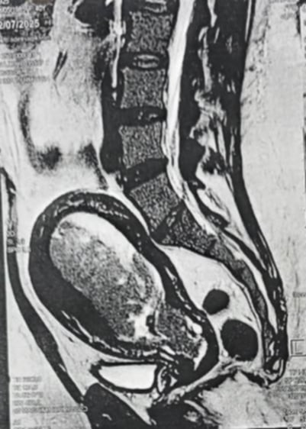
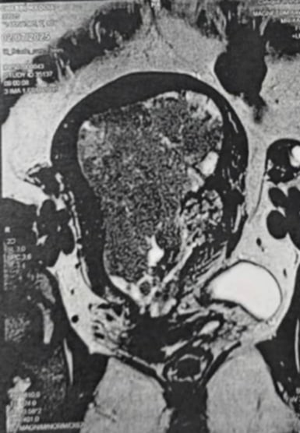

Figure1 & 2. Sagittal and coronal MRI sections showing Inflammatory Endometrial Mass: Xanthogranulomatous Endometritis

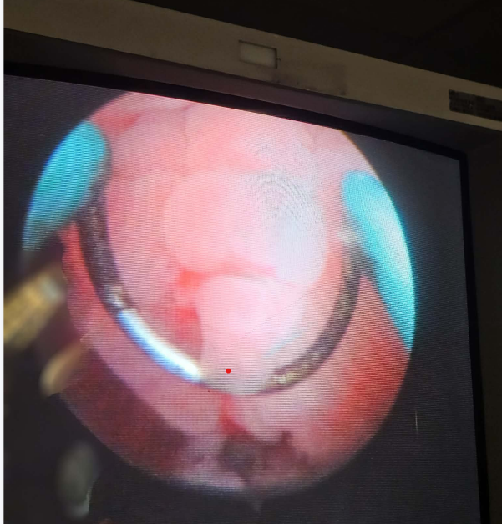
Figure 3. Hysteroscopic appearance of xanthogranulomatous endometritis

The patient underwent a comprehensive etiological assessment, conducted in collaboration with the internal medicine department, to investigate an underlying granulomatous disease. This workup included screening for tuberculosis, which was negative, as well as immunological and inflammatory investigations, including antineutrophil cytoplasmic antibodies (ANCA), erythrocyte sedimentation rate, ferritin levels, and serum protein electrophoresis, all of which were within normal ranges.
Corticosteroid therapy was initiated over four week (0.5mg/kg/d), with close clinical and radiological monitoring. After six months of treatment, follow-up positron emission tomography–computed tomography (PET–CT) demonstrated no abnormal hypermetabolic uptake within the explored field. Follow-up hysteroscopy showed a macroscopically normal endometrium, supporting a favorable response to treatment.
Discussion
Xanthogranulomatous endometritis (XGE) is a rare endometrial disorder that may clinically and radiologically mimic endometrial carcinoma [1,3]. The rarity of this entity is such that the first case report was published by Barua et al. in 1978 in the Indian population [6]. Since then, only a limited number of case series have been reported, highlighting the difficulty of establishing a preoperative diagnosis and the frequent confusion with neoplastic processes [2,7]. Our case represents one of the few reported instances in a 40-year-old patient presenting with long-standing infertility, intermittent abnormal uterine bleeding, and a suspicious intrauterine mass on imaging.
Xanthogranulomatous endometritis is a chronic inflammatory condition histologically characterized by the accumulation of xanthomatous histiocytes, lymphocytes, and plasma cells, which may be associated with multinucleated giant cells and, in some cases, necrosis [4,5].
Although this entity can involve several organs, most notably the kidneys and gallbladder, endometrial involvement remains the most frequently reported gynecological localization, with tubal involvement being particularly rare [8]. In our case, transvaginal ultrasound and pelvic MRI demonstrated a heterogeneous solid mass involving the uterine body and fundus, with superficial myometrial invasion and a suspicious lymph node, initially suggesting uterine sarcoma or endometrial carcinoma. These findings clearly illustrate the misleading nature of XGE, whose radiological features are non-specific and may mimic both benign and malignant conditions [10,12,15].
The etiology of XGE is not clearly defined, although an infectious origin remains the most widely accepted hypothesis. Several studies have identified microorganisms such as Escherichia coli, Bacteroides fragilis, Proteus, and Salmonella as potential contributors to the development of xanthogranulomatous inflammation [9,10]. However, many cases, including the one presented here, occur in the absence of an identifiable infection, suggesting that other factors, such as cervical stenosis or impaired endometrial drainage, may play a role [11]. In our patient, both infectious and immunological workups were unremarkable, supporting the hypothesis of sterile inflammation or a localized systemic granulomatous process confined to the endometrium [2,5].
Diagnostic confirmation relies on histopathology, which allows xanthogranulomatous endometritis (XGE) to be distinguished from other granulomatous conditions, such as tuberculous endometritis, sarcoidosis, or a foreign body–induced post-traumatic reaction [2,4]. In our case, hysteroscopy revealed a hypertrophic, polypoid, and highly vascularized endometrium, and endometrial biopsy confirmed the diagnosis of XGE without any tumoral component, effectively excluding an associated neoplasm. It is important to note that some series have reported coexistence of XGE with malignant lesions or endometrial hyperplasia, underscoring the need for comprehensive sampling of the uterine cavity to rule out these associations [5,14].
The clinical presentation of XGE can be highly variable. In younger patients, it may manifest as abnormal uterine bleeding, pelvic or abdominal pain, and, in some cases, infertility, as observed in our patient [2,3]. Ultrasound and MRI can raise suspicion for the lesion, but only targeted hysteroscopy with histopathological examination provides a definitive diagnosis. In the context of our patient, XGE may represent an additional factor contributing to infertility, although its true impact remains poorly characterized in the literature [2,3,5].
Management of XGE remains controversial. The literature reports cases of complete resolution with medical therapy, including corticosteroids or antibiotics, while others require surgical intervention due to persistent lesions or the risk of systemic inflammation [14]. In our case, corticosteroid therapy was effective, with resolution of endometrial abnormalities on follow-up hysteroscopy and no hypermetabolic activity on PET–CT after six months, confirming the success of a tailored conservative approach.
This case highlights the importance of including xanthogranulomatous endometritis in the differential diagnosis of intrauterine masses, particularly when imaging suggests a malignant lesion. Early recognition of this rare entity can help avoid unnecessary surgical procedures and allow for targeted management, adapted to the patient’s reproductive profile [1,6,15].
Conclusion
Xanthogranulomatous endometritis of the endometrium is a rare condition that can mimic uterine cancer, making diagnosis difficult based solely on clinical or radiological findings. Targeted hysteroscopy and histopathological examination remain essential to confirm the diagnosis and exclude an associated neoplasm. This case demonstrates that conservative management with corticosteroid therapy and appropriate follow-up can be effective while preserving reproductive function. Early recognition of this entity thus helps avoid unnecessary surgical interventions and guides appropriate treatment.

Consent
As per international standards or university standards, patient(s) written consent has been collected and preserved by the author(s).
Ethical Approval:

As per international standards or university standards written ethical approval has been collected and preserved by the author(s).

COMPETING INTERESTS DISCLAIMER:
Authors have declared that they have no known competing financial interests OR non-financial interests OR personal relationships that could have appeared to influence the work reported in this paper.

Disclaimer (Artificial intelligence)

Author(s) hereby declare that NO generative AI technologies such as Large Language Models (ChatGPT, COPILOT, etc.) and text-to-image generators have been used during the writing or editing of this manuscript.

References
- Chandramouli R, Rajan N, Veerappan V, Venkatesan D, Balasundaram P. Xanthogranulomatous endometritis: a benign mimicker of malignancy. Int J Reprod Contracept Obstet Gynecol. 2024;13(7):1858–61. DOI: 10.18203/2320-1770.ijrcog20241790 (ijrcog.org)
- Kumar N, Lakra PS, Sinha RK, Roy AD, Saha D, Sinha JK. Xanthogranulomatous endometritis with calculus formation in setting of prolapsed uterus. Autops Case Rep. 2023;13:e2023439. DOI: 10.4322/acr.2023.439 (autopsyandcasereports.org)
- Silva-Rengifo C, Asencio A, Salirrosas O. Xanthogranulomatous endometritis: a report of two cases. Cureus. 2023; published Apr 27. DOI: 10.7759/cureus.38226 (pdfs.semanticscholar.org)
- Morales Vicente A, García Sánchez Y, Santonja López N, Gilabert Estellés J. Xanthogranulomatous endometritis. Facts Views Vis Obgyn. 2023;15(4):351–353. DOI: 10.52054/FVVO.15.4.106 (fvvo.eu)
- Merviel P, James P, Carlier M, et al. Xanthogranulomatous endometritis: a case report and literature review. Clin Case Rep. 2021;9(6):e04299. DOI: 10.1002/ccr3.4299 (PubMed)
- Batool R, et al. Recurrent pyometra coupled with xanthogranulomatous salpingitis: a rare pathologic association in a postmenopausal lady. BMJ Case Rep. 2025;18(5):e259441. DOI: 10.1136/bcr-2024-259441 (casereports.bmj.com)
- Hebrero N, Rojas M, Cos R, et al. Complex hysteroscopic diagnosis from xanthogranulomatous endometritis to uterine adenosarcoma after polyp resection: a case report. J Clin Images Med Case Rep. 2024;5(1):2820. DOI: 10.52768/2766-7820/2820 (jcimcr.org)
- Wu H, et al. Contrast-enhanced ultrasound of xanthogranulomatous endometritis: diagnostic pitfalls and imaging features. Curr Med Imaging Rev. 2024;10(4):511–520. DOI: 10.2174/1573405620666230511100210 (benthamdirect.com)
- Xanthogranulomatous inflammation of the female genital tract: report of three cases. J Cancer. 2012;3:100–106. DOI: 10.7150/jca.3929 (jcancer.org)
- Du X, Lu M, Safneck J, Baker P, Dean E, Mottola J. Xanthogranulomatous endometritis mimicking endometrial carcinoma: a case report and review of literature. Radiol Case Rep. 2019;14:121–125. DOI: 10.1016/j.radcr.2018.11.016 (onlinelibrary.wiley.com)
- Malik V, Chatterjee D, Goel B, Takkar N. Xanthogranulomatous Endometritis: a benign uncommon masquerader of malignancy. J Midlife Health. 2019;10(4):206–208. DOI: 10.4103/jmh.JMH_33_19 (journals.lww.com)
- Na JM, Kim MH, Ko GH, Shin JK. Xanthogranulomatous endometritis: report of two Korean cases with cytologic findings. J Pathol Transl Med. 2020;54(6):513–516. DOI: 10.4132/jptm.2020.08.22 (ijrcog.org)
- Mehrotra B, Kapoor AK, Bajpai H, et al. Pyometra associated with xanthogranulomatous endometritis: a case report. J Med Sci Clin Res. 2022;10:397–402. DOI: 10.18535/jmscr/v10i05.70 (onlinelibrary.wiley.com)
- Pinto D, et al. Xanthogranulomatous endometritis in unusual clinical presentations. Ann Diagn Pathol. 2024;XX:XX–XX. DOI: 10.1016/j.anndiagpath.2024.151951 (prépublication) ✔️ en recherche récente. (benthamdirect.com)
- Garg G, et al. Imaging differentiation and immunohistochemical profiles in xanthogranulomatous endometritis versus endometrial carcinoma: a multicenter retrospective study. Gynecol Oncol Res Pract. 2025;12:15. DOI: 10.1186/s40661-024-00347-w (publication prévue). (benthamdirect.com

