Intrauterine Fetal Demise in a Patient with HELLP Syndrome, Superimposed Preeclampsia and Placental Calcification: A Case Report

Abstract
This case describes a 37-year-old gravida 3 para 1+1 woman at 31+3 weeks gestation who experienced intrauterine fetal death secondary to Hemolysis, Elevated Liver enzymes and Low Platelets (HELLP) syndrome and placental calcification, on a background of chronic hypertension with superimposed preeclampsia and gestational thrombocytopenia. Her obstetric history included previous preeclampsia, gestational diabetes managed with diet, obesity, and one prior miscarriage. She was managed with close monitoring and timely supportive care. This case highlights the diagnostic and management challenges of hypertensive disorders in high-risk pregnancies and underscores the importance of early detection, vigilant surveillance, and a coordinated multidisciplinary approach to optimize maternal outcomes.

Key words: Intrauterine Death, HELLP Syndrome, Placental, Hypertension, superimposed, Preeclampsia, Gestational Thrombocytopenia

Introduction
Hypertensive disorders affect about 5–10% of pregnancies and are among the top causes of complications for both mothers and babies[1]. A 2025 systematic review and meta-analysis of hypertensive disorders in pregnancy reported that the overall global prevalence of HELLP syndrome was ~0.37–0.39% of all pregnancies [2]. Pertaining to our setting, a Malaysian academic report cited an incidence of HELLP syndrome among severe preeclampsia presentations as ~9.5 per 1,000 deliveries [3].
The fetal component primarily arises from abnormal placentation, leading to impaired trophoblastic invasion and inadequate remodeling of the spiral arteries. This results in placental hypoperfusion and ischemia, which compromises oxygen and nutrient delivery to the fetus. Consequently, the fetal manifestations of preeclampsia include fetal growth restriction (FGR), oligohydramnios, placental abruption, and in severe cases, intrauterine fetal demise (IUFD) [6].
The maternal component is driven by widespread endothelial dysfunction secondary to the release of anti-angiogenic and inflammatory mediators from the ischemic placenta into the maternal circulation. This systemic endothelial injury leads to increased vascular permeability, vasoconstriction, and activation of the coagulation cascade. Clinically, this manifests as hemolysis, glomerular endotheliosis with proteinuria, hepatic dysfunction, thrombocytopenia, and severe complications such as HELLP syndrome, pulmonary edema, acute kidney injury, and eclampsia [8,9].
In women with high-risk factors—including advanced maternal age (>35 years), previous history of preeclampsia, and chronic hypertension—the pathological processes are often more pronounced. In these patients, both the placental (fetal) and systemic maternal components may be simultaneously affected, leading to earlier onset disease, increased severity, and poorer maternal and fetal outcomes.

This case illustrates the challenges faced by a high-risk pregnant woman with chronic hypertension with superimposed preeclampsia who ultimately suffered fetal loss in the setting of HELLP syndrome. The case clearly demonstrates the complex interplay between placental dysfunction, thrombocytopenia, superimposed preeclampsia, and persistent hypertension. It underscores the importance of close monitoring and coordinated care in high-risk pregnancies. The discussion addresses both the immediate and long-term implications for maternal health and is supported by recent evidence.
Case Summary
Our patient previously never had underlying hypertension. However, during her previous pregnancy was diagnosed with severe preeclampsia at 28 weeks of gestation. In which the patient presented with documented high BP ranging from (145-180/95-100mmHg), however the patient remained asymptomatic. Antenatal scan during that period noted FGR, estimated fetal weight 1000gm and oligohydramnios with deep vertical pool of 1cm and doppler revealed absent end-diastolic flow. A decision for caesarean section was made in view of severe preeclampsia and fetal distress. Post delivery patient’s blood pressure was controlled with tablet Amlodipine 10mg OD which was only taken till 6 weeks of postpartum, subsequently the patient defaulted her follow up and medication. No antiphospholipid antibodies screening was done during postpartum. Her 1st newborn currently is well with no further irreversible complications from the prematurity and under paediatric follow up.

During the current pregnancy, the patient had regular antenatal visits, with her booking weight of 75kg and body-mass-index 33kg/m². Booking platelet was normal 201 × 10⁹/L. Throughout her pregnancy, her blood pressure fluctuated between 122–139/61–89 mmHg, while home readings were more stable, ranging from 101–130/60–86 mmHg. She had multiple admission throughout pregnancy for blood pressure stabilisation and was last discharged on tablet Methyldopa 750 mg TDS and along with preeclampsia prophylaxis (tablet Aspirin 150 mg OD and tablet calcium carbonate 500 mg TDS). The patient was planned for cardiac assessment at 34 weeks of gestation as per local practice. Other risk factors include gestational diabetes mellitus on diet control which had a good control with HbA1c of 4.5% and maternal obesity. Additionally at 14 weeks of gestation, the patient’s platelet counts noted 101 × 10⁹/L otherwise, other blood parameters including renal profile and liver function test were normal and blood pressure well controlled subsequently. Our patient had routine obstetrics follow ups with an obstetrics scan every 2-3 weeks which shows normal growing fetus and normal doppler.
However at 24 weeks of gestation the patient was diagnosed with chronic hypertension with preeclampsia following an admission for asymptomatic hypertensive crisis accompanied by proteinuria of Urine Protein/Creatinine Index (UPCI) 0.03 mg/mmol , which then blood pressure was stabilised with tablet Methyldopa 1 g TDS. The decision of using methylopa was a centrally acting sympatholytic. During the admission, the platelet value noted decreased significantly 53 × 10⁹/L however the haemoglobin was normal at 11 g/dL, renal profile and liver function test showed no acute kidney injury or transaminitis. Further investigation for the thrombocytopenia was done including negative antinuclear antibody (ANA), normal complement levels, and a negative viral serology infective screening -including Human immunodeficiency virus (HIV), Hepatitis B virus and Hepatitis C virus. Hematology consultation recommended avoiding steroid treatment unless her platelet count drop further below 50 × 10⁹/L or if she was close to delivery with low counts.

Unfortunately at 30 weeks of gestation, she presented with a one-day history of reduced fetal movements and irregular contractions. Her blood pressure at the general practitioner clinic was recorded at 160/78 mmHg; she took her tablet methyldopa 1g stat on her way to the hospital. Blood pressure during admission in our centre ranges from 160-180/78-100mmHg which requires parenteral antihypertensive including IV Hydralazine 5mg slow bolus then subsequently blood pressure well controlled. Otherwise the patient had no other symptoms including headache, blurring of vision, epigastric pain, vomiting, or bleeding tendencies. Physical examination shows a clinically alert patient, obey commands, clinically uterus at 30 weeks size with no clinical features of placenta abruption and fetus in breech presentation, cardiovascular examination normal and bilateral minimal pitting oedema up to midshin with reflexes not brisk. Vaginal examination showed unfavourable cervix. An ultrasound showed no fetal heart activity, with measurements indicating a gestational age of 28–30 weeks with estimated fetal weight of 1200gram. Her blood parameters upon admission revealed thrombocytopenia 25 × 10⁹/L and transaminitis as per in (Table 1). The diagnosis of HELLP syndrome was established and decision for an emergency lower segment caesarean section was made in view of unfavourable cervix not favouring vaginal delivery. The patient requested for bilateral tubal ligation under the same setting as the patient had no future fertility desire and had completed family. The caesarean section was done under general anaesthesia. Intraoperatively the patient was transfused with 4 units of platelet coverage, operation was uneventful with estimated blood loss of 400mls, no primary postpartum hemorrhage. delivered a female stillbirth weighing 1.29 kg. The fetus appeared generally normal with no visible external defects, but the placenta looked unhealthy, showing multiple areas of calcification as per in (Figure 1).

The patient required ward admission in a total of 5 days of stay. The patient remained well in the ward with no bleeding tendencies , blood pressure ranging from 118-136/77-85mmHg. Day 2 post operative wound examination was normal with no sign of infection/inflammation. No steroid required postoperatively. Platelet trend noted upgoing with platelet of 100 × 10⁹/L and improving transaminitis as per in (Table 1). The patient subsequently was scheduled for 2 weeks follow up in our clinic. The patient was discharged with tablet amlodipine 10mg OD. During the postpartum visit, patient remained well, home monitoring blood pressure well optimised, wound well healed, the platelet has improved to normal value of 189× 10⁹/L and resolved transaminitis. The patient was then discharged for continuation of care in the primary clinic setting.

Gestation/  Blood parameters | Booking- 9 weeks | 14 weeks | 24 weeks | 30 weeks | Day 2 postpartum | Day 14 postpartum
Haematology
White cell count (WCC): ×10⁹/L | 7.4 | 5.2 | 7.6 | 10.0 | 10.2 | 6.9
Haemoglobin (Hb): g/dL | 11.2 | 10.9 | 11.0 | 10.7 | 10.9 | 11
Platelet count: ×10⁹/L | 201 | 101 | 53 | 25 | 100 | 189
Renal Profile
Urea: mmol/L |  | 4.1 | 4.3 | 5.1 | 4.9
Sodium (Na⁺): mmol/L |  | 138 | 135 | 135 | 139
Potassium (K⁺): mmol/L |  | 3.8 | 3.5 | 4.1 | 3.6
Creatinine: µmol/L |  | 69 | 68 | 72 | 61
Coagulation Profile
Prothrombin time (PT): seconds (s) |  |  | 13.4
INR: unitless |  |  | 0.99
time (aPTT): seconds (s) |  |  | 38.0
Liver Function Test
Total protein: g/L |  | 74 | 72 | 74 | 69 | 71
Albumin: g/L |  | 26 | 28 | 26 | 32 | 30
Aspartate aminotransferase (AST): U/L |  | 28 | 24 | 73 | 48 | 15
Alanine aminotransferase (ALT): U/L |  | 23 | 33 | 90 | 45 | 21
Alkaline phosphatase (ALP): U/L |  | 200 | 249 | 437 | 222
Total bilirubin: µmol/L |  | 7.9 | 6.2 | 7.8 | 4.5
Direct (conjugated) bilirubin: µmol/L |  | 5.1 | 3.4 | 5.3 | 2.1
Haemolysis Markers
Lactate dehydrogenase (LDH): U/L |  |  |  | 34
Uric acid: µmol/L |  |  |  | 405
Reticulocyte percentage: % |  |  |  | 2.53
Others
HbA1c: % |  | 4.5
Urine Protein/Creatinine Index (UPCI): mg/mmol |  |  | 0.03
Antinuclear antibody (ANA) |  |  | Negative
Complement, C3: g/L |  |  | 0.9
Complement, C3: g/L |  |  | 0.1
Human immunodeficiency virus (HIV) serology |  |  | Non-reactive
Hepatitis B virus serology |  |  | Non-reactive
Hepatitis C virus serology |  |  | Non-reactive
Table 1: Blood parameters trend according to gestation period

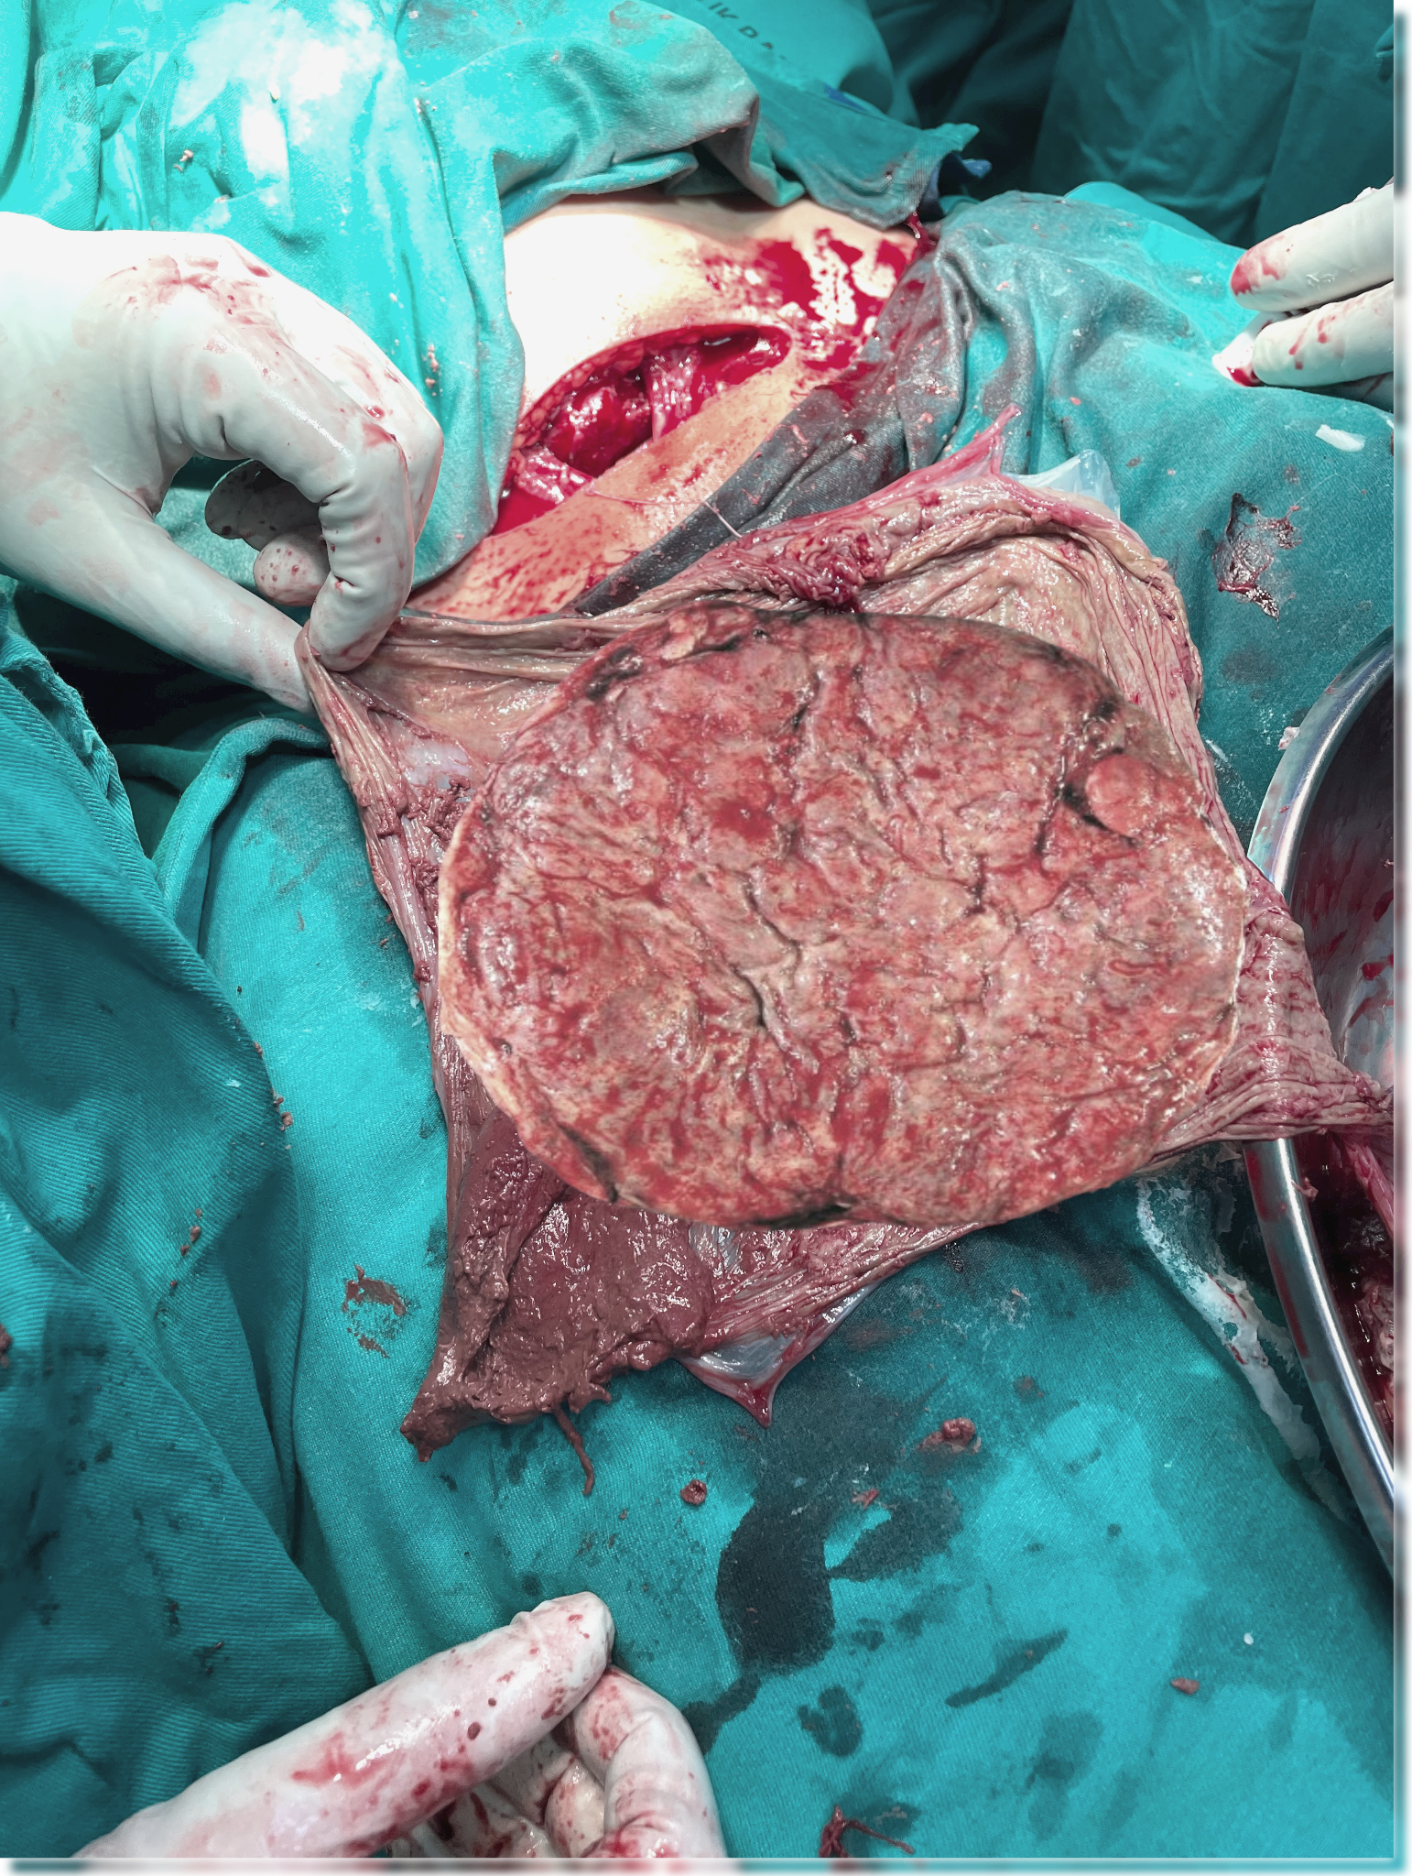
Figure 1: unhealthy placenta with multiple areas of calcification

Discussion
This patient's case presents a complex interplay of risk factors including chronic hypertension with superimposed preeclampsia, obesity (with a BMI > 34), gestational diabetes mellitus, gestational thrombocytopenia and multiple pregnancy losses.
At the molecular level, dysfunctional and calcified placenta leads to hypoxia and oxidative stress, which in turn triggers the release of anti-angiogenic factors like soluble fms-like tyrosine kinase-1 (sFlt-1). This factor neutralizes placental growth factor (PlGF) and contributes to systemic endothelial dysfunction [4]. The sFlt-1/PlGF ratio is particularly useful for predictions: in the PROGNOSIS study, a ratio of above 38 indicated a likelihood of onset of preeclampsia within four weeks, with a 36.7% positive predictive value (PPV) and 66.2% sensitivity, along with 83.1% specificity [5].
Preeclampsia is a major contributor to placental insufficiency, primarily due to abnormal remodeling of the spiral arteries. When maternal spiral arteries aren't properly converted, it leads to high-resistance, low-flow circulation, which can cause intervillous thrombosis and fibrinoid necrosis [1]. This microvascular pathology diminishes uteroplacental perfusion, resulting in chronic fetal hypoxia. If this hypoperfusion continues, it can lead to intrauterine growth restriction and, in severe cases, intrauterine fetal demise [6]. A study involving 51 preeclamptic placentas reported that 66.4% exhibited pathological features, including villous necrosis, increased syncytial knots, and thrombosis. These findings are associated with impaired placental perfusion and fetal growth restriction [7]. Premature placental calcification (PPC), is observed in preeclampsia. The prevalence of PPC varies across studies, ranging from 3.8% to 23.7%. PPC is associated with adverse maternal and neonatal outcomes, including preeclampsia, fetal growth restriction, low birth weight, low Apgar scores, and abnormal Doppler parameters [8].
Histopathological studies show that up to 65% of placentas from preeclamptic pregnancies exhibit thrombotic lesions, infarctions, or both, highlighting the link between maternal endothelial dysfunction and fetal compromise [9].
Maternal complications associated with HELLP syndrome include disseminated intravascular coagulation (DIVC), hepatic rupture, renal failure, and pulmonary oedema. Maternal mortality following HELLP syndrome 2.9% and 18.% stillbirth [10]. Another study conducted in Pakistan shows a 7% risk of intrauterine fetal demise in case of HELLP syndrome [11].
The long-term effects are quite concerning: a study from Sweden involving over 2 million women found that those who experienced hypertensive disorders during pregnancy had double the risk of developing ischemic heart disease later on [12]. This elevated cardiovascular risk can persist for decades, highlighting how complications during pregnancy can serve as important indicators of future heart health.

Conclusion & Recommendations
This case of a 37-year-old woman with chronic hypertension, superimposed preeclampsia, and a history of previous preeclampsia and miscarriage resulted in intrauterine fetal death secondary to HELLP syndrome with placental calcification at 31+3 weeks gestation. The case underscores the diagnostic and management challenges posed by overlapping high-risk factors. It highlights the importance of close observation and active management of high-risk pregnancies, particularly when multiple maternal and obstetric complications coexist, to optimize maternal outcomes and reduce the risk of adverse fetal events.
Here are some key recommendations to consider:
- Early multidisciplinary care: Involve obstetricians, maternal-fetal medicine specialists, hematologists, and neonatologists from the outset.
- Strict maternal and fetal monitoring: Regularly track blood pressure, platelet counts, and fetal well-being during pregnancy.
- Postpartum planning and patient education: Focus on postpartum follow-up, preparation for future pregnancies, long-term cardiovascular risk management, and empowering the patient to recognize warning signs.

Acknowledgement
The authors would like to express their sincere gratitude to the patient (Madam N) for willingly participating in this study and for providing informed consent for publication. The patient’s cooperation made this work possible. We also thank the department of O&G Hospital Sungai Buloh Malaysia for the opportunity.
Informed consent
Both written and verbal informed consent was obtained from the patient (Mdm N) for publication of this report and any accompanying images.
Disclaimer (Artificial intelligence)

Author(s) hereby declare that NO generative AI technologies such as Large Language Models (ChatGPT, COPILOT, etc.) and text-to-image generators have been used during the writing or editing of this manuscript.

References
1/ Roberts, J. M., & Escudero, C. (2012). The placenta in preeclampsia. Pregnancy Hypertension: An International Journal of Women's Cardiovascular Health, 2(2), 72-83.
2/ Vera-Ponce, V. J., Loayza-Castro, J. A., Ballena-Caicedo, J., Valladolid-Sandoval, L. A. M., Zuzunaga-Montoya, F. E., & Gutierrez De Carrillo, C. I. (2025). Global prevalence of preeclampsia, eclampsia, and HELLP syndrome: a systematic review and meta-analysis. Frontiers in reproductive health, 7, 1706009.
3/ Tamizi, N. F. M., Abdullah, S., Ab Hamid, S. A., Jummaat, F., & Adnan, W. N. A. W. (2024). Preeclampsia severity and associated factors in Kelantan, Malaysia. Gulhane Medical Journal.
4/ Yung, H. W., & Charnock-Jones, D. S. (2008). Anti-angiogenic factors in preeclampsia: sFlt-1 and soluble endoglin. Placenta, 29(Suppl A), S51–S56. https://doi.org/10.1016/j.placenta.2007.11.008
5/ Levine, R. J., et al. (2016). Soluble endoglin and other circulating antiangiogenic factors in preeclampsia. New England Journal of Medicine, 355(10), 992–1005.
6/ Brosens, I., Pijnenborg, R., Vercruysse, L., & Romero, R. (2011). The “Great Obstetrical Syndromes” are associated with disorders of deep placentation. American Journal of Obstetrics and Gynecology, 204(3), 193–201.
7/ Nurdin, R., Rina Masadah, Berti Nelwan, Djumadi Achmad, Gatot S. Lawrence, Mardiati, & Andi Alfian Zainuddin. (2022). Histopathological Findings in Placentas from Pregnancies Complicated with Preeclampsia. International Journal of Sciences: Basic and Applied Research (IJSBAR), 65(1), 31-37. make the bracket
8/ Dash, S., Das, B., Panda, S. R., Rajguru, M., Jena, P., Mishra, A., & Rath, S. K. (2021). Perinatal outcomes in premature placental calcification and the association of a color doppler study: report from a tertiary care hospital in eastern India. Clinics and Practice, 11(4), 841-849.
9/ Redline, R. W. (2008). Placental pathology: A guide for clinicians. Pathology, 40(2), 115–126.
10/ Kali, Zercan & Cagiran, Fatma & Kirici, Pinar & Meydanli, Mehmet. (2022). Incidence, Characteristics, Maternal and Perinatal Outcomes of HELLP Syndrome. Gynecology & Reproductive Health. 6. 10.33425/2639-9342.1190.
11/ Wali S, Qazi KF, Begum A, Ara J, Rekha, Bibi N. (2024). Adverse fetomaternal outcomes in women with HELLP syndrome. Journal of Population Therapeutics and Clinical Pharmacology, 31(4), 2274–2281.
12/ Crump, C., Sundquist, J., & Sundquist, K. (2023). Hypertensive disorders of pregnancy and long-term risk of ischemic heart disease in mothers: National cohort study. BMJ, 380, e072155.

