MALIGNANT SMOOTH MUSCLE TUMOR OF BROAD LIGAMENT: A RARE DIAGNOSTIC CHALLENGE

ABSTRACT

Leiomyosarcoma (LMS) represent a minority of uterine malignancies, comprising merely 1-2% of the total cases.Those of the broad ligament are very rare, rapidly progressive and highly malignant gynaecological tumor.

Because of it’s rarity and atypical localization, we present a case of a young woman
38 years old which initially mimicked an ovarian malignancy and was complicated by multi-organ involvement at presentation. She underwent Total Abdominal Hysterectomy + Bilateral Salphingoophorectomy + Resection of left broad ligament tumor,in which histopathological diagnosis prove as myxoid type of leiomyosarcoma of the left broad ligament.She received total 6 cycle of adjuvant chemotherapy (Cisplatin+Doxorubicin) followed by adjuvant radiotherapy (45Gy/25 fraction) of external beam radiotherapy.

Key words: Leiomyosarcoma, uterine malignancies, uterine sarcomas, muscle tumor

INTRODUCTION

“Leiomyosarcoma (LMS) is a rare malignant neoplasm arising from smooth muscle cells and accounts for approximately 10% of all soft tissue sarcomas. LMS has a varied prognosis but in general is aggressive with 5 year survival of 25-76%.LMS most commonly originates from the uterus, while extra-uterine involvement is distinctly uncommon. Primary leiomyosarcoma of the broad ligament is exceptionally rare, with only a limited number of cases reported in the literature. Owing to its rarity and anatomical location, broad ligament LMS poses significant diagnostic and therapeutic challenges” [2].

“The broad ligament is a double layer of peritoneum extending from the lateral aspects of the uterus to the pelvic side walls, divided into three main parts mesometrium, mesosalpinx and mesovarium. It is a vital structure in providing support,protection and conduit for essential vessel and nerves.Tumours arising from this location often
present with non-specific symptoms or are clinically indistinguishable from adnexal or uterine masses. Consequently, pre-operative diagnosis is difficult, and many cases are misidentified as ovarian or uterine tumours on imaging studies. Definitive diagnosis is frequently established only after surgical excision and histopathological examination, supplemented by immunohistochemical analysis” [3].

Leiomyosarcoma is an aggressive malignancy with an unpredictable clinical course and generally poor prognosis, characterised by a high risk of local recurrence and
distant metastasis. Due to the scarcity of cases involving the broad ligament, there is no standardised management protocol, and treatment strategies are largely extrapolated from uterine leiomyosarcoma guidelines. Surgical resection remains the cornerstone of management, while the role of adjuvant chemotherapy and radiotherapy continues to be debated.

This case highlights the diagnostic challenges, histopathological features, and multidisciplinary management approach required for this uncommon and aggressive tumour.

CASE PRESENTATION

A 38 years old lady, married,nulliparous presented with 1 week history of generalized abdominal pain associated with fever and lethargy.She develop sudden onset of shortness of breath upon arrival to hospital with impending respiratory collapse requiring intubation and nursed in intensive care unit. She was then treated as pneumonia with acute respiratory distress syndrome (ARDS) and acute kidney injury. During abdominal examination, there was a palpable mass measuring 24/52 of gravid uterus with irregular border. Pelvic examination revealed normal vulva,elongated vagina,cervix felt high up.There was a mass felt occupying the POD.Transabdominal ultrasonography revealed uterus pushed anteriorly measuring 8.1x3.3cm, endometrial lining unable to visualize.Presence of mass occupying the POD measuring
16x10cm,solid cystic with irregular border and left hydronephrosis.Proceeded with CT PA and CT Thorax Abdomen and Pelvis. CT TAP showed large heterogenous enhancing lobulated mass in the pelvis 18.4x16x23.2cm with area of hypodensity may represent cystic or necrotic component.Mass is displacing the uterus and urinary bladder anteriorly. It is also displacing the rectum and sigmoid colon to the right with no clear fat plane causing luminal narrowing.Left ovary is not visualize,right ovary is visualize. Left obstructive uropathy with cortical necrosis.CTPA showed no evidence of pulmonary embolism or cardiomegaly with multifocal consolidation and ground glass opacities represent active infection or metastasis.Overall features give an impression of ovarian malignancy.

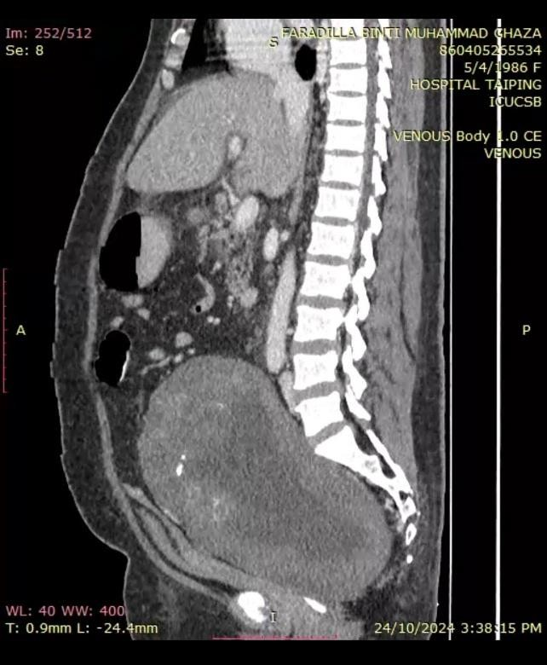

Figure 1. A. Sagittal view of CT Thorax Abdomen Pelvis

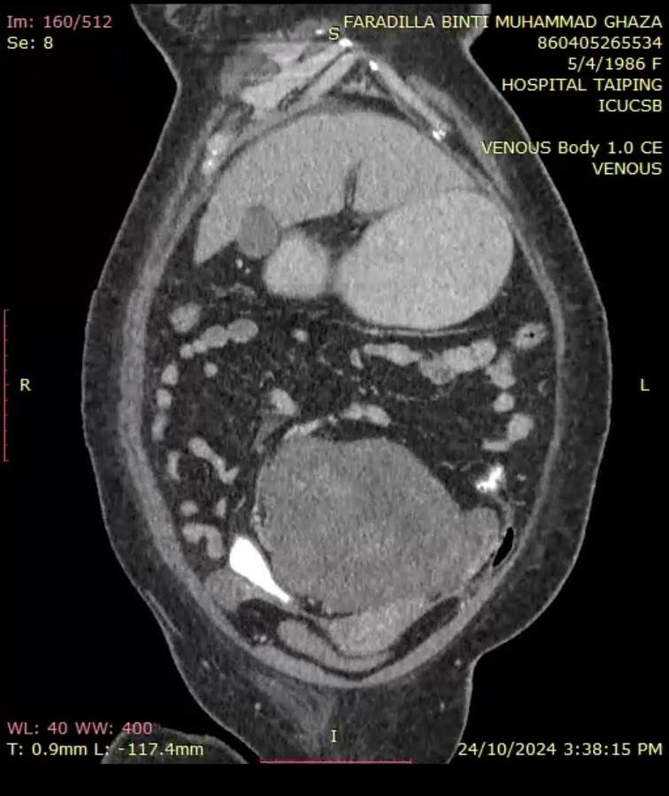

Figure 1. B. Coronal view of CT Thorax Abdominal pelvis (Mass located posterior to uterus)

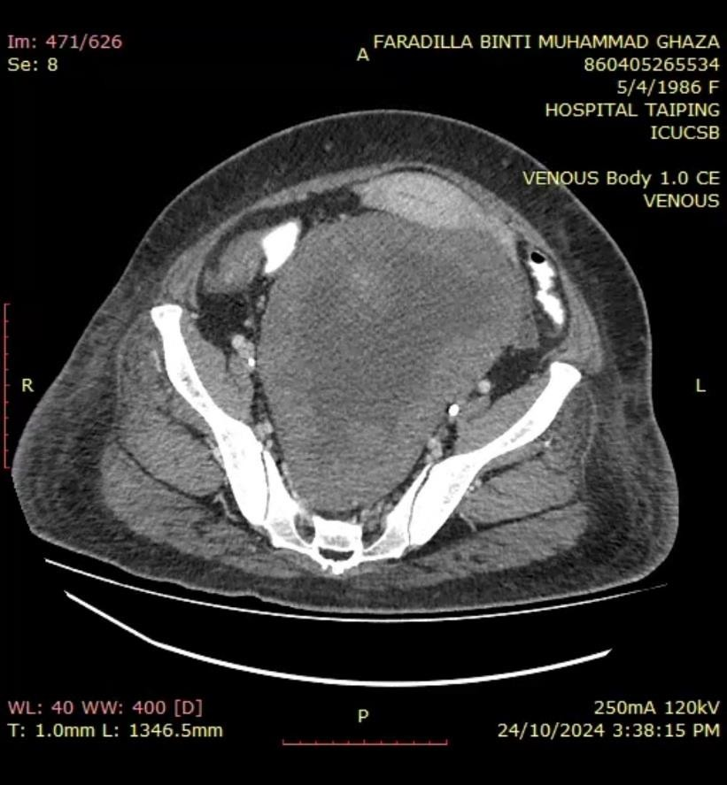

Figure 1. C. Axial view of CT Thorax Abdomen Pelvis

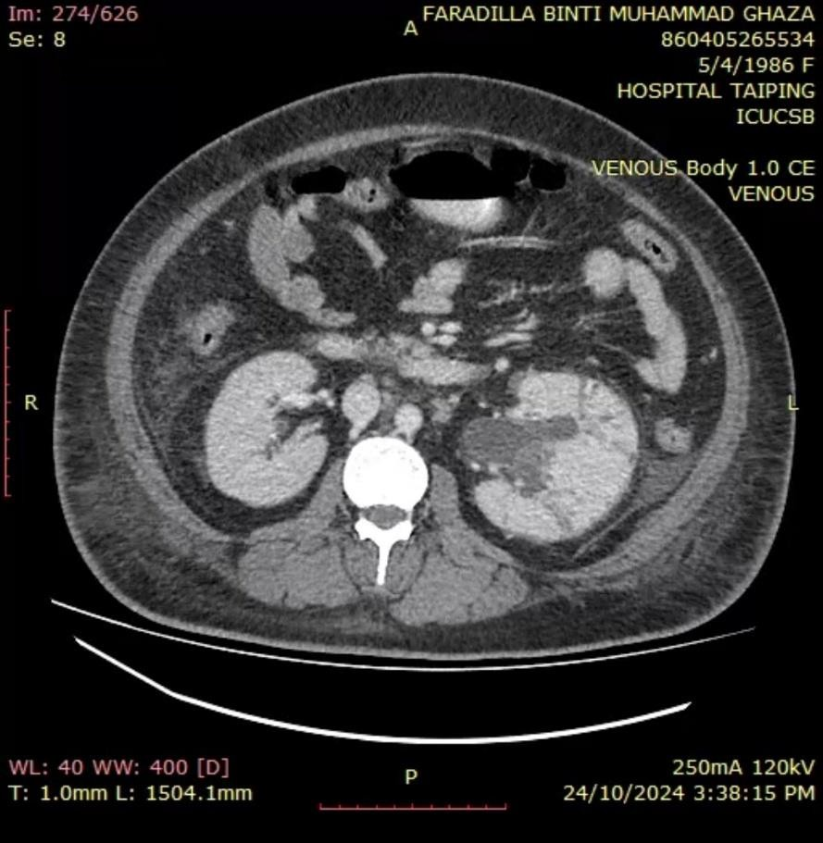

Figure 1. D. Axial View showing compressive effect to left ureter and kidney causing hydronephrosis

Her initial blood investigation showed moderate anemia with Hb 8.7g/dL with renal impairment.Creatinine of 260 , urea 24.2 in which she require dialysis (SLED x 3). Her tumor markers CA 125 41.1 (slightly raised), CEA 1.9,Ca 19-9 21,Alphafetoprotein <
1.6, LDH 352.

Proceeded with examination under anaesthesia + vaginoscopy + endometrial and vaginal biopsy. EUA findings revealed an elongated vagina about 10cm with multiple nodule at anterior vaginal wall.Cervix felt high up and normal but deviated to the
left.Pipelle sampling done under USG guidance – endometrial tissue send for
HPE.Mass felt posterior to uterus measuring 20/52 size occupying POD till midway of vagina. HPE from vaginal nodule and endometrial tissue showed no malignancy. Went in for Bilateral Ureteric Stenting + Exploratory laparotomy + Resection of left broad ligament tumor + sigmoidoscopy + Total abdominal Hysterectomy + Bilateral salphingoophorectomy + left pelvic lymph node dissection. Intraoperatively, no ascites, small bowel and omentum grossly normal.Uterus normal 8 week size,bilateral fallopian tube,ovary and cervix grossly normal. There was a mass sitting retroperitoneally beneath to sigmoid mesentery displacing the rectum to the right
side. Upon dissecting peritoneum noted mainly solid tumor arising from left broad ligament measuring 20x 18cm extending down to the sacral curve occupying the whole POD. Tumor capsule ruptured during adhesiolysis and removed in pieces.Noted area of cystic and hemorrhagic necrosis. No tumor involvement to
rectum. Enlarged left pelvic lymph node. Bilateral ureter identified and preserved. Left ureter grossly dilated with bilateral stent felt in situ.

HPE report of left broad ligament tumor,multiple fragments of brownish masses (all together 2700g), largest fragment 23x20x 4cm,second largest 10x10x7cm, third largest
8x7x7cm,remaining fragments 2.3cm.Outer surface of these fragments are lobulated, grey in colour and covered with thin capsule-like structure.Cut surfaces are tan in colour with friable and brownish tissue. Microscopically,fragmented mass show irregular outline with infiltrative edges and it compose of hypocellular spindle cells disposed in a myxoid matrix.The myxoid element are seen surrounding the atypical spindle cells (individualy or arranged in poorly formed fascicles as well as pseudoglandular structure formation).The spindle cell display mild to moderate nuclear atypia with mitosis seen in approximately 1-2/10HPF.Infarct and coagulative necrosis are seen characterized by an abrupt transition from viable to non viable tumor cells are seen.No vascular invasion detected.Immunohistochemical staining of spindle cells are immune reactive for actin,desmin,caldesman.They are negative for CKAE1/AE3,S100 and p16.p53 expression is of wild type.TAHBSO specimen , uterine corpus showed leiomyoma 10x10x15mm in diameter.Bilateral ovary, fallopian tubes
cervix and left pelvic lymph nodes were negative for malignancy. Final interpretation from HPE was myxoid leiomyosarcoma with no lymphovascular invasion.

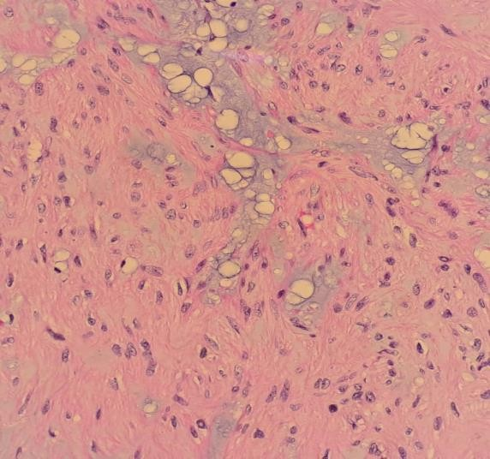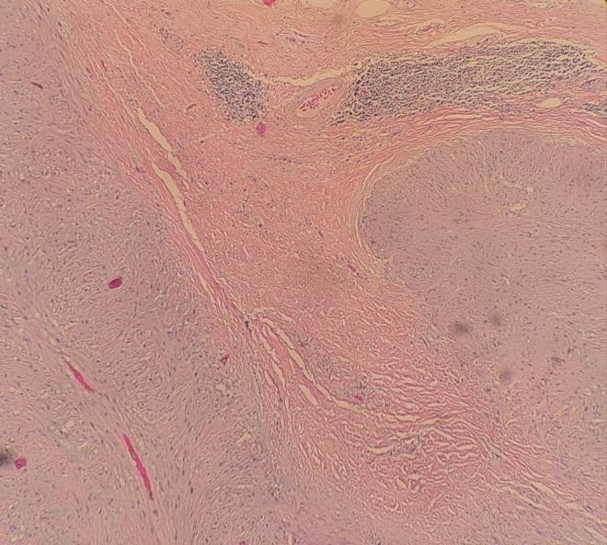A B

Figure 2. (A) Tumor with infiltrative edges. H&E magnification x40. (B) Tumor compose of hypocellular spindle cells disposed in a myxoid matrix. The spindle cells display mild to moderate nuclear atypia. H&E magnification x400.

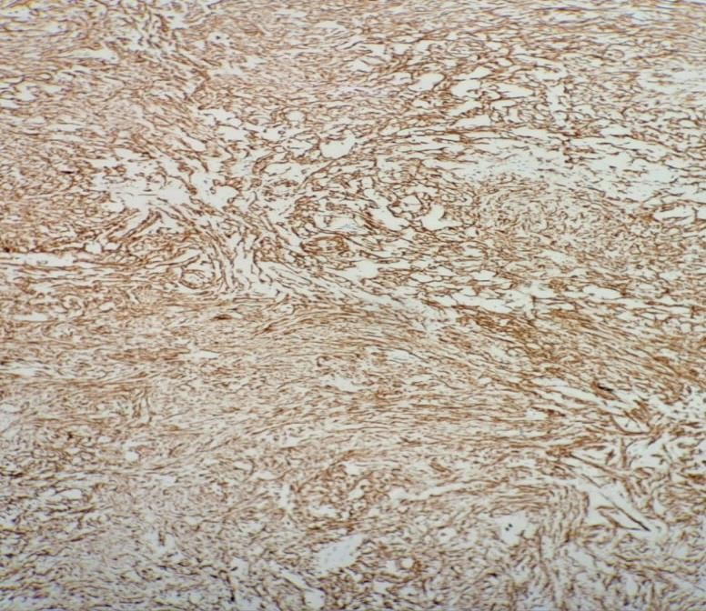C

(C) The spindle cells are diffusely immunoreactive for Caldesman. Immunostain, magnification x200.
Post op recovery were uneventful.She received total 6 cycle of adjuvant chemotherapy Cisplatin 75mg/m2 + Doxorubicin 50mg/m2.Repeated CT TAP post 6 cycle chemo showed no evidence of local recurrence,improving lung metastasis,mild left hydronephrosis and proximal hydroureter,stable expansile lytic lesion at the 7th anterior rib.There was acute pulmonary embolism detected at bilateral main pulmonary arteries extending to right descending pulmonary artery,rim enhancing collection at pelvic region with surrounding inflammatory changes.Subcentimeter left parametrial necrotic node likely metastasis.PET scan was arranged following CT TAP,
there was no significant FDG avid uptake at pelvis or bilateral lung with mild FDG avid expansile right 7th rib lesion which is indeterminate in nature.Mild FDG avid soft tissue density lesion surrounding rectum represent post operative changes and foci FDG avidity at left distal ureter.

Patient was subsequently referred to oncology unit and she received 45Gy/25# of external beam radiotherapy for local pelvic control.Currently patient is well with no evidence of recurrent.

DISCUSSION:

Leiomyosarcoma of the broad ligament is an extremely rare, aggressive cancer arising in the uterine supporting tissue, distinct from uterine or ovarian tumors.. Broad ligament tumours are generally asymptomatic. If they are large they may be palpable and cause symptoms related to compression of pelvic organs.

Presenting with vague symptoms like pain or mass and often diagnosed late. Due to vague symptoms it create a dilemma in the diagnosis between ovary or uterus in origin. The clinical manifestations of the cases are non specific signs and symptoms. However no case has been diagnosed before surgery and the final diagnosis is based on microscopic examination, supported by IHC studies.

Over the years the diagnosis of leiomyosarcoma relies on the presence of three criteria: coagulative tumour cell necrosis, cytologic atypia and mitotic activity.This case represent relatively low mitotic activity (1-2/10HPF) which indicate less aggressiveness of tumor and better response to adjuvant treatment.The diagnosis of myxoid leiomyosarcoma was made based on criteria taken from WHO Female Genital Tract (5th Edition) in which it fulfil one or more of the following ,moderate to severe cytological atypia,tumor cell necrosis,more than 1/10 HPF and infiltrative borders.In this case,relatively low mitotic activity fits the criteria myxoid leiomyosarcoma.

Piecemeal removal of the tumor intraoperatively do give important prognostic implication especially in term risk of recurrent. Thus,adjuvant treatment such as chemo and radiation therapy is crucial for local pelvic control. Management of extrauterine leiomyosarcoma is similar to uterine leiomyosarcoma.Combination therapy cisplatin + doxorubicin are often used together in the management of sarcoma and other solid tumor.This regimen has been shown to be effective in managing symptoms and improving survival rates.

There is wide variation in the management practices of this uncommon tumour but initial treatment is same as that of uterine leiomyosarcoma, i.e., total abdominal hysterectomy and bilateral salpingoophorectomy. The imaging and microscopic
pattern play a crucial role in defining overall prognosis and need for adjuvant therapy. Pelvic irradiation therapy has been used for adjuvant treatment of uterine leiomyosarcomas as radiation therapy and has been shown to decrease the pelvic locoregional relapse rate.

CONCLUSION

Diagnosing broad ligament leiomyosarcoma is a challenge because of it’s rarity,non specific clinical presentation,limitation of imaging,pre operative misidentification of tumor origin and histopathologic challenge making it often diagnose postoperatively.

Consent
As per international standards or university standards, patient(s) written consent has been collected and preserved by the author(s).

Disclaimer (Artificial intelligence)

Author(s) hereby declare that NO generative AI technologies such as Large Language Models (ChatGPT, COPILOT, etc.) and text-to-image generators have been used during the writing or editing of this manuscript.

ACKNOWLEDGEMENT

The authors would like to thank all healthcare workers of Hospital Raja Permaisuri
Bainun, Ipoh who were involved in the management of this patient.

REFERENCES

- Kumar S, Giridhar P, Verma S, Phulware RH, Malhotra N, Kumar R. Primary Broad Ligament Leiomyosarcoma: a Rare Case Report with Review of Literature. Indian J Surg Oncol. 2020 Sep;11(Suppl 1):96-101. doi: 10.1007/s13193-020-01050-5. Epub 2020Feb 15. PMID: 33088140; PMCID: PMC7534766.

- Calderillo-Ruiz, G. & Juárez-Solís et al (2009). Cisplatin plus doxorubicine in advanced soft tissue sarcoma: First line chemotherapy. Gaceta Mexicana de Oncologia. 8. 12-18.

- Mirsadraee, Saadat, et al. "Leiomyosarcoma of the broad ligament: a case report and literature review." Iranian Journal of Pathology 3.2 (2008): 104-108.

- N. Makihara, T. Maeda, Y. Ebina, K. Kitajima, F. Kawakami, S. Hara, H. Yamada. Leiomyosarcoma of the broad ligament: a case report with CT and MRI images. European Journal of Gynaecological Oncology. 2014. 35(2);174-177.

- Bousfina N., Saadi H., Errarhay S.: “Leiomyosarcoma of the broad ligament: a case report and the review of the literature”. Anatol. J. Obstet. Gynecol., 2011, 2, 2.

- Oliveira JD, Cunha TM, Tereso A. Tumors of the broad ligament: what and when to suspect such rare location. Radiol Bras. 2020 Sep-Oct;53(5):349-355. doi:
10.1590/0100-3984.2019.0073. PMID: 33071380; PMCID: PMC7545728.

- Chaichian, Shahla et al. “Leiomyosarcoma of the Broad Ligament With Fever Presentation: A Case Report and Review of Literature.” Iranian Red Crescent Medical Journal 18 (2016): n. pag.

- Female genital tract tumors, WHO Classification of tumor 5th Edition,2020
- Spencer J & Ghattamaneni S. MR Imaging of the Sonographically Indeterminate
Adnexal Mass. Radiology. 2010;256(3):677-94

- Fasih N, Prasad Shanbhogue A, Macdonald D et al. Leiomyomas Beyond the Uterus: Unusual Locations, Rare Manifestations. Radiographics. 2008;28(7):1931-48

- Duhan N1, Singh S, Kadian YS, Duhan U, Rajotia N, Sangwan N; Primary Leiomyosarcoma of the broad ligament. A Case report and review of literature. Arch Gynecol Obstet., 2009; 279(5): 705 -708.

