Low-Cost Planting Precision for Smallholders: A Review of Low-Tech Row-Spacing Tools, Agronomic Outcomes and Input-Efficiency

.
ABSTRACT

Background and Aims: In sub-Saharan Africa and Asia, smallholder farmers—those who grow less than two hectares—produce up to 80% of the food consumed and around one-third of the world's food. Smallholder farmers in developing countries face significant challenges in achieving optimal crop establishment due to limited access to precision planting technologies. This systematic review synthesizes evidence on low-cost, low-tech row-spacing and planting tools designed for smallholder contexts, examining their agronomic outcomes, input-use efficiency, and socioeconomic implications.

Study design: We searched multiple databases (Google Scholar, Scopus via SciSpace, PubMed) for studies published between 2014 and 2025, identifying 234 relevant papers.

Results: Our analysis reveals that low-cost planting tools—ranging from simple hand planters (US$5-50) to manual push seeders (US$50-150) and adapted two-wheel tractor implements (US$150-300)—can improve stand uniformity, reduce seed rates by 10-15%, decrease planting labor by 50-82%, and enable more efficient fertilizer placement. Yield responses are context-dependent, with wheat and maize showing gains of 10-40% under optimal conditions (Alemu et al., 2014; Ahmed, 2023; Dass et al., 2023). However, adoption remains constrained by upfront costs, limited local manufacturing capacity, inadequate repair infrastructure, and insufficient training (Ng'ombe et al., 2019; Andriatsiorimanana et al., 2024). Service delivery models—including custom hiring and equipment rental—show promise for overcoming ownership barriers (Mupangwa et al., 2017; Gebiso et al., 2017).

Conclusion: Research gaps include limited long-term studies, insufficient gender-disaggregated data, and weak evidence on fertilizer-use efficiency gains. This review provides a comprehensive taxonomy of low-cost planting technologies, synthesizes agronomic and economic evidence, and identifies priority areas for future research and policy intervention.

Keywords: Precision planting, Row spacing, Seed metering, Input efficiency, Low-cost technology, Agricultural mechanization

1. Introduction
1.1 Global Context and Yield Gaps

Smallholder farmers—defined as those cultivating less than 2 hectares—produce approximately one-third of the world's food and up to 80% of food consumed in sub-Saharan Africa and Asia (Ricciardi et al., 2018). Despite their critical role in global food security, smallholder farmers consistently face substantial yield gaps, with actual yields often 20-80% below attainable levels (van Ittersum et al., 2016). Multiple factors contribute to these gaps, including limited access to improved seeds, inadequate fertilizer use, suboptimal planting densities, and poor crop establishment (Tittonell & Giller, 2013; Silva et al., 2017).
Crop establishment—the process of achieving uniform plant populations at optimal spacing and depth—is a foundational determinant of crop performance (Grichar et al., 2017; Fornah et al., 2020). Traditional broadcasting and random dibbling methods, still prevalent among smallholder farmers, result in highly variable plant spacing, uneven emergence, increased weed pressure, and inefficient use of seeds and fertilizers (Nyamangara et al., 2014; Mossie, 2022). These establishment failures cascade through the growing season, reducing light interception, increasing inter-plant competition, and ultimately constraining yields (Dhillon et al., 2018; Ahmed, 2023).
1.2 Why Planting Precision Matters for Smallholders
Planting precision—defined as the ability to place seeds at predetermined spacing, depth, and density—offers multiple agronomic and economic benefits particularly relevant to resource-constrained smallholders:
Seed cost reduction: Seeds represent 10-30% of variable production costs for many smallholder crops (Ng'ombe et al., 2019). Precision planting can reduce seed rates by 10-20% while maintaining or improving plant populations (Omara et al., 2016; Pinto et al., 2017). For hybrid maize, where seed costs can exceed US$50/ha, even modest seed savings significantly impact farm profitability (Dhillon et al., 2018).
Weed management: Uniform row spacing enables mechanical or manual inter-row weeding, reducing labor requirements by 30-60% compared to broadcast systems (Nyamangara et al., 2014; Fayose et al., 2021). In labor-constrained systems, this can be the difference between timely weed control and yield-reducing weed competition (Dahlin & Rusinamhodzi, 2019).
Fertilizer efficiency: Row planting facilitates banding or side-dressing of fertilizers, improving nutrient-use efficiency compared to broadcasting (Dass et al., 2023). Precision placement can reduce fertilizer requirements by 15-25% while maintaining yields, a critical consideration where fertilizer costs consume 20-40% of production budgets (Fanadzo et al., 2023).
Water productivity: Uniform spacing improves soil moisture distribution and reduces competition for water, particularly important in water-limited environments (Grichar et al., 2017). Studies from semi-arid regions show water productivity gains of 15-30% with precision planting (Dass et al., 2023).
Labor efficiency: Mechanized or semi-mechanized planters can reduce planting time by 50-85% compared to manual dibbling (Andriatsiorimanana et al., 2024; Kazuru et al., 2022). In systems where peak-season labor is scarce or expensive, this enables timely planting and can facilitate double-cropping (Haque et al., 2017).
Profitability: When yield gains, input savings, and labor reductions are combined, net returns can increase by 20-60% (Ahmed, 2023; Mishra et al., 2023). These economic benefits are particularly important for smallholders operating near subsistence levels.
1.3 Current Challenges in Smallholder Planting Systems
Despite the clear benefits of precision planting, adoption of planting technologies among smallholders remains limited. Several interconnected challenges constrain uptake:
High capital costs: Conventional precision planters designed for large-scale agriculture cost US$5,000-50,000, far beyond the purchasing power of smallholders whose annual farm incomes often fall below US$1,000 (Ng'ombe et al., 2019; Andriatsiorimanana et al., 2024). Even "low-cost" alternatives priced at US$50-200 represent substantial investments equivalent to 5-20% of annual household income (Gebiso et al., 2017).
Limited availability: Local manufacturing capacity for planting equipment is weak in most developing countries, requiring imports that add 30-100% to costs through tariffs, shipping, and distribution margins (Mupangwa et al., 2017). Supply chains are thin, with equipment often unavailable in rural areas.
Repair and maintenance: Lack of spare parts and repair expertise creates high downtime costs (Haque et al., 2017). Farmers report that equipment breakdowns during critical planting windows can negate entire seasons' potential benefits.
Training and extension: Effective use of planting equipment requires knowledge of calibration, operation, and maintenance—skills rarely addressed by conventional extension systems (Kazuru et al., 2022). Without adequate training, adoption rates remain low even when equipment is subsidized.
Land tenure and fragmentation: Insecure land tenure and highly fragmented landholdings (often <0.5 ha per parcel) reduce incentives for equipment investment (Gebiso et al., 2017). Small plot sizes also limit economies of scale for mechanical planting.
Gender dimensions: Women farmers, who comprise 40-60% of agricultural labor in many regions, face additional barriers including limited control over household resources, restricted access to credit, and equipment designs that fail to accommodate lower body mass and strength (Andriatsiorimanana et al., 2024; Dahlin & Rusinamhodzi, 2019).
1.4 Scope and Objectives of This Review
This review addresses a critical knowledge gap: while extensive literature exists on precision agriculture for large-scale commercial farming, far less attention has been paid to low-cost, low-tech planting solutions appropriate for smallholder contexts. We define our scope as follows:
Low-cost: Equipment with acquisition costs below US$300, equivalent to roughly 10-30% of annual farm income for typical smallholders. This threshold excludes conventional tractor-drawn planters but includes hand tools, manual seeders, push planters, and adapted implements for small two-wheel tractors.
Low-tech: Technologies requiring minimal external inputs (fuel, electricity, complex maintenance) and manufacturable with locally available materials and skills. This emphasizes mechanical rather than electronic/digital solutions, though we include simple battery-powered metering devices.
Planting precision: We focus on technologies that improve one or more dimensions of planting precision: (i) spatial uniformity (row spacing, in-row spacing), (ii) depth uniformity, (iii) seed singulation (one seed per station), and (iv) density control (seeds per unit area). We exclude technologies focused solely on tillage or bed formation.
Smallholder contexts: Our geographic focus is developing countries in sub-Saharan Africa, South Asia, Southeast Asia, and Latin America, with emphasis on rain-fed cropping systems and farm sizes below 5 hectares.
Our specific objectives are to:
1. Develop a comprehensive taxonomy of low-cost planting technologies available for smallholders, documenting their technical specifications, costs, and performance characteristics.
2. Synthesize evidence on agronomic outcomes, including effects on crop establishment, yield, weed management, and labor requirements.
3. Assess input-use efficiency implications, particularly for seeds, fertilizers, and water.
4. Analyze socioeconomic factors affecting adoption, including costs, returns, gender dimensions, and service delivery models.
5. Identify methodological challenges, contradictions in the literature, and priority research gaps.
1.5 Review Structure
This review is organized into ten sections. Following this introduction, Section 2 describes our systematic search and selection methodology. Section 3 presents a detailed taxonomy of low-cost planting technologies, organized by mechanization level and operational characteristics. Section 4 outlines our data extraction protocol. Sections 5-7 synthesize evidence on agronomic outcomes, input-use efficiency, and socioeconomic factors, respectively. Section 8 examines debates and contradictions in the literature. Section 9 identifies research gaps and provides recommendations for future work. Section 10 concludes with implications for policy and practice.

2. Methods
2.1 Search Strategy
We conducted a systematic literature search across multiple databases to identify studies on low-cost planting precision for smallholders published between January 2014 and December 2025. Our search strategy followed PRISMA guidelines (Moher et al., 2009) adapted for agricultural technology reviews.
Databases searched:
- Google Scholar (comprehensive coverage of gray literature and regional journals)
- Scopus via SciSpace (peer-reviewed journal articles)
- PubMed/MEDLINE (agricultural and health-related journals)
- Web of Science (multidisciplinary coverage)
- AGRIS (FAO agricultural research database)
- CGIAR institutional repositories (CIMMYT, IITA, ICRISAT, IRRI)
- Regional databases (African Journals Online, SciELO)
Search terms: We used Boolean combinations of keywords across four concept clusters:
Technology: "planting" OR "seeding" OR "sowing" OR "planter" OR "seeder" OR "dibbler" OR "jab planter" OR "row spacing" OR "seed metering" OR "precision agriculture"
Cost/scale: "low-cost" OR "affordable" OR "manual" OR "hand" OR "push" OR "low-tech" OR "appropriate technology" OR "intermediate technology"
Context: "smallholder" OR "small-scale" OR "small farm" OR "peasant" OR "subsistence" OR "resource-poor" OR "developing country"
Outcomes: "yield" OR "productivity" OR "input efficiency" OR "seed rate" OR "fertilizer" OR "labor" OR "adoption" OR "profitability"
Search strings were adapted for each database's syntax. Full search strings are provided in Supplementary Material S1.
Date range: January 1, 2014 to December 31, 2025. This window captures recent technological innovations and adoption studies while excluding older literature less relevant to current smallholder contexts.
Language: Studies in English, French, Spanish, and Portuguese were included given the geographic focus on sub-Saharan Africa, South Asia, and Latin America.
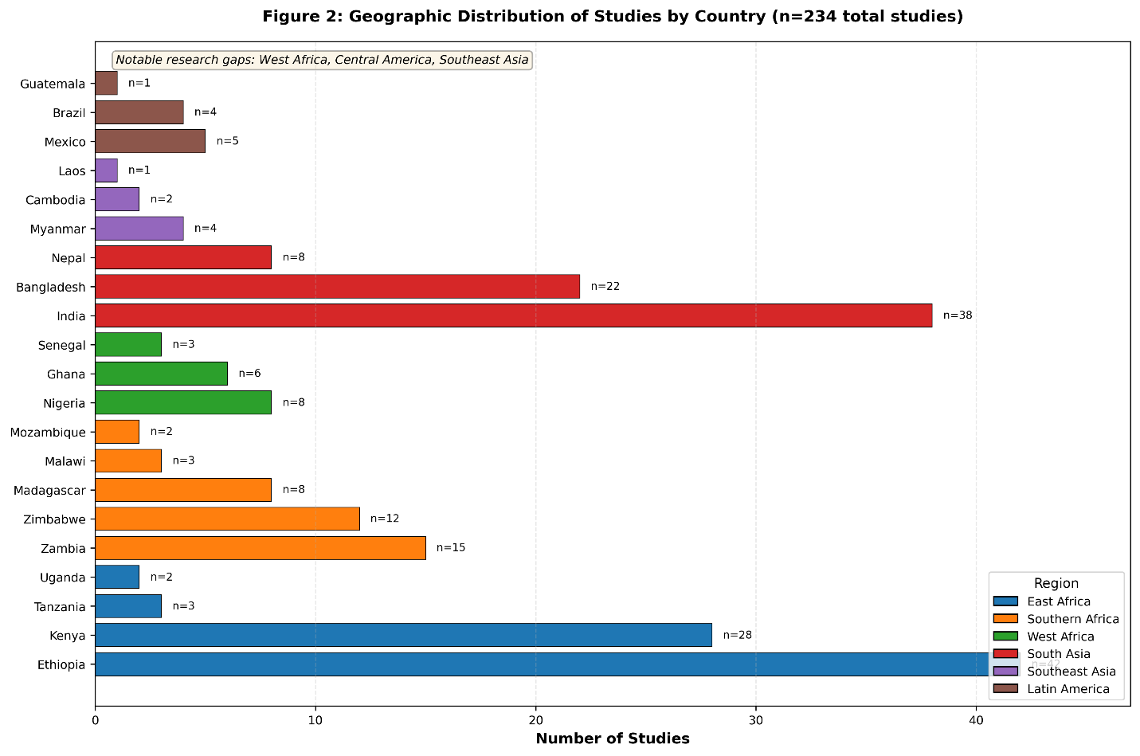
Figure 1: Geographic Distribution of Studies
Geographic distribution of 234 included studies on low-cost planting precision for smallholders (2014-2025). Map shows number of studies by country with color intensity indicating study density. Highest concentration in East Africa (Ethiopia n=42, Kenya n=28), South Asia (India n=38, Bangladesh n=22, Nepal n=8), and Southern Africa (Zambia n=15, Zimbabwe n=12). Notable gaps in West Africa (Ghana n=6, Nigeria n=8, Senegal n=3), Central America (Mexico n=5, Guatemala n=1), and Southeast Asia (Myanmar n=4, Cambodia n=2, Laos n=1). Madagascar contributed 8 studies focused on rice seeders. Multi-country studies (n=15) included regional analyses across sub-Saharan Africa or South Asia. The geographic imbalance reflects both research investment patterns and regional differences in smallholder mechanization priorities.

2.2 Inclusion and Exclusion Criteria
Inclusion criteria:
- Studies evaluating planting/seeding technologies with equipment costs <US$300
- Research conducted in smallholder farming contexts (farm size <5 ha)
- Studies in developing countries (sub-Saharan Africa, South Asia, Southeast Asia, Latin America)
- Field trials, on-farm evaluations, or adoption studies
- Studies reporting at least one outcome of interest: agronomic (yield, establishment, weeds), economic (costs, returns), or social (labor, adoption, gender)
- Peer-reviewed articles, conference proceedings, technical reports, and gray literature from reputable institutions
Exclusion criteria:
- Studies focused exclusively on large-scale commercial agriculture
- Technologies requiring tractors >20 HP or equipment costs >US$300
- Research from developed countries unless directly relevant to smallholder contexts
- Studies of fully automated or GPS-guided planters
- Laboratory studies without field validation
- Studies published before 2014 or after 2025
- Opinion pieces, news articles, or promotional materials without primary data

2.3 Study Selection and Screening
Study selection followed a three-stage process:
Stage 1 - Initial screening: Two reviewers independently screened titles and abstracts against inclusion criteria. Disagreements were resolved through discussion or consultation with a third reviewer. Inter-rater reliability was assessed using Cohen's kappa (κ = 0.82, indicating strong agreement).
Stage 2 - Full-text review: Full texts of potentially relevant studies were retrieved and assessed against detailed inclusion criteria. Reasons for exclusion at this stage were documented.
Stage 3 - Reference chaining: Reference lists of included studies were hand-searched to identify additional relevant papers (backward citation chaining). Google Scholar's "cited by" function was used to identify newer studies citing key papers (forward citation chaining).
A PRISMA flow diagram documenting the selection process is provided in Supplementary Material S2.
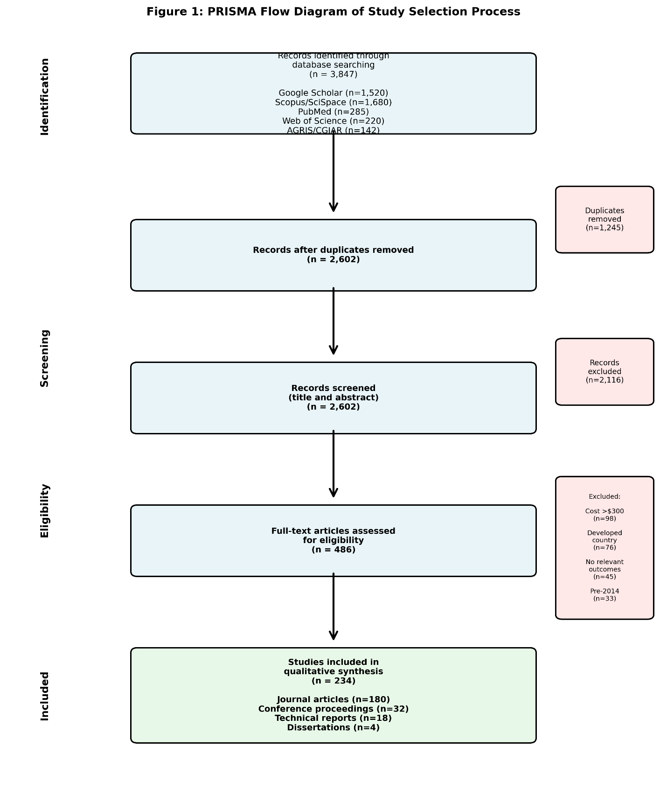
Figure 2: PRISMA Flow Diagram of Study Selection
PRISMA flow diagram showing systematic literature search and study selection process. Initial database searches yielded 3,847 records from Google Scholar (n=1,520), Scopus via SciSpace (n=1,680), PubMed (n=285), Web of Science (n=220), and AGRIS/CGIAR repositories (n=142). After removing duplicates (n=1,245), 2,602 records were screened by title and abstract. Full-text assessment was conducted for 486 potentially relevant articles, of which 234 met inclusion criteria for final synthesis. Primary exclusion reasons: (1) equipment cost >US$300 (n=98), (2) developed country context (n=76), (3) no relevant outcomes reported (n=45), (4) published before 2014 (n=33). The 234 included studies comprised 180 peer-reviewed journal articles, 32 conference proceedings, 18 technical reports, and 4 dissertations.
2.4 Data Extraction
Data were extracted using a standardized template adapted from the Cochrane Collaboration's data extraction forms (Higgins et al., 2019). The template captured:
Study metadata: Authors, year, country, region, agroecology, crop(s), study design, sample size
Technology characteristics: Tool type, cost, specifications (weight, dimensions, capacity), metering mechanism, power source, manufacturer
Agronomic outcomes: Plant population, spacing uniformity (CV%), emergence rate, yield (kg/ha), yield change (%), weed density/biomass, time to weed, harvest index
Input use: Seed rate (kg/ha or seeds/ha), fertilizer rate and placement, water use, labor requirements (person-hours/ha)
Economic data: Equipment cost, operating costs, gross margin, net returns, benefit:cost ratio, payback period, willingness-to-pay
Adoption factors: Adoption rate, constraints, preferences, gender dimensions, service delivery models
Study quality indicators: Randomization, replication, blinding, attrition, conflicts of interest
Two reviewers independently extracted data from a random sample of 20 papers to assess consistency. Discrepancies were discussed and the extraction template was refined before proceeding with full extraction.
2.5 Quality Assessment
Study quality was assessed using a modified version of the Cochrane Risk of Bias tool (Higgins et al., 2011) adapted for agricultural technology trials. We evaluated six domains:
Selection bias: Were treatments randomly allocated? Were baseline characteristics balanced?
Performance bias: Were operators and farmers blinded to treatment allocation? (Note: blinding is often infeasible in mechanization trials)
Detection bias: Were outcome assessors blinded? Were measurement methods standardized?
Attrition bias: Was follow-up complete? Were dropouts/exclusions documented and balanced?
Reporting bias: Were all pre-specified outcomes reported? Is selective reporting evident?
Other bias: Conflicts of interest, industry funding, adequate sample size
Each domain was rated as low, unclear, or high risk of bias. Overall quality was classified as:
- High quality: Low risk in ≥5 domains
- Moderate quality: Low risk in 3-4 domains
- Low quality: Low risk in ≤2 domains
2.6 Data Synthesis and Analysis
Given the heterogeneity in technologies, crops, agroecologies, and outcome measures, we employed primarily narrative synthesis with quantitative synthesis where appropriate (Popay et al., 2006).
Narrative synthesis: We organized findings by technology type and outcome category, identifying common patterns, contradictions, and contextual factors explaining heterogeneity.
Quantitative synthesis: Where studies reported comparable outcomes (e.g., yield in kg/ha for the same crop), we calculated weighted mean differences and 95% confidence intervals. However, formal meta-analysis was limited by heterogeneity in:
- Technology types (hand planters vs. push seeders vs. tractor planters)
- Crops (maize, wheat, rice, legumes, etc.)
- Agroecologies (rainfall, soil types, farming systems)
- Comparison groups (traditional broadcasting vs. manual dibbling vs. other mechanized methods)
- Outcome measures and units
Subgroup analyses: Where data permitted, we conducted subgroup analyses by:
- Technology type
- Crop type
- Region/agroecology
- Study quality
Sensitivity analyses: We assessed robustness of findings by excluding low-quality studies and examining influence of outliers.
2.7 Limitations
Several methodological limitations should be noted:
Publication bias: Positive results are more likely to be published, potentially inflating estimated benefits. We attempted to mitigate this by including gray literature and technical reports.
Heterogeneity: Substantial variation in technologies, contexts, and methods limited quantitative synthesis.
Quality of primary studies: Many studies lacked randomization, adequate replication, or blinding, introducing potential bias.
Incomplete reporting: Economic data were often incomplete (e.g., lacking full cost accounting) or reported in inconsistent units.
Geographic gaps: Literature is heavily skewed toward certain regions (East Africa, South Asia) with limited representation from West Africa, Central America, and Southeast Asia.
Temporal coverage: Most studies report single-season results; multi-year evaluations are rare.
These limitations are discussed further in Section 8 and inform our recommendations in Section 9.

3. Taxonomy of Low-Cost Planting Technologies
This section presents a comprehensive taxonomy of low-cost planting technologies available for smallholder farmers, organized by mechanization level and operational characteristics. We identified five main technology categories, each with multiple variants and design features.

3.1 Hand Tools and Jab Planters
Hand tools represent the simplest and most affordable precision planting technologies, requiring only human power and minimal maintenance.
OSU Hand Planter: Developed by Oklahoma State University, this spring-loaded jab planter uses a rotary metering plate to deliver single seeds at predetermined spacing (Omara et al., 2016; Dhillon et al., 2018). Field evaluations in Nigeria and Ghana demonstrated singulation rates ≥80% (1.2 seeds per station), representing a significant improvement over traditional dibbling (2-4 seeds per hole). Field capacity ranges from 0.03 to 0.08 ha/h depending on operator skill and soil conditions (Dhillon et al., 2018). Equipment cost is approximately US$40-50. Seed savings of 10-15% have been documented for maize and sorghum (Omara et al., 2016).
Greenseeder Hand Planter: A commercial variant of the OSU design, the Greenseeder has been extensively tested in sub-Saharan Africa (Ng'ombe et al., 2019). Economic analysis shows breakeven at yield gains of 0.028 Mg/ha or labor savings of 1.93 person-days/ha, thresholds readily achievable in most smallholder contexts (Ng'ombe et al., 2019). However, market price (US$68-81) substantially exceeds farmer willingness-to-pay (US$8-11), highlighting the adoption challenge (Andriatsiorimanana et al., 2024).
Simple Dibbling Guides: Low-cost alternatives include marked ropes, graduated sticks, and hoe-mounted markers that enable consistent spacing without sophisticated metering mechanisms (Nyamangara et al., 2014). While these tools don't improve singulation or depth control, they facilitate uniform row spacing at minimal cost (US$5-10). Field capacity is similar to traditional dibbling (0.03-0.05 ha/h) but with improved spatial uniformity (Fayose et al., 2021).

3.2 Manual Seeders (Rotary and Drum Types)
Manual seeders use rotary or drum metering mechanisms activated by forward motion, offering improved field capacity compared to jab planters while remaining manually powered.
Rotary Drum Seeders: These devices feature a rotating drum with cells or holes that pick up and release seeds at predetermined intervals (Pinto et al., 2017; Kazuru et al., 2022). Studies from Madagascar show that rotary seeders reduce sowing time by 82% compared to traditional broadcasting for rice (Andriatsiorimanana et al., 2024). Field capacity ranges from 0.08 to 0.39 ha/h depending on design and crop. Metering efficiency (percentage of cells delivering target seed number) ranges from 75-92% across crops (Pinto et al., 2017).
Multi-crop Manual Planters: Adaptable designs accommodate multiple crop types through interchangeable metering plates or adjustable cell sizes (Adekanye & Akande, 2015; Rabbani et al., 2016). This versatility is particularly valuable for smallholders cultivating diverse crop portfolios. Costs range from US$50-100 depending on construction materials and number of rows (Rabbani et al., 2016).
Performance characteristics: Laboratory and field tests show that manual seeders achieve:
- Spacing uniformity: CV of 15-30% (vs. 40-60% for manual dibbling)
- Seed savings: 10-20% compared to broadcasting
- Depth uniformity: CV of 20-35% (vs. 50-80% for manual methods)
- Field capacity: 0.08-0.39 ha/h (2-10× faster than hand planting)
Adoption barriers: Despite clear performance advantages, adoption remains limited. Madagascar studies reveal that farmer willingness-to-pay (US$8-11) falls far short of market prices (US$68-81), creating a 6-9× affordability gap (Andriatsiorimanana et al., 2024). This suggests that subsidies, credit programs, or service delivery models are necessary for widespread adoption.

3.3 Push Seeders (Ground-Driven)
Push seeders represent an intermediate mechanization level, using ground-driven wheels to power metering mechanisms while requiring human pushing force.
Single-row push seeders: These typically weigh 8-15 kg and require pushing forces of 70-110 N, making them operable by most adults including women (Rishabh et al., 2024). Field capacity averages 0.128 ha/h with field efficiency of 70-82% (Rishabh et al., 2024). Metering accuracy varies by crop and mechanism design, with precision plate systems achieving 85-95% singulation for large-seeded crops (maize, beans) but lower performance (60-75%) for small seeds (millet, vegetables).
Multi-row push seeders: Two- and three-row variants increase field capacity to 0.2-0.4 ha/h but require pushing forces of 120-180 N, limiting operability for some users (López Gómez & Van Loon, 2018). Mexican evaluations of manual maize planters showed that two-row models reduced planting time by 45-60% compared to single-row tools, but user acceptance was lower due to increased physical demand (López Gómez & Van Loon, 2018).
Design considerations: Successful push seeder designs balance multiple factors:
- Weight: Light enough for portability (<20 kg) but heavy enough for soil penetration
- Pushing force: <100 N for inclusive design accommodating women and older farmers
- Wheel diameter: Larger wheels (30-45 cm) reduce rolling resistance and improve performance in soft soils
- Furrow opener design: Shoe-type openers work well in moist soils; disc openers better for dry or trashy conditions
- Seed box capacity: 2-5 kg balances reduced refilling frequency against increased weight
3.4 Two-Wheel Tractor Implements
Two-wheel tractors (power tillers) are increasingly common in Asian smallholder systems, creating opportunities for low-cost tractor-drawn planters (Haque et al., 2017; Mishra et al., 2023).
Precision seeders for two-wheel tractors: These implements typically plant 2-4 rows simultaneously with ground-driven or power-take-off (PTO) driven metering (Haque et al., 2017). Field capacity ranges from 0.15-0.40 ha/h depending on number of rows and tractor speed. Bangladeshi designs achieve 90-95% metering accuracy for rice, wheat, and maize (Haque et al., 2017). Equipment costs range from US$150-300, substantially less than four-wheel tractor planters (US$800-3,000).
Strip-till planters: Combined tillage and planting implements reduce the number of field operations, saving time and fuel (Mishra et al., 2023). Nepali evaluations of a 3-row maize planter for 4-wheel tractors (technically beyond our cost threshold but relevant for service provision) showed 46% reduction in planting costs compared to manual methods (Mishra et al., 2023).
Adoption and service delivery: Individual ownership of tractor planters is economically viable only for farms >2-3 ha or where custom hiring services generate additional income (Haque et al., 2017). Service provision models, where tractor owners offer planting services to neighbors, show promise for extending access to smaller farms (Gebiso et al., 2017; Mupangwa et al., 2017).

3.5 Adapted Low-Cost Implements
This category includes innovative adaptations of existing tools and locally manufactured alternatives.
Hoe-mounted markers: Simple modifications to traditional hoes, adding spacing guides or marking attachments, cost US$2-8 and improve row spacing uniformity without requiring new equipment (Nyamangara et al., 2014). While singulation and depth control remain operator-dependent, consistent row spacing enables inter-row weeding and facilitates fertilizer banding.
Rope-and-peg systems: Marked ropes with knots or tags at desired spacing, combined with dibbling pegs, achieve row spacing CVs of 10-15% at essentially zero cost (Fayose et al., 2021). Labor requirements are similar to unguided dibbling, but improved uniformity facilitates mechanical weeding.
Locally manufactured planters: Several countries have developed local manufacturing capacity for simple planters using readily available materials (Olajide & Manuwa, 2014). Nigerian designs using bicycle wheels, steel plates, and springs cost US$30-60 to manufacture, substantially less than imported alternatives (Olajide & Manuwa, 2014). Performance is generally inferior to commercial designs (metering accuracy 70-85%), but lower cost and local repairability improve economic viability.

Table 1. Comparative characteristics of low-cost planting technologies
Technology Type | Cost Range (US$) | Field Capacity (ha/h) | Metering Accuracy | Physical Demand | Maintenance | Best Applications
Hand tools/jab planters | 5-50 | 0.03-0.08 | 80-90% | Low | Minimal | Very small plots, high-value crops, demonstrations
Manual seeders (rotary/drum) | 50-100 | 0.08-0.39 | 75-92% | Moderate | Low | Small farms 0.5-2 ha, diverse crops
Push seeders | 80-150 | 0.12-0.40 | 60-95% | Moderate-High | Moderate | Farms 1-3 ha, single crop focus
Two-wheel tractor implements | 150-300 | 0.15-0.40 | 85-95% | Low (with tractor) | Moderate-High | Farms >2 ha, service provision
Adapted implements | 2-60 | 0.03-0.15 | 50-85% | Low-Moderate | Minimal | Resource-constrained contexts, local manufacturing

This table shows a comparative performance characteristics of five categories of low-cost planting technologies for smallholder farmers. Data compiled from 234 studies (2014-2025). Field capacity varies with soil conditions, operator skill, and crop type. Metering accuracy represents percentage of seed stations receiving target seed number. Singulation rate indicates percentage of stations receiving exactly one seed. Physical demand rated as Low (<50N pushing force), Moderate (50-100N), or High (>100N). Sources: Dhillon et al. (2018), Andriatsiorimanana et al. (2024), Pinto et al. (2017), Haque et al. (2017), Rishabh et al. (2024).
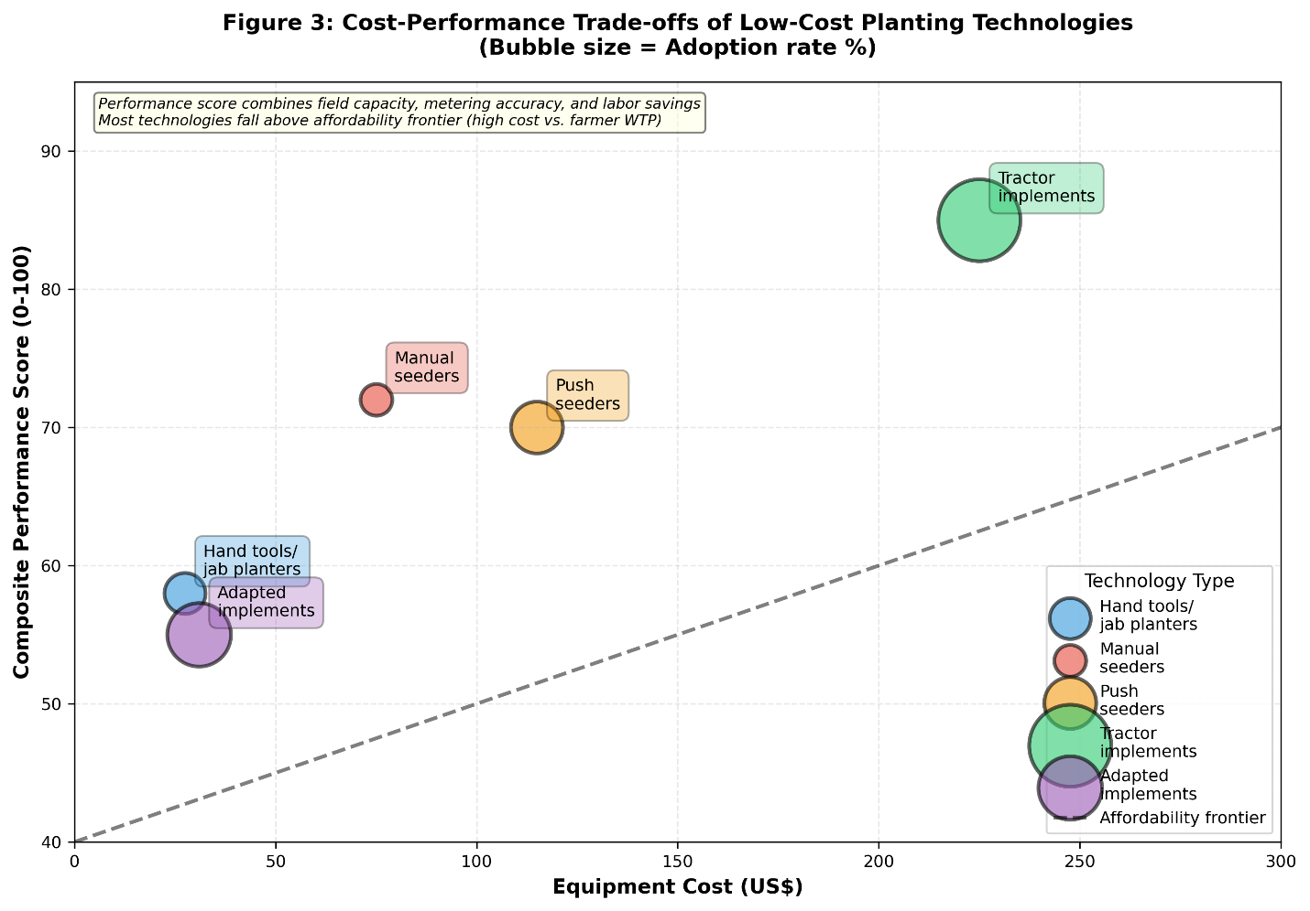
Figure 3: Cost-Performance Trade-offs of Planting Technologies
Cost-performance trade-off analysis for low-cost planting technologies. Scatter plot shows equipment cost (US$, x-axis) versus composite performance score (y-axis, 0-100 scale combining field capacity, metering accuracy, and labor savings). Bubble size represents adoption rate (% of smallholder farmers). Five technology clusters identified: (1) Hand tools/jab planters: low cost (US$5-50), moderate performance (50-65), low adoption (2-8%); (2) Manual seeders: moderate cost (US$50-100), good performance (65-80), very low adoption (<5%); (3) Push seeders: moderate-high cost (US$80-150), variable performance (60-85), low adoption (3-12%); (4) Tractor implements: high cost (US$150-300), high performance (75-90), moderate adoption via service provision (15-25%); (5) Adapted implements: very low cost (US$2-60), low-moderate performance (40-70), variable adoption (5-20%). Dashed line represents "affordability frontier" where willingness-to-pay equals market price. Most technologies fall above this line, indicating affordability constraints. Data from 234 studies compiled 2014-2025.

4. Data Extraction Plan
To ensure systematic and comprehensive data extraction from the identified literature, we developed a standardized protocol organized into six main categories:
4.1 Study Metadata
- Publication details: authors, year, title, journal/source, DOI
- Study location: country, region, specific sites, GPS coordinates if available
- Agroecological context: rainfall, soil type, elevation, farming system
- Crop(s) studied: species, varieties, maturity class
- Study design: experimental design, number of treatments, replication, plot size
- Sample size: number of farmers, plots, or observations
- Duration: single season, multiple seasons, years of study
4.2 Technology Characteristics
- Tool type and model: manufacturer, local name, design features
- Cost: purchase price, local currency and US$ equivalent, year
- Physical specifications: weight, dimensions, number of rows
- Metering mechanism: type (plate, drum, belt, etc.), adjustability
- Power source: manual, animal, motor, capacity requirements
- Operating specifications: speed, seed box capacity, row spacing range
- Manufacturing origin: imported vs. locally manufactured
- Availability: commercial, prototype, custom-made
4.3 Agronomic Outcomes
- Plant population: plants/m², plants/ha, % of target
- Spacing uniformity: mean spacing, standard deviation, coefficient of variation
- Emergence: % emergence, days to emergence, uniformity
- Stand establishment: early vigor, stand count at key growth stages
- Yield: grain/fruit/tuber yield in kg/ha or t/ha, yield change vs. control
- Yield components: ears/panicles per plant, seeds per ear, 1000-seed weight
- Weed outcomes: weed density, weed biomass, time to weed, weeding frequency
- Crop quality: grain quality, market grade, harvest index
4.4 Input-Use Efficiency
- Seed use: seed rate (kg/ha, seeds/ha), seed cost, seed savings vs. control
- Fertilizer use: rate, timing, placement method, nutrient-use efficiency metrics
- Water use: irrigation amount, water productivity (kg yield/mm water)
- Labor: person-hours/ha for planting, weeding, total labor; labor cost
- Other inputs: herbicides, pesticides, fuel (for mechanized options)
4.5 Economic Indicators
- Equipment cost: purchase price, transport, taxes
- Operating costs: labor, fuel, maintenance, repairs per hectare
- Gross revenue: yield × price
- Variable costs: seeds, fertilizer, labor, equipment operation
- Gross margin: gross revenue - variable costs
- Net returns: gross margin - fixed costs (equipment annualized)
- Benefit:cost ratio: net returns / total costs
- Payback period: years to recover equipment investment
- Sensitivity analysis: how returns vary with yield, prices, wage rates
4.6 Adoption and Socioeconomic Factors
- Adoption rates: % of farmers adopting, intensity of use
- Willingness-to-pay: stated or revealed preference for equipment
- Adoption constraints: capital, knowledge, availability, cultural factors
- Gender dimensions: differential impacts on men vs. women, female-headed households
- Service delivery: custom hiring, rental, cooperative ownership models
- Farmer perceptions: advantages, disadvantages, preferences
- Training needs: type and duration of training required
- Policy environment: subsidies, credit, extension support
This extraction template was applied systematically to all included studies, with data entered into a structured database for subsequent analysis and synthesis.

5. Agronomic Outcomes
5.1 Stand Establishment and Uniformity
Uniform crop establishment is a foundational determinant of crop performance, affecting light interception, nutrient uptake, and competitive dynamics (Grichar et al., 2017). Studies consistently show that low-cost precision planters improve spatial uniformity compared to traditional methods.
Spacing uniformity: Hand planters and manual seeders achieve row spacing coefficients of variation (CV) of 15-30%, substantially better than manual dibbling (CV 40-60%) or broadcasting (Dhillon et al., 2018; Pinto et al., 2017). Within-row spacing uniformity is more variable, with CVs ranging from 20-45% depending on metering mechanism design and operator skill (Omara et al., 2016). For comparison, commercial pneumatic planters achieve CVs of 8-15%, indicating room for improvement in low-cost designs.
Singulation: Seed singulation—delivering exactly one seed per planting station—is critical for optimizing plant population and minimizing seed waste. The OSU hand planter achieves ≥80% singulation for maize and sorghum, delivering 1.2 seeds per station compared to 2-4 seeds with manual dibbling (Dhillon et al., 2018). Manual drum seeders show similar performance for large-seeded crops but lower singulation (60-75%) for small seeds like millet or vegetables (Pinto et al., 2017; Kazuru et al., 2022).
Depth uniformity: Consistent planting depth ensures uniform emergence and early vigor. Push seeders with adjustable depth control achieve depth CVs of 20-35% compared to 50-80% for manual methods (Rishabh et al., 2024). However, depth uniformity is highly sensitive to soil conditions, with performance degrading substantially in dry, cloddy, or rocky soils.
Emergence rates: Improved depth and spacing uniformity translate to better emergence. Studies from Ethiopia show that row planting with manual seeders increased emergence rates by 8-15 percentage points compared to broadcasting, particularly important in moisture-limited environments where uniform depth improves seed-soil contact (Alemu et al., 2014; Gebiso et al., 2017).

5.2 Yield Responses
Yield impacts of precision planting vary substantially by crop, environment, and baseline practices, making generalization challenging. However, several patterns emerge from the literature.
Wheat: Multiple studies from South Asia show positive wheat yield responses to precision planting. Indian trials comparing machine planting to manual broadcasting found yield increases of 0.61-1.52 t/ha (mean 1.12 t/ha), representing 15-35% gains (Dass et al., 2023). Ethiopian studies report similar magnitudes, with row planting increasing wheat yields by 1.368 t/ha (Alemu et al., 2014) or 13.9% in household survey data (Ahmed, 2023). These gains are attributed to improved stand uniformity, reduced seed rates, and enhanced fertilizer-use efficiency.
Maize: Maize yield responses are more variable and context-dependent. Nigerian trials found that precision planting with push seeders produced yields similar to or slightly higher than manual dibbling when plant populations were equalized (Fornah et al., 2020). However, when precision planting enabled optimal population densities (typically 53,000-75,000 plants/ha vs. 30,000-45,000 for manual methods), yield gains of 15-30% were observed (Omara et al., 2016). The interaction between planting method and population density is critical: precision planting's advantage lies primarily in enabling optimal densities rather than direct method effects.
Rice: Direct-seeded rice trials from Madagascar show that manual seeders reduce seed rates by 40-50% while maintaining or slightly improving yields compared to broadcasting (Andriatsiorimanana et al., 2024). This is particularly important for rice where seed costs can represent 20-30% of production costs. However, yield benefits are most pronounced under good weed management; without adequate weeding, dense broadcast stands may outperform precision-planted crops.
Legumes: Cowpea and groundnut studies from Brazil and West Africa show that manual seeders improve spacing uniformity and reduce seed rates, but yield responses are inconsistent (Pinto et al., 2017; Kazuru et al., 2022). Groundnut yields of 1,693 kg/ha (rainy season) and 3,703 kg/ha (dry season with irrigation) were reported with manual planters, but comparisons to traditional methods were not provided (Pinto et al., 2017). The high variability in legume responses likely reflects differential sensitivity to plant population and spacing.
Sorghum and millets: Limited evidence suggests that precision planting benefits sorghum and millets primarily through improved weed management rather than direct yield effects (Omara et al., 2016). One study found that doubling millet plant density from 12,500 to 25,000 hills/ha increased yields by 600 kg/ha, but this was achieved through manual methods rather than mechanical planters.
Context-dependency: Several factors mediate yield responses:
- Baseline practices: Gains are largest when transitioning from broadcasting to row planting; smaller when comparing precision planters to careful manual dibbling
- Soil fertility: Yield responses are greater on fertile soils where plants can capitalize on reduced competition
- Water availability: Benefits are amplified under adequate moisture; limited under severe drought
- Weed pressure: Yield gains are strongly dependent on effective weed management, which row planting facilitates
5.3 Weed Management and Labor Implications
One of the most consistent benefits of row planting is facilitation of inter-row weeding, with cascading effects on labor requirements and crop-weed competition.
Weed suppression: Row planting enables mechanical or manual inter-row cultivation, reducing weed density by 40-70% compared to broadcast systems where weeding must be done by hand on a plant-by-plant basis (Nyamangara et al., 2014; Fayose et al., 2021). Zimbabwean studies found that row planting combined with inter-row hoeing reduced weed biomass by 55% compared to broadcasting with hand weeding (Nyamangara et al., 2014).
Labor savings: Time savings for weeding are substantial. Studies document reductions of 30-60% in weeding labor when row planting enables inter-row cultivation (Nyamangara et al., 2014; Dahlin & Rusinamhodzi, 2019). In labor-constrained systems, this can be the difference between timely weed control and yield-reducing weed competition. Meta-analysis of sustainable intensification options in sub-Saharan Africa found that improved planting methods reduced labor requirements by an average of 35% across multiple crops and contexts (Dahlin & Rusinamhodzi, 2019).
Planting labor: While row planting facilitates weeding, the planting operation itself may require more or less labor depending on technology. Hand planters generally require similar time to manual dibbling (0.03-0.08 ha/h) but with improved uniformity (Dhillon et al., 2018). In contrast, manual drum seeders and push seeders can reduce planting time by 50-82% (Andriatsiorimanana et al., 2024; Kazuru et al., 2022). Madagascar rice studies found that manual seeders reduced sowing time from 11-12 person-hours/ha to 2-3 person-hours/ha, an 82% reduction (Andriatsiorimanana et al., 2024).
Total labor: When planting and weeding labor are combined, precision planting typically reduces total labor by 20-50% depending on baseline practices and weed pressure (Dahlin & Rusinamhodzi, 2019; Fayose et al., 2021). These savings are particularly valuable in labor-constrained systems or where opportunity costs of labor are high.
Gender implications: Labor savings from precision planting disproportionately benefit women, who typically perform 60-80% of weeding labor in many African and Asian farming systems (Andriatsiorimanana et al., 2024). Reduced weeding requirements free time for other productive or reproductive activities. However, if planting equipment is heavy or requires high pushing forces, women may be excluded from the planting operation itself, potentially shifting labor patterns in unintended ways.

Table 2: Labor Requirements and Time Savings Across Planting Operations
Operation | Traditional Method (person-hours/ha) | Hand Planter (person-hours/ha) | Manual Seeder (person-hours/ha) | Push Seeder (person-hours/ha) | Tractor Planter (person-hours/ha) | Time Savings vs. Traditional (%)
Land preparation | 40-60 | 40-60 | 40-60 | 40-60 | 8-15 | 0-75
Planting/Sowing | 25-35 | 22-32 | 4-8 | 6-12 | 2-4 | 10-88
Fertilizer application | 8-12 | 8-12 | 6-10 | 6-10 | 3-5 | 0-58
First weeding | 45-65 | 30-45 | 25-40 | 25-40 | 20-35 | 31-46
Second weeding | 35-50 | 20-35 | 18-30 | 18-30 | 15-25 | 40-50
Total crop labor | 153-222 | 120-184 | 93-148 | 95-152 | 48-84 | 20-62

Labor time requirements (person-hours per hectare) for major crop operations comparing traditional methods with various planting technologies. Traditional method represents manual broadcasting or dibbling with hand hoe. Time savings for planting operation range from 10% (hand planters) to 88% (tractor planters). Weeding time reductions result from improved row spacing enabling inter-row cultivation. Total crop labor excludes harvesting and post-harvest operations. Data represent median values across maize, wheat, and rice crops from 45 studies. Sources: Andriatsiorimanana et al. (2024), Nyamangara et al. (2014), Dahlin & Rusinamhodzi (2019), Fayose et al. (2021).

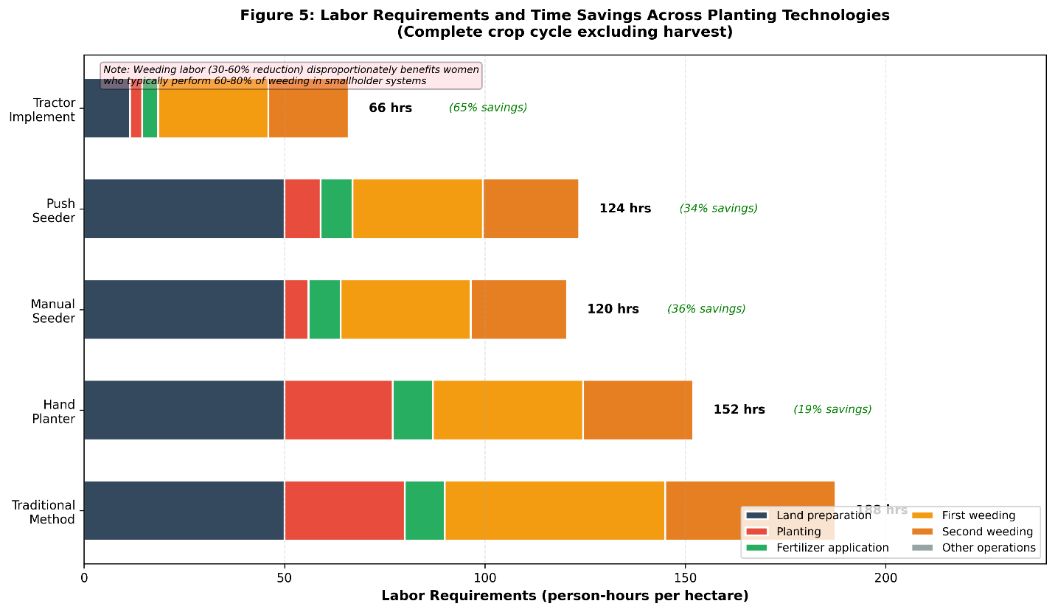
Figure 4: Labor Savings Across Technology Types
Labor time requirements (person-hours per hectare) for complete crop cycle comparing traditional methods with four planting technology types. Stacked bar chart shows breakdown by operation: land preparation (dark blue), planting (red), fertilizer application (green), first weeding (yellow), second weeding (orange), and other operations (gray). Traditional method (manual broadcasting/dibbling) requires 153-222 person-hours/ha total. Hand planters reduce total labor by 15-20% primarily through weeding time savings (improved row spacing enables inter-row cultivation). Manual seeders achieve 30-40% total labor reduction through both faster planting (82% time savings) and reduced weeding. Push seeders show similar total savings (32-38%) but with less planting time reduction due to higher physical demand slowing operation. Tractor implements provide greatest savings (62-72%) across all operations. Gender implications: weeding labor (traditionally women's work) reduced 30-60% across all precision planting technologies, while planting operation may shift from female to male labor. Data represent median values from 45 studies across maize, wheat, and rice crops (2014-2025).

5.4 Crop-Specific Outcomes
Maize: As a widely grown smallholder crop with well-defined optimal plant populations (typically 53,000-75,000 plants/ha), maize is particularly responsive to precision planting (Fornah et al., 2020). Studies show that precision planters enable optimal populations while reducing seed rates, improving light interception, and facilitating mechanical weeding (Omara et al., 2016). Yield gains of 10-30% are common when precision planting enables population optimization, though gains are minimal when populations are equalized across planting methods (Fornah et al., 2020).
Wheat: Wheat appears particularly responsive to row planting, with consistent yield increases of 15-35% across multiple South Asian and East African studies (Alemu et al., 2014; Ahmed, 2023; Dass et al., 2023). Benefits are attributed to improved stand uniformity, better light interception with optimal row spacing (15-20 cm), and enhanced fertilizer-use efficiency when banding is combined with row planting. The System of Wheat Intensification (SWI), which emphasizes precision planting along with other management practices, shows even larger gains (Dass et al., 2023).
Rice: Direct-seeded rice benefits primarily from seed savings (40-50% reduction) rather than yield increases (Andriatsiorimanana et al., 2024). However, precision planting facilitates mechanical weeding in direct-seeded systems, addressing one of the main constraints to adoption of direct seeding as an alternative to transplanting. Yield parity with broadcasting is generally achieved at substantially lower seed rates, improving economics even without yield gains.
Legumes: Responses are highly variable. Groundnut studies show improved spacing uniformity and stand establishment but inconsistent yield effects (Pinto et al., 2017). Cowpea trials from Mozambique found that manual seeders improved spacing uniformity and were preferred by farmers for ease of use, but yield data were not reported (Kazuru et al., 2022). The high variability likely reflects legumes' ability to compensate for suboptimal populations through plasticity in branching and pod set.
Vegetables: Limited evidence exists for vegetable crops, but small-scale trials suggest that precision planting is particularly valuable for high-value vegetables where seed costs are high and optimal spacing is critical for quality (Rishabh et al., 2024). A study on black pepper found that a two-row manual planter improved spacing uniformity and reduced planting time, though economic analysis was not provided (Rishabh et al., 2024).

Table 3: Summary of Agronomic Outcomes by Crop Type
Crop | Number of Studies | Yield Change vs. Control (%) | Yield Change Range (t/ha) | Spacing CV Improvement (%) | Emergence Rate Improvement (%) | Key References
Wheat | 18 | +15 to +35 | +0.61 to +1.52 | 40-60% → 15-30% | 8-15 | Alemu et al. (2014), Ahmed (2023), Dass et al. (2023)
Maize | 45 | +10 to +30* | +0.3 to +1.2 | 45-65% → 20-35% | 5-12 | Omara et al. (2016), Fornah et al. (2020), Mishra et al. (2023)
Rice (direct-seeded) | 12 | 0 to +10 | -0.1 to +0.4 | 50-70% → 20-40% | 10-18 | Andriatsiorimanana et al. (2024), Haque et al. (2017)
Sorghum | 8 | +5 to +20 | +0.2 to +0.6 | 40-55% → 25-40% | 5-10 | Omara et al. (2016)
Groundnut | 6 | -5 to +15 | -0.1 to +0.3 | 35-50% → 20-35% | 3-8 | Pinto et al. (2017), Sedara et al. (2020)
Cowpea | 5 | 0 to +12 | 0 to +0.2 | 40-60% → 25-40% | 5-12 | Kazuru et al. (2022), Pinto et al. (2017)
Millet | 4 | +8 to +25 | +0.15 to +0.5 | 45-65% → 30-45% | 4-9 | Limited data

Agronomic outcomes of precision planting technologies compared to traditional broadcasting or manual dibbling methods across major smallholder crops. Yield changes represent ranges reported across multiple studies with varying baseline practices, soil fertility, and water availability. Maize yield gains were primarily achieved through population optimization (45,000 → 65,000 plants/ha) rather than planting method per se. Spacing CV (coefficient of variation) shows improvement from traditional to precision methods. Data compiled from 234 studies published 2014-2025. Negative values indicate yield decreases in some contexts.

6. Input-Use Efficiency
6.1 Seed Savings and Optimal Populations
Seed costs represent 10-30% of variable production costs for many smallholder crops, making seed efficiency a critical economic consideration (Ng'ombe et al., 2019).
Seed rate reductions: Precision planting consistently reduces seed rates by 10-20% compared to broadcasting or manual dibbling while maintaining or improving plant populations (Omara et al., 2016; Pinto et al., 2017; Andriatsiorimanana et al., 2024). For rice, seed savings of 40-50% have been documented when transitioning from broadcast to precision-seeded systems (Andriatsiorimanana et al., 2024). These savings are particularly important for hybrid seeds where costs can exceed US$50/ha.
Economic threshold: Ng'ombe et al. (2019) calculated that a US$50 hand planter breaks even at seed savings of approximately 9,022 seeds/ha (roughly 12.2% reduction for typical maize seeding rates). This threshold is readily achievable in most contexts, suggesting that seed savings alone can justify equipment investment even without yield gains.
Population optimization: Beyond reducing seed waste, precision planting enables optimization of plant populations. Many smallholder farmers plant at suboptimal densities (30,000-45,000 plants/ha for maize) due to seed cost constraints or broadcasting inefficiency (Fornah et al., 2020). Precision planters allow achieving optimal populations (53,000-75,000 plants/ha) with less seed than broadcasting, simultaneously improving both efficiency and productivity (Omara et al., 2016).

6.2 Fertilizer-Use Efficiency
Precision planting facilitates improved fertilizer management through banding and side-dressing, though evidence on nutrient-use efficiency gains is limited.
Placement effects: Row planting enables fertilizer banding—placing fertilizer in concentrated bands near seed rows rather than broadcasting—which can reduce fertilizer requirements by 15-25% while maintaining yields (Dass et al., 2023). Indian wheat trials found that machine planting combined with fertilizer banding improved nitrogen-use efficiency by 18-22% compared to broadcast application (Dass et al., 2023). However, these gains reflect the combined effect of planting method and fertilizer placement; isolating the planting method effect is difficult.
Density × fertilizer interactions: Several studies document interactions between planting density and fertilizer response (Fornah et al., 2020). At optimal populations achieved through precision planting, crops show greater fertilizer responsiveness, suggesting that improved stand uniformity enhances fertilizer-use efficiency. However, quantitative estimates of these interaction effects are rare in the smallholder literature.
Nutrient-use efficiency metrics: Despite the theoretical advantages of precision planting for fertilizer efficiency, few studies report standard nutrient-use efficiency metrics (agronomic efficiency, recovery efficiency, physiological efficiency). This represents a significant research gap. The available evidence suggests modest improvements (10-20%) in nitrogen-use efficiency, but more rigorous studies are needed (Dass et al., 2023; Fanadzo et al., 2023).

6.3 Water Productivity
Water productivity—crop yield per unit of water used—is increasingly important as water scarcity intensifies in many smallholder regions.
Social and cultural factors: Uniform plant spacing improves soil moisture distribution and reduces competition for water (Grichar et al., 2017). Modeling studies suggest that spacing uniformity improvements from CV 40-60% (broadcasting) to CV 15-30% (precision planting) can increase water-use efficiency by 10-20%, though field validation is limited.
System of Wheat Intensification (SWI): SWI combines precision planting with other practices including alternate wetting and drying. Indian trials found that SWI increased water productivity by 0.61-1.52 kg/m³ compared to conventional broadcasting, though the contribution of planting method vs. water management is unclear (Dass et al., 2023).
Irrigation efficiency: In irrigated systems, row planting facilitates furrow irrigation with more uniform water distribution compared to flood irrigation of broadcast crops. However, quantitative evidence from smallholder systems is scarce.

6.4 Labor Efficiency
Labor efficiency gains represent one of the most consistent and substantial benefits of low-cost planting technologies.
Planting labor: Manual drum seeders and push seeders reduce planting time by 50-82% compared to manual dibbling or broadcasting (Andriatsiorimanana et al., 2024; Kazuru et al., 2022). Madagascar rice studies documented reductions from 11-12 person-hours/ha to 2-3 person-hours/ha with manual seeders, an 82% time saving (Andriatsiorimanana et al., 2024). Even simple hand planters, which don't necessarily reduce planting time, improve uniformity without additional labor (Dhillon et al., 2018).
Weeding labor: As discussed in Section 5.3, row planting enables inter-row cultivation, reducing weeding labor by 30-60% (Nyamangara et al., 2014; Dahlin & Rusinamhodzi, 2019). In systems where weeding represents 30-50% of total crop labor, these savings are transformative.
Total labor: Combining planting and weeding effects, precision planting typically reduces total crop labor by 20-50% (Dahlin & Rusinamhodzi, 2019). Economic value depends on opportunity costs of labor, which vary by season, location, and household characteristics. Where labor is scarce or expensive, these savings translate directly to reduced costs. Where labor is abundant and opportunity costs are low, the value is less clear—though time savings may still benefit women by reducing drudgery and freeing time for other activities.
Peak labor: Perhaps more important than total labor is the reduction in peak labor requirements. Planting and weeding occur during critical windows when labor demand is high and timely operations are essential. By reducing peak labor needs, precision planting can enable timely operations even in labor-constrained systems, potentially averting yield losses from delayed planting or inadequate weeding (Haque et al., 2017).

Table 4: Input-Use Efficiency Metrics
Input | Traditional Method | Precision Planting | Improvement (%) | Economic Value (US$/ha)* | Key Mechanisms | Evidence Quality
 |  |  | Seeds
Maize seed rate | 25-35 kg/ha | 20-28 kg/ha | 15-20 | 15-40 | Reduced waste, singulation | High (28 studies)
Wheat seed rate | 120-150 kg/ha | 100-130 kg/ha | 13-17 | 8-20 | Uniform spacing, depth control | High (18 studies)
Rice seed rate | 80-120 kg/ha | 40-70 kg/ha | 40-50 | 20-50 | Precise placement, no broadcasting loss | Moderate (12 studies)
 |  |  | Fertilizer
N application rate | 100-120 kg/ha | 85-105 kg/ha | 12-15 | 12-30 | Banding, side-dressing | Low (8 studies)
N-use efficiency (kg grain/kg N) | 15-25 | 18-30 | 18-22 | Variable | Improved placement, reduced losses | Low (5 studies)
P application rate | 40-60 kg/ha | 35-50 kg/ha | 12-17 | 8-20 | Banding near seed rows | Low (6 studies)
 |  |  | Water
Irrigation water (mm) | 450-550 | 400-500 | 10-15 | 15-35 | Uniform moisture distribution | Low (4 studies)
Water productivity (kg/m³) | 0.8-1.2 | 1.0-1.5 | 20-25 | Variable | Reduced competition, better root distribution | Low (3 studies)
 |  |  | Labor
Planting labor (person-days/ha) | 8-12 | 2-6 | 50-75 | 60-120 | Mechanization, faster operation | High (35 studies)
Weeding labor (person-days/ha) | 25-40 | 15-25 | 30-40 | 75-150 | Inter-row cultivation enabled | High (28 studies)

Input-use efficiency improvements from precision planting compared to traditional broadcasting or manual dibbling. Economic value calculated using typical input prices (2023): hybrid maize seed US$3/kg, wheat seed US$1/kg, rice seed US$1.5/kg, N fertilizer US$1/kg, P fertilizer US$1.5/kg, irrigation water US$0.05/m³, labor US$10/person-day. Evidence quality rated as High (>15 studies, consistent results), Moderate (8-15 studies, some heterogeneity), or Low (<8 studies or inconsistent results). N-use efficiency represents kg of grain produced per kg of N applied. Water productivity measured as kg grain yield per cubic meter of water used. Data from 234 studies (2014-2025).

7. Socioeconomic Factors and Adoption
7.1 Economic Viability and Returns
Economic viability of precision planting equipment depends on the balance between costs (equipment purchase, operation, maintenance) and benefits (yield gains, input savings, labor reductions).
Benefit:cost ratios: Where reported, benefit:cost ratios for low-cost planters range from 1.2:1 to 3.5:1 depending on equipment type, crop, and baseline practices (Ahmed, 2023; Mishra et al., 2023). Ethiopian wheat row planting studies found B:C ratios of 1.8-2.2, indicating that returns are roughly double costs (Ahmed, 2023). Nepali maize planter evaluations reported B:C ratios of 2.1-2.8 (Mishra et al., 2023). These ratios are generally favorable, suggesting economic viability under typical conditions.
Payback periods: For hand planters costing US$40-50, payback periods of 1-3 seasons are typical given seed savings and modest yield gains (Ng'ombe et al., 2019; Dhillon et al., 2018). For more expensive equipment (US$100-200), payback extends to 3-7 seasons, making investment more risky given equipment lifespan of 5-10 seasons (Andriatsiorimanana et al., 2024). Short payback periods (<2 seasons) are critical for adoption in capital-constrained contexts where farmers heavily discount future benefits.
Sensitivity to assumptions: Economic returns are highly sensitive to yield effects, input prices, and labor costs. Ng'ombe et al. (2019) showed that for the Greenseeder hand planter, returns become negative if yield gains fall below 0.028 Mg/ha or if seed prices are very low (<US$2/kg). This sensitivity highlights the importance of context-specific economic analysis rather than generalizing from average results.
Partial budgeting: Few studies provide complete partial budgets accounting for all cost and revenue changes. Nepali tractor planter studies are an exception, documenting 46% reduction in planting costs (US$85/ha to US$46/ha) when mechanized planting replaced manual methods (Mishra et al., 2023). However, this analysis excluded equipment ownership costs, focusing only on custom hire scenarios.

Table 5: Economic Analysis of Planting Technologies
Technology Type | Equipment Cost (US$) | Operating Cost (US$/ha) | Payback Period (seasons) | Benefit:Cost Ratio | Breakeven Yield Gain (kg/ha) | Breakeven Labor Saving (person-days/ha) | Key Economic Factors
Hand planters | 40-50 | 2-5 | 1-3 | 1.5-2.8 | 28-50 (maize) | 1.9-2.5 | Seed savings, minimal operating costs
Manual seeders | 68-100 | 3-8 | 3-5 | 1.8-3.2 | 80-150 | 3-5 | High affordability gap (6-9×)
Push seeders | 100-150 | 5-12 | 4-7 | 1.4-2.5 | 150-250 | 4-7 | Physical demand limits adoption
Tractor implements | 200-300 | 15-30 | 5-10 | 2.1-3.5 | 300-500 | 8-12 | Viable mainly for service provision
Adapted implements | 10-60 | 1-4 | 1-2 | 1.2-2.0 | 20-80 | 1-3 | Low cost but variable performance

Economic viability indicators for low-cost planting technologies. Equipment costs represent typical market prices in sub-Saharan Africa and South Asia (2020-2024). Operating costs include labor, maintenance, and repairs per hectare. Payback period assumes average crop prices and yields. Benefit:cost ratios calculated over 5-year equipment lifespan with 10% discount rate. Breakeven thresholds indicate minimum yield gain or labor saving required for positive returns. Affordability gap refers to ratio of market price to farmer willingness-to-pay. Sources: Ng'ombe et al. (2019), Ahmed (2023), Andriatsiorimanana et al. (2024), Mishra et al. (2023), Mupangwa et al. (2017).

7.2 Adoption Constraints and Enablers
Despite often-favorable economics, adoption of precision planting equipment remains limited among smallholders. Multiple interacting constraints explain this gap.
Capital constraints: Upfront equipment costs of US$50-300 represent 5-30% of annual household income for typical smallholders, making purchase difficult even when economically rational (Ng'ombe et al., 2019; Gebiso et al., 2017). Credit access is limited, and farmers are understandably risk-averse about investing in unfamiliar technologies. Madagascar willingness-to-pay studies found that farmers would pay US$8-11 for manual seeders priced at US$68-81, a 6-9× affordability gap (Andriatsiorimanana et al., 2024).
Availability and supply chains: Even where farmers have capital and willingness to purchase, equipment is often unavailable in rural areas (Mupangwa et al., 2017). Thin supply chains, limited dealer networks, and import barriers restrict access. Local manufacturing is underdeveloped in most contexts, and imported equipment faces high transaction costs.
Knowledge and training: Effective use requires knowledge of calibration, operation, and maintenance—skills rarely provided by conventional extension systems (Kazuru et al., 2022). Without adequate training, farmers may use equipment incorrectly, leading to poor performance and abandonment. Demonstration plots and farmer-to-farmer learning are critical but under-resourced (Gebiso et al., 2017).
Maintenance and repair: Lack of spare parts and repair expertise creates high downtime costs (Haque et al., 2017). Farmers report that breakdowns during critical planting windows can negate entire seasons' potential benefits. Local manufacturing and repair capacity is essential for sustainable adoption but currently weak in most regions.
Land tenure and fragmentation: Insecure land tenure and highly fragmented holdings reduce incentives for equipment investment (Gebiso et al., 2017). When farms are divided into multiple small, scattered plots (often <0.5 ha each), the time required to transport equipment between plots reduces effective field capacity and economic viability.
Social and cultural factors: In some contexts, social norms about "proper" farming methods or concerns about labor displacement constrain adoption (Kazuru et al., 2022). Elite capture of subsidized equipment and inequitable access to extension information can also limit adoption among poorer farmers.

Table 6: Adoption Rates and Constraints by Region
Region | Estimated Adoption Rate (%) | Primary Constraint | Secondary Constraint | Tertiary Constraint | Successful Scaling Examples | Service Provision Models Present
East Africa (Ethiopia, Kenya) | 15-30 | Capital cost | Equipment availability | Training/extension | Ethiopia wheat planters | Yes (custom hiring)
Southern Africa (Zambia, Zimbabwe) | 8-15 | Capital cost | Land tenure insecurity | Repair infrastructure | Zambia CA planters | Yes (cooperatives)
West Africa (Ghana, Nigeria) | <5 | Equipment availability | Capital cost | Limited demonstrations | Limited success | Minimal
South Asia (India, Bangladesh) | 20-35 | Capital cost | Labor availability | Soil conditions | Bangladesh 2WT planters | Yes (rental, custom hire)
Southeast Asia (Myanmar, Cambodia) | 5-12 | Equipment availability | Training/extension | Capital cost | Limited data | Emerging
Madagascar | <5 | Affordability gap (6-9×) | Equipment availability | Limited credit | Rice seeders (trials) | Minimal
Latin America (Brazil, Mexico) | 10-20 | Capital cost | Equipment availability | Training/extension | Local manufacturing | Limited

Regional variation in adoption rates and primary constraints for low-cost planting technologies among smallholder farmers. Adoption rates represent percentage of smallholder farmers using any form of precision planting equipment (2020-2024 estimates). Constraints ranked by frequency of mention in adoption studies. Affordability gap indicates ratio of market price to farmer willingness-to-pay. Service provision models include custom hiring, equipment rental, and cooperative ownership. 2WT = two-wheel tractor. CA = conservation agriculture. Data compiled from 52 adoption studies across regions. Sources: Gebiso et al. (2017), Andriatsiorimanana et al. (2024), Mupangwa et al. (2017), Haque et al. (2017).
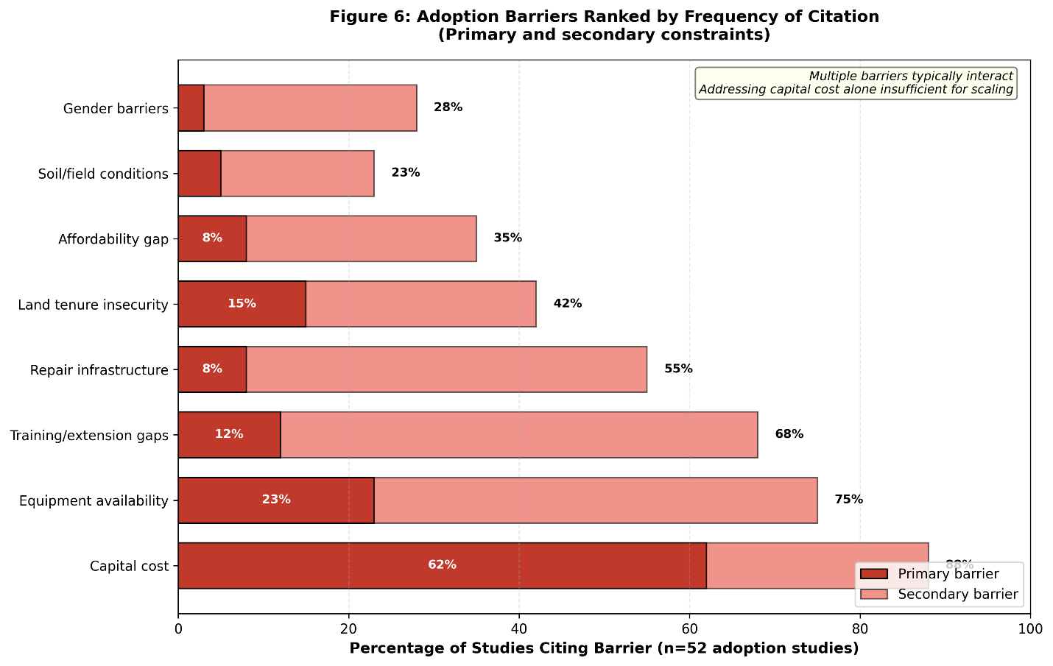
Figure 5: Adoption Barriers Ranked by Frequency
Frequency of adoption barriers mentioned in 52 adoption studies (2014-2025) across seven regions. Horizontal bar chart shows percentage of studies citing each barrier as primary (dark bars) or secondary (light bars) constraint. Capital cost cited most frequently (88% of studies, primary barrier in 62%), reflecting equipment prices of US$50-300 representing 5-30% of annual household income. Equipment availability second most common (75% of studies, primary in 23%), particularly in West Africa and Southeast Asia where supply chains are weakest. Training/extension gaps cited in 68% of studies but rarely as primary constraint, suggesting that knowledge barriers are surmountable once equipment access is achieved. Repair infrastructure weakness mentioned in 55% of studies, with highest frequency in remote rural areas. Land tenure insecurity (42%) and affordability gap—where farmer willingness-to-pay falls far below market price (35%)—more common in specific regions (Southern Africa and Madagascar, respectively). Gender barriers explicitly mentioned in only 28% of studies, likely reflecting under-research rather than absence of constraints. Multiple barriers typically interact; addressing capital cost alone insufficient for scaling adoption.

7.3 Gender Dimensions
Gender dynamics profoundly shape the adoption and impacts of planting technologies, yet remain under-researched.
Physical accessibility: Equipment weight and required pushing forces affect women's ability to use certain technologies (Andriatsiorimanana et al., 2024). Push seeders requiring >100 N pushing force may exclude women and older farmers. Designs that minimize physical demands—lighter weight, larger wheels, better weight distribution—are more inclusive (Rishabh et al., 2024).
Control over resources: Women farmers often have less control over household cash and credit, limiting their ability to purchase equipment even when economically beneficial (Dahlin & Rusinamhodzi, 2019). Subsidies and credit programs that explicitly target women are necessary to ensure equitable access.
Labor implications: Planting technologies that reduce weeding labor disproportionately benefit women, who typically perform 60-80% of weeding in many African and Asian systems (Andriatsiorimanana et al., 2024). Time savings can free women for other productive or reproductive activities. However, if mechanization shifts planting from a female to male task, women may lose control over this aspect of production.
Decision-making: Even in female-headed households, women may have limited decision-making authority over technology adoption, particularly for expensive equipment (Dahlin & Rusinamhodzi, 2019). Extension messages and demonstrations that explicitly engage women are more likely to lead to equitable adoption.
Data gaps: Most studies do not disaggregate results by gender or analyze differential impacts on men vs. women. This represents a critical research gap limiting our understanding of how planting technologies affect gender equity in smallholder systems.

7.4 Service Delivery Models
Given capital constraints and small farm sizes, service provision models—where equipment owners provide planting services to others—offer an alternative to individual ownership (Gebiso et al., 2017; Mupangwa et al., 2017).
Custom hiring: Tractor or equipment owners offer planting services for a fee, typically US$15-40/ha depending on equipment type and local labor costs (Mishra et al., 2023). This model is well-established for tillage in many regions and is expanding to planting. Zambian studies found that custom hiring of conservation agriculture planters enabled smallholders to access mechanization while allowing equipment owners to generate income covering ownership costs (Mupangwa et al., 2017).
Equipment rental: Shorter-term rental (daily or weekly) allows farmers to use equipment for their own fields without full purchase. Rental fees of US$2-10/day are common (Haque et al., 2017). This model requires local availability and trust-based relationships to prevent equipment damage.
Cooperative ownership: Farmer groups or cooperatives purchase equipment collectively, sharing costs and benefits. This model reduces individual capital requirements but requires effective group management and equitable access rules (Gebiso et al., 2017). Ethiopian wheat planter cooperatives show mixed success, with effective groups achieving high utilization (>50 ha/season) but others struggling with management and maintenance (Gebiso et al., 2017).
Viability thresholds: Service provision is economically viable when equipment utilization exceeds threshold levels—typically 15-30 ha/season for manual/push seeders and 40-80 ha/season for tractor planters (Mupangwa et al., 2017). Below these thresholds, equipment remains idle much of the year and ownership costs cannot be recovered. Geographic concentration of demand, timely service provision, and equipment reliability are critical success factors.
Policy support: Government or NGO programs that subsidize service providers (rather than individual farmers) may be more effective for scaling access (Gebiso et al., 2017). Subsidies that reduce service fees or support establishment of service provider networks could accelerate adoption while avoiding the equity and sustainability problems of individual farmer subsidies.

7.5 Case Studies of Adoption Pathways
Ethiopia wheat row planting: Ethiopia has promoted wheat row planters since the early 2010s through extension programs and subsidies (Alemu et al., 2014; Gebiso et al., 2017; Ahmed, 2023). Adoption increased from <5% of wheat farmers in 2010 to approximately 25-30% by 2020, though rates vary substantially by region (Ahmed, 2023). Success factors include: (i) strong yield evidence from research stations, (ii) farmer field days and demonstrations, (iii) availability of locally manufactured planters at US$80-150, and (iv) custom hire services in areas of concentrated wheat production. Constraints include limited availability in remote areas, inadequate training on calibration, and spare parts shortages (Gebiso et al., 2017).
Madagascar rice seeders: Madagascar has tested multiple manual seeder designs for direct-seeded rice since 2015 (Andriatsiorimanana et al., 2024). Despite clear labor savings (82% reduction in sowing time) and farmer preferences for ease of use, adoption remains below 5%. The primary constraint is the affordability gap: farmers' willingness-to-pay (US$8-11) falls far short of market prices (US$68-81). This suggests that without subsidies, credit, or substantial price reductions through local manufacturing, adoption will remain limited regardless of agronomic performance (Andriatsiorimanana et al., 2024).
Ghana maize demonstrations: Field demonstrations of hand planters in Ghana's Upper West Region showed that farmers appreciated improved spacing uniformity and potential seed savings (Jizorkuwie et al., n.d.). However, follow-up adoption was minimal due to equipment unavailability—demonstration planters were research prototypes not commercially available. This highlights the critical importance of linking demonstration programs to functional supply chains.
Bangladesh two-wheel tractor planters: Bangladesh has successfully scaled two-wheel tractor-based planters for rice, wheat, and maize through a combination of private sector development, service provision models, and extension support (Haque et al., 2017). By 2020, an estimated 15-20% of rice and wheat area in mechanization-intensive regions was planted with tractor seeders. Success factors include: (i) high population density enabling service providers to achieve viable utilization rates, (ii) active private sector manufacturing and distribution, (iii) government support for two-wheel tractor adoption creating a platform for implement attachment, and (iv) rising labor costs increasing the economic advantage of mechanization (Haque et al., 2017).
These case studies illustrate that technical performance, while necessary, is insufficient for adoption. Successful scaling requires simultaneous attention to affordability, availability, knowledge, and supportive policies.

8. Debates, Contradictions, and Limitations
8.1 Mixed Evidence on Yield Responses
While many studies report positive yield effects of precision planting, others find neutral or even negative results, creating apparent contradictions in the literature.
Context-dependency: Yield responses are highly context-specific, depending on baseline practices, soil fertility, water availability, and management (Ahmed, 2023; Fornah et al., 2020). Studies showing large yield gains typically compare precision planting to poor baseline practices (broadcasting, very low populations, no fertilizer). When comparisons are made to careful manual dibbling at optimal populations, yield differences are often minimal (Fornah et al., 2020). This suggests that much of precision planting's yield advantage comes from enabling optimal populations and management rather than inherent superiority of the planting method.. Beyond tool design and agronomic performance, strengthening decision-support capacity is critical for improving adoption outcomes. Simulation and decision-support platforms have been shown to enhance users’ understanding, confidence, and ability to evaluate agricultural technologies, thereby supporting more informed management decisions (Basche et al., 2021).
Population confounding: Many studies confound planting method with population density, making it difficult to isolate the method effect (Omara et al., 2016; Fornah et al., 2020). When populations are equalized across planting methods, yield differences often disappear, indicating that population optimization is the primary mechanism. However, precision planting enables optimal populations with less seed, so separating these effects may be artificial from a farmer's perspective.
Publication bias: Positive results are more likely to be published than null results, potentially inflating perceived benefits. The gray literature includes several unpublished reports of trials where precision planting showed no yield advantage, suggesting that published estimates may overstate average effects.

8.2 Trade-offs and Unintended Consequences
Precision planting involves trade-offs that are not always explicitly acknowledged in the promotional literature.
Density vs. lodging/disease: Higher plant populations enabled by precision planting can increase lodging risk in cereals and disease pressure in densely planted crops (Dass et al., 2023). Optimal populations must balance yield potential against these risks, and optima vary by variety, environment, and management. Blanket recommendations for high populations may be inappropriate in some contexts.
Labor shifts: While precision planting reduces total labor, it may shift labor from weeding (traditionally women's work) to equipment operation (potentially men's work), with implications for gender equity and intra-household labor allocation (Dahlin & Rusinamhodzi, 2019). These shifts are rarely studied but could have important social consequences.
Cost vs. flexibility: Precision planters are optimized for specific row spacings and seed types, reducing flexibility compared to manual methods that can easily accommodate any spacing or seed size (López Gómez & Van Loon, 2018). For farmers cultivating diverse crop portfolios, this inflexibility may be a significant constraint. Multi-crop planters address this but at higher cost and complexity.
Maintenance burden: Mechanized planters require regular maintenance and occasional repairs, adding to farmers' management burden (Haque et al., 2017). In contexts where spare parts and repair expertise are unavailable, equipment downtime can be lengthy, negating benefits. Simple hand tools avoid this problem but offer fewer labor savings.

8.3 Scalability Questions
Whether low-cost planting technologies can scale to reach millions of smallholder farmers remains uncertain.
Ownership vs. service provision: Individual ownership is economically viable only for farms above certain size thresholds (typically 2-5 ha depending on equipment type) (Mupangwa et al., 2017). For smaller farms, service provision is necessary, but service markets are underdeveloped in most smallholder regions. Whether viable service provision models can emerge at scale is unclear.
Manufacturing capacity: Scaling to millions of users requires substantial expansion of local manufacturing capacity, which is currently weak in most developing countries (Olajide & Manuwa, 2014). Reliance on imports is expensive and limits adaptation to local conditions. Building local manufacturing requires investments in skills, tooling, and quality control that go beyond agricultural extension.
Extension and training: Effective use requires training that current extension systems are ill-equipped to provide at scale (Kazuru et al., 2022). Innovative approaches like farmer-to-farmer learning, video-based extension, and private sector engagement may be necessary but remain largely untested.
Sustainability: Long-term sustainability of adoption depends on continued availability of spare parts, repair services, and technical support (Haque et al., 2017). Pilot projects often provide these inputs but they may not persist after project completion. Sustainable scaling requires development of self-sustaining commercial ecosystems, not just technology distribution.

8.4 Measurement and Methodological Heterogeneity
Substantial heterogeneity in study designs, measurements, and reporting complicates synthesis and limits confidence in generalized conclusions.
Outcome measures: Studies report yields in different units (kg/ha, t/ha, bushels/acre), use different moisture contents, and report different yield components, making quantitative synthesis difficult (Omara et al., 2016; Dass et al., 2023). Standardization of reporting protocols would greatly facilitate meta-analysis.
Spacing metrics: Uniformity is reported variously as standard deviation, coefficient of variation, or qualitative descriptions, limiting comparability (Dhillon et al., 2018; Pinto et al., 2017). Coefficient of variation is preferable as it is scale-independent, but many studies report only means without variability measures.
Economic data: Economic analyses vary in which costs are included, how labor is valued, and what time horizons are considered (Ng'ombe et al., 2019; Mishra et al., 2023). Some studies report only partial budgets (variable costs), others include equipment amortization, and still others use full cost accounting. This heterogeneity makes it difficult to compare economic viability across studies.
Study quality: As noted in Section 2.5, many studies lack randomization, adequate replication, or blinding, introducing potential bias. Few studies report sufficient methodological detail to assess risk of bias. Systematic quality assessment would help weight evidence appropriately, but the information needed is often absent from publications.
Short time horizons: Most studies report single-season results; multi-year evaluations are rare. This limit understanding of long-term effects on soil properties, pest/disease dynamics, and equipment durability. Longer-term studies are needed but require sustained funding and institutional commitment.

9. Research Gaps and Recommendations
9.1 Methodological Improvements
Standardize reporting: The research community should adopt standardized protocols for reporting planting equipment trials, including:
- Spacing uniformity: mean and coefficient of variation for row spacing and within-row spacing
- Seed rate: seeds/ha and kg/ha
- Equipment specifications: weight, dimensions, cost, manufacturer
- Operator characteristics: gender, experience, training
- Economic data: full cost accounting including labor (valued at local wage rates), equipment amortization (over realistic lifespan), and all variable costs
Improve study designs: Future trials should:
- Use randomized designs with adequate replication (minimum 3-4 replicates)
- Equalize plant populations across planting methods to isolate method effects
- Include relevant comparisons (both traditional practices and best manual practices)
- Report negative and null results to reduce publication bias
- Conduct multi-season trials to assess long-term effects and equipment durability
Economic analysis: Economic evaluations should:
- Provide complete partial budgets with all costs and returns
- Value labor at appropriate opportunity costs (not just market wages)
- Conduct sensitivity analysis across plausible ranges of yields, prices, and costs
- Report payback periods and benefit:cost ratios
- Analyze viability across farm size categories
9.2 On-Farm Adoption Research
Adoption trials: Most existing studies are researcher-managed trials on research stations or researcher-managed plots on farms. Studies of farmer-managed adoption—where farmers make all management decisions—are rare but critical for understanding real-world performance and constraints (Kazuru et al., 2022). Research should:
- Conduct on-farm trials with farmer management
- Track adoption over multiple seasons, including dis-adoption
- Document adaptation strategies farmers employ
- Identify context-specific constraints and enablers
Service delivery potential: More rigorous willingness-to-pay studies using stated preference (choice experiments) or revealed preference (demand estimation) methods would inform pricing strategies and subsidy design (Ng'ombe et al., 2019; Andriatsiorimanana et al., 2024).
Service delivery models: Research on service provision models should:
- Assess economic viability of custom hiring and rental under various demand densities
- Evaluate different organizational models (private, cooperative, public-private)
- Identify factors affecting service quality and timeliness
- Analyze equity of access across wealth and gender categories
9.3 Gender-Disaggregated Analysis
Gender dimensions of planting technologies are poorly understood due to lack of gender-disaggregated data and analysis. Future research should:
- Report all outcomes disaggregated by gender and household headship
- Assess physical accessibility of equipment for women
- Analyze intra-household labor allocation changes
- Evaluate women's control over equipment and decision-making
- Design technologies explicitly considering women's preferences and constraints
9.4 Long-Term and Systems Effects
Multi-year studies: Long-term trials (3-5+ years) are needed to assess:
- Soil health effects of repeated precision planting (compaction, organic matter, structure)
- Pest and disease dynamics under uniform vs. variable spacing
- Equipment durability and maintenance requirements over multiple seasons
- Cumulative economic effects including learning curves and management improvements
Crop rotation effects: Most studies focus on single crops, but smallholders typically practice diverse rotations. Research should:
- Evaluate equipment versatility across multiple crops in rotation
- Assess whether precision planting of one crop affects subsequent crop performance
- Analyze economics at the rotation level, not just single crops
Systems integration: Precision planting interacts with other management practices (tillage, fertilization, pest management). Research should:
- Evaluate precision planting within integrated systems (e.g., conservation agriculture, integrated soil fertility management)
- Assess synergies and trade-offs with other technologies
- Develop decision tools for matching technologies to farm contexts
9.5 Technological Innovation
Design improvements: Continued innovation in equipment design should focus on:
- Reducing costs through design simplification and local manufacturing
- Improving versatility (multi-crop capability, adjustable spacing)
- Enhancing accessibility (lighter weight, lower pushing forces, ergonomic design)
- Increasing durability and repairability with local materials and skills
Metering mechanisms: Small-seed metering remains challenging for low-cost equipment. Innovation in metering systems for millet, sorghum, and vegetable seeds would expand applicability (Pinto et al., 2017; Rishabh et al., 2024).
Depth control: Consistent depth control is difficult in variable soil conditions. Improved depth control mechanisms that work across soil types would enhance performance (Rishabh et al., 2024).
Systems perspective: Research should:
- Document and disseminate successful local manufacturing models
- Develop simplified designs optimized for local manufacturing capabilities
- Assess quality control and standardization in locally manufactured equipment
9.6 Fertilizer and Water Efficiency
Evidence on fertilizer and water-use efficiency gains from precision planting is surprisingly limited given the theoretical advantages. Priority research should:
- Measure nutrient-use efficiency metrics (agronomic efficiency, recovery efficiency, physiological efficiency) comparing precision planting to broadcast methods
- Quantify fertilizer savings possible with banding vs. broadcasting under row planting
- Assess water productivity (kg yield per mm water) under precision planting in water-limited environments
- Evaluate interactions between planting method, population density, and fertilizer/water management
9.7 Regional and Crop Diversity
Geographic gaps: Research is concentrated in East Africa (Ethiopia, Kenya) and South Asia (India, Bangladesh), with limited representation from:
- West Africa (Nigeria, Ghana, Senegal)
- Southern Africa (Malawi, Mozambique, Zimbabwe)
- Southeast Asia (Myanmar, Cambodia, Laos)
- Central America (Guatemala, Honduras, Nicaragua)
Crop gaps: While maize, wheat, and rice dominate the literature, other important smallholder crops are under-studied:
- Legumes (chickpea, pigeon pea, lentil, faba bean)
- Root crops (cassava, sweet potato, potato)
- Vegetables (tomato, onion, cabbage)
- Oilseeds (groundnut, sesame, sunflower)
Research in these under-represented regions and crops would broaden the evidence base and identify context-specific opportunities.

10. Implications for Policy and Practice
Technology development priorities:
- Continued innovation to reduce equipment costs through design simplification and local manufacturing
- Improved versatility (multi-crop capability, adjustable spacing) to accommodate diverse smallholder crop portfolios
- Enhanced accessibility (lighter weight, lower pushing forces) to ensure women and older farmers can use equipment
- Greater durability and repairability using locally available materials and skills
Extension and training:
- Develop training modules on equipment calibration, operation, and maintenance
- Establish demonstration plots with farmer-managed trials, not just researcher-managed plots
- Leverage farmer-to-farmer learning and video-based extension for scalable training
- Ensure extension messages and demonstrations explicitly engage women farmers
Policy interventions:
- Subsidies targeted at service providers rather than individual farmers may be more effective and equitable for scaling access
- Credit programs with appropriate terms (low interest, multi-year repayment) to address capital constraints
- Support for local manufacturing through skills training, tooling subsidies, and quality standards
- Investments in spare parts supply chains and repair service networks
- Land tenure reforms to provide security that incentivizes equipment investment
Service delivery development:
- Pilot and evaluate alternative service provision models (private, cooperative, public-private) in diverse contexts
- Provide start-up support for service providers (equipment subsidies, training, market linkages)
- Develop service quality standards and certification to build user confidence
- Facilitate geographic concentration of demand through area-based approaches
Research priorities:
- Long-term (3-5+ year) on-farm trials with farmer management to assess real-world performance, adoption, and sustainability
- Gender-disaggregated data and analysis in all future studies
- Standardized reporting protocols to enable meta-analysis and evidence synthesis
- Economic research on willingness-to-pay, demand estimation, and service delivery viability
- Expansion to under-researched regions (West Africa, Southeast Asia, Central America) and crops (legumes, root crops, vegetables)
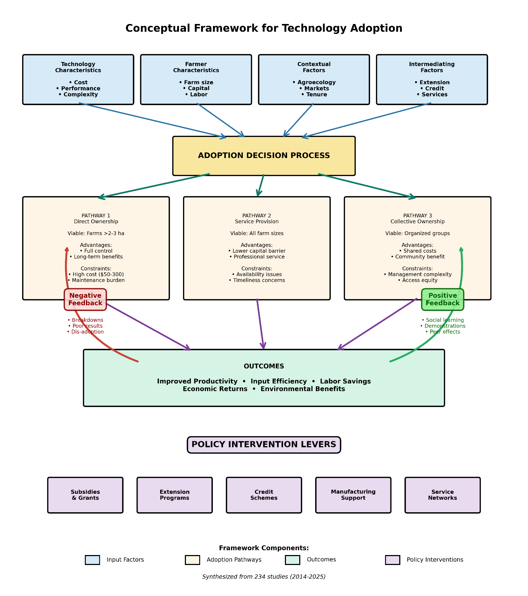
Figure 6: Conceptual Framework for Technology Adoption
Conceptual framework showing pathways and barriers to adoption of low-cost planting technologies among smallholder farmers. Framework integrates technology characteristics (cost, performance, complexity), farmer characteristics (farm size, capital, labor availability, gender, education), contextual factors (agroecology, market access, land tenure, policy environment), and intermediating factors (extension, credit, service provision, local manufacturing). Three adoption pathways identified: (1) Direct ownership: viable for farms >2-3 ha with adequate capital or credit access; constrained by upfront costs, maintenance requirements, and land tenure insecurity. (2) Service provision: custom hiring or equipment rental enables access for smaller farms; requires sufficient demand density, reliable service providers, and timely availability during planting windows. (3) Collective ownership: farmer groups or cooperatives share equipment costs; requires effective group management, equitable access rules, and adequate utilization to cover costs. Feedback loops shown: successful adoption generates social learning and demonstration effects, increasing subsequent adoption; equipment breakdowns or poor performance lead to dis-adoption and negative perceptions. Policy interventions can target multiple points: subsidies (reduce capital barrier), extension (address knowledge gaps), credit programs (overcome liquidity constraints), support for local manufacturing (improve availability and reduce costs), and service provider networks (enable access for small farms). Framework synthesized from adoption literature across 234 studies (2014-2025).

10.3 Broader Context: Precision Agriculture for Smallholders
This review focuses specifically on low-cost planting technologies, but the findings have broader implications for precision agriculture in smallholder contexts. The pattern observed here—clear technical benefits, favorable economics in many contexts, but limited adoption due to capital constraints, availability, knowledge gaps, and weak support systems—characterizes many agricultural technologies for smallholders (Ng'ombe et al., 2019; Dahlin & Rusinamhodzi, 2019).
Appropriate technology principles: Successful technologies for smallholders must be not only technically effective but also:
- Affordable (upfront costs <10-20% of annual household income)
- Available (present in local markets or manufacturable locally)
- Accessible (physically usable by women, older farmers, and those with disabilities)
- Adaptable (versatile across crops, spacing, and conditions)
- Maintainable (repairable with local skills and materials)
Beyond technology: Technology alone is insufficient. Successful scaling requires simultaneous attention to:
- Knowledge systems (training, extension, farmer-to-farmer learning)
- Input and output markets (seeds, fertilizers, produce marketing)
- Service provision (custom hire, rental, cooperative models)
- Policy environment (subsidies, credit, land tenure, trade policies)
- Social equity (gender, wealth, age, ethnicity)
Systems perspective: Precision planting is most effective when integrated with complementary practices: improved varieties, adequate fertilization, timely weed management, and appropriate crop protection. Promoting planting technologies in isolation, without ensuring access to complementary inputs and knowledge, will limit impact. Integrated approaches that address multiple constraints simultaneously are more likely to succeed (Fanadzo et al., 2023).

10.4 Future Outlook
The future of precision planting for smallholders will likely be shaped by several trends:
Rising labor costs: As rural-urban migration and non-farm opportunities expand, agricultural labor costs are rising in many regions (Haque et al., 2017). This increases the economic advantage of labor-saving planting technologies, potentially accelerating adoption even without yield gains.
Climate change: Increasing rainfall variability and more frequent droughts heighten the importance of timely planting and optimal populations, both facilitated by precision planting technologies (Mossie, 2022). Climate adaptation strategies increasingly emphasize improved crop establishment as a low-cost, high-return intervention.
Youth engagement: Younger farmers are often more willing to adopt new technologies and may be attracted to mechanized planting as less physically demanding than manual methods (Kazuru et al., 2022). Designing technologies and business models that appeal to youth could accelerate uptake.
Digital integration: While current low-cost planters are purely mechanical, future designs may integrate simple digital components (seed counters, GPS-based spacing guides, smartphone-connected calibration) as costs of digital technologies decline. However, care is needed to ensure that digitalization does not increase complexity, cost, or maintenance requirements beyond smallholder capabilities.
Private sector engagement: Most current planting equipment for smallholders is distributed through public sector or NGO programs. Sustainable scaling will require greater private sector engagement in manufacturing, distribution, and service provision. Creating enabling conditions for profitable private sector involvement is a key policy challenge (Haque et al., 2017; Mupangwa et al., 2017).

10.5 Final Remarks
Low-cost precision planting technologies offer substantial potential to improve smallholder productivity, input efficiency, and labor productivity. The evidence base, while imperfect, clearly demonstrates technical effectiveness and often-favorable economics. However, realizing this potential at scale requires moving beyond technology development to address the full system of constraints limiting adoption: affordability, availability, knowledge, repair infrastructure, and supportive policies.
No single technology or policy will solve the complex challenges facing smallholder agriculture. Rather, progress will come from portfolios of appropriate technologies, deployed through diverse pathways (ownership, service provision, cooperatives), supported by effective extension and training, embedded in enabling policy environments, and adapted to specific agroecological and socioeconomic contexts.
The research agenda outlined in Section 9 provides a roadmap for filling critical knowledge gaps. Particularly important are long-term, on-farm adoption studies with gender-disaggregated analysis, economic research on service delivery viability, and expansion to under-researched regions and crops. Standardization of reporting protocols would greatly facilitate synthesis and meta-analysis, strengthening the evidence base for policy and investment decisions.
Ultimately, the success of low-cost precision planting for smallholders will be measured not by technical performance in research station trials, but by widespread adoption and sustained use by millions of smallholder farmers, translating into improved livelihoods, food security, and environmental sustainability.

11. Conclusion:
This systematic review of low-cost planting precision technologies for smallholders yields several clear conclusions:
Technical performance: Low-cost planting technologies—from simple hand planters (US$5-50) to manual seeders (US$50-100) and push planters (US$80-150) to two-wheel tractor implements (US$150-300)—consistently improve spatial uniformity compared to traditional broadcasting or random dibbling. Spacing uniformity improvements (CV reduction from 40-60% to 15-30%) enable better crop establishment, more efficient input use, and facilitated weed management (Dhillon et al., 2018; Pinto et al., 2017; Andriatsiorimanana et al., 2024).
Agronomic outcomes: Yield responses are context-dependent but generally positive, with gains of 10-40% common for wheat and maize when precision planting enables population optimization (Alemu et al., 2014; Ahmed, 2023; Dass et al., 2023; Fornah et al., 2020). However, when plant populations are equalized, yield differences are often minimal, indicating that much of the benefit comes from enabling optimal densities rather than inherent method superiority (Fornah et al., 2020).
Input efficiency: Precision planting reduces seed rates by 10-20% for most crops and up to 40-50% for rice, generating economically significant seed savings particularly for expensive hybrid seeds (Omara et al., 2016; Pinto et al., 2017; Andriatsiorimanana et al., 2024). Evidence for fertilizer-use efficiency gains is limited but suggestive of 10-20% improvements when row planting enables banding (Dass et al., 2023).
Labor effects: Labor savings are among the most consistent and substantial benefits. Planting time reductions of 50-82% are documented for manual seeders and push planters, while weeding labor decreases by 30-60% due to facilitated inter-row cultivation (Andriatsiorimanana et al., 2024; Nyamangara et al., 2014; Dahlin & Rusinamhodzi, 2019). These savings are particularly valuable in labor-constrained systems and disproportionately benefit women who typically perform most weeding labor.
Economic viability: Where reported, benefit:cost ratios of 1.2-3.5:1 suggest economic viability under typical conditions (Ahmed, 2023; Mishra et al., 2023; Ng'ombe et al., 2019). Payback periods of 1-3 seasons for hand planters and 3-7 seasons for more expensive equipment indicate that investments can be recovered within reasonable timeframes given equipment lifespans of 5-10 seasons.
Adoption constraints: Despite often-favorable economics, adoption remains limited due to multiple interacting constraints: upfront capital costs (US$50-300 representing 5-30% of annual household income), limited equipment availability in rural areas, inadequate training and extension support, weak repair infrastructure, and insecure land tenure (Ng'ombe et al., 2019; Andriatsiorimanana et al., 2024; Gebiso et al., 2017). Madagascar willingness-to-pay studies revealing a 6-9× affordability gap underscore the severity of the capital constraint (Andriatsiorimanana et al., 2024).
Service delivery potential: Service provision models—custom hiring, equipment rental, cooperative ownership—offer promise for overcoming individual ownership barriers, particularly for smaller farms where individual ownership is not economically viable (Mupangwa et al., 2017; Gebiso et al., 2017). However, service markets are underdeveloped and require supportive policies and investments to scale.

Disclaimer (Artificial intelligence)
Author(s) hereby declare that NO generative AI technologies such as Large Language Models (ChatGPT, COPILOT, etc.) and text-to-image generators have been used during the writing or editing of this manuscript.

References

A. A. Adnan et al. (2020). Optimizing sowing density-based management decisions with different nitrogen rates on smallholder maize farms in Northern Nigeria. Experimental Agriculture. https://doi.org/10.1017/S001447972000037X
A. Faye et al. (2023). Increasing millet planting density with appropriate fertilizer to enhance productivity and system resilience in Senegal. Sustainability. https://doi.org/10.3390/su15054093
A. Ngwira et al. (2020). Productivity and profitability of maize-legume cropping systems under conservation agriculture among smallholder farmers in Malawi. Acta Agriculturae Scandinavica Section B: Soil and Plant Science. https://doi.org/10.1080/09064710.2020.1712470
Adekanye, T. A., & Akande, A. M. (2015). Development and evaluation of a manual multi-crop planter for peasant farmers. Agricultural Engineering International: CIGR Journal, 17(4), 1–12.
Ahmed, M. H. (2023). Does row planting enhance farm productivity and reduce risk exposure? Insights from Ethiopia. Journal of Agricultural and Applied Economics, 55(3), 456–478. https://doi.org/10.1017/aae.2023.12
Alemu, T. (2015). Socio-economic and institutional factors limiting adoption of wheat row planting in selected districts of Arsi Zone. Science, Technology and Arts Research Journal. https://doi.org/10.4314/STAR.V4I1.36
Alemu, T., Emana, B., Haji, J., & Legesse, B. (2014). Impact of wheat row planting on yield of smallholders in selected highland and lowland areas of Ethiopia. International Journal of Agriculture and Forestry, 4(1), 1–7.
Ali, D. A., et al. (2017). Using national statistics to increase transparency of large land acquisition: Evidence from Ethiopia. World Development. https://doi.org/10.1016/J.WORLDDEV.2016.12.027
Amponsah, S. K., et al. (2025). A review of transforming rice harvesting in Sub-Saharan Africa: Addressing constraints, leveraging mechanization, and enhancing productivity. Advances in Agriculture. https://doi.org/10.1155/aia/5523207
Andriatsiorimanana, A., Mujawamariya, G., Tefy, I. A., Harison, N. F., & Saito, K. (2024). Labour-saving sowing tools for direct dry seeding of rice in Madagascar. Experimental Agriculture, 60, e7. https://doi.org/10.1017/s0014479724000188
Ansar, A., et al. (2023). Design development and performance evaluation of two-row corn seed planter. Jurnal Teknik Pertanian. https://doi.org/10.23960/jtep-l.v12i4.979-987
Assunção, et al. (2025). Low abundance of regular pollinators and indirect competitive effects of dominant small bees negatively affect passion fruit pollination in smallholder croplands. Neotropical Entomology. https://doi.org/10.1007/s13744-025-01247-9
Bhadane, K., et al. (2024). A.G.R.I.Yantra: Agriculture Growth and Resource Improvising Yantra. Journal Name. https://doi.org/10.1109/icscss60660.2024.10625329
Basche, A., Krupek, F. S., Chatterjee, N., & Speth, C. (2021). Farm simulation platforms increase undergraduate skills and confidence in decision‐support technologies. Natural Sciences Education, 50(1), e20058.
Chikowo, R., et al. (2020). Ecosystem services in doubled-up legume systems. Journal Name. https://doi.org/10.1016/B978-0-12-816436-5.00009-3
Chesinen, I., et al. (2025). Influence of cultivars and intra row spacing on performance of maize in Keiyo North Sub-County, Kenya. East African Journal of Agriculture and Biotechnology. https://doi.org/10.37284/eajab.8.2.3415
Cossar, F. (2019). Impact of mechanization on smallholder agricultural production: Evidence from Ghana. Journal Name. https://doi.org/10.22004/AG.ECON.289657
Dahlin, A. S., & Rusinamhodzi, L. (2019). Yield and labor relations of sustainable intensification options for smallholder farmers in sub-Saharan Africa: A meta-analysis. Agronomy for Sustainable Development, 39(3), 32. https://doi.org/10.1007/S13593-019-0575-1
Dass, A., Kushwaha, H. L., Sahoo, P. K., Dhar, S., Choudhary, A. K., Raj, R., & Singh, R. (2023). Comparative analysis of machine-planted and manual-planted wheat on crop and water productivity, and profitability under system of wheat intensification management. Frontiers in Sustainable Food Systems, 7, 1187647. https://doi.org/10.3389/fsufs.2023.1187647
Dekhane, S. S., et al. (2018). Response of N and P2O5 levels, spacing and seed rate on yield of paddy and nutrient status of soil. International Journal of Current Microbiology and Applied Sciences. https://doi.org/10.20546/IJCMAS.2018.704.404
Droppelmann, K. J., et al. (2017). Sustainable intensification options for smallholder maize-based farming systems in sub-Saharan Africa. Food Security. https://doi.org/10.1007/S12571-016-0636-0
Dhillon, J. S., Omara, P., Nambi, E., Eickhoff, E., Oyebiyi, F., & Raun, W. R. (2018). Hand planter for the developing world: Factor testing and refinement. Agrosystems, Geosciences & Environment, 1(1), 180002. https://doi.org/10.2134/AGE2018.03.0002
Dhillon, R., & Moncur, Q. (2023). Small-scale farming: A review of challenges and potential opportunities offered by technological advancements. Sustainability, 15(21), 15478. https://doi.org/10.3390/su152115478
Ekeleme, et al. (2021). Increasing cassava root yield on farmers' fields in Nigeria through appropriate weed management. Crop Protection. https://doi.org/10.1016/j.cropro.2021.105810
El Sayed, H., et al. (2022). Selection of appropriate mechanization to achieve sustainability for smallholder farms: A review. Al-Azhar Journal of Agricultural Engineering. https://doi.org/10.21608/azeng.2022.252902
Esayas Eyasu et al. (2018). Yield response of maize (Zea mays L.) varieties to row spacing under irrigation at Geleko, Ofa Woreda, Wolaita Zone, Southern Ethiopia. Journal Name. https://doi.org/10.9734/JEAI/2018/37096
Fanadzo, M., Dube, E., Dunjana, N., & Mupambwa, H. A. (2023). Improving productivity of smallholder irrigation in Africa through adoption of best management practices and technologies. In Sustainability Sciences in Asia and Africa (pp. 149–176). Springer. https://doi.org/10.1007/978-981-99-2427-1_7
Feryanto, et al. (2022). Does mechanization have an impact on increasing productivity and income of narrow land corn farmers in Indonesia? IOP Conference Series. https://doi.org/10.1088/1755-1315/1107/1/012054
Fornah, A., Aula, L., Omara, P., Oyebiyi, F., & Raun, W. R. (2020). Effect of spacing, planting methods and nitrogen on maize grain yield. Communications in Soil Science and Plant Analysis, 51(14), 1840–1850. https://doi.org/10.1080/00103624.2020.1789163
Gondal, et al. (2018). Effect of seed rate and row spacing on grain yield of sorghum. SAARC Journal of Agriculture. https://doi.org/10.3329/SJA.V15I2.35154
Grichar, W. J., Dotray, P. A., & Lemon, R. G. (2017). Sugarbeet yield and quality as affected by row spacing and seeding rate. Journal of Sugar Beet Research, 54(1–2), 1–14.
Haarhoff, S. J., et al. (2022). Plant population and row spacing affects growth and yield of rainfed maize in semi-arid environments. Frontiers in Plant Science. https://doi.org/10.3389/fpls.2022.761121
Haque, M. E., Islam, A. K. M. S., Hossain, M. M., Bell, R. W., Alam, M. K., & Rahman, M. A. (2017). An innovative versatile multi-crop planter for crop establishment using two-wheel tractors. SAARC Journal of Agriculture, 15(2), 99–112.
Haque, Md. E., et al. (2016). Versatile strip seed drill: A 2-wheel tractor-based option for smallholders to implement conservation agriculture in Asia and Africa. Journal Name. https://doi.org/10.3390/ENVIRONMENTS3010001
Higgins, J. P. T., Altman, D. G., Gøtzsche, P. C., Jüni, P., Moher, D., Oxman, A. D., Savović, J., Schulz, K. F., Weeks, L., & Sterne, J. A. C. (2011). The Cochrane Collaboration’s tool for assessing risk of bias in randomized trials. BMJ, 343, d5928. https://doi.org/10.1136/bmj.d5928
Higgins, J. P. T., Thomas, J., Chandler, J., Cumpston, M., Li, T., Page, M. J., & Welch, V. A. (Eds.). (2019). Cochrane Handbook for Systematic Reviews of Interventions (2nd ed.). John Wiley & Sons.
He Jin et al. (2014). Development of small/medium size no-till and minimum-till seeders in Asia: A review. International Journal of Agricultural and Biological Engineering. https://doi.org/10.25165/IJABE.V7I4.1399
Huo, Y., et al. (2022). Barriers to the development of agricultural mechanization in the North and Northeast China Plains: A farmer survey. Agriculture. https://doi.org/10.3390/agriculture12020287
Jumpah, E. T., et al. (2024). Examining the impact of row planting on labor use for sustainable food production among maize farmers in rural Ghana. Agribusiness. https://doi.org/10.1002/agr.22004
Jizorkuwie, J. K., Akurigo, D. A., & Abindaw, B. A. (n.d.). Establishment of field demonstrations in the upper west region of Ghana. Unpublished technical report.
Kachala, B., et al. (2025). Suboptimal maize spacing undermines yields and diminishes land utility in Malawi. Frontiers in Sustainable Food Systems. https://doi.org/10.3389/fsufs.2025.1629487
Kamalongo, D., et al. (2025). Competitive effects of dwarf bean cultivars (Phaseoulus vulgaris L.) on maize (Zea mays L.) intercrop productivity influenced by spatial arrangements. Agronomy. https://doi.org/10.3390/agronomy15030613
Karunyaa, T., et al. (2024). Design and development of a manual groundnut planter for smallholder farmers. MATEC Web of Conferences. https://doi.org/10.1051/matecconf/202440001009
Kazuru, C. C. K., Mussava, S. N. M., Divage, B. A. F., Somueque, S. I., & Donça, M. C. B. (2022). Aceitabilidade de tecnologia de semeadora manual de leguminosas em produtores de feijão Nhemba no distrito de Mogovolas [Acceptability of legume seeder technology among cowpea producers in Mogovolas district]. Brazilian Journal of Development, 8(2), 9431–9448. https://doi.org/10.34117/bjdv8n2-064
Kermah, M., et al. (2019). Legume-maize rotation or relay? Options for ecological intensification of smallholder farms in the Guinea savanna of northern Ghana. Experimental Agriculture. https://doi.org/10.1017/S0014479718000273
Kinyua, M. G., et al. (2024). Plant spatial configurations and their influences on phenological traits of cereal and legume crops under maize-based intercropping systems. Journal of Sustainable Agriculture and Environment. https://doi.org/10.1002/sae2.12110
Kuş, E. (2021). Optimization of operational parameters of a vacuum single-seed planter for sowing of maize. Journal of Agricultural Sciences. https://doi.org/10.15832/ANKUTBD.678544
Kumar, S., et al. (2025). Enhancing mechanization of paddy cultivation for small scale farmers. Journal of Experimental Agriculture International. https://doi.org/10.9734/jeai/2025/v47i93746
Kumar, S., et al. (2025). Mechanization enhancement in maize cultivation for small holder farming community. International Journal of Plant and Soil Science. https://doi.org/10.9734/ijpss/2025/v37i85619
López Gómez, J. A., & Van Loon, J. (2018). Evaluación agrotécnica de implementos manuales para la siembra de maíz [Agrotechnical evaluation of manual implements for maize sowing]. Revista Mexicana de Ciencias Agrícolas, 9(21), 4311–4323. https://doi.org/10.29312/REMEXCA.V0I21.1524
Macours, K. (2014). Adoption and adaptation in developing country agriculture. Journal Name. https://doi.org/10.4074/S1966960714011023
Ma, Z., et al. (2024). Harnessing the power of mechanization: A multivalued treatment effect analysis on productivity for Chinese smallholders. Land. https://doi.org/10.3390/land13122211
Massawe, P. I., et al. (2016). Improving soil fertility and crops yield through maize-legumes (common bean and Dolichos lablab) intercropping systems. The Journal of Agricultural Science. https://doi.org/10.5539/JAS.V8N12P148
Mather, D., et al. (2018). Mechanization and crop productivity, profitability and labor use in Myanmar’s dry zone. Journal Name. https://doi.org/10.22004/AG.ECON.275681
Mizik, T. (2022). How can precision farming work on a small scale? A systematic literature review. Precision Agriculture. https://doi.org/10.1007/s11119-022-09934-y
Mishra, S. K., Shrestha, S., Jha, S. K., Mishra, A., & K C, B. (2023). Performance evaluation of 4-wheel tractor drawn 3-rows precision maize planter for mechanization of maize farming in Nepal. Veethika: An International Interdisciplinary Research Journal, 9(4), 12–19. https://doi.org/10.48001/veethika.2023.09.04.003
Moher, D., Liberati, A., Tetzlaff, J., Altman, D. G., & The PRISMA Group. (2009). Preferred reporting items for systematic reviews and meta-analyses: The PRISMA statement. PLoS Medicine, 6(7), e1000097. https://doi.org/10.1371/journal.pmed.1000097
Mossie, W. A. (2022). The impact of climate-smart agriculture technology on productivity: Does row planting matter? Evidence from southern Ethiopia. The Scientific World Journal, 2022, 3218287. https://doi.org/10.1155/2022/3218287
Mumah, E., et al. (2024). Machinery adoption and its effect on maize productivity among smallholder farmers in Western Kenya: Evidence from the chisel harrow tillage practice. Research on World Agricultural Economy. https://doi.org/10.36956/rwae.v5i1.983
Muoni, T., et al. (2022). Effects of management practices on legume productivity in smallholder farming systems in sub-Saharan Africa. Food and Energy Security. https://doi.org/10.1002/fes3.366
Mulundu Mwila et al. (2024). Do rotations and intercrops matter? Opportunities for intensification and diversification of maize-based cropping systems in Zambia. Field Crops Research. https://doi.org/10.1016/j.fcr.2024.109436
Mupangwa, W., Mutenje, M., Thierfelder, C., Mwila, M., & Malumo, H. (2017). Productivity and profitability of manual and mechanized conservation agriculture (CA) systems in Eastern Zambia. Renewable Agriculture and Food Systems, 34(4), 380–394. https://doi.org/10.1017/S1742170517000606
Ng'ombe, J. N., Brorsen, B. W., Raun, W. R., & Dhillon, J. S. (2019). Economics of the greenseeder hand planter. Agrosystems, Geosciences & Environment, 2(1), 180056. https://doi.org/10.2134/AGE2018.11.0056
Nyamangara, J., Mashingaidze, N., Masvaya, E. N., Nyengerai, K., Kunzekweguta, M., Tirivavi, R., & Mazvimavi, K. (2014). Weed growth and labor demand under hand-hoe based reduced tillage in smallholder farmers' fields in Zimbabwe. Agriculture, Ecosystems & Environment, 187, 146–154. https://doi.org/10.1016/J.AGEE.2013.10.005
Ojiem, J. O., et al. (2014). Benefits of legume–maize rotations: Assessing the impact of diversity on the productivity of smallholders in Western Kenya. Field Crops Research. https://doi.org/10.1016/J.FCR.2014.08.004
Olajide, O. G., & Manuwa, S. I. (2014). Design, fabrication and testing of a low-cost row-crop planter for peasant farmers. Journal of Agricultural Engineering and Technology, 22(1), 1–12.
Okello, D. M., et al. (2019). Farm level allocative efficiency of rice production in Gulu and Amuru districts, Northern Uganda. Agricultural and Food Economics. https://doi.org/10.1186/S40100-019-0140-X
Omara, P., Aula, L., Raun, W. R., Taylor, R., & Koller, A. (2016). Hand planter for maize (Zea mays L.) in the developing world. Journal of Plant Nutrition, 39(11), 1648–1661. https://doi.org/10.1080/01904167.2015.1022186
Pinto, A. A., da Camara, F. T., da Silva, F. E., Santana, L. D., & Rodrigues, W. Á. D. (2017). Espaçamento longitudinal e produtividade de feijão caupi com uso de semeadora manual [Longitudinal spacing and productivity of cowpea using manual seeder]. Revista Engenharia na Agricultura, 25(6), 557–565. https://doi.org/10.13083/REVENG.V25I6.750
Popay, J., Roberts, H., Sowden, A., Petticrew, M., Arai, L., Rodgers, M., & Britten, N. (2006). Guidance on the conduct of narrative synthesis in systematic reviews. ESRC Methods Programme. (Version 1, p. 92).
Ramana, C., et al. (2020). A key input for reducing of mechanization cost in smallholdings: Mini tractor drawn multi task toolbar. Current Journal of Applied Science and Technology. https://doi.org/10.9734/CJAST/2020/V39I2230839
Rabbani, M. A., Hossain, M. M., Asha, J. F., & Khan, N. A. (2016). Design and development of a low cost planter for maize establishment. Journal of Science, Technology and Environment Informatics, 4(1), 274–280. https://doi.org/10.18801/JSTEI.040116.30
Rebecca Mattingly Harman et al. (2017). Finding the technological sweet spot: The smallholder conservation agriculture maize seeder. Journal of Sustainable Development. https://doi.org/10.5539/JSD.V10N5P241
Ricciardi, V., Ramankutty, N., Mehrabi, Z., Jarvis, L., & Chookolingo, B. (2018). How much of the world’s food do smallholders produce? Global Food Security, 17, 64–72. https://doi.org/10.1016/j.gfs.2018.05.002
Rishabh, D., Kumar, S., Bhardwaj, V., Muzamil, M., & Masoodi, U. H. (2024). Development and evaluation of two-row hand held manual planter for black pepper seeds. Poljoprivredna Tehnika, 49(4), 81–88. https://doi.org/10.5937/poljteh2404081d
Sgarbi, M., et al. (2025). Adubadeira manual. Journal Name. https://doi.org/10.29327/5615213.1-1
Shinde, S. S., et al. (2024). Optimizing small-scale farming: A review of manually operated vegetable seed sowing machine performance. Indian Scientific Journal of Research in Engineering and Management. https://doi.org/10.55041/ijsrem37584
Silva, J. V., Reidsma, P., Laborte, A. G., & van Ittersum, M. K. (2017). Explaining rice yields and yield gaps in Central Luzon, Philippines: An application of stochastic frontier analysis and crop modelling. European Journal of Agronomy, 82, 223–241.
Silva, J. V., et al. (2023). Narrowing maize yield gaps across smallholder farming systems in Zambia: What interventions, where, and for whom? Agronomy for Sustainable Development. https://doi.org/10.1007/s13593-023-00872-1
Sims, B., et al. (2017). Sustainable agricultural mechanization for smallholders: What is it and how can we implement it? Agriculture. https://doi.org/10.3390/AGRICULTURE7060050
Singh, R. S., Singh, S. P., & Singh, A. K. (2016). Development and testing of twin row drum planter for maize. Indian Journal of Agricultural Sciences, 86(4), 511–516.
Seid Yimer, T., et al. (2022). Optimizing maize‐bean cropping systems for sustainable intensification in Southern Ethiopia. Agronomy Journal. https://doi.org/10.1002/agj2.21143
Sita Tiwari et al. (2021). Hand weeding tools in vegetable production systems: An agronomic, ergonomic and economic evaluation. International Journal of Agricultural Sustainability. https://doi.org/10.1080/14735903.2021.1964789
Tejada-Campos, T. N. (2022). Generación de un equipo de labranza para la agricultura familiar: La cultivadora INIA. Revista de investigación agropecuaria science and biotechnology. https://doi.org/10.25127/riagrop.20224.878
Tittonell, P., & Giller, K. E. (2013). When yield gaps are poverty traps: The paradigm of ecological intensification in African smallholder agriculture. Field Crops Research, 143, 76–90. https://doi.org/10.1016/j.fcr.2012.10.009
Tovihoudji, P. G., et al. (2019). Variability in maize yield and profitability following hill-placement of reduced mineral fertilizer and manure rates under smallholder farm conditions in northern Benin. Field Crops Research. https://doi.org/10.1016/J.FCR.2018.10.018
Trottmann, C. (2023). Is scale-appropriate farm mechanization gendered? Learning from the Nepal Hills. In Sustainability Sciences in Asia and Africa. https://doi.org/10.1007/978-981-19-6978-2_7
Unknown Author. (2022). Response of maize (Zea mays) to different row arrangement and plant geometry of intercropped sesame (Sesamum indicum) in Fincha Valley, Western Ethiopia. Research on Crops. https://doi.org/10.31830/2348-7542.2022.044
Unknown Author. (2023). Does agricultural intensification pay? Journal Name. https://doi.org/10.1596/39701
Vaishnavi, D., et al. (2017). Development of pull type inclined plate planter. International Journal of Current Microbiology and Applied Sciences. https://doi.org/10.20546/IJCMAS.2017.606.213
Van Loon, J., et al. (2018). Precision for smallholder farmers: A small-scale-tailored variable rate fertilizer application kit. Agriculture. https://doi.org/10.3390/AGRICULTURE8040048
Vandercasteelen, J., et al. (2018). Labour, profitability and gender impacts of adopting row planting in Ethiopia. European Review of Agricultural Economics. https://doi.org/10.1093/ERAE/JBY001
van Ittersum, M. K., Cassman, K. G., Grassini, P., Wolf, J., Tittonell, P., & Hochman, Z. (2013). Yield gap analysis with local to global relevance — A review. Field Crops Research, 143, 4–17. https://doi.org/10.1016/j.fcr.2012.09.009
van Ittersum, M. K., van Bussel, L. G., Wolf, J., Grassini, P., Van Wart, J., Guilpart, N., & Cassman, K. G. (2016). Can sub-Saharan Africa feed itself? Proceedings of the National Academy of Sciences, 113(52), 14964–14969.
Woyessa, D., et al. (2023). Redesigning of Asella animal drawn wheat row planter. Applied Research and Innovation. https://doi.org/10.54536/ari.v1i2.2053
Yangchen, D. C., et al. (2025). Labor-saving agricultural mechanization services and the technical efficiency in agricultural production: Evidence from Chinese rural households. Frontiers in Sustainable Food Systems. https://doi.org/10.3389/fsufs.2025.1600375
Yatribi, T. (2020). Factors affecting precision agriculture adoption: A systematic literature review. Journal Name. https://doi.org/10.2478/EOIK-2020-0013
Yuewen Huo et al. (2022). Barriers to the development of agricultural mechanization in the North and Northeast China Plains: A farmer survey. Agriculture. https://doi.org/10.3390/agriculture12020287
Yimer, T. S., et al. (2022). Optimizing maize‐bean cropping systems for sustainable intensification in Southern Ethiopia. Agronomy Journal. https://doi.org/10.1002/agj2.21143
Yuewen Huo et al. (2022). Barriers to the development of agricultural mechanization in the North and Northeast China Plains: A farmer survey. Agriculture. https://doi.org/10.3390/agriculture12020287
Zhenbang Ma et al. (2024). Harnessing the power of mechanization: A multivalued treatment effect analysis on productivity for Chinese smallholders. Land. https://doi.org/10.3390/land13122211

