Original Research Article

Comparative Assessment of Personal and Socio-economic Characteristics Among Dairy, Sheep/Goat and Backyard Poultry Farmers in Andhra Pradesh

Abstract
Livestock farming forms the foundation of the rural economy in Andhra Pradesh, encompassing dairy, sheep/goat and backyard poultry systems that differ in scale, resource availability and socio-economic context. This ex post facto study examines the personal and socio-economic characteristics of farmers proficient in social media across these categories, aiming to address gaps in digital extension services amid challenges such as limited veterinary access and market instability. This study aims to compare the personal and socio-economic characteristics of 540 livestock farmers who use social media, grouped into three categories (dairy, sheep/goat and backyard poultry farmers). The goal is to identify key differences and similarities to help design better extension strategies and digital tools that support productivity and rural development. The study adopted an ex post facto design, dividing Andhra Pradesh into the Coastal, North Coastal and Rayalaseema regions. The researcher purposefully selected 9 districts known for their abundant livestock populations, then randomly selected 27 mandals from these areas. Within each mandal, they conducted in-person interviews with 20 farmers, ensuring equal representation across categories. The collected data were analysed using frequency, percentage, mean, standard deviation, one-way ANOVA and Tukey HSD post hoc test. Significant differences were found in gender, social status, education, landholding, family size, herd size, experience in livestock farming, material possession, annual income, scientific orientation, information-seeking behaviour and credibility (p < 0.05 or < 0.001). The one-way ANOVA found highly significant differences between livestock categories in landholding (F = 19.175), experience (F = 14.841), herd size (F = 21.712), material possession (F = 8.379) and annual income (F = 65.975; p < 0.001). Information seeking behaviour (F = 8.447), scientific orientation (F = 7.531; p < 0.001) and credibility (F = 3.746; p < 0.05) showed significant differences. In contrast, motivation and social media–related variables were not significant (p > 0.05). Dairy farmers had a higher socio-economic status. Sheep/goat farmers were more scientifically engaged. Backyard poultry farming was gender-inclusive and associated with medium incomes. No significant differences were observed in achievement motivation, age, market orientation, social media exposure and economic motivation. The findings highlight the necessity for category-specific policies to address disparities, utilize social media for inclusive extension services, promote equity in dairy sector growth and improve resource access for sheep/goat and backyard poultry farmers to support sustainable rural livelihoods.
Keywords: Dairy farmers, Sheep/Goat farmers, Backyard poultry farmers, Personal and Socio-economic characteristics, Comparative analysis.

Introduction:
Livestock farming forms the backbone of India's rural economy, sustaining millions of smallholder farmers and playing a crucial role in the nation's food basket. In Andhra Pradesh, where the livestock sector thrives, dairy, sheep/goat and backyard poultry farming create a vibrant tapestry of systems, each with its own scale, resource needs and impact on rural life. Andhra Pradesh is a leading state in livestock production, ranking first in egg output (accounting for nearly 33 per cent of India's total), third in meat production and sixth in milk yield. These sub-sectors fuel economic progress, contributing almost 9-10 per cent to the state's GDP while also opening doors to jobs and nutritional security for marginalized groups such as women and backward castes (AP Economic Survey, 2022-23). Livestock farmers in Andhra Pradesh encounter persistent challenges, including limited access to veterinary services, market instability, fodder shortages and insufficient knowledge of scientific practices. Socio-economic disparities further exacerbate these difficulties by limiting the adoption of innovations, such as digital tools and social media platforms for information exchange. Personal and socio-economic characteristics such as age, education, gender, income, landholding and psychological characteristics play an important role in shaping farming practices, resilience and the use of extension services (Mandi et al., 2022; Shubham et al., 2024). Looking across livestock categories, striking differences emerge, dairy farming tends to attract the highly educated and commercially minded farmers; sheep/goat farming is favoured by older farmers with varied landholdings while backyard poultry stands out for its inclusivity, welcoming women and resource-poor households alike (Chaturvedani et al., 2017; Kumar et al., 2011). Amid India's digital transformation, livestock farmers are increasingly using social media platforms such as WhatsApp, YouTube and Facebook to access real-time advice, engage in peer-to-peer networking and consume multimedia content in local languages (CGIAR, 2024; Pandey and Mazhar, 2023). However, the effectiveness of these platforms is influenced by farmers' social and economic situations which can be different for different livestock categories. Not much research has looked at these backgrounds among farmers in Andhra Pradesh who use social media. This study compares the personal and socio-economic characteristics of dairy, sheep/goat and backyard poultry farmers in Andhra Pradesh who use social media. By highlighting similarities and key differences, the research aims to guide policies and provide digital solutions to boost livestock productivity and rural growth.
Methodology:

This study employed an ex post facto research design to explore and compare the personal and socio-economic backgrounds of livestock farmers of different categories i.e., dairy, sheep/goat and backyard poultry. To achieve this, the state was thoughtfully segmented into three regions: Coastal, North Coastal and Rayalaseema. The researcher used purposive sampling to select three districts with the highest livestock population in each region, resulting in a total of 9 districts. Three mandals were chosen at random from each district, resulting in a total of twenty-seven mandals. In each mandal, 20 farmers were carefully selected to represent dairy, sheep/goat and backyard poultry equally. A total of 540 respondents participated with 180 farmers representing each category. To ensure meaningful insights, the study focused exclusively on livestock farmers who were already familiar with social media, thereby keeping it relevant.
Fig. 1: Map of Andhra Pradesh state depicting selected districts and mandals for the study
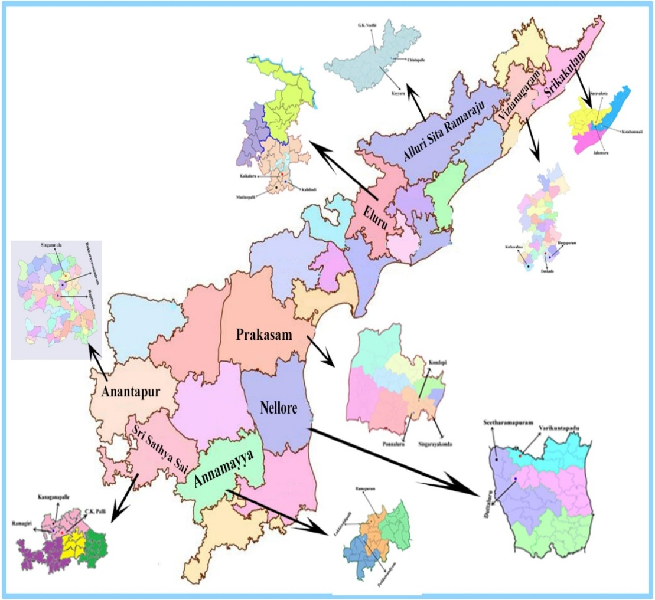

The researcher met with farmers face-to-face, guiding them through a structured interview to gather data on their socio-economic backgrounds. Following the collection and analysis of the responses, statistical procedures such as frequency, percentage, mean, standard deviation, one-way ANOVA and the Tukey HSD post hoc test were used to categorize the respondents. Ordinal variables were assigned numerical scores (for example, low = 1, medium = 2, high = 3) for analysis of variance (ANOVA) and frequencies were reported to provide additional context. Chi-square tests were used to assess categorical differences when applicable.
Results:
Table 1 demonstrates that the profile characteristics of dairy (n=180), sheep/goat (n=180) and backyard poultry farmers (n=180) differ significantly across personal and socio-economic aspects. The majority of farmers across all livestock types are middle-aged with the most in backyard poultry (68.33%) then sheep/goat (59.44%) and then dairy (55.56%). Young and older farmers are most common in dairy (21.11% young; 23.33% old), less common in sheep or goats (19.44% young; 21.11% old) and least common in backyard poultry (15.56% young; 16.11% old). The gender distribution showed high male dominance among dairy farmers (75.6%) and sheep/goat farmers (76.7%). In contrast, backyard poultry farming had a more balanced gender ratio with 36.7 per cent of respondents being female. Regarding education, all categories showed complete literacy. However, dairy farmers had the highest percentage of people with secondary education (48.3%), followed by those involved in sheep/goat farming (36.1%) and backyard poultry (35.6%). Notably, sheep/goat farmers accounted for the largest share of graduates, comprising 23.9 per cent.
Table 1: Comparison of Personal and Socio-economic characteristics of Dairy, Sheep/Goat and Backyard poultry farmers
S.no. | Category | Dairy Farmers |  | Sheep/Goat Farmers |  | Backyard Poultry Farmers
S.no. | Category | Frequency (N = 180) | Percentage | Frequency (N = 180) | Percentage | Frequency (N = 180) | Percentage
1. | Age
1. | Young | 38 | 21.11 | 35 | 19.44 | 28 | 15.56
1. | Middle | 100 | 55.56 | 107 | 59.44 | 123 | 68.33
1. | Old | 42 | 23.33 | 38 | 21.11 | 29 | 16.11
2. | Gender
2. | Male | 136 | 75.56 | 138 | 76.66 | 114 | 63.33
2. | Female | 44 | 24.44 | 42 | 23.37 | 66 | 36.67
3. | Education
3. | Primary school | 31 | 17.22 | 45 | 25.00 | 42 | 23.33
3. | Secondary school | 87 | 48.34 | 65 | 36.11 | 64 | 35.56
3. | Intermediate | 31 | 17.22 | 27 | 15.00 | 41 | 22.78
3. | Graduate and above | 31 | 17.22 | 43 | 23.89 | 33 | 18.33
4. | Social status
4. | OC | 75 | 41.67 | 41 | 22.78 | 30 | 16.67
4. | BC | 73 | 40.56 | 95 | 52.78 | 93 | 51.67
4. | SC | 11 | 6.11 | 24 | 13.33 | 33 | 18.33
4. | ST | 21 | 11.67 | 20 | 11.11 | 24 | 13.33
5. | Family size
5. | Small | 35 | 19.44 | 41 | 22.78 | 60 | 33.33
5. | Medium | 131 | 72.78 | 126 | 70.00 | 103 | 57.22
5. | Large | 14 | 7.78 | 13 | 7.22 | 17 | 9.44
6. | Landholding
6. | Landless/Agricultural labourers | 20 | 11.11 | 16 | 8.89 | 12 | 6.67
6. | Marginal (< 2.5 acres) | 23 | 12.78 | 40 | 22.22 | 46 | 25.56
6. | Small (2.5 - 5 acres) | 91 | 50.56 | 52 | 28.89 | 82 | 45.56
6. | Medium (5 - 10 acres) | 39 | 21.67 | 57 | 31.67 | 34 | 18.89
6. | Large (> 10 acres) | 7 | 3.89 | 15 | 8.33 | 6 | 3.33
7. | Experience in livestock farming (years)
7. | Less than 5 years | 9 | 5.00 | 32 | 17.78 | 9 | 5.00
7. | 5 – 10 years | 87 | 48.33 | 55 | 30.56 | 82 | 45.56
7. | 11–15 years | 27 | 15.00 | 47 | 26.11 | 37 | 20.56
7. | More than 15 years | 57 | 31.67 | 46 | 25.56 | 52 | 28.89
8. | Herd size
8. | Small (1 – 2) | 2 | 1.11 | 74 | 41.11 | 66 | 36.67
8. | Medium (3 - 6) | 137 | 76.11 | 73 | 40.56 | 90 | 50.00
8. | Large (>7) | 41 | 22.78 | 33 | 18.33 | 24 | 13.33
9. | Material possession
9. | Low | 64 | 35.56 | 71 | 39.44 | 21 | 11.67
9. | Medium | 75 | 41.67 | 88 | 48.89 | 127 | 70.56
9. | High | 41 | 22.78 | 21 | 11.67 | 32 | 17.78
10. | Annual Income
10. | Low | 17 | 9.44 | 36 | 20.00 | 12 | 6.67
10. | Medium | 122 | 67.78 | 103 | 57.22 | 146 | 81.11
10. | High | 41 | 22.78 | 41 | 22.78 | 22 | 12.22
11. | Achievement motivation
11. | Low | 52 | 28.89 | 34 | 18.89 | 48 | 26.67
11. | Medium | 81 | 45.00 | 103 | 57.22 | 97 | 53.89
11. | High | 47 | 26.11 | 43 | 23.89 | 35 | 19.44
12. | Social media exposure
12. | Low | 48 | 26.67 | 44 | 24.44 | 52 | 28.89
12. | Medium | 74 | 41.11 | 80 | 44.44 | 66 | 36.67
12. | High | 58 | 32.22 | 56 | 31.11 | 62 | 34.44
13. | Information seeking behaviour
13. | Low | 38 | 21.11 | 31 | 17.22 | 28 | 15.56
13. | Medium | 95 | 52.78 | 114 | 63.33 | 112 | 62.22
13. | High | 47 | 26.11 | 35 | 19.44 | 40 | 22.22
14. | Scientific orientation
14. | Low | 23 | 12.78 | 22 | 12.22 | 29 | 16.11
14. | Medium | 110 | 61.11 | 118 | 65.56 | 103 | 57.22
14. | High | 47 | 26.11 | 40 | 22.22 | 48 | 26.67
15. | Market orientation
15. | Low | 42 | 23.33 | 47 | 26.11 | 49 | 27.22
15. | Medium | 76 | 42.22 | 82 | 45.56 | 86 | 47.78
15. | High | 62 | 34.44 | 51 | 28.33 | 45 | 25.00
16. | Economic motivation
16. | Low | 20 | 11.11 | 46 | 25.56 | 30 | 16.67
16. | Medium | 119 | 66.11 | 100 | 55.56 | 108 | 60.00
16. | High | 41 | 22.78 | 34 | 18.89 | 42 | 23.33
17. | Credibility
17. | Low | 41 | 22.78 | 33 | 18.33 | 51 | 28.33
17. | Medium | 79 | 43.89 | 107 | 59.44 | 88 | 48.89
17. | High | 60 | 33.33 | 40 | 22.22 | 41 | 22.78

Social status showed notable differences: the majority (41.7%) of dairy farmers were from OC, whereas sheep/goat and backyard poultry farmers were mostly from backward castes (52.8% and 51.7%, respectively). Scheduled caste involvement was highest among backyard poultry farmers (18.3%). The majority of families were medium-sized across livestock categories (70–73%), although backyard poultry farmers had a higher percentage of small families (33.3%) than dairy (19.4%) and sheep/goat farmers (22.8%). Landholding patterns indicate that dairy farmers are predominantly concentrated in small holdings (2.5–5 acres: 50.6%) and a similar trend is also observed among backyard poultry farmers (45.6%). In contrast, sheep/goat farmers are more frequently represented in medium (5–10 acres: 31.7%) and large (>10 acres: 8.3%) landholding categories. Experience levels in livestock farming were similar among dairy and backyard poultry with nearly half (45.6–48.3%) having 5 to 10 years of experience. In contrast, 17.8 per cent of sheep/goat farmers had less than five years of experience. Herd sizes exhibited considerable variation. The majority of dairy farmers maintained medium-sized herds of 3 to 6 animals (76.1%). In contrast, small herds of 1 to 2 animals were more prevalent among sheep/goat farmers (41.1%) and backyard poultry farmers (36.7%).
Backyard poultry farmers exhibited the most favourable material possession and annual income levels with 70.6 per cent classified in the medium possession category and 81.1 per cent in the medium income bracket. Dairy farmers ranked next, whereas sheep/goat farmers accounted for the highest proportion in the low-income category (20.0%). The psychological attributes of achievement motivation, scientific orientation, information seeking, economic motivation, market orientation and credibility showed moderate similarity across groups. Minor variations were observed with dairy farmers showing slightly higher levels of market orientation (34.4%) and credibility (33.3%). Backyard poultry farming is typically linked to more gender-inclusive, smaller-scale operations. In contrast, dairy farming is associated with larger enterprises and higher caste and education backgrounds while sheep/goat farming is more common among older farmers and those with diverse land holdings.
Table 2 shows that one-way ANOVA revealed significant differences among farmer categories in personal and socio-economic variables. Specifically, gender (F = 9.366, p < 0.001), education (F = 6.266, p < 0.01), social status (F = 13.790, p < 0.001) and family size (F = 11.115, p < 0.001) showed notable variations among dairy, sheep/goat and backyard poultry farmers. Age (F = 1.260, p > 0.05) did not differ significantly, suggesting a similar age distribution among the three farmer categories.
Table 2: One-way ANOVA test results for personal and socio-economic variables

S.no | Variable | F- value | P – value | Significance
1. | Age | 1.260 | 0.2844 | Not significant
2. | Gender | 9.366 | 0.0001003 | Significant
3. | Education | 6.266 | 0.00204 | Significant
4. | Social status | 13.790 | 1.444e-06 | Significant
5. | Family size | 11.115 | 1.862e-05 | Significant
6. | Land holding | 19.175 | 9.039e-09 | Significant
7. | Experience in livestock farming (years) | 14.841 | 5.324e-07 | Significant
8. | Herd size | 21.712 | 8.559e-10 | Significant
9. | Material possession | 8.379 | 0.0002609 | Significant
10. | Annual income | 65.975 | 2.397e-26 | Significant
11. | Achievement motivation | 0.589 | 0.554 | Not significant
12. | Social media exposure | 2.326 | 0.0986 | Not significant
13. | Information Seeking Behaviour | 8.447 | 0.0002442 | Significant
14. | Scientific orientation | 7.531 | 0.0005946 | Significant
15. | Market orientation | 2.072 | 0.126 | Not significant
16. | Economic motivation | 0.697 | 0.498 | Not significant
17. | Credibility | 3.7461 | 0.02423 | Significant

Key variables like landholding (F = 19.175, p < 0.001), livestock farming experience (F = 14.841, p < 0.001), herd size (F = 21.712, p < 0.001), material possession (F = 8.379, p < 0.001) and especially annual income (F = 65.975, p < 0.001) all showed strikingly significant differences. The notably high F-value for annual income points to pronounced economic gaps among the three farming categories. Information seeking behaviour (F = 8.447, p < 0.001), scientific orientation (F = 7.531, p < 0.001) and credibility (F = 3.746, p < 0.05) varied significantly across farmer groups. In contrast, achievement motivation (F = 0.589, p > 0.05), social media exposure (F = 2.326, p > 0.05), market orientation (F = 2.072, p > 0.05) and economic motivation (F = 0.697, p > 0.05) showed no significant difference, indicating these variables remained consistent across the three livestock farming categories.
The results of the Tukey HSD post-hoc test indicate significant personal and socio-economic differences among dairy, backyard poultry and sheep/goat farmers with the most pronounced distinctions observed between dairy farmers and the other groups. These variables included gender (p < 0.001), education (p < 0.01), social status (p < 0.001), family size (p < 0.001), land holding (p < 0.001), farming experience (p < 0.001), herd size (p < 0.001), material possession (p < 0.05) and annual income (p < 0.05).
Table 3: Tukey HSD post-hoc test results (Pairwise Comparisons)
S.no | Variable | Group 1 | Group 2 | Mean Difference | p-adjusted | Lower CI | Upper CI | Significance
1. | Age | Dairy | Backyard poultry | 1.760 | 0.286 | -0.978 | 4.498 | Not significant
1. | Age | Dairy | Sheep/Goat | 0.387 | 0.940 | -2.350 | 3.125 | Not significant
1. | Age | Backyard poultry | Sheep/Goat | -1.372 | 0.466 | -4.110 | 1.365 | Not significant
2. | Gender | Dairy | Backyard poultry | -4.472 | 0.0007 | -7.319 | -1.625 | Significant
2. | Gender | Dairy | Sheep/Goat | -4.605 | 0.0005 | -7.452 | -1.758 | Significant
2. | Gender | Backyard poultry | Sheep/Goat | -0.133 | 0.993 | -2.980 | 2.713 | Not significant
3. | Education | Dairy | Backyard poultry | -2.119 | 0.006 | -3.734 | -0.505 | Significant
3. | Education | Dairy | Sheep/Goat | -2.092 | 0.0069 | -3.706 | -0.477 | Significant
3. | Education | Backyard poultry | Sheep/Goat | 0.027 | 0.999 | -1.586 | 1.642 | Not significant
4. | Social status | Dairy | Backyard poultry | -3.994 | 0.0 | -6.102 | -1.886 | Significant
4. | Social status | Dairy | Sheep/Goat | -4.161 | 0.0 | -6.269 | -2.052 | Significant
4. | Social status | Backyard poultry | Sheep/Goat | -0.166 | 0.981 | -2.275 | 1.941 | Not significant
5. | Family size | Dairy | Backyard poultry | -4.588 | 0.0001 | -7.206 | -1.971 | Significant
5. | Family size | Dairy | Sheep/Goat | -4.505 | 0.0002 | -7.123 | -1.888 | Significant
5. | Family size | Backyard poultry | Sheep/Goat | 0.0833 | 0.996 | -2.534 | 2.7009 | Not significant
6. | Land holding | Dairy | Backyard poultry | -4.455 | 0.0 | -6.363 | -2.547 | Significant
6. | Land holding | Dairy | Sheep/Goat | -4.244 | 0.0 | -6.152 | -2.336 | Significant
6. | Land holding | Backyard poultry | Sheep/Goat | 0.211 | 0.963 | -1.696 | 2.119 | Not significant
7. | Experience in livestock farming (years) | Dairy | Backyard poultry | -4.694 | 0.0 | -7.163 | -2.225 | Significant
7. | Experience in livestock farming (years) | Dairy | Sheep/Goat | -5.183 | 0.0 | -7.652 | -2.714 | Significant
7. | Experience in livestock farming (years) | Backyard poultry | Sheep/Goat | -0.486 | 0.887 | -2.958 | 1.9802 | Not significant
8. | Herd size | Dairy | Backyard poultry | -3.769 | 0.0 | -5.216 | -2.322 | Significant
8. | Herd size | Dairy | Sheep/Goat | -3.183 | 0.0 | -4.630 | -1.736 | Significant
8. | Herd size | Backyard poultry | Sheep/Goat | 0.585 | 0.607 | -0.861 | 2.0328 | Not significant
9. | Material possession | Dairy | Backyard poultry | -2.121 | 0.0002 | -3.359 | -0.882 | Significant
9. | Material possession | Dairy | Sheep/Goat | -1.403 | 0.0218 | -2.641 | -0.164 | Significant
9. | Material possession | Backyard poultry | Sheep/Goat | 0.717 | 0.361 | -0.520 | 1.956 | Not significant
10. | Annual income | Dairy | Backyard poultry | -190345.769 | 0.0 | -243431.788 | -1.37259.751 | Significant
10. | Annual income | Dairy | Sheep/Goat | 57527.368 | 0.0299 | 4441.349 | 110613.386 | Significant
10. | Annual income | Backyard poultry | Sheep/Goat | 247873.137 | 0.0 | 194787.119 | 300959.156 | Significant
11. | Achievement motivation | Dairy | Backyard poultry | -0.457 | 0.566 | -1.513 | 0.599 | Not significant
11. | Achievement motivation | Dairy | Sheep/Goat | -0.376 | 0.679 | -1.433 | 0.679 | Not significant
11. | Achievement motivation | Backyard poultry | Sheep/Goat | 0.0802 | 0.982 | -0.976 | 1.136 | Not significant
12. | Social media exposure | Dairy | Backyard poultry | -0.895 | 0.268 | -2.253 | 0.462 | Not significant
12. | Social media exposure | Dairy | Sheep/Goat | 0.303 | 0.859 | -1.054 | 1.661 | Not significant
12. | Social media exposure | Backyard poultry | Sheep/Goat | 1.198 | 0.096 | -0.159 | 2.557 | Not significant
13. | Information seeking behaviour | Dairy | Backyard poultry | -0.126 | 0.944 | -1.051 | 0.798 | Not significant
13. | Information seeking behaviour | Dairy | Sheep/Goat | 1.335 | 0.0022 | 0.408 | 2.258 | Significant
13. | Information seeking behaviour | Backyard poultry | Sheep/Goat | 1.459 | 0.0007 | 0.534 | 2.384 | Significant
14. | Scientific orientation | Dairy | Backyard poultry | 0.285 | 0.706 | -0.558 | 1.13 | Not significant
14. | Scientific orientation | Dairy | Sheep/Goat | 1.324 | 0.0007 | 0.4804 | 2.168 | Significant
14. | Scientific orientation | Backyard poultry | Sheep/Goat | 1.038 | 0.0111 | 0.194 | 1.883 | Significant
15. | Market orientation | Dairy | Backyard poultry | 0.1127 | 0.9714 | -1.0418 | 1.267 | Not significant
15. | Market orientation | Dairy | Sheep/Goat | 0.917 | 0.1494 | -0.237 | 2.071 | Not significant
15. | Market orientation | Backyard poultry | Sheep/Goat | 0.8043 | 0.2309 | -0.350 | 1.958 | Not significant
16. | Economic motivation | Dairy | Backyard poultry | 0.191 | 0.848 | -0.632 | 1.015 | Not significant
16. | Economic motivation | Dairy | Sheep/Goat | 0.413 | 0.465 | -0.410 | 1.237 | Not significant
16. | Economic motivation | Backyard poultry | Sheep/Goat | 0.222 | 0.801 | -0.601 | 1.046 | Not significant
17. | Credibility | Dairy | Backyard poultry | -0.802 | 0.223 | -1.938 | 0.334 | Not significant
17. | Credibility | Dairy | Sheep/Goat | 0.510 | 0.541 | -0.625 | 1.647 | Not significant
17. | Credibility | Backyard poultry | Sheep/Goat | 1.313 | 0.018 | 0.176 | 2.449 | Significant

The mean differences varied according to the specific variable and coding scheme. Nevertheless, dairy farmers consistently demonstrated higher scores in socio-economic indicators including herd size, landholding, income and material possessions. Conversely, backyard poultry and sheep/goat farmers showed no significant differences in any socio-economic variables, highlighting their similarities. The analysis of psychological and behavioural variables revealed a mixed pattern. There were no significant differences in social media exposure, achievement motivation, information seeking behaviour (with the exception of sheep/goat farmers, as they stand out well above both dairy and backyard poultry farmers while the latter two groups remain on equal footing), economic motivation and market orientation across the groups.
Fig. 2: Heatmap of Pairwise Significance (p-adjusted)
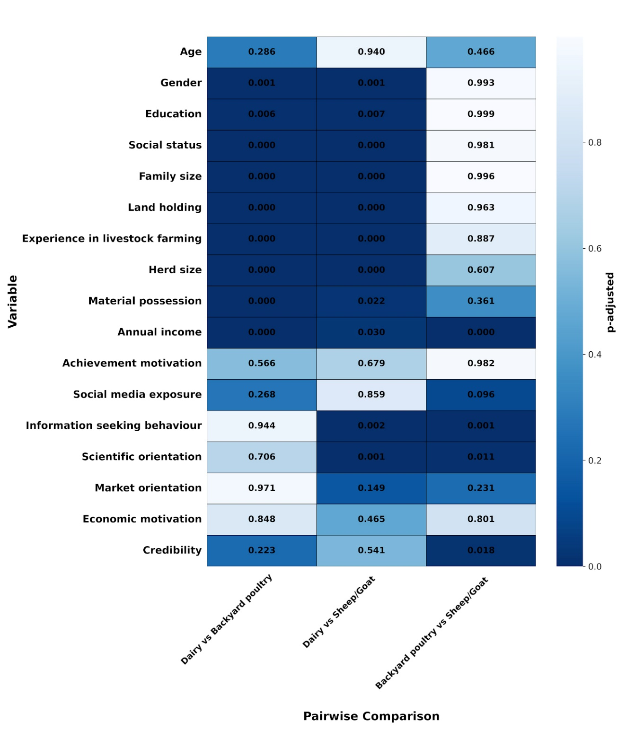
Sheep/goat farmers demonstrated significantly higher levels of scientific orientation (p < 0.01), information-seeking behaviour (p < 0.01) and credibility (p < 0.05) than both dairy and backyard poultry farmers. No significant differences were observed between the dairy and backyard poultry groups. These findings indicate that dairy farming tends to attract farmers with higher socio-economic status while sheep/goat farming is linked to greater scientific and informational engagement. This insight can help guide targeted extension strategies in livestock categories.
Discussion:
Comparison of personal and socio-economic profiles of dairy, sheep/goat and backyard poultry farmers: A comparative assessment of personal and socio-economic characteristics reveals distinct patterns across livestock categories. Since it involves minimal capital and risk, backyard poultry farming attracts mostly middle-aged people. Dairy farming, driven by higher investment and family succession, spans evenly over all ages. Between these extremes is sheep/goat farming. Men largely led the dairy and sheep/goat sectors but backyard poultry stood out as a space where women thrived, especially in areas with limited resources. Nearly everyone could read and write, yet dairy farmers often had higher levels of education and social status and managed intensive small landholdings. The outcomes of this study are consistent with the results of Shubham et al., (2024).
On the other hand, most sheep/goat and backyard poultry farmers were from backward castes and had varied land holdings. In contrast, dairy farmers typically managed medium-sized herds and were often more experienced whereas sheep/goat farmers were mostly newer to the field and managed smaller herds. Backyard poultry farmers demonstrated greater economic stability with medium income and material possessions, surpassing the lower economic indicators observed in sheep/goat farming. This trend echoes findings of Sahoo and Panigrahi, (2017); Mandi et al., (2022); Singh et al., (2009). Sheep/goat farmers were primarily landless or marginal, characterized by low incomes, small herd sizes and a predominance of individuals from backward castes Kumar et al., (2011); Mohan et al., (2012) and more women take part in backyard poultry farming than in dairy or sheep/goat farming which shows that backyard poultry farming is more inclusive for women and had a moderate socio-economic status and provided accessible opportunities for poorer families Chaturvedani et al., (2017); Choudhary et al., (2025).
One-way ANOVA test results for personal and socio-economic variables: The test revealed striking differences in personal and socio-economic variables across the three categories of livestock farmers, highlighting the diversity of livestock production systems. Significant variation in variables related to media ownership, farming experience, herd size and income reflects enterprise-specific structural differences. The results of this investigation align completely with those of Patil et al., (2019); Rathod et al., (2018). In contrast, the absence of significant differences in economic motivation, achievement motivation and market orientation indicates that farmers share similar aspirations regardless of livestock category. These results are consistent with previous findings reported by Meena et al., (2012).
Tukey HSD post-hoc test (pairwise comparisons): The Tukey HSD analysis revealed that dairy farmers differed significantly from sheep/goat and backyard poultry groups across socio-economic variables. Dairy farmers exhibited higher levels in gender representation, educational attainment, family size, social status, farming experience, herd size, landholding, material possessions and annual income. Although backyard poultry and sheep or goat farmers exhibited similarities across several socio-economic variables, they demonstrated significant differences in annual income, scientific orientation, information-seeking behavior and credibility. These findings were in concurrent with those of Singh et al., (2019); Yadav et al., (2018).
There were no differences between dairy and backyard poultry farmers. This suggests that sheep/goat farming may encourage greater engagement with extension services and new scientific practices due to its broad scope. These pairwise insights pave the way for targeted extension strategies, such as tailoring programs to close socio-economic gaps for sheep/goat and backyard poultry farmers and harnessing their unique strengths to enhance knowledge dissemination. These differences show how important it is to have sector-specific policies that support dairy farming growth in a fair way. Such policies should guarantee that resource-intensive dairy farming does not outcompete more inclusive, low-input systems such as backyard poultry farming. These results were in line with the outcomes of Khode et al., (2009); Manivannan et al., (2011); Rewani et al., (2023).
Conclusion:
The study finds significant differences in the socio-economic characteristics of livestock farming systems, highlighting diversity among dairy, sheep/goat and backyard poultry systems. Dairy farming is primarily associated with higher socio-economic status, greater educational attainment, larger herd sizes, larger landholdings and higher income levels, reflecting its commercial and capital-intensive nature. In contrast, sheep/goat farming is primarily undertaken by farmers with lower incomes, especially from backward castes who have smaller herds and diverse landholdings. Despite these challenges, they stand out for their keen scientific orientation, information-seeking behaviour and strong credibility. Backyard poultry farming is characterized by greater gender inclusivity, evidenced by substantial female participation, as well as smaller family and herd sizes.
Additionally, these farmers exhibit comparatively favourable medium-level income and material possession profiles which underscores the accessibility of backyard poultry as a supplementary, low-input intensive livelihood option and has relative income stability rather than higher economic status. The results from ANOVA and Tukey HSD post hoc analyses show clear differences, highlighting the need for development and extension strategies tailored to specific livestock types. Although farmers across various categories exhibit comparable levels of motivation, market orientation and social media exposure, structural and economic disparities require targeted interventions. Enhancing access to resources and income opportunities for sheep/goat and backyard poultry farmers, alongside promoting equitable and sustainable growth in dairy farming, can contribute to the comprehensive development of the livestock sector. The findings highlight the need for tailored policies and extension approaches that address the unique strengths and constraints of each livestock category to support inclusive and balanced rural livelihoods.

COMPETING INTERESTS DISCLAIMER:
Authors have declared that they have no known competing financial interests, non-financial interests or personal relationships that could have appeared to influence the work reported in this paper.
References:
- CGIAR Initiative on Digital Innovation. (2024). CGIAR Research Initiative on Digital Innovation: Annual technical report 2024. CGIAR System Organization. https://hdl.handle.net/10568/174261
- Chaturvedani, A. K., Lal, N., Pratap, J. and Khyalia, N. K. (2017). Socio-economic status of tribal backyard poultry rearers in Bastar district of Chhattisgarh. Indian Research Journal of Extension Education, 17(2), 45-50. https://journals.acspublisher.com/index.php/ijee/article/view/5060
- Choudhary, K., Shruti, Singh, M. and Verma, H. (2025). Cornell-based insights: Analyzing farmers' attitudes towards scientific backyard poultry farming using the Guttman scale. Indian Journal of Extension Education, 61(3), 92-96. https://doi.org/10.48165/IJEE.2025.613RT02
- Data Reportal. (2025). Digital 2025: India. Kepios Analysis in partnership with We Are Social and Meltwater. https://datareportal.com/reports/digital-2025-india.
- Department of Animal Husbandry & Dairying (DAHD), Govt. of India (2023). Annual report 2022–23. Ministry of Fisheries, Animal Husbandry and Dairying, Government of India. https://www.dahd.gov.in/node/48
- Digital India. (2024). Digital India programme overview. Ministry of Electronics and Information Technology, Government of India. https://www.digitalindia.gov.in/about-us/
- Khode, N., Sawant, M. N. and Thorat, V. S. (2009). Typology of milk producing households in Maharashtra: Explaining use of animal husbandry practices and dairy herd productivity. Indian Research Journal of Extension Education, 9(2), 80–84. https://seea.org.in/indian-research-journal-of-extension-education/
- Kumar, S., Singh, S.R.K. and Singh, R.P. (2011). Socio-economic status of goat farmers in eastern plain zone of Uttar Pradesh. Indian Research Journal of Extension Education, 11(1), 85-88. https://seea.org.in/indian-research-journal-of-extension-education/
- Mandi, K., Chakravarty, R., Ponnusamy, K., Kadian, K. S., Dixit, A. K., Singh, M. and Misra, A. K. (2022). Impact of Jharkhand State Cooperative Milk Producers’ Federation on socio-economic status of dairy farmers. Indian Journal of Extension Education, 58(2), 47-52. https://doi.org/10.48165/IJEE.2022.58211
- Manivannan, C., Vasanthakumar, J. and Prabakaran, R. (2011). Differences in management efficiency among dairy farmers in urban, peri-urban and rural areas. Indian Research Journal of Extension Education, 11(3), 54–58. https://seea.org.in/indian-research-journal-of-extension-education/
- Meena, M. S., Singh, K. M. and Malik, B. S. (2012). Socio-economic and communication characteristics of livestock farmers. Indian Journal of Extension Education, 48(3&4), 35–40. https://seea.org.in/indian-journal-of-extension-education/
- Mohan, B., Singh, K. and Dixit, A.K. (2012). Socio-economic status of goat farmers in semi-arid zone of Uttar Pradesh. Indian Research Journal of Extension Education, 12(2), 128-131. https://seea.org.in/indian-research-journal-of-extension-education/
- Nayak, A. S., Mallampati, S. R., Satyanarayana, C. H., Rajanna, N., Nagalakshmi, D., Vijay, K. and Rani, M. S. (2025). Socio personal and psychological profile of tribal livestock farmers of Telangana state. International Journal of Agriculture Extension and Social Development, 8(5), 280–285. https://www.extensionjournal.com/archives/2025/8/5
- Pandey, M. and Mazhar, S. H. (2023). Knowledge and attitude regarding social media as a source of information among farmers of district Kota, Rajasthan. Asian Journal of Agricultural Extension, Economics & Sociology, 41(7), 94–101. https://doi.org/10.9734/ajaees/2023/v41i71952
- Pasare, G., Waghmare, P. G., Patil, V. M., Biradar, S. C., Rathod, P. and Dodamani, S. (2022). Socio-economic status of farmers maintaining indigenous cattle in Bidar district of Karnataka State. The Pharma Innovation Journal, SP-11(9), 1927–1929.
- Patel, P. K. and Mallappa, V. K. H. (2022). Predictive factors for farmers’ knowledge of social media for sustainable agricultural development. Indian Journal of Extension Education, 58(4), 55-59. https://doi.org/10.22271/tpi.2022.v11.i9S.15058
- Patil, A. P., Burte, R. R. and Kharde, P. B. (2019). Personal, socio-economic and psychological characteristics of goat farmers in Western Maharashtra. Indian Research Journal of Extension Education, 19(2–3), 67–71. https://seea.org.in/indian-research-journal-of-extension-education/
- Prajapati, N. K., Khare, N. K. and Jaiswal, D. (2022). Socio-economic and psychological profile of farmers with reference to smart agricultural practices (SAPs) of Jabalpur district, Madhya Pradesh. The Pharma Innovation Journal, SP-11(3), 818–821. https://doi.org/10.22271/tpi.2022.v11.i3S.11092
- Rajadurai, A., Rajamanickam, K. and Kumeravelu, N. (2020). Socio-economic profile of the dairy farmers in Villupuram district of Tamil Nadu. Journal of Entomology and Zoology Studies, 8(2), 128–130. https://www.entomoljournal.com/archives/2020/vol8issue2/PartC/8-2-22-428.pdf
- Rathod, P., Nikam, T. R., Landge, S. and Hatey, A. (2018). A comparative study on socio-economic status and constraints of dairy farmers. Indian Research Journal of Extension Education, 18(1), 77–81. https://seea.org.in/indian-research-journal-of-extension-education/
- Rewani, S.K., Singh, S., Singh, N. and Singh, D. (2023). Adoption of improved small ruminant practices among tribal farmers: A zonal analysis. Indian Research Journal of Extension Education, 23(1), 45-50. https://seea.org.in/indian-research-journal-of-extension-education/
- Roy, M. L., Chandra, N., Mukherjee, A., Jethi, R. and Joshi, K. (2018). Extent of use of ICT tools by hill farmers and associated social factors. Indian Research Journal of Extension Education, 18(3), 27-31. https://seea.org.in/indian-research-journal-of-extension-education/
- Sahoo, S. K. and Panigrahi, S. (2017). Material possession and entrepreneurial behaviour of livestock farmers in Eastern India. Indian Research Journal of Extension Education, 17(2), 45–49. https://seea.org.in/indian-research-journal-of-extension-education/
- Seevagan, M., Ravimurugan, T., Karthickeyan, S. M. K., Thamil Vanan, T., Anna, T., Rajendran, R., Gopu, P. and Karuthadurai, T. (2025). Socio-economic profile of Pallai Adu goat farmers in the southern districts of Tamil Nadu. International Journal of Veterinary Sciences and Animal Husbandry, 10(1), 32–34. https://www.veterinarypaper.com/archives/2025/10/1
- Sharma, N. R., Khare, N. K., Singh, P. K. and Bisht, K. (2022). Socio personal and economic traits of tribal FIGs of farmer producer company. The Pharma Innovation Journal, SP-11(3), 1123–1125. https://doi.org/10.22271/tpi.2022.v11.i3S.11394
- Shubham, Sharma, R., Sharma, S., Bishist, R. and Shilpa. (2024). Socio-economic status and constraints faced by dairy farmers of Kangra District, Himachal Pradesh. Indian Journal of Dairy Science, 77(2), 155–161. https://epubs.icar.org.in/index.php/IJDS
- Singh, D., Singh, N. and Singh, S. (2009). Socio-economic determinants of dairy farmers' knowledge on dairy farming practices in Uttar Pradesh. Indian Research Journal of Extension Education, 9(3), 75-80. https://seea.org.in/indian-research-journal-of-extension-education/
- Singh, R. and Gupta, J. (2020). Role of backyard poultry farming in enhancing rural livelihoods. Indian Journal of Extension Education, 56(1), 45–50. https://seea.org.in/indian-journal-of-extension-education/
- Singh, M. K., Kumar, A. and Bharati, S. (2019). Socio-economic dynamics and technological needs of sheep/goat farmers in Bihar. Indian Research Journal of Extension Education, 19(4), 112–116. https://seea.org.in/indian-research-journal-of-extension-education/
- Yadav, V., Lata, K. and Singh, A. (2018). Credibility of information sources among livestock farmers in Haryana. Indian Research Journal of Extension Education, 18(4), 88–92. https://seea.org.in/indian-research-journal-of-extension-education/

