Evaluation of Integrated Nutrient Management Practice for Tomato (Solanum lycopersicum) Production under Greenhouse Conditions

.
ABSTRACT

Understanding integrated nutrient management is crucial for promoting the production of crops, including tomatoes, while minimizing the harsh effects of chemical fertilizers on soil health as well as humans. To evaluate the effects of different combinations of organic and inorganic fertilizers, including farmyard manure (FYM), vermicompost, and compost, and their combinations on tomato growth and yield, a randomized complete block design experiment was conducted in a plastic tunnel of Lamjung Campus, Institute of Agriculture and Animal Science, Tribhuvan University, Nepal, in 2023. In this study, the morphological parameters, such as height and diameter of the plants, were observed at 15, 30, 45, and 60 days after transplanting (DAT). Furthermore, the flowers per bunch were counted at sixty DAT, and finally, yield was measured. The result revealed that there was no significant difference in height of plants among different treatments. The number of flowers per bunch (p-value = 0.028) and stem diameter at 60 DAT (p-value = 0.019) were found to be higher when the combination of ½ recommended chemical fertilizer and ½ farmyard manure (FYM, 25 t/ha) was applied. Simultaneously, yield was significantly higher in the same treatment (p-value <0.0001). Instead of applying organic or inorganic fertilizers individually, the integrated approach was found to be more promising, particularly the combination of chemical fertilizers with FYM.

Keywords: Integrated nutrient management, organic and inorganic fertilizers, farmyard manure, vermicompost,

1. INTRODUCTION

Tomatoes (Solanum lycopersicum) are one of the most grown vegetables in Nepal. It is cultivated as a subsistence and commercial crop in an area of 22,911 hectares with 422,703 metric tons of production (MOALD, 2023). Tomatoes not only hold economic importance but are also a beneficial source of vitamins, minerals, phenolic compounds, and antioxidants, thereby serving nutritional purposes (Collins et al. 2022; Kakabouki et al. 2022). To extend its production from seasonal to year-round, greenhouse technology plays an important role by protecting the crop from extreme climatic conditions, pests, and disease, and maintaining the steady supply of high-quality tomatoes when the market demand is high (Bhandari et al. 2016). As an off-season production, the ‘Srijana’ variety of tomato is widely popular and mostly cultivated due to its superior taste, tolerance to bacterial wilt, and higher yield potential (Thapa et al. 2016).
As tomatoes are a heavy nutrient feeding crop, their morphological and physiological growth can be significantly influenced by nutrient management practices. For instance, excessive supply of nutrients results in unnecessary biomass production, while insufficiency affects the growth and development of plants, both impacting production and profit to farmers. The nutrient demand is met either through inorganic fertilizers or organic fertilizers such as compost, farmyard manure (FYM), or vermicompost. The demand of inorganic fertilizers is comparatively higher, which is evidenced by the annual sales of 342,723 metric tons of synthetic fertilizers including urea, DAP, and potash in 2022/23 (Government of Nepal, 2024). Undue application of chemical fertilizers alters soil properties such as soil pH and electrical conductivity and impair microbial diversity, ultimately declining yield over years (Kai et al. 2020; Song et al. 2022; Tadesse et al. 2013). Moreover, it imposes environmental threats such as nutrient leaching, groundwater pollution, eutrophication, and greenhouse gas emissions (Gao et al. 2023; Amirahmadi et al. 2023). At the same time, it deteriorates human health by lowering the food quality; for instance, it results in the excessive accumulation of nitrate in food, which is lethal to humans (Amirahmadi et al. 2023).
One approach to mitigate the adverse effect of inorganic fertilizer without compromising the yield is blending organic and inorganic fertilizers, i.e., integrated nutrient management. With the application of organic fertilizer, soil organic matter content increases, improving soil structure (Cen et al. 2020; Fan et al. 2023). Furthermore, this supports aeration, proper drainage, and root elongation, which promotes the water and nutrient absorption of plants. This system of nutrient management has not only improved soil health, leading to sustainable production but also increased the yield (Beeby et al. 2020; Gao et al. 2023; Tadesse et al. 2013; Khan et al. 2010; Yadav et al. 2024).
Several studies have been conducted to assess the influence of organic and inorganic fertilizers on tomato production. However, there occurs spatial variation in the research outcome due to differences in climate and soil properties. Thus, we aimed to evaluate the effects of inorganic and organic fertilizers and their integrated management on the growth and yield of tomatoes, in the context of the mid hills of Nepal, particularly the Lamjung district.

2. material and methods

2.1. Experimental details

This experiment was conducted in the Lamjung Campus, Institute of Agriculture and Animal Science at Lamjung district of Nepal, which is located at an altitude of 625 masl (longitude: 84˚ 12 ̍ 35 ̍ ̍ E and latitude: 28˚ 21 ̍ 35 ̍ ̍ N). The research experiment was carried out in a randomized complete block design (RCBD) with eight treatments with three replications. To assess the initial nutrient status, pH, and organic matter content of the research field, a composite soil sample was taken and analyzed in Soil and Fertilizer Testing Laboratory, Pokhara. The details of treatment are mentioned in Table 1 whereas the soil results are illustrated in Table 2.
Table 1. Details of treatments
Treatment | Fertilizer application
T1 | Recommended dose of Chemical Fertilizer (200:180:80 NPK kg/ha)
T2 | ½ Recommended Chemical Fertilizer + ½ FYM 25 t/ha
T3 | ½ Recommended Chemical Fertilizer + ½ Vermicompost 5 t/ha
T4 | ½ Recommended Chemical Fertilizer + ½ Compost 6 t/ha
T5 | Farmyard Manure (FYM) 25 t/ha (0.5:0.2:0.5 NPK %)
T6 | Vermicompost (VC) 5 t/ha (2.62:1.69:2.08 NPK %)
T7 | Compost 6 t/ha (2.3:4.7:3.04 NPK %)
T8 | Control

Table 2. Soil chemical properties of the research field
PH | Total Nitrogen (kg/ha) | Phosphorous (Kg/ha) | Potassium (Kg/ha) | Organic Matter (%)
6.2 | 3510 | 36.64 | 481.44 | 3.63

2.2. Observations details

Tomatoes of the ‘Srijana’ variety were sown, and after 20 days of sowing, the robust and vigorous seedlings were transplanted into the research field. Before transplanting, twenty-four experimental plots, with a size of 1.8 ✕ 1.8 meter, were thoroughly plowed to get well-pulverized soil free of weeds. As per the requirement, irrigation was done. To support the plants, the staking was done 30 DAT. The parameters that were assessed are mentioned below.
2.2.1. Plant height

From each experimental plot, the height of four plants were measured using a long scale from the base of the plant at ground level to the most growing tip. It was measured at 15, 30, 45, and 60 DAT.
2.2.2. Plant diameter

The diameter of the same sample plants at the base was measured with the help of a vernier caliper at 15, 30, 45, and 60 DAT.
2.2.3. Yield per plant

The fresh weight of harvested fruits was weighed using an electric balance.

2.2.4. Number of flowers per bunch
The number of flowers per bunch of the four sample plants was taken 45 DAT.
2.3. Statistical analysis

A linear model was used to assess the effect of integrated nutrient management on the yield of tomatoes. Post Hoc pairwise comparisons were conducted when ANOVA results indicated significant effects using the emmeans package with the Tukey’s Honestly Significant Difference (HSD) test (α = 0.05). Model assumptions were verified by inspecting residuals for normality with the Shapiro-Wilk test (W > 0.95) and Q-Q plots. Homogeneity of variance across treatments was tested using Levene’s test.

3. results and discussion

3.1. Effect on plant height
As shown in Fig. 1, plant height was not significantly affected by treatments at 15 (F (7,16) = 0.2725, p-value = 0.956), 30 (F (7,16) = 0.8232, p-value = 0.582), 45 (F (7,16) = 1.5494, p-value = 0.221), and 60 (F (7,16) = 0.6537, p-value = 0.707) DAT. This parameter might have been less sensitive to different combinations of organic and inorganic fertilizers due to sufficient baseline nitrogen (0.18%) in the soil. When soil nitrogen content exceeds the requirement of plants, additional availability of nutrients doesn’t necessarily result in a significant increase in plant height (Olagunja et al., 2024). Similar results were found by Laily et al. (2021).
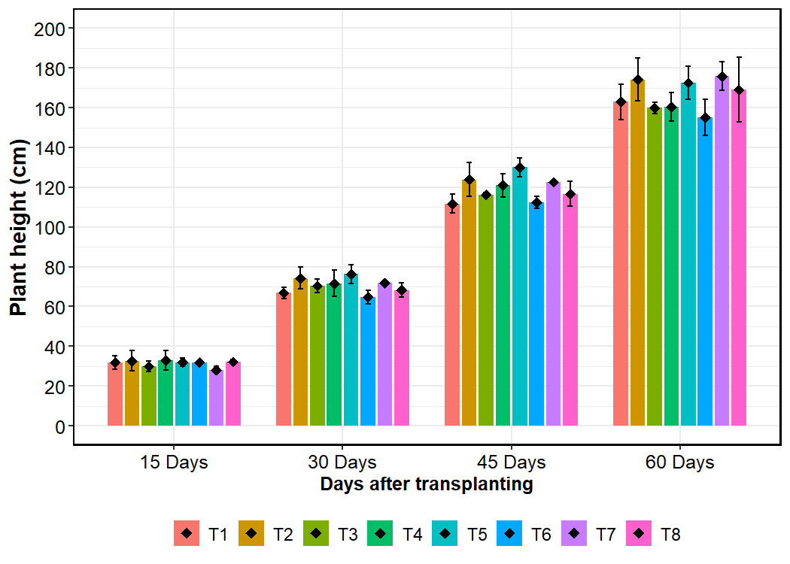
However, Wu et al. (2022) and Wang et al. (2017) claimed a significant difference in the height of plants between the combination of organic and inorganic fertilizer. Whereas studies by Du et al. (2021) and Hasnain et al. (2020) observed the significant impact on the earlier vegetative stages diminishes over time.

Fig. 1. Effect of different treatments on height of tomatoes at 15, 30, 45, and 60 DAT
T1: Recommended dose of Chemical Fertilizer (200:180:80 NPK kg/ha)/ T2: ½ Recommended Chemical Fertilizer + ½ FYM 25 t/ha/ T3: ½ Recommended Chemical Fertilizer + ½ Vermicompost 5 t/ha/ T4: ½ Recommended Chemical Fertilizer + ½ Compost 6 t/ha/ T5: Farmyard Manure (FYM) 25 t/ha/ T6: Vermicompost (VC) 5 t/ha/ T7: Compost 6 t/ha/ T8: Control

3.2. Effect on stem diameter

Among the treatments, there was no significant difference in diameter of plants at 15, 30, and 45 DAT as shown in Table 3. However, a significant difference was observed at 60 DAT among the treatments at 5% level of significance. The pairwise comparison, Tukey-adjusted analysis, revealed that diameter was increased by 2.04 mm with the application of ½ Recommended Chemical Fertilizer + ½ FYM 25 t/ha as compared to control. Similar results were also observed by Sher et. al. (2022). This could be due to higher uptake of phosphorus and potassium by plants, which promotes root growth and enhances water and nutrient absorption. This notion is supported by Khan et al. (2010), who claimed that when organic and inorganic fertilizers are applied in an integrated form, there is a higher uptake of soil nutrients. A similar result was obtained by Kai et al. (2020), where the diameter of the plant was significantly higher under application of organic fertilizers as compared with inorganic fertilizers.

Table 3. Effect of different treatments on diameter of stem, number of flowerings per bunch, and total yield.

Day | Diameter (cm) |  |  |  | Number of flowerings per bunch | Yield (t/ha)
Day | 15 | 30 | 45 | 60 | Number of flowerings per bunch | Yield (t/ha)
T1 | 0.40±0.02 | 0.63±0.04 | 0.86±0.05 | 0.92±0.06^{ab} | 5.79±0.31^{ab} | 53.38±2.55^{bc}
T2 | 0.42±0.01 | 0.66±0.02 | 0.88±0.02 | 0.11±0.06ª | 6.65±0.22ª | 62.07±1.34ª
T3 | 0.42±0.02 | 0.63±0.01 | 0.82±0.03 | 0.88±0.02^{ab} | 6.19±0.33^{ab} | 59.43±0.57^{ab}
T4 | 0.43±0.03 | 0.63±0.02 | 0.83±0.01 | 0.86±0.01^{b} | 5.83±0.27^{ab} | 54.01±2.54^{abc}
T5 | 0.45±0.02 | 0.70±0.01 | 0.88±0.04 | 0.97±0.02^{ab} | 6.37±0.07^{ab} | 53.02±1.05^{bc}
T6 | 0.42±0.02 | 0.66±0.03 | 0.84±0.04 | 0.90±0.03^{ab} | 6.08±0.34^{ab} | 47.37±2.21^{c}
T7 | 0.40±0.02 | 0.63±0.01 | 0.85±0.02 | 0.92±0.01^{ab} | 6.62±0.16ª | 47.36±1.46^{c}
T8 | 0.43±0.03 | 0.60±0.05 | 0.80±0.03 | 0.85±0.04^{b} | 5.36±0.15^{b} | 38.16±0.63^{d}
p-value | 0.839 | 0.338 | 0.699 | 0.019 | 0.028 | <0.001
Mean ± Standard error; T1: Recommended dose of Chemical Fertilizer (200:180:80 NPK kg/ha)/ T2: ½ Recommended Chemical Fertilizer + ½ FYM 25 t/ha/ T3: ½ Recommended Chemical Fertilizer + ½ Vermicompost 5 t/ha/ T4: ½ Recommended Chemical Fertilizer + ½ Compost 6 t/ha/ T5: Farmyard Manure (FYM) 25 t/ha/ T6: Vermicompost (VC) 5 t/ha/ T7: Compost 6 t/ha/ T8: Control

3.3. Effect on flowering per bunch

As shown in Table 3, both organic and inorganic fertilizers increase the number of flowers per bunch as compared to the control. T2 (½ recommended chemical fertilizer + ½ FYM 25 t/ha) has the highest mean value (6.65), is statistically similar to T1 (recommended dose of chemical fertilizer), but is significantly higher than the control (p-value = 0.028). A similar result was found by Saha et al. (2019). The slow nutrient release characteristics of organic manure like FYM combined with synthetic fertilizers containing the readily available nutrients might have improved the timely availability of phosphorus and enhanced its use efficiency, which plays a vital role in flower initiation and fruits per cluster (Khan et al., 2010; Xin-yu et al., 2025).
3.4. Effect on yield of tomatoes

Results from Anova fitted with a linear model indicated that there is a significant difference among the treatments (F (7,14) = 44.585, p-value = <0.001). Furthermore, the post-hoc test conducted with Tukey’s adjustment depicted that T8 (Control) is significantly lower than other remaining treatments as shown in Fig. 2. This is supported by Woldemariam et al. (2018), which reported that yield of tomatoes increased by 67.75% when fertilizers (250 K₂O/ha) were applied as compared to control. Particularly, the highest yield (62.07 t/ha) was obtained when ½ recommended chemical fertilizer and ½ FYM (25 t/ha) was applied followed by the combination of ½recommended chemical fertilizer and ½ vermicompost (5 t/ha) (59.43 t/ha). A similar result was claimed by Laily et al. (2021), Saha et al. (2019), and Wu et al. (2022), where yield was higher when combination of organic and inorganic fertilizers was used together as compared to application of recommended dose of chemical fertilizers only.
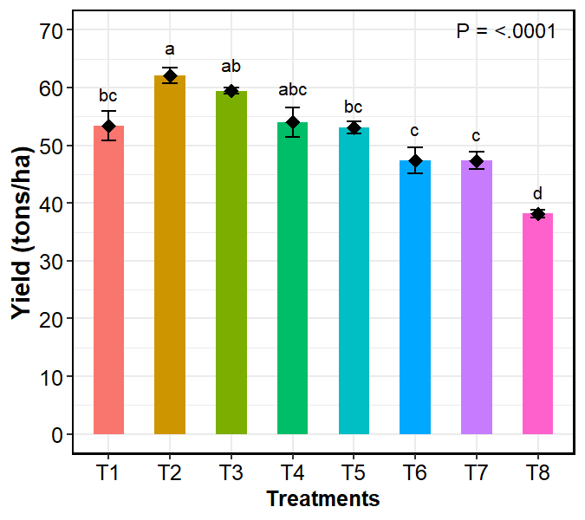
Fig. 2. Effect of different combinations of organic and inorganic fertilizers on the yield of tomatoes.
T1: Recommended dose of Chemical Fertilizer (200:180:80 NPK kg/ha)/ T2: ½ Recommended Chemical Fertilizer + ½ FYM 25 t/ha/ T3: ½ Recommended Chemical Fertilizer + ½ Vermicompost 5 t/ha/ T4: ½ Recommended Chemical Fertilizer + ½ Compost 6 t/ha/ T5: Farmyard Manure (FYM) 25 t/ha/ T6: Vermicompost (VC) 5 t/ha/ T7: Compost 6 t/ha/ T8: Control

Tadesse et al. (2013) claimed that the combination of FYM and inorganic fertilizer improves the availability of soil nitrogen, phosphorus, and potassium, which might have promoted photosynthesis activity. This further enhances the carbohydrate translocation into fruits, increasing fruit weight and yield. Following this, organic fertilizers increase the organic matter content and microbial biomass, enhance the water-holding capacity of soil, and improve cation exchange capacity and soil pH, supporting higher yield (Cen et al., 2020; Khan et al., 2010; Wu et al., 2022; Xin-yu et al., 2025).

4. Conclusion

This research examined the effect of the combination of inorganic fertilizers with different organic fertilizers, including vermicompost, FYM, and compost, on morphological and agronomic traits (height, diameter, and number of flowerings per bunch) and yield of tomatoes in the Lamjung district of Nepal. The combined application of the recommended dose of chemical fertilizer and farmyard manure increased the diameter of plants and the number of flowerings per bunch, further increasing the total yield. Thus, the integrated nutrient management practice, which includes chemical and organic fertilizer, is a practical and sustainable way to achieve higher tomato production in greenhouses while maintaining soil health. This approach not only improves plant growth and enhances productivity but also reduces the reliance of farmers on chemical fertilizers. Further studies are needed to understand how and to what extent this approach can improve the soil’s properties and minimize the adverse effect of chemical fertilizers.

Disclaimer (Artificial intelligence)
Author(s) hereby declare that NO generative AI technologies such as Large Language Models (ChatGPT, COPILOT, etc.) and text-to-image generators have been used during the writing or editing of this manuscript.

References

Amirahmadi, E., Mohammad G., Jan M., Petr K., & Marek K. (2023). Impacts of Environmental Factors and Nutrients Management on Tomato Grown under Controlled and Open Field Conditions, Agronomy 13, no. 5: 1421, https://doi.org/10.3390/agronomy13051421.
Beeby, J., Steve M., Laura T., & Samuel N. (2020). Effects of a One-Time Organic Fertilizer Application on Long-Term Crop and Residue Yields, and Soil Quality Measurements Using Biointensive Agriculture, Frontiers in Sustainable Food Systems, Agroecology and Ecosystem Services section, vol. 4, https://doi.org/10.3389/fsufs.2020.00067.
Bhandari, N. B., Dinesh, B., and Aryal, M. (2016). Demand and Supply Situation of Tomato in Nepal, Hariharbhawan, Lalitpur: Government of Nepal.
Cen, Y., Liyue G., Meizhen L., Xian, G., Caihong, L., & Gaoming, J. (2020). Using Organic Fertilizers to Increase Crop Yield, Economic Growth, and Soil Quality in a Temperate Farmland, Ecology (Research Article, Agricultural Science, Soil Science), https://doi.org/10.7717/peerj.9668.
Collins, E. J., Cressida, B., Audrey, Tsouza., & Mridula, C. (2022). Tomatoes: An Extensive Review of the Associated Health Impacts of Tomatoes and Factors That Can Affect Their Cultivation, Biology 11, no. 2. MDPI, https://doi.org/10.3390/biology11020239.
Du, Q., Huai-Juan, X., Juan-Qi, Li., Jia-Xin, Z., Lu-Yao, Z., & Ji-Qing, W. (2021). Effects of Different Fertilization Rates on Growth, Yield, Quality and Partial Factor Productivity of Tomato under Non-Pressure Gravity Irrigation, PLoS One 16, no. 3: e0247578, https://doi.org/10.1371/journal.pone.0247578.
Fan, H., Yanshu, Z., Jingchen, Li., Jiajun, JI., Abdul, W., Shuguang, W. et al. (2023). Effects of Organic Fertilizer Supply on Soil Properties, Tomato Yield, and Fruit Quality: A Global Meta-Analysis, Sustainability 15, no. 3: 2556, https://doi.org/10.3390/su15032556.
Gao, F., Haijun Li., Xiaoguo, Mu., Hu, G., Ying, Z., Ruimiao, Li. et al. (2023). Effects of Organic Fertilizer Application on Tomato Yield and Quality: A Meta-Analysis, Agronomy 13, no. 2: 396, https://doi.org/10.3390/agronomy13020396.
Government of Nepal, Ministry of Agriculture and Livestock Development. (2024). Statistical Information on Nepalese Agriculture, Statistics and Analysis Section, Singhadurbar, Kathmandu.
Hasnain, M., Chen, J., Ahmed, N., Memon, S., Wang, L., Wang, Yimei., & Wang, P. (2020). The Effects of Fertilizer Type and Application Time on Soil Properties, Plant Traits, Yield and Quality of Tomato, Sustainability, 12(21), https://doi.org/10.3390/su12219065.
Kai, T., Shunya, N., & Masahiko, T. (2020). Effect of Organic and Chemical Fertilizer Application on Growth, Yield, and Quality of Small-Sized Tomatoes, Plants 12, no. 5: 1092, https://doi.org/10.3390/plants12051092.
Kakabouki, I., Ioannis, R., Magdalin, K., Antonios, M., Panteleimon, S., Stella, K. et al. (2022). Comparative Study: Effect of Different Urea Fertilizers and Tomato Pomace Composts on the Performance and Quality Traits of Processing Tomato (Lycopersicon esculentum Mill.), Agronomy 12, no. 10: 2438, https://doi.org/10.3390/agronomy12102438.
Khan, N. I., Asmat U., Farah, U., & Mahmood, A. B. (2010). Effect of Tillage and Farmyard Manure on Physical Properties of Soil.
Laily, UK., Rahman, M. S., Haque, Z., Barman, K. K., & Talukder, M. A. H. (2021). Effects of Organic Fertilizer on Growth and Yield of Tomato, Progressive Agriculture 32, no. 1. 10–16, https://doi.org/10.3329/pa.v32i1.55710.
MoALD (2023). Ministry of Agriculture and Livestock Development. Statistical information on Nepalese agriculture 2078/79 (2021-22). https://moald.gov.np/content/42/statistical-information-on-nepalese-agriculture/.
Olagunja, O. S., Sosanya, S. O., Oguntade, A. Oladede, A. O., Adewusi, M. K., Soremi, A.S. P. et al. (2024). Effect of NPK Fertilizer on Upper and Basal Stem Diameters and Implication on Growth Habit of Tomato, 23(1), https://doi.org/10.1016/j.jssas.2023.09.002.
Shah, K., Kabir, Y, M., Mondal, C., & Mannan, A, M. (2019). Growth and Yield of Tomatoes as affected by Organic and Inorganic Fertilizers, Journal of the Bangladesh Agricultural University, https://doi.org10.3329/jbau.v17i4.44618.
Sher, A., Adnan, M., Sattae, A., Ul-Allah, S., Ijaz, M., Hassan, U. M. et al. (2022). Combined Application of Organic and Inorganic Amendments Improved the Yield and Nutritional Quality of Forage Sorghum, Agronomy, 12(4), https://doi.org/10.3390/agronomy12040896.
Song, Q., Hongdan, F., Qingwen, S., Xuan, S., Zhen, W., Zhouping, Sun. et al. (2022). Overfertilization Reduces Tomato Yield under Long-Term Continuous Cropping System via Regulation of Soil Microbial Community Composition, Frontiers in Microbiology, Terrestrial Microbiology section, vol. 13, https://doi.org/10.3389/fmicb.2022.952021.
Tadesse, T., Nigussie, D., Wondimu, B., & Setegn, G. (2013). Effects of Farmyard Manure and Inorganic Fertilizer Application on Soil Physico-Chemical Properties and Nutrient Balance in Rain-Fed Lowland Rice Ecosystem, American Journal of Plant Sciences 4, no. 2, https://doi.org/10.4236/ajps.2013.42041.
Thapa, M., Babu, D., Gauchan, D., Timsina, K., & Ghimire, Y. N. (2016). Srijana Hybrid Tomato: A Potential Technology for Enterprise Development in Nepal, Nepal Agricultural Research Council, https://doi.org/10.13140/RG.2.1.1425.3048.
Wang, X., Zhao, F., Zhang, G., Zhang, Y., & Yang, L. (2017), Vermicompost Improves Tomato Yield and Quality and the Biochemical Properties of Soils with Different Tomato Planting History in Greenhouse Study, Frontiers in Plant Science, 8, https://doi.org/10.3389/fpls.2017.01978.
Woldemariam, S. H., Sewa, L., Daniel, Z. Z., & Mulugheta, T. S. (2018). Effect of Potassium Levels on Productivity and Fruit Quality of Tomato (Lycopersicon esculentum L.), Journal of Agricultural Studies 6, no. [issue] ([year]): [pages]. ISSN 2166-0379.
Wu, W., Zhong, L., Xiaoping, Z., Gaoyang, L., Weijian, Z., Yijie, C. et al. (2022). Improved Tomato Yield and Quality by Altering Soil Physicochemical Properties and Nitrification Processes in the Combined Use of Organic-Inorganic Fertilizers, European Journal of Soil Biology 109: 103384. https://doi.org/10.1016/j.ejsobi.2022.103384.
Xin-yu, G., Wei, Z., Chun-yan, W., Xu, T., Chang, Y., Tao, S. et al. (2025). Combined Application of Organic and Inorganic Fertilizers Improve Nutrient Availability Through High Carbonyl Carbon in Soil Aggregates, Journal of Plant Nutrition and Fertilizers, 31(6): 1095-1108. https://doi.org/10.11674/zwyf.2024475.
Yadav, A., Bundela, M. K., Dhayal, L. S., Khemraj, M., & Choudhary, S. (2024). Effect of Integrated Nutrient Management on Growth and Yield of Tomato (Solanum esculentum Mill.) Agronomy 7, no. SP-10: 304–306, https://doi.org/10.33545/2618060X.2024.v7.i10Se.1787.

