Socio-Economic Impacts of Tourism (2000–2024): A Bibliometric and Systematic Review of Global Research Trends
Abstract
This study investigates the socio-economic impacts of tourism through an integrated bibliometric and systematic review approach. Using the Web of Science (WoS) Core Collection database, 283 peer-reviewed articles published between 2000 and 2024 were identified and analyzed. Bibliometric mapping was conducted using VOSviewer and R Studio to examine co-authorship networks, keyword co-occurrence patterns, and publication trends over time. The analysis reveals substantial growth in research on tourism’s socio-economic implications during the past two decades, reflecting increasing international collaboration and expanding multidisciplinary engagement. The systematic review identifies key thematic areas, including employment generation, income creation, entrepreneurship development, and infrastructure improvement. At the same time, the literature also identifies challenges such as economic leakage, income inequality, seasonal employment instability, and cultural commodification. The findings indicate a growing scholarly emphasis on sustainability, governance, and climate change, with significant research contributions emerging from countries such as China, the United States, and Australia. By combining quantitative bibliometric mapping with qualitative thematic synthesis, this study provides a structured overview of the intellectual evolution of tourism impact research. It identifies major research clusters, geographic patterns, and emerging themes, while also indicating gaps in distributional analysis and equity-focused evaluation. The results offer valuable insights for scholars and policymakers seeking to advance inclusive, sustainable, and context-sensitive tourism development strategies in an increasingly dynamic global environment.
KeyWords: Socio-economic Impact, Inequality, local Community, Bibliometric analysis, Countries, Web of Science, Review
- Introduction
One of the main causes of the global economic shifts in society has been tourism. Tourism and socioeconomic factors are associated activities that are present in the majority of communities worldwide (Melita, 2014). Tourism enhances understanding and appreciation of different communities, fostering international cultural exchange and social interactions among residents and tourists. It also has negative impacts, including an increase in undesirable activities such as alcoholism, drug use, and prostitution (Bandusena et al.,2023). Economic development is an important component that drives economic growth, generating employment opportunities and improved quality of life. Economic growth and development of a tourist destination are important factors used in determining a tourist destination by the tourism operators (Bollam, 2023). A nation's economy is impacted by tourism in several ways, including increased income from visitor arrivals, increased domestic demand resulting from the rise in visitor flows, and the creation of demand for travel and tourism-related products and services. The extension of the multicultural environment through increased knowledge of the host destination's citizens' habits, religions, and other characteristics of tourists is one aspect of the social development brought about by tourism, which is far more extensive than economic development (Stryzhak et al., 2024).
The tourism experience is made more valuable by the series of events. Every action promotes economic growth, development of tourism, including infrastructure for all activities related to the tourism process, employment creation, and income production (Baloch et al., 2023). As a result, the tourism industry has played a significant part in accelerating economic growth and increasing the number of job opportunities available globally (Lee & Chang, 2008). However, Uslu et al., (2020) state that there will be a shift in the local community's attitude toward tourism growth as a result of their growing discontent with the development's detrimental effects on their perception. Finding out how the local community views the positive and negative economic, sociocultural, and environmental impact of tourism is crucial. Kozhokulov et al., (2019) says that the social impact increased more rapidly than the economic impact, indicating a strong relationship between tourism and social well-being. Tourism promotes cultural exchange, which fosters understanding and tolerance, helping to reduce prejudices and enhance social cohesion among diverse groups (Premovic & Arsic (2020). The local communities also benefit from tourism, such as improvement of the social infrastructure like roads, schools, libraries, health care institutions, internet cafes, and so on. But it is seen that tourism also has a negative impact on the local cultures, such as local dignity, erosion of traditional culture, local cultural changes, migration of the local community, intensification of imitation of the behavior and culture of tourists who visit often, etc. Tourism also promoted illegal activities, crimes, labor problems, flowing of the major tourism income to migrants in the district (Shivaraju & Kumar, 2017).
Many research studies have been done on the impact of tourism, but they are often scattered and focus only on one part of the issue, such as just the economic benefit or only the cultural problems. Most of these studies are short-term and don’t consider the long-term impact on communities. Also, in many cases, the views and experiences of the local people are not included, especially in rural areas or developing countries. Because of this, there is a strong need to bring together all this research and analyze it systematically. This will help us understand how tourism is affecting communities in different parts of the world. It can also help identify the problems and suggest better ways to make tourism more fair, inclusive, and sustainable for local people. Therefore, this study will try to analyze the socio-economic impacts of tourism on local communities worldwide and also compare how these impacts vary between regions and people. It will also try to identify gaps in the existing literature and propose evidence-based policy recommendations aimed at promoting more inclusive, equitable, and sustainable tourism development at the community level.
The paper is structured as follows. The literature sources and the collection and processing methods are covered in the second section. The results, which include the development of studies and their trends, co-occurrence analysis of keywords, country collaboration network, and pertinent sources, make up the third section. The fourth section discusses a systematic review that is conducted based on themes. In conclusion, the constraints and opportunities for further investigation in the domain of tourism and its socio-economic aspects are examined.
2. Materials and Methods
Data Source and It’s Retrieval
The Web of Science core database (WoS) was utilized to choose the retrieval platform. In addition to being utilized for bibliometric research, the Web of Science (WoS) is home to prestigious scholarly journals that provide a comprehensive overview of the advancement and evolution of scholarly research. A total of 1018 documents were initially identified from the Web of Science. The search term TS = (“tourism” AND (“socio-economic impact*” OR “local development” OR “community development”)) for the time range between 2000 and 2024 was used in the Web of Science platform. The data was retrieved from the WoS database on 2 September 2025 for Vosviewer and R Studio analysis. The articles were in English and belonged to the "Article" or "Review" document types. Only English-language articles were included in this study as English is the main language used in international academic journals, especially in the Web of Science database, which also ensures clear understanding, accurate analysis, and consistency during the review process. However, this may have excluded some relevant studies published in other languages, which is acknowledged as a limitation of the study.
Screening and Selection Process
The study followed the PRISMA 2020 guidelines (Page et al., 2021) to ensure transparency in the screening and selection process. During the screening process, titles and abstracts were reviewed first, followed by full-text reading. Articles were excluded if they did not clearly examine socio-economic impacts, community development, employment, income, inequality, or related themes. Conference papers, editorials, duplicates, and non-relevant studies were also removed. After applying these criteria, 283 articles were found to be directly relevant and were included in the final analysis.
Chart .1 Procedure for screening studies
Identification
Web of Science Database records found (n=1018)
Excluded Duplicate Records, Conference Proceedings, Editorial material or retracted publication, and selecting english as the language (n=44)

Remaining Studies (n=978)
Screening
Excluded non tourism studies (n=233)

Remaining Studies (n= 745)
Excluded not addressing socio-economic impacts based on Abstract (n=247)
Eligibility

Remaining studies (n=498)

Removed after reading the entire text (n=215)
Included

Final Studies (n=283)

Source: The author's work

Bibliometric Analysis Method
The review process followed PRISMA 2020 reporting standards (Page et al., 2021). Bibliometric mapping was conducted using VOSviewer (van Eck & Waltman, 2010), following established science mapping procedures (Zupic & Cater, 2015). The analytical approach was further guided by bibliometric review frameworks proposed by Donthu et al., (2021).
VOSviewer was used to construct and visualize bibliometric networks, including source density visualization, country-level co-authorship networks, and keyword co-occurrence analysis. These analyses helped identify major thematic clusters and the intellectual structure of the field. The following parameters were applied in VOSviewer: a minimum keyword occurrence threshold of five, full counting as the counting method, the default clustering resolution, and association strength normalization. Network visualizations were generated to examine dominant research themes and emerging trends. R Studio was used to analyze publication trends over time and to identify the most productive affiliations contributing to research on tourism and socio-economic impacts globally.
Thematic Analysis
This study also employs a systematic literature review approach to examine the socio-economic impacts of tourism on local communities globally. The studies were analyzed thematically, with findings categorized by nature of impact (positive or negative) and their other impacts. The thematic groups were developed using an inductive approach. First, all selected articles were carefully read to understand their main focus and findings. During this process, recurring concepts, keywords, and research topics were noted. Similar concepts were then grouped to form preliminary categories. For example, studies discussing employment, income generation, and entrepreneurship were grouped under “Economic Impacts,” while studies addressing community perceptions, cultural change, and social cohesion were classified under “Social Impacts.” These preliminary categories were refined through repeated review to ensure conceptual clarity and avoid overlap between themes. After several rounds of revision, thematic groups were finalized into: Economic impact of tourism, Negative impact of tourism, Social impact of tourism, Environmental impact, Community perceptions, and Inequality-related impacts. To ensure consistency, a subset of articles was re-examined after an interval to verify the accuracy of theme classification.
- Result
Figure:1 Annual Scientific Production of Studies
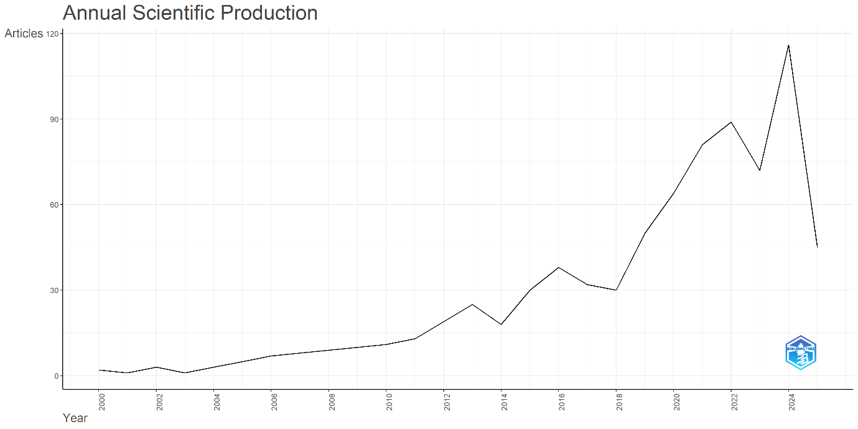
The paper analyzes the number and trend of literature productions over the years from 2000 to 2024. Figure 1 shows an increasing trend over the years in the annual production of articles from the year 2000 to 2024. The number of articles in the year 2000 was just 1 Article, and it has increased to 116 articles in the year 2024. This substantial growth highlights the increasing academic interest and relevance of tourism research, particularly its socio-economic dimensions.
Sources and Publications
Figure 2: Most Relevant Sources
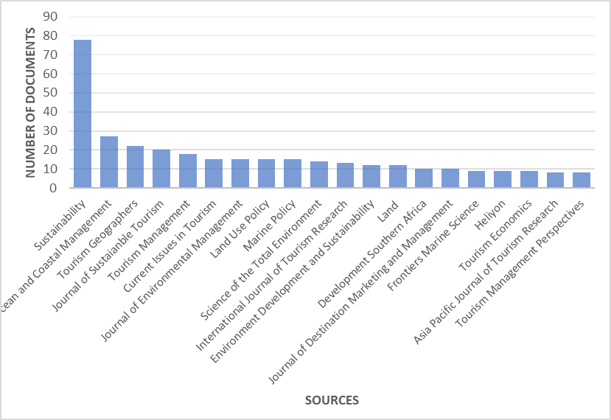

Figure 2 presents the most relevant sources in the study of tourism and its socio-economic impact. It has been found that the Journal of Sustainability has the most number of articles(78) indicating its highest relevance, which is then followed by Ocean and Coastal Management (27), Tourism Geographies (22), Journal of Sustainable Tourism (20), Tourism Management (18), Current Issues in Tourism (15), Journal of Environmental Management (15), Land Use Policy ( 15), Marine Policy (15), Scientific of the total environment (14). The number of journals in the above figure 2 indicates the growing number of journals publishing articles related to the study.
Figure 3 : Density Visualization of the Co-Cited Sources.
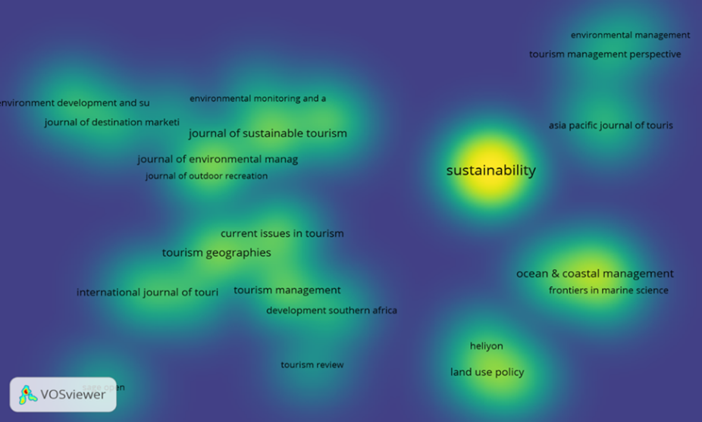

Figure 3 presents a density visualization of co-cited sources using VOSviewer. In the map, yellow areas indicate higher citation density. The source Sustainability stands out with the highest citation density, followed by Ocean and Coastal Management and Tourism Geographies. This visualization illustrates the centrality and influence of these journals in the academic network of tourism-related research.
Figure 4 : Relevant Affiliations
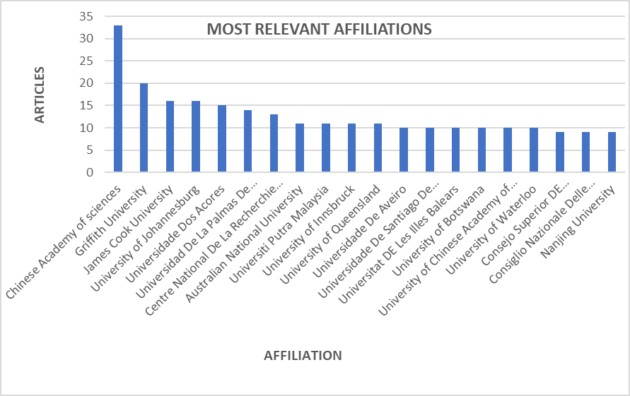
Figure 4 displays the most productive research affiliations based on publication output. The Chinese Academy of Sciences leads with 33 publications, followed by Griffith University (20), James Cook University (16), University of Johannesburg (16), and Universidade dos Açores (15). These institutions demonstrate significant scholarly engagement in tourism and socio-economic research, reflecting a global and collaborative academic environment.
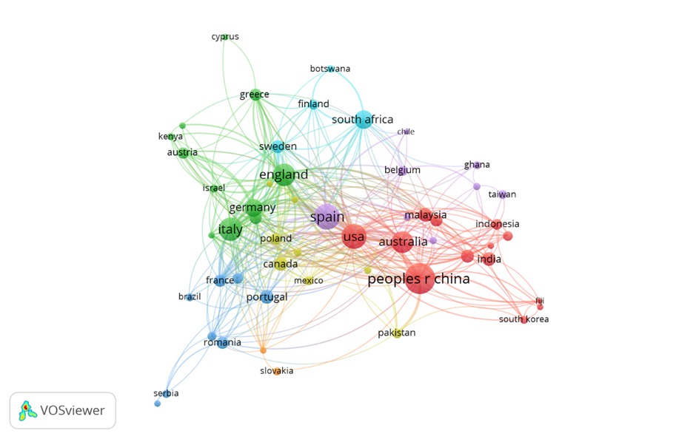
Figure 5: Co-author Collaboration Network
Figure 5 presents the Co-authorship network visualization and collaboration among the countries, where a minimum of 5 documents was used as a criterion before the analysis. Countries with the greatest total linked strength were selected. The figure presents 7 clusters, 349 links, and a total link strength of 702. Countries such as China, USA, Australia, Malaysia, India, and Indonesia show the highest number of co-authorship collaborations. Another group of co-authorship collaboration can be seen between the countries such as Germany, England, Italy, Israel, and Kenya.
Country | Document | Citations | Total Link strength
USA | 85 | 3016 | 112
People's Republic of China | 125 | 2939 | 96
Australia | 64 | 2325 | 94
Spain | 90 | 2402 | 89
England | 69 | 3160 | 81
Italy | 71 | 2351 | 78
South Africa | 46 | 1451 | 66
United Arab Emirates | 6 | 485 | 43
Israel | 9 | 677 | 42
Canada | 25 | 1680 | 40
Table 1: Country Publication and Collaboration

Country | Document | Citations | Total Link strength
USA | 85 | 3016 | 112
People's Republic of China | 125 | 2939 | 96
Australia | 64 | 2325 | 94
Spain | 90 | 2402 | 89
England | 69 | 3160 | 81
Italy | 71 | 2351 | 78
South Africa | 46 | 1451 | 66
United Arab Emirates | 6 | 485 | 43
Israel | 9 | 677 | 42
Canada | 25 | 1680 | 40

From table 1 we can see that the documents from the USA have the highest number of citations with 3016 and 85 documents. England shows 69 documents with 3160 citations, followed by Italy, which has 71 documents and 2351 citations, Spain 90 documents and 2402 citations, with China 125 documents and 2939 citations.The USA leads in citation impact, while China contributes the highest number of publications, emphasizing both productivity and influence across nations.
Figure 6: Country Collaboration
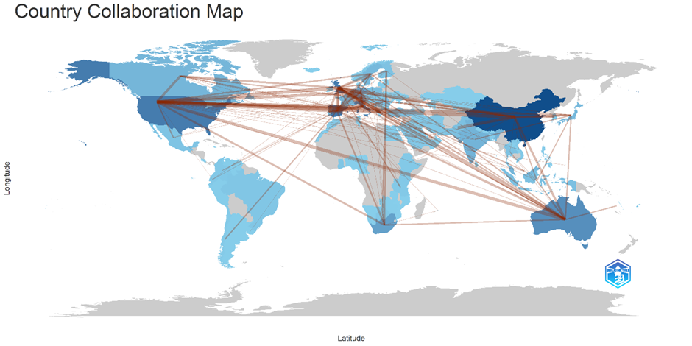

Figure : 7 Key word Co-Occurrence Network
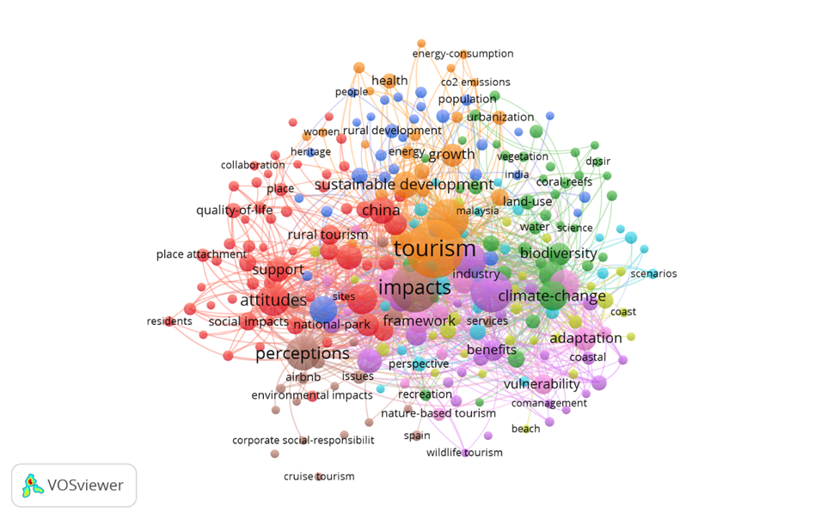
The figure presents 7 clusters, with 5400 links and a total link strength of 9260. Table 2 shows the top 10 keywords in terms of their highest occurrence and total link strength. It can be stated that most of the studies have paid more focus on areas such as tourism, impacts, management, perception, attitude, conservation, sustainability, sustainable tourism, climate change, and have used this keyword repeatedly. The keyword “tourism” is the most frequently occurring term, indicating its centrality. Keywords like impacts, management, perception, sustainability, and climate change suggest that research in this domain primarily revolves around understanding the consequences of tourism, stakeholders’ perspectives, and strategies for sustainable development. Keywords are employed to display the literature's content. In this study, Vosviewer was used to examine the co-occurrence of terms. A minimum occurrence criterion of five times was employed to detect keywords, and 263 keywords met this criterion.
Table 2: Keyword Co-Occurrence
Keyword | Occurences | Total Link Strength
Tourism | 205 | 961
Impacts | 140 | 729
Management | 108 | 586
perception | 72 | 456
impact | 102 | 438
attitudes | 63 | 397
Conservation | 66 | 367
Sustainability | 64 | 340
Sustainable tourism | 58 | 296
Climate Change | 52 | 276

4. Discussions
Economic Impacts of Tourism
Multiple studies present the positive socio-economic impact of tourism on local communities across diverse global contexts. Kozhokulov et al., (2019) found that tourism in the Issyk-Kul region of Kyrgyzstan significantly contributed to local economic growth, with communities expressing optimism about improved livelihoods and the preservation of their cultural heritage. Similarly, Halim et al., (2022) support this view, emphasizing tourism's role in promoting both income opportunities and cultural development. In the Ngorongoro Conservation Area, Melita (2014) observed active participation of the Maasai community in tourism-related activities, though awareness of how revenues directly benefited them was limited. Vujovic et al., (2016) and Wosu & Ogan (2022) states tourism's role in facilitating income flow and job creation, thereby raising living standards, particularly through hospitality services. Shizhao & Mingying (2023) stress the importance of a favorable tourism business environment, linking it to broader economic performance. Community support for ecotourism was also noted in Loboin, Philippines, where residents linked it to income growth and sustainability (Bansil et al., 2015). In Messina, Italy, Chiappa & Abbate (2016) found residents largely supportive of cruise tourism, citing improvements in private investments and local services. Shivaraju & Kumar (2017) and Gill & Singh (2013) document similar findings in India, noting that tourism has enhanced local livelihoods by generating jobs, developing infrastructure, and reducing dependence on traditional subsistence practices. The multiplier effect of tourism is further emphasized by Premovic & Arsic (2020) and Alam (2020), who argue that tourism stimulates economic activity across sectors such as agriculture, construction, and handicrafts. Kumar (2018) points out that even industries not directly linked to tourism benefit economically. Residents' support for tourism is strongly influenced by its economic potential, as shown in Dyer et al., (2007). In Kumaon, Gill (2012) describes how tourism creates both direct and indirect employment, with migration from nearby villages reflecting its economic pull. Kidane & Berhe (2017), Vitriani et al., (2017), and Johnson (2022) further reinforce that tourism has improved household incomes, enhanced social cohesion, promoted MSMEs, and elevated the overall quality of life through better employment and education opportunities.
Negative Impacts of Tourism
While tourism is widely recognized for its economic benefits, many studies show its complex and often negative socio-cultural impacts on local communities. Economic gains such as employment and infrastructure development are frequently reported, but they are not evenly distributed, with locals often lacking the education, financial resources, and skills to fully benefit (Lokeshwara et al., 2023; Dyer et al., 2007). Several authors note that tourism can lead to rising land prices, income leakage to migrants, and a shift in focus away from traditional livelihoods (Garua et al., 2018; Stylidis et al., 2014). Social issues such as cultural erosion, prostitution, theft, begging, and illicit trade in cultural heritage have been identified as serious concerns (Assaye et al., 2023; Premovic & Arsic, 2020). Environmental and infrastructural problems, including poor sanitation, waste mismanagement, and lack of road access, also hinder sustainable tourism development (Sigdel, 2014; Tiwari et al., 2021). In some regions, tourism-related employment growth has not kept pace with population changes, while vulnerable groups like the elderly and youth face increased pressure to sell land to investors (Aliyeva et al., 2019; Phoummasak et al., 2014). Moreover, studies warn that immediate economic benefits may overshadow long-term sustainability, as residents often prioritize short-term income over environmental and cultural concerns due to a lack of awareness and education (Karimi et al., 2024; Prasad & Kumar, 2022). Research on tourism’s socio-economic impacts accelerated after COVID-19 due to increased concern over employment vulnerability and destination resilience (Gossling et al., 2021). The COVID-19 crisis exposed the vulnerability of tourism-dependent communities and informal workers (Baum & Hai, 2020).
Impact on the environment
Communities have shown strong support for the environmental benefits of ecotourism, particularly where biodiversity is a key attraction (Bansil et al., 2015). However, several studies present that tourism also puts pressure on fragile ecosystems, especially in sensitive regions like the Himalayas, where activities such as trampling have led to soil erosion and degradation (Kaur, 2024). Inadequate infrastructure has led to issues such as uncontrolled camping along trekking and riverside areas. While tourism significantly contributes to economic growth through job creation, revenue generation, and socio-economic development, it also faces critical challenges, including infrastructure deficits, waste management problems, and logistical difficulties during peak seasons. In the Sundarbans, local communities generally depend on agriculture and fishing, with tourism acting as a secondary income source (Jamal et al., 2022). However, limited livelihood alternatives and unregulated tourism pose threats to both biodiversity and the community. In Sri Lanka, increasing tourist arrivals have not led to good revenue gains, indicating a possible decline in tourist spending and raising concerns about long-term economic viability (Lokeshwara et al., 2023). Similarly, in vulnerable regions, short-term economic benefits are often prioritized over long-term environmental and social sustainability (Garua et al., 2018). Therefore, future tourism development must emphasize inclusivity, equitable benefit distribution, and sustainability. Building local capacity, diversifying tourism offerings, integrating tourism with other sectors, and regularly monitoring its broader economic and environmental impacts are essential for maximizing its role as a sustainable tool for local development.
Social Impact of Tourism
According to studies, tourism has led to socio-economic transformation in local communities, often leading to improvements in infrastructure, employment, and social cohesion. In the case of Dago Pojok Creative Tourism Village, Nabila et al., (2023) states how creative tourism positively influenced community dynamics, fostering social relations and educational opportunities through engagement in cultural festivals and workshops. However, the study also notes that while tourism has reduced unemployment, the benefits remain economically unstable and heavily reliant on tourist inflows, raising concerns about sustainability. Kumar (2018) emphasizes the importance of monitoring socio-cultural parameters such as social mobility, cohesion, value systems, and heritage practices, pointing out that tourism’s socio-cultural impacts are multidimensional. This aligns with Uslu et al., (2020), who found that community satisfaction significantly influences attitudes toward tourism development and that gender acts as a moderating factor in these attitudes. Similarly, Alam (2020) found that tourism in Nalanda has positively impacted women and children by improving literacy and educational access due to interactions with tourists. The gap between desired and perceived impacts, as noted by Wu et al., (2020), suggests a disconnect in community expectations and actual tourism benefits. Ap (1992) suggests that equitable distribution of tourism benefits fosters positive community attitudes, while perceptions of exploitation may lead to dissatisfaction. Zhongfu (2010) opines that while demographics like age and education influence perceptions of tourism, it is the degree of involvement in tourism activities that shapes attitudes most strongly. Residents involved in tourism-related work tend to be more supportive, as they directly benefit from economic gains. The economic ripple effects of tourism are evident in many regions. For instance, in the Sauraha region, tourism has stimulated related sectors such as agriculture and transport, creating both primary and secondary employment (Sigdel, 2014). Tourism also leads to local infrastructure development and contributes to government revenues (Zhongfu, 2010), thereby supporting wider community services. In the Solomon Islands, despite limited direct employment in tourism (2%), communities showed a willingness to expand tourism opportunities, though they feared socio-cultural disruptions from external influences (Diedrich & Aswani, 2016). Similarly, in the Svaneti region of Georgia, Vasadze & Ositashvili (2021) reported overwhelming local support for tourism due to its economic prospects, but also emphasized the need for stronger cultural and environmental conservation efforts. Tourism can promote cultural preservation and local pride, as seen in Johnson (2022) and Vitriani et al., (2017), where residents actively showcased traditions to tourists. However, tourism does not always lead to gender equity; for example, Johnson (2022) shows minimal improvement in women’s roles, while Letoluo & Wangombe (2018) find that tourism in the Maasai Mara improved women's empowerment and access to education. Similarly, Yusoh et al., (2023) show the economic and social empowerment of women, noting increased cooperation within communities, though they worry against the exclusion of indigenous voices in tourism planning.
The sense of ownership and participation play a critical role in tourism’s sustainability. Inocencio (2023) asserts that communities lacking involvement in tourism planning often feel disconnected, which hinders long-term success. Zakaria et al., (2024) stressed the importance of cultural intelligence and capacity, warning that rapid tourism development without attention to cultural adaptability can result in cultural erosion. This shows that socio-cultural changes occur in phases, depending on tourism development levels. The economic benefits of tourism are not always equitably distributed. In Bauchi, Nigeria, tourism-related businesses dominate the economy, with significant private sector involvement (Nwankwo & Agboeze, 2013). Poor infrastructure and ineffective policy implementation hinder tourism's full potential. Community participation remains crucial for tourism sustainability. In some cases, World Heritage Site designations have transformed local economies. Jimura (2011) states that tourism in Shirakawa-mura, Japan, revitalized the economy but also disrupted traditional livelihoods and social bonds. A similar case is seen in Manali, India, where Gardner et al., (2002) report explosive tourism growth resulting in economic diversification, but also raise concern about environmental degradation, political instability, and overexploitation of resources. Therefore, economic growth alone does not guarantee community well-being. Stryzhak et al., (2024) argue that self-perception of happiness among residents is influenced by more than income; social and cultural factors play a significant role in how tourism is experienced and valued at the local level.
Community Perception and Social Cohesion
Residents’ support for tourism development is often shaped not just by perceived benefits but also by whether those benefits are physically felt at the community level. Chow et al., (2019), in their study of Tai O, Hong Kong, found that residents’ perceived impacts of tourism did not significantly influence their support for future development. Support depended upon experiencing direct and tangible benefits. The study presents concerns of economic leakage, wherein tourism revenues did not circulate within the local economy, resulting in negative community sentiment and skepticism about tourism’s long-term value. Similarly, Sanjay (2008), in the case of Valemount, found that although residents largely viewed tourism development positively, associating it with economic growth and improved quality of life, there was dissatisfaction with existing tourism offerings. This discontent suggests that while the community supports tourism in principle, unrealized expectations and insufficient development may hinder continued support. Importantly, the study noted that stronger community ties and attachment enhanced residents’ willingness to back tourism initiatives. Alrwajfah et al., (2019) further investigated how sociodemographic variables such as gender and proximity to tourist sites affect perceptions of tourism. Economic impacts were considered the most important, with positive economic perceptions strongly correlating with higher satisfaction in local tourism management. Interestingly, negative impacts had less influence on satisfaction, indicating that perceived benefits might outweigh concerns in shaping resident attitudes. However, the study also revealed gender disparities, with women perceiving fewer economic benefits than men. Moreover, residents with greater attachment to their community were more likely to perceive tourism positively and support its development.
Inequality and Livelihood Change
While tourism is often considered a means for economic development, several studies reveal that its benefits are not uniformly distributed, leading to social polarization, income inequality, and diminished local empowerment. In Peterborough, New Hampshire, Tsundoda & Mendlinger (2009) observed a divide in community perceptions: wealthier residents viewed tourism positively, while working-class locals expressed disappointment, particularly about disruptions to their lifestyle and peace. This shows how non-material concerns, such as cultural and social peacefulness, can outweigh measurable economic gains in shaping resident attitudes. Income disparities often come from unequal participation in tourism activities. Bamanik (2023) found that households engaged in tourism had significantly higher average incomes and asset accumulation than those who were not, suggesting a clear stratification based on involvement. Similarly, Petrikovicova et al., (2019) documented signs of societal dualization, where a division emerged between those who gained from tourism and those who were facing the problem of rising living costs. Kronenberg & Fuchs (2021;2022) offer a similar examination of tourism’s alignment with Sustainable Development Goals (SDGs), particularly “decent work” and “reduced inequalities.” Although income inequalities among tourism occupations in regions like Jamtland County, Sweden, were initially low, these studies report increasing disparities, especially for low-income workers. Their analysis using Gini coefficients and Lorenz curves reveals worrying trends such as employment multipliers are falling, tourism is becoming more labor-efficient, and the number of low-skilled, poorly paid jobs is a growing concern over job quality and long-term workforce sustainability. Gill & Singh (2013) found income gaps between highly educated professionals securing stable tourism jobs and low-skilled workers relegated to seasonal, insecure employment. High turnover and job dissatisfaction are common in tourism, as reflected in Kronenberg & Fuchs (2022), where wage stagnation and poor conditions lead to high attrition. In developing countries, the foreign dominance of the tourism sector often limits local economic benefits. Mbaiwa (2003) showed that in the Okavango Delta, Botswana, international safari companies control tourism revenues, leading to minimal investment in local development. This economic leakage, where revenues flow out rather than circulate within communities, shows concerns raised by Chiappa & Abbate (2016) about cruise tourism disproportionately benefiting external investors rather than local residents. Other studies further show that locals are often excluded from decision making or pushed out of the tourism economy altogether. Guo & Sun (2016) describe a “replacement process” in Chinese tourism villages, where villagers initially involved in tourism were replaced by government-led development, resulting in community displacement and cultural decline. Similarly, Letoluo & Wangombe (2018) point out that in Maasai Mara, many tourism jobs go to non-locals, reducing the sector’s potential to empower indigenous populations. Despite such concerns, some regions benefit from tourism through improved services and infrastructure. Assaye et al., (2023) state a moderate but positive contribution to the expansion of hotels, transport, and telecommunications, though these benefits are uneven across destinations. As Biagi et al., (2020) state, while tourism brings economic benefits, it can also harm urban quality of life (UQoL) by inflating housing costs and crime rates. In Sitges, non-touristic areas reported higher satisfaction with living conditions than heavily touristic ones, suggesting a need to balance economic growth with livability. Finally, Jehan et al., (2023) and others emphasize the importance of local participation and stakeholder engagement to ensure that tourism development is not only economically beneficial but also socially just and inclusive. Involving communities in planning can mitigate inequality, prevent displacement, and enhance both the sustainability and acceptance of tourism initiatives.
5. Conclusions and Recommendations
The literature shows that tourism has a lot of different impacts on society and the economy. Tourism is known for providing economic growth because it creates jobs, raises household incomes, and builds infrastructure in both cities and rural areas. Studies show that tourism can help the economy grow in the long term, especially when there are good policies and business environments in place. At the community level, tourism often acts as a source for entrepreneurship and local investment, as seen in Phoummasak et al., (2014) and Gill & Singh (2013). While tourism is widely regarded as a driver of economic growth, employment generation, and infrastructure development, the benefits are often unevenly distributed. People often overlook the social, cultural, and environmental costs that come with economic gains. The following recommendations are proposed to enhance the study of tourism and its socio-economic impact. It can be used to enhance the positive impact of tourism and reduce its negative impacts.
- Tourism development should involve the local community, the marginalized group of people in the tourism activities, and decision-making to enhance the social and economic life of the local people. To prevent the economic leakage, efforts should be made to promote local entrepreneurship and local ownership, employing local labor, and regulating foreign-dominated and non-local tourism operations.
- Social awareness, proper training, workshops, and tourism education should be given to create better service management for the tourists and to foster better guest-host relations in tourist regions.
- Policies should include local needs. Create policies to reduce wage gaps and job insecurity, especially for seasonal and low-skilled workers in tourism. Promote skills development and vocational training in tourism-related sectors to improve workforce quality. Ensure gender equity by encouraging women’s participation and leadership in tourism-related enterprises.
- Focus Invest in transportation, sanitation, digital connectivity, and public amenities that benefit both tourists and residents. Ensure and provide healthy, safe, and waste management systems in tourism areas to minimize negative experiences.
- Include environmental sustainability in tourism policies, especially in ecologically sensitive areas. Promote eco-tourism and low-impact tourism practices that conserve natural and cultural resources. Establish carrying capacity limits and tourism impact monitoring systems to prevent overuse and degradation.
- Encourage collaboration between academic institutions, governments, and local stakeholders to produce knowledge and policy solutions. Micro-level and qualitative research is needed to capture community perceptions, attitudes, and experiences.
- Develop diversified local economies to avoid over-dependence on tourism, which can be unstable and seasonal, and reduce overdependence on tourism during crises like COVID-19. There needs to be long term tourism resilient policies and strategies.
This study has tried to explore the socio-economic consequences of tourism, presented by a comprehensive bibliometric mapping of worldwide trends of research between 2000-2024. The study shows the nature of tourism development. Though it provides immense opportunities for economic growth and community advancement, it also poses challenges that, if not handled, can compromise long-term sustainability and social justice. Tourism has always proven its ability to develop local economies by creating employment, fostering entrepreneurship, developing infrastructure, and expanding access to education and services. Several case studies, including examples from India, Africa, Southeast Asia, and Europe, show that communities that participate in tourism tend to have higher income levels and improved standards of living. In addition, tourism has contributed to cultural preservation and environmental sensitivity in many parts of the world. The advantages of tourism, though, are not shared equally. The literature presents an increasing socio-economic disparity, with richer or better-educated people and or non-local often benefiting more, while low-skilled residents have to suffer due to seasonal or low-paying jobs. Economic leakage, social polarization, displacement of residents, and commodification of culture are common problems, most particularly in regions with poor regulatory systems or inadequate involvement of the residents. Where residents are engaged in planning and decision-making, tourism has a greater chance of being seen as sustainable and beneficial.
The bibliometric analysis also shows that there has been an increasing global interest in socio-economic and environmental consequences of tourism. There has been a dramatic increase in academic literature on the subject, with the journal Sustainability becoming the most influential source. Keyword trends present ongoing issues of concern with regard to impacts, perception, management, and climate change, telling us the need to move to a research agenda that is broader and focused on sustainability. Strong global cooperation, especially between nations such as China, the USA, Australia, and England, is indicated through analysis, as well as major academic institutions involved in this literature. Finally, the potential of tourism to promote sustainable development is high but reliant on equitable, inclusive, and planned approaches. Tourism growth needs to extend beyond economic growth to consider issues of justice, participation, and environmental quality. As stated by Hall (2019), tourism development must balance economic benefits with environmental and social sustainability concerns. Policies in the future need to focus on empowering local communities, reducing socio-economic imbalances, and enhancing the resilience of host communities. People-centered, culturally focused, and ecologically conscious methods are necessary for ensuring that the benefits of tourism are not only extensive but long-lasting. The pandemic has prompted calls for more resilient and sustainable tourism systems (Gossling et al., 2021).
6. Limitations and Future Research Directions
This study has some limitations that should be recognized. Firstly, the review is limited to publications indexed in Web of Science and written in English, which may have excluded relevant research from regional databases and gray literature, especially from developing countries. Second, as a bibliometric and systematic review, the study identifies general patterns in the literature but does not establish direct cause-and-effect relationships. The findings are also influenced by the selected search terms, inclusion criteria, and software settings used in the analysis.
Future research can build on these limitations in several ways. Despite growing research on tourism’s socio-economic impacts, several gaps remain. Methodologically, many studies rely on cross-sectional data, with limited longitudinal research examining long-term impacts. There is also a need for more mixed-method approaches combining quantitative and qualitative analysis. Most of the major tourism studies have been focused on developed nations, whereas the developing countries like Africa, the Middle East, and other countries are underrepresented. So, more studies coming up from these regions can enhance better tourism understanding and it’s dimension. Emerging themes such as post-COVID-19 recovery, climate adaptation, overtourism, and digital transformation require further investigation. Expanding searches to include multiple databases, non-English sources, and policy reports would provide a more comprehensive understanding of tourism’s socio-economic impacts. Developing common indicators, such as a Tourism Equity Index, could improve how researchers measure and compare distributional outcomes across regions. Finally, greater collaboration with local scholars and community stakeholders would strengthen the relevance, inclusiveness, and practical value of tourism research.
Disclaimer (Artificial intelligence)
Author(s) hereby declare that NO generative AI technologies such as Large Language Models (ChatGPT, COPILOT, etc.) and text-to-image generators have been used during the writing or editing of this manuscript.
References
Alam, T. (2020). Impact of Tourism on Local Communities: A Case of Nalanda, Bihar. Researchgate.Net, October 2020. https://www.researchgate.net/profile/Tazyeen-Alam/publication/350525357
Aliyeva, S., Chen, X., Yang, D., Samarkhanov, K., Mazbayev, O., Sekenuly, A., Issanova, G., & Kozhokulov, S. (2019). The socioeconomic impact of tourism in East Kazakhstan Region: Assessment approach. Sustainability (Switzerland), 11(17). https://doi.org/10.3390/su11174805
Alrwajfah, M. M., Almeida-García, F., & Cortés-Macías, R. (2019). Residents’ perceptions and satisfaction toward tourism development: A case study of Petra Region, Jordan. Sustainability, 11(7), 1907.
Antonakakis, N., Dragouni, M., Eeckels, B., & Filis, G. (2019). The tourism and economic growth enigma: Examining an ambiguous relationship through multiple prisms. Journal of Travel Research, 58(1), 3-24.
Ap, J. (1992). Residents' perceptions on tourism impacts. Annals of tourism Research, 19(4), 665-690.
Assaye, G., Wolyie, J., & Endaweke, Y. (2023). Heliyon The local communities ’ perceptions on the social impact of tourism and its implication for sustainable development in Amhara regional state. Heliyon, 9(6), e17088. https://doi.org/10.1016/j.heliyon.2023.e17088
Bamanik, Jayanta ( 2023). Development of tourism for Socio Economic Changes a case study of Bankura District West Bengal. University of Calcutta. Depertment of Geography. http://hdl.handle.net/10603/514894
Baum, T., & Hai, N. T. T. (2020). Hospitality, tourism, human rights and the impact of COVID-19. International Journal of Contemporary Hospitality Management, 32(7), 2397–2407. https://doi.org/10.1108/IJCHM-03-2020-0242
Bandusena, P., Dissanayaka, N., & Silva, D. A. C. S. (2023). Tourism Impacts on Socio-Economic Development of Residential Community in Ella Destination, Sri Lanka. CINEC Academic Journal, 6(1), 36–45. https://doi.org/10.4038/caj.v6i1.117
Bansil, P. D. D., Capellan, S. A. R., & Castillo, R. C. (2015). Local Community Assessment on the Economic , Environmental and Social Aspects of Ecotourism in Lobo , Philippines. December.
Baloch, Q. B., Shah, S. N., Iqbal, N., Sheeraz, M., Asadullah, M., Mahar, S., & Khan, A. U. (2023). Impact of tourism development upon environmental sustainability: a suggested framework for sustainable ecotourism. Environmental Science and Pollution Research, 30(3), 5917–5930. https://doi.org/10.1007/s11356-022-22496-w
Biagi, B., Ladu, M. G., Meleddu, M., & Royuela, V. (2020). Tourism and the city: The impact on residents' quality of life. International Journal of Tourism Research, 22(2), 168-181.
Bollam, Sanjeeva (2023). Impact of tourism on socio- economic Development in India. A study of North Telenagana. Kakatiya university, Warangal, Department of Tourism Mamagement.http://hdl:handle.net/10603/541364
Chiappa, G. Del, & Abbate, T. (2016). Current Issues in Tourism Island cruise tourism development : a resident ’ s perspective in the context of Italy. July 2015. https://doi.org/10.1080/13683500.2013.854751
Chow, A. S. Y., Liu, S., & Cheung, L. T. O. (2019). Importance of residents ’ satisfaction for supporting future tourism development in rural areas of Hong Kong. 5706. https://doi.org/10.1080/10225706.2019.1634110
Diedrich, A., & Aswani, S. (2016). Exploring the potential impacts of tourism development on social and ecological change in the Solomon Islands. Ambio, 45(7), 808–818. https://doi.org/10.1007/s13280-016-0781-x
Donthu, N., Kumar, S., Mukherjee, D., Pandey, N., & Lim, W. M. (2021).How to conduct a bibliometric analysis: An overview and guidelines. Journal of Business Research, 133, 285–296. https://doi.org/10.1016/j.jbusres.2021.04.070
Dyer, P., Gursoy, D., Sharma, B., & Carter, J. (2007). Structural modeling of resident perceptions of tourism and associated development on the Sunshine Coast , Australia. 28, 409–422. https://doi.org/10.1016/j.tourman.2006.04.002
Fernando, P., Berrone, S., Scialò, S., Arnold, U., Yildiz, Ö., Chung, J., Min, K., Oh, S., Sunwoo, M., Khoobbakht, G., Akram, A., Karimi, M., Najafi, G., López-González, D., Fernandez-Lopez, M., Valverde, J. L., Sanchez-Silva, L., D’Ambrosio, S., Ferrari, A. L., … Gu, M. (2019). Tourism and its Socio-economic Effects on Tourism Villages of Kaski, Nepal. Journal of Wind Engineering and Industrial Aerodynamics, 26(1), 1–4. https://doi.org/10.1007/s11273-020-09706-
Gardner, J., Sinclair, J., Berkes, F., & Singh, R. B. (2002). Accelerated tourism development and its impacts in Kullu-Manali, H.P., India. Tourism Recreation Research, 27(3), 9–20. https://doi.org/10.1080/02508281.2002.11081370
Garau-Vadell, J. B., Gutierrez-Taño, D., & Diaz-Armas, R. (2018). Economic crisis and residents’ perception of the impacts of tourism in mass tourism destinations. Journal of destination marketing & management, 7, 68-75.
Gebreanenya Gebru Kidane, & Meaza Hadush Berhe. (2017). Socio-Economic Impacts of Tourism in Axum Town, Tigray Regional State, Ethiopia. J. of Tourism and Hospitality Management, 5(1). https://doi.org/10.17265/2328-2169/2017.02.001
Gill, N., & Singh, R. P. (2013). Socio -Economic Impact Assessment of Tourism in Pithoragarh District, Uttarakhand. GIS and Geography, 1(1), 1–7.
Gill, Neetu ( 2012). Impact of Tourism on Socio- Economic Development in Kumaon Region a Geographical Study. Mahatma Jyotiba Phule Rohilkand University. Department of Geography.htpp://hdl.handle.net/10603/334594
Gossling, S., Scott, D., & Hall, C. M. (2021). Pandemics, tourism and global change: A rapid assessment of COVID-19. Journal of Sustainable Tourism, 29(1), 1–20. https://doi.org/10.1080/09669582.2020.1758708
Grzebyk, M. (2020). Socio-economic Development and the Level of Tourism Function Development in European Union Countries – a Comparative Approach. https://doi.org/10.1017/S106279872000099X
Guo, Z., & Sun, L. (2016). The planning, development and management of tourism: The case of Dangjia, an ancient village in China. Tourism Management, 56, 52–62. https://doi.org/10.1016/j.tourman.2016.03.017
Halim, M. A., Mawa, J., Deb, S. K., & Nafi, S. M. (2022). Local community perception about tourism impact and community support for future tourism development: A study on Sylhet, Bangladesh. Geo Journal of Tourism and Geosites, 44(4), 1260-1270.
Hall, C. M. (2019). Constructing sustainable tourism development: The 2030 Agenda and the managerial ecology of sustainable tourism. Journal of Sustainable Tourism, 27(7), 1044–1060. https://doi.org/10.1080/09669582.2018.1560456
Haralambopoulos, N., & Pizam, A. (1996). Perceived impacts of tourism: The case of Samos. Annals of tourism Research, 23(3), 503-526.
Inocencio, J. M. G. (2023). Socio-Economic and Environmental Impact of Community-Based Tourism Development in the Province of Biliran. Indonesian Journal of Multidisciplinary Science, 2(4), 2205–2217. https://doi.org/10.55324/ijoms.v2i4.374
Jamal, S., Ghosh, A., Hazarika, R., & Sen, A. (2022). Livelihood, conflict and tourism: An assessment of livelihood impact in Sundarbans, West Bengal. International Journal of Geoheritage and Parks, 10(3), 383–399. https://doi.org/10.1016/j.ijgeop.2022.07.004
Jehan, Y., Batool, M., Hayat, N., & Hussain, D. (2023). Socio-economic and environmental impacts of tourism on local community in Gilgit Baltistan, Pakistan: A local community prospective. Journal of the Knowledge Economy, 14(1), 180-199.
Jimura, T. (2011). The impact of world heritage site designation on local communities e A case study of Ogimachi , Shirakawa – mura , Japan. Tourism Management, 32(2), 288–296. https://doi.org/10.1016/j.tourman.2010.02.005
Johnson, G., Johnson, G., (2022). Socio-Economic Impact of Rural Tourism: a Case Study on Kumbalangi Village. Interantional Journal of Scientific Research in Engineering and Management, 06(06), 1–13. https://doi.org/10.55041/ijsrem14622
Karimi, M. S., Karamelikli, H., & Naysary, B. (2024). The role of tourism in driving economic growth: An asymmetric augmented autoregressive distributed lag analysis of Singapore's experience. International Journal of Tourism Research, 26(4), e2696.
kaur, E. Nayyar (2024). Socio Economic and Environmental Impact of Pilgrimage Tourism in Uttarakhand; A study of Badrinath and Kedarnathn regions. Hemwati Nandan Bahuguna Garhwal University. http://hdl.handle.net/10603/632341
Kozhokulov, S., Chen, X., Yang, D., Issanova, G., Samarkhanov, K., & Aliyeva, S. (2019). Assessment of tourism impact on the socio-economic spheres of the Issyk-Kul Region (Kyrgyzstan). Sustainability (Switzerland), 11(14), 1–18. https://doi.org/10.3390/su11143886
Kronenberg, K., & Fuchs, M. (2021). Aligning tourism’s socio-economic impact with the United Nations’ sustainable development goals. Tourism Management Perspectives, 39. https://doi.org/10.1016/j.tmp.2021.100831
Kronenberg, K., & Fuchs, M. (2022). The socio-economic impact of regional tourism: an occupation-based modelling perspective from Sweden. Journal of Sustainable Tourism, 30(12), 2785–2805. https://doi.org/10.1080/09669582.2021.1924757
Kumar, Anand( 2023). Impact of Tourism on the socio-economic Development in Rajasthan a case study of Jaipur City. Apex University, Rajastan. Department of Commerce and Management. http://hdl.handle.net/ 10603/545111
Kumar, P. (2018). Residents perception analysis of tourism traits and its impact on prospects of Jharkhand tourism. International Journal of Business, Economics & Management, 1, 1–21. https://doi.org/10.31295/ijbem.v1n1.23
Lari Letoluo, M., & Wangombe, L. (2018). Exploring the Socio-economic Effects of the Community Tourism Fund to the Local Community, Maasai Mara National Reserve. Universal Journal of Management, 6(2), 51–58. https://doi.org/10.13189/ujm.2018.060202
Lee, C. C., & Chang, C. P. (2008). Tourism development and economic growth: A closer look at panels. Tourism management, 29(1), 180-192.
Lokeshwara, A., Nagendrakumar, N., Jayasuriya, K. R. G. T., Ravisara, H. G. A. M., Weerawickrama, M. J., & Madushan, M. G. D. (2023). Socio-Economic Factors and Tourism – Impact Analysis using Indicator Approach. ASEAN Journal on Hospitality and Tourism, 21(1), 1–16. https://doi.org/10.5614/ajht.2023.21.1.01
Mbaiwa, J. E. (2003). The socio-economic and environmental impacts of tourism development on the Okavango Delta, north-western Botswana. Journal of Arid Environments, 54(2), 447–467. https://doi.org/10.1006/jare.2002.1101
Mbaiwa, J. E. (2005). The socio-cultural impacts of tourism development in the Okavango delta, Botswana. Journal of Tourism and Cultural Change, 2(3), 163–184. https://doi.org/10.1080/14766820508668662
Melita, A. W. (2014). The Relationship between Tourism and Socio-Economic Aspects of the Maasai in Ngorongoro Conservation, Tanzania. Business and Management Horizons, 2(1), 78. https://doi.org/10.5296/bmh.v2i1.5860
Miralles, C. C., Roura, M. B., Salas, S. P., Argelaguet, L. L., & Jordà, J. C. (2024). Assessing the socio-economic impacts of tourism packages: a methodological proposition. The International Journal of Life Cycle Assessment, 29(6), 1096-1115.
Moldagaliyeva, A., Aktymbayeva, A., Issakov, Y., Assylbekova, A., Kenzhalin, K., Beisembinova, A., Begimova, G., & Dávid, L. D. (2024). Socio-Economic Significance of Tourism Development on the Great Silk Road (Kazakhstan Section). GeoJournal of Tourism and Geosites, 52(1), 116–124. https://doi.org/10.30892/gtg.52111-1188
Nabila, A. S., Marsongko, E. P., & Endah Trihayuningtyas. (2023). Impact of Creative Tourism Development on Conditions Socio-Economic Local Communities in Dago Pojok Tourism Villages. International Journal of Sustainable Competitiveness on Tourism, 2(02), 87–95. https://doi.org/10.34013/ijscot.v2i02.1365
Nwankwo, E. a, & Agboeze, M. U. (2013). Community Development and Tourism : A Socio-economic Analysis of Tourism Impacts in Bauchi. 4(10), 115–124.
Petrikovičová, L., Krogmann, A., Fialová, D., & Andrej, S. (2019). Intensive tourist-related urbanisation impacts on a mountain village: The case study of veka lomnica in slovakia. Geographia Polonica, 92(4), 395–408. https://doi.org/10.7163/GPol.0155
Phoummasak, K., Kongmanila, X., & Changchun, Z. (2014). The Socio-Economic Impact of Tourism and Entrepreneurs in Luang Prabang Province, Lao PDR. International Journal of Business and Management, 9(12), 275–284. https://doi.org/10.5539/ijbm.v9n12p275
Prasad, N. S., & Kumar, N. N. (2022). Resident Perceptions of Environment and Economic Impacts of Tourism in Fiji. Sustainability (Switzerland), 14(9), 1–20. https://doi.org/10.3390/su14094989
Premović, J., & Arsić, L. (2020). Socio-economic aspects of tourism in the modern society. Collection of Papers of the Faculty of Philosophy L(3)/2020, 50(3), 125–154. https://doi.org/10.5937/zrffp50-28518
R Core Team. (2025). R: A language and environment for statistical computing (Version 4.5.0) [Computer software]. R Foundation for Statistical Computing. https://www.r-project.org
Saha, B. (2012). People ’ s Attitudes towards Tourism Development in the Urban Areas of Koch Bihar District West Bengal. 5(2).
Saikia, Mriganka (2017). Tourism and Economic Development a case study of Assam. Nagaland University. Department of Economics.http://hdl.handle.net/10603/219916
Sanjay, K. (2008). Tourism Geographies : An International Journal of Residents ’ Attitudes to Tourism in Central British Residents ’ Attitudes to Tourism in Central British Columbia , Canada. December 2013, 37–41. https://doi.org/10.1080/14616680701825123
Shivaraju, H. ., & Kumar, A. (2017). Socio-Economic and Environmental Impact of Tourism in Kodagu District (India): A Case Study. Universal Journal of Environmental Research and Technology, 5(1), 41–48. www.environmentaljournal.org
Shizhao, Z., & Mingying, M. (2023). Study on Economic Impact of Guizhou Tourism Business Environment Based on CGE Model. Journal of the Knowledge Economy, 0123456789. https://doi.org/10.1007/s13132-023-01325-6
Sigdel, T. P. (2014). Socio-Economic Impact of Tourism in Sauraha Chitwan, Nepal. The Third Pole: Journal of Geography Education, 13(November 2014), 60–64. https://doi.org/10.3126/ttp.v13i0.11549
Stryzhak, O., Cibák, Ľ., Sidak, M., & Yermachenko, V. (2024). Socio-Economic Development of Tourist Destinations: a Cross-Country Analysis. Journal of Eastern European and Central Asian Research, 11(1), 79–96. https://doi.org/10.15549/jeecar.v11i1.1442
Stylidis, D., Biran, A., Sit, J., & Szivas, E. M. (2014). Residents ’ support for tourism development : The role of residents ’ place image and perceived tourism impacts. Tourism Management, 45, 260–274. https://doi.org/10.1016/j.tourman.2014.05.006
Tiwari, S., Tomczewska-popowycz, N., Gupta, S. K., & Swart, M. P. (2021). Local Community Satisfaction toward Tourism Development in Pushkar Region of Rajasthan , India. 1–20.
Tsartas, P. (1992). Socioeconomic impacts of tourism on two Greek isles. Annals of tourism research, 19(3), 516-533.
Tsundoda, T., & Mendlinger, S. (2009). in SciRes (www.SciRP.org/journal/jssm) Economic and Social Impact of Tourism on a Small Town: Peterborough New Hampshire. In J. Service Science & Management (Vol. 2). www.SciRP.org/journal/jssm
Uslu, A., Alagoz, G., & Gunes, E. (2020). Socio-cultural, Economic, and Environmental Effects of Tourism from the Point of View of the Local Community. Journal of Tourism and Services, 11(21), 1–21. https://doi.org/10.29036/jots.v11i21.147
Van Eck, N. J., & Waltman, L. (2010). Software survey: VOSviewer, a computer program for bibliometric mapping. Scientometrics, 84(2), 523–538. https://doi.org/10.1007/s11192-009-0146-3
Vasadze, M., & Ositashvili, N. (2021). Socio-economic Impact on Sustainable Mountain Tourism of Georgia. World science, (4 (65)), 31-34.
Vitriani, C. D., Sudibyo, D., & Hermantoro, H. (2017). Socio-Economic Impacts of Tourism Development in Rural Area of Sembalun East Lombok West Nusa Tenggara. TRJ Tourism Research Journal, 1(1), 1. https://doi.org/10.30647/trj.v1i1.2
Vujovic, S., Curcic, N., & Miletic, V. (2016). Impact of tourism on roundabout of economic process. Ekonomika Poljoprivrede, 63(1), 323–337. https://doi.org/10.5937/ekopolj1601323v
WOSU, B. I., & Ogan, S. S. (2022). Hospitality Tourism Impact on Socio-Economic Development in Rivers State, Nigeria. Global Academic Journal of Humanities and Social Sciences, 4(3), 124–131. https://doi.org/10.36348/gajhss.2022.v04i03.005
Wu, H., Kim, S. S., King, A., Wong, F., Wu, H., Kim, S. S., King, A., & Wong, F. (2020). Residents ’ perceptions of desired and perceived tourism impact in Hainan Island Residents ’ perceptions of desired and perceived tourism impact in. 1665. https://doi.org/10.1080/10941665.2020.1752749
Yusoh, M. P., Kumalah, M. J., Abdul Latip, N., Hussin, R., Zakaria, Z., Jamru, L. R., Hanafi, N., Samsul, S. S., & Pingking, A. (2023). Impact of the Tourism Sector on the Socio- Economy of Indigenous People on The Islands Around Semporna. BIO Web of Conferences, 73. https://doi.org/10.1051/bioconf/20237303008
Zakaria, S. A., Azinuddin, M., Ab Ghani, H. H., Wan Mohd Zain, W. M. A., Mior Shariffuddin, N. S., & Hanafiah, M. H. (2024). Tourism development impacts, cultural intelligence and community support for future development. Tourism and hospitality management, 30(2), 211-223.
Zhongfu, W. (2010). Resident Tourism Impact Perception Impact Factors Research. 10–13.
Zupic, I., & Cater, T. (2015).Bibliometric methods in management and organization. Organizational Research Methods, 18(3), 429–472.

