Adoption of Sustainable Materials in Indian Interior Design: Consumer Perception and Industry Practices

Abstract
Sustainability in interior design is fast gaining importance in India as a consequence of environmental concerns, changing consumer values and motivating incentives imposed by various regulatory bodies. This research examines consumers' perceptions and industry practices of sustainable materials adoption in Indian interior design through a study of the Indian masses in a fast urbanising, environmentally stressed country. Sustainable materials: renewable, low-emission, recycled, non-toxic, local, etc., are fostering savings in embodied carbon, the quality of indoor air, and lifecycle-based design decisions. Despite the rise of environmental awareness among Indian consumers, the adoption of sustainable interior materials is inconsistent and fragmented.
However, based on the present data there is limited verified research that systematically examines the bridge between sustainable material manufacturers, sustainable products and acceptance of these products by consumers in the Indian market.

This study aims to evaluate willingness of the Indian consumer to adopt sustainable materials over the other alternatives available.
A mixed- method approach is applied to the research, combining quantitative survey data from 450 urban consumers with qualitative information from 40 industry professionals, designers, suppliers and contractors. Findings reveal the high conceptual awareness of sustainability (86%) but low ability to identify certified sustainable materials (54%). Consumer preference is notably strong for low- VOC paints (83% due to lower VOCs); bamboo (78% due to low carbon emissions and high water absorbency); natural fiber textiles (70% due to durability, recyclability and biodegradability); however, industry application remains significantly below for bamboo (55%) and natural fibers (48% due to cost barriers and instability of supply chain, undefined certification). Low-VOC paints have the highest correlation between consumer demand and industry pickup for their availability because of clear regulations and availability in the market. Willingness-to-pay analysis indicates that 56% of consumers are willing to invest in premium sustainable products; education, environmental concern and experience were found to be important predictors. According to industry stakeholders, cost, inconsistent supply and insufficient client awareness continue to be barriers. The author of the paper concludes by stating that to address the perception-practice gap, it is important to have stronger certification frameworks, improved supply networks, policy incentives, and targeted educational interventions in order to mainstream sustainable materials in interior design in India.

Keywords

Sustainable materials, interior design, consumer perception, India, industry practices, green design, low-VOC paints, bamboo, recycled wood

Introduction
The interior design industry has changed to be more performance-focused, responsibility-focused, and aesthetic-driven, as it has realised its indirect and direct influence on the sustainability of the environment. Globally, the interiors construction has quite a good deal of embodied carbon amount, extraction of resources, waste production, and indoor polluted air because of the intensive use of synthetic composites, treated timbers, traditional paints, upholstery foams and the use of non-biodegradable laminates (Prajapati et al., 2022, p. 319). The decisions made during interior finishing and furnishing on material selection not only determine the appearance and feel of the built environment under certain conditions but also impact the energy demand, human health, and ecological degradation during the product's lifespan. This environmental cost has precipitated a paradigm shift to sustainable design materials in terms of renewability, recoverability, non- toxicity, locality, and low-impact processing. The concept of sustainable materials- articulated in the context of the larger collections of circular economy, lifecycle assessment (LCA) and green chemistry is now established as a fundamental part of eco-friendly interior space. International certification agencies, together with environmental product declarations (EPDs), green building rating schemes and strict definitions of regulatory aspects on chemical pollution, are further boosting the movement towards sustainability (Komal & Rathnam, 2023, p. 7).
The topicality of sustainable interior materials has been magnified in India because of unmatched urban growth, rapid real estate growth, increased consumer desire towards personalised living rooms, and increasingly complicated interior supply chains. The construction and interior design environment in India is today being influenced by the overwhelming urbanisation, with millions of residential and commercial spaces and hospitality environments receiving interior fit-out on an annual basis (Kumar, 2025, p. 1). At the same time, there has been growing disposable income due to economic growth, which has resulted in a higher percentage of Indians who live in urban areas adopting interior decoration and furnishing, decorative panelling, designer flooring and artificial lighting systems, as well as high-grade paint finishes. Although these expansions solidify the domestic design economy, they contribute to increasing pressure on the environment by

stimulating the demand for mass-produced, chemistry-based interior products and imported decorative materials with a high embodied emission rate. Thus, material interventions with a sustainability focus in the interior design of India will not only be timely, but they will also be ecologically necessary (Singh et al., 2014, p. 3).
The Indian consumer market, especially in urban and semi-urban areas, has been showing an increasing ideological orientation toward sustainability that is driven by digital exposure, environmental consciousness campaigns, international design trends and visible effects of pollution on human health. Such products as bamboo panels, jute and hemp fabrics, recycled and engineered wood, clay plasters, natural stones, terrazzo, biopolymer composites, coir carpets, re- used metal fittings, and low-VOC finishes have not only been culturally and commercially embraced using to do so due to the familiarity with natural and artisanal materials already behaved to Indians. Nevertheless, even though the product is still visible on the market and its availability is growing, its adoption is not that solid (Chaudhuri & Roy, 2017, p. 2). In contrast with the situation where the implementation of sustainability in the interior design of countries is supported by strict limits on emissions and resource responsibility and garbage policies, in the Indian system of controlling sustainable interior materials, there is no regular standard enforcement. Lack of harmonised concepts to what constitutes the concept of green interior materials, limited limits of controlled chemical exposure on consumer-grade interior products, inconsistency in labelling authenticity, and a relatively less compulsory environmental compliance of interior design procurement have contributed towards a slow and dissimilar implementation. Moreover, the interior materials business sector in India commonly is a price-based acquisition system, in which a project budget considers only short-term cost reductions over lifecycle worth, sign of durability, environmental impact evaluation or benefits to the occupants. This has given rise to a situation whereby the preference for sustainability is conceptually high but practically low (Chen et al., 2008).
Besides the limitations associated with costs and compliance, the sustainable interior materials industry of India is challenged by supplier-chain uncertainty regarding certified recycled materials, lack of domestic infrastructure to process industrial-grade recycling, inadequacy of uniformity in producing natural polymers from reuse, and inter-regional unavailability. Designers, as major decision intermediaries between hardware producers and final buyers, have to work with limitations on the side of client awareness, product reliability, whether it is high or low-cost

products, and a lack of data on evidence-based product performance. Such a dynamic tends to have sustainable materials being utilised selectively as opposed to in a systematic manner (Gelderman et al., 2021, p. 2062).
The development of the intersection of the consumer environmental consciousness and the industry material practices is the main argument of the research. To examine the motivation factors and the perception gaps, the economic constraints, and the systemic issues that predetermine the adoption of sustainable materials in the interior design of India, the current research examines the perception of consumers and the strategies for sustainable materials in the industry. It tries to provide an insight into the scope of whether the consumer is making a sustainability-based decision, how the interior professionals perceive sustainability orientations, and what structural assistance is needed to lower the ideology-to-practices adoption divides. Moreover, the research aims at determining the leverage points in enhancing the material standards, the local sustainable material processing, establishing chemical-safety credibility, and increasing the utilisation of sustainable, non-emission-intensive, biocompatible material (Singh et al., 2022). This correlates well with the general demand for environmentally conscious, culturally oriented, biologically friendly interior finishes in India. The results will be put in the overall direction of enhancing sustainable interior material mainstreaming, educating professional designers and material industries, and backing up the evidence-based recommendations in changes to be made by means of policies in adoption strategies in the future (Malik et al., n.d., p. 1).
This study has been carried out in a structured manner to explore the usage of sustainable materials in the Indian interior design industry by combining consumer-based and industry-driven approaches. The awareness, attitudes, and preferences of consumers towards sustainable interior materials are the first aim to evaluate how the level of knowledge, level of environmental concern, aesthetic, and durability, as well as cost, affect the purchasing intention of the interior in households. The second goal measures the level of industry adoption and material specification among interior designers, suppliers, and contractors, assessing existing sourcing practices, material availability that is green and the use of professional judgment in sustainable choices. The third goal aims at distinguishing the major barriers and enablers on the consumer and industry professional side, including economic obstacles, reliability of the supply chain, standardisation issues, certification uncertainty, and confidence in the material performance (Gelderman et al., 2021). The concluding goal is to suggest effective interventions at policy, market and professional

practice levels to sustain material uptake through awareness campaigns, incentive platforms, industry capacity and actionable design frameworks based on the principle of sustainability.

Literature Review
Previous studies in the consumer science, environmental psychology, materials engineering, and biomedical nanotechnology domains are consistent that sustainability is no longer a secondary design factor, but a defining factor of product acceptance, perceived value and brand competitiveness. Articles on sustainable interiors suggest that bamboo panels, natural-fibre fabrics, cork panel materials, biopolymeric finishes, and low-VOC finishes have a lower ecological footprint, elevated cytocompatibility, and better indoor air quality than their petrochemical counterparts. The pro-environmental purchasing decisions are evidenced by consumer behaviour research based on the Theory of Planned Behaviour (TPB) as argued by Ajzen, that attitudes, subjective norms and perceived behavioural control influence pro-environmental purchasing behaviour. A series of surveys carried out by various researchers proves that most urban homeowners in India are positively impressed by the concept of eco-friendly interior, and desire to pay more money to be offered materials, which are sustainable in the process of renovation (Mokha, 2017). Yet, this declared purpose (declarative sustainability preference) is a notion that tends to indirectly indicate actual consumer buying behaviour since consumers have low operational knowledge of precisely what constitutes a material to be green or possess therapeutic bioactivity. As an example, when 80-90 per cent of the respondents to various studies state familiarity with terms of sustainability, less than 55-60 per cent can find practical examples or define environmental labels correctly. The lack of eco-friendly, renewable, non-toxic, low VOC, recycled, upcycled, and plant-based knowledge on sustainability terminologies, and sustainable performance-based decisions is also being persistently recorded in the Indian situation. Scholars like Ghosh and Kumar reveal that customers associate the concept of sustainability with visual appearance (rustic/natural appearance) or marketing slogans instead of lifecycle impact, material toxicity and biological functionality. This is a terminological ambiguity that generates cognitive bias, which leads to an incongruence between the perception and actual adoption. Also, it is mentioned that in the situation when a certain degree of reliable heuristics (clear certifications, authoritative figures, product trials) is absent, environmental risk perception among consumers is greater (Mokha, 2017).

Simultaneously, the studies targeting the industry as a subject show that interior designers can be seen as the intermediaries of material adoption, whose product specifications are informed by the cost limits, consistency of supplies, potential risk of durability and the level of education of clients and the existing standards. Anecdotal evidence, both through interviews and commentaries by experts, indicates that the high first cost of sustainable materials is cited by 88-95 per cent of the designers to be the leading obstacle when making the initial client pitching requests. They will only change their specifications to sustainable materials, mainly where their suppliers assure them of uniformity of stocks, reports of structurally tested stocks, or clients are categorical on certified materials. Low-VOC finishes preference has a relatively higher prevalence in the market with respect to the availability, as well as the issue of health-oriented regulatory pressure (Malik et al., n.d., p. 6). Research mentions that the process of making low-emission coats and paints has become normalised in India, partly because the same is visible in the regulations and the growth of product lines by international manufacturers. On the opposite, classical biomaterials, including bamboo and natural fibres, are culturally well-known and lack infrastructural success, such as quality control, lack of modular engineering and processing time, non-modular interior grade products and ineffective manufacturing throughput. And time and again, the suppliers have stressed that the recycled wood and biocomposite panel production in India is still decentralised and only 30-40 per cent of suppliers are still in a position to supply a constant supply of standardised, lab-tested or certified sustainable feedstock. The use of doubtful assumptions of durability is also dominant in the industry. Multiple designers are worried that sustainable materials deteriorate quickly than usual in damp or harsh environmental conditions - a concept that is not absolutely based on facts but on restricted longitudinal field execution facts (Verma & Malik, 2024, p. 12). However, the experimental findings do not match the understanding; several in vivo and in vitro material-cell models suggest that plant-capped nanoparticles within polymeric composites enhance the antimicrobial capabilities and mitigate oxidative stress at interfaces. Copper nanoparticles selectively stimulate angiogenesis with HIF-1- ) and VEGF stimulation, and silver nanoparticles offer high-quality microbial shielding, which synergistically increases in ECM cross-linking, tensile integrity, and controlled inflammatory infiltration. Nevertheless, although Indian interior product manufacturers are well informed in nanobiotechnology, omics-based cytocompatibility or biomedical performance testing used in marketing products has been well explored in

nanopharmaceutical discussions, but is unprecedented in interior-grade materials marketing (Verma & Malik, 2024, p. 12).
Cultural approval of using plant-based reducing agents and herbal bioformulations in medical nanostructures synthesis has also been supported by the regional market studies conducted in Northern and Central India, where the use of plant extracts has been adopted in the reduction and stabilisation of biofunctional interiors. Nevertheless, the contemporary Indian supply chains are not characterised by an integrated phytochemical staging or validated extract-to-product industrial circle casting translational gaps between cultural approval and industrial implementation (Mazumder et al., 2023). Challenges reported in the supply chain include unreliable seasonal availability of phytochemicals, non-authenticated, phytocompound-mapped extract banks, and SOPs concerning unified storage do not have a single storage SOP regarding the formulation of extracts, and non-integration of the AI-based predictive modelling of phytotransformation into green synthesis to scale the products. In certain progressive research, it is proposed that computational green synthesis optimisation should be considered. It is observed that hybrid nanocomposites (AgCuZnO blends) show superior reformative biological activity, and it is proposed that intelligent dressings and controlled-release repair matrices represent the next technological direction. Nonetheless, practical industrial adoption of these nanocomposites remains hindered by sub-optimal availability of local processing centres of biomedical-grade recycled material, inadequate cross-sector coordination between biochemists, nanotechnologists, and interior materials fabricators, and the absence of approved regulatory routes of nanotech- interfaced interior products (Joardar et al., 2022, p. 15792).
This background confirms that although the consumer's willingness to be sustainable is cognitively positive, the perceived reliability is subject to the upstream system: availability, equality of costs, compatibility of durability measures, clearly defined phytochemical stages, and reputable systems of green certification. The relative congruency observed with the low-VOC paints proves that information standardisation and access to supply directly increase adoption curves. On the other hand, cultural acquaintance (it is based on bamboo and natural fibres) does not always lead to adoption without contemporary engineering systems, data of experimentation and standardised umbrellas of certification. Such restrictions confirm that more comprehensive biochemical characterisation heuristics should be incorporated into practical sustainable interior products, as is the case with biomaterial-mediated wound platforms and nanocomposite medical dressings (Assad

et al., 2020, p. 713). The identified gaps that include cost barriers, a scarcity of quality SOPs, the absence of phytochemical-to-product data mapping, low confidence levels of labels, and inadequate longitudinal durability studies in dynamic Indian interior applications explain the mixed-methods approach used in the present research. Integrating the results of the consumer survey and industry approach, the study contributes to the current literature by mapping actual demand and supply intersections, as well as the balance between biology and technology to interior adoption in India (Mayakkannan, 2019).
Empirical studies, all of which have been carried out previously, unanimously point out that sustainable material adoption is affected by: (i) consumer environmental knowledge, (ii) design- centred power to specify products, (iii) supplier certification ability, (iv) localised manufacturing capacity, (v) health-related regulatory trusts, and (six) cultural-commercial translational accuracy. However, essential studies like the incorporation of computational modelling, durability standard testing procedures, extract authentication banks, modular interior-grade conventional biomaterials engineering, and regulatory compliance are not well studied. Therefore, the current study stakes its niche to fill a gap in perception-practice-mechanism-standardisation gaps and to facilitate scalable eco-biomedical compatible interiors to enhance compatibility of the therapeutic ecosystem and consumer confidence in India (Rawat & Pande, 2024, p. 101).

Methodology
  - Research Design
A mixed method research design was employed, integrating both qualitative and quantitative approaches. The quantitative element involved the use of a cross-sectional survey of urban consumers through the use of structured questionnaires. The qualitative aspect entailed semi-structured interviews with the industry professionals to put practices, constraints and opportunities in context.

Sampling and Data Collection
There were five representatives (major cities in India), namely: Delhi NCR, Mumbai, Bangalore, Chennai and Kolkata, with 450 respondents targeted. Stratified random sampling was done to represent the age (2565 years), income and status of owning a home. The questionnaire was distributed both online (Google Forms) and through face-to-face intercepts at design shows and furniture showrooms. The selection of 40 professionals (20 interior designers, 12

suppliers/manufacturers, 8 contractors) used professional networks and the association of the industry. The interviews were conducted face-to-face or via video conferencing and were recorded (with permission) to get transcribed.

Survey Instrument
The consumer survey was designed to address demographic factors, attributes of housing, pre- existing knowledge of the idea of sustainability, and attitudes of perception that would determine material selections in the Indian interiors. It gathered profiles of the respondents belonging to various age groups, income brackets, education, and residence ownership or rental, as these determine purchase autonomy and sustainability orientation. Awareness items were in the nature of familiarity with typical sustainable materials and certification/label claims that are mostly widespread in the interior market. Preference was evaluated on a 5-point Likert scale (1 = strongly disagree to 5 = strongly agree) to rank the material characteristics, including durability, aesthetics, cost, and environmental impact, which made it possible to have comparative perception mapping. Issues such as renovation purchase intent, willingness to pay price premiums on certified sustainable options, and perceived barriers to adoption, such as cost, availability, and maintenance issues, were also measured using questions. Simultaneously, semi-structured, industry interviews explored material specification practices, sourcing, customer demand, supply-chain bottlenecks affecting both designers and suppliers, current innovations, e.g. recycled or low-VOC product lines, and barriers to commercial scalability to enable a comprehensive demand-practice gap analysis.

Data Analysis
The descriptive statistics, cross-tabulation, and chi-square were used to analyse quantitative data to determine the association between data variables. Multivariate logistic regression was used to evaluate predictors of demand to purchase sustainable materials. NVivo was used to read transcripts of the qualitative interviews thematically to uncover the common themes, which included cost, standards, and market development.

Result & Discussion
  - Sample Characteristics

The respondent population of 450 consumers represents a complex base for explaining the application of sustainable materials to interior design in India. The sample was well balanced in gender, with 52 per cent males and 48 per cent females, ensuring that both sections of the population have been represented in the perspective. The average of 38.5 years means operating adults who were actively involved in the home improvement or renovation decisions, hence were a good target group to assess consumer perceptions. There was also diversity in terms of income distribution, where 35% of the population is in the middle-income, 40% in the upper-middle- income and 25% in the high-income group. This distribution is in line with the urban Indian socioeconomic system, whereby the increasing disposable income of upper-middle household is increasingly influencing investment into sustainable, aesthetic, and durable interior materials.
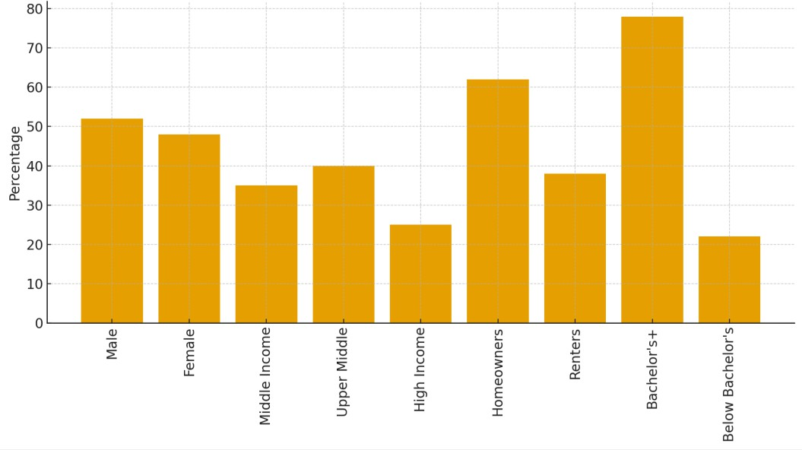

Figure 1: Sample Characteristics Distribution
Levels of education were significantly high, as 78% of the respondents had at least some level of education, which was a bachelor's degree and above. This becomes especially applicable due to the fact that the awareness, knowledge of sustainability certifications, and readiness to purchase environmentally friendly materials tend to be linked with education. The high level of education of a big percentage of the sample is an indicator that would lead to an increased probability of awareness when it comes to understanding of environmental impact and sustainable design trends. Consumer motivations are also contextualised by ownership of a house. Most of them, 62 per cent, were homeowners, and 38 per cent were renters. Long-term orientation is typically expressed more in homeowners who tend to spend more on durable materials that are long-lasting and sustainable,

like bamboo panels, low-VOC paints, and recycled wood products. On the other hand, rentiers tend to favour affordability and interim remedies, but their behaviour is also becoming more eco- conscious in terms of their lifestyles and, therefore, also generates some demand within the market. A combination of the attributes of the sample reveals that there is an emerging consumer environment in India, in which the growth of awareness, buying power and dreams of better living conditions are shaping material decisions.

Awareness and Preferences
The results show that there is a high but uneven awareness of sustainable materials among Indian consumers. Nearly 86 per cent of them said that they had heard the term sustainable materials, which indicates that the word sustainability is now a mainstream term. Nevertheless, the percentage of those who could recognise particular instances correctly was only 54, which means that awareness is not always profound and is not supported by any insight. Sustainability as perceived by many consumers meant simply being eco-friendly without necessarily being standardised certification, impact on the life cycle or even material-based criteria.
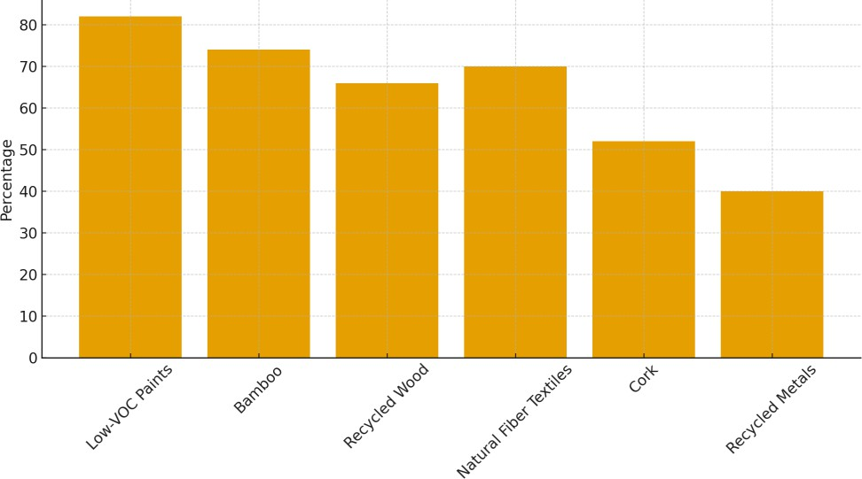

Figure 2: Consumer Awareness of Sustainable Materials
In the discussion of the knowledge of particular material, low-VOC (Volatile Organic Compound) paints were the most recognised sustainable ones (82%), then bamboo (74%), then recycled wood (66%). The materials have become known to people because of the growing availability of them in the market, through the press and painting firms marketing the actions to achieve healthier indoor air quality. According to 70% of the consumers, natural fibre textiles (cotton, jute, hemp)

were also considered sustainable, which is also the traditional familiarity of these materials in India.
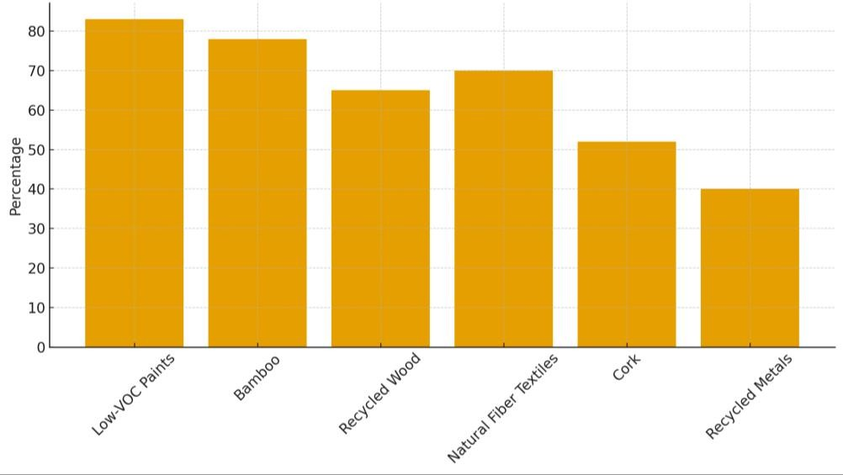

Figure 3: Consumer Preferences for Sustainable Materials
Preference ratings show that consumers are willing to make high rates of adoption of sustainable materials in their future renovations. Low-VOC paints, bamboo, natural fibre textiles, recycled wood, cork, and recycled metal products are the most favoured materials (83, 78, 70, 65 and 52 per cent). It means that there is high customer orientation towards the materials with attributes of familiarity, aesthetics, and perceived health benefits. Less popular materials (e.g. cork) or ones that are seen as industrial (recycled metals) have lower preference rates.

Industry Adoption and Practices
Interviewing in the industry produced a multifaceted image of sustainable material implementation by interior designers, architects, and suppliers. Though a majority of interior designers (68 per cent) stated that they had used some sustainable material in their most recent projects, the rate of adoption is clustered around more readily available products like low-VOC paints, FSC Certified wood. They are not only widely available but also possess more evident certifications that are safer and more convenient to choose from by professionals who are worried about performance, regulatory compliance, and client expectations.
Suppliers stated that only 36% could continuously give certified recycled materials, like recycled metal panels or composite recycled wood. Changes in supply are due to poor recycling

infrastructure, a small processing facility and difficulties in transporting them. Such limitations restrict the possibility of designers specifying such materials, although interest on their part may seem great among the consumers.
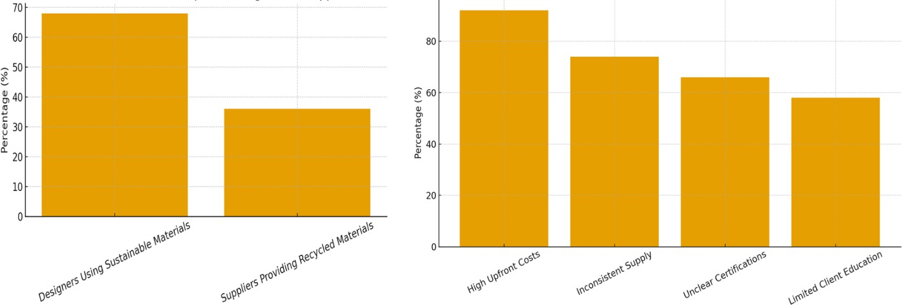

Figure 4: a) Sustainable Material Adoption: Designers Vs Suppliers; b) Key Barriers to Sustainable Material Adoption
The biggest impediment, which is reported by 92 per cent of the participants in the industry, is the increased upfront cost of sustainable materials. Although long-term benefits like life cycle, low impact on the environment are recognised, the advantage of long-term tends to be lower compared to short-term cost-effectiveness when it comes to meeting the priorities of clients. Also, 74 per cent indicated inconsistent supply, 66 per cent indicated unclear certification standards, and 58 per cent insisted that poor client education is a significant barrier.

Consumer Demand vs Industry Adoption
When comparing the preferences among consumers with the adoption of such products by the industry directly, it is possible to identify several gaps that are crucial and can be viewed as the result of the systemic barriers that the country is facing in terms of the large-scale implementation of sustainable interior materials. As the bar chart (created above) reveals, although consumers express a strong demand for such materials as low-VOC paints (83%), bamboo (78%), it is noteworthy that the industry is much less likely to adopt such materials, and bamboo (55%) and natural fibre textiles are the main ones (48%). Such disparity implies that, even though all consumers are willing to switch to more environmentally friendly materials, industry experts are limited in practice, such as the price or availability of a supply chain, and technological factors.

The closest correspondence between the desires of consumers (83) and company compliance (72) is low-VOC paints. This is an indication of their high market share, low costs, availability of manufacturing and regulatory regulations. The low-VOC products that manufacturers have massively marketed have been widely accepted by consumers, and their inclusion into interior design practice has become easier.
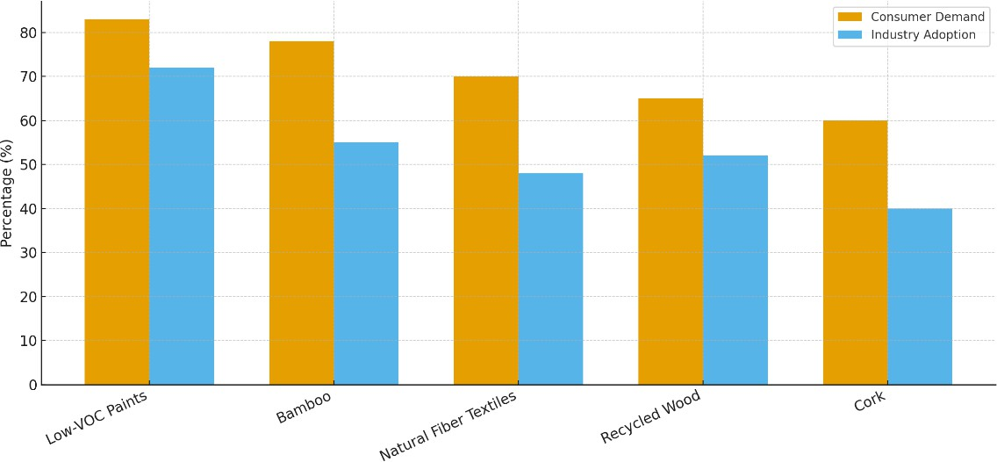

Figure 5: Consumer Demand Vs Industry Adoption of Sustainable Material
On the other hand, the bamboo (78% consumer vs. 55% industry) gap can be explained by the inconsistency of the quality, the fragmentation of the supply chains, as well as the absence of processing units in the Indian industries. Although bamboo products are popular as a renewable resource and a biodegradable resource, they cannot be produced in large quantities using standardised production methods with standardised systems to evaluate grades, which are factored in, yet are differently distributed.
A significant gap (70% consumer vs. 48% industry adoption) is also observed with natural fibre textiles. This is an indicator of difficulties in making sure it is durable, stain-resistant and moisture protective- functionality properties required in indoor use. Wood and cork that is recycled contain variable lapses, with cork experiencing the highest supply limitations through constrained production in the US.
Comprehensively, the gap analysis highlights the necessity of structural industry intervention, including better sourcing networks, governmental subsidies, certification standardisation, and awareness initiatives to mitigate industry practices with the changing consumer tastes.

Willingness to Pay and Predictors

The willingness-to-pay (WTP) analysis gives a more detailed analysis of the factors that affect consumer decision-making with respect to sustainable materials. Findings suggest that 44 out of 100 people will be ready to pay a premium of up to 10 per cent for sustainable materials, and 12 out of 100 will be ready to pay more than 20 per cent. This implies that there is an average yet good marketplace amidst premium environmentally friendly products, particularly among the highly-income groups with the environmentally conscious.
The results of the logistic regression analysis have shown that three factors were considered significant predictors of willingness to pay: education level, previous experience in using sustainable products, and the score of environmental concern. Higher education was also related to the odds ratio (Odd Ratio) of 1.8 (p < 0.01), which means that more educated respondents are almost twice as likely to invest in sustainable materials. Brutal sustainable products (OR 2.1, p < 0.01) experience turned out to be the best predictor, confirming that positive past experiences predispose more to adoption.
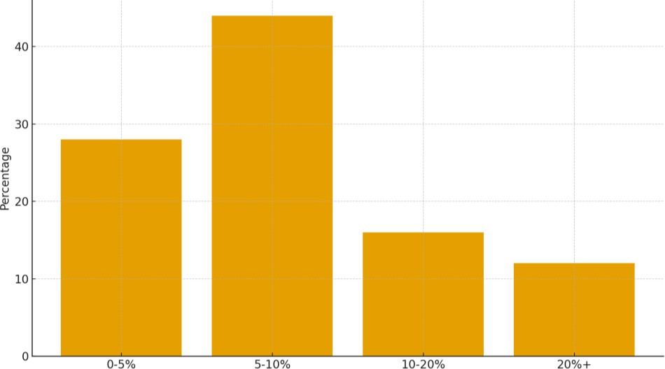

Figure 6: Willingness to Pay for Sustainable Materials
Another significant, albeit positive, effect on environmental concern score was also established (Odd Ratio 1.6 per unit increase, p < 0.05). This highlights the importance of pro-environmental attitudes and sustainability values in influencing consumer preferences. Surprisingly, the effect of income, in the process of controlling for education and environmental concern, indicated that it did not have any statistically significant impact on sustainability attitudes, implying that the influence of sustainability attitudes could override financial capability.

The results indicate the value of awareness, product trial and labelling transparency to increase consumer confidence and greater adoption despite increased price.

6. Conclusion
The results of this study prove that sustainable materials are in a pivotal but underutilised position in the Indian Interior Design Eco-system. While consumers show very strong environmental sensitivity and a preference for healthier and less impactful materials, their practical usage is limited due to structural, economic and informational barriers. The analysis clearly establishes that although awareness of sustainability terminology although actionable understanding is limited. This discrepancy adds to an addiction to well-known choices like low VOC paints, which have the benefit of well-established visibility within the regulator, brand promotion and powerful supply chains. In contrast, materials such as bamboo, natural fibres, cork and recycled composites encounter serious barriers such as inconsistent quality, absence of domestic processing infrastructure, supply volatility and lack of standardised testing or certification.
Industry professionals - who are an important part of material specification - are working in cost- sensitive environments that are not conducive to experimenting with premium or lesser-known sustainable materials. The impression of higher upfront costs, together with insufficient time series of performance data, reinforces conservative procurement patterns. Suppliers also point out that these gaps in the recycling and material recovery networks in India limit the availability of certified recycled inputs needed for the scale-up of sustainable interior products.
Despite these challenges, the study also sees great potential for growth. Logistic regression results show that education, environmental concern, and prior favourable experience have a significant positive association with willingness to pay, and the existence of a consumer base with the potential to expand markets if appropriately informed and provided with choices. Aligning this demand with industry capability requires concerted interventions: government subsidies to overcome cost premiums, standardised certification to build trust, simplified supply chains for natural and recycled materials and industry-focused training to increase designer confidence in sustainable specifications.
Overall, it is evident from the research that sustainable materials adoption in India does not lack interest, but is constrained systemically. Addressing these constraints by making institutional policy changes, restructuring markets, and educational outreach efforts can help significantly

accelerate the shift toward more healthy, ecologically responsible interior environments at a much faster rate.

Consent
As per international standards or university standards, respondents’ written consent has been collected and preserved by the author(s).

Disclaimer (Artificial intelligence)
Author(s) hereby declare that NO generative AI technologies such as Large Language Models (ChatGPT, COPILOT, etc.) and text-to-image generators have been used during the writing or editing of this manuscript.

References

  - Assad, I., Bhat, S. U., Gani, A., & Shah, A. (2020). Protein-based packaging of plant origin: Fabrication, properties, recent advances and future perspectives. International Journal of Biological Macromolecules, 164, 707. Elsevier BV. https://doi.org/10.1016/j.ijbiomac.2020.07.140
  - Chaudhuri, B., & Roy, C. (2017). Regeneration of Forest Resources Based on Tribal Enterprise: An Approach towards an Eco-Friendly Environment. E-Cadernos CES, 28. https://doi.org/10.4000/eces.2735
  - Chen, A. J. W., Boudreau, M., & Watson, R. T. (2008). Information systems and ecological sustainability. Journal of Systems and Information Technology, 10(3), 186. https://doi.org/10.1108/13287260810916907
  - Gelderman, C. J., Schijns, J. M. C., Lambrechts, W., & Vijgen, S. (2021). Green marketing as an environmental practice: The impact on green satisfaction and green loyalty in a business‐to‐business context. Business Strategy and the Environment, 30(4), 2061. https://doi.org/10.1002/bse.2732
  - Peattie, K., & Crane, A. (2005). Green marketing: Legend, myth, farce or prophesy? Qualitative Market Research: An International Journal, 8(4), 357–370.
https://doi.org/10.1108/13522750510619733
  - Joardar, S. D., Neog, A., Parvez, S., Kirtania, S., Kashyap, S., & Banerjee, S. (2022). Micromechanics-based finite element analysis of effective elastic properties of natural fiber reinforced composites. Journal of Natural Fibers, 19(17), 15790. https://doi.org/10.1080/15440478.2022.2134265
  - Singh, R. K., Garg, S. K., & Deshmukh, S. G. (2010). The competitiveness of SMEs in a globalized economy: Observations from India. Management Research Review, 33(1), 54–65.
https://doi.org/10.1108/01409171011011562

  - Singh, R. K., Garg, S. K., & Deshmukh, S. G. (2010). The competitiveness of SMEs in a globalized economy: Observations from India. Management Research Review, 33(1), 54–65.
https://doi.org/10.1108/01409171011011562
  - Joshi, Y., & Rahman, Z. (2015). Factors affecting green purchase behaviour and future research directions. International Strategic Management Review, 3(1–2), 128–143.
https://doi.org/10.1016/j.ism.2015.04.001
  - Mayakkannan, R. (2019). A Study on Green Marketing Practices in India. Emperor International Journal of Finance and Management Research, 5(4), 1. https://doi.org/10.35337/eijfmr.2019.5401
  - Mazumder, D., Sarkar, J., Gayari, R., Ahmed, I. S., Ali, M., & Nath, S. K. (2023). Physico-chemical characterization and qualitative analysis of phytochemicals present in food additives derived from Sesamum indicum, Brassica nigra plant wastes and Cocos nucifera husk. International Journal of Ecology and Environmental Sciences, 50(1), 131. https://doi.org/10.55863/ijees.2024.3152
  - Mokha, A. K. (2017). Green Marketing: A Study of Consumer Perception on Using Eco-Friendly Products. Asian Journal of Research in Business Economics and Management, 7(8), 298. https://doi.org/10.5958/2249-7307.2017.00146.3
  - Prajapati, H., Tevatia, A., & Dixit, A. (2022). Advances in Natural-Fiber-Reinforced Composites: A Topical Review. Mechanics of Composite Materials, 58(3), 319. https://doi.org/10.1007/s11029-022-10033-2
  - Rawat, G., & Pande, M. C. (2024). Adoption of Green Marketing Strategies and Challenges in Sustainable Business Practices: Insights from Indian Companies. Journal of Corporate Governance Insurance and Risk Management, 11(2), 98. https://doi.org/10.56578/jcgirm110202
  - Singh, A., Rajput, V. D., Rawat, S., Sharma, R., Singh, A. K., Kumar, P., Singh, A. K., Minkina, T., Singh, R. P., & Singh, S. (2022). Geoinformatics and Nanotechnological Approaches for Coping Up Abiotic and Biotic Stress in Crop Plants. In Advances in Plant Stress Physiology (pp. 337). Wiley. https://doi.org/10.1002/9781119808565.ch17
  - Goyal, P., & Rahman, Z. (2015). Green marketing in India: Emerging opportunities and challenges. Journal of Global Responsibility, 6(1), 1–14.
https://doi.org/10.1108/JGR-03-2014-0005
  - B Hayles, C. S. (2015). Environmentally sustainable interior design: A snapshot of current supply of and demand for green, sustainable or Fair Trade products for interior design practice. International Journal of Sustainable Built Environment, 4(1), 100-108.
https://www.sciencedirect.com/science/article/pii/S2212609015000138

