Development of Atom Teaching Aids Made from Recycled Materials in Constructing Student Knowledge

.
ABSTRACT

This study was conducted to develop teaching aids for atomic and molecular material. The use of teaching aids is expected to improve students' knowledge. This study used a research and development method. The development model used was the ADDIE model (Analyse, Design, Develop, Implementation, and Evaluate). The research was conducted from June to August at the Chemistry Education Laboratory, Indonesian Christian University. The teaching aids were implemented in the teaching of atomic structure at State Senior High School 48 in Jakarta. The results of the development show that the teaching aids received good to very good ratings from experts. In addition, testing on a small group showed that the teaching aids could be used effectively. Furthermore, implementation in the classroom showed an increase in student knowledge. Statistical analysis showed a significant difference, indicating that learning with the aid of teaching aids had a positive impact on student learning outcomes or knowledge (p<0.005). The conclusion of this study is that the teaching aids developed were rated good to very good, and that the teaching aids can help students construct knowledge about atomic structure, as indicated by the increase in student knowledge. Learning using teaching aids made from recycled materials can be an innovation for further research. The use of recycled materials will foster environmental awareness among students and teachers. Learning using recycled materials contributes to waste reduction and can facilitate schools with limited resources.

Keywords: Teaching aids, atomic materials, knowledge construction, research and development, ADDIE models, Used Papers, Used Crayons

1. INTRODUCTION
High school students' ability to understand atomic and molecular structure material is still low. Students' low understanding of atomic concepts is due to their inability to build their knowledge of chemical bonds between atoms that form molecules. The study found that 27% of students did not understand the concepts and 20% had misconceptions about atomic material (Nufus and Silfianah, 2023). In addition, the average score for atomic concepts and chemical bonds was 58.68 (low category) (Nugraha et. al., 2024).
Students' low comprehension skills in understanding atomic and molecular theory are due to the abstract nature of the material and the difficulty of visualising it directly. Concepts such as atomic structure, interatomic bonds, and molecular formation are often only presented through verbal explanations or chemical symbols (Rizal et al., 2024), making it difficult for students to construct a complete picture of the knowledge. Chemistry works on three levels of representation, namely macroscopic (visible phenomena), submicroscopic (atoms, molecules, ions), and symbolic (formulas, equations, diagrams). Learning difficulties and misconceptions often arise because students are not helped to connect these three levels. Students only memorise symbols and formulas without understanding what happens to particles (Salame, Krauss, and Suleman, 2022). Therefore, a learning medium in the form of atomic and molecular teaching aids is needed to help students construct their knowledge more concretely. Through the use of teaching aids, students can observe, manipulate, and understand the relationships between particles visually and kinesthetically, so that the learning process becomes more meaningful, interactive, and able to increase their understanding of atomic and molecular concepts more deeply (Musahidin et al., 2022).
Chemistry teaching aids on atoms and molecules help students construct knowledge by transforming abstract concepts into concrete representations, thereby improving understanding and retention. Research in journals shows a significant increase in students' conceptual understanding and metacognitive awareness. The use of teaching aids can enable 63.6% of students with learning difficulties to reach the informed level (understanding the internal structure of atoms), with significantly better results than the traditional control group (Girón-Gambero and Franco-Mariscal, 2023). The use of teaching aids enables students to better connect prior knowledge with new concepts (e.g., the development of atomic theory, electron configuration, cation/anion formation), so that concepts are not merely memorised but truly reconstructed by students.

2. material and methods
This research was conducted in Juni-August 2025 at the Chemistry Education Laboratory, Indonesian Christian University and SMA Negeri 48 Jakarta. The research began with the development of chemistry teaching aids in July 2025 at the Chemistry Education Laboratory, Indonesian Christian University. The aids developed were teaching aids on the subject of atomic and molecular structure, using recycled paper materials. The teaching aids developed were then used in science lessons at senior high school level. Learning activities using the teaching aids were conducted in August at SMA Negeri 48 Jakarta.

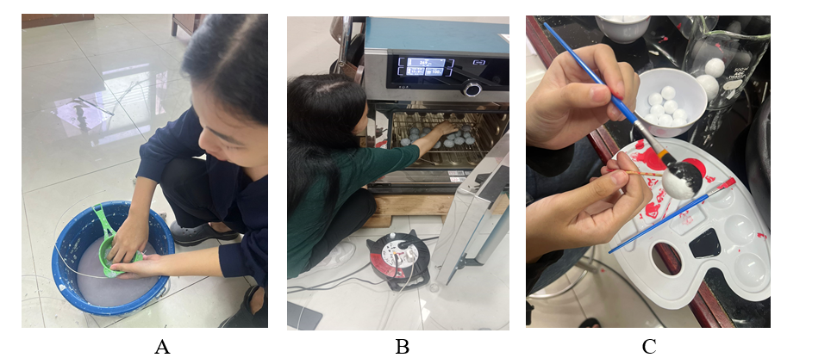
Figure 1. Production of atoms and molecules using recycled paper as raw material (A), formation of atom-molecule balls and drying process (b), and colouring of atom-molecule balls (c)

This study utilised a research and development (R&D) method. It developed teaching aids on the concepts of atoms and molecules using recycled paper, toothpicks, wire, and used crayons. The teaching aids were developed starting from the stage of analysing student needs, to designing the teaching aids and developing them for use in learning. The developed tools were applied in learning. The research model used is the ADDIE model (Analyse, Design, Develop, Implementation, and Evaluation).
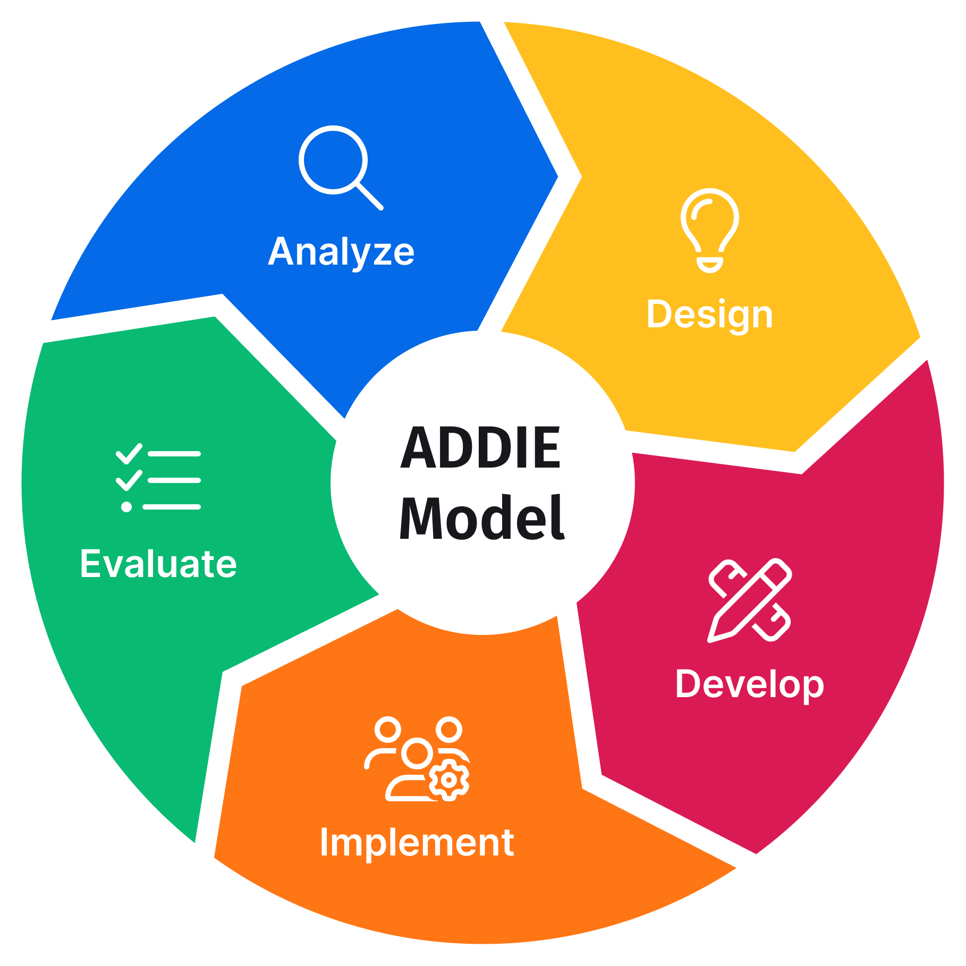

Figure 2. ADDIE Models Diagrm (Source: SessionLab)

Table 1. Description of the ADDIE Model Stages
No. | Stage | Activity Description
1 | Analyze | The analysis stage involves conducting interviews and surveys with students and teachers regarding chemistry material that students find difficult to understand, as well as the need for and availability of learning media.
2 | Design | During the design stage, atomic and molecular models were created, along with the tools and materials to be used. Recycled paper and used crayons were used to make the teaching aids.
3 | Develop | During the development stage, the team developed teaching aids using the tools and materials provided. The tools developed underwent expert testing and small group testing before being used in class.
4 | Implement | During the implementation stage, the impact of the teaching aids on improving student knowledge was measured.
5 | Evaluate | Each stage is evaluated

This study aims to develop chemistry teaching aids, particularly for atomic and molecular material. The development of atomic and molecular modelling helps to construct students' knowledge and provides a realistic representation of atomic and molecular structures. The instruments used in this study are a needs analysis instrument, media justification by subject matter and media experts, a user assessment instrument, and a student knowledge instrument. The indicators used in each instrument are as follows:
Table 2. Indicators in the Instrument as Research Parameters
Need Assesment
No | Dimention | Indicators
1. | Conceptual Material Requirements | Students' difficulty in understanding the concepts of molecules and interatomic bonds.
1. | Conceptual Material Requirements | The level of abstraction of atomic and molecular material in learning.
1. | Conceptual Material Requirements | The need for visualisation of atomic and molecular structures in the learning process.
2. | Availability and Utilisation of Teaching Aids | Availability of atomic and molecular teaching aids in schools.
2. | Availability and Utilisation of Teaching Aids | Level of utilisation of existing teaching aids in learning.
2. | Availability and Utilisation of Teaching Aids | Suitability of available teaching aids to the applicable curriculum.
3. | Characteristics of Required Teaching Aids | The need for teaching aids that are easy to use by teachers and students.
3. | Characteristics of Required Teaching Aids | The need for teaching aids that clearly illustrate the structure of atoms and molecules.
3. | Characteristics of Required Teaching Aids | The need for teaching aids that are affordable to produce.
4 | Teacher Readiness | Teachers' readiness to use teaching aids in learning
4 | Teacher Readiness | Teachers' willingness to integrate teaching aids into learning
Expert Judgement
1 | Design and Visualization | The attractiveness of the design of the teaching aids.
1 | Design and Visualization | The clarity of shapes and colours in representing atoms and molecules.
2 | Function and Practicality | Ease of use by teachers and students.
2 | Function and Practicality | Ease of assembly and disassembly of teaching aids.
2 | Function and Practicality | Flexibility of use in various learning models.
2 | Function and Practicality | Clarity of instructions for using teaching aids.
3 | Technical and Security Aspects | The strength and durability of recycled materials.
3 | Technical and Security Aspects | The stability of teaching aids when in use.
3 | Technical and Security Aspects | The safety of teaching aids for students.
4 | Innovation and Suistainability | Innovation in the use of recycled materials as learning media.
4 | Innovation and Suistainability | Ease of obtaining recycled raw materials.
4 | Innovation and Suistainability | Environmental education value (eco-literacy).
4 | Innovation and Suistainability | Cost efficiency in the manufacture of teaching aids.
5 | Pedagogical Suitability | The suitability of teaching aids to the characteristics of students.
5 | Pedagogical Suitability | The support of teaching aids for active and collaborative learning.
5 | Pedagogical Suitability | The ability of teaching aids to increase learning motivation.
5 | Pedagogical Suitability | The potential for repeated use in learning.
User’s Judgement
1. | Ease of Use | The teaching aids are easy to use without intensive assistance from teachers.
1. | Ease of Use | The instructions for using the teaching aids are easy to understand.
1. | Ease of Use | The components of the teaching aids are easy to assemble and disassemble.
1. | Ease of Use | The teaching aids are comfortable to use during learning.
2. | Visual Clarity and Representation | The shape and colour of the teaching aids help students understand atoms and molecules.
2. | Visual Clarity and Representation | The visualisation of the teaching aids makes it easier to understand interatomic bonds.
2. | Visual Clarity and Representation | The size of the teaching aids is easy for students to observe.
3. | Interest and Motivation to Learn | Teaching aids make learning more interesting.
3. | Interest and Motivation to Learn | Students are more active in asking questions and participating in discussions.
3. | Interest and Motivation to Learn | Teaching aids increase students' curiosity.
3. | Interest and Motivation to Learn | Students are motivated to follow the lesson until it is finished.
4. | Conceptual Understanding | Models help us understand atomic structure.
4. | Conceptual Understanding | Models help us understand how molecules are formed.
4. | Conceptual Understanding | Models help reduce confusion about abstract concepts.
4. | Conceptual Understanding | Models help us relate concepts to everyday life.
5. | Safety and Comfort Aspects | The teaching aids are safe to use in class.
5. | Safety and Comfort Aspects | There are no parts that could harm students.
5. | Safety and Comfort Aspects | The recycled materials do not interfere with learning.
5. | Safety and Comfort Aspects | The teaching aids remain stable when in use.
Cognitive Instrument
1. | Factual Knowledge | Define atoms and molecules.
1. | Factual Knowledge | Identify the particles that make up atoms (protons, neutrons, electrons).
1. | Factual Knowledge | State the charge and location of subatomic particles.
1. | Factual Knowledge | State the symbols of simple chemical elements.
1. | Factual Knowledge | Identify examples of atoms and molecules in everyday life.
2 | Conceptual Knowledge | Explain the differences between atoms, elemental molecules, and compound molecules.
2 | Conceptual Knowledge | Explain the concept of interatomic bonds in simple terms.
2 | Conceptual Knowledge | Explain the relationship between atoms in the formation of molecules.
2 | Conceptual Knowledge | Explain the role of electrons in the formation of molecules.
2 | Conceptual Knowledge | Explain the structure of atoms based on simple atomic models.
3 | Procedural Knowledge | Classifying substances based on their types of atoms and molecules
3 | Procedural Knowledge | Assembling models of atoms and molecules using teaching aids
3 | Procedural Knowledge | Determining the number of atoms in a molecule
3 | Procedural Knowledge | Using models/teaching aids to explain the formation of molecules
3 | Procedural Knowledge | Interpreting images or models of atoms and molecules

3. results and discussion
Teaching aids are one of the learning media that can construct students' knowledge. By using teaching aids as learning media, students' cognitive, affective, and psychomotor competencies are well honed. Through touching the teaching aids, students will form new knowledge memories. The teaching aids developed in this study are atom and molecule teaching aids made from recycled materials. The use of recycled materials is a form of environmental awareness and can educate students on how to protect the environment by reducing waste and turning it into recycled goods. Atoms and molecules were chosen as the subject matter for the teaching aids because they are abstract basic concepts in chemistry. Students find it difficult to visualise the shape of atoms and the bonds between molecules. The concepts of atoms and molecules are microscopic and invisible, far from everyday experience, so students must imagine something they cannot see directly (Fanfiana and Hadisaputra, 2024). The research on the development of teaching aids used the Research and Development method with the ADDIE (Analyse, Design, Develop, Implementation, and Evaluation) model.

Analysis of Teaching Aids Based on Student and Teacher Needs (Analyze)
At this stage, researchers distributed questionnaires using survey and interview techniques to users, namely teachers and students. The instruments used in the needs analysis stage of the research included questions about the teaching aids needed, materials considered difficult, the availability of learning media, and teacher readiness (see Table 2). In addition, interviews were conducted with students and teachers during the analysis stage to examine the consistency between the responses of the two groups of respondents. The interview questions for students ranged from how learning takes place in the classroom, the use of learning media by teachers, and difficulties in learning chemistry, especially in the subject of atoms and molecules. Meanwhile, interviews with teachers ranged from the process of learning chemistry, the challenges of being a chemistry teacher, the learning media used, and the readiness of teachers to use chemistry teaching aids.
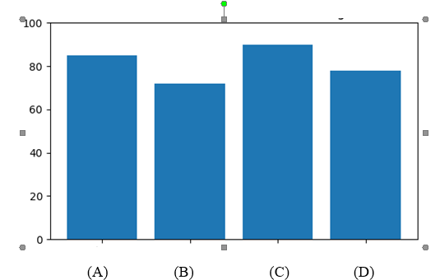
Figure 3. Needs Analysis Chart, values of material needs (A), availability and use of media and teaching aids (b), characteristics of teaching aids needed (c), teacher readiness (d)

From the results of the needs analysis, it was found that atomic and molecular material is one of the most difficult subjects, with a need for this material at 85% compared to other subjects. The availability and use of media and teaching aids in learning is in the adequate category (70%); teachers do not use teaching aids much, preferring to use media such as PowerPoint and videos (during the learning process. The results of the needs analysis show that students need teaching aids that can support cognitive, affective, and psychomotor skills (90%). The results of the needs analysis assess that teachers, in terms of knowledge, skills, and experience, are capable of using and operating teaching aids to support student knowledge (80%). The development of chemistry teaching aids is important to be carried out in accordance with the needs of students and teachers. Concrete teaching aids help reduce the abstract nature of concepts so that the material is easier to understand and more interesting for students (Prihatiningtyas and Putra, 2018). In science/physics, simple teaching aids can be an alternative to practical work when laboratories/standard equipment are limited and still produce high learning outcomes (Surya et. al., 2021).

Designing Teaching Aids (Design)
Following the analysis of requirements, the next stage is to design teaching aids made from recycled materials. The steps involved in this design process are as follows:
1. The materials used to represent atoms, molecules, electrons, protons and neutrons are paper. The paper is shredded and made into a pulp. It is then shaped into balls and dried or baked in an oven. The paper used is waste paper that is no longer needed for learning purposes. Atomic model teaching aids made from recycled materials meet the needs of chemistry education in Indonesian schools as they are low cost, environmentally friendly, and easy to make from everyday waste such as paper or styrofoam. These needs include simple materials to represent protons, neutrons, electrons, and interatomic bonds (Hanifah et. al., 2022).
2. The dried paper balls are then coloured using used crayons. Colouring is used to distinguish between atoms (e.g. carbon atoms are red and hydrogen atoms are green), as well as to distinguish between electrons (green), protons (orange), and neutrons (red).
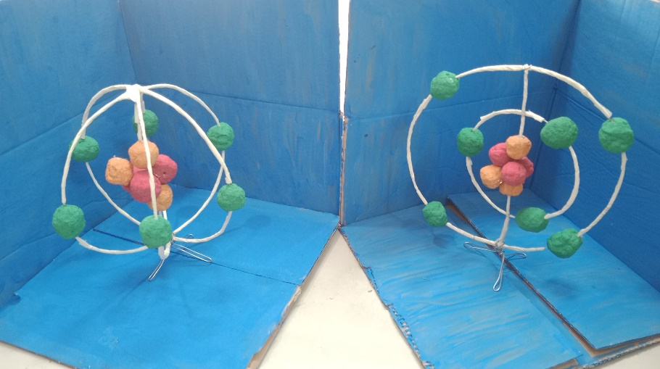
Figure 4. Atomic Structure Modelling

3. The orbital path or inter-atomic bond connector is made of wire and coated with used paper.
4. After that, a manual book is created on the use of teaching aids in atomic and molecular modelling. The manual book is intended for teachers and students in using teaching aids. The manual book outlines the learning objectives, materials, and steps for using the manual book. The manual book is important in product development because it serves as a guide for students to conduct practical work independently. Textbooks/manuals serve as a source of information and a means of applying theory to practice, while also stimulating creative thinking and problem solving (Khachaturyan and Ghalachyan, 2023).

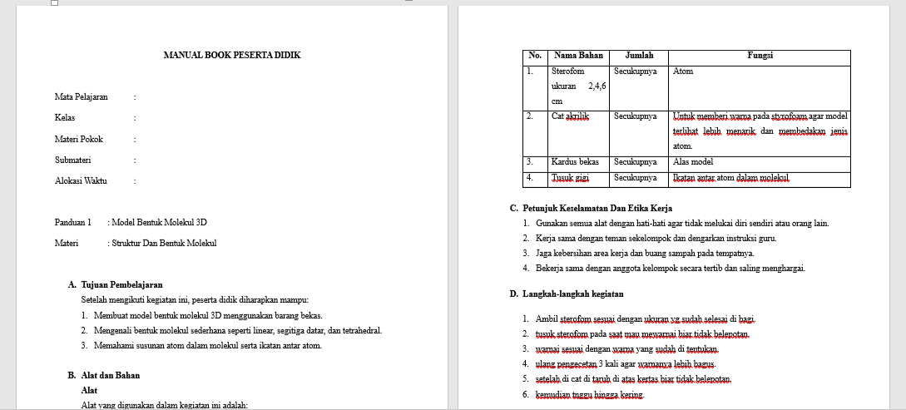
Figure 5. Manual Book

Developing Atomic And Molecular Teaching Aids Tools Using Recycled Materials (Development)
The development stage involves developing tools and testing them on experts and a limited number of users. At the development stage, teaching aids are developed in accordance with the predetermined design. In addition, a manual and student worksheets are also created. The manual is used as a guide for using the teaching aids (see Figure 5). Meanwhile, the worksheets are used as material for reporting student performance and assessment in using the teaching aids. The worksheets contain blank tables that must be filled in by students. In addition, the worksheets contain questions that guide students to construct their knowledge through the use of teaching aids. Student worksheets (LKPD) are important for providing guidance in the thinking pattern stage regarding atomic and molecular material. In addition, LKPD serves as evaluation material for student abilities. Student worksheets (LKPD) in practical work are very important for guiding students to follow structured procedures, collect data, and draw independent conclusions. This tool improves students' understanding of concepts, scientific process skills, and learning activities in subjects such as science and chemistry. Its use has been proven effective in various Indonesian educational studies (Safitri et. al., 2019). LKPD guides students in collecting and analysing experimental data, thereby avoiding practical work that merely follows a recipe without conceptual understanding (Mahrawi, Usman, and Setiani, 2021). LKPD fosters responsibility, discipline, creativity, and the ability to work in groups and independently, which improves learning achievement to the point where 100% of students achieve the minimum passing grade. In addition, LKPD emphasises laboratory safety and critical thinking, making practical work more enjoyable and effective (Astriani, 2021).
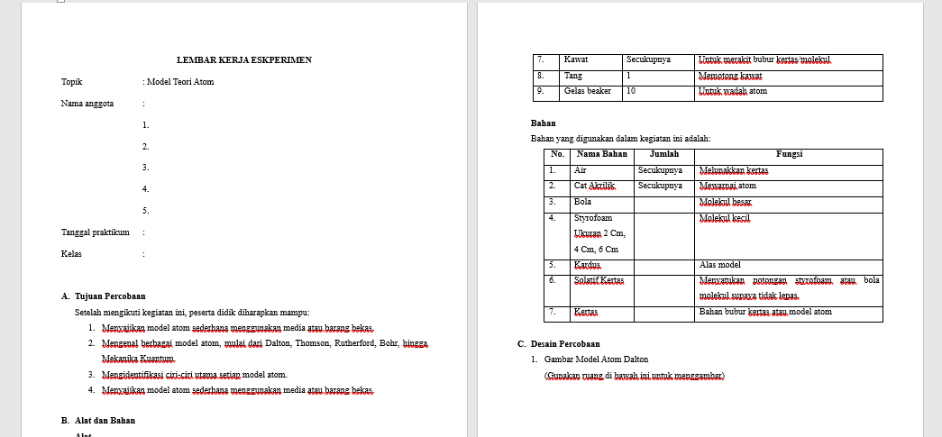
Figure 6. Student Worksheet (LKPD)
The teaching aids developed in this study are atomic and molecular balls made from recycled materials. These recycled materials consist of recycled paper, used crayons, used paper straws, and wire.
1. Atomic structures such as protons, electrons, and neutrons are made from recycled paper. Used paper is soaked in water, then shaped into balls. The paper is then dried in an oven for 24 hours.
2. Prepare used crayons, then melt them with a mixture of water over a Bunsen burner to obtain dye from the crayons.
3. The dried paper is then painted using the dye from the used crayons.
4. To create examples of interatomic bonds and orbital paths, use wire coated with used paper straws or recycled paper.
5. Each component is assembled and put together.

Feasibility and Experts Tests
In the development stage using the ADDIE model, in addition to developing teaching aids, the results of the teaching aids that have been developed are also assessed. This stage is divided into two parts, namely assessment by experts and user testing by students and teachers. Testing by experts involves assessing the concept and anatomy of the teaching aids to determine whether they are in accordance with chemistry science and support chemistry learning, particularly in the subject matter of atoms and molecules. In the assessment by the expert and user teams, an instrument or questionnaire is used to assess the teaching aids, which uses dimensions that measure the teaching aids and their use in learning. The dimensions and indicators used in the assessment can be seen in Table 2. The results of the expert testing can be seen in the following graph:

Figure 7. Experts Feasibility Test Results

Based on the feasibility test results (see Figure 7), the design and visualisation as well as innovation and sustainability scores were 80 (in the good category). When compared to digital learning media, the design and visualisation of teaching aids are still in the simple category. However, the advantage of teaching aids is that they can be touched by hand (hands-on) and involve many senses compared to digital media. Manual teaching aids are easier for students to understand and help tutors explain abstract atomic material in a coherent manner (Erlina, Prayekti, and Wicaksono, 2022), humanise the material (Baptiste and Abramovich, 2024), and are also more inclusive than digital forms (Yu et. al., 2023). In terms of innovation and sustainability, the teaching aids developed are not as sophisticated as their digital counterparts, but the use of teaching aids made from recycled materials is a promising breakthrough for the future in reducing waste and supporting the SDGs (Sustainable Development Goals). The creation and use of media/crafts from recycled materials trains design creativity, problem-solving, and manual skills (Prayoga, 2022). In students, the use of educational teaching aids made from recycled materials significantly improves cognitive development (pre-post test scores increase significantly) (Surya et al., 2021). For schools with limited funds, this is very helpful in procuring a variety of teaching aids without incurring large costs (Rukmana et al., 2025).
In terms of functionality and practicality, it scored 85 (in the good category). Teaching aids are easier to use than other learning media. The use of teaching aids is more practical and easier to operate than digital media. These easy-to-use teaching aids will be more memorable for students than digital media, which requires more understanding (Pagels, Eschke, and Luedtke, 2024). In terms of technical and safety aspects as well as pedagogical suitability, it scored 87 (in the very good category). This shows that the teaching aids are safe to make and use and that the teaching aids developed are in line with the learning of atoms and molecules. Teaching aids allow molecules to be visualised in three dimensions, so that students can visualise the arrangement of atoms and understand the previously abstract geometry of molecules (Mursida, 2020). Physical 3D molecular models, such as 3D printed examples, transform material that previously had low gain into medium gain (Răzvan-Ștefan, Nicoleta, and Mihășan, 2025).

User Test
User testing was conducted after expert testing, followed by revisions based on expert input. The teaching aids were then evaluated by teachers and students. One chemistry teacher and six students participated in the evaluation. The results of the user testing are shown in the following graph:
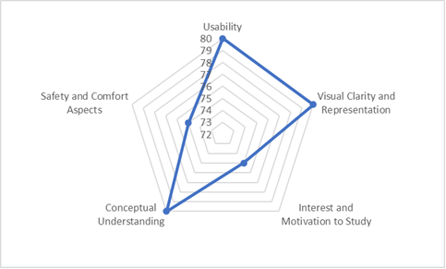
Figure 8. Users Test Result

The graph (Figure 8) shows that the user test results indicate a score of 75 (fairly good) for safety of use, learning motivation, and interest. This indicates that the use of teaching aids can make students interested in learning and understanding atoms and chemical bonds in molecules. This is reinforced by the results of interviews with teachers, which show that learning by using digital teaching aids made from recycled materials is innovative. The school has teaching aids, but they are not made from recycled materials. These teaching aids will be useful. The results of the student interviews show that students are very happy using this teaching aid because it is easy to use. Students also experience new learning with the teaching aid, especially since it is made from recycled materials.
When using teaching aids, all students became very enthusiastic because their level of learning activity and learning knowledge increased significantly compared to learning without teaching aids (Septi, Riani, and Karangmulya, 2023). In learning, almost all students stated that learning with teaching aids was more fun and not boring compared to lectures alone (Pane et al., 2022). Meanwhile, in terms of material clarity, usage, and knowledge comprehension, the score was 80 (good). Teaching aids can illustrate abstract material, allowing students to visualise chemical bonds, atomic shapes or structures, and how electrons orbit the nucleus. The use of 3D-based tools makes molecular geometry, which was previously only visible on paper, into a clear spatial form; this can produce a much more accurate and detailed image of the molecular structure after 3D intervention compared to the traditional 2D group (Alharbi, 2025). 3D molecular visualisation software allows students to build basic geometry, view electron density, and match 3D structures with line formulas, thus facilitating the translation from symbols in books to actual spatial forms (Phankingthongkum and Limpanuparb, 2021). The use of teaching aids makes it easier to understand the concepts of atoms and molecules than traditional learning. Materials consistently improve learning outcomes because abstract concepts are made visible, tangible, and directly experiential (Kristina, 2021).

Application in Learning (Implementation)
Atomic and molecular teaching aids play an important role in supporting science learning, as these aids make it easier for students to visualise abstract concepts or those that cannot be observed directly. By using atomic models, molecular models, or three-dimensional visual media, students are able to visualise the arrangement, structure, interactions between particles, and so on, clearly and more realistically. Atomic and molecular teaching aids play a crucial role in chemistry learning because the material is abstract, so physical visualisation helps students understand the concepts concretely. This can particularly improve conceptual understanding and also develop students' active participation in the teaching and learning process. Furthermore, atomic and molecular teaching aids enable the development of curiosity, train scientific thinking skills, and reduce misconceptions about basic chemistry concepts. Thus, the use of appropriate teaching aids with material characteristics will be very effective in improving the quality and effectiveness of learning.
Apart from serving to visualise abstract concepts, atomic and molecular teaching aids also become contextual learning media that support the various learning styles of students. Students who tend to have visual and kinesthetic learning styles will grasp the material more quickly when they can see, touch, and manipulate atomic and molecular models directly. The use of teaching aids also encourages more active and collaborative learning, for example through group discussions, simple experiments, or molecular modelling activities, so that students do not just passively receive information.
On the other hand, atomic and molecular teaching aids can increase students' motivation and interest in learning, as the learning process becomes more interesting and relevant. If these tools are made from simple or recyclable materials, teaching aids can also foster creativity, environmental awareness, and problem-solving skills. With guidance from teachers who can integrate teaching aids into appropriate learning methods, students can gradually build their understanding of concepts, connect theory with real-life phenomena, and develop a scientific attitude that is very important in the process of learning science. In this study, teaching aids on atoms and molecules were used in chemistry lessons. In chemistry learning, pre-tests and post-tests were conducted to assess students' level of knowledge in understanding chemistry material, specifically on atoms and molecules, which were integrated using teaching aids. The dimensions used to measure students' knowledge were factual, conceptual, and procedural (see Table 2). A total of 34 students participated in this study. The results are as follows:
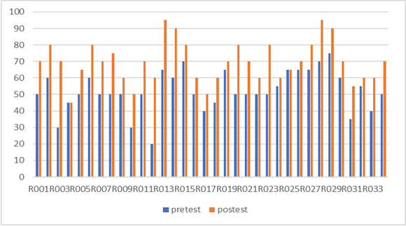
Figure 9. Students' Pre-test and Post-test Scores Before and After Using Teaching Aids

The research results graph (Figure 9) shows a comparison of the pretest and posttest scores of students (R001–R034), which generally shows an increase in learning outcomes after learning using teaching aids. Almost all students experienced an increase in their post-test scores compared to their pre-test scores, as indicated by the post-test bars (orange) being higher than the pre-test bars (blue). This improvement varied among students, but the pattern was generally consistent, indicating that the learning intervention implemented—for example, the use of atomic and molecular teaching aids—had a positive impact on students' understanding of the concepts. Some students showed a significant improvement, especially those in the low to moderate initial score group, indicating that the learning process helped improve their basic understanding. Overall, this graph reinforces that the learning process was effective in improving student learning outcomes.
After the learning process, the post-test results showed more stable and higher progress, with some students even achieving near-maximum scores. This indicates that the learning method using teaching aids was effective in overcoming the initial understanding gap among students. Significant improvement was seen in students with low pretest scores, showing that learning had a major influence in helping students understand basic concepts that were previously difficult to comprehend. On the other hand, students who obtained moderate to high pretest scores also experienced improvement, although not as strong as the lower group.
Overall, the upward trend in scores from the pretest to the posttest for almost all students indicates that the learning approach used, including the use of atomic and molecular teaching aids, was successful in improving learning outcomes. This graph also shows that learning not only improved the average scores of students, but also played an important role in balancing the understanding of concepts among all students. By using teaching aids, students constructed the knowledge they acquired.

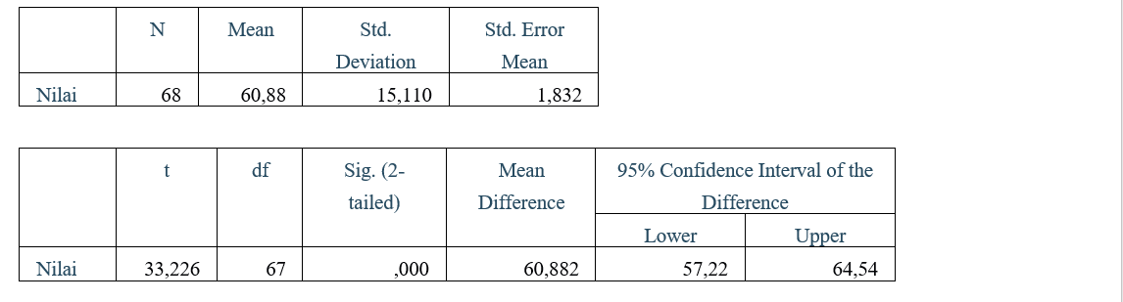
Table 3. Statistical Test Results

Based on the statistical analysis results shown in the table 3, a sample size of 68 data points was obtained with a mean value of 60.88, a standard deviation of 15.11, and a standard error of the mean of 1.83. The t-test results show a t-value of 33.226 with a degree of freedom (df) of 67 and a significance value (Sig. 2-tailed) of 0.000 (< 0.05). This value indicates that there is a very significant difference between the conditions before and after learning. In addition, the mean difference value of 60.88 with a 95% confidence interval range of 57.22 to 64.54 shows that the increase that occurred was consistent and not caused by chance factors.
These findings indicate that the use of atomic and molecular teaching aids has a significant effect on improving students' understanding (Azzahra, 2025). Teaching aids help students visualise abstract concepts so that information is not only received verbally but also processed through more concrete learning experiences. Thus, students do not merely memorise concepts but are able to actively connect, interpret, and construct new understandings. This shows that teaching aids not only improve learning outcomes quantitatively but also play an important role in helping students construct knowledge, in line with the principles of constructivist learning.
The results of statistical analysis showing a significant increase in learning outcomes after the use of atomic and molecular teaching aids can be strongly linked to the development of students' factual, conceptual, and procedural knowledge dimensions. In terms of factual knowledge, teaching aids help students recognise and remember basic facts, such as the names of the particles that make up atoms, element symbols, molecular shapes, and types of chemical bonds. Concrete visualisation makes factual information easier to understand and remember, thereby reducing errors or initial misconceptions that often occur in microscopic material.
In terms of conceptual knowledge, teaching aids play an important role in helping students understand the relationships between concepts, such as the relationship between atomic structure, electron configuration, and molecule formation. Through atomic and molecular models, students can see first-hand how these concepts are interrelated, rather than learning them separately. This is in line with a consistent increase in post-test scores, as students are able to build a more complete and meaningful understanding of abstract concepts.
Meanwhile, in the procedural knowledge dimension, the use of teaching aids trains students to understand the steps or processes in learning about atoms and molecules, such as how to assemble molecular models, determine the type of bond, or simulate interactions between particles. These activities encourage students to learn through direct experience (learning by doing), so that they not only know what and why, but also how a concept is applied. Thus, the use of teaching aids has been proven to not only improve conceptual understanding but also support students' ability to construct knowledge comprehensively in all three dimensions of knowledge.
The findings of the study show that physical models and teaching aids transform abstract concepts into visual and manipulative representations, allowing students to see, hold, and change models to construct their own meaning (Maharani, Wati, and Hartini, 2017). The concepts of atoms, ions, and molecules are highly abstract, difficult to observe directly, and often become a source of misconceptions when taught only through lectures (Diannisa et al., 2023). In other findings, the use of molecular shape teaching aids improved chemistry learning outcomes; learning completeness increased by 33% from cycle I to II, and students reported that it was easier to remember and understand 3D molecular shapes (Mursida et al., 2020). Learning using atomic and molecular teaching aids allows students to actively construct knowledge through the visualisation of abstract concepts such as atomic structure, chemical bonds, and molecular shapes, in line with the constructivist approach where students build understanding from direct experience. Other research shows that 3D models made from waste wood and worksheets increased high school students' learning outcomes by up to 92% mastery, as students independently designed models of ionic, covalent, and molecular geometry bonds. Other findings reveal that modelling with simple teaching aids (such as balls and chalk for Dalton, Thomson, and Bohr models) improves understanding of atomic structure concepts from 65.20 (cycle I) to 75.47 (cycle II) with an n-gain of 0.30 (moderate), as well as metacognitive awareness from 63.02 to 76.25 (n-gain 0.35). This approach is effective because students reflect, discuss in groups, and connect new knowledge with existing schemas, thereby reducing passive memorisation (Fatmawati, 2023).

In-Process Evaluation (Evaluation)
The research developed atomic and molecular teaching aids using recycled materials. There are several points for evaluation in this research. When making connections or examples of bonds, it is difficult to bend them with other parts. In the research, more respondents were used in the user testing stage, involving other teachers so that they could provide perspectives from other sides. In addition, learning with teaching aids must be better controlled, especially in terms of following the steps in the manual and worksheets, as some students did not follow them.

4. Conclusion
Based on the results of the study, it can be concluded that the use of atomic and molecular teaching aids has been proven effective in supporting science learning. The teaching aids developed were able to help students understand abstract concepts more concretely, resulting in a significant increase in learning comprehension before and after learning. Statistical analysis shows a significant difference, indicating that learning with the aid of teaching aids has a positive impact on student learning outcomes or knowledge (p<0.005).
In addition to improving understanding, teaching aids also play a role in helping students construct knowledge in the factual, conceptual, and procedural dimensions. Students are not only able to recognise basic facts and terms, but also understand the relationships between concepts and apply learning procedures through direct activities. Thus, atomic and molecular teaching aids are suitable for use as effective and innovative learning media to improve the quality of science learning and support a more active, meaningful, and constructive learning process.

Ethical Approval:
As per international standards or university standards written ethical approval has been collected and preserved by the author(s).

Disclaimer (Artificial intelligence)
Author(s) hereby declare that generative AI technologies such as Large Language Models, etc. have been used during the editing of manuscripts. This explanation will include the name, version, model, and source of the generative AI technology and as well as all input prompts provided to the generative AI technology
Details of the AI usage are given below:
1. Consensus for literature
2. Preplexity for literature
3. Deepl for Translation

References
Alharbi, A. (2025). Cognitive learning approach to improve molecular geometry visualisation in chemical compounds by university students: A case study in Saudi Arabia. Journal of Radiation and Applied Science Research. https://doi.org/10.1016/j.jrras.2024.101283.
Astriani, D., Nurita, T., Rosdiana, L., F, A., Hidayati, S., & M, R. (2021). Virtual Laboratory-Based Student Worksheets: Efforts to Optimise Science Practicals during the Pandemic. SEJ (Journal of Science Education). https://doi.org/10.21070/sej.v5i2.1611.
Azzahra, St Fatimah. The Role of Chemistry Teaching Materials and Learning Resources in Building Students' Knowledge Construction. Asian Research Journal of Arts & Social Sciences, 2025, 23 (10), pp. 220-235. ⟨hal-05334769⟩
Baptiste, Y., & Abramovich, S. (2024). Community College Students' Perceptions of Digital Anatomy Models as Curricular Resources. Anatomical Sciences Education, 17, 1731 - 1748. https://doi.org/10.1002/ase.2523.
Diannisa, N., Erlina, E., Harun, A., Sahputra, R., & Ulfah, M. (2023). Description of Conceptual Understanding of Atomic Structure Material in Grade X at Ngabang State Senior High School 01. Hydrogen: Journal of Chemistry Education. https://doi.org/10.33394/hjkk.v11i4.8091.
Erlina, N., Prayekti, P., & Wicaksono, I. (2022). Atomic Physics Teaching Materials in Blended Learning to Improve Independent Learning Skills in Distance Education. Turkish Online Journal of Distance Education. https://doi.org/10.17718/tojde.1182747.
Fanfiana, R., Hadisaputra, S., & , S. (2024). Identification of Student Misconceptions Using a Three-Level Test on the Concepts of Atoms, Ions, and Molecules. Chemistry Education Practice. https://doi.org/10.29303/cep.v7i1.6133.
Fatmawati. (2023). Development of molecular structure teaching aids to support science learning. Biopedagogia, 5(2), 171–182. https://doi.org/10.21831/biopedagogia.v5i2.4620
Girón-Gambero, J., & Franco-Mariscal, A. (2023). “Atomizados”: An Educational Game for Understanding Atomic Structure. A Case Study with Year 9 Students Experiencing Difficulties in Learning Chemistry. Journal of Chemical Education. https://doi.org/10.1021/acs.jchemed.2c00614.
Hanifah, F. N., Widianingtyas, H. N., Kartini, I., & Kartika, T. (2022). Processing styrofoam waste into 3D molecular models as a basis for developing the creative economy of the community. Enviros: Journal of Environmental Engineering, 2(2).
Khachaturyan, V., & Ghalachyan, А. (2023). TEXTBOOKS AS A MEANS TO ENHANCE THE LEARNING PROCESS. Scientific Bulletin. https://doi.org/10.24234/scientific.v1i44.48.
Kristina, F. (2021). SYSTEMATIC REVIEW OF THE EFFECT OF USING TEACHING AIDS TO IMPROVE STUDENTS' LEARNING OUTCOMES IN SCIENCE SUBJECTS AT PRIMARY SCHOOLS. Handayani Journal. https://doi.org/10.24114/jh.v12i2.34253.
Maharani, M., Wati, M., & Hartini, S. (2017). Development of Teaching Aids on Work and Energy Material to Train Science Process Skills Through the Guided Inquiry Discovery Learning (IDL) Model. , 5, 351-367. https://doi.org/10.20527/bipf.v5i3.4043.
Mahrawi, Usman, & Setiani, A. R. (2021). Development of biology e-modules as teaching materials on cell topics. JUTECH: Journal of Education and Technology, 2(2), 1–13. https://journal.stkippgrada.ac.id/jurnal/index.php/jutech/index
Mursida, S. (2020). The Effect of Using Balloons as Teaching Aids in Learning Molecular Structure Material on Learning Outcomes and Student Activities in Class X MIPA 1 at SMA Negeri 3 Kotabumi in the 2018–2019 Academic Year. , 10, 35–41. https://doi.org/10.47637/eksponen.v10i2.288.
Musahidin, M., Muhali, M., Asy’ari, M., & Sukaisih, R. (2022). Improving Students' Conceptual Understanding and Metacognitive Awareness of Atomic Structure Material Through Modelling. Journal of Authentic Research. https://doi.org/10.36312/jar.v1i1.637.
Pagels, L., Eschke, R., & Luedtke, K. (2024). The Effectiveness of Digital and Analogue Learning Methods in Teaching Anatomical Structure in Physiotherapy Education. BMC Medical Education, 24. https://doi.org/10.1186/s12909-024-05484-1.
Pane, J., Nainggolan, A., Nainggolan, J., Silaban, B., & Tumanggor, R. (2022). Increasing Students' Interest and Learning Outcomes in Physics through Tutoring Using Electrical Circuit Teaching Aids. PaKMas: Journal of Community Service. https://doi.org/10.54259/pakmas.v2i1.818.
Phankingthongkum, S., & Limpanuparb, T. (2021). A virtual alternative to molecular model sets: a beginners’ guide to constructing and visualising molecules in open-source molecular graphics software. BMC Research Notes, 14. https://doi.org/10.1186/s13104-021-05461-7.
Prayoga, K. (2022). Creation of Baris Dance Sculptures Using Recycled Cardboard. Journal of Fine Arts Education Undiksha. https://doi.org/10.23887/jjpsp.v12i1.43445.
Prihatiningtyas, S., & Putra, I. (2018). The effectiveness of using simple teaching aids based on a community science and technology approach in static fluid material. Journal of Physics Education Research and Studies. https://doi.org/10.12928/jrkpf.v5i2.10988.
Putri, C., & Prabowo, P. (2020). Development of Simple Hydraulic Teaching Aids as a Medium for Physics Learning on Pascal's Law for Grade XI Students at Kesamben State High School, Jombang. IPF: Physics Education Innovation. https://doi.org/10.26740/ipf.v9n3.p551-554.
Nufus, S., & Silfianah, I. (2023). Analysis of Students' Misconceptions on Atomic Structure Using a Pictorial-Based Five-Tier Multiple Choice Diagnostic Test. Orbital: Journal of Chemistry Education. https://doi.org/10.19109/ojpk.v7i2.19239.
Nugraha, A., Sinaga, M., Sutiani, A., Darmana, A., & Aini, N. (2024). Analysing the Difficulties Students Face in Comprehending Fundamental Concepts in the Field of Atomic Structure and Chemical Bonds in the Basic Chemistry Course. Proceedings of the 5th International Conference on Innovation in Education, Science, and Culture, ICIESC 2023, 24 October 2023, Medan, Indonesia. https://doi.org/10.4108/eai.24-10-2023.2342094.
Răzvan-Ștefan, B., Nicoleta, P., & Mihășan, M. (2025). Impact of 3D‐printed molecular models on student understanding of macromolecular structures: a compensatory research study. Biochemistry and Molecular Biology Education, 53, 358–369. https://doi.org/10.1002/bmb.21902.
Rizal, W., Widhiyanti, T., & Islahiah, N. (2024). Multi-representation Analysis of General Chemistry Books on Chemical Bonding Subject. Orbital: Journal of Chemistry Education. https://doi.org/10.19109/ojpk.v8i1.21609.
Rukmana, S., Fitriana, I., Kusuma, P., Jovita, N., Muchlis, M., Putri, S., Kusuma, D., , P., Octaviani, N., Ardelia, C., , C., Ramadhan, I., Febriyanti, I., Utomo, M., & Fahmi, M. (2025). Hydroponic Pakcoy Cultivation Using Recycled Materials: An Innovative Urban Farming Solution to Support Family Food Security. SEWAGATI: Indonesian Journal of Community Service. https://doi.org/10.56910/sewagati.v4i3.3161.
Safitri, M., Helendra, H., Selaras, G., & Sumarmin, R. (2019). The Practicality of Biology Experiment Worksheets Oriented Towards Science Process Skills for Grade XI High School Students in Semester 1. Bioilmi: Journal of Education. https://doi.org/10.19109/bioilmi.v5i2.4668.
Salame, I., Krauss, D., & Suleman, S. (2022). Examining learning difficulties and alternative conceptions students face in learning about hybridisation in organic chemistry. International Journal of Chemistry Education Research. https://doi.org/10.20885/ijcer.vol6.iss2.art4.
Septi, H., Riani, M., & Karangmulya, M. (2023). The Effect of Using Teaching Aids on the Learning Interest of Grade 5 Students in Science Education at MI Islamiyah Babakan. La-Tahzan: Journal of Islamic Education. https://doi.org/10.62490/latahzan.v15i1.382.
Surya, S., Bachtiar, M., Herlina, H., & Saodi, S. (2021). The Effect of Using Educational Puzzle Teaching Aids Made from Recycled Materials on the Cognitive Development of Children in Kindergarten. Journal of Early Childhood Education. https://doi.org/10.23960/jpa.v7n2.22750.
Yu, J., Kim, J., Liu, J., Mangal, U., Ahn, H., & Cha, J. (2023). Reliability and time-based efficiency of artificial intelligence-based automatic digital model analysis system. European Journal of Orthodontics. https://doi.org/10.1093/ejo/cjad032.

