Interconnecting Socioeconomic Inequalities, Informal Markets, and Livelihood Systems: A Review of Sustainable Development Pathways in India

Abstract
Sustainable development in India is a result of a complex mix of structural socioeconomic inequalities, market dynamics, and diverse livelihood systems. Although the country has experienced continuous economic growth, significant disparities still exist among social groups, regions, and employment structures that determine who has access to opportunities and who can withstand economic shocks. This study discusses and integrates literature results on the impact of education, gender, and social identity inequalities that are compounded by the informal market structures and employment patterns in determining sustainable development outcomes. It also sets out the significant role of economic participation through informal and community-level markets in the face of precarious livelihoods with income instability and inadequate social protection. Moreover, it considers the contributions of policy institutions, social protection mechanisms, and inclusive growth strategies toward reducing vulnerability and enhancing resilience.
By integrating research and evidence from four tightly interlinked areas, structural inequalities, market systems, livelihood dynamics, and institutional pathways, this review develops a holistic framework for understanding sustainable development challenges in India. The results reveal a strong demand for multi-dimensional, inclusive, and context, specific policy approaches that would simultaneously tackle inequality, market participation, and livelihood security as the keys to the progress of sustainable development. This study adopts a systematic narrative review approach, synthesizing peer-reviewed literature across development economics, labour studies, and policy research to develop an integrated conceptual framework.

Keywords: Sustainable development; Socioeconomic inequalities; Informal markets; Livelihood systems; Inclusive growth; India

- Introduction
India’s sustainable development has been a long-term result of the intricate interplay of deep structural socioeconomic inequalities, different types of market environments, and a wide array of livelihood systems (Chatterjee, 2021). Rapid economic growth periods notwithstanding, huge disparities in development have remained at the forefront of issues between regions, social groups, and sectors determining the extent to which individuals and communities can access markets, accumulate human capital, and have stable livelihoods (Raman et al., 2025; Turaga et al., 2018; Singh et al., 2024; Kumari et al., 2023). These disparities point towards development pathways in India being not only uneven but also dependent on deeply rooted institutional and social constraints, rather than economic performance as such. Socioeconomic inequalities that have their roots in education, gender, caste, tribal identity as well as spatial exclusion, continue to hamper people’s access to opportunities and thus keep them stuck at the lower levels of the social ladder (Choudhury et al, 2023). Inequality in education and labour market outcomes are the main factors behind the continued income and employment security gaps especially among the traditionally marginalized groups (Garg et al., 2022; Pandoh & Singh, 2025). These inequalities determine labour participation patterns and the capacity of households to absorb and recover from shocks both economic and social.
Markets in India are segmented in a similar way and characterized by a high level of informality (Agrawal et al., 2022). Village markets, small scale units, and informal service sectors constitute a very critical role in the livelihood of the poor especially in rural and semi-urban areas while these sectors are usually work under conditions of high uncertainty and very little support from institutions (Choithani et al., 2021; Mustofa, 2025). These market arrangements determine the type of work people can get and thus influence uneven levels of income stability in different households. Livelihood systems are still largely dependent on informal employment where wages are mostly unstable and social protection coverage is very limited. On top of that, vulnerability in employment and limited labor market mobility continue to be a major factor in household strategies thus deepening livelihood insecurity even in periods of economic growth (Abraham & Kesar, 2025; Mehta & Awasthi, 2022; Jha & Mishra, 2022). These situations also overlap with the existing structural inequalities thus exacerbating the development problems in the long run.
Amid the major changes, policy and institutional frameworks took a lead role in directing the sustainable development results. When they work well, social protection mechanisms, inclusive growth strategies, and financial inclusion initiatives not only enhance people’s resilience but also their ability to participate (Drze & Khera, 2017; Faishal, 2025). The present study combines the research throughout four largely interrelated fields structural inequalities, market systems, livelihood dynamics, and institutional pathways to give a comprehensive picture of how these different elements together influence sustainable development in India.
- Review Methodology
This research employs a systematic narrative literature review method to integrate current studies on socioeconomic disparities, market frameworks, livelihood systems, and sustainable development in India. Academic databases like Scopus, Web of Science, and Google Scholar were used to identify peer-reviewed journal articles, policy reports, and institutional publications. Keywords encompassed mixtures of “socioeconomic disparities,” “informal economies,” “livelihood frameworks,” and “sustainable growth in India.” Research was chosen for its relevance, scholarly quality, and thematic consistency, emphasizing new literature in conjunction with essential foundational studies. The chosen studies were examined thematically to create a cohesive conceptual framework that connects inequalities, markets, livelihoods, and policy institutions (Table 1 & Fig-1).
Table 1: Conceptual Synthesis of Socioeconomic Inequalities, Market Dynamics, Livelihood Systems, and Sustainable Development in India
Thematic Area | Core Mechanisms | Key Evidence Pathways | Implications for Sustainable Development
Structural Socioeconomic Inequalities | Education gaps, gender disparities, caste and tribal exclusion, regional imbalances | Unequal access to human capital formation, limited mobility, persistent poverty and social exclusion | Constrains inclusive growth, weakens intergenerational mobility, slows progress toward equitable and sustainable development
Market Structures and Informal Economies | Informal market participation, local trading systems, microenterprise constraints, limited financial access | Market segmentation, income volatility, weak integration with formal value chains | Limits livelihood resilience, reinforces inequality, restricts productivity growth in local economies
Livelihood Systems and Employment Patterns | Informal employment, skills mismatch, seasonal work, mobility-based livelihoods | Employment vulnerability, income insecurity, limited upward mobility | Increases livelihood risk, weakens household resilience, undermines long-term development outcomes
Policy Institutions and Inclusive Growth Strategies | Social protection systems, financial inclusion, decentralised governance, institutional coordination | Risk mitigation, enhanced participation, improved access to services and opportunities | Strengthens sustainable development pathways, reduces inequality, supports inclusive and resilient growth
Note. This table synthesizes the four core thematic areas reviewed in the paper and highlights the mechanisms through which structural inequalities, market structures, livelihood systems, and policy institutions interact to shape sustainable development outcomes in India.
Figure 1. Conceptual framework linking socioeconomic inequalities, market structures, livelihood systems, and sustainable development outcomes in India.
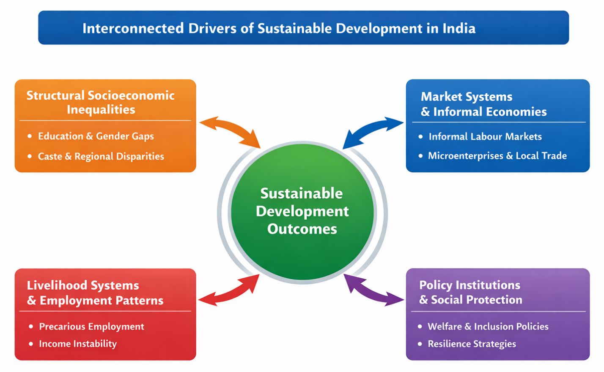
Note. The figure illustrates the interconnected and mutually reinforcing relationships between structural inequalities, market dynamics, livelihood systems, and policy institutions in shaping sustainable development outcomes.
- Structural Socioeconomic Inequalities and Human Development Barriers in India
Structural socioeconomic inequalities continue to characterize the development landscape of India and have been at the very center of human development outcomes. These inequalities have been entrenched over time by the historical, social, and institutional foundations of society and affect the shareholders in various ways such as their access to education, employment, healthcare, and public services. Though there have been overall improvement in indicators, disparities among caste groups, tribal populations, genders, and regions still remain, thus resulting into multiple barriers for the formation of capabilities and economic participation (Coffey et al., 2019; Garg et al., 2022). Education remains one main factor of inequality. Although more children go to school, there are still big differences in learning outcomes, dropout rates, and access to higher education. These differences are very much related to the household's economic condition, location, and social identity and eventually lead to unequal readiness for the labor market and different earning potentials in the long run (Garg et al., 2022). Women, as a group, are disproportionately held back from realizing their full human development potentials due to their lower labour force participation, occupational segregation, and persistent wage gap in different regions and sectors (Pandoh & Singh, 2025; Bala, 2025).
Besides, caste and tribal background influence developmental disadvantages through the way they govern access to resources, markets, and political representation. Indeed, marginalized communities are usually the ones with limited access to quality infrastructure, public services, and job opportunities. For instance, they are largely experiencing the shortage of such things which are made available only to the people living geographically near the centers of the regions. Such regional disparities also reinforce these patterns because the districts with less administrative capacity and lower public investment are the ones that usually suffer from the lowest levels of human development (Coffey et al., 2019). Besides, these structural inequalities have direct implications for sustainable development.
Unequal access to education and employment makes it more difficult for families to withstand crises, increases their vulnerability and limits the possibility of social and economic mobility of the next generations. Moreover, inequality reduces the overall impact of development initiatives as the marginalised groups are often the ones who have the least capacity to take advantage of the available opportunities. If we add to this consideration the fact that financial exclusion is even making these issues more difficult by preventing households from further investing in education, health, or production, then the extent of the problem becomes clearer (Faishal, 2025). Therefore, socioeconomic inequality is a key issue to be discussed when broader patterns of market participation and livelihood outcomes are analyzed. Not only do structural disparities determine the distribution of income but also the ability of individuals and communities to contribute to sustainable development processes in the long run.
- Market Structures, Informal Economies, and Community-Level Economic Participation
Market structures in India are very diverse and still largely beholden to informal economic arrangements. A substantial portion of economic activity takes place outside the formal regulatory frameworks, especially in rural areas, tribal regions, and semi urban settlements. Informal markets serve as the main access points for trade, employment, and consumption; they enable households to participate in economic activities even if they have little access to formal institutions (Choithani et al., 2021). Nevertheless, such markets remain subject to the risks of volatility, limited scale, and lack of protection.
Local markets and community level trading systems are indeed crucial for providing the necessary means of sustenance, especially in areas that are geographically isolated and have poor infrastructure. Markets in tribal and rural areas are vital hubs for the trade of agricultural products, locally produced goods, and daily necessities. However, while these markets are instrumental in generating incomes and fostering social cohesion, their linkages to larger value chains are still very weak, thus limiting both income growth and the ability to withstand shocks (Kenye & Faishal, 2025). Besides, the lack of access to finance, market information, and institutional support poses even greater limitations to the productivity of small traders and producers. This characterization of informality is consistent with foundational studies on India’s informal economy, which emphasize its structural persistence, deep social embeddedness, and central role in employment and survival strategies rather than its transitional nature (Harris-White, 2010; NCEUS, 2009).
Urban and peri urban informal markets show a different pattern of participation. They employ a large number of technically skilled, semi-skilled, and unskilled laborers excluded from formal employment. Besides this, they provide flexibility, at least, in terms of time and location and can be used to smooth consumption, thus ensuring survival. However, they are characterized by irregular earnings, long working hours, and limited bargaining power of the workers. Care work, which is part of these informal markets, is prone to demand and supply factors. Thus, fluctuation in demand, as well as the supply of care workers, leads to the vulnerability of livelihood (Sahu & Behera, 2025a; Sahu & Behera, 2025b). Participation in the market is also influenced by gender and social norms. Women's participation in informal markets is mainly through low return activities, with limited opportunities for expansion. Apart from these structural barriers such as lack of access to credit, assets, and networks limit their ability to reap the benefits of market participation (Sahu & Behera, 2025b). These trends further contribute to the persistence of income disparities and give the existing framework of socioeconomic inequalities a new lease of life.
As a whole, the nature and operation of markets constitute a major factor shaping sustainable development outcomes. Informal and local markets provide essential venues for the livelihood of the population. They, however, come with a lot of limitations in terms of the insulation of the motives and lack of institutional support for raising the level of mobility. Solutions to these problems must involve policies that create stronger local markets, facilitate access to finance and infrastructure, and allow informal economic actors better integration into the general developmental processes.
- Livelihood Systems, Employment Patterns, and Vulnerability in a Transforming Economy
India’s livelihood systems essentially depend on the kind of employment opportunities available, the ways in which households manage their problems, and the overall economic changes. A major portion of the working population is still involved in the informal sector where wages are not stable and workers have little or no access to social security. Labour market transitions are thus limited, as it is typical for workers to switch from one form of informal work to another instead of moving up to a stable formal job, hence, vulnerability and income insecurity become a regular feature (Abraham & Kesar, 2025; Mehta & Awasthi, 2022). However, casual and seasonal work, and small-scale local trading/working for oneself basically account for the vast majority of jobs both in rural and urban areas. Productivity and efficiency are quite low. On the one hand, educational levels have been on the rise, but on the other hand, skills mismatches still obstruct access to good jobs. A lot of workers don't have the kind of training that meets the labour market requirement of the future, which, in turn, limits their options for changing jobs and results in underemployment (Bhattacharya, 2023; Sangtam & Faishal, 2025).
Livelihood diversification is the most common way people manage risks in their lives. Most people even combine multiple income generating activities e. g. transport services, small retail trade, or household-based enterprises to stabilize their earnings. The strategies that they use may help them cope in the short term, but they dont really offer long term security. Operations that are dependent on mobility like the informal service sector employment, for example, and thus, very sensitive to demand fluctuations and regulatory uncertainty, workers might suddenly lose their whole income (Konyak & Faishal, 2025). Urban labour markets provide workers with the possibility of earning more, but at the same time, migrant and informal workers still face problems concerning housing, documentation, and social exclusion. Those barriers, therefore, exclude people from better jobs, and also limit their access to essential services, thus losing out on the benefits of urbanization. On the other hand, technological changes as well as the growth of platform-based work are modifying the job situation. Even though these changes allow for new livelihood opportunities, they bring with them, nevertheless, new insecurities of gig work and contractual instability (Mehta & Awasthi, 2022).
The link between work and livelihood vulnerability has a major impact on sustainable development. If people do not have stable incomes, families find it difficult to spend on their health, education, and assets for production. Hence, solving employment problems and stabilizing livelihoods should be among the key elements of the strategies for Indias inclusive and sustainable development. ".
Figure 2. Pathways linking structural inequality, market participation, livelihood vulnerability, and sustainable development outcomes in India.

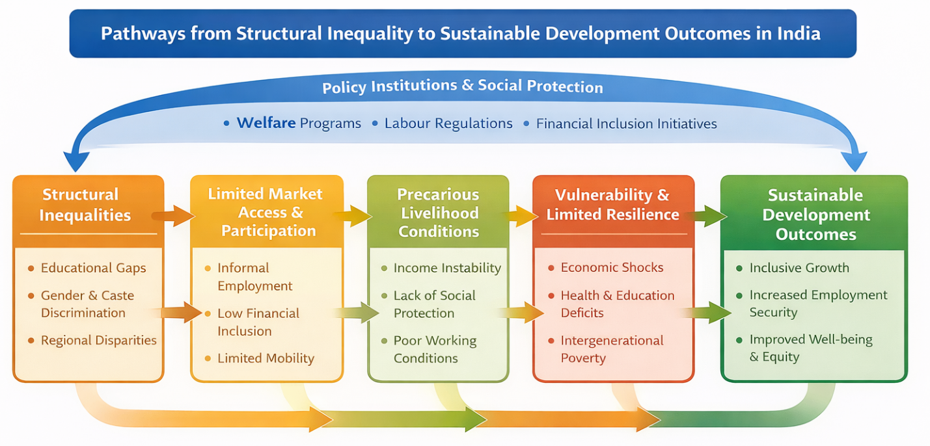
Figure 2 summarizes how structural socioeconomic inequalities affect sustainable development outcomes in India. Unequal distribution of wealth and power influences people’s ability to get jobs and sell products, which eventually controls how stable, vulnerable, and resilient their livelihoods are. Government bodies and social security measures act as a intervention means of these different stages and have either of the two potentials to reduce or exacerbate current inequalities.
- Sustainable Development Pathways through Policy Institutions, Social Protection, and Inclusive Growth Strategies
Policy institutions and governance frameworks have a very significant impact on the ways in which socioeconomic inequalities, market forces, and livelihood systems lead to environmental, economic, and social development outcomes in India. Markets and households through their everyday economic activities contribute to economic growth along with public institutions, which play a role in distributing opportunities, managing risks, and the inclusiveness of growth processes. Hence, sustainable development hinges not only on economic growth but also on the efficiency of policy formulation and the capacity of institutions (Turaga et al., 2018; Raman et al., 2025). Social protection systems are an indispensable part of the strategy that India is pursuing for its development. Employment schemes, food security programs, health cover facilities, and direct cash transfers to individuals can potentially help low income families to maintain their consumption levels and thus reduce their vulnerability. If such measures are well targeted and successfully rolled out, they can increase the capacity of people to withstand shocks and facilitate human capital development, especially for informal and low-income workers (Drze & Khera, 2017). Nevertheless, their total influence is still being curtailed by lack of coverage, administrative inefficiencies, and patchy local level implementation.
Inclusive growth strategies have more and more been stressing financial inclusion, decentralised governance, and institutional coordination. Giving more people and microenterprises access to formal financial services means they will be able to better manage the risk, work on the productive activities, and have steady consumption over time. Therefore, financial inclusion measures have become an important lever to tackle the root causes of inequality and to improve the livelihoods of the small entrepreneurs and the informal workers living sustainably (Vo et al., 2021; Faishal, 2025). Besides that, a good governance is the one that, among other things, ensures the right inputs and conditions at the local level: Policy coherence is still a major hurdle to the progress of sustainable development. Uncoordinated interventions in the labour, education, infrastructure, and social welfare sectors may exacerbate the fragmentation of the outcome if the actions are not mutually reinforcing. The integrated policy approaches that deal with inequality, market participation, and livelihood security at the same time have a higher probability of resulting in lasting development gains (Raman et al., 2025).
In fact, the success of India’s sustainable development scenarios largely hinges on the capacity of institutions to be flexible in the face of changing social and economic situations. Building up institutional coordination, enhancing accountability, and opening up participation to all are necessary conditions for getting equitable and sustainable results from policy measures.
- Policy and Regulatory Implications
Synthesizing structural inequalities, market dynamics, and livelihood systems sheds light on the necessity of an integrated policy approach for Indias sustainable development. Alone, interventions in education, markets, or employment, even if targeted, are unlikely to bring about enduring changes. Sustainable development outcomes, therefore, need to be achieved through coordinated policies that take account of the ways in which social inequalities limit market participation and how they determine the exposure of livelihood to risks (Turaga et al., 2018; Raman et al., 2025). Making a dent in the deeply embedded structural socioeconomic inequalities requires keeping human development at the core through the continuous provision of education, health, and skill development. Apart from just widening the doors, the policies should also concentrate on enhancing the quality and suitability, so that even the disadvantaged ones can have the tools to enter the markets of the future and labour force evolution (Garg et al., 2022; Pandoh & Singh 2025). Programs that are responsive to gender and localized with respect to the needs of the area are absolutely necessary to close the divide and foster growth that is beneficial for everyone. Market oriented policies should be geared towards improving the performance and inclusiveness of informal and neighbourhood level markets. Local market changes such as upgrading the infrastructure, broadening the credit sphere, and making the market information more available can all help to boost the productivity and income stability of small traders and microenterprises. The phased and incentive-based formalization of the informal sector can minimize the risk exposure of the informal operators without tearing away the source of their survival (Sahu & Behera, 2025a; Kenye & Faishal, 2025).
Livelihood security should be at the core of development planning. Employment policies have to encourage better matching of skills with labour market requirements while also offering expanded access to stable and dignified work. Flexible social protection systems that are transportable and can respond to changes in employment are very helpful in decreasing the vulnerability of informal and mobile workers (Abraham & Kesar, 2025; Mehta & Awasthi, 2022). Institutional coordination is also vital for carrying out the policy intent that leads to sustainable development outcomes. A social protection, financial inclusion, and labour market policy alignment in a well-structured development framework can enhance effectiveness as well as accountability. Deepening decentralised governance and utilizing financial inclusion efforts can also be very productive in building resilience and fostering inclusive development paths (Vo et al., 2021; Faishal, 2025). This perspective aligns with the DFID Sustainable Livelihood Framework, which conceptualizes livelihoods as shaped by assets, vulnerability contexts, and institutional processes, thereby reinforcing the need for integrated policy responses to reduce risk and enhance resilience.
- Conclusion
Originally the review discussed various aspects of sustainable development in India. Among the main modes of the analysis were socioeconomic inequalities, market structures, livelihood systems, and policy institutions. The investigation reveals that the development of a society is not just a simple process of making the average income higher, but the inequalities between different social groups determine their level of education, employment, and other economic activities, thus indirectly affecting the general poor state of the environment in the society. Issues like gender, caste, and geographical inequalities still stand in the way of inclusive development and keep making it difficult for families to get out of their plight (Garg et al., 2022; Coffey et al., 2019). Furthermore, markets and livelihood systems are of utmost importance in explaining how this happens. Local markets and informal markets may be the only way for people from socially excluded groups to gain a foothold economically but, because these markets are broken up and don’t have strong institutions behind them, it is difficult for people there to get steady incomes and work their way out of poverty. It is only because people here try to use such strategies as working in the informal sector and having a number of different sources of income that they are able to get along day to day. However, they are at the same time quite vulnerable and do not feel emotionally secure (Choithani et al., 2021; Abraham & Kesar, 2025). Hence, these factors determine the pattern of inequalities existing today as well as how they will change in the future. These dimensions are not static; rather, they dynamically interact over time, with changes in one domain continuously reshaping market participation, livelihood strategies, and development outcomes.
Policy agencies are key players in dealing with these deep-rooted problems. When done right, social protection mechanisms, inclusive growth strategies, and financial inclusion initiatives can help people become resilient and reduce their vulnerabilities. Nonetheless their success relies on institutional coordination, being in line with local conditions, and a lasting political commitment (Turaga et al., 2018; Vo et al., 2021; Faishal, 2025). The results of this research indicate that for India to move forward with sustainable development, it needs integrated approaches that address inequality, market participation, and livelihood security at the same time. Research in the future should uncover more how these domains interact, especially under the impact of technological change, environmental stress, and demographic transitions (Raman et al., 2025). Bolstering these connections will become a requirement for making India's development trajectory a sustainable and inclusive one.
Disclaimer (Artificial intelligence)

The author(s) declare that generative artificial intelligence tools were used only for language editing and improving clarity of the manuscript. AI was not used for data collection, analysis, interpretation, or generation of scholarly content.

Details of the AI usage are given below:

1. ChatGPT (OpenAI), model: GPT-5.2

References
- Abraham, R., & Kesar, S. (2025). Trajectories of labour market transitions in the Indian economy. World Development, 195, 107029. https://doi.org/10.1016/j.worlddev.2025.107029
- Bala, S. (2025). The distribution of earnings among males and females: Evidence from India. Indian Journal of Labour Economics. https://doi.org/10.1007/s41027-025-00573-1
- Bhattacharya, J. (2023). Indian urban workers’ labour market transitions. Indian Journal of Labour Economics, 66, 471-494. https://doi.org/10.1007/s41027-023-00434-9
- Choithani, C., van Duijne, R. J., & Nijman, J. (2021). Changing livelihoods at India’s rural-urban transition. World Development, 146, 105617. https://doi.org/10.1016/j.worlddev.2021.105617
- Coffey, D., Deshpande, A., Hammer, J., & Spears, D. (2019). Local social inequality, economic inequality, and disparities in child height in India. Demography, 56(4), 1427-1452. https://doi.org/10.1007/s13524-019-00794-2
- Department for International Development (DFID). (1999). Sustainable livelihoods guidance sheets. London: DFID.
- Drèze, J., & Khera, R. (2017). Recent social security initiatives in India. World Development, 98, 555-572. https://doi.org/10.1016/j.worlddev.2017.05.035
- Faishal, M. (2025). The role of digital financial inclusion in microenterprise growth: Evidence from Kohima, Nagaland. South Asian Journal of Social Studies and Economics, 22(7), 135-143. https://doi.org/10.9734/sajsse/2025/v22i71068
- Harris-White, B. (2010). Work and wellbeing in informal economies: The regulative roles of institutions. World Development, 38(2), 170–183. https://doi.org/10.1016/j.worlddev.2009.10.005
- Garg, M. K., Chowdhury, P., & Kanchan, M. I. S. K. (2022). An overview of educational inequality in India: The role of social and demographic factors. Frontiers in Education, 7, Article 871043. https://doi.org/10.3389/feduc.2022.871043
- Kenye, R., & Faishal, M. (2025). Economic contributions of tribal markets in Nagaland: A Kohima-centric study. Journal of Current Social Issues Studies, 2(7), 47-56. https://doi.org/10.71113/JCSIS.v2i7.388
- Konyak, S. K., & Faishal, M. (2025). Navigating mobility and livelihoods: An empirical study of two-wheeler taxi services in Mon Town, Nagaland, India. Asian Journal of Economics, Business and Accounting, 25(6), 226-234. https://doi.org/10.9734/ajeba/2025/v25i61848
- Mehta, B. S., & Awasthi, I. C. (2022). Dynamics of urban labour market and informality. Indian Journal of Labour Economics, 65, 19-37. https://doi.org/10.1007/s41027-022-00354-0
- National Commission for Enterprises in the Unorganised Sector (NCEUS). (2009). The challenge of employment in India: An informal economy perspective. Government of India, New Delhi.
- Pandoh, A., & Singh, A. (2025). Examining wage inequality among women in India: A multidimensional analysis of socio-economic disparities. PLOS ONE, 20(4), e0320940. https://doi.org/10.1371/journal.pone.0320940
- Raman, R., Nair, V. K., Lathabai, H. H., & Nedungadi, P. (2025). Research on sustainable development in India: Growth, key themes, and challenges. Social Sciences & Humanities Open, 11, 101637. https://doi.org/10.1016/j.ssaho.2025.101637
- Sahu, P. R., & Behera, D. K. (2025). Assessing the nature and determinant of informal employment in India. Discover Global Society, 3, 86. https://doi.org/10.1007/s44282-025-00239-9
- Sahu, P. R., & Behera, D. K. (2025b). Barriers to women’s empowerment in India’s informal sector: Structural and socio-economic constraints. Discover Sustainability, 6, Article 514. https://doi.org/10.1007/s43621-025-01398-0
- Sangtam, D., & Faishal, M. (2025). Vocational vs. general education and employment outcomes: Evidence from Kohima, Nagaland, India. Journal of Economics, Management and Trade, 31(8), 1-11. https://doi.org/10.9734/jemt/2025/v31i81329
- Turaga, R. M. R., Chakrabarti, M., Chatterjee, M., Jolad, S., Vaijayanti, K., & Sriram, M. S. (2018). State of inclusive growth in India: Some perspectives. Vikalpa, 43(1), 24-46. https://doi.org/10.1177/0256090918758849
- Vo, D. H., Nguyen, N. T., & Van, L. T. H. (2021). Financial inclusion and stability in the Asian region using bank-level data. Borsa Istanbul Review, 21(1), 36-43. https://doi.org/10.1016/j.bir.2020.06.003
- Chatterjee, S. (2021). Implementing Sustainable Development Goals in India: Progress So Far. South Asian Journal of Social Studies and Economics, 12(3), 1–9.
- Agrawal, D. K., Brinda, M., Singh, A., Hemalatha, S., Chandrakala, M., & Kethan, M. (2022). An Empirical Study On Socioeconomic Factors Affecting Producer's Participation In Commodity Markets In India. Journal of Positive School Psychology, 6(5).
- Mustofa, A. (2025). Economic Adaptation and Resilience: How Small Businesses in Rural Areas Face Market Fluctuations. Journal of Universal Economic Dynamics, 1(1), 32-41.
- Singh, M. K., Kumar, V., & Ber, Y. (2024). Social and economic disparities in India: An interregional analysis. Educational Administration: Theory and Practice, 30(6), 4673-4679.
- Kumari, R., Raman, R., & Patel, R. K. (2023). Regional disparities in social, environmental, and economic indicators among the Indian States. GeoJournal, 88(4), 4351-4371.
- Choudhury, P. K., Joshi, R., & Kumar, A. (2023). Regional and socioeconomic inequalities in access to pre-primary education in India: evidence from a recent household survey. International Journal of Child Care and Education Policy, 17(1), 13.
- Jha, P., & Mishra, P. (2022). Persistent vulnerabilities in the world of work and contemporary capitalism: Some reflections on India. The Indian Journal of Labour Economics, 65(2), 347-372.

