Earthquake Disaster Capacity Analysis and Mitigation Through Geographic Information System (GIS) Mapping: A Case Study of Unjani Cimahi Campus

ABSTRACT

Background & Aims: Universities have a strategic role in building disaster preparedness capacity, particularly in the context of climate change and the increasing intensity of natural disasters in Indonesia. As a higher education institution, Jenderal Achmad Yani University (Unjani) has a responsibility to ensure a safe environment for its academic community. This study aims to map disaster risks at Unjani by 2025 to increase campus resilience to potential disaster threats.
Methodology: This study employed a qualitative approach using Geographic Information Systems (GIS)-based spatial mapping and risk analysis, including the identification of hazards, vulnerabilities, capacities, and disaster impacts. Data were collected through surveys, stakeholder interviews, and analysis of campus policy documents related to disaster management.
Result: In the context of UNJANI, the campus area is generally located in a low landslide vulnerability zone around the campus centre and a medium vulnerability zone on the southern and eastern edges. The medium vulnerability zone indicates that landslide potential can increase if slope disturbances occur, such as unstable slope cutting or extreme rainfall conditions. This finding has important implications for campus area management, particularly in development planning, geotechnical research, and the evaluation of slope stability and building foundations to support sustainable disaster mitigation efforts. The high hazard index across the UNJANI area indicates that, regardless of the campus's distance from the earthquake source, the characteristics of the underlying ground, such as the presence of soft soil or a relatively thick layer of sediment, have the potential to amplify seismic waves. This can result in more intense surface shaking and potentially greater damage to campus infrastructure. Interview findings indicate the importance of implementing sustainable building maintenance management as an integral part of disaster risk mitigation efforts.
Conclusion: The study confirms that disaster risk reduction efforts in campus environments depend not only on the strength of building structures, but also on the awareness of managers in maintaining facilities, providing a complete evacuation information system, and ensuring that buildings continue to meet safety standards over time.

Keywords: campus resilience, disaster risk, mitigation, spatial mapping, preparedness

Introduction

Universities have a strategic role in building disaster preparedness capacity, especially in the context of climate change and the increasing intensity of natural disasters in Indonesia. As a higher education institution, Jenderal Achmad Yani University (UNJANI) is responsible for ensuring a safe environment for its academic community. UNJANI is a private university located in Cimahi City, West Java, and West Java is one of the provinces with a high disaster risk index in Indonesia. Based on data from the West Java KRB Document, the population density in West Java Province in 2021 was 1,354.00 people/km2. Population density in 27 regencies/cities is quite diverse, with the highest population density in Cimahi City at 15,643.00 people/km2. Potential disaster threats include earthquakes, floods and landslides, extreme weather, and potential infrastructure failure. Geographically, UNJANI is located in an area with a high level of disaster vulnerability, so the existence of a disaster mitigation system on campus is a strategic necessity to protect the academic community and ensure the continuity of educational activities. UNJANI, as a higher education institution with complex academic and non-academic activities, has a high level of vulnerability to disaster disruptions, thus requiring a planned and integrated mitigation system. The institutional characteristics of UNJANI, which has a strong discipline and organisational structure, have the potential to support the systematic implementation of disaster mitigation, but have not been widely studied academically.
Disaster mitigation studies in Indonesia are still dominated by community-based and local government-based approaches, while research that utilises universities as the unit of analysis is relatively limited. Although Indonesia has a national disaster management policy framework, the implementation of disaster mitigation at the higher education institution level still faces various challenges, both in terms of planning, institutional capacity, and resource capacity.
The Head of the National Disaster Management Agency (BNPB) Regulation No. 4 of 2012 concerning Guidelines for Developing Disaster Management Plans in Higher Education mandates that each campus has a risk-based mitigation strategy. However, the implementation of this policy still faces challenges in its implementation at the operational level. A study by Kristian & Fajar Ikhsan (2024) shows that a top-down approach to mitigation planning is often ineffective without the active involvement of various stakeholders. Therefore, a more inclusive approach is needed, such as the Quadruple Helix model, which integrates academics, government, the private sector, and the campus academic community in disaster mitigation planning. This model has been proven to increase the effectiveness of disaster response by utilizing resources and technology more optimally (Aprillia, 2024; Yunas, 2021) .
Disaster risk mapping is a crucial first step in building campus resilience. A spatial-based approach to risk mapping can help identify areas with high levels of vulnerability and design appropriate mitigation strategies. The use of GIS technology in disaster risk mapping has proven effective in presenting visual data that can be used as a basis for decision-making (Kristian, 2022; Rodríguez et al., 2018). The absence or weakness of a disaster mitigation system on campus has the potential to threaten the safety of the academic community and disrupt the continuity of education, research, and community service. Internationally, for example, universities in the United States have developed a systematic and integrated approach to disaster management, one of which is through the development of a Crisis and Emergency Management Plan (CEMP). Dillard University, as a university located in an area prone to extreme weather disasters, implements the CEMP as the primary framework for managing disaster risks and impacts. Disaster mitigation at Dillard University is implemented through a risk-based approach, considering dominant threats such as tropical storms, floods, and tornadoes (Dillard University, 2025) . In addition to Dillard University, Northwestern University has also developed the Emergency Response Framework (ERF) as a comprehensive framework for disaster management based on an all-hazards approach. Within this framework, disaster mitigation is positioned as a crucial initial step to reduce risks and impacts before a disaster occurs. Disaster mitigation at Northwestern University is based on a systematic risk identification and assessment process for various potential threats, whether originating from nature, technology, or human activity. These threats include extreme weather, hurricanes and tornadoes, fires, infrastructure and utility failures, as well as security disturbances and threats of violence. This risk assessment forms the basis for developing policies, procedures, and mitigation plans tailored to the characteristics of the campus environment and surrounding areas.
Various studies have shown that there are still challenges in implementing disaster mitigation policies on campus, both in terms of preparedness, response, and post-disaster recovery. According to Kristian (2022) disaster mitigation policies in various educational institutions still face obstacles in implementation, particularly related to the lack of comprehensive risk mapping. This is in line with the findings of (Aprillia et al., 2022), which emphasise the importance of a participatory approach in capacity and vulnerability analysis for the protection of vulnerable groups in emergency situations. Unfortunately, existing mitigation policies still focus on reactive measures rather than risk-based prevention, so campuses often lack optimal preparedness mechanisms. In the policy context, various regulations have been issued to strengthen the resilience of educational institutions to disasters. Another study by Ritchie et al. (2025) evaluated student involvement in disaster mitigation research on campus through a campus community survey and formulated mitigation strategies that were then discussed with policymakers, demonstrating the need for improved training, warning systems, and risk awareness in academic environments. In line with this, Naim Kapucu & Khosa, (2013) study that developed a model of university involvement in Disaster Risk Reduction Education revealed that the integration of transdisciplinary learning and practice-based experiences enhances the academic role in mitigating and reducing risks on campus and in the surrounding community. Furthermore, Chen & Adefila, (2020) research on disaster resilience and culture of preparedness in universities confirms that policies, mitigation curricula, and preparedness programs contribute to the formation of a culture of resilience among academics in facing disasters.
This research is expected to serve as a reference for other universities in their efforts to build disaster-resilient campuses, particularly in the higher education sector. It explores how a spatial data-based earthquake risk mapping model encompasses hazard, vulnerability, and capacity aspects to improve the preparedness and resilience of higher education institutions.
Methodology

This research uses qualitative methods to explain mapping through Geographic Information Systems (GIS) and explore processes, policies, perceptions, and institutional capacity in managing disaster risk. According to Creswell (2018), quantitative research emphasises mapping methods measured in numbers, while qualitative research allows researchers to understand social phenomena holistically based on the perspectives of participants in their natural contexts.

This research combines a qualitative approach with the use of Geographic Information Systems (GIS) as a spatial analysis tool. GIS is used not as a quantitative approach, but rather as a means to visualise and interpret spatial data to support qualitative disaster risk analysis, specifically in identifying the distribution of hazards, vulnerabilities, and capacities within the campus area.

Theoretical Framework

Capacity

Capacity refers to all the strengths, attributes, and resources that are available in communities, organisations, or the Campus Academic Community to manage and reduce disaster risks and strengthen resilience (UNISDR Terminology, 2017). The concept of capacity in this study is the knowledge, attitudes, and adaptation possessed by an individual or group that enables them to maintain and prepare for, prevent, cope with the adverse impacts, or recover from disasters. According to Anderson and Woodrow (1989), categorise capacity into 3 types, namely: social, physical and motivational (IIRR & Cordaid, 2007). The Department for International Development (DFID) states that capacity is included in the framework of sustainable livelihood resources as capital, physical, social, natural, spatial, and human resources. Capacity in the concept of disaster risk reduction is analysed as the relationship of the strength of these types of resources by various risk groups and the overall system and structure of the Campus Academic Community that can increase or decrease capacity in facing threats. From the descriptions regarding the capacity of the Campus Academic Community, to measure the capacity of the Campus Academic Community (Students) in efforts to reduce disaster risks, this study uses indicators of capacity for mitigation, capacity for preparedness, and capacity for survival or adaptation of the Campus Academic Community in facing disasters.
The initial and crucial step in implementing mitigation is a thorough understanding of the nature of the hazards to be faced. The impact of emerging hazards and the damage they cause depend on the conditions in a given area, including the campus community, its buildings, available resources, and infrastructure. Capacity for preparedness in this study relates to the ability of the campus community or group to respond to the threat of disaster. The capacity of the campus community in the context of disaster risk reduction is expected to be carried out sustainably. Therefore, a policy is needed to serve as a foundation for the formation of empowered campus community groups to respond to disaster threats. Capacity for preparedness in this study relates to the ability of the campus community or group to respond to the threat of disaster. The capacity of the campus community in the context of disaster risk reduction is expected to be carried out sustainably. Therefore, a policy is needed to serve as a foundation for the formation of empowered campus community groups to respond to disaster threats.
Disaster Mitigation

Disaster mitigation is one of the steps in disaster risk reduction. Modern disaster management approaches increasingly emphasise the paradigm of disaster risk reduction (DRR). The United Nations Office for Disaster Risk Reduction (UNDRR) views disaster management as a systematic effort to manage the factors causing risk, with an emphasis on the interaction between hazards, vulnerabilities, and capacities. Within this framework, disasters are not merely viewed as natural events, but rather as the result of the inability of social and institutional systems to manage existing risks. In the context of educational institutions, Shaw & Izumi (2014) emphasised that universities have a dual role in disaster management, namely as entities that must be protected and as agents of disaster risk reduction. Universities are not only responsible for the safety of academics and infrastructure protection, but also play a role in developing knowledge, increasing capacity, and establishing a culture of disaster preparedness within the campus environment and surrounding communities.
Based on these various perspectives, disaster management in this study is understood as an integrated process that emphasises disaster risk reduction through managing hazards, vulnerabilities, and the capacity of higher education institutions. The use of mapping methods using Geographic Information Systems (GIS) is crucial as a reference for planning disaster risk reduction for potential future disasters. This theoretical framework serves as the foundation for analysing spatial data-based disaster mitigation efforts to support the development of a resilient, safe, and sustainable campus.
Results & Discussion

Base Map and General Overview of Disaster Conditions in the UNJANI Campus Area

The location map serves as a base map that provides the geospatial framework for all disaster analysis. The physical geography and administrative boundaries on this map indicate the campus's location relative to physical features (rivers, road networks) and political boundaries (sub-districts, villages). In theory, determining these boundaries is crucial for Disaster Mitigation Jurisdiction. Disasters do not recognise administrative boundaries; however, response and mitigation planning (e.g., spatial planning, evacuation) are legally bound by administrative boundaries, such as Cimahi City and surrounding sub-districts. From a hydrological perspective, the presence of river and drainage networks around the campus influences the potential for hydrometeorological hazards (such as flooding), which form the basis for the flood hazard map.

Figure 1. Image of Location Map and Map of Areas Prone to Land Movement Disasters
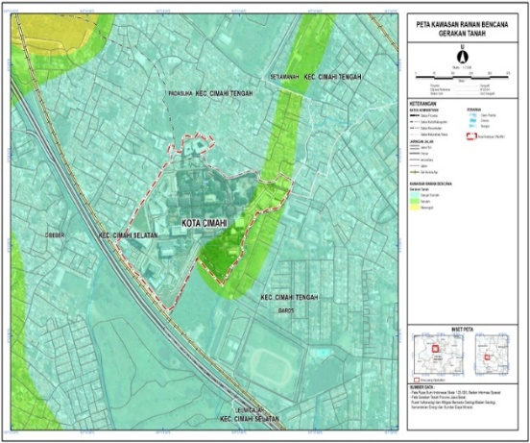
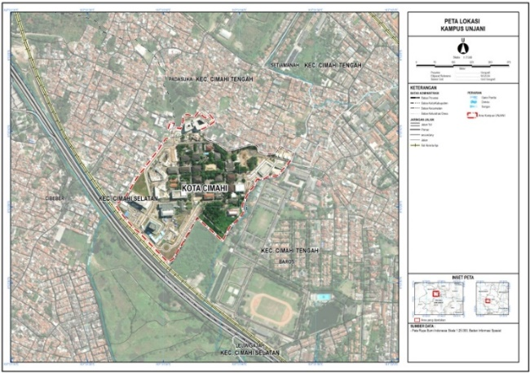

In the Landslide Disaster Prone Area (KRB GT) map, the theory behind this map is Slope Vulnerability Analysis, which measures the potential for rock or soil to move down a slope. The triggers and controls for landslide vulnerability are determined by a combination of geological, topographic, and hydrological factors. Geological conditions and soil type are important factors that influence the potential for landslides. Weathered rocks and soils, such as old volcanic deposits, generally have a lower level of stability and are therefore more susceptible to land mass movement. Topographic factors also play a significant role, where steep slopes increase shear forces and reduce slope stability. In addition, hydrological conditions, particularly water saturation due to high rainfall, can increase the weight of the soil mass while reducing interparticle cohesion, thus triggering landslides.
In the context of UNJANI, the campus area is generally located in a low landslide vulnerability zone around the campus centre and a medium vulnerability zone on the southern and eastern edges. The medium vulnerability zone indicates that landslide potential can increase if slope disturbances occur, such as unstable slope cutting or extreme rainfall conditions. This finding has important implications for campus area management, particularly in development planning, geotechnical research, and the evaluation of slope stability and building foundations to support sustainable disaster mitigation efforts.
Map of Areas Prone to Earthquake Disasters (KRB Earthquake)

This map is based on Seismic Hazard Analysis, which assesses the probability of strong ground shaking in an area. High earthquake vulnerability is closely related to the predicted high Peak Ground Acceleration ( PGA ) value due to the influence of surrounding earthquake sources. A high PGA value indicates that an area has the potential to experience strong ground shaking during an earthquake, which can originate from subduction zone activity, particularly earthquakes centred on the oceanic plate south of Java, or from the presence of active local faults in the region, such as the Lembang Fault. Both earthquake sources contribute significantly to increasing the intensity of ground shaking in the surrounding area.
In the context of UNJANI, the entire campus area is classified as a Highly Seismic Hazard Area. Conceptually, this classification requires the application of strict earthquake-resistant building codes to all campus infrastructure development and construction. Furthermore, this condition emphasises the importance of structural research focused on building resilience to high ground accelerations, in order to minimise the risk of damage and improve the safety of the academic community in the face of potential earthquakes. In addition to the threat of earthquakes and landslides influenced by regional geology, topography, and tectonic dynamics, the campus environment also needs to be analysed in the context of other potential geological hazards originating from volcanic activity. Although the characteristics and mechanisms of volcanic hazards differ from those of earthquakes and landslides, all three are part of a geological disaster system that is interconnected in area-based mitigation planning.
Figure 2. Picture Map of Earthquake Disaster-Prone Areas and Tangkuban Perahu Volcano Disaster-Prone Area Map
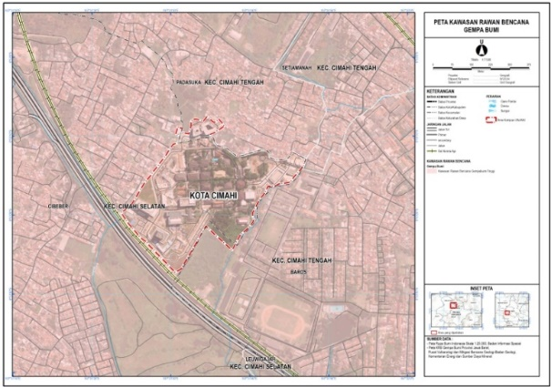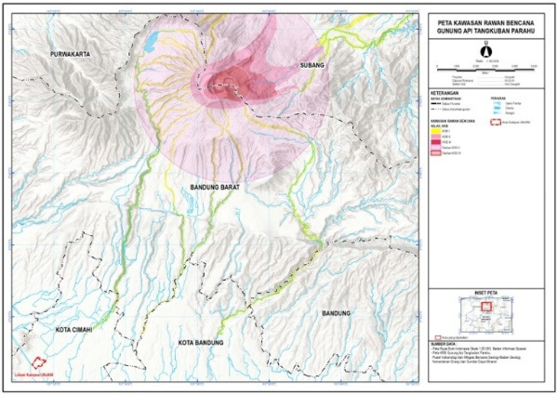

The mapping of the Tangkuban Parahu Volcano Disaster-Prone Area is based on the Distance and Material Effect concept, which models the distribution of primary volcanic hazards, such as lava flows and hot clouds, and secondary hazards, such as lahars, by considering the volcano's morphology and eruption mechanisms. Within this framework, hazard zones are classified into Disaster-Prone Areas (KRB) I, II, and III based on the type and intensity of the threat, where KRB III is the zone closest to the crater and has the highest level of danger. As the distance from the eruption centre increases, the intensity of the primary volcanic hazard tends to decrease significantly.
In the context of UNJANI, the campus in Cimahi City lies far outside the KRB II and KRB III zones of the Tangkuban Parahu Volcano. This condition theoretically places the campus area at a very low risk of primary volcanic eruption hazards. Therefore, disaster studies at UNJANI related to volcanic activity are more relevant if they focus on potential secondary hazards, such as exposure to low-intensity volcanic ashfall, as well as the indirect social and economic impacts that may arise from the evacuation or displacement of residents from the northern Bandung area.
Within the framework of a multi-hazard geological hazard analysis, the discussion of earthquake vulnerability in the campus area cannot be separated from the presence of active geological structures in the surrounding area, particularly the Lembang Fault. The Lembang Fault Disaster-Prone Area Map was compiled using the Fault Hazard Analysis approach to map the potential for vibrations and ground deformation generated by active fault activity. The Lembang Fault is an active horizontal fault that theoretically has the ability to generate earthquakes with significant magnitudes. The presence of this active fault causes the surrounding area to potentially experience higher ground acceleration and longer shaking duration, thereby increasing the level of vulnerability to seismic shocks.
Figure 3. Map of the Lembang Fault Disaster-Prone Area
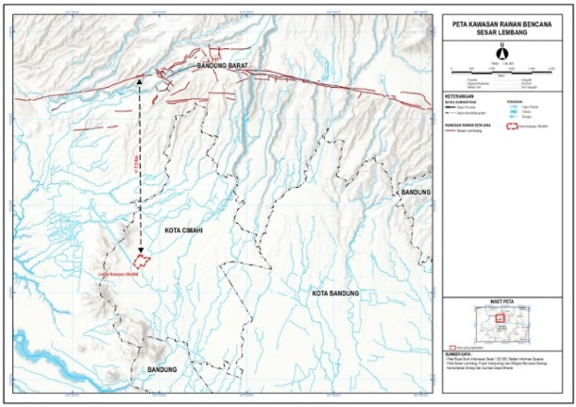

The UNJANI campus, located approximately 7.5 km from the Lembang Fault, is still relatively close in seismological terms. This distance directly contributes to the high level of earthquake vulnerability in the Cimahi City area, as reflected in the regional earthquake vulnerability map. This condition confirms that seismic risk in the campus area is influenced not only by distant earthquake sources, such as subduction zones, but also by local fault activity, which has a significant impact on earthquake intensity.
Therefore, disaster studies on the UNJANI campus need to explicitly incorporate the characteristics of the Lembang Fault, such as the potential maximum magnitude and fault shear rate, as key parameters in seismic risk modelling. Integrating these factors is crucial for structural and non-structural mitigation planning, as well as for developing campus development strategies oriented toward earthquake resilience.
An Earthquake Hazard Map is a spatial representation of the probability of damage resulting from the interaction between the seismic hazard level and local ground conditions. In this context, ground shaking generated by an earthquake, as represented by the PGA value, is not always transmitted uniformly to the surface, but can be amplified or attenuated by local geological characteristics. This phenomenon is known as site amplification, where soil type and sediment thickness play a significant role in determining the intensity of shaking felt at the surface.

Figure 4. Earthquake Hazard Map Image

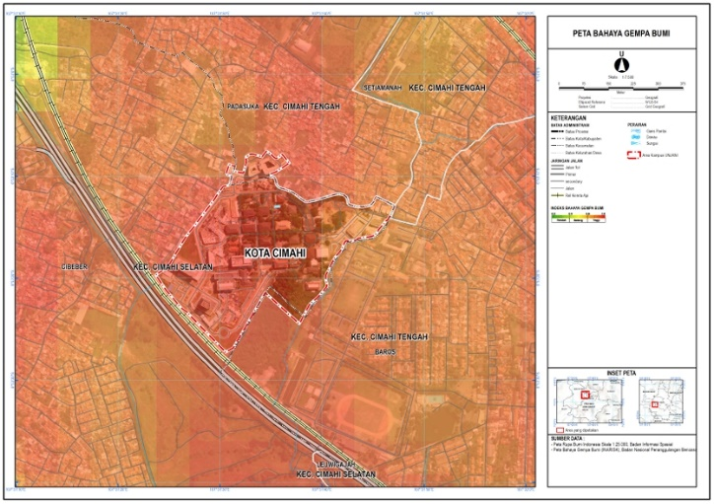

The INARISK Earthquake Hazard Map takes into account the effects of ground amplification, providing a more realistic picture of the hazard level in an area. The high hazard index across the UNJANI area indicates that, regardless of the campus's distance from the earthquake source, the characteristics of the underlying ground, such as the presence of soft soil or a relatively thick layer of sediment, have the potential to amplify seismic waves. This can result in more intense surface shaking and potentially greater damage to campus infrastructure.
The implications of these findings underscore the importance of further research focusing on seismic microzonation within the UNJANI campus environment. A microzonation approach is needed to identify variations in local vulnerability to ground amplification, thus providing a basis for structural mitigation planning, establishing building design standards, and developing more specific, site-based earthquake risk reduction strategies.
Study of the Vulnerability and Capacity of the Campus Academic Community in Facing Disaster Threat

A study of the vulnerability and capacity of the campus academic community in facing disaster threats shows that the main problem lies not only in the physical aspects of the campus environment, but also in aspects of knowledge, preparedness, and disaster management. Based on the results of the problem identification, the academic community faces limited socialisation and education related to disasters, so that most campus residents do not have an adequate understanding of the procedures to be followed when a disaster occurs. This condition is exacerbated by the characteristics of campus building construction, which is dominated by the use of large amounts of glass materials, which not only contributes to increasing environmental temperatures but also has the potential to pose a higher safety risk in the event of an earthquake.
The academic community's vulnerability is increasing due to limited and inadequate evacuation routes. Some evacuation routes are considered poorly opened, difficult to access, and some emergency exits are locked, potentially making them invisible or unusable in an emergency. Furthermore, the lack of disaster relief equipment and the lack of adequate evacuation sites complicate evacuations when disasters occur. Environmentally, low water absorption capacity and a lack of green open spaces on campus also have the potential to trigger other, secondary disasters if planned mitigation efforts are not implemented promptly.
According to the academic community, the most pressing issues on campus, located in an earthquake-prone area, are the lack of evacuation route signs, as well as the limited open space and safe evacuation points. These limitations result in a lack of space for the academic community to conduct a rapid and organised evacuation. Furthermore, the lack of education on disaster mitigation has resulted in low student awareness of the true extent of disaster danger.
The root causes of this situation are related to the suboptimal implementation of ongoing disaster mitigation outreach and training, as well as the lack of a structured training system to create a disaster-prepared campus. Limited disaster support facilities, such as evacuation aids and escape routes, also contribute to increased vulnerability. Furthermore, the lack of coordination between campus employees, staff, and officials in disaster management also impacts the effectiveness of mitigation efforts.
In an effort to address these issues, the academic community believes that communication plays a crucial role in disaster management. Strengthening communication systems, providing easily identifiable evacuation spaces, adding disaster relief equipment, and establishing safe assembly points are all necessary strategic steps. Comprehensive awareness of evacuation routes is also considered crucial to increasing the preparedness of the entire campus community. Furthermore, the construction and development of campus infrastructure should adhere to disaster-friendly building standards as stipulated in Law Number 24 of 2007 concerning Disaster Management.
Several concrete efforts have been made by the campus academic community to reduce this level of vulnerability, including providing infrastructure such as emergency stairs and exit signs in accordance with safety guidelines, conducting disaster training, and developing long-term plans to deal with post-disaster conditions. The campus has also prepared disaster signs, provided vacant land as evacuation sites, and established important emergency contacts as part of the disaster mitigation system. After a disaster occurs, the academic community demonstrates a sense of preparedness by maintaining calm, participating in disaster education, understanding the early warning system, and avoiding panic. Disaster education is also obtained through academic activities, such as practicums in disaster management courses.
In implementing disaster management, the campus academic community does not work alone, but is supported by various external parties. The National Disaster Management Agency (BNPB) serves as the focal point at the national level, while the Regional Disaster Management Agency (BPBD) at the provincial and district/city levels, as well as other agencies such as the fire department, the Indonesian Red Cross (PMI), and local governments also contribute to supporting disaster mitigation and response efforts on campus. The involvement of these various stakeholders demonstrates that strengthening the capacity of the campus academic community requires cross-sector collaboration to create a disaster-resilient campus.
Interview Findings Regarding Construction and Building Management Aspects in Disaster Risk Mitigation at UNJANI

Interviews with technical, construction, and building management personnel within the UNJANI campus indicate that disaster risk reduction has been considered through building structural design, material selection, and building maintenance concepts. The glass used in each building at UNJANI can reflect light and absorb heat by up to 40% and block 60% of incoming light, thus helping to maintain indoor temperature stability. Furthermore, the glass structure reduces the total building load, thus supporting the building's resistance to vibrations. According to researchers, this adds value to comfort and energy efficiency, while also reducing the risk of disruption due to extreme temperatures. These findings indicate that material design aspects have contributed to risk mitigation, particularly related to climate change and shocks.
Furthermore, the informant explained that the entire building was designed with strong structural bonds and the use of cylinders as vibration dampers. This is a significant finding considering UNJANI's geographical location in the Lembang Fault zone, an area with high potential for seismic activity. However, the use of renewable energy sources such as solar panels has not been optimised due to technical and aesthetic considerations.
Solar panels are considered unsafe for installation on glass facades and are more appropriately placed on building roofs. This interview also revealed the technical reasons why solar panels (solasel) have not yet been implemented on the UNJANI building facades. According to informants, from a technical standpoint, solar panels are indeed safer and more effective when installed on roofs, rather than glass walls. However, heat absorption by glass will require the use of alternative energy to reduce the cooling load (AC). In the context of increasingly intense climate change, campuses should not only be safe from disasters but also ecologically resilient. This condition indicates limitations in the integration of green technology in specially designed buildings.
Disaster preparedness within buildings was one of the areas examined in this study. Researchers identified that evacuation route markers are already available as a minimum standard in campus buildings. However, the existence of assembly points remains unclear. Within the Disaster Risk Reduction framework, the misalignment between evacuation routes and assembly points constitutes a significant gap, as these two elements are integral to the evacuation process. Informants stated that installing evacuation route markers is the minimum standard that is already available. However, the determination of assembly points still depends on the building management's policy and is not yet evenly distributed.
This is an important consideration in risk mapping, given that the existence of clear assembly points is a vital element for safety during mass evacuations. The provision of assembly points, which still depends on the respective building management, implies the absence of campus standards for evacuation management. This could potentially cause confusion during a disaster, especially when evacuations require rapid and massive action. Researchers believe that the Unjani campus evacuation operational standards still require updating to be more integrated and clearly documented. Researchers also observed that this technical information has not been widely communicated to building users. As a result, risk perceptions may differ between technicians and students or lecturers. The lack of socialisation can reduce the level of trust of building users (lecturers, educational staff, and students) in building safety. However, user understanding is a crucial element in non-structural risk management.
However, researchers found other information regarding the evacuation process in building fire situations. Informants stated that elevators can be used for up to an hour during a fire in certain buildings. Even though the elevator has a 1-hour fire safety capability, it is still not recommended to use the elevator when a disaster occurs. However, researchers believe that this implementation requires user training and clear standard operating procedures (SOPs). Without education, users could misunderstand that elevators are always safe to use in fire conditions, when in fact, this feature has time limits and specific technical requirements.
Beyond the technical aspects of the building, the interview also revealed that UNJANI's architectural design concept embraces the theme of "Ancient Bandung Mountain," creating a campus landscape that resembles rolling hills. This concept reinforces the campus' visual identity, but also requires attention from a disaster risk perspective. This topographical character requires an integrated drainage system and regularly updated contour mapping. Without these, even minor risks like flooding can become significant evacuation obstacles when a disaster strikes.
Interview findings indicate the importance of implementing sustainable building maintenance management as an integral part of disaster risk mitigation efforts. Informants emphasized that regular building maintenance plays a role in maintaining long-term building performance and function. Although poorly maintained buildings do not necessarily show a direct decline in structural resilience, such conditions can lead to a degradation of the aesthetic quality and cleanliness of the building environment. In the long term, suboptimal maintenance still has the potential to increase risks, particularly those related to non-structural components. Therefore, elements such as ceilings, glass materials, electrical installations, and fire protection systems require attention through regular inspections and maintenance.
In general, the interview results indicate that most aspects of disaster risk within the UNJANI environment have been considered since the planning and design stages of construction. However, several aspects still require further strengthening, particularly related to the development of a safety information system, clear mapping of evacuation routes and assembly points, the use of safe alternative energy sources, and consistency in the implementation of building maintenance management. These findings underscore the need for comprehensive and sustainable disaster risk mitigation within the campus environment, not only through technical construction approaches but also through managerial policies, increased occupant awareness, and systematic monitoring mechanisms.
Conclusion

This study shows that the level of disaster resilience of buildings in the UNJANI area is significantly influenced by the quality of planning, construction, and maintenance management. Analysis and interviews indicate that most campus buildings have been designed with structural safety, energy efficiency, and long-term functionality in mind, in line with design principles that emphasise a balance between value and quality.
However, structural resilience does not fully guarantee overall safety. Non-structural aspects, particularly evacuation management and safety information systems, still require strengthening, particularly regarding standardisation of assembly points and clarity of evacuation routes for the entire academic community. Furthermore, the continued function of a building depends heavily on consistent maintenance. Suboptimal maintenance has the potential to degrade the building's environmental quality and impact user comfort and preparedness in emergency situations.
This research confirms that disaster risk reduction on campus must be managed comprehensively, not only through structural strength but also through strengthening risk management, evacuation systems, and ongoing facility maintenance. By strengthening these aspects, UNJANI has the potential to create a disaster-resilient, safe, and adaptive campus for all its users.

Disclaimer (Artificial intelligence)
Author(s) hereby declare that NO generative AI technologies such as Large Language Models (ChatGPT, COPILOT, etc.) and text-to-image generators have been used during the writing or editing of this manuscript.

Reference
- Aprillia, B. (2024). Quadruple Helix Model for Women Migrant Workers Protection During Natural Disaster; learn from COVID-19 protection preparations. Indonesian Journal of Social Science Research , 5 (1), 294–301. https://doi.org/https://doi.org/10.11594/ijssr.05.01.25
- Aprillia, B. … Saleha, E. (2022). Protection of Women in Disaster Emergency Situations; Seven Stages of Participatory Capacity and Vulnerability Analysis. Indonesian Journal of Social Science Research , 3 (1), 39–43. https://doi.org/https://doi.org/10.11594/ijssr.03.01.05
- Chen, Y.-F., & Adefila, A. (2020). Enhancing school safety through university engagement in DRR education. International Journal of Disaster Risk Reduction , 44 . https://www.sciencedirect.com/science/article/abs/pii/S2212420919305321
- Creswell, J. W. (2018). Research design: Qualitative, quantitative, and mixed methods approaches. In Sage Publications (5th ed.).
- Dillard University. (2025). Crisis & Emergency Management Plan . Dillard. Edu. https://www.dillard.edu/about/administration/emergency-preparedness/crisis-emergency-management-plan
- Deputy for Systems and Strategy of the National Disaster Management Agency (BNPB). (2022). National Disaster Risk Assessment Document for West Java Province 2022-2026. In narisk.bnpb.go.id . https://inarisk.bnpb.go.id/pdf/Jawa Barat/Dokumen KRB Prov. Jawa Barat_final draft.pdf
- Kristian, I. (2022). Decision Making in Disaster Management Operations: Challenges and Opportunities. Journal of Public Management and Public Policy (JMPKP) , 4 (2), 82–91. https://doi.org/https://doi.org/10.36085/jmpkp.v4i2.4687
- Kristian, I., & Fajar Ikhsan, OKM (2024). Integrating Community-Based Approaches into National Disaster Management Policies: Lessons from Recent Natural Disasters. The International Journal of Law Review and State Administration , 4 (115–12). https://doi.org/https://doi.org/10.58818/ijlrsa.v2i4.150
- Naim Kapucu, & Khosa, S. (2013). Disaster Resiliency and Culture of Preparedness for University and College Campuses. Sage Journal , 45 (1). https://journals.sagepub.com/doi/abs/10.1177/0095399712471626
- Northwestern University. (2021). Emergency Response Framework (Base Plan). In northwestern.edu . https://www.northwestern.edu/emergency-management/docs/master-erf-base-plan-web-version.pdf
- Ritchie, M.A. … Morris, A. (2025). Engaging undergraduate students in research for disaster mitigation on campus. International Journal of Disaster Management , 8 (1), 45–56.
- Shaw, R., & Izumi, T. (2014). Civil Society Organization and Disaster Risk Reduction. In Springer .
- United Nations Office for Disaster Risk Reduction. (2015). Sendai Framework for Disaster Risk Reduction 2015–2030. In undrr.org .
- Yunas, N. S. (2021). Implementation of pentahelix collaboration in handling Covid-19 pandemic through Kampung Tangguh program in Malang. International Journal of Research in Business and Social Science, 10(5), 207-215.
- Rodríguez-Espíndola, O., Albores, P., & Brewster, C. (2018). Decision-making and operations in disasters: challenges and opportunities. International Journal of Operations & Production Management, 38(10), 1964-1986.

