Application of Artificial Intelligence Algorithms in Digital Media Arts: Chinese Calligraphy Education for Children with Specific Learning Disabilities (SLDs)

ABSTRACT: With the rapid advancement of artificial intelligence (AI) and digital media technologies, new possibilities have emerged for interdisciplinary applications in art, education, and special education. This study explores the application of AI algorithms within a digital media art framework, focusing on Chinese calligraphy education as an intervention for children with specific learning disabilities (SLDs). Addressing a gap in existing research, the paper integrates perspectives from digital media art, intelligent systems, and special education to examine how AI-assisted artistic training can support cognitive and attentional development. A quasi-experimental pretest–posttest design was adopted involving 115 children aged 6–10 diagnosed with SLD, attention-deficit/hyperactivity disorder (ADHD), or intellectual disability. Participants engaged in an eight-week Chinese calligraphy intervention supported by an AI-based analysis system capable of real-time stroke recognition, pressure and speed analysis, and adaptive feedback. Quantitative results indicated that children in the experimental group demonstrated significant improvements in attention performance, fine motor coordination, and task engagement compared with the control group. These findings suggest that AI-assisted digital calligraphy training may enhance attention stability, selectivity, and flexibility through the combined effects of artistic expression and intelligent feedback. Rather than offering definitive conclusions, this study proposes a conceptual and methodological framework that highlights the potential of integrating traditional cultural art forms with AI technologies. The research provides an exploratory foundation for future empirical studies and interdisciplinary development in digital media art–based intelligent education for children with learning disabilities.

KEYWORDS: Artificial intelligence algorithm, Digital media art,Children with specific learning disabilities, Chinese Calligraphy, Intervene
- INTRODUCTION
With the rapid development of digital media technologies, abstract and intangible information is increasingly transformed into content that can be recorded, perceived, and visualized. As an important technological means for cultural construction and social development, digital media has been widely applied in artistic creation, education, and information interaction. In this context, artificial intelligence (AI) algorithms, characterized by their capabilities in data processing, pattern recognition, and intelligent decision-making, have introduced new technical approaches and creative possibilities to the field of digital media art.

Artificial intelligence simulates human cognitive and learning processes to analyze and process complex information, demonstrating clear advantages in reducing labor costs, improving operational efficiency, and minimizing errors caused by human intervention. In recent years, AI technologies have been increasingly applied in areas such as network security, information filtering, and intelligent recommendation systems. Their adaptive learning and risk assessment capabilities have contributed to the stability and optimization of digital media systems, while also promoting the continuous evolution of digital media art in terms of interactivity, generativity, and innovative expression.
Since the beginning of the twenty-first century, the maturity of artificial intelligence technologies has expanded their application scope to the field of education. Alongside the growing prevalence of learning disabilities among children, related educational and technological research has attracted increasing academic attention. Existing studies have explored the application of AI algorithms in educational interventions for children with learning disabilities from perspectives including cognitive science, educational psychology, and computer science, yielding a substantial body of theoretical and empirical成果. However, research that examines the application of AI algorithms for children with specific learning disabilities from the perspective of digital media art remains limited. In particular, there is a lack of systematic analysis addressing the integration of artistic expression, algorithmic implementation, and educational intervention mechanisms.
Based on this research gap, the present study introduces a digital media art perspective into the discussion of AI-assisted education for children with specific learning disabilities. The manuscript proposes several theoretically verifiable research concepts, algorithmic implementation ideas, and potential intervention strategies. It should be emphasized that these proposals are primarily situated at the stage of theoretical exploration and experimental design, and have not yet been validated through comprehensive empirical testing. Moreover, the relationships among the digital application of Chinese calligraphy, algorithmic realization, and digital art expression require further clarification and in-depth discussion.
Therefore, the primary objective of this study is to construct an interdisciplinary theoretical framework and methodological approach. With a particular focus on a fuzzy learning intervention system, the paper explores its potential applicability within educational contexts for children with specific learning disabilities. Rather than presenting definitive conclusions regarding practical effectiveness, this research aims to provide a conceptual reference and exploratory foundation for future empirical studies and cross-disciplinary development in digital media art and intelligent education.

- METHODOLOGY
  - Participants
A total of 115 children participated in this study, including 55 boys and 60 girls, aged 6 to 10 years. Participants were recruited from special education schools and inclusive education resource classrooms in Nanjing, China. This age range represents a critical developmental stage for attention regulation, fine motor control, and foundational learning skills.
Participants were classified into three diagnostic groups based on standardized clinical and educational assessment procedures:

Specific Learning Disabilities (SLD) group (n = 38):
Children in this group met diagnostic criteria for Specific Learning Disabilities according to the Diagnostic and Statistical Manual of Mental Disorders, Fifth Edition (DSM-5) and the Chinese Classification and Diagnostic Criteria for Mental Disorders (CCMD-3). Diagnoses were confirmed by certified educational psychologists and were characterized by persistent difficulties in reading, writing, or mathematics despite normal intelligence and adequate educational opportunities.
Attention-Deficit/Hyperactivity Disorder (ADHD) group (n = 40):
Children in the ADHD group were diagnosed based on DSM-5 criteria by licensed pediatric psychiatrists. Both inattentive and combined subtypes were included. Participants receiving pharmacological treatment were required to maintain a stable medication regimen throughout the intervention period.
Intellectual Disability (ID) group (n = 37):
Children classified as having intellectual disability had a full-scale IQ below 70, as measured by standardized intelligence assessments (e.g., Chinese version of the WISC), and demonstrated significant limitations in adaptive functioning consistent with diagnostic guidelines.
Children with comorbid autism spectrum disorder, major neurological disorders, or severe visual or motor impairments were excluded from the study.

2.2.Study Design and Procedure
This study adopted a quasi-experimental pretest–posttest design. All participants received the same intervention consisting of Chinese calligraphy practice supported by an artificial intelligence (AI) system.
The research procedure comprised three phases:
Pre-intervention assessment:
Baseline assessments of attention, fine motor performance, and learning-related abilities were conducted one week prior to the intervention.
Intervention phase:
The intervention lasted 8 weeks, with two sessions per week, each session lasting approximately 40 minutes.
Post-intervention assessment:
Identical assessment measures were administered within one week following the completion of the intervention.

2.3.Chinese Calligraphy Intervention
The intervention was designed based on traditional Chinese calligraphy practice, which emphasizes focused attention, precise motor control, stroke sequencing, and spatial organization. Each session followed a standardized format:

Warm-up activities (5 minutes)
Fine motor preparation exercises involving finger, wrist, and arm movements.
Guided calligraphy practice (25 minutes)
Participants practiced writing basic Chinese characters using a brush stylus on a digital writing tablet. Characters were selected according to simple stroke structures and high-frequency usage, such as 一, 十, 人, and 木. Emphasis was placed on correct stroke order, balanced structure, and controlled movement speed.
Independent practice and feedback (10 minutes)
Children practiced independently while receiving individualized feedback generated by the AI system.
Chinese calligraphy was selected as the core intervention activity because it integrates visual attention, executive control, and fine motor coordination, which are often impaired in children with SLD, ADHD, and intellectual disability.

2.4.Artificial Intelligence–Assisted System
An AI-assisted calligraphy analysis system was developed to support the intervention and provide objective performance evaluation. The system utilized machine learning and computer vision techniques to analyze writing behavior in real time.
The AI system performed the following functions:
Stroke trajectory tracking, capturing movement paths and deviations.
Pressure and speed analysis, assessing motor stability and control.
Character structure recognition, comparing written characters with standard templates.
Based on these analyses, the system generated real-time visual and verbal feedback, such as alerts for incorrect stroke order or excessive pressure. In addition, the system automatically recorded behavioral metrics including stroke accuracy, completion time, and consistency, which were used for subsequent data analysis.

2.5.Outcome Measures
To clearly distinguish outcomes across diagnostic groups, multiple measures were employed:
Attention performance
Assessed using standardized attention rating scales suitable for children (e.g., Conners’ Rating Scales or validated Chinese equivalents).
Fine motor and visuomotor coordination
Evaluated using quantitative indicators derived from the AI system, including stroke smoothness, pressure stability, and writing consistency.
Learning-related performance
Measured through task accuracy during calligraphy activities and teacher-rated learning engagement scales.
All outcome measures were administered at both pretest and posttest.

- RESULT ANALYSIS
Based on the knowledge and experience of doctors, experts and scholars, this paper develops and designs a mathematical model and diagnostic process for early warning of children with special learning disabilities. The diagnostic process is shown in Figure 1 below:

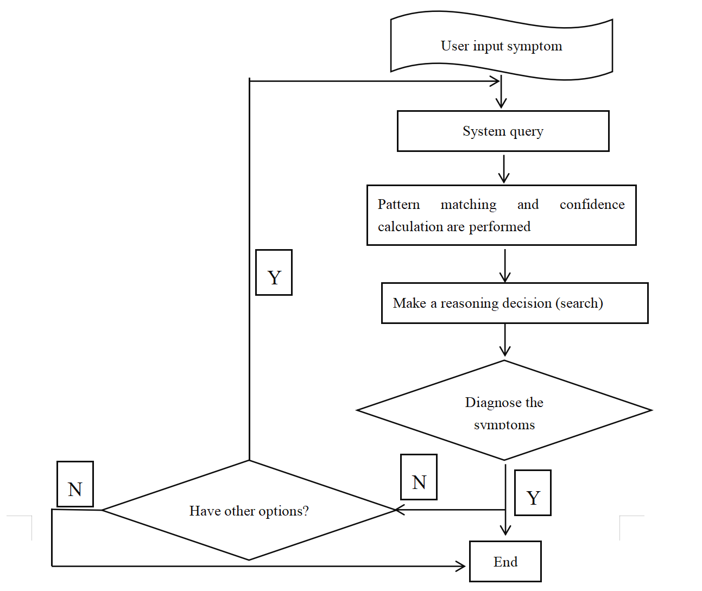
Fig.1. Flow chart of evaluation diagnosis

In the process of evaluation and diagnosis, it is necessary to do data mining and data analysis, as shown in Figure 2 below:
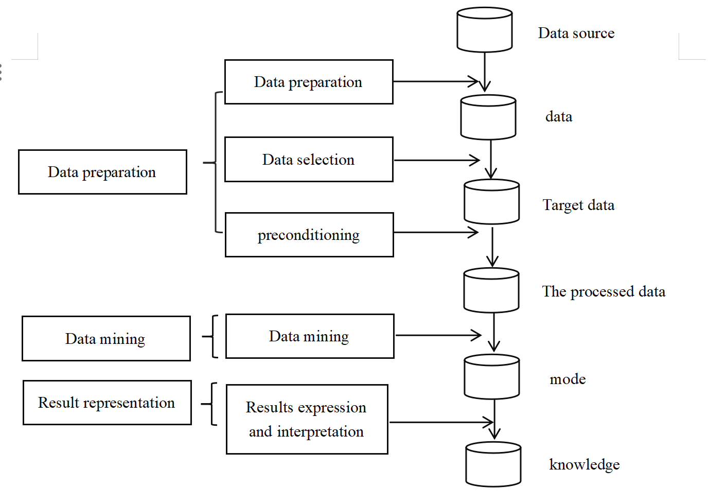
Fig.2. Flow chart of data mining and analysis

Analyze through the above process and proceed to the next important step, which is a test. The research subjects are divided into two groups, namely Group A (control group) and Group B (experimental group). to determine whether the data is normally distributed. To this end, the researchers conducted normality tests using deviant attitudes and kurtosis. The number of differences and the likelihood of occurrence are mainly used to find out what type of analysis will be performed (parametric or non-parametric). The significance of the difference between the means of the two groups was analyzed by statistically processing the data obtained from the two tests using SPSS as a window. This is accomplished by labeling the value of the difference code as t, and the probability of occurrence as p. This allows testing the significance of the difference between the means of the two groups. The form of parametric analysis used was chosen based on the results of difference values and likelihood of occurrence.
After three months of artificial intelligence technology testing, the experimental group (Group B) showed a significant increase in the total number of checks, the number of crossovers, and the number of omissions in the scratch test per unit time, with very significant differences (P < 0.01), and a significant reduction in the number of false crossovers and omissions, with a significant difference (P < 0.05). These results are shown in Table 1.

Table 1: Comparison of the experimental group (group B) before and after the attention deficit test intervention
 | Pre-testing | Post-testing | t | P
Total inspections | 116.58±32.97 | 224.78±64.98 | -8.76 | <0.01
Number of  cross-outs | 69.69±20.54 | 110.85±24.82 | -12.53 | <0.01
Incorrect number  of crossings | 1.08 ±1.04 | 0.46±0.52 | 2.31 | <0.05
Number of  omissions | 9.31 ±4.57 | 6.08±3.01 | 4.88 | <0.01

As can be seen from Table 2, the control group, designated as group, did not reach significant differences between the two tests in the total number of checks, number of crossovers, number of incorrect crossovers, and number of missed crossovers per unit time (P > 0.05).
Table 2: Control group (group A) attention deficit test pre-test and post-test scores
 | Pre-testing | Post-testing | t | P
Total inspections | 118.20±21.38 | 122.66 ±18.32 | -1.73 | >0.05
Number of  cross-outs | 71.15±31.98 | 74.31 ±34.35 | -1.06 | >0.05
Incorrect number  of crossings | 1.08 ±1.66 | 1.08±1.26 | 0.00 | >0.05
Number of  omissions | 10.15 ±2.12 | 9.54±1.81 | 1.60 | >0.05

As can be seen from Table 3, the experimental group (Group B) is significantly better than the control group (Group A) in terms of total number of inspections, number of omissions and other indicators, and there is a significant difference (P < 0.01). In addition, on the indicator of the number of incorrect crossings, the post-test score of the calligraphy behavior group (Group B) was higher than that of the control group. The posttest results of the members of Group B were not significantly different from each other.

Table 3: Comparison of posttest scores on the Attention Deficit Test between the two groups
Post-testing | group B | group A | t | P
Total inspections | 224.78±64.98 | 122.66 ±18.32 | 5.24 | <0.01
Number of  cross-outs | 110.85±24.82 | 74.31 ±34.35 | 2.97 | <0.01
Incorrect number  of crossings | 0.46 ±0.52 | 1.08±1.26 | -1.57 | >0.05
Number of  omissions | 6.08 ±3.01 | 9.54±1.81 | -3.14 | <0.01

After three months of experimental testing, the experimental group (Group B) completed two TMT tests in a shorter period of time, and the difference between the two groups was significant (P < 0.01). This can be shown in Table 4. The difference in the time it took subjects in the control group to complete the TMT for the second time was less than the time it took subjects to complete the pre-test, but the difference did not reach statistical significance (P > 0.05). The difference in the pre-test results between the two groups was not statistically significant, but the difference between the two groups was not statistically significant. The difference in post-test results reached statistical significance (P < 0.05).
Table 4: Comparison of pre- and post-test scores of TMT in the two groups and between the two groups
 | Pre-testing | Post-testing | t | P
group B | 113.92±35.34 | 90.62 ±27.37 | 6.04 | 0.01
group A | 120.54±22.40 | 114.69±24.01 | 2.10 | 0.05
t | 2.15 | 2.29
P | >0.05 | <0.05

This shows that the attention of children with special learning disabilities who belong to the experimental group (Group B) also improved significantly after digital art intervention. Note that flexibility is the term used to describe this improvement.
According to the above analysis, after the evaluation and diagnosis, the system will provide corresponding intervention and correction methods according to the previously stored expert suggestions, and clearly inform users of the professional knowledge and treatment methods of special learning disabilities, so as to facilitate the continued education and guidance of professionals or learning tutors. Judging from the current application of artificial intelligence technology in the education of normally developing children, with the continuous development of digital media art, artificial intelligence technology algorithms are becoming more and more perfect, which can truly practice the automation, personalization and intelligent research goals of education and teaching. However, there are few research and exploration topics related to artificial intelligence technology algorithm in the field of learning disabilities of special children, and there are not many theoretical knowledge and research results obtained. Therefore, future research should comprehensively grasp the latest research methods and technical means in the field of artificial intelligence, start from the perspective of the development of children with special learning disabilities, and according to the characteristics and learning needs of children with special learning disabilities, Gradually optimize the existing artificial intelligence algorithms, pay attention to the four aspects of diagnosis, intervention, evaluation and service continue to study, and finally get more effective algorithm models.

- DISCUSSIONS
The findings of the present study indicate that artificial intelligence–based intervention has a positive effect on improving attention in children with intellectual disabilities, particularly in terms of attention stability, selectivity, and flexibility. Rather than merely confirming short-term behavioral changes, these results suggest that algorithm-assisted artistic training may serve as an effective supplementary approach for attention rehabilitation in special education contexts.
The results are generally consistent with previous studies conducted in Hong Kong and Taiwan, which reported that structured artistic behavior training significantly enhanced attention-related functions in children with ADHD and specific learning disabilities. Prior research has shown notable improvements in selective attention, sustained attention, attention shifting, and automatic attention through art-based interventions. By integrating artificial intelligence algorithms into digital art and Chinese calligraphy training, the present study extends this line of research by introducing a more structured, data-driven, and feedback-oriented intervention framework. This technological integration may enhance the precision and consistency of training effects compared to traditional art-based approaches.
From a mechanistic perspective, AI-assisted calligraphy and digital art training represent a multidimensional intervention that combines cognitive engagement, motor coordination, and emotional regulation. Calligraphy practice inherently requires sustained visual–motor coordination, rhythmic control, and focused attention, all of which are essential components of attentional functioning. The incorporation of artificial intelligence allows for real-time feedback, adaptive task difficulty, and individualized learning trajectories, which may strengthen participants’ engagement and self-regulation abilities. This synergistic interaction between artistic expression and algorithmic feedback may partially explain the observed improvements in attention performance.
In addition, the findings highlight the broader potential of artificial intelligence as a supportive tool in special education and psychological rehabilitation, rather than merely as a standalone cognitive training technology. By analyzing behavioral patterns, writing dynamics, and engagement levels, AI-driven systems can facilitate more personalized interventions that account for individual differences among children with intellectual and learning disabilities. This approach provides a promising framework for integrating traditional cultural practices, such as Chinese calligraphy, with modern intelligent technologies to support psychological and educational outcomes.
Despite these encouraging results, several limitations should be acknowledged. First, the intervention period was relatively short and the sample size was limited, which may have constrained the magnitude and generalizability of the observed effects. Second, the present study did not examine the long-term maintenance of attention improvements, leaving the sustainability of the intervention outcomes unclear. Consequently, the findings should be interpreted as preliminary. Future research should employ larger samples, extended intervention durations, and longitudinal follow-up designs to further validate the effectiveness of AI-assisted artistic interventions and to clarify their underlying mechanisms in special education and rehabilitation settings.

- CONCLUSION
To sum up, there are more and more researches on the application of artificial intelligence technology algorithms in the diagnosis, intervention, assessment and service of children with special learning disabilities. In the future, it is necessary to continue to combine more theoretical knowledge and technical algorithms for in-depth discussion. Only in this way can we provide technical support for the educational management of children with special learning disabilities and promote the steady development of digital media art.

Acknowledgments
This work was supported by The 6th Jiangsu Province Vocational Education Teaching Reform Research Topics(2025) [grant number 2025ZDZC417].
I would like to express my sincere thanks to the instructors and team members of Jiangsu Communication and Media School, Jiangsu Union Technical Institute.For their assistance in this research. .

Ethical Approval:

As per international standards or university standards written ethical approval has been collected and preserved by the author(s).

Disclaimer (Artificial intelligence)
Author(s) hereby declare that NO generative AI technologies such as Large Language Models (ChatGPT, COPILOT, etc.) and text-to-image generators have been used during the writing or editing of this manuscript.

REFERENCES
Bishop, D. V. M., & Snowling, M. J. (2004). Developmental dyslexia and specific language impairment: Same or different? Psychological Bulletin https://doi.org/10.1037/0033-2909.130.6.858

American Psychiatric Association. (2013). Diagnostic and Statistical Manual of Mental Disorders (5th ed.). Washington, DC: American Psychiatric Association Publishing. https://doi.org/10.1176/appi.books.9780890425596

Cortiella, C., & Horowitz, S. H. (2014). The state of learning disabilities: Facts, trends and emerging issues. National Center for Learning Disabilities. https://www.ncld.org/wp-content/uploads/2014/11/2014-State-of-LD.pdf

Shalev-Shwartz, S., & Ben-David, S. (2014). Understanding Machine Learning: From Theory to Algorithms. Cambridge University Press. https://doi.org/10.1017/CBO9781107298019

Guyon, I. M., Weston, J., Barnhill, S. D., & Vapnik, V. N. (2002). Gene selection for cancer classification using support vector machines. Machine Learning, 46(1), 389–422. https://doi.org/10.1023/A:1012487302797

Kosko, B. (1986). Fuzzy cognitive maps. International Journal of Man-Machine Studies, 24(1), 65–75. https://doi.org/10.1016/S0020-7373(86)80040-2

Rizzo, A. A., & Kim, G. J. (2005). A SWOT Analysis of the Field of Virtual Reality Rehabilitation and Therapy. Presence: Teleoperators and Virtual Environments. https://doi.org/10.1162/1054746053967094

Fletcher, J. M., Lyon, G. R., Fuchs, L. S., & Barnes, M. A. (2018). Learning disabilities: From identification to intervention. Guilford Press. https://www.guilford.com/books/Learning-Disabilities/Fletcher-Lyon-Fuchs-Barnes/9781462536375

DuPaul, G. J., Weyandt, L. L., & Janusis, G. M. (2011). ADHD in the Classroom: Effective Intervention Strategies. Theory Into Practice, 50(1), 35–42. https://doi.org/10.1080/00405841.2011.534935

Luckin, R., Holmes, W., Griffiths, M., & Forcier, L. B. (2016). Intelligence Unleashed: An Argument for AI in Education. London: Pearson. https://www.pearson.com/content/dam/corporate/global/pearson-dot-com/files/innovation/Intelligence-Unleashed-Publication.pdf

Stuckey, H. L., & Nobel, J. (2010). The connection between art, healing, and public health: A review of current literature. American Journal of Public Health, 100(2), 254–263. https://doi.org/10.2105/AJPH.2008.156497

Klingberg, T. (2010). Training and plasticity of working memory. Trends in Cognitive Sciences. https://doi.org/10.1016/j.tics.2010.05.002

Wu, L., Chau, K. T., Wan Yahaya, W. A. J., Wang, S., & Wu, X. (2025). The Effect of Electroencephalogram Feedback in Virtual Reality Interactive System on Creativity Performance, Attention Value, and Cognitive Load. International Journal of Human–Computer Interaction, 41(10), 5955-5972.https://doi.org/10.1080/10447318.2024.2371692

Posner, M. I., & Rothbart, M. K. (2007). Research on Attention Networks as a Model for the Integration of Psychological Science, 58, 1–23. https://doi.org/10.1146/annurev.psych.58.110405.085516

Diamond, A. (2013). Executive functions. Annual Review of Psychology, 64, 135–168.DOI: 10.1146/annurev-psych-113011-143750

Makeig, S., Debener, S., Onton, J., & Delorme, A. (2004). Mining event-related brain dynamics. Trends in Cognitive Sciences, 8(5), 204–210. https://doi.org/10.1016/j.tics.2004.03.008

Wu, L., & Wang, S. (2025). Development of a virtual reality creative enhancement system utilizing haptic vibration feedback via electroencephalography. Education and Information Technologies, 30(5), 5727-5753.https://doi.org/10.1007/s10639-024-13051-w

Wolpaw, J. R., Birbaumer, N., McFarland, D. J., Pfurtscheller, G., & Vaughan, T. M. (2002). Brain–computer interfaces for communication and control. Clinical Neurophysiology, 113(6), 767–791. https://doi.org/10.1016/S1388-2457(02)00057-3

Kao, H. S. R. (2010). Calligraphy therapy: A complementary approach to psychotherapy. Asia Pacific Journal of Counselling and Psychotherapy, 1(1), 55–66. https://doi.org/10.1080/21507680903570334

Boden, M. A. (2016). AI: Its Nature and Future. Oxford University Press. https://doi.org/10.1093/acprof:oso/9780199672973.001.0001

Siemens, G., & Baker, R. (2012). Learning analytics and educational data mining: towards communication and collaboration. Proceedings of the 2nd International Conference on Learning Analytics and Knowledge https://doi.org/10.1145/2330601.2330661.

Wu, L., Wang, S., Yang, L., & Wu, X. (2025). Effects of electroencephalography-based art therapy on emotion regulation difficulties, psychological well-being, relaxation and attention levels among college students. Humanities and Social Sciences Communications, 12(1), 1-13.https://doi.org/10.1057/s41599-025-05943-0

