Application of Artificial Intelligence Algorithms in Digital Media Arts: Chinese Calligraphy Education for Children with Specific Learning Disabilities(SLDs)

ABSTRACT: Artificial intelligence (AI) has shown increasing potential in the intervention and support of children with specific learning disabilities (SLDs); however, systematic and interdisciplinary research remains limited. This study investigates the application of artificial intelligence algorithms integrated with digital media art to support the learning and developmental processes of children with SLDs, using Chinese calligraphy as a culturally grounded intervention medium.A controlled experimental design was adopted, in which participating children with SLDs were divided into an experimental group and a control group. The experimental group received AI-assisted digital calligraphy interventions, while the control group followed conventional learning methods. Quantitative data were collected and analyzed to compare learning performance, engagement levels, and cognitive development between the two groups.The results indicate that the AI-based calligraphy intervention significantly improves learning motivation and learning outcomes in children with SLDs compared to traditional approaches. This study provides empirical evidence for the effectiveness of combining artificial intelligence, digital media art, and traditional cultural resources in special education, offering new insights for interdisciplinary research and practical applications in intelligent educational intervention systems.

KEYWORDS: Artificial intelligence algorithm, Digital media art,Children with specific learning disabilities, Chinese Calligraphy, Intervene
- INTRODUCTION
With the rapid development of digital media technologies, abstract and intangible information is increasingly transformed into content that can be recorded, perceived, and visualized. As an important technological means for cultural construction and social development, digital media has been widely applied in artistic creation, education, and information interaction. In this context, artificial intelligence (AI) algorithms, characterized by their capabilities in data processing, pattern recognition, and intelligent decision-making, have introduced new technical approaches and creative possibilities to the field of digital media art.

Artificial intelligence simulates human cognitive and learning processes to analyze and process complex information, demonstrating clear advantages in reducing labor costs, improving operational efficiency, and minimizing errors caused by human intervention. In recent years, AI technologies have been increasingly applied in areas such as network security, information filtering, and intelligent recommendation systems. Their adaptive learning and risk assessment capabilities have contributed to the stability and optimization of digital media systems, while also promoting the continuous evolution of digital media art in terms of interactivity, generativity, and innovative expression.
Since the beginning of the twenty-first century, the maturity of artificial intelligence technologies has expanded their application scope to the field of education. Alongside the growing prevalence of learning disabilities among children, related educational and technological research has attracted increasing academic attention. Existing studies have explored the application of AI algorithms in educational interventions for children with learning disabilities from perspectives including cognitive science, educational psychology, and computer science, yielding a substantial body of theoretical and empirical成果. However, research that examines the application of AI algorithms for children with specific learning disabilities from the perspective of digital media art remains limited. In particular, there is a lack of systematic analysis addressing the integration of artistic expression, algorithmic implementation, and educational intervention mechanisms.
Based on this research gap, the present study introduces a digital media art perspective into the discussion of AI-assisted education for children with specific learning disabilities. The manuscript proposes several theoretically verifiable research concepts, algorithmic implementation ideas, and potential intervention strategies. It should be emphasized that these proposals are primarily situated at the stage of theoretical exploration and experimental design, and have not yet been validated through comprehensive empirical testing. Moreover, the relationships among the digital application of Chinese calligraphy, algorithmic realization, and digital art expression require further clarification and in-depth discussion.
Therefore, the primary objective of this study is to construct an interdisciplinary theoretical framework and methodological approach. With a particular focus on a fuzzy learning intervention system, the paper explores its potential applicability within educational contexts for children with specific learning disabilities. Rather than presenting definitive conclusions regarding practical effectiveness, this research aims to provide a conceptual reference and exploratory foundation for future empirical studies and cross-disciplinary development in digital media art and intelligent education.

- METHODOLOGY
  - Diagnosis
When studying the education of children with special learning disabilities, some scholars put forward an AI algorithm involving the diagnosis of children's learning disabilities, which is mainly used to improve the diagnosis accuracy of children's learning disabilities. Nowadays, the AI algorithms for the diagnosis of children's learning disabilities in academia are divided into two types, one refers to deep learning algorithms, and the other refers to support vector machine algorithms. Some scholars use artificial neural network classifiers to diagnose learning disabilities. The actual process is shown in Figure 1 below. The final result shows that this method can diagnose more than 50% of children with learning disabilities, which is more effective than traditional statistical methods. At the same time, some scholars have proposed to use support vector machine to develop a more accurate and effective diagnosis platform for attention deficit hyperactivity disorder, which can provide medical personnel with diagnostic and certification questionnaire survey data, and use support vector calculation method to judge whether special children suffer from attention deficit hyperactivity disorder. From the perspective of practical application, The classifier and diagnostic platform constructed by the two algorithms have achieved the expected results, and can effectively improve the diagnostic accuracy of children with special learning disabilities. Scholars proposed to develop and design an expert system for the diagnosis of learning disabilities of children with special needs. Fuzzy cognitive maps, as a soft computing method using symbols to describe and model complex systems, can provide expert doctors with differential diagnosis results of specific language disorders, dyslexia and autism, and can achieve excellent results in practical application.
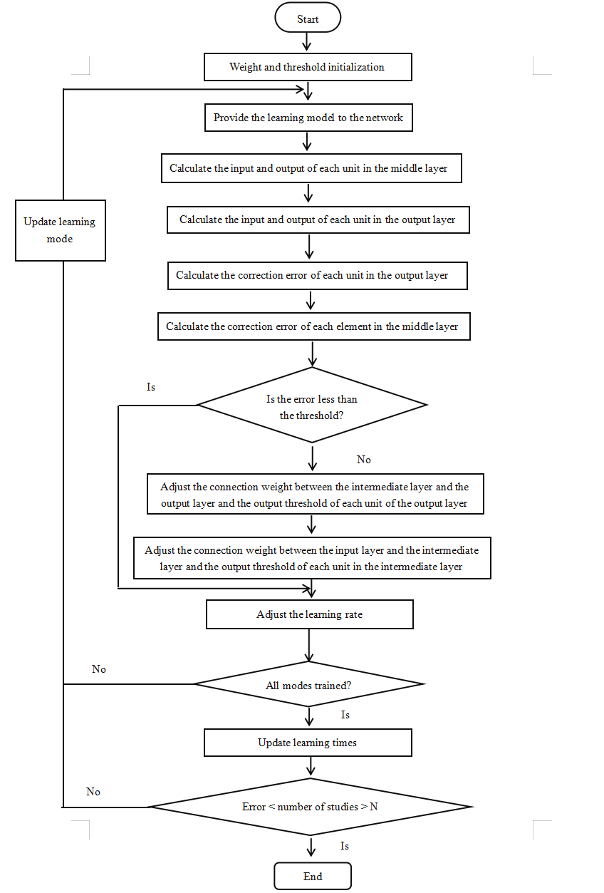
Fig. 1. Flow chart of artificial neural network classifier.
2.2.Intervention
As a basic component of the education of children with special learning disabilities, intervention aims to accurately guide students to learn. Nowadays, the scientific research field uses artificial intelligence technology algorithms to implement intervention education for children with special learning disabilities. Some scholars have found that the development of a system platform based on artificial intelligence technology algorithms should be studied according to different categories of children with special learning disabilities, and the system can be divided into developmental learning disability intervention and learning learning disability intervention. Some scholars have created a speech therapy system with fuzzy expert system as the core, using the fuzzy expert system to develop and design a framework to help special children with speech disorders obtain the best treatment plan and provide more intervention time for special children with speech disorders. The structure of the fuzzy expert system is shown in Figure 2 below:
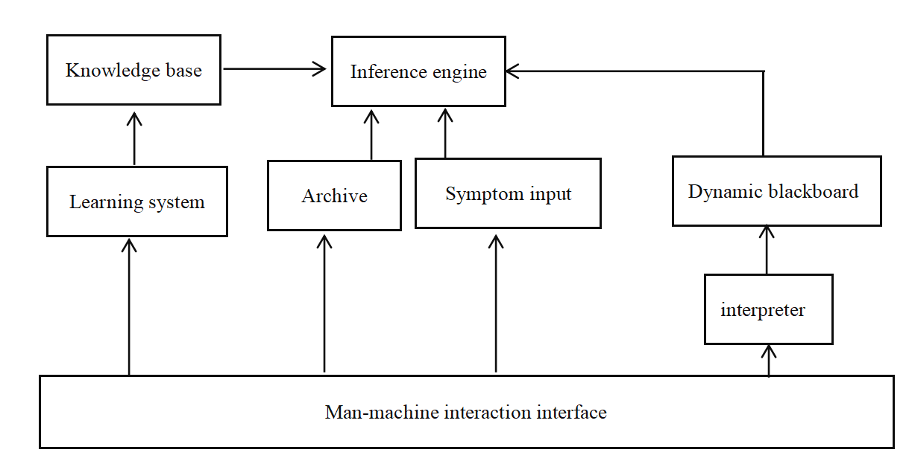
Fig. 2. Structure diagram of fuzzy expert system.

When studying the intervention system for learning disabilities, some scholars have effectively solved the psychological barriers in reading, spelling, writing, mathematics and other learning activities, and built a mathematical intelligent tutoring system with a network platform as the core, mainly used to help children with special learning disabilities learn math knowledge. This system supports children to learn in their own comfortable environment, will use artificial intelligence technology to form an adaptive curriculum system, students can complete modeling, feedback, interactive learning and other work. During the operation of the platform, children with special learning disabilities will conduct self-assessment according to the concepts they have mastered, then choose appropriate learning objectives and learning scenarios, and adjust the difficulty of the course according to their mastery level. The eye tracker in the system can track children's attention and reading time in detail, which is convenient for follow-up education management.
2.3.Evaluation
Learning disabilities can cause children to be unable to learn and use certain skills, so according to the main causes of children's learning disabilities and classification results, the selection of appropriate assessment tools for children with special learning disabilities is the main direction of scholars' discussion. Artificial neural networks, as the focus of attention in the field of artificial intelligence since the 1980s, will use neural network methods to support students with special learning disabilities to conduct self-assessment, and use computer programs to gradually optimize, which can accurately judge the problems of children with special learning disabilities in grammar/sentence structure, reading and writing, letter recognition, alphabetic order, spelling/vocabulary. Some scholars have used the genetic programming neural network method of virtual learning environment to evaluate and analyze special children with disabilities in different directions, which is very suitable for individuals with physical or sensory disorders. Some scholars use artificial neural network to identify dyslexic children with special learning disabilities, which is also the first attempt to use artificial intelligence algorithm to solve the problem of child dyslexia recognition technology application results; Some scholars have used artificial intelligence to build application models, mainly to carry out the assessment of children's learning disabilities. For example, Freitas, as a "mind headset" with BCI technology as the core launched by a company in the United States, can be applied to all groups, but it is mainly used in the attention deficit hyperactivity disorder children. The application model consists of a headset with three electrodes, which can effectively read the child's brain wave signals as input data, mainly used to assess the child's attention level. The results of the experimental study proved that there was a positive correlation between the test results and the self-reported attention level of the participants. Among them, the technical structure is shown in Figure 3 below:
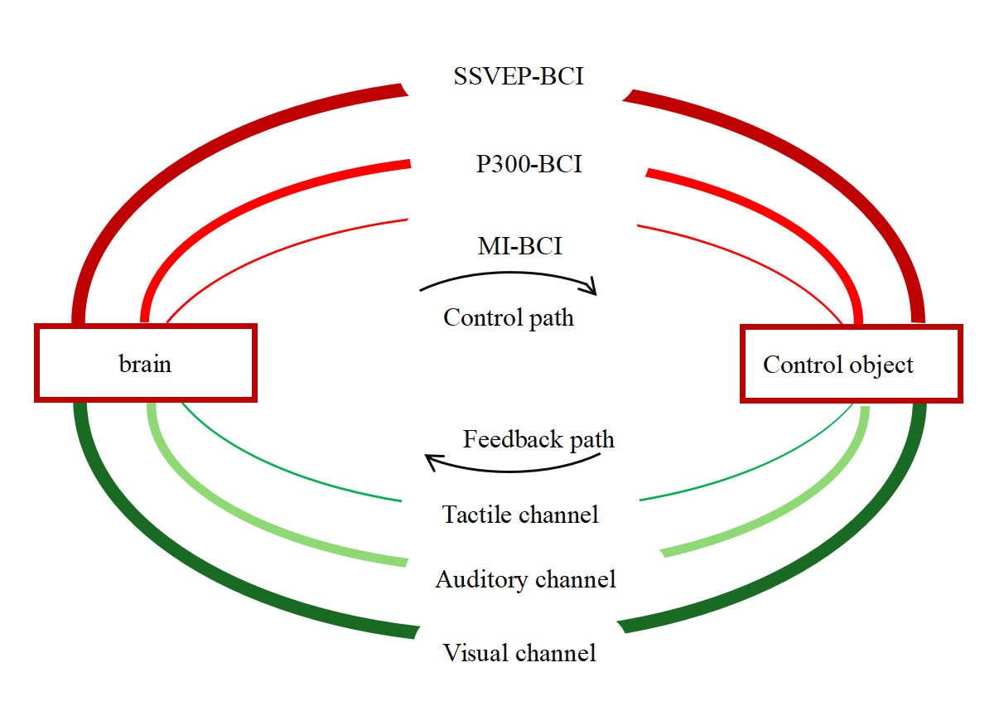
Fig. 3. Structure diagram of BCI technology
2.4.Services
According to the learning support needs of children with special learning disabilities, in the development of big data, cloud computing, Internet and other technologies, artificial intelligence technology algorithms can provide personalized support services for children with special learning disabilities, professional teachers and children's parents based on cloud computing and big data. In 2010, iFLYc Open Platform built corresponding software for children with reading disabilities, which truly realized the use of voice to operate computers, help realize the function of screen reading, and facilitate the access of dyslexic users to the Internet in China; In 2015, iFLYtek launched the "hearing" product, which can completely transform the teacher's speech content into text, which can be implemented in the classroom to help the hearing impaired children better understand the teaching content. Some scholars have studied the artificial intelligence technology with big data technology as the core to provide accurate learning support services for children with special learning disabilities, which is reflected in three aspects: First, according to the learning needs of children with special learning disabilities, provide them with the required learning content from the original data; Secondly, the data generated by children with special learning disabilities during their learning period should be continuously collected to form intervention measures in line with each child's own development according to the obstacles encountered by children during their learning period. Finally, the behavioral data of children with special learning are recorded. Although these data have no regularity and correlation from the surface, when the data accumulates to a certain amount, the in-depth analysis of the data can find the behavioral rules of children with special learning disabilities.

- RESULT ANALYSIS
Based on the knowledge and experience of doctors, experts and scholars, this paper develops and designs a mathematical model and diagnostic process for early warning of children with special learning disabilities. The diagnostic process is shown in Figure 4 below:
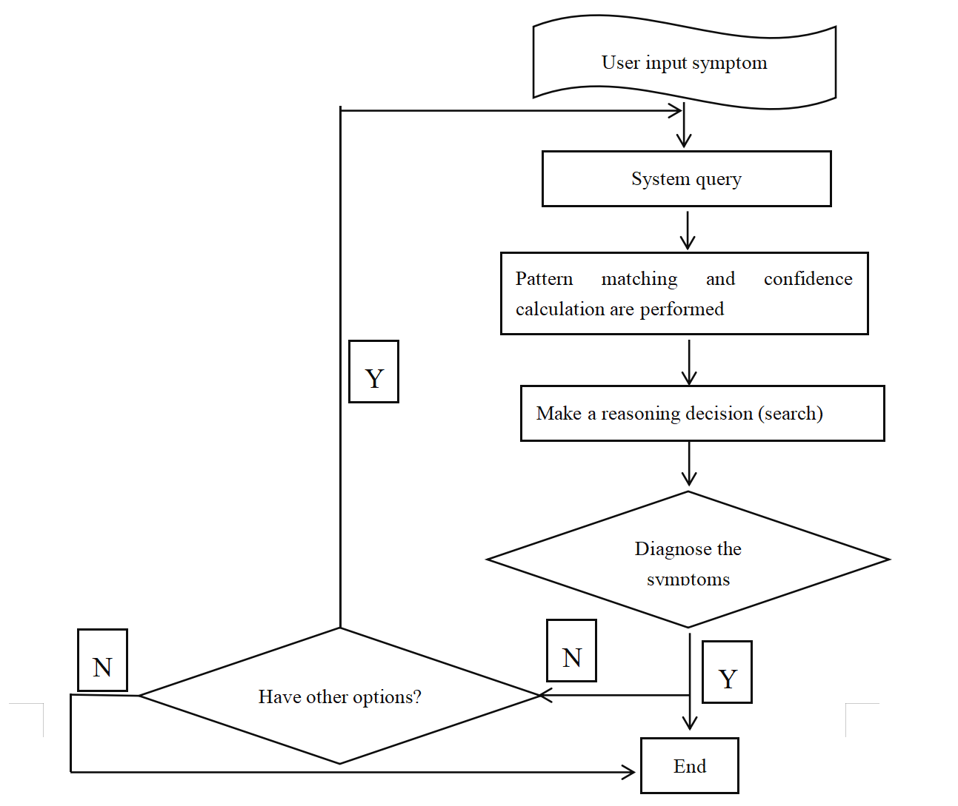
Fig.4. Flow chart of evaluation diagnosis

In the process of evaluation and diagnosis, it is necessary to do data mining and data analysis, as shown in Figure 5 below:
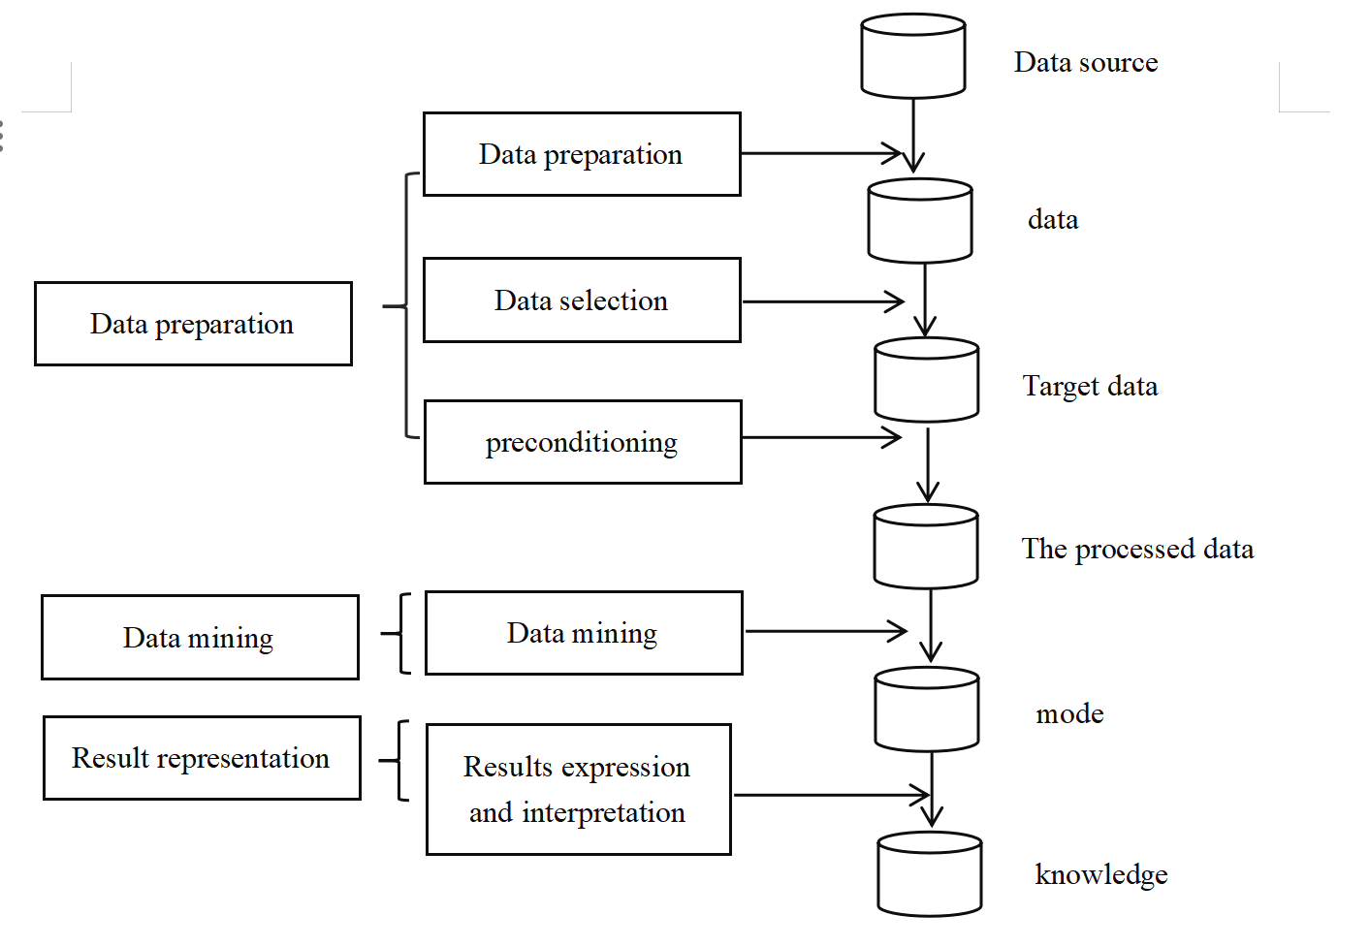
Fig.5. Flow chart of data mining and analysis

Analyze through the above process and proceed to the next important step, which is a test. The research subjects are divided into two groups, namely Group A (control group) and Group B (experimental group). to determine whether the data is normally distributed. To this end, the researchers conducted normality tests using deviant attitudes and kurtosis. The number of differences and the likelihood of occurrence are mainly used to find out what type of analysis will be performed (parametric or non-parametric). The significance of the difference between the means of the two groups was analyzed by statistically processing the data obtained from the two tests using SPSS as a window. This is accomplished by labeling the value of the difference code as t, and the probability of occurrence as p. This allows testing the significance of the difference between the means of the two groups. The form of parametric analysis used was chosen based on the results of difference values and likelihood of occurrence.
After three months of artificial intelligence technology testing, the experimental group (Group B) showed a significant increase in the total number of checks, the number of crossovers, and the number of omissions in the scratch test per unit time, with very significant differences (P < 0.01), and a significant reduction in the number of false crossovers and omissions, with a significant difference (P < 0.05). These results are shown in Table 1.

Table 1: Comparison of the experimental group (group B) before and after the attention deficit test intervention
 | Pre-testing | Post-testing | t | P
Total inspections | 116.58±32.97 | 224.78±64.98 | -8.76 | <0.01
Number of  cross-outs | 69.69±20.54 | 110.85±24.82 | -12.53 | <0.01
Incorrect number  of crossings | 1.08 ±1.04 | 0.46±0.52 | 2.31 | <0.05
Number of  omissions | 9.31 ±4.57 | 6.08±3.01 | 4.88 | <0.01

As can be seen from Table 2, the control group, designated as group, did not reach significant differences between the two tests in the total number of checks, number of crossovers, number of incorrect crossovers, and number of missed crossovers per unit time (P > 0.05).
Table 2: Control group (group A) attention deficit test pre-test and post-test scores
 | Pre-testing | Post-testing | t | P
Total inspections | 118.20±21.38 | 122.66 ±18.32 | -1.73 | >0.05
Number of  cross-outs | 71.15±31.98 | 74.31 ±34.35 | -1.06 | >0.05
Incorrect number  of crossings | 1.08 ±1.66 | 1.08±1.26 | 0.00 | >0.05
Number of  omissions | 10.15 ±2.12 | 9.54±1.81 | 1.60 | >0.05

As can be seen from Table 3, the experimental group (Group B) is significantly better than the control group (Group A) in terms of total number of inspections, number of omissions and other indicators, and there is a significant difference (P < 0.01). In addition, on the indicator of the number of incorrect crossings, the post-test score of the calligraphy behavior group (Group B) was higher than that of the control group. The posttest results of the members of Group B were not significantly different from each other.

Table 3: Comparison of posttest scores on the Attention Deficit Test between the two groups
Post-testing | group B | group A | t | P
Total inspections | 224.78±64.98 | 122.66 ±18.32 | 5.24 | <0.01
Number of  cross-outs | 110.85±24.82 | 74.31 ±34.35 | 2.97 | <0.01
Incorrect number  of crossings | 0.46 ±0.52 | 1.08±1.26 | -1.57 | >0.05
Number of  omissions | 6.08 ±3.01 | 9.54±1.81 | -3.14 | <0.01

After three months of experimental testing, the experimental group (Group B) completed two TMT tests in a shorter period of time, and the difference between the two groups was significant (P < 0.01). This can be shown in Table 4. The difference in the time it took subjects in the control group to complete the TMT for the second time was less than the time it took subjects to complete the pre-test, but the difference did not reach statistical significance (P > 0.05). The difference in the pre-test results between the two groups was not statistically significant, but the difference between the two groups was not statistically significant. The difference in post-test results reached statistical significance (P < 0.05).
Table 4: Comparison of pre- and post-test scores of TMT in the two groups and between the two groups
 | Pre-testing | Post-testing | t | P
group B | 113.92±35.34 | 90.62 ±27.37 | 6.04 | 0.01
group A | 120.54±22.40 | 114.69±24.01 | 2.10 | 0.05
t | 2.15 | 2.29
P | >0.05 | <0.05

This shows that the attention of children with special learning disabilities who belong to the experimental group (Group B) also improved significantly after digital art intervention. Note that flexibility is the term used to describe this improvement.
According to the above analysis, after the evaluation and diagnosis, the system will provide corresponding intervention and correction methods according to the previously stored expert suggestions, and clearly inform users of the professional knowledge and treatment methods of special learning disabilities, so as to facilitate the continued education and guidance of professionals or learning tutors. Judging from the current application of artificial intelligence technology in the education of normally developing children, with the continuous development of digital media art, artificial intelligence technology algorithms are becoming more and more perfect, which can truly practice the automation, personalization and intelligent research goals of education and teaching. However, there are few research and exploration topics related to artificial intelligence technology algorithm in the field of learning disabilities of special children, and there are not many theoretical knowledge and research results obtained. Therefore, future research should comprehensively grasp the latest research methods and technical means in the field of artificial intelligence, start from the perspective of the development of children with special learning disabilities, and according to the characteristics and learning needs of children with special learning disabilities, Gradually optimize the existing artificial intelligence algorithms, pay attention to the four aspects of diagnosis, intervention, evaluation and service continue to study, and finally get more effective algorithm models.

- DISCUSSIONS
The findings of the present study indicate that artificial intelligence–based intervention has a positive effect on improving attention in children with intellectual disabilities, particularly in terms of attention stability, selectivity, and flexibility. Rather than merely confirming short-term behavioral changes, these results suggest that algorithm-assisted artistic training may serve as an effective supplementary approach for attention rehabilitation in special education contexts.
The results are generally consistent with previous studies conducted in Hong Kong and Taiwan, which reported that structured artistic behavior training significantly enhanced attention-related functions in children with ADHD and specific learning disabilities. Prior research has shown notable improvements in selective attention, sustained attention, attention shifting, and automatic attention through art-based interventions. By integrating artificial intelligence algorithms into digital art and Chinese calligraphy training, the present study extends this line of research by introducing a more structured, data-driven, and feedback-oriented intervention framework. This technological integration may enhance the precision and consistency of training effects compared to traditional art-based approaches.
From a mechanistic perspective, AI-assisted calligraphy and digital art training represent a multidimensional intervention that combines cognitive engagement, motor coordination, and emotional regulation. Calligraphy practice inherently requires sustained visual–motor coordination, rhythmic control, and focused attention, all of which are essential components of attentional functioning. The incorporation of artificial intelligence allows for real-time feedback, adaptive task difficulty, and individualized learning trajectories, which may strengthen participants’ engagement and self-regulation abilities. This synergistic interaction between artistic expression and algorithmic feedback may partially explain the observed improvements in attention performance.
In addition, the findings highlight the broader potential of artificial intelligence as a supportive tool in special education and psychological rehabilitation, rather than merely as a standalone cognitive training technology. By analyzing behavioral patterns, writing dynamics, and engagement levels, AI-driven systems can facilitate more personalized interventions that account for individual differences among children with intellectual and learning disabilities. This approach provides a promising framework for integrating traditional cultural practices, such as Chinese calligraphy, with modern intelligent technologies to support psychological and educational outcomes.
Despite these encouraging results, several limitations should be acknowledged. First, the intervention period was relatively short and the sample size was limited, which may have constrained the magnitude and generalizability of the observed effects. Second, the present study did not examine the long-term maintenance of attention improvements, leaving the sustainability of the intervention outcomes unclear. Consequently, the findings should be interpreted as preliminary. Future research should employ larger samples, extended intervention durations, and longitudinal follow-up designs to further validate the effectiveness of AI-assisted artistic interventions and to clarify their underlying mechanisms in special education and rehabilitation settings.

- CONCLUSION
To sum up, there are more and more researches on the application of artificial intelligence technology algorithms in the diagnosis, intervention, assessment and service of children with special learning disabilities. In the future, it is necessary to continue to combine more theoretical knowledge and technical algorithms for in-depth discussion. Only in this way can we provide technical support for the educational management of children with special learning disabilities and promote the steady development of digital media art.

COMPETING INTERESTS DISCLAIMER:
Authors have declared that they have no known competing financial interests OR non-financial interests OR personal relationships that could have appeared to influence the work reported in this paper.

Acknowledgments
This work was supported by The 6th Jiangsu Province Vocational Education Teaching Reform Research Topics(2025) [grant number 2025ZDZC417].
I would like to express my sincere thanks to the instructors and team members of Jiangsu Communication and Media School, Jiangsu Union Technical Institute.For their assistance in this research. .

Disclaimer (Artificial intelligence)
Author(s) hereby declare that NO generative AI technologies such as Large Language Models (ChatGPT, COPILOT, etc.) and text-to-image generators have been used during the writing or editing of this manuscript.

REFERENCES
- Bishop, D. V. M., & Snowling, M. J. (2004). Developmental dyslexia and specific language impairment: Same or different? Psychological Bulletin https://doi.org/10.1037/0033-2909.130.6.858

- American Psychiatric Association. (2013). Diagnostic and Statistical Manual of Mental Disorders (5th ed.). Washington, DC: American Psychiatric Association Publishing. https://doi.org/10.1176/appi.books.9780890425596

- Cortiella, C., & Horowitz, S. H. (2014). The state of learning disabilities: Facts, trends and emerging issues. National Center for Learning Disabilities. https://www.ncld.org/wp-content/uploads/2014/11/2014-State-of-LD.pdf

- Shalev-Shwartz, S., & Ben-David, S. (2014). Understanding Machine Learning: From Theory to Algorithms. Cambridge University Press. https://doi.org/10.1017/CBO9781107298019

- Guyon, I. M., Weston, J., Barnhill, S. D., & Vapnik, V. N. (2002). Gene selection for cancer classification using support vector machines. Machine Learning, 46(1), 389–422. https://doi.org/10.1023/A:1012487302797

- Kosko, B. (1986). Fuzzy cognitive maps. International Journal of Man-Machine Studies, 24(1), 65–75. https://doi.org/10.1016/S0020-7373(86)80040-2

- Rizzo, A. A., & Kim, G. J. (2005). A SWOT Analysis of the Field of Virtual Reality Rehabilitation and Therapy. Presence: Teleoperators and Virtual Environments. https://doi.org/10.1162/1054746053967094

- Fletcher, J. M., Lyon, G. R., Fuchs, L. S., & Barnes, M. A. (2018). Learning disabilities: From identification to intervention. Guilford Press. https://www.guilford.com/books/Learning-Disabilities/Fletcher-Lyon-Fuchs-Barnes/9781462536375

- DuPaul, G. J., Weyandt, L. L., & Janusis, G. M. (2011). ADHD in the Classroom: Effective Intervention Strategies. Theory Into Practice, 50(1), 35–42. https://doi.org/10.1080/00405841.2011.534935

- Luckin, R., Holmes, W., Griffiths, M., & Forcier, L. B. (2016). Intelligence Unleashed: An Argument for AI in Education. London: Pearson. https://www.pearson.com/content/dam/corporate/global/pearson-dot-com/files/innovation/Intelligence-Unleashed-Publication.pdf

- Stuckey, H. L., & Nobel, J. (2010). The connection between art, healing, and public health: A review of current literature. American Journal of Public Health, 100(2), 254–263. https://doi.org/10.2105/AJPH.2008.156497

- Klingberg, T. (2010). Training and plasticity of working memory. Trends in Cognitive Sciences. https://doi.org/10.1016/j.tics.2010.05.002

- Wu, L., Chau, K. T., Wan Yahaya, W. A. J., Wang, S., & Wu, X. (2025). The Effect of Electroencephalogram Feedback in Virtual Reality Interactive System on Creativity Performance, Attention Value, and Cognitive Load. International Journal of Human–Computer Interaction, 41(10), 5955-5972.https://doi.org/10.1080/10447318.2024.2371692

- Posner, M. I., & Rothbart, M. K. (2007). Research on Attention Networks as a Model for the Integration of Psychological Science, 58, 1–23. https://doi.org/10.1146/annurev.psych.58.110405.085516

- Diamond, A. (2013). Executive functions. Annual Review of Psychology, 64, 135–168.DOI: 10.1146/annurev-psych-113011-143750

- Makeig, S., Debener, S., Onton, J., & Delorme, A. (2004). Mining event-related brain dynamics. Trends in Cognitive Sciences, 8(5), 204–210. https://doi.org/10.1016/j.tics.2004.03.008

- Wu, L., & Wang, S. (2025). Development of a virtual reality creative enhancement system utilizing haptic vibration feedback via electroencephalography. Education and Information Technologies, 30(5), 5727-5753.https://doi.org/10.1007/s10639-024-13051-w

- Wolpaw, J. R., Birbaumer, N., McFarland, D. J., Pfurtscheller, G., & Vaughan, T. M. (2002). Brain–computer interfaces for communication and control. Clinical Neurophysiology, 113(6), 767–791. https://doi.org/10.1016/S1388-2457(02)00057-3

- Kao, H. S. R. (2010). Calligraphy therapy: A complementary approach to psychotherapy. Asia Pacific Journal of Counselling and Psychotherapy, 1(1), 55–66. https://doi.org/10.1080/21507680903570334

- Boden, M. A. (2016). AI: Its Nature and Future. Oxford University Press. https://doi.org/10.1093/acprof:oso/9780199672973.001.0001

- Siemens, G., & Baker, R. (2012). Learning analytics and educational data mining: towards communication and collaboration. Proceedings of the 2nd International Conference on Learning Analytics and Knowledge https://doi.org/10.1145/2330601.2330661.

- Wu, L., Wang, S., Yang, L., & Wu, X. (2025). Effects of electroencephalography-based art therapy on emotion regulation difficulties, psychological well-being, relaxation and attention levels among college students. Humanities and Social Sciences Communications, 12(1), 1-13.https://doi.org/10.1057/s41599-025-05943-0

